Detection of the Phoma pathogens Plenodomus biglobosus subclades ‘brassicae’ and ‘canadensis’ on wasabi, and ‘canadensis’ in Europe

Kevin M. King & Jonathan S. West

Corresponding author: Kevin.king@rothamsted.ac.uk

ORCID IDs:
K. M. King: https://orcid.org/0000-0002-9928-1353
J. S. West: https://orcid.org/0000-0002-5211-2405

Biointeractions and Crop Protection Department, Rothamsted Research, Harpenden, Hertfordshire, AL5 2JQ, United Kingdom

Statements and Declarations

The authors have no conflicts of interest to declare that are relevant to the content of this article.

Compliance with Ethical Standards

The authors declare that the research complies with ethical standards.

Acknowledgements

This work was partly supported by funding from the Smart Crop Protection strategic programme (BBS/OS/CP/000001) funded through the BBSRC’s Industrial Strategy Challenge Fund, and the OREGIN project (CH0110) funded by Defra.

Abstract

Phoma stem canker / Blackleg is an internationally important disease of Brassicas including B. napus (oilseed rape, OSR), caused by multiple genetic subclades of the fungi Plenodomus lingam (formerly Leptosphaeria maculans) and P. biglobosus (L. biglobosa). In Spring 2021, Phoma-like disease symptoms were observed on leaves and stems of Eutrema japonicum (wasabi) crops at three UK sites (Northern Ireland, Southern England and the West Midlands). Fungal isolation from wasabi leaf spots yielded colonies with two distinct phenotypes on potato dextrose agar (PDA). Isolates from the Northern Ireland and Southern England sites had white colonies with abundant pink cirri that were confirmed (based on ITS rDNA, beta tubulin and actin sequences) as P. biglobosus subclade ‘canadensis’ (Pbc). Those from the West Midlands site, however, had yellow pigmented colonies and were confirmed by sequencing as P. biglobosus subclade ‘brassicae’ (Pbb). Greenhouse pathogenicity testing showed that Pbb and Pbc wasabi isolates were pathogenic not only to this host but also OSR, B. oleracea (cabbage), and B. rapa (pak choi). Re-isolation of the fungi was attempted and confirmed from lesions that developed on inoculated OSR and wasabi, thus completing Koch’s postulates. These findings represent new discoveries for both Pbb and Pbc on wasabi, plus for Pbc in Europe. The crop health implications of these results are briefly considered.

Keywords: Blackleg, Brassica, Leptosphaeria spp., Phoma, Plenodomus spp., subclade

In Spring 2021, Phoma-like leaf spot symptoms were observed on Eutrema japonicum (wasabi) crops at three geographically distinct UK locations (Northern Ireland, Southern England, and the West Midlands). Lesions were dark brown / black often with chlorotic yellow margins, with larger lesions often coalescing together (Fig. 1A-C). Occasionally, black elongate lesions were present on some petioles, and when stems (rhizomes) were cut open black streaks were sometimes observed running alongside the vascular bundles with black internal lesions evident.
Fungal isolation from lesion margins was attempted by surface sterilization of ~3mm² leaf fragments (by rinsing in 70% ethanol for 30 secs, 5% (w/w) sodium hypochlorite solution for 30 secs, and three times in sterile distilled water (SDW)). Leaf fragments were subsequently blotted dry on sterile paper, transferred to potato dextrose agar (PDA) plates (containing 50 μg / mL each of penicillin plus streptomycin sulphate) and incubated at 20°C in the dark for seven days. After this time, emergent colonies were examined under stereomicroscope, and single hyphal strands were transferred using a sterile needle to fresh PDA plates. After 12 days growth on PDA plates, colonies displayed two distinct phenotypes. When viewed from above, the isolates from Northern Ireland and Southern England produced white colonies with abundant oozing pink cirri and no yellow pigment (Fig. 1D). By contrast, isolates from the West Midlands had distinctive yellow pigmented colonies (Fig. 1E). These isolates were all provisionally considered, based on fungal colony morphologies and disease symptomologies, to probably be a Plenodomus species, most likely the Brassica Phoma pathogens P. lingam (formerly Leptosphaeria maculans) or P. biglobosus (formerly L. biglobosa) (de Gruyter et al., 2013).
Genomic DNA was extracted from lyophilized mycelium of five of the newly cultured wasabi isolates (Table 1) with a MasterPure Yeast DNA Purification kit (Epicentre, USA). Using the Easy A cloning enzyme kit (Agilent Technologies), fragments were amplified via PCR (with a 55°C annealing temperature in all cases) for the ITS rDNA (primers ITS4/5), beta tubulin (β-tubulin F/R), and actin (Actin F/R) loci (White et al., 1990; Van de Wouw et al., 2008). PCR amplicons were purified and sent for bidirectional sequencing to MWG Eurofins (Germany). Phylogenetic analyses were based on concatenated ITS rDNA, beta tubulin, and actin sequences derived from isolates collected in this study (Table 1), and also reference sequences of all known genetic subclades of P. lingam (subclades ‘brassicae’ and ‘lepidii’) and P. biglobosus (subclades ‘americensis’, ‘australensis’, ‘brassicae’, ‘canadensis’, ‘erysimii’, ‘occiaustralensis’ and ‘thlaspii’) sourced from GenBank (see Fig. 2 legend for full details). The analyses revealed that isolates from Southern England and Northern Ireland (21WAS1-2, 21WAS7-1, 21WAS7-7), that had produced white non pigmented colonies on PDA, as P. biglobosus subclade ‘canadensis’ (Pbc). However, isolates from the West Midlands (21WAS8-4, 21WAS8-5), that instead yielded yellow pigmented colonies on PDA, were resolved as P. biglobosus subclade ‘brassicae’ (Pbb). Newly obtained sequences were deposited to GenBank, and reference isolates were deposited into both the CABI (IMI) and CHAP live culture collections (Table 1).
The pathogenicity profiles of three newly obtained tester isolates (Pbc: 21WAS1-2, 21WAS7-1; Pbb: 21WAS8-4) were evaluated on live plants under greenhouse conditions in Surrey in July/August 2021, with OSR (Brassica napus, cv. Westar), cabbage (B. oleracea), and pak choi (B. rapa cv. Yuushou F1) plants 14 days old at time of testing, and wasabi plants having leaves ~10 cm diameter. Conidial suspensions were harvested from PDA cultures (grown at 20°C in the dark for 8 – 12 weeks) and adjusted to 10⁷ conidia / mL using SDW. Four cotyledons of each of the Brassica hosts (left lobes only), and three wasabi leaves (both left and right sides) were gently wounded (with a sterile cocktail stick) and point inoculated with either 10 μl isolate conidial suspension or treated with 10 μl SDW. Plants were sealed in polyethylene bags to maintain high humidity for 48 hours. After one week for OSR, cabbage and pak choi cotyledons, and two weeks for wasabi leaves, Phoma lesions were evident on all hosts at points inoculated with Pbc or Pbb isolates, but not SDW-treated controls. Representative pathogenicity testing results are shown in Fig. 3. Subsequently, re-isolation of Pbc/Pbb was attempted from surface sterilized lesion margins (i.e. fungal inoculated) or SDW treatment points (i.e. controls) from OSR cotyledons and wasabi leaves (Fig. 4, see legend for additional information). Isolates, the species and subclade identities of which were confirmed as either Pbb/Pbc based on colony morphology and ITS rDNA sequencing were successfully cultured from lesions that developed after inoculation. Cultures of Pbc were obtained from lesions that developed after inoculation with Pbc isolates (i.e. 21WAS1-2, 21WAS7-1); cultures of Pbb were obtained from lesions that developed after inoculation with the Pbb isolate (i.e. 21WAS8-4). Last, no fungi grew from SDW-treated controls, thus completing Koch’s postulates.
To date, Pbc has been reported from Brassica species (and also Thlaspii arvense) in Australia, Canada, China, Mexico and the USA (e.g. Mendes-Pereira et al., 2003; Van de Wouw et al., 2008; Dilmaghani et al., 2009, 2010; Luo et al., 2021). However, the present study extends the known geographic range of Pbc to now include Europe, having been found in the UK at two geographically distinct UK sites (Southern England and Northern Ireland). Moreover, this study also represents, to the best of the authors’ knowledge, new discoveries for both Pbb and Pbc as causal agents of Phoma disease on wasabi plants. Prior to this study, based on available sequence data, P. biglobosus subclade ‘occiaustralensis’ appears to be the predominant subclade on Phoma-symptomatic wasabi, with reports from Canada, New Zealand and Taiwan (de Gruyter et al., 2013; Punja et al., 2017; Johnston et al., 2017). Thus, it is evident that multiple genetic subclades of P. biglobosus are pathogenic to wasabi.
In the present study, petiole and stem lesions were also observed occasionally on naturally infected wasabi plants suggestive of systemic infection of this host by P. biglobosus. However, as fungal isolation was attempted in the present study only from foliar lesions, and not from those on petioles/stems, further work is required to investigate the infection strategy of P. biglobosus on wasabi. Additional research is also now needed to explore the geographic distribution, comparative epidemiology, taxonomic status, and Brassica crop health implications of the P. biglobosus subclades. In recent years, there is evidence that P. biglobosus has become an increasingly problematic important pathogen of UK OSR crops (Huang et al., 2014). Previously, only P. biglobosus subclade Pbb has been reported on European OSR (e.g. Mendes-Pereira et al., 2003; Liu et al., 2014). One hypothesis for the reported increase in P. biglobosus importance is that additional genetic subclades, including Pbc, may now be present. Additional monitoring surveys to are now required to understand the geographic distribution of the P. biglobosus subclades present in current pathogen populations, both on wild and cultivated (particularly OSR) brassicas from throughout the British Isles and continental Europe. Molecular-based approaches will be required, as although previous studies have used pigment production in agar culture as a criterion for discrimination of P. lingam / P. biglobosus (Williams & Fitt, 1999), given that only some P. biglobosus appear to produce such pigment this is insufficient for species / subclade discrimination.

Table 1. Details of Plenodomus biglobosus isolates from Eutrema japonicum (wasabi) in 2021 examined in this study

 |  |  |  |  | Newly obtained GenBank accession Nos. |  |  |  | Live culture deposit Nos.
Isolate code | Geographic origin | Genetic subclade | Yellow pigmented coloniesª |  | ITS rDNA | Beta tubulin | Actin |  | CABI^{b} | CHAP^{c}
21WAS1-2^{d} | Southern England, UK | ‘canadensis’ | No |  | OK273900 | xxxx | Xxxx |  | - | -
21WAS7-1^{d} | Northern Ireland, UK | ‘canadensis’ | No |  | OK273901 | xxxx | Xxxx |  | IMI 507211 | CB00116
21WAS7-7 | Northern Ireland, UK | ‘canadensis’ | No |  | OK273902 | xxxx | Xxxx |  | - | -
21WAS8-4^{d} | West Midlands, UK | ‘brassicae’ | Yes |  | OK273903 | xxxx | Xxxx |  | IMI 507212 | CB00117
21WAS8-5 | West Midlands, UK | ‘brassicae’ | Yes |  | OK273904 | xxxx | Xxxx |  | - | -
- After incubation on potato dextrose agar plates for 10-12 days at 20°C in the dark.
- CABI GRC: https://www.cabi.org/services/microbial-services/culture-collection-microorganism-supply/grc/
- CHAP NRC: https://chap-solutions.co.uk/nrc-portal/
- Included in pathogenicity testing.

Figure legends

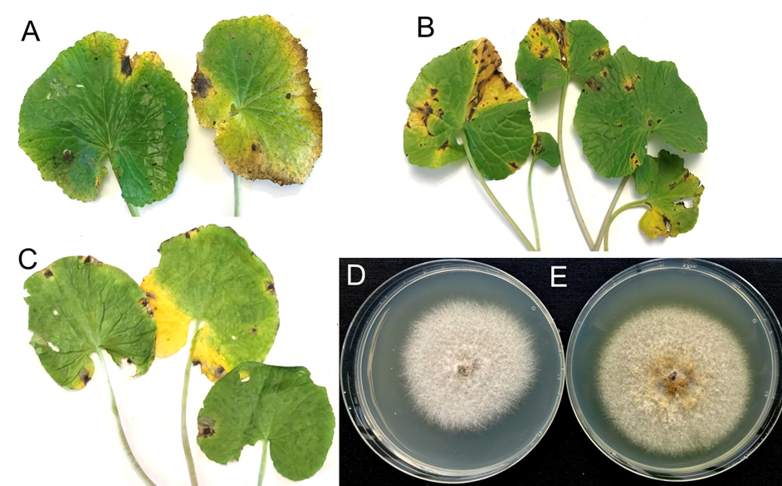

Figure 1. Isolation of Plenodomus biglobosus subclade ‘canadensis’ (Pbc) and P. biglobosus subclade ‘brassicae’ (Pbb) from diseased Eutrema japonicum (wasabi) leaves collected from three UK field sites in Spring 2021. Shown are diseased wasabi leaves from (A) Southern England (from which Pbc was isolated), (B) Northern Ireland (Pbc isolated), and (C) the West Midlands (Pbb isolated). Representative isolates obtained from the material and grown on potato dextrose agar (PDA) plates for 12 days growth are (D) 21WAS7-1 (from Northern Ireland, white colony with pink oozing cirri evident, Pbc), and (E) 21WAS8-4 (from the West Midlands, yellow pigmented colony, Pbb).

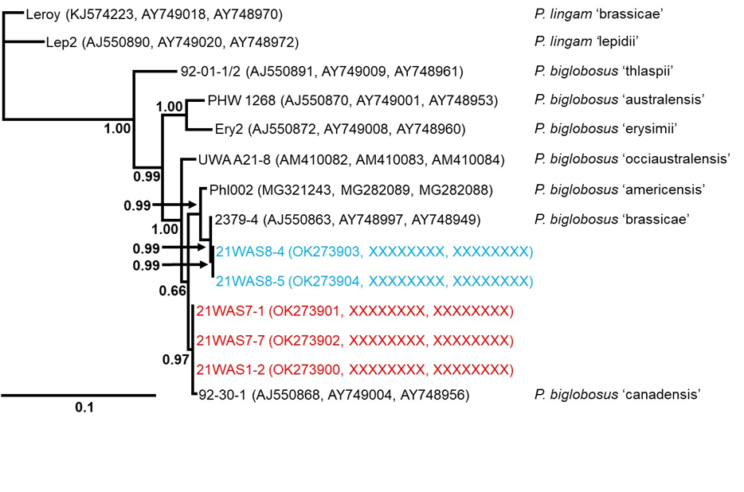

Figure 2. Bayesian phylogenetic tree (constructed with MrBayes) inferred from concatenated partial ITS rDNA (456 bp), beta tubulin (375 bp), and actin (415 bp) sequences of Plenodomus species. Isolates newly obtained from Eutrema japonicum (wasabi) in the UK in this study were identified as either P. biglobosus subclade ‘canadensis’ (red) or P. biglobosus subclade ‘brassicae’ (blue); newly obtained sequences were deposited onto GenBank (see brackets). Reference sequences from isolates of known genetic subclades of P. lingam and P. biglobosus used in the analyses are indicated to the right, with sequences downloaded from GenBank (see brackets). The tree shown was based on the on the GTR+I+G model (determined as optimal via JModelTest), with 1,000,000 MCMC generations and a 25% burn in. Bayesian posterior probabilities are indicated in bold at nodes. The outgroup for this tree was P. lingam subclade ‘brassicae’. The scale bar represents the number of nucleotide substitutions per site.

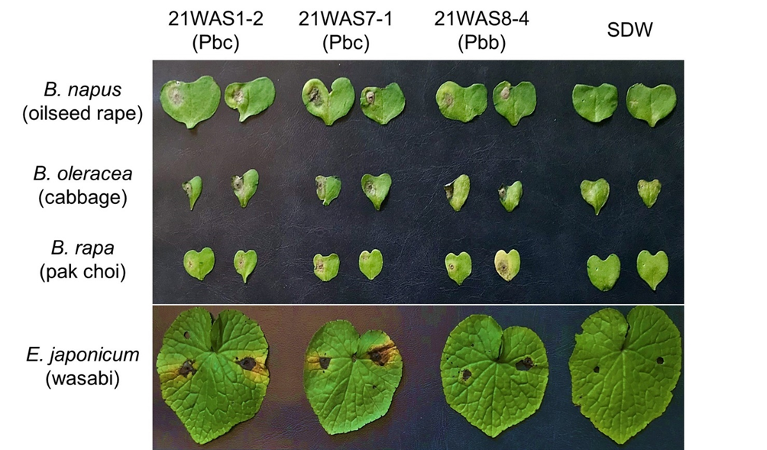
Figure 3. Greenhouse pathogenicity testing of isolates of Plenodomus biglobosus subclade ‘canadensis’ (Pbc) and P. biglobosus subclade ‘brassicae’ (Pbb) isolates originally obtained from Eutrema japonicum (wasabi) in the UK. Two representative Brassica napus (oilseed rape), B. oleracea (cabbage), and B. rapa (pak choi) cotyledons are shown at 1 week post inoculation (wpi) for each isolate or sterile distilled water (SDW) treatment tested (note that cotyledons were tested on left lobes only). A representative wasabi leaf is shown at 2 wpi for each isolate or SDW treatment tested (note both sides of wasabi leaves were tested). All plants were wounded prior to either isolate inoculation or SDW treatment.

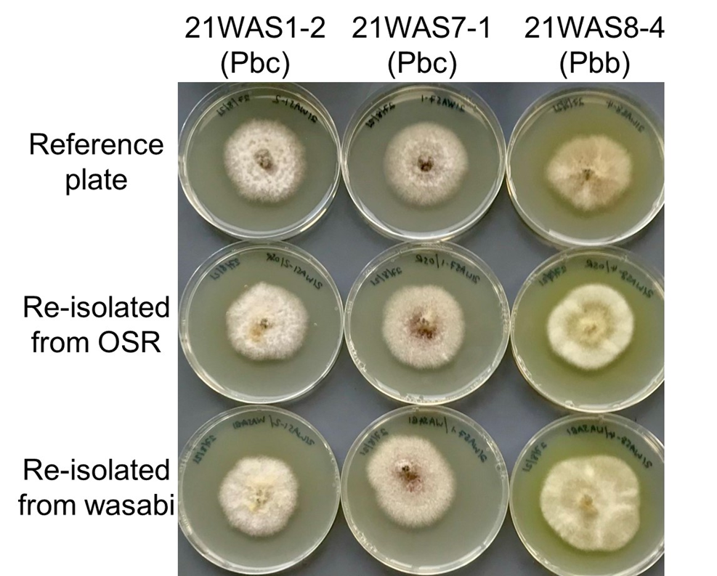
Figure 4. Re-isolation of Plenodomus biglobosus subclade ‘canadensis’ (Pbc) and P. biglobosus subclade ‘brassicae’ (Pbb) from lesion margins of artificially inoculated Eutrema japonicum (wasabi) and Brassica napus (oilseed rape, OSR) leaves. The three isolates used for pathogenicity testing were cultured from diseased wasabi leaves (tester isolate reference plates, top row), caused disease on artificially inoculated leaves of both oilseed rape and wasabi (see Fig. 2), and were subsequently re-isolated on potato dextrose agar (PDA) plates from lesions that had developed inoculated OSR (middle row) and wasabi (bottom row) leaves. Plates shown were incubated at 20°C in the dark for 10 days. Note the production of bright yellow pigmented colonies for Pbb isolate 21WAS8-4 but not Pbc isolates 21WAS1-2 or 21WAS7-1. Species and subclade identities of the reisolated cultures were confirmed by sequencing of the ITS rDNA region (data not shown).

References

- de Gruyter, J., Woudenberg, J. H. C., Aveskamp, M. M., Verkley, G. J. M., Groenewald, J. Z., & Crous, P. W. (2013). Redisposition of Phoma-like anamorphs in Pleosporales. Studies in Mycology, 75, 1-36. https://doi.org/10.3114/sim0004
- Dilmaghani, A., Balesdent, M. H., Didier, J. P., Wu, C., Davey, J., Barbetti, M. J., Li, H., Moreno‐Rico, O., Phillips, D., Despeghel, J. P., Vincenot, L., Gout, L., & Rouxel, T. (2009). The Leptosphaeria maculans–Leptosphaeria biglobosa species complex in the American continent. Plant Pathology, 58, 1044-1058. https://doi.org/10.1111/j.1365-3059.2009.02149.x
- Dilmaghani, A., Balesdent, M. H., Rouxel, T., & Moreno-Rico, O. (2010). First report of Leptosphaeria biglobosa (blackleg) on Brassica oleracea (cabbage) in Mexico. Plant Disease, 94, 791. https://doi.org/10.1094/PDIS-94-6-0791C
- Huang, Y. J., Karandeni-Dewage, C. S., & Fitt, B. D. L. (2014). Importance of Leptosphaeria biglobosa as a cause of phoma stem canker on winter oilseed rape in the UK. Aspects of Applied Biology, 127, 117-122.
- Johnston, P. R., Park, D., Ho, W. W. H., & Alexander, B. J. R. (2017). Genetic validation of historical plant pathology records – a case study based on the fungal genus Phoma from the ICMP culture collection. Plant Pathology, 66, 1424-1431. https://doi.org/10.1111/ppa.12728
- Liu, Z., Latunde-Dada, A. O., Hall, A. M., & Fitt, B. D. L. (2014). Phoma stem canker disease on oilseed rape (Brassica napus) in China is caused by Leptosphaeria biglobosa ‘brassicae’. European Journal of Plant Pathology, 140, 841-857. https://doi.org/10.1007/s10658-014-0513-7
- Luo, T., Li, G., & Yang, L. (2021). First report of Leptosphaeria biglobosa ‘canadensis’ causing blackleg on oilseed rape (Brassica napus) in China. Plant Disease. doi: https://doi.org/10.1094/PDIS-12-20-2735-PDN
- Mendes-Pereira, E., Balesdent, M.-H., Brun, H., & Rouxel, T. (2003). Molecular phylogeny of the Leptosphaeria maculans–L. biglobosa species complex. Mycological Research, 107, 1287-1304. https://doi.org/10.1017/S0953756203008554
- Punja, Z. K., Chandanie, W. A., Chen, X., & Rodríguez, G. (2017). Phoma leaf spot of wasabi (Wasabia japonica) caused by Leptosphaeria biglobosa. Plant Pathology, 66, 480-489. https://doi.org/10.1111/ppa.12589
- Van de Wouw, A. P., Thomas, V. L., Cozijnsen, a. j., Marcroft, S. J., Salisbury, P. A., and Howlett, B. J. (2008). Identification of Leptosphaeria biglobosa ‘canadensis’ on Brassica juncea stubble from northern New South Wales, Australia. Australasian Plant Disease Notes, 3, 124-128. https://doi.org/10.1007/BF03211265
- White, T. J., Bruns, T., Lee, S., & Taylor, J. (1990). Amplification and direct sequencing of fungal ribosomal RNA genes for phylogenetics. PCR protocols: a guide to methods and applications 18, 315–322.
- Williams, R. H., & Fitt, B. D. L. (1999). Differentiating A and B groups of Leptosphaeria maculans, causal agent of stem canker (blackleg) of oilseed rape. Plant Pathology, 48, 161-175. https://doi.org/10.1046/j.1365-3059.1999.00333.x

