**SUPPORTING INFORMATION II**

Disease yield relationships.

Estimation of the disease free yield and yield loss coefficient: For each year yield was plotted as function of STB severity for all fungicide treatments. A linear relationship between yield and disease severity was fitted to the data

$Y= Y_{0}(1-L S)$

where *Y* is the yield, *S*, is the disease severity, *Y*0, is the disease-free yield, and *L* is the yield loss coefficient.

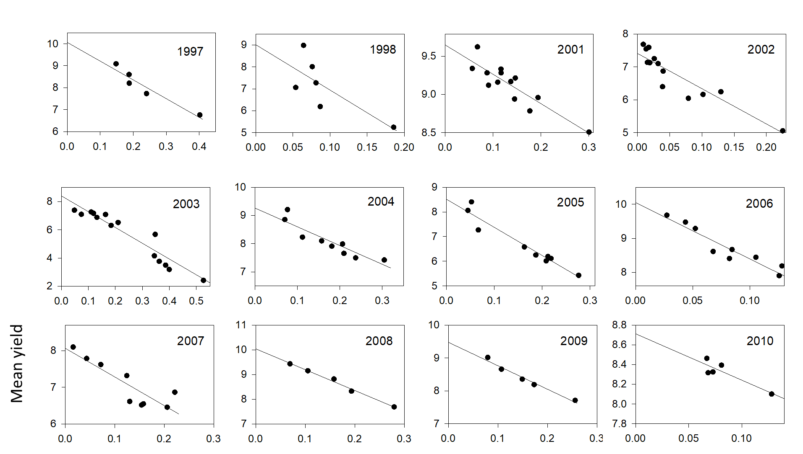

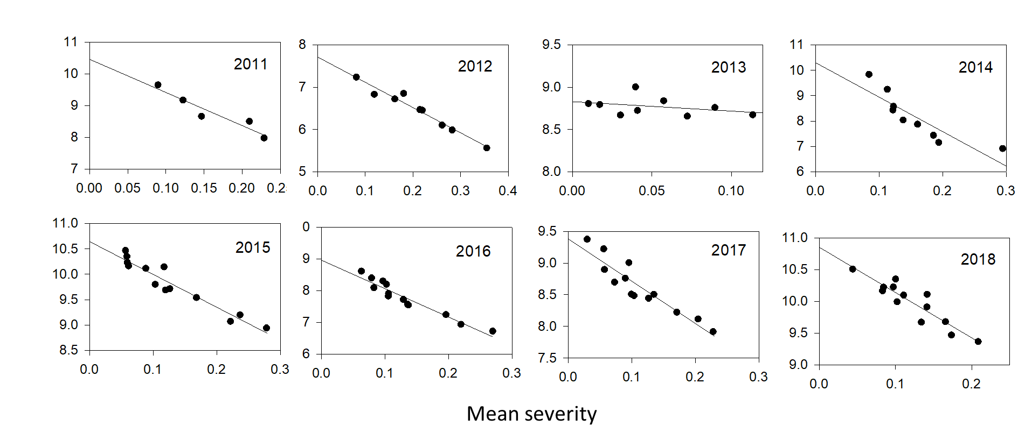

|  |  |  |
| --- | --- | --- |
| year | Max yield | Yield loss coeff L |
| 1997 | 10.06 | 0.85 |
| 1998 | 9.01 | 2.29 |
| 2001 | 9.65 | 0.39 |
| 2002 | 7.41 | 1.46 |
| 2003 | 8.40 | 1.33 |
| 2004 | 9.26 | 0.72 |
| 2005 | 8.52 | 1.34 |
| 2006 | 10.05 | 1.65 |
| 2007 | 8.07 | 0.97 |
| 2008 | 10.04 | 0.84 |
| 2009 | 9.48 | 0.75 |
| 2010 | 8.71 | 0.54 |
| 2011 | 10.46 | 0.99 |
| 2012 | 7.71 | 0.78 |
| 2013 | 8.83 | 0.12 |
| 2014 | 10.30 | 1.32 |
| 2015 | 10.64 | 0.61 |
| 2016 | 8.96 | 1.00 |
| 2017 | 9.38 | 0.71 |
| 2018 | 10.85 | 0.65 |
|  |  |  |

The relationship between Y0 and L was investigated. The below figure shows the results. I linear regression analysis shows that there is no correlation between mean yield and the yield loss coefficient. The slope of the estimated relationship was -0.0832 with a standard deviation of 0.1163.

