**Supporting Information**

**Table S1.** AMS Radiocarbon date determinations.

**Table S2.** Charcoal morphotypes and entrainability index.

**Figure S1.** Soil accumulation rate estimates.

**Figure S2.** Theoretical entrainment indices and transport distance of charcoal morphotypes.

**Supporting Information**

**Table S1.** AMS Radiocarbon date determinations.

|  |  |  |  |  |  |
| --- | --- | --- | --- | --- | --- |
| Laboratory code | Depth (cm) | *p*MC (%) | Radiocarbon age  (14C yr BP) | Calibrated  2σ range  (cal yr BP) | Median calibrated age  (cal yr BP) |
| D-AMS029604 | 39–40 | 79.76±0.38 | 1817±38 | 1587–1750 | 1682±82 |
| D-AMS029605 | 75–76 | 67.72±0.27 | 3131±32 | 3183–3387 | 3295±102 |
| D-AMS029606 | 201–202 | 43.94±0.24 | 6606±44 | 7421–7571 | 7475±75 |

**Table S1.** Results of AMS radiocarbon dating of soil organic matter. Uncalibrated 14C ages have not been rounded (Stuiver and Polach, 1977). Radiocarbon ages were calibrated with the SHCal20 curve (Hogg et al., 2020) and have not been rounded. The age determinations were used to estimate soil accumulation rates and to calculate charcoal accumulation rates (see Figures 3, 6 and 7). Acronyms: *p*MC, percent Modern Carbon; cal yr BP, calibrated years Before Present (1950 Common Era).

**REFERENCES FOR TABLE S1**

Hogg, A.G., Heaton, T.J., Hua, Q., et al. (2020) SHCal20 Southern Hemisphere calibration, 0–55,000 years cal BP. Radiocarbon, 62(4), 759–778.

Stuiver, M., & Polach, H.A. (1977). Discussion reporting of 14C data. Radiocarbon, 19(3), 355–363.

**Supporting Information**

**Figure S1.** Soil accumulation rate estimates.

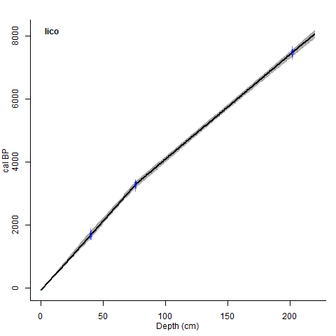

**FIGURE S1.** Estimates of soil accumulation rates based on three radiocarbon date geochronological determinations in the Mount Lico soil pit.Linear interpolated age-depth model of three AMS radiocarbon determinations from the Mount Lico soil pit calibrated with the SHCal20 calibration curve (Hogg et al., 2020) generated with the R package ‘clam’ (Blaauw, 2010) and replotted in Figure 3.

**REFERENCES FOR FIGURE S1**

Blaauw, M. (2010) Methods and code for ‘classical’ age-modelling of radiocarbon sequences. Quaternary Geochronology, 5(5), 512–518.

Hogg, A.G., Heaton, T.J., Hua, Q., et al. (2020) SHCal20 Southern Hemisphere calibration, 0–55,000 years cal BP. Radiocarbon, 62(4), 759–778.

**Supporting Information**

**Table S2.** Charcoal morphotypes and entrainability index.

**Shape Type Description Features Dimensionality Entrainability index >250μm observed**

(1=easily, to 5=resistant)

**Polygonal** A1 Irregular, subangular polygon Solid with parallel striations 2D 2 yes

A2 Irregular, subangular polygon Solid with conspicuous stomata holes 2D 1

A3 Irregular, subangular polygon Solid and featureless 2D 2

A4 Irregular, subangular polygon Structured reticulate mesh 2D 1

A1a Irregular, subangular polyhedron Solid with parallel striations 3D 3 yes

A3a Irregular, subangular polyhedron Solid and featureless 3D 3 yes

**Blocky** B2 Rectangular Solid with parallel striations 2D 3

B3 Rectangular Solid and featureless 2D 3

B4 Rectangular Solid with conspicuous stomata holes 2D 1

B5 Rectangular Structured reticulate mesh 2D 1

B2.1a Cubic Solid with parallel striations 3D 5

B5.1 Rectangular Structured reticulate mesh with venation 2D 1

B2a Rectangular prism Solid with parallel striations 3D 5 yes

B3a Cubic Solid and featureless 3D 5

B5a Rectangular prism Structured reticulate mesh, often at least partially filled 3D 4

**Elongate** D1 Long, very thin and straight Solid and featureless 2D 1

D2 Long, thin and straight Solid and featureless 2D 2

D4 Long, thin and straight Solid with parallel striations 2D 2

D5 Long, thin, hollow cylindrical Solid with parallel striations 3D 1

D5.1 Long, thin, outer hemicylinder Solid with parallel striations 3D 1

D4a Long, thin rectangular prism Solid with striations 3D 4 yes

D5a Long, thin, solid cylindrical Solid with parallel striations 3D 2

D6.1a Long, thin, hollow cylindrical Structured reticulate mesh 3D 3

**Other** E Slightly curved irregular prism Resembled charred non-woody plant part 3D 5 yes

**TABLE S2.** Descriptions of charcoal morphotypes >125 μm in the Mount Lico soil profile that accompany the idealised forms presented in Figure 5. The apparent dimensionality at 10–40× magnifications: charcoal that appeared thin in the optical z-axis and tends to lie flat in the Petri dish and nearly impossible to lie stationary when stood on the thin axes was classed as 2D, and 3D charcoal had a visually obvious z-axis thickness and could lie stationary at the bottom of Petri dish when manually probed and rotated. The final column lists if charcoal morphotypes observed >250 μm at any depth in the soil profile regardless of fragment morphotype (Figure 6). Type E superficially resembled a fragment of charred succulent xerophyte leaf.

Supporting Information

Figure S2. Theoretical entrainment indices and transport distance of charcoal morphotypes.

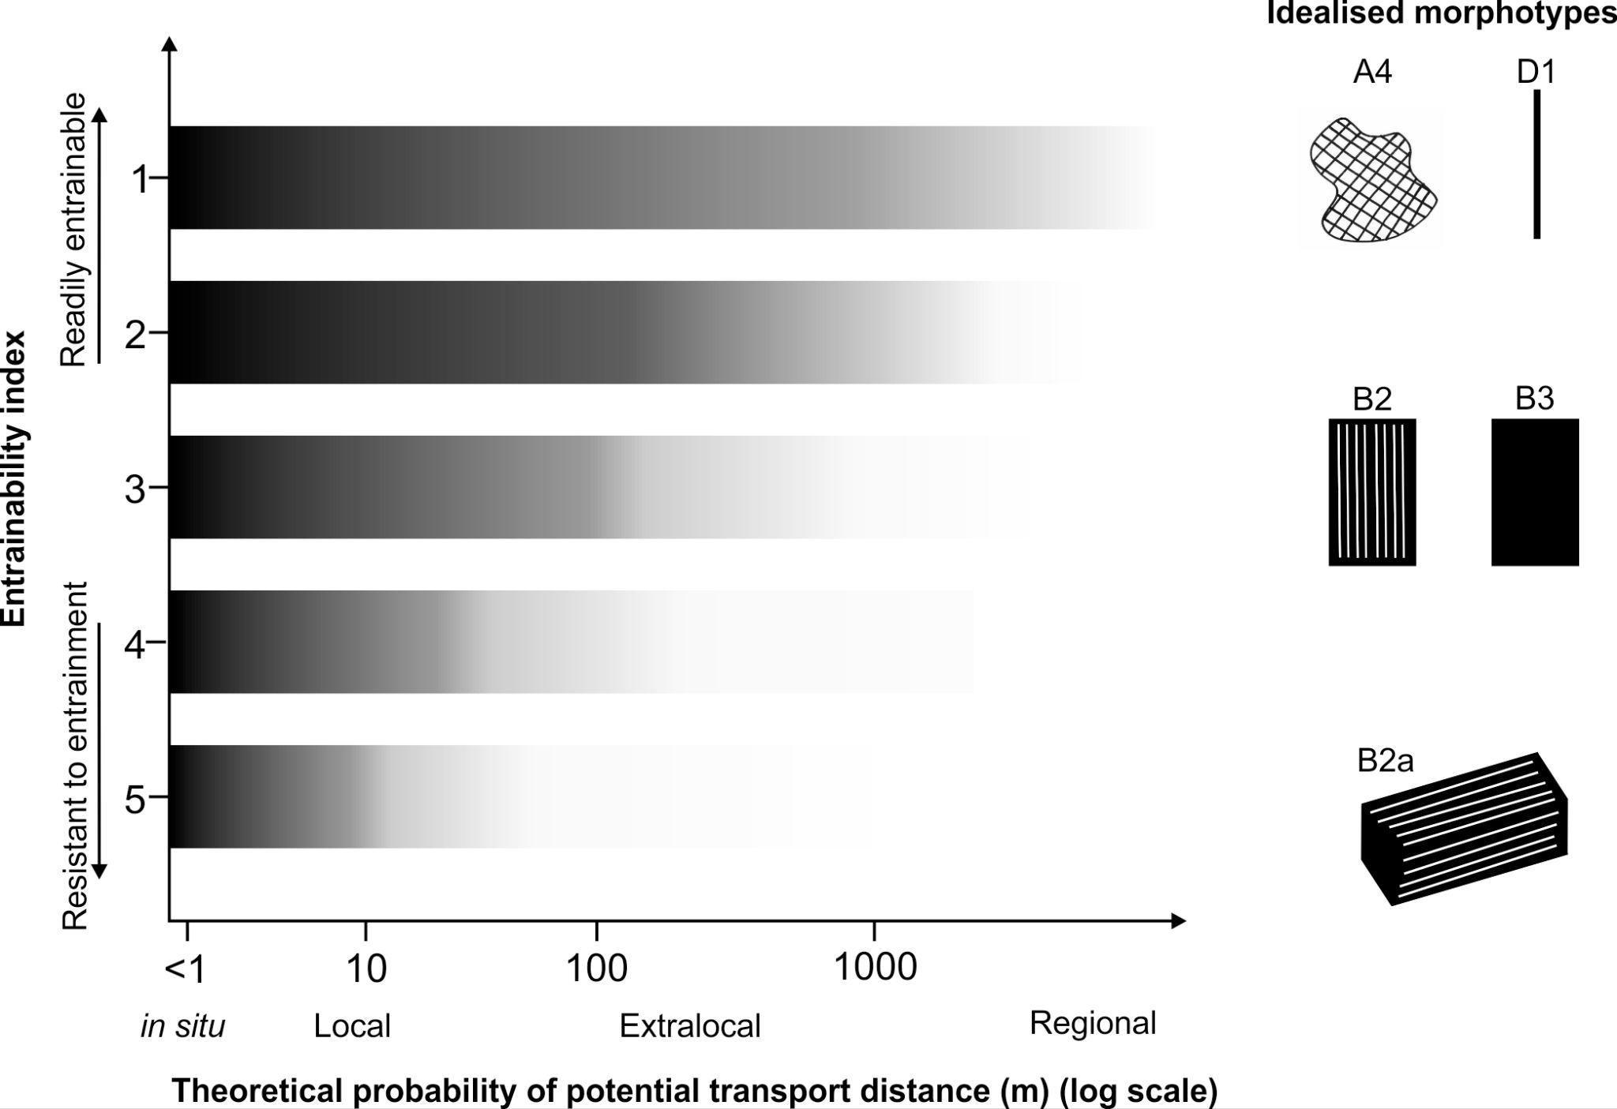

**Figure S2.** Conceptual diagram of potential theoretical transport distances (x-axis log scale) to final deposition for entrainability indices (discrete classes 1–5 , y-axis) based on charcoal morphotypes (irrespective of charcoal size) produced at a point source fire. All morphotypes have the potential to be produced and deposited in situ, local to the fire, or transported by convection and advection. Readily entrainable charcoal morphotypes have a higher probability to be transported to extralocal and regional scales before final deposition, relative to charcoal morphotypes that have a higher inertia to entrainment and that would require much more energy to sustain transport beyond local distances.