The role of interspecific variability and herbicide pre-adaptation in the cinmethylin response of Alopecurus myosuroides.

Authors:
David Comont¹, Laura Crook¹, Richard Hull¹, Bernd Sievernich², Stuart Kevis³, Paul Neve^{1,4}

Affiliations:
1. Department of Protecting Crops and the Environment, Rothamsted Research, Harpenden, Hertfordshire, AL5 2JQ, UK
2. BASF SE, Speyerer Strasse 2, 67117 Limburgerhof, Germany
3. BASF plc, 2 Stockport Exchange, Railway Road, Stockport, SK1 3GG, United Kingdom
4. Department of Plant and Environmental Sciences, Section for Crop Sciences, University of Copenhagen, Højbakkegård Allé 13, 2630 Taastrup, Denmark

* For correspondence: david.comont@rothamsted.ac.uk

Keywords:
cinmethylin, inter-population variability, herbicide resistance

Abstract:
BACKGROUND: Cinmethylin is an inhibitor of plant fatty acid biosynthesis, with in-plant activity caused by its binding to fatty acid thioesterases (FAT). The recent registration of cinmethylin for pre-emergence herbicidal use in the UK represents a new mode of action (MOA) for control of the grassweed blackgrass (Alopecurus myosuroides). To date there is little published information on the extent of blackgrass’ inter-population variability in sensitivity to cinmethylin, nor on any potential effect of existing non-target-site resistance (NTSR) mechanisms on cinmethylin efficacy.
RESULTS: Here we present a study of variability in cinmethylin sensitivity amongst 97 UK blackgrass populations. We demonstrate that under controlled conditions, a UK field-rate dose of 500 g ha⁻¹ provides effective control of the tested populations. Nevertheless, we reveal significant inter-population variability at doses below this rate, with populations previously characterised as strongly NTSR displaying the lowest sensitivity to cinmethylin. Assessment of paired resistant “R” and sensitive “S” lines from standardised genetic backgrounds confirms that selection for NTSR to the acetyl-CoA-carboxylase inhibitor fenoxaprop, and the microtubule assembly inhibitor pendimethalin, simultaneously results in reduced sensitivity to cinmethylin at doses below 500 g ha⁻¹. Whilst we find no resistance to the field-rate dose, we reveal that cinmethylin sensitivity can be further reduced through experimental selection with cinmethylin.
CONCLUSION: Cinmethylin therefore represents a much-needed further MOA for blackgrass control, but needs to be carefully managed within a resistance monitoring and integrated weed management (IWM) framework to maximise the effective longevity of this compound.
Introduction:
Herbicides represent a mainstay of agricultural weed control, and productivity in many agricultural systems globally is predicated on the effective use of herbicide products. Nevertheless, the widespread, rapid, and repeated evolution of herbicide resistance has compromised the efficacy of a vast range of herbicide active ingredients. To date, 267 species have been reported with evolved resistance to 21 herbicidal modes-of-action (MOAs) ¹. Exacerbating this issue, herbicide discovery has failed to keep pace with the evolution of resistance, with no ‘new’ herbicide MOAs introduced for approximately 30 years, following their relatively regular introduction over the 1970s and 80s ². Recently however, the site of action have been discovered for a range of herbicidal actives, including inhibition of fatty acid thioesterase (HRAC group 30), inhibition of serine threonine protein phosphatase (HRAC group 31), and inhibition of solanesyl diphosphate synthase (HRAC group 32), ^{3–5}, leading to a resurgence of interest in these groups.
The benzylether compound cinmethylin was discovered in the early 1980s by the Shell Chemical Company, and first commercialised for use against weeds in rice ⁶. It was found to be effective at controlling a range of both monocotyledonous and dicotyledonous weed species ⁷. Due to the simultaneous development of several other effective herbicidal modes-of-action (MOAs) such as the acetyl-CoA carboxylase inhibitors (ACCase, HRAC group 1), very long chain fatty acid inhibitors (VLCFA, HRAC group 15), and acetolactate-synthase inhibitors (ALS, HRAC group 2), the registration and use of cinmethylin for grass-weed control was not extensively pursued in other crops, however. Increasing herbicide resistance to these other MOAs has led to a resurgence of interest in alternative herbicide active ingredients, and recently the in-plant site of action for cinmethylin was discovered to be the fatty acid biosynthesis pathway. Cinmethylin inhibits plant fatty acid biosynthesis through binding to the fatty acid thioesterases (FAT), obstructing the release of fatty acids (FA) from their acyl carrier proteins (ACP) and thereby inhibiting further lipid biosynthesis. Although other plant herbicides target the fatty acid biosynthesis pathway, e.g. the ACCase and VLCFA inhibitors, the inhibition of FAT proteins by cinmethylin constitutes a novel herbicidal mode of action ³, with cinmethylin classified as HRAC group 30 (legacy HRAC group ‘Q’) herbicide ¹. Due to its cereal crop selectivity and capacity to control problematic weeds including Alopecurus myosuroides and Lolium multiflorum, as of autumn 2022, cinmethylin has been registered and approved for use in UK cereal cropping.
While registration of new or alternative herbicides is encouraging for growers, their introduction needs to be carefully managed in relation to the resistance status and variation in sensitivity of their target weed populations. Of particular importance is the extent to which prior selection with other actives might have pre-selected for resistance to the newer chemistry. As an example, Petit et al. ⁸ identified pinoxaden resistance in French populations of A. myosuroides before pinoxaden was released in France, while quinclorac resistance was observed in Californian populations of Echinochloa phyllopogon without any prior exposure to this herbicide ⁹. Non-target-site (NTSR) resistance mechanisms are of particular concern in this regard, due to their potential to result in broad and unpredictable cross-resistance, across structurally different herbicide groups ^{10,11}. For example, the cytochrome P450 ‘CYP81A10v7’ in the grassweed Lolium rigidum has been implicated in NTSR to five different herbicide MOAs ¹². Inter-population variability in cinmethylin sensitivity has also been found amongst Australian L. rigidum populations at doses below the field-approved rate, and is also thought to be conveyed via P450 mediated oxidation of the cinmethylin molecule ¹³. Whilst not currently sufficient to convey resistance to cinmethylin at the field dose, this highlights the importance of considering inter-population variability when introducing a new herbicide.
A. myosuroides is the most pernicious UK weed of winter cereal crops, with evolved resistance to seven herbicide modes-of-action ¹, causing an annual £0.4 billion in crop yield losses ¹⁴. NTSR is now the predominant resistance mechanism amongst UK blackgrass populations, involving upregulation of plant glutathione-S-transferases, ABC-transporters, cytochrome P450s, and other metabolism-related genes, providing resistance to a wide range of actives from multiple MOAs ^{15–18}. Prevalence of resistance to ALS and ACCase inhibitors in UK populations has led to greater reliance on alternative actives, particularly soil-residual pre-emergence herbicides ¹⁹. Although resistance to pre-emergence herbicides has generally evolved more slowly than to post-emergence actives ²⁰, resistance to the HRAC group-3 herbicide pendimethalin is now widely observed, and evidence suggests selection towards flufenacet (HRAC group 15) resistance is also occurring ^{21,22}. The introduction of cinmethylin therefore represents an important additional herbicide for blackgrass control, yet there is the risk of strong selective pressure for resistance on this active if it is not sustainably used. The widespread presence of NTSR amongst blackgrass populations raises the question of: to what extent has selection for metabolic resistance to prior herbicides provided pre-adaptation to cinmethylin?
In light of such issues, it has been argued that any herbicide introduction should be accompanied by detailed evaluation of existing sensitivity in field populations, assessment of cross-resistance from exposure to other herbicide groups, and monitoring for potential further shifts in sensitivity ²³. To date, while some field trials have demonstrated the potential for cinmethylin to control populations of A. myosuroides ²⁴, there has been no large-scale assessment of inter-population variability in cinmethylin response in this species, nor how pre-existing NTSR mechanisms might affect cinmethylin efficacy. Here we provide such a study for UK populations of A. myosuroides, to coincide with the UK introduction of cinmethylin. We provide a detailed assessment of inter-population variability in sensitivity to this new active across 97 blackgrass populations. Using experimentally derived blackgrass lines segregating for NTSR resistance to the HRAC group 1, 2, 3, and 15 herbicides, we evaluate the potential for metabolic cross-resistance between these groups. Finally, using experimental evolution we investigate the potential for cinmethylin selection to cause directional shifts in cinmethylin sensitivity.

Methods:
Inter-population variability in cinmethylin sensitivity
A dose-response experiment was conducted under glasshouse conditions to test the efficacy of cinmethylin against a variety of UK A. myosuroides (blackgrass) field collected populations. In total 97 populations were assessed, 94 collected from different fields across the Black-grass Resistance Initiative (BGRI) field network ¹⁷ over 2018 and 2019, and three ‘standard’ populations with well characterised resistance phenotypes. These standard populations were ‘Rothamsted 2018’ (susceptible), ‘Notts 2005’ (ACCase TSR only), and ‘Peldon 2013’ (NTSR). Seeds of each population were germinated in Petri dishes containing three Whatman No. 1 filter papers soaked in 5 ml of 0.02 M KNO₃. Petri dishes were incubated for seven days in a Sanyo MLR-350 growth cabinet with a 17/11°C temperature cycle and a 14/10 hour light/dark cycle, with light provided by 15 fluorescent Philips TL-D 90 36W bulbs, set to their maximum irradiance.
After pre-germination, pots of each blackgrass population were sown by transplanting eight pre-germinated seeds into 8 cm plastic plant pots containing a Kettering loam soil mixed with 2 kg m⁻³ of osmocote fertiliser. Seeds were sown 5 – 10mm below the soil surface, and 24 pots of each blackgrass population were prepared in this way (sufficient for four replicate pots at each herbicide dose). Pots were placed in a glasshouse chamber, set to maintain approximately 17/11°C day/night temperature cycles. No supplementary lighting was required beyond the ambient natural light within the glasshouse. Due to the large number of populations involved and the need for prompt pre-emergence spraying directly after sowing, the experimental set up was staged over two weeks with half of the replicates sprayed in each week. All populations and doses were equally represented across each sowing and spraying date. Pots were assigned to positions within the glasshouse using a randomised alpha design.
Pots were sprayed the day immediately after sowing, with herbicide applied using a fixed track sprayer. The spray nozzle (flat fan 110015VK; Teejet, Wisbech, UK) was mounted 50 cm above the pots, with boom speed set at 0.33 m s⁻¹. The herbicide sprayer was calibrated before each run to account for any small variation in pressure or flow rate and ensure doses applied were consistent, resulting in application rates of 205 L ha⁻¹ for reps 1 and 2 and 212 L ha⁻¹ for reps 3 and 4. Six doses of cinmethylin were used; 0, 15, 50, 125, 250 and 500 g ai/ha⁻¹, with the highest (500 g ha⁻¹) dose representing the UK field rate registered for grassweed control. Four replicate pots (n=4) of each population were sprayed at each herbicide dose, and pots were placed back in the glasshouse immediately following spraying. Pots were watered from above and kept in free-draining trays. Eight weeks after spraying, pots were visually assessed for plant emergence and aboveground biomass was harvested. Dry weights were recorded after oven drying at 80° C for 48 hours.

Confirming variation in cinmethylin sensitivity
To confirm results observed in the glasshouse experiment, a sub-set of populations identified to have differing sensitivity to cinmethylin were grown outdoors in larger containers and assayed again for cinmethylin sensitivity. Containers (285 mm x 185 mm x 130 mm deep) were filled with a 2.5 cm layer of hydroleca at the bottom for drainage, with the remaining space filled with Kettering loam soil. Four populations identified to have contrasting sensitivity to cinmethylin were selected; two field collected populations (Lola 8, Lola 91) and two ‘standard’ populations (Rothamsted 2018, Peldon 2013). Containers were dry-seeded by mixing 0.5 g of seed (approximately 200 seeds) with a standard quantity of the Kettering loam soil and spreading this over the soil surface in each container. This results in an even distribution of seeds throughout the surface 3 cm, mimicking a typical field situation. Containers were arranged in a randomised design in a plant nursery exposed to ambient environmental conditions at Harpenden (Hertfordshire, UK) over October – December. After sowing, containers were watered lightly for 2-3 days to stimulate seed germination, but subsequent watering was by natural rainfall only.
Herbicides were applied one week after the containers were sown, at the point of seed germination but before seedling emergence. Cinmethylin was applied to containers at 0, 31.25, 62.5, 125, 250, and 500 g ai ha⁻¹ as described above at a rate of 210 L ha⁻¹. There were three replicate containers (n=3) of each population at each herbicide dose. In addition, three further replicate containers of each population were sprayed with either pendimethalin (formulation “Claymore”) at 1200 g ai ha⁻¹, or flufenacet (formulation “Sunrise”) at 180 g ai ha⁻¹. After spraying, containers were immediately moved back outside. Herbicide efficacy was assessed seven weeks after spraying by counting the number of healthy emerged black-grass seedlings.

Evaluating cross-resistance with other herbicide MOAs
The effect of evolved metabolic resistance to four other herbicide MOAs on cinmethylin sensitivity, was assessed in a further glasshouse dose response experiment. Experimentally derived blackgrass lines were used with either metabolic resistance (“R”) or sensitivity (“S”) to the ALS inhibitor “Atlantis” (containing the actives mesosulfuron-methyl and iodosulfuron-methyl, hereafter referred to as meso+iodosulfuron), the ACCase inhibitor fenoxaprop-p-ethyl, the VLCFA inhibitor flufenacet, or the microtubule assembly inhibitor pendimethalin (Table 1). In the case of the meso+iodosulfuron, flufenacet, and pendimethalin resistant lines, the “R” seed families were derived through experimental selection for two, nine, and eight years respectively, exposing sequential generations to the focal herbicide and allowing survivors to cross-pollinate and set seed. The ACCase resistant line was derived from an F₂ segregating seed family resulting from a pairwise cross between the herbicide sensitive population “Rothamsted” and the NTSR field population “Lola91”. Plants from the F₂ family (n=600) were grown under glasshouse conditions, vegetatively cloned by tillering, and screened with two doses (138 and 1656 g ha⁻¹) of the herbicide fenoxaprop-p-ethyl. Clones of surviving healthy plants at the higher dose were allowed to cross-pollinate, creating the “R” seed line, while clones of plants which died at the lower herbicide dose were separately cross pollinated to create the “S” seed line. These pairs of “R” and “S” seed lines therefore represent populations with shared genetic backgrounds, but which differ only in metabolic resistance to the focal herbicide.
Seeds of each of these lines were pre-germinated and sown into 8 cm plastic plant pots containing a Kettering loam soil as previously, and 72 pots (576 plants) of each population were sown in this way. To confirm differences in metabolic resistance between each pair of “R” and “S” lines, half of the pots from each seed line were treated with the herbicide used during experimental selection to create the line (see Table 1). The remaining pots of each line were treated with a range of doses of cinmethylin. The herbicide actives cinmethylin, pendimethalin, and flufenacet were applied pre-emergence to the soil the day after sowing. The actives fenoxaprop-p-ethyl and meso+iodosulfuron were applied post-emergence, to three-leaf plants after approximately three weeks of seedling growth. In the case of meso+iodosulfuron, a commercial formulation (“Atlantis") was used, containing both mesosulfuron-methyl and iodosulfuron-methyl active ingredients in a 5:1 g/g ratio. All herbicides were applied with the same fixed-track sprayer as previously described, applying herbicide at a rate of 200 - 210 L ha⁻¹, at 252 kPa pressure. For detailed description of all dose rates of each herbicide, see the supporting materials Table S1. Efficacy of herbicide treatments was assessed through counts of plant survival four weeks after treatment (for post-em actives), or seedling emergence eight weeks after treatment (for pre-em actives).

Experimental selection with cinmethylin
Plants from two field populations with lower sensitivity to cinmethylin (Peldon and Lola91) were exposed to recurrent cinmethylin selection for three generations. Plants were grown outside in large containers as previously described (n=3, approximately 200 plants per container). Each year, the “Peldon” population was exposed to selection with a cinmethylin dose of 125 g ha⁻¹, while “Lola91” was selected at 250 g ha⁻¹. These doses were chosen as previous phenotyping identified that they would result in 5-10% survival of respective populations. A further three containers of each line were maintained with no herbicide selection. After herbicide selection, plant numbers in untreated containers were thinned to an equal number of plants as the herbicide treated survivors. All containers were then maintained outdoors until maturity. Before the onset of flowering, treated and untreated containers from each population were placed into separate small glasshouses and allowed to flower in isolation to prevent cross pollination between selection lines. After three generations of selection, a larger experiment was established to determine the extent of any change in cinmethylin sensitivity. Eighteen containers were sown for each seed line (Peldon selected, Peldon unselected, Lola91 selected, Lola91 unselected) and sprayed with cinmethylin doses of 0, 32.3, 62.5, 125, 250, and 500 g ha⁻¹ (n=3 containers per dose). Seedling emergence was counted six weeks after spraying.

Statistical analysis
In all cases, herbicide efficacy was assessed from counts of plants surviving herbicide application. For post-emergence herbicides, ‘survival’ was evaluated as the number of plants surviving herbicide, divided by the total number of plants sprayed within each replicate. For pre-emergence herbicides, ‘emergence’ was calculated as the number of healthy plants emerging after herbicide treatment, divided by the mean number of plants emerging in the unsprayed control replicates of that population. Both measures provide a proportional value between 0 – 1, representing 0 – 100% of plants surviving treatment.
All analysis was conducted using ‘R’ version 4.1.1 using a dose-response-curve fitting procedure. All dose response curves were fitted using the ‘drm()’ function of the ‘drc’ package. Dose response curves were fitted with either survival or emergence as the response, weighted by either the total number of plants per rep (survival data), or the mean unsprayed control emergence (emergence data). Initially, binomial two parameter log-logistic functions were fitted to estimate the slope and ED₅₀, with upper and lower limits fixed at 1 and 0 respectively. Model goodness-of-fit was compared against other two- and three-parameter log-logistic and Weibull functions using the ‘mselect()’ function. Models were then re-fitted with the optimal curve type based on comparison of AIC. Dry weight data collected for the inter-population variability assay was also analysed in this way, but with models initially fitted using a four-parameter log-logistic function, and compared against other four parameter models using the ‘mselect()’ function.
For the experimentally selected “R” and “S” lines, significance testing for dose-response models was performed using a likelihood ratio testing procedure. Both a ‘full’ and ‘reduced’ model was fitted for each population, fitting either an individual curve for each “R” and “S” line (full model), or a single global curve from the “R” and “S” lines combined (reduced model). A likelihood ratio test was then used to compare the full model against the reduced model. Model comparison was performed using the ‘anova()’ function, and the resulting approximate F-test used to determine the significance of the predictor variable in improving the overall model fit. ED₅₀ values were also extracted from the fitted models using the ED() function, and a resistance ‘Index’ calculated as the ratio of the estimated “R” and “S” ED₅₀ values, computed with “S” as the denominator. Where likelihood-ratio testing suggested a significant difference between the “R” and “S” lines, ED₅₀ values were also statistically compared using a Z-test, implemented with the ‘compParm()’ function.

Results
Experiment 1 (Glasshouse)
Under standardised, unheated glasshouse conditions, the efficacy of cinmethylin on both seedling emergence and plant biomass was high (Figure 1, Table S2). The two herbicide susceptible ‘standard’ populations (Roth18 and Notts05) exhibited close to 100% control, even at doses ≤100 g ha⁻¹ (with UK field rate being 500 g ha⁻¹). The majority of UK collected field populations were similarly sensitive, with an estimated overall mean ED₅₀ of 20 g ha⁻¹ (emergence) and 7 g ha⁻¹ (dry weight). The mean percentage control of seedlings at the field-rate dose of 500g ha⁻¹, calculated from all UK populations, was estimated as 97.6%. Nevertheless, the standard NTSR population (Peldon13) showed reduced sensitivity to cinmethylin, maintaining approximately 15% emergence at the highest dose. Two field collected populations (Lola 91 and Lola 101) showed similar reduced sensitivity to the herbicide. Seed collected in-field over two separate years (2014 and 2018) was included for population Lola 91. Both seed sets had consistently lower sensitivity to cinmethylin than the majority of other UK field collected populations. These results demonstrate that the overall efficacy of cinmethylin in UK blackgrass populations at the field rate (500 g ha⁻¹) is high, although highlighting that significant inter-population variability exists at doses below this rate.

Experiment 2 (Outdoor containers)
Four populations identified from the glasshouse study with variable sensitivity to cinmethylin (Roth18, Lola8, Lola91, and Peldon), were screened again for cinmethylin sensitivity outdoors in large containers (Figure 2, A). For all populations, control of black-grass emergence by cinmethylin at 500 g ai ha⁻¹ was 90 – 100% (see supporting material Table S3). As previously however, significant variability in cinmethylin sensitivity was apparent at doses below 500 g ai ha⁻¹. Roth2018 and Lola8 demonstrated greater sensitivity, with the majority of emergence controlled at doses ≤100 g ha⁻¹ (Figure 2, B). The two known NTSR populations (Peldon 2013 and Lola 91) demonstrated significantly lower sensitivity to cinmethylin however, with considerable emergence apparent at 125 and 250 g ha⁻¹ doses (Figure 2, A, B). To compare variation in cinmethylin sensitivity with variation in sensitivity to other pre-emergence herbicides, further containers of all four populations were sprayed with either flufenacet (at 180 g ai ha⁻¹) or pendimethalin (at 1200 g ai ha⁻¹). Control of all four populations was uniformly high using the herbicide flufenacet (Figure 2, C). Much greater variability in seedling emergence was observed in the pendimethalin treatment, with 0-15% control of the two NTSR populations (Peldon 13 and Lola 91), 30-40% control of population Lola 8, and 80-90% control of Roth18. Although clearly not a direct 1:1 relationship, this highlights a potential association; whereby populations with greater pendimethalin resistance are also less sensitive to low doses of cinmethylin.

Experiment 3 (Cross-resistance)
All four experimentally selected resistant lines were confirmed to have a significant difference in resistance to the herbicide that they had been selected with (pendimethalin, flufenacet, fenoxaprop, and meso+iodosulfuron), compared with their unselected baseline (Table 2, Figures S1-S5). Using likelihood-ratio testing, two out of the four lines (pendimethalin and fenoxaprop resistance) were found to similarly have significantly reduced sensitivity to cinmethylin (Table 2). In both cases, it was the blackgrass line with non-target-site resistance which displayed lower cinmethylin sensitivity, compared with the unselected baseline (Figure 3). In the pendimethlin selected line, cinmethylin ED₅₀ was increased from 31 g ha⁻¹ in the baseline, to 118 g ha⁻¹ following eight years selection with pendimethalin. In the fenoxaprop resistant segregating line, cinmethylin ED₅₀ was increased from 15 g ha⁻¹ in the baseline, to 108 g ha⁻¹ in the resistant line.

Experiment 4 (cinmethylin selection)
Two of the populations with lower sensitivity to cinmethylin (Peldon and Lola91) were exposed to recurrent low-dose selection for three generations to determine if cinmethylin sensitivity could be further reduced. Screening in large containers outdoors, both experimentally selected lines were found to have further reduced sensitivity to cinmethylin, compared with their unselected baseline (Figure 4). For the Peldon line, the estimated ED₅₀ had risen from 170 g ha⁻¹ in the unselected line to 407 g ha⁻¹ in the selected line, an increase of approximately 139% and equivalent to an R:S resistance index of 2.39. For the Lola91 line, the estimated ED₅₀ had risen from 132 g ha⁻¹ in the unselected line to 439 g ha⁻¹ in the selected line, a percentage increase of 232% and equivalent to an R:S resistance index of 3.33. These results demonstrate that three years of recurrent selection with low cinmethylin doses (125 g ha⁻¹ for Peldon and 250 g ha⁻¹ for Lola 91) under experimental conditions can result in further significant reductions in cinmethylin sensitivity.

Discussion
With large population sizes and evolved resistance to seven herbicide modes-of-action (MOAs), blackgrass (Alopecurus myosuroides) remains the UK’s principal weed problem in arable fields ^{1,14,17}. Selective herbicidal control of this species is now predominantly based on mixtures of multiple soil-active residual herbicides applied pre-emergence, though resistance to several of these actives is either present or likely evolving ^{19,21,25}. The benzylether cinmethylin, approved for UK grassweed control in 2022, provides a further herbicidal MOA, potentially aiding in effective blackgrass control and easing selection against existing actives. Nevertheless, the utility of this herbicide for blackgrass control will be determined by its efficacy across all populations, including those with pre-existing metabolic resistance, and by how rapidly resistance to this MOA might evolve.
Results from the 97 blackgrass populations studied here demonstrates that cinmethylin generally provides effective control of UK blackgrass at the field-rate dose of 500 g ha⁻¹, observed both under glasshouse and ambient outdoor conditions. This concurs with previously published field-trial data for cinmethylin efficacy against blackgrass ²⁴, as well as the finding by Busi et al ²⁶ that cinmethylin effectively controls both sensitive and herbicide resistant Australian populations of the weed Lolium rigidum. Nevertheless, both of these prior studies identified significant variability in cinmethylin response amongst different field populations or accessions. In the current study, pronounced variation amongst blackgrass populations was also observed at doses below the UK field rate. In particular, populations with well-characterised enhanced metabolism resistance to other herbicides (Peldon, Lola91) had concomitantly lower sensitivity to cinmethylin than other field collected populations. The potential for non-target-site resistance mechanisms (NTSR) to provide broad and unpredictable cross-resistance to multiple MOAs has long been recognised ¹¹, with this phenomena prioritised for resistance research ¹⁰. While the current study did not identify populations meeting the criteria for ‘resistance’ to cinmethylin, our findings clearly raise the possibility that existing NTSR in blackgrass might contribute to the inter-population variation in sensitivity observed at lower doses.
To investigate the contribution of pre-existing NTSR more directly, contrasting ‘NTSR resistant’ and ‘sensitive’ populations within standardised genetic backgrounds were compared for cinmethylin sensitivity. Lines with metabolic resistance to the ALS inhibitor meso+iodosulfuron or the VLCFA active flufenacet, showed no significant alteration in response to cinmethylin, suggesting that pre-selection with these actives had not contributed to a change in cinmethylin sensitivity. For lines with selected (or evolved) NTSR resistance to the dinitroaniline active pendimethalin and the ACCase inhibitor fenoxaprop however, a significant reduction in cinmethylin sensitivity was observed. In each case, changes in the resistance index were relatively small (3.8 and 7.3 respectively) and effective control was observed at the field-rate dose (500 g ha⁻¹), yet the cinmethylin ED₅₀ values of the resistant lines were clearly and significantly higher than their herbicide sensitive counterparts, despite never receiving selection with cinmethylin. Only one experimentally derived resistant line for each MOA was available for study, and independent populations might evolve resistance mechanisms utilising a variety of different genetic loci ^{18,27}. Nevertheless, our results are consistent in that the field populations observed to have lower sensitivity to cinmethylin (Peldon, Lola91, and Lola101) also have well characterised NTSR to fenoxaprop ¹⁷, and are amongst the most resistant to pendimethalin (Figure S6). Taken together, these results provide a strong indication that selection for NTSR to the HRAC group 1 (ACCase) and HRAC group 3 (K1) herbicides has likely provided pre-selection for reduced sensitivity to cinmethylin.
In the case of Lolium rigidum, inter-population variability in cinmethylin sensitivity is thought to be via P450 mediated oxidation of the cinmethylin molecule ¹³. P450s are widely implicated in NTSR ²⁸, and one P450 in particular, ‘CYP81A10v7’, reportedly contributes to resistance to five separate MOAs in L. rigidum ¹². In blackgrass, differential gene expression analysis has previously identified six and eleven P450s to be upregulated in the pendimethalin- and fenoxaprop-resistant lines studied here, including an orthologue of ‘CYP81A10v7’ ^{18,29}. It may therefore be that activity of these P450s contributes to the variation in cinmethylin sensitivity observed and provide logical targets for further study. Many Blackgrass populations are also observed to upregulate expression of plant glutathione transferases ¹⁶, thought to be important in detoxification of other pre-emergence active ingredients including flufenacet ²². A clearer understanding of the molecular pathways responsible for detoxification of cinmethylin, and other pre-emergence herbicides, would aid our capability to more rapidly diagnose and manage potential shifts in sensitivity. This knowledge could also help inform the design of rational strategies for rotation and mixture of pre-emergence herbicides, to slow evolution of resistance.
Although the genetic control of reduced cinmethylin sensitivity in blackgrass remains to be confirmed, our results do highlight that this trait is heritable and responds to further cinmethylin selection. Over just three generations of selection with cinmethylin, we saw ED₅₀ values increase by 139% and 232% in the two tested lines. Importantly, selective doses applied here were lower than the field-rate cinmethylin dose, and resultant populations do not yet constitute resistant lines. It is also noted that experimental selection in this manner does not replicate the dynamics of herbicide selection under field conditions ³⁰. Nevertheless, results such as those described here help to demonstrate whether in principle resistance can evolve rapidly to a particular active. Given the observed variability in cinmethylin sensitivity amongst populations, the association with previously evolved NTSR, and the further response to cinmethylin selection, our findings reiterate the importance of careful stewardship to minimise further selection when introducing this active.

Conclusions
The registration of cinmethylin for UK blackgrass control represents a much-needed additional herbicidal MOA to tackle this species, with effective control (mean 97% reduction in emergence) demonstrated across our tested UK blackgrass populations under glasshouse conditions. However, the variation in sensitivity observed below field rate, and the influence of pre-existing mechanisms of enhanced herbicide metabolism on cinmethylin sensitivity are a cause for concern in relation to future resistance evolution. It has been argued that the effectiveness of newly introduced actives can only be maximised where we have detailed baseline sensitivity data, proactive monitoring for shifts in resistance, and a clear iterative decision-making process to enact in light of these data ²³. The current study provides such sensitivity data, characterising the potential links with pre-existing metabolic resistance. Moreover, we highlight the capacity to select for cinmethylin sensitivity, and identify field locations within a blackgrass monitoring network most at risk of evolving a resistance trait. Future experimental selection, coupled with in-field monitoring across this blackgrass network is needed, in order to pro-actively detect resistance evolution. Similarly, newly developed genomic resources for this species ²⁹ will be an invaluable resource to identify molecular pathways responsible for the observed variation in sensitivity, and to develop diagnostics for the rapid detection of potential resistance ³¹. While the introduction of a new MOA is encouraging for growers, it is imperative that its use is advocated within an integrated weed management (IWM) framework, to minimise selection, and ensure effective and pro-active stewardship of this new active.

Acknowledgments
The study was conducted with the financial support of BASF. The field blackgrass populations studied were originally collected with funding from the Biotechnology and Biological Sciences Research Council (BBSRC; BB/L001489/1) and the Agriculture and Horticulture Development Board (AHDB). DC, PN, RH and LC were also supported by the Smart Crop Protection (SCP) strategic programme (BBS/OS/CP/000001), funded through the Biotechnology and Biological Sciences Research Council's Industrial Strategy Challenge Fund, with DC, RH and LC currently supported through the BBSRC “Growing Health” (BB/X010953/1) Institute Strategic Programme.

Conflict of Interest
The study was conducted with the financial support of BASF. Authors BS and SK are employees of BASF, which manufactures and sells cinmethylin
References
1 Heap I, The International Herbicide-Resistant Weed Database. www.weedscience.org [accessed 22 September 2022].
2 Duke SO, Why have no new herbicide modes of action appeared in recent years?, Pest Manag Sci 68:505–512 (2012).
3 Campe R, Hollenbach E, Kämmerer L, Hendriks J, Höffken HW, Kraus H, et al., A new herbicidal site of action: Cinmethylin binds to acyl-ACP thioesterase and inhibits plant fatty acid biosynthesis, Pestic Biochem Physiol 148:116–125, Academic Press (2018).
4 Bajsa J, Pan Z, Dayan FE, Owens DK, and Duke SO, Validation of serine/threonine protein phosphatase as the herbicide target site of endothall, Pestic Biochem Physiol 102:38–44, Academic Press (2012).
5 Kahlau S, Schröder F, Freigang J, Laber B, Lange G, Passon D, et al., Aclonifen targets solanesyl diphosphate synthase, representing a novel mode of action for herbicides, Pest Manag Sci 76:3377–3388, John Wiley and Sons Ltd (2020).
6 Grayson BT, Williams KS, Freehauf PA, Pease RR, Ziesel WT, Sereno RL, et al., The physical and chemical properties of the herbicide cinmethylin (SD 95481), Pestic Sci 21:143–153, John Wiley & Sons, Ltd (1987).
7 Dayan FE, Romagni JG, and Duke SO, Herbicides, Cinmethylin, Encyclopedia of Agrochemicals, John Wiley & Sons, Ltd (2003).
8 Petit C, Bay G, Pernin F, and Délye C, Prevalence of cross- or multiple resistance to the acetyl-coenzyme a carboxylase inhibitors fenoxaprop, clodinafop and pinoxaden in black-grass (Alopecurus myosuroides Huds.) in France, Pest Manag Sci 66:168–177, Wiley-Blackwell (2010).
9 Yasuor H, Milan M, Eckert JW, and Fischer AJ, Quinclorac resistance: A concerted hormonal and enzymatic effort in Echinochloa phyllopogon, Pest Manag Sci 68:108–115, John Wiley & Sons, Ltd (2012).
10 Délye C, Gardin JAC, Boucansaud K, Chauvel B, and Petit C, Non-target-site-based resistance should be the centre of attention for herbicide resistance research: Alopecurus myosuroides as an illustration, Weed Res 51:433–437, Wiley/Blackwell (10.1111) (2011).
11 Yu Q and Powles S, Metabolism-based herbicide resistance and cross-resistance in crop weeds: A threat to herbicide sustainability and global crop production 1, Plant Physiol 166:1106–1118 (2014).
12 Han H, Yu Q, Beffa R, González S, Maiwald F, Wang J, et al., Cytochrome P450 CYP81A10v7 in Lolium rigidum confers metabolic resistance to herbicides across at least five modes of action, Plant J 105:79–92, Blackwell Publishing Ltd (2021).
13 Goggin DE, Cawthray GR, Busi R, Porri A, and Beckie HJ, Enhanced production of water-soluble cinmethylin metabolites by Lolium rigidum populations with reduced cinmethylin sensitivity, Pest Manag Sci 78:3173–3182, John Wiley & Sons, Ltd (2022).
14 Varah A, Ahodo K, Coutts SR, Hicks HL, Comont D, Crook L, et al., The costs of human-induced evolution in an agricultural system, Nat Sustain 3:63–71 (2020).
15 Tétard-Jones C, Sabbadin F, Moss S, Hull R, Neve P, and Edwards R, Changes in the proteome of the problem weed blackgrass correlating with multiple-herbicide resistance, Plant J 94:709–720, Wiley/Blackwell (10.1111) (2018).
16 Cummins I, Wortley DJ, Sabbadin F, He Z, Coxon CR, Straker HE, et al., Key role for a glutathione transferase in multiple-herbicide resistance in grass weeds, Proc Natl Acad Sci 110:5812–5817 (2013).
17 Hicks HL, Comont D, Coutts SR, Crook L, Hull R, Norris K, et al., The factors driving evolved herbicide resistance at a national scale, Nat Ecol Evol 2:529–536 (2018).
18 Franco-Ortega S, Goldberg-Cavalleri A, Walker A, Brazier-Hicks M, Onkokesung N, and Edwards R, Non-target Site Herbicide Resistance Is Conferred by Two Distinct Mechanisms in Black-Grass (Alopecurus myosuroides), Front Plant Sci 12:194, Frontiers Media S.A. (2021).
19 Moss S, Black-grass (Alopecurus myosuroides): Why has this weed become such a problem in western europe and what are the solutions?, Outlooks Pest Manag 28:207–212, Research Information (2017).
20 Moss S, Ulber L, and Hoed I den, A herbicide resistance risk matrix, Crop Prot 115:13–19, Elsevier Ltd (2019).
21 Dücker R, Zöllner P, Parcharidou E, Ries S, Lorentz L, and Beffa R, Enhanced metabolism causes reduced flufenacet sensitivity in black-grass (Alopecurus myosuroides Huds.) field populations, Pest Manag Sci 75:2996–3004, John Wiley & Sons, Ltd (2019).
22 Dücker R, Parcharidou E, and Beffa R, Flufenacet activity is affected by GST inhibitors in blackgrass (Alopecurus myosuroides) populations with reduced flufenacet sensitivity and higher expression levels of GSTs, Weed Sci 68:451–459, Cambridge University Press (2020).
23 Gaines TA, Busi R, and Küpper A, Can new herbicide discovery allow weed management to outpace resistance evolution?, Pest Manag Sci 77:3036–3041, John Wiley & Sons, Ltd (2021).
24 Messelhäuser MH, Saile M, Sievernich B, and Gerhards R, Effect of cinmethylin against Alopecurus myosuroides huds. In winter cereals, Plant, Soil Environ 67:46–54, Czech Academy of Agricultural Sciences (2021).
25 Bailly GC, Dale RP, Archer SA, Wright DJ, and Kaundun SS, Role of residual herbicides for the management of multiple herbicide resistance to ACCase and ALS inhibitors in a black-grass population, Crop Prot 34:96–103, Elsevier (2012).
26 Busi R, Dayan FE, Francis I, Goggin D, Lerchl J, Porri A, et al., Cinmethylin controls multiple herbicide-resistant Lolium rigidum and its wheat selectivity is P450-based, Pest Manag Sci 76:2601–2608, John Wiley and Sons Ltd (2020).
27 Van Etten M, Lee KM, Chang SM, and Baucom RS, Parallel and nonparallel genomic responses contribute to herbicide resistance in Ipomoea purpurea, a common agricultural weed, PLOS Genet 16:e1008593, Public Library of Science (2020).
28 Dimaano NG and Iwakami S, Cytochrome P450-mediated herbicide metabolism in plants: current understanding and prospects, Pest Manag Sci 77:22–32, John Wiley and Sons Ltd (2021).
29 Cai L, Comont D, MacGregor D, Lowe C, Beffa R, Neve P, et al., The blackgrass genome reveals patterns of non-parallel evolution of polygenic herbicide resistance, New Phytol 237:1891–1907, John Wiley & Sons, Ltd (2023).
30 Neve P, Busi R, Renton M, and Vila-Aiub MM, Expanding the eco-evolutionary context of herbicide resistance research, Pest Manag Sci 70:1385–1393, Wiley-Blackwell (2014).
31 Onkokesung N, Brazier-Hicks M, Tetard-Jones C, Bentham A, and Edwards R, Molecular diagnostics for real-time determination of herbicide resistance in wild grasses, J Biotechnol 358:64–66 (2022).

Figures and tables:

Table 1: Blackgrass lines with experimentally derived resistance to other herbicide modes-of-action, used to examine effects of pre-selection on cinmethylin sensitivity. “Origin” represents the name of the field-collected blackgrass population that each pair of “R” and “S” lines was derived from, while “selection procedure” details the way in which the ”R” and “S” lines were experimentally created. “Focal MOA” gives the WSSA herbicide mode-of-action for which the lines’ “R” and “S” seed families differ in sensitivity. “Screened with” gives the herbicidal actives that each line has been screened with in this study.
Line | Origin | Selection procedure | Focal MOA | Screened with
ALS (meso+ iodosulfuron) | Highfield | “R” and “S” created by Experimental selection for two generations | Group 2 | meso+iodosulfuron, cinmethylin
flufenacet | Peldon | “R” and “S” created by Experimental selection for nine generations | Group 15 | flufenacet,  cinmethylin
pendimethalin | Rothamsted | “R” and “S” created by Experimental selection for eight generations | Group 3 | pendimethalin,  cinmethylin
fenoxaprop | Pairwise cross of “Rothamsted” x “Lola91”, called “CC5” | “R” and “S” F₃ generation selected from a segregating F₂ seed family. | Group 1 | fenoxaprop,  cinmethylin

Table 2: Curve fitting and significance parameters for analysis of plant emergence in response to herbicide treatments. ‘F-test’ represents the result of comparing a model fitted with separate ‘R’ and ‘S’ curves versus one with only a single curve estimated. ‘Curve’ represents the drc R-package codes for the best-fitting dose response function following comparison of AIC, with “LL.2” representing a 2-parameter log-logistic, and “W1.2” representing a 2-parameter Weibull function. ‘Index’ represents the ratio of the estimated the ‘R’ and ‘S’ ED₅₀ values, computed with ‘S’ as the denominator. Significant differences are denoted using asterisks (* p<0.05, ** p<0.01, *** p<0.001).
Selected Herbicide | Tested Herbicide | Curve | F-test | Index (ED₅₀)
pendimethalin | pendimethalin | LL.2 | <0.001 *** | R/S 60.52
flufenacet | flufenacet | W1.2 | <0.001 *** | R/S 10.02
fenoxaprop | fenoxaprop | LL.2 | <0.001 *** | R/S >100
meso+iodosulfuron | meso+iodosulfuron | LL.2 | <0.001 *** | R/S 3.1
pendimethalin | cinmethylin | LL.2 | <0.001 *** | R/S 3.77
flufenacet | cinmethylin | LL.2 | 0.106 ns | R/S 1.44
fenoxaprop | cinmethylin | LL.2 | <0.001 *** | R/S 7.32
meso+iodosulfuron | cinmethylin | LL.2 | 1.00 ns | R/S 1.42

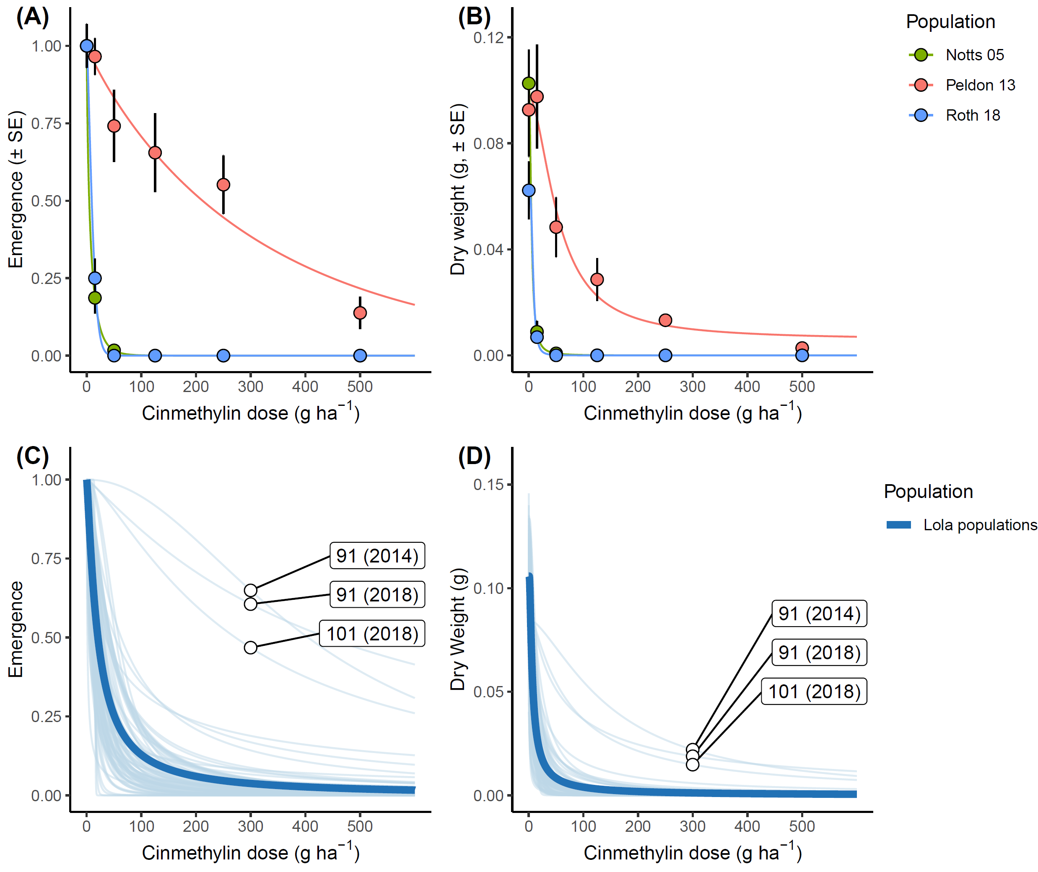

Figure 1: Efficacy of pre-emergence cinmethylin treatment on UK populations conducted under glasshouse conditions. (A) and (B) show the effects of increasing cinmethylin dose on plant emergence and aboveground biomass (g) for three ‘standard’ experimental blackgrass populations. Error bars in (A) and (B) represent the standard error of the mean (SE). (C) and (D) show the plant emergence and aboveground biomass (g) for a wider collection of UK field populations. Each single thin line represents the result from a different field collected population, while the thick blue line represents the overall mean response across all tested populations. Field populations with apparent lower sensitivity to cinmethylin in (B) and (C) are labelled with their population number, with year of collection given in parenthesis.
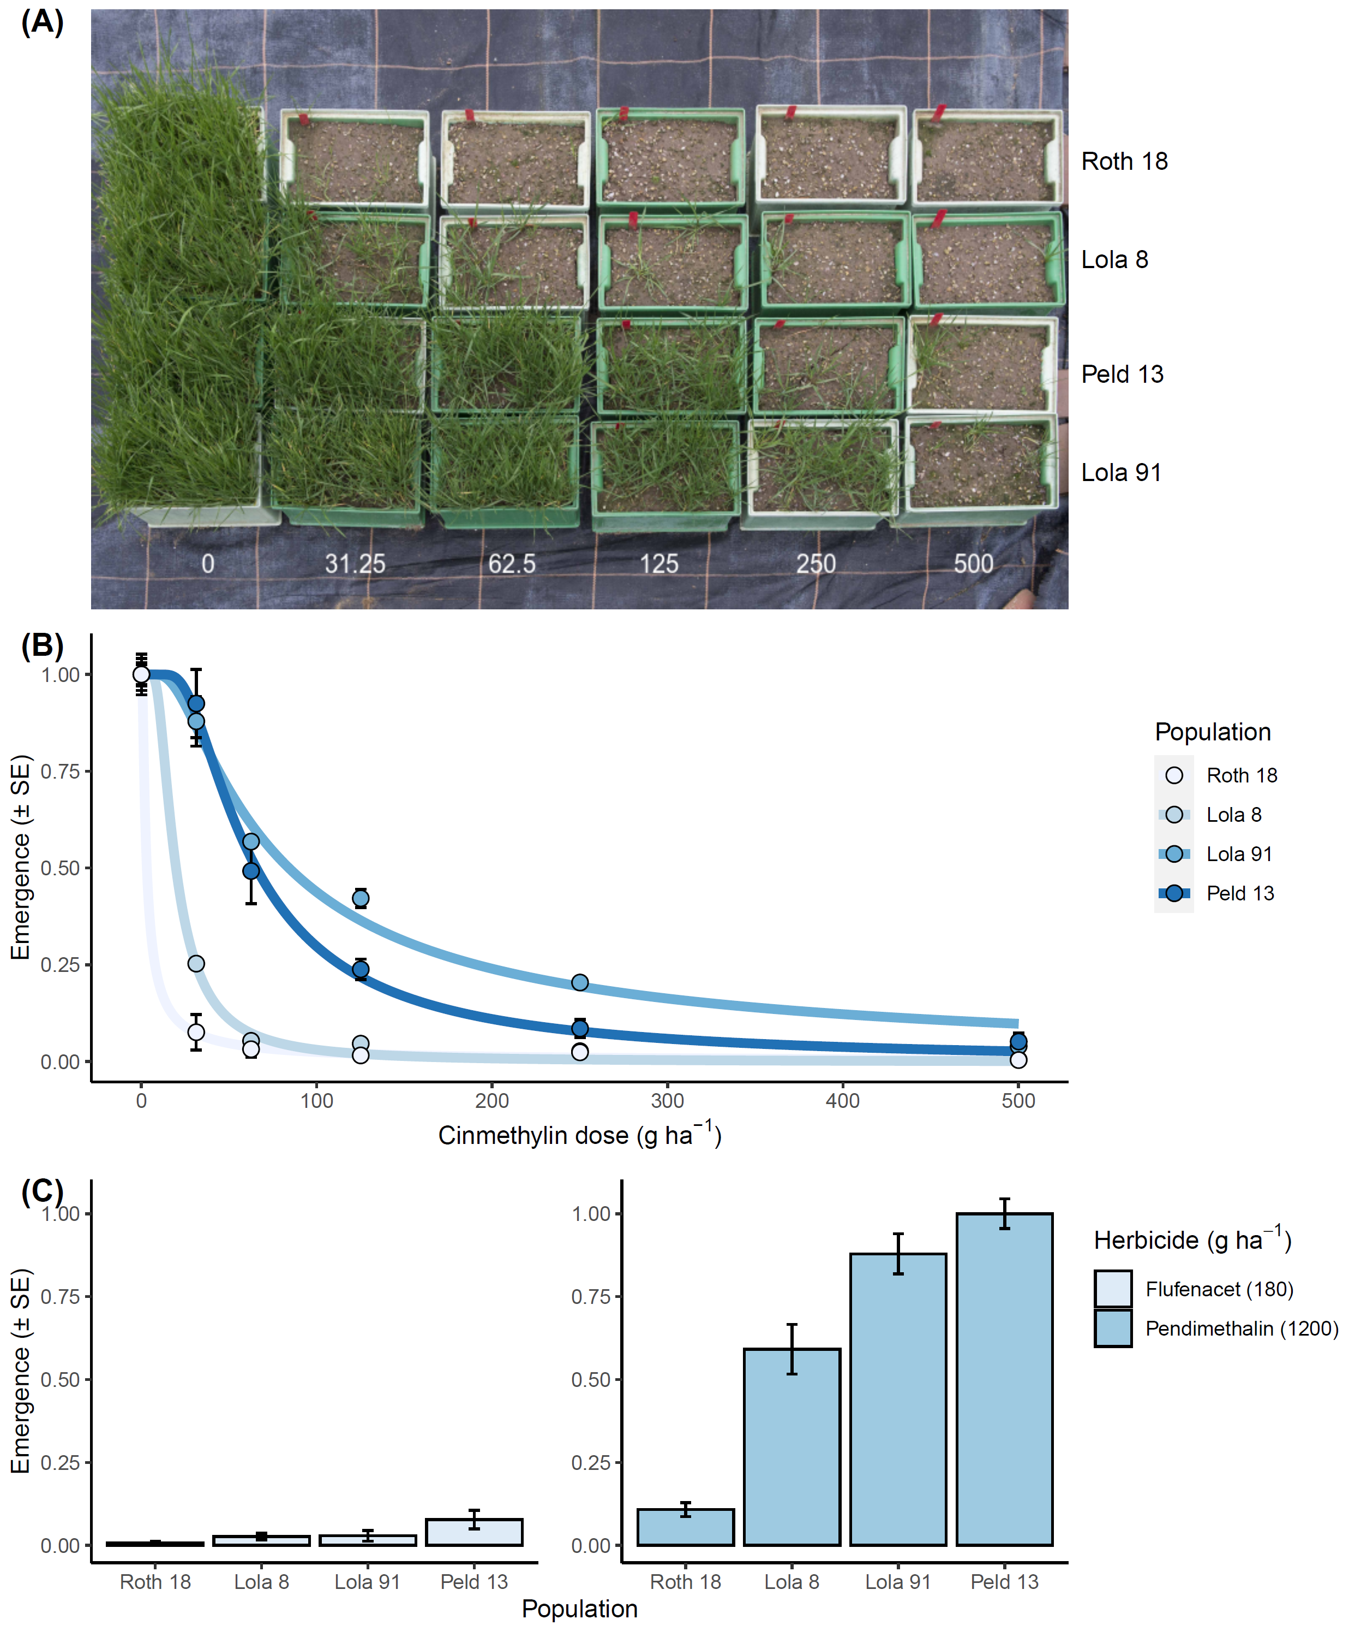
Figure 2: Efficacy of pre-emergence cinmethylin treatment on selected populations conducted outdoors. (A) Representative containers of each population over the tested cinmethylin doses. Containers are arranged with population as rows, and herbicide dose in columns, with doses given in g ai ha⁻¹ as white text. (B) Dose-response relationship for each population exposed to cinmethylin, fitted using a Weibuill type-2, 2-parameter non-linear function using the ‘R’ package ‘drc’. (C) Proportional seedling emergence of each population from additional containers treated with flufenacet at 180 g ha⁻¹ (left), or pendimethalin at 1200 g ha⁻¹ (right), (compared with unsprayed control containers). Error bars in (B) and (C) represent the standard error of the mean (SE).

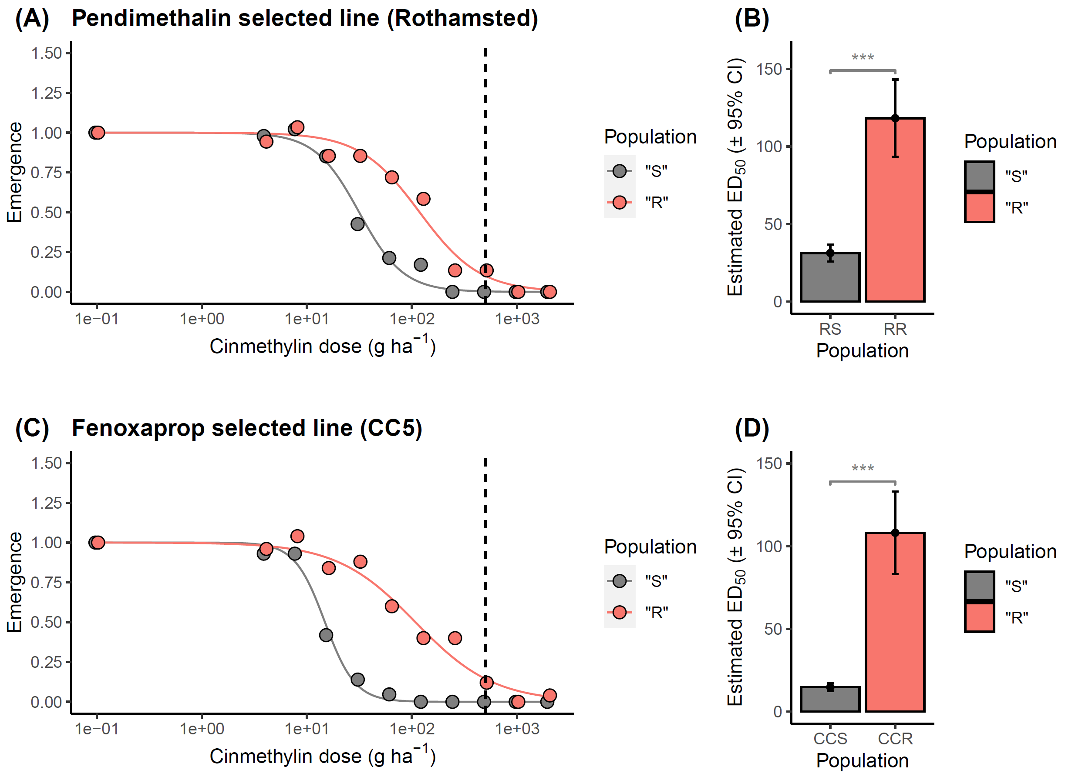
Figure 3: Effect of pre-selection with other herbicides on the efficacy of cinmethylin. (A) and (B) show the fitted cinmethylin dose response relationship and estimated cinmethylin ED₅₀ values for a blackgrass line experimentally selected for resistance to pendimethalin. (C) and (D) show the fitted cinmethylin dose response relationship and estimated cinmethylin ED₅₀ values for a blackgrass line segregating for resistance to fenoxaprop. In each case “R” and “S” are derived from the same genetic background, but differ in non-target-site resistance to their selected herbicide. Error bars show the 95% confidence interval around each estimated ED₅₀ value. Significant differences are denoted using asterisks (* p<0.05, ** p<0.01, *** p<0.001).

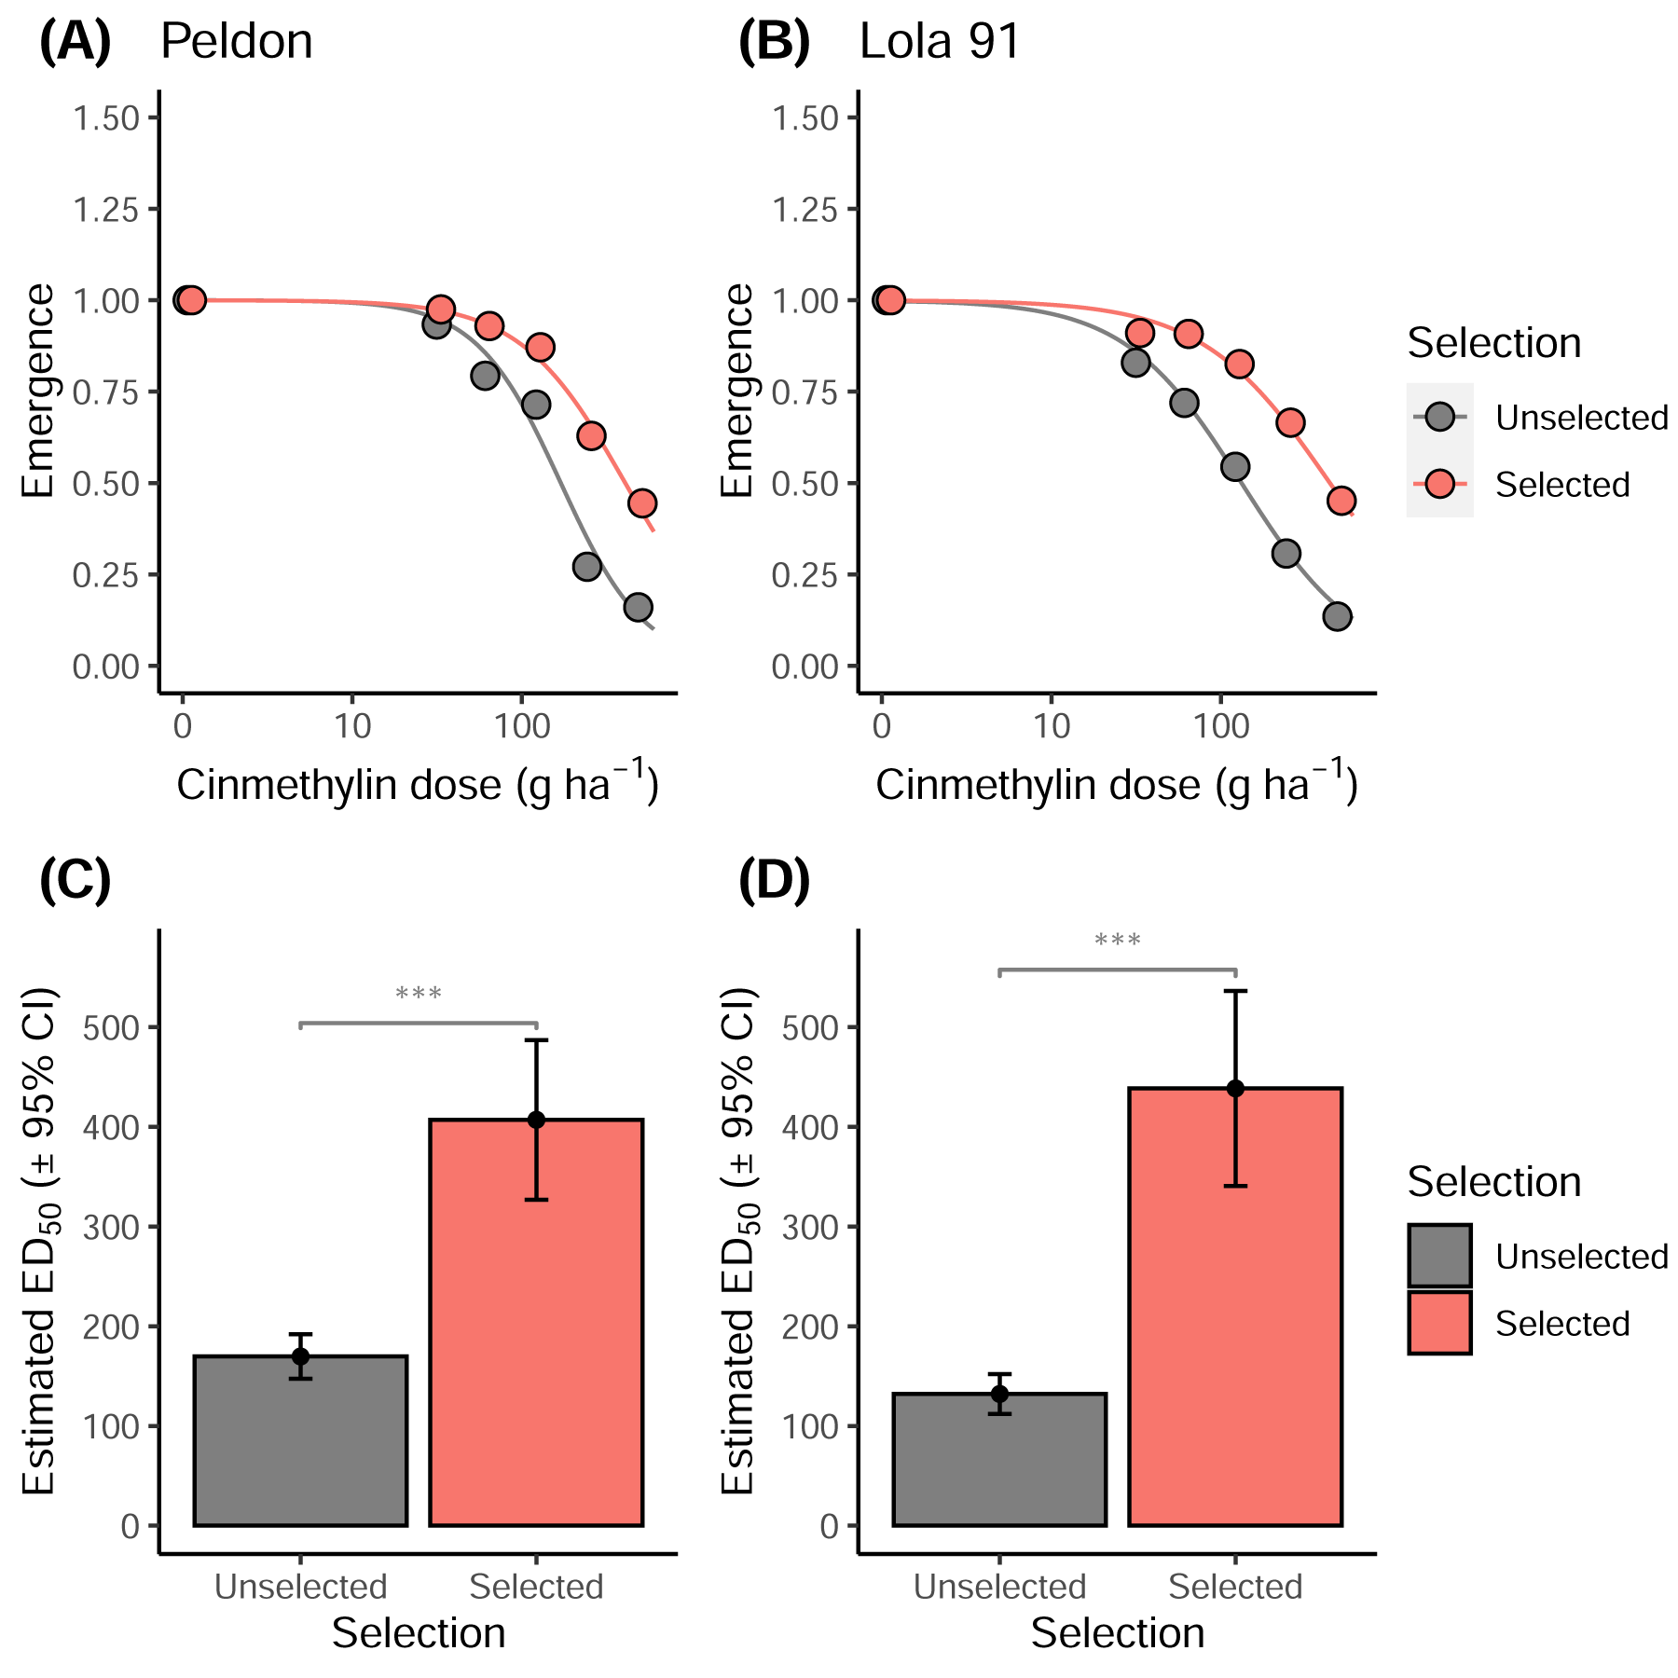
Figure 4: Effect of cinmethylin experimental selection on cinmethylin sensitivity in two blackgrass populations. Results are shown for lines derived from (A) Peldon, and (B) Lola 91. Lines had been selected for three consecutive generations with cinmethylin at 125 g ha⁻¹ (Peldon), or 250 g ha⁻¹ (Lola 91). In each case, the “Unselected” line is derived from a similar number of plants which have undergone the same growth and seed-bulking procedures, but without exposure to cinmethylin. (C) and (D) show the estimated cinmethylin ED₅₀ values for the unselected and selected blackgrass lines from the ‘Peldon’ and ‘Lola91’ lines respectively. Error bars show the 95% confidence interval around each estimated ED₅₀ value. Significant differences are denoted using asterisks (* p<0.05, ** p<0.01, *** p<0.001).

