SUPPORTING INFORMATION I.
Dose response curves and estimated parameter values.
Severity data from the trial sites in each year were scaled such that the severity at dose zero,
S₀, equals 1 and then averaged across experimental sites. For each year-fungicide combination
dose response curves, the relative severity, S_{rel}, as function of fungicide application dose, were
fitted, using non-linear least squares, with the equation
$S_{rel}(D)=\left(1-RD+RD e^{-k D}\right)$
where S_{rel} is disease severity, RD is the maximum reduction in the relative severity (at a theoretical infinite dose), k is the curvature parameter and D the fungicide dose.

azoxystrobin (as commercial product ‘Amistar’, Syngenta)
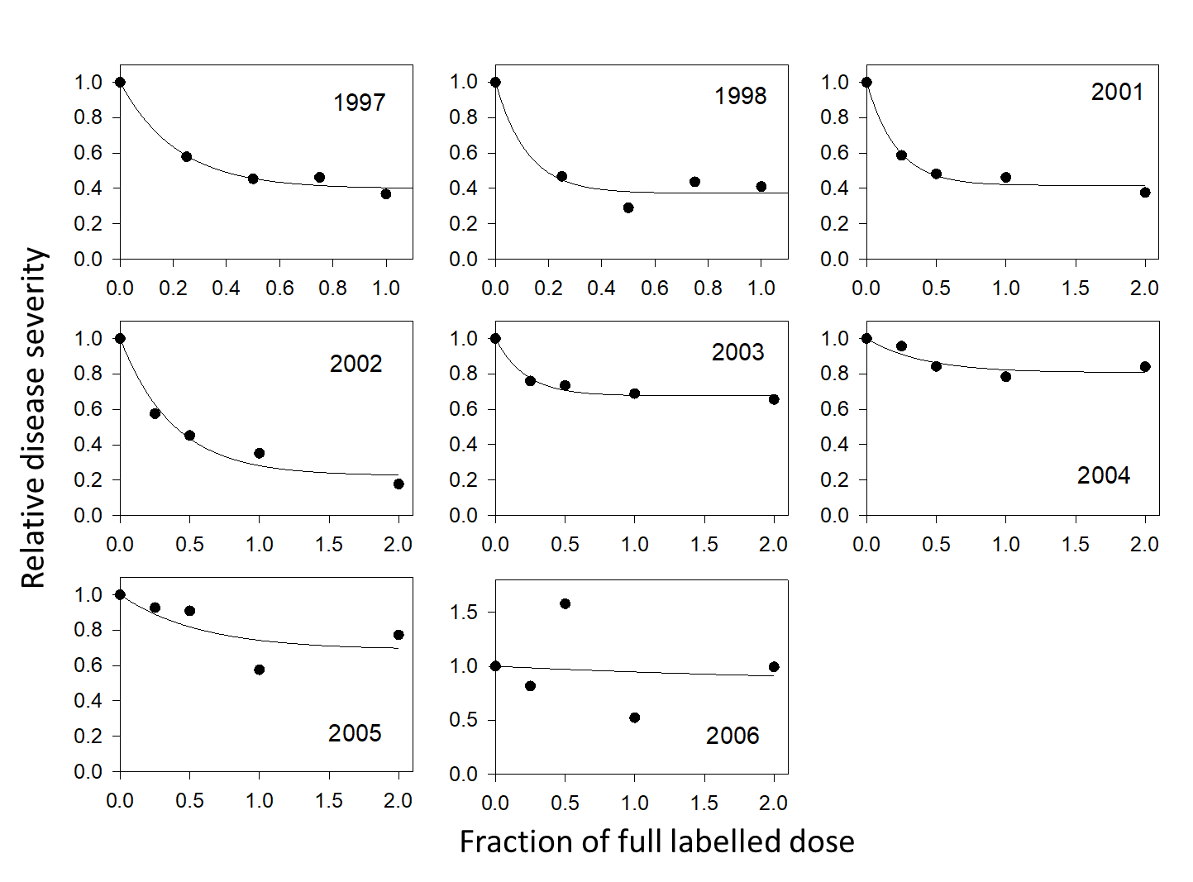

year | k | RD | R²
1997 | 4.68±0.91 | 0.602±0.029 | 0.97
1998 | 8.45±3.66 | 0.628±0.033 | 0.96
2001 | 4.70±0.82 | 0.583±0.024 | 0.99
2002 | 2.62±0.56 | 0.775±0.054 | 0.97
2003 | 4.69±1.01 | 0.324±0.017 | 0.98
2004 | 2.47±1.47 | 0.193±0.039 | 0.85
2005 | 1.75±2.08 | 0.312±0.145 | 0.627
2006 | 0.36±17.11 | 0.177±6.319 | 0.02

prothioconazole (as commercial product ‘Proline’, Bayer)
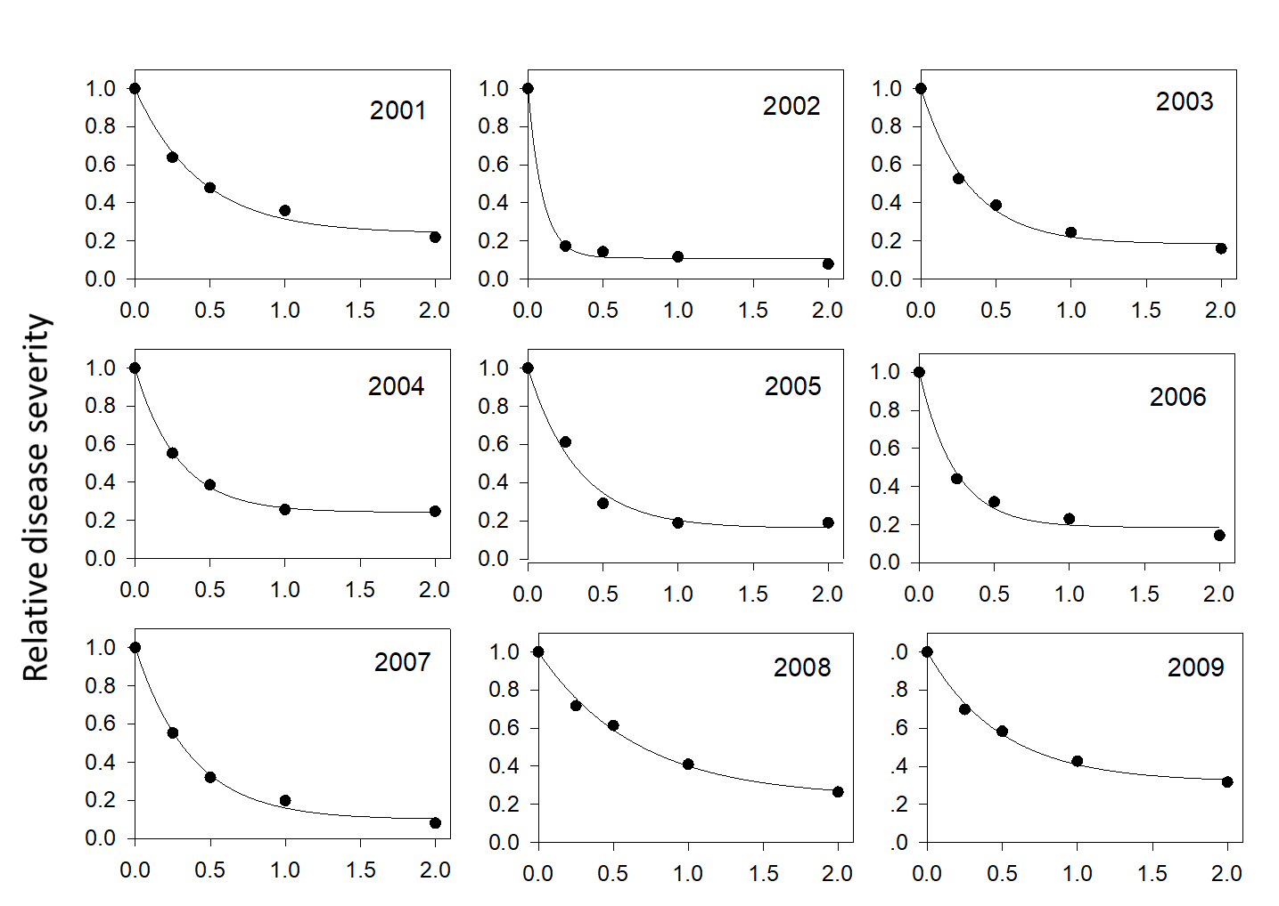
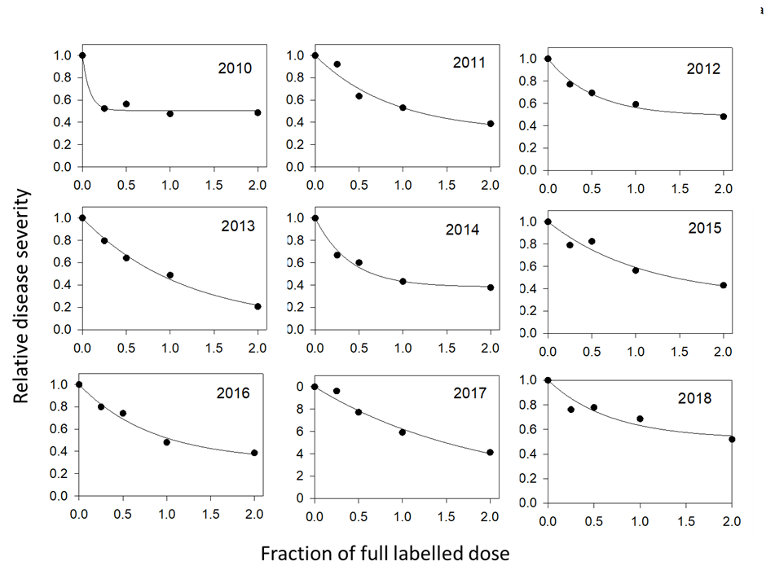
year | RD | k | R²
2001 | 0.760±0.033 | 2.32±0.29 | 0.99
2002 | 0.891±0.015 | 10.29±1.71 | 0.99
2003 | 0.816±0.028 | 3.08±0.34 | 0.99
2004 | 0.757±0.007 | 3.49±0.12 | 0.99
2005 | 0.839±0.042 | 3.02±0.49 | 0.99
2006 | 0.813±0.030 | 4.22±0.62 | 0.99
2007 | 0.900±0.024 | 2.70±0.23 | 0.99
2008 | 0.763±0.037 | 1.54±0.18 | 0.99
2009 | 0.683±0.027 | 2.01±0.21 | 0.99
2010 | 0.494±0.023 | 12.36±0.94 | 0.97
2011 | 0.690±0.127 | 1.14±0.44 | 0.95
2012 | 0.512±0.032 | 1.92±0.31 | 0.98
2013 | 0.948±0.087 | 0.87±0.15 | 0.99
2014 | 0.617±0.034 | 2.51±0.41 | 0.98
2015 | 0.684±0.165 | 0.91±0.42 | 0.94
2016 | 0.689±0.073 | 1.19±0.28 | 0.98
2017 | 0.910±0.325 | 0.54±0.29 | 0.97
2018 | 0.477±0.094 | 1.48±0.69 | 0.89

fluxapyroxad (as commercial product ‘Imtrex’, BASF)
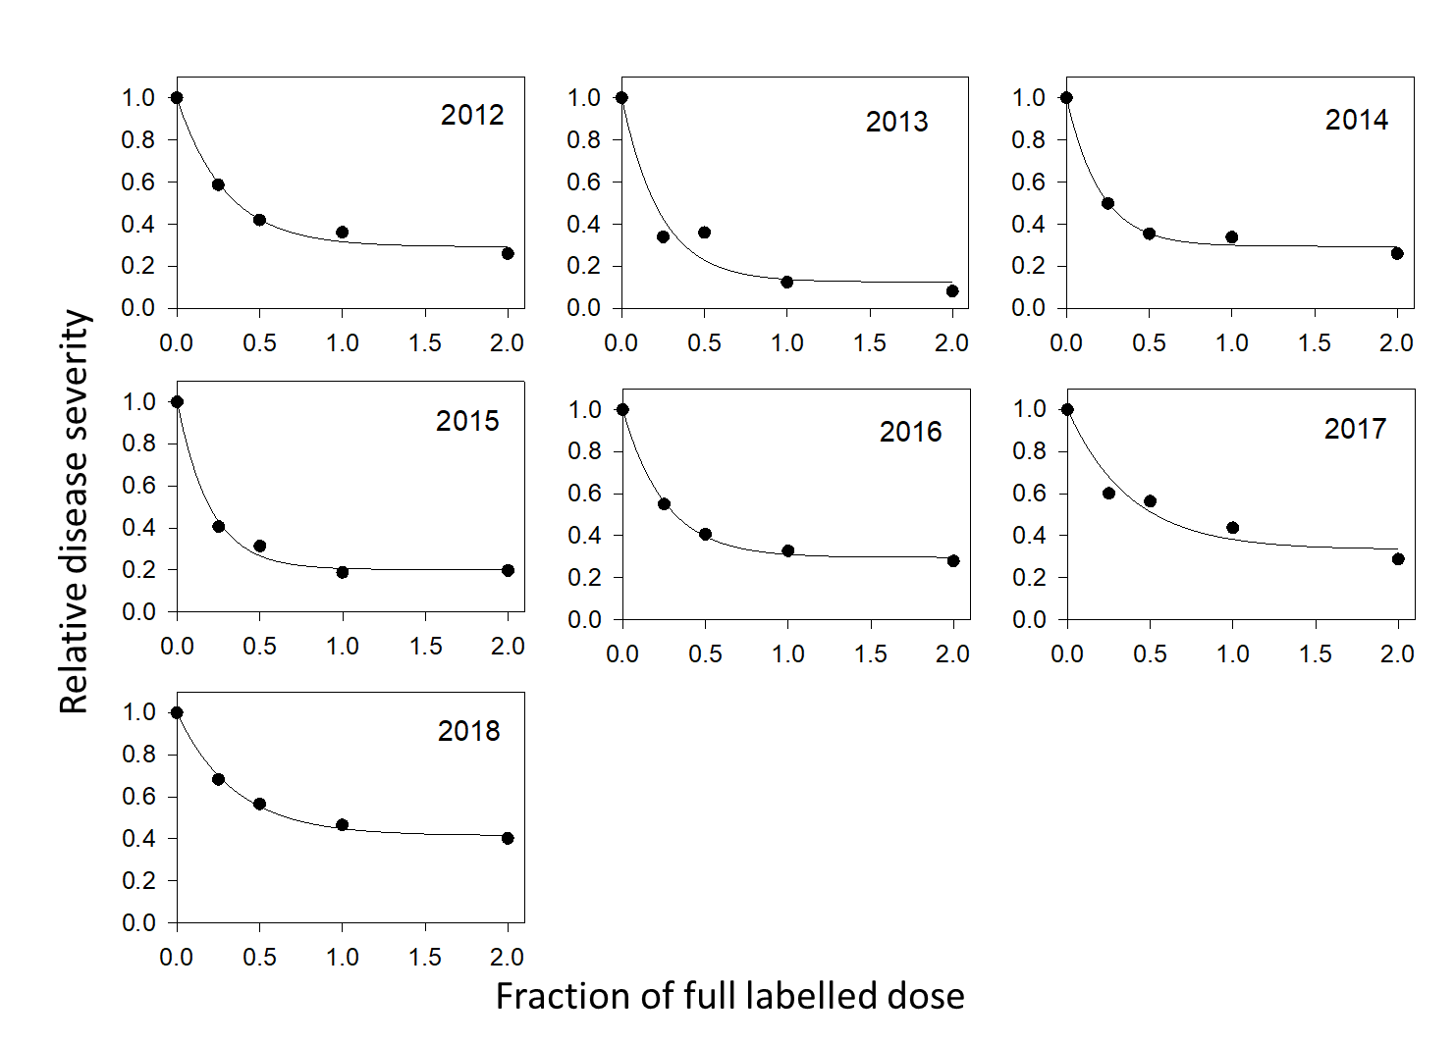

year | k | RD | R²
2012 | 3.38±0.43 | 0.707±0.262 | 0.99
2013 | 4.27±1.36 | 0.874±0.070 | 0.95
2014 | 4.90±0.67 | 0.705±0.021 | 0.99
2015 | 4.99±0.63 | 0.799±0.039 | 0.99
2016 | 3.91±0.27 | 0.704±0.013 | 0.99
2017 | 2.62±0.76 | 0.666±0.063 | 0.95
2018 | 2.87±0.25 | 0.585±0.016 | 0.99

