Running head: Analysis of Swift demographic rates
Demography of Common Swifts Apus apus breeding in the UK associated with local weather but not aphid biomass
In common with many other insectivorous birds, the Common Swift Apus apus is undergoing population declines, with an estimated 57% reduction in abundance between 1995 and 2017 in the UK. The ultimate drivers of this decline are poorly understood, but links have been drawn to reductions in the abundance and availability of insect prey, as well as loss of nesting sites. The aim of this study is to improve understanding of the demographic and environmental drivers of Swift decline in Great Britain, with a particular focus on weather and aphid biomass. We explore spatio-temporal trends in the biomass of aphids, an important source of food for these aerial feeders, from a network of seventeen 12.2 m suction-traps. We then use data from national nest recording and ringing schemes to describe temporal trends in, and covariates of, Swift breeding success and annual survival. Demographic data are sparse prior to the mid-1990s but show stable adult survival, a reduction in first-year survival and an increase in nest failure rate since the mid-1970s. Despite marked declines in aphid biomass across much of southern and eastern England during this period, we find no association between aphid biomass and Swift demography. Weather was a stronger correlate of variation in Swift demography, with increased precipitation associated with smaller brood size, higher nest failure rate and lower first-year survival. Our data suggest that falling first-year survival, partly linked to wetter summers, may be the most likely demographic driver of population decline. Given that the only convincing correlates of Swift demography were weather-related, we suggest it would be precautionary for conservation efforts to continue to focus on ensuring that safe and productive nesting sites are in sufficient supply. Further research to identify habitats and land management practices which provide foraging resources, particularly during periods of inclement weather, is required, and future demographic modelling exercises would benefit from increased nest recording and ringing efforts.
Key words: insectivore, breeding success, survival, weather, Swift, aphid
Many insectivorous birds are experiencing population declines, but these declines are not uniform (Nebel et al., 2010, Smith et al., 2015, Bowler et al., 2019, Rosenberg et al., 2019). In the UK, for example, many insectivorous birds are declining in the south but increasing in the north (Balmer et al., 2013, Morrison et al., 2013, see Nebel et al., 2010 for equivalent gradients in North America), suggesting spatial patterns in the underlying drivers (e.g. the magnitude of agricultural intensification; Reif (2020)), or in the sensitivity to these drivers. Because of their shared diet, links have been drawn between the decline of insectivorous birds and declines in the abundance and availability of insect prey (Benton et al., 2002, Nebel et al., 2010, Moller, 2019, Tallamy, 2021). Evidence for insect population declines is complex, however (e.g. Outhwaite et al., 2020); a recent global meta-analysis reported an average decline in terrestrial insect abundance of ca. 11% per decade, but an increase in aquatic insect abundance of ca. 7% per decade (van Klink et al., 2020). In the UK, there is limited evidence of large-scale declines in aerial insects (Shortall et al., 2009, Bell et al., 2020), although bees, hoverflies and moths have declined in both range (Powney et al., 2019) and abundance (Powney et al., 2019, Bell et al., 2020).
Trends in Common Swift Apus apus population size are poorly quantified, though declines are widely reported. Europe-wide data reveals a 4% decline between 1980 and 2019, though uncertainty intervals are wide (Pan-European Common Bird Monitoring Scheme: https://pecbms.info/). In the UK, national breeding atlas data indicate near-ubiquitous declines in relative abundance (though limited change in distribution) between 1998-91 and 2007-11 (Balmer et al., 2013). Trends derived from UK Breeding Bird Survey (BBS) transect counts indicate a 56% decline between 1995 and 2017 (Massimino et al., 2019) and as a result the Swift was moved to the Amber list of conservation concern in 2009 (Eaton et al., 2009), and the Red list in 2021 (Stanbury et al., 2021). Equivalent trends derived only from urban transect sections, which arguably better reflect numbers of breeding birds, reveal an almost identical decline of 57% 1995-2017 (D. Massimino, pers. comm.). The ultimate drivers of this decline are not well resolved, but possible candidates include the loss of nesting cavities, reductions in the abundance of aerial invertebrates and deteriorating weather conditions, either during the breeding season or abroad during migration or over the (northern) winter (Thomson et al., 1996, Newell, 2019).
The aim of this study is to improve understanding of the demographic and environmental drivers of the Swift’s decline in Great Britain, with a particular focus on associations with weather and aphid biomass. First, we explore spatio-temporal trends in the biomass of aphids trapped across a network of 12.2 m suction-traps that continually sample the daily aerial biomass and have operated for decades (Bell et al., 2015). Second, we explore temporal trends in Swift reproduction and survival, and test for spatio-temporal covariation between demography and weather and aphid biomass. Finally, we derive population growth rates from estimated demographic parameters, and compare the resulting population trajectory with that derived from BBS data.
Methods
Trends in aphid biomass
Aphids represent a numerically important, though variable, component of Swift diet. The best available data for the UK comes from Lack and Owen (1955), where Hemiptera (including some non-aphids) represented approximately two thirds of prey items recovered from 24 meals collected in Oxfordshire in the 1940s and 1950s. Aphids were also the most abundant single prey type recovered from 32 boluses collected from Plain Swifts (Apus unicoloris) in the Canary Islands (Garcia-del-Rey et al., 2010), though other taxa are likely to be more important in some locations or years (Lack and Owen, 1955, Cramp, 1985, Cucco and Malacarne, 1993, Orłowski and Karg, 2013). The Rothamsted Insect Survey (RIS) includes a network of more than 30 suction-traps, of which 17 were selected for this analysis because they matched the Swift nest record dataset in space and time. The RIS counts aphids (identified to species level) on a daily basis throughout the aphid season (Bell et al., 2015), and we used data covering the period 1973-2018. The maximum body length of aphid species in our dataset is 4 mm, and Lack and Owen (1955) suggest that Swifts typically prey on insects between 2 and 10 mm long (see also Cucco and Malacarne, 1993); we therefore excluded aphid species with body length greater than 10 mm. Following Gruner (2003), we estimated the body mass (mg) of each aphid species based on its mean body length (mm, taken from Bell et al. (2012)) as:
(1) $mass= 0.0175 ×{length}^{2.629}$
We summed estimated aphid biomass over four periods of the Swift breeding season: the pre-laying period (May 1st – May 27th, assuming a typical first egg date of May 28th, the median date in our sample of n = 471 nests; see below), the incubation period (May 28th – June 17th, assuming a 20-day incubation period; Cramp (1985)), the chick-rearing period (June 18th – July 31st, assuming a 43-day chick-rearing period; Cramp (1985)), and the total breeding season (May 1st to July 31st). We calculated trapping effort as the proportion of days each trap was in operation, and excluded trap-periods with a trapping effort < 0.8 (22-23% of trap-periods were excluded, depending on the period). For trap-periods with trapping effort ≥ 0.8, we corrected for variable trapping effort by dividing total biomass by trapping effort, following Macgregor et al. (2019).
Next, we identified clusters of suction traps with similar inter-annual variation in total season biomass. We first constructed a correlation matrix for all pairs of traps, then used hierarchical cluster analysis (using the R function hclust, R version 3.4.3) to identify k = 4 clusters with similar inter-annual biomass variation. These clusters were geographically congruent (Fig. 1a).
Finally, we used four linear mixed models to predict aphid biomass (log-transformed) in each of the four periods (pre-laying, incubation, chick-rearing and total season) as a function of the interaction between year (43-level factor) and regional cluster (four-level factor), with a random intercept of trap identity. We used the predictions from these models as annual indices of aphid biomass during each period for each regional cluster. To visualise long-term smoothed trends in aphid abundance, we re-fitted the four linear mixed models with a quadratic effect of year (continuous) interacting with regional cluster. To test for regional variation in long-term biomass trends, we compared these models with and without interaction terms using ANOVAs (F test, using Satterthwaite’s method to approximate degrees of freedom). We also calculated marginal and conditional coefficients of determination representing the proportion of variance explained by fixed effects (R²_{m}), and fixed and random effects combined (R²_{c}) (Nakagawa and Schielzeth, 2013, Barton, 2016).
Trends in breeding success
To quantify variation in Swift breeding success we used data collected by volunteers under the British Trust for Ornithology’s Nest Record Scheme (Crick et al., 2003), excluding records collected prior to 1975 and those falling outside of mainland Great Britain. Following Crick et al. (2003), and assuming a maximum clutch size of 4 (Cramp, 1985), we derived six breeding variables: clutch size (n = 605 nest records), brood size (n = 2549), daily whole nest failure rates at the egg (n = 798), nestling (n = 1388) and whole-nest stage (n = 1532), and mean fledglings per attempt (estimated at the population level). Not all nests contribute estimates of all 6 variables, due to differences in the timing and frequency of visits (hence different sample sizes).
To derive temporal trends between 1975 and 2015 we used generalized linear models with year represented as either a continuous linear covariate, a continuous quadratic covariate, a 41-level factor (with one level per year), or a six-level factor representing six time blocks starting in 1975, 1985, 1995, 2000, 2005 and 2010, as well as an intercept-only model. To account for the non-systematic spatial distribution of nest records, we fitted a random intercept of region (Nomenclature of Territorial Units for Statistics (NUTS) level 1, which subdivides Scotland, Wales and nine English regions). We compared intercept-only, linear and quadratic models using ANOVAs. Clutch size and brood size were heavily under-dispersed because of the limited range of values (1-4) they could take, so we assumed a Conway-Maxwell-Poisson error distribution, fitted with a log link using the glmmTMB R package (Brooks et al., 2017). Population-level daily failure rates were estimated using the Mayfield method, assuming a binomial error structure with logit link; the response variable was a binominal trial with the numerator set to 1 for nests which failed (or 0 for nests from which at least one chick fledged), and the denominator defined as the number of exposure days.
We used equation 2 to derive population-level mean fledglings per breeding attempt (hereafter fecundity, F) from the predictions of brood size and egg and nestling stage failure rates separately for each year and time block:
(2) $F= B ×{(1-EFR)}^{EP}×{(1-NFR)}^{NP}$,
where B = brood size, EFR = whole nest egg stage daily failure rate, NFR = whole nest nestling stage daily failure rate, EP (incubation period) = 20 days and NP (chick-rearing period) = 43 days. We used a Monte-Carlo sampling approach to propagate the uncertainties associated with estimates of B, EFR and NFR by estimating F 1000 times from samples independently drawn from a normal or logistic distribution defined by the fitted mean and standard error of each variable (on the original link scale).
Nest records submitted by the Oxford University Museum of Natural History were heavily over-represented in our data (59% of records for clutch size, 33% for brood size and 54% for nest-stage failure rate), particularly during the second half of the time series. To address this uneven distribution of nest records, we conducted a parallel analysis in which we subsampled the dataset such that no more than 10 records were used per 10-km square per year. This resulted in a 34% reduction in sample size for clutch size, 31% for brood size, and 44% for nest-stage failure rate, and reduced the representation of Oxford records to 38%, 10% and 20%, respectively.
Trends in annual survival
We estimated variation in annual survival of first-year (i.e. between year of hatching and second calendar year) and adult (i.e. between all subsequent years) Swifts based on the rates at which ringed birds were recovered dead by members of the public during the period 1975-2015. Swifts ringed in Great Britain (mostly at breeding colonies) as part of the national ringing scheme were identified as either nestlings (n = 10,177) or full-grown birds in their second or later calendar year (n = 92,464). We collated recoveries of birds found dead in Britain during successive annual periods between May 1st and Aug 31st, separately for the two age-classes (n = 69 for birds ringed as first-years, 546 for adults). We use dead recovery models (Brownie, 1978, Williams et al., 2002) rather than multi-state models (which require (live) recapture or resight data), and modelled survival as annual deviations from a long-term mean, and annual recovery probability as a 5-year running mean (truncated for the first two and last two years). Annual survival was estimated separately for birds marked as first-years and adults, but recovery probability was shared between the two age classes. To test for long-term linear trends in annual survival, we fitted year as a linear covariate. See Appendix 1 for model code.
Models were fitted using JAGS (Plummer, 2003) via the jagsUI R package (Kellner, 2020). Three chains of 100,000 iterations were used, discarding the first 90,000 as burn-in, and sampling every 10th iteration of the remainder to yield a posterior sample of 3,000. Convergence was assessed visually and by checking the Brooks-Gelman-Rubin statistic was close to 1.
We compared observed inter-annual variance in annual survival between adults and first-years to the maximum expected variance given the observed mean survival (calculated as s × (1 - s), where s is mean survival), which accounts for the fact that variance inevitably declines when mean survival probabilities approach 0 or 1 (Gaillard and Yoccoz, 2003).
Spatio-temporal covariates of breeding success
To test for environmental predictors of Swift breeding success we considered only nest records with grid references accurate to a 1 km grid-square and within 80 km of the nearest suction-trap (the approximate range across which suction-traps are thought to represent local aphid dynamics Shortall et al. (2009)). This resulted in the exclusion of 5-14% of nest records, depending on the response variable. For each nest record, we extracted variables describing spatial and temporal variation in aphid biomass, lentic habitat availability and weather.
First, we paired each nest record to the nearest suction-trap (range = 0.04 – 79.5 km, mean = 46.7 km), and attributed aphid biomass in the pre-laying, incubation and chick-rearing periods for the appropriate year and trap (resulting in a single value of aphid biomass for the three periods for all nests within 80 km of each suction-trap). For missing trap-years, we used the annual biomass index for the corresponding regional cluster.
Inland water bodies are known to be important foraging resources for Swifts, especially during poor weather (Lack and Owen, 1955, Cramp, 1985). We downloaded a shapefile of water features using the QuickOSM QGIS plugin (accessed Dec 9th 2019), considering only still, non-tidal water bodies ≥ 25 m². We then calculated, for each nest location, the total area of freshwater habitat within 10 km and 30 km radii.
Next, we downloaded daily mean temperature (°C) and precipitation (mm) values interpolated to a 1-km grid (Robinson et al., 2017), and calculated mean daily temperature, total precipitation, and the maximum consecutive run of days with > 0 mm rain (‘rain days’) and ≥ 10 mm rain (‘heavy rain days’), across the pre-laying, incubation and chick-rearing periods (defined as above). Following Oedekoven et al. (2017), we derived centred weather variables representing spatial variation (i.e. the average value for each location across all years), temporal variation (i.e. the average value across Great Britain for each year), and residual variation (i.e. the spatial and temporal average values subtracted from the location- and year-specific values). We then calculated the average value of each weather variable across all 1-km squares within 20 km of each nest (strongly correlated with average values within both 10 and 30 km of each nest; r > 0.99).
We used generalized linear models to test for environmental predictors of brood size, egg-stage daily failure rate and nestling-stage daily failure rate. As above, we assumed a Conway-Maxwell-Poisson distribution with a log link error structure for brood size, and adopted a binomial trials structure for daily failure rate. Brood size and egg-stage failure rate models used weather/biomass from the pre-laying and incubation period, whilst nestling-stage failure rate models used variables from the pre-laying, incubation and chick-rearing period. All covariates were centred and scaled, and we fitted a global model for each response variable containing all covariates. There was moderate spatial autocorrelation in the residuals of the global brood size model (Moran’s I > 0.2 for spatial lags < 15 km), so we fitted a random intercept grouping records into 5-km squares. There was no strong spatial autocorrelation in the residuals of daily failure rate models (Moran’s I < ±0.01 for spatial lags up to 200 km). As estimates of explanatory power, we report marginal and conditional coefficients of determination (R²_{m} and R²_{c}) for the brood size model (Nakagawa and Schielzeth, 2013) and Macfadden’s pseudo-R² for the failure rate models.
As an additional test of associations between insect biomass and Swift breeding success, we repeated the above models for a smaller dataset with a single independent variable representing total aerial insect biomass from Shortall et al. (2009). These data are available for a limited number of traps (Rothamsted, Wye, Starcross and Hereford) and years (1973-2001), but include a wider range of insect taxa (including Diptera, Hymenoptera and Lepidoptera), many of which are likely to be consumed by Swifts (Cramp, 1985).
Temporal covariates of annual survival
Breeding season weather variables (average temperature and precipitation, rainy days and heavy rain days for the combined incubation and chick-rearing period) were derived as above, with annual values averaged across all English counties except Cornwall, Cumbria and Northumberland (representing the core distribution of Swift ringing locations). Aphid biomass was summed across the combined incubation and chick-rearing period for all traps covering the core distribution of Swift ringing locations (excluding traps in Scotland, Wales and the extreme south-west of England). In migrant birds, monthly mortality tends to be highest during migratory periods, and spring migration in particular (Robinson et al., 2020). We therefore extracted mean temperature and total precipitation during the core spring migration months of April and May for the area between 10W 1E, 31N and 42N (incorporating western North Africa and Iberia, as far north as the Pyrenees) (CRU TS3.24.01, Harris and Jones, 2017). During the northern winter, Swifts spread across a large part of sub-Saharan Africa (Åkesson et al., 2020), so identifying relevant weather conditions is a challenge; we also expect their mobility to provide resilience against inclement weather during this period.
We fitted separate survival models for each covariate, using the same model structure as described above replacing the ‘year’ linear covariate with each environmental covariate in turn. Whilst a multivariate model would have been preferable, this suffered from convergence issues, likely due to insufficient sample size. Parameter estimates were estimated separately for the two age classes.
Population growth rate
Finally, we combined annual estimates of fecundity and survival to estimate annual population growth rate (r) using equation 3:
(3) $r= S_{ad}+0.5×F×S_{p}×S_{fy}×{S_{ad}}^{age-1}$
where S_{ad} = adult annual survival, S_{fy} = first year survival, F = fecundity (multiplying by 0.5 accounts for F applying to pairs, rather than individuals), S_{p} = survival of pulli, or the proportion of the brood lost through partial brood reduction, and age = average age at first breeding (where 1 = year after hatching). In each year, 3000 posterior draws of parameters S_{ad} and S_{fy} were derived from the Bayesian survival models. For F we used modelled estimates for each of the 6 time-blocks, because annual estimates were subject to high uncertainty; we generated 3000 pseudo-posterior draws of F, capturing the mean and standard error of brood size and egg- and nestling-stage daily failure rate.
Parameters S_{p} and age are unknown. Values of age from the literature range from 2.8 (southern Scotland, n = 12; Thomson et al., 1996) to 3.0 (Oxford, n = 6; Perrins, 1971), so we explore scenarios in which age varies between 2, 2.5 and 3. S_{p} accounts for partial brood reduction in the mid- to late-stage of chick-rearing. Of 259 broods of 2 or 3 chicks monitored in Oxford between 1949 and 1964, Lack (1973) reports an average nestling survival of 0.79. A similar value (0.81) was reported from a study of 47 Swift nests in Italy (Sicurella et al., 2014). Our own analysis suggests a mean nestling-stage whole nest failure rate of just 2.6%, implying that partial losses account for the majority of the losses reported by Lack (1973). We therefore explore scenarios in which S_{p} varies between 0.75, 0.85 and 0.95. We estimate r for each posterior draw in each year and for all 12 combinations of age and S_{p}.
We then used estimates of r to reconstruct an index of population size for each year since 1995 (index = 1 in 1995). We summarised the 0.025, 0.5 and 0.975 percentiles across posterior draws in each year, and compared the resulting population trajectory to one derived from urban and suburban Breeding Bird Survey transect sections only (deemed to be more representative of trends in breeding populations than transect sections in the wider countryside which will include a high proportion of foraging, rather than breeding, birds). We repeated this exercise sequentially holding either S_{ad} and/or S_{fy} and/or F at their mean value 1995-2018. The aim of this exercise was to assess the empirical sensitivity of r to temporal variation in these three demographic parameters.
Finally, to explore longer-term variation in population growth rates, we estimated population growth rate for each 5 or 10-year block (derived from observed mean S_{ad}, S_{fy} and F in each period), and assuming age = 2.5 and S_{p} = 0.75, as well as the value of F required to achieve population stability.
Results
Trends in aphid biomass
Estimated aphid biomass showed substantial inter-annual variation (Fig. 1b, Table 1). Hierarchical cluster analysis revealed regional variation in these fluctuations, separating geographically congruent clusters of traps in the north-east (Elgin, Dundee, East Craigs and Newcastle), the west (Ayr, Preston and Aberystwyth), the south-east (High Mowthorpe, Kirton, Hereford, Brooms’ Barn, Rothamsted, Writtle, Silwood and Wye) and the south-west (Rosewarne and Starcross; Fig. 1a). For all four periods of the Swift breeding season, the year-region interaction was statistically significant (p < 0.001; Table 1), providing strong support for regional differences in inter-annual biomass variation. During the chick-rearing period, average aphid biomass (predictions from region-only model, 95% confidence interval) was highest in the south-east (732 g, 577–930), followed by the west (429 g, 346–532), the north-east (318 g, 262–386) and the south-west (248 g, 195–316)
There was strong support for region-specific quadratic trends between 1973 and 2018 (∆AIC > 73.6 between models with and without the year²-region interaction term). For the chick-rearing period, the strongest long-term trend was in the south-east, where biomass declined by 68% between 1973 and 2018, and by 78% since 1985 (Fig. 1b). Declines in the north-east and south-west were more modest (15% and 29% between 1973 and 2018, and 44% and 71% since 1995, respectively). In the west, there was an overall increase of 81% between 1973 and 2018, but a decline of 42% since 1995.
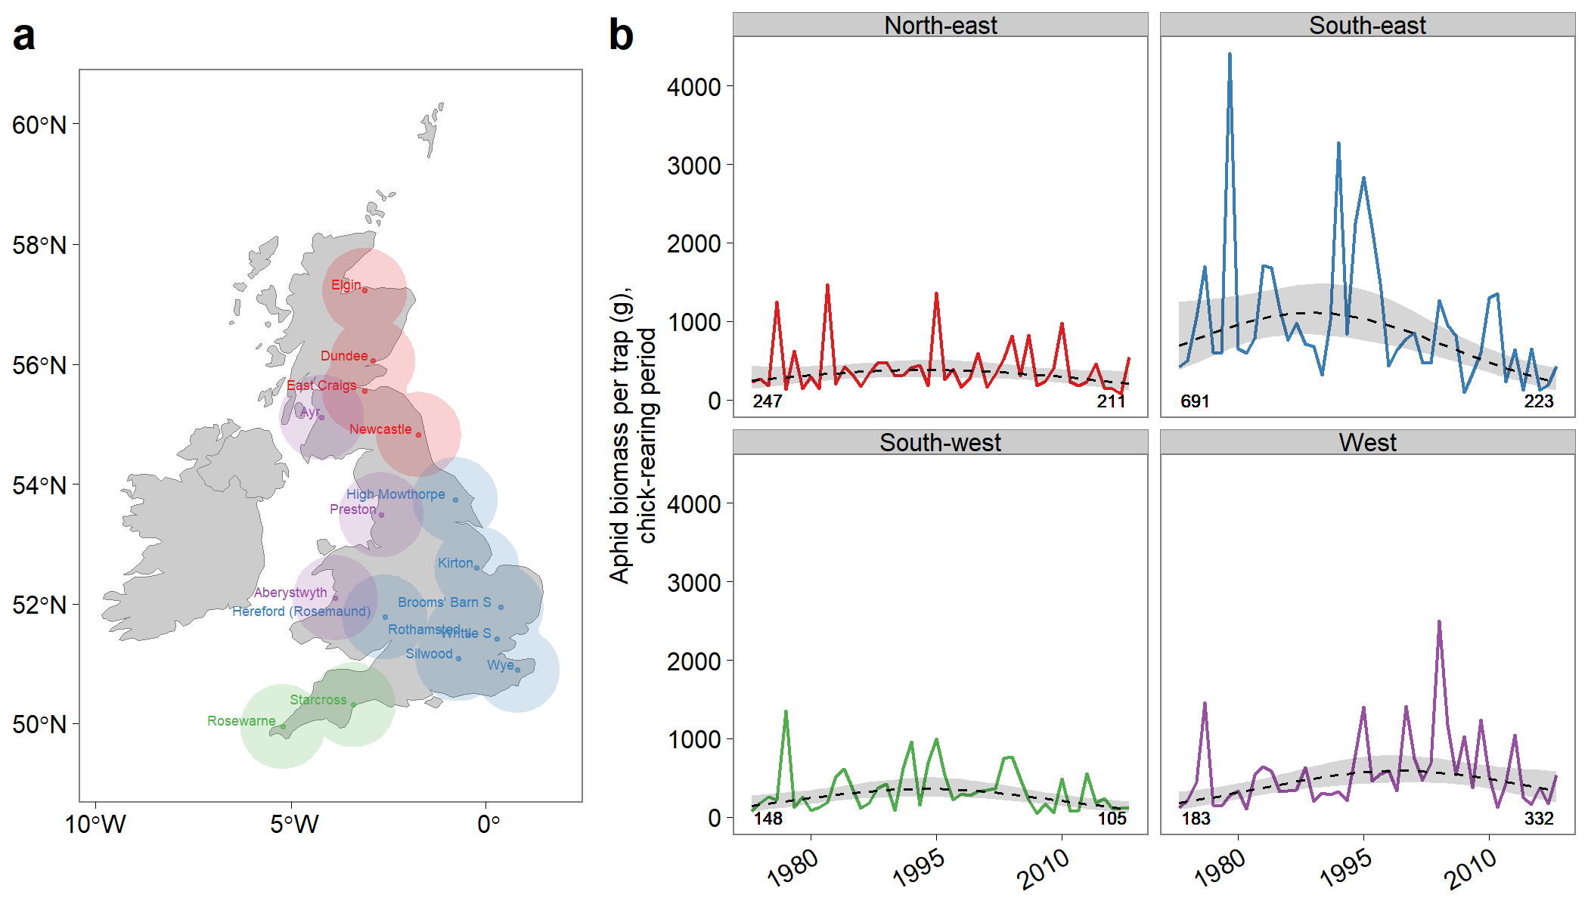
Figure 1. Trends in aphid biomass per trap. a shows the location of 17 aphid suction-traps (labelled points), buffered by 80-km radii. Colours indicate trap clusters (red = north-east, blue = south-east, green = south-west, purple = west). b shows long-term trends in aphid biomass in each cluster during the chick-rearing period (June 18th – July 31st). Solid line shows predicted values from linear mixed models with the two-way interaction between region and year as categorical covariates. Dashed lines (± 95% CI) show quadratic trends. Numbers in bottom left and right corners show the value of these quadratic fits in the first (1973) and last (2018) years of the time series.

Table 1. ANOVA table for models of aphid biomass. 1 linear mixed model per period, using Satterthwaite's method to approximate the degrees of freedom (d.f.). R²m and R²c are the marginal and condition coefficients of determination, which can be interpreted as the variance explain by fixed and fixed + random effects, respectively. F = test statistic, p = associated p-value.
 | R²m | R²c | d.f. | F | p
Pre-laying period | 0.68 | 0.78
Year |  |  | 46, 232.3 | 20.4 | < 0.001
Region |  |  | 3, 13.4 | 3.0 | 0.067
Year × Region |  |  | 134, 417.4 | 2.6 | < 0.001
Incubation period | 0.55 | 0.66
Year |  |  | 46, 231.7 | 16.5 | < 0.001
Region |  |  | 3, 13.7 | 4.6 | 0.020
Year × Region |  |  | 134, 412.7 | 2.6 | < 0.001
Chick-rearing period | 0.62 | 0.81
Year |  |  | 46, 228.3 | 23.6 | < 0.001
Region |  |  | 3, 4.2 | 4.2 | 0.028
Year × Region |  |  | 131, 410.1 | 4.7 | < 0.001
Total season | 0.61 | 0.80
Year |  |  | 46, 230.1 | 27.3 | < 0.001
Region |  |  | 3, 13.2 | 4.5 | 0.022
Year × Region |  |  | 132, 412.2 | 4.6 | <0.001

Trends in breeding success
Assessing long-term trends in breeding is hampered by modest sample sizes and therefore low precision, especially prior to 1995 (Fig. 2). Average clutch size showed a slight hump-shaped quadratic trend, with no overall change between 1975 (2.32, 2.00–2.69 95% CI) and 2015 (2.37, 2.13–2.65; Fig. 2a). Average brood size showed a modest decline from 1.98 (1.81–2.16) in 1975 to 1.77 (1.63–1.93) in 2015 (Fig. 2b), but 95% confidence intervals overlapped throughout the study period.
There was no statistical support for linear or quadratic changes in egg-stage daily failure rate (0.0025, 0.0018–0.0035), but nestling-stage daily failure rate showed a non-linear increase from <0.0001 (<0.0001–0.0008) in 1975 to 0.0005 (0.0001–0.0017) in 2015. As a result, overall daily failure rate increased from 0.0002 (0.0001–0.0006) in 1975 to 0.0016 (0.0007–0.0035) in 2015 (Fig. 2c). Over the 63-day nesting period, this equates to an increase in overall nest failure probability from 1.15% (0.33–3.92) to 9.52% (4.45–19.74).
Estimates of population-level fecundity were highly uncertain in most years, as well as in 1975-84 and 1985-94, making long-term trends difficult to ascertain (average annual mean = 1.72, range = 1.06–2.20; Fig. 2d). Annual estimates of fecundity are lower for the second half of the time-series (consistent with the reduction in brood size and increase in nest failure rate), but 95% confidence intervals are wide.
Modelled trends in clutch size, brood size and overall daily failure rate were practically identical for a subsampled version of the full dataset in which a maximum of 10 records are used per 10-km square per year (Fig. S2).
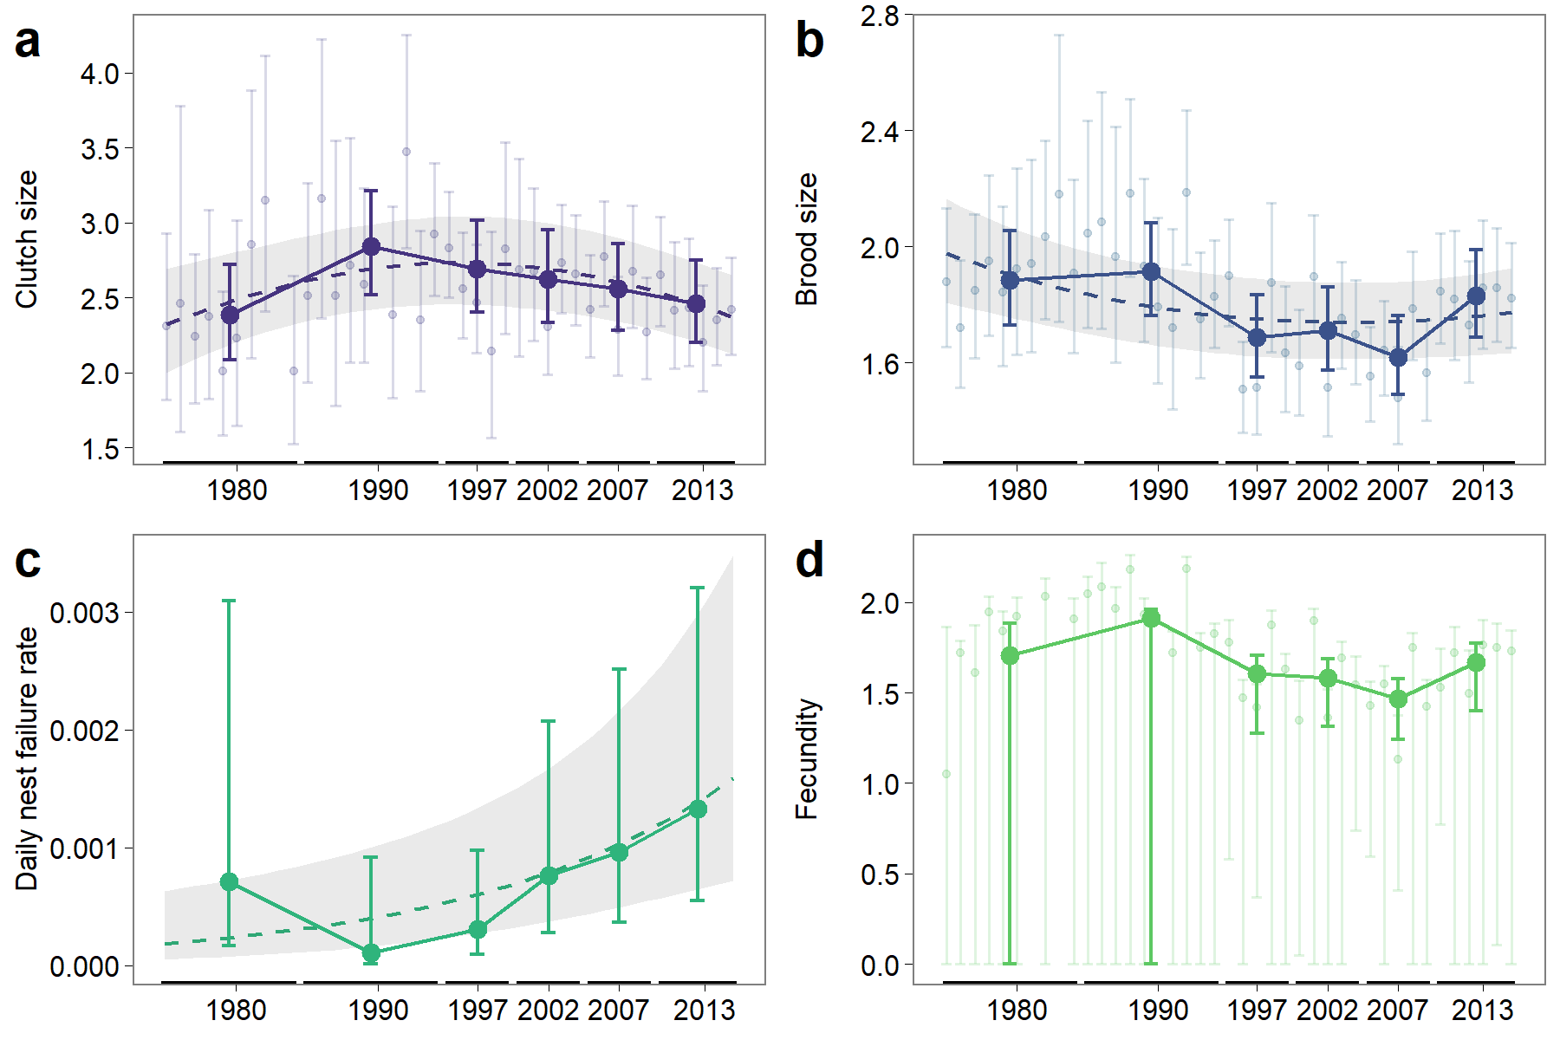
Figure 2. Trends in Swift reproductive success. Panels show year- and block-specific estimates of a clutch size, b brood size, c daily nest-stage failure rate, and d mean fecundity. Error-bars show 95% confidence intervals. Long-term trends are shown where significant, with the dashed line showing the fitted effect of year, and the shaded ribbon showing approximate 95% confidence intervals (based on variation in fixed effects only). Long-term trends were not evaluated for mean fledglings per breeding attempt, and annual effects were not estimated for daily failure rates.

Trends in annual survival
Mean annual survival was 0.80 (0.76-0.85, 95% CI) for adults and 0.54 (0.27-0.80) for first-years (see Table S1 for estimated parameters of annual survival and recovery probability). Adult survival showed comparatively low inter-annual variation (min = 0.67, 0.47-0.86, max = 0.91, 0.78-0.98) and no evidence of any long-term trend (β = -0.004; 95% CI = -0.03, 0.03; Fig. 3a). Estimates of first-year survival were less precise, showed high inter-annual variation (min = 0.21, 0.00-0.68, max = 0.87, 0.52-1.00) and declined over time (-0.096; -0.23, -0.01; Fig. 3a). Mean adult survival is closer to the boundary of possible survival probabilities (i.e. 1), so has a lower potential for variation (maximum expected variance given mean survival rate = 0.17 for adults, compared to 0.25 in juveniles). Nonetheless, the ratio between observed variance and maximum expected variance was still 12-fold lower for adults than for first-years.
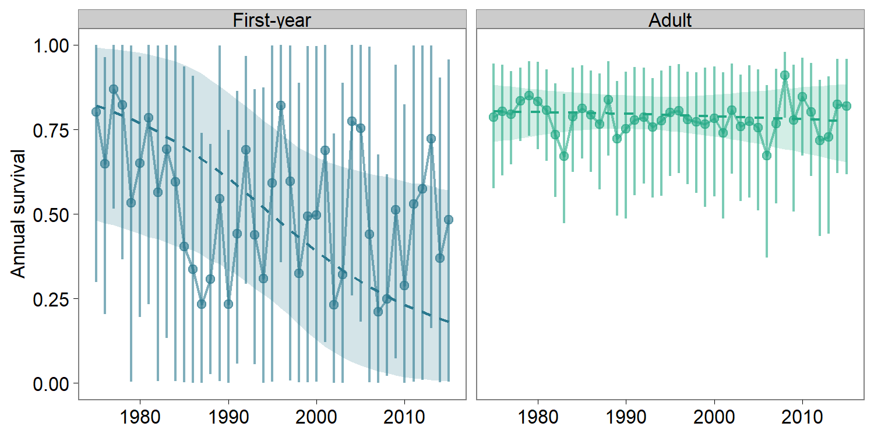
Figure 3. Trends in first-year and adult annual survival. Points show the mean posterior annual estimates, and error bars show 95% credible intervals. Dashed line shows fitted linear trend over time.

Covariates of Swift breeding success
The brood size model had extremely low explanatory power (R²_{m} = 0.02). Temporal variation in precipitation (standardised β = -0.05; 95% CI = -0.075, -0.034) and temperature (β = -0.03; -0.049, -0.012) during the incubation period were both negatively associated with brood size, whilst spatial variation in temperature during the incubation period had a positive association (β = 0.03; 0.016-0.048). No other covariates were statistically relevant. The random intercept explained a relatively high proportion of the total variance (R²_{c} = 0.31), suggesting unexplained spatial structure in brood size (Fig. S1).
The egg-stage daily failure rate model had higher, though still low, explanatory power (R² = 0.14), with temporal variation in precipitation during the incubation period showing a positive association with failure rate (i.e. higher failure rates in wetter yeas; β = 1.45; 0.055, 1.482). Against expectations, area of freshwater habitat within 10 km (β = 0.78; 0.128, 3.199) and aphid biomass during the pre-laying period (β = 0.75; 0.205, 1.372) both had a positive association with failure rate.
The chick-stage daily failure rate model had moderate explanatory power (R² = 0.21). Whilst temporal variation in precipitation during the chick-rearing period was positively associated with nest failure rate, (β = 2.05; 0.028, 5.461), the same measure from the pre-laying period had a negative association (β = -1.63; -3.749, -0.224). Spatial variation in precipitation during the chick-rearing period (β = -3.03; -24.163, -1.788) and residual variation in rainy-days during the pre-laying period (β = -1.28; -2.715, -0.154) also exhibited positive associations with failure rate. Against expectations, aphid biomass during the incubation period had a positive association with failure rate (β = 1.50; 0.389, 2.897).
Total insect biomass (from Shortall et al. (2009)) had no significant effect on brood size, egg-stage or chick-stage failure rate.
Covariates of annual survival
Total precipitation during the breeding season had a significant negative effect on first-year (β = -1.36; 95% CI = -3.40, -0.09) but not adult (0.05; -0.41, 0.33) survival (Fig. 4a). Credible intervals for effects of breeding season temperature (Fig. 4b), aphid biomass (Fig. 4c) and passage precipitation overlapped zero for both first-year and adult survival, though 97.3% of the posterior distribution for the effect of mean temperature on adult survival was below zero, strongly suggesting a negative relationship. There was no evidence for an effect of rainy days, heavy rain days or passage temperature on first-year or adult survival.
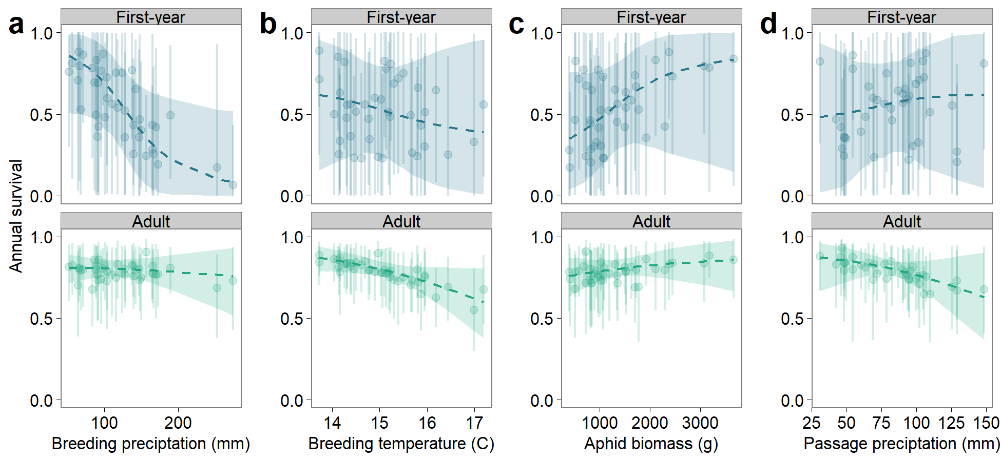
Figure 4. Covariates of Swift survival. Dashed lines show the fitted relationship between a total precipitation, b mean temperature, c aphid biomass and d passage precipitation and first-year (top) and adult (bottom) annual survival. Points show annual predictions. Ribbons and vertical lines show 95% confidence intervals.

Population growth rate
The simulated population change between 1995 and 2015 varied substantially depending on the values chosen for parameters age and S_{p} (Fig. 5a). The simulation which most closely reproduced the observed BBS population decline assumed age = 2.5 and S_{p} = 0.75 (though age = 3 and S_{p} = 0.85 performed similarly well). Most other simulations underestimated the magnitude of the BBS decline. Holding F at its mean value (1995-2015) had virtually no impact on the magnitude of the simulated decline, whereas holding S_{ad} or S_{fy} (and especially both) at their long-term mean values reduced the magnitude of the simulated decline (Fig. 5b).
Both the simulated and observed population trajectories showed a near-linear decline (Fig. 5c). Although the simulated trajectory matched the observed magnitude of decline, there was a poor correspondence between simulated and observed inter-annual variation in population growth rate (Fig. 5d). Nonetheless, both simulated and observed population indices show a stabilisation since ca. 2010.
Based on mean survival and fecundity, and assuming age = 2.5 and S_{p} = 0.75, we predicted population growth during 1975-1984, followed by a mixture of stability and decline (Fig. 5e). This predicted growth pattern largely mirrors temporal variation in first-year survival, and observed growth was underestimated compared to BBS in two of the four recent periods. Fecundity required for population stability varied from 1.18 to 2.16, and exceeded observed fecundity in 1985-1994, 2000-2004 and 2005-2009 (Fig. 5f).
Modelled population trajectories were similar between the full dataset and the subsampled version (Fig. 5c, 5e).

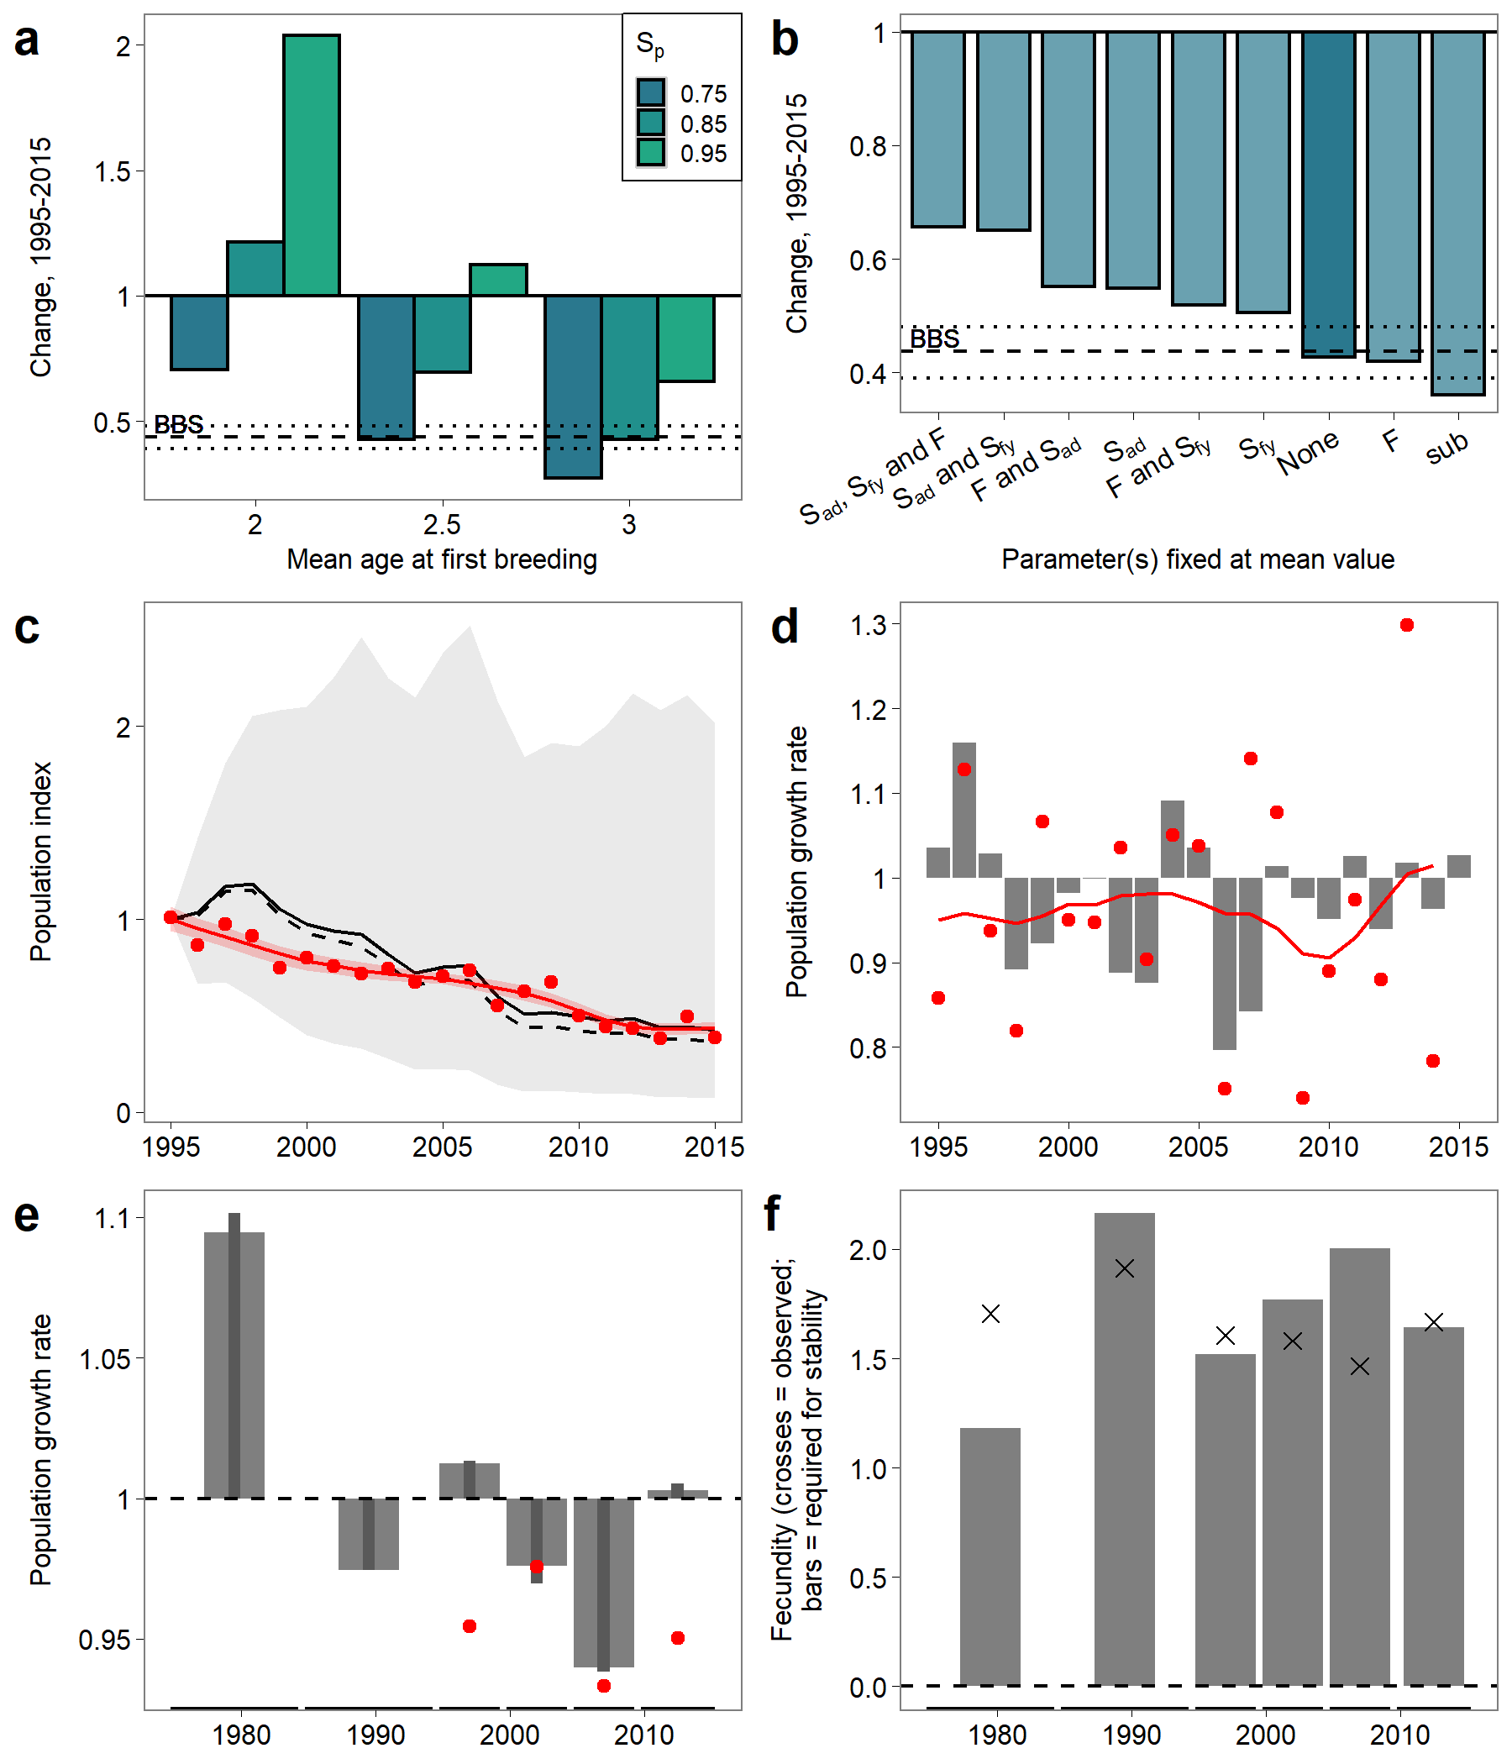
Figure 5 Simulated change in Swift population index. a shows 9 scenarios of age at first breeding (where 2.5 is equivalent to half the population breeding at age 2 and half at age 3) and nestling survival (S_{p}) and b when any or all of parameters F, S_{a} or S_{fy} are held at their long-term (1995-2015) mean values (for age = 2.5 and S_{p} = 0.75). Dashed horizontal line shows population change derived from smoothed urban-suburban BBS data (± 95% C.I.). Assuming age = 2.5 and S_{p} = 0.75, c shows simulated (black line ± 85% CI) and observed (red points, unsmoothed BBS trend; red line, smoothed BBS trend) population index (fixed at 1 in 1995); d shows simulated (bars) and observed (red points, unsmoothed BBS trend; red line, smoothed BBS trend) annual population growth rates; e shows estimated (bars) and observed (red points, geometric mean of unsmoothed BBS trend) population growth rate for each 5 or 10 year block; and f shows observed fecundity (crosses) and fecundity required to achieve population stability (bars, given observed survival and assumed age = 2.5 and S_{p} = 0.75) for each 5 or 10 year block. Dashed line in c and thin bars in e show results for a subsampled version of the full dataset in which a maximum of 10 records are used per 10-km square per year.

Discussion
Our results point to the UK Swift population having experienced an increase in nest failure rate and a decrease in first-year survival since 1975, whilst adult survival has remained relatively stable. There is, however, substantial uncertainty prior to ca. 1995, and the simulated population trajectory poorly reproduces inter-annual population fluctuations indicated by BBS data. It should be noted, however, that Swifts recorded on BBS transects may not be nesting nearby, and the validity of using BBS to construct population trends for wide-ranging aerial species has not been tested.
Our estimate of adult survival (80%) is comparable to previous reported estimates from the UK (81%; Baillie, 1987), southern Scotland (76%; Thomson et al., 1996), Oxford (85%; Perrins, 1971), France (76% in a ‘good’ colony and 62% in a ‘poor’ one; Lebreton and Burnham, 1992) and Northern Italy (78%; Boano et al., 2020), as well as for the related Pallid Swift Apus pallidus (75%; Boano et al., 1993). These relatively high survival rates are as expected from a single-brooded species with low fecundity. Our estimate of fecundity (1.74, excluding partial losses during the chick stage) is broadly comparable to 1.6 in southern Scotland (Thomson et al., 1996) and 2.0 in Czechia (Rajchard et al., 2006). Our estimate of first-year survival (54%, declining from an average of 70% during 1975-84 to 44% during 2006-2015) aligns with the expectation of low survival in the first annual cycle of migratory birds (Calvert and Walde, 2009). Low sample sizes meant we were unable to identify when during the annual cycle mortality is greatest, though we would expect high juvenile mortality in the period immediately post fledging (e.g. Grüebler et al., 2014).
Our study identifies several associations between weather and demographic rates. Negative effects of inclement weather on aerial insectivores have been widely reported in the literature (e.g. Thomson et al., 1996, Rajchard et al., 2006, Cox et al., 2019), and are likely driven by reduced insect activity or challenging foraging conditions, compounded by increased nestling energetic requirements. Most strikingly, first-year survival was strongly reduced in years with high total precipitation through June and July. Between 1975 and 2015 there was a weak but statistically significant increase in precipitation during the approximate chick-rearing period (Pearson correlation coefficient with year; r = 0.37, p = 0.02, d.f. = 39), which may have contributed to the observed reduction in first-year survival over this period. The exact mechanism driving the negative effect of summer rainfall on subsequent survival is unclear, but could involve a carry-over effect of food shortages (not captured by our measure of aphid biomass) during egg or chick development, mediated by reduced body condition or oxidative stress (Bryant, 1978, Mitchell et al., 2011, Stanton and Clark, 2017). Wet conditions also resulted in smaller broods and higher nest failure rates, as expected if poor weather impairs foraging. In contrast, wet years during the pre-laying period were associated with lower chick failure rates, perhaps due to a beneficial impact of rainfall in the early summer on subsequent insect abundance (e.g. Frampton et al., 2000). The association between warmer locations and smaller broods is consistent with Ashmole’s hypothesis (i.e. larger clutches at higher latitudes; Ashmole, 1963), though Åkesson et al. (2020) showed the opposite trend in European Common Swifts. Overall, linking Swift breeding success to spatial variation in local foraging habitat quality is challenging due to the large distances breeding birds are capable of travelling (Lack 1973). Substantial unexplained variance in breeding success remains, perhaps driven by other factors causing nest failure such as predation at the nest or of adults, nest disturbance, and abandonment by inexperienced breeders.
By assigning insect suction-traps to regional clusters, we identify hitherto overlooked spatial variation in aphid biomass trends (Shortall et al., 2009, Bell et al., 2020). Of particular interest is the long-term decline in aphid biomass across the 8 traps in the south-eastern cluster, which covers much of the arable-dominated lowland parts of England. The south-east region also showed higher aphid biomass than other regions (despite the long-term decline), with two cereal-associated aphids (Sitobion avenae and Metopolophium dirhodum) contributing 25% of total aphid biomass in our dataset. A third species (Drepanosiphum platanoidis, contributing 42% of total aphid biomass), is associated with the ubiquitous Sycamore tree (Acer pseudoplatanus). The overall magnitude of BBS-derived population trends do not, however, differ appreciably between the four regional aphid clusters (D. Massimino, pers. comm.) and, surprisingly, we found only negative (though weak) associations between aphid biomass and Swift breeding performance, though this must be caveated by historically poorer quality breeding data, especially prior to 1995. Other studies have also failed to detect associations between insect biomass and aerial insectivore performance (e.g. Imlay et al., 2017, though see e.g. Bryant, 1978), and it’s possible that our spatially coarse aphid biomass data failed to effectively capture variation at a relevant scale. Additionally, Swifts can feed at altitudes above 50m whilst suction-traps estimate aphid biomass at 12.2 m; aphid densities tend to be lower at higher altitudes (Taylor, 1974), which may further weaken the relationship between measured aphid biomass and aphid availability for Swifts. Alternatively, and perhaps most likely, aphid biomass may simply be a poor proxy for Swift dietary availability, and aphids may be sub-optimal prey items compared to larger, more calorie-dense taxa (Nocera et al., 2012). Indeed, Lack and Owen (1955) observed shifts in Swift diet associated with weather conditions and in Poland, for example, analysis of Swift nestling faecal sacs reveals weevils (Curculionidae) and shield bugs (Pentatomidae) comprise almost three-quarters of insect biomass (Orłowski and Karg, 2013). Nonetheless, we found no association between any measure of Swift breeding success and the biomass of a wider range of insect taxa (albeit for a narrower range of locations and years; Shortall et al. (2009)).
The relevance of our findings to other insectivorous birds is unclear. In North America, weak spatial synchrony in the population trajectories of five aerial insectivores points to complex species‐ and region‐specific drivers (Michel et al., 2016). Whilst other British aerial insectivores (Barn Swallow Hirundo rustica, House Martin Delichon urbicum, Sand Martin Riparia riparia) have declined in some regions or time-periods (Massimino et al., 2019), none appear to share the widespread and sustained decline shown by the Swift. The Swift differs from these hirundines in both foraging strategy (reaching higher altitudes) and nesting strategy (tending to nest in more urban areas), whilst all show distinct migratory strategies (e.g. Pancerasa et al., 2018, Åkesson et al., 2020).
Whilst the decline in aphid biomass in south-east England is concerning, we find no evidence that this has contributed to the Swift’s population decline. However, quantifying variation in the availability of the relevant prey taxa at appropriate temporal and spatial scales is challenging. Regardless, the factors responsible for causing a population’s decline are not necessarily the factors most amenable to conservation management (Morrison et al., 2016). Given that weather is largely out of our control, nest-box provisioning remains the primary tool at our disposal for Swift conservation. Whilst we are aware of no direct evidence that nest-site limitation has driven the Swift’s decline (though see Braun (1999), cited in Schaub et al., 2015), nest-box provisioning arguably represents a precautionary approach, and has been shown to be effective at compensating for loss of nesting sites as a result of building modernisation (Schaub et al., 2015). Nest-boxes have the added potential benefits of increasing engagement with nature in urban environments and facilitating nest monitoring, and we would encourage increased nest recording efforts to improve the precision of future demographic modelling exercises. Our understanding of Swift diet and foraging behaviour remains poor, and we recommend that future research aims to identify land management practices which improve foraging opportunities and breeding success, particularly during periods of poor weather. Finally, the decline in aphid biomass, which is particularly marked in southern and eastern England, is worthy of further investigation given that many insectivorous birds are declining in England but not Scotland (Balmer et al., 2013, Morrison et al., 2013).

Acknowledgements: We thank all those who have ringed Swifts, reported finding them dead, or recorded their nests, mostly in a voluntary capacity. The Ringing and Nest Record Schemes are supported by JNCC (on behalf of Natural England, Natural Resources Wales, Scottish Natural Heritage and the Department of the Environment, Northern Ireland). The Rothamsted Insect Survey, a National Capability, is funded by the Biotechnology and Biological Sciences Research Council under the Core Capability Grant BBS/E/C/000J0200. The Royal Society for the Protected of Birds contributed to the costs of data computerisation and analysis. We are also grateful to Dario Massimino (British Trust for Ornithology) for calculating the habitat-specific BBS trend estimates, and to Chris Perrins and 2 anonymous reviewers for helpful comments on the manuscript.
References
Åkesson, S., Atkinson, P. W., Bermejo, A., Puente, J., Ferri, M., Hewson, C. M., Holmgren, J., Kaiser, E., Kearsley, L., Klaassen, R. H. G., Kolunen, H., Matsson, G., Minelli, F., Norevik, G., Pietiäinen, H., Singh, N. J., Spina, F., Viktora, L. & Hedenström, A. 2020. Evolution of chain migration in an aerial insectivorous bird, the common swift Apus apus. Evolution.
Ashmole, N. 1963. The regulation of numbers of tropical oceanic birds. Ibis, 103b: 458-473.
Baillie, S. R. G., R. E. 1987. The importance of variation in recovery rates when estimating survival rates from ringing recoveries. Acta Ornithologica, 23: 41-60.
Balmer, D. E., Gillings, S., Caffrey, B., Swann, B., Downie, I. & Fuller, R. (2013) Bird Atlas 2007-11: The Breeding and Wintering Birds of Britain and Ireland: William Collins.
Barton, K. (2016) MuMIn: Multi-Model Inference. R package version 1.15.6.
Bell, J. R., Alderson, L., Izera, D., Kruger, T., Parker, S., Pickup, J., Shortall, C. R., Taylor, M. S., Verrier, P. & Harrington, R. 2015. Long-term phenological trends, species accumulation rates, aphid traits and climate: five decades of change in migrating aphids. J Anim Ecol, 84: 21-34.
Bell, J. R., Blumgart, D. & Shortall, C. R. 2020. Are insects declining and at what rate? An analysis of standardised, systematic catches of aphid and moth abundances across Great Britain. Insect Conserv Divers, 13: 115-126.
Bell, J. R., Taylor, M. S., Shortall, C. R., Welham, S. J. & Harrington, R. 2012. The trait and host plant ecology of aphids and their distribution and abundance in the United Kingdom. Global Ecology and Biogeography, 21: 405-415.
Benton, T. G., Bryant, D. M., Cole, L. & Crick, H. Q. P. 2002. Linking agricultural practice to insect and bird populations: a historical study over three decades: Farming, insect and bird populations. Journal of Applied Ecology, 39: 673-687.
Boano, G., Cucco, M., Malacarne, G. & Orecchia, G. 1993. Survival rate and mate fidelity in the Pallid Swift Apus pallidus. Avocetta, 17: 189-197.
Boano, G., Pellegrino, I., Ferri, M., Cucco, M., Minelli, F. & Åkesson, S. 2020. Climate anomalies affect annual survival rates of swifts wintering in sub‐Saharan Africa. Ecology and Evolution.
Bowler, D. E., Heldbjerg, H., Fox, A. D., Jong, M. & Böhning‐Gaese, K. 2019. Long‐term declines of European insectivorous bird populations and potential causes. Conservation Biology, 33: 1120-1130.
Brooks, M., Kristensen, K., van Benthem, K., Magnusson, A., Berg, C., Nielsen, A., Skaug, H., Maechler, M. & Bolker, B. 2017. glmmTMB Balances Speed and Flexibility Among Packages for Zero-inflated Generalized Linear Mixed Modeling. The R Journal, 9: 378-400.
Brownie, C. (1978) Statistical inference from band recovery data: a handbook (Vol. 131). : US Department of the Interior, Fish and Wildlife Service.
Bryant, D. 1978. Environmental influences on growth and survival of nestling house martins Delichon urbica. Ibis, 120: 271-283.
Calvert, A. & Walde, S. T., PD. 2009. Nonbreeding-Season Drivers of Population Dynamics in Seasonal Migrants: Conservation Parallels Across Taxa. Avian Conservation and Ecology, 4: 5.
Cox, A. R., Robertson, R. J., Lendvai, A. Z., Everitt, K. & Bonier, F. 2019. Rainy springs linked to poor nestling growth in a declining avian aerial insectivore ( Tachycineta bicolor). Proc Biol Sci, 286: 20190018.
Cramp, S. (1985) The Birds of the Western Palearctic, Volume 4: Terns to Woodpeckers: Oxford University Press.
Crick, H. Q. P., Baillie, S. R. & Leech, D. I. 2003. The UK Nest Record Scheme: its value for science and conservation. Bird Study, 50: 254-270.
Cucco, M. B., DM & Malacarne, G. 1993. Differences in diet of Common (Apus apus) and Pallid (A. pallidus) Swifts. Avocetta, 17: 131-138.
Eaton, M., Brown, A., Noble, D., Musgrove, A., Hearn, R., Aebischer, N., Gibbons, D., Evans, A. & Gregory, R. 2009. Birds of Conservation Concern 3 The population status of birds in the United Kingdom, Channel Islands and Isle of Man. British Birds, 102: 296-341.
Frampton, G. K., Van den Brink, P. J. & Gould, P. J. L. 2000. Effects of spring drought and irrigation on farmland arthropods in southern Britain. Journal of Applied Ecology, 37: 865-883.
Gaillard, J.-M. & Yoccoz, N. G. 2003. Temporal Variation in Survival of Mammals: A Case of Environmental Canalization? Ecology, 84: 3294-3306.
Garcia-del-Rey, E., Collins, C. T. & Volpone, N. W. 2010. Food Composition of the Endemic Plain Swift Apus unicolor in the Canary Islands (Macaronesia). Ardea, 98: 211-215.
Grüebler, M. U., Korner-Nievergelt, F. & Naef-Daenzer, B. 2014. Equal nonbreeding period survival in adults and juveniles of a long-distant migrant bird. Ecology and Evolution, 4: 756-765.
Gruner, D. 2003. Regressions of Length and Width to Predict Arthropod Biomass in the Hawaiian Islands. Pacific Science, 57: 325-336.
Harris, I. & Jones, P. 2017. CRU TS3.24.01: Climatic Research Unit (CRU) Time-Series (TS) Version 3.24.01 of High Resolution Gridded Data of Month-by-month Variation in Climate (Jan. 1901- Dec. 2015). Centre for Environmental Data Analysis.
Imlay, T. L., Mann, H. A. R. & Leonard, M. L. 2017. No effect of insect abundance on nestling survival or mass for three aerial insectivores. Avian Conservation and Ecology, 12.
Kellner, K. 2020. jagsUI: A Wrapper Around 'rjags' to Streamline 'JAGS' Analyses. R package version 1.5.1.9024. https://github.com/kenkellner/jagsUI.
Lack, D. (1973) Swifts in a Tower: Chapman and Hall.
Lack, D. & Owen, D. 1955. The Food of the Swift. Journal of Animal Ecology, 24: 120-136.
Lebreton, J.-D. & Burnham, K. C., J
Anderson, DR. 1992. Modeling survival and testing biological hypotheses using marked animals: a unified approach with case studies. Ecological Monographs, 62: 67-118.
Macgregor, C. J., Williams, J. H., Bell, J. R. & Thomas, C. D. 2019. Moth biomass increases and decreases over 50 years in Britain. Nature Ecology & Evolution, 3: 1645-1649.
Massimino, D., Woodward, I., Hammond, M., Harris, S., Leech, D., Noble, D., Walker, R., Barimore, C., Dadam, D., Eglington, S., Marchant, J., Sullivan, M., Baillie, S. & Robinson, R. 2019. BirdTrends 2019: trends in numbers, breeding success and survival for UK breeding birds. Research Report 722. BTO, Thetford. www.bto.org/birdtrends.
Michel, N. L., Smith, A. C., Clark, R. G., Morrissey, C. A. & Hobson, K. A. 2016. Differences in spatial synchrony and interspecific concordance inform guild-level population trends for aerial insectivorous birds. Ecography, 39: 774-786.
Mitchell, G. W., Guglielmo, C. G., Wheelwright, N. T., Freeman-Gallant, C. R. & Norris, D. R. 2011. Early life events carry over to influence pre-migratory condition in a free-living songbird. PLoS One, 6: e28838.
Moller, A. P. 2019. Parallel declines in abundance of insects and insectivorous birds in Denmark over 22 years. Ecol Evol, 9: 6581-6587.
Morrison, C. A., Robinson, R. A., Butler, S. J., Clark, J. A. & Gill, J. A. 2016. Demographic drivers of decline and recovery in an Afro-Palaearctic migratory bird population. Proceedings of the Royal Society B: Biological Sciences, 283: 20161387.
Morrison, C. A., Robinson, R. A., Clark, J. A., Risely, K. & Gill, J. A. 2013. Recent population declines in Afro-Palaearctic migratory birds: the influence of breeding and non-breeding seasons. Diversity and Distributions, 19: 1051-1058.
Nakagawa, S. & Schielzeth, H. 2013. A general and simple method for obtaining R2 from generalized linear mixed-effects models. Methods in Ecology and Evolution, 4: 133-142.
Nebel, S., Mills, A., McCracken, J. & Taylor, P. 2010. Declines of Aerial Insectivores in North America Follow a Geographic Gradient. Avian Conservation and Ecology, 5.
Newell, D. 2019. A test of the use of artificial nest forms in common swift Apus apus nest boxes in southern England. Conservation Evidence, 16: 24-26.
Nocera, J. J., Blais, J. M., Beresford, D. V., Finity, L. K., Grooms, C., Kimpe, L. E., Kyser, K., Michelutti, N., Reudink, M. W. & Smol, J. P. 2012. Historical pesticide applications coincided with an altered diet of aerially foraging insectivorous chimney swifts. Proc Biol Sci, 279: 3114-20.
Oedekoven, C. S., Elston, D. A., Harrison, P. J., Brewer, M. J., Buckland, S. T., Johnston, A., Foster, S. & Pearce-Higgins, J. W. 2017. Attributing changes in the distribution of species abundance to weather variables using the example of British breeding birds. Methods in Ecology and Evolution, 8: 1690-1702.
Orłowski, G. & Karg, J. 2013. Diet breadth and overlap in three sympatric aerial insectivorous birds at the same location. Bird Study, 60: 475-483.
Outhwaite, C. L., Gregory, R. D., Chandler, R. E., Collen, B. & Isaac, N. J. B. 2020. Complex long-term biodiversity change among invertebrates, bryophytes and lichens. Nat Ecol Evol.
Pancerasa, M., Ambrosini, R., Saino, N. & Casagrandi, R. 2018. Barn swallows long-distance migration occurs between significantly temperature-correlated areas. Scientific Reports, 8.
Perrins, C. M. 1971. Age of First Breeding and Adult Survival Rates in the Swift. Bird Study, 18: 61-70.
Plummer, M. 2003. JAGS: A Program for Analysis of Bayesian Graphical Models Using Gibbs Sampling. Proceedings of the 3rd international workshop on distributed statistical computing, 124: 1-10.
Powney, G. D., Carvell, C., Edwards, M., Morris, R. K. A., Roy, H. E., Woodcock, B. A. & Isaac, N. J. B. 2019. Widespread losses of pollinating insects in Britain. Nature Communications, 10.
Rajchard, J., Prochazka, J. & Kindlmann, P. 2006. Long-term decline in Common Swift Apus apus annual breeding success may be related to weather conditions. Ornis Fennica, 83: 66-72.
Reif, J. H., J. 2020. Continent‐wide gradients in open‐habitat insectivorous bird declines track spatial patterns in agricultural intensity across Europe. Global Ecology and Biogeography.
Robinson, E., Blyth, E., Clark, D., Comyn-Platt, E., Finch, J. & Rudd, A. 2017. Climate hydrology and ecology research support system meteorology dataset for Great Britain (1961-2015) [CHESS-met] v1.2. NERC Environmental Information Data Centre.
Robinson, R. A., Meier, C. M., Witvliet, W., Kery, M. & Schaub, M. 2020. Survival varies seasonally in a migratory bird: Linkages between breeding and non-breeding periods. J Anim Ecol, 89: 2111-2121.
Rosenberg, K. V., Dokter, A. M., Blancher, P. J., Sauer, J. R., Smith, A. C., Smith, P. A., Stanton, J. C., Panjabi, A., Helft, L., Parr, M. & Marra, P. P. 2019. Decline of the North American avifauna. Science, 366: 120-124.
Schaub, T., Meffert, P. J. & Kerth, G. 2015. Nest-boxes for Common Swifts Apus apus as compensatory measures in the context of building renovation: efficacy and predictors of occupancy. Bird Conservation International, 26: 164-176.
Shortall, C. R., Moore, A., Smith, E., Hall, M. J., Woiwod, I. P. & Harrington, R. 2009. Long-term changes in the abundance of flying insects. Insect Conservation and Diversity, 2: 251-260.
Sicurella, B., Caffi, M., Caprioli, M., Rubolini, D., Saino, N. & Ambrosini, R. 2014. Weather conditions, brood size and hatching order affect Common Swift Apus apus nestlings’ survival and growth. Bird Study, 62: 64-77.
Smith, A. C., Hudson, M. A., Downes, C. M. & Francis, C. M. 2015. Change Points in the Population Trends of Aerial-Insectivorous Birds in North America: Synchronized in Time across Species and Regions. PLoS One, 10: e0130768.
Stanbury, A. J., Eaton, M., Aerbischer, N., Balmer, D. E., Brown, A., Douse, A., Lindley, P., McCulloch, N., Noble, D. & Win, I. 2021. The status of our bird populations: the fifth Birds of Conservation Concern in the United Kingdom, Channel Islands and Isle of Man and second IUCN Red List assessment of extinction risk for Great Britain. British Birds, 114: 723-747.
Stanton, R. & Clark, R. M., CA. 2017. Intensive agriculture and insect prey availability inﬂuence oxidative status and return rates of an aerial insectivore. Ecosphere, 8: e01746.
Tallamy, D. S., WG. 2021. Are declines in insects and insectivorous birds related? Ornithological Applications, 123: 1-8.
Taylor, L. 1974. Monitoring changes in the distribution and abundance of insects. Rothamsted Experimental Station Report for 1973 Part 2. pp 202 – 239.
Thomson, D. D.-H., H, Furness, R. & Monaghan, P. 1996. Breeding success and survival in the common swift Apus apus: a long-term study on the effects of weather. Journal of Zoology, 239: 29-38.
van Klink, R., Bowler, D., Gongalsky, K., Swengel, A., Gentile, A. & Chase, J. 2020. Meta-analysis reveals declines in terrestrial but increases in freshwater insect abundances. Science, 368: 417-420.
Williams, B., Nichols, J. & Conroy, M. (2002) Analysis and management of animal populations: Academic Press.

Data Availability Statement:
The data that support the findings of this study are available from the corresponding author upon reasonable request

Supporting Online Information:
Figure S1. Random intercept value for each 5-km grid square for the brood size model.
Figure S2. Trends in (a) clutch size, (b) brood size and (c) daily nest-stage failure rate, using all data and a subsampled version of the full dataset
Table S1. Estimated parameters (95% credible interval) from annual survival model.
Appendix 1. survival model code

