**Induced variation in *BRASSINOSTEROID INSENSITIVE 1* (*BRI1*) confers a compact wheat architecture**

Manpartik S. Gill1, Andrew L. Phillips1, Danuše Tarkowská2,John Addy1, Patrycja Sokolowska1, M. John Foulkes3, Stephen Pearce1, Peter Hedden1,2, Stephen G. Thomas1

1 Rothamsted Research, Harpenden AL5 2JQ, UK

2 Laboratory of Growth Regulators, Palacký University & Institute of Experimental Botany, Czech Academy of Sciences, Šlechtitelů 27, CZ-779 00 Olomouc, Czech Republic

3 University of Nottingham, Sutton Bonington, LE12 5RD, UK

**Email addresses:**

Manpartik S. Gill: [manpartik@gmail.com](mailto:manpartik@gmail.com)

Andy Phillips: [cycad@btinternet.com](mailto:andy.phillips@rothamsted.ac.uk)

Danuše Tarkowská: [tarkowska@ueb.cas.cz](mailto:tarkowska@ueb.cas.cz)

John Addy: [john.addy@bioss.ac.uk](mailto:john.addy@bioss.ac.uk)

Patrycja Sokolowska: [patrycjasokolowska999@gmail.com](mailto:patrycjasokolowska999@gmail.com)

John Foulkes: [john.foulkes@nottingham.ac.uk](mailto:john.foulkes@nottingham.ac.uk)

Stephen Pearce: [stephen.pearce@rothamsted.ac.uk](mailto:stephen.pearce@rothamsted.ac.uk)

Peter Hedden: [peter.hedden@rothamsted.ac.uk](mailto:peter.hedden@rothamsted.ac.uk)

Stephen Thomas: [stephen.thomas.visiting@rothamsted.ac.uk](mailto:stephen.thomas.visiting@rothamsted.ac.uk)

**Data availability statement**

RNA-seq reads and expression data for all libraries are available for download from the National Center for Biotechnology Information’s Gene Expression Omnibus under accession number GSE274403 (<https://www.ncbi.nlm.nih.gov/geo/query/acc.cgi?acc=GSE274403>). All other data generated in this study are provided in the manuscript and supporting tables. Biological materials are available upon request from the corresponding author.

**Funding statement**

We are grateful to the Future Food International DTP agreement (contract number 18187) between the University of Nottingham and Rothamsted Research Limited for funding the studentship. Additionally, this project was funded by the Biotechnology and Biological Sciences Research Council (BBSRC) through the Delivering Sustainable Wheat (BB/X011003/1) and Designing Future Wheat (BB/P016855/1) programs. We acknowledge funding from the European Regional Developmental Fund Project ‘Towards Next Generation Crops’ No. CZ.02.01.01/00/22_008/0004581), www.tangenc.cz (PH and DT.

**Conflict of interest disclosure**

The authors have no conflict of interest to report.

**Ethics approval statement**

Not applicable.

**Permission to reproduce material from other sources**

Not applicable.

**Abstract**

The brassinosteroid (BR) plant hormones regulate numerous developmental processes, including those determining stem height, leaf angle, and grain size that have agronomic relevance in cereals. Indeed, barley (*Hordeum vulgare*) varieties containing *uzu* alleles that impair BR perception through mutations in the BR receptor BRASSINOSTEROID INSENSITIVE 1 (BRI1) exhibit a semi-dwarf growth habit and more upright leaves suitable for high-density planting. We used forward and reverse genetic approaches to develop novel *BRI1* alleles in wheat (*Triticum aestivum* L.) and investigated their potential for crop productivity improvement.

The combination of ethyl methanesulfonate-induced mutations introducing premature stop codons in all three homoeologous *TaBRI1* genes resulted in severe dwarfism, malformed leaves and sterility as observed in *bri1* mutants in other species. Double mutants had reduced flag-leaf angles (FLAs) conferring a more upright canopy but exhibited no differences in height or grain weight. In a forward genetics screen using a double mutant, we identified two BR-insensitive lines with reduced height and FLA that contained amino acid substitutions in conserved regions of BRI-A1. The less severe mutant had a 56 % reduction in FLA and was 35 % shorter than the wild-type although seed set, seed area and grain weights were also reduced. The most severe mutants contained elevated levels of bioactive BRs and increased expression of BR-biosynthesis genes consistent with reduced feedback suppression of biosynthesis.

Our study gives a better understanding of BRI1 function in wheat and provides mutants that could potentially be explored for improving grain yields when sown at high density.

**Keywords: wheat, brassinosteroids, EMS-mutagenesis, BR insensitivity, upright leaf angles, semi-dwarf**

**Introduction**

Brassinosteroids (BRs) are a class of plant steroids, which includes bioactive compounds such as brassinolide (BL) and castasterone (CS) that function as hormones with essential roles in plant growth and development (Yokota et al., 1982). Other BRs are intermediates in the biosynthesis pathways or inactivated products of BR catabolism. In cereals, BRs regulate many important agronomic traits such as stem elongation, leaf angle, grain size, flowering time, and senescence (Divi and Krishna 2009; Tong and Chu, 2018).

Bioactive BRs are perceived by the transmembrane receptor BRASSINOSTEROID INSENSITIVE1 (BRI1), a leucine-rich repeat (LRR) serine-threonine (Ser/Thr) protein kinase (Li et al., 2001). In Arabidopsis (*Arabidopsis thaliana*), BRI1 contains three domains that are essential for its function; extracellular, transmembrane, and Ser/Thr-kinase (Li and Chory, 1997). Biologically active BRs bind to the BRI1 extracellular domain forming a groove (containing an island domain spanning 70 amino acids and five LRRs) which induces autophosphorylation. Phosphorylated BRI1 then associates with its co-receptor BRI1-ASSOCIATED KINASE 1 (BAK1) and disassociates from the negative regulator BRI1 KINASE INHIBITOR 1 (BKI1) (Zhu et al., 2013). Transphosphorylation between BRI1 and BAK1 initiates a signalling cascade that maintains the transcription factors BRASSINAZOLE-RESISTANT 1 (BZR1) and BR-INSENSITIVE-EMS-SUPPRESSOR 1/BRASSINAZOLE-RESISTANT 2 (BES1/BZR2) in a dephosphorylated state in which they are sequestered in the nucleus and bind to the promoters of target genes (Zhu et al., 2013). The BR biosynthetic pathway is regulated by bioactive BRs through a homeostatic feedback mechanism. External BR application leads to the downregulation in the expression of sterol and BR biosynthetic genes, including *HYDRA2 (HYD2)*, *DWARF7 (DWF7)*, *DWF4*, *DWF5*, *constitutive photomorphogenesis and dwarfism* (*CPD*), *ebisu dwarf* (*D2)* and *BR6OX1,2* (Mathur et al., 1998; Tanaka et al., 2005; Sun et al., 2010; Yu et al., 2011). This homeostatic mechanism is regulated via BZR1 and BZR2, which bind to the promoters of BR biosynthesis genes to suppress their expression (Wang et al., 2002; Yin et al., 2002; He et al., 2005).

The *BRI1* genes in hexaploid bread wheat (*Triticum aestivum* L.)encode proteins that have high homology with orthologues in the monocot species barley (*Hordeum vulgare*) (95 % amino acid identity) and rice (*Oryza sativa*) (83 %), and with Arabidopsis (54 %), which differs from the monocot BRI1 proteins in having 25 tandem LRRs in the extracellular domain rather than 22 in monocots (Navarro et al., 2015).

In cereals, some mutant *bri1* alleles confer beneficial traits and have been exploited in breeding. Severe mutant alleles of *OsBRI1* such as *d61-3*, which encodes a protein with an amino acid substitution, H420P, within the LRR region, and *d61-4*, which encodes a truncated protein due to the introduction of a premature stop codon, E847*, within the kinase domain, result in extreme dwarfism, sterility and malformed leaves (Nakamura et al., 2006). However, a weaker allele, *d61-7* (A467V in the LRR region) confers more upright leaves and a semi-dwarf stature, yielding 35% higher biomass compared to wild-type when grown at high planting density (Morinaka et al., 2006). However, the *d61-7* mutant also has smaller grains so does not lead to overall higher grain yields (Morinaka et al., 2006). By contrast, *uzu* barley landraces, which carry mutations in *HvBRI1*, have been in cultivation for over a century in central and southern Japan and southern coastal parts of Korea (Miyake and Imai 1922; Saisho et al., 2004). The *uzu1.a* allele which carries an H857R substitution in the kinase domain (Chono et al., 2003) confers a 20% height reduction, due to restricted internode elongation, and a more upright canopy architecture, thus supporting dense planting and heavy manuring, leading to higher biomass and lodging resistance under field conditions (Saisho et al., 2004). Due to these favourable traits, by the 1930s *uzu* varieties were grown in >70 % of arable land under barley cultivation in Japan and >30 % in the Korean peninsula (Takahashi and Yamamoto 1951). By the early 2000s, all the cultivated hull-less barley varieties grown in southern Japan were of the *uzu* type. In China, 68.4% of semi-dwarf barley varieties released since 1950 carry *uzu* alleles (Jing and Wanxia, 2003). Thus, altering BRI1activity has considerable potential for tailoring plant architecture for more favourable distribution of light among canopy leaf layers for photosynthesis and/or enhanced partitioning of assimilate to the ear through restricted internode elongation and ultimately crop improvement but to date has not been exploited in wheat breeding programmes.

The homoeologous *TaBRI1* wheat genes are located on the long arms of chromosomes 3A, 3B and 3D (Navarro et al., 2015). Plants carrying deletions in *TaBRI1-A1* or *TaBRI1-D1*, produced by ion beam mutagenesis,exhibit erect leaf architecture during seedling development and across the reproductive stages (0 to 30 days post anthesis) as well as a significant reduction in final plant height, thousand-grain weight (TGW) and harvest index (Fang et al., 2020). The numbers of spikelets and grains per spike were unaffected. Additionally, these mutants had reduced photosynthetic efficiency and increased susceptibility to high light and temperature stresses (Fang et al., 2020). However, ion-beam mutagenesis induces large deletions in the genome which can confound mutant characterisation. Thus, there is a need for a full range of backcrossed, stable single, double, and triple *tabri1* mutants to explore the potential of manipulating *TaBRI1* for wheat genetic improvement.

In the current study, we used reverse genetics to identify loss-of-function mutations in all three homoeologous *TaBRI1* genes and found that different combinatorial mutants confer a more erect growth habit in both glasshouse and field conditions. We also identified two novel alleles with point mutations in the LRR and Ser/Thr-kinase domains of *TaBRI1-A1* that, in combination with loss-of-function *TaBRI1-B1* and *TaBRI1-D1* alleles, confer reduced BR sensitivity, erect growth and semi-dwarf phenotypes. This study characterises the role of *BRI1* in regulating wheat growth and development and highlights the potential for introducing beneficial traits in this species through manipulating BR signalling.

**Results**

**Generation of *tabri1* mutants**

We developed a *tabri1* loss-of-function mutant in hexaploid wheat by combining three lines carrying mutations, derived from the Cadenza EMS population (Krasileva et al., 2017), that introduce premature stop codons in the coding sequence of *TaBRI1-A1*, *TaBRI1-B1*,and *TaBRI1-D1* (Figure 1A, Table 1). All three mutant alleles encode truncated proteins lacking the transmembrane and Ser/Thr-kinase domains which are essential for protein function (Figure 1B). The *TaBRI1* mutations were combined by inter-crossing and backcrossed three times to generate a BC3F2 population segregating for each mutation. We selected all single (*tabri1-a.1*, *tabri1-b,* and *tabri1-d*), double (*tabri1-a.1b*, *tabri1-a.1d* and *tabri1-bd*) and triple (*tabri1-a.1bd*) mutant combinations, as well as the segregating wild-type null segregant line (*TaBRI1-NS*) from this population for phenotypic characterisation.

**Table 1: *BRI1* homoeologues and mutant alleles used in this study.** The position of nonsense mutations identified from the Cadenza TILLING population and missense mutations identified from our forward genetics screen are indicated. * = stop codon.

|  |  |  |  |  |
| --- | --- | --- | --- | --- |
| **Gene** | **Gene ID** | **Mutant name** | **Amino acid substitution** | **Cadenza TILLING Line** |
| *TaBRI1-A1* | TraesCS3A02G245000 | *tabri1-a.1* | Q509* | 0802 |
|  |  | *tabri1-a.2* | P671S | - |
|  |  | *tabri1-a.3* | G1008E | - |
| *TaBRI1-B1* | TraesCS3B02G275000 | *tabri1-b* | W273* | 0313 |
| *TaBRI1-D1* | TraesCS3D02G246500 | *tabri1-d* | W447* | 0119 |

Figure 1 shows the gross morphology of single, double, and triple mutants along with the wild-type *TaBRI1-NS* at the grain-filling stage growing under glasshouse conditions. The *tabri1-a.1bd* triple mutant was infertile and displayed a severe dwarf phenotype with malformed leaves, demonstrating that the wheat *BRI1* genes are essential for normal development (Figure 1C). The height of the single and double mutants was comparable to that of *TaBRI1-NS* (with some small, non-replicable differences as discussed below), demonstrating a high level of functional redundancy for plant height amongst the *TaBRI1* homoeologues (Figure 1D).

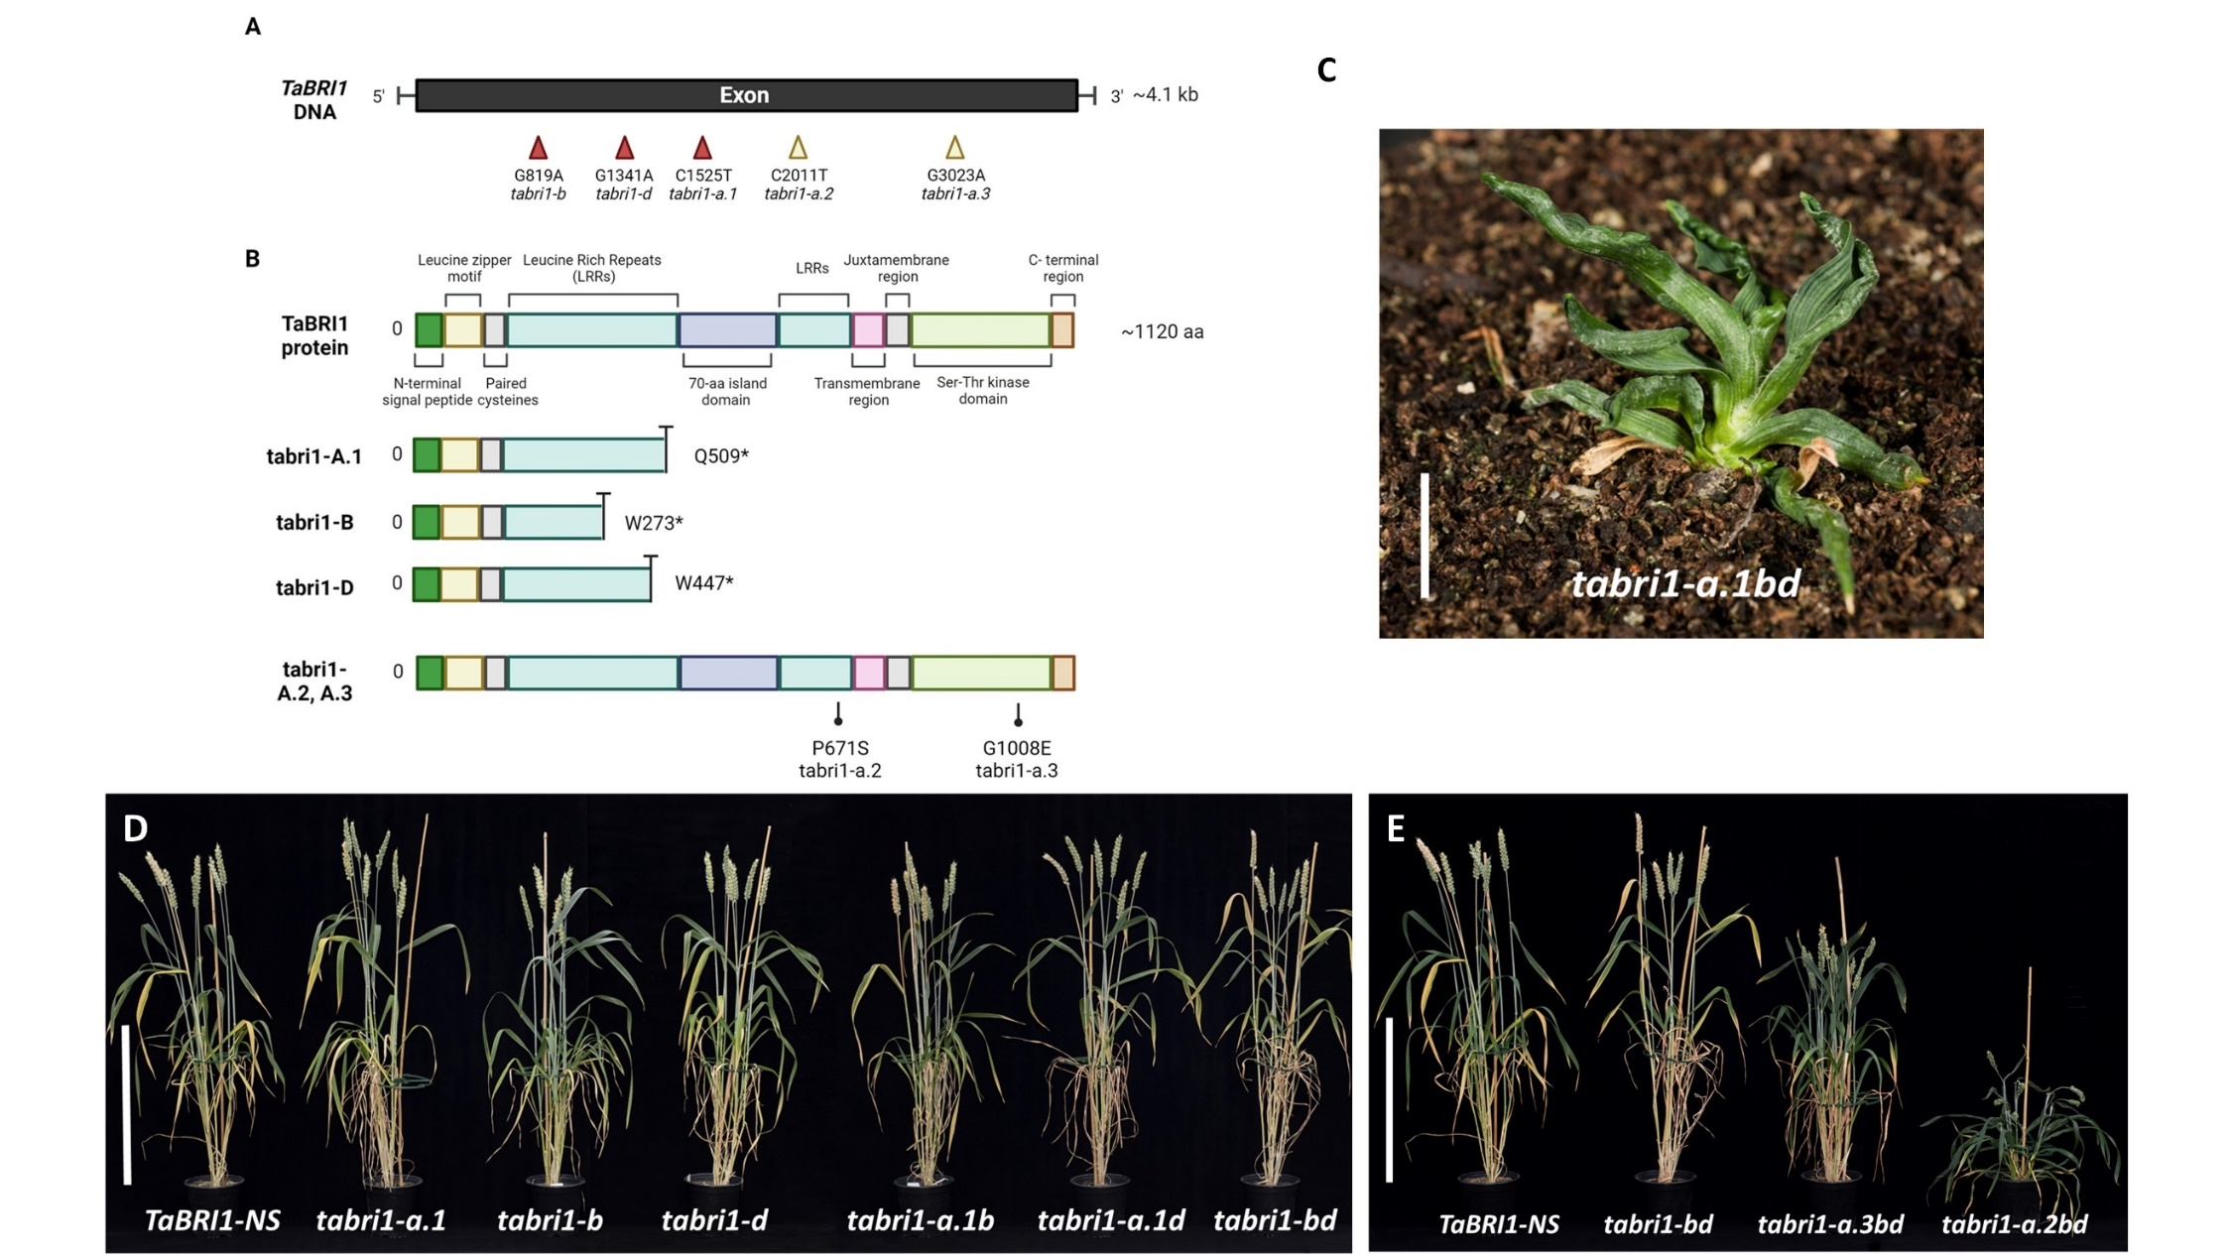

Figure 1: *tabri1* mutants developed via reverse- and forward-genetics approaches (A) *TaBRI1* gene indicating the position of nonsense mutations in the three homoeologues (red arrows) and missense mutations identified in *TaBRI1-A1* (yellow arrows) (B) Structure of the TaBRI1 protein showing conserved domains and the predicted TaBRI1 proteins encoded by the mutant alleles. The positions of the amino acid substitutions in *tabri1-a.2bd* (P671S) and *tabri1-a.3bd* (G1008E) are indicated. Produced using Biorender.com. (C) Phenotype of the triple *tabri1-a.1bd* mutant at two months after germination growing under glasshouse conditions (bar length is 2.5 cm). The phenotype of (D) the segregating wild-type (*TaBRI1-NS*) with single and double mutants (E) the triple mutants (*tabri1-a.2bd* and *tabri1-a.3bd*) and a representative double mutant (*tabri1-bd*). Plants were photographed at GS83. Bar length is 40 cm.

**Identification of novel *TaBRI1-A1* mutants from a forward genetics screen**

The high level of functional redundancy among the *TaBRI1* homoeologues and the severe dwarf phenotype of the triple loss-of-function mutant prompted us to identify weaker mutations that might confer a potentially useful ideotype combining a semi-dwarf growth habit with upright leaves. We performed a forward genetics screen by mutagenizing the *tabri1-bd* double mutant and identified two lines, *M3-31* and *M3-49*, which were shorter than both *TaBRI1-NS* and *tabri1-bd* and had more upright leaves (Figure 1E). *M3-49* displayed the milder mutant phenotype (Figure 1E) while in *M3-31* the leaves were dark green and twisted (Figure 1E and Figure S1) which is characteristic of BR signalling mutants in other cereals (Yamamuro et al., 2000; Morinaka et al., 2006; Dockter et al., 2014). Unlike the *tabri1-a.1bd* mutant, both lines transitioned to the reproductive stage and set seeds. We hypothesized that these phenotypes might be due to leaky mutations in *TaBRI1-A1*. Sequencing revealed that *M3-31* carries a G to A point mutation in *TaBRI1-A1* resulting in a P671S substitution in the 22nd LRR and that *M3-49* carries a C to T point mutation resulting in a G1008E substitution in the Ser/Thr-kinase domain (Figure 1B). The mutant alleles were named *tabri1-a.2bd* (*M3-31*) and *tabri1-a.3bd* (*M3-49*) (Table 1). We crossed both mutants to the *tabri1-bd* mutant and selected triple mutants from the BC1F2 generation for phenotypic characterisation.

**Phenotypic characterization of *tabri1* mutants under glasshouse conditions**

We phenotyped the wheat *bri1* mutants in glasshouse conditions (GH) during 2021 and 2022. The data collected from GH2021 are presented below and data from GH2022 are presented in Figure S2 as the results were largely consistent between experiments.

The *tabri1-a.2bd* and *tabri1-a.3bd* mutants were 57% and 27% shorter than *TaBRI1-NS*, respectively(Figures 2A and 3A). This height difference was caused by significant reductions in the lengths of the spike, peduncle, P-1, P-2, and P-3 internodes in both mutants (Figures 2C, 3B, 3C). By contrast, final plant height was not significantly different in any single or double *tabri1* mutant compared to *TaBRI1-NS* in either experimental replication, except for *tabri1-b* and *tabri1-a.1d* mutants which were significantly shorter than *TaBRI1-NS* in GH2021 and GH2022, respectively (Figure 3A and Figure S2). Spike length was unaffected in the single and double mutants, except for *tabri1-a.1b* and *tabri1-b* mutants in which spikes were significantly shorter than *TaBRI1-NS* in GH2021 and GH2022, respectively (Figure 3C, Figure S2). This result indicates *BRI1* genes are functionally redundant in controlling stem and rachis elongation in wheat.

All double *tabri1* mutants exhibited significantly reduced flag leaf angles (FLA) conferring a more upright architecture compared to *TaBRI1-NS* (Figure 3E). The effect was strongest in the *tabri1-a.3bd* triple mutant where FLA was reduced by 56% (Figure 3E). Among single *bri1* mutants, only *bri1-d* exhibited significantly reduced FLA and only in the GH2021 experiment (Figure 3E). It was not possible to record the leaf angle in the *tabri1-a.2bd* triple mutant due to its twisted and disoriented leaves (Figure S1). Relative differences in FLA were maintained in two experimental replications (Figure S2) and were consistent at ear emergence, anthesis, watery endosperm, soft dough, and ripening stages (Figure S3).

The number of spikelets per spike was reduced in *tabri1-a.2bd*, but only in GH2021 (Figure 3D) and increased in *tabri1-a.1b* and *tabri1-a.1d*,only in GH2022 (Figure S2)compared to *TaBRI1-NS*. While TGW was significantly higher in all three single mutants and the *tabri1-a1.d* double mutant,the *tabri1-a.2bd* and *tabri1-a.3bd* triple mutants exhibited significant reductions compared to *TaBRI1-NS* (Figures 3F and S2). These results were consistent with changes in seed area (Figure 2D, 3G, Figure S2).

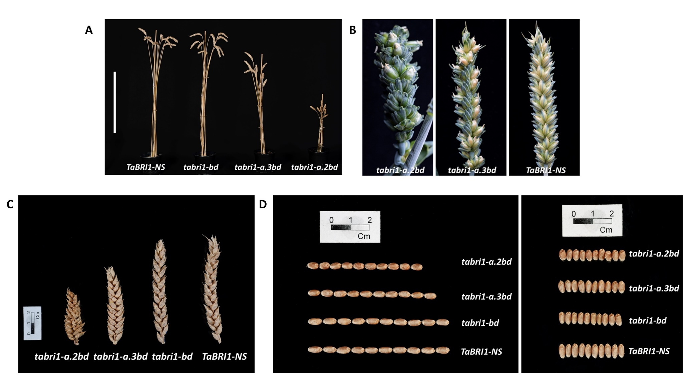

**Figure 2:** **Phenotype of novel *tabri1* triple mutants. (A)** Mature stems of the triple mutants (*tabri1-a.2bd* and *tabri1-a.3bd*), a representative double mutant (*tabri1-bd*) and control *TaBRI1-NS* from GH2021 photographed at GS93. Bar length is 40 cm. **(B)** Spikes from *tabri1-a.2bd* and *tabri1-a.3bd* compared to *TaBRI1-NS* at GS83 (soft dough stage) **(C)** Spikes and **(D)** grains (10 grains photographed end-to-end and side-by-side) from the triple mutants (*tabri1-a.2bd* and *tabri1-a.3bd*), representative double mutant (*tabri1-bd*) and control *TaBRI1-NS* photographed at maturity.

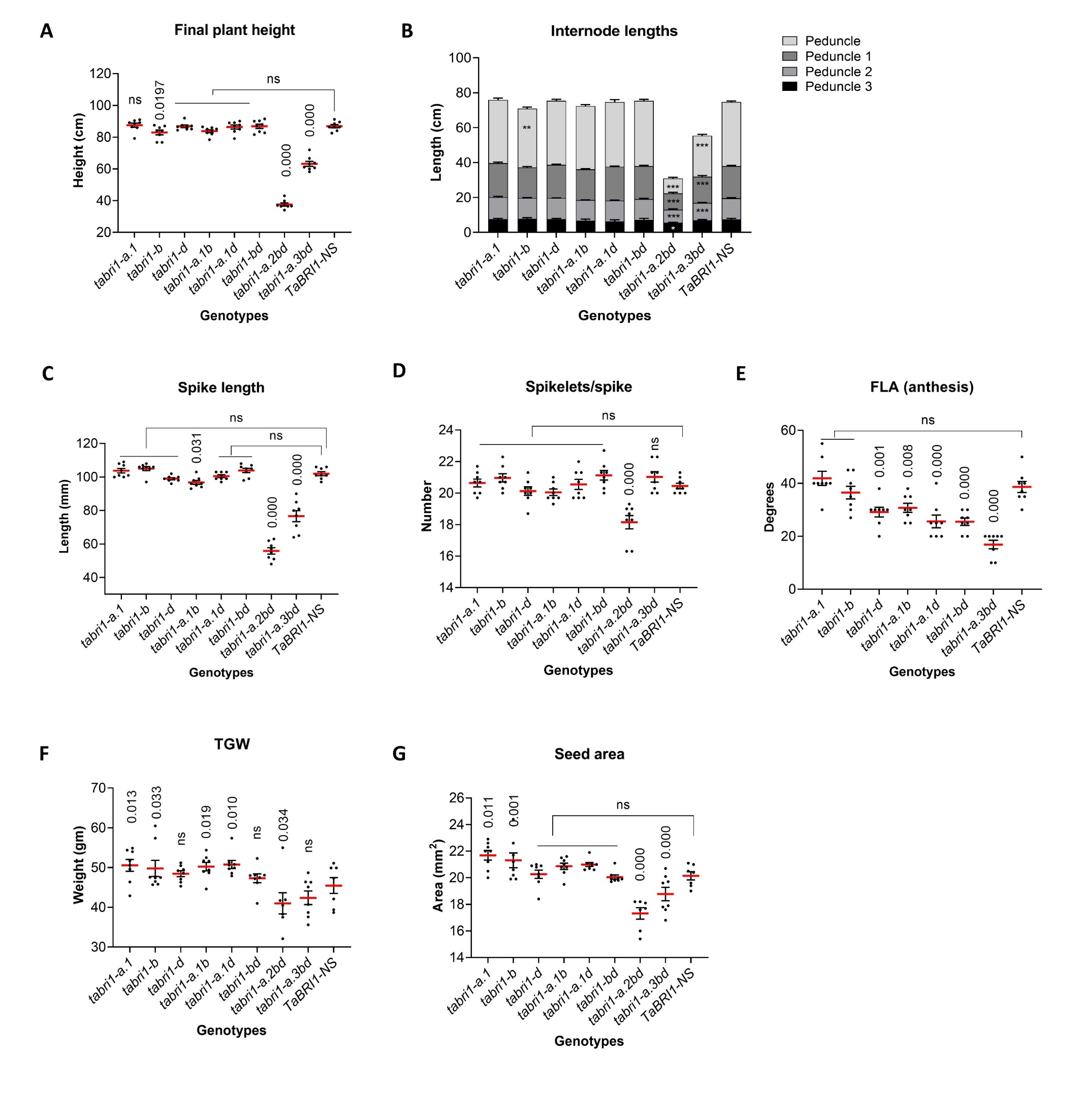

Figure 3: Phenotypic characterisation of *tabri1* mutants in GH2021. (A) Final plant height at maturity (n = 8). (B) Internode lengths recorded at maturity (n = 8). (C) Spike length at maturity (n = 8). (D) Number of spikelets per spike (n = 8). (E) FLA at anthesis (n = 8). (F) TGW in mature grains (n = 8). (G) Area of mature grains (n = 8). ***, ** and * indicate significant difference from *TaBRI1-NS*, *P* < 0.001, 0.01 > *P* > 0.001 and 0.05 > *P* > 0.01, respectively. *P*-values were obtained using Fisher’s unprotected LSD test.

**Phenotypic characterization of *tabri1* mutants under field conditions**

The phenotypes of some selected *tabri1* mutants were assessed under field conditions in 2022. The triple mutant *tabri1-a.3bd* was significantly shorter than *TaBRI1-NS* (34.3 cm compared with 53.0 cm, a 35% reduction) (Figure 4A). There were no significant differences in final height between the controls and the single and double mutants, except for *tabri1-a.1b* which was 8.5% taller than *TaBRI1-NS* (although this was not observed in the glasshouse experiments). Spikes were 16% shorter in the *tabri1-a.3bd* compared to *TaBRI1-NS* (Figure 4B). Significant increases in spike length compared with *TaBRI1-NS* were found in *tabri1-bd* (5%), *tabri1-d* (4.7%), and *tabri1-b* (9.4%), although apart from *tabri1-b*, for which a longer spike was also noted in GH2022, these differences were not observed in the glasshouse experiments.

All *tabri1* double and triple mutants exhibited significant reductions in FLA compared to the *TaBRI1-NS* conferring a more upright leaf architecture (Figure 4C). Compared to *TaBRI1-NS*, TGW was reduced by 15.9% in *tabri1-a.3bd* and 10.6% in *tabri1-bd* (not noted in GH trials) but was not significantly different in other mutant lines (Figure 4D). The seed area was unaffected in the *bri1* mutants, except for in the *tabri1-a.3bd* mutant, where seeds were 7% smaller than *TaBRI1-NS* (Figure 4E).

Taken together, our results show that the *tabri1* mutant phenotypes were largely consistent between GH and field conditions. The *tabri1-a.1b* and *tabri1-a.1d* double mutants exhibited increased leaf erectness with no alteration in plant height, spike, and grain characteristics.

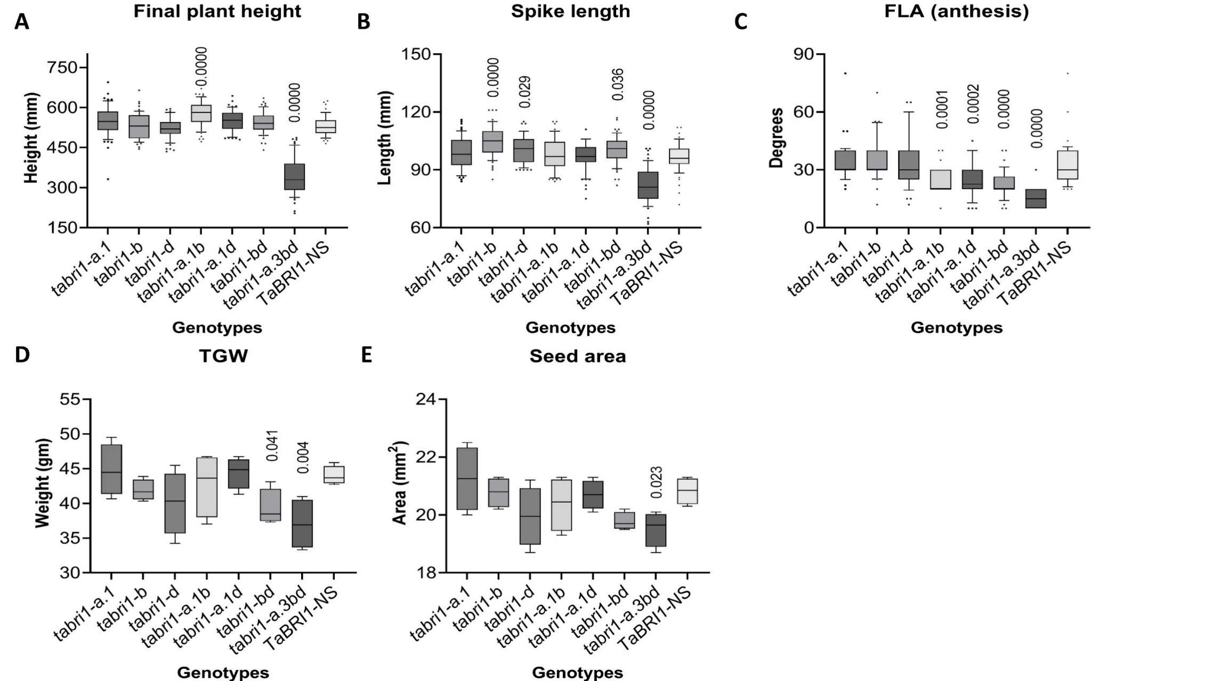

**Figure 4: Phenotypic characterisation of *tabri1* mutants in a field trial in 2022.** **(A)** Final plant height at maturity (n = 55-60). **(B)** Spike length at maturity (n = 55-60). **(C)** FLA at anthesis (n = 40). **(D)** TGW of mature grains (n = 4). **(E)** Seed area of mature grains (n = 4). *P*-values for significant differences between mutants and *TaBRI1-NS*, were obtained using Fisher’s unprotected LSD test.

***tabri1* mutants display reduced sensitivity to external BR application**

To determine whether the semi-dwarf phenotype of the triple *tabri1* mutants is caused by reduced sensitivity to endogenous BRs, we tested the effect of applied 24-*epi*brassinolide (*epi*BL) on leaf angle in seedlings using lamina joint inclination assays (Li et al., 2017). Leaf angle was significantly increased in the control *TaBRI1-NS* by 59 % following *epi*BL treatment compared to the water control (Figure 5A and 5B). By contrast, *epi*BL treatment did not affect leaf angle in either *tabri1-a.2bd* or *tabri1-a.3bd* triple mutant, consistent with reduced BR sensitivity.

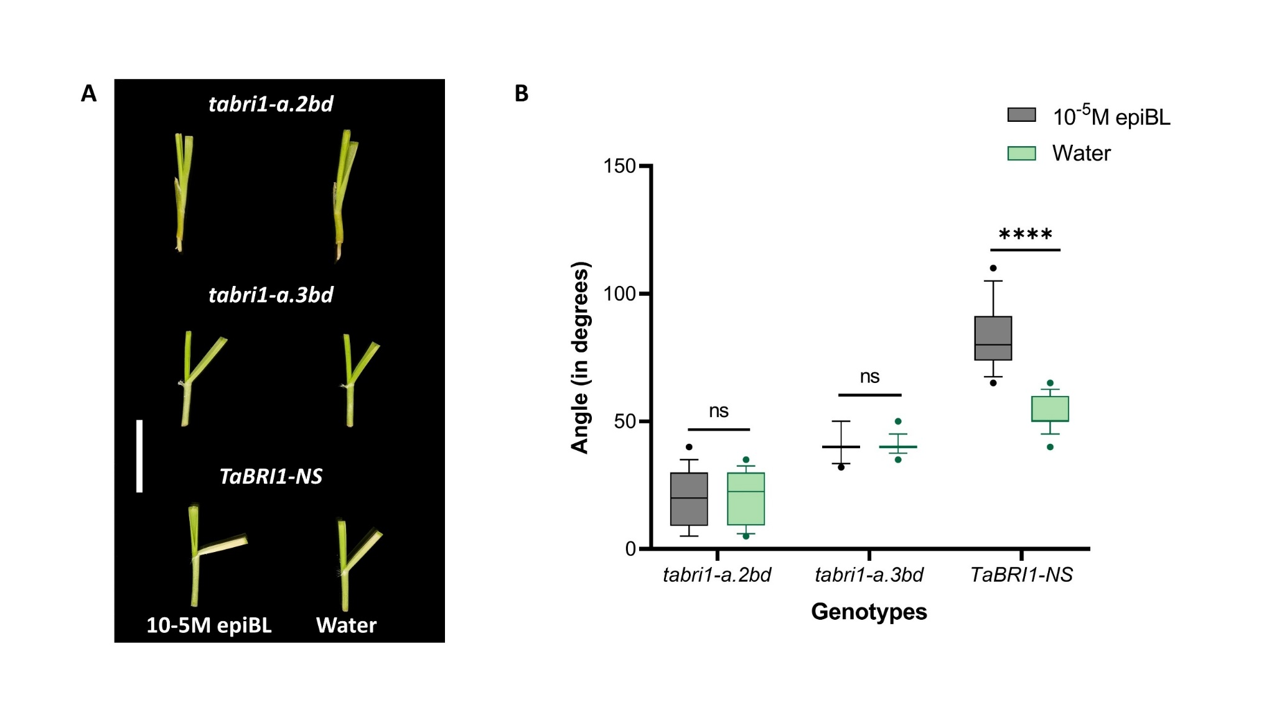

Figure 5: Response of *tabri1* mutants and the control line to external BR application. (A) Lamina joint inclination assays in *TaBRI1-NS*, *tabri1-a.2bd* and *tabri1-a.3bd* seedlings following treatment with 10-5M *epi*BL or water. Bar length is 2 cm. (B) Leaf angles (n = 14) after treatment with 10-5M *epi*BL or water. Statistical significance is denoted by adjusted *P* values: \*\*\*\**P*<0.0001 (obtained by pairwise Student’s t-test).

***tabri1* mutants accumulate intermediates and bioactive products of BR biosynthesis pathway**

We detected nine BRs and precursors in the *tabri1* mutants and *TaBRI1-NS* (Figure 6, Table S1). The levels of CS, a bioactive BR, were increased by 376- and 12-fold in the triple mutants *tabri1-a.1bd* and *tabri1-a.2bd*, respectively, compared to *TaBRI1-NS* but its increase was not significant in *tabri1-a.3bd* (Figure 6, Table S1). We observed a9.6-fold accumulation in BL content in the most severe triple mutant *tabri1-a.1bd* compared to *TaBRI1-NS* with no significant differences for the other *bri1* mutants. Additionally, we observed significant accumulation of TY and 6-oxoCN, which are intermediates in the early C-6 oxidation pathway, and of 6-deoxoCT, an intermediate in the late C-6 oxidation pathway, in *tabri1-a1.bd* compared to *TaBRI1-NS*.

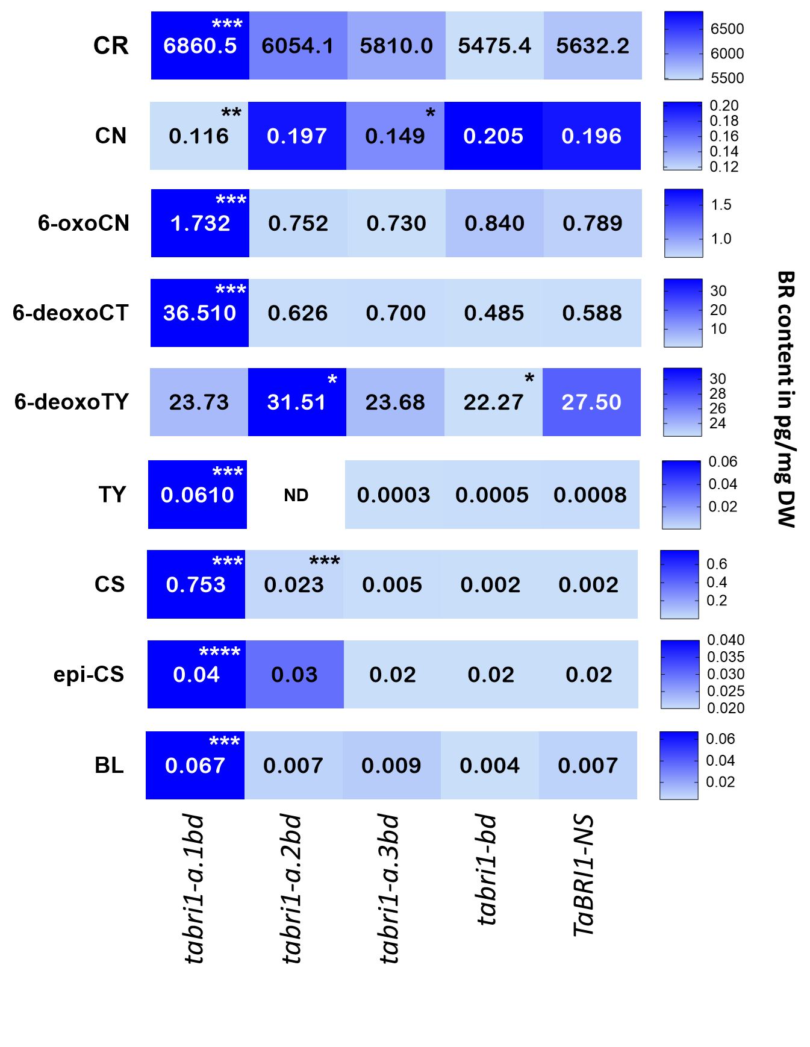

**Figure 6: BR levels in *tabri1* mutants and *TaBRI1-NS.*** The concentrations of BRs (pg/mg DW) namely CR (campesterol), CN (campestanol), 6-oxoCN, 6-deoxoCT (6-deoxocathasterone), 6-deoxoTY, TY (typhasterol), CS (castasterone), BL (brassinolide), and epiCS were determined in *tabri1* mutant (*tabri1-a.1bd*, *tabri1-a.2bd*, *tabri1-a.3bd, tabri1-bd*) and *TaBRI1-NS* seedlings. Mean values from five biological replicates are recorded. Statistically significant differences from the *TaBRI1-NS* control are denoted by * 0.05 > *P* > 0.01, ** 0.01 > *P* > 0.001, *** 0.001> *P* >0.0001, **** *P*< 0.0001 (obtained by pairwise Student’s t-test). ND = not detected.

**BR biosynthesis and signalling genes are differentially expressed in the *tabri1* mutants**

To determine the effect of reduced TaBRI1 function on gene expression we sequenced the transcriptomes of *tabri1* mutant and control seedlings. The transcriptome was radically altered in the *tabri1-a.1bd* mutant which had 35,504 differentially expressed genes (DEGs) compared to *TaBRI1-NS* (Figure S4C in File S1, File S2). Transcriptomic differences in the *tabri1-a.1bd* mutant were also evident in the principal component analysis, which grouped the mutant separately from other genotypes in the experiment (Figure S4).

By contrast, there were just 139 DEGs between the double mutant *tabri1-bd* and *TaBRI1-NS* consistent with the functional redundancy in *BRI1* genes in wheat seedling tissues (Figure S4, File S2). The milder *tabri1-a.3bd* mutant exhibited 2,867 DEGs, consistent with the partial disruption of BR signalling in this mutant (Figure S4, File S2).

We hypothesised that genes differentially expressed in both *tabri1-a.1bd* and *tabri1-a.2bd* mutants which share a dwarfed phenotype might represent a core set of BR-regulated genes in wheat. In total, 4,654 genes were differentially expressed in both mutants which were significantly enriched for functional terms relating to carbohydrate metabolism (File S3). The BR biosynthesis genes *DWF4*, *CPD*, and *BR6oxs* were significantly up-regulated in both dwarfed mutant lines but not in the milder *tabri1-a.3bd* mutant, consistent with changes in bioactive BR levels (Figure 7A, File S4). By contrast, transcript levels of the BR signalling genes *TaBZR1*, *TaBKI1* and *TaCDG1* were significantly reduced only in the most severe *tabri1-a.1bd* mutant (Figure 7C, File S4).

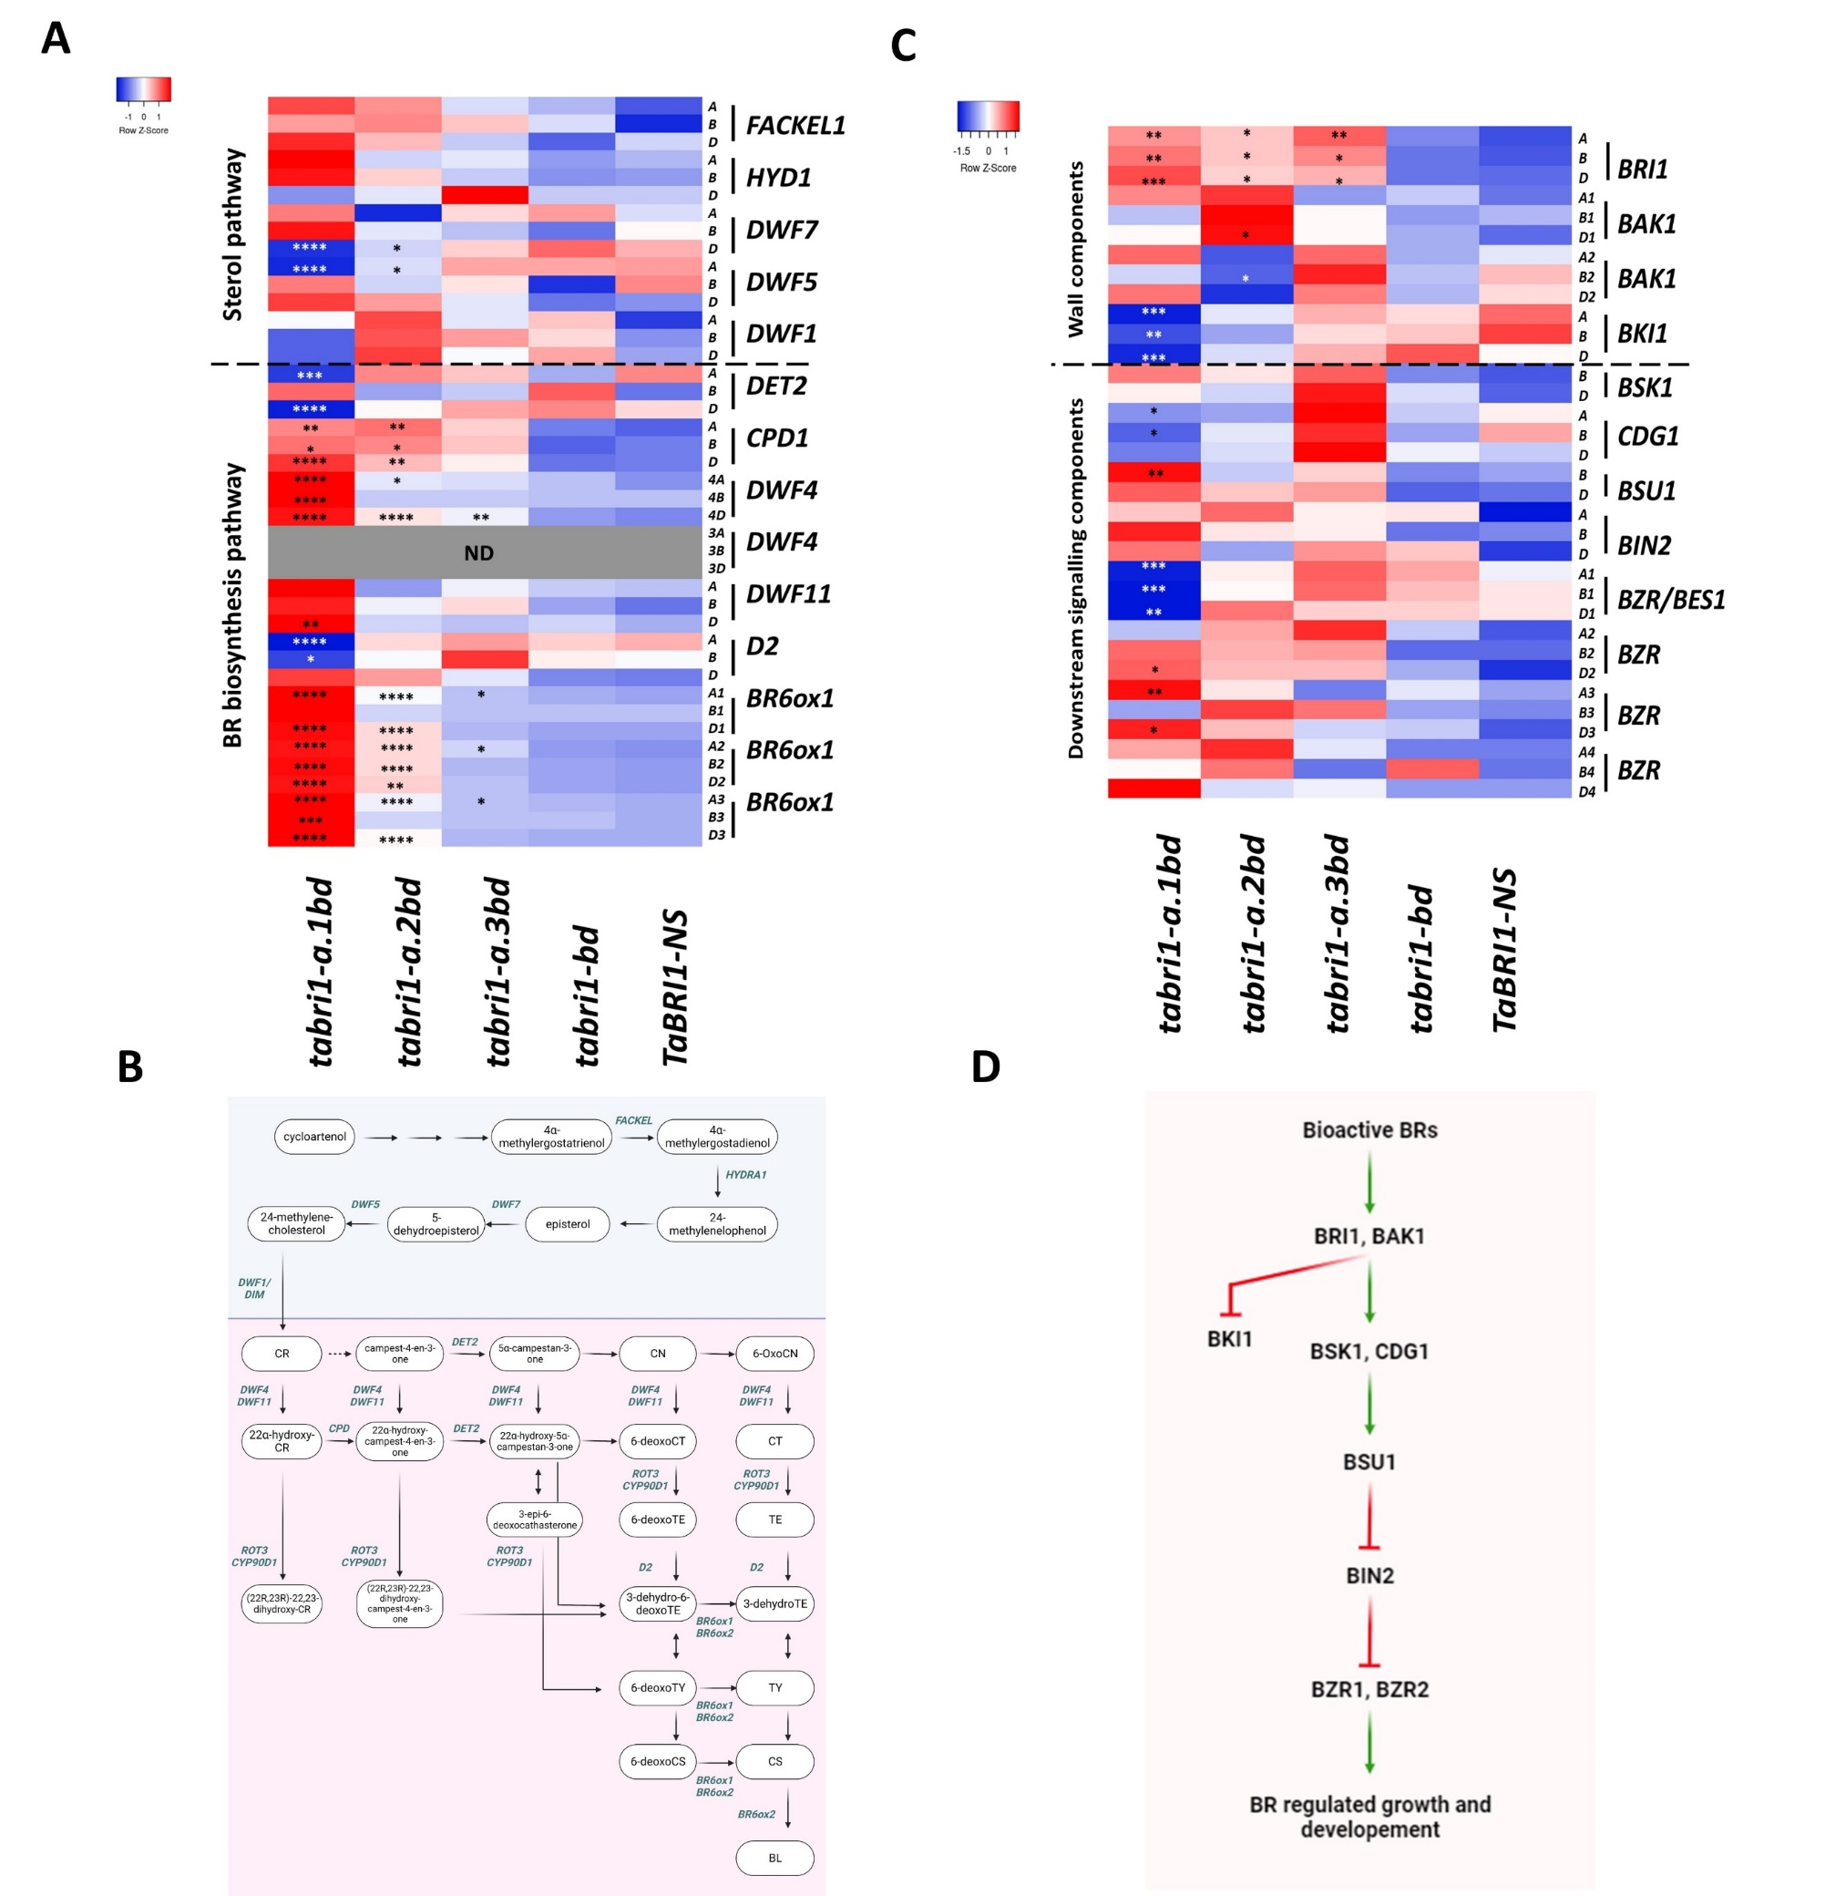

Figure 7: Transcript levels of BR biosynthesis and BR signalling genes in *tabri1* mutants and *TaBRI1-NS*. (A) Heatmap of relative expression levels of genes in the sterol and BR-biosynthesis pathways in the *tabri1-a.1bd*, *tabri1-a.2bd*, *tabri1-a.3bd*, *tabri1-bd* mutants and *TaBRI1-NS*. (B) The sterol pathway (in blue background) and BR-specific biosynthesis pathways (in pink background) leading to the bioactive BRs CS and BL. The names of the enzymes that catalyse each step is shown above the arrows. (C) Heatmap indicating expression levels (TPM) of genes in the BR-signalling pathway in the *tabri1-a.1bd*, *tabri1-a.2bd*, *tabri1-a.3bd*, and *tabri1-bd* mutants and control *TaBRI1-NS.* Statistically significant differences from the *TaBRI1-NS* control are denoted by * 0.05 > *P-adj* > 0.01, ** 0.01 > *P-adj* > 0.001, *** 0.001> *P-adj* >0.0001, **** *P-adj* < 0.0001. ND = not detected. (D) BR signalling pathway in plants. The pathways were produced using Biorender.com.

**Discussion**

***TaBRI1* genes are essential for normal wheat development**

The triple knockout mutant *tabri1-a1.bd* carries allelic variants of *TaBRI1-A1*, *TaBRI1-B1,* and *TaBRI1-D1* that are expected to encode truncated proteins lacking LRR and Ser/Thr-kinase domains that are essential for BRI1 activity in other species (Figure 1B, Clouse, 2011; Wang et al., 2012; Hothorn et al., 2011; Li and Chory, 1997; She et al., 2011; Wang et al., 2001). The wheat *tabri1-a1.bd* mutant is severely dwarfed, exhibits dark green, thickened leaves and does not transition to the reproductive stage causing complete infertility (Figure 1C). This phenotype is consistent with *bri1* null mutants in Arabidopsis and rice (Clouse et al., 1996; Nakamura et al., 2006) demonstrating that orthologous *BRI1* genes have conserved functions between monocots and dicots. Furthermore, our results demonstrate that *BRI1* genes are essential for normal development in wheat and that the LRR and Ser/Thr-kinase domains are required for BRI1 activity.

Through a forward genetics screen, we identified two mutant lines carrying point mutations that introduce amino acid substitutions in the LRR and Ser/Thr-kinase domains of TaBRI1-A1 which, in combination with *tabri1-b1* and *tabri1-d1* loss-of-function mutations exhibit less severe phenotypes. The *tabri1-a.2bd* mutant carries an amino acid substitution in the final LRR domain and exhibits a milder phenotype, consistent with the phenotype of the Arabidopsis mutant *bri1-711* having a mutation in the last LRR i.e., reduced rosette width and height (G746S) BRI1 mutants in Arabidopsis (Sun et al., 2017). Mutations in the LRR domains might disrupt BR signalling by interfering with BR binding into the protein superhelix (Hothorn et al., 2011; She et al., 2011).

The *tabri1-a.3bd* mutant carries an amino acid substitution in the IX subdomain of the Ser/Thr-kinase domain (G1008E, Figure 1B). In rice, the *d61-1* mutant also carries an amino acid substitution in the IX subdomain (T989I) and exhibits dwarfism, erect leaves, and reduced grain number per panicle, consistent with the *tabri1-a.3bd* phenotype (Morinaka et al., 2006; Chono et al., 2003). Mutations in the IX subdomain likely affect BR signalling due to their proximity to the activation loop in the BRI1 kinase domain (Bojar et al., 2014). Autophosphorylation of the activation loop in BRI1 and association with the kinase domain of BAK1 stabilizes the conformation leading to the activation of BR signalling (Oh et al., 2000; Vert et al., 2005; Yan et al., 2012).

**BR-insensitive *tabri1* mutants have higher BR levels**

The *tabri1-a.2bd* and *tabri1-a.3bd* mutants exhibit reduced BR sensitivity, consistent with missense *bri1* mutants in rice and barley (Yamamuro et al., 2000; Chono et al., 2003; Dockter et al., 2014). Thus, it can be concluded that the altered BR signalling in the *tabri1* triple mutants is responsible for the observed differences in growth and architecture.

Nine BRs were detected in wheat seedlings (Figure 6, Table S1). BL was previously detected in wheat by Janeczko and Swaczynova, 2010, but its presence in other cereals has not been reported (Chono et al., 2003, Yamamuro et al., 2000; Kim et al., 2008). Intermediates in the late C-6 oxidation pathway were more abundant than those in the early C-6 oxidation pathway, but both pathways are present in Arabidopsis, rice, pea, and zinnia (Hong et al., 2002; Yamamuro et al., 2000; Nomura et al., 1999; Nomura et al., 1997; Yamamoto et al., 2001).

*tabri1-a.1bd* and *tabri1-a.2bd* triple mutants which exhibit the most severe developmental defects accumulated high levels of bioactive BRs (Figure 6 and Table S1). This was associated with the upregulation of multiple BR biosynthesis genes and downregulation of BR signalling genes *BKI1* and *BES1/BZR1* (He et al., 2005; Turk et al., 2005; Yuan et al., 2007; Neff et al., 1999; Sandhu et al., 2013; Wang et al., 2017). These results are consistent with BR-insensitive *bri1* mutants in Arabidopsis, rice and barley (Noguchi et al., 1999; Nomura et al., 1999; Yamamuro et al., 2000; Chono et al., 2003, Choe et al., 2002; Montoya et al., 2002) and demonstrate that the elevated BR levels in the wheat *bri1* mutants are due to suppression of the feedback mechanism that down-regulates expression of BR biosynthesis genes in response to BR signal transduction (Yu et al, 2011).

***BRI1* mutants exhibit erect leaf architecture and reduced height**

Bread wheat has a hexaploid genome, so combinations of alleles in different *BRI1* homoeologues might provide more subtle reductions in BR signalling than in the *bri1* null mutant. In the different mutant combinations, FLA at anthesis was correlated with the number of functional *BRI1* homoeologues suggesting a gene-dosage effect for this trait. The single *tabri1-d* mutant exhibited a significant reduction in FLA only in experiment GH2021, but all double mutants exhibited reduced FLA in all environments tested (Figure 3E, S2 and 4C). The greatest reduction in FLA (56 %) was observed in the triple *tabri1-a.3bd* mutant (Figure 3E). These observations are consistent with experiments in rice, barley, wheat, and maize, where reduced BR signalling confers decreased leaf angle and a more erect architecture (Morinaka et al., 2006; Dockter et al., 2014; Fang et al., 2020; Kir et al., 2015). Taken together, our results show that *tabri1-a.1b* and *tabri1-a.1d* double mutants exhibited more erect leaves without any pleotropic effects on seed area, TGW or plant height. It will be important to test the performance of these lines in replicated field experiments with different sowing densities.

In contrast to the effect on leaf angle, mutations in one or two *BRI1* homoeologues had only a very mild effect on plant height, suggesting that, in wheat, stem elongation is less sensitive than leaf angle to a reduction in BR signalling. Reductions in height required mutations in all three homoeologues, which contrasts the findings of Fang and colleagues (2020), who reported a reduction in final plant height in the single *tabri1-a1* and *tabri1-d1* mutants. It is possible that the use of ion-beam mutagenesis coupled with limited backcrossing may have confounded the results from this earlier study.

Height reduction in *tabri1-a.2bd* and *tabri1-a.3bd* is due to restricted elongation of the rachis, peduncle and upper internodes compared to *TaBRI1-NS* (Figure 3B and 3C). In maize, *ZmBRI1-RNAi* lines exhibited significantly shorter internodes compared to non-transgenic siblings leading to reduced final plant height (Kir et al., 2015). In rice, *osbri1* mutants exhibited reduced height due to a shorter peduncle and P-4 internode (Yamamuro et al., 2000). Spike length was significantly reduced in *tabri1-a.2bd* and *tabri1-a.3bd* compared to *TaBRI1-NS*, consistent with the *uzu1.a* barley mutant that exhibits reduced rachis internode length (Dockter et al., 2014). However, in rice, panicle length was either similar (*d61-1* mutant) or longer (*d61-2* and *d61-7* mutants) in the *bri1* mutants compared to the wild-type suggesting that BR signalling may play different roles in panicle and spike elongation (Yamamuro et al., 2000; Morinaka et al., 2006).

The effect of *tabri1* mutations on TGW were inconsistent between glasshouse and field conditions. Significant reductions in TGW noted in the *tabri1-bd* and *tabri1-a.3bd* mutants compared to wild-type under field conditions, were not observed under glasshouse conditions. Fang et al. (2020) noted a reduction in grain size in *tabri1-a1* and *tabri1-d1* mutants. However, this was not observed for the single and double mutants in the current study conducted under glasshouse or field conditions. While grain area was significantly reduced in the *tabri1* triple mutants in some cases, this was not observed consistently across all GH and field experiments. In rice, *osbri1* mutants including *d61-1*, *d61-2* and *d61-7* also exhibit reduced grain size (Sinclair and Sheehy, 1999; Morinaka et al., 2006). These results showed that the reduced height in the triple *bri1* mutants was associated with pleiotropic effects on grain and spike characteristics, likely limiting their application in wheat breeding. But *tabri1-a.1b* and *tabri1-a.1d* double mutants, having upright canopy architecture without negative impacts on agronomic traits, have scope for further testing to evaluate effects on canopy photosynthesis, biomas, yield compoments and yield at a range of plant densities.

**Conclusion**

Our results demonstrate that *BRI1* genes are essential for normal wheat development. Wheat plants carrying just one functional *BRI1* homoeologue exhibit a more erect leaf architecture without any pleotropic effects on height or grain development and are thus potential targets for yield improvement in high-density sowing regimes. Plants carrying a combination of loss-of-function alleles and amino acid substitutions in conserved BRI1 domains were semi-dwarfed with a more erect leaf architecture, although negative effects on grain and reproductive development likely preclude their use in wheat breeding. Screening for natural variation in *BRI1* genes in wheat germplasm collections or inducing specific alleles by CRISPR-Cas mutagenesis informed by our characterisation of these genes may be a promising approach to identify beneficial alleles for wheat breeding.

**Materials and methods**

**Plant materials and growth conditions**

**Growth conditions under glasshouse experiment**

The spring wheat cultivar ‘Cadenza’ was used in all experiments. For the GH2021, GH2022 and lamina joint inclination assays, wheat seeds were imbibed on damp filter paper at 4 ℃ for 4-5 d then transferred to soil in 15 cm pots (75 % peat, 12 % sterilised loam, 3 % vermiculite and 10 % grit) and grown in GH conditions (18-20 ℃ day/14-15 ℃ night temperature, 16 h photoperiod).

For BR quantification and RNA-seq experiments, germinated seeds were transferred to damp vermiculite in a controlled environment (CE) chamber (Constant 21 ℃ and 24 h photoperiod using fluorescent light source set at 300 μmolm-2s-1 PAR). The entire above-ground tissue was harvested from seedlings at the 2nd leaf stage in liquid nitrogen.

**Screening Cadenza TILLING population**

Premature stop codon mutations in *TaBRI1-A1*, *TaBRI1-B1* and *TaBRI1-D1* genes were identified from an online database (<http://plants.ensembl.org/Triticum_aestivum/> (Krasileva et al., 2017). Each M4 line was inter-crossed to combine mutations, and F1 plants (AaBbDd) were backcrossed 3x to non-mutagenized ‘Cadenza’ to reduce background mutations then selfed to obtain a BC3F2 population segregating for various combinatorial mutants (*tabri1-a.1*, *tabri1-b* and *tabri1-d*, *tabri1-a.1b*, *tabri1-a.1d* and *tabri1-bd*, *tabri1-a.1bd* and *TaBRI1-NS*).

**Forward genetics screen**

Seeds of the *tabri1-bd* double knockout mutant were treated with 0.4% EMS as described previously (Chen et al., 2012; Uauy et al., 2009). The M1 seed was planted in the field in March 2018 with a sowing density of 100 grains/m2 in twelve separate plots (1.8 x 12 m plots). At maturity, the M2 seed was harvested from each plot to generate twelve individual M2 bulk pools which were sown in the field in March 2019. Eight plots of 1.8 x 12 m per pool were sown at a planting density of 100 grains /m2. Visual screening of the plots was conducted from GS65 to GS87 to identify mutants displaying altered height and/or leaf erectness in individual M2 plants. M3 seed was collected from selected M2 plants at maturity which were then grown in GH conditions at M3 and M4 stage.

**Phenotypic characterisation of *tabri1* mutants under glasshouse conditions**

*tabri1* mutants were phenotyped in GH conditions using 6-8 biological replicates which were sown in a randomised complete block design. Final plant height was recorded as the length of the tallest tiller from the base of the stem touching the soil to the tip of the spike at maturity. Internode and spike length (from the base of the first spikelet to the top of the terminal spikelet just beneath the base of the awns) was taken from 2-3 tallest tillers per plant. The number of spikelets producing grain per spike was also measured. The leaf angle was defined as the angle between the vertical stem and the midrib of the leaf measured at the seedling stage (2nd leaf) and reproductive stage on the flag leaf. For measuring FLA the date of ear emergence and anthesis was recorded on a representative primary tiller. The leaf angle was measured using a protractor and was recorded on the primary tiller at ear emergence (GS-55), anthesis (GS-61), completion of anthesis (GS-69), soft dough (GS-77), late milk (GS-85) and ripening stage (GS-93). The Marvin grain analyser (INDOSAW, India) was used to determine grain area using 3-5 g of clean threshed seed. TGW was measured by weighing 1,000 clean-threshed grains.

**Field assessment of wheat *tabri1* mutants**

The genotypes *tabri1-a.1, tabri1-b, tabri1-d, tabri1-a.1b, tabri1-a.1d, tabri1-bd, tabri1-a.3bd* and *TaBRI1-NS* were sown on 15th April 2022 at Rothamsted Research in 1 m2 plots as a randomised complete block design with four replicates. All experiments were grown with standard farm practice for fertiliser and pesticides but with no plant growth regulators applied. Final plant height, spike length, number of spikelets/spike, grain area and grain weight were measured as in the GH experiment using 10-15 plants per plot. FLA was measured in 10-15 uniform tillers using a protractor. The final plant height was recorded on the 10 tallest tillers per plot.

**Brassinosteroid hormone profiling**

Bioactive and precursor BRs concentrations were measured in 2nd leaf seedling tissues of *tabri1-a1.bd*, *tabri1-a.2bd*, *tabri1-a.3bd, tabri1-bd* and *TaBRI1-NS*. Multiple plants were pooled to obtain sufficient tissue for five biological replicates. Leaf tissue was weighed frozen in liquid N2 and freeze-dried. BRs were extracted, purified, and analysed by UPLC-ESI-MS/MS as described by Tarkowska et al. (2016).

**Genotyping**

Genomic DNA was extracted from seedling tissue using a CTAB-buffer extraction.

*TaBRI1* genes were amplified using 0.05 μM of homoeologue-specific PCR primers (Table S2 and S3) with Hot Shot Diamond Mastermix (Clent Life Science, Stourbridge, UK) and annealing temperature between 55-65 ℃ depending on the primer pair (Table S2 and S3).

PCR products were purified using QIAquick PCR Purification kit (Qiagen, Hilden, Germany). and sequenced by Eurofins Genomics (Wolverhampton, U.K.).

We selected *bri1* mutations using KASP assays (Table S4). Each assay was run using KASP low-ROX Mastermix (LGC, Teddington, UK) with primers specific to each SNP with FAM, HEX or VIC tails and a common reverse primer with 37 cycles of touchdown PCR. Plates were read using the 7500 Fast Software v2.3 (Applied Biosystems, Foster City, California, USA) and analysed using the KlusterCaller™ software (LGC, Teddington, UK).

### RNA sequencing

The same tissues used for BR profiling were used to extract RNA using a Monarch® Total RNA Miniprep Kit (New England Biolabs, Ipswich, Massachusetts, USA) according to the manufacturer’s instructions and including DNase treatment. To assess RNA concentration and quality, Agilent 2100 Bioanalyzer (Agilent, Santa Clara, California, USA) and Agilent 6000 Nano RNA Kit (Agilent, Santa Clara, California, USA) was used according to the manufacturer’s instructions. RNA-seq was performed by Novogene Bioinformatics Technology Co. Ltd. (Cambridge, UK). Paired reads were trimmed to remove adaptor sequences and for quality using Trimmomatic 0.39 software (Bolger et al., 2014) (SLIDINGWINDOW:4:20; MINLEN:50). The raw FASTQ files were mapped to wheat IWGSC RefSeq v2.1 genome assembly using STAR 2.7.8a (Dobin et al., 2013) (outFilterMismatchNmax 6; -- alignIntronMax 10000). Raw mapped reads were counted using HTSeq 0.11.3 (Putri et al., 2022) and converted to TPMs (transcripts per million). Differential expression between each mutant genotype and *TaBRI1-NS* was performed using DESeq2 (Love et al., 2014) in RStudio version 4.1.1717 (RStudioTeam, 2015). Genes with >two-fold change in expression and FDR-adjusted *P*-value of ≤0.05 were classified as DEGs. PCA plot were generated using Bioconductor package pheatmap version 1.0.12 (Kolde, R. *Pheatmap: pretty heatmaps*. R Package Version 1.0.12. [https://CRAN.R-project.org/package=pheatmap](https://cran.r-project.org/package=pheatmap) (2012). Differential expression was visualized by generating heatmaps for the BR-pathway genes as reported by Ptošková et al., 2022 and Hou et al., 2019 using Heatmapper (Babicki et al., 2016, <http://www.heatmapper.ca/>). Venny2.1 (Oliveros JC 2007, <https://csbg.cnb.csic.es/BioinfoGP/venny.html>) was used to produce Venn diagrams for the genes co-expressed in the *tabri1* mutants compared to *TaBRI1-NS*. g:Profiler (<http://biit.cs.ut.ee/gprofiler/>, Reimand et al., 2016) was used to visualize gene ontology (GO) terms.

**Lamina joint inclination assay**

Two-cm sections containing the 2nd leaf lamina joint, leaf sheath, and leaf blade were excised from uniformly developed seedlings and floated in petri dishes containing autoclaved water for 10 min. The samples were transferred to 10-5M *epi*BL solution or autoclaved water in Petri dishes, sealed using parafilm and transferred to an incubator set at 29 °C in the dark for 2 d. The leaf angles were recorded using a protractor (Li et al., 2017).

**Statistical analysis**

The mutants along with wild-type *TaBRI1-NS* were planted in randomised and replicated blocks to reduce statistical error in GH and field experiments. Analysis of variance was conducted for estimating statistical differences between genotypes and treatments. ANOVA was performed using Genstat software (21.1st Edition). *P*-values, SED, and LSD at a 5 % level of significance. The field data were analysed using unbalanced ANOVA using regression (Genstat software 21.1st Edition). Statistically significant differences between mutants and controls were further tested from Fisher’s LSD unprotected test providing *P*-values. Paired *t*-test was performed using Graphpad Prism software (version 9.4.0) to test means before and after treatment which yielded *P*-values. Mean and residual plots for each dataset were generated to access the normality. The graphs using individual values or means and *P*-values (obtained using Fisher’s unprotected LSD test) were made in Graphpad Prism software (version 9.4.0).

**Author contribution**

SGT, PH, MSG, JF, and ALP designed the experiments. MSG and SGT performed intercrossing of Cadenza TILLING lines followed by backcrossing to isolate *TaBRI1* combinatorial mutants. SGT mutagenized the *tabri1-bd* mutant and harvested the M2 population. MSG performed the forward genetics screen on the M2 population and conducted phenotypic characterization on *tabri1* mutants under glasshouse and field conditions and performed a lamina joint inclination assay. MSG prepared the tissue for BR hormone estimation and RNA sequencing. DT performed BR hormone estimation. SP, PS and MSG analyzed the RNA-seq data. MSG and JA performed statistical analysis. PH, MSG, SP and SGT drafted and reviewed the manuscript. All authors read and approved the final manuscript.

**Acknowledgement**

We thank Graham Shephard at the visual communication unit (VCU) at Rothamsted Research for photographing wheat plants. We are grateful to the glasshouse and farm staff at Rothamsted Research for plant husbandry throughout the crop’s life cycle.

**Short legends for supplementary data**

**Figure S1:** GrossMorphology of *tabri-a.2bd* mutant

**Figure S2:** Phenotypic data collected on *tabri1* mutants during GH2022

**Figure S3:** FLA relationship between reproductive growth stages

**Figure S4:** RNA-seq analysis

**Figure S5:** Scheme used for sequencing *TaBRI1A* gene

**Table S1:** BR levels (pg/mg DW) in *tabri1* mutants and controls

**Table S2:** Homeologue-specific primers designed to amplify fragments around the deleterious mutations in *TaBRI1* genes

**Table S3:** Primers used for sequencing *TaBRI1A* gene

**Table S4:** KASP primers designed to differentiate the mutant and wild-type alleles in segregating *TaBRI1* populations

**File S2:** DEseq2 in *tabri1* mutants compared to *TaBRI1-NS* with *P-adj value* <0.05 and log2fold change

**File S3:** GO terms for 1312 and 4653 core DEGs

**File S4:** log2fold change and *P-adj* values for BR pathway genes in *tabri1* mutants compared to *TaBRI1-NS*

**References**

Babicki, S., Arndt, D., Marcu, A., Liang, Y., Grant, J.R., Maciejewski, A. and Wishart, D.S., 2016. Heatmapper: web-enabled heat mapping for all. *Nucleic acids research*, *44*(W1), pp.W147-W153.

Bolger, A.M., Lohse, M. and Usadel, B., 2014. Trimmomatic: a flexible trimmer for Illumina sequence data. *Bioinformatics*, *30*(15), pp.2114-2120.

Bojar, D., Martinez, J., Santiago, J., Rybin, V., Bayliss, R. and Hothorn, M., 2014. Crystal structures of the phosphorylated BRI 1 kinase domain and implications for brassinosteroid signal initiation. *The Plant Journal*, *78*(1), pp.31-43.

Chen, Y.L., Liang, H.L., Ma, X.L., Lou, S.L., Xie, Y.Y., Liu, Z.L., Chen, L.T. and Liu, Y.G., 2013. An efficient rice mutagenesis system based on suspension‐cultured cells. *Journal of Integrative Plant Biology*, *55*(2), pp.122-130.

Choe, S., Schmitz, R.J., Fujioka, S., Takatsuto, S., Lee, M.O., Yoshida, S., Feldmann, K.A. and Tax, F.E., 2002. Arabidopsis brassinosteroid-insensitive dwarf12 mutants are semidominant and defective in a glycogen synthase kinase 3β-like kinase. *Plant physiology*, *130*(3), pp.1506-1515.

Chono, M., Honda, I., Zeniya, H., Yoneyama, K., Saisho, D., Takeda, K., Takatsuto, S., Hoshino, T. and Watanabe, Y., 2003. A semidwarf phenotype of barley uzu results from a nucleotide substitution in the gene encoding a putative brassinosteroid receptor. *Plant physiology*, *133*(3), pp.1209-1219.

Clouse, S.D., 2011. Brassinosteroid signal transduction: from receptor kinase activation to transcriptional networks regulating plant development. *The Plant Cell*, *23*(4), pp.1219-1230.

Clouse, S.D., Langford, M. and McMorris, T.C., 1996. A brassinosteroid-insensitive mutant in Arabidopsis thaliana exhibits multiple defects in growth and development. *Plant physiology*, *111*(3), pp.671-678.

Divi, U.K. and Krishna, P., 2009. Brassinosteroid: a biotechnological target for enhancing crop yield and stress tolerance. *New biotechnology*, *26*(3-4), pp.131-136.

Dobin, A., Davis, C.A., Schlesinger, F., Drenkow, J., Zaleski, C., Jha, S., Batut, P., Chaisson, M. and Gingeras, T.R., 2013. STAR: ultrafast universal RNA-seq aligner. *Bioinformatics*, *29*(1), pp.15-21.

Dockter, C., Gruszka, D., Braumann, I., Druka, A., Druka, I., Franckowiak, J., Gough, S.P., Janeczko, A., Kurowska, M., Lundqvist, J. and Lundqvist, U., 2014. Induced variations in brassinosteroid genes define barley height and sturdiness, and expand the green revolution genetic toolkit. *Plant physiology*, *166*(4), pp.1912-1927.

Fang, J., Zhu, W. and Tong, Y., 2020. Knock-down the expression of brassinosteroid receptor TaBRI1 reduces photosynthesis, tolerance to high light and high temperature stresses and grain yield in wheat. *Plants*, *9*(7), p.840.

Gruszka, D., Szarejko, I. and Maluszynski, M., 2011. New allele of HvBRI1 gene encoding brassinosteroid receptor in barley. *Journal of applied genetics*, *52*, pp.257-268.

He, J.X., Gendron, J.M., Sun, Y., Gampala, S.S., Gendron, N., Sun, C.Q. and Wang, Z.Y., 2005. BZR1 is a transcriptional repressor with dual roles in brassinosteroid homeostasis and growth responses. *Science*, *307*(5715), pp.1634-1638.

Hong, Z., Ueguchi‐Tanaka, M., Shimizu‐Sato, S., Inukai, Y., Fujioka, S., Shimada, Y., Takatsuto, S., Agetsuma, M., Yoshida, S., Watanabe, Y. and Uozu, S., 2002. Loss‐of‐function of a rice brassinosteroid biosynthetic enzyme, C‐6 oxidase, prevents the organized arrangement and polar elongation of cells in the leaves and stem. *The Plant Journal*, *32*(4), pp.495-508.

Hothorn, M., Belkhadir, Y., Dreux, M., Dabi, T., Noel, J.P., Wilson, I.A. and Chory, J., 2011. Structural basis of steroid hormone perception by the receptor kinase BRI1. *Nature*, *474*(7352), pp.467-471.

Hou, L., Zhang, A., Wang, R., Zhao, P., Zhang, D., Jiang, Y., Diddugodage, C.J., Wang, X., Ni, Z. and Xu, S., 2019. Brassinosteroid regulates root development with highly redundant genes in hexaploid wheat. *Plant and Cell Physiology*, *60*(8), pp.1761-1777.

Janeczko, A. and Swaczynová, J., 2010. Endogenous brassinosteroids in wheat treated with 24-epibrassinolide. *Biologia Plantarum*, *54*, pp.477-482.

Je, B.I., Piao, H.L., Park, S.J., Park, S.H., Kim, C.M., Xuan, Y.H., Park, S.H., Huang, J., Do Choi, Y., An, G. and Wong, H.L., 2010. RAV-Like1 maintains brassinosteroid homeostasis via the coordinated activation of BRI1 and biosynthetic genes in rice. *The Plant Cell*, *22*(6), pp.1777-1791.

Jing, Z. and Wanxia, Z., 2003. Tracing sources of dwarfing genes in barley breeding in China. *Euphytica*, *131*(3), pp.285-293.

Kim, B.K., Fujioka, S., Takatsuto, S., Tsujimoto, M. and Choe, S., 2008. Castasterone is a likely end product of brassinosteroid biosynthetic pathway in rice. *Biochemical and Biophysical Research Communications*, *374*(4), pp.614-619.

Kir, G., Ye, H., Nelissen, H., Neelakandan, A.K., Kusnandar, A.S., Luo, A., Inzé, D., Sylvester, A.W., Yin, Y. and Becraft, P.W., 2015. RNA interference knockdown of BRASSINOSTEROID INSENSITIVE1 in maize reveals novel functions for brassinosteroid signaling in controlling plant architecture. *Plant physiology*, *169*(1), pp.826-839.

Krasileva, K.V., Vasquez-Gross, H.A., Howell, T., Bailey, P., Paraiso, F., Clissold, L., Simmonds, J., Ramirez-Gonzalez, R.H., Wang, X., Borrill, P. and Fosker, C., 2017. Uncovering hidden variation in polyploid wheat. *Proceedings of the National Academy of Sciences*, *114*(6), pp.E913-E921.

Li, H.Y., Wang, H.M. and Jang, S., 2017. Rice lamina joint inclination assay. *Bio-protocol*, *7*(14), pp.e2409-e2409.

Li, J. and Chory, J., 1997. A putative leucine-rich repeat receptor kinase involved in brassinosteroid signal transduction. *Cell*, *90*(5), pp.929-938.

Li, J., Nam, K.H., Vafeados, D. and Chory, J., 2001. BIN2, a new brassinosteroid-insensitive locus in Arabidopsis. *Plant physiology*, *127*(1), pp.14-22.

Love, M.I., Huber, W. and Anders, S., 2014. Moderated estimation of fold change and dispersion for RNA-seq data with DESeq2. *Genome Biology*, *15*(12), pp.1-21.

Mathur, J., Molnár, G., Fujioka, S., Takatsuto, S., Sakurai, A., Yokota, T., Adam, G., Voigt, B., Nagy, F., Maas, C. and Schell, J., 1998. Transcription of the Arabidopsis CPD gene, encoding a steroidogenic cytochrome P450, is negatively controlled by brassinosteroids. *The Plant Journal, 14(5),* pp.593-602.

Miyake, K., and Imai, Y., 1922. Genetic studies in barley. I. *Bot. Mag. Tokyo*, *36*, pp.25-38.

Montoya, T., Nomura, T., Farrar, K., Kaneta, T., Yokota, T. and Bishop, G.J., 2002. Cloning the tomato curl3 gene highlights the putative dual role of the leucine-rich repeat receptor kinase tBRI1/SR160 in plant steroid hormone and peptide hormone signaling. *The Plant Cell*, *14*(12), pp.3163-3176.

Morinaka, Y., Sakamoto, T., Inukai, Y., Agetsuma, M., Kitano, H., Ashikari, M. and Matsuoka, M., 2006. Morphological alteration caused by brassinosteroid insensitivity increases the biomass and grain production of rice. *Plant physiology*, *141*(3), pp.924-931.

Nakamura, A., Fujioka, S., Sunohara, H., Kamiya, N., Hong, Z., Inukai, Y., Miura, K., Takatsuto, S., Yoshida, S., Ueguchi-Tanaka, M. and Hasegawa, Y., 2006. The role of OsBRI1 and its homologous genes, OsBRL1 and OsBRL3, in rice. *Plant physiology*, *140*(2), pp.580-590.

Nakamura, A., Nakajima, N., Goda, H., Shimada, Y., Hayashi, K.I., Nozaki, H., Asami, T., Yoshida, S. and Fujioka, S., 2006. Arabidopsis Aux/IAA genes are involved in brassinosteroid‐mediated growth responses in a manner dependent on organ type. *The Plant Journal*, *45*(2), pp.193-205.

Navarro, C., Moore, J., Ott, A., Baumert, E., Mohan, A., Gill, K.S. and Sandhu, D., 2015. Evolutionary, comparative and functional analyses of the brassinosteroid receptor gene, BRI1, in wheat and its relation to other plant genomes. *PLoS One*, *10*(5), p.e0127544.

Neff, M.M., Nguyen, S.M., Malancharuvil, E.J., Fujioka, S., Noguchi, T., Seto, H., Tsubuki, M., Honda, T., Takatsuto, S., Yoshida, S. and Chory, J., 1999. BAS1: A gene regulating brassinosteroid levels and light responsiveness in Arabidopsis. *Proceedings of the National Academy of Sciences*, *96*(26), pp.15316-15323.

Noguchi, T., Fujioka, S., Choe, S., Takatsuto, S., Yoshida, S., Yuan, H., Feldmann, K.A. and Tax, F.E., 1999. Brassinosteroid-insensitive dwarf mutants of Arabidopsis accumulate brassinosteroids. *Plant physiology*, *121*(3), pp.743-752.

Nomura, T., Kitasaka, Y., Takatsuto, S., Reid, J.B., Fukami, M. and Yokota, T., 1999. Brassinosteroid/sterol synthesis and plant growth as affected by lka and lkb mutations of pea. *Plant physiology*, *119*(4), pp.1517-1526.

Nomura, T., Nakayama, M., Reid, J.B., Takeuchi, Y. and Yokota, T., 1997. Blockage of brassinosteroid biosynthesis and sensitivity causes dwarfism in garden pea. *Plant physiology*, *113*(1), pp.31-37.

Oh, M.H., Ray, W.K., Huber, S.C., Asara, J.M., Gage, D.A. and Clouse, S.D., 2000. Recombinant brassinosteroid insensitive 1 receptor-like kinase autophosphorylates on serine and threonine residues and phosphorylates a conserved peptide motif in vitro. *Plant physiology*, *124*(2), pp.751-766.

Oliveros, J.C., 2007. VENNY. An interactive tool for comparing lists with Venn Diagrams. *http://bioinfogp. cnb. csic. es/tools/venny/index. html*.

Ptošková, K., Szecówka, M., Jaworek, P., Tarkowská, D., Petřík, I., Pavlović, I., Novák, O., Thomas, S.G., Phillips, A.L. and Hedden, P., 2022. Changes in the concentrations and transcripts for gibberellins and other hormones in a growing leaf and roots of wheat seedlings in response to water restriction. *BMC plant biology*, *22*(1), p.284.

Putri, G.H., Anders, S., Pyl, P.T., Pimanda, J.E. and Zanini, F., 2022. Analysing high-throughput sequencing data in Python with HTSeq 2.0. *Bioinformatics*, *38*(10), pp.2943-2945.

Reimand, J., Arak, T., Adler, P., Kolberg, L., Reisberg, S., Peterson, H. and Vilo, J., 2016. g: Profiler—a web server for functional interpretation of gene lists (2016 update). *Nucleic acids research*, *44*(W1), pp.W83-W89.

Saisho, D., Tanno, K.I., Chono, M., Honda, I., Kitano, H. and Takeda, K., 2004. Spontaneous brassinolide-insensitive barley mutants ‘uzu’adapted to East Asia. *Breeding science*, *54*(4), pp.409-416.

Sandhu, K.S., Koirala, P.S. and Neff, M.M., 2013. The ben1-1 brassinosteroid-catabolism mutation is unstable due to epigenetic modifications of the intronic T-DNA insertion. *G3: Genes, Genomes, Genetics*, *3*(9), pp.1587-1595.

She, J., Han, Z., Kim, T.W., Wang, J., Cheng, W., Chang, J., Shi, S., Wang, J., Yang, M., Wang, Z.Y. and Chai, J., 2011. Structural insight into brassinosteroid perception by BRI1. *Nature*, *474*(7352), pp.472-476.

Sinclair, T.R. and Sheehy, J.E., 1999. Erect leaves and photosynthesis in rice. *Science*, *283*(5407), pp.1455-1455.

Sun, C., Yan, K., Han, J.T., Tao, L., Lv, M.H., Shi, T., He, Y.X., Wierzba, M., Tax, F.E. and Li, J., 2017. Scanning for new BRI1 mutations via TILLING analysis. *Plant physiology*, *174*(3), pp.1881-1896.

Sun, Y., Fan, X.Y., Cao, D.M., Tang, W., He, K., Zhu, J.Y., He, J.X., Bai, M.Y., Zhu, S., Oh, E. and Patil, S., 2010. Integration of brassinosteroid signal transduction with the transcription network for plant growth regulation in Arabidopsis. *Developmental cell*, *19*(5), pp.765-777.

Symons, G.M. and Reid, J.B., 2004. Brassinosteroids do not undergo long-distance transport in pea. Implications for the regulation of endogenous brassinosteroid levels. *Plant physiology*, *135*(4), pp.2196-2206.

Takahashi, R. and Yamamoto, J., 1951. Studies on the Classification and the Geographical Distribution of the Japanese Barley Varieties. III On the Linkage Relation and the Origin of the ‘uzu’or Semi-Brachytic Character in Barley. *Berichte des Ohara Instituts für landwirtschaftliche Forschungen*, *9*(4), pp.399-410.

Tanaka, K., Asami, T., Yoshida, S., Nakamura, Y., Matsuo, T. and Okamoto, S., 2005. Brassinosteroid homeostasis in Arabidopsis is ensured by feedback expressions of multiple genes involved in its metabolism. *Plant physiology*, *138*(2), pp.1117-1125.

Tarkowská, D., Novák, O., Oklestkova, J. and Strnad, M., 2016. The determination of 22 natural brassinosteroids in a minute sample of plant tissue by UHPLC–ESI–MS/MS. *Analytical and bioanalytical chemistry*, *408*, pp.6799-6812.

Tong, H. and Chu, C., 2018. Functional specificities of brassinosteroid and potential utilization for crop improvement. *Trends in Plant Science*, *23*(11), pp.1016-1028.

Turk, E.M., Fujioka, S., Seto, H., Shimada, Y., Takatsuto, S., Yoshida, S., Wang, H., Torres, Q.I., Ward, J.M., Murthy, G. and Zhang, J., 2005. BAS1 and SOB7 act redundantly to modulate Arabidopsis photomorphogenesis via unique brassinosteroid inactivation mechanisms. *The Plant Journal*, *42*(1), pp.23-34.

Uauy, C., Paraiso, F., Colasuonno, P., Tran, R.K., Tsai, H., Berardi, S., Comai, L. and Dubcovsky, J., 2009. A modified TILLING approach to detect induced mutations in tetraploid and hexaploid wheat. *BMC plant Biology*, *9*, pp.1-14.

Vert, G., Nemhauser, J.L., Geldner, N., Hong, F. and Chory, J., 2005. Molecular mechanisms of steroid hormone signaling in plants. *Annu. Rev. Cell Dev. Biol.*, *21*(1), pp.177-201.

Wang, M., Wang, D., Zhang, Q., Chai, J., Peng, Y. and Cai, X., 2017. Identification and cytochemical immunolocalization of acetyl-CoA acetyltransferase involved in the terpenoid mevalonate pathway in Euphorbia helioscopia laticifers. *Botanical studies*, *58*(1), pp.1-11.

Wang, Z.Y., Bai, M.Y., Oh, E. and Zhu, J.Y., 2012. Brassinosteroid signaling network and regulation of photomorphogenesis. *Annual review of genetics*, *46*(1), pp.701-724.

Wang, Z.Y., Nakano, T., Gendron, J., He, J., Chen, M., Vafeados, D., Yang, Y., Fujioka, S., Yoshida, S., Asami, T. and Chory, J., 2002. Nuclear-localized BZR1 mediates brassinosteroid-induced growth and feedback suppression of brassinosteroid biosynthesis. *Developmental cell*, *2*(4), pp.505-513.

Wang, Z.Y., Seto, H., Fujioka, S., Yoshida, S. and Chory, J., 2001. BRI1 is a critical component of a plasma-membrane receptor for plant steroids. *Nature*, *410*(6826), pp.380-383.

Yamamoto, R., Fujioka, S., Demura, T., Takatsuto, S., Yoshida, S. and Fukuda, H., 2001. Brassinosteroid levels increase drastically prior to morphogenesis of tracheary elements. *Plant physiology*, *125*(2), pp.556-563.

Yamamuro, C., Ihara, Y., Wu, X., Noguchi, T., Fujioka, S., Takatsuto, S., Ashikari, M., Kitano, H. and Matsuoka, M., 2000. Loss of function of a rice brassinosteroid insensitive1 homolog prevents internode elongation and bending of the lamina joint. *The Plant Cell*, *12*(9), pp.1591-1605.

Yan, L., Ma, Y., Liu, D., Wei, X., Sun, Y., Chen, X., Zhao, H., Zhou, J., Wang, Z., Shui, W. and Lou, Z., 2012. Structural basis for the impact of phosphorylation on the activation of plant receptor-like kinase BAK1. *Cell research*, *22*(8), pp.1304-1308.

Ye, H., Li, L. and Yin, Y., 2011. Recent Advances in the Regulation of Brassinosteroid Signaling and Biosynthesis Pathways F. *Journal of Integrative Plant Biology*, *53*(6), pp.455-468.

Yin, Y., Wang, Z.Y., Mora-Garcia, S., Li, J., Yoshida, S., Asami, T. and Chory, J., 2002. BES1 accumulates in the nucleus in response to brassinosteroids to regulate gene expression and promote stem elongation. *Cell*, *109*(2), pp.181-191.

Yokota, T., Arima, M. and Takahashi, N., 1982. Castasterone, a new phytosterol with plant-hormone potency, from chestnut insect gall. *Tetrahedron Letters*, *23*(12), pp.1275-1278.

Yu, X., Li, L., Zola, J., Aluru, M., Ye, H., Foudree, A., Guo, H., Anderson, S., Aluru, S., Liu, P. and Rodermel, S., 2011. A brassinosteroid transcriptional network revealed by genome‐wide identification of BESI target genes in Arabidopsis thaliana. *The Plant Journal*, *65*(4), pp.634-646.

Yuan, T., Fujioka, S., Takatsuto, S., Matsumoto, S., Gou, X., He, K., Russell, S.D. and Li, J., 2007. BEN1, a gene encoding a dihydroflavonol 4‐reductase (DFR)‐like protein, regulates the levels of brassinosteroids in Arabidopsis thaliana. *The Plant Journal*, *51*(2), pp.220-233.

Zhao, B. and Li, J., 2012. Regulation of brassinosteroid biosynthesis and inactivation F. *Journal of integrative plant biology*, *54*(10), pp.746-759.

Zhu, W., Wang, H., Fujioka, S., Zhou, T., Tian, H., Tian, W. and Wang, X., 2013. Homeostasis of brassinosteroids regulated by DRL1, a putative acyltransferase in Arabidopsis. *Molecular Plant*, *6*(2), pp.546-558.