Article Type: Research Paper

Date of preparation: 2022.03.26

Number of text pages: 18

Number of tables: 1

Number of figures: 9
Title: Spatiotemporal characteristics and source apportionment of water-soluble organic acids in PM_{2.5} in the North China Plain
Names of authors: Yunzhe Liª, Chen Wangª, Aohan Tang*ª, Keith Goulding^{b}, Aihua Zheng^{c}, Xuejun Liuª
Present addresses of authors:
- Beijing Key Laboratory of Farmland Soil Pollution Prevention and Remediation, College of Resources and Environmental Science, China Agricultural University, Beijing 100193, P. R. China
- Department of Sustainable Agricultural Sciences, Rothamsted Research, Harpenden AL5 2JQ, UK
- Analysis and Testing Center, Beijing Normal University, Beijing 100875, China
Complete postal address: No. 2 Yuanmingyuan West Road, Beijing 100193, China
Corresponding author: Dr. Aohan Tang, (aohantang@cau.edu.cn)
Corresponding author phone: +86 184 0127 0359

Abstract: Water-soluble organic acids (WSOAs) play a key role in fine particulate matter (PM_{2.5}) formation and contribute to the acidity of aerosols and rain. PM_{2.5} pollution in the North China Plain (NCP) has been extensively researched. However, with the decrease in PM_{2.5} concentrations and enhancement of atmospheric oxidation in the NCP, it is unclear how the amount and source of WSOAs in ambient PM_{2.5} change. In this study, we investigated WSOAs in PM_{2.5} pollution from 2018 to 2019 at urban and rural sites in the NCP. Our results showed WSOAs accounted for 0.8% of PM_{2.5} mass with oxalic acid dominant, followed by formic acid and methanesulfonic acid (MSA). MSA in PM_{2.5} mainly came from anthropogenic activities rather than marine sources as previously thought. WSOAs in ambient PM_{2.5} were comparable at rural and urban sites. Secondary transformation of pollutants from coal combustion and vehicle exhaust emissions was the main source of WSOA, with an average contribution of 70% at all sites. Southern Hebei and central Shandong province are potential source areas for WSOAs in the NCP. In the future, the integrated regional control of precursor and oxidant emissions will be particularly important in the NCP.

Keywords: PM_{2.5}; water-soluble organic acids; rural and urban; sources; regional transport

- Introduction
Water-soluble organic acids (WSOAs), such as monocarboxylic acid, dicarboxylic acid and sulfonic acid are important chemical components of fine particulate matter (PM_{2.5}). WSOAs have been shown to influence climate change, human health and atmospheric chemistry (Arquero et al., 2017; Charlson et al.,1987; Zhang et al., 2022). For example, WOSAs act as condensation nuclei to form new particles, which can affect global radiative forcing or aggravate regional PM_{2.5} pollution (Hodshire et al., 2019; Lin et al., 2019; Zhang et al., 2021a). Dissociative hydrogen ions released from WSOAs can increase the acidity of atmospheric particles and have a potential impact on gas-particle partitioning (Guo et al., 2021; Nenes et al., 2021). In addition, WSOAs in ambient PM_{2.5} can dissolve in rainwater, reducing the pH of rainwater and increasing the frequency of acid rain with a potential risk to human health and ecosystems. Therefore, there has been an increasing interest in research into WSOAs .
Extensive research has shown a variety of sources for WSOAs. Some are directly emitted from automobile exhausts, biomass burning or vegetation (Kawamura and Bikkina, 2016; Kawamura and Kaplan, 1987). Others are derived from photochemical or liquid phase oxidation of volatile organic compounds (VOCs), such as isoprene or aromatic hydrocarbons (Ding et al., 2021; Yu et al., 2019). It has recently been observed that most WSOAs are derived from transformations of VOCs (Meng et al., 2021; Yi et al., 2021). The emission of precursors such as VOCs and atmospheric oxidation capacity are therefore important factors affecting the generation of WOSAs (Liu et al., 2021), followed by meteorological conditions and regional transmission (Meng et al., 2020; Yi et al., 2021).
The North China Plain (NCP) has a well-developed industry, intensive agriculture and high population density. In the past decade, frequent PM_{2.5} pollution episodes have occurred in the NCP, which have attracted much concern (Kuerban et al., 2020; Xu et al., 2019). Policies introduced by the Chinese government have been remarkably effective in reducing such incidents (Liu et al., 2020) - annual PM_{2.5} concentrations in China declined by more than 40% from 2013 to 2017 (Wang et al., 2020) - but there are still problems that need attention. Emissions of VOCs remain stubbornly high in the NCP (Li et al., 2021a), providing abundant precursors for WSOAs. Large amounts of VOCs are released from anthropogenic activities such as coal combustion, transportation and solvent use (Han et al., 2021; Sha et al., 2021). Also, the ozone concentration has been increasing recently in the NCP, which increases the atmospheric oxidation capacity (Li et al., 2021c).
With the enhancement of precursor emissions and atmospheric oxidation, we hypothesised that the amounts and sources of WSOAs in ambient PM_{2.5} will also change. Few studies have focused on the comparation of WSOAs in rural and urban regions, nor explored the influence of different anthropogenic activities in the NCP. In this study, we aimed to explore the spatiotemporal characteristics and sources of WSOAs in rural and urban regions in the NCP to provide a sound scientific basis for the more effective control of air pollution in China.

- Materials and methods
  - Sampling
Five sampling points were established in the NCP, two rural and three urban sites. Detailed information about each site is in Fig. 1 and Tab. S1. The sampler used at China Agriculture University (CAU) was a four-channel particle sampler (Wuhan, TH-16A). The sampling time was from 8:00 a.m. in the morning to 8:00 a.m. the following morning (24 hours), and the sampling flow rate was 16.7 L/min. The samplers at the other sites were medium flow samplers (Wuhan, TH-150CⅢ) and the sampling time was from 8:00 a.m. in the morning to 8:00 p.m. in the evening each day (12 hours), with a sampling flow rate of 100 L/min. All samples were collected from November 2018 to October 2019 with a frequency of once every three days.
Quartz filters (Whatman, 47mm at CAU and 90mm at the other sites) were used in the samplers. Before use, the filters were heated in a muffle furnace at 550℃ for 5.5h to remove any interference from organic material. Before and after sampling, the filters were placed in a chamber at a humidity of 40 ± 5% and temperature of 20 ± 2℃ for 24 h and then weighed on an analytical balance (TB-215D, Denver) to measure the mass of PM_{2.5.} After weighing, filters were put into a membrane box which was wrapped with foil paper to prevent the volatilization of organic particulates and stored at -4℃ before chemical analysis.

  - Chemical Analyses
The weighed filters were cut with a hole punch for subsequent extraction. The 90 mm filters were cut with a 25 mm-diameter punch and the 47 mm filters with a 17 mm-diameter punch. The cut film was placed in a 50 ml tube with 10 ml of high purity water (18.2MΩ cm) and extracted in an ultrasonic oscillometer (Kunshan KQ5200DE) for 30 min and then filtered with a disposable needle filter (Tianjin, water system 0.22 μm).
An ion chromatograph (Dionex ICS-600) equipped with a conductivity detector (Thermo, DS5) was used to determine water-soluble ions. Aqueous WSOAs (formic acid (FA), acetic acid (AA), methanesulfonic acid (MSA), oxalic acid (OA), succinic acid (SA) and glutaric acid (GA)) and inorganic anions (F⁻, Cl⁻, NO₃⁻, SO₄²⁻, PO₄³⁻) were analyzed on an AS11 column (4 mm) with gradient elution. The eluent for the anion analysis was 0.7–35 mM KOH. Aqueous inorganic cations (Na⁺, NH₄⁺, K⁺, Mg²⁺, Ca²⁺) were determined on a CS12 column with an eluent of 20 mM MSA. The percent uncertainty of AA, FA, MSA, GA, SA and OA are 4.24%, 7.57%, 3.87%, 4.43%, 8.21% and 6.15%, respectively. The recovery rate was between 80% and 100%.

  - Data collection and processing
The air quality data (SO₂, NO₂ and O₃) was collected from China's environmental monitoring network (https://www.aqistudy.cn/historydata/). Meteorological parameters were obtained using the package “worldmet” in R.
Principal component analysis was performed with packages “factoextra” and “FactoMineR” in R. Positive matrix factorization (PMF) based on EPA-PMF 5.0 was used to identity the contribution of each source. Components FA, AA, MSA, OA, SA, GA, Na⁺, NH₄⁺, K⁺, Mg²⁺, Ca²⁺, F⁻, Cl⁻, NO₃⁻, SO₄²⁻ and PO₄³⁻ were included in the model. The error fraction and uncertainty in the model was calculated according to the formula in the user guide; 3-8 factors were tested and Q/Qexp calculated to find a suitable solution. The value of Q/Qexp gradually stabilised with increasing factor numbers. The optimal solution was found with 5-6 factors.
The potential source contribution function (PSCF) was introduced to explore the potential source area of pollutants. 24-h back trajectories for the air mass with a height of 500 m were calculated every 2 h during sampling. The grid resolution was 0.5°×0.5° and the 75% percentile concentration of each component was set as the criteria to represent a severely polluted condition. Calculation was based on MeteoInfo 3.0 using the TrajStat package (Wang, 2014). The value of PSCF was calculated according to the formula below (Polissar et al., 1999):
$${PSCF}_{ij}=\frac{M_{ij}}{N_{ij}}$$
where N_{ij} is the number of endpoints in the ij^{th} cell and M_{ij} the number of endpoints in the ij^{th} cell with concentrations exceeding the criteria. To reduce the uncertainties of cells with small values of n_{ij}, weighted PSCF values (WPSCF) were calculated for W_{ij} according to the formula below (Polissar et al., 1999)
$${WPSCF}_{IJ}={PSCF}_{ij}×W_{ij}$$
$$W_{ij}=\left\{\begin{aligned}1.00, 80<N_{ij} \\ 0.70,20<N_{ij}≤80 \\ 0.42,10<N_{ij}≤20 \\ 0.05,N_{ij}\end{aligned}\right\}$$

- Results and Discussion
  - Chemical characteristics of PM_{2.5} and WSOAs
The annual average concentrations of PM_{2.5} and total WSOAs in PM_{2.5} are shown in Fig. 2. During the sampling period, the severest air pollution occurred at BD with the highest PM_{2.5} concentration (105.65 μg/m³), followed by QZ (100.32 μg/m³), QD (91.92 μg/m³), YC (81.67 μg/m³), and CAU (49.20 μg/m³), and the annual average concentrations of PM_{2.5} in rural and urban areas were 91.11 ± 55.75 μg/m³ and 82.82 ± 59.05 μg/m³, respectively. PM_{2.5} concentrations at all five sites were higher than the secondary standard of the China National Air Standard (35 μg/m³, GB 3095-2012) and much higher than the WHO standard (10 μg/m³). Compared with previous studies, the annual average concentration of PM_{2.5} had decreased by 40%-70% at four of the sites but not at QD (Dong et al., 2016; Gao et al., 2018; Zhang et al., 2021b). This shows that notable progress has been made in controlling PM_{2.5} pollution in most of the NCP, especially Beijing, where local emission controls account for the very clear reduction (Cheng et al., 2019). However, although air quality across the NCP has improved greatly, there are still many areas where air quality is poor and far above the WHO standard. It is vital that PM_{2.5} pollution in the NCP is reduced further in the future.
The concentration of total WSOAs was highest at YC (0.80 μg/m³), followed by CAU (0.71 μg/m³), although CAU had the lowest total PM_{2.5} concentration. At the other three sites, the concentrations of total WSOAs were similar (QZ, 0.66 μg/m³; QD, 0.64 μg/m³; BD, 0.62 μg/m³). The annual average concentrations of total WSOAs in rural and urban areas were 0.73 ± 0.46 μg/m³ and 0.66 ± 0.40 μg/m³respectively, contributing approximately 0.8% of the PM_{2.5} mass. Fig. 3 shows the spatiotemporal variation of the six WSOAs. The proportional distribution of organic acid composition was similar at all of the sites: all were dominated by OA followed by FA and MSA. The concentrations of OA, SA and GA were generally higher in summer; the concentrations of MSA and FA were highest in winter at most sites. Comparison between clean (-C) and haze (-H) periods showed that the concentration of MSA and FA increased markedly in haze periods at rural and urban sites. MSA and FA can act as nuclei in the formation of PM_{2.5} (Nadine et al., 2019; Shen et al., 2019). As shown in Tab. S2, the concentration of WSOAs was of the same order of magnitude as in previous observations. There was little change in concentrations of OA, SA, GA and FA in any one season.
Previous studies have shown that most dimethyl sulfide (DMS) is produced by the metabolic activities of marine algae in seawater and then emitted to the atmosphere (Watts, 2000). MSA is the main oxidation product of DMS reacting with OH and NO₃ radicals (Koga and Tanaka, 1996). Accordingly, the MSA concentration in PM_{2.5} should be higher in coastal areas. However, our data do not support this view. MSA concentrations at inland sites such as YC and BD were slightly higher than those at the coastal site QD (as shown in Tab.S2). In terms of the proportion of MSA in PM_{2.5}, that at YC was significantly higher than that at QD (P < 0.05), and BD equivalent to QD, with no significant difference (P>0.05). This suggests that there are other, more important sources of DMS in inland areas of the NCP. Similar observations have been made over the western United States and US coastal areas (Sorooshian et al., 2015). Some research has suggested that the source of DMS may be closely related to anthropogenic activities such as papermaking and combustion (Huang et al., 2013; Lee and Brimblecombe, 2016), which we now discuss.

  - Source apportionment of WSOAs
Concentrations of both PM_{2.5} and total WSOAs were comparable at rural and urban sites (P > 0.05). PCA results showed that there was no spatial difference between water-soluble components at all sites (Fig. S1). There are two reasons for this: (i) there are similar sources of WSOAs, and (ii) different sources exist but with similar emission intensities. Therefore, source apportionment was conducted for a better understanding of sources.
In previous research, the ratio of acetic to formic acid in PM_{2.5} has been used to calculate the relative contribution of primary and secondary sources (Wang et al., 2007). Primary sources dominated when the ratio of acetic to formic acid (R_{(AA/FA)}) was >1 and secondary sources dominated when the ratio was <1. The results for our sites are shown in Fig.4. 71.1% of samples at all sites were distributed below the line y=x, and so most values of R_{(AA/FA)} were <1, suggesting that organic acids mainly come from the secondary formation of pollutants. However, the R_{(AA/FA)} of some samples at QZ and YC were >1, indicating that primary sources of WSOAs are sometimes significant at rural sites, with OA as the main component. Therefore we made a more detailed analysis of the sources of OA.
Previous studies had demonstrated that secondary sources dominate in the production of OA (Laongsri and Harrison, 2013), with a small amount emitted directly from biomass burning (Yang et al., 2014). The contribution of biomass burning to OA was estimated using formulae S1 and S2. As shown in Fig. 5, seasonal variation trends were similar at all sites and the contribution of biomass burning was high in winter and low in summer. It is very likely that the high concentration in winter resulted from biomass burning for heating homes and businesses. However, the average contribution of biomass burning was always <12% whether in rural or urban areas (as shown in Fig. 5), which means that a secondary source was dominant at all sites.
Sulfur and nitrogen oxidation ratios (SOR and NOR), defined as SOR=[SO₄²⁻]/([SO₄²⁻] +[SO₂]) and NOR=[NO₃⁻]/([NO₃⁻] +[NO₂]), respectively, where [ ] indicates the molar concentration, were taken to represent the production of secondary inorganic aerosols in the atmosphere (Xu et al., 2022; Zhang et al., 2021b). As shown in Fig. 6, a significant linear correlation was found between total WSOAs and SOR or NOR at all sites (P < 0.05 at all sites). These results also verified that WSOA formation is closely related to secondary processes in the atmosphere. To quantify the contribution of each source, further research was made based on the PMF model with 5-6 factors at each site. Results are shown in Tab.1 and Tab.S3.
Factor 1 and Factor 2 (F1 and F2) accounted for the highest contribution at all sites. FA, MSA, OA, NO₃⁻ and NH₄⁺ were mainly distributed in F1. Generally, NO₃⁻ and NH₄⁺ are secondary inorganic ions and FA and MSA are mainly derived from secondary transformations (Koga and Tanaka, 1996; Wang et al., 2007). It can therefore be assumed that F1 is related to secondary sources. The increasing contribution of F1 in winter suggests that F1 is associated with seasonal activities. It has been reported that coal combustion for heating buildings can make a large contribution to NO₃⁻ production (Song et al., 2019). Also, the concentration of DMS, a precursor of MSA, increases in winter when fuels are burned for heating (Huang et al., 2013). K⁺ and Cl⁻ can also be included in F1, which are characteristic elements emitted during coal combustion (He et al., 2017; Yu et al., 2018). Based on the above, F1 can be considered as representing secondary transformations following coal combustion.
OA, SA and GA were abundant in factor F2, which made a major contribution to the model in summer (Fig. S2). The photochemical oxidation of VOCs is driven by strong solar radiation and high ozone concentrations in summer, which are conducive to the formation of dicarboxylic acids, especially oxalic acid (Kawamura and Yasui, 2005). Moreover, it has been reported that dicarboxylic acids are usually derived from the conversion of long-chain hydrocarbons in vehicle exhausts (Kawamura and Bikkina, 2016; Kawamura and Kaplan, 1987). The highest contribution of F2 to the model was found at CAU (as shown in Tab. 1), because car ownership in Beijing is the highest in all of China, and car exhausts provide rich precursors for the formation of WSOAs at CAU in Beijing. Therefore, F2 represents secondary transformations from vehicle exhausts. Other factors were identified from the ions making a large contribution. For example, Mg²⁺ and Ca²⁺ are representative of soil sources (Guo et al., 2020), and NH₄⁺agricultural sources at rural sites (Sha et al., 2021; Zhang et al., 2018). As shown in Tab. S3, factors 3-6 were therefore regarded as representing primary sources with a smaller secondary component. Approximately 30% of WSOAs were derived from direct releases from soil, industry and agriculture.
Secondary sources were clearly dominant at all sites with their contribution (F1+F2) to WSOAs being approximately 70%. Photochemical and aqueous phase oxidation are the main pathways for WSOA secondary formation. Hence, we selected atmospheric oxidants (Ox, NO₂+O₃) and RH to represent photochemical and aqueous phase oxidation processes, respectively. Correlation of WSOAs with Ox and RH were analyzed and results are shown in Tab. S4. WSOAs and atmospheric oxidants exhibited a significant positive correlation at most sites, but especially at urban sites, while WSOAs and RH showed a positive correlation only at YC and CAU. Our results therefore indicate that photochemical and aqueous phase oxidation occurred simultaneously, and that photochemical processes may contribute the most.
Precursors and atmospheric oxidation capacity are key factors for secondary sources of WSOAs. VOCs are the important precursors promoting the formation of WSOAs. Industrial activities and fossil fuel combustion are large anthropogenic sources of VOCs in the NCP (Li et al., 2021a). Seasonal activities such as domestic heating also increase the contribution from coal combustion over the short term (Xie et al., 2021). However, energy structures will be transformed with progress in China towards carbon neutrality, reducing the consumption of fossil fuels (Qiu et al., 2021). Atmospheric oxidation capacity in the NCP increased with the increasing concentration of ozone from 2013 to 2019 (Li et al., 2021c), an important factor triggering photochemical oxidation and promoting the formation of WSOAs (Ding et al., 2021). In future, as proposed in the 14th Five-year Plan by the Chinese government, the joint reduction of NOx and VOCs will be key to controlling both ozone and PM_{2.5} pollution (He et al., 2022).
  - Potential sources area of WSOAs
We found no obvious spatial differences in total WSOAs, with similar sources at the five sites. It has been reported that regional transport is an important factor affecting the sources and thus the spatial distribution of pollutants (Chen et al., 2021; Zhao et al., 2020). We discuss this below.
The hydroxyl group of succinic acid can be further oxidized to oxalic acid (Kawamura and Sakaguchi, 1993), and the oxidation process is an aging process for organic acids, which occurs during regional transport (Meng et al., 2018). Therefore, we used the ratio between oxalic acid and succinic acid (R_{(OA/SA)}) as an indicator of the impact of long-distance transport on WSOAs. The characteristic values of R_{(OA/SA)} from different sources are listed in Tab. S5. It can be shown that the value of R_{(OA/SA)} will be low when fresh organic aerosols are first emitted and then increase with aging. The R_{(OA/SA)} values of our five sites are shown in Fig. 7. That at CAU was the highest, with a median value of 17.7, far exceeding that of the other four sites, which suggests that the WSOAs in PM_{2.5} at CAU had a long residence time in the atmosphere. It is likely that transformations and aging had occurred during regional transport to CAU. In contrast, the low values at the other sites suggests that these WSOAs had been in the atmosphere for less time, implying that these sites may be mainly affected by local sources or local transformations in Hebei and Shandong province.
Based on the above discussion, potential contribution source areas of PM_{2.5} and total WSOAs were analyzed by PSCF. As shown in Fig. 8 and Fig. S3, high weighted PSCF values (WPSCF) for both PM_{2.5} and total WSOAs were distributed in southern Hebei and central Shandong province. Though policies and actions for mitigating haze pollution have been very successful, air quality in Hebei and Shandong provinces is still poor (Li et al., 2021b).
Regional transport has a clear impact on air quality across the NCP, in particular the contribution of nonlocal sources exceeded 60% in Beijing (Wu et al., 2021). The emissions of VOCs in Hebei and Shandong are higher than the average for China (Zheng et al., 2018), providing precursors and making a major contribution to the formation of WSOAs. Regional transport of PM_{2.5} and WSOAs subsequently occurred across the NCP, which explains the similarity of sources of PM_{2.5} and total WSOAs at all five sites. In the future, cross-regional joint controls will be necessary for mitigating PM_{2.5} and WSOAs pollution.
It had been reported that MSA is likely derived from the oxidation of DMS from anthropogenic activities or vegetation emissions rather than marine emissions as suggested in previous research (Zhou et al., 2021). As shown in Fig. 9, high WPSCF values are found in inland areas. Also, as for PM_{2.5} and total WSOAs, the potential source areas are mainly found in Hebei and Shandong province, which are unrelated to marine emissions. Existing research has shown that papermaking, agriculture activities such as livestock production and cultivation are the largest anthropogenic sources for DMS (Lee and Brimblecombe, 2016), but with some arising from coal combustion and population respiration (Huang et al., 2013; Van den Velde et al., 2008). According to the China Statistical Yearbook (2020) these anthropogenic activities are very large in the NCP and account for 10%-20% of the total activity for China (Fig. S4). This suggests that MSA and its precursor DMS are mainly derived from inland sources. With the continuing development of the social economy of China, sources of DMS and MSA in the atmosphere of inland areas deserve further research.

- Conclusions
Our research found that WSOAs in PM_{2.5} were comparable at rural and urban sites in the NCP, accounting for 0.8% of PM_{2.5} mass, in which oxalic acid is dominant, followed by formic acid and MSA. Higher MSA concentrations in PM_{2.5} at inland sites implied nonnegligible inland sources. More than 70% of WSOAs in PM_{2.5} were derived from transformations of coal combustion and vehicle exhaust emissions, indicating the importance of integrated control of precursor and oxidant emissions. Southern Hebei and central Shandong provinces contributed most PM_{2.5} and WSOAs in the NCP. Cross-regional joint controls will be necessary for mitigating PM_{2.5} and WSOAs pollution in the NCP.
Acknowledgment
This work was supported by the Key Program of the National Natural Science Foundation of China (No. 41730855), the major project of Inner Mongolian Natural Science Foundation (No. 2019ZD02), and the High-level Innovative Talent Project of China Agricultural University.

References
Arquero, K.D., Gerber, R.B., Finlayson-Pitts, B.J., 2017. The Role of Oxalic Acid in New Particle Formation from Methanesulfonic Acid, Methylamine, and Water. Environ. Sci. Technol. 51:2124-2130.
Bikkina, S., Kawamura, K., Sakamoto, Y., Hirokawa, J., 2021. Low molecular weight dicarboxylic acids, oxocarboxylic acids and alpha-dicarbonyls as ozonolysis products of isoprene: Implication for the gaseous-phase formation of secondary organic aerosols. Sci. Total Environ. 769:144472.
Bikkina, S., Kawamura, K., Sarin, M., 2017. Secondary Organic Aerosol Formation over Coastal Ocean: Inferences from Atmospheric Water-Soluble Low Molecular Weight Organic Compounds. Environ. Sci. Technol. 51:4347-4357.
Cao, F., Zhang, S.C., Kawamura, K., Liu, X., Yang, C., Xu, Z., Fan, M., Zhang, W., Bao, M., Chang, Y., Song, W., Liu, S., Lee, X., Li, J., Zhang, G., Zhang, Y.L., 2017. Chemical characteristics of dicarboxylic acids and related organic compounds in PM_{2.5} during biomass-burning and non-biomass-burning seasons at a rural site of Northeast China. Environ. Pollut. 231:654-662.
Charlson R., Lovelock J., Andreae M., Warren S. G., 1987. Oceanic phytoplankton, atmospheric sulphur, cloud albedo and climate. Nature, 326(6114): 655-661.
Chen, D., Xia, L., Guo, X., Lang, J., Zhou, Y., Wei, L., Fu, X., 2021. Impact of inter-annual meteorological variation from 2001 to 2015 on the contribution of regional transport to PM_{2.5} in Beijing, China. Atmos. Environ. 260.
Cheng, J., Su, J., Cui, T., Li, X., Dong, X., Sun, F., Yang, Y., Tong, D., Zheng, Y., Li, Y., Li, J., Zhang, Q., He, K., 2019. Dominant role of emission reduction in PM2.5 air quality improvement in Beijing during 2013-2017: a model-based decomposition analysis. Atmospheric Chemistry and Physics 19:6125-6146.
Deshmukh, D.K., Kawamura, K., Gupta, T., Haque, M.M., Zhang, Y.-L., Singh, D.K., Tsai, Y.I., 2019. High Loadings of Water-Soluble Oxalic Acid and Related Compounds in PM_{2.5} Aerosols in Eastern Central India: Influence of Biomass Burning and Photochemical Processing. Aerosol Air Qual Res. 9:2625-2644.
Ding, Z., Du, W., Wu, C., Cheng, C., Meng, J., Li, D., Ho, K., Zhang, L., Wang, G., 2021. Summertime atmospheric dicarboxylic acids and related SOA in the background region of Yangtze River Delta, China: Implications for heterogeneous reaction of oxalic acid with sea salts. Sci. Total Environ. 757:143741.
Dong, L., Qi, J., Shao, C., Zhong, X., Gao, D., Cao, W., Gao, J., Bai, R., Long, G., Chu, C., 2016. Concentration and size distribution of total airborne microbes in hazy and foggy weather. Sci. Total Environ. 541:1011-1018.
Gao, J., Wang, K., Wang, Y., Liu, S., Zhu, C., Hao, J., Liu, H., Hua, S., Tian, H., 2018. Temporal-spatial characteristics and source apportionment of PM_{2.5} as well as its associated chemical species in the Beijing-Tianjin-Hebei region of China. Environ. Pollut. 233:714-724.
Guo, W., Zhang, X., Zhang, Z., Zheng, N., Xiao, H., Xiao, H., 2021. Low-molecular-weight carboxylates in urban southwestern China: Source identification and effects on aerosol acidity. Atmos. Pollut. Res. 12.
Guo, W., Zhang, Z., Zheng, N., Luo, L., Xiao, H., Xiao, H., 2020. Chemical characterization and source analysis of water-soluble inorganic ions in PM2.5 from a plateau city of Kunming at different seasons. Atmos. Res. 234.
Han, T., Ma, Z., Li, Y., Pu, W., Wu, J., Li, Z., Shang, J., He, D., Zhou, L., Wang, Y., 2021. Chemical characteristics and source apportionments of volatile organic compounds (VOCs) before and during the heating season at a regional background site in the North China Plain. Atmos. Res. 262.
He, Q., Yan, Y., Guo, L., Zhang, Y., Zhang, G., Wang, X., 2017. Characterization and source analysis of water-soluble inorganic ionic species in PM_{2.5} in Taiyuan city, China. Atmos. Res. 184:48-55.
He, Z., Liu, P., Zhao, X., He, X., Liu, J., Mu, Y., 2022. Responses of surface O₃ and PM_{2.5} trends to changes of anthropogenic emissions in summer over Beijing during 2014-2019: A study based on multiple linear regression and WRF-Chem. Sci. Total Environ. 807:150792.
Hodshire, A.L., Campuzano-Jost, P., Kodros, J.K., Croft, B., Nault, B.A., Schroder, J.C., Jimenez, J.L., Pierce, J.R., 2019. The potential role of methanesulfonic acid (MSA) in aerosol formation and growth and the associated radiative forcings. Atmospheric Chemistry and Physics 19:3137-3160.
Huang, K., Zeng, L.M., Yu, X.N., Hu, M., 2013. Online monitoring technique for Dimethyl Sulfide in the atmosphere. Environ Chem. 32:2162-2169 (in Chinese).
Kawamura, K., Bikkina, S., 2016. A review of dicarboxylic acids and related compounds in atmospheric aerosols: Molecular distributions, sources and transformation. Atmos. Res. 170:140-160.
Kawamura, K., Kaplan, I.R., 1987. Motor exhaust emissions as a primary source for dicarboxylic acids in Los Angeles ambient air. Environ. Sci. Technol. 21:105-110.
Kawamura, K., Sakaguchi, F., 1993. Distributions of Low Molecular Weight Dicarboxylic Acids in the North Pacific Aerosol Samples. J. Geophys. Res-Atmos. 103:3501-3509.
Kawamura, K., Yasui, O., 2005. Diurnal changes in the distribution of dicarboxylic acids, ketocarboxylic acids and dicarbonyls in the urban Tokyo atmosphere. Atmos. Environ. 39:1945-1960.
Koga, S., Tanaka, H., 1996. Simulations of seasonal variations of sulfur compounds in the remote marine atmosphere. J Atmos Chem. 23:163-192.
Kuerban, M., Waili, Y., Fan, F., Liu, Y., Qin, W., Dore, A.J., Peng, J., Xu, W., Zhang, F., 2020. Spatio-temporal patterns of air pollution in China from 2015 to 2018 and implications for health risks. Environ. Pollut. 258:113659.
Kundu, S., Kawamura, K., Andreae, T.W., Hoffer, A., Andreae, M.O., 2010. Diurnal variation in the water-soluble inorganic ions, organic carbon and isotopic compositions of total carbon and nitrogen in biomass burning aerosols from the LBA-SMOCC campaign in Rondônia, Brazil. J. Aerosol Sci. 41:118-133.
Laongsri, B., Harrison, R.M., 2013. Atmospheric behaviour of particulate oxalate at UK urban background and rural sites. Atmos. Environ. 71:319-326.
Lee, C.L., Brimblecombe, P., 2016. Anthropogenic contributions to global carbonyl sulfide, carbon disulfide and organosulfides fluxes. Earth-Sci Rev. 160:1-18.
Li, B., Ho, S.S.H., Li, X., Guo, L., Chen, A., Hu, L., Yang, Y., Chen, D., Lin, A., Fang, X., 2021a. A comprehensive review on anthropogenic volatile organic compounds (VOCs) emission estimates in China: Comparison and outlook. Environ Int 156:106710.
Li, H., Yang, Y., Wang, H., Li, B., Wang, P., Li, J., Liao, H., 2021b. Constructing a spatiotemporally coherent long-term PM_{2.5} concentration dataset over China during 1980-2019 using a machine learning approach. Sci. Total Environ. 765:144263.
Li, K., Jacob, D.J., Liao, H., Qiu, Y., Shen, L., Zhai, S., Bates, K.H., Sulprizio, M.P., Song, S., Lu, X., Zhang, Q., Zheng, B., Zhang, Y., Zhang, J., Lee, H.C., Kuk, S.K., 2021c. Ozone pollution in the North China Plain spreading into the late-winter haze season. Proc Natl Acad Sci. 118.
Lin, Y., Ji, Y., Li, Y., Secrest, J., Xu, W., Xu, F., Wang, Y., An, T., Zhang, R., 2019. Interaction between succinic acid and sulfuric acid–base clusters. Atmos. Chem. Phys. 19:8003-8019.
Liu, J., Zhou, S., Zhang, Z., Kawamura, K., Zhao, W., Wang, X., Shao, M., Jiang, F., Liu, J., Sun, X., Hang, J., Zhao, J., Pei, C., Zhang, J., Fu, P., 2021. Characterization of dicarboxylic acids, oxoacids, and alpha-dicarbonyls in PM_{2.5} within the urban boundary layer in southern China: Sources and formation pathways. Environ. Pollut. 285:117185.
Liu, J., Zhou, S., Zhang, Z., Kawamura, K., Zhao, W., Wang, X., Shao, M., Jiang, F., Liu, J., Sun, X., Hang, J., Zhao, J., Pei, C., Zhang, J., Fu, P., 2021. Characterization of dicarboxylic acids, oxoacids, and alpha-dicarbonyls in PM2.5 within the urban boundary layer in southern China: Sources and formation pathways. Environ. Pollut. 285:117185.
Liu, X.J., Xu, W., Du, E.Z., Tang, A.H., Zhang, Y., Zhang, Y.Y., Wen, Z., Hao, T.X., Pan, Y.P., Zhang, L., Gu, B.J., Zhao, Y., Shen, J.L., Zhou, F., Gao, Z.L., Feng, Z.Z., Chang, Y.H., Goulding, K., Collett, J.L., Jr., Vitousek, P.M., Zhang, F.S., 2020. Environmental impacts of nitrogen emissions in China and the role of policies in emission reduction. Philos Trans A Math Phys Eng Sci 378:20190324.
Meng, J., Li, Z., Zhou, R., Chen, M., Li, Y., Yi, Y., Ding, Z., Li, H., Yan, L., Hou, Z., Wang, G., 2021. Enhanced photochemical formation of secondary organic aerosols during the COVID-19 lockdown in Northern China. Sci. Total Environ. 758:143709.
Meng, J., Liu, X., Hou, Z., Yi, Y., Yan, L., Li, Z., Cao, J., Li, J., Wang, G., 2020. Molecular characteristics and stable carbon isotope compositions of dicarboxylic acids and related compounds in the urban atmosphere of the North China Plain: Implications for aqueous phase formation of SOA during the haze periods. Sci. Total Environ. 705:135256.
Meng, J., Liu, X., Hou, Z., Yi, Y., Yan, L., Li, Z., Cao, J., Li, J., Wang, G., 2020. Molecular characteristics and stable carbon isotope compositions of dicarboxylic acids and related compounds in the urban atmosphere of the North China Plain: Implications for aqueous phase formation of SOA during the haze periods. Sci. Total Environ. 705:135256.
Meng, J., Wang, G., Hou, Z., Liu, X., Wei, B., Wu, C., Cao, C., Wang, J., Li, J., Cao, J., Zhang, E., Dong, J., Liu, J., Ge, S., Xie, Y., 2018. Molecular distribution and stable carbon isotopic compositions of dicarboxylic acids and related SOA from biogenic sources in the summertime atmosphere of Mt. Tai in the North China Plain. Atmos. Chem. Phys. 18:15069-15086.
Meng, J., Wang, G., Li, J., Cheng, C., Cao, J., 2013. Atmospheric oxalic acid and related secondary organic aerosols in Qinghai Lake, a continental background site in Tibet Plateau. Atmos. Environ. 79:582-589.
Nadine, B.D., Ossola, R., David, R.O., Boynton, L.S., Weichlinger, V., Kanji, Z.A., McNeill, K., 2019. Photomineralization mechanism changes the ability of dissolved organic matter to activate cloud droplets and to nucleate ice crystals. Atmos. Chem. Phys. 19:12397-12412.
Nenes, A., Pandis, S.N., Kanakidou, M., Russell, A.G., Song, S., Vasilakos, P., Weber, R.J., 2021. Aerosol acidity and liquid water content regulate the dry deposition of inorganic reactive nitrogen. Atmos. Chem. Phys. 21:6023-6033.
Niu, Y., Li, X., Pu, J., Huang, Z., 2018. Organic acids contribute to rainwater acidity at a rural site in eastern China. Air Qual Atmos Hlth. 11:459-469.
Pavuluri, C.M., Wang, S., Fu, P., Zhao, W., Xu, Z., Liu, C.-Q., 2021. Molecular Distributions of Diacids, Oxoacids, and alpha-Dicarbonyls in Summer- and Winter-Time Fine Aerosols From Tianjin, North China: Emissions From Combustion Sources and Aqueous Phase Secondary Formation. J. Geophys. Res-Atmos. 126.
Polissar, A.V., Hopke, P.K., Paatero, P., Kaufmann, Y.J., Hall, D.K., Bodhaine, B.A., Dutton, E.G., Harris, J.M., 1999. The aerosol at Barrow, Alaska_ long-term trends and source locations. Atmos. Environ. 33:2441-2458.
Qiu, S., Lei, T., Wu, J., Bi, S., 2021. Energy demand and supply planning of China through 2060. Energy 234.
Sha, Q., Zhu, M., Huang, H., Wang, Y., Huang, Z., Zhang, X., Tang, M., Lu, M., Chen, C., Shi, B., Chen, Z., Wu, L., Zhong, Z., Li, C., Xu, Y., Yu, F., Jia, G., Liao, S., Cui, X., Liu, J., Zheng, J., 2021. A newly integrated dataset of volatile organic compounds (VOCs) source profiles and implications for the future development of VOCs profiles in China. Sci. Total Environ. 793:148348.
Sha, Z., Liu, H., Wang, J., Ma, X., Liu, X., Misselbrook, T., 2021. Improved soil-crop system management aids in NH3 emission mitigation in China. Environ. Pollut. 289:117844.
Shen, J., Xie, H.B., Elm, J., Ma, F., Chen, J., Vehkamaki, H., 2019. Methanesulfonic Acid-driven New Particle Formation Enhanced by Monoethanolamine: A Computational Study. Environ. Sci. Technol. 53:14387-14397.
Song, W., Wang, Y.L., Yang, W., Sun, X.C., Tong, Y.D., Wang, X.M., Liu, C.Q., Bai, Z.P., Liu, X.Y., 2019. Isotopic evaluation on relative contributions of major NOx sources to nitrate of PM_{2.5} in Beijing. Environ. Pollut. 248:183-190.
Sorooshian, A., Crosbie, E., Maudlin, L.C., Youn, J.S., Wang, Z., Shingler, T., Ortega, A.M., Hersey, S., Woods, R.K., 2015. Surface and Airborne Measurements of Organosulfur and Methanesulfonate Over the Western United States and Coastal Areas. J Geophys Res Atmos 120:8535-8548.
Tang, S., Zhou, X., Zhang, J., Xue, L., Luo, Y., Song, J., Wang, W., 2020. Characteristics of water-soluble organic acids in PM_{2.5} during haze and Chinese Spring Festival in winter of Jinan, China: concentrations, formations, and source apportionments. Environ Sci Pollut Res Int 27:12122-12137.
Van den Velde, S., Nevens, F., Van Hee, P., van Steenberghe, D., Quirynen, M., 2008. GC-MS analysis of breath odor compounds in liver patients. J Chromatogr B Analyt Technol Biomed Life Sci 875:344-348.
Wang, Y., Gao, W., Wang, S., Song, T., Gong, Z., Ji, D., Wang, L., Liu, Z., Tang, G., Huo, Y., Tian, S., Li, J., Li, M., Yang, Y., Chu, B., Petaja, T., Kerminen, V.M., He, H., Hao, J., Kulmala, M., Wang, Y., Zhang, Y., 2020. Contrasting trends of PM_{2.5} and surface-ozone concentrations in China from 2013 to 2017. Natl Sci Rev 7:1331-1339.
Wang, Y., Zhuang, G., Chen, S., An, Z., Zheng, A., 2007. Characteristics and sources of formic, acetic and oxalic acids in PM_{2.5} and PM₁₀ aerosols in Beijing, China. Atmos. Res. 84:169-181.
Wang, Y., 2014. MeteoInfo: GIS software for meteorological data visualization and analysis. Meteorol Appl. 21:360-368.
Watts, S., 2000. The mass budgets of carbonyl sulfide, dimethyl sulfide, carbon disulfide. Atmos. Environ. 34 761-779.
Wu, J., Bei, N., Wang, Y., Li, X., Liu, S., Liu, L., Wang, R., Yu, J., Le, T., Zuo, M., Shen, Z., Cao, J., Tie, X., Li, G., 2021. Insights into particulate matter pollution in the North China Plain during wintertime: local contribution or regional transport? Atmos. Chem. Phys. 21:2229-2249.
Xie, G., Chen, H., Zhang, F., Shang, X., Zhan, B., Zeng, L., Mu, Y., Mellouki, A., Tang, X., Chen, J., 2021. Compositions, sources, and potential health risks of volatile organic compounds in the heavily polluted rural North China Plain during the heating season. Sci. Total Environ. 789:147956.
Xu, H., Xiao, Z., Chen, K., Tang, M., Zheng, N., Li, P., Yang, N., Yang, W., Deng, X., 2019. Spatial and temporal distribution, chemical characteristics, and sources of ambient particulate matter in the Beijing-Tianjin-Hebei region. Sci. Total Environ. 658:280-293.
Xu, M., Liu, Z., Hu, B., Yan, G., Zou, J., Zhao, S., Zhou, J., Liu, X., Zheng, X., Zhang, X., Cao, J., Guan, M., Lv, Y., Zhang, Y., 2022. Chemical characterization and source identification of PM_{2.5} in Luoyang after the clean air actions. J Environ Sci (China) 115:265-276.
Yang, F., Gu, Z., Feng, J., Liu, X., Yao, X., 2014. Biogenic and anthropogenic sources of oxalate in PM_{2.5} in a mega city, Shanghai. Atmos. Res. 138:356-363.
Yi, Y., Meng, J., Hou, Z., Wang, G., Zhou, R., Li, Z., Li, Y., Chen, M., Liu, X., Li, H., Yan, L., 2021. Contrasting compositions and sources of organic aerosol markers in summertime PM_{2.5} from urban and mountainous regions in the North China Plain. Sci. Total Environ. 766:144187.
Yi, Y., Meng, J., Hou, Z., Wang, G., Zhou, R., Li, Z., Li, Y., Chen, M., Liu, X., Li, H., Yan, L., 2021. Contrasting compositions and sources of organic aerosol markers in summertime PM2.5 from urban and mountainous regions in the North China Plain. Sci. Total Environ. 766:144187.
Yu, J., Yan, C., Liu, Y., Li, X., Zhou, T., Zheng, M., 2018. Potassium: A Tracer for Biomass Burning in Beijing? Aerosol Air Qual Res. 18:2447-2459.
Yu, Q., Chen, J., Cheng, S., Qin, W., Zhang, Y., Sun, Y., Ahmad, M., 2021. Seasonal variation of dicarboxylic acids in PM_{2.5} in Beijing: Implications for the formation and aging processes of secondary organic aerosols. Sci. Total Environ. 763:142964.
Yu, Q., Chen, J., Qin, W., Cheng, S., Zhang, Y., Ahmad, M., Ouyang, W., 2019. Characteristics and secondary formation of water-soluble organic acids in PM₁, PM_{2.5} and PM₁₀ in Beijing during haze episodes. Sci. Total Environ. 669:175-184.
Zhang, C., Ma, N., Fan, F., Yang, Y., Größ, J., Yan, J., Bu, L., Wang, Y., Wiedensohler, A., 2021a. Hygroscopic growth of aerosol particles consisted of oxalic acid and its internal mixture with ammonium sulfate for the relative humidity ranging from 80% to 99.5%. Atmos. Environ. 252.
Zhang, L., Li, X., Chen, H., Wu, Z., Hu, M., Yao, M., 2022. Haze Air Pollution Health Impacts of Breath-Borne VOCs. Environ. Sci. Technol.
Zhang, Y., Lang, J., Cheng, S., Li, S., Zhou, Y., Chen, D., Zhang, H., Wang, H., 2018. Chemical composition and sources of PM1 and PM2.5 in Beijing in autumn. Sci. Total Environ. 630:72-82.
Zhang, Y., Liu, X., Zhang, L., Tang, A., Goulding, K., Collett, J.L., Jr., 2021b. Evolution of secondary inorganic aerosols amidst improving PM_{2.5} air quality in the North China plain. Environ. Pollut. 281:117027.
Zhao, N., Wang, G., Li, G., Lang, J., Zhang, H., 2020. Air pollution episodes during the COVID-19 outbreak in the Beijing-Tianjin-Hebei region of China: An insight into the transport pathways and source distribution. Environ. Pollut. 267:115617.
Zhao, W., Wang, Z., Li, S., Li, L., Wei, L., Xie, Q., Yue, S., Li, T., Liang, Y., Sun, Y., Wang, Z., Li, X., Kawamura, K., Wang, T., Fu, P., 2019. Water-soluble low molecular weight organics in cloud water at Mt. Tai Mo Shan, Hong Kong. Sci. Total Environ. 697:134095.
Zheng, B., Tong, D., Li, M., Liu, F., Hong, C., Geng, G., Li, H., Li, X., Peng, L., Qi, J., Yan, L., Zhang, Y., Zhao, H., Zheng, Y., He, K., Zhang, Q., 2018. Trends in China's anthropogenic emissions since 2010 as the consequence of clean air actions. Atmos. Chem. Phys. 18:14095-14111.
Zhou, S., Chen, Y., Paytan, A., Li, H., Wang, F., Zhu, Y., Yang, T., Zhang, Y., Zhang, R., 2021. Non‐Marine Sources Contribute to Aerosol Methanesulfonate Over Coastal Seas. J. Geophys. Res-Atmos. 126.

Fig. 1 Descriptions of the five sampling sites (Distribution (a); Temperature (b); Relative humdity (c); windrose (d) )

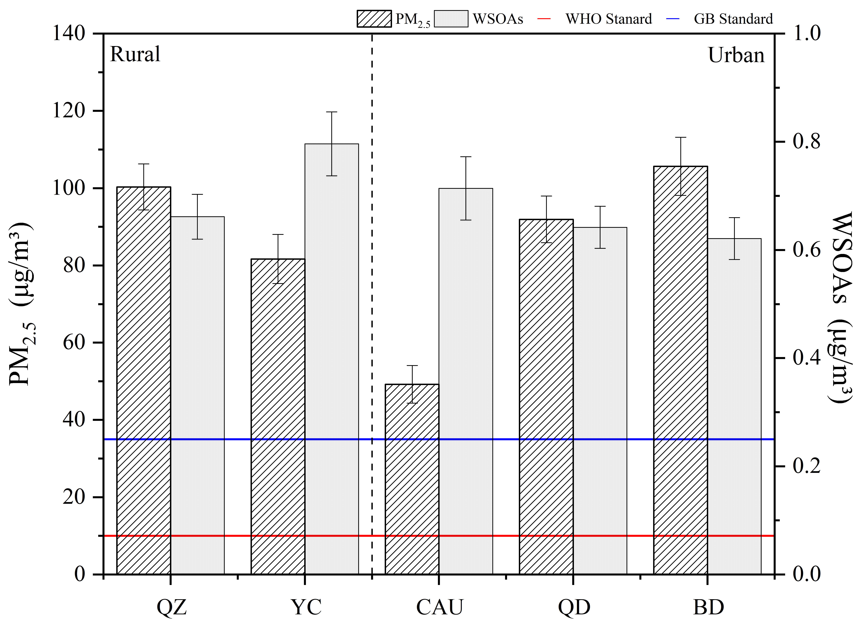
Fig. 2 Annual concentrations of PM_{2.5} and total WSOAs at five sites in the NCP, 2018-2019.

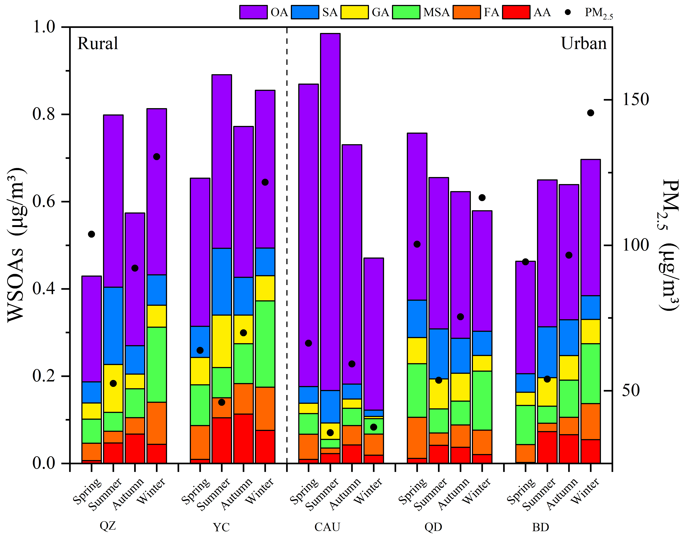  (a) |  | 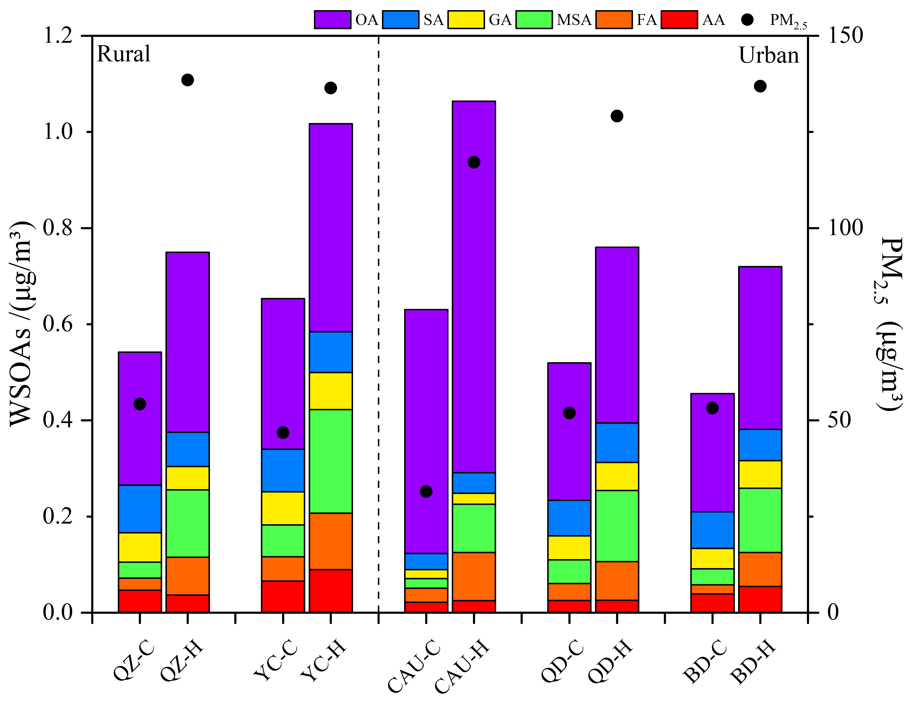  (b)
Fig. 3 Seasonal distribution of total WSOAs (a) and comparison of total WSOAs (b) in PM_{2.5} between clean and haze periods at five sites in the NCP, 2018-2019.

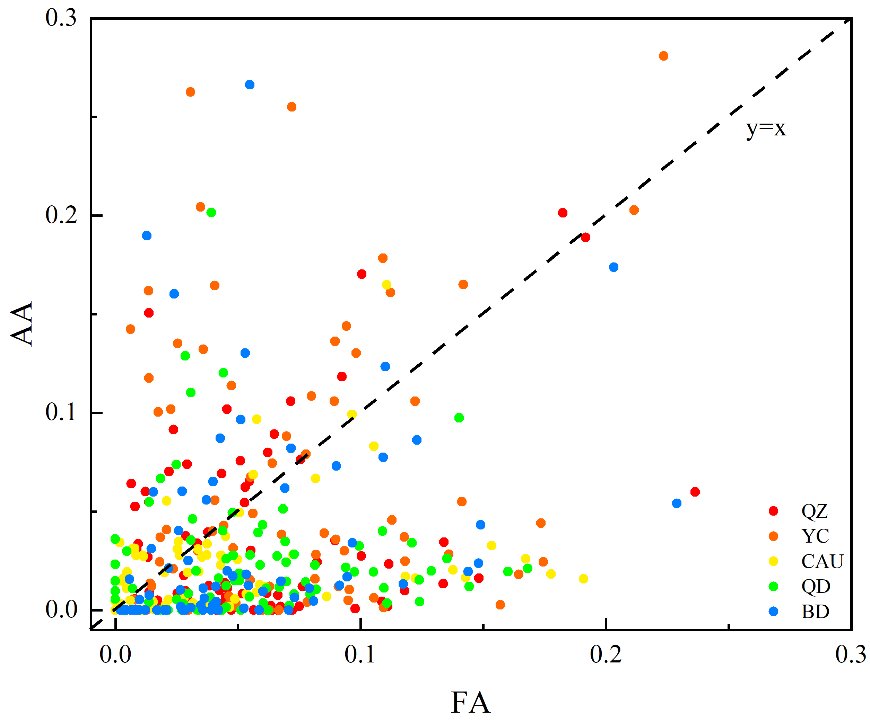
Fig. 4 The correlation between formic (FA) and acetic (AA) acids in PM_{2.5} at five sites in the NCP.

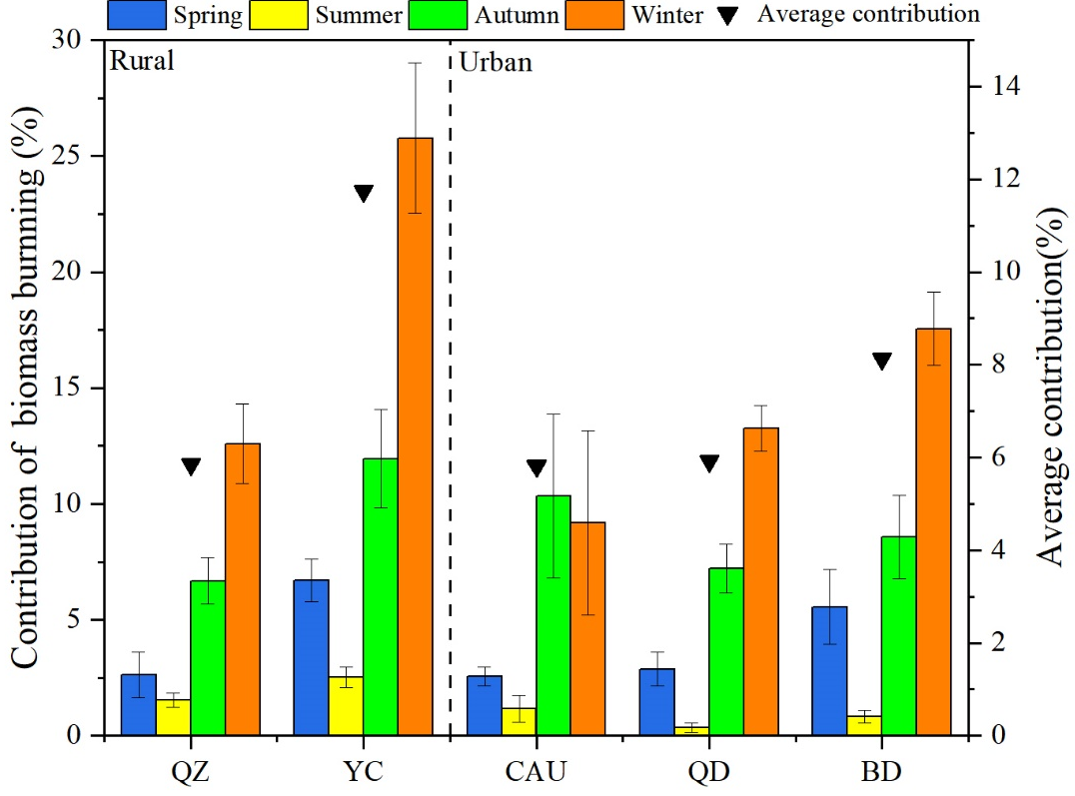
Fig. 5 Contribution of biomass burning to oxalic acid in PM_{2.5} at five sites in the NCP.
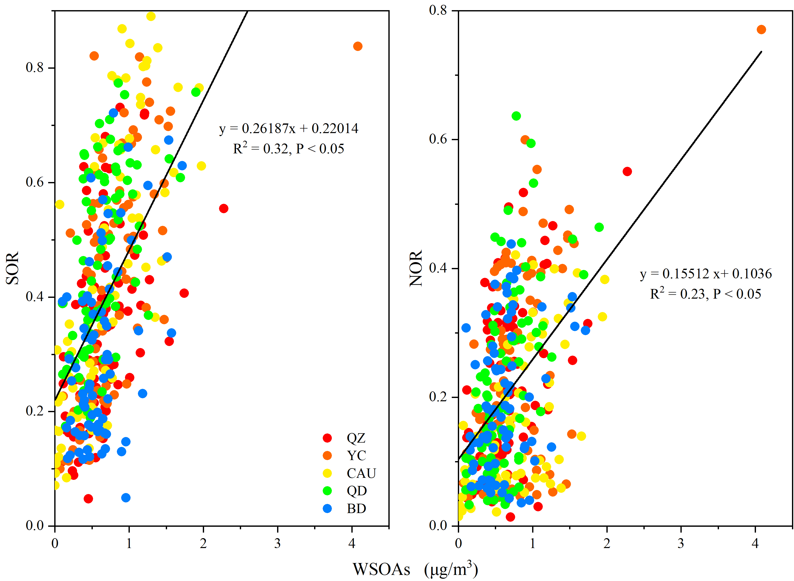
Fig. 6 The correlation between total WSOAs in PM_{2.5} and SOR and NOR at five sites in the NCP.
Fig. 7 The values of R_{(OA/SA)} at five sites in the NCP.
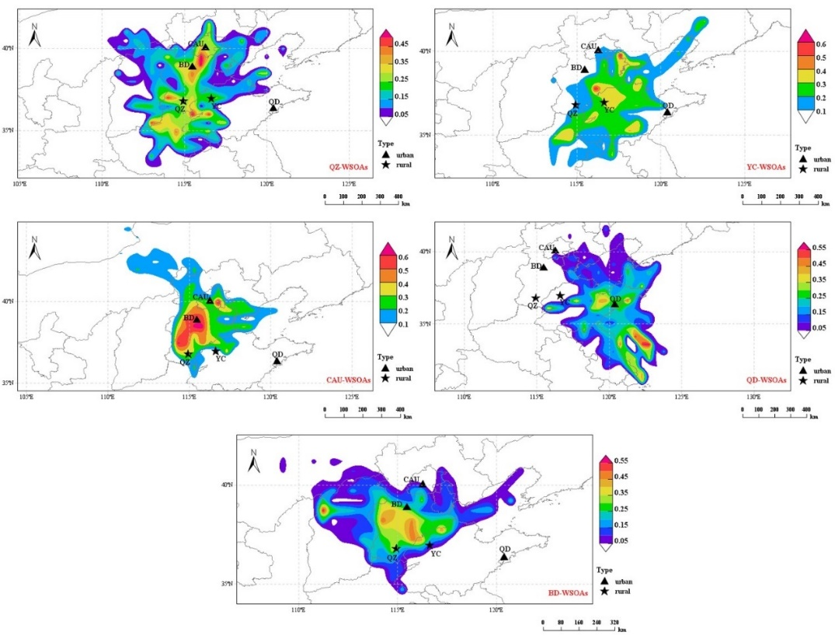
Fig. 8 PSCF analysis of total WSOAs in PM_{2.5} at five sites in the NCP.

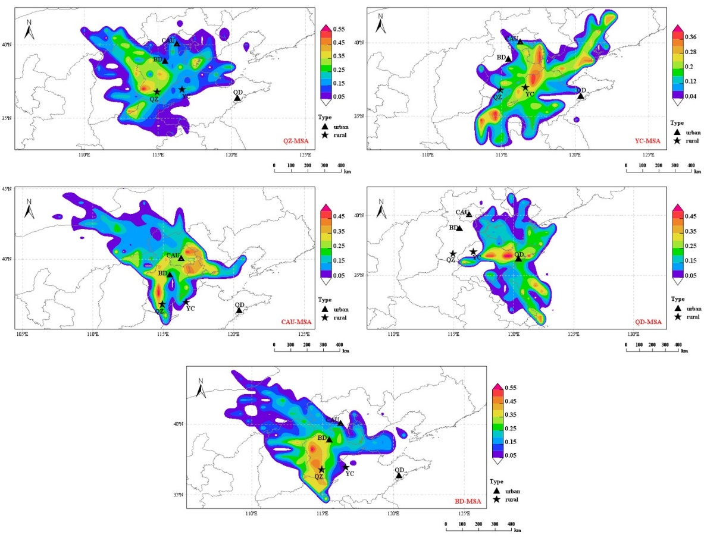
Fig. 9 PSCF analysis of MSA in PM_{2.5} at five sites in the NCP.

Tab. 1 Relative contributions of each factor in PMF analysis at the sites in the NCP.
Site | Factor (relative contribution %)
 | Factor 1 | Factor 2 | Factor 3 | Factor 4 | Factor 5 | Factor 6
QZ | 28.79 | 42.42 | 12.11 | 6.37 | 5.76 | 4.55
YC | 46.21 | 24.7 | 10.9 | 9.06 | 8.26 | 0.87
CAU | 17.29 | 66.18 | 8.20 | 6.48 | 1.85 | n.d.
QD | 29.85 | 40.81 | 13.36 | 5.82 | 5.20 | 4.96
BD | 34.98 | 34.15 | 13.54 | 13.45 | 3.87 | n.d.
Note: n.d. not defined.

Supplementary Materials
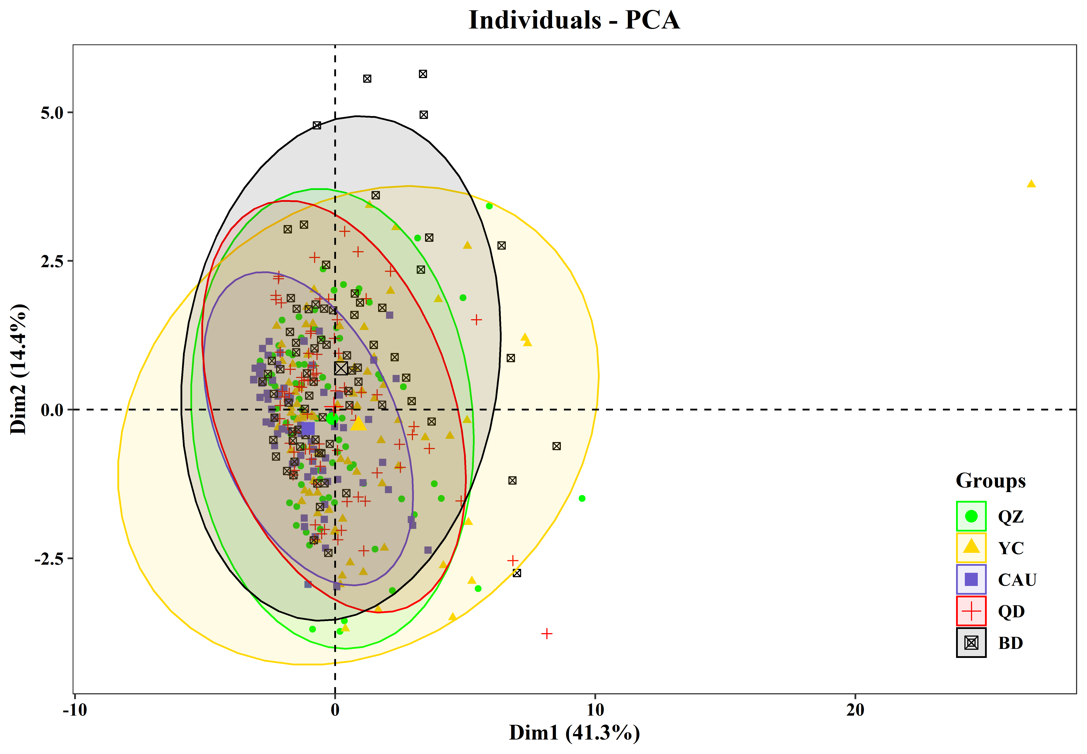
Fig. S1 PCA analysis of water-soluble components

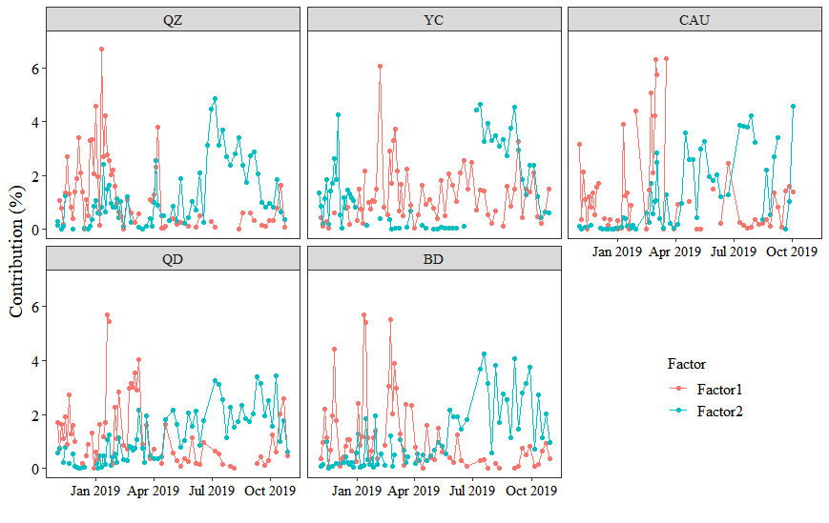
Fig. S2 Temporal variation in the contributions of factor 1 and factor 2 at each of five sites in the NCP

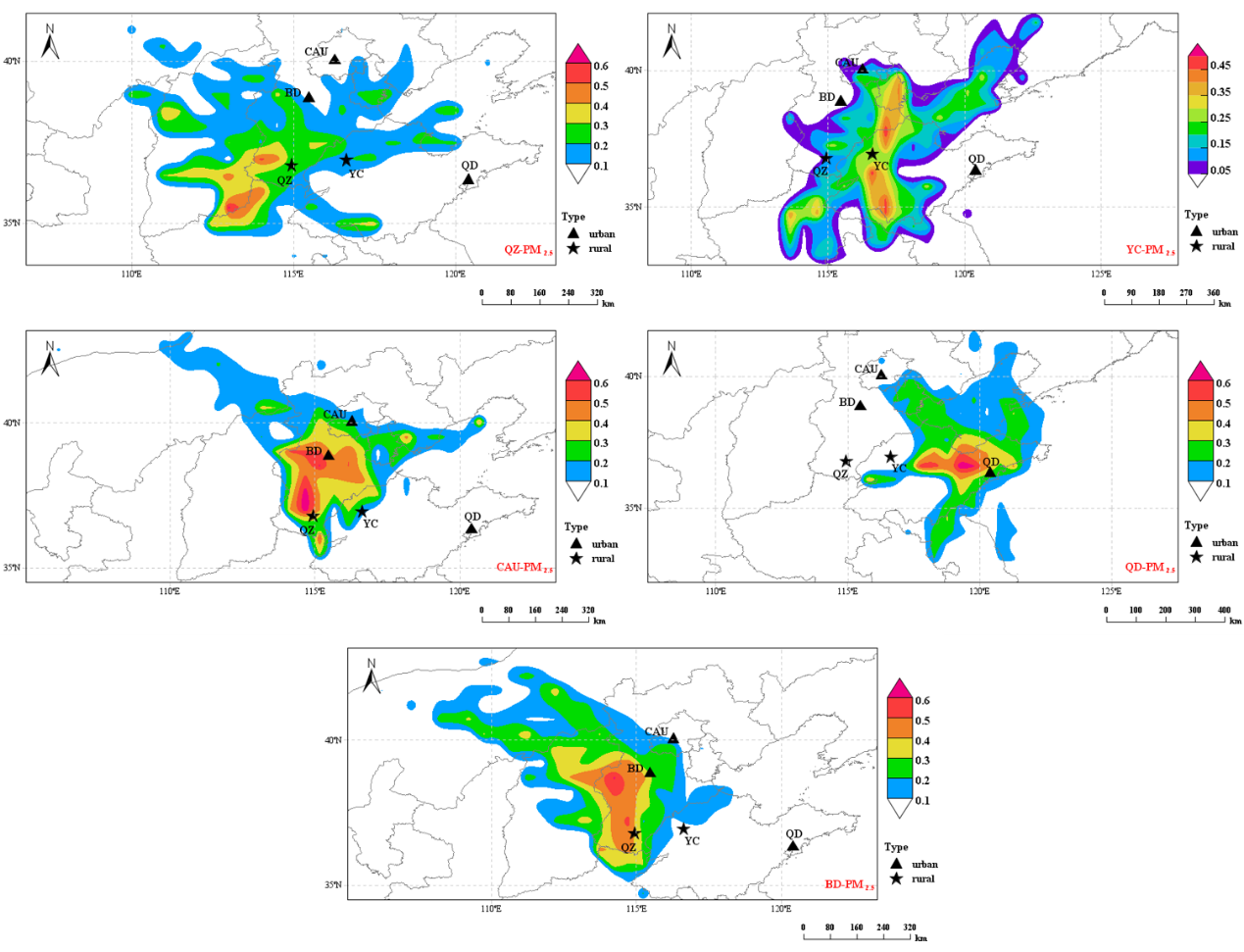
Fig. S3 PSCF analysis of PM_{2.5} at each of five sites in the NCP

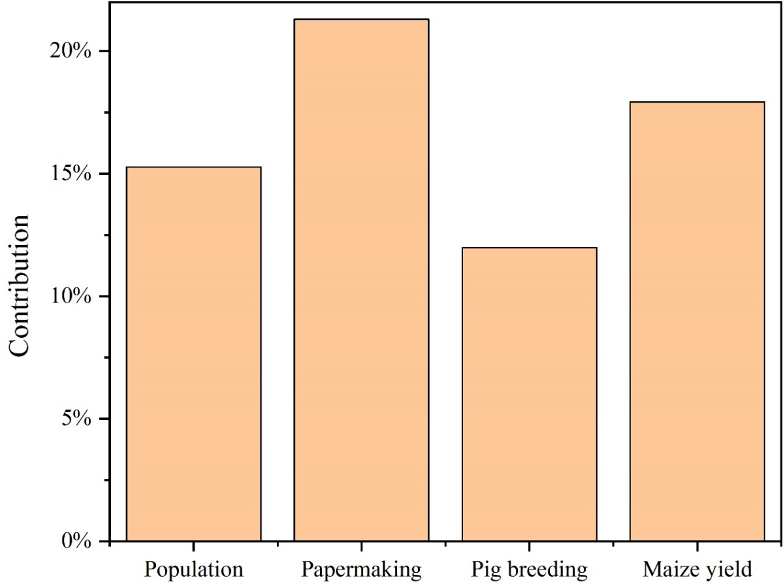
Fig. S4 The relative contribution of four key activities related to DMS emission of NCP in China

Tab. S1 Detailed information of the five sampling sites in the NCP.
Site | Type | Location | Coordinate | Detail
QZ | Rural | Inland | 36.78°N,114.94°E | sampler is set on the center of 20 hectares cropland in Quzhou Experimental Station, Handan. Maize and wheat were sown in summer and autumn respectively.
YC | Rural | Inland | 36.94°N,116.63°E | sampler is set in Yucheng Experimental Station in Dezhou, surrounded by farmland and small villages. Maize and wheat were sown in summer and autumn respectively.
CAU | Urban | Inland | 40.02°N,116.28°E | sampler is set at roof of the Institute of Resources and Environment building of China Agricultural University, Beijing, surrounded by heavy traffic and dense residential areas
QD | Urban | Coastal | 36.32°N,120.40°E | sampler is set at roof of the Chemical building of Qingdao Agricultural University, Qingdao, near the industrial parks in both west and northeast direction
BD | Urban | Inland | 38.85°N,115.48°E | sampler is set at roof the Institute of Resources and Environment building of Hebei Agricultural University, Baoding, with a main road in east direction

Tab. S2 Statistics of WSOAs concentrations in China (μg/m³)
Site | Types | Period | OA | SA | GA | FA | AA | MSA | References
QZ | rural | 2018.11-2019.10 | 0.24 | 0.03 | 0.02 | 0.04 | 0.04 | 0.06 | This study
YC | rural |  | 0.35 | 0.06 | 0.06 | 0.07 | 0.05 | 0.11
QD | urban |  | 0.31 | 0.06 | 0.05 | 0.06 | 0.02 | 0.10
CAU | urban |  | 0.55 | 0.009 | 0.007 | 0.03 | 0.02 | 0.02
BD | urban |  | 0.31 | 0.05 | 0.05 | 0.06 | 0.04 | 0.12
Beijing, China | urban | 2017.01-10 | 0.49 | 0.04 | 0.02 |  |  |  | (Yu et al., 2021)
Tianjin, China | urban | 2016.06 | 0.21 | 0.008 | 0.002 |  |  |  | (Pavuluri et al., 2021)
 |  | 2016.11-12 | 0.41 | 0.008 | 0.003
Jinan, China | urban | 2016.12-2017.01 | 0.39 |  |  | 0.20 | 0.41 | 0.13 | (Tang et al., 2020)
Liaocheng, China | urban | 2017.01-02 | 0.82 | 0.24 | 0.009 |  |  |  | (Meng et al., 2020)
Sanjiang, China | rural | 2010.02-04  (Biomass burning) | 1.20 | 0.75 | 0.10 |  |  |  | (Cao et al., 2017)
 |  | 2010.02-04  (Non-biomass burning) | 0.16 | 0.04 | 0.008
Guangzhou, China | urban | 2017.09-10 | 0.48 | 0.055 | 0.016 |  |  |  | (Liu et al., 2021)
Nanning, China | urban | 2018.10-11 | 0.22 | 0.06 | 0.07 | 0.10 | 0.11 |  | (Guo et al., 2021)
Kunming, China | urban | 2018.10-11 | 0.39 | 0.09 | 0.04 | 0.10 | 0.10
Hong Kong, China | suburban | 2016.11-2017.03 | 0.94 | 0.25 | 0.06 |  |  |  | (Zhao et al., 2019)

Tab. S3 Details and types of PMF factors at five sites in the NCP
Region | Factor | AA | FA | MSA | GA | SA | OA | F⁻ | Cl⁻ | NO₃⁻ | SO₄²⁻ | PO₄³⁻ | Na⁺ | NH₄⁺ | K⁺ | Mg²⁺ | Ca²⁺ | Source
QZ | Factor 1 | 0 | 56.57 | 83.18 | 21.32 | 16.58 | 24.03 | 2.07 | 23.66 | 78.76 | 49.67 | 5.41 | 6.57 | 75.01 | 50.89 | 0 | 0 | Transformation from coal combustion
 | Factor 2 | 7.76 | 8.18 | 8.25 | 72.23 | 78.45 | 40.53 | 0 | 0.21 | 1.1 | 23.69 | 0 | 0 | 10.37 | 6 | 6.78 | 13.3 | Transformation  from vehicle exhaust
 | Factor 3 | 0 | 0 | 0.99 | 2.7 | 0 | 23.19 | 0 | 7.61 | 13.51 | 16.67 | 68.25 | 9.6 | 11.65 | 10.12 | 19.95 | 7.08 | Agriculture
 | Factor 4 | 14.44 | 14.72 | 0 | 1.91 | 0 | 7.88 | 62.48 | 65.47 | 0.65 | 0 | 0 | 0 | 2.98 | 21.49 | 16.62 | 0 | Direct release from biomass  burning
 | Factor 5 | 75.94 | 3.51 | 2.78 | 1.84 | 1.75 | 0 | 0 | 3.05 | 2.34 | 2.11 | 24.44 | 83.83 | 0 | 4.55 | 9.25 | 0.11 | Industry
 | Factor 6 | 1.86 | 17.02 | 4.8 | 0 | 3.22 | 4.37 | 35.45 | 0 | 3.64 | 7.86 | 1.9 | 0 | 0 | 6.95 | 47.4 | 79.51 | Soil
YC | Factor 1 | 0 | 44.95 | 45.16 | 60.13 | 68.64 | 46.06 | 0 | 2.75 | 0 | 32.16 | 0 | 0 | 13.84 | 15.88 | 4.42 | 18.65 | Transformation from coal combustion
 | Factor 2 | 66.24 | 1.23 | 0 | 33.34 | 31.36 | 21.42 | 0 | 2.19 | 0.75 | 16.67 | 41.06 | 5.23 | 6.91 | 4.2 | 14.66 | 6.31 | Transformation from vehicle exhaust
 | Factor 3 | 0 | 19.54 | 29.34 | 5.58 | 0 | 12.1 | 0 | 35.98 | 78.87 | 36 | 6.31 | 0 | 65.35 | 40.18 | 8.93 | 0 | Transformation from biomass burning
 | Factor 4 | 3.02 | 11.22 | 0 | 0.96 | 0 | 16.71 | 32.03 | 0 | 15.16 | 11.55 | 46.68 | 0 | 10.74 | 8.81 | 32.7 | 57.69 | Soil
 | Factor 5 | 30.74 | 21.15 | 23.58 | 0 | 0 | 2.59 | 67.97 | 58.9 | 0 | 3.61 | 0 | 25.64 | 2.48 | 30.22 | 24.62 | 0 | Direct release from biomass burning
 | Factor 6 | 0 | 1.91 | 1.91 | 0 | 0 | 1.12 | 0 | 0.19 | 5.23 | 0 | 5.95 | 69.13 | 0.68 | 0.71 | 14.66 | 17.35 | Dust
CAU | Factor 1 | 0 | 65.99 | 81.83 | 11.34 | 0 | 3.78 | 8.46 | 44.7 | 65.99 | 10.95 | 4.51 | 4.19 | 38.66 | 38.46 | 11.99 | 0 | Transformation from coal combustion
 | Factor 2 | 0 | 0 | 0 | 79.65 | 58.72 | 49.97 | 1.61 | 6.52 | 18.81 | 56.03 | 0.24 | 49.52 | 43.53 | 16.73 | 22.35 | 35.71 | Transformation from vehicle exhaust
 | Factor 3 | 35.79 | 0.32 | 0 | 9 | 1.01 | 0 | 26.58 | 33.10 | 7.43 | 11.96 | 2.21 | 27.27 | 6.96 | 21.68 | 65.66 | 28.26 | Dust
 | Factor 4 | 64.21 | 13.02 | 18.17 | 0 | 38.79 | 35.03 | 35.34 | 1.69 | 0 | 18.24 | 0 | 7.17 | 6.27 | 7.49 | 0 | 24.03 | Dust
 | Factor 5 | 0 | 20.66 | 0 | 0 | 1.47 | 11.21 | 28 | 14 | 7.77 | 2.82 | 93.05 | 11.86 | 4.58 | 15.64 | 0 | 12 | Direct release from vehicle exhaust
QD | Factor 1 | 9.75 | 43.59 | 52.2 | 29.64 | 18.18 | 28.19 | 4.9 | 13.71 | 76.04 | 46.78 | 7.93 | 0 | 67.05 | 47.35 | 7.6 | 0 | Transformation from coal combustion
 | Factor 2 | 4.13 | 11.04 | 14.59 | 56.69 | 69.13 | 41.84 | 2.05 | 1.4 | 0 | 21.57 | 28.18 | 0 | 8.62 | 0 | 14.62 | 28.15 | Transformation from vehicle exhaust
 | Factor 3 | 0 | 42.27 | 12.37 | 0 | 1.95 | 16.19 | 37.09 | 0 | 4.03 | 7.5 | 0 | 8 | 0 | 9.14 | 30.74 | 59.29 | Soil
 | Factor 4 | 0 | 0 | 0 | 2.11 | 0 | 10.8 | 2.87 | 6.85 | 7.96 | 10.45 | 59.51 | 63.22 | 4.49 | 7.18 | 37.53 | 8.36 | Sea salt
 | Factor 5 | 1.3 | 0 | 20.36 | 7.68 | 6.07 | 2.99 | 53.09 | 75.38 | 8.29 | 13.7 | 0 | 27.2 | 19.54 | 32.39 | 7.96 | 1.81 | Direct release from biomass burning
 | Factor 6 | 84.82 | 3.09 | 0.49 | 3.87 | 4.66 | 0 | 0 | 2.65 | 3.67 | 0 | 4.39 | 1.58 | 0.3 | 3.93 | 1.55 | 2.39 | Other
BD | Factor 1 | 5.12 | 53.59 | 81.89 | 30.61 | 24.95 | 32.33 | 8.58 | 12.16 | 70.3 | 49.94 | 1.46 | 7.02 | 67.72 | 39.8 | 0 | 3.38 | Transformation from coal combustion
 | Factor 2 | 1.76 | 7.49 | 5.96 | 54.4 | 65.92 | 34.98 | 1.15 | 0 | 1.95 | 23.41 | 21.35 | 0 | 8.31 | 5.52 | 8.88 | 17.21 | Transformation from vehicle exhaust
 | Factor 3 | 88.62 | 24.82 | 0.24 | 13.52 | 5.34 | 3.72 | 65.48 | 70.91 | 12.42 | 12.31 | 1.27 | 0 | 17.93 | 40.23 | 19.46 | 0 | Direct release from biomass burning
 | Factor 4 | 0 | 14.1 | 10.12 | 0.01 | 2.74 | 22.78 | 24.79 | 5.31 | 7.75 | 6.59 | 13.49 | 0 | 0.3 | 5.91 | 37.98 | 69.27 | Soil
 | Factor 5 | 4.5 | 0 | 1.78 | 1.47 | 1.04 | 6.19 | 0 | 11.62 | 7.58 | 7.75 | 62.43 | 92.98 | 5.74 | 8.55 | 33.68 | 10.15 | Industry

Tab. S4 Correlations of WSOAs with atmospheric oxidants (Ox, NO₂+O₃) and RH at five sites in NCP.
Region | QZ | YC | CAU | QD | BD
Ox | -0.128 | 0.3** | 0.576** | 0.313** | 0.337**
RH | 0.023 | 0.32** | 0.44** | -0.11 | 0.082
** denotes highly significant correlation (P < 0.01).
 | Sources | R_{(OA/SA)} | References
Fresh | Biomass burning | 3.3 | (Deshmukh et al., 2019)
 | Vehicle exhausts | 4.1 | (Kawamura and Kaplan, 1987)
 | Biomass burning plumes | 5.0 | (Kundu et al., 2010)
 | Isoprene oxidating | 6.5 | (Bikkina et al., 2021)
Aging | Liquid phase oxidized aerosols | 10.8 | (Bikkina et al., 2017)
 | Photochemically aged aerosols | 11.0 | (Meng et al., 2013)
Tab. S5 The values of R_{(OA/SA)} from different sources.

Calculating the contribution of biomass burning to oxalic acid, based on the formula of Tang et al. (2020):
${K^{+}}_{biomass}=\frac{{K^{+}}_{measure}-0.0332N{a^{+}}_{measure}-0.1C{a^{2+}}_{measure}}{0.99}$ (S1)
$OA_{\text{biomass }buring}={K^{+}}_{\text{biomass }buring}×0.04$ (S2)

Reference
Tang, S., Zhou, X., Zhang, J., Xue, L., Luo, Y., Song, J., et al., 2020. Characteristics of water-soluble organic acids in PM_{2.5} during haze and Chinese Spring Festival in winter of Jinan, China: Concentrations, formations, and source apportionments. Environ Sci Pollut Res Int 27:12122-12137.

