**RRES Press Release 17th April 2025** [A Fifth of Global Farmland Contaminated by Toxic Metals, Study Reveals](https://www.rothamsted.ac.uk/news/fifth-global-farmland-contaminated-toxic-metals-study-reveals)

*Scientists warn of major risks to food security and public health as soil pollution spreads worldwide*

Nearly a fifth of the world's agricultural land is contaminated by toxic metals, posing a serious threat to food security, public health, and ecosystems, according to a new global study published today in the journal *Science*. Researchers have mapped soil pollution at an unprecedented scale, finding that more than 14% - 17% of cropland is affected by dangerous levels of metals such as arsenic, lead, and cadmium.

The study, which used data from nearly 800,000 soil samples from around the world, identified a previously unrecognised high-risk zone stretching across southern Europe, the Middle East, and South Asia. The contamination is linked to both natural geological processes and centuries of industrial activity, including mining and smelting.

*Protecting our soils is as important as protecting our air and water. Without clean soil, we cannot produce safe food*

With up to 1.4 billion people living in polluted regions, experts warn that toxic metals in soil can enter the food chain, harming biodiversity and exacerbating poverty. "Soil pollution is not just an environmental issue—it directly affects human health and global food security," said Rothamsted’s Professor Steve McGrath, who was part of the multi-institute research team led by Tsinghua University, School of Environment in Beijing, China.

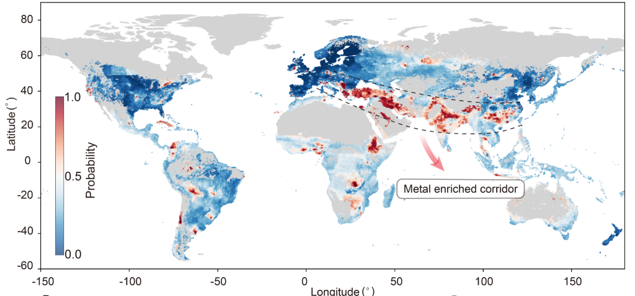Aggregate distribution of exceedance of arsenic, cadmium, cobalt,  
chromium, copper, nickel, and lead; color code shows the maximum probability of exceedance among the seven metals.

The findings come at a time of growing concern over soil degradation, particularly as demand for critical metals increases due to the transition to green energy technologies like electric vehicle batteries and solar panels. The researchers call for urgent international action, including targeted funding for pollution monitoring and soil restoration, particularly in data-poor regions such as Africa and Russia.

The study also highlights the limitations of existing data, with many remote areas lacking sufficient soil sampling. While the researchers used machine learning to fill in gaps, they stress that more detailed, site-specific studies are needed to develop effective solutions.

With toxic metal pollution set to rise, the researchers urge policymakers to take immediate action. "Protecting our soils is as important as protecting our air and water. Without clean soil, we cannot produce safe food," added McGrath.

The study adds to growing global concern over the hidden dangers of soil pollution, reinforcing calls for stricter environmental regulations and sustainable land management practices.

**Publication**

**Deyi Hou *et al.*Global soil pollution by toxic metals threatens agriculture and human health. *Science* 388, 316-321(2025) DOI:**[**10.1126/science.adr5214**](https://doi.org/10.1126/science.adr5214)

Contacts Prof Steve Mcgrath