**Supplementary information**

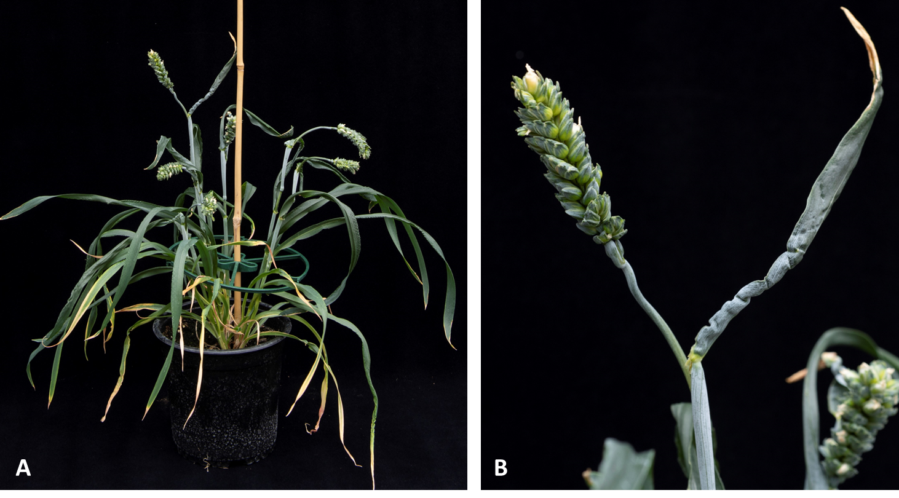

**Supplementary Figure 1:** **Gross Morphology of *tabri-a.2bd* mutant** (A) Closeup photo of *tabri1-a.2bd* mutant grown in the glasshouse and photographed at GS83 during GH2021. (B) Curled and wrinkled flag-leaf of *tabri1-a.2bd* mutant.

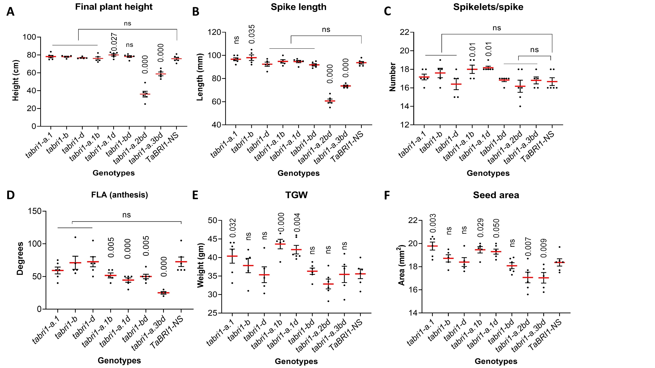

**Supplementary figure 2:** **Phenotypic data collected on *tabri1* mutants during GH2022.** **(A)** Final plant heights at maturity (n=6). **(B)** Spike length recorded at maturity (n=6). **(C)** Number of spikelets/spike recorded on mature spikes (n=6). **(D)** FLAs at anthesis (n=6). **(E)** 1000 grain weight (TGW) recorded on mature grains (n=6). **(F)** Seed area obtained using the Marvin seed analyser on mature grains (n=6). *P*-values for differences between mutants and *TaBRI1-NS* were obtained using Fisher’s unprotected LSD test are also shown on the graph.

**A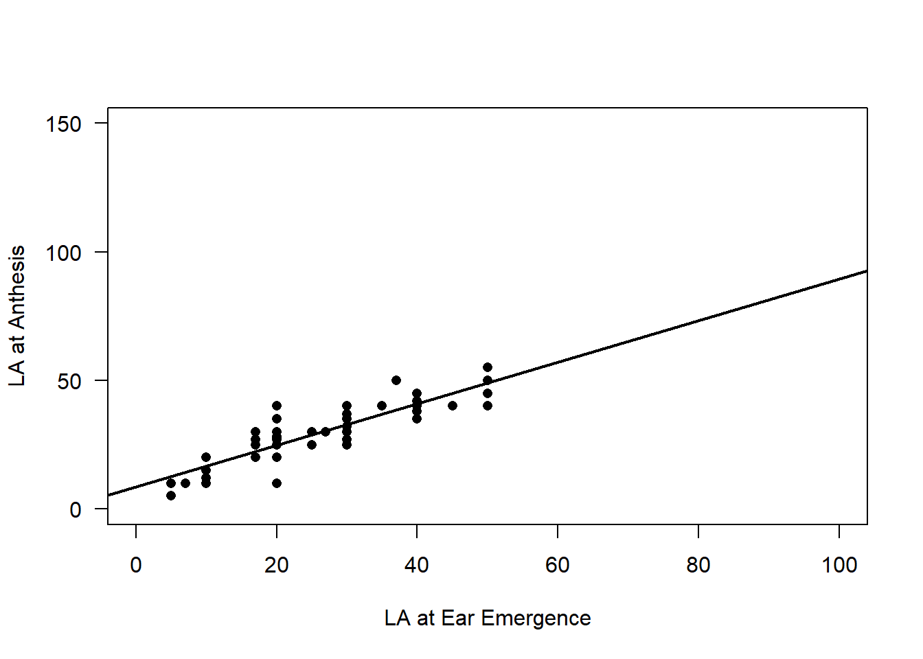 B**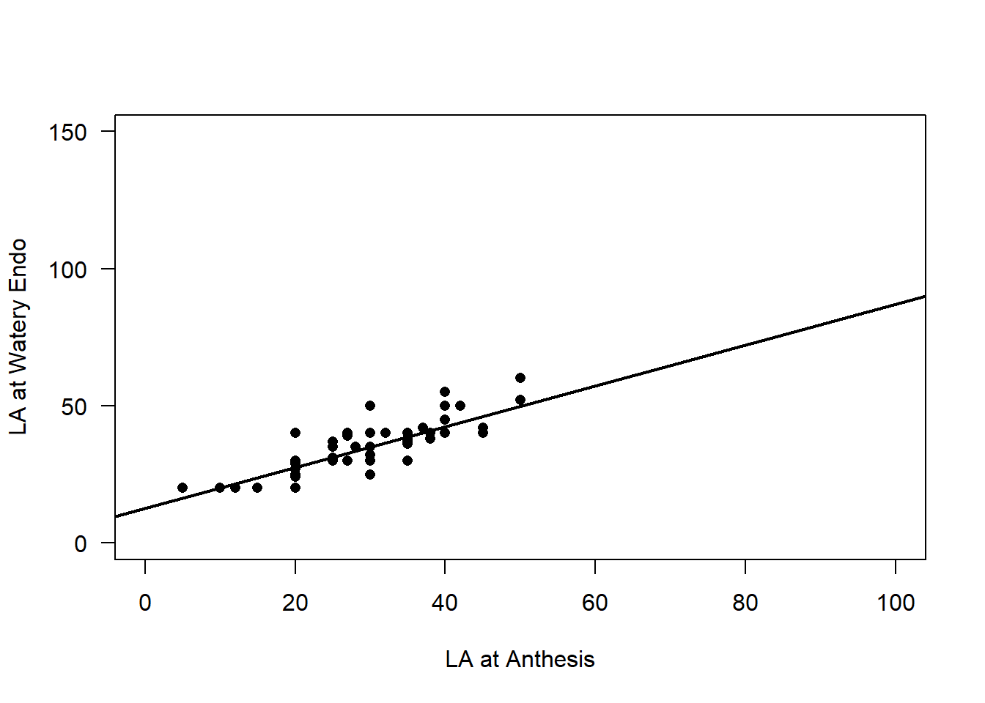

**C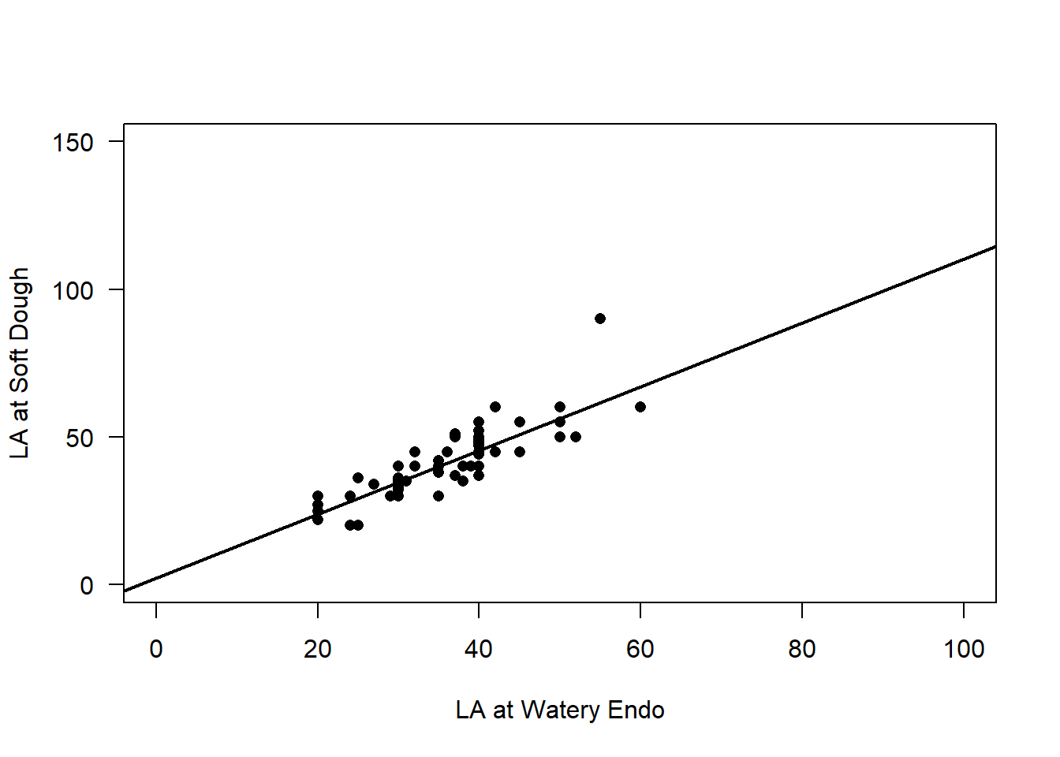 D**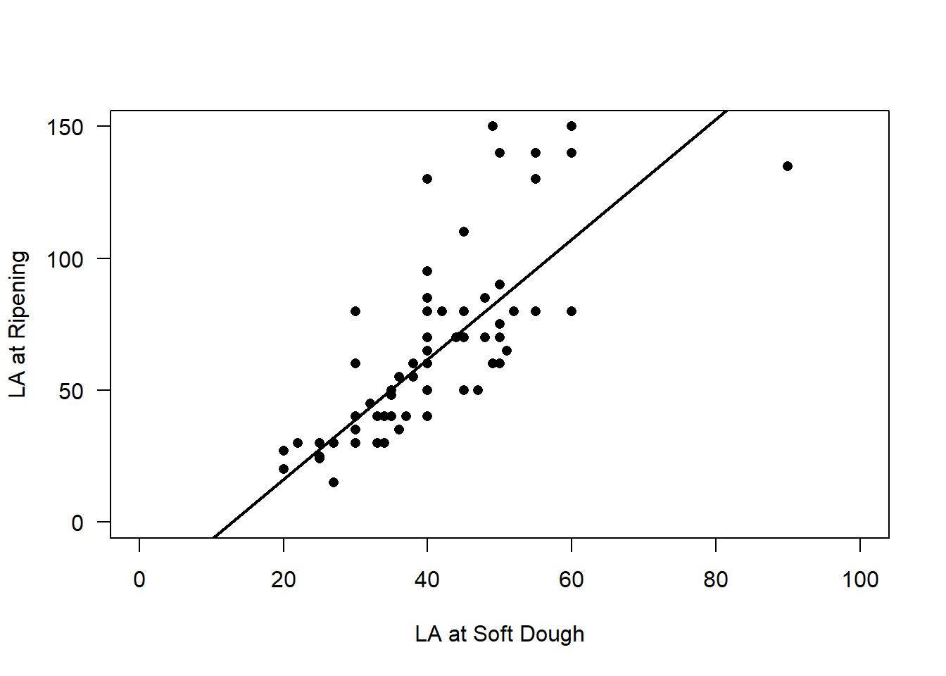

Supplementary figure 3: FLA relationship between reproductive growth stages. Relationship of Flag leaf angle between ear emergence and anthesis (A), anthesis and water endosperm (B), watery endosperm and soft dough (C) and soft dough and ripening (D) growth stages. Very strong 1:1 relationship was observed in flag leaf angle between subsequent growth stages (*p* < 0.001).

**Supplementary table 1:** **BR levels (pg/mg DW) in *tabri1* mutants and controls.** Mean values (pg/mg DW) ± SD are shown for four *tabri1* mutants along with controls i.e., *TaBRI1-NS* and Cadenza at the seedling stage. The data were analysed using one-way ANOVA which yielded *p*-values, SED, and LSD at 5% level of significance. Fisher’s unprotected LSD test was performed for multiple pair-wise comparisons. Statistically significant difference between mutants and *TaBRI1-NS* were denoted \**P*<0.05, \*\**P*<0.01, \*\*\**P*<0.001, \*\*\*\**P* < 0.0000 (obtained from Fisher’s LSD unprotected test).

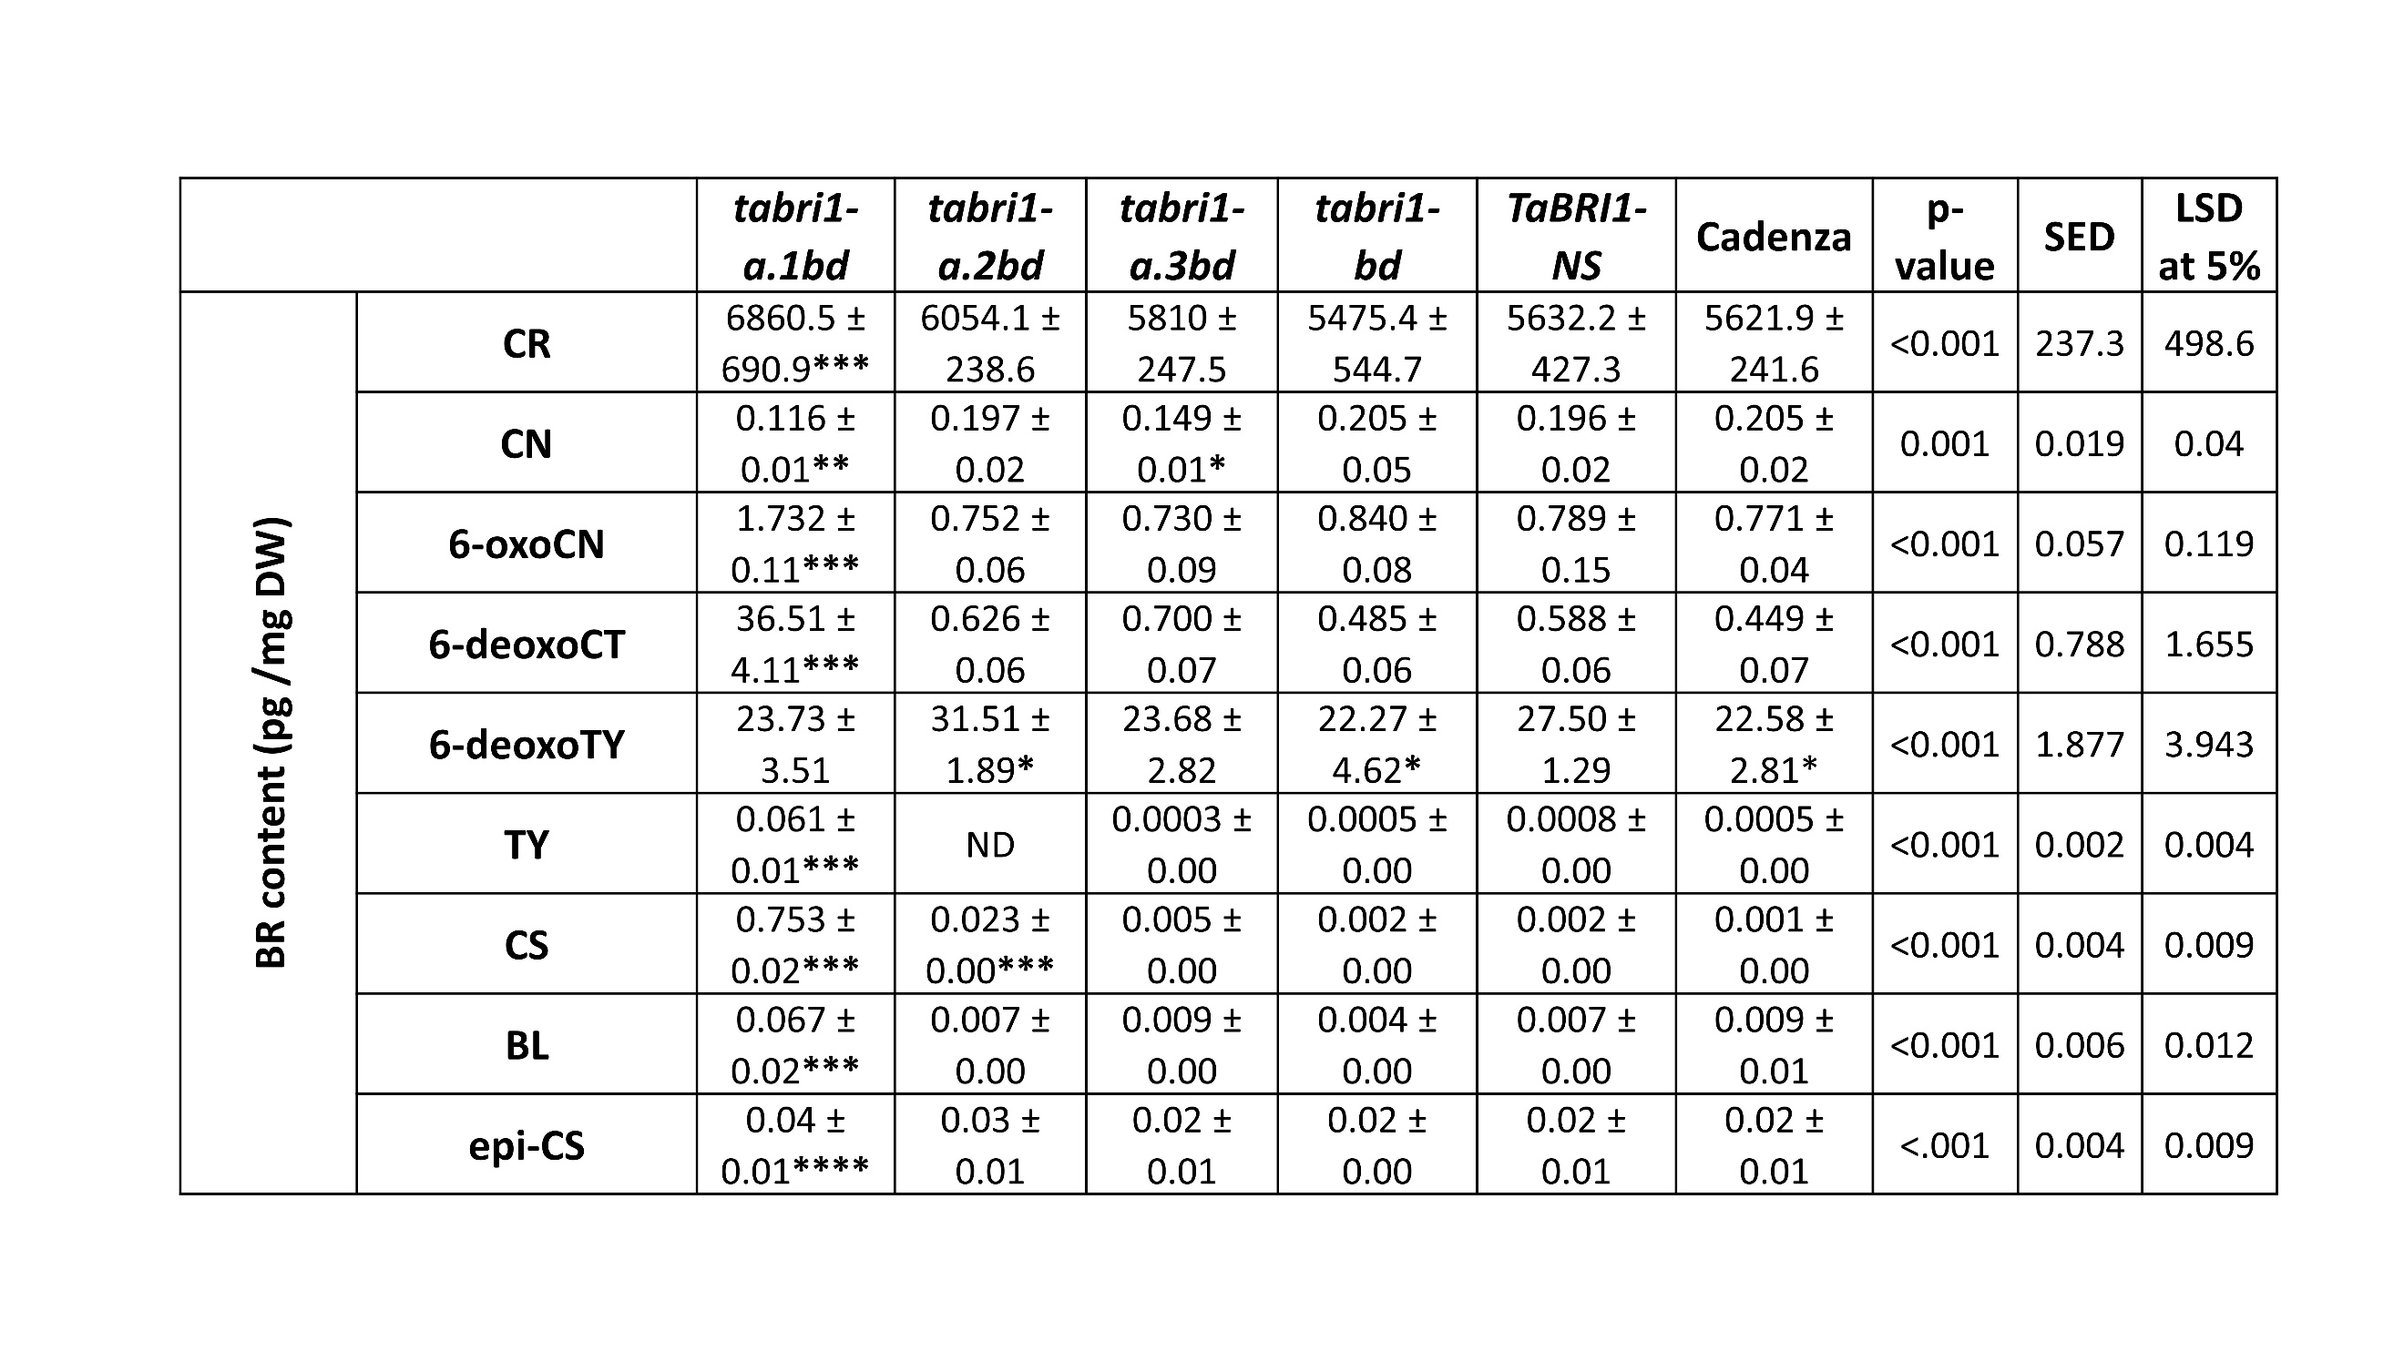

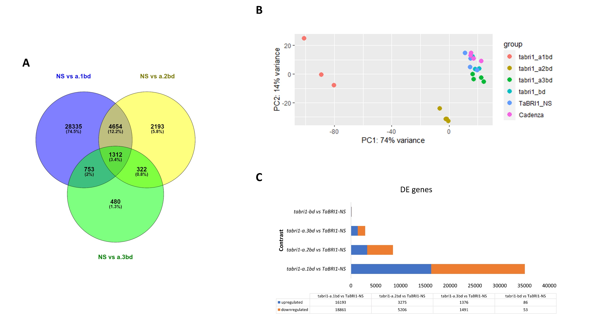

**Supplementary figure 4: RNAseq analysis.** **(A)** Venny2.1 (<https://csbg.cnb.csic.es/BioinfoGP/venny.html>) was used to produce Venn diagrams for the genes co-expressed in the *tabri1-a.1bd, tabri1-a.2bd* and *tabri1-a.3bd* mutants compared to *TaBRI1-NS*. **(B)** PCA plot was generated using Bioconductor package pheatmap version 1.0.12 to show the overall variation in gene expression in *tabri1-a.1bd, tabri1-a.2bd, tabri1-a.3bd*, *tabri1-bd* mutants compared to *TaBRI1-NS* and Cadenza. **(C)** Stacked bar graph was produced in Microsoft excel 365 to show number of differentially expressed genes (with *p*-value >0.05) in *tabri1-a.1bd, tabri1-a.2bd, tabri1-a.3bd* and *tabri1-bd* mutants compared to *TaBRI1-NS*.

**Supplementary table 2:** **Homeologue specific primers designed to amplify fragments around the deleterious mutations in *TaBRI1* genes.** The gene information, primer sequence, fragment length produced, and Tm (℃) used for PCR reaction is mentioned below.



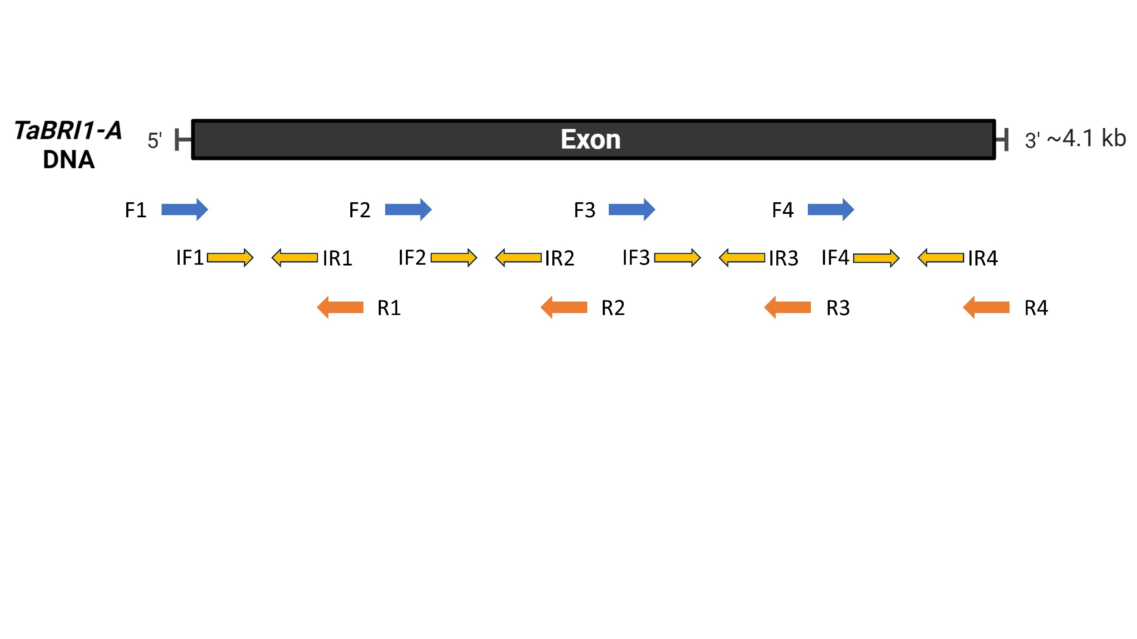

**Supplementary figure 5:** **Scheme used for sequencing *TaBRI1A* gene.** Primer pairs F1-R1, F2-R2, F3-R3 and F4-R4 were used to amplify fragments in *TaBRI1A* gene from shortlisted M3 mutant lines. Sanger sequencing of the fragments was performed using F1, R1 (and IF1, IR1), F2, R2 (and IF2, IR2), F3, R3 (and IF3, IR3), F4, R4 (and IF4, IR4). The sequence of primers and conditions for PCR reactions used are mentioned in supplementary table 3.

**Supplementary table 3:** **Primers used for sequencing *TaBRI1A* gene.** The primer sequence, fragment length and Tm (℃) used for PCR reaction is mentioned below. Internal primers were used only for sequencing.



**Supplementary table 4:** KASP primers designed to differentiate the mutant and wild type allele in segregating *TaBRI1* populations.

