The origins of global invasions of the German wasp (Vespula germanica) and its infection with four honey bee viruses

Running title: Origin of global invasive wasp populations

Evan C. Brenton-Rule¹, Jana Dobelmann¹, James W. Baty¹, Robert L. Brown², Libor Dvorak³, Julien Grangier⁴, Maité Masciocchi⁵, Chris McGrannachan⁶, Chris R. Shortall⁷, Julia Schmack⁸, Carolien van Zyl⁹, Ruan Veldtman⁹, Philip J Lester¹

¹ Centre for Biodiversity and Restoration Ecology, Victoria University of Wellington, PO Box 600, Wellington, New Zealand

² Landcare Research, PO Box 6940, Lincoln, New Zealand
³ Mestske museum Marianske Lazne, Goethovo namesti 11, CZ-35301 Marianske Lazne, Czech Republic
⁴ Julien’s address
⁵ Grupo de Ecologia de Insectos, INTA EEA Bariloche, Bariloche, Argentina School of
⁶ Biological Sciences, Monash University, Melbourne, Victoria 3800, Australia

⁷ Rothamsted Insect Survey, Rothamsted Research, Harpenden, AL52JQ, England

⁸ Centre for Biodiversity and Biosecurity, School of Biological Sciences, University of Auckland, Private Bag 92019, Auckland 1071, New Zealand
⁹ South African National Biodiversity Institute, Pretoria, South Africa

Correspondence: Phil Lester, , Victoria University of Wellington, PO Box 600, Wellington, New Zealand. Email: phil.lester@vuw.ac.nz

Acknowledgments
For submitting samples used in this study we thank: Keith Fleming, Helmut Kovac, John McLean, Hendrik Munks, Adrian Pike, Nuria Roura, Davide Santoro, Rudi Schnitzler, Tim Scott, , , , Rikard Unelius Funding was provided by a RSNZ Marsden Grant to PJL, a Victoria University of Wellington PhD Scholarship to ECB-R, Rothamsted Insect Survey is a BBSRC-supported National Capability. Rothamsted Research receives strategic funding from the BBSRC. [FUNDING OTHER AUTHORS WANT TO ACKNOWLEDGE]

Conflict of Interest
The authors declare no conflict of interest.

Abstract

Aim A successful control or eradication programme using biological control or genetically-mediated methods requires knowledge of the origin and the extent of wasp genetic diversity. Mitochondrial DNA variation in the native and invaded range of the social wasp Vespula germanica was used to examine intra-specific genetic variation and invasive source populations. We also examined wasps for the presence of honey bee viruses.

Location Argentina, Australia, Europe, New Zealand, South Africa, United Kingdom.
Methods Phylogenetic trees and haplotype networks were constructed from combined COI, CO2 and cytb mitochondrial markers. Four viral pathogens were surveyed using PCR assays and Sanger sequencing: Deformed wing virus, Acute bee paralysis virus, Israeli acute paralysis virus and the Kashmir bee virus.
Results German wasps showed reduced genetic diversity in the invaded range compared to that of their native range. Two haplotypes were detected in New Zealand, four in Australia, four in South Africa, and one in Argentina. The populations in the introduced range are likely to have arrived from different source populations: New Zealand and Australia were most similar to the United Kingdom, Argentine wasps to the south of France, and South Africa to central Europe. All four viral honey bee pathogens were found in V. germanica, although they varied in their distribution and strain. For example, the Acute bee paralysis virus and Israeli acute paralysis virus were only found in European populations.
Main conclusions Multiple introductions have occurred for most invaded regions, though the New Zealand and Argentinian populations are genetically homogenous. The differing locations of origin will guide researchers searching for biocontrol agents. The reduced genetic diversity makes these wasps a potential target for control via gene drives. Vespula germanica is capable of carrying honey bee pathogens that may directly affect wasp fitness or influence other host-pathogen interactions - including in honey bees.

KEYWORDS

Biological invasions, pathogen, pest control, social wasp, Vespula germanica.

1 INTRODUCTION

Many authors have lamented the difficulty of controlling well-established biological invasions (Silverman & Brightwell, 2008; Hoffmann, 2011; Dearden et al., 2017). Eradication of invasive species is a frequently-sought ideal but is even more difficult than control, particularly in the case of plants and animals with short generation times, high reproductive output and effective dispersal (Rejmánek & Pitcairn, 2002). Current and historical approaches to control or eradication typically utilise chemical or mechanical methods such as herbicides, pesticides, lethal baits or mechanical removal. These methods are expensive as they require ongoing investment, and can result in environmental contamination as well as non-target effects (Bergstrom et al., 2009). Another approach is the implementation of classical biological control, which involves the introduction of a co-evolved natural enemy from the native range into the area that the invasive pest now occupies. Central to the efficacy of classical biological approaches is a knowledge of the home range of the pest species (Goolsby et al., 2006; Lester et al., 2014a). Many invasive species, however, have a broad geographic range. Determining the precise origin of invasive species is possible with genetic techniques, such as the use of mtDNA (Corin et al., 2007; Lester et al., 2014a).
New genetic technologies, such as CRISPR/Cas9 gene drive systems, have the potential to revolutionise the control and eradication of invasive species (Esvelt et al., 2014; Webber et al., 2015). Gene drives are genetic systems that push engineered genes through target populations far faster than possible through natural inheritance (Burt, 2003). The CRISPR/Cas9 system is highly specific as the enzyme Cas9 can target precise sequences of DNA, guided by a short guide RNA (gRNA) sequence. This gRNA can be designed to target precise sequences in the genome to be edited. For the purposes of invasive species control or eradication this process could be used to drive deleterious target alleles to fixation. Deleterious mutations affecting individual fitness may be nuclear or mitochondrial in origin (Dowling et al., 2015; Hammond et al., 2016).
The German wasp (Vespula germanica) is a social species native to Eurasia (Archer, 1998). It has become invasive in several countries around the world including Argentina, Australia, New Zealand and South Africa (Beggs et al., 2011). Along with the closely related Vespula vulgaris, V. germanica has been indicted as one of the most widespread and damaging of all invasive Vespidae globally and the species are a critical issue for entomology in New Zealand (Beggs et al., 2011; Lester et al., 2014b). New Zealand has the highest recorded Vespula densities in the world, with up to 370 wasps per m² of tree trunk (Moller et al., 1991). Introduced Vespula wasps have a variety of environmental, economic and social impacts. For instance, in New Zealand the economic costs of Vespula wasps are estimated to be approximately $130 million each year (MacIntyre & Hellstrom, 2015). The biomass of wasps in New Zealand honeydew beech forests is estimated to be similar to, or greater than, the entire biomasses of birds, rodents and stoats (Thomas et al., 1990). In several countries Vespula impacts and abundance have stimulated varying degrees of management, using chemical, mechanical and biocontrol techniques (Wood et al., 2006; Beggs et al., 2008; Edwards et al., 2017). However, currently utilised control options are untenable over large areas of many hundreds of thousands of hectares, as they are typically chemical based and require ongoing investment (Dearden et al., 2017). The biology and distribution of Vespula wasps mean they are likely to be amenable to control through systems such as CRISPR/Cas9 directed gene drives (Dearden et al., 2017). A first step in this genera of genetically-mediated approaches for control or eradication of invasive species is to identify the genetic diversity in the home and invaded range of the invasive species to be targeted (Dearden et al., 2017).
Natural enemies, such as pathogens, can have major impacts on the fitness, abundance and distribution of plants and animals. These effects may be particularly detrimental for social animals due to high host density and social interactions (Anderson & May, 1979; Potts et al., 2010). In the case of social insects, pathogen effects can be even more pronounced as they often spend many generations living in fixed nesting sites. Perhaps the most well-known example of the influence of social insect pathogens is their effect on honey bees. Among pathogens, viruses appear to play a key role in causing honey bee losses (Schroeder & Martin, 2012; McMahon et al., 2016). There have been a wide variety of pathogens observed in wasps (Evison et al., 2012), including the Deformed wing virus (DWV) (Santamaria et al., 2017), which has been implicated as a key driver of honey bee colony collapse (Dainat et al., 2012; McMahon et al., 2016). The Kashmir bee virus has recently also been observed in wasps (Dobelmann et al., 2017) although its pathogenicity is uncertain. Given wasps carry a range of pathogens, one approach to genetically-mediated control could be altering or blocking wasp immune responses; as has been demonstrated in silver whitefly (Bemisia tabaci) (Zhang et al., 2017). However, pathogens or key pathogen strains affecting fitness may also be absent in the invaded range, as suggested by enemy release hypothesis (Keane & Crawley, 2002). An understanding of pathogen distributions could be central to both genetic and biological control methods.
Our first aim in this study was to use variation in mtDNA to estimate the home range of global invasions of V. germanica and elucidate genetic diversity in the invaded range. Specifically, we examined invasive populations in Argentina, Australia, New Zealand and South Africa; as well as the possible home range of Europe. Our second aim was to survey wasps from throughout these ranges for the presence and strain diversity of Acute bee paralysis virus (ABPV), Deformed wing virus (DWV), Israeli acute paralysis virus (IAPV) and Kashmir bee virus (KBV).

2 METHODS

2.1 Samples
Wasps used in this study were gathered by contacting researchers in the native and invaded range, or by scientists opportunistically sampling foragers while travelling. Individual worker samples were either freshly collected for this study, or were preserved specimens (Fig. 1; Table S1). In instances where wasps were collected from nests only a single worker from that nest was used in our analysis. Although we collected samples from a broad distribution, we note we will have under-sampled genetic diversity in some areas. Samples were collected alive and immediately stored in 95% ethanol, followed by storage at -20°C as soon as possible after collection.

2.2 Wasp phylogenetic relationships
In order to elucidate the phylogenetic relationship between wasps sampled, as well as the prevalence of viral pathogens, we sequenced DNA and RNA from wasp workers sampled throughout these ranges (Fig. 1). DNA and RNA was extracted by bead-beating (BeadBeater 16, Biospec Products, USA) entire wasps in GENEzol reagent (Geneaid, Taiwan) and 5% β-mercaptoethanol followed by chloroform and isopropanol purification. DNA concentrations were quantified with a NanoDrop spectrophotometer (NanoDrop/ThermoFisher Scientific, USA). 1 µg/sample was used for cDNA synthesis using qScript XLT SuperMix (Quantabio, USA). Extraction products were stored at -20°C.
For the phylogenetic analysis we used PCR to amplify portions of the mitochondrial loci cytochrome oxidase I (COI), cytochrome oxidase II (CO2) and cytochrome b (cytb). The mitochondrial primers were: COI: C1-J-1718 (Sid) 5’ GGA GGA TTT GGA AAT TGG CTT ATT CC-3’ and C1-N-2191 (Nancy) 5’ CCC GGT AAA ATT AAA ATA TAA ACT TC – 3’ (Simon et al., 1994) as well as CO1b C1-1901 5’ TAC CAG TTC TTG CAG GAG CAA T 3’ and C1-2820 5’ GTG GCG TAA GGA ATT TGT TCA-3’ (Dobelmann et al., 2017); CO2 C2-2604 5’ ATC TGG TTT TCC TCG ACG ATA CT – 3’ and C1-3437 5’ TAC GTC CAG GGG TAG CAT CA- 3’ (Dobelmann et al., 2017); cytb: CB1 50- TAT GTA CTA CCA TGA GGA CAA ATA TC-30 and CB2 50- ATT ACA CCT CCT AAT TTA TTA GGA AT-30 (Simon et al., 1994). Each 15-μl PCR reaction consisted of: 1 x PCR buffer, 0.4 mg/mL bovine serum albumin (BSA), 200 um of each dNTP, 0.4um of each primer and 0.1 unit of taq DNA polymerase (Thermofisher). Thermal cycling conditions for the primer sets were as follows: Sid/Nancy (CO1) and CB1/CB2 (cytb): Initial denaturation at 94°C for 2 min, followed by 40 cycles of denaturing at 94°C for 30 s, annealing for 40 s at 45°C and extension at 72°C for 1 min, followed by a final extension at 72°C for 10 min. CO1b and CO2: Initial denaturation at 94°C for 2 min, followed by 35 cycles of denaturing at 94°C for 30 s, annealing for 30 s at 47°C and extension at 72°C for 1 min, followed by a final extension at 72°C for 10 min. Amplified products were purified using ExoSAP-IT (Affymetrix) and sequenced directly using Sanger sequencing. Mitochondrial DNA was sequenced from 112 samples. We manually checked for quality, edited and aligned the sequences using MEGA7 (Kumar et al., 2015). We used BLASTn searches of the NCBI (Genbank) nucleotide (nr) database to confirm the authenticity of our 112 samples as V. germanica. The same method was followed for the outgroup species of V. vulgaris.
For our phylogenetic analysis, we assessed the CO1 (1372 bases), CO2 (172 bases) and cytb (413 bases) datasets separately and as a concatenated dataset (1957 bases; note that there was overlap between some primer pairs). To determine the most appropriate model of sequence evolution we used Bayesian Information Criterion (BIC) scores derived in MEGA7, which also estimated base frequencies, substitution rates, the proportion of invariable sites (I) and the uniformity of substitution rates among sites (G) (Table S2). The models of evolution selected as best-fitting were slightly different across the three datasets, but the best-fitting model for the concatenated mtDNA dataset also ranked among the four best models for the COI, CO2 and cytb datasets using BIC and Akaike information criterion scores (Table S2). Therefore, we considered the patterns of sequence evolution to be comparable and used the Hasegawa-Kishino-Yano (HKY) (Hasegawa et al., 1985) model in our phylogenetic analyses. Our selected model and its parameters were then used to build a maximum composite likelihood tree. The level of support for this tree was assessed using 1000 bootstrap replicates. MEGA7 was also used to calculate percentage genetic distance and standard errors (S.E) among groups of individuals.
The relationship between mitochondrial haplotypes and regions of origin were visualised by creating a spatially structured haplotype network in the package TempNet (Prost & Anderson, 2011) using R version 3.2.2 (R Core Development Team 2017). We grouped samples into 6 geographic regions. United Kingdom (England, Scotland), Europe (Austria, Belgium, France, Germany, Italy, Portugal, Spain, Sweden, Switzerland) Argentina, Australia, New Zealand and South Africa. To investigate the closest genetic relationships of samples from individual regions to our invaded regions (Argentina, Australia, South Africa and New Zealand), we used a maximum composite likelihood model (Tamura et al., 2004). The analysis was conducted in MEGA7.

2.3 Viral infection and diversity
We used PCR to detect the presence or absence of viruses in all 112 samples used in this study. The primers used were: Deformed wing virus: DWV 1848f 5’ TAA CAA CTC AGC GAG ATC CT-3’ and DWV 2364r 5’ GTA GTC CAA TCT GGC ACA AT-3’ (Berényi et al., 2007); Dicistroviridae complex: Acute bee paralysis virus/Israeli acute paralysis virus/Kashmir bee virus: 6201f 5’ AAT TGG TGT CGA GGA GGA CT-3’ and 6844r 5’ ATG AGA ACG GGG CGT TGT AG-3’ (Gruber et al., 2017). We used the same DNA/RNA extractions as were used for the mtDNA analysis. PCR recipes were also identical. Cycling conditions for DWV amplicons were 94°C x 2 min, followed by 37 cycles 94°C for 30s denaturing, annealing at 55°C for 50s, and extension at 72°C for 1 min, with a final extension step of 72°C for 7 min. Dicistroviridae cycling conditions were: Initial denaturing of 94°C for 2 min, followed by 35 cycles of 94°C for 30s denaturing, annealing at 60°C for 45s, and extension at 72°C for 1 min, with a final extension step of 72°C for 10 min. Amplified products of virus-positive PCR assays were purified and sequenced in the same manner as mtDNA samples (n = 22).
For our phylogenetic analysis of viral strain diversity, we assessed a structural polyprotein gene (330 bases). We used the same process to estimate the appropriate model of sequence evolution as the wasp phylogenetic relationships (Table S3-S4).

3 RESULTS

3.1 Wasp phylogenetic relationships
Our sequencing revealed 37 unique V. germanica haplotypes among the 112 samples collected for this study across the native and invaded range (Fig. 2, Table 1). Our maximum composite likelihood model revealed overall genetic similarities between certain populations (Fig. S1, Tab. S5). In particular, the samples from New Zealand, Australia and the United Kingdom shared a number of haplotypes and the populations were most closely related to each other (Fig. 2, Fig 3. Fig. S1, Tab. S5). Only two haplotypes were detected from the 33 New Zealand specimens (Fig. 2, Tab 1); one was common (n = 31) and one rare (n = 2). The common haplotype was an exact match to the most common haplotype in the United Kingdom. The rare wasp haplotype was only found in Auckland and is genetically similar to populations from central Europe (Fig. 2, Fig. 3).
Three haplotypes were sampled from the 11 Australian specimens. The most common (n = 7/11) was the most frequently found haplotype in New Zealand and the United Kingdom (Fig. 2). The second haplotype (n = 1/11) clustered with samples from the United Kingdom in our maximum composite likelihood phylogenetic analysis (Fig. 2, Fig. 3). While the third haplotype (n = 3/11) was only found in Western Australia and was an exact match to samples to central Europe.
The Argentinian population sampled only contained one haplotype which was also found in a wasp from the south of France, near the border of Spain. This population therefore clustered within Europe and most closely with French samples (Fig. 2, Fig. 3, Fig. S1). We were unable to find a match with the haplotypes found in South Africa. However, our maximum composite likelihood phylogeny indicates a close genetic affinity to central Europe (Fig. 3, Fig. S1).
The home range of Europe was the most genetically diverse region sampled. A total of 31 specimens from nine countries revealed 20 unique haplotypes. Exact matches to European haplotypes were found in Argentina and Australia; but surprisingly not the United Kingdom (Fig. 2). We sampled nine specimens in South Africa, revealing a total of four unique haplotypes. None of these proved an exact match to our samples from Europe. However, our maximum likelihood phylogenetic analysis places them with samples from mainland Europe (Fig. 3).
We performed a rarefaction analysis (Fig. 4), which suggests we have sampled much of the genetic diversity in Argentina, New Zealand and potentially Australia. Conversely, South Africa, the United Kingdom, and especially Europe likely have haplotypes that have not been sampled (Fig. 4). Our data suggest the native range of Eurasia harbours more genetic variability than the introduced range (Fig. 4, Table 1).

3.2 Wasp virus pathogen presence

Three viruses in the Dicistroviridae family were observed: the Acute bee paralysis virus (ABPV), the Kashmir bee virus (KBV), and the Israeli acute paralysis virus (IAPV). ABPV presence in V. germanica was confirmed only in the United Kingdom (n = 5/16). Percentage cover of sequences was 100% with identity of 96-99%. The phylogenetic analysis demonstrated that the ABPV sequences from the United Kingdom were more closely related to each other than to global sequences from GenBank (Fig. 5). Our sampling revealed that each of the five positive samples of ABPV were distinct viral genotypes (Fig. 5). KBV presence was confirmed in New Zealand (n = 5/33) and England (n = 1/16. Percentage cover of sequences was 100% with identity of 96-99% (n = 6). These samples had a comparatively low strain diversity with only two KBV genotypes sampled. Four of the New Zealand samples and the one English sample were the same haplotype; while the second haplotype was discovered once in Northland, New Zealand (Fig. 5). IAPV presence was only confirmed once (n = 1/31) in a sample from France, which was part of our European population. Percentage cover of the sequence was 99% with identity of 98%. Our sequence formed a distinct branch relative to the ABPV and KBV samples (Fig. 5).
The only virus in the Iflaviridae family detected in our samples was the Deformed wing virus (DWV), which was present in V. germanica in New Zealand (n = 8/33) and Europe (n = 3/31). Percentage cover of sequences was 100% with identity of 97-99% in all cases (n = 11). The positive sequences from New Zealand clustered with other New Zealand samples (Fig. 6). Positive European samples clustered with other samples from central Europe; although the relationships within Europe were poorly resolved (Fig. 6). Across the two populations the only evidence of co-infection with these any of these viruses was a French sample, which was positive for both DWV and IAPV.
No samples positive for the viruses assayed for were detected in Argentina (n = 0/11) Australia (n = 0/11) or South Africa (n =0/9). Viral presence and absence data are summarised in Table 2.

4 DISCUSSION

A first step in utilising biological control or technologies such as CRISPR/Cas9 gene drive systems for the control or eradication of invasive species is knowledge of the genetic diversity of populations in the native and invaded range (Dearden et al., 2017). Entrainment in an invasion pathway may lead to reduced genetic diversity in founding populations (Tsutsui et al., 2000; Corin et al., 2007; Lester et al., 2014a). Genetic diversity may be especially reduced where invaded populations are extremely geographically distant. Our first aim in this study was to use variation in mtDNA to estimate the home range of global invasions of V. germanica and elucidate genetic diversity in the invaded range. The three mitochondrial genes investigated suggest high levels of genetic diversity in the home range of Europe (Fig. 2, Table 1). We sampled 31 wasps from their European range and found 20 haplotypes. Indeed, it is likely that we under-sampled genetic diversity in this region (Fig. 4). Our sampling showed that, from this data, wasps in Europe are genetically diverse and appear to lack the clear haplotype boundaries found in the invaded populations.
We demonstrate reduced genetic diversity in each of the four invaded ranges (Fig. 2, Table 1). Our data have captured the likely donor regions to the invaded ranges (Table 3). However, the resolution with which we can pinpoint areas of origin varies. Our results from sampling of the invaded range indicates that the southern hemisphere invasions of this species may have potentially diverse origins (Table 3). Ultimately, however, they largely match haplotypes found in western Europe (Fig. 2, Fig. 3, Fig. S1, Table S5). As German wasp nests are founded by a single queen and mtDNA is maternally inherited, the presence of several mitochondrial haplotypes in a region indicates the successful introduction and establishment of multiple queens. Vespid wasp queens have been found to hibernate in an array of human structures, such as under roofing eaves, within wood piles and in-between books in shelves (personal observations). Given findings of long-range intra-country movement of Vespid wasps (Crosland, 1991; Masciocchi & Corley, 2013) it appears likely that fertilised queens are probably moved internationally subsequent to finding a suitable overwintering habitat. Ultimately, this work unravelling the likely origins of invasions could be used to highlight where to look for co-evolved natural enemies, such as parasitoids.
Our work highlighting the likely region of origin of invasive propagules of V. germanica could aid in the discovery of biological control agents. Biological control agents such as parasitoids coevolve with their host prey, which can lead to distinct host-strain relationships that vary geographically (Dupas et al., 2003). The failure of biological control agents to affect prey densities has previously been hypothesised as due to a mismatch between prey strain and predator (Grodowitz et al., 1997). Wasp biological control has previously been attempted in New Zealand by the importation of the Holarctic parasitoid Sphecophaga vesparum (Hymenoptera: Ichneumonidae). Populations of S. vesparum burra (Cresson) were sourced from Washington State in the USA, and S. vesparum vesparum were sourced from Austria, Germany and Switzerland (Donovan & Read, 1987). Populations of S. vesparum have established in New Zealand but have offered no evidence of social wasp control (Beggs et al., 2008). There is no evidence of S. vesparum burra establishment (Beggs et al., 2002). Part of the reason for the failure of these biological control attempts may be a mismatch between the geographically distinct social wasp and parasitoid strain. Our results should guide future searches for biological control agents. For example, we would recommend the UK or western Europe as a source of coevolved natural enemies for strains of V. germanica found in Australia and New Zealand. Similarly, central Europe appears to be the location for invasive strains of German wasps in South Africa. Natural enemies that might be effective for New Zealand strains may not have similar results in South Africa.
Current techniques used to control invasive species such as wasps rely heavily on chemical and mechanical treatment, as well as require ongoing investment. Traditional methods of invasive species control across large land areas of many thousands of hectares is untenable. Biological control is one potential method to reduce wasp densities at a large scale. Genetically-mediated pest-management technologies such as gene drives also have the potential for large-scale control, and may revolutionise the control or eradication of invasive species (Esvelt et al., 2014; Webber et al., 2015).
The utilisation of this category of control techniques requires knowledge of the genetic diversity within native and invaded populations (Dearden et al., 2017). Entrainment in an invasion pathway may often lead to reduced genetic diversity in the founding population, particularly in geographically isolated populations (Tsutsui et al., 2000; Sakai et al., 2001; Corin et al., 2007; Lester et al., 2014a). Pest populations with high levels of genetic diversity can contain genetic variants that render certain genotypes immune to CRISPR/Cas9 gene drive systems (Drury et al., 2017). Our data have demonstrated that populations of the invasive V. germanica appear to harbour reduced mitochondrial genetic diversity relative to the home range of Eurasia (Fig. 2, Table 1). This reduced genetic diversity in the invaded range may act as a safeguard for the use of a gene drive system in these populations, because if any genetically modified individuals were re-introduced back to their native range, it would be likely that some haplotypes would remain unaffected (Dearden et al., 2017). Further sequencing of genes proposed as targets in a gene drive would need to be undertaken to confirm this hypothesis. The likelihood of gene drive ‘escape’ is further reduced by the geographical isolation of New Zealand relative to the United Kingdom where a matching mitochondrial haplotype is found. However, genetically-mediated pest control technologies are nascent and are of concern to regulators and the public. For a discussion of the issues relating to the use of genetically-mediated pest-control internationally and within New Zealand see Esvelt et al. 2014, and Dearden et al. 2017 respectively.
Our second aim in this study was to survey wasps from throughout the native and invaded range for the presence of viruses commonly found in honey bees, as these pathogens have been implicated as key contributors to the fitness of honey bees and even colony collapse disorder (Schroeder & Martin, 2012; McMahon et al., 2016). We confirmed the presence of each virus tested for (Table 2) and that there was evidence for replication within wasps (i.e. that wasps were being parasitised by the viruses). The presence and percentage infection rates appeared to vary between ranges, although we recognise the limited amount of samples for such a comparative analysis. Each virus detected showed distinct geographic clustering based on our maximum composite likelihood trees (Figs. 5-6). This finding can potentially be explained by the large geographic distances between populations and the high mutation rates of viruses. If these results are, in fact, indicative of a low pathogen infection rate any biological control or modification of immune systems to increase the effects of viruses on wasps may have low efficacy.
Previous work has found that Vespula wasps carry a range of honey bee pathogens (Evison et al., 2012; Lester et al., 2014a, 2015; Dobelmann et al., 2017). Wasps forage in the same habitat as honey and bumble bees, as well as raiding honey bee hives (Clapperton et al., 1989), increasing opportunities for pathogen sharing. Honey bee viruses have been found actively replicating in a range of arthropods (Levitt et al., 2013). From our data we cannot conclude that any viruses tested for are definitively absent from the populations in which they were not found, though the absence of viruses such as IAPV from New Zealand is in agreement with extensive sampling from honey bees (McFadden et al., 2014). Our viral pathogen assays instead indicate that V. germanica are a globally widespread invasive species that are capable of carrying honey bee viruses. However, the biological relevance of these pathogens in wasps and other arthropods is unknown and is an important avenue for future research. An increasing numbers of studies are revealing that ostensible ‘honey bee’ pathogens may in fact be generalist pathogens found in a wide number of arthropods (Evison et al., 2012; Levitt et al., 2013; Lester et al., 2014a, 2015; Sébastien et al., 2015; Gruber et al., 2017). Given V. germanica carry these diseases, one potential avenue of control could be the use of a gene silencing approach to alter wasp immune responses to these pathogens – increasing pathogen efficacy as a biocontrol. Such an approach has been demonstrated a major agricultural pest, the silver whitefly (Bemisia tabaci) (Zhang et al., 2017). Further, differential immune gene expression has been demonstrated in other Hymenoptera in response to virulent and avirulent virus infections (Niu et al., 2016); providing potential genes to target with such approaches. This approach may, however, differ in its efficacy between countries based on the distribution and prevalence of viral pathogens. Immune gene silencing in invasive wasps may also be of concern if it significantly increases the local abundance of viruses that might spillover to other species including honey bees.
Many authors have lamented the difficulty of controlling well-established biological invasions (Silverman & Brightwell, 2008; Hoffmann, 2011; Dearden et al., 2017). The control or eradication of widespread invaders is extremely difficult and not without risk. An understanding of the intra-specific genetic diversity is critical for successful control programmes involving biological control or emerging genetic methods such as gene drives or gene silencing. We believe that it is critical to evaluate this intra-specific variation in any invasive species population prior to developing control strategies that utilise these technologies.

BIOSKETCH
The general research interests of the authors lie in biological invasions of social insects, or wasp biology and population ecology. Major goals of the group are to understand why dramatically higher populations of wasps occur in the native compared to introduce range and to find mitigation options.
Author contributions: E.C.B-R., and P.J.L conceived the project; E.C.B-R, J.D., R.L.B, L.D., J.G., M.M., C.M., C.R.S., J.S., C.V.Z, and R.V. collected the samples, E.C.B-R., J.D., J.W.B. analysed the samples; E.C.B-R. led the writing and interpretation with input from all authors.
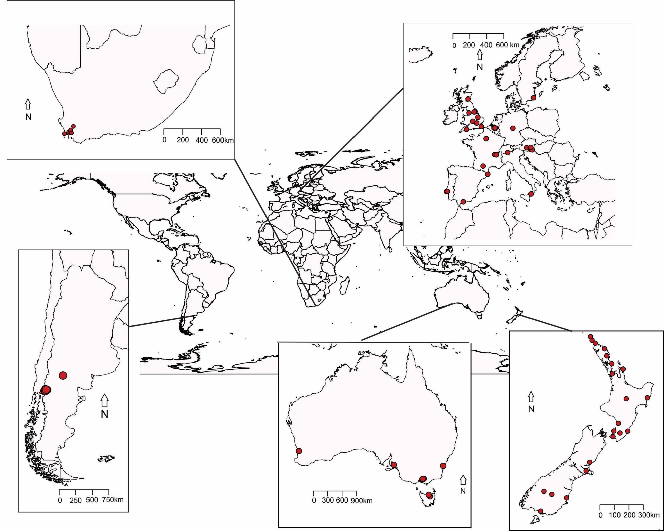

Figure 1 Origin of the Vespula germanica samples used in this study.

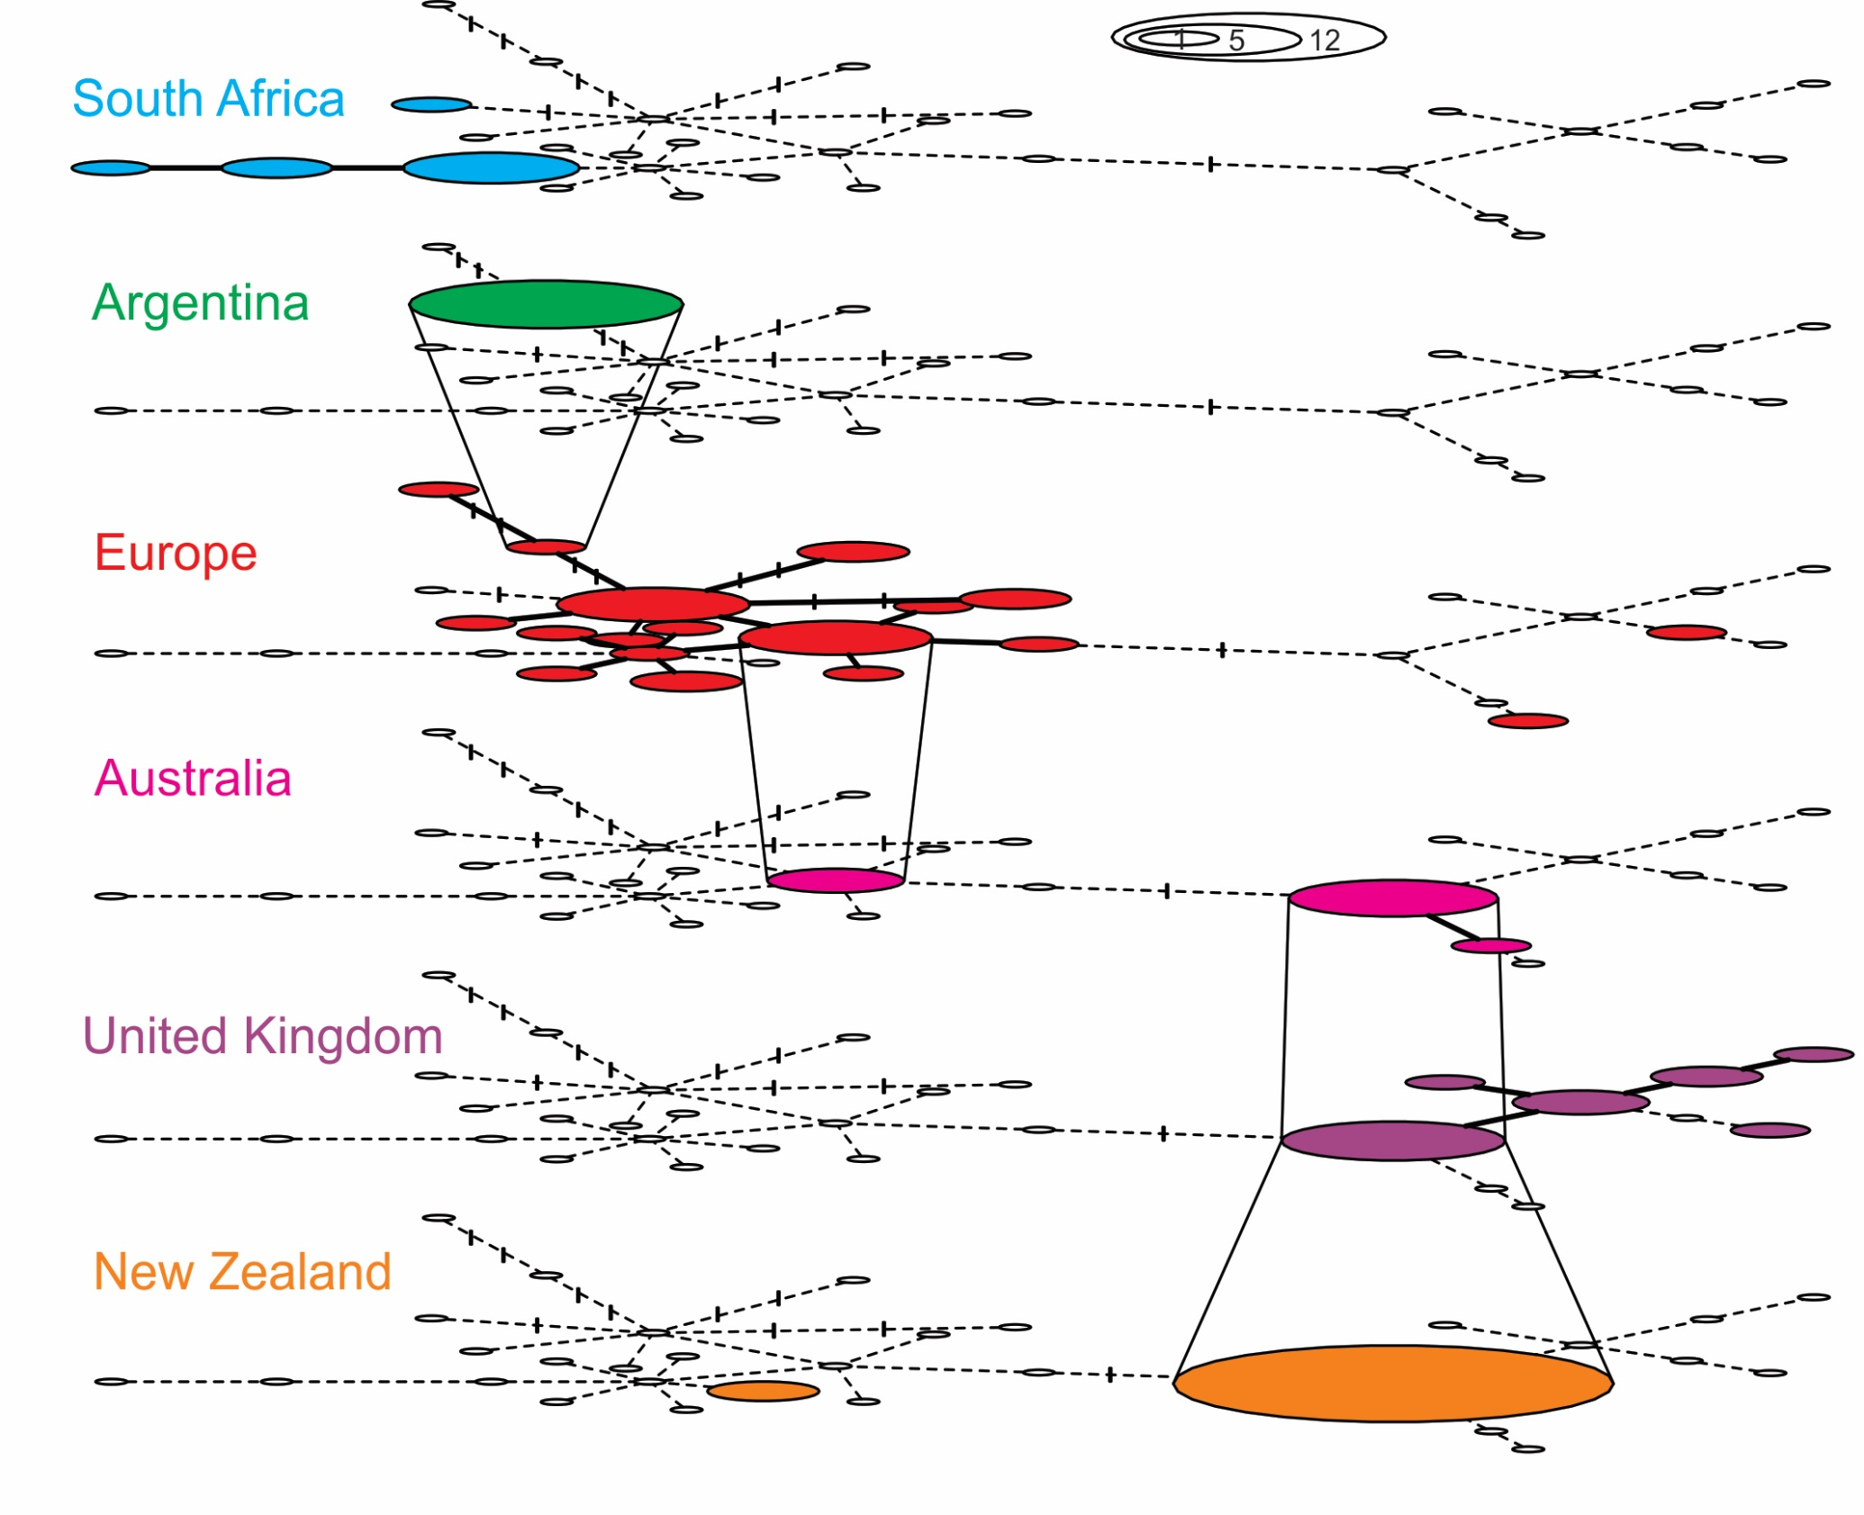
Figure 2 Spatially structured haplotype network of Vespula germanica constructed in TempNet. Lines between haplotype groups in adjacent layers indicate identical haplotypes between the groups. Filled ellipses indicate a positive sample and the relative number of samples for each haplotype. Empty ellipses show the absence of a haplotype in a particular region. Each point along the lines between haplotypes indicates base substitution. Regional groupings are: South Africa (n = 9), Argentina (n = 12), Europe (Austria, Belgium, France, Germany, Italy, Portugal, Spain, Switzerland, Sweden, n = 31), Australia (n = 11), United Kingdom (England, Scotland, n = 16), New Zealand (n = 33).

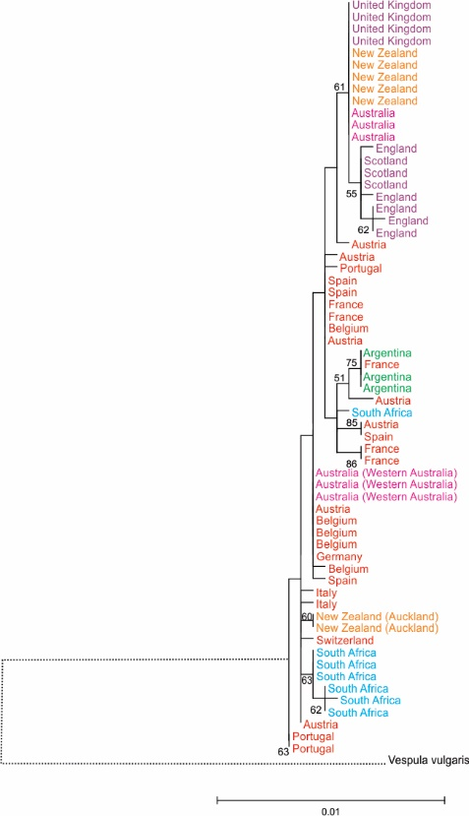
Figure 3 Maximum composite likelihood tree for Vespula germanica sampled throughout the native and introduced range. V. vulgaris was used to root the evolutionary tree. The tree was based on 1000 bootstraps of a Hasegawa-Kishino-Yano model using a concatenated dataset of COI, CO2 and cytb mt DNA sequences. Colours identify different regional groupings (see Fig. 2) The line connecting the outgroup V. vulgaris is not to scale.

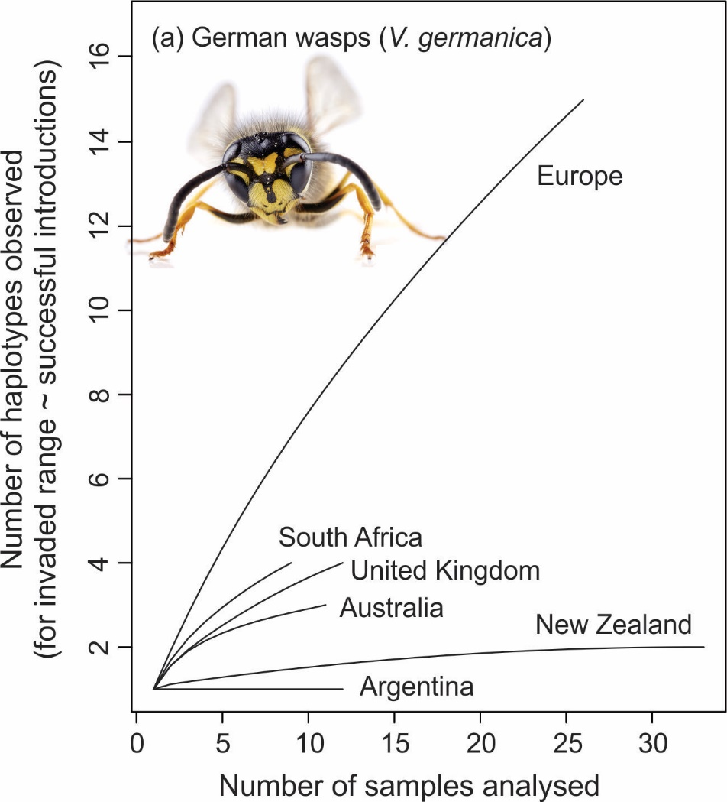

Figure 4 Haplotype discovery curves from the six population areas sampled. These curves show that the full diversity of haplotypes was likely sampled from New Zealand and Argentina and Australia. Full haplotype diversity was not captured from the three other populations.

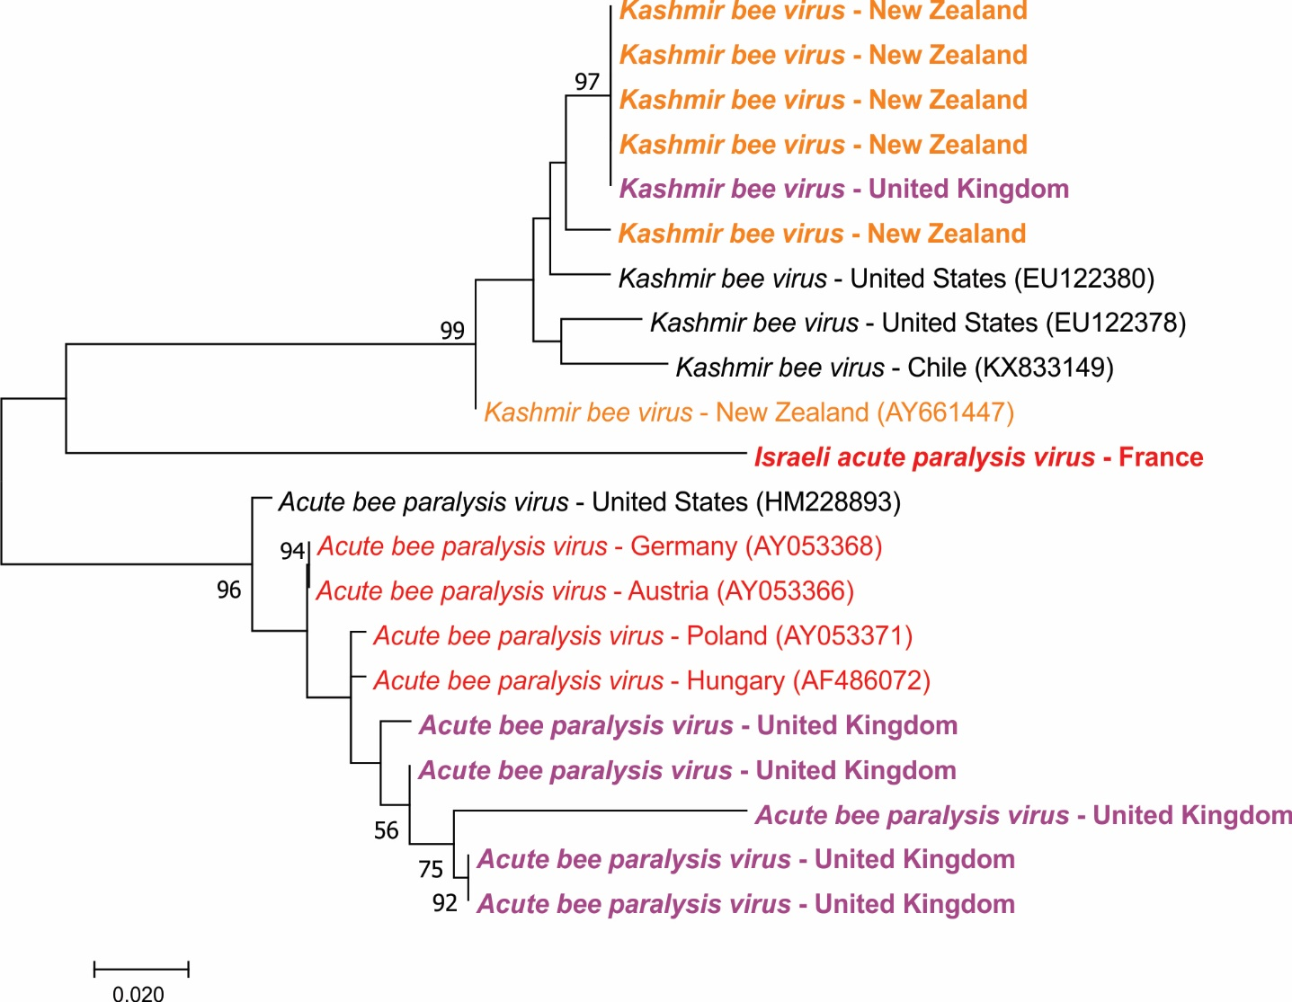

Figure 5 Maximum composite likelihood tree for Dicistroviridae sequences sampled, as well as samples from utilised from GenBank. The tree was based on 1000 bootstraps of a Kimura-2 parameter model. Samples in bold are from this study. Colours indicate geographic origin (see Fig. 3)

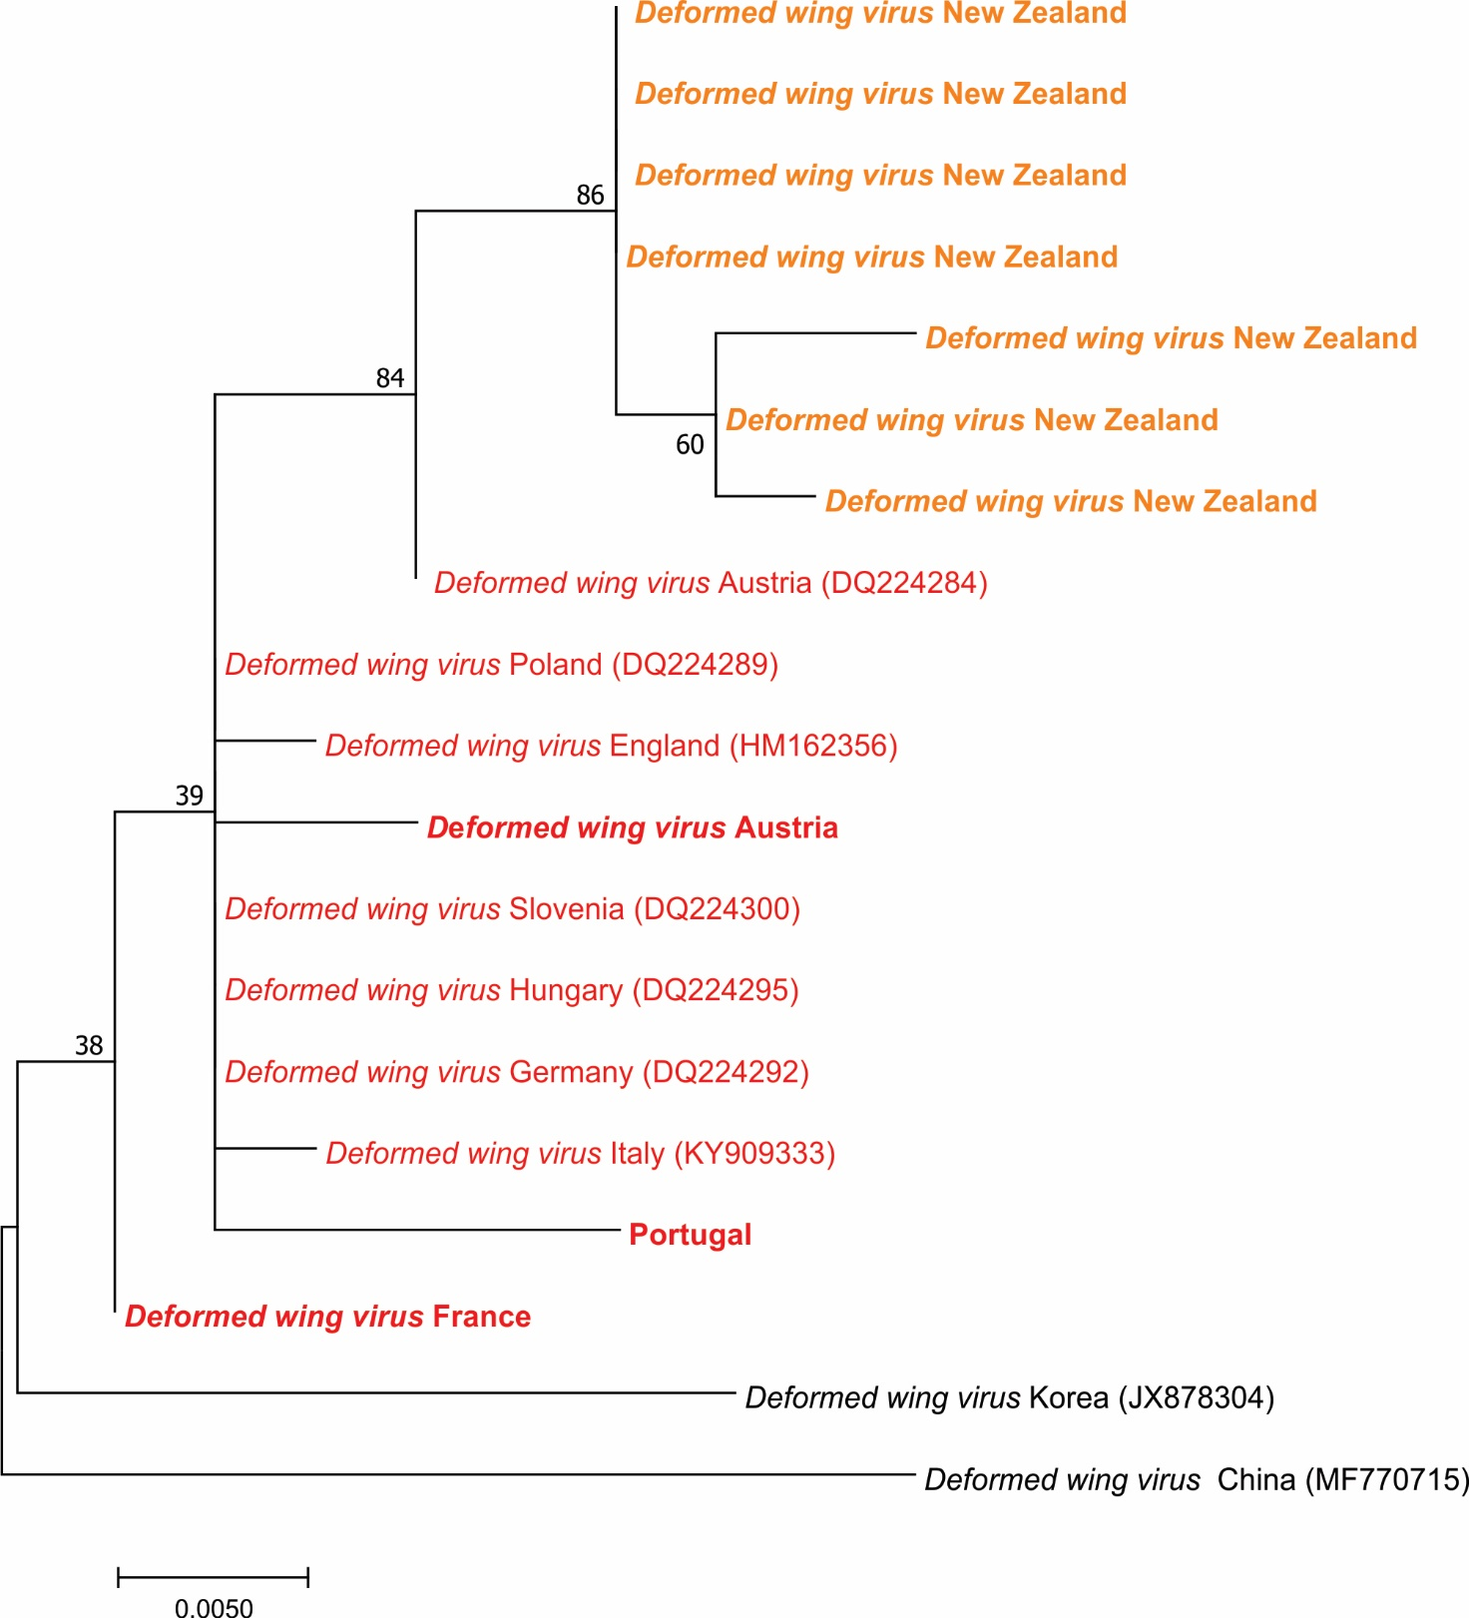
Figure 6 Maximum composite likelihood tree for DWV sequences sampled, as well as samples from utilised from GenBank. The tree was based on 1000 bootstraps of a Kimura-2 parameter model. Samples in bold are from this study. Colours indicate geographic origin (see Fig. 3)

Table 1 Summary of number of V. germanica specimens sampled and the unique haplotypes found in each range
Region | Specimens sampled | Unique haplotypes
Europe | 31 | 20
United Kingdom | 16 | 6
Australia | 11 | 3
New Zealand | 33 | 2
Argentina | 12 | 1
South Africa | 9 | 4
Totals | 112 | 37

Table 2 Viral presence in German wasps in the native and invaded range. The data shown are the mean prevalence rate. Dashes indicate the pathogen was not detected.
Virus | Region
 | Argentina | Australia | Europe | New Zealand | South Africa | United Kingdom
ABPV |  | - | - | - | - | 31%
DWV | - | - | 10% | 24% | - | -
IAPV | - | - | 3% | - | - | -
KBV | - | - | - | 15% | - | 6%

Table 3 Summary of previous literature and findings of this study on the origin of invasions of V. germanica populations around the world. A more detailed description may be found in the supplementary materials.
Invaded range | Date of first report and location of origin previous literature | Closest haplotypes (this study)
Argentina | Adults first reported during 1980s (Willink, 1980). Hypothesised donor region of Chile (Beggs et al., 2011). Present across much of central Argentina (Masciocchi & Corley, 2013). | We discovered one haplotype in Argentina. It was most similar to a sample from the south of France on the border with Spain (Fig. 2). Given this finding the Argentinian population clusters with French and Spanish haplotypes (Fig. 3). Although our haplotype discovery curve suggests we have sampled the full mitochondrial diversity in Argentina (Fig. 4); our geographic sampling area does not encompass the entire range of the species in South America. We cannot therefore exclude incursions from elsewhere.
Australia | Reported in Tasmania 1959 (Crosland, 1991). Recorded on mainland in 1975 (Spradbery & Maywald, 1992). Hypothesised donor pathway and region of origin: Cargo from New Zealand (Spradbery & Maywald, 1992). | Three haplotypes were sampled in Australia. The most common (n = 7/11) was the most frequently found haplotype in New Zealand and the United Kingdom (Fig. 2). The second haplotype (n = 1/11) clustered with samples from the United Kingdom (Fig. 2; Fig.3). While the third haplotype, found in Western Australia (n =3/11), was an exact match to samples from central Europe (Fig. 2, Fig. 3); and this haplotype was not found elsewhere in Australia. There have likely been multiple introduction events in Australia. These have likely been from New Zealand, the United Kingdom and central Europe. Our haplotype discovery curve (Fig. 4) suggests we have sampled most of the diversity present in Australia.
New Zealand | First reported 1945 (Thomas, 1960). Hypothesised to have arrived with crates of equipment flown from Europe to New Zealand (Thomas, 1960). | The majority of New Zealand’s samples (n = 31/33) belonged to a single haplotype, identical to the most common haplotype in the United Kingdom and Australia (Fig. 2). This haplotype was spread across the country. A second rare haplotype was discovered in Auckland and is most similar to central European haplotypes (Fig. 3). There appear to have been at least two introduction events to New Zealand. The 1945 introduction from the United Kingdom, which became widespread; and a more recent introduction, potentially from central Europe, which at present only found in Auckland. Our haplotype discovery curve suggests we have sampled most of the diversity present in New Zealand (Fig. 4).
South Africa | First reported 1974 (Whitehead & Prins, 1975) at a container depot (Tribe & Richardson, 1994). | We detected the presence of four haplotypes in South Africa and sampled across the full invaded range (Veldtman et al., 2012). None of these proved an exact match to our samples from Europe. However, our maximum likelihood phylogenetic analysis places them within samples from mainland Europe (Fig. 3). The presence of four haplotypes may indicate one introduction event with several queens, or alternatively, multiple introductions. Our haplotype discovery curve suggests we have not sampled the full mitochondrial diversity in South Africa (Fig. 4).

REFERENCES

Anderson, R., M. & May, R., M. (1979) Population biology of infectious disease: Part I. Nature, 280, 361–367.
Archer, M.E. (1998) The world distribution of the Euro-Asian species of Paravespula (Hym., Vespinae). Entomologists’ Montly Magazine, 134, 279–284.
Beggs, J.R., Brockerhoff, E.G., Corley, J.C., Kenis, M., Masciocchi, M., Muller, F., Rome, Q., & Villemant, C. (2011) Ecological effects and management of invasive alien Vespidae. BioControl, 56, 505–526.
Beggs, J.R., Rees, J.S., & Harris, R.J. (2002) No evidence for establishment of the wasp parasitoid, Sphecophaga vesparum burra (Cresson) (Hymenoptera: Ichneumonidae) at two sites in New Zealand. New Zealand Journal of Zoology, 29, 205–211.
Beggs, J.R., Rees, J.S., Toft, R.J., Dennis, T.E., & Barlow, N.D. (2008) Evaluating the impact of a biological control parasitoid on invasive Vespula wasps in a natural forest ecosystem. Biological Control, 44, 399–407.
Berényi, O., Bakonyi, T., Derakhshifar, I., Köglberger, H., Topolska, G., Ritter, W., Pechhacker, H., & Nowotny, N. (2007) Phylogenetic analysis of deformed wing virus genotypes from diverse geographic origins indicates recent global distribution of the virus. Applied and Environmental Microbiology, 73, 3605–3611.
Bergstrom, D.M., Lucieer, A., Kiefer, K., Wasley, J., Belbin, L., Pedersen, T.K., & Chown, S.L. (2009) Indirect effects of invasive species removal devastate World Heritage Island. Journal of Applied Ecology, 46, 73–81.
Burt, A. (2003) Site-specific selfish genes as tools for the control and genetic engineering of natural populations. Proceedings of the Royal Society B: Biological Sciences, 270, 921–928.
Clapperton, B.K., Alspach, P.A., Moller, H., & Matheson, A.G. (1989) The impact of common and German wasps (Hymenoptera: Vespidae) on the New Zealand beekeeping industry. New Zealand Journal of Zoology, 16, 325–332.
Corin, S.E., Lester, P.J., Abbott, K.L., & Ritchie, P.A. (2007) Inferring historical introduction pathways with mitochondrial DNA: The case of introduced Argentine ants (Linepithema humile) into New Zealand. Diversity and Distributions, 13, 510–518.
Crosland, M.W. (1991) The spread of the social wasp, Vespula germanica, in Australia. New Zealand Journal of Zoology, 18, 375–388.
Dainat, B., Evans, J.D., Chen, Y.P., Gauthier, L., & Neumann, P. (2012) Dead or alive: Deformed Wing Virus and Varroa Destructor Reduce the Life Span of Winter Honeybees. Applied and Environmental Microbiology, 78, 981–987.
Dearden, P.K., Gemmell, N.J., Mercier, O.R., & Lester, P.J. (2017) The potential for the use of gene drives for pest control in New Zealand: a perspective. Journal of the Royal Society of New Zealand, 1–20.
Dobelmann, J., Loope, K.J., Wilson-Rankin, E., Quinn, O., Baty, J.W., Gruber, M.A.M., & Lester, P.J. (2017) Fitness in invasive social wasps: the role of variation in viral load, immune response and paternity in predicting nest size and reproductive output. Oikos, 126, 1208–1218.
Donovan, B.J. & Read, P.E.C. (1987) Attempted biological control of social wasps, Vespula spp., (Hymenoptera: Vespidae) with Sphecophaga vesparum (curtis) (Hymenoptera: Ichneumonidae) in New Zealand. New Zealand Journal of Zoology, 14, 329–335.
Dowling, D.K., Tompkins, D.M., & Gemmell, N.J. (2015) The Trojan Female Technique for pest control: A candidate mitochondrial mutation confers low male fertility across diverse nuclear backgrounds in Drosophila melanogaster. Evolutionary Applications, 8, 871–880.
Drury, D.W., Dapper, A.L., Siniard, D.J., Zentner, G.E., & Wade, M.J. (2017) CRISPR/Cas9 gene drives in genetically variable and nonrandomly mating wild populations. Science Advances, 3, e1601910.
Dupas, S., Carton, Y., & Poiriè, M. (2003) Genetic dimension of the coevolution of virulence-resistance in Drosophila - Parasitoid wasp relationships. Heredity, 90, 84–89.
Edwards, E., Toft, R., Joice, N., & Westbrooke, I. (2017) The efficacy of Vespex® wasp bait to control Vespula species (Hymenoptera: Vespidae) in New Zealand. International Journal of Pest Management, 63, 266–272.
Esvelt, K.M., Smidler, A.L., Catteruccia, F., & Church, G.M. (2014) Concerning RNA-guided gene drives for the alteration of wild populations. eLife, 3, 1–21.
Evison, S.E.F., Roberts, K.E., Laurenson, L., Pietravalle, S., Hui, J., Biesmeijer, J.C., Smith, J.E., Budge, G., & Hughes, W.O.H. (2012) Pervasiveness of parasites in pollinators. PloS one, 7, e30641.
Goolsby, J.A., De Barro, P.J., Makinson, J.R., Pemberton, R.W., Hartley, D.M., & Frohlich, D.R. (2006) Matching the origin of an invasive weed for selection of a herbivore haplotype for a biological control programme. Molecular Ecology, 15, 287–297.
Grodowitz, M.J., Center, T.D., Cofrancesco, A.F., & Freedman, J.E. (1997) Release and establishment of Hydrellia balciunasi (Diptera: Ephydridae) for the biological control of the submersed aquatic plant Hydrilla verticillata (Hydrocharitaceae) in the United States. Biological Control, 9, 15–23.
Gruber, M.A.M., Cooling, M., Baty, J.W., Buckley, K., Friedlander, A., Quinn, O., Russell, J.F.E.J., Sébastien, A., & Lester, P.J. (2017) Single-stranded RNA viruses infecting the invasive Argentine ant, Linepithema humile. Scientific Reports, 7, 3304.
Hammond, A., Galizi, R., Kyrou, K., Simoni, A., Siniscalchi, C., Katsanos, D., Gribble, M., Baker, D., Marois, E., Russell, S., Burt, A., Windbichler, N., Crisanti, A., & Nolan, T. (2016) A CRISPR-Cas9 gene drive system targeting female reproduction in the malaria mosquito vector Anopheles gambiae. Nature Biotechnology, 34, 78–83.
Hasegawa, M., Kishino, H., & Yano, T. aki (1985) Dating of the human-ape splitting by a molecular clock of mitochondrial DNA. Journal of Molecular Evolution, 22, 160–174.
Hoffmann, B.D. (2011) Eradication of populations of an invasive ant in northern Australia: successes, failures and lessons for management. Biodiversity and Conservation, 20, 3267–3278.
Keane, R.M. & Crawley, M.J. (2002) Exotic plant invasions and the enemy release hypothesis. Trends in Ecology & Evolution, 17, 164–170.
Kumar, S., Stecher, G., & Tamura, K. (2015) MEGA7: Molecular Evolutionary Genetics Analysis version 7.0 for bigger datasets.
Lester, P.J., Bosch, P.J., Gruber, M.A.M., Kapp, E.A., Peng, L., Brenton-Rule, E.C., Buchanan, J., Stanislawek, W.L., Archer, M., Corley, J.C., Masciocchi, M., Van Oystaeyen, A., & Wenseleers, T. (2015) No evidence of enemy release in pathogen and microbial communities of common wasps (vespula vulgaris) in their native and introduced range. PLoS ONE, 10, e0121358.
Lester, P.J., Brown, S.D.J., Edwards, E.D., Holwell, G.I., Pawson, S.M., Ward, D.F., & Watts, C.H. (2014a) Critical issues facing New Zealand entomology. New Zealand Entomologist, 37, 1–13.
Lester, P.J., Gruber, M.A.M., Brenton-Rule, E.C., Archer, M., Corley, J.C., Dvořák, L., Masciocchi, M., & Van Oystaeyen, A. (2014b) Determining the origin of invasions and demonstrating a lack of enemy release from microsporidian pathogens in common wasps (Vespula vulgaris). Diversity and Distributions, 20, 964–974.
Levitt, A.L., Singh, R., Cox-Foster, D.L., Rajotte, E., Hoover, K., Ostiguy, N., & Holmes, E.C. (2013) Cross-species transmission of honey bee viruses in associated arthropods. Virus Research, 176, 232–240.
MacIntyre, P. & Hellstrom, J. (2015) An evaluation of the costs of pest wasps (Vespula species) in New Zealand. Department of Conservation and Ministry for Primary Industries, 57, .
Masciocchi, M. & Corley, J. (2013) Distribution, dispersal and spread of the invasive social wasp (Vespula germanica) in Argentina. Austral Ecology, 38, 162–168.
McFadden, A.M.J., Tham, K.-M., Stevenson, M., Goodwin, M., Pharo, H., Taylor, B., Munro, G., Owen, K., Peacock, L., Stanslawek, W.L., & Stone, M. (2014) Israeli acute paralysis virus not detected in Apis mellifera in New Zealand in a national survey. Journal of Apicultural Research, 53, 520–527.
McMahon, D.P., Natsopoulou, M.E., Doublet, V., Fürst, M.A., Weging, S., Brown, M.J.F., Gogol-Döring, A., & Paxton, R.J. (2016) Elevated virulence of an emerging viral genotype as a driver of honeybee loss. Proceedings of the Royal Society B: Biological Sciences, .
Moller, H., Tilley, J., Thomas, B., & Gaze, P. (1991) Effect of introduced social wasps on the standing crop of honeydew in New Zealand beech forests. New Zealand Journal of Zoology, 18, 171–179.
Niu, J., Meeus, I., & Smagghe, G. (2016) Differential expression pattern of Vago in bumblebee (Bombus terrestris), induced by virulent and avirulent virus infections. Scientific Reports, 6, 1–9.
Potts, S.G., Biesmeijer, J.C., Kremen, C., Neumann, P., Schweiger, O., & Kunin, W.E. (2010) Global pollinator declines: trends, impacts and drivers. Trends in Ecology and Evolution, 25, 345–353.
Prost, S. & Anderson, C.N.K. (2011) TempNet: A method to display statistical parsimony networks for heterochronous DNA sequence data. Methods in Ecology and Evolution, 2, 663–667.
Rejmánek, M. & Pitcairn, M.J. (2002) When is eradication of exotic pest plants a realistic goal? In Veitch CR, Clout MN (eds) Turning the tide: the eradication of invasive species. IUCN Species Survival Commission, Gland. 249–253.
Sakai, A.K., Allendorf, F.W., Holt, J.S., Lodge, M., Molofsky, J., With, K.A., Cabin, R.J., Cohen, J.E., Norman, C., Mccauley, D.E., Neil, P.O., Parker, M., Thompson, J.N., & Weller, S.G. (2001) The Population Biology of Invasive Species. Annual Review of Ecology and Systematics, 32, 305–332.
Santamaria, J., Villalobos, E.M., Brettell, L., Nikaido, S., Graham, J.R., & Martin, S. (2017) Evidence of Varroa-mediated Deformed Wing virus spillover in Hawaii. Journal of Invertebrate Pathology (in press).
Schroeder, D.C. & Martin, S.J. (2012) Deformed wing virus: The main suspect in unexplained honeybee deaths. Virulence, 3, 589–598.
Sébastien, A., Lester, P.J., Hall, R.J., Wang, J., Moore, N.E., & Gruber, M.A.M. (2015) Invasive ants carry novel viruses in their new range and form reservoirs for a honeybee pathogen. Biology Letters, 11, 20150610.
Silverman, J. & Brightwell, R.J. (2008) The Argentine ant: Challenges in managing an invasive unicolonial pest. Annual Reviews of Entomology, 53, 231–252.
Simon, C., Frati, F., Beckenbach, A., Crespi, B., Liu, H., & Flook, P. (1994) Evolution, weighting and phylogenetic utility of mitochondrial gene sequences and a compilation of conserved polymerase chain reaction “primers.” Annals of the Entomological Society of America, 87, 651–701.
Spradbery, J. & Maywald, G. (1992) The Distribution of the European or German Wasp, Vespula-Germanica (F) (Hymenoptera, Vespidae), in Australia - Past, Present and Future. Australian Journal of Zoology, 40, 495–510.
Tamura, K., Nei, M., & Kumar, S. (2004) Prospects for inferring very large phylogenies by using the neighbor-joining method. Proceedings of the National Academy of Sciences, 101, 11030–11035.
Thomas, C.D., Moller, H., Plunkett, G.M., & Harris, R.J. (1990) The prevalence of introduced Vespula vulgaris wasps in a New Zealand beech forest community. New Zealand Journal of Ecology, 13, 63–72.
Thomas, C.R. (1960) The European wasp (Vespula germanica Fab.). New Zealand. New Zealand Department of Scientific and Industrial Research Information Series, 27, 1–74.
Tribe, G.D. & Richardson, D.M. (1994) The European Wasp, Vespula-germanica (fabricius) (Hymenoptera, Vespidae), In Southern Africa and Its Potential Distribution As Predicted By Ecoclimatic Matching. African Entomology, 2, 1–6.
Tsutsui, N.D., Suarez, A. V., Holway, D.A., & Case, T.J. (2000) Reduced genetic variation and the success of an invasive species. Proceedings of the National Academy of Sciences, 5948–5953.
Veldtman, R., Addison, P., & Tribe, G.D. (2012) Current status and potential future impact of invasive vespid wasps (Vespula germanica and Polistes dominulus) in South Africa. IOBC/WPRS Bulletin, 75, 217–227.
Webber, B.L., Raghu, S., & Edwards, O.R. (2015) Is CRISPR-based gene drive a biocontrol silver bullet or global conservation threat? Proceedings of the National Academy of Sciences, 112, 10565–10567.
Whitehead, V.B. & Prins, A.J. (1975) The European wasp, Vespula germanica (F.), in the Cape Peninsula. Journal of the Entomological Society of Southern Africa, 38, 39–42.
Willink, A. (1980) Sobre la presencia de Vespula germanica (Fabricius) en la Argentina. Neotropica, 26, 205–206.
Wood, G.M., Hopkins, D.C., & Schellhorn, N.A. (2006) Preference by Vespula germanica (Hymenoptera: Vespidae) for Processed Meats: Implications for Toxic Baiting. Journal of Economic Entomology, 99, 263–267.
Zhang, C., Yan, S.Q., Shen, B. Bin, Ali, S., Wang, X.M., Jin, F.L., Cuthbertson, A.G.S., & Qiu, B.L. (2017) RNAi knock-down of the Bemisia tabaci Toll gene (BtToll) increases mortality after challenge with destruxin A. Molecular Immunology, 88, 164–173.

