Appendix
Insect endosymbiont model stability analysis
The insect endosymbiont model is determined by two equations:
$$\frac{dX}{dt}=c\frac{h}{h+1}(X+R(1-α)Z)-\left(Ξ+b(X+Z)\right)X,$$
$$\frac{dZ}{dt}=c\frac{h}{h+1}(RαZ)-\left(Ξ+b\left(X+Z\right)\right)Z.$$
The steady states of the system $(\overline{X}, \overline{Z})$ are:
$$\left(0,0\right),$$
$$\left(\frac{ch-\left(h+1\right)Ξ}{b\left(h+1\right)},0\right),$$
$$\left( \frac{R(1-α)(Rchα-Ξ(h+1)}{b\left(R-1\right)\left(h+1\right)},\frac{(Rα-1)(Rchα-Ξ(h+1)}{b\left(R-1\right)\left(h+1\right)}\right).$$
The Jacobian matrix of the insect endosymbiont model is:
$$\left(\begin{matrix}\frac{-((Ξ+b\left(2X+Z\right))\left(h+1\right)- ch)}{h+1} & \frac{-(Xb\left(h+1\right)-Rch\left(1-α\right))}{h+1} \\ -Zb & \frac{-(\left(Ξ+b\left(X+2Z\right)\left(h+1\right)\right)-Rchα)}{h+1}\end{matrix}\right)$$
The eigenvalues associated with the Jacobian matrix evaluated at the non-trivial equilibrium point are:
$$λ_{1}=Ξ-\frac{Rchα}{(h+1)},$$
$$λ_{2}=\frac{ch(1-Rα)}{(h+1)},$$
and hence stability occurs when $Ξ<{Rchα}/{\left(h+1\right)}$ and $1<Rα$. Further, it follows from $λ_{1}-λ_{2}<0$ that the basic reproductive number for the insect endosymbiont system is $Rα:$
$$λ_{1}-λ_{2}=Ξ-\frac{Rchα}{\left(h+1\right)}-\frac{ch\left(1-Rα\right)}{\left(h+1\right)}=Ξ- \frac{ch}{\left(h+1\right)},$$
$$Ξ- \frac{ch}{\left(h+1\right)}<0,$$
which can be rewritten as:
$$\frac{ch}{\left(h+1\right)}-Ξ>0.$$
The condition for stability of eigenvalue $λ_{1}$ can be rewritten as:
$$\frac{Rchα}{(h+1)}-Ξ>0.$$
From these inequalities we find that the basic reproduction ratio in this system is $Rα$ and that when the non-trivial equilibrium point exists, it is stable.
Insect vectored plant pathogen stability analysis
The insect vectored plant pathogen model is controlled by the following equations:
$$\frac{dH}{dt}=σ-ηH-β_{1}\left(θ\right)ZH,$$
$$\frac{dI}{dt}=-ϕI-ηI+β_{1}\left(θ\right)ZH,$$
$$\frac{dX}{dt}=c\frac{h}{h+1}\left(X+R\left(1-α\left(θ\right)\right)Z\right)-\left(Ξ+b\left(X+Z\right)\right)X-β_{2}\left(θ\right)XI,$$
$$\frac{dZ}{dt}=c\frac{h}{h+1}\left(Rα\left(θ\right)Z\right)-\left(Ξ+b\left(X+Z\right)\right)Z+β_{2}\left(θ\right)XI.$$

The known steady states of the system $(\overline{X}, \overline{Z},\overline{H},\overline{I})$ are:
$$\left(0,0,\frac{σ}{η},0\right),$$
$$\left(\frac{ch-\left(h+1\right)Ξ}{b\left(h+1\right)},0,\frac{σ}{η},0\right),$$
and the non-trivial equilibrium point numerically found with the ODE solver odeint, from the Python library scipy, as stated in the main manuscript.
The Jacobian matrix of the insect vectored plant pathogen system is:
$$\left(\begin{matrix}J_{1} & J_{2} \\ J_{3} & J_{4}\end{matrix}\right),$$
where:
$$J_{1}=\left(\begin{matrix}\frac{ch}{h+1}-bX-b\left(X+Z\right)-β_{1}I-Ξ & -bX-\frac{Rch(α-1)}{h+1} \\ β_{1}I-bZ & \frac{Rchα}{h+1}-bZ-b\left(X+Z\right)-Ξ\end{matrix}\right),$$
$$J_{2}=\left(\begin{matrix}0 & -β_{1}X \\ 0 & β_{1}X\end{matrix}\right),$$
$$J_{3}=\left(\begin{matrix}0 & -β_{2}H \\ 0 & β_{2}H\end{matrix}\right),$$
and
$$J_{4}=\left(\begin{matrix}-η-β_{2}Z & 0 \\ β_{2}Z & -η-Φ\end{matrix}\right).$$
The eigenvalues of the Jacobian matrix evaluated at the insect and disease-free state are:
$$λ_{1}=-η,$$
$$λ_{2}=-η-Φ,$$
$$λ_{3}=\frac{Rchα}{(h+1)}-Ξ,$$
$$λ_{3}=\frac{ch}{(h+1)}-Ξ,$$
and hence this point is unstable if ${ch}/{\left(h+1\right)>Ξ}$.
The eigenvalues of the disease-free state could not be expressed in a simple enough way to analyse, but numerical simulations of the system reveal the possible stability of the disease-free equilibrium state, Figure S1.
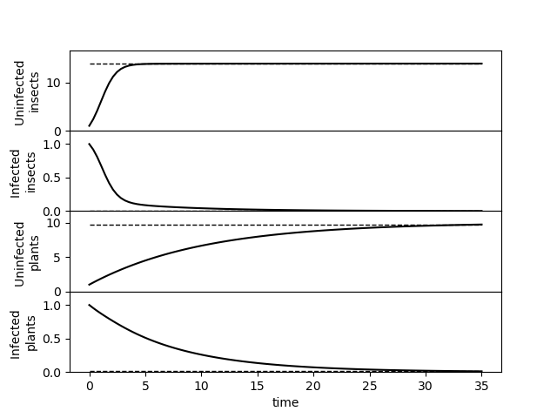
Figure S1: The disease-free equilibrium state can be stable. Parameters used: $b=0.1, c=3, h=1, R=1.5, σ=1, η=0.1, Φ=0.05$, $Ξ=0.1$ with shaping parameters $α_{max}=0.05, β_{1_{max}}=β_{2_{max}}=0.03$, $A=1.2$ and $θ=0.5$.

Unequal insect sex-ratio
In this form of the model, we consider the evolutionary analysis of the system with unequal insect sex ratio to determine how robust the results are with respect to this central assumption, the system takes the following form:
$$\frac{dH}{dt}=σ-ηH-β_{1}\left(θ\right)ZH,$$
$$\frac{dI}{dt}=-ϕI-ηI+β_{2}\left(θ\right)ZH,$$
$$\frac{dX}{dt}=\frac{2chρ(1-ρ)}{1-ρ+ρh}\left(X+R\left(1-α\left(θ\right)\right)Z\right)-\left(Ξ+b\left(X+Z\right)\right)X-β_{2}\left(θ\right)XI,$$
$$\frac{dZ}{dt}=\frac{2chρ(1-ρ)}{1-ρ+ρh}\left(Rα\left(θ\right)Z\right)-\left(Ξ+b\left(X+Z\right)\right)Z+β_{2}\left(θ\right)XI.$$

Note that when $ρ=1/2$ then the system dynamics are equivalent to those in the main manuscript.
There were few differences between the results of the model with equal insect sex ratio and unequal insect sex ratio. An example of this can be seen by comparing the insect evolutionary dynamics with an equal sex ratio, Figure 7 in the main manuscript to the equivalent evolutionary dynamics with a male dominated population ($ρ=0.85$) in Figure S2 and a female dominated population $(ρ=0.15)$ in Figure S3. We find the direction of change in the CSS does not alter for each form of the model considered, but we do see that magnitude of change in CSS is lessened when the insect sex ratio is unequal. We did, however, find significant evolutionary interaction between the insect sex ratio and the mating system, see the differences in row b in Figures S2 and S3. This interaction is not surprising owing to the obvious relationship between the insect population’s sex structure and the mating systems considered.
Further to the insect evolutionary dynamics, we also considered the robustness of the results in the main text when the assumption of an equal sex ratio is relaxed. A link to the Github repository is available on request for a full elaboration of how sex ratio interacts with the plant evolutionary dynamics, the trade-off curve shaping parameters evolutionary dynamics and the stability of the non-trivial equilibrium point.
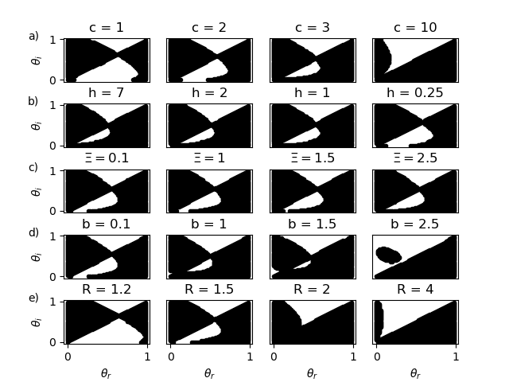
Figure S2: The insect evolutionary dynamics in Figure 5 reproduced with a male majority population $(ρ=0.85)$ There is limited difference in the evolutionary dynamics when an unequal sex ratio in the population is considered. Unless otherwise stated, the parameters used in the making of these PIPs in rows a and b were: $c=3, h=1, R=1.5, Ξ=0.1, b=0.1, σ=1, η=0.1, Φ=0.05, A=1.2, α_{max}=0.95$ and $β_{1_{max}}=β_{2_{max}}=0.2$. The same parameters were used in rows c to d, with the exception of $c=10$ and $σ=3.5$.
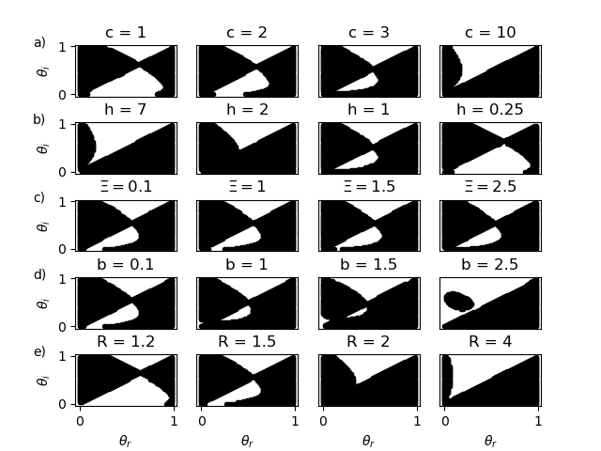 Figure S3: The insect evolutionary dynamics in Figure 5 reproduced with a female majority population $(ρ=0.15)$ There is limited difference in the evolutionary dynamics when an unequal sex ratio in the population is considered. Unless otherwise stated, the parameters used in the making of these PIPs in rows a and b were: $c=3, h=1, R=1.5, Ξ=0.1, b=0.1, σ=1, η=0.1, Φ=0.05, A=1.2, α_{max}=0.95$ and $β_{1_{max}}=β_{2_{max}}=0.2$. The same parameters were used in rows c to d, with the exception of $c=10$ and $σ=3.5$.

Parameter Exploration
Here we explore the full stated range of the parameter space. There are 10 parameters within the model, excluding the trade-off curve shaping parameters. We explored a wide range of parameter combinations by repeatedly performing adaptive dynamics for two parameters at a time over a subset of their parameter space. We plotted the evolutionary endpoint on a graph with the parameters tested as the x and y axis, and the value of the evolutionary endpoint of $θ$ as a colour. On these graphs the darker a point is, the closer to 1 the evolutionary endpoint is, the lighter a point is, the closer the evolutionary endpoint is to 0. An evolutionary endpoint at $θ=0$ corresponds to an insect endosymbiont lifestyle and an evolutionary endpoint at $θ=1$ corresponds to an insect vectored plant pathogen lifestyle. To test each pair of parameter interaction for a given set of parameters, 28 graphs will be created. This will create a large number of graphs and as such, we must limit our output. We test coupled parameters within their parameter spaces as shown in Table 1 in the main manuscript, when the two parameters aren’t stated in the graph’s x and y axes, the parameter values used are: $c=6, h=1, R=1.2, Ξ=0.1, b=0.1, α_{max}=0.95, β_{1_{max}}=0.2,β_{2_{max}}=0.2, σ=3.5, η=0.1$, $Φ=0.05$ and $ρ=0.5$. An example of such a plot is given in Figure S2.

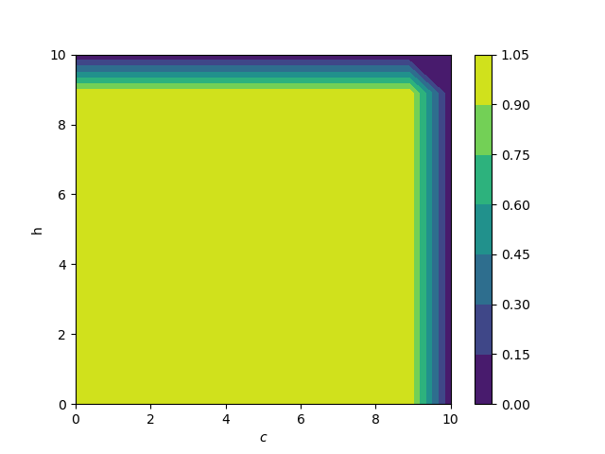
Figure S4: An example of the parameter interaction graphs used to investigate the evolutionary dynamics of the system. We take a fairly dense sample of two parameter combinations, in this case $c$ and $h$ and then numerically calculate the value of the CSS, displaying the CSS values with colour. From these graphs, we can find the effect of the interaction between different parameters in the model.

Exploring different trade-off curves
Here we investigate the effect of different trade-off functions on the evolutionary outcome of transmission method. In Table S 1, a variety of trade-off functions are given; in Figure S3 we plot these functions.

Function shape | Function used
Linear | $$α\left(θ\right)=α_{max}(1-θ)$$
Concave | $$α\left(θ\right)=α_{max}\frac{A(θ-1)}{(θ-A)}, A>1$$
Convex | $$α\left(θ\right)=α_{max}\frac{-B(θ-1)}{(θ+B)}, 0<B<1$$
Table S 1: Various trade-off functions used

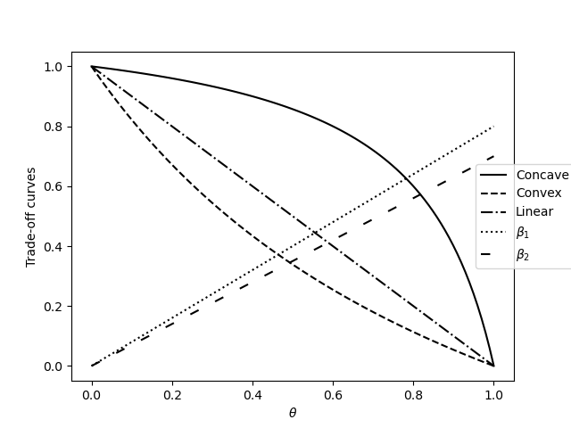 Figure S5: The various trade-off curves used in the further analysis

We tested the change of parameters with all trade off functions. Figure S6 for parameter $α_{max}$; Figure S7 for parameter $β_{1_{max}}$; Figure S8 for parameter $β_{2_{max}}$; Figure S9 for $b$; Figure S10 for $c$; Figure S11 for $η$; Figure S12 for $h$; Figure S13 for $Φ$; Figure S14 for $R$; Figure S15 for parameter $σ$ and S16 for parameter $Ξ$. In the majority of these pairwise invasibility plots and in the majority of our simulations (not shown), the only trade-off function which caused the model to respond to changes in parameters with a change in the evolutionarily stable state was the concave trade-off function, Table S 1. We tested these functions for completeness, but these trade-off functions do not have the same biological reasoning behind their use as the concave function. From these PIPs and the larger set of simulations referred to in the previous section, we find similar qualitative results from using different trade-off curves, but noticed that when using trade-off curves other than the concave trade-off curve, bi-stability was more prevalent.
One possible explanation for this would be a local fitness maximum around $θ=0$ for linear and convex trade-off curves that does not exist for concave trade-off curves. For simplicity, we look at the basic reproduction ratio of the resident system for differing values of $θ$, as this will give us a picture of the relationship between fitness and transmission route. Using the next generation method (Heffernan et al., 2005), we find the following term for the basic reproduction ratio of the resident system:
$$R_{0}=\frac{Rα\left(θ\right)+\sqrt{Rα\left(θ\right)+\frac{4β_{1}(θ)β_{2}(θ)}{ch(ϕ+η)}\overline{X}\overline{H}}}{2}.$$
Here $\overline{X}$ and $\overline{H}$ as the disease-free equilibrium points for the uninfected and insect and plant hosts respectively. Using our calculation of $R_{0}$ we show that there can exist a local fitness maximum at $θ=0$ for linear and convex trade-off curves that does not exist for concave trade-off curves, see Figure S17. This is of course, just an example and not a proof, but it does offer a possible explanation as to why we see such different results for different trade-off curve.
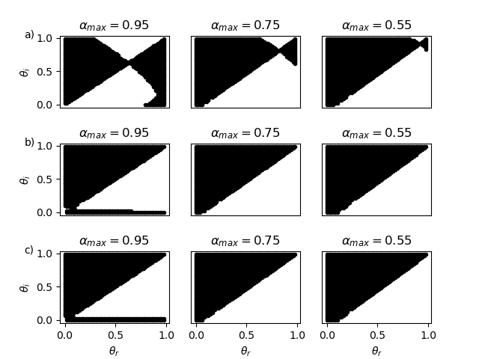
Figure S6: The effects of $α_{max}$ with a concave trade-off curve (row a), a convex trade-off curve (row b) and a linear trade-off curve (row c). In linear and convex trade-off curves, the possibility of evolutionary bistability transmission mode is more likely to be present than in the concave trade-off curve, but only when $α_{max}$ is sufficiently high. Unless otherwise stated, the parameters used in the making of these plots is: $c=3, h=1, R=1.2, Ξ=0.1, b=0.1, σ=1, η=0.1$, $Φ=0.05$, $A=1.2$ and $B=1.2$.

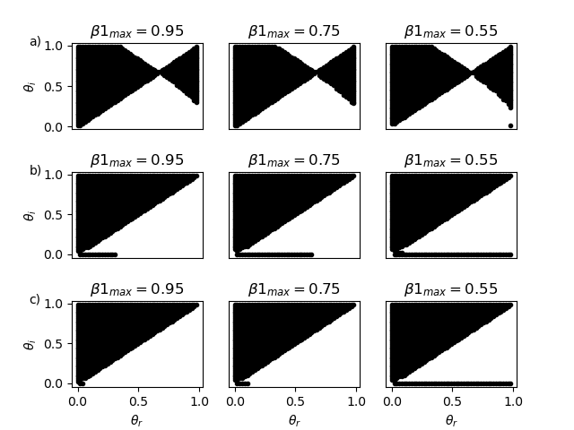
Figure S7: The effects of $β_{1_{max}}$ with a concave trade-off curve (row a), a convex trade-off curve (row b) and a linear trade-off curve (row c). In linear and convex trade-off curves, the possibility of evolutionary bistability transmission mode is more likely to be present than in the concave trade-off curve. Unless otherwise stated, the parameters used in the making of these plots is: $c=3, h=1, R=1.2, Ξ=0.1, b=0.1, σ=1, η=0.1, Φ=0.05, A=1.2 and B=1.2.$

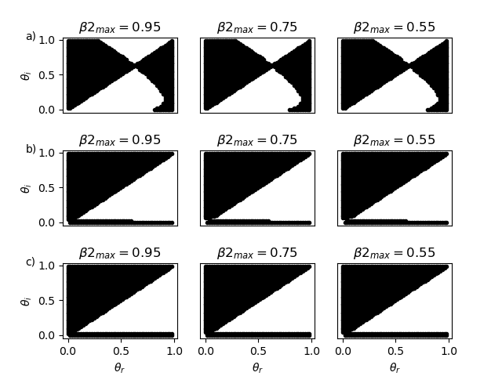 Figure S8: The effects of $β_{2_{max}}$ with a concave trade-off curve (row a), a convex trade-off curve (row b) and a linear trade-off curve (row c). In linear and convex trade-off curves, the possibility of evolutionary bistability transmission mode is more likely to be present than in the concave trade-off curve. Unless otherwise stated, the parameters used in the making of these plots is: $c=3, h=1, R=1.2, Ξ=0.1, b=0.1, σ=1, η=0.1, Φ=0.05, A=1.2 and B=1.2.$

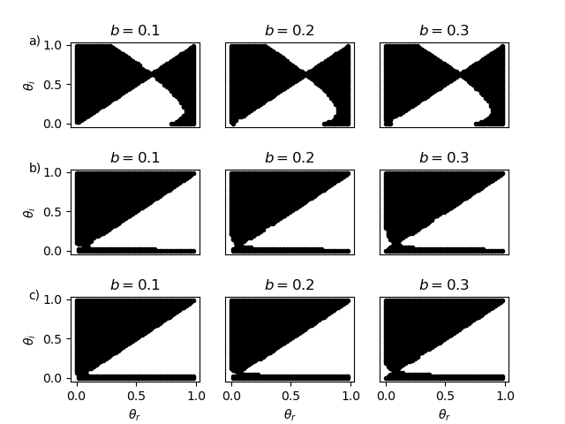
Figure S9: The effects of $b$ with a concave trade-off curve (row a), a convex trade-off curve (row b) and a linear trade-off curve (row c).In linear and convex trade-off curves, the possibility of evolutionary bistability transmission mode is more likely to be present than in the concave trade-off curve. Unless otherwise stated, the parameters used in the making of these plots is: $c=3, h=1, R=1.2, Ξ=0.1, b=0.1, σ=1, η=0.1, Φ=0.05, A=1.2 and B=1.2.$

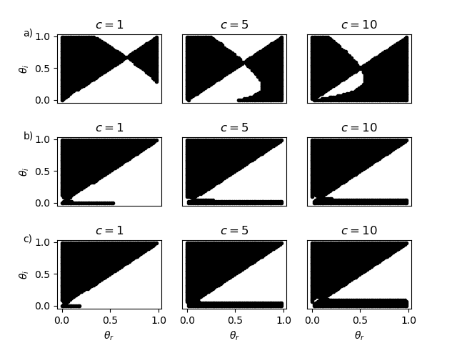
Figure S10: The effects of $c$ with a concave trade-off curve (row a), a convex trade-off curve (row b) and a linear trade-off curve (row c). In linear and convex trade-off curves, the possibility of evolutionary bistability transmission mode is more likely to be present than in the concave trade-off curve. Unless otherwise stated, the parameters used in the making of these plots is: $c=3, h=1, R=1.2, Ξ=0.1, b=0.1, σ=1, η=0.1, Φ=0.05, A=1.2 and B=1.2.$

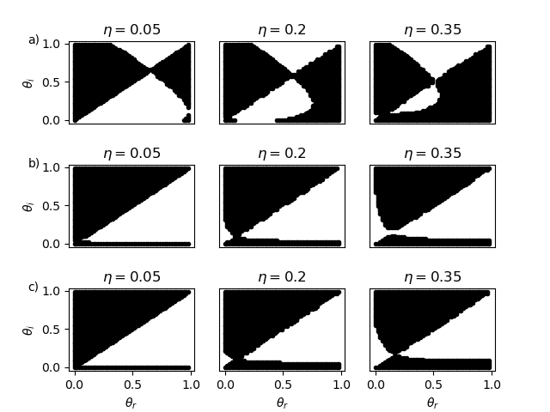
Figure S11: The effects of $η$ with a concave trade-off curve (row a), a convex trade-off curve (row b) and a linear trade-off curve (row c).. In linear and convex trade-off curves, the possibility of evolutionary bistability transmission mode is more likely to be present than in the concave trade-off curve. Unless otherwise stated, the parameters used in the making of these plots is: $c=3, h=1, R=1.2, Ξ=0.1, b=0.1, σ=1, η=0.1, Φ=0.05, A=1.2 and B=1.2.$

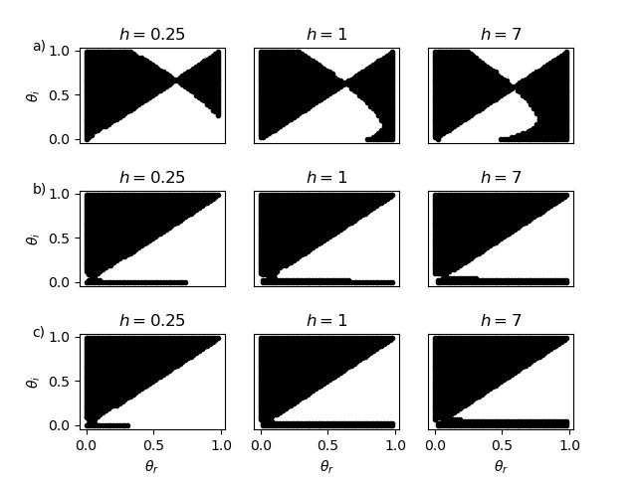
Figure S12: The effects of $h$ with a concave trade-off curve (row a), a convex trade-off curve (row b) and a linear trade-off curve (row c). In linear and convex trade-off curves, the possibility of evolutionary bistability transmission mode is more likely to be present than in the concave trade-off curve. Unless otherwise stated, the parameters used in the making of these plots is: $c=3, h=1, R=1.2, Ξ=0.1, b=0.1, σ=1, η=0.1, Φ=0.05, A=1.2 and B=1.2.$

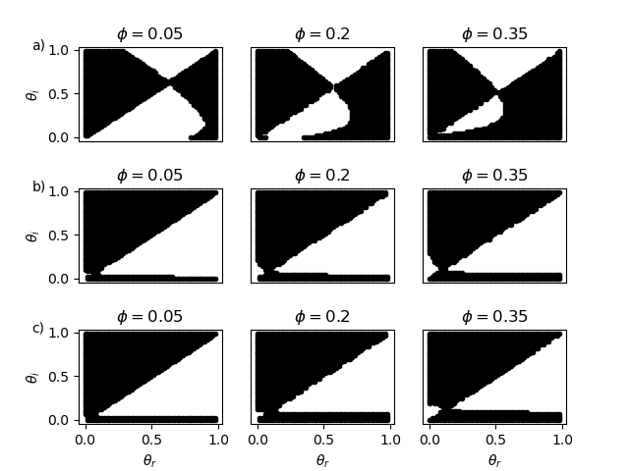
Figure S13: The effects of $Φ$ with a concave trade-off curve (row a), a convex trade-off curve (row b) and a linear trade-off curve (row c). In linear and convex trade-off curves, the possibility of evolutionary bistability transmission mode is more likely to be present than in the concave trade-off curve. Unless otherwise stated, the parameters used in the making of these plots is: $c=3, h=1, R=1.2, Ξ=0.1, b=0.1, σ=1, η=0.1, Φ=0.05, A=1.2 and B=1.2.$

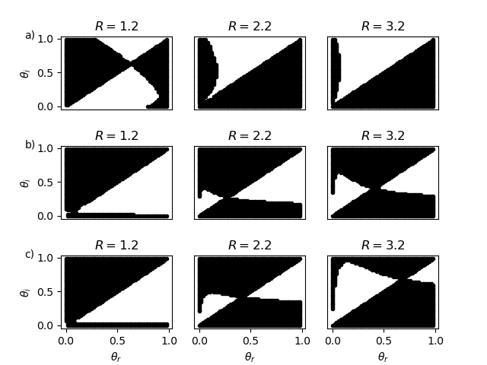
Figure S14: The effects of $R$ with a concave trade-off curve (row a), a convex trade-off curve (row b) and a linear trade-off curve (row c). In linear and convex trade-off curves, the possibility of evolutionary bistability transmission mode is more likely to be present than in the concave trade-off curve. Unless otherwise stated, the parameters used in the making of these plots is: $c=3, h=1, R=1.2, Ξ=0.1, b=0.1, σ=1, η=0.1, Φ=0.05, A=1.2 and B=1.2.$

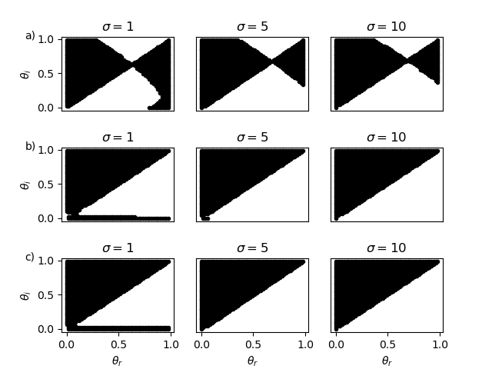
Figure S15: The effects of $σ$ with a concave trade-off curve (row a), a convex trade-off curve (row b) and a linear trade-off curve (row c). In linear and convex trade-off curves, the possibility of evolutionary bistability transmission mode is more likely to be present than in the concave trade-off curve. Unless otherwise stated, the parameters used in the making of these plots is: $c=3, h=1, R=1.2, Ξ=0.1, b=0.1, σ=1, η=0.1, Φ=0.05, A=1.2 and B=1.2.$

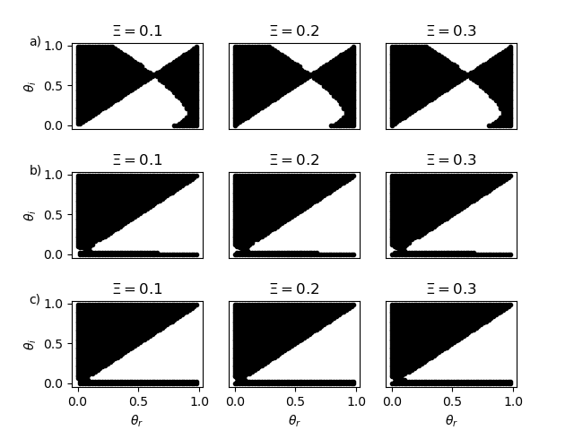
Figure S16: The effects of $Ξ$ with a concave trade-off curve (row a), a convex trade-off curve (row b) and a linear trade-off curve (row c). In linear and convex trade-off curves, the possibility of evolutionary bistability transmission mode is more likely to be present than in the concave trade-off curve. Unless otherwise stated, the parameters used in the making of these plots is: $c=3, h=1, R=1.2, Ξ=0.1, b=0.1, σ=1, η=0.1, Φ=0.05, A=1.2 and B=1.2.$

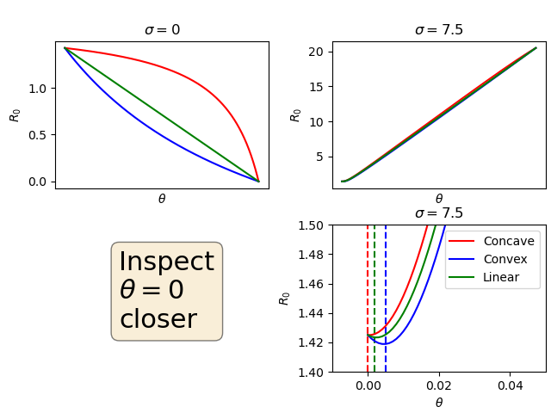
Figure S17: The basic reproduction ratio of the resident system over the parameter space of $θ$. Here we investigate why we saw differing evolutionary dynamics for different trade-off curves used for $α(θ)$. In this example, when there are no plant hosts in the system, $σ=0$, we see a fitness maximum for $θ=0$. When we then introduce plant hosts to the system, we would expect to see this change as horizontal transmission is available. This is indeed seen when we change the planting rate, $σ=7.5$. Now it appears that fitness is maximized for higher $θ$, which in part explains the selection to horizontal transmission seen in the adaptive dynamics; but upon closer inspection we also find is a local fitness maximum for $θ=0$ that exists for convex and linear trade-off curves but not for concave trade-off curves. The minimum value for $R_{0}$ is denoted with vertical dashed lines in the close up, for the concave curve this is at $θ=0$, but for the linear and convex curves the fitness minimum is non-zero for $θ$, implying that two local fitness maximums exist. This may in part explain the altered evolutionary dynamics we see between the concave trade-off curve and the convex and linear trade-off curves: $c=3, h=1, R=1.5, Ξ=0.1, b=0.1, σ=1, η=0.1, Φ=0.05,α_{max}=0.95, β_{1_{max}}=β_{2_{max}}=0.3, A=1.2 and B=1.2.$

References for Appendix
Heffernan, J. M., Smith, R. J., & Wahl, L. M. (2005). Perspectives on the basic reproductive ratio. Journal of the Royal Society, Interface, 2(4), 281-293. Doi:10.1098/rsif.2005.0042

