Supporting information
RNA and protein biomarkers for detecting enhanced metabolic resistance to herbicides mesosulfuron-methyl and fenoxaprop-ethyl in black-grass (Alopecurus myosuroides)
Running title: Herbicide resistance biomarkers in black-grass
Claudia Lowe^{1$†*}, Nawaporn Onkokesung^{2†§}, Alina Goldberg², Roland Beffa³, Paul Neve^{1#}, Robert Edwards², and David Comont¹
1 Protecting Crops and the Environment, Rothamsted Research, Harpenden, Hertfordshire, AL5 2JQ, UK.
² Agriculture, School of Natural and Environmental Sciences, Newcastle University, Newcastle Upon Tyne, NE1 7RU, United Kingdom
³ Senior Scientific Consultant, 65835, Liederbach, Germany
Present Addresses:
$ Royal Botanical Gardens Kew, Richmond, London, TW9 3AE, UK
§ Weed Resistance Research, Bayer AG, 65926, Frankfurt am Main, Germany
# Department of Plant and Environmental Sciences, Section for Crop Sciences, University of Copenhagen, Højbakkegård Allé 13, 2630 Taastrup, Denmark
† Joint first author
* Corresponding Author

Supplementary method
Quantitative real-time PCR
RT-qPCR was performed in Light Cycler 96 system (Roche, United Kingdom) in total volume of 20 µL containning 5 µL of cDNA, 2 µL of 0.5 µM forward primer, 2 µL of 0.5 µM reverse primer, and 10 µL LightCycler FastStart DNA Master SYBR Green I (Roche, United Kingdom). The specific primer sequences are listed in Suppplmentary Table S1. The reactions were run in the three-step programme including metling curve, pre-incubation at 95°C, 3 minutes, amplification for 40 cycles (95°C for 10 seconds, 60°C for 10 seconds and 72°C for 20 seconds minutes), and melting curve analysis from 65°C to 95°C. The reference gene used for normallisation is the blackgrass glycerealdehype-3-phosphate dehydrogenase (AmGAPPH, accession number: JN599100). The relative transcript expression (2^{-ΔΔCt}) was calculated based on Livak and Schimitten, 2001 and Pfalffl, 2001.

Supplementary Table S1 Specific primer sequences for qRT-PCR of 24 candidate genes identified in NTSR in black-grass
Contig | Primer ID | Forward (5’ 3’) | Reverse (5’ 3’)
R00041432 | CYP450s | AAGCACCCCAATGCCTTGT | TCGCGAAGTTCTGCCCTATG
R00030509 | CYP450s | AACCGCGGACGTGATCTC | AGACCTTTTTCCCTTCCGTGTAG
R00027925 | CYP450s | TCCCCTAAGTACGTCCATGC | CTACATCTCCGGGCTCTTCA
R000277289 | Isoflavone hydroxylase | ATGGCTGCATCCACCATGT | AGAGTGACGATGATGGGCAAGTTC
R002332027 | OPR1 | GGTACCTCATCGAGCAGTTCCT | TTTTCAAGGCTACCACCGTACTC
R00052495 | OPR1 | GGGCCGCAGATTAGTTTTGA | GTCATCGACTATCCCGGGAAT
Rm00002116 | OPR1 | ATCCGTCTCTCCCCCTTCAC | TCGTTGAGCACGGTAGACATG
R00029421 | Carboxyl esterase | GGCGACGTCGAGTTCTACGA | AGCTCCTTGGCGGCATTC
R00029215 | Zeatin UGT | GCAGCAAGCAGAGGTTCATCT | TCGCCGGACTCTGCAAAT
R00007921 | GSTU6-like | GCCAACAAGAGCGAGCTTCT | TGGATGAGCACCGGTATCTTC
R00030700 | GSTU6-like | ACTCCCTCGGGTATCTCGATCT | GACCGTCATGCCGAACATC
R00005793 | GSTU6-like | TTTGTCAGCAGGGTGAAACTTG | TTGTGCACCGGGTTGGA
R00096975 | GSTU6-like | TCCCTGGTCATCGTGCAGTA | GGGTCGGAGGAAAGCAATG
R00029476 | GSTF1 | AGCATAAGAGCCCCGAGCAC | CCGTCCTGGAAAGCAGGGATTTG
R00010869 | Aminotransferase | GCATTFCAACCGTTTGTTGT | TGTATCTTCTTTGCCTGGTTGACT
R00029959 | Cellulose synthase | ACGTGGGATTGCGACATGTTC | CAGCAGCAGGCACATAAGCAT
Rm00043661 | ABC transporter | TGTGGTGCAGGAAATGGTATTTT | TGGTCTGCTGCCCTGCAT
R00030815 | MATE transporter | TCCACAACCTCTCTGTGCTG | TGGGAACTCCGACCAAGTAG
R0000345 | Thiol methyl transferase | ACCTCATGTACCTGCCTCAA | TCGAGCACCGTGGTCTTGT
Rm00016513 | Thiol methyl transferase | ACCCTCATGTACCTGCCTCAA | TCGAGCACCGTGGTGTTGT
Rm00004119 | Thiol methyl transferase | CCCTCATGTACCTGCCTCAAG | CATAGTCGAGCACTGTGGTGTTG
R00029303 | Pathogenesis related protein | ACAGTCTCATCAACGAAGTCTTAGCTA | GTGGCGTGTCGAAGTGGAA
R00003857 | Pathogenesis related protein | GCTTCGCCATCGAGGTGAT | GTACCCCAGTGACGGAACTT
R00004163 | Gag-pol retrotransposon | AGATCGTCGAGTATCAACCGTATG | TTTGACGTTCCGCCTTAAGAG
Reference | Glyceraldehype 3 phosphate dehydrogenase | ACTGATCGAACATCTTFATGC | GACCATCCACAGTCTTCTGG

Supplementary Table S2 HPLC gradient timings for mesosulfuron
Time (m) | % Solvent A | % Solvent B
1.0 | 80 | 20
8.0 | 0 | 100
10.0 | 80 | 20

Supplementary Table S3 HPLC gradient timings for fenoxaprop
Time (m) | % Solvent A | % Solvent B
1.0 | 80 | 20
1.5 | 25 | 75
8.0 | 0 | 100
10.0 | 80 | 20

Supplementary Figure S1 Fenoxaprop chromatograms from a susceptible plant (top) or a resistant plant (bottom), fenoxaprop acid retention time is between 5min 8secs and 5min 44secs
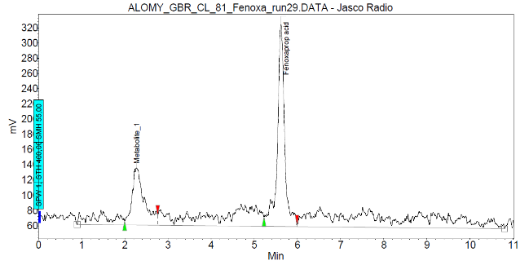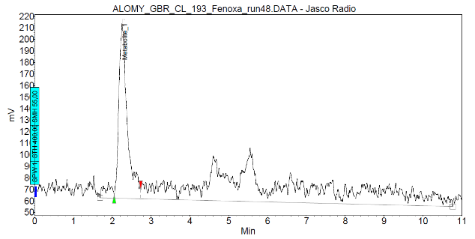

Supplementary Figure S2 Mesosulfuron chromatograms from a susceptible plant (top) or a resistant plant (bottom), mesosulfuron-methyl retention time is between 4min 54secs and 5min 22secs
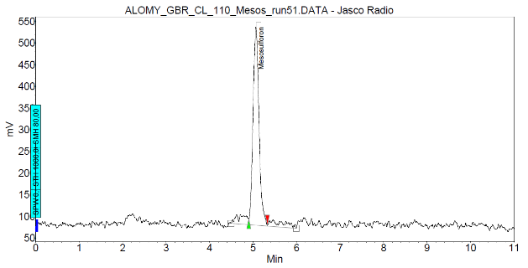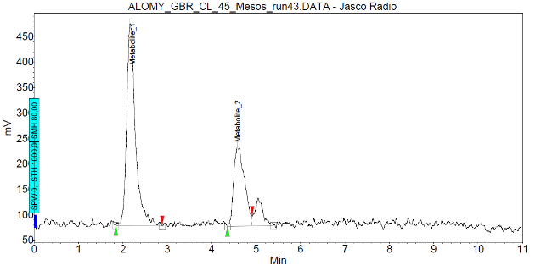

Supplementary Table S4 Specific primer sequences for qRT-PCR of six biomarkers for detection of NTSR in black-grass
Primer ID | Forward (5´ 3´) |  | Reverse (5´ 3´)
AmGSTF1 | CCGAGTACGAGGTGGTGAAC |  | CGTCCTGGAAAGCAGGGATT
AmGSTU2 | TTGACCCCGTTAAGACTCCC |  | GCAAACTCGACCAACCTGTC
AmCYP450 | TTCTCCTTCTCCCTGTCCCC |  | TCAGGACCATGGGAAGACCA
AmOPR1 | TTGAGATCCATGGCGCGAAT |  | CAAGGCTACCACCGTACTCG
AmUGT | GCAGCAAGCAGAGGTTCATCT |  | TCGCCGGACTCTGCAAAT
AmABC |  | TGTGGTGCAGGAAATGGTATTTT | TGGTCTGCTGCCCTGCAT
AmGADPH |  | CCCTCAAGCAAGGACTGGAG | AGCTTGCCATTGAACTCAGGA
AmUBQ |  | AGAAGACCTACACCAAGCCC | AGTAGTGGCGGTCGAAGTG

Supplementary Table S5 qRT-PCR cycling conditions
Step | Temperature °C | Time | No. of cycles
Takyon activation | 95 | 3 min. | 1
Denaturation | 95 | 3 sec. | 40
Annealing | 60 | 15 sec. | 40
Extension | 72 | 15 sec. | 40

Supplementary Table S6 Pyrosequencing conditions and primer sequences for analysis of herbicide target-site mutations
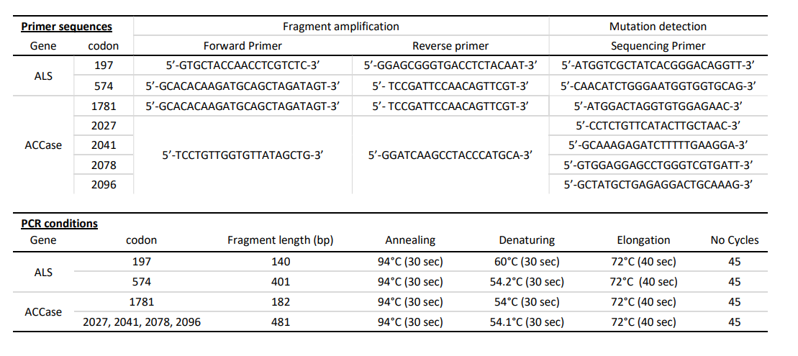

Supplementary Table S7 Linear regression models with basal transcript expression regressed against fenoxaprop acid. The normalised basal expression of each biomarker was used as independent variable to predict the remaining radiolabelled fenoxaprop at 16 h after treatment in black-grass population.
Model | Response variable | Explanatory variable | Estimate | S.E. | N | R² | Adjusted R² | F_{(1,28)} | P-value
1 | Fenoxaprop acid | AmGSTF1 | -0.04 | 0.01 | 30 | 0.37 | 0.35 | 16.67 | <0.001**
2 | Fenoxaprop acid | AmGSTU2 | -0.02 | 0.01 | 30 | 0.18 | 0.15 | 6.24 | <0.001**
3 | Fenoxaprop acid | AmCYP450 | -0.00 | 0.02 | 30 | 0.00 | -0.03 | 0.04 | 0.83
4 | Fenoxaprop acid | AmOPR1 | -0.03 | 0.01 | 30 | 0.29 | 0.26 | 11.24 | 0.002**
5 | Fenoxaprop acid | AmUGT | -0.03 | 0.02 | 30 | 0.02 | -0.01 | 0.64 | 0.43
6 | Fenoxaprop acid | AmABC | 0.01 | 0.03 | 30 | 0.01 | -0.03 | 0.15 | 0.70
** significant difference

Supplementary Table S8 Linear regression models with basal transcript expression regressed against mesosulfuron. The normalised basal expression of each biomarker was used as independent variable to predict the remaining radiolabelled mesosulfuron at 16 h after treatment in black-grass population.
Model | Response variable | Explanatory variable | Estimate | S.E. | N | R² | Adjusted R² | F_{(1,28)} | P-value
1 | Mesosulfuron | AmGSTF1 | -0.06 | 0.04 | 30 | 0.07 | 0.03 | 1.96 | 0.17
2 | Mesosulfuron | AmGSTU2 | -0.08 | 0.04 | 30 | 0.17 | 0.14 | 5.72 | <0.001**
3 | Mesosulfuron | AmCYP450 | -0.04 | 0.07 | 30 | 0.01 | -0.02 | 0.42 | 0.52
4 | Mesosulfuron | AmOPR1 | -0.10 | 0.03 | 30 | 0.23 | 0.25 | 10.62 | 0.003**
5 | Mesosulfuron | AmUGT | -0.12 | 0.07 | 30 | 0.10 | 0.07 | 3.08 | 0.09
6 | Mesosulfuron | AmABC | 0.02 | 0.11 | 30 | 0.00 | -0.03 | 0.03 | 0.86
** significant difference

Supplementary Table S9 Linear regression models with protein expression regressed against fenoxaprop acid. The basal abundance level of each protein biomarker was used as independent variable to predict the remaining radiolabelled fenoxaprop at 16 h after treatment in black-grass population. The ability to significantly predict the metabolism of fenoxaprop of each biomarker gene was based the significant of F-test for linear regression.
Model | Response variable | Explanatory variable | Estimate | S.E. | N | R² | Adjusted R² | F_{(1,28)} | P-value
1 | Fenoxaprop acid | AmGSTF1 | -0.00045 | 0.00014 | 30 | 0.27 | 0.25 | 10.53 | 0.003**
2 | Fenoxaprop acid | AmGSTU2 | -0.00017 | 0.000041 | 30 | 0.38 | 0.36 | 17.15 | <0.001**
3 | Fenoxaprop acid | AmOPR1 | -0.17 | 0.070 | 30 | 0.17 | 0.14 | 5.67 | 0.02**
** significant difference

Supplementary Table S10 Linear regression models with protein expression regressed against mesosulfuron. The basal abundance level of each protein biomarker was used as independent variable to predict the remaining radiolabelled mesosulfuron at 16 h after treatment in black-grass population.
Model | Response variable | Explanatory variable | Estimate | S.E. | N | R² | Adjusted R² | F_{(1,28)} | P-value
1 | Mesosulfuron | AmGSTF1 | -0.0016 | 0.00052 | 30 | 0.26 | 0.23 | 11.96 | 0.002**
2 | Mesosulfuron | AmGSTU2 | -0.00056 | 0.00016 | 30 | 0.31 | 0.28 | 14.31 | <0.001**
3 | Mesosulfuron | AmOPR1 | 0.040 | 0.28 | 30 | 0.020 | 0.89 | 0.02 | 0.89
** significant difference

