Running head: Revisiting the loss-on-ignition method
Converting loss-on-ignition to organic carbon content in arable topsoil: Pitfalls and proposed procedure
J. L. JENSENª, B. T. CHRISTENSENª, P. SCHJØNNINGª, C. W. WATTS^{b}, L. J. MUNKHOLMª
ªDepartment of Agroecology, Aarhus University, AU-Foulum, 8830 Tjele, Denmark
^{b}Department of Sustainable Agriculture Sciences, Rothamsted Research, Harpenden, Hertfordshire AL5 2JQ, UK
Correspondence: J. L. JENSEN. E-mail: jlj@agro.au.dk
Summary
Assessments of changes in soil organic carbon (SOC) stocks depend heavily on reliable SOC concentration values as obtained by automated high-temperature C analysers. However, historical as well as current studies often rely on indirect SOC estimates such as loss-on-ignition (LOI). In this study, we revisit the conversion of LOI to SOC using soil from two long-term agricultural field experiments and one arable field differing in contents of SOC, clay and particles < 20 µm (Fines20). Clay-, silt- and sand-sized fractions were isolated from the arable soil. Samples were analysed for texture, LOI (500 ºC for 4 h) and SOC by dry combustion. For a topsoil with 2 g C and 30 g clay 100 g⁻¹ converting LOI to SOC by the conventional factor 0.58 overestimated the SOC stock by 45 Mg C ha⁻¹. The error increased with increasing contents of clay and Fines20. Converting LOI to SOC by a regression model underestimated the SOC stock by 5 Mg C ha⁻¹ at low clay and Fines20 contents and overestimated the SOC stock by 8 Mg C ha⁻¹ at high contents. This was due to losses of structural water from clay minerals. The best model to convert LOI to SOC incorporated clay content. Evaluating this model against an independent data set gave a root mean square error and mean error of 0.295 and 0.125 g C 100 g⁻¹, respectively. To avoid misleading accounts of SOC stocks in agricultural soils, we recommend re-analysis of archived soil samples for SOC using high-temperature dry combustion methods. Where archived samples are not available, accounting for clay content improves conversion of LOI to SOC considerably. The use of the conventional conversion factor 0.58 is antiquated and provides misleading estimates of SOC stocks.
Highlights
- Assessment of SOC concentrations is often based on less accurate methods such as LOI.
- Reliable accounts of changes in SOC stocks remain high on the agenda (4 ‰ initiative).
- Conversion of LOI to SOC is considerably improved by accounting for clay content.
- Converting LOI to SOC by the conventional factor 0.58 leads to grossly overestimated SOC stocks.
Introduction
Accounting for changes in soil organic carbon (SOC) induced by changes in climate, land use and soil management remains high on the agenda as exemplified by the 4 per mille initiative launched at the recent COP-21 conference in Paris (Minasny et al., 2017). This global research initiative aims at a relative annual increase in SOC of 0.4 percent in the top 40 cm soil. Changes in SOC stocks occur slowly and over long periods, therefore verification of changes involves present as well as historical accounts of SOC. Verification of changes in SOC stocks on global scales are not always well described in terms of sources of SOC concentration data and methods used for determination of SOC (Stockmann et al., 2015; Hengl et al., 2017). Accurate and precise determination of SOC concentrations is fundamental for reliable estimates of SOC stocks (Goidts et al., 2009; Conant et al., 2011; Schrumpf et al., 2011) this can be obtained by automated, high-temperature dry combustion methods (Chatterjee et al., 2009).
However, loss-on-ignition (LOI) remains a widely used method for assessing SOC in agricultural and forest soils with LOI being converted to SOC either by a fixed conversion factor or by regression analyses (Konen et al., 2002; De Vos et al., 2005; Salehi et al., 2011; Reynolds et al., 2013; Wetterlind et al., 2015). The basic assumption is that LOI is due only to combustion of soil organic matter (SOM) and that the concentration of SOC in SOM is constant (Christensen & Malmros, 1982). No standard protocol exists for LOI analysis, but it is well documented that LOI is affected by ignition temperature, duration of ignition and ignited sample mass (Abella & Zimmer, 2007; Salehi et al., 2011; Hoogsteen et al., 2015). Further, structural water loss (SWL) from soil minerals may contribute significantly to LOI (Sun et al., 2009; Hoogsteen et al., 2015) and the validity of the conventional LOI-to-SOC conversion factor of 0.58 although widely used, remains dubious (Pribyl, 2010). When LOI and SOC are both measured, regression models for converting LOI to SOC have been proposed (Grewal et al., 1991; De Vos et al., 2005; Abella & Zimmer, 2007). Regression models based on less accurate analytical approaches such as dichromate oxidation/titration and soils with confounding effects from differences in clay mineralogy have been found to be less reliable (Howard & Howard, 1990).
In our current research attempting to define critical low SOM contents for soil structural properties based on the clay (< 2 µm)/SOC and particles < 20 µm (Fines20)/SOC ratios (Schjønning et al., 2012; Getahun et al., 2016; Jensen et al., 2017a), it is essential to have access to reliable SOC concentration values. As a spin-off from this research, we revisited the conversion of LOI to SOC. Data for temperate zone arable topsoil with different contents of SOC were collected from long-term agricultural field experiments with contrasting management at Askov (Denmark) and Rothamsted (UK), and from a texture gradient in a farmer’s field at Lerbjerg (Denmark) with uniform management and mineralogy. These fields had large ranges in LOI, SOC, clay and Fines20 making them rather representative for arable soils with respect to these properties. We also included clay-, silt- and sand-sized fractions isolated from Lerbjerg soils.

Materials and methods
Rothamsted Highfield Ley-Arable Experiment
Soil texture and SOC data for the Highfield Experiment at Rothamsted Research, UK (51°80’N, 00°36’W) were extracted from Jensen et al. (2017b). This experiment is on a silt loam soil belonging to the Batcombe series, the parent material including silty (loess-containing) deposit overlying and mixed with clay-with-flints (Avery & Catt, 1995). The soil was classified as an Aquic Paludalf (USDA Soil Taxonomy System) and Chromic Luvisol (WRB). The clay fraction is dominated by smectite, mica and kaolinite with traces of feldspar, chlorite and crystalline and amorphous ferric oxides (Avery & Catt, 1995). Bulk soil was retrieved in spring 2015 from the 6-15 cm layer of four different treatments: Bare fallow maintained free of vegetation since 1959; Arable rotation with winter cereals (winter wheat (Triticum aestivum L.) and winter oat (Avena sativa L.)) since 1948; Ley-arable rotation with three-year grass/clover ley (meadow fescue (Festuca pratensis L.), timothy-grass (Phleum pratense L.) and white clover (Trifolium repens L.)) followed by three years arable (managed as arable rotation) since 1948; Grassland ploughed and reseeded to grass (predominantly rye grass, Lolium perenne L.) in 1948. Soil was sampled from three positions within each of four replicate plots providing 48 samples. Jensen et al. (2017b) provide further details.
Askov Long-Term Experiment on Animal Manure and Mineral Fertilizers (Askov-LTE)
Data on soil texture and SOC for the Askov-LTE in southern Denmark (55°28’N, 09°07’E) were retrieved from Jensen et al. (2017a). This experiment was established in 1894 on a sandy loam soil, the parent material being terminal morainic deposits from the Weichselian glaciation. The soil was classified as an Ultic Hapludalf (USDA Soil Taxonomy System) and Aric Haplic Luvisol (WRB). The clay fraction is dominated by illite, kaolinite, quartz and smectite with traces of vermiculite, Al-Fe-oxyhydroxides, feldspar and chlorite. Following harvest of winter wheat (Triticum aestivum L.), bulk soil was sampled in autumn 2014 from the 6-15 cm layer of four different treatments in the B5-field: Unfertilized; ½ mineral fertilizer (since 1923); 1 mineral fertilizer; 1½ animal manure. Nutrient addition rate 1 corresponds to 150 kg total-N ha⁻¹, 30 kg P ha⁻¹ and 120 kg K ha⁻¹. Three replicate plots of each treatment were sampled providing 12 samples. Further details are given in Jensen et al. (2017a).
Lerbjerg Textural Gradient
Soil was sampled from a naturally occurring textural gradient located in an arable field at Lerbjerg, Denmark (56°22’N, 09°59’E). The Lerbjerg field has a uniform parent material (Weichselian morainic deposits), but varies widely in both texture and SOC concentration. The clay fraction is dominated by illite, smectite and vermiculite with traces of kaolinite, quartz and feldspar (Schjønning et al., 1999). Bulk soil from the 5-10 cm layer was sampled in autumn 2015 at 16 locations along the texture gradient following harvest of oil-seed rape (Brassica napus L.).
Lerbjerg Soil Particle Size Fractions
Archived samples of soil particle-size fractions from Lerbjerg (Schjønning & de Jonge, 1999) were used to estimate soil mineral structural water loss (SWL) from clay- (< 2 μm), silt- (2-63 μm) and sand-sized (63-2000 μm) soil components. Soil samples were fully dispersed using an ultrasonic probe (300 W for 15 min) and the size fractions isolated by a combination of sedimentation in water and dry sieving. Schjønning & de Jonge (1999) describe the protocol for particle size fractionation in detail.
Determination of Clay, Silt, Loss-on-Ignition and Soil Organic Carbon
Clay (< 2 μm) and silt (2-20 μm) contents of air-dried soil (< 2 mm) were determined with the hydrometer method for Highfield and Askov, and with the pipette method for Lerbjerg, both described by Gee & Or (2002). Samples for determination of clay and silt were treated with hydrogen peroxide to remove SOM. The presence of carbonates was tested by adding a few droplets of 10% HCl, but none was found. LOI was determined on the oven-dried subsamples of bulk soil and soil size fractions. Five grams air-dry soil was added to previously ignited and weighed porcelain crucibles, dried at 105 °C for 24 h in a ventilated oven, cooled in a desiccator and weighed again. Residual water content (RWC) was calculated as the difference between the air-dry and oven-dry weight and related to oven-dry soil. Finally, the crucibles were ignited at 500 °C for 4 h in a muffle furnace (Thermolyne Largest Tabletop Muffle Furnace, Thermo Fisher Scientific, Waltham, Massachusetts, USA). After ignition, the crucibles were cooled in a desiccator and weighed. The LOI was calculated as the difference between the oven-dry weight before and after ignition and related to oven-dry soil. The SOC content was determined by high-temperature dry combustion using ball-milled subsamples of air-dried soil (< 2 mm). A Thermo Flash 2000 NC Soil Analyser (Thermo Fisher Scientific, Waltham Massachusetts, USA) was used for soil size fractions from Lerbjerg and bulk soil from Highfield and Askov, while an ELTRA Helios C-Analyser (ELTRA GmbH, Germany) was used for bulk soil from Lerbjerg. Results for SOC, LOI and soil size fractions are expressed as g 100 g⁻¹ oven-dry soil (105 °C for 24 h). The combined fraction of clay plus silt (particles < 20 μm) is denoted Fines20.
Evaluation data set
The regression model developed to convert LOI to SOC was evaluated using a study reporting data on LOI-450 (450°C for 5 h), LOI-550 (550°C for 5 h), SOC (high-temperature dry combustion) and clay content (Grewal et al., 1991). This study was used since they focused on arable soil, measured SOC by high-temperature dry combustion, reported clay content, used a LOI protocol close to ours, and reported raw data in tabulated form. The study was based on 40 samples from cultivated soils and grasslands in New Zealand, including topsoil and subsoils. The samples were from eight different fields of which five differed in parent material. Since our study was based solely on data from topsoil, subsoil samples (>35 cm depth) in the evaluation dataset were not considered, reducing the evaluation dataset to 31 samples. This subset of data ranged in SOC, clay, LOI-450, and LOI-550 from 0.75 to 6.33, 17 to 57, 2.64 to 15.19 and 3.35 to 15.94 g 100 g⁻¹, respectively.
Statistics
Linear regression was applied using the R-project software package Version 3.1.1 (R Foundation for Statistical Computing). The Variance Inflation Factor (VIF) was calculated when more than one predictor was used in the regression. VIF expresses the degree of multicollinearity among the predictors. The upper threshold value for non-erroneous conclusions from multiple regressions has been set to 5 (Rogerson, 2001) or 10 (Kutner et al., 2004). For models with more than one predictor and an intercept term, the adjusted coefficient of determination (R²) is reported. R² was calculated as 1-SS_{res}/SS_{tot} for models without intercept, where SS_{res} is from the model without intercept and SS_{tot} from the model with intercept. Akaike’s Information Criterion (AIC) was used to compare models with different numbers of parameters (Akaike, 1973). A smaller or more negative AIC indicates better model performance. The root mean square error (RMSE) and mean error (ME) were calculated to evaluate model performance:
$\text{RMSE=}\sqrt{\frac{1}{m}\sum_{i=1}^{m}{d_{i}^{2}}}$ (1)
$\text{ME=}\frac{1}{m}\sum_{i=1}^{m}{d_{i}}$ (2)
where d_{i} is the difference between the predicted and measured SOC content and m is the sample size.
Results
The soils differed in SOC content due to long-term contrasting management at Highfield and Askov, and soil topography at Lerbjerg (Table 1). Clay and Fines20 contents varied little at Highfield and Askov, whereas samples from Lerbjerg reflected the wide texture gradient.
The VIF, calculated for the combination of LOI and clay, was 1.02, 1.18 and 6.83 for Highfield, Askov and Lerbjerg, respectively. For LOI and Fines20, the corresponding VIF was 1.00, 1.06 and 6.58. Although the use of VIF threshold values has been questioned (O’Brien, 2007), the degree of multicollinearity among predictors in the regressions was small for Highfield and Askov and allowed using both in the regression analysis. We recognize that the VIF value for Lerbjerg was on the limit of multicollinearity.
The RWC ranged from 0.9 to 6.2 g 100 g⁻¹ oven-dry soil and increased linearly with increasing contents of SOC and clay content (data not shown). For the soil with the highest content of clay (69 g clay 100 g⁻¹) and SOC (4.14 g C 100 g⁻¹), neglecting the correction for RWC underestimates SOC by 0.26 g C 100 g⁻¹.
There was a strong positive relationship between LOI and SOC (SOC = 0.39 x LOI – 0.28; Figure 1). Generally, the sandy soils are above the regression line, whereas the clayey soils are below. The clay (<2 μm), silt (2-63 μm) and sand (63-2000 μm) fractions were not included in the linear regression. They are used only for determination of SWL.
Table 2 shows the results from tests of various linear models of the relation between SOC and LOI, clay and Fines20. Fines20 was tested in addition to clay because silt-sized separates also may contain clay minerals. The interaction between LOI and clay for the individual sites was not significant (Highfield: P=0.995, Askov: P=0.193, Lerbjerg: P=0.301). Similarly the interaction between LOI and Fines20 was not significant (Highfield: P=0.125, Askov: P=0.248, Lerbjerg: P=0.086). Quadratic clay or Fines20 terms were not significant, when included in the models for Highfield (clay²: P=0.937, Fines20²: P=0.581) and Lerbjerg (clay²: P=0.439, Fines20²: P=0.137). For Askov the quadratic clay term was not significant (clay²: P=0.439). However, the quadratic Fines20 term was significant (Fines20²: P=0.009), but the homoscedasticity assumption for the linear regression model was not fulfilled, so the quadratic term was not included in the model. When the intercept of a given model was non-significant, it was disregarded and the regression forced through the origin. In general, the regression coefficient for LOI was positive while clay and Fines20 showed negative regression coefficients when both LOI and clay or Fines20 were included in the models. The best model for each site was taken as the model with the largest R² and smallest AIC. If the intercept was non-significant, the model without intercept was selected as the best model. Models differing < 2 in AIC values are not considered significantly different (Burnham & Anderson, 2002). The best models for Highfield included clay, whereas the best models for Askov and Lerbjerg included Fines20. In order to find the best overall model based on data from all three sites, a model including a linear effect of LOI and clay was tested. However, this model was not able to capture the residuals for the individual sites, and the residual plot revealed that a quadratic clay term was needed. Thus, the best overall model included a quadratic clay expression (model O2.1, Table 3):
SOC = 0.513 LOI – (0.047 Clay – 0.00025 Clay²) (3)
The inclusion of clay as a predictor increased the explained variation by 7 % compared to the simpler model including LOI only (Table 3). The model including Fines20 (O3, Table 3) was almost as good as the model including clay. The interaction term in the models was not significant (O2.1: P=0.172, O3: P=0.991). The clay and Fines20 models predict SOC with RMSE of only 0.101 and 0.114 g C 100 g⁻¹, respectively, and the predicted versus measured SOC corresponded closely to the 1:1 line (Figure 2).
The mineral structural water loss (SWL) was estimated by calculating the SOC content as LOI x 0.513 (Eq. 3) and then subtracting the measured SOC content. SWL from Lerbjerg clay (<2 μm), silt (2-63 μm) and sand (63-2000 μm) fractions was 2.11, 0.45 and 0.08 g 100 g⁻¹, respectively, with standard deviations of 0.10, 0.18 and 0.04 g 100 g⁻¹. The SWL was mainly from the clay fraction, emphasizing the need to include clay or Fines20 in the regression models. When using the conventional conversion factor of 0.58, the overestimation of SOC increased significantly with increasing contents of clay (Figure 3a) and Fines20 (Figure 3b).
For soils high in clay and Fines20, the SOC concentration was overestimated by up to 2.86 g C 100 g⁻¹. Predicting SOC from LOI by a regression model overestimated SOC at high clay and Fines20 contents, and underestimated SOC at low contents (Figure 3c and 3d). Clay and Fines20 had a significant effect on overestimation of SOC for Highfield (clay: R²=0.46, P<0.001; Fines20: R²=0.39, P<0.001) and for all sites (clay: R²=0.31, P<0.001; Fines20: R²=0.33, P<0.001). Fines20 had a significant effect on overestimation of SOC for Askov (R²=0.42, P<0.022). When the regression model was based on LOI only (O1, Table 3), SOC was underestimated by 0.37 g C 100 g⁻¹ and overestimated by 0.81 g C 100 g⁻¹ for soils with 9 and 73 g clay 100 g⁻¹, respectively. The systematic error disappeared when quadratic clay or Fines20 expressions were included in combination with LOI (Figure 3e and 3f). The best overall model including LOI and a quadratic clay expression (Eq. 3) predicted SOC with an RMSE of 0.101 g C 100 g⁻¹ (Figure 2a).
The data extracted from Grewal et al. (1991) for evaluation did not include silt contents and was used only to evaluate the model including the quadratic clay expression (Eq. 3). The range in LOI and SOC contents in the evaluation soils was similar to that of our soils, whereas the range in clay was smaller. Prediction accuracy and bias of Eq. 3 were better when using the dataset based on LOI-450 (RMSE=0.295, ME=0.125) than when using that based on LOI-550 (RMSE=0.402, ME=0.348). SOC in the evaluation soils was predicted with an accuracy of ±0.295 g C 100 g⁻¹ at 450 °C with Eq. 3 and this model had similar predictive capability for low and high contents of LOI and clay (Figure 4).
Discussion
Pitfalls
Historical as well as recent estimates of SOC have relied on less accurate analytical approaches such as dichromate oxidation/titration and LOI (Bellamy et al., 2005; Xie et al., 2007; Reynolds et al., 2013; Aitkenhead & Coull, 2016). Although these methods involve conversion factors of uncertain scientific foundation (Lettens et al., 2007; Pribyl, 2010), they have recently been reported unreservedly as methods for SOC analysis in the Soil Organic Carbon Mapping manual issued by UN-FAO (Olmedo et al., 2017).
In accordance with Poeplau et al. (2015), we found that correcting for RWC is critical to avoid a systematic underestimation of SOC. Without correction for RWC, the SOC stock will be underestimated by 2 Mg C ha⁻¹ for a topsoil (0-20 cm depth) with a bulk density of 1.5 g cm⁻³, 2 g C and 30 g clay 100 g⁻¹. Converting LOI data by multiplication with the conventional conversion factor 0.58 (Figure 3a and 3b) overestimates the SOC stock by 45 Mg C ha⁻¹ for the same soil. Predicting SOC from LOI with regression model O1 (Table 3) underestimates the SOC stock by 5 Mg C ha⁻¹ for a soil low in clay content (10 g 100 g⁻¹) and overestimates the SOC stock by 8 Mg C ha⁻¹ for a soil high in clay content (50 g 100 g⁻¹). Predicting SOC content from LOI by a regression model that accounts for clay increases the SOC stock accuracy to ±3 Mg C ha⁻¹ regardless of the clay or Fines20 content. The prediction accuracy could be compared with management-induced differences in SOC sequestration in an agricultural context, which vary from 0.1 to 1.0 Mg C ha⁻¹ year⁻¹ (Paustian et al., 2016), illustrating that if LOI data is used uncritically the error in the SOC estimate can easily exceed any management induced difference even when adjusted for SWL and RWC. Our study was restricted to arable topsoil from the temperate zone with clay and SOC concentrations ranging from 9 to 73 and 0.78 to 4.14 g 100 g⁻¹ soil, respectively. Thus, the relationships established with the dataset may not be valid for soils under different land use, with different clay mineralogy, subsoils, soils rich in carbonates, and soils with clay and SOC concentrations outside these ranges (Christensen & Malmros, 1982; Jolivet et al., 1998).
Proposed Procedure
Previous studies have shown that if clay content was included in the prediction of SOC by LOI the explained variance was increased (Grewal et al., 1991; De Vos et al., 2005; Abella & Zimmer, 2007) corroborating our findings. The difference in the regression coefficients for clay or Fines20 between sites (Table 2) could possibly be due to differences in clay mineralogy causing differences in structural bound water. The higher regression coefficient for clay at Highfield than Lerbjerg may relate to a higher content of kaolinite in the clay fraction from Highfield. Kaolinite shows a high-water loss when ignited at 550 °C for 4 h (Sun et al., 2009). The presence of negative intercepts for Lerbjerg both when including clay and Fines20 (Table 2) may be related to other losses than SOM and mineral structural water loss, e.g. certain salts or free iron (Pribyl, 2010). The models including clay or Fines20 accounted for structural water loss from clay minerals (Sun et al., 2009), which improved the models substantially.
For all sites, the models accounting for clay or Fines20 improved the conversion of LOI to SOC compared to models based on LOI alone. Eq. 3 included a quadratic clay expression, which can be interpreted as a decreasing clay effect with increasing clay content. Similarly, Spain et al. (1982) included a quadratic clay expression in their prediction model. However, the mechanisms behind are not clear, and further studies are needed to elucidate the observation. The regression model based on our Danish and British soils (Eq. 3) was able to predict the SOC concentrations in New Zealand soils with satisfactory accuracy (LOI-450: RMSE=0.295, LOI-550: RMSE=0.402). Differences in temperature, sample size, clay mineralogy and SOM characteristics between the validation data set and our data set may affect model performance.
Where archived soil samples are available, SOC should be determined directly by high-temperature dry combustion methods with detection of evolved CO₂ by infrared or thermal conductivity detectors. However, Arrouays et al. (2012) conclude that some 40 % of the monitoring programs in the European Union do not archive soil samples. Where LOI has been used to estimate SOC concentrations and soil samples are no longer available, Eq. 3 provides more reliable estimates of SOC stocks for agricultural topsoil provided that LOI data are accompanied by information on soil texture. Eq. 3 is valid for conversion of LOI data that meet the following criteria: Ignition temperature of approximately 500 °C, ignition duration of 3-6 hours and preferably a sample mass of at least 5 g soil. Additional studies including a wider range of soil types will increase the applicability of Eq. 3.
The regression coefficient for LOI, interpreted as SOM, was similar for all sites when the regression equation accounted for effects of clay or Fines20 (Table 2). The regression coefficient ranged from 0.45-0.52 (= 45 to 52 % SOC in SOM), substantiating that the conventional conversion factor of 0.58 is too high (Pribyl, 2010). Nevertheless, the so-called van Bemmelen factor of 1.724 (1/0.58) is still used to convert SOC to SOM (Olmedo et al. 2017). The SOC to SOM conversion factor for Highfield, Askov, and Lerbjerg was 1.92, 2.02, and 1.94, respectively. Estimating the conversion factor based on all soils gave 1.92. In line with previous reports (Christensen & Malmros, 1982; Abella & Zimmer, 2007; Chatterjee et al., 2009; Pribyl, 2010), we conclude that the conventional LOI-to-SOC conversion factor 0.58 is antiquated and leads to grossly overestimated SOC concentrations and misleading accounts of SOC stocks.
We acknowledge that other potential sources of error in addition to the accuracy of the analytical approach have to be considered when estimating SOC stocks. These potential error sources include sampling design and intensity, information on the depth of the respective soil layers, and adjustment for stone content and bulk density (Poeplau et al., 2017). However, precise estimates of SOC concentrations remain a key issue when establishing credible accounts of SOC stocks (Goidts et al., 2009; Schrumpf et al., 2011).
Acknowledgements
We gratefully acknowledge Trine Nørgaard (Department of Agroecology, Aarhus University) for getting access to the soil samples from Lerbjerg. The Rothamsted Long-term Experiments National Capability (LTE-NCG) is supported by the UK BBSRC (Biotechnology and Biological Sciences Research Council) and the Lawes Agricultural Trust.
References
Abella, S. R. & Zimmer, B. W. 2007. Estimating organic carbon from loss-on-ignition in northern Arizona forest soils. Soil Science Society of America Journal, 71, 545-550.
Aitkenhead, M. J. & Coull, M. C. 2016. Mapping soil carbon stocks across Scotland using a neural network model. Geoderma, 262, 187-198.
Akaike, H. 1973. Information theory and an extension of the maximum likelihood principle. In Second International Symposium in Information Theory, B. N. Petrov & F. Cáski, 267-281, Budapest: Akadémiai Kiadó.
Arrouays, D., Marchant, B. P., Saby, N. P. A., Meersmans, J., Orton, T. G., Martin, M. P. et al. 2012. Generic issues on broad-scale soil monitoring schemes: A review. Pedosphere, 22, 456-469.
Avery, B. W. & Catt, J. A. 1995. The soils at Rothamsted. Lawes Agricultural Trust, Harpenden, 1-44.
Bellamy, P. H., Loveland, P. J., Bradley, R. I., Lark, R. M. & Kirk, G. J. D. 2005. Carbon losses from all soils across England and Wales 1978-2003. Nature, 437, 245-248.
Burnham, K. P. & Anderson, D. R. 2002. Model selection and multimodel inference: a practical information-theoretic approach: Springer-Verlag.
Chatterjee, A., Lal, R., Wielopolski, L., Martin, M. Z. & Ebinger, M. H. 2009. Evaluation of different soil carbon determination methods. Critical Reviews in Plant Sciences, 28, 164-178.
Christensen, B. T. & Malmros, P. 1982. Loss-on-ignition and carbon content in a beech forest soil profile. Holarctic Ecology, 5, 376-380.
Conant, R. T., Ogle, S. M., Paul, E. A. & Paustian, K. 2011. Measuring and monitoring soil organic carbon stocks in agricultural lands for climate mitigation. Frontiers in Ecology and the Environment, 9, 169-173.
De Vos, B., Vandecasteele, B., Deckers, J. & Muys, B. 2005. Capability of loss-on-ignition as a predictor of total organic carbon in non-calcareous forest soils. Communications in Soil Science and Plant Analysis, 36, 2899-2921.
Gee, G. W. & Or, D. 2002. Particle-size analysis. In Methods of Soil Analysis. Part 4 - Physical methods, J. H. Dane & G. C. Topp, 255-294, Soil Science Society of America, Inc. Madison, Wisconsin, USA.
Getahun, G. T., Munkholm, L. J. & Schjønning, P. 2016. The influence of clay-to-carbon ratio on soil physical properties in a humid sandy loam soil with contrasting tillage and residue management. Geoderma, 264 Part A, 94-102.
Goidts, E., Van Wesemael, B. & Crucifix, M. 2009. Magnitude and sources of uncertainties in soil organic carbon (SOC) stock assessments at various scales. European Journal of Soil Science, 60, 723-739.
Grewal, K. S., Buchan, G. D. & Sherlock, R. R. 1991. A comparison of three methods of organic carbon determination in some New Zealand soils. Journal of Soil Science, 42, 251-257.
Hengl, T., Mendes de Jesus, J., Heuvelink, G. B. M., Ruiperez Gonzalez, M., Kilibarda, M., Blagotić, A. et al. 2017. SoilGrids250m: Global gridded soil information based on machine learning. PLoS ONE, 12, e0169748.
Hoogsteen, M. J. J., Lantinga, E. A., Bakker, E. J., Groot, J. C. J. & Tittonell, P. A. 2015. Estimating soil organic carbon through loss on ignition: effects of ignition conditions and structural water loss. European Journal of Soil Science, 66, 320-328.
Howard, P. J. A. & Howard, D. M. 1990. Use of organic carbon and loss-on-ignition to estimate soil organic matter in different soil types and horizons. Biology and Fertility of Soils, 9, 306-310.
Jensen, J. L., Schjønning, P., Christensen, B. T. & Munkholm, L. J. 2017a. Suboptimal fertilisation compromises soil physical properties of a hard-setting sandy loam. Soil Research, 55, 332-340.
Jensen, J. L., Schjønning, P., Watts, C. W., Christensen, B. T. & Munkholm, L. J. 2017b. Soil texture analysis revisited: Removal of organic matter matters more than ever. PLoS ONE, 12, e0178039.
Jolivet, C., Arrouays, D. & Bernoux, M. 1998. Comparison between analytical methods for organic carbon and organic matter determination in sandy Spodosols of France. Communications in Soil Science and Plant Analysis, 29, 2227-2233.
Konen, M. E., Jacobs, P. M., Burras, C. L., Talaga, B. J. & Mason, J. A. 2002. Equations for predicting soil organic carbon using loss-on-ignition for north central U.S. soils. Soil Science Society of America Journal, 66, 1878-1881.
Kutner, M. H., Nachtsheim, C. & Neter, J. 2004. Applied Linear Regression Models. New York: McGraw-Hill.
Lettens, S., De Vos, B., Quataert, P., Van Wesemael, B., Muys, B. & Van Orshoven, J. 2007. Variable carbon recovery of Walkley-Black analysis and implications for national soil organic carbon accounting. European Journal of Soil Science, 58, 1244-1253.
Minasny, B., Malone, B. P., McBratney, A. B., Angers, D. A., Arrouays, D., Chambers, A. et al. 2017. Soil carbon 4 per mille. Geoderma, 292, 59-86.
O’Brien, R. M. 2007. A caution regarding rules of thumb for variance inflation factors. Quality & Quantity, 41, 673-690.
Olmedo, G. F., Baritz, R. & Yigini, Y. 2017. Preparation of local soil property data. In Soil organic carbon mapping cookbook, Y. Yigini, R. Baritz, & R. R. Vargas, 3-19, Rome, Italy: Food and Agriculture Organization (FAO) of the United Nations.
Paustian, K., Lehmann, J., Ogle, S., Reay, D., Robertson, G. P. & Smith, P. 2016. Climate-smart soils. Nature, 532, 49-57.
Poeplau, C., Eriksson, J. & Kätterer, T. 2015. Estimating residual water content in air-dried soil from organic carbon and clay content. Soil and Tillage Research, 145, 181-183.
Poeplau, C., Vos, C. & Don, A. 2017. Soil organic carbon stocks are systematically overestimated by misuse of the parameters bulk density and rock fragment content. SOIL, 3, 61-66.
Pribyl, D. W. 2010. A critical review of the conventional SOC to SOM conversion factor. Geoderma, 156, 75-83.
Reynolds, B., Chamberlain, P. M., Poskitt, J., Woods, C., Scott, W. A., Rowe, E. C. et al. 2013. Countryside survey: National “soil change” 1978–2007 for topsoils in Great Britain—Acidity, carbon, and total nitrogen status. Vadose Zone Journal, 12, 1-15.
Rogerson, P. A. 2001. Statistical Methods for Geography: SAGE Publications.
Salehi, M. H., Beni, O. H., Harchegani, H. B., Borujeni, I. E. & Motaghian, H. R. 2011. Refining soil organic matter determination by loss-on-ignition. Pedosphere, 21, 473-482.
Schjønning, P. & de Jonge, H. 1999. Experimental test of the applicability of a multisensor photo-sedimentation technique for the measurement of soil particle size distributions. Communications in Soil Science and Plant Analysis, 30, 1773-1788.
Schjønning, P., de Jonge, L. W., Munkholm, L. J., Moldrup, P., Christensen, B. T. & Olesen, J. E. 2012. Clay dispersibility and soil friability—Testing the soil clay-to-carbon saturation concept. Vadose Zone Journal, 11, 174-187.
Schjønning, P., Thomsen, I. K., Møberg, J. P., de Jonge, H., Kristensen, K. & Christensen, B. T. 1999. Turnover of organic matter in differently textured soils: I. Physical characteristics of structurally disturbed and intact soils. Geoderma, 89, 177-198.
Schrumpf, M., Schulze, E. D., Kaiser, K. & Schumacher, J. 2011. How accurately can soil organic carbon stocks and stock changes be quantified by soil inventories? Biogeosciences, 8, 1193-1212.
Spain, A. V., Probert, M. E., Isbell, R. F. & John, R. D. 1982. Loss-on-Ignition and the Carbon Contents of Australian Soils. Australian Journal of Soil Research, 20, 147-152.
Stockmann, U., Padarian, J., McBratney, A., Minasny, B., de Brogniez, D., Montanarella, L. et al. 2015. Global soil organic carbon assessment. Global Food Security, 6, 9-16.
Sun, H., Nelson, M., Chen, F. & Husch, J. 2009. Soil mineral structural water loss during loss on ignition analyses. Canadian Journal of Soil Science, 89, 603-610.
Wetterlind, J., Piikki, K., Stenberg, B. & Söderström, M. 2015. Exploring the predictability of soil texture and organic matter content with a commercial integrated soil profiling tool. European Journal of Soil Science, 66, 631-638.
Xie, Z., Zhu, J., Liu, G., Cadisch, G., Hasegawa, T., Chen, C. et al. 2007. Soil organic carbon stocks in China and changes from 1980s to 2000s. Global Change Biology, 13, 1989-2007.

FIGURE CAPTIONS
Figure 1 Soil organic carbon (SOC) as a function of loss on ignition (LOI) for (a) samples grouped by soil clay content (n=88), and (b) samples grouped by soil mineral particles < 20 µm (Fines20) content (n=80). The clay- (< 2 µm), silt- (2-63 µm) and sand-sized (63-2000 µm) fractions from the Lerbjerg site are shown with triangle up, triangle down and square symbols, respectively. Due to different size limits for silt isolated from Lerbjerg, Figure 1b does not include Fines20 from Lerbjerg. The line representing the conventional relationship between LOI and SOC (SOC = 0.58 x LOI) is also shown.
Figure 2 Soil organic carbon (SOC) content predicted by (a) the linear model including loss-on-ignition (LOI) and the quadratic clay expression (model O2.1, Table 3 [Eq. 3]), and (b) the linear model including LOI and the quadratic mineral particles <20 μm (Fines20) expression (model O3, Table 3) as a function of the measured SOC content.
Figure 3 Overestimation (predicted minus measured values) of soil organic carbon (SOC) as a function of clay or mineral particles < 20 µm (Fines20) when multiplying loss on ignition (LOI) with the conventional conversion factor 0.58 (a, b), when estimating SOC by a model including measured LOI (model O1, Table 3) (c, d), and when estimating SOC by a model including LOI and the quadratic clay expression (model O2.1, Table 3 [Eq. 3]) (e) or LOI and the quadratic Fines20 expression (model O3, Table 3) (f). Solid regression lines are indicated if clay or Fines20 had a significant effect on overestimation of SOC.
Figure 4 The relationship between measured soil organic carbon (SOC) in the evaluation data set and SOC predicted by the linear model including loss-on-ignition (LOI) and the quadratic clay expression (Eq. 3). SOC predictions were tested using data on LOI based on an ignition temperature of 450 °C (a, b) and 550 °C (c, d). Samples are grouped by LOI content (a, c) and clay content (b, d). Based on data published by Grewal et al. (1991).
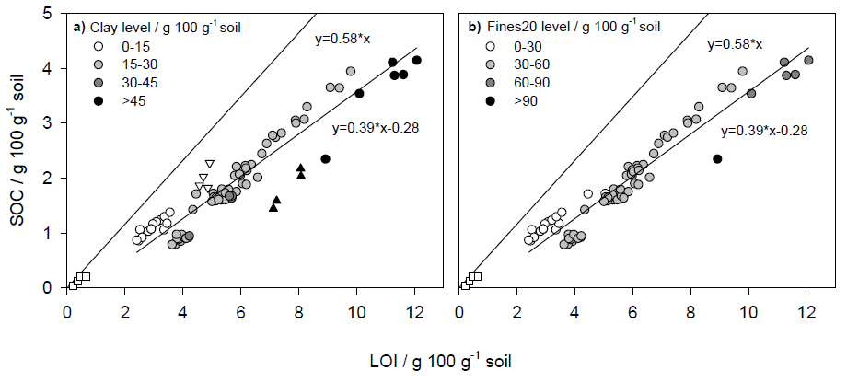
Figure 1 Soil organic carbon (SOC) as a function of loss on ignition (LOI) for (a) samples grouped by soil clay content (n=88), and (b) samples grouped by soil mineral particles < 20 µm (Fines20) content (n=80). The clay- (< 2 µm), silt- (2-63 µm) and sand-sized (63-2000 µm) fractions from the Lerbjerg site are shown with triangle up, triangle down and square symbols, respectively. Due to different size limits for silt isolated from Lerbjerg, Figure 1b does not include Fines20 from Lerbjerg. The line representing the conventional relationship between LOI and SOC (SOC = 0.58 x LOI) is also shown.
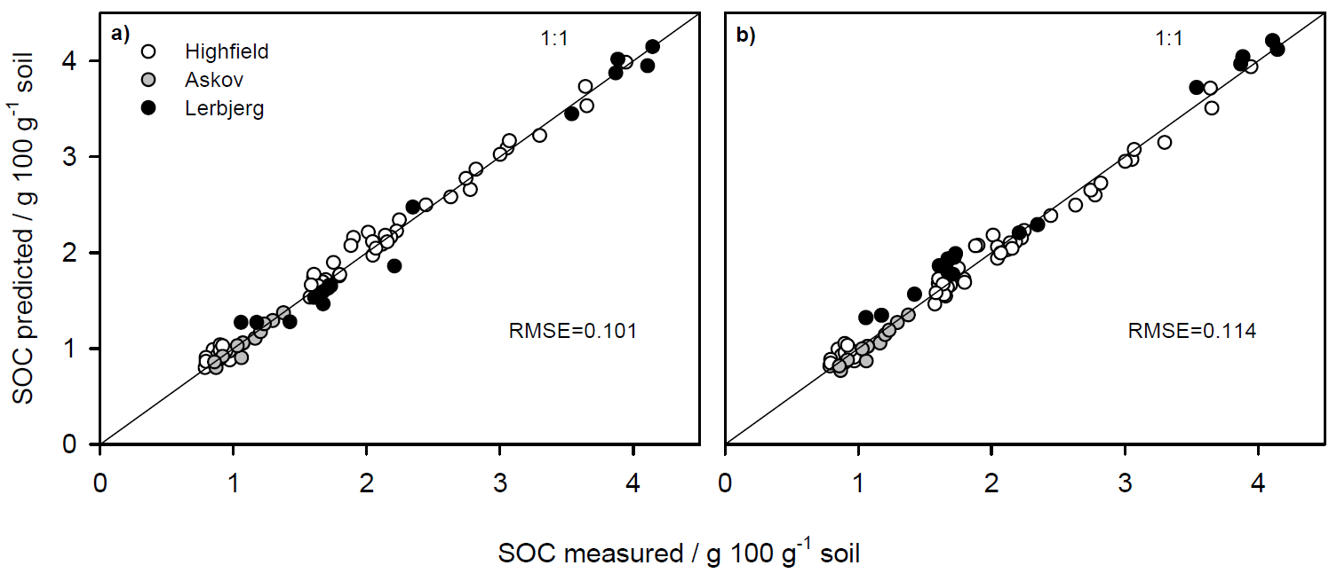
Figure 2 Soil organic carbon (SOC) content predicted by (a) the linear model including loss-on-ignition (LOI) and the quadratic clay expression (model O2.1, Table 3 [Eq. 3]), and (b) the linear model including LOI and the quadratic mineral particles <20 μm (Fines20) expression (model O3, Table 3) as a function of the measured SOC content.
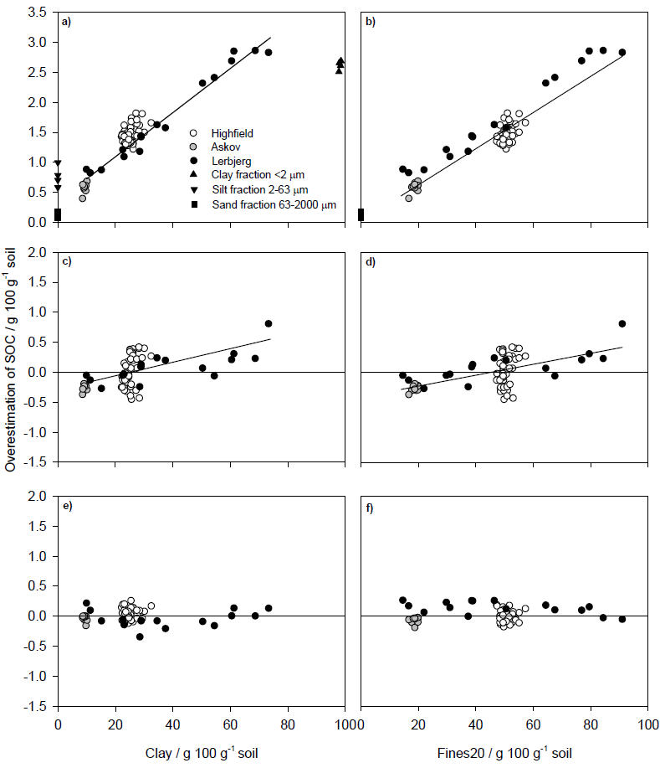
Figure 3 Overestimation (predicted minus measured values) of soil organic carbon (SOC) as a function of clay or mineral particles < 20 µm (Fines20) when multiplying loss on ignition (LOI) with the conventional conversion factor 0.58 (a, b), when estimating SOC by a model including measured LOI (model O1, Table 3) (c, d), and when estimating SOC by a model including LOI and the quadratic clay expression (model O2.1, Table 3 [Eq. 3]) (e) or LOI and the quadratic Fines20 expression (model O3, Table 3) (f). Solid regression lines are indicated if clay or Fines20 had a significant effect on overestimation of SOC.
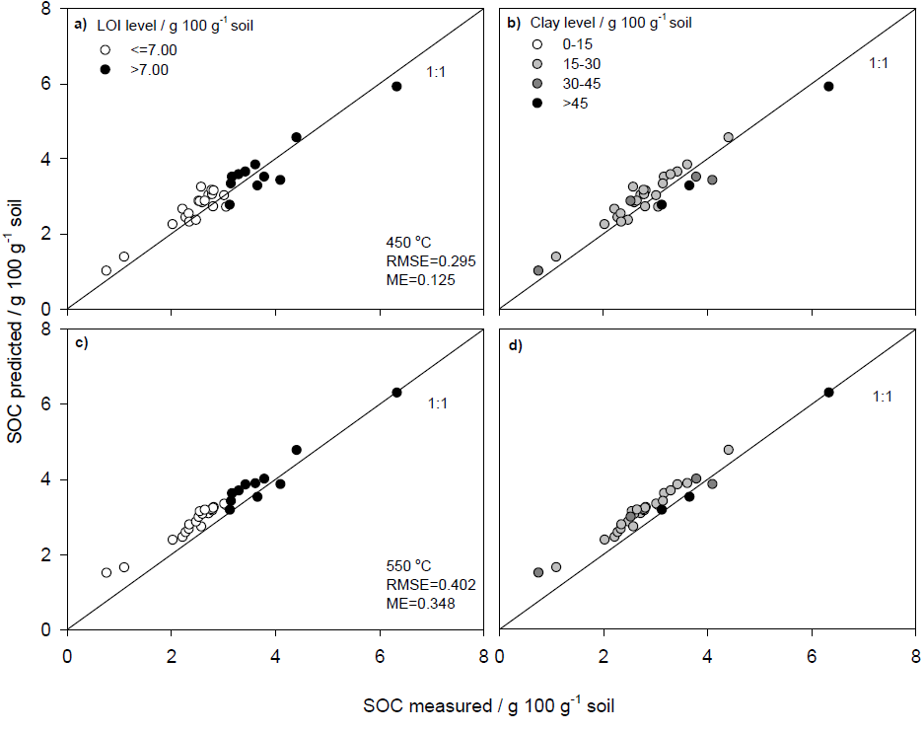
Figure 4 The relationship between measured soil organic carbon (SOC) in the evaluation data set and SOC predicted by the linear model including loss-on-ignition (LOI) and the quadratic clay expression (Eq. 3). SOC predictions were tested using data on LOI based on an ignition temperature of 450 °C (a, b) and 550 °C (c, d). Samples are grouped by LOI content (a, c) and clay content (b, d). Based on data published by Grewal et al. (1991).
TABLES
Table 1 Soil organic carbon (SOC), loss-on-ignition (LOI), clay (< 2 μm) and mineral particles < 20 μm (Fines20) for bulk soils and particle-size fractions from Lerbjerg. n = number of samples and NA = not applicable.
Sample | n | SOC | LOI | Clay | Fines20
Mean, minimum and maximum
/ g 100 g⁻¹ soil
Highfield (UK) | 48 | 1.93 (0.78-3.94) | 5.84 (3.62-9.80) | 25 (22-32) | 50 (47-57)
Askov (Denmark) | 12 | 1.09 (0.86-1.37) | 2.90 (2.40-3.55) | 9 (9-10) | 19 (17-20)
Lerbjerg (Denmark) | 16 | 2.37 (1.06-4.14) | 7.11 (3.34-12.08) | 38 (10-73) | 49 (15-91)
Clay fraction <2 μm | 4 | 1.81 (1.44-2.17) | 7.63 (7.12-8.08) | 98 (98-99) | NA
Silt fraction 2-63 μm | 4 | 2.00 (1.82-2.27) | 4.76 (4.57-4.92) | 0 | NA
Sand fraction 63-2000 μm | 4 | 0.14 (0.04-0.20) | 0.42 (0.22-0.65) | 0 | 0

Table 2 Parameter estimates, R², and the Akaike’s Information Criterion (AIC) for linear models of the relation between soil organic carbon (SOC) and loss-on-ignition (LOI), clay (< 2 µm) and mineral particles < 20 µm (Fines20) for individual sites.
Model | Intercept | P-value | LOI /  g 100 g⁻¹ | P-value | Clay /  g 100 g⁻¹ | P-value | Fines20 /  g 100 g⁻¹ | P-value | R² | AIC
Highfield
H1 | -1.145 | <0.001 | 0.526 | <0.001 |  |  |  |  | 0.981 | -66.6
H2 | -0.164 | 0.322 | 0.519 | <0.001 | -0.037 | <0.001 |  |  | 0.990 | -94.9
H2.1 | 0 |  | 0.515 | <0.001 | -0.043 | <0.001 |  |  | 0.990 | -95.8
H3 | 0.579 | 0.083 | 0.525 | <0.001 |  |  | -0.034 | <0.001 | 0.988 | -88.2
H3.1 | 0 |  | 0.528 | <0.001 |  |  | -0.023 | <0.001 | 0.988 | -86.9
Askov
A1 | -0.155 | 0.244 | 0.432 | <0.001 |  |  |  |  | 0.910 | -33.2
A1.1 | 0 |  | 0.379 | <0.001 |  |  |  |  | 0.896 | -33.5
A2 | 0.314 | 0.301 | 0.461 | <0.001 | -0.059 | 0.107 |  |  | 0.919 | -34.8
A2.1 | 0 |  | 0.461 | <0.001 | -0.026 | 0.080 |  |  | 0.925 | -35.3
A3 | 0.440 | 0.103 | 0.453 | <0.001 |  |  | -0.035 | 0.025 | 0.939 | -38.2
A3.1 | 0 |  | 0.465 | <0.001 |  |  | -0.013 | 0.046 | 0.942 | -36.5
Lerbjerg
L1 | -0.103 | 0.501 | 0.347 | <0.001 |  |  |  |  | 0.959 | 3.2
L1.1 | 0 |  | 0.335 | <0.001 |  |  |  |  | 0.957 | 1.8
L2 | -0.230 | <0.001 | 0.506 | <0.001 | -0.026 | <0.001 |  |  | 0.992 | -23.0
L3 | -0.150 | 0.028 | 0.505 | <0.001 |  |  | -0.022 | <0.001 | 0.993 | -25.0

Table 3 Parameter estimates, R², and the Akaike’s Information Criterion (AIC) for linear models of the relation between soil organic carbon (SOC) and loss-on-ignition (LOI), clay (< 2 µm) and mineral particles < 20 µm (Fines20). The models are based on data from all three sites.
Model | Intercept | P-value | LOI /  g 100 g⁻¹ | P-value | Clay /  g 100 g⁻¹ | P-value | Clay² / g 100 g⁻¹ | P-value | Fines20 /  g 100 g⁻¹ | P-value | Fines20² /  g 100 g⁻¹ | P-value | R² | AIC
O1 | -0.280 | <0.001 | 0.385 | <0.001 |  |  |  |  |  |  |  |  | 0.921 | 14.9
O2 | -0.018 | 0.720 | 0.513 | <0.001 | -0.046 | <0.001 | 0.00024 | <0.001 |  |  |  |  | 0.987 | -123.5
O2.1 | 0 |  | 0.513 | <0.001 | -0.047 | <0.001 | 0.00025 | <0.001 |  |  |  |  | 0.988 | -125.3
O3 | -0.206 | 0.006 | 0.507 | <0.001 |  |  |  |  | -0.00956 | 0.003 | -0.00014 | <0.001 | 0.984 | -105.1

