**Efficient qPCR estimation and discrimination of airborne inoculum of *Leptosphaeria maculans* and *L. biglobosa,* the causal organisms of phoma leaf spotting and stem canker of oilseed rape**

**Joanna Kaczmarek1*, Jonathan S. West2*, Kevin M. King2, Gail G. M. Canning2, Akinwunmi O. Latunde-Dada2, 3, Yong-Ju Huang2, 3, Bruce D. L. Fitt2, 3, & Malgorzata Jedryczka1#**

*1Institute of Plant Genetics, Polish Academy of Sciences, Strzeszynska 34, 60-479 Poznan, Poland*

*2Rothamsted Research, Harpenden, AL5 2JQ, UK*

*3Centre for Agriculture, Food and Environmental Management Research, School of Life and Medical Sciences, University of Hertfordshire, Hatfield, AL10 9AB, UK*

*Joanna Kaczmarek and Jonathan S. West are to be regarded as joint first authors of this paper

**Running title: qPCR detection of *Leptosphaeria* airborne inoculum**

***#*** *Corresponding author:*

*Malgorzata Jedryczka*

*Pathogen Genetics and Plant Resistance Team*

*Institute of Plant Genetics, Polish Academy of Sciences, Strzeszyńska 34, 60-479 Poznan,*

*Poland*

*E-mail:* [*mjed@igr.poznan.pl*](mailto:mjed@igr.poznan.pl)

*Tel: +48 65 50 271*

**Abstract**

BACKGROUND: The detection of inoculum of phytopathogens greatly assists in the management of diseases, but it is difficult for those pathogens with airborne fungal propagules. In this paper, we present experiments on the determination of the abundance and distribution frequencies of the ascospores of *Leptosphaeria* (*Plenodomus*) species that were collected on the tapes of volumetric Hirst-type traps near oilseed rape fields of Poznan, Poland and Harpenden, UK. Fungal detection and species discrimination were achieved using SYBR-Green qPCR with two different pairs of primers previously reported to differentiate *Leptosphaeria maculans* (*Plenodomus lingam*) or *L. biglobosa* (*P. biglobosus*).

RESULTS: Detection was successful even at less than 5 spores per m3 of air. The primer pairs differed in the correlation coefficients obtained between DNA yields and the daily abundance of ascospores that were quantified by microscopy on duplicate halves of the spore trap tapes. Important differences in specificity and sensitivity of the published SYBR-Green assays were also found, indicating that the Liu primers did not detect *L. biglobosa* subclade ‘canadensis’ while the Mahuku primers detected *L. biglobosa* subclade ‘canadensis’ and also the closely-related *Plenodomus dezfulensis.*

CONCLUSIONS: Comparisons affirmed that application of qPCR assays to spore trap samples can be used for the early detection, discrimination and quantification of aerially dispersed *L. maculans* and *L. biglobosa* propagules before leaf spot symptoms are visible in winter oilseed rape fields. The specificity of the primers must be taken into consideration because the final result will greatly depend on the local population of the pathogen.

**Key words:** airborne inoculum, ascospore detection, *Brassica napus,* Burkard spore sampler, rapeseed

**1 Introduction**

Phoma stem canker (blackleg) and necrosis of the upper canopy (*sensu*1) are damaging diseases of winter oilseed rape (*Brassica napus*) plants globally caused by the sibling species *Leptosphaeria maculans* and *L. biglobosa* (synonyms *Plenodomus lingam and P. biglobosus*)*.*2-4 To date, two genetic subclades of *L. maculans* (‘brassicae’ and ‘lepidii’) and seven genetic subclades of *L. biglobosa* (‘americensis’, ‘australensis’, ‘brassicae’, ‘canadensis’, ‘erysimii’, ‘occiaustralensis’ and ‘thlaspii’) have been identified.5 The disease cycle of both species begins with necrotic lesions on the cotyledonary and true leaves of seedlings incited primarily by autumn-produced wind-dispersed ascospores that are produced within pseudothecia of these dothediomycete fungi, surviving in the debris of the previous season’s crop. Thereafter, mycelia of the pathogens in the infected plant advance along the leaf petiole towards the stem, where the pathogen is initially asymptomatic and endophytic but this relationship with the host switches to necrotrophy, manifested by destructive stem lesions and cankers in the following summer.6-7 Conidia dispersed by wind-swept rain from pycnidia are also pathogenic and contribute to phoma epiphytotics.8-9 Although West and Fitt10 considered conidia to be less important than ascospores in the epidemiology of stem canker of brassicas in the UK, a much greater role has been attributed to conidia in Australia11, Canada12 and France13. Furthermore, airborne spores of both species are also associated with allergenic causes of the phenomenon of ‘autumn asthma’ in humans.14 Due to their small size, detection of conidia, which can become aerosolized, is difficult by normal light microscopy. In addition, the identification and quantification of the larger ascospores by light microscope is very time-consuming. Thus, DNA-based assays have been developed for early detection and estimation of the aerial biomass, abundance and distribution patterns of airborne propagules of these pathogens to enable the formulation of intervention programmes and enhance the timeliness of incorporating such decisions into disease management practices.15-17 Estimation of aerial inoculum abundance, and determination of patterns and distribution frequencies of airborne biological particles, including pollen and fungal spores, are done routinely with the aid of volumetric traps and samplers equipped with adhesive-coated tapes18. Originally, visual assessment of the numbers of spores collected was used routinely by light microscopy and staining techniques.18 With advances in detection technology for fungal spores, earlier molecular biological approaches to estimation by end-point PCR have been replaced by real-time qPCR techniques utilising species-specific primers designed for greater accuracy and precision, and enabling DNA quantifications in the pico- and femto-molar range.3,19-22 The DNA yields are thereafter relatable to the abundance of spores that were collected. Jedryczka et al.23 and Kaczmarek et al.24 postulated that the irregularity and differences in the dynamics of sporulation of *L. maculans* and *L. biglobosa* require constant monitoring of air samples for the benefit of farmers, whose crops may be severely affected by the disease originating from airborne inoculum. The monitoring may be supported by molecular detection of particular alleles and genes specific for the *Leptosphaeria* species complex.23 Diagnostic primers have been designed for detecting effector (*Avr*), mating type and sterol-metabolizing gene alleles from collected aerially dispersed propagules of these dothideomycete pathogens.19,24,25 In a recent publication22, qPCR primers and dual-labelled fluorescent probes targeted against fragments of the genes for EF1α and *actin* from *L. maculans* ‘brassicae’ and *L. biglobosa* ‘brassicae’, respectively,were successfully developed (to species and subclade level) for the specific detection, quantification and discrimination of the phoma disease pathogens in infected rapeseed leaf, stem and stubble samples. However, this technical advance remains to be applied to aerially dispersed, trapped ascospores and propagules of these *Leptosphaeria* species. The present study concentrates on evaluation of published SYBR-Green assays because this type of assay is less-expensive than dual-labelled probe assays.

Recently, a new species found to infect oilseed rape in Iran in 2021, was named *Plenodomus dezfulensis*.26 This species appears to be closely related to *L. biglobosa* and although it has not been found in Europe, evaluation of diagnostic primers, originally designed for detection of *L. maculans* and *L. biglobosa*, was made in this study to test for potential misidentification by the primer sets, which were designed before the new species had been described.

Experiments were done in the current study to determine the abundance and distribution frequencies of airborne propagules of the *Leptosphaeria* species that were collected on the tapes of volumetric Hirst-type samplers operated near oilseed rape fields at the Institute of Plant Genetics, Polish Academy of Sciences, Poznan in Poland and Rothamsted Research, Harpenden in the UK. Two pairs of different primers (based on the internal transcribed spacer (ITS) regions of rDNA) utilising SYBR-Green fluorescence were used for fungal detection and species discrimination and quantification. The relative efficiencies and specificities of these primer pairs were estimated and compared.

**2 Materials and Methods**

*2.1 Ascospore trapping and quantification by microscopy*

Propagules of *Leptosphaeria* spp. were collected with a Hirst-type volumetric 7-day spore sampler (Burkard Manufacturing Company, Rickmansworth, UK) routinely in the autumn months (September to November) with 214 samples from Poznan in Poland (41-44 days per year in 2004-2008) and 56 samples in 2002 from Harpenden in the UK; in total 270 samples were tested over five years. Both spore samplers were surrounded (in a radius of ≈2 m from the spore trap3) by stubble from canker-infected stems of an oilseed rape crop, from the previous years, collected from local fields. The Burkard seven-day spore traps were operated with the standard 2 mm x 14mm air intake and this was set to be approximately 50 cm above ground level. Both units were powered by 12V batteries and the air flow was checked regularly and, if needed, adjusted to 10 L/min. The drum of the sampler rotated at 2 mm h-1, attained 1 revolution per week, during which airborne particles were deposited on to a Vaseline-coated Melinex tape coating the rotating drum. Each week, the 20 mm-wide tape was cut into 48 mm-long pieces, each representing a 24-h day and each was divided length-wise into equal halves (each 48 mm x 10 mm); one half was stained (0.1% w/v Trypan Blue in lactophenol, Figure 1) for ascospore detection and counting for abundance determination (per m3 of air) by light microscopy. Ascospores were identified by microscopy as both *L. maculans* and *L. biglobosa* if they fitted the description of being biseriate, 5 septate, cylindrical to ellipsoidal, with guttules, 35-70 x 5-8 µm, with rounded ends27,28. Their colour is normally pale yellow-brown but not when stained with Trypan blue as shown in Figure 1.

The average number of ascospores counted in two longitudinal traverses of each piece of tape was used to calculate the concentration of spores per cubic metre of air sampled according to the formula of Lacey and West18. Briefly, the counts of *Leptosphaeria* ascospores in two microscope traverses along the length of the spore tape, located near the centre-line of the tape, were used to estimate the total number of *Leptosphaeria* ascospores deposited on each daily spore trap sample. The width of both traverses combined was 1,750 µm and the total area of the spore deposit was 14mm x 48mm. Therefore, the area counted in the two traverses as a proportion of the total area was given by (1750 x 48000)/ (14,000 x 48000), which simplifies to (1750/14,000) or 0.125. To convert to the number of spores on the entire tape, the number of spores counted in the two traverses was divided by 0.125, e.g. 20 spores counted divided by 0.125 gives 160 spores estimated on the entire tape. The other half-tape was used for DNA extraction (method below). In Poland and the UK, a similar spore sampling and detection protocol was set up in the autumn of winter oilseed rape cropping seasons (from the beginning of September until the end of November).

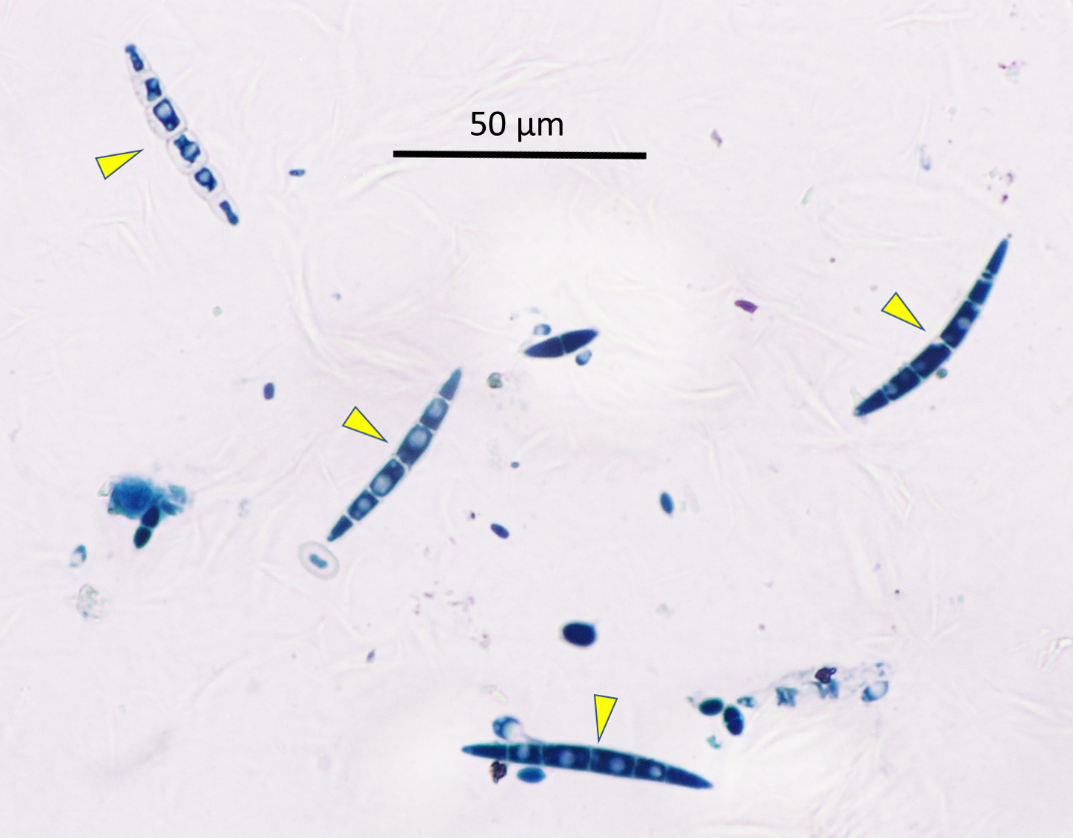

**Figure 1**. Example of ascospores of *Leptosphaeria maculans* and *L. biglobosa* (marked by yellow arrows with no distinction between the two species), stained with Trypan blue.

*2.2 DNA extraction*

DNA was extracted from all propagules, including ascospores, that were trapped on the second half pieces of tapes from the volumetric spore sampler using a modification of the CTAB (cetylammonium bromide = hexadecyl trimethyl ammonium bromide) extraction method of Graham et al.29 Each piece of tape was placed in a sterile 2-ml screw-capped microtube with 0.15 g of 425-600 µm diameter acid-washed glass beads (Sigma, UK) and extracted with 2% w/v CTAB buffer at pH 7.5 containing 100 mM Tris, 1.4 mM NaCl and 20 mM EDTA (Sigma, UK) with 2% β-mercaptoethanol included at the point of use. Each sample was subjected to two rounds of 40-second Fast-Prep (Savant Instruments, Holbrook, New York, USA) cycles and extracts were heated (70oC, 30 min) and centrifuged (16,000 ***g***, 15 min). The supernatant was extracted after centrifugation (16,000 ***g***, 15 min) of an equal volume of a 24:1 chloroform/isoamyl alcohol mixture and DNA was precipitated by incubation at -20oC by adding 2 volumes of absolute ethanol and 0.1 volume of 3 M sodium acetate (pH 5). Pellets were washed with ice-cold 70% v/v ethanol, dried at 37oC, dissolved in 100 µL Tris-EDTA buffer (10 mM Tris HCl pH 7.5, plus 1 mM EDTA) and stored at -20oC.

*2.3 Quantitative PCR for assessment of proportions of DNA from species of Leptosphaeria*.

Quantitative PCR determinations were done in 20-µL standard reaction volumes containing 5 µL (1:4 aqueous dilution) template DNA extract from spore tapes, 200 nM forward primer, 180 nM reverse primer30-31 plus 10 µL Sybr Green JumpStart Taq ReadyMix (Sigma UK), 0.08 µL ROX internal reference dye (Sigma, UK) and 3.78 µL nuclease-free water. The primers used in this study are listed in Table 1.

**Table 1**. The source and sequence of primers tested in this study designed to detect *Leptosphaeria maculans* and *L. biglobosa*, the causes of phoma leaf spotting and stem canker

|  |  |  |
| --- | --- | --- |
| Source | Forward primer 5’-3’ | Reverse primer 5’-3’ |
| *Leptosphaeria maculans* (*Plenodomus lingam*) | | |
| Mahuku et al. 199630 | LmF (HV17S): CCCATTTTCAAAGCACTGCC | LmR (HV26C): GAGTCCCAAGTGGAACAAACA |
| Liu et al. 200631 | LmacF: CTTGCCCACCAATTGGATCCCCTA | LR*: GCAAAATGTGCTGCGCTCCAGG |
| *Leptosphaeria biglobosa* (*Plenodomus biglobosus*) | | |
| Mahuku et al. 199630 | LbF (WV17S) CCCTTCTATCAGAGGATTGG | LbR (5.8C) GCTGCGTTCTTCATCGATGC |
| Liu et al. 200631 | LbigF: ATCAGGGGATTGGTGTCAGCAGTTGA | LR*: GCAAAATGTGCTGCGCTCCAGG |

* The common reverse primer originally termed ‘LmacR’ used for *Leptosphaeria maculans* and *L. biglobosa* in the study by Liu et al. 31

Both sets of primers were designed from gene fragments of the internal transcribed spacer (ITS) regions of either Canadian *L. maculans* and *L. biglobosa* ‘canadensis’ isolates30 or European *L. maculans* ‘brassicae’ and *L. biglobosa* ‘brassicae’ isolates.31 For this study, involving SYBR-Green chemistry, 20-µL assays were routinely done in duplicate. The thermal cycling parameters for amplification and detection were 95oC for 2 min followed by 38 cycles of 95oC for 15 s, 60oC for 30 s and 72oC for 45 s. A melting (dissociation) curve was run and analysed after each final amplification by heating samples at 95oC for 15 s, cooling to 60oC for 1 min and heating to 95oC for 15 min, in order to ascertain the specificity of the procedure. Fluorescence was measured continuously, and standard curves were plotted from the Ct values of the amplification of standard genomic DNA concentration in the 10 ng µL-1 to 1 pg µL-1 range from mycelial cultures of *L. maculans* or *L. biglobosa*.

All reactions were done in capped plastic Thermo-Fast 96-well non-skirted reaction plates (ABgene, Epsom, UK). Amplification and detection were done in an Applied Biosystems 7500 Real Time qPCR thermocycling System (Applied Biosystems, Forster City, CA, USA).

*2.4 Testing specificity of primer pairs*

The two different primer sets, each for *L. maculans* and *L. biglobosa* (Table 1), were tested for specificity of a range of isolates of *L. maculans*, *L. biglobosa* subclades ‘brassicae’ and ‘canadensis’ and *Plenodomus dezfulensis* (Table 2). The isolates used in this study were selected to represent subclades that are currently the most prevalent in the UK and Poland and generally in Europe. Assays were as described for the spore trap samples, except that the 5 µL of DNA added was standardised for each isolate at 0.2 ng/µL. Therefore, each individual reaction contained 1 ng total genomic DNA of an individual isolate. Quantification of the pure DNA was made by Qubit fluorescence photometry, using Qubit 2.0 and Invitrogen Qubit dsDNA HS assay kit, according to the manufacturer’s instructions.

**Table 2**. Isolates and species tested with SYBR Green assays and two primer pairs listed in Table 1

|  |  |  |
| --- | --- | --- |
| Isolate symbol | Species (subclade if known) | Country of origin |
| IRE/A/05 | *L. maculans* | Ireland |
| FRA/M/05 | *L. maculans* | France |
| 22PURPLE02 | *L. maculans* | Poland |
| 22HOH01 | *L. maculans* | Germany |
| 22GERSH01 | *L. maculans* | Germany |
| FRA/B/06 | *L. biglobosa* | France |
| 23NEMKT02 | *L. biglobosa* | UK |
| 21WAS8-4 | *L. biglobosa ‘*brassicae*’* | UK |
| 21WAS1-2 | *L. biglobosa ‘*canadensis*’* | UK |
| 23DERE03 | *L. biglobosa* | UK |
| 22BLACK01 | *L. biglobosa* | UK |
| S41 | *P. dezfulensis* | Iran |

*2.5 Statistical analyses*

Pearson correlation coefficients from relating ascospore counts to DNA yields were calculated after log (x + 1) transformation of the data to attain normalization. All statistical analyses were performed using Statistica (12.0).

**3 Results**

*3.1 Ascospore quantification*

The extraction of spore tapes yielded fungal DNA solutions that were quantified through amplification by real time qPCR using primers that were designed for specific detection of *L. maculans* and *L. biglobosa* (Table 1). When quantified DNA was related to numbers of spores categorised by light microscopic examinations of stained half tapes, it was possible to draw comparisons of precision and efficiency as well as accuracy among the species-specific primer pairs.

Reduced detection reliability of both assays at lower levels of ascospore abundance (0-30 m-3 of air sampled) was detected (Table 3). The UK materials contained samples with spore numbers per cubic metre up to 300, whereas spore numbers in Polish samples reached a maximum of 50 spores per cubic metre.

**Table 3.** Quantification of the DNA yields from *Leptosphaeria*-like ascospores collected in air samples in close proximity to oilseed rape debris from Poznan, Poland and Harpenden, UK grouped based on spore numbers

|  |  |  |  |  |  |  |
| --- | --- | --- | --- | --- | --- | --- |
| Number of *Leptosphaeria* spores per m3 of air | Number of samples | | DNA in one spore (pg/µl) calculated  based on primers | | | |
| Mahuku et al., 1996 | | Liu et al., 2006 | |
| Poznan | Harpenden | Poznan | Harpenden | Poznan | Harpenden |
| 0.1-5 | 184 | 14 | 35.72 | 97.07 | 40.83 | 77.64 |
| 5.1-10 | 10 | 3 | 18.83 | 15.00 | 10.96 | 8.23 |
| 10.1-20 | 8 | 6 | 30.54 | 16.32 | 6.01 | 22.96 |
| 20.1-30 | 8 | 4 | 3.79 | 5.41 | 6.80 | 50.22 |
| 30.1-50 | 3 | 5 | 1.75 | 4.14 | 4.96 | 18.39 |
| 50.1-100 | 1 | 15 | 2.33 | 9.75 |  | 8.47 |
| 100.1-200 |  | 7 |  | 3.35 |  | 2.74 |
| 200.1-300 |  | 2 |  | 1.09 |  | 6.44 |
|  | Sum | | Mean | | Mean | |
|  | 214 | 56 | 15.49 | 19.02 | 13.91 | 24.39 |

The paradox of more DNA at low concentrations of spores per cubic metre (right-hand side of Table 3) is thought to be due to the presence of aerosolised rain-splashed conidia (pycnidiospores), which provide a background of the same target DNA but were not counted by microscopy due to being very small inconspicuous spores that cannot be distinguished visually. Therefore, this background DNA from conidia could explain why the amount of DNA per ascospore is greatest when there were few ascospores present and that the DNA per ascospore apparently decreases as the number of ascospores increase due to the background amount of DNA from conidia becoming negligible. A little variability is also likely due small differences due to random deposition on the spore trap tape between numbers of spores counted visually on one half of the tape and the number of spores on the other half that was used for DNA extraction and molecular evaluation.

The correlation coefficients for relationships between ascospore number obtained through microscope counts and DNA yield by qPCR using the ITS primers of Mahuku et al.30 gave smaller values of Pearson’s correlation coefficients than those obtained with the primers of Liu et al.31, especially for the spore samples collected in Poznan (Table 4). There was also a difference in primer efficiencies between Harpenden and Poznan, which is most likely because the population of the pathogen was different between the two sites, with more *L. biglobosa* present in the air in Poland as compared to the UK.

The efficiencies of the primers were assessed by comparing the DNA yields obtained per ascospore when different species-specific primers were used. The results suggest very different ratios of *L. maculans* to *L. biglobosa* determined by the different primers, showing for both sites that ascospores were mainly *L. maculans* if Mahuku primers were used but that the ascospores were predominantly *L. biglobosa* if the Liu primers were used (Table 4).

**Table 4.** Correlation between light-microscope counts of *Leptosphaeria*-like ascospores and molecular quantification of the same species by qPCR using DNA extracted from a duplicate half-tape of spore traps from sites in Poland and the UK, comparing the efficiency of different PCR primer pairs; estimation of the efficiency of primer pairs was judged by the ratios of DNA from *Leptosphaeria maculans* to that of *L. biglobosa*

|  |  |  |  |  |
| --- | --- | --- | --- | --- |
| Spore collection site | Pearson correlation coefficients between molecular detection and spore counts | | Primer efficiency ratio,  *Lm:Lb* | |
| Mahuku et al., 199630 | Liu et al.,  200631 | Mahuku et al., 199630 | Liu et al.,  200631 |
| Harpenden (2002) | 0.465 | 0.578 | 1:0.65 | 1:2.02 |
| Poznan (2004-8) | 0.409 | 0.647 | 1:0.05 | 1:2.46 |

*3.2 Specificity of assays*

The results of the primer sets tested show that some assays either were not specific to a single species or did not amplify DNA of all isolates of selected species (Table 5). Both primer sets were specific for *L. maculans*, but the Mahuku primers for *L. biglobosa* detected not just subclades ‘brassicae’ and ‘canadensis’ but also amplified *P. dezfulensis*, whereas the Liu primers for *L. biglobosa* detected subclade ‘brassicae’ but not ‘canadensis’ nor *P. dezfulensis*.

In terms of quantification, the Liu primers quantified *L. maculans* more efficiently than the Mahuku primers. For *L. biglobosa*, both primer sets worked equally for *L. biglobosa* ‘brassicae’ but the Mahuku primers were consistently and significantly (*P*<0.05) more sensitive for *L. biglobosa* ‘canadensis’ (smaller Ct value) than for *L. biglobosa* ‘brassicae’ (Figure 2). Other differences in quantification between isolates tested using both primer sets (Fig. 2) were sometimes statistically significant but were so small that they were most likely due to variation in initial DNA template concentrations as determined by Qubit photometry.

**Table 5.** Summary of results of amplifications of DNA of target species using the two different pairs of qPCR primers

|  |  |  |  |  |
| --- | --- | --- | --- | --- |
| Assay / primers | Amplified DNA of | | | |
| *L. maculans* | *L. biglobosa* ‘brassicae’ | *L. biglobosa* ‘canadensis’ | *Plenodomus dezfulensis* |
| Mahuku et al., 199630  *L. maculans* | Yes | No | No | No |
| Liu et al., 2006 31  *L. maculans* | Yes | No | No | No |
| Mahuku et al., 199630  *L. biglobosa* | No | Yes | Yes | Yes |
| Liu et al., 200631  *L. biglobosa* | No | Yes | No | No |

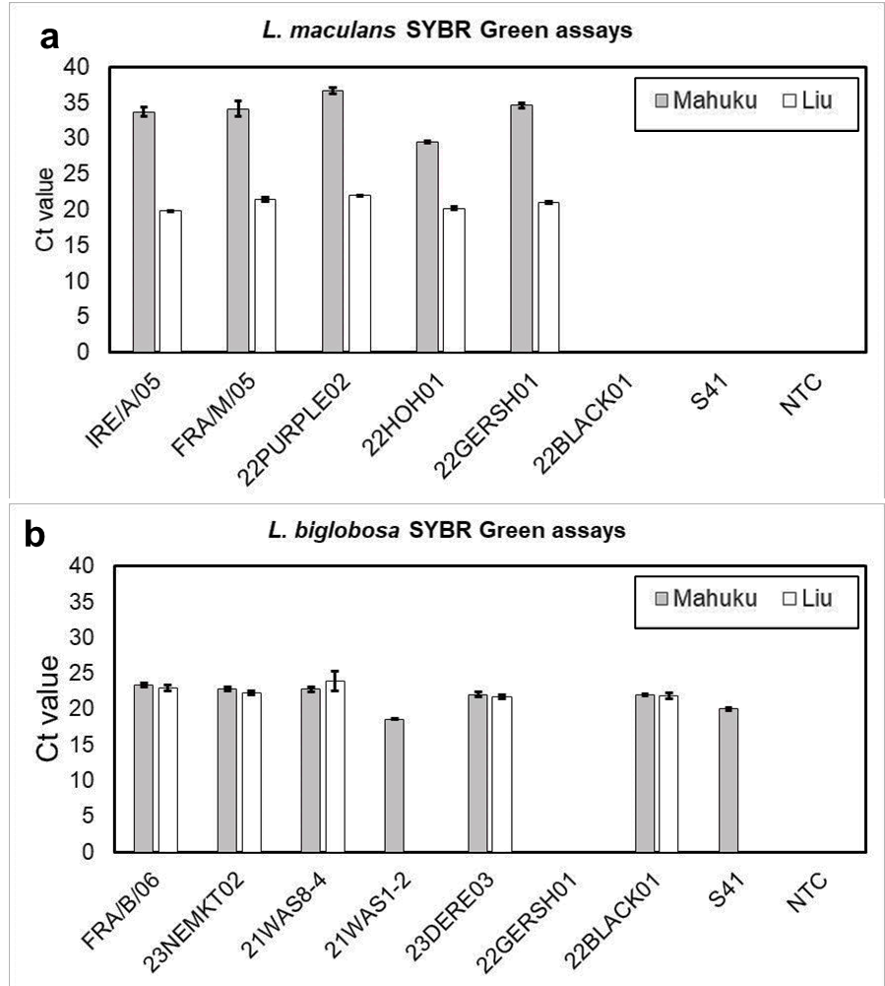

**Figure 2**. Cycle threshold (Ct) values indicating quantification of different isolates by SYBR-Green assays for the same amount of *Leptosphaeria maculans* (a) or *L. biglobosa* (b) DNA. Each bar represents the mean of four technical replicates. Error bars represent the standard deviation (*P*<0.05). Isolate species are given in Table 2.

**4 Discussion**

Over the last 15 years, quantification techniques for aerially dispersed fungal spores have relied increasingly on the use of species-specific primers and polymerase chain reaction for both precision in detection and efficiency in quantification. Towards this aim, real-time quantitative PCR (qPCR) has replaced end-point PCR and primers based on internal transcribed spacer (ITS) gene fragments of the target pathogen have been the most frequently used. For studies on the aerobiology of *Leptosphaeria*,species-specific primers based on gene fragments of diagnostic ITS regions of *L. maculans* and *L. biglobosa* were used. These primers were originally designed by Mahuku et al.30 for differentiating between isolates (*sic*: highly virulent, HV, i.e. *L. maculans*, and weakly virulent, WV, i.e. *L. biglobosa*) of these phoma species in infected tissues of Canadian oilseed rape plants. Subsequently, they were adapted30 and deployed for qPCR quantification of both species in air spora collected from oilseed rape fields in the UK33-34 and Poland.16 Weaknesses in the diagnostic precision and efficiency of the Mahuku ITS primers at detecting non-Canadian isolates of species of *Leptosphaeria* led to the development and release of ITS primers by Liu et al. that detected European isolates of both *Leptosphaeria* species.31 However, the present study has found that the Liu primers, although the primer set used for *L. maculans* detection (LmacF/LmacR) were specific to *L. maculans*, the primer set used for specific detection of *L. biglobosa* (LmacR/LbigF) detected *L. biglobosa* ‘brassicae’ but did not amplify the ‘canadensis’ subclade. This paper highlights that there is important variability in performance of PCR primers according to the clades present in a geographic location and highlight the importance of using primers that detect all *L. biglobosa* subclades. Variation in quantification of the pathogens due to different clades being present may even occur on different days at the same site and year if ascospores mature on different parts of crop debris infected by different clades. The fact that Mahuku primers were designed prior to the formal description of *P. dezfulensis*, meant that they had not previously been tested against this sibling species. The fact that this primer set can detect *P. dezfulensis* was not surprising given its close phylogenetic relatedness to *L. biglobosa*. As global trade, travel and climate change are thought to be responsible for the spread of plant pathogens into new territories, the future occurrence of *P. dezfulensis* in Europe and other territories remains a possibility and arising from this, rapid methods to differentiate detection of this pathogen from *L. biglobosa* are needed.

When 408 bp (including gaps) partial sequences of the ITS rRNA region from species of *Leptosphaeria* were aligned, *L. maculans* 'brassicae' showed only about 89.5-92.6% identity to the seven known *L. biglobosa* subclades, and only 89.5% identity to the newly described species *Plenodomus dezfulensis*. Across this region, the seven known *L. biglobosa* subclades shared between 95.3-99.5% identity. *Plenodomus dezfulensis* exhibited a very high (99.3-99.8%) identity to four previously described *L. biglobosa* subclades ('americensis', 'brassicae', 'canadensis' and occiaustralensis'). Furthermore, when 479 bp partial sequences of the beta-tubulin gene fragment were aligned, *L. maculans* 'brassicae' exhibited only about 91-93.8% identity to the seven known *L. biglobosa* subclades. Similar divergence was, however, identified with fragments of this gene, between the seven *L. biglobosa* subclades (about 92.9-97.9% identity); the two most geographically widespread *L. biglobosa* subclades ('brassicae' and 'canadensis') exhibited about 97.5% identity. The utility of different molecular biological diagnostics to detect all the known subclades of *L. biglobosa* requires careful evaluation, as target sequence divergence evident between subclades may result in failed amplification for some subclades (as demonstrated in this study). Moreover, *P. dezfulensis* has recently been elevated from infra-specific status to species status while, arguably based on available sequence data, it appears more likely to represent an additional subclade within *L. biglobosa*. Thus, additional research is required to formalise the taxonomic status of *L. biglobosa,* as the current *‘*subclade’ nomenclature commonly used by the *Leptosphaeria* research community appears to be strictly informal.

Further advances and improvements in *L. maculans, L biglobosa* (and *Pyrenopeziza brassicae*) propagule detection and quantification methods were made by designing primers that are targeted at the relatively more abundant, *β*-tubulin gene fragments of these pathogens, which improves sensitivity. 4,32,35-36  In addition, these improved assays used the more efficacious dual-labelled fluorescent probe approach, which will be evaluated along with the assay of Jacques et al.22 in a future study of aerially dispersed propagule detection.

The approach of comparing numbers of spores counted on half of a spore trap tape with the DNA quantified from spores of the target species on the corresponding half of the spore trap tape is valid since spores are deposited randomly on the tape and so should be in approximately equal amounts from one half of the tape to the other. There is, however, some potential for variability, particularly when airborne spore concentrations are very small, as evidenced by our findings in the current study. Although DNA is extracted from all spores deposited on half the tape and then quantified, the area of the spore tape counted by microscopy is more prone to experimental error because with two microscope traverses of the tape, only 12.5% of the total spore-deposition surface (depending on the field of view used) was actually counted. Thus, in addition to error caused when the average number of spores in that small area is multiplied by a conversion factor to estimate the total number present, very small numbers of deposited spores, by chance may be missed completely by light microscopy.37 This error may account for some of the variation seen in comparisons of airborne spores of *Leptosphaeria* made by microscopy compared to qPCR used in this study. This was especially clear for the samples collected in Poland, in which the spore counts were much smaller as compared to the samples originating from the UK. The spore counts in Poland reached a maximum of 50 spores per cubic metre of air, whereas in the UK the spore counts were up to 300 per cubic metre, which corresponded to correlation coefficients being a smaller for Polish samples as compared to the UK values. The smaller concentration of detected spores released from the crop debris in Poland than the UK may be due to differences in the severity of infection on the plant debris that were collected from (a consequence of many factors including host resistance), and other environmental differences, including the residual nutrients in the stubble, consumption by detritovorous invertebrates and the weather.

However, in addition to a small error caused by counting an area less than the entire half of the spore tape, there was an apparent systematic decrease in pathogen DNA per spore calculated from the DNA-extracted half of the tape according to the number of ascospores counted by microscopy (Table 3). This false impression could be due to the presence of aerosolised rain-splashed conidia providing a background of the same target DNA, which therefore had a greater influence when the number of ascospores counted were small. This is also exacerbated by the fact that rainy conditions, which are likely to have caused aerosolization of the conidia, tend to reduce the release of ascospores, which are released in dry conditions following rain or dew.28

The collection and quantification of airborne fungal propagules are now routine and feature prominently in arriving at both prophylactic and therapeutic decisions for the management and control of plant diseases caused by aerially-dispersed fungal inoculum.14,38-39 Since the initial conception of Hirst-type air samplers by Gregory40 and Hirst41 (reviewed by West and Kimber42), advances in the coupling of the methods of aerobiology and techniques of wind-dispersed fungal propagule collection, detection and quantification have enabled earlier, easier and more effective decisions in disease management.43-46 Taken together, the integration of spore trapping with quantitative diagnostic assays such as qPCR can facilitate and enhance a faster and more accurate assessment than by abundance estimation made by spore counting on light microscope slides, particularly if these spores are difficult to identify visually at the species and infra-species levels, which is very often the case with phytopathogens of important crop plants.

Successful management of air-dispersed fungal diseases requires precision in the evaluation of the onset and concentration of airborne spores that are being monitored. Further studies are needed, to improve and even automate spore counting by microscope, for example using image analysis aided by artificial intelligence, or alternatively to automate their molecular detection, while reducing costs of these activities, which form a key component of integrated pest management.

**Acknowledgments:** The authors would like to thank Magdalena Wlaszczyk for her technical support in spore sampling. The authors are grateful to all donors of *Leptosphaeria* isolates used in this study.

**Conflicts of Interest:** The authors declare no conflict of interest.

**Author Contributions:** Conceptualization, J. W., A.L.D. B.F. and M.J.; methodology, K.K. and A.L.-D.; software, J.K., G.C. and K.K.; validation, M.J. and J.W.; formal analysis, J.W. and M.J.; investigation, J.K, A.L.-D., G.C., Y.H. and K.K.; resources, M.J. B.F. and J.W.; data curation, J.K., J.W. and A.L.-D.; writing—original draft preparation, M.J., J.W. and A.L.-D., writing—review and editing, J.K., B.F., J.W., A.L.-D., Y.H. and M.J.; visualization, M.J. and K.K.; supervision, M.J. and J.W.; project administration, B.F. and M.J.; funding acquisition, B.F. and M.J. All authors have read and agreed to the published version of the manuscript.

**Funding:** In Poland this research was funded by the Corteva Poland (previously DuPont Poland Ltd.). Rothamsted Research receives funding from the UK Biotechnology and Biological Sciences Research Council (BBSRC) & BBSRC’s Industrial Strategy Challenge Fund, Smart Crop Protection strategic programme (BBS/OS/CP/000001). The University of Hertfordshire (UK) receives founding from the UK BBSRC (P00489X/1) and the Innovate UK (102641). The UK authors also acknowledge the UK Defra-funded OREGIN Programme (CH0104). Part of these studies was also supported by the British Council.

**References**

1. Sprague SJ, Marcroft SJ, Lindbeck KD, Ware AH, Khangura RK *et al*., Detection, prevalence and severity of upper canopy infection on mature *Brassica napus* plants caused by *Leptosphaeria maculans* in Australia. *Crop Pasture Sci* **69**:65-78 (2017).
2. Fitt BDL, Brun H, Barbetti MJ and Rimmer SR, World-wide importance of Phoma stem canker (*Leptosphaeria maculans* and *L. biglobosa*) on oilseed rape (*Brassica napus*). *Eur J Plant Pathol* **114**:3-15 (2006).
3. Kaczmarek J and Jedryczka M, Characterization of two coexisting pathogen populations of *Leptosphaeria* spp., the cause of stem canker of brassicas. *Acta Agrobot* **64**:3-14 (2011).
4. Kaczmarek J, Jedryczka M, Cools, HJ, Fitt BDL, Lucas JA *et al*., Quantitative PCR analysis of abundance of airborne propagules of *Leptosphaeria* species in air samples from different regions of Poland. *Aerobiologia* **28**:199-212 (2012).
5. King KM and West JS, Detection of the Phoma pathogens *Plenodomus biglobosus* subclades ‘*brassicae*’ and ‘*canadensis*’ on wasabi, and ‘*canadensis*’ in Europe. *Eur J Plant Pathol* **162**: 751-756 (2022).
6. Hammond KE and Lewis BG, The establishment of systemic infection in leaves of oilseed rape by *Leptosphaeria maculans*. *Plant Pathol* **36**:135-147 (1987).
7. Huang Y-J, Pirie EJ, Evans N, Delourme R, King GJ, *et al.* Quantitative resistance to symptomless growth of *Leptosphaeria maculans* (phoma stem canker) in *Brassica napus* (oilseed rape). *Plant Pathol* **58**, 314–323 (2009).
8. Hall R, Epidemiology of blackleg of oilseed rape. *Can J Plant Pathol* **14**:46-55 (1992).
9. Travadon R, Bousset L, Saint Jean S, Brun H and Sache I, Splash dispersal of *Leptosphaeria maculans* pycnidiospores and the spread of blackleg on oilseed rape. *Plant Pathol* **56:**595-603 (2007).
10. West JS and Fitt BDL, Population dynamics and dispersal of *Leptosphaeria maculans* (blackleg of canola). *Aust Plant Pathol* **34**:457-461 (2005).
11. Howlett BJ, Idnurm A and Pedras MSC, *Leptosphaeria maculans*, the causal agent of blackleg disease of Brassicas. *Fungal Genet Biol* **33**:1-14 (2001).
12. Guo XW and Fernando WGD, Seasonal and diurnal patterns of spore dispersal by *Leptosphaeria maculans* from canola stubble in relation to environmental conditions. *Plant Dis* **89**:97-104 (2005).
13. Travadon R, Bousset L, Saint-Jean S, Brun H and Sache I, Splash dispersal of *Leptosphaeria maculans* pycnidiospores and the spread of blackleg on oilseed rape. *Plant Pathol* **56:**595-603 (2007).
14. Jedryczka M, Sadys M, Gilski M, Grinn-Gofron A, Kaczmarek J *et al., Leptosphaeria* spp. ascospores are partially explaining ‘autumn asthma’. *Ann Allergy Asthma Immunol* **117**:495-501 (2016).
15. Salam MU, Khangura RK, Diggle AJ and Barbetti MJ, Blackleg Sporacle: a model for predicting onset of pseudothecia maturity and seasonal ascospore showers in relation to blackleg in canola. *Phytopatho*l **93**:1073-1081 (2003).
16. Kaczmarek J, Jedryczka M, Fitt BDL, Lucas JA and Latunde-Dada AO, Analyses of air samples for ascospores of *Leptosphaeria maculans* and *L. biglobosa* with light microscopic and molecular techniques. *J Appl Genet* **50**:411-419 (2009).
17. West JS, Plant pathogen dispersal: eLS, ed. by Wiley J and Sons, Chichester, UK (2014).
18. Lacey M and West JS, The Air Spora: A manual for catching and identifying airborne biological particles. Springer-Verlag GmbH, New York, pp. 1-156 (2006).
19. Van de Wouw AP, Stonard JF, Howlett BJ, West JS, Fitt BDL *et al*., Determining frequencies of avirulent alleles in airborne *Leptosphaeria maculans* inoculum using quantitative PCR. *Plant Pathol* **59**:809-818 (2010).
20. Kunjeti SG, Anchieta A, Martin FN, Choi YJ, Thines M *et al*., Detection and quantification of *Bremia lactucae* by spore trapping and quantitative PCR. *Phytopathol* **106**:1426-1437 (2016).
21. Thiessen LD, Keune JA, Neill TM, Turechek WW, Grove GG *et al*., Development of a grower-conducted inoculum detection assay for management of grape powdery mildew. *Plant Pathol* **65**:238-249 (2016).
22. Jacques N, Balesdent M-H, Rouxel T and Laval V, New specific quantitative real-time PCR assays shed light on the epidemiology of two species of the *Leptosphaeria maculans*-*Leptosphaeria biglobosa* species complex. *Plant Pathol* **70**:643-654 (2021).
23. Jedryczka M, Burzynski A, Brachaczek A, Langwinski W, Song P *et al*., Loop-mediated isothermal amplification as a good tool to study changing *Leptosphaeria* populations in oilseed rape plants and air samples. *Acta Agrobot* **67:**93-100 (2013).
24. Kaczmarek J, Latunde-Dada AO, Irzykowski W, Cools HJ, Stonard JF *et al*., Molecular screening for avirulence alleles *AvrLm1* and *AvrLm6* in airborne inoculum of *Leptosphaeria maculans* and winter oilseed rape (*Brassica napus*) plants from Poland and the UK. *J Appl Genet* **55**:529-539 (2014).
25. King KM, Canning G, Zhou K, Liu Z, Wu M *et al*., Indirect evidence based on mating type ratios for the role of sexual reproduction in European and Chinese populations of *Plenodomus biglobosus* (blackleg of oilseed rape). Pathogens **12**:3 (2023).
26. Safi A, Mehrabi-Koushki M, Farokhinejad R, *Plenodomus dezfulensis* sp. nov. causing leaf spot of Rapeseed in Iran. *Phytotaxa* **523**:141-154 (2021).
27. 27 Punithalingam E, Holliday P. *Leptosphaeria macula*ns. CMI Descriptions of Pathogenic Fungi and Bacteria, No. 331. Wallingford, UK: CAB International (1972).
28. West JS, Kharbanda PD, Barbetti MJ, Fitt BDL. Epidemiology and management of *Leptosphaeria maculans* (phoma stem canker) on oilseed rape in Australia, Canada and Europe. *Plant Pathol.* **50**: 10-27 (2001).
29. Graham GC, Mayers P, Henry RJ, A simplified method for the preparation of fungal genomic DNA for PCR and RAPD analysis. Biotechniques **16**:48-50 (1994).
30. Mahuku GS, Hall R and Goodwin PH, Co-infection and induction of systemic acquired resistance by weakly and highly virulent isolates of *Leptosphaeria maculans* in oilseed rape. *Physiol Mol Plant Pathol* **49**:61-72 (1996).
31. Liu SY, Liu Z, Fitt BDL, Evans N, Foster SJ, *et al*., Resistance to *Leptosphaeria maculans* (phoma stem canker) in *Brassica napus* (oilseed rape) induced by *L. biglobosa* and chemical defence activators in field and controlled environments. *Plant Pathol* **55**:401-412 (2006).
32. Latunde-Dada AO, West JS, Measures S, Huang Y-J, Pirie ES *et al*., New methods to understand quantitative resistance to *Leptosphaeria maculans* and *Pyrenopeziza brassicae* in oilseed rape. Proceedings of the 12th International Rapeseed Congress; 2007 March 26-30; Wuhan, China, pp. 310 (2007).
33. Stonard JF, The effect of geographical location on phoma stem canker on oilseed rape in the U.K. PhD Thesis, University of Nottingham, pp. 1-272 (2008).
34. Huang Y-J, Hood JR, Eckert MR, Stonard JF, Cools HJ *et al*., Effects of fungicide on the growth of *Leptosphaeria maculans* and *L. biglobosa* in relation to development of phoma stem canker on oilseed rape (*Brassica napus*). *Plant Pathol* **60**:607-620 (2011).
35. Latunde-Dada AO, Downes K, Stonard JF, Rogers S., West JS *et al.,* Pre-harvest qPCR diagnostics for better management of phoma stem canker and light leaf spot in oilseed rape. Proceedings of the BSPP Presidential Meeting: Cereal Pathogenesis, Queen Mary College, London, UK, 17-19 December 2008, p .27 (2008).
36. Karolewski Z, Kaczmarek J, Jedryczka M, Cools HJ, Fraaije BA *et al*., Detection and quantification of *Pyrenopeziza brassicae* in Polish and winter oilseed rape crops by real-time PCR assays. *Grana* **51**:270-279 (2012).
37. Rogers SL, Atkins SD and West JS, Detection and quantification of airborne inoculum of *Sclerotinia sclerotiorum* using quantitative PCR. *Plant Pathol* **58:**324-331 (2009).
38. Fountaine JM, Shaw MW, Napier B, Ward E and Fraaije BA, Application of real-time and multiplex PCR assays to study leafblotch epidemics in barley. *Phytopathol* **97***:*297-303 (2007).
39. Huang Y-J, Sidique SN, Karandeni Dewage CS, Gajula LH, Mitrousia GK, Qi A, West JS, and Fitt BDL, Effective control of *Leptosphaeria maculans* increases importance of *L. biglobosa* as a cause of phoma stem canker epidemics on oilseed rape. *Pest Manag Sci* <https://doi.org/10.1002/ps.7248> (2022).
40. Gregory PH, The Microbiology of the Atmosphere, ed. by Wiley J and Sons, New York. (1973).
41. Hirst JM, Stedman OJ and Hogg WG, Long-distance spore transport: Methods of measurement, vertical spore profiles and the detection of immigrant spores. *J Gen Microbiol* **48**:329-355 (1967).
42. West, JS and Kimber RBE, Innovations in air sampling to detect plant pathogens. *Ann App Biol* **166**:4-17 (2015).
43. Brachaczek A, Kaczmarek J and Jedryczka M, Monitoring blackleg (*Leptosphaeria* spp.) ascospore release timing and quantity enables optimal fungicide application to improved oilseed rape yield and seed quality. *Eur J Plant Pathol* **145**:643-657 (2016).
44. Havis N, Kaczmarek J, Jedryczka M, Hess M and Fang Z, Spore dispersal patterns of the ascomycete fungus *Ramularia collo‑cygni* and their influence on disease epidemics. *Aerobiologia* **39**: 105-118 (2023).
45. Van der Heyden H, Dutilleul P, Charron JB, Gilodeau BJ and Carisse O, Monitoring airborne inoculum for improved plant disease management. A review. *Agron. Sustain. Dev.* **41:**40 (2021).
46. West JS, Atkins SD, Emberlin J and Fitt BDL, PCR to predict risk of airborne disease*. Trends Microbiol* **16**:380-387 (2008).