Article
Aerobiology of the Wheat Blast Pathogen: Inoculum
Monitoring and Detection of Fungicide Resistant Alleles
Citation: Vicentini, S.N.C.; Hawkins, N.; King, K.M.; Moreira, S.I.; de Paiva Custódio, A.A.; Leite Júnior, R.P.; Portalanza, D.; Garcés-Fiallos, F.R.; Krug, L.D.; West, J.S.; et al.
Aerobiology of the Wheat Blast Pathogen: Inoculum Monitoring and Detection of Fungicide Resistant
Alleles. Agronomy 2023, 13, x. https://doi.org/10.3390/xxxxx
Academic Editor(s): Sang-Won Lee
Received: 28 February 2023
Revised: 18 April 2023
Accepted: 20 April 2023
Published: date
Copyright: © 2023 by the authors. Submitted for possible open access publication under the terms and conditions of the Creative Commons Attribution (CC BY) license (https://creativecommons.org/licenses/by/4.0/).
Samara Nunes Campos Vicentini ¹, Nichola Hawkins ², Kevin M. King ³, Silvino Intra Moreira ¹,
Adriano Augusto de Paiva Custódio ⁴, Rui Pereira Leite Júnior ⁴, Diego Portalanza ^{5,6}, Felipe Rafael Garcés-Fiallos ⁷, Loane Dantas Krug ¹, Jonathan S. West ³, Bart Fraaije ^{2,8}, Waldir Cintra de Jesus Junior ⁹ and Paulo Cezar Ceresini ^{1,}*
¹ Department of Crop Protection, Agricultural Engineering and Soil, Sao Paulo State University, UNESP,
Ilha Solteira 15385-000, SP, Brazil; samara.campos@unesp.br (S.N.C.V.);
silvino.moreira@unesp.br or silvinointra1@gmail.com (S.I.M.); loane.krug@unesp.br (L.D.K.);
² National Institute of Agricultural Botany, NIAB, Cambridge CB3 0LE, UK;
nichola.hawkins@niab.com (N.H.); bart.fraaije@wur.nl (B.F.)
³ Protecting Crops and Environment, Rothamsted Research, Harpenden AL5 2JQ, UK;
kevin.king@rothamsted.ac.uk (K.M.K.); jon.west@rothamsted.ac.uk (J.S.W.)
⁴ Paraná Agricultural Development Institute, IDR–Paraná/IAPAR, Londrina 86047-902, PR, Brazil;
custodio@idr.pr.gov.br (A.A.d.P.C.); ruileite@idr.pr.gov.br (R.P.L.J.)
⁵ Carrera de Ingeniería Ambiental, Facultad de Ciencias Agrarias, Instituto de Investigación “Ing. Jacobo Bucaram Ortiz, Ph.D”, Universidad Agraria del Ecuador (UAE), Avenida 25 de Julio, Guayaquil,
Guayas 090104, Ecuador; diegoportalanza@gmail.com
⁶ Center of Natural and Exact Sciences, Department of Physics, Federal University of Santa Maria (UFSM), Avenida Roraima 1000, Santa Maria 97105-900, RS, Brazil
⁷ Laboratory of Phytopathology, Experimental Campus La Teodomira, Faculty of Agronomic Engineering, Technical University of Manabí, Santa Ana EC130105, Ecuador; felipe.garces@utm.edu.ec
⁸ BU Biointeractions & Plant Health, Wageningen Plant Research, Wageningen University & Research,
6700 AA Wageningen, The Netherlands
⁹ Federal University of São Carlos, UFScar, Lagoa do Sino Campus, Buri 18290-000, SP, Brazil;
wcintra@ufscar.br
* Correspondence: paulo.ceresini@unesp.br
Abstract: Wheat blast, caused by the ascomycetous fungus Pyricularia oryzae Triticum lineage (PoTl), is mainly controlled by fungicide use, but resistance to the main fungicide groups—sterol demethylase (DMI), quinone outside (QoI), and succinate dehydrogenase inhibitors (SDHI)—has been reported in Brazil. In order to rationalize fungicide inputs (e.g., choice, timing, dose-rate, spray number, and mixing/alternation) for managing wheat blast, we describe a new monitoring tool, enabling the quantitative measurement of pathogen’s inoculum levels and detection of fungicide resistance alleles. Wheat blast airborne spores (aerosol populations) were monitored at Londrina in Paraná State, a major wheat cropping region in Brazil, using an automated high-volume cyclone coupled with a lab-based quantitative real-time PCR (qPCR) assay. The objectives of our study were as follows: (1) to monitor the amount of PoTl airborne conidia during 2019–2021 based on DNA detection, (2) to reveal the prevalence of QoI resistant (QoI-R) cytochrome b alleles in aerosol populations of wheat blast, and (3) to determine the impact of weather on the dynamics of wheat blast aerosol populations and spread of QoI resistant alleles. PoTl inoculum was consistently detected in aerosols during the wheat cropping seasons from 2019 to 2021, but amounts varied significantly between seasons, with highest amounts detected in 2019. High peaks of PoTl DNA were also continuously detected during the off-season in 2020 and 2021. The prevalence of QoI resistant (QoI-R) cytochrome b G143A alleles in aerosol populations was also determined for a subset of 10 PoTl positive DNA samples with frequencies varying between 10 and 91% using a combination of PCR-amplification and SNP detection pyrosequencing. Statistically significant but low correlations were found between the levels of pathogen and the weather variables. In conclusion, for wheat blast, this system provided prior detection of airborne spore levels of the pathogen and of the prevalence of fungicide resistance alleles.
Keywords: Pyricularia oryzae Triticum lineage; airborne spores; epidemic predictors; integrated disease management

1. Introduction
Wheat blast is a globally important disease caused by the hemibiotrophic ascomycetous fungal pathogen Pyricularia oryzae Triticum lineage (PoTl). Since the emergence of the disease in wheat fields from Paraná State, Brazil, in 1985 [1], the pathogen has spread to most of the Brazilian wheat cropping regions, and also to other countries in South America, including Argentina, Bolivia, and Paraguay [2–4]. The efficient geographical range expansion of the pathogen in South America has been associated with spread via contaminated seed lots [2]. The most recent outbreaks of wheat blast outside South America date back to 2016 in Bangladesh, Southeast Asia [5], and to 2017 in Zambia, East Africa [6], raising an urgent need to develop strategies to stop the further spread of this destructive pathogen to other disease-free wheat cropping areas [7–9]. The first intercontinental dispersal of the pathogen to Southeast Asia was linked to a South American origin [5].
Knowledge about the life cycle and population biology of PoTl on wheat has increased in the last decade, and some recent studies have shed light on our understanding of the pathogen’s major reproductive mode and genetic structure [2,10,11]. For instance, contemporary populations of PoTl carry high genotypic and virulence diversity. This is consistent with a mixed reproductive system in which cycles of sexual reproduction are followed by the dispersal of locally adapted clones [2,10,12]. In addition, populations either in close proximity, or even those separated by more than 2000 km, were very similar, which is consistent with a high degree of gene flow across both short and large spatial scales. Gene flow was also detected between wheat and non-wheat derived populations of PoTl, including from common signal grass (Urochloa brizantha) pastures and from 12 other invasive or cultivated grass species. The high gene flow can reflect the efficient wind-dispersal of conidia and/or ascospores from surviving perithecia on crop residues over short to moderate distances [11,13], as well as a long-distance dispersal via infected seeds of wheat and Urochloa spp. [11,13–15].
Currently, the two most common management strategies to reduce the intensity of the disease on wheat fields include the deployment of resistant cultivars and fungicide spray applications [16,17]. Notwithstanding, wheat blast has become a very challenging disease to manage due the lack of cultivars with durable resistance [18] and the low efficacy of fungicides sprays, especially in Brazil due to the evolution of fungicide resistance [2,3,19,20]. In fact, Brazilian populations of PoTl have shown moderate to high levels of resistance to all three groups of site-specific systemic high-risk fungicides labeled for the management of wheat diseases in the country, which include the azoles (sterol demethylation inhibitor–DMIs) [21], quinone outside inhibitors–QoIs [22,23], and the second-generation carboxamide fluxapyroxad, a succinate dehydrogenase inhibitor–SDHI [24]. Fungicide sprays provide only partial control of the disease, even after multiple applications [25].
In order to maximize the effective life of new and currently available fungicides for managing wheat blast and other diseases alike, there is a need to design optimal and effective, evolutionary-smart anti-resistance strategies aimed to delay the evolution and spread of resistance to the existing (azoles and QoIs), the new (SDHIs), and upcoming fungicide actives, which growers and extension wheat pathologists can use as soon as new products are entering the market [26]. For this purpose, high performance devices for monitoring populations of the pathogen, enabling quantitative measurement of inoculum levels and early detection of fungicide resistant alleles, in combination with disease forecasting, could be applied as smart tools. These tools would then guide the implementation of anti-resistance measures based on the rationalization of fungicide inputs (e.g., choice, timing, dose-rate, spray number, and mixing/alternation). For example, an automated air sampler coupled with molecular DNA-based detection can be used to quantify the inoculum levels of air-dispersed pathogens [27].
Airborne conidia released from infected wheat seedlings or from other grass hosts in neighboring fields are thought to provide an important source of PoTl inoculum for infection of wheat spikes [28,29]. Airborne inoculum of PoTl is more abundant under conducive weather conditions, including high humidity and warm temperatures. These favorable weather conditions include long and frequent moisture periods (24–40 h), associated with high temperatures (25–30 °C) [30,31]. If high levels of PoTl airborne inoculum coincides with the wheat heading stage, it can result in severe ear infection and high yield losses [14,32].
Studying the dynamics of airborne populations of plant pathogens such as PoTl by quantifying the amount of spores in air samples (i.e., its aerobiology) can help in forecasting disease epidemics. In principle, aerobiology-based disease forecasting models are distinct from the climate-based models, such as Sisalert (Plant Disease Epidemic Risk Prediction System) [31], which rely upon systematic monitoring of weather parameters across distinct wheat-growing regions to forecast infection periods. While they both should provide valuable tools to predict the occurrence and magnitude of wheat blast epidemics [33–36], aerobiology-based models are still lacking behind to allow any comparison on differences in accuracy and reliability, and fine tuning uses a combined model.
Research on fungal aerobiology has been developed worldwide for more than two decades with the aim to provide real-time on-site quantitative measurements on the airborne inoculum of plant pathogens to improve disease management [27]. Innovations have been made in air sampling devices to improve the capture efficiency at high air volume collection rates for fungal aerobiology studies [36], since the first fully automated device for detection of airborne spores of Sclerotinia sclerotiorum was introduced in 1952 [37]. In recent years, spore-trapping combined with quantitative real-time polymerase chain reaction (qPCR) have been used successfully to detect and quantify airborne spores of wheat pathogens such as Puccinia striiformis [38], Mycosphaerella graminicola (Zymoseptoria tritici) [39,40], and Blumeria graminis [41]. Using DNA based SNP detection, the frequency of fungicide resistant alleles within pathogen aerosol populations can also be measured [39].
Automated collection of weather data coupled with continually updated on-site PoTl aerobiology data could provide a warning of the likely risk of wheat blast infection periods [35,36]. Data on how much primary and/or secondary inoculum is produced can provide a direct prediction of the impending disease risk [35,42] and allows real-time decision making for the most effective fungicide spraying schedule in reducing yield losses while decreasing the environmental impact and the selection pressure for fungicide resistance.
To monitor wheat blast aerosol populations at Londrina in Paraná State, a major wheat cropping region in Brazil, we used a high-volume cyclone, an automated air sampling device, coupled with a quantitative real-time PCR (qPCR) assay. The objectives of our study were as follows: (1) to monitor the amount of PoTl airborne conidia during 2019–2021 based on DNA detection, (2) to detect QoI resistant (QoI-R) G143A cytochrome b alleles in aerosol populations of wheat blast [22], and (3) to determine the impact of weather on the dynamics of wheat blast aerosol populations and spread of QoI resistant alleles.

2. Materials and Methods
Airborne spores were collected daily in 2 mL tubes using the automated high-volume cyclone, which is available from Agri Samplers Ltd. (Cressex Enterprise Centre, Cressex Business Park, Lincoln Rd. High Wycombe, Buckinhamshire HP12 3RL, UK) (Figure 1). The air flow was set according to the manufacturer’ standard setting of 270 L min⁻¹.
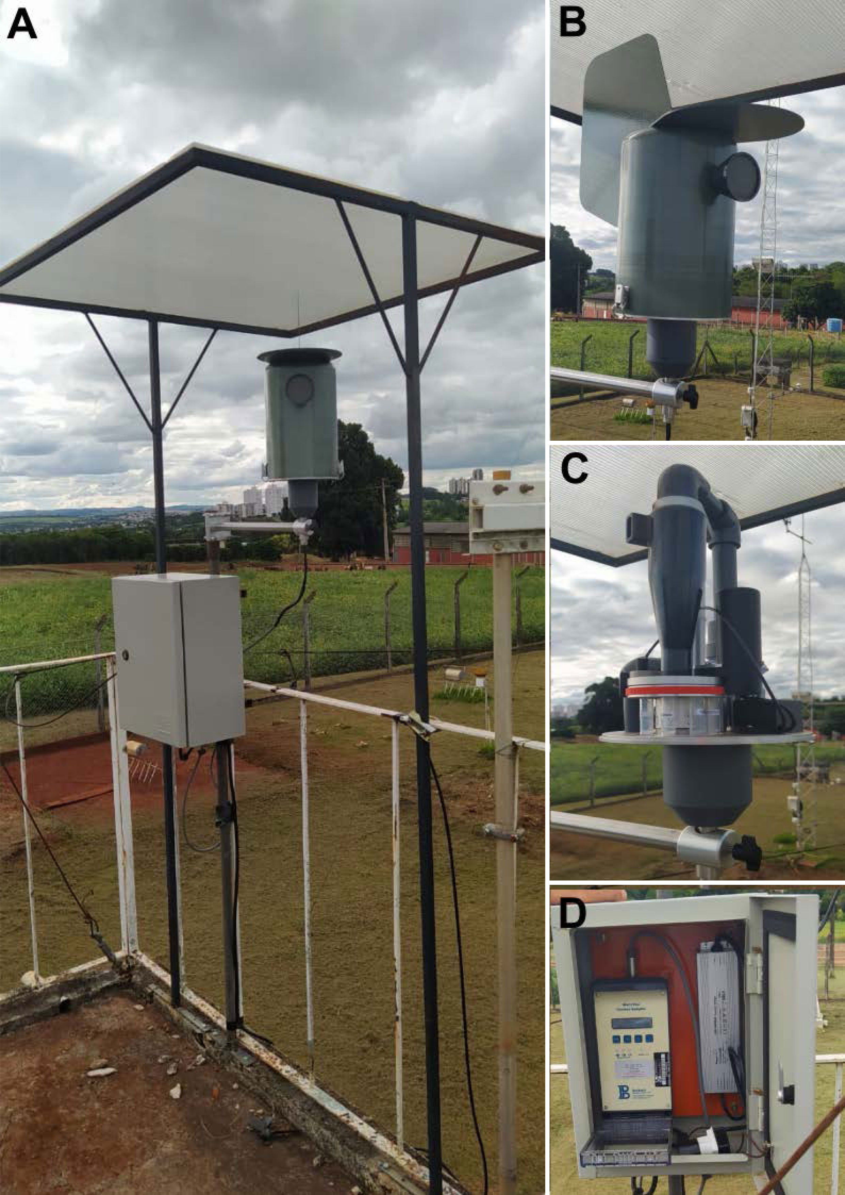
Figure 1. (A) High-volume cyclone air sampler from Agri Samplers Ltd., (High Wycombe, UK), with a protective roof designed, built and attached to the top of the equipment, installed in Londrina, PR, operating at the IDR—Paraná (Paraná Agricultural Development Institute) Experimental Station. (B) Front view of the sampler unit mounted with a wind-driven wing, installed within the limits of a weather station in the background. (C) Details of the uncovered spore sampler unit and (D) control panel by which sampler parameters are defined. ¹ Pictures from A.A.P.Custódio. ¹ The device samples a high volume of air (270 L per minute, which is 27 times more than the traditional Burkard seven-day spore trap. Spores are also collected directly into tubes to facilitate easy lab-based processing. The figure (A) shows important adaptations built by our group for its use in Brazil to protect it from the extremes of the sun and heavy rain, and to raise it into more mobile air-flow, which improves the representation of the sample to the wider region.
The high-volume cyclone air sampler captured aerosols in Paraná state during 2019–2021, for 12 h per day, from 6:00 to 18:00 h. It operated at the IDR—Paraná Experimental Station (former IAPAR) (23°21′34.2″ S; 51°09′52.9″ W), in Londrina County, positioned within the limits of the weather station at 4.5 m high above the ground level and a minimum of 2 km from a wheat crop.

2.1. Fungal DNA Extraction from Air Samples and Purification
For DNA extraction, 0.5 g of sterile glass beads (400–455 µm diameter; Sigma, San Louis, MI, USA) were added to each 2 mL tube together with 440 µL of extraction buffer (400 mM Tris-HCl; 50 mM EDTA pH 8; 500 mM NaCl; 2% polyvinylpyrrolidone; 5 mM 1,10-phenanthroline monohydrate, and just before use, 0.1% β-mercaptoethanol). Tubes were subsequently transferred to a FastPrep homogenizer (Savant FastPrep BIO101 Homogenizer, Thermo Fisher, Waltham, MA, USA) for three cycles of 6.0 m s⁻¹ for 40 s, with 2 min cooling on ice between cycles. Then, a total of 400 µL 2% SDS (sodium dodecyl sulfate) was added to the tubes, which were inverted several times to homogenize the solution, and was then incubated at 65 °C in a water bath for 30 min, while mixing every 10 min. Subsequently, 800 µL of phenol:chloroform (1:1) was added to each tube, which was vortexed briefly and then centrifuged at 13 k rpm for 10 min at 4 °C. To another set of 1.5 mL eppendorf tubes, we added 30 µL 7.5 M ammonium acetate, 480 µL isopropanol, and 1 µL glycoblue. The supernatant from the centrifuged solution was pipetted into the new set of tubes and gently mixed and placed in a −20 °C freezer overnight. The tubes were then centrifuged at 13 k rpm for 30 min at 4 °C and the pellet was washed with 200 µL of 70% ethanol and centrifuged at 13 k rpm for 5 min. The DNA pellet, made visible by glycoblue, was air-dried in a laminar flow cabinet (approx. 30 min) and resuspended in 100 µL of 10 mM Tris pH 8.0, and then placed in a water bath at 65 °C for 5 min to fully resuspend the DNA, before storage at −20 °C. The DNA was purified using EchoCLEAN DNA CleanUp column (BioEcho Life Sciences, Cologne, North Rhine-Westphalia, Germany) according to manufacturer’s instructions.

2.2. Detection of PoTl in Air Samples Using qPCR.
For DNA extraction, 0.5 g of sterile glass beads (400–455 µm diameter; Sigma, San Louis, MI, USA) were added to each 2 mL tube. PCR reactions were performed in a 15-µL reaction (in capped 96 well PCR plates) consisting of 2 µL DNA sample, 13 µL solution containing 7.5 µL of KAPA probe fast qPCR Master Mix (Biosystem, Foster City, CA, USA) and 5.425 µL sterile distilled water containing primers MoT3_1F and MoT3_1R, and the 5′FAM and 3′BHQ1 labeled probe MoT3_FAM2 for PoTl detection targeting a 361 bp amplicon according Pieck et al. [43], as well as the Rox reference dye (Invitrogen; 0.075 µL per reaction). The cycling conditions included 2 min at 98 °C, followed by 50 cycles of 10 secs at 95 °C and 30 s at 60 °C. Each reaction was carried out in duplicate in an AriaMx Real-time PCR System (Agilent, Santa Clara, California, USA). In each qPCR run, standard samples consisting of calibrated amounts of target DNA from PoTl (0.02 pg; 0.2 pg; 2 pg; 20 pg; 200 pg; 2000 pg; 20,000 pg; 100 ng; 500 ng were included for the standard curve. Non-templates controls (NTC, i.e., sterilized distilled water) were also included in every qPCR run. Data were analyzed using the Agilent AriaMx software.

2.3. Pyrosequencing Assay for cyt b Alleles Quantification in Airborne PoTl Populations
The frequency of the cyt b A143 allele in PoTl was associated with QoI-resistance (G-to-C nucleotide exchange at position 54 of the nested PCR amplicon or at position 700 from the GenBank accession number AY245424 sequence) resulting in the amino acid substitution of glycine by alanine at position 143 of the protein [22], was determined using a SNP detection pyrosequencing assay. Prior to pyrosequencing, an initial PCR and a subsequent second PCR (nested-PCR) assay with amplicons from the first reactions were performed to amplify the cyt b gene fragment, which contained the target sequence. The amplification reaction of the initial PCR targeting a 305 bp cyt b fragment was performed in a total reaction volume of 25 µL containing 20 ng of DNA template, 100 µM of dNTPs, 0.2 µM of each primer (Table 1), 0.5 U of Taq DNA Polymerase (GoTaq, Promega, Madison, WI, USA), and 1X GoTaq buffer (3 mM MgCl₂). A negative control (PCR mixture without DNA) was included in all PCR experiments. The amplification reaction was carried out in a thermocycler as follows: initial denaturation at 94 °C for 2 min, 40 cycles of denaturation at 94 °C for 30 s, annealing at 55 °C for 1 min, extension at 72 °C for 1 min, and final extension at 72 °C for 5 min. For the nested PCR, targeting a 101 bp fragment, the following protocol was used, with 15 μL of 1:500 dilution of the product from the initial PCR reaction: 100 µM of dNTPs, 0.2 µM of each nested PCR primer (Table 1), 0.5 U of Taq DNA Polymerase (GoTaq, Promega, USA), and 1X GoTaq buffer (3 mM MgCl₂, Promega). The amplification reaction was carried out in a thermocycler as follows: initial denaturation at 94 °C for 2 min, 40 cycles of denaturation at 94 °C for 30 s, annealing at 55 °C for 1 min, extension at 72 °C for 1 min, and final extension at 72 °C for 5 min. Pyrosequencing of the biotinylated nested PCR products was performed on a PyroMark Q48 instrument (Qiagen, Hilden, Mettmann, Germany) using TCGTGCTA as dispensation order and C/GTGCTACAGTTATTACTAATCTTATT as sequence to analyze. The pyrosequencing reagent kit (Qiagen, Mettmann, Germany) containing binding buffer, annealing buffer, dNTPs, substrate mixture (adenosine 5′ phosphosulfate, and luciferin), and an enzyme mixture (DNA polymerase, ATP sulfurylase, and luciferase) were loaded to the cartridges with set volumes according to the Pyromark software. The sequencing primer was added to the cartridge in a predetermined volume; 10 µL of each nested PCR product was loaded to each well of a PyroMark Q48 Disc in triplicate and 3 µL of PyroMark Q48 Magnetic beads (Qiagen, Mettmann, Germany) was added to each reaction. PoTl isolates with and without cyt b G143A were included as controls. The PyroMark Q48 Autoprep Software was used to quantify the underlying G to C mutation as indicated by the peak heights of the target cyt b gene sequence. Final data on the frequency of QoI-resistant A143 alleles are based on the mean of three technical replicate reactions.
Table 1. Primers and probe used for real-time qPCR detection of Pyricularia oryzae Triticum lineage and cyt b primers for detection of the A143 allele associated with QoI resistance using a nested-polymerase chain reaction (nested-PCR) assay and pyrosequencing from fungal DNA extracted from airborne spore samples.
Oligonucleotide Name | Type | Oligonucleotide Sequence and  Labeling (5′–3′)
MoT3_1F | Forward primer for qPCR | AGGATGTATGCCCTGACTGG
MoT3_1R | Reverse primer for qPCR | CTCGGCGATGCAAAAGTGAA
MoT3_FAM2 | qPCR probe ¹ | TTCTAACGGTTTGCAATTGCACAAAACAAC
cyt b initial PCR
F1 | Forward primer | GTTTGAGCTATTGGTACTGTTATATTA
R1 | Reverse primer | GAAACACCAAGAGGATTGCTT
cyt b nested PCR
F2 | Forward primer | GGCTATCGGTTTCCTAGGTTATGT
R2 | Reverse primer ² | TGCCCTATTCAAGGTATAGCACTA
cytB primer for pyrosequencing
S1 | Sequencing primer | GGACAGATGTCATTATGAG
¹ Probe labeled with the fluorophore FAM at the 5′ end and with the BHQ1 quencher at the 3′ end. ² Primer labeled with biotin at 5′ end.

2.4. Pearson Correlation Analysis among Weather Variables and the Amount of PoTl DNA Detected in Air Samples Using a Real Time qPCR Assay
Weather data were obtained from the IDR Paraná Experimental Station, which was located at short distance from the air sampler. Maximum, minimum, and average temperatures (°C), rainfall (mm), leaf wetness duration (hour.day⁻¹), maximum, minimum, and average relative humidity (%), and wind speed (m.s⁻¹) were recorded daily for two years (Figure 2).
Figure 2. Daily (A) rainfall (mm, orange lines) and average temperature (°C, dark gray bars), (B) leaf wetness period (hours day⁻¹, light gray bars) and average relative humidity (%, purple lines) in Londrina, PR, at the IDR–Paraná Experimental Station, from June 2019 to June 2021.
To test the correlation between weather variables and the detected amount of PoTl DNA from airborne inoculum, data on daily rainfall and leaf wetness period accumulated during 30, 15, 10, and 5 day-periods before the detection event, generating the variables rainfall 30, 15, 10 and 5 and LW 30, 15, 10 and 5. We also determined the optimal temperature index (number of days within the optimum temperature for wheat blast disease development, ranging from 22 °C to 28 °C [30,44] accumulated in 30, 15, 10, and 5 day-periods. In addition, we also used relative humidity daily values reflecting the optimal relative humidity index (number of days in which the relative humidity was ≥85%, which is considered optimum for fungal sporulation [30,44] accumulated in 30, 15, 10, and 5 day-periods. The Pearson correlation analyses were conducted for four-time windows (May and June; June and July; July and August; August and September) spanning heading, flowering, and grain filling stages, according to the distinct regional wheat sowing dates (National Program for Agricultural Zoning based on Climate Risk for Paraná State, ZARC–PR [45]. We also included a period completely outside of the wheat cropping (January to April) to check for correlations with weather variables.

2.5. Descriptive Representation of the Time Series and Statistical Analyses
The time series of the daily amounts of PoTl DNA detected in aerosol samples using qPCR were summarized using the R software packages [46], dplyr, lubridate, scales, gridExtra, ggthemes, ggplot2, and the functions geom_line, geom_point, and facet_wrap.
Pearson correlation analysis (p ≤ 0.05) among weather variables and the amount of PoTl DNA was conducted using the Stats and Performance Analytics packages from R software and the R studio interface [46].

3. Results

3.1. Detection of PoTl in Aerosol Samples Using qPCR
Based on the results of calibration curve samples that were tested in each run, in which 0.2 pg was sometimes detected whereas 2 pg always was detected within 35 cycles of qPCR, we used 2 pg as the detection threshold. Using this detection threshold, PoTl target DNA was detected in 167 out of the 480 samples (35%) taken and tested during the period July 5, 2019, till April 14, 2021 (Figure 3). The average amount of PoTl DNA in 2 μL of DNA sample was 8.9 pg. The highest amount of the fungus DNA detected in the entire two-year sampling period was from 5 September 2019 (1022 ± 13 pg), while less than 200 pg of target DNA was detected on all other days.
From July to September 2019, which was the period coinciding with wheat cropping in the Londrina region, the average daily amount of fungal DNA detected was 28.7 pg. High peaks of the PoTl DNA were continuously detected off-season, from December 2019 until late March 2020 (average of 15.2 pg), with only a few days below the detection threshold.
The average amount of fungal DNA detected daily from May to September 2020 during wheat cropping was 1.8 pg, which was considerably lower than the 2019 cropping season (the mean of 2019 minus 2020 equals 26.9; t = 2.2654, with df = 188, two-tailed p-value = 0.0246*). Later, in both early and late June 2020, which fell right within the annual wheat cropping season in Paraná State, two isolated higher peaks of PoTl DNA were detected (equal to 40.7 and 79.9 pg). In the following off-season, high peaks of the PoTl DNA were also continuously detected from December 2020 until late March 2021 (average of 17.5 pg). The average amount of PoTl DNA detected on both previous (2020) and posterior (2021) off-seasons was significantly higher than the average amount detected in the 2020 growing season (the mean of both 2020 and 2021 off-seasons minus the 2020 in-season 2020 amount = −14.6; t = 2.1973, with df = 316, two-tailed p-value = 0.0287*).
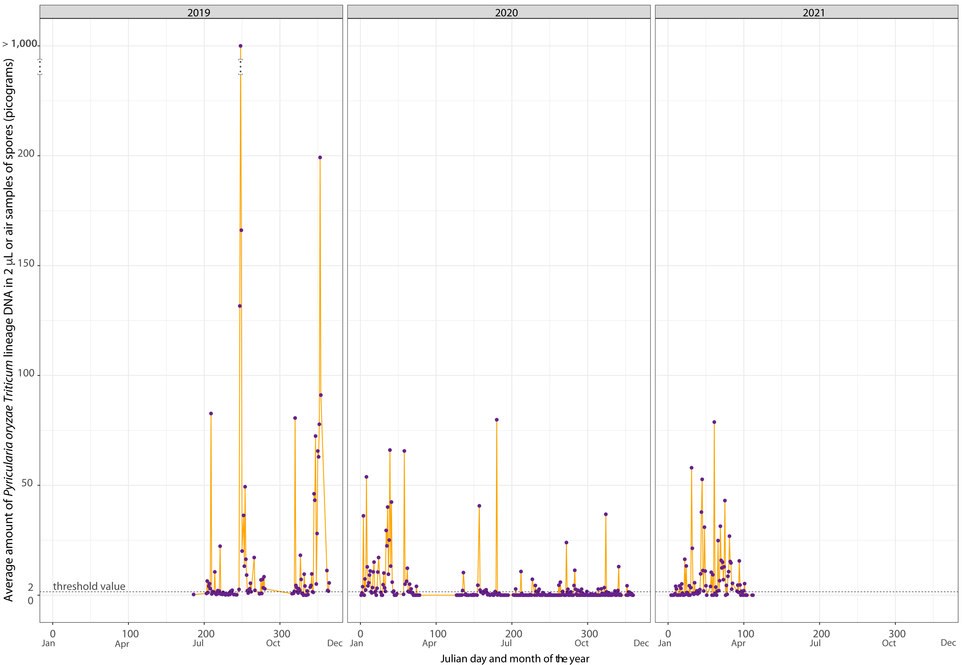
Figure 3. Average daily amounts of PoTl DNA detected by qPCR in aerosols sampled for 12 h with a high-volume cyclone air sampler at Londrina, Paraná, from July 5, 2019, till April 14, 2021. Average daily amount of target DNA was determined from the results obtained after testing 2 μL of in sample in duplicate.
A medium peak (36.8 pg) of PoTl DNA was detected in November 2020 followed by relatively lower peaks. Similarly, in the 2020 off-season, several peaks of PoTl DNA from airborne spore samples were detected between late January to late March 2021 (such peaks varied from 26.9 to 78.8 pg). Therefore, there was a consistent trend in higher peaks of PoTl DNA detected during two consecutive wheat off-seasons (in the summer of 2019/20 and 2020/21).

3.2. Quantification of QoI-Resistant cyt b Alleles in PoTl Populations Present in Air Samples
The partial cyt b gene fragment representing QoI-resistant (A143) and/or QoI-sensitive (G143) alleles was PCR-amplified and pyrosequenced from ten PoTl positive aerosol samples that were collected at different times during the two year monitoring period (Figure 4).
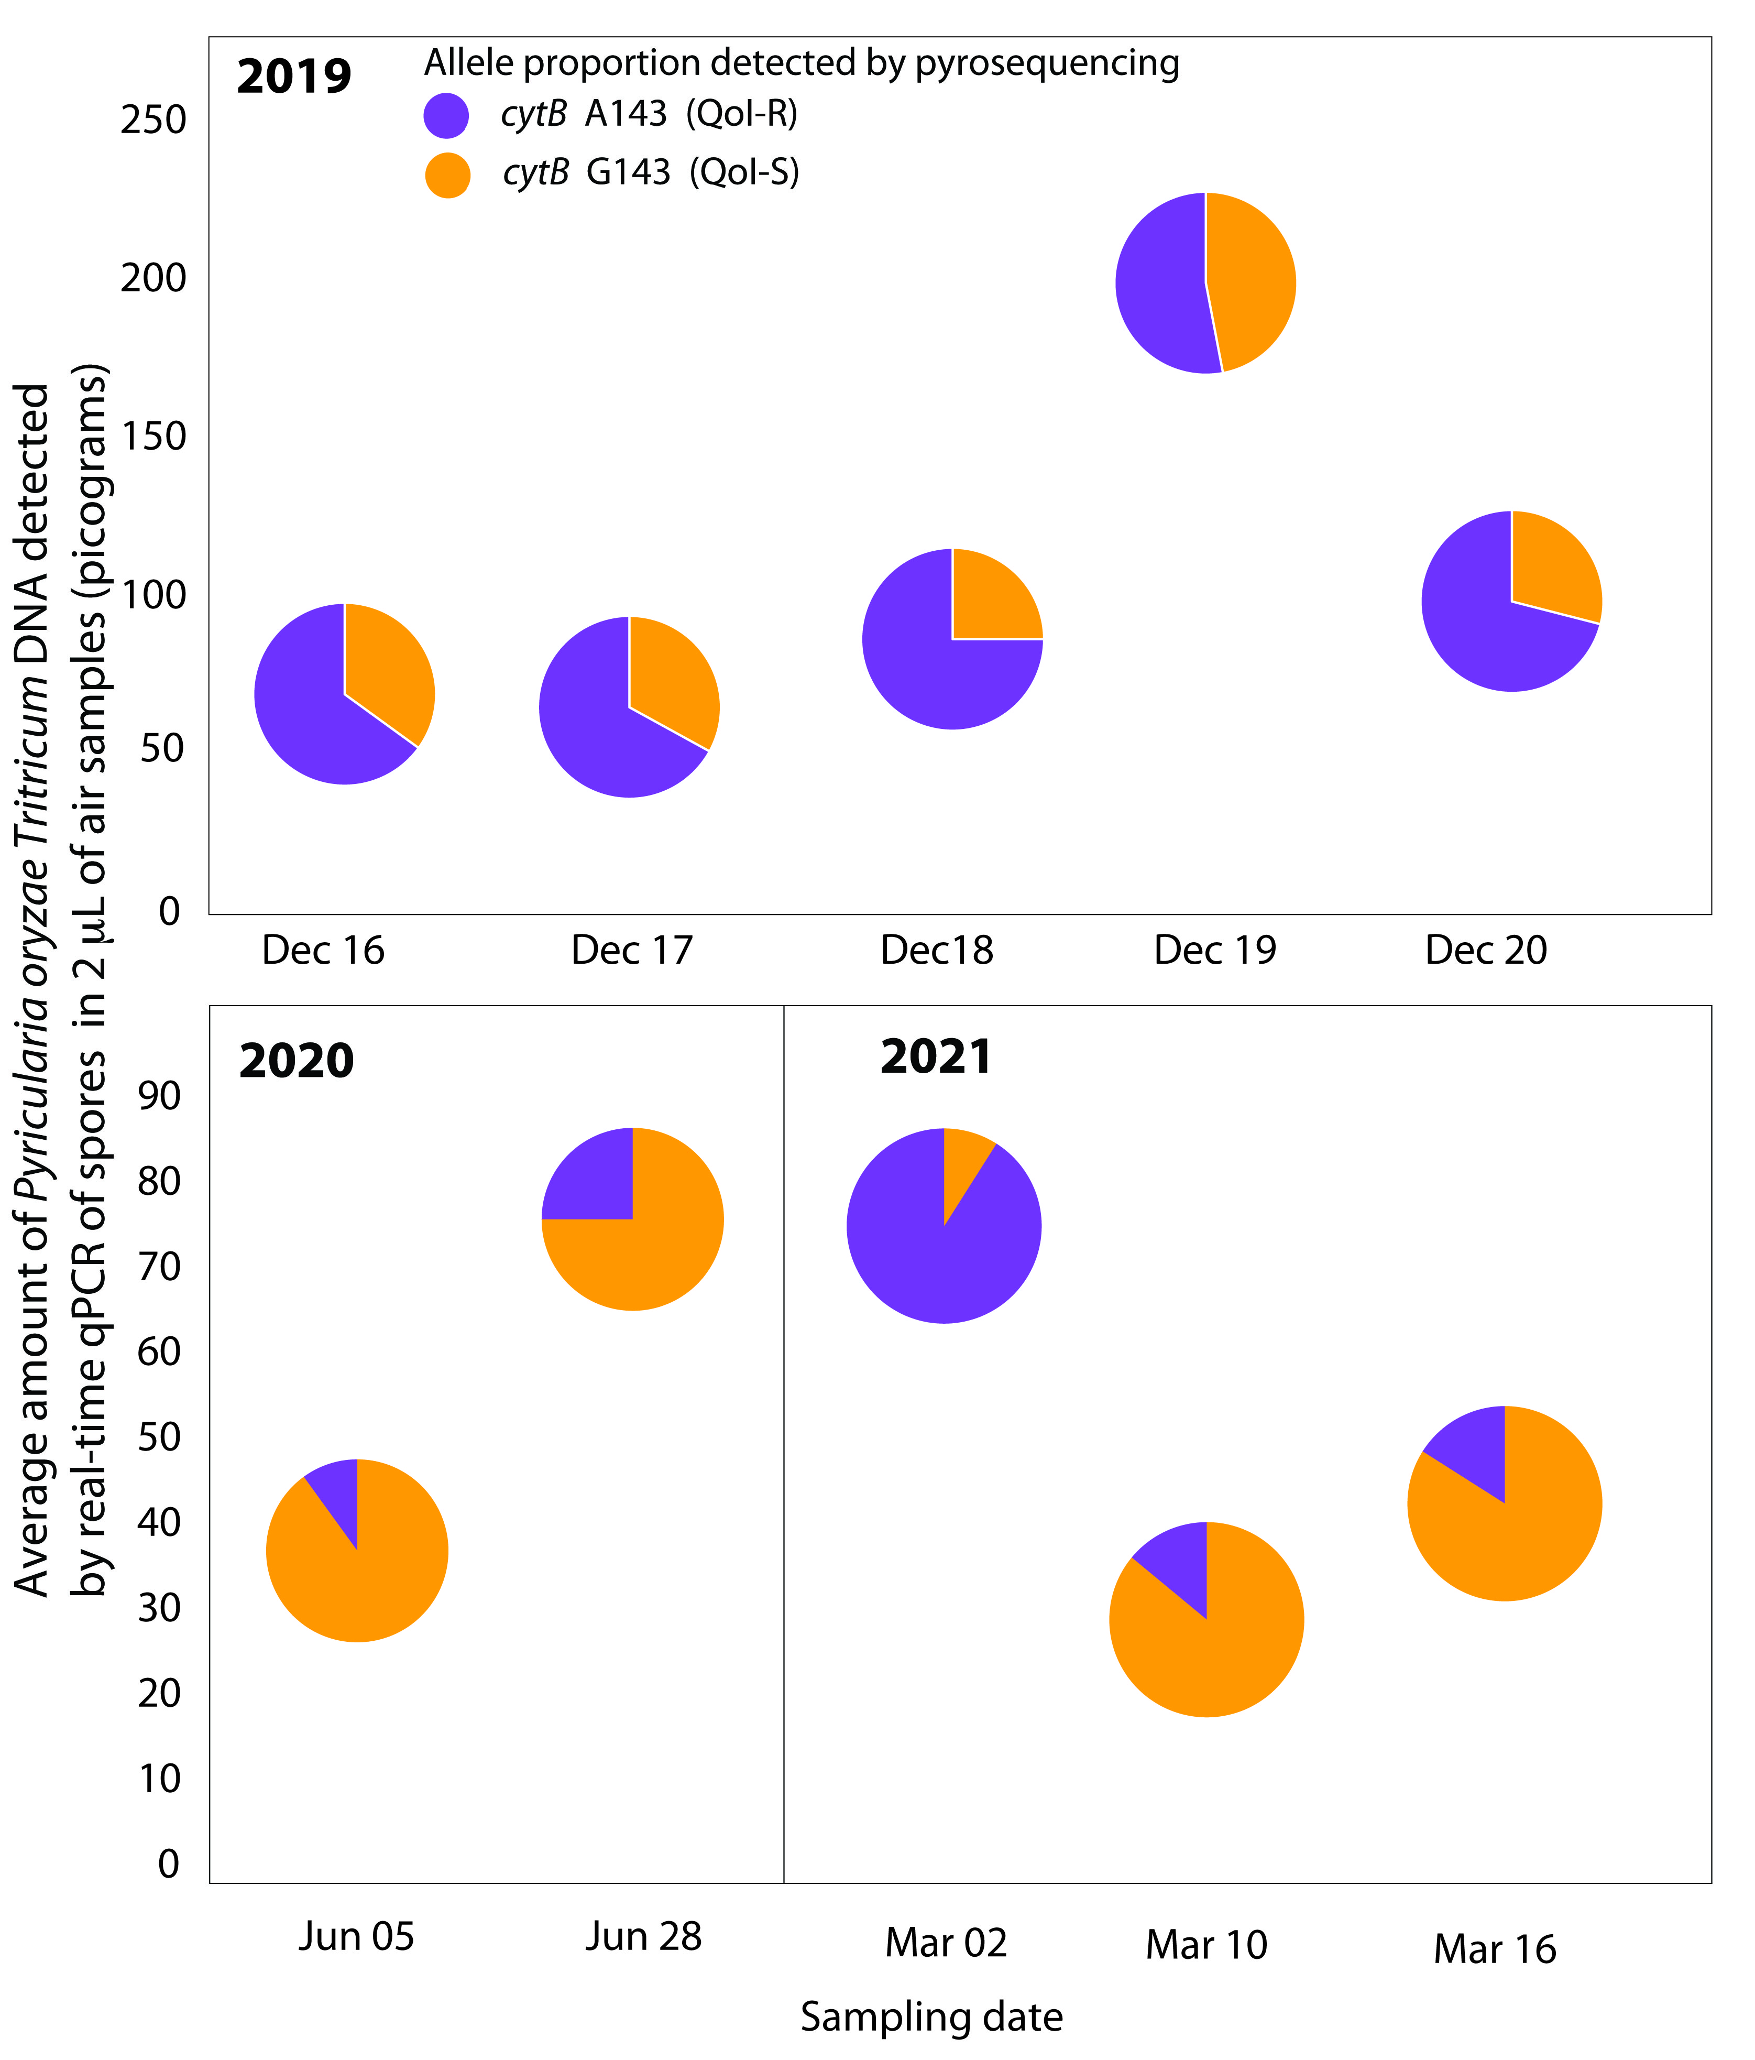
Figure 4. Quantitative detection of cytochrome b G143A in PoTl aerosol populations sampled daily in Londrina (PR, Brazil) using PCR and SNP detection pyrosequencing assays. Two microliters of DNA of each air sample was tested.
QoI-resistant A143 alleles were detected in all ten air samples tested but there were differences in frequencies (Figure 4). Five PoTl aerosol populations sampled during December 2019 showed a uniform QoI-R frequency, between 52.5 and 74.5%, whereas lower frequencies of 10.1 and 24.6% were recorded for two populations sampled during June 2020 and contrasting frequencies between 14.1 and 91.4% were measured in three samples collected in March 2021.

3.3. Pearson Correlation Analysis among Weather Variables and the Amount of PoTl DNA in Air Samples
In the first period, encompassing the heading, flowering, and grain filling stages (from May to June), a significant correlation was observed between the amount of PoTl DNA detected and the following six weather variables: daily rainfall accumulated for 15 days prior to the detection event (dpde) (r = 0.28, p = 0.1) and for 5 dpde (r = 0.34, p = 0.05), the optimal relative humidity index (number of days with relative humidity ≥ 85%) accumulated for 5 dpde (r = 0.34, p = 0.05), the leaf wetness accumulated for 30 dpde (r = 0.24, p = 0.1), and the wind speed (r = 0.30, p = 0.05); the highest correlation was observed with leaf wetness accumulated for 30 dpde (r = 0.40, p = 0.01) (Figure 5).
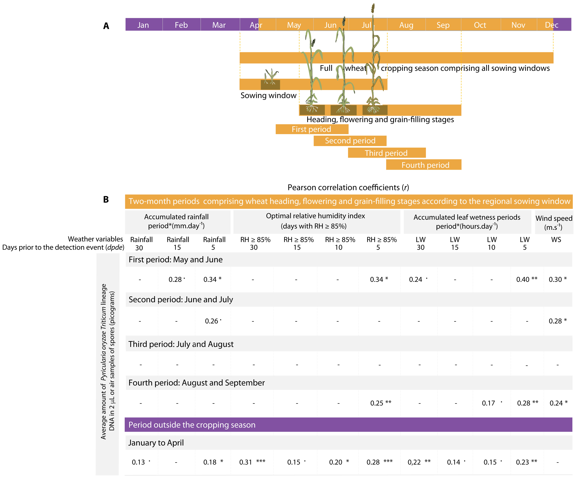
Figure 5. (A) Correlations were determined for two-month data periods comprising the heading, flowering, and grain filling stages, as defined based on the regional sowing window [45]. (B) Pearson correlation coefficient (r) between PoTl DNA (pg) present in DNA of a daily air sample (2 μL tested) and weather variables accumulated 5, 10, 15, and 30 days prior to spore release detection event. Rainfall, optimal relative humidity index (days with RH ≥ 85%), leaf wetness period (LW), and wind speed (WS) at 2 m. Significance levels (p values) at *** = 0.001; ** = 0.01; * = 0.05; • = 0.1.
Only two weather variables were correlated with the amount of PoTl DNA detected in air samples from the second period (June to July): rainfall accumulated for 5 dpde (r = 0.26, p = 0.1) and wind speed (r = 0.28, p = 0.05). No significant correlation with weather variables was detected in the third period (from July to August). In the fourth period (from August to September), there was significant correlation between the amount of PoTl DNA detected and the optimal relativity humidity index accumulated for 5 dpde (r = 0.25, p = 0.01), the accumulated leaf wetness for 10 dpde (r = 0.17, p = 0.1) and 5 dpde (r = 0.28, p = 0.01), and the wind speed (r = 0.24, p = 0.05).
Correlations between the amount of PoTl DNA detected and weather variables were also observed in the period outside of the wheat growing season, from January to April. Although the r values for these correlations were relatively low, this was the period with more weather variables that correlated with the molecular detection levels of the pathogen. A positive significant correlation was observed with the accumulated rainfall for 30 dpde (r = 0.13, p = 0.1) and 5 dpde (r = 0.18, p = 0.05). The amount of pathogen DNA correlated with the optimal relative humidity index accumulated for 30 dpde (r = 0.31, p = 0.001), 15 dpde (r = 0.13, p = 0.1), 10 dpde (r = 0.20, p = 0.05), and 5 dpde (r = 0.28, p = 0.001). A significant correlation was also observed with the accumulated daily leaf wetness for 30 dpde (r = 0.22, p = 0.01), 15 dpde (r = 0.14, p = 0.1), 10 dpde (r = 0.15, p = 0.1), and 5 dpde (r = 0.23, p = 0.01).
There was no correlation between the optimal temperature index (number of days with temperatures ranging from 22 °C to 28 °C) accumulated for any of the periods and the amount of fungal DNA detected.

4. Discussion
Using a high-volumetric cyclone air sampler positioned in a major wheat cropping area in Paraná State, coupled with a qPCR assay for pathogen detection, our first aim was to directly measure PoTl target DNA representing airborne conidia continuously released from 2019 to 2021, both within and not within the wheat growing season, in Londrina, PR. The direct detection of the PoTl airborne inoculum density using an automated continuous air sampling system, on a regional scale, may, in combination with molecular detection, be useful in providing more accurate predictions of the risks of severe wheat blast epidemics, even before they occur [47], as it has been documented for other pathosystems [27,30]. Knowledge on airborne inoculum for wheat blast could optimize fungicide spray decision making as part of an integrated disease management program, allowing the reduction of unnecessary sprays and lowering the environmental impact [48].
In our study, PoTl inoculum was consistently detected during the 2019 and 2020 wheat cropping seasons, but amounts varied significantly between these two cropping seasons, with higher amounts detected in 2019. However, high peaks of PoTl DNA were also continuously detected in both the 2020 and 2021 off-seasons, with an average of 16.42 pg mL⁻¹, which was even significantly higher than the amount detected within the 2020 cropping season. Assuming 0.042 pg of DNA corresponds to approximately 1 spore and 194 m³ air was sampled daily for 12 h, the highest level of spores recorded daily for the 12 h sampling period was 6259 spores.m⁻³ on September 5, 2019, with all other samples having daily numbers equal to or well below 1219 spores.m⁻³ based on a DNA sample volume of 100 µL. These numbers are comparable to PoTl spore numbers recorded in air samples collected with a self-made PVC pipe wind vane spore trap near wheat fields in Passo Fundo (Rio Grande do Sul state, Brazil) using spore counting [49]. Danelli et al. [49] also recorded high amounts of PoTl airborne inoculum in the off-season period from February to March.
With the lack of regional wheat cultivation in the off-season during summer, from December to March (according to the National Program for Agricultural Zoning based on Climate Risk for Paraná State, ZARC–PR [45]), the detection of PoTl airborne inoculum indicates that the pathogen is continuously and successfully reproducing in other grass hosts and being air dispersed. In fact, PoTl can survive between growing seasons in over 12 invasive grass host species [22] and may contribute to the initial inoculum for the onset of wheat blast disease every cropping season. Besides the invasive grass species, important forage crop species, such as signal grass (U. brizantha, the country’s most extensively cultivated grass pasture for cattle grazing) and perennial ryegrass (Lolium perenne), are important susceptible secondary hosts for PoTl, from which fungal conidia is constantly and abundantly wind-dispersed over short to medium distances [22,50]. Therefore, our aerobiology data corroborates the assertion that off-season non-wheat hosts play an important role in the early onset of the wheat blast, which can keep a year’s long bridge of fungal inoculum in between wheat cropping seasons.
The second objective of our study was to establish the prevalence of QoI-R cyt b A143 alleles in PoTl aerosol populations. Using a combination of nested PCR and pyrosequencing, we were able to detect A143 alleles in all ten PoTl positive PCR samples that were selected from different periods of our monitoring studies. Five PoTl aerosol populations sampled during 16–20 December, 2019, showed a uniform QoI-R frequency between 52.5 and 74.5%, indicating that inoculum is originating from the same source during this period, whereas lower frequencies of 10.1 and 24.6% were recorded for two populations sampled on 5 and 28 June, 2020. The aerosol population sampled on March 2, 2021, showed the highest frequency of QoI resistance alleles, 91%, whereas the other two samples collected on 10 and 16 March, 2021, showed contrasting frequencies of 16 and 14%, respectively. Because the cyt b sequence is very similar between PoTl and PoOl, the nested PCR Pyrosequencing assay is not able to distinguish the two lineages. We, therefore, also carried out a quantitative SYBR Green real-time PCR assay using primers Pot2a-L2 and Pot2a-R2, which will detect both lineages, as described by Pieck et al. [43]. By comparing the results of the two assays, it was clear that PoOl was either absent or present in such limited amounts that it would not have an impact on the recorded QoI-R allele frequencies (data not shown).
Despite the seasonal fluctuations detected in the prevalence of the cyt b allele for QoI resistance in the PoTl airborne inoculum, it was clear from our study that QoI-R strains were prompt to reemerge and dominate the wheat blast fungal population along the cropping season. This ability for re-emergence has been attributed to an inherited competitive advantage associated with the PoTl QoI-R strains [51] although a competitive disadvantage has been reported for the cyt b G143A allele carrying QoI-R strains from fungal species, such as Zymoseptoria tritici, and the sister species P. oryzae Lolium lineage [52,53].
Because of the widespread prevalence of resistance to QoI fungicides in field populations of PoTl across the major wheat cropping areas from Central and Southern Brazil reported in recent years, corroborated by our current aerobiology study in Londrina, PR, spraying multiple QoI fungicide-based applications should be avoided as an anti-resistance precautionary strategy [54]. The intensive long-term use of QoI fungicides in managing wheat diseases has kept a non-stop selection pressure favoring the prevalence of QoI-R PoTl strains in the wider environment [2,22–24].
A similar scenario can occur with the recently introduced site-specific systemic high-risk SDHI fungicide fluxapyroxad, because SDHI-resistant baseline populations of PoTl have been detected even before the local labeling of these actives for the management of wheat diseases in Brazil and persisted in current populations of the pathogen [24]. The SDHI-resistance in PoTl has not been associated with single point mutations in the target genes sdh-B, C, or D, but rather to a more complex energy-dependent efflux pump mechanism typical of multidrug resistance [24,55].
In fact, in vivo fungicide sensitivity testing of PoTl isolates under a controlled environment has shown moderate to high levels of resistance to multiple fungicides groups, with blast control efficacy as lower as 3.3% for the QoI azoxystrobin, 31.3% for the QoI pyrachlostrobin (QoI), 31.0% for the SDHI fluxapyroxad, and 51.0% for the DMI epoxiconazole [56]. The multiple fungicide resistance detected in this in vivo assay [56] was probably due to enhanced efflux pump activity in PoTl [55]. Although the impact of this resistance mechanism detected both in vitro [24,55] and in vivo [56] assays might be less than expected for disease control in the field, a meta-analysis from 42 field trials over 9 years (2012 to 2020) indicated an average control efficacy of QoI and DMI fungicides ranging from as low as 43% to a maximum of 58% [57]. Given this poorer performance and lower profitability of fungicide sprays [57], there is an urgent need for the adoption of integrated wheat blast management strategies that do not rely so heavily on fungicides.
Upon further selection of SDHI fungicides, it is likely that PoTl will evolve the target-site, with a whole range of mutations in SdhB, C, and/or D already reported in cereal pathogens such as Z. tritici, Pyrenophora teres, and Ramularia collo-cygni [58]. For early detection of new mutations at extremely low frequencies, allowing early implementation and monitoring of fungicide resistance management strategies, next generation sequencing techniques, such as Illumina MiSeq for short reads targeting single SNPs and Oxford Nanopore MinION for long reads targeting combinations of SNPs, can be used in combination with automated air sampling [59,60].
The third aim of our study was to determine the correlation among weather variables and the amount of PoTl DNA in airborne spore samples. We tested the hypothesis that weather variables were correlated with levels of PoTl DNA detected in airborne spore samples collected along two consecutive years.
In our study, statistically significant but low correlations were found between the levels of pathogen molecular detection and the weather variables analyzed in four distinct two-months periods (comprising the wheat heading, flowering, and grain-filling stages) within the cropping season. These four periods were defined a priori based on the distinct sowing windows established by an official zoning program along the full cropping season (National Program for Agricultural Zoning based on Climate Risk for Paraná State, ZARC–PR [45]).
For any of the periods examined, except for the third one (Figure 5A,B, period from July to August), a few climatic variables were correlated with the amount of the pathogen DNA (Figure 5B). However, in the off-season, most of the weather variables were correlated with the amount of pathogen DNA detected. The optimal relative humidity index accumulated for 30 dpde (r = 0.31, p = 0.001) and accumulated daily leaf wetness for 5 dpde (r = 0.23, p = 0.01) showed the highest correlation in the off-season period. Despite significance, correlations were very low. Therefore, we concluded that a system based on weather variables has very low predictive value for determining the levels of airborne PoTl inoculum.
This observation does not invalidate the potential of continuous direct monitoring of the PoTl airborne inoculum as it can provide a better understanding of the dynamics of airborne inoculum production, release, and dispersal, as well as pathogen epidemics, which can be critical for more accurate predictions of wheat blast risk [32]. If high levels of PoTl airborne inoculum coincide with the wheat heading stage, it can result in severe ear infection and high yield losses [14,32]. Therefore, monitoring PoTl inoculum from air samples both within cropping fields and at the regional scale is very important to develop aerobiology-based forecasting models for blast disease incidence [34]. In conclusion, for wheat blast, prior detection of airborne spore levels of the pathogen can prevent major crop yield losses by ensuring that timely and appropriate disease management practices will be adopted.
Author Contributions: Conceptualization, P.C.C., J.S.W., and B.F.; methodology, P.C.C., J.S.W., and B.F.; software, S.N.C.V., N.H., S.I.M., and D.P.; validation, B.F., N.H., and P.C.C.; formal analysis, P.C.C., N.H., and S.N.C.V.; investigation, S.N.C.V., N.H., K.M.K., and L.D.K.; resources, S.N.C.V., N.H., and L.D.K.; data curation, N.H, S.N.C.V., B.F., and J.S.W.; writing—original draft preparation, S.N.C.V. and P.C.C.; writing—review and editing, P.C.C., J.S.W., B.F., A.A.d.P.C., W.C.d.J.J., and F.R.G.-F.; visualization, P.C.C., J.S.W., and B.F.; supervision, P.C.C. and B.F.; project administration, P.C.C. and A.A.d.P.C.; funding acquisition, P.C.C., A.A.d.P.C., and R.P.L.J. All authors have read and agreed to the published version of the manuscript.
Funding: This research was funded by the São Paulo Research Foundation, Brazil (FAPESP) through regular research grants to P.C. (2020/07611-9; 2021/03402-9; and 2022/12661-0); in partnership with Fundação Araucária to A.C. (FPS2020011000057); a Newton Fund grant from the Biotechnology and Biological Sciences Research Council (BBSRC) and UK Research and Innovation (UKRI), with FAPESP as partner institution in Brazil to P.C. (2017/50456-1; 2018/21197-0) and to S.M. (postdoctoral scholarship 2019/12509-1), CNPq (Brazilian National Council for Scientific and Technological Development), grant/award number: Pq-1D 313825/2018-1 and Pq-1C 311895/2022-0; CAPES (Coordination for the Improvement of Higher Level Personnel), Grant/Award Numbers: CAPES/Pro-equipment Program 775202/2012, CAPES/AUXPE Program 88881.593505/2020-01—UNESP Ilha Solteira Campus, CAPES PrInt/UNESP 41/2017–88887.570719/2020-00. B.F. received funding from the Newton Fund through grant BB/S018867/2 awarded by BBSRC under the BBSRC-FAPESP AMR and Insecticide Pest Resistance in Livestock and Agriculture Programme at NIAB–National Institute of Agricultural Botany, Cambridge, UK and Rothamsted Research, Harpenden, UK. S.V. and L.K. were supported by Ph.D. scholarships from CAPES studentship Program 001. L.K. was supported by a studentship from FAPESP (2022/09787-2). The article processing charges were supported mostly by São Paulo State University’s Vice-Presidency for Research (PROPE) special grant for publication (Public Call 10/2022) and partially by funds from the Paraná Agricultural Development Institute, IDR—Paraná/IAPAR.
Informed Consent Statement: The Brazilian Ministry of Environment/National System for the Management of Genetic Heritage and Associated Traditional Knowledge—SisGen, issued the Certificates numbered A59E163 and A100786 authorizing the scientific activities associated with the collection of botanical and fungal material from the wheat agroecosystem in the Cerrado’s biome and access to the genetic diversity of Pyricularia species.
Data Availability Statement: The data are not publicly available due to the authors’ option.
Acknowledgments: We acknowledge Rothamsted Research, UK from donating four Cyclone spore samplers purchased from Agri Samplers Ltd., which were then incorporated by UNESP for the realization of this study. We also thank L. C. Borsato, M. V. Nunes, P. R. Nitsche, A. L. Johann, and H. C. Delalibera from IDR-Paraná/IAPAR for their very important technical assistance in this research.
Conflicts of Interest: The authors declare no conflict of interest. The funders had no role in the design of the study; in the collection, analyses, or interpretation of data; in the writing of the manuscript; or in the decision to publish the results.

References
- Igarashi, S.; Utiamada, C.; Igarashi, L.; Kazuma, A.; Lopes, R. Pyricularia Em Trigo. 1. Ocorrência de Pyricularia sp. No Estado Do Paraná. Fitopatol. Bras. 1986, 11, 351–352.
- Ceresini, P.C.; Castroagudin, V.L.; Rodrigues, F.A.; Rios, J.A.; Eduardo Aucique-Perez, C.; Moreira, S.I.; Alves, E.; Croll, D.; Maciel, J.L.N. Wheat Blast: Past, Present, and Future. Annu. Rev. Phytopathol. 2018, 56, 427–456. https://doi.org/10.1146/annurev-phyto-080417-050036.
- Cruz, C.D.; Santana, F.M.; Todd, T.C.; Maciel, J.L.N.; Kiyuna, J.; Baldelomar, D.F.; Cruz, A.P.; Lau, D.; Seixas, C.S.; Goulart, A.C.P.; et al. Multi-Environment Assessment of Fungicide Performance For Managing Wheat Head Blast (WHB) In Brazil And Bolivia. Trop. Plant Pathol. 2019, 44, 183–191. https://doi.org/10.1007/s40858-018-0262-9.
- Kohli, M.; Mehta, Y.R.; Guzman, E.; Viedma, L.; Cubilla, L.E. Pyricularia Blast–a Threat to Wheat Cultivation. Czech J. Genet. Plant Breed. 2011, 47, S130–S134. http://doi.org/10.17221/3267-CJGPB.
- Islam, M.T.; Croll, D.; Gladieux, P.; Soanes, D.M.; Persoons, A.; Bhattacharjee, P.; Hossain, M.S.; Gupta, D.R.; Rahman, M.M.; Mahboob, M.G.; et al. Emergence of Wheat Blast in Bangladesh Was Caused by A South American Lineage of Magnaporthe Oryzae. BMC Biol. 2016, 14, 84. https://doi.org/10.1186/s12915-016-0309-7.
- Tembo, B.; Mulenga, R.M.; Sichilima, S.; M’Siska, K.K.; Mwale, M.; Chikoti, P.C.; Singh, P.K.; He, X.; Pedley, K.F.; Peterson, G.L.; et al. Detection And Characterization Of Fungus (Magnaporthe Oryzae Pathotype Triticum) Causing Wheat Blast Disease On Rain-Fed Grown Wheat (Triticum Aestivum L.) In Zambia. PloS ONE 2020, 15, e0238724. https://doi.org/10.1371/journal.pone.0238724.
- Malaker, P.K.; Barma, N.C.D.; Tiwari, T.P.; Collis, W.J.; Duveiller, E.; Singh, P.K.; Joshi, A.K.; Singh, R.P.; Braun, H.J.; Peterson, G.L.; et al. First Report Of Wheat Blast Caused By Magnaporthe Oryzae Pathotype Triticum In Bangladesh. Plant Dis. 2016, 100, 2330–2330. https://doi.org/10.1094/PDIS-05-16-0666-PDN.
- McDonald, B.A.; Stukenbrock, E.H. Rapid Emergence Of Pathogens In Agro-Ecosystems: Global Threats To Agricultural Sustainability And Food Security. Philos. Trans. R. Soc Lond. B Biol. Sci. 2016, 371. https://doi.org/10.1098/rstb.2016.0026.
- Sadat, M.A.; Choi, J. Wheat Blast: A New Fungal Inhabitant to Bangladesh Threatening World Wheat Production. Plant Pathol. J. 2017, 33, 103–108. https://doi.org/10.5423/PPJ.RW.09.2016.0179.
- Maciel, J.L.N.; Ceresini, P.C.; Castroagudin, V.L.; Zala, M.; Kema, G.H.J.; McDonald, B.A. Population Structure And Pathotype Diversity Of The Wheat Blast Pathogen Magnaporthe Oryzae 25 Years After Its Emergence In Brazil. Phytopathology 2014, 104, 95–107. https://doi.org/10.1094/PHYTO-11-12-0294-R.
- Pizolotto, C.A.; Maciel, J.L.N.; Fernandes, J.M.C.; Boller, W. Saprotrophic Survival Of Magnaporthe Oryzae In Infested Wheat Residues. Eur. J. Plant Pathol. 2019, 153, 327–339. https://doi.org/10.1007/s10658-018-1578-5.
- Castroagudín, V.L.; Danelli, A.L.D.; Moreira, S.I.; Reges, J.T.A.; de Carvalho, G.; Maciel, J.L.N.; Bonato, A.L.V.; Forcelini, C.A.; Alves, E.; McDonald, B.A.; et al. The Wheat Blast Pathogen Pyricularia Graminis-Tritici Has Complex Origins And A Disease Cycle Spanning Multiple Grass Hosts. bioRxiv 2017. https://doi.org/10.1101/203455.
- Urashima, A.S.; Leite, S.F.; Galbieri, R. Eficiência Da Disseminação Aérea Em Pyricularia Grisea. Summa Phytopathol. 2007, 33, 275–279.
- Gomes, D.P.; Rocha, V.S.; Pereira, O.L.; Souza, M.A.d. Damage Of Wheat Blast On The Productivity And Quality Of Seeds As A Function Of The Initial Inoculum In The Field. J. Seed Sci. 2017, 39, 066–074. https://doi.org/10.1590/2317-1545v39n1172688.
- Goulart, A.C.P.; Paiva, F.A.; Andrade, P.J.M. Relação Entre A Incidência Da Brusone Em Espigas De Trigo E A Presença De Pyricularia Grisea Nas Sementes Colhidas. Fitopatol. Bras. 1995, 20, 184–189.
- Goulart, A.C.P.; Paiva, F.d.A. Sobrevivência De Pyricularia Oryzae Cav. Em Sementes De Trigo (Triticum Aestivum L.) Armazenadas Em Diferentes Ambientes. Rev. Bras. De Sementes 1993, 15, 153–156.
- Urashima, A.S.; Lavorent, N.A.; Goulart, A.C.P.; Mehta, Y.R. Resistance Spectra Of Wheat Cultivars And Virulence Diversity Of Magnaporthe Grisea Isolates In Brazil. Fitopatol. Bras. 2004, 29, 511–518. https://doi.org/10.1590/S0100-41582004000500007.
- Cruz, M.F.; Prestes, A.M.; Maciel, J.L.N.; Scheeren, P.L. Resistência Parcial À Brusone De Genótipos De Trigo Comum E Sintético Nos Estádios De Planta Jovem E De Planta Adulta. Trop. Plant Pathol. 2010, 35, 24–31. https://doi.org/10.1590/S1982-56762010000100004.
- Torres, G.A.M.; Ferreira, J.R.; Binneck, E.; Maciel, J.L.N.; Consoli, L. Blast Disease And Wheat Production In Brazil. Pesqui. Agropecuária Bras. 2022, 57, 02487. https://doi.org/10.1590/S1678-3921.pab2022.v57.02487.
- Sharma, R. Wheat Blast Research: Status And Imperatives. Afr. J. Agric. Res. 2017, 12, 377–381. https://doi.org/10.5897/AJAR2016.11860.
- Poloni, N.M.; Carvalho, G.; Nunes Campos Vicentini, S.; Francis Dorigan, A.; Nunes Maciel, J.L.; McDonald, B.A.; Intra Moreira, S.; Hawkins, N.; Fraaije, B.A.; Kelly, D.E.; et al. Widespread Distribution Of Resistance To Triazole Fungicides In Brazilian Populations Of The Wheat Blast Pathogen. Plant Pathol. 2021, 70, 436–448. https://doi.org/10.1111/ppa.13288.
- Castroagudín, V.L.; Ceresini, P.C.; Oliveira, S.C.; Reges, J.T.; Maciel, J.L.; Bonato, A.L.; Dorigan, A.F.; McDonald, B.A. Resistance To Qoi Fungicides Is Widespread In Brazilian Populations Of The Wheat Blast Pathogen Magnaporthe Oryzae. Phytopathology 2015, 105, 284–294. https://doi.org/10.1094/PHYTO-06-14-0184-R.
- Oliveira, S.C.; Castroagudín, V.L.; Maciel, J.L.N.; Pereira, D.A.S.; Ceresini, P.C. Resistência Cruzada Aos Fungicidas Iqo Azoxistrobina E Piraclostrobina No Patógeno Da Brusone Do Trigo Pyricularia Oryzae No Brasil. Summa Phytopathol. 2015, 41, 298–304. https://doi.org/10.1590/0100-5405/2072.
- Vicentini, S.N.C.; Casado, P.S.; de Carvalho, G.; Moreira, S.I.; Dorigan, A.F.; Silva, T.C.; Silva, A.G.; Custódio, A.A.P.; Gomes, A.C.S.; Nunes Maciel, J.L.; et al. Monitoring Of Brazilian Wheat Blast Field Populations Reveals Resistance To Qoi, DMI, And SDHI Fungicides. Plant Pathol. 2022, 71, 304–321. https://doi.org/10.1111/ppa.13470.
- Pagani, A.P.S.; Dianese, A.C.; Café-Filho, A.C. Management Of Wheat Blast With Synthetic Fungicides, Partial Resistance And Silicate And Phosphite Minerals. Phytoparasitica 2014, 42, 609–617, 2014. https://doi.org/10.1007/s12600-014-0401-x.
- Corkley, I.; Fraaije, B.; Hawkins, N. Fungicide Resistance Management: Maximizing The Effective Life Of Plant Protection Products. Plant Pathol. 2022, 71, 150–169. https://doi.org/10.1111/ppa.13467.
- Van der Heyden, H.; Dutilleul, P.; Charron, J.-B.; Bilodeau, G.J.; Carisse, O. Monitoring Airborne Inoculum For Improved Plant Disease Management. A review. Agron. Sustain. Dev. 2021, 41, 40. https://doi.org/10.1007/s13593-021-00694-z.
- Cruz, C.; Kiyunab, J.; Bockusa, W.; Todda, T.; Stack, J.; Valent, B. Magnaporthe Oryzae Conidia On Basal Wheat Leaves As A Potential Source Of Wheat Blast Inoculum. Plant Pathol. 2015, 64. https://doi.org/10.1111/ppa.12414.
- Urashima, A.S.; Grosso, C.R.F.; Stabili, A.; Freitas, E.G.; Silva, C.P.; Netto, D.C.S.; Franco, I.; Bottan, J.H.M. Effect of Magnaporthe Grisea on Seed Germination, Yield and Quality Of Wheat. Advances in Genetics, Genomics and Control of Rice Blast Disease Dordrecht; Springer: The Netherlands, 2009; pp. 267–277.
- Cardoso, C.A.d.A.; Reis, E.M.; Moreira, E.N. Development Of A Warning System For Wheat Blast Caused By Pyricularia Grisea. Summa Phytopathol. 2008, 34, 216–221. https://doi.org/10.1590/S0100-54052008000300002.
- Fernandes, J.M.C.; Nicolau, M.; Pavan, W.; Hölbig, C.A.; Karrei, M.; de Vargas, F.; Bavaresco, J.L.B.; Lazzaretti, A.T.; Tsukahara, R.Y. A Weather-Based Model For Predicting Early Season Inoculum Build-Up And Spike Infection By The Wheat Blast Pathogen. Trop. Plant Pathol. 2017, 42, 230–237. https://doi.org/10.1007/s40858-017-0164-2.
- Fernandes, J.M.; Del Ponte, E.; Ascari, J.; Krupnik, T.; Pavan, W.; Vargas, F.; Berton, T. Towards An Early Warning System For Wheat Blast: Epidemiological Basis And Model Development; 2021; pp. 623–641.
- Cruz, C.D.; Magarey, R.D.; Christie, D.N.; Fowler, G.A.; Fernandes, J.M.; Bockus, W.W.; Valent, B.; Stack, J.P. Climate Suitability for Magnaporthe oryzae Triticum Pathotype in the United States. Plant Dis. 2016, 100, 1979–1987. https://doi.org/10.1094/PDIS-09-15-1006-RE.
- Nicolau, M.; Fernandes, J.M.; Danelli, A.L.D.; Pavan, W. Using a Bayesian model for estimating airborne infection risks: Wheat blast. In International Symposium On Fusarium Head Blight, 5.; International Workshop On Wheat Blast, 2., 2016, Florianópolis. Book of abstracts... Passo Fundo: Ed. Universidade de Passo Fundo: Embrapa Trigo; Viçosa, MG: Universidade Federal de Viçosa, 2016. p. 159, abstr. P95.
- West, J.S.; Canning, G.G.M.; Perryman, S.A.; King, K. Novel Technologies For The Detection Of Fusarium Head Blight Disease And Airborne Inoculum. Trop. Plant Pathol. 2017, 42, 203–209. https://doi.org/10.1007/s40858-017-0138-4.
- West, J.S.; Kimber, R.B.E. Innovations In Air Sampling To Detect Plant Pathogens. Ann. Appl. Biol. 2015, 166, 4–17. https://doi.org/10.1111/aab.12191.
- Hirst, J.M. An Automatic Volumetric Spore Trap. Ann. Appl. Biol. 1952, 39, 257–265. https://doi.org/10.1111/j.1744-7348.1952.tb00904.x.
- Dedeurwaerder, G.; Duvivier, M.; Mvuyenkure, S.; Renard, M.; Hese, V.; Marchal, G.; Moreau, J.; Legrève, A. Spore Traps Network: A New Tool For Predicting Epidemics Of Wheat Yellow Rust. Commun. Agric. Appl. Biol. Sci. 2011, 76, 667–670.
- 39. Fraaije, B.A.; Cools, H.J.; Fountaine, J.; Lovell, D.J.; Motteram, J.; West, J.S.; Lucas, J.A. Role of Ascospores in Further Spread of QoI-Resistant Cytochrome b Alleles (G143A) in Field Populations of Mycosphaerella graminicola. Phytopathology 2005, 95, 933–941. https://doi.org/10.1094/PHYTO-95-0933.
- Duvivier, M.; Dedeurwaerder, G.; De Proft, M.; Moreau, J.-M.; Legrève, A. Real-Time PCR Quantification And Spatio-Temporal Distribution Of Airborne Inoculum Of Mycosphaerella Graminicola In Belgium. Eur. J. Plant Pathol. 2013, 137, 325–341. https://doi.org/10.1007/s10658-015-0854-x.
- Cao, X.; Yao, D.; Zhou, Y.; West, J.S.; Xu, X.; Luo, Y.; Ding, K.; Fan, J.; Duan, X. Detection And Quantification Of Airborne Inoculum Of Blumeria Graminis F. Sp. Tritici Using Quantitative PCR. Eur. J. Plant Pathol. 2016, 146, 225–229. https://doi.org/10.1007/s10658-016-0908-8.
- Carisse, O.; Levasseur, A.; Van der Heyden, H. A New Risk Indicator For Botrytis Leaf Blight Of Onion Caused By Botrytis Squamosa Based On Infection Efficiency Of Airborne Inoculum. Plant Pathol. 2012, 61, 1154–1164. https://doi.org/10.1111/j.1365-3059.2012.02594.x.
- Pieck, M.; Ruck, A.; Farman, M.; Peterson, G.; Stack, J.; Valent, B.; Pedley, K. Genomics-Based Marker Discovery and Diagnostic Assay Development for Wheat Blast. Plant Dis. 2017, 101, 103–109. https://doi.org/10.1094/PDIS-04-16-0500-RE.
- Alves, K.J.P.; Fernandes, J.M.C. Influência Da Temperatura E Umidade Relativa Do Ar Na Esporulação De Magnaporthe Grisea Em Trigo. Fitopatol. Bras. 2006, 31, 579–584. https://doi.org/10.1590/S0100-41582006000600007.
- Ministério da Agricultura, P.e.A.M. National Program for Agricultural Zoning based on Climate Risk [ZARC] for Paraná State. 2022. Available online: https://www.gov.br/agricultura/pt-br/assuntos/riscos-seguro/programa-nacional-de-zoneamento-agricola-de-risco-climatico/portarias/safra-vigente/parana/parana-pr (accessed on).
- R Development Core Team. R: A Language And Environment For Statistical Computing. Vienna, Austria: The R Foundation for Statistical Computing. 2020. Available online: http://www.r-project.org/index.html (accessed on).
- Luo, Y.; ma, Z.; Reyes, H.; Morgan, D. Quantification of Airborne Spores Of Monilinia Fructicola In Stone Fruit Orchards Of California Using Real-Time PCR. Eur. J. Plant Pathol. 2007, 118, 145–154. https://doi.org/10.1007/s10658-007-9124-x.
- West, J.S.; Atkins, S.D.; Emberlin, J.; Fitt, B.D.L. PCR To Predict Risk Of Airborne Disease. Trends Microbiol. 2008, 16, 380–387. https://doi.org/10.1016/j.tim.2008.05.004.
- Danelli, A.; Fernandes, J.M.; Nunes Maciel, J.; Boaretto, C.; Forcelini, C. Monitoring Pyricularia sp. Airborne Inoculum In Passo Fundo, Rio Grande Do Sul, Brazil. Summa Phytopathol. 2019, 45, 361–367. https://doi.org/10.1590/0100-5405/178086.
- Maciel, J.L.N.; Kovaleski, M.; Silva, A.N.; Bonato, A.L.V.; Costa, I.F.D.d. Ocorrência De Pyricularia Oryzae Triticum Em Plantas Do Gênero Urochloa No Brasil. Ciência Rural. 2022, 53, e20210839. https://doi.org/10.1590/0103-8478cr20210839.
- Dorigan, A.F.; Moreira, S.I.; Ceresini, P.C.; Pozza, E.A.; Belan, L.L.; da Silveira, P.R. and Alves, E. Higher Fitness And Competitive Advantage Of Pyricularia Oryzae Triticum Lineage Resistant To Qoi Fungicides. Pest Manag. Sci. 2022, 78, 5251–5258. https://doi.org/10.1002/ps.7144.
- Hagerty, C.H.; Mundt, C.C. Reduced Virulence Of Azoxystrobin-Resistant Zymoseptoria Tritici Populations In Greenhouse Assays. Phytopathology 2016, 106, 884–889. https://doi.org/10.1094/PHYTO-01-16-0029-R.
- Ma, B.; Uddin, W. Fitness And Competitive Ability Of An Azoxystrobin-Resistant G143A Mutant Of Magnaporthe Oryzae From Perennial Ryegrass. Plant Disease 2009, 93, 1044–1049. https://doi.org/10.1094/PDIS-93-10-1044.
- Ishii, H.; Hollomon, D.W. Fungicide Resistance in Plant Pathogens, Principles and a Guide to Practical Management, 1st ed.; Hideo, I., Derek William, H., Eds.; Springer: Tokyo, Japan, 2015. https://doi.org/10.1007/978-4-431-55642-8I.
- Vicentini, S.N.C.; Moreira, S.I.; Silva, A.G.d.; Oliveira, T.Y.K.; Silva, T.C.; Assis Junior, F.G.; Krug, L.D.; de Paiva Custódio, A.A.; Leite Júnior, R.P.; Teodoro, P.E.; et al. Efflux Pumps and Multidrug-Resistance in Pyricularia oryzae Triticum Lineage. Agronomy 2022, 12, 2068. https://doi.org/10.3390/agronomy120920682.
- Cazón, L.I.; Ascari, J.P.; dos Santos, G.B.; Del Ponte, E.M. Differential Response To DMI, Qoi And SDHI Fungicides In Wheat And Signal Grass Blast Populations From Minas Gerais, Brazil. Plant Pathol. 2022, 72, 1–19. https://doi.org/10.1111/ppa.13678.
- Ascari, J.P.; Barro, J.P.; Santana, F.M.; Padua, J.M.V.; Maciel, J.L.N.; Lau, D.; Torres, G.A.M.; Sbalcheiro, C.C.; Seixas, C.D.S.; Goulart, A.C.P.; et al. Sequential Post-Heading Applications for Controlling Wheat Blast: A 9-Year Summary of Fungicide Performance in Brazil. Plant Dis. 2021, 105, 4051–4059. https://doi.org/10.1094/PDIS-06-21-1183-RE.
- Mair, W.; Lopez-Ruiz, F.; Stammler, G.; Clark, W.; Burnett, F.; Hollomon, D.; Ishii, H.; Thind, T.S.; Brown, J.K.; Fraaije, B.; et al. Proposal For A Unified Nomenclature For Target Site Mutations Associated With Resistance To Fungicides. Pest Manag. Sci. 2016, 8, 1449–1459. https://doi.org/10.1002/ps.4301.
- Pieczul; Wasowska, A. The Application of Next-Generation Sequencing (NGS) For Monitoring of Zymoseptoria Tritici Qoi Resistance. Crop Prot. 2017, 92, 143–147. https://doi.org/10.1016/j.cropro.2016.10.026.
- Gutierrez Vazquez, Y.; Adams, I.P.; McGreig, S.; Walshaw, J.; van den Berg, F.; Sanderson, R.; Hollie, P.; Conyers, C.; Langton, D.; Broadhead, R.; et al. Profiling Azole Resistant Haplotypes Within Zymoseptoria Tritici Populations Using Nanopore Sequencing. Front. Agron. 2022, 4, 943440. https://doi.org/10.3389/fagro.2022.943440.
Disclaimer/Publisher’s Note: The statements, opinions and data contained in all publications are solely those of the individual author(s) and contributor(s) and not of MDPI and/or the editor(s). MDPI and/or the editor(s) disclaim responsibility for any injury to people or property resulting from any ideas, methods, instructions or products referred to in the content.

