Moisture effects on microbial protein biosynthesis from ammonium and nitrate in an unfertilised grassland
Michaela K. Reayª*, Nadine Loick^{b}, Richard P. Evershed^{a,e}, Christoph Müller^{c,d,e}, Laura Cardenas^{b,e}
a Organic Geochemistry Unit, School of Chemistry, University of Bristol, Cantock’s Close, Bristol, BS8 1TS, UK
b Rothamsted Research, North Wyke, Okehampton, Devon EX20 2SB, UK
c Institute of Plant Ecology, Justus Liebig University Giessen, 35392 Giessen, Germany
d School of Biology and Environmental Science and Earth Institute, University College Dublin, Belfied, Dublin 4, Ireland
e Liebig Centre for Agroecology and Climate Impact Research, Justus Liebig University, Germany

Corresponding Author: Michaela Reay
Corresponding Address: Organic Geochemistry Unit, School of Chemistry, University of Bristol, Cantock’s Close, Bristol, BS8 1TS
Corresponding email: Michaela.reay@bristol.ac.uk
Figure S1: Total and individual hydrolysable amino acid concentrations in soil following addition of ¹⁵NH₄NO₃ or NH₄¹⁵NO₃ at differing WFPS over 10 days. All values are mean ± SE (n=3).
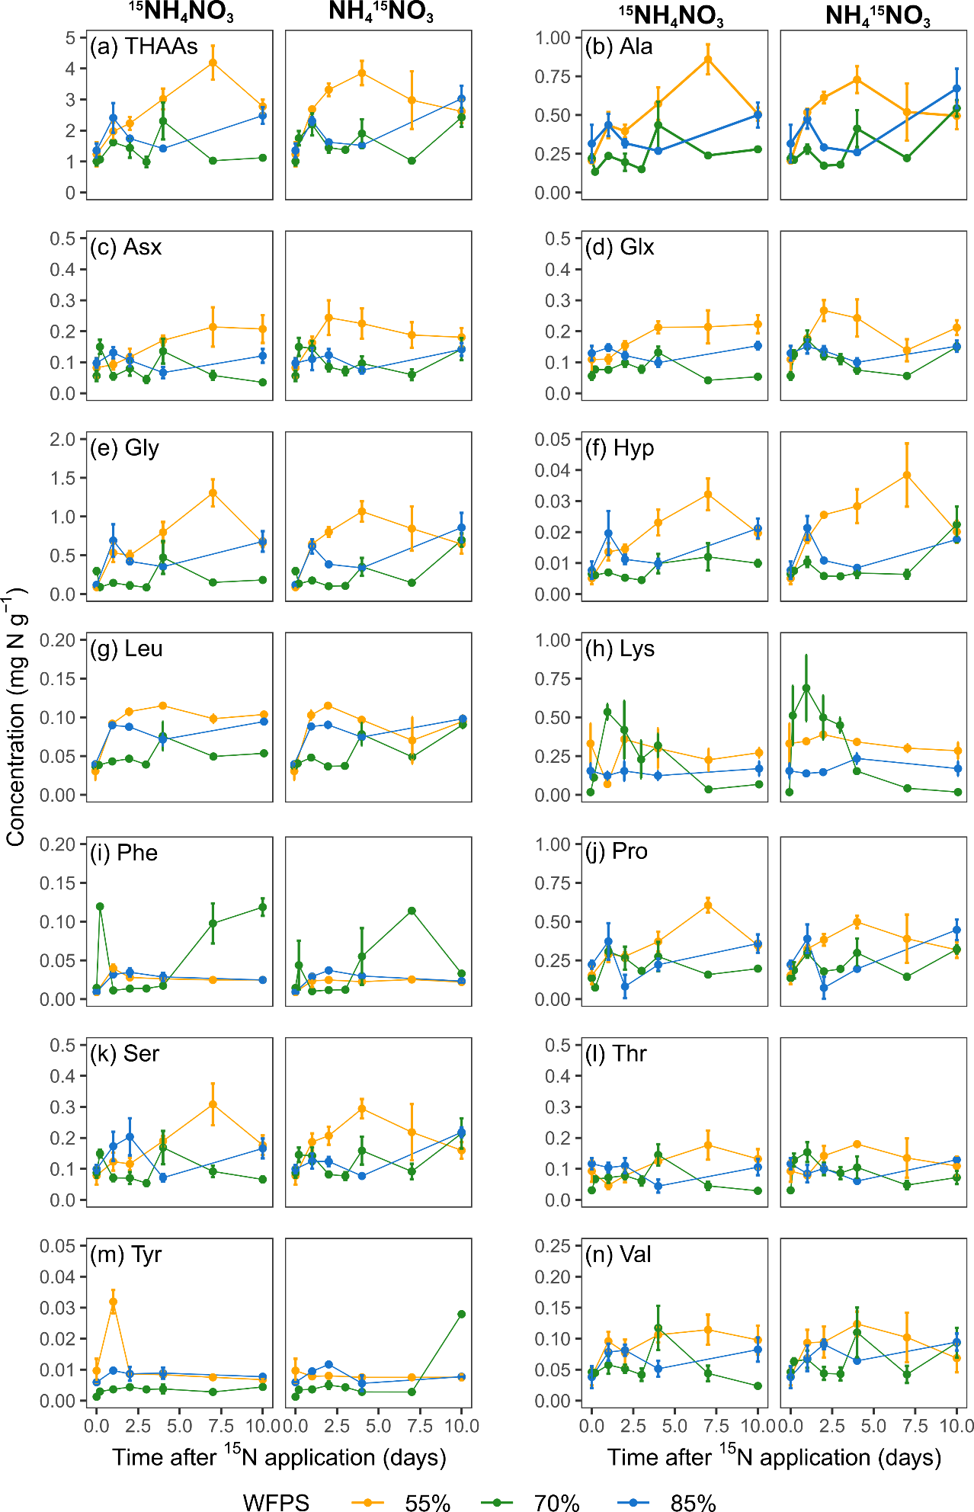

Table S1: Summary of soil properties before N application (Loick et al., 2021). Values are mean ± SE (n=3).

Parameter | Mean (±SE)
pH (water 1:2.5 w/v) | 5.6 ± 0.27
Bulk density (g cm⁻²) | 0.8 ± 0.0005
Total N (g kg⁻¹ dry soil) | 5.0 ± 0.10
Total extractable oxidized nitrogen (mg kg⁻¹ dry soil) | 15.1 ± 0.09
Ammonium N (mg kg⁻¹ dry soil) | 9.2 ± 0.09
THAA (g N kg⁻¹ dry soil) | 1.7 ± 0.4
Total organic carbon (% w/w) | - 0.17

Table S2: Results of mixed effect models for amino acid concentrations over 10 d, following application of ¹⁵NH₄NO₃ or NH₄¹⁵NO₃ (n=6). Values in bold indicate there was a significant difference (p<0.05).
AA | Time |  | WFPS |  | Time*WFPS
 | F(7,95) | p | F(2,950 | p | F(9,95) | p
Ala | 5.123 | <0.001 | 13.543 | <0.001 | 10.379 | <0.001
Asx | 1.745 | 0.108 | 15.642 | <0.001 | 3.960 | <0.001
Glx | 1.500 | 0.177 | 24.745 | <0.001 | 4.357 | <0.001
Gly | 6.922 | <0.001 | 26.814 | <0.001 | 18.028 | <0.001
Hyp | 7.026 | <0.001 | 24.896 | <0.001 | 10.689 | <0.001
Leu | 15.559 | <0.001 | 30.480 | <0.001 | 26.654 | <0.001
Lys | 4.664 | <0.001 | 9.916 | <0.001 | 7.004 | <0.001
Phe | 10.394 | <0.001 | 10.889 | <0.001 | 6.796 | <0.001
Pro | 4.924 | <0.001 | 7.563 | <0.001 | 8.829 | <0.001
Ser | 1.922 | 0.074 | 5.171 | 0.007 | 7.496 | <0.001
Thr | 0.436 | 0.877 | 4.865 | 0.010 | 4.832 | <0.001
Tyr | 3.275 | 0.004 | 7.927 | <0.001 | 5.521 | <0.001
Val | 2.255 | 0.036 | 3.449 | 0.036 | 6.691 | <0.001
THAA

Table S3: Assimilation rates into individual and total (THAAs) amino acids over 10 d following application of ¹⁵NH₄NO₃, NH₄¹⁵NO₃, or the combination of these treatments. The rate units are all % day⁻¹. Poor fits are highlighted in red.
 | 55% |  |  |  |  |  | 70% |  |  |  |  |  | 85%
 | ¹⁵NH₄NO₃ |  | NH₄¹⁵NO₃ |  | Combined |  | ¹⁵NH₄NO₃ |  | NH₄¹⁵NO₃ |  | Combined |  | ¹⁵NH₄NO₃ |  | NH₄¹⁵NO₃ |  | Combined
AA | Rate | r² | Rate | r² | Rate | r² | Rate | r² | Rate | r² | Rate | r² | Rate | r² | Rate | r² | Rate | r²
Ala | 0.040 | 0.69 | 0.001 | 0.19 | 0.031 | 0.44 | 0.022 | 0.71 | 0.024 | 0.49 | 0.012 | 0.05 | 0.053 | 0.93 | 0.025 | 0.39 | 0.030 | 0.48
Gly | 0.033 | 0.67 | 0.004 | 0.73 | 0.028 | 0.58 | 0.008 | 0.46 | 0.008 | 0.40 | 0.018 | 0.24 | 0.046 | 0.88 | 0.010 | 0.44 | 0.012 | 0.40
Val | 0.006 | 0.60 | -0.002 | 0.42 | 0.005 | 0.50 | 0.001 | 0.20 | 0.002 | 0.22 | 0.002 | 0.07 | 0.008 | 0.75 | 0.0006 | 0.08 | 0.001 | 0.08
leu | 0.010 | 0.79 | 0.0001 | 0.10 | 0.006 | 0.33 | 0.006 | 0.80 | 0.002 | 0.30 | 0.011 | 0.63 | 0.016 | 0.97 | 0.0005 | 0.62 | 0.002 | 0.51
Thr | 0.006 | 0.38 | -0.006 | 0.74 | 0.014 | 0.36 | 0.005 | 0.26 | 0.005 | 0.21 | -0.054 | 0.28 | 0.015 | 0.85 | 0.033 | 0.47 | 0.036 | 0.52
Ser | 0.005 | 0.39 | 0.042 | 0.30 | 0.006 | 0.37 | 0.004 | 0.53 | 0.006 | 0.17 | -0.024 | 0.16 | 0.015 | 0.68 | 0.014 | 0.60 | 0.016 | 0.71
Pro | 0.009 | 0.29 | 0.0003 | 0.46 | 0.006 | 0.14 | 0.008 | 0.74 | 0.004 | 0.32 | 0.003 | 0.02 | 0.021 | 0.92 | 0.017 | 0.50 | 0.014 | 0.62
Asx | 0.018 | 0.77 | 0.0003 | 0.02 | 0.018 | 0.79 | 0.003 | 0.29 | 0.0002 | 0.09 | 0.003 | 0.09 | 0.015 | 0.84 | 0.0005 | 0.02 | 0.001 | 0.08
Glx | 0.045 | 0.82 | 0.0009 | 0.50 | 0.038 | 0.73 | 0.009 | 0.37 | 0.003 | 0.13 | 0.039 | 0.74 | 0.045 | 0.91 | 0.0008 | 0.25 | -0.002 | 0.03
Hyp | 0.0002 | 0.13 | 0.0001 | 0.27 | 0.000 | 0.04 | 0.000 | 0.21 | 0.001 | 0.44 | -0.001 | 0.24 | 0.0007 | 0.58 | 0.001 | 0.35 | 0.001 | 0.34
Phe | 0.002 | 0.69 | 0.000 | 0.53 | -0.006 | 0.19 | 0.012 | 0.70 | 0.0006 | 0.31 | 0.000 | 0.00 | 0.003 | 0.91 | 0.0002 | 0.16 | 0.006 | 0.67
Lys | 0.011 | 0.73 | 0.001 | 0.10 | 0.015 | 0.68 | 0.0003 | 0.00 | -0.004 | 0.12 | 0.011 | 0.38 | 0.017 | 0.82 | 0.0002 | 0.16 | -0.005 | 0.31
Tyr | 0.0002 | 0.26 | 0.000 | 0.10 | 0.000 | 0.00 | 0.0002 | 0.68 | 0.0001 | 0.26 | 0.001 | 0.80 | 0.0007 | 0.84 | 0.000 | 0.18 | 0.000 | 0.21
THAA | 0.184 | 0.79 | 0.010 | 0.66 | 0.161 | 0.69 | 0.078 | 0.68 | 0.052 | 0.27 | 0.020 | 0.01 | 0.25 | 0.95 | 0.096 | 0.72 | 0.113 | 0.70

Table S4: Incorporation (%I) into individual and total (THAAs) amino acids of applied ¹⁵NH₄NO₃, NH₄¹⁵NO₃, or the combination of these treatments at 10 d at differing WFPS. The units for %I and SE are % and all values are mean (n=3).
 | 55% |  |  |  |  |  | 70% |  |  |  |  |  | 85%
 | ¹⁵NH₄NO₃ |  | NH₄¹⁵NO₃ |  | Combined |  | ¹⁵NH₄NO₃ |  | NH₄¹⁵NO₃ |  | Combined |  | ¹⁵NH₄NO₃ |  | NH₄¹⁵NO₃ |  | Combined
AA | %I | SE | %I | SE | %I | SE | %I | SE | %I | SE | %I | SE | %I | SE | %I | SE | %I | SE
Ala | 0.34 | 0.05 | 0.21 | 0.06 | 0.55 | 0.07 | 0.25 | 0.03 | 0.34 | 0.07 | 0.59 | 0.06 | 0.51 | 0.04 | 0.25 | 0.14 | 0.76 | 0.18
Gly | 0.24 | 0.04 | 0.10 | 0.01 | 0.34 | 0.04 | 0.09 | 0.01 | 0.11 | 0.02 | 0.20 | 0.02 | 0.42 | 0.07 | 0.14 | 0.04 | 0.56 | 0.12
Val | 0.06 | 0.02 | 0.01 | 0.006 | 0.07 | 0.02 | 0.02 | 0.003 | 0.03 | 0.01 | 0.05 | 0.01 | 0.07 | 0.02 | 0.01 | 0.006 | 0.08 | 0.02
Leu | 0.10 | 0.03 | 0.005 | 0.002 | 0.10 | 0.03 | 0.06 | 0.01 | 0.02 | 0.004 | 0.08 | 0.01 | 0.15 | 0.01 | 0.005 | 0.001 | 0.15 | 0.008
Thr | 0.05 | 0.02 | 0.22 | 0.06 | 0.27 | 0.05 | 0.05 | 0.01 | 0.24 | 0.08 | 0.29 | 0.07 | 0.14 | 0.02 | 0.44 | 0.09 | 0.58 | 0.08
Ser | 0.04 | 0.01 | 0.37 | 0.02 | 0.41 | 0.02 | 0.03 | 0.005 | 0.14 | 0.05 | 0.17 | 0.05 | 0.14 | 0.05 | 0.17 | 0.02 | 0.32 | 0.04
Pro | 0.06 | 0.02 | 0.03 | 0.005 | 0.09 | 0.03 | 0.09 | 0.02 | 0.08 | 0.01 | 0.16 | 0.02 | 0.19 | 0.02 | 0.12 | 0.05 | 0.31 | 0.07
Asx | 0.16 | 0.04 | 0.04 | 0.006 | 0.19 | 0.04 | 0.03 | 0.00 | 0.04 | 0.01 | 0.07 | 0.004 | 0.14 | 0.03 | 0.03 | 0.005 | 0.17 | 0.03
Glx | 0.44 | 0.09 | 0.02 | 0.003 | 0.46 | 0.09 | 0.13 | 0.006 | 0.02 | 0.003 | 0.14 | 0.01 | 0.44 | 0.05 | 0.02 | 0.005 | 0.46 | 0.05
Hyp | 0.002 | 0.002 | 0.01 | 0.001 | 0.01 | 0.002 | 0.003 | 0.002 | 0.02 | 0.004 | 0.02 | 0.004 | 0.01 | 0.002 | 0.01 | 0.006 | 0.02 | 0.004
Phe | 0.02 | 0.005 | 0.01 | 0.002 | 0.03 | 0.005 | 0.13 | 0.03 | 0.01 | 0.002 | 0.13 | 0.03 | 0.03 | 0.002 | 0.01 | 0.000 | 0.04 | 0.002
Lys | 0.11 | 0.02 | 0.03 | 0.006 | 0.14 | 0.02 | 0.04 | 0.006 | 0.002 | 0.001 | 0.04 | 0.006 | 0.15 | 0.04 | 0.01 | 0.001 | 0.16 | 0.04
Tyr | 0.003 | 0.001 | 0.000 | 0.000 | 0.003 | 0.001 | 0.002 | 0.000 | 0.001 | 0.001 | 0.004 | 0.001 | 0.01 | 0.000 | 0.000 | 0.000 | 0.007 | 0.000
THAA | 1.61 | 0.30 | 0.71 | 0.11 | 2.32 | 0.20 | 0.92 | 0.12 | 1.04 | 0.15 | 1.96 | 0.06 | 2.39 | 0.17 | 1.22 | 0.16 | 3.61 | 0.26

