Is sorghum a promising summer catch crop for reducing nitrate accumulation and enhancing eggplant yield in intensive greenhouse vegetable systems?
Yan Ma¹, Lingyun Kang^{1, 2}, Yanqing Li¹, Xinjun Zhang¹, Laura M. Cardenas³, Qing Chen^{1, *}
¹ Beijing Key Laboratory of Farmyard Soil Pollution Prevention-control and Remediation, College of Resources and Environmental Sciences, China Agricultural University, Beijing, 100193, China
² Institute of Plant Nutrition, Resources and Environment, Beijing Academy of Agriculture and Forestry Sciences, Beijing 100097, China
³ Sustainable Agriculture Sciences Department, North Wyke, Okehampton, Devon, EX20 2SB, UK

*Corresponding Authors: Prof. Qing Chen
Email: qchen@cau.edu.cn
Postal address: College of Resources and Environmental Sciences, China Agricultural University, Beijing, 100193, China

Keywords
catch crop; biological nitrification inhibition; sweet corn; residues; ammonia-oxidizing archaea; ammonia-oxidizing bacteria

Abstract
Purpose
Summer catch crop (CC) has been introduced into the vegetable rotating system in greenhouse fields to reduce nitrogen (N) losses through crop uptake and residual N immobilization. However, the effects of planting sorghum with high N uptake and biomass, and biological nitrification inhibition (BNI) potential as a CC on soil N dynamics and subsequent crop yield remain unclear.
Methods
In the two-year field experiment, the comprehensive effects of planting sorghum as CC on subsequent eggplant yield, soil mineral N dynamics, ammonia-oxidizing archaea (AOA) and bacteria (AOB) amoA gene abundances were determined, in comparison to the sweet corn and fallow treatments.
Results
Compared to the fallow and sweet corn, planting sorghum as CC increased subsequent eggplant yield by 24.88% and 18.94% in the 2014-2015 and 2015-2016 over-winter growing season, respectively. CC planting reduced soil nitrate (NO₃⁻-N) accumulation during the summer fallow season. Sorghum planting could significantly maintain higher level of ammonium (NH₄⁺-N) concentration during the summer fallow season and the first month of succeeding over-winter season. In addition, sorghum planting reduced soil net nitrifying potential, which could be partially attributed to the decreased amoA gene abundance of AOA at the 0-30 and 30-60 cm soil layers and AOB at 0-30 cm soil layer.
Conclusion
We conclude that planting sorghum in the summer fallow season is a promising strategy to retain soil NH₄⁺-N, reduce soil NO₃⁻-N accumulation, and enhance subsequent eggplant yield.

Abbreviations
N: nitrogen
NO₃⁻-N: nitrate
CC: catch crop
NH₄⁺: ammonium
SOM: soil organic matter
BNI: biological nitriﬁcation inhibition
NI: nitrification inhibitor
MHPP: methyl 3-(4-hydroxyphenyl) propionate
AOA: ammonia-oxidizing archaea
AOB: ammonia-oxidizing bacteria
EC: electrical conductivity
NO₂⁻-N: nitrite
qPCR: quantitative polymerase chain reaction
PCR: polymerase chain reaction
ANOVA: analysis of variance
LSD: least significant difference

Introduction
Differing from cereal crop systems, intensive greenhouse vegetable production systems in northern China receive excess fertilizers and water supply (Kianpoor Kalkhajeh et al. 2021), resulting in serious nitrogen (N) losses to the environment (Hou et al. 2018; Wang et al. 2018). Although root zone N management strategies, such as N side-dressing which is based on placing available N close to the root system, can reduce N fertilizers input by 53% (Guo et al. 2008) and decrease N surplus from 800 to 101 kg N ha⁻¹ (Ren et al. 2010), considerable nitrate (NO₃⁻) loss in drainage water is still unavoidable (Zhang et al. 2019; Bai et al. 2020).
Maintaining the lowest residual N in vegetable planting systems is the key to avoid NO₃⁻ leaching loss, especially in the summer fallow season with high temperature and heavy precipitation in North China. Besides the control of N application through manure and chemical fertilizers, catch crops (CC) planting in the summer fallow season has been validated as another efficient way to exhaust the soil residual N and reduce NO₃⁻ leaching in intensive greenhouse vegetable fields (Xiao et al. 2021; Kang et al. 2022). In recent years, some researchers described the successful planting of sweet corn as a summer CC to reduce N losses by plant uptake and microbial N immobilization due to the incorporation of the summer CC residues (Guo et al. 2018; Kang et al. 2018, 2022).
In China, nearly 90% of the N fertilizers are applied to the fields in the form of ammonium (NH₄⁺) N fertilizer or urea which can be hydrolyzed to NH₄⁺, and a small proportion in the form of NO₃⁻-N fertilizer (such as NH₄NO₃, NaNO₃) (Sha et al. 2021). Nevertheless, NH₄⁺-N is rapidly oxidized to NO₃⁻-N by soil nitrifiers in dry land. Compared to labile leaching characteristics of NO₃⁻ with its negative charge, NH₄⁺ is able to be held by clay surfaces and soil organic matter (SOM) (Amberger 1993). Thus, suppressing the transformation of NH₄⁺-N to NO₃⁻-N may be an alternative strategy to prolong the plants’ utilization of mineral N and reduce the risk of NO₃⁻ leaching.
Certain plants have the ability to release phytochemicals in root zone, which affected soil nitrifiers activity (Zakir et al. 2008; Subbarao et al. 2009; Lu et al. 2019). This activity was defined as biological nitriﬁcation inhibition (BNI) (Subbarao et al. 2006). Sorghum was proven to have a BNI capability through releasing biological nitrification inhibitors (NIs) from its roots, such as methyl 3-(4-hydroxyphenyl) propionate (MHPP), sakuranetin and sorgoleone (Zakir et al. 2008; Subbarao et al. 2013). However, BNI capacity of plants varies drastically depending on ﻿landraces (O’Sullivan et al. 2016). Previous research found that the sorghum variety (Jinza 12) had highest biomass, root surface, root volume and N uptake compared with other varieties (Jinza 15, Kangsi, Jinzhong 405, Longza No.9, Jiliang No. 2) (Kang et al., 2015). In addition, soil NH₄⁺-N concentration was ranked second with the sorghum variety (Jinza 12) planting, behind the sorghum variety (Jiliang No. 2).
The objective of this study was to assess the comprehensive effects of planting sorghum (Jinza 12) and sweet corn as CC on subsequent eggplant yield, soil N dynamics, soil nitrifying potential, AOA and AOB amoA gene abundances. Based on previous studies, we hypothesized that: 1) sweet corn and planting sorghum as CC would enhance subsequent eggplant yield, in comparison to the fallow treatment; 2) sorghum planting would preserve soil with greater NH₄⁺-N and lower NO₃⁻-N concentration than the sweet corn and fallow treatments.

Materials and methods
Site description and soil properties
A two-year field experiment was set up in a traditional, unheated and commercial solar greenhouse field (80 m × 8 m) at Daxing district (39.67 N, 116.57 E), Beijing, Northern China. The soil texture in 0-30, 30-60 and 60-90 cm was sandy loam, sandy loam and clay, respectively, according to the USDA's soil texture classification system. The soil properties are presented in Table 1. Soil pH and electrical conductivity (EC) were determined in a 1:2.5 (w/v) soil-distilled water ratio. SOM was measured by loss-on-ignition. Total N was determined using a CHN2000 analyser. Extractable NH₄⁺-N and NO₃⁻-N concentrations were measured with a continuous flow analyzer (AA3, Seal, Germany) (Mulvaney 1996; Miranda et al. 2001). Olsen phosphorus (P) was estimated by colourimetric analysis .(Ohno and Zibilske 1991). Soil available potassium (K) was extracted with 1 mol L⁻¹ ammonium acetate and then determined by a photoelectric flame photometer (Page et al., 1982).

Crop management and experimental setup
Figure 1 presents the crop management and experimental setup in this study. In 2014-2015 growing season (summer fallow and over-winter seasons), two treatments with three replicates were established in a randomized block design: 1) CK (no CC planting), 2) CC-S (planting sorghum as the CC). Each plot size was 48 m² (6 m × 8 m). On 7/7/2014, sorghum (Sorghum bicolor (L.) Moench, Jinza 12) was transplanted as the summer CC. The planting density of the sorghum was 55,555 plants ha⁻¹, with row spacing of 0.6 m and plant spacing of 0.3 m. Sorghum was harvested on 15/9/2014. Afterwards, fresh sorghum residues were broadcasted on the soil surface as basal fertilizer (40 t ha⁻¹ at wet basis, the total biomass of sorghum residues), and then incorporated into the soil by plowing, supplying 113, 21.2, 155 kg ha⁻¹ of N, P and K, respectively. However, basal fertilizer was not applied in the CK treatment. There was only one over-winter cropping season per year. Eggplant (Solanum melongena) was the sole crop alternately. At the start of the over-winter season, four-week-old eggplant seedlings were transplanted into double rows (wide: 0.9 m; narrow: 0.6 m) by hand on 22/9/2014. The planting density of the eggplant was 29,600 plants ha⁻¹ with 0.5 m plant spacing. During the over-winter cropping season, the top dressing (water-soluble chemical fertilizer) in the CK and CK-S treatments was the same, supplying 867, 289, 578 kg ha⁻¹ of N, P₂O₅ and K₂O, respectively. The timing of top dressing was based on weather condition and eggplant cultivation in the investigated seasons. Recommended fertigation technique, drip irrigation, was applied in all treatments, with the total irrigation amount of 428 mm and 538 mm in 2014-2015 over-winter cropping season (see Figure S1 for details). On 11/6/2015, the eggplant was harvested. After harvest, the eggplant vines were removed from the field to lower the likelihood that disease would spread to the following crop.
In 2015-2016 growing season, the CC-S treatment was split to compare the effects of sorghum and sweet corn, resulting in three treatments: 1) CK (no CC planting, 2) CC-S (planting sorghum as the CC), and 3) CC-SC (planting sweet corn as the CC). On 15/7/2015, sorghum and sweet corn (Zea mays) were sown as the CC, with the same planting density, row spacing and plant spacing as described above. In the CC-S and CC-SC treatments, fresh sorghum (46 t ha⁻¹) and sweet corn (37 t ha⁻¹) residues were incorporated into soil by plowing as the basal fertilizer, supplying 177.8, 33.4, 254 kg ha⁻¹ of N, P, K and 158, 28.2, 237 kg ha⁻¹ of N, P, K, respectively. Basal fertilizer was not applied in the CK treatment. On 6/10/2015, eggplant was transplanted using the same techniques as those outlined above in all treatments. During the 2015-2016 over-winter cropping season, the total irrigation amount in each treatment was 538 mm, supplying 441, 260, 741 kg ha⁻¹ of N, P₂O₅ and K₂O, respectively. The timing of top dressing was based on weather condition and eggplant cultivation in the investigated seasons.

Sampling and analysis
Eggplant yield
The eggplant was harvested on 11/6/2015 and 9/6/2016. Eggplants were weighed immediately after harvest and total fresh yield was calculated as t ha⁻¹.

Soil sampling and analysis
In 2014-2015 and 2015-2016 growing seasons, each treatment repeated three times (three plot). At each sampling time, four soil cores (diameter: 3 cm) were taken from each plot. Then, soil samples were sieved through 2 mm mesh and stored at -20 °C or -80 °C to wait for the following analysis. During the 2014-2015 growing season, soil samples were collected in order to analyze soil NH₄⁺-N and NO₃⁻-N concentrations at 0-30 cm at 24 and 70 days after CC planting and 1, 3, 8, 16, 31, 69, 262 days after eggplant transplanting. In addition, soil samples were taken at 0-30 cm for the soil nitrification potential and real-time quantitative polymerase chain reaction (qPCR) analysis on 25/9/2014. During the 2015-2016 growing season, soil samples were obtained at 0-30, 30-60, and 60-90 cm soil layers at 46, 68 days after CC planting and 247 days after eggplant transplanting for the NH₄⁺-N and NO₃⁻-N concentrations analysis. And soil pH, EC, OM, total N, P, K, AOA and AOB gene abundances at 0-30, 30-60 and 60-90 cm were determined when CC was harvested in the summer fallow season of 2015.
Soil NH₄⁺-N and NO₃⁻-N concentrations, total N, P and K: At each sampling time, 6 g fresh soil samples were extracted by shaking for one hour at 200 rpm with 100 mL of 1 mol L⁻¹ KCl. Extractable NH₄⁺-N and NO₃⁻-N concentrations, soil pH, EC, OM, total N were determined as the methods described above. Total P and K were analyzed as the methods outlined in the study of Marsden et al. (2015).
Soil nitriﬁcation potential: 5 g sieved fresh soil (preconditioning at 15 °C for two weeks with 50% of field water capacity) was added to a 200 ml ﬂask, and then 50 ml 1 mM phosphate buffer (pH=7.2) containing 1.5 mM NH₄⁺ was added to the ﬂask. Flasks were incubated for 48 h at 180 rev min⁻¹ at 30 °C. During the incubation, soil samples were sampled at 6, 12, 24, 36, 48 h. The NO₂⁻ -N and NO₃⁻ -N concentrations were then measured with an ultraviolet-visible spectrophotometer and a continuous flow analyzer, respectively (Norton and Stark 2011).
AOA and AOB amoA gene abundances: According to the manufacturer’s instructions, four repeated DNA extractions were prepared for each replicate using MO BIO Power Soil DNA Extraction kit from MO BIO Laboratories in Carlsbad, CA, USA. After extraction, DNA quality was evaluated by the ratio of A260/280 and A260/230 using a NanoDrop spectrophotometer, and DNA concentrations were quantiﬁed with Qubit assay (Invitrogen, CA). AOA amoA gene was ampliﬁed by using the polymerase chain reaction (PCR) primers amoA-AF (STAATGGTCTGGCTTAGACG) and amoA-AR (GCGGCCATCCATCTGTATGT) with the identical thermal proﬁle to Francis et al. (2005). Each reaction contained 12.5 μl of Platinum SYBR Green JumpStart Taq ReadyMix (Invitrogen, Carlsbad, CA, USA), 0.6 μl of each primer at a concentration of 10 μM, 1 μl of bovine albumin at a dose of 8 μg μl⁻¹, 1 μl of ten times-diluted DNA template and 9.3 μl of sterile deionized water. PCR ampliﬁcation of AOB amoA gene was carried out using the primer pairs: amoA-1F (forward) (GGGGTTTCTACTGGTGGT) and amoA-2R (reverse) (CCCCTCKGSAAAGCCTTCTTC) (Rotthauwe et al. 1997). Each reaction was made up of 12.5 μl of Platinum SYBR Green JumpStart Taq ReadyMix (Invitrogen, Carlsbad, CA, USA), 0.8 μl of 10 μM of each forward and reverse primer, 1 μl of 8 μg μl⁻¹ of bovine albumin, 2 μl of ten times-diluted DNA template, and 7.9 μl of sterilized deionized water. Real-time qPCR was conducted by using an ABI7500 (Applied Biosystem, Foster City, CA, USA) with the following thermal proﬁle for ampliﬁcation: 5 min at 95 °C; 40 cycles of 30 s at 95 °C, 30 s at 57 °C and 60 s at 72 °C. Melting curve analysis was performed to verify the specificity of amplification products at the end of each reaction.

Statistical analysis
To ascertain the treatment effects on eggplant yield, NH₄⁺-N and NO₃⁻-N concentrations, soil nitrification potential, AOA and AOB amoA gene abundances, one-way analysis of variance (ANOVA) was performed following least significant difference (LSD) test at the 0.05 level. Spearman correlation analysis was conducted to relate soil parameters, mineral N, nitrification potential, AOA and AOB amoA gene abundances. P values were adjusted via Benjamini-Hochberg method. Normality and homogeneity test were conducted prior to statistical analysis by using Shapiro-Wilk test and Levene’s test, respectively. Statistical analysis was performed using SPSS Statistics 27.0 (IBM Inc., Armonk, NY, USA).

Results
Eggplant yield
Compared to the CK treatment, planting sorghum as the CC significantly increased eggplant yield by 24.88% and 18.94% in the over-winter cropping seasons of 2014-2015 and 2015-2016, respectively (Figure 2). However, there was no significant influence of planting sweet corn as the CC on subsequent eggplant production. The average yield of eggplant during the first over-winter cropping season (89.25 t ha⁻¹) was higher than the second over-winter cropping season (66.56 t ha⁻¹).

Soil NH₄⁺-N and NO₃⁻-N concentrations
During the first month of the over-winter cropping season in 2014, soil at 0-30 cm from the CC-S treatment had a significantly greater NH₄⁺-N concentration than the CK treatment (Figure 3a). Soil NO₃⁻-N concentration in the CC-S treatment was significantly lower than the CK treatment during the fallow season. However, there were no significant variations in the soil NO₃⁻-N concentration between the CK and CC-S treatments throughout the over-winter cropping season (Figure 3b).
In 2015-2016 growing season, planting sorghum and sweet corn as the CC significantly decreased the soil NO₃⁻-N concentration at 0-30 cm and 60-90 cm compared to the CK treatment at 46 days after CC planting (Table 2). When the CC was harvested on 21 September 2015, planting sorghum significantly increased soil NH₄⁺-N concentrations at the 0-30, 30-60 and 60-90 cm soil layers by 95.04%, 71.91% and 31.38%, respectively, compared to the CK treatment (reaching to 2.42, 1.78, 1.88 mg N kg⁻¹ dry soil at 0-30, 30-60, 60-90 cm, respectively). And soil NH₄⁺-N concentrations in the CC-S treatment at the 0-30 and 30-60 cm soil layers were also significantly higher than that in the CC-SC treatment. Only at the 0-30 cm soil layer did the NH₄⁺-N concentration in the CC-SC treatment remain 23.55% higher than that of the CK treatment (P<0.05). When the CC was harvested, the CC-S and CC-SC treatments had significantly lower soil NO₃⁻-N concentration than the CK treatment at the 0-30, 30-60, and 60-90 cm soil layers. Nevertheless, there were no significant differences in the NO₃⁻-N concentration between the CC-S and CC-SC treatments. when the eggplant was harvested on 9 June 2016, soil NO₃⁻-N concentration in the CC-SC treatment at the 0-30 cm soil layer was significantly lower than the CK treatment.

Soil nitrifying potential
In 2014, soil nitrifying potential in the CC-S treatment (0.89 mg N kg⁻¹ dry soil h⁻¹) was significantly lower than that in the CK treatment (1.34 mg N kg⁻¹ dry soil h⁻¹) (Figure 4). This effect was also observed in 2015, planting sorghum as the CC significantly decreased soil nitrifying potential. However, there were no significant differences in the soil nitrification potential between CK and CC-SC treatments.

AOA and AOB amoA gene abundances
Compared to the CK treatment, AOA and AOB amoA gene abundances at the 0-30 cm soil layer were significantly lower in the CC-S treatment after the summer fallow season in 2014 (Figure 5). After the harvest of the CC in 2015, AOA amoA gene abundances at 0-30 and 30-60 cm and AOB amoA gene abundances at 0-30 cm were significantly decreased by sorghum, while no effect of sweet corn on AOA and AOB amoA gene abundances was observed. Additionally, planting sorghum as the CC had no influence on AOA and AOB amoA gene abundances at 60-90 cm. In 2015, AOA amoA gene abundance in all treatments increased with the increasing soil depth, but AOB amoA gene abundances had the opposite tendency.

Correlations of soil and N cycling parameters
Spearman correlation analysis revealed correlations between soil parameters (pH, EC, OM, total N, P, K, moisture content) and N cycling parameters (NH₄⁺-N, NO₃⁻-N, AOA and AOB amoA gene abundances, soil nitrification potential) at the end of the summer fallow season in 2015 (Figure 6). At the 0-30 cm soil layer, soil NH₄⁺-N concentration was positively correlated with OM (P<0.01), P (P<0.001), and negatively correlated with soil NO₃⁻-N (P<0.05), AOA and AOB amoA gene abundances (P<0.001), nitrification potential (P<0.001). However, soil NO₃⁻-N concentration was positively associated with K (P<0.05), AOB amoA gene abundance (P<0.05), nitrification potential (P<0.05), and inversely associated with NH₄⁺-N (P<0.05). Both soil NH₄⁺-N and NO₃⁻-N concentrations at the 30-60 cm soil layer were significantly correlated with OM, P, moisture content, AOA and AOB amoA gene abundances. Nevertheless, soil NH₄⁺-N at the 60-90 cm soil layer was only negatively associated with NO₃⁻-N (P<0.001) and AOA amoA gene abundance (P<0.01).

Soil N balance
Table 3 presents the soil N balance at 0-30 cm during the summer fallow seasons and over-winter cropping seasons. There was a negative N balance during the summer fallow season of 2014 and 2015. The N uptake by sorghum was higher than the sweet scorn. And, soil N_{min} accumulation was lowest in the CC-S treatment both during the summer fallow season of 2014 and 2015. In addition, soil remained higher NH₄⁺-N and lower NO₃⁻-N concentrations in the CC-S treatment compared to the CC-SC treatment when CC was harvested on 12 September 2015. However, from the start of eggplant transplanting till the harvest of eggplant, the N balance from each treatment was positive. N uptake by eggplant was higher in the CC-SC and CC-SC treatments than the CK treatment.

Discussion
Effects of CC planting on eggplant yield
Planting CC has been recognized as an efficient technique for capturing residual N in soil, enhancing crop yield, and reducing N leaching (Guo et al. 2008; Zhang et al. 2019; Kang et al. 2022). In this study, planting sorghum as the CC significantly increased eggplant yield in the over-winter cropping seasons of 2014-2015 and 2015-2016 (24.88% and 18.94%, respectively) compared to the CK treatment (Figure 2). Nevertheless, this effect was not observed with the sweet corn planting. The impact of CC planting on the yield of main crop is dependent on the variety of CC and the main crop that followed (Zhang et al. 2019; Matsumura et al. 2020). Tian et al. (2010) found that sweet corn planting increased productivity when cucumber was the main crop. Guo et al. (2008) demonstrated that succeeding cucumber yields were unaffected by a reduction in N fertilizer input of 53% (compared to ﻿conventional N management) when a CC was planted. Vogeler et al. (2022) verified that the yield of the subsequent spring barley crop was higher when a CC was used.
The increasing eggplant yield may be partly attributed to the reduced N losses by CC planting. Soil available N was absorbed and stored in plant tissues during the fallow season, and then released through CC residues incorporation (Guo et al. 2008; Kang et al. 2022). Even though the N recycling by CC residues incorporation accounted for a small proportion (less than 12%) in this study (Table 3), high C/N residues incorporation (sorghum: >80; sweet corn: >50) may immobilize soil N temporarily (Melkonian et al. 2017). The critical value of C:N above which N immobilization occurred ranges from between 20 and 40 (Thapa et al. 2021). As the decomposition of the CC residues, mineralization occurs and then N is released to support crop growth. In addition, the N, P, K uptake capacity and a total biomass of sorghum were higher than those of sweet corn (Table 3).

Effects of CC planting on soil mineral N
Calculated N balance indicated that there was large soil mineralization during the summer fallow seasons, especially in the CK treatment (Table 3). Our results demonstrated that CC planting was effective to reduce soil mineral N accumulation when the CC was harvested. And sorghum planting showed more reduction than the sweet corn, which is consistent with previous study (Kang et al., 2015). Sorghum planting extracted higher amounts of N from the soil than sweet corn. In addition to the amount of mineral in soil, CC planting also affected soil N forms. Soil NH₄⁺-N in the CC-S treatment continuously increased over time and was twice as high as that in the CK treatment at the end of the summer fallow season (Figure 3a). This phenomenon was also observed in the summer fallow season of 2015, in which soil NH₄⁺-N concentration in the CC-S treatment was significantly greater than the CK and CC-SC treatments, notably at the 0-30 and 30-60 cm soil layers (Table 2). This could be partly attributed to BNI activity of sorghum. Subbarao et al. (2013) reported that sorghum roots released hydrophilic (sakuranetin and MHPP) and hydrophobic BNIs (sorgoleone) to inhibit soil nitrification. Previous findings reported that MHPP reduced the abundances of AOA and AOB (Nardi et al. 2013; Lan et al. 2022). Sarr et al. (2020) found that a high amount of sorgoleone application mainly inhibited AOA amoA gene abundance to regulate soil nitrification. However, Li et al. (2021) observed that sorghum root exudates had a strong inhibitory impact on AOB but not AOA. These imply that sorghum root exudates may decrease AOA and AOB amoA gene abundances, which is consistent with the findings of our research. Besides, the lower soil nitrifying potential at 0-30 cm could also partly give support to the BNI of planting sorghum (Figure 4). A meta-analysis performed by Cheng et al. (2017) found that simple organic C at rates more than 500 mg C kg⁻¹, or complex organic C with C/N ratios greater than 18 would enhance microbial NO₃⁻-N immobilization. The release of BNIs may also lead to microbial NH₄⁺-N and/or NO₃⁻-N immobilization, resulting in lower NO₃⁻-N concentration in soils (Nardi et al. 2020; Ma et al. 2021; Egenolf et al. 2022; Teutscherová et al. 2022).
CC planting mainly affected soil mineral N during the first month of over-winter season (Figure 3). Spearman correlation analysis demonstrated that soil NH₄⁺-N concentration was positively related to SOM and negatively related to the soil nitrification potential and AOA and AOB amoA gene abundances (Figure 6). Incorporation of CC residues increases SOM to the soil (Fageria et al. 2005; Ding et al. 2006), which may be one of the explanations for the higher NH₄⁺-N concentration in the CC-S treatment than the CK treatment in 2014-2015 over-winter cropping season. Another possible explanation for our observed reduced soil mineral N by CC planting when the eggplant was harvested could be N immobilization. The C:N ratio of sorghum and sweet corn applied in our study was above this critical range which N immobilization occurred.
In this study, we primarily focused on the mineral N dynamics, subsequent eggplant yield, AOA and AOB amoA gene abundances. Our results may encourage further efforts to characterize the impact of sorghum planting as the CC on plant N uptake and N leaching using ¹⁵N isotope technique, therefore tracing the N fate in soil and crops. Future research on both direct and indirect effects of sorghum root activity is necessary to better comprehend the BNI mechanism of sorghum.

Conclusions
This study demonstrated that summer CC (sorghum and sweet corn) planting was capable of reducing soil NO₃⁻-N accumulation and soil net mineralization throughout the summer fallow season. In addition, planting sorghum as the CC significantly increased eggplant yield by 24.88% and 18.94% in the over-winter cropping season of 2014-2015 and 2015-2016, respectively. Besides, planting sorghum as the CC also maintained greater soil NH₄⁺-N concentration during the summer fallow season and the first month of the over-winter cropping season, which could be partly due to the nitrification inhibition of sorghum roots and the increasing OM of CC residues incorporation. It had been proven that sorghum planting reduced AOA amoA gene abundances at the 0-30 cm and 30-60 cm soil layers, and decrease AOB amoA gene abundances at the 0-30 cm soil layer during the summer fallow season. We conclude that planting sorghum as the CC is a promising strategy to enhance subsequent crop yield, maintain higher soil NH₄⁺-N concentration, and reduce soil NO₃⁻-N accumulation during the summer fallow season and over-winter cropping season.

Acknowledgements
This study was funded by China Postdoctoral Science Foundation and Beijing Academy of Agriculture and Forestry Sciences [QNJJ202219, QNJJ201809].

References
Amberger A (1993) Efficient management of nitrogen fertilization in modern cropping systems. Optim Plant Nutr 619–622. https://doi.org/10.1007/978-94-017-2496-8_96
Bai X, Zhang Z, Cui J, et al (2020) Strategies to mitigate nitrate leaching in vegetable production in China: a meta-analysis. Environ Sci Pollut Res 27:18382–18391. https://doi.org/10.1007/s11356-020-08322-1
Cheng Y, Wang J, Wang J, et al (2017) The quality and quantity of exogenous organic carbon input control microbial NO₃⁻ immobilization: A meta-analysis. Soil Biol Biochem 115:357–363. https://doi.org/10.1016/j.soilbio.2017.09.006
Ding G, Liu X, Herbert S, et al (2006) Effect of cover crop management on soil organic matter. Geoderma 130:229–239. https://doi.org/10.1016/j.geoderma.2005.01.019
Egenolf K, Schad P, Arevalo A, et al (2022) Inter-microbial competition for N and plant NO₃⁻ uptake rather than BNI determines soil net nitrification under intensively managed Brachiaria humidicola. Biol Fertil Soils 58:307–319. https://doi.org/10.1007/s00374-021-01606-9
Fageria NK, Baligar VC, Bailey BA (2005) Role of cover crops in improving soil and row crop productivity. Commun Soil Sci Plant Anal 36:2733–2757. https://doi.org/10.1080/00103620500303939
Francis CA, Roberts KJ, Beman JM, et al (2005) Ubiquity and diversity of ammonia-oxidizing archaea in water columns and sediments of the ocean. Proc Natl Acad Sci U S A 102:14683–14688. https://doi.org/10.1073/pnas.0506625102
Guo R, Li X, Christie P, et al (2008) Influence of root zone nitrogen management and a summer catch crop on cucumber yield and soil mineral nitrogen dynamics in intensive production systems. Plant Soil 313:55–70. https://doi.org/10.1007/s11104-008-9679-0
Guo R, Qin W, Jiang C, et al (2018) Sweet corn significantly increases nitrogen retention and reduces nitrogen leaching as summer catch crop in protected vegetable production systems. Soil Tillage Res 180:148–153. https://doi.org/10.1016/j.still.2018.03.003
Hou Y, Wei S, Ma W, et al (2018) Changes in nitrogen and phosphorus flows and losses in agricultural systems of three megacities of China, 1990–2014. Resour Conserv Recycl 139:64–75. https://doi.org/10.1016/j.resconrec.2018.07.030
Kang L, Chen S, Liang B, et al (2022) Catch crop planting and residue incorporation to reduce nitrogen leaching in intensive vegetable greenhouse field. J Environ Qual 51:44–54. https://doi.org/10.1002/jeq2.20306
Kang L, Fan B, Chen S, Chen Q (2018) Fertigation combined with catch crop maximize vegetable yield and minimize N and P surplus. Nutr Cycl Agroecosystems 112:87–99. https://doi.org/10.1007/s10705-018-9932-8
Kang L, Huang S, Chen S, Chen Q (2015) ﻿The potential to reduce nitrogen loss through rotating different sorghum varieties in greenhouse vegetable Field (in chinese). J Agric Resour Environ 32(3): 215-221. https://doi.org/10.13254/j.jare.2014.0336
Kianpoor Kalkhajeh Y, Huang B, Hu W, et al (2021) Environmental soil quality and vegetable safety under current greenhouse vegetable production management in China. Agric Ecosyst Environ 307:107230. https://doi.org/10.1016/j.agee.2020.107230
Lan T, Huang Y, Song X, et al (2022) Biological nitrification inhibitor co-application with urease inhibitor or biochar yield different synergistic interaction effects on NH₃ volatilization, N leaching, and N use efficiency in a calcareous soil under rice cropping. Environ Pollut 293:118499. https://doi.org/10.1016/j.envpol.2021.118499
Li Y, Zhang Y, Chapman SJ, Yao H (2021) Biological nitrification inhibition by sorghum root exudates impacts ammonia-oxidizing bacteria but not ammonia-oxidizing archaea. Biol Fertil Soils 57:399–407. https://doi.org/10.1007/s00374-020-01538-w
Lu Y, Zhang X, Jiang J, et al (2019) Effects of the biological nitrification inhibitor 1,9-decanediol on nitrification and ammonia oxidizers in three agricultural soils. Soil Biol Biochem 129:48–59. https://doi.org/10.1016/j.soilbio.2018.11.008
Ma Y, Jones DL, Wang J, et al (2021) Relative efficacy and stability of biological and synthetic nitrification inhibitors in a highly nitrifying soil: Evidence of apparent nitrification inhibition by linoleic acid and linolenic acid. Eur J Soil Sci 72:2356–2371. https://doi.org/10.1111/ejss.13096
Marsden KA, Scowen M, Hill PW, et al (2015) Plant acquisition and metabolism of the synthetic nitrification inhibitor dicyandiamide and naturally-occurring guanidine from agricultural soils. Plant Soil 395:201–214. https://doi.org/10.1007/s11104-015-2549-7
Matsumura A, Hirosawa K, Masumoto H, Daimon H (2020) Effects of maize as a catch crop on subsequent garland chrysanthemum and green soybean production in soil with excess nitrogen. Sci Hortic (Amsterdam) 273:109640. https://doi.org/10.1016/j.scienta.2020.109640
Melkonian J, Poffenbarger HJ, Mirsky SB, et al (2017) Estimating nitrogen mineralization from cover crop mixtures using the precision nitrogen management model. Agron J 109:1944–1959. https://doi.org/10.2134/agronj2016.06.0330
Miranda KM, Espey MG, Wink DA (2001) A Rapid, Simple Spectrophotometric Method for Simultaneous Detection of Nitrate and Nitrite. Nitric Oxide 5:62–71. https://doi.org/10.1006/NIOX.2000.0319
Mulvaney RL (1996) Nitrogen—Inorganic Forms. In: Methods of Soil Analysis Part 3—Chemical Methods. Soil Science Society of America, American Society of Agronomy, pp 1123–1184
Nardi P, Akutsu M, Pariasca-Tanaka J, Wissuwa M (2013) Effect of methyl 3-4-hydroxyphenyl propionate, a Sorghum root exudate, on N dynamic, potential nitrification activity and abundance of ammonia-oxidizing bacteria and archaea. Plant Soil 367:627–637. https://doi.org/10.1007/s11104-012-1494-y
Nardi P, Laanbroek HJ, Nicol GW, et al (2020) Biological nitrification inhibition in the rhizosphere: Determining interactions and impact on microbially mediated processes and potential applications. Oxford University Press
Norton JM, Stark JM (2011) Regulation and measurement of nitrification in terrestrial systems. Methods Enzymol 486:343–368. https://doi.org/10.1016/B978-0-12-381294-0.00015-8
O’Sullivan CA, Fillery IRP, Roper MM, Richards RA (2016) Identification of several wheat landraces with biological nitrification inhibition capacity. Plant Soil 404:61–74. https://doi.org/10.1007/s11104-016-2822-4
Ohno T, Zibilske LM (1991) Determination of Low Concentrations of Phosphorus in Soil Extracts Using Malachite Green. Soil Sci Soc Am J 55:892–895. https://doi.org/10.2136/sssaj1991.03615995005500030046x
Ren T, Christie P, Wang J, et al (2010) Root zone soil nitrogen management to maintain high tomato yields and minimum nitrogen losses to the environment. Sci Hortic (Amsterdam) 125:25–33. https://doi.org/10.1016/j.scienta.2010.02.014
Rotthauwe JH, Witzel KP, Liesack W (1997) The ammonia monooxygenase structural gene amoa as a functional marker: Molecular fine-scale analysis of natural ammonia-oxidizing populations. Appl Environ Microbiol 63:4704–4712. https://doi.org/10.1128/aem.63.12.4704-4712.1997
Sarr PS, Ando Y, Nakamura S, et al (2020) Sorgoleone release from sorghum roots shapes the composition of nitrifying populations, total bacteria, and archaea and determines the level of nitrification. Biol Fertil Soils 56:145–166. https://doi.org/10.1007/s00374-019-01405-3
Sha Z, Liu H, Wang J, et al (2021) Improved soil-crop system management aids in NH₃ emission mitigation in China. Environ Pollut 289:117844. https://doi.org/10.1016/j.envpol.2021.117844
Subbarao G V., Ishikawa T, Ito O, et al (2006) A bioluminescence assay to detect nitrification inhibitors released from plant roots: A case study with Brachiaria humidicola. Plant Soil 288:101–112. https://doi.org/10.1007/s11104-006-9094-3
Subbarao G V., Nakahara K, Hurtado MP, et al (2009) Evidence for biological nitrification inhibition in Brachiaria pastures. Proc Natl Acad Sci 106:17302–17307. https://doi.org/10.1073/pnas.0903694106
Subbarao G V, Nakahara K, Ishikawa T, et al (2013) Biological nitrification inhibition (BNI) activity in sorghum and its characterization. Plant Soil 366:243–259. https://doi.org/10.1007/s11104-012-1419-9
Teutscherová N, Vázquez E, Trubač J, et al (2022) Gross N transformation rates in soil system with contrasting Urochloa genotypes do not confirm the relevance of BNI as previously assessed in vitro. Biol Fertil Soils 58:321–331. https://doi.org/10.1007/s00374-021-01610-z
Thapa R, Tully KL, Cabrera ML, et al (2021) Effects of moisture and temperature on C and N mineralization from surface-applied cover crop residues. Biol Fertil Soils 57:485–498. https://doi.org/10.1007/s00374-021-01543-7
Tian Y, Liu J, Zhang X, Gao L (2010) Effects of summer catch crop, residue management, soil temperature and water on the succeeding cucumber rhizosphere nitrogen mineralization in intensive production systems. Nutr Cycl Agroecosystems 88:429–446. https://doi.org/10.1007/s10705-010-9367-3
Vogeler I, Böldt M, Taube F (2022) Mineralisation of catch crop residues and N transfer to the subsequent crop. Sci Total Environ 810: 152142. https://doi.org/10.1016/j.scitotenv.2021.152142
Wang X, Zou C, Gao X, et al (2018) Nitrate leaching from open-field and greenhouse vegetable systems in China: a meta-analysis. Environ Sci Pollut Res 25:31007–31016. https://doi.org/10.1007/s11356-018-3082-z
Xiao H, Fan X, Sun H, et al (2021) The benefit of leafy vegetable as catch crop to mitigate N and P leaching losses in intensive plastic-shed production system. J Soils Sediments 21:2253–2261. https://doi.org/10.1007/s11368-021-02930-1
Zakir HAKM, Subbarao G V, Pearse SJ, et al (2008) Detection, isolation and characterization of a root-exuded compound, methyl 3-(4-hydroxyphenyl) propionate, responsible for biological nitrification inhibition by sorghum (Sorghum bicolor). New Phytol 180:442–451. https://doi.org/10.1111/j.1469-8137.2008.02576.x
Zhang H, Hu K, Zhang L, et al (2019) Exploring optimal catch crops for reducing nitrate leaching in vegetable greenhouse in North China. Agric Water Manag 212:273–282. https://doi.org/10.1016/j.agwat.2018.09.018

Statements and Declarations
The authors declare that they have no known competing financial interests or personal relationships that could have appeared to influence the work reported in this paper.

Table 1 Initial physicochemical properties of soil used in this study.
Soil property | Depth (cm)
 | 0-30 | 30-60 | 60-90
Soil texture* | Sandy loam | Sandy loam | Clay
Particle size (%)
Sand (2-0.05 mm) | 56 | 61 | 26
Loam (0.05-0.002 mm) | 29 | 19 | 2
Clay (<0.002 mm) | 15 | 20 | 73
pH | 7.77 | 8.01 | 8.19
Electrical conductivity (mS cm⁻¹) | 1.22 | 0.30 | 0.28
Organic matter (g kg⁻¹ dry soil) | 18.9 | 4.3 | 3.1
Total nitrogen (g kg⁻¹ dry soil) | 1.08 | 0.54 | 0.35
N_{min} (mg kg⁻¹ dry soil) | 203 | 113 | 83
Olsen-P (mg kg⁻¹ dry soil) | 159 | 45 | 10
Available K (mg kg⁻¹ dry soil) | 437 | 184 | 77
* According to the USDA's soil texture classification system.

Table 2 Soil NH₄⁺-N and NO₃⁻-N concentrations at a depth of 0-90 cm in the 2015 summer fallow season and 2015-2016 over-winter cropping season.
Treatment | NH₄⁺-N (mg N kg⁻¹ dry soil) |  |  | NO₃⁻-N (mg N kg⁻¹ dry soil)
 | 0-30 cm | 30-60 cm | 60-90 cm | 0-30 cm | 30-60 cm | 60-90 cm
 | 30/8/2015 46 days after CC planting
CK | 11.98±0.66 ab | 9.67±1.37 a | 10.43±1.12 a | 251.30±27.43 a | 66.97±15.36 a | 59.87±13.76 a
CC-S | 13.78±1.38 a | 10.37±0.61 a | 14.32±3.45 a | 153.78±30.77 b | 63.67±13.77 a | 18.21±6.52 b
CC-SC | 10.29±0.54 b | 10.20±0.74 a | 11.86±0.77 a | 76.87±9.09 b | 43.20±17.76 a | 20.72±8.38 b
 | 21/9/2015 Harvest of CC
CK | 2.42±0.06 c | 1.78±0.03 b | 1.88±0.12 b | 337.37±19.38 a | 145.81±9.35 a | 115.47±8.32 a
CC-S | 4.72±0.10 a | 3.06±0.21 a | 2.47±0.07 a | 213.95±1.32 b | 74.11±1.18 b | 14.70±4.42 b
CC-SC | 2.99±0.03 b | 2.14±0.03 b | 2.17±0.10 ab | 231.24±12.97 b | 85.80±2.83 b | 21.86±2.88 b
 | 9/6/2016 Harvest of eggplant
CK | 1.16±0.34 a | 1.18±0.20 a | 0.81±0.12 a | 144.36±17.46 a | 48.85±0.47 ab | 35.51±10.72 a
CC-S | 1.20±0.13 a | 0.95±0.13 a | 0.93±0.18 a | 76.91±26.32 ab | 29.21±3.18 b | 39.84±5.27 a
CC-SC | 1.81±0.30 a | 1.18±0.24 a | 0.74±0.05 a | 65.23±14.73 b | 56.63±10.41 a | 63.59±10.36 a
Note: Different lowercase letters indicate significant differences between treatments at each soil layer at P<0.05 by LSD. Values represent means ± standard error of mean (n=3).

Table 3 Calculated N balance in the summer fallow season and over-winter cropping season (kg N ha⁻¹).
Season | N source | CK | CC-S | CC-SC
Summer fallow season of 2014 | N_{min} when CC was transplanted | 203 | 203 | NA
 | N_{min} when CC was harvested | 1282 | 597 | NA
 | CC uptake | 0 | 113 | NA
 | Balance | -1079 | -507 | NA
Over-winter cropping season of 2014-2015 | CC residue incorporation | 0 | 113 | NA
 | N_{min} when eggplant was transplanted | 1282 | 597 | NA
 | Top-dressing | 867 | 867 | NA
 | N_{min} when eggplant was harvested | 255 | 275 | NA
 | Eggplant uptake | 364 | 448 | NA
 | Balance | 1530 | 855 | NA
Summer fallow season of 2015 | N_{min} when CC was transplanted | 255 | 123 | 123
 | N_{min} when CC was harvested | 1346 | 866 | 928
 | CC uptake | 0 | 178 | 158
 | Balance | -1091 | -921 | -963
Over-winter cropping season of 2015-2016 | CC residue incorporation | 0 | 178 | 158
 | N_{min} when eggplant was transplanted | 1346 | 866 | 928
 | Top-dressing | 441 | 441 | 441
 | N_{min} when eggplant was harvested | 576 | 309 | 265
 | Eggplant uptake | 286 | 302 | 344
 | Balance | 925 | 873 | 917
Note: NA means not available.

Figure captions
Figure 1 Crop management and experimental set up in this study.
Figure 2 Eggplant yield as effected by catch crop planting in the over-winter cropping seasons of 2014-2015 and 2015-2016. Error bars represent mean standard error (n=3). Different lowercase letters indicate significant differences between treatments at P<0.05.
Figure 3 Effects of sorghum as catch crop planting on soil NH₄⁺-N and NO₃⁻-N concentrations at 0-30 cm during the 2014-2015 summer fallow season and over-winter cropping season. Error bars represent mean standard error (n=3). * and ** denote significant differences between treatments at P<0.05 and 0.01, respectively.
Figure 4 Soil nitrification potential as effected by catch crop planting after the summer fallow season. Error bars represent mean standard error (n=3). Different lowercase letters indicate significant differences between treatments at P<0.05.
Figure 5 Effects of catch crop planting on AOA and AOB amoA gene abundances after the summer fallow season in 2014 (0-30 cm soil layer) and 2015 (0-30, 30-60 and 60-90 cm soil layers). Error bars represent mean standard error (n=3). Different lowercase letters indicate significant differences between treatments at P<0.05.
Figure 6 Spearman correlations between soil parameters, AOA and AOB amoA gene abundances, nitrifying potential at the end of summer fallow season in 2015 (n=3).

Figure 1
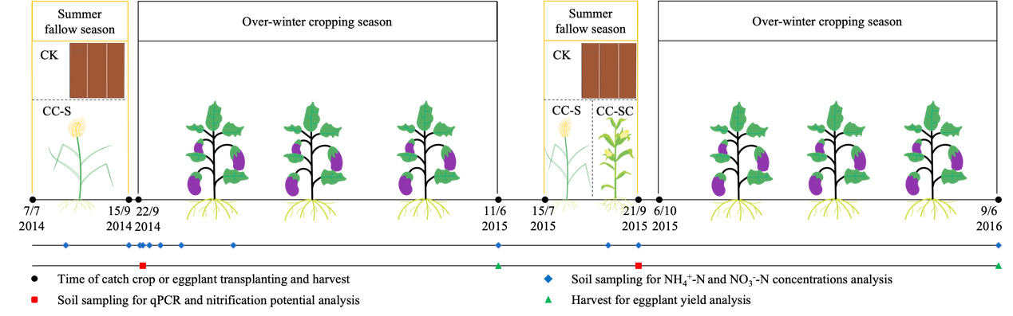

Figure 2
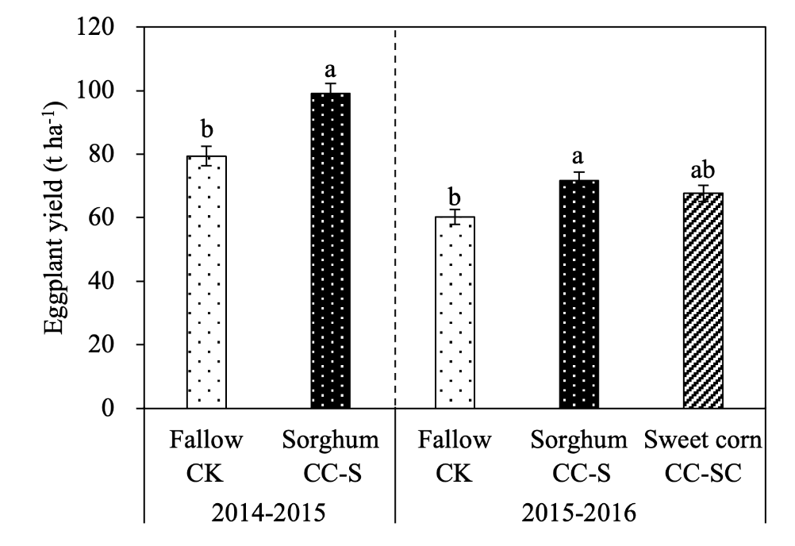

Figure 3
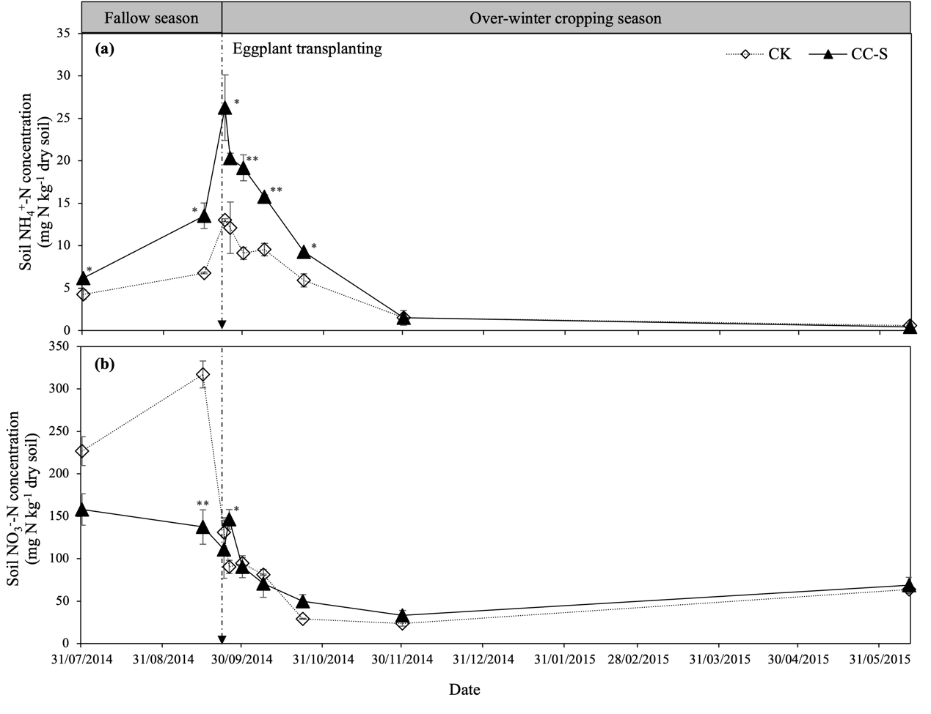

Figure 4
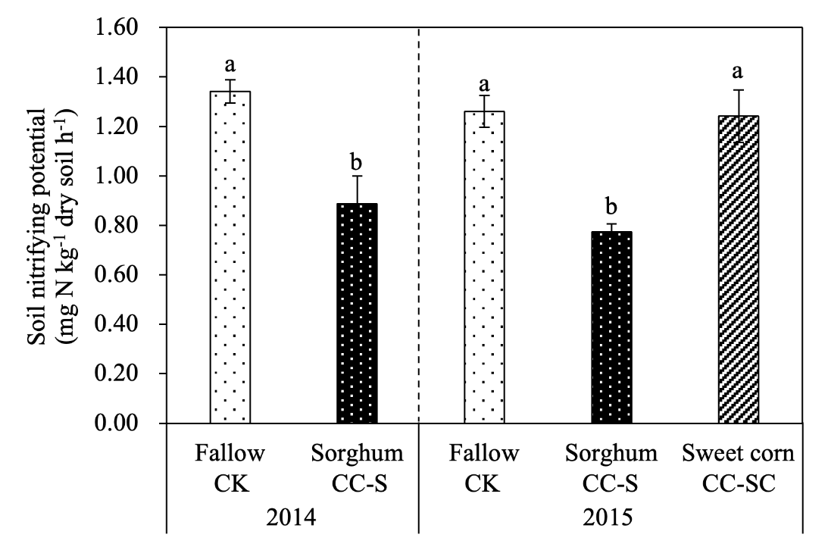

Figure 5
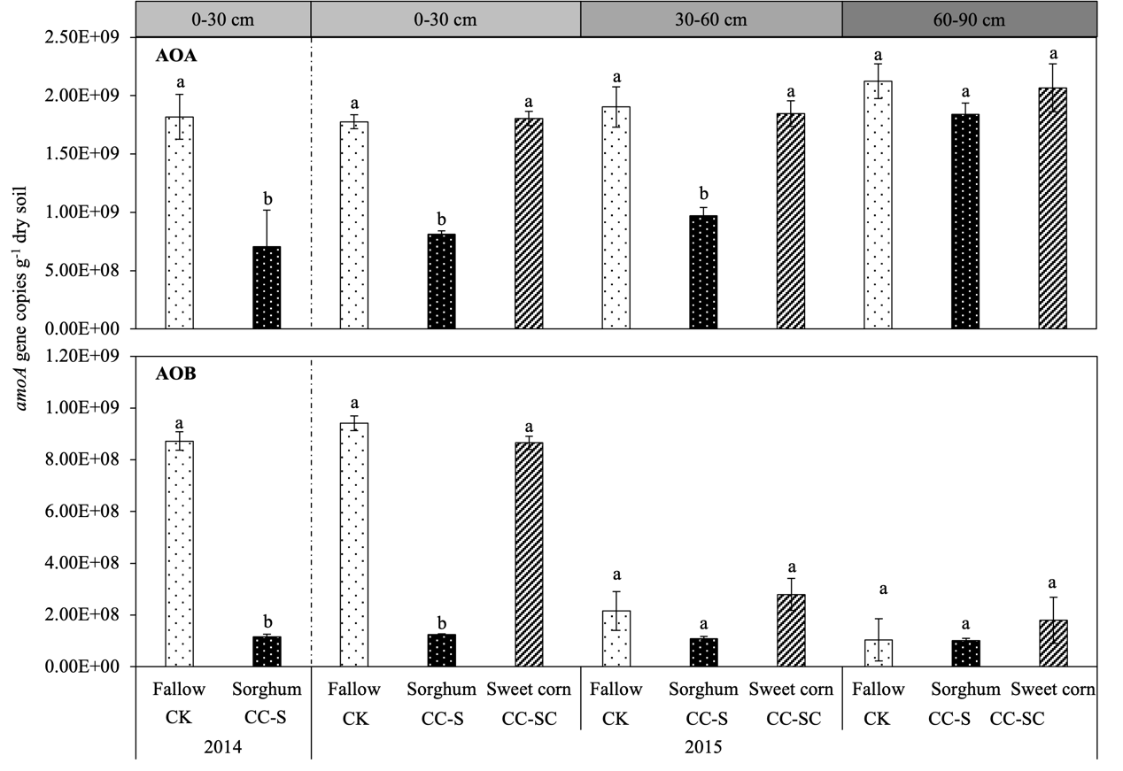

Figure 6

