1. Edward “Johnny” Johnston, 27th January1929 – 1st May 2025.

Although it is with great sadness that we mourn the death of Johnny Johnston we can take consolation from the fact that he will be remembered with love by his extended family and as a highly respected member of the agricultural science community by his many friends and colleagues. He had a very long and illustrious career and even in the last few weeks before he died, he was involved in writing up results from one of the long-term experiments at Rothamsted; experiments with which he has been associated for more than 70 years!



Johnny was born on 27th January 1929. After gaining a BSc in Chemistry and Agricultural Chemistry at The University College of North Wales, Bangor in 1950 he then spent his two years of National Service in the Education Branch of the RAF teaching science to new recruits.

He joined the Chemistry Department at Rothamsted Experimental Station in March 1953. Working with R G Warren, he was immediately involved with sampling and analysing soils from the Classical experiments, using the recently developed Olsen P method. He was closely linked with the long-term experiments since then but was always looking at those practical aspects of the research that would best help the farmer improve their yields as efficiently as possible while minimising losses. It was that basic grounding in sampling and analysis that gave Johnny an instinct for looking at and interpreting the data and giving him a clear understanding of how reliable and *applicable* those results might be.

When Warren retired in 1964, Johnny became the lead scientist for most of the long-term experiments at Rothamsted, Woburn and Saxmundham. He was instrumental in making modifications to the Rothamsted long-term experiments during the 1960s and later to ensure that they continued to be relevant as scientific resources and as the basis for practical information for farmers. He was also keen to collaborate with scientists who could bring new skills to bear in order to use the experiments as a platform for new research. He became head of the Soils and Plant Nutrition Division in 1984; a post he held until he “retired” in 1989 when he was appointed as a Lawes Agricultural Trust Senior Fellow. He continued to attend national and international conferences and to publish papers which dealt with all aspects of practical agriculture, including the effects of soil organic matter on yield, the value of fresh and residual phosphorus and potassium applications and the effects of environmental and atmospheric pollution. Some of his earlier papers appeared in the Rothamsted Annual Reports and reported results from Barnfield, Park Grass, Exhaustion Land, Agdell, Hoos Barley and Broadbalk. He had an encyclopaedic knowledge of these and the other long-term experiments at Rothamsted and a remarkable memory for detail. He was always happy to share his knowledge with junior colleagues, visiting scientists, farmers, agronomic advisors and to give talks at meetings and conferences. He edited many books and contributed to several book chapters. He was the sole author or co-author of about 200 papers between 1960 and 2024 and was currently helping with a write-up of the Park Grass experiment. On his 90th birthday in 2019 we were delighted to present him with six bound volumes of his papers. In the same year, he was also awarded an Honorary Fellowship for Services to Agricultural Science by Bangor University. The citation for which read “Throughout your career you have demonstrated a passionate commitment to your profession, and your contributions have been critical to the understanding of basic processes in soil fertility and crop nutrition, providing much of the basis of soil quality and sustainable agriculture research. Your achievements make you an outstanding candidate for an Honorary Fellow”.

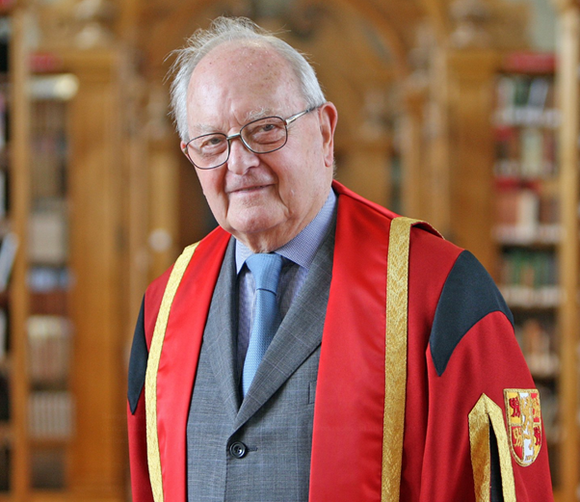

That he was widely respected by the scientific community is also evidenced by some of the other awards that he received:-

* He was a very regular attendee at the International Fertiliser Society meetings and co-authored 26 papers for the Society’s Proceedings, more than any other author. He was awarded the Francis New Medal in 1997 for his contribution to the Society and the industry.
* He received the 1994 International Fertilizer Award from the International Fertilizer Industry Association for “outstanding research contributing to the efficient use of mineral fertilizers and for the effective communication of the findings to the agricultural community “.
* He received a plaque “For long, fertile and friendly cooperation with the International Potash Institute” in 2007.
* In 2009, the Royal Swedish Academy of Agriculture and Forestry appointed him to be an Honourable Member of the Agricultural Section of the Academy.
* In 2010 he delivered the Leo M. Walsh Soil Fertility Distinguished Lecture and was recognised by The Soil Science Society of America as a “Distinguished Scholar”.
* In 2012 Johnny was the recipient of The International Plant Nutrition Institute Science Award which “recognizes and promotes distinguished contributions by scientists involved with global ecological intensification as related to crop production”.

Johnny is sadly missed but will be remembered for many years. His legacy can be found in the many published papers and book chapters to which he contributed.

We send our sincere condolences to Johnny’s family.

Paul Poulton, David Powlson, Steve McGrath

Rothamsted Research

May 2025