Novel approaches to estimate penetrometer resistance in a loamy sand soil
Wencan Zhang^{a,b}, Weida Gao^{a*}, Tusheng Renª, W Richard Whalley^{b*}
ª College of Resources and Environmental Science, China Agricultural University, Beijing, 100193, China
^{b} Department of Sustainable Agricultural Sciences, Rothamsted Research, Harpenden, AL5 2JQ, UK

*corresponding author.
E-mail addresses: wencanzhang@163.com (W. Zhang), weida_gao@cau.edu.cn (W. Gao), tsren@cau.edu.cn (T. Ren), richard.whalley@rothamsted.ac.uk (W.R. Whalley).

Abstract
Continuous estimates of penetrometer resistance (Q) would be useful in root elongation and in soil management studies. However, penetrometers produce estimates of penetration resistance at discrete time points. In this paper, a method with the potential to provide of continuous penetrometer estimates is developed. We use measurements of shear wave velocity (V_{s}), determined from piezo electric devices, and bulk density (ρ_{b}), determined with the heat pulse (HP) method, to estimate penetrometer resistance. Soil samples of a loamy sand were packed into cylinders with axial pressures of 50, 100, and 200 kPa, and allowed to equilibrate at matric potentials of -2, -6, -10, -30, -100, -300, and -500 kPa. Thermal conductivity (λ), V_{s} and Q were measured after equilibration. A λ-based approach was applied to estimate ρ_{b} and small strain shear modulus (G) was calculated from ρ_{b} and V_{s}. Our results confirmed a linear relationship between Q and G (where G = V_{s}ρ_{b}² with measured V_{s} and estimated ρ_{b}), which provides a basis to estimate penetrometer data in the field using buried sensors and a physically based model.
Keywords: Penetrometer resistance, Bulk density, Thermal conductivity, Small strain shear modulus, Prediction
1. Introduction
High soil strength limits seeding establishment (Whalley et al., 1999) and subsequent root growth (Bengough and Mullins, 1990) Increases in strength in soil surface layers are responsible for restricting root proliferation (Gao et al., 2016a) and stunting shoot elongation (Whalley et al., 2008, 2006). A knowledge of soil strength is also important to determine the ability of soil to withstand trafficking by farm machinery (Håkansson, 2005). Despite the importance of soil strength within a general management framework, approaches to its measurement remain relatively undeveloped. Typically, penetrometers are used to provide an estimation for the pressure required to push a steel cone down through the soil profile. Empirically, penetrometer resistances (Q) greater than 2.5 MPa have been shown to limit root elongation (Whalley and Bengough., 2013). While penetrometer data are useful, they are discrete measurements.
Soil strength varies in time and with water status (Whalley et al., 2006). Under field conditions, the Q of the surface layers can be predicted when matric potential, water content and bulk density are available (Whalley et al., 2007), but the prediction functions are empirical (Whitmore et al., 2011). An alternative to the empirical procedure was developed by Gao et al. (2013) and Shin et al. (2017), where Q was estimated from the small strain shear modulus (G), which can be calculated from shear wave velocity (V_{s}) and bulk density (ρ_{b}) (Gao et al., 2013; Santamarina et al., 2001; Whalley et al., 2012) with
$G=ρ_{s}V_{s}^{2}$ (1)
Shin et al. (2017) obtained G as a function of depth from measurements of acoustic seismic coupling, and then estimated penetrometer resistance to a depth of 30 cm using a linear relation between Q and G (Gao et al., 2013). The Shin et al. (2017)methods gives a measurement of soil strength non-invasively but requires a significant amount of numerical analysis.
Here we explore the possibility of estimating G from measurements of V_{s} and ρ_{b}, which can both be measured with buried sensors. This would enable one to monitor Q in situ and continuously. The bulk density, ρ_{b,} can be determined with the heat pulse (HP) method (Lu et al., 2016; Ochsner et al., 2001a, 2001b) and V_{s} can be determined with buried piezo electric devices or from non-invasive geophysical techniques (Donohue et al., 2013). The purpose of this study is to establish a functional relationship between G and Q, where G is estimated from Eq. (1), using estimates of ρ_{b} from HP method, and direct measurements of V_{s}. The relationship will provide a basis for the prediction of Q in the field. We compare this approach with other published equations relating Q to soil density and moisture status.

2. Materials and methods
2.1 Soil and sample preparation
We used the Butt Close soil (Whalley et al., 2012), which is a loamy sand soil from 0-20 cm layer in the Woburn Farm, Bedfordshire, UK. The basic soil properties are listed in Table 1. The soil was air dried and passed through a 2-mm sieve. The soil samples were equilibrated to water contents of 0.17 g g⁻¹ by adding distilled water, which gave the greatest compactiblility (Gao et al., 2013; Gregory et al., 2010), stored in a 4ºC fridge for 48 h, and then packed into steel rings (51 mm high and 54 mm diameter) with corresponding axial pressures of 50, 100 or 200 kPa. Finally, the packed samples were equilibrated at matric potentials of -2, -6, -10, -30, -100, -300, and -500 kPa. Each treatment combination was replicated three times.
2.2 Measurement of shear wave velocity
Following removal from the tension plate or pressure plate apparatus, the soil cores were weighed and shear wave velocity was measured. We used two piezoelectric devices: one generated a shear wave and the second detected the shear wave which had travelled through the soil. The instrumentation is commercially available from GDS (Global Digital Systems Ltd, Unit 13 Murrell Green Business Park London Road, Hook RG27 9GR). The input into in the first piezoelectric device was a single cycle electrical signal in the form of a sine wave with a 0.2-ms period, which generated a shear wave. The time for the shear wave to travel through the soil sample was determined by comparing the input and detected shear waves (Whalley et al., 2011).
2.3 Measurement of thermal conductivity
Following the shear wave measurement, the samples were wrapped in cling film to maintain the water status. A three-needle heat pulse probe was used to determine the thermal conductivity of at the different matric potentials (Fig. 1a). The method is based on the theory of radial heat conduction from a line source following a short-duration heat pulse (Carslaw and Jaeger, 1959). We applied the PILS-peak method (Bristow et al., 1995) to evaluate the temperature data with the MATLAB software. Lu et al. (2016) proposed a λ-based approach to determine soil bulk density.
We used the Lu et al. (2007) λ model to estimate λ,
$λ=\left(λ_{sat}-λ_{dry}\right)K_{e}+λ_{dry}$ (2)
$λ_{dry}=-0.56×τ+0.51$ (3)
$λ_{sat}={λ_{s}}^{1-τ}{λ_{w}}^{τ}$ (4)
$λ_{s}={λ_{q}}^{q}{λ_{o}}^{1-q}$ (5)
$K_{e}=exp[B\left(1-S^{B-C}\right)]$ (6)
where $λ_{sat}$ and ${ λ}_{dry}$are the thermal conductivity of dry and saturated soils (W m⁻¹ K⁻¹), respectively, $τ=1-\frac{ρ_{b}}{ρ_{s}}$ is soil porosity, $λ_{s}$ is the thermal conductivity of soil solids, $λ_{w}$ is the thermal conductivity of water (0.594 W m⁻¹ K⁻¹ at 20$℃$), $λ_{q}$ is the thermal conductivity of quartz (7.7 W m⁻¹ K⁻¹) and $λ_{o}$ the thermal conductivity of other minerals (was taken as 2.0 W m⁻¹ K⁻¹ for soils with q > 0.2), q is the quartz content (taken as the sand content), S is the degree of saturation, B (0.96 for coarse soil) is a soil texture dependent parameter, and C (1.33) is a shape parameter.
There is no explicit solution for ρ_{b} from Eq. (2-6) because the relationships between $λ_{sat}$ ,${ λ}_{dry}$, $S_{r}$ and ρ_{b} are nonlinear. To estimate ρ_{b} using the empirical model, an iterative approach was used to numerically solve ρ_{b} from Eq. (2)-(6). This process was obtained with the nonlinear equation solver in Excel. The initial value for ρ_{b} was set as 1.0 g cm⁻³, and ρ_{b} was estimated from measured λ and θ data.
2.4 Measurement of penetrometer resistance
Penetrometer resistance was measured immediately after the thermal conductivity measurement. We used a small cone penetrometer with 2-mm cone diameter and 60º cone angle. It was implemented with a universal test machine (Instron model, 5900 series, Coronation Road, High Wycombe, Buckinghamshire, HP12 3SY, United Kingdom) at a speed of 20 mm min⁻¹. The penetrometer resistance of each sample was the average value between depths of 10-40 mm in each core. Three Q measurements were made on each core (Fig. 1b). After all the measurements, samples were oven dried at 105ºC for 48 h to obtain the water contents and bulk densities.
3. Results and discussion
3.1 Soil water content and bulk density
The soil water contents at equilibrium (-2, -6, -10, -30, -100, -300 and -500 kPa) and ρ_{b} values following compression (50, 100 and 200 kPa) are shown in Table 2. Bulk density increased with compaction. The water release curves of this sand dominated soil, on the other hand, did not vary greatly with the applied pressure except for at the higher matric potentials (greater than -30 kPa) (Fig 2). Thus, the increase in bulk density with increasing compaction was due to the loss of larger pores.
3.2 Soil bulk density results with the λ-based method
Analysis of variance showed that the effects of matric potential and compression stress on λ were both significant at P < 0.001, but there was only a weak effect of the interaction (P = 0.046). Figure 3 (a) shows the relationships between soil thermal conductivity and water content, along with the fitted λ-θ curves obtained with the Lu et al. (2007) model. Fig. 3 (b) compares ρ_{b} estimated from HP measurements with that determined from oven drying. For the repacked soil samples, the errors of the estimated ρ_{b} were mostly within ±10%. The λ-based method gave the RMSEs in ρ_{b} estimation with 0.039, 0.059 and 0.064 g cm⁻³ for soils packed with 50, 100 and 200 kPa compression pressures respectively. The greater the compression stress, the larger the error. The possible reasons to cause this error may come from: (1) the uniformity differences of the packed samples; (2) the errors in λ measured with the HP method; and (3) the limitation of the Lu et al. (2007) model. Knight et al. (2012) observed that the finite probe properties associated with heat pulse method could cause underestimation in λ, and then resulted in the underestimation in ρ_{b} with the λ-based method. In addition, we substituted sand content for quartz fraction following Lu et al. (2007), who stated that a small error in q can cause a considerable error in $λ_{s}$, as well as in λ. Bristow (1998) demonstrated that this could result in over prediction of soil thermal conductivity.
3.3 Estimation of shear wave velocities
The relationships between θ, V_{s} and λ are shown in Fig. 4. As θ increased, V_{s} decreased while λ increased. Shear wave velocity was linearly related to λ, but separate parallel curves were needed for each level of compression (Fig. 4C) to explain 90% of the variance in V_{s} (P < 0.001). Both V_{s} and λ increased with the level of compression, which was consistent with the improved particle contacts in the more compacted soils (Figs. 4A and 4B). The decrease in V_{s} with increasing λ, for each level of compression, was consistent with the effects of soil water. In wet soils, the higher θ contributed to an increase in λ, while in dry soils and increased suction stress (Sψ) led to a higher V_{s}, λ was lower at the smaller water contents. Shear wave velocity was more closely related to matric potential while thermal conductivity was related to water content.
In general, the terms V_{s} can be related to soil physical properties with (Whalley et al., 2012)
$V_{s}=A\frac{{\left(F-e\right)}^{2}}{1+e}{\left[{σ_{s}}^{r}-ψ{\left(\frac{ψ}{ψ_{ae}}\right)}^{-0.55}\right]}^{γ}$ (7)
where A is the value of V_{s} when the effective stress is 1 kPa; $e$ is the void ratio (Lo Presti, 1995); $F$ can be obtained empirically by fitting to data, but a value 2.97 has been recommended for angular particles (Santamarina et al., 2001) and a range of agricultural soils as well (Whalley et al., 2011); $σ_{s}$ is the overburden pressure due to the weight of soil (or the confining pressure) and $ψ$ is the matric potential of soil water; $ψ_{ae}$ is the air entry potential; r and $γ$ are adjustable empirical parameters. We assumed that the${ σ}_{s}$ in packed soil was zero, once the compression was complete, Eq. (7) can, for our purposes, be simplified as
$V_{s}=A\frac{{\left(F-e\right)}^{2}}{1+e}{\left[ψS\right]}^{γ}$ (8)
where S is degree of saturation, and in this work, it was always smaller than 1. The value F was taken as 2.97 (Santamarina et al., 2001). The values of A and ϒ, determined from the curve fitting, were 16.46 m s⁻¹ and 0.406, respectively. The relationship between fitted and measured V_{s} is shown in Fig. 5.
3.4 Penetrometer resistance
The general relationships between soil water content, bulk density, and penetrometer resistance are well understood and widely reported (Gao et al., 2016a, 2012; Whalley et al., 2005). Penetrometer resistance when fitted to
${Log}_{10}Q=A+B{Log}_{10}\left(ψS\right)+Cρ$ (9)
where $ψ$ is the absolute value of matric potential and S is the degree of saturation; A, B and C are adjustable fitting parameters (Whalley et al., 2007) accounted for 98.9% of the variance in Log₁₀Q (Fig. 6 B). The values of A, B and C were 0.023 (+/-0.171), 0.584 (+/-0.008) and 1.446 (+/-0.104) respectively. These fitted parameters compare with 1.26 (+/-0.0823), 0.35 (+/-0.009) and 0.93 (+/-0.0572) respectively, when the same equation was fitted to a set of Canadian soils with a range of textures (Whalley et al., 2007). Gao et al. (2016b) developed a semi-empirical model for penetrometer resistance based on the assumption that it was proportional to the small strain shear modulus such that
$Q=kG$ (10)
Thus, by combining Eqs. (1) and (8) for the case ${ σ}_{s}=0$, penetrometer resistance may be written as
$Q=ρ{\left(\frac{{\left(F^{'}-e\right)}^{2}}{1+e}{\left[ψS\right]}^{f}\right)}^{2}$ (11)
where $ρ$ is soil bulk density in N m⁻³, e is the void ratio, ψ is matric potential, S is the degree of saturation and F’ and f are adjustable fitting parameters. For our data, F’ and f were 3.144 and 0.290, respectively. Figure 6 A compares the fitted Q calculated with Eq. (11) with measured Q. Gao et al. (2016b) explained that including the proportionality constant A (of Eq. (8)) in Eq. (10) made the model over parameterised. Hence, the requirement for A is accommodated for in F’ which should not be equated with F. This model accounted for 98% of the variance in Q (Fig. 6A). An alternative to this approach is to use estimates of G (i.e. $\left(ρ_{b}V_{s}^{2}\right))$ made with measured V_{s} and λ-based ρ_{b} such that
$Q=m\left(ρ_{b}V_{s}^{2}\right)+c$ (12)
which when fitted to our data gives
$Q=0.0144G+ 0.3103$ (13)
which explained 96% of the variance in Q (P < 0.001) (Fig. 7A). The standard errors of the slope and intercept are 0.0004 and 0.042, respectively. In practice, it may be better to use Eq. (13) with measured V_{s} and ρ_{b} because of the difficulty of obtaining accurate matric potential data (Whalley et al., 2013), which is needed for Eq. (11). Compared to Eq. (11), fitted Q with Eq. (13) accounts for somewhat smaller percentage of the variance (96% compared with 98%), but it still provides a reasonable correlation with Q (Fig. 7B). Shear wave velocity can be measured relatively easily with buried piezoelectric devices similar to those used in this work (Lu and Sabatier, 2009) or with non-invasive methods (Donohue et al., 2013). It should be noted that Eq. (11), in the form used here, does not take account of the effect of soil depth (or surcharge) on penetrometer resistance (Gao et al., 2016a, 2016b) whereas direct measurements of G will take account of the effects surcharge on shear wave velocity and hence penetrometer resistance.
4. Conclusions
We have proposed an approach to estimate penetrometer resistance using measured shear wave velocity and soil bulk density, which can be implemented with sensors buried in the soil. Having established the scientific and technical feasibility of using sensed shear wave velocity and soil bulk density to estimate penetrometer resistance, the next stage will be to develop a field deployable sensing system. This will have the distinct advantage that matric potential, which is needed by existing models of penetrometer resistance, will not need to be measured.
Acknowledgements
WRW is supported at Rothamsted Research by the BBSRC Designing Future Wheat project [grant number BB/P016855/1] and the BBSRC/NERC ASSIST project [NE/N018117/1]. Collaboration between WRW, TR and WZ was facilitated by a BBSRC exchange project BB/P025595/1 “China: A Virtual Centre for Monitoring the Rhizosphere”. WZ is a visiting scientist at Rothamsted funded by the China Scholarship Council.
References
Bengough, A.G., Mullins, C.E., 1990. Mechanical impedance to root growth: a review of experimental techniques and root growth responses. J. Soil Sci. 41, 341–358. https://doi.org/10.1111/j.1365-2389.1990.tb00070.x
Bristow, K.L., 1998. Measurement of thermal properties and water content of unsaturated sandy soil using dual-probe heat-pulse probes. Agric. For. Meteorol. 89, 75–84. https://doi.org/10.1016/S0168-1923(97)00065-8
Bristow, K.L., Bilskie, J.R., Kluitenberg, G.J., Horton, R., 1995. Comparison of techniques for extracting soil thermal properties from dual-probe heat-pulse data. Soil Sci. https://doi.org/10.1097/00010694-199507000-00001
Carslaw, H.S., Jaeger, J.C., 1959. Conduction of heat in solids.pdf. Oxford Clarendon Press. 2nd. Ed. https://doi.org/10.1371/journal.pone.0041178
Donohue, S., Forristal, D., Donohue, L.A., 2013. Detection of soil compaction using seismic surface waves. Soil Tillage Res. 128, 54–60. https://doi.org/10.1016/j.still.2012.11.001
Gao, W., Hodgkinson, L., Jin, K., Watts, C.W., Ashton, R.W., Shen, J., Ren, T., Dodd, I.C., Binley, A., Phillips, A.L., Hedden, P., Hawkesford, M.J., Whalley, W.R., 2016a. Deep roots and soil structure. Plant Cell Environ. 39, 1662–1668. https://doi.org/10.1111/pce.12684
Gao, W., Ren, T., Bengough, A.G., Auneau, L., Watts, C.W., Whalley, W.R., 2012. Predicting Penetrometer Resistance from the Compression Characteristic of Soil. Soil Sci. Soc. Am. J. 76, 361. https://doi.org/10.2136/sssaj2011.0217
Gao, W., Watts, C.W., Ren, T., Shin, H.-C., Taherzadeh, S., Attenborough, K., Jenkins, M., Whalley, W.R., 2013. Estimating Penetrometer Resistance and Matric Potential from the Velocities of Shear and Compression Waves. Soil Sci. Soc. Am. J. 77, 721. https://doi.org/10.2136/sssaj2012.0394
Gao, W., Whalley, W.R., Tian, Z., Liu, J., Ren, T., 2016b. A simple model to predict soil penetrometer resistance as a function of density, drying and depth in the field. Soil Tillage Res. 155, 190–198. https://doi.org/10.1016/j.still.2015.08.004
Gregory, A.S., Bird, N.R.A., Whalley, W.R., Matthews, G.P., Young, I.M., 2010. Deformation and Shrinkage Effects on the Soil Water Release Characteristic. Soil Sci. Soc. Am. J. 74, 1104. https://doi.org/10.2136/sssaj2009.0278
Håkansson, I., 2005. Machinery-induced compaction of arable soils, incidence—consequences—counter-measures.
Knight, J.H., Kluitenberg, G.J., Kamai, T., Hopmans, J.W., 2012. Semianalytical Solution for Dual-Probe Heat-Pulse Applications that Accounts for Probe Radius and Heat Capacity. Vadose Zo. J. 11, 0. https://doi.org/10.2136/vzj2011.0112
Lo Presti, D.C.F., 1995. General report: measurement of shear deformation in geomaterials. Pre-failure Deformation of Geomaterials.
Lu, S., Ren, T., Gong, Y., Horton, R., 2007. An Improved Model for Predicting Soil Thermal Conductivity from Water Content at Room Temperature. Soil Sci. Soc. Am. J. 71, 8. https://doi.org/10.2136/sssaj2006.0041
Lu, Y., Liu, X., Heitman, J., Horton, R., Ren, T., 2016. Determining Soil Bulk Density with Thermo-Time Domain Reflectometry: A Thermal Conductivity-Based Approach. Soil Sci. Soc. Am. J. 80, 48. https://doi.org/10.2136/sssaj2015.08.0315
Lu, Z., Sabatier, J.M., 2009. Effects of Soil Water Potential and Moisture Content on Sound Speed. Soil Sci. Soc. Am. J. 73, 1614. https://doi.org/10.2136/sssaj2008.0073
Ochsner, T.E., Horton, R., Ren, T., 2001a. Measurements with Thermo-Time Domain Reflectometry. Soil Sci. Soc. Am. J. 1618–1622.
Ochsner, T.E., Horton, R., Ren, T., 2001b. A New Perspective on Soil Thermal Properties. Soil Sci. Soc. Am. J. 65, 1641–1647. https://doi.org/10.2136/sssaj2001.1641
Santamarina, J.C., Klein, K.A., Fam, M.A., 2001. Soils and waves. J. Soils Sediments. https://doi.org/10.1007/BF02987719
Shin, H.C., Watts, C.W., Whalley, W.R., Attenborough, K., Taherzadeh, S., 2017. Non-invasive estimation of the depth profile of soil strength with acoustic-to-seismic coupling measurement in the presence of crops. Eur. J. Soil Sci. 68, 758–768. https://doi.org/10.1111/ejss.12462
Whalley, W., Bengough, A., 2013. Soil Mechanical Resistance and Root Growth and Function, in: Plant Roots. https://doi.org/10.1201/b14550-43
Whalley, W.R., Clark, L.J., Gowing, D.J.G., Cope, R.E., Lodge, R.J., Leeds-Harrison, P.B., 2006. Does soil strength play a role in wheat yield losses caused by soil drying? Plant Soil 280, 279–290. https://doi.org/10.1007/s11104-005-3485-8
Whalley, W.R., Finch-Savage, W.E., Cope, R.E., Rowse, H.R., Bird, N.R.A., 1999. The response of carrot (Daucus carota L.) and onion (Allium cepa L.) seedlings to mechanical impedance and water stress at sub-optimal temperatures. Plant, Cell Environ. 22, 229–242. https://doi.org/10.1046/j.1365-3040.1999.00412.x
Whalley, W.R., Jenkins, M., Attenborough, K., 2012. The velocity of shear waves in unsaturated soil. Soil Tillage Res. 125, 30–37. https://doi.org/10.1016/j.still.2012.05.013
Whalley, W.R., Jenkins, M., Attenborough, K., 2011. The velocity of shear waves in saturated soil. Soil Sci. Soc. Am. J. 75, 1652–1657.
Whalley, W.R., Leeds-Harrison, P.B., Clark, L.J., Gowing, D.J.G., 2005. Use of effective stress to predict the penetrometer resistance of unsaturated agricultural soils. Soil Tillage Res. 84, 18–27. https://doi.org/10.1016/j.still.2004.08.003
Whalley, W.R., Ober, E.S., Jenkins, M., 2013. Measurement of the matric potential of soil water in the rhizosphere. J. Exp. Bot. https://doi.org/10.1093/jxb/ert044
Whalley, W.R., To, J., Kay, B.D., Whitmore, A.P., 2007. Prediction of the penetrometer resistance of soils with models with few parameters. Geoderma 137, 370–377. https://doi.org/10.1016/j.geoderma.2006.08.029
Whalley, W.R., Watts, C.W., Gregory, A.S., Mooney, S.J., Clark, L.J., Whitmore, A.P., 2008. The effect of soil strength on the yield of wheat, in: Plant and Soil. pp. 237–247. https://doi.org/10.1007/s11104-008-9577-5
Whitmore, A.P., Whalley, W.R., Bird, N.R.A., Watts, C.W., Gregory, A.S., 2011. Estimating soil strength in the rooting zone of wheat. Plant Soil. https://doi.org/10.1007/s11104-010-0588-7

Table 1. Properties of the soil used in this paper.
Property | Units | Butt Close
Location |  | Woburn Farm Res. Hertfordshire
Grid reference | GB national grid
 | Latitude | 50º00’42’’N
 | Longitude | 00º32’42’’W
Soil type | SSWE group | Brown Earth
 | SSWE series | Cottenham
 | FAO† | Cambic Arenosols
 | USDA† | Udipsamments
Land use |  | Arable
Sand (2000-63 μm) | g g⁻¹ dry soil | 0.875
Silt (63-2 μm) | g g⁻¹ dry soil | 0.055
Clay (<2 μm) | g g⁻¹ dry soil | 0.07
Texture | SSWE class‡ | Loamy sand
Particle density | g cm⁻³ | 2.65
Organic matter | g g⁻¹ dry soil | 0.01
†Avery (1980).
‡Soil Survey of England and Wales classification.

Table 2. Soil water content and bulk density of soil samples under three compress stresses. The values are the means of triple replicates. The values in the parentheses are the standard deviations of the means.
Compress Stress  (kPa) | Matric potential  (-kPa) | Water content  (g g⁻¹) | Bulk density  (g cm⁻³)
50 | 2 | 0.182 (0.0007) | 1.499 (0.0024)
 | 6 | 0.152 (0.0010) | 1.497 (0.0020)
 | 10 | 0.148 (0.0002) | 1.502 (0.0032)
 | 30 | 0.132 (0.0022) | 1.482 (0.0022)
 | 100 | 0.105 (0.0006) | 1.496 (0.0020)
 | 300 | 0.084 (0.0002) | 1.498 (0.0119)
 | 500 | 0.073 (0.0006) | 1.496 (0.0013)
100 | 2 | 0.194 (0.0065) | 1.575 (0.0035)
 | 6 | 0.153 (0.0006) | 1.574 (0.0015)
 | 10 | 0.142 (0.0004) | 1.574 (0.0047)
 | 30 | 0.133 (0.0015) | 1.567 (0.0062)
 | 100 | 0.106 (0.0005) | 1.560 (0.0036)
 | 300 | 0.084 (0.0003) | 1.563 (0.0026)
 | 500 | 0.074 (0.0006) | 1.566 (0.0043)
200 | 2 | 0.200 (0.0019) | 1.628 (0.0009)
 | 6 | 0.154 (0.0002) | 1.630 (0.0014)
 | 10 | 0.145 (0.0005) | 1.622 (0.0020)
 | 30 | 0.134 (0.0014) | 1.609 (0.0133)
 | 100 | 0.107 (0.0004) | 1.620 (0.0022)
 | 300 | 0.084 (0.0002) | 1.614 (0.0012)
 | 500 | 0.070 (0.0003) | 1.618 (0.0016)

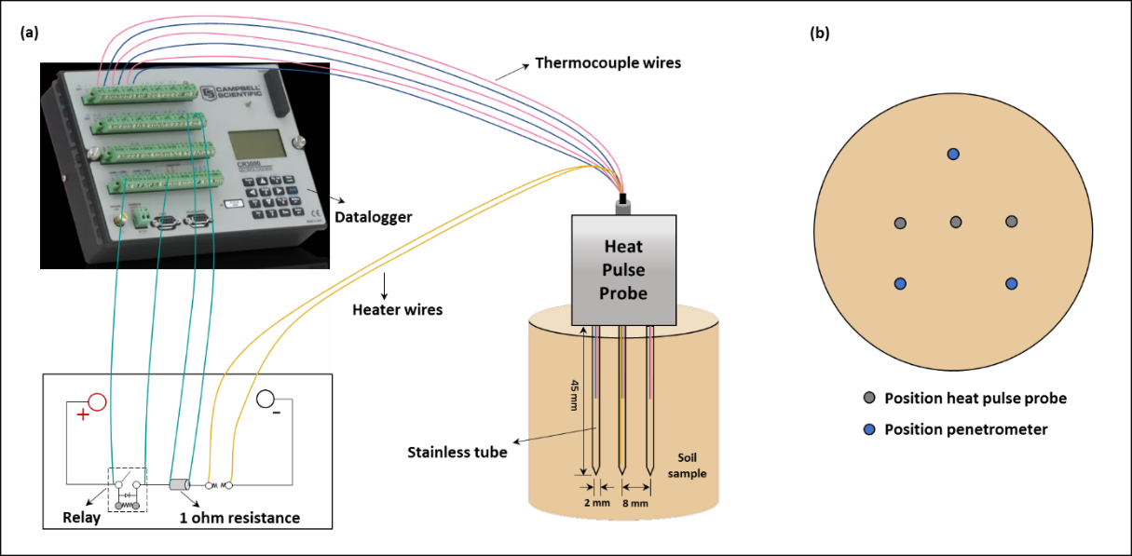Fig. 1 (a) Schematic view of the apparatus and experiment setup for heat pulse (HP) measurement. The drawings are not to scale; (b) Needles position of heat pulse probe and penetrometer.

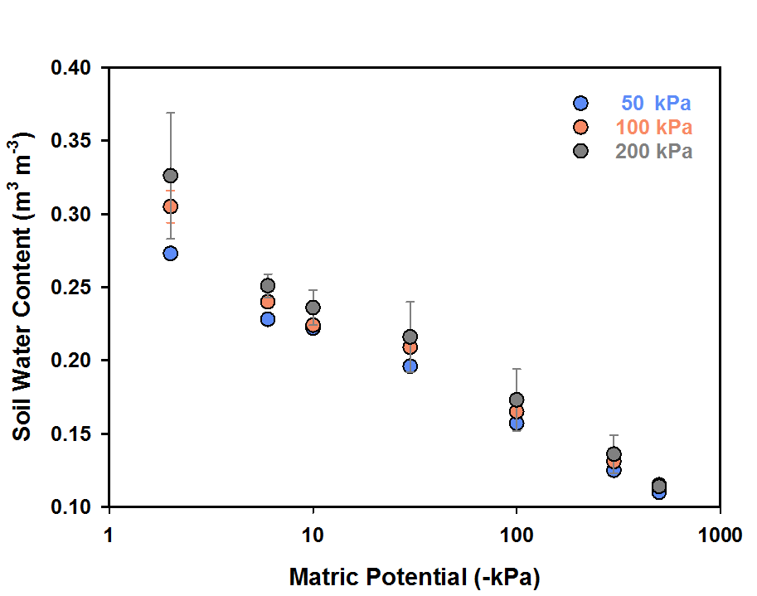
Fig. 2 Water release characteristics of soil samples prepared at various degree of compression.

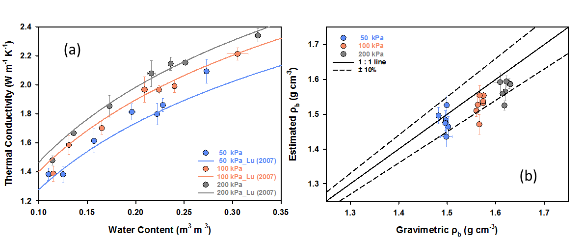
Fig. 3 (a) Measured and fitted thermal conductivity (λ) (Lu et al., 2007) against soil water content; (b) estimated bulk density (ρ_{b}) based on the λ-based approach (Lu et al., 2014). The solid line is the 1:1 line and the dashed lines represent the 10% errors in ρ_{b}.
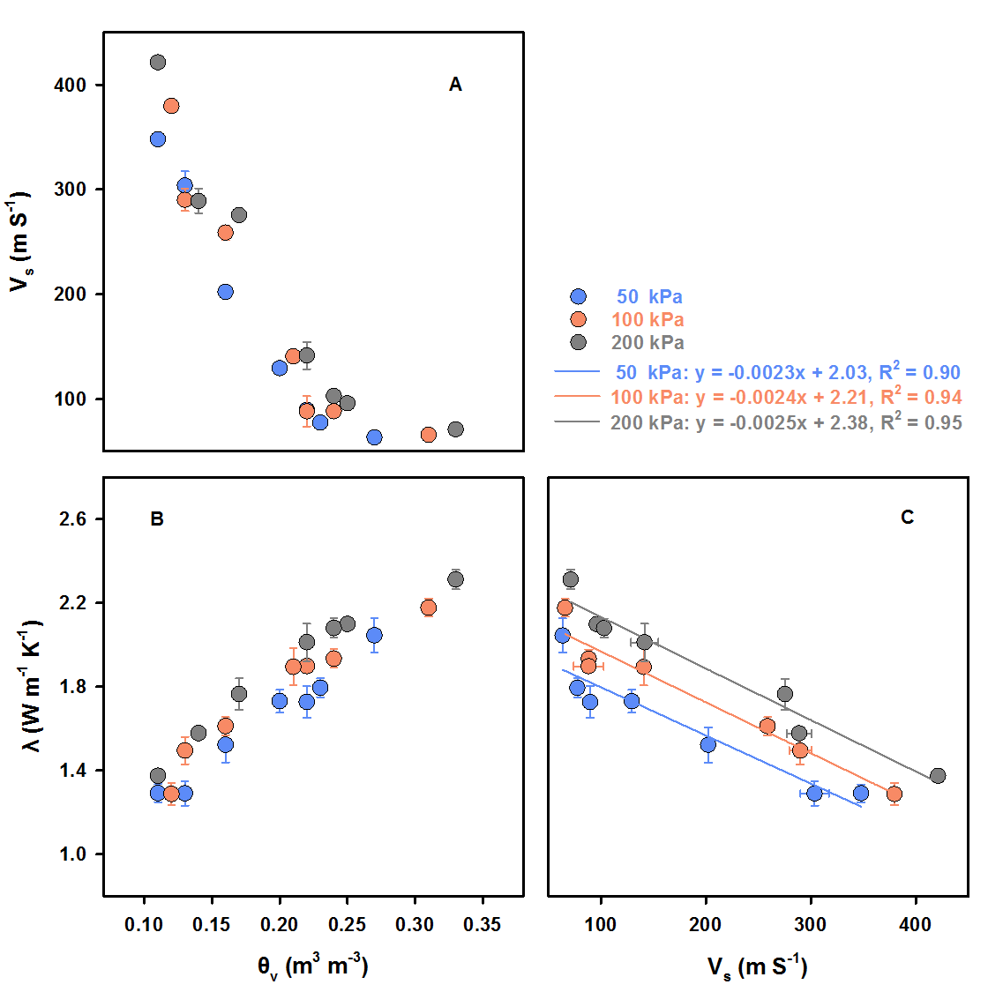
Fig. 4 The interactive relationships between soil water content (θ), thermal conductivity (λ) and shear wave velocities (V_{s}). The lines are linear regression results of soil samples under each compression stress.
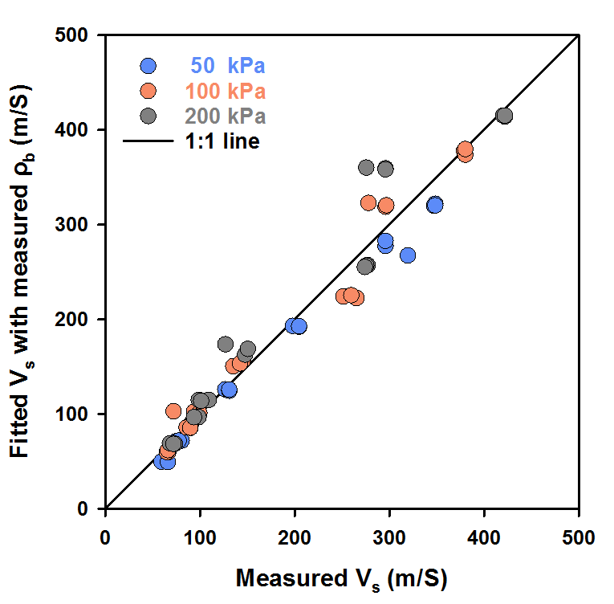
Fig. 5 Fitted values of shear wave velocities (V_{s}) plotted against measured V_{s} using Eq. (8). The solid line is the 1:1 line.

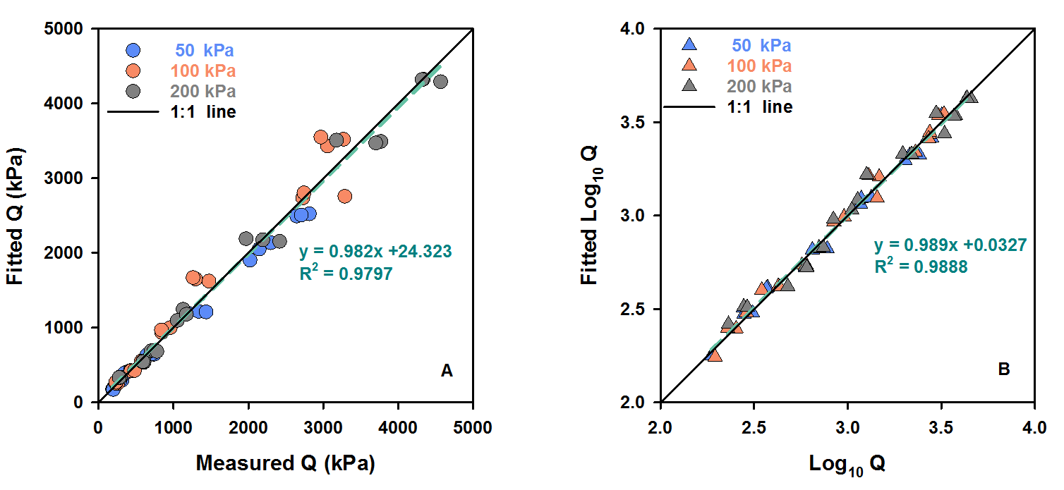Fig. 6 (A) Fitted values of penetrometer resistance (Q) plotted against measured Q using Eq. (11). (B) Fitted values of Log₁₀Q are plotted against measured Log₁₀Q using Eq. (9). The solid lines are the 1:1 line. The green dashed lines are the linear regression lines of all the samples.

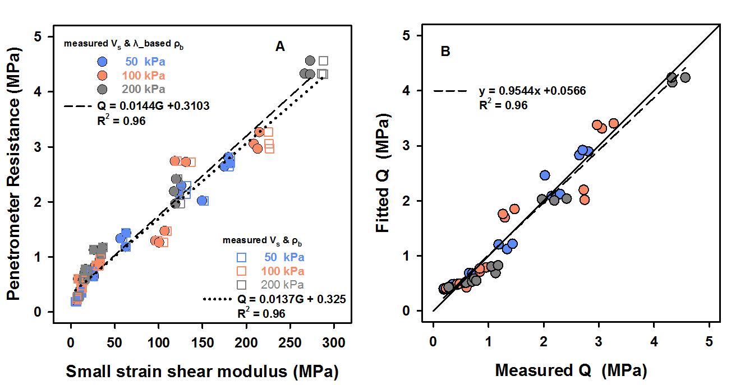
Fig. 7 (A) The relationship between penetrometer resistance (Q) and small strain shear modulus (G). circle scatters are estimated with measured and λ-based ρ_{b} and the square scatters are with measured V_{s} and ρ_{b}. The dashed line and the equation indicate the relationship between G (measured V_{s} and λ-based ρ_{b}) and Q. (B) Fitted and measured Q with the equation in (A). The dashed line is the linear regression line between fitted and measured Q. The solid line is the 1:1 line.

