Realities of using self-administered smartphone surveys to solve sustainability challenges

Amy R. Lewis1, Simon Willcock1,2, Ana Casas3, Beata Kupiec-Teahan3,4, José Mendoza Sanchez5,6, Fiona Anciano7, Dani J. Barrington8, Mmeli Dube7, Paul Hutchings9, Caroline Karani10, Arturo Llaxacondor11, Hellen López5,Anna L. Mdee12, Keosothea Nou13, Alesia D. Ofori3, Joy N. Riungu10,Kory C. Russel14, Md Ehsanul Haque Tamal15, Alison H. Parker3, Andrew R. Bell 16

1 School of Environmental & Natural Sciences, Bangor University, Bangor, Gwynedd LL57 2DG, UK

2 Net Zero and Resilient Farming, Rothamsted Research, Harpenden, Hertfordshire AL5 2JQ, UK

3 School of Water, Energy and Environment, Cranfield University, Cranfield MK43 0AL, UK

4 Bangor Business School, Bangor University, Bangor, Gwynedd LL57 2DG, UK

5 Department of Management Science, Pontificia Universidad Católica del Perú, Perú

6 Instituto de Estudios Peruanos, Perú

7 Department of Political Studies, University of the Western Cape, South Africa

8 School of Population and Global Health, The University of Western Australia, 35 Stirling Highway, Crawley, 6009, Western Australia, Australia

9 School of Civil Engineering, University of Leeds, UK, LS29JT

10 Meru University of Science and Technology, Kenya, 972-60200

11 Sanima, Av. Grau 629, Barranco, Lima – Perú

12 School of Politics and International Studies, University of Leeds, UK, LS29JT

13Department of Agricultural Science, Prek Leap National Institute of Agriculture, Cambodia

14 Department of Landscape Architecture and the Environmental Studies Program, University of Oregon, Eugene, OR 97403, USA

15Department of Health Economics, Murdoch Business School, Murdoch University, Western Australia

16Department of Global Development, Cornell University, Ithaca, NY, 14850

**Abstract**

To fill data gaps in human-environment systems, especially in difficult to access locations, novel tools are needed to collect (near) real time data from diverse populations across the globe. Here we discuss the practicalities, constraints and lessons learnt from six field studies using high spatial and temporal smartphone surveys in six different countries. We suggest that high spatiotemporal, self-administered smartphone surveys will produce novel insights into human behaviour, attitudes and socio-economic characteristics that, when matched with high spatiotemporal resolution environmental data (e.g. from remote sensing), can be used to address sustainability challenges for global communities. Furthermore, we highlight the need for continuous refinement and improvement in future developments to enhance the efficacy of this methodology. By sharing the practical implications and constraints associated with smartphone surveys, this article contributes to the evolving landscape of data collection methods.

Introduction

Sustainable development is a pressing and complex issue that requires a comprehensive understanding of human-environment systems (Glaser et al. 2012; Kabisch, Qureshi, and Haase 2015; Dearing et al. 2006; Arias-Maldonado 2015; Soga and Gaston 2020). Although the United Nations Sustainable Development Goals (SDGs; UN 2015) provide a framework for addressing this challenge, achieving and evaluating successful delivery of these goals rely on the availability and accuracy of data (Lu et al. 2015). Despite advances in data collection, there remains a critical data gap on the interactions between people and the environment which hinders development of effective policies across numerous disciplines (e.g., urban ecology, human ecology, and sociology; Glaser et al. 2012; Kabisch, Qureshi, and Haase 2015; Dearing et al. 2006; Arias-Maldonado 2015; Soga and Gaston 2020) and challenges (such as climate change, inequality and poverty; Scharlemann et al. 2020).

A major impediment to advances in the science of human-environment interactions, with practical implications for our ability to address the global challenges laid out in the SDGs, is that we generally are not able to measure people in the same way that we measure the environment (Glaser et al. 2012; Kabisch, Qureshi, and Haase 2015; Dearing et al. 2006; Arias-Maldonado 2015; Soga and Gaston 2020). Large-scale ‘big’ data on sustainability are, at present, predominantly focussed on environmental variables. These data include, for example, high spatiotemporal resolution satellite imagery, as well as on-the-ground sensors (e.g. high frequency flow gauges monitoring across watersheds; Hürlimann et al. 2019; Shekhar et al. 2017). These data mean the observation of natural phenomena can be regular, be highly resolved in space and time, cover vast extents (often global), and be representative at many scales. Importantly, this regularised ‘baseline’ measurement of how things are enables natural scientists to identify and speak of ‘anomalies’ – in surface temperature, rainfall, etc. – that stand out from the mean and are worthy of examination and explanation.

Data collection in the social sciences, in contrast, does not typically allow anomalies to be robustly identified or examined as data on baselines are sparse. Socio-economic data are typically either collected at a larger spatial scale but infrequently (e.g., census data conducted every 5-10 years) or as a snap-shot (Willcock et al. 2021) (e.g., one-off household surveys covering a relatively small geographic extent; Figure 1). Longitudinal (panel) socio-economic data contain information from the same participant over an extended period of time and can provide valuable insights into changes in behaviour, attitudes or socio-economic characteristics. Such longitudinal data collection are frequently enumerator-led, where trained individuals interact with a participant via a face-to-face interview or phone call (Brück and Regassa 2022). The expense and logistical challenge of these efforts precludes data collection at the frequency and extent necessary to capture the socio-economic drivers or responses to key sustainability challenges – which may occur on monthly, weekly or daily timescales across nations/continents. Increases in frequency and/or extent of this data collection requires additional person-power, as well as increased travel and subsistence for enumerator-led surveys. As such, the cost and logistic challenges of engaging respondents, coupled to the sheer volume of different things to ask respondents, and variation in respondents’ capacity and willingness to answer, mean that a social data collection campaign may be extensive in geography, broad across subject areas, and frequent in engagement – but typically not more than one of these at any one time. We have simply lacked the resources to engage regularly with large numbers of people when things are not going wrong – when funding is sometimes made available (e.g., during the Covid-19 pandemic; Nguyen, Willcock, and Hassan 2024).

McCubbins and Schwartz (1984) proposed a framework of monitoring that parallels emergency services. This framework divides socio-economic data collection into two categories. Studies can be reactive and event-driven (termed ‘fire alarms’ within this framework), whereby data collection and studies are initiated in response to a situation thought likely to have caused changes in socio-economic characteristics (McCubbins and Schwartz 1984). For example, Bakker et al. (2019) used mobile data to analyse the social integration of Syrian refugees in Turkey by evaluating call frequency and duration in reaction to the Syrian civil war (Bakker et al. 2019). However, by lacking a baseline of the levels of social integration before the crisis, the insight gained on the impacts of these changes are limited. For example, fire alarm data campaigns following calamities (e.g., episodes of mass displacement) preclude us from learning what conditions might have led to resilience against these disasters.

By contrast, aligning with natural science data collection, baselines and anomalies could be identified through regular search and observation (termed a ‘police patrol’ by McCubbins and Schwartz (1984)). In conventional models of social data collection, police patrols have been expensive – census campaigns or integrated household surveys – and typically infrequent or of low coverage. However, the frequency of data collection may impact the recall ability of participants (Bell et al. 2019). Consistent, police-patrol engagement with diverse populations, could provide novel insights into societal conditions and how these change. Drawing on examples relevant to the SDGs, by contrasting regular baselines under ‘normal’ conditions with those during extreme weather events, insight can be gained into sustainable food production systems and identifying farmers that showed little/no socioeconomic change across both periods could help make other farmers more resilient (Target 2.4; UN 2015). Similarly, insight can be gained to facilitate migration (Target 10.7) and help eliminate trafficking and sexual and other types of exploitation (Target 5.2) by having data on what socio-economic characteristics support resilience to these events by contrasting ‘police patrol’ data from before and after the event(UN 2015).

The recent global spread of smartphone technology is allowing researchers to reduce the cost barrier of regular engagement in data collection (Bell et al. 2019), making ‘police patrols’ more feasible. Nearly 75% of the global population, aged over 10 years old, now own a mobile phone (though ownership remains higher than internet connectivity, especially in low-income countries; ITU 2022). This makes large scale online, short messaging services (sms) and smartphone surveys possible. However, in low-income regions, many still own basic phones rather than smartphones which impacts potential survey formats (Silver and Johnson 2018).

Researchers are increasingly using autonomous longitudinal approaches, via pre-recorded phone interviews or text message based surveys, though these approaches favour shorter, simpler questionnaires (Gourlay et al. 2021). Such approaches allow capture of short-term variation and minimal recall losses, with text message based surveys also allowing participants to self-administer the survey in their own time, in their own spaces and without pressure or expectation from an enumerator – providing opportunity for representation that many socioeconomic datasets do not offer (i.e., capturing those who are unavailable at the time enumerators visit; Bell et al. 2019). Remotely-led research proved essential during the Covid-19 pandemic, ensuring the safety of both researchers and participants (Bundervoet, Dávalos, and Garcia 2022). Large-scale online surveys share these benefits, also providing the opportunity for longer, more complex questionnaires, though longitudinal research can be challenging and so high temporal frequencies are difficult to achieve (Bell et al. 2016). Smartphone surveys build on these benefits by also supporting collection of multiple data types (such as recording sound, visual imagery, or GPS [i.e., routes to a natural resource]) or ‘nudging’ participants to complete the survey (e.g., using automated smartphone notifications to reduce attrition rates). Smartphone surveys can be conducted at high temporal frequencies in locations with patchy or intermittent data connections, at a time convenient for the participant and using free, open source software, such as Open Data Kit (ODK) (Hartung et al. 2010).

We believe self-administered smartphone surveys provide an opportunity for a currently underutilised but affordable alternative to traditional enumerator led surveys to start filling the data gaps required to undertake ‘police patrol’ surveys and help address the SDGs. For self-administered smartphone surveys, research funds previously used for enumerators can, instead, be channelled directly to participants to compensate them for their effort. The proliferation of mobile wallet services – to pay for energy, utilities, or to share money or data – and the expanding demand for data and bandwidth provide the opportunity to reward respondents in locally relevant ways for engaging regularly with data collection campaigns through their mobile devices. For example, following a ‘micro-payments for micro-tasks’ approach (Kittur, Chi, and Suh 2008), Bell et al (2016) developed a method to collect high-frequency social data by distributing smartphones (that participants could keep at project end) to almost 500 individuals and compensating participation through data and talk time over a 50 week study in Bangladesh. Thus, the impact of these projects can go beyond filling data gaps by providing increased access to technology and information (i.e., via the internet), especially in low-income countries.

To date, high spatiotemporal, self-administered smartphone surveys (S4) have been run in vulnerable communities across multiple countries including Bangladesh (above), Cambodia, Haiti, South Africa, Peru and Kenya (Figure 2; Table 1; <https://msds.tools/>). Participants were provided with smartphones (or used their own) to regularly completed short daily tasks (3-10 minutes) in return for small payments in the form of data top-ups (average payment per task was between 0.18USD to 0.25 USD). Topics ranged from basic demographic information, household expenditure, to data on shocks experienced or sanitation access (see SI1-SI5 for questions asked, and Figure 3 for completion of tasks by topic over a one year survey).

Table 1: A summary of the high spatiotemporal, self-administered smartphone surveys (S4) previously run in Bangladesh, Cambodia, Haiti, South Africa, Peru and Kenya.

|  |  |  |  |  |  |  |
| --- | --- | --- | --- | --- | --- | --- |
|  | **S4 Case Study Sites** | | | | | |
| **Bangladesh**  (IFPRI 2018) | **Cambodia** (Willcock, Lewis, and Bell 2022) | **Haiti** (Lewis et al. 2024a; 2024b) | **Kenya** (Lewis et al. 2024a;. 2024b) | **Peru** (Lewis et al. 2024a; 2024b) | **South Africa** (Lewis et al. 2024a; 2024b) |
| Study Year | 2015 | 2020/21 | 2022/23 | 2022/23 | 2022/23 | 2022/23 |
| Mobile subscriptions as a percentage of population at time of study (ITU Data Hub, 2023)α. | 83 | 130 | 64 (data from 2021) | 120 | 130 | 170 |
| Number of participants | 480 | 104 | 0¥ | 102 | 102 | 104 |
| Survey Language | Bangla | Khmer | Haitian Creole & French | Swahili & English | Spanish | Xhosa & English |
| Research length  (Weeks) | 50 | 30 | 0 | 52 | 52 | 52 |
| Total compensation budget per participant (including phone costs; USD) | 110 | 120 | 120 | 145 | 120 | 325ǂ |
| Sex Ratio  (male to female) | 8.53 | 1.76 | ¥ | 0.68 | 0.12 | 0.64 |
| Average Age | 32.9 | 33 | ¥ | 29 | 39 | 39 |
| α Note that this refers to the number of subscriptions to a public mobile-phone service as a proportion of the population of the country at that time see (ITU Data Hub, 2023) for further statistics. Where the percentage is greater than 100, this implies multiple subscriptions per individual.  ¥Note we have included this as a case study to provide insight on the realities of running a S4, including when that results in failure.  ǂ In South Africa, the team increased the weekly compensation rates over the duration of the project to maintain retention rates. | | | | | | |

This paper seeks to qualitatively answer the following questions. What were the lessons learned when rolling out these research studies? What were the constraints? What opportunities arose? Here, we critically reflect on the realities of using S4 and review these six field studies from 2015 to 2023, while we aim to reduce barriers to future researchers taking-up this innovative approach. We focus on six key areas: project management, designing the survey environment, software, sampling bias, participant engagement and data management as well as discussing the novel insights to human-environmental behaviours. Further case study specific issues and solutions can be found in the Supporting Information (SI1-SI5).

Project management & ethics

As with any research collecting data on people, the safety of those individuals and their data is paramount and inherently with a new method or technology, new ethical issues emerge for consideration (Brittain et al. 2020). In each of our case studies, team leads in all countries sought ethical approval from relevant bodies and informed consent was sought from all survey participants to take part in the studies. As data collection in S4 is accomplished using smartphone technologies direct to an encrypted server, there are no paper copies of the completed survey instruments that could be misplaced, or otherwise violate confidentiality. However, smartphones allow for collection of some highly identifying data (e.g., precise GPS locations) which must be collected and stored with caution. Access to these data should be exclusive to those where it is absolutely necessary, and it should be anonymised (for example given a fixed displacement, or data aggregated through distance calculations) before sharing more widely, to reduce any threat of deductive disclosure (Sherman and Fetters 2007). There was also a risk that non-participants may become envious of the participants’ role in the study and the receipt of a mobile phone handset (if applicable) which can create (potentially violent and/or criminal) conflicts in the community. There was a risk that the handset may be stolen, or their own phone may be declared stolen or broken so they can receive a new one.

As with other forms of survey data collection, S4 requires substantial investment in survey design, code development and (where required) translation. However, S4 has the additional step of server preparation (i.e., encryption, etc) and upload. That said, total effort required to support S4 need not be greater than traditional surveys as, for example, ODK allows for development of numerous data input rules, resulting in reduced data cleaning prior to analysis. There are a number of free training resources online, and as with many open source software, a large community of users willing to help each other (for example, ODK has over two million users across the globe; ODK 2023). S4 may also require additional training at the project level. The case study projects developed a series of training videos (Lewis, Willcock, and Bell 2024) for research and implementation partners to enable them to understand the processes involved in the survey development and roll out (Lewis, Willcock, and Bell 2024). In addition, partners developed help/troubleshooting materials such as screen shots and videos, which could be sent via messages (e.g., WhatsApp) directly to participants and team members.

Designing the S4 Environment

S4 data spanning 30-52 weeks with almost 900 participants across six countries with varying rates of smartphone prevalence have been collected and published (Table 1). Using an adapted interface of ODK (Hartung et al. 2010) participants have had the opportunity of regularly completing short daily tasks (3-10 minutes) in return for small payments in the form of data top-ups (0.18USD to 0.25 USD). The micro tasks included various topics, from basic demographic information and expenditure to data on economic or environmental shocks experienced, sanitation access or harvest yields (Figure 1).

In these case studies, the micro tasks were pre-loaded onto a smartphone during a training and consent collection workshop. An adapted ODK interface (Data Exchange) was available to download via the google play store or loaded directly to the phone. The Data Exchange app allowed the notification of a new survey that day or reminded them a micro task was expiring (Figure 4a). Participants click the notification and were taken to the correct micro task that had already been preloaded onto the device. On completion of the task, data was encrypted and sent (when required signal is available) to a server (Figure 4b & 4c). Data was then pulled from the server, decrypted and unzipped using the R package RuODK (Mayer 2021; Figure 4d). Based on the relative difficulty of each micro task, participants were compensated for their effort by adding data or talk time to the phone number linked to that device (Figure 4e). Participants could use their own phone or be given a project phone. If given a phone, the data top up budget was adjusted to ensure that the compensation per participant was equitable.

The cost of S4 extends beyond phone and data costs. To enable participants to reliably self-administer the surveys, training workshops were required, followed by regular feedback sessions, participant check-ups, and software update workshops – all of which added to the overall cost of the data collection. For example, in Kenya monthly workshops were held, while in Cambodia monthly phone call “check-ins” were conducted. In South Africa and Peru, the teams used WhatsApp to communicate with participants. In South Africa, the team set up a WhatsApp group for individuals to raise concerns on an *ad hoc* basis alongside one-to-one communication with participants and the team arranged bi-weekly ‘technical support meetings’ with participants who could not resolve their queries remotely. The team also trained some participants to assist other participants. Such support was a necessary step in ensuring consistent engagement and reliable data but added project expense, and time costs for the participants.

Software

Whilst smartphone prevalence has increased (ITU Data Hub, 2023), these statistics may overestimate the levels of smartphone ownership capable of inclusion in S4. For example, ODK only functions with an Android operating system. Similarly, even some Android smartphones may not have the capabilities to run ODK (e.g., with poor GPS quality and/or storage capacity). In Peru, it was found that, while some phones worked initially, these ceased to function after six months due to outdated systems. In South Africa, in some instances, models of the same brand faced different challenges with running ODK and the Data exchange app. For instance, one model of Samsung worked particularly well with ODK whereas other models, together with some low-end brands were unable to run one or both applications. Purchasing higher-end phones added additional cost to the project and some of them still did not work optimally. Although ODK needs very low storage capacity, many participants’ smartphones have limited or zero storage capacity and there is fear that ODK can slow down their phones. In South Africa, many participants were receptive of the idea of being issued with memory cards to expand their phone memory although this was not done as all participants were instead given project smartphones. It was noted that while most of the surveys could run offline, having a good internet connection to initially download the apps and surveys was essential.

Extensive testing of smartphone handsets is required prior to distribution but depends on the smartphone handsets availability in each country. For example, we found that handsets cost more in Peru than South Africa or Cambodia. In some cases, Android updates forced a reboot and required a reinstallation of the apps, and while this did not lose data, this required input from researchers and frustrated participants. To combat this, we found that remote access software such as Anydesk (AnyDesk, 2023) worked well (e.g., in Kenya), however, this software was not used in South Africa because of higher data costs. There were also regular in-person ‘technical support meetings’, calls, or materials sent by WhatsApp with step-by-step processes. However, to make support clinics work, participant engagement is needed so that issues can be properly diagnosed and addressed.

During the collection of data, our case studies show that multiple communication channels were often required to ensure a good participant experience. For instance, while S4 can be conducted predominantly remotely, frequent in-person visits were included in most cases. In Kenya these were mainly in the first three months, while in South Africa they were done throughout the survey period. This meant increasing the number of research assistants and their hours of work than had been planned initially. Country teams shared experiences each month to learn and add new strategies that might work in each context.

The S4 examples used here also faced a series of software based set-backs. The original Data Exchange app developed in 2015 for the Bangladesh survey was rendered obsolete as a result of android updates (Android Developers, 2023) by the time the project in Cambodia was rolled out in 2019. New Google PlayStore updates (GooglePlayStore, 2023) also meant that by 2021 the rules by which Data Exchange and ODK were able to ‘communicate’ changed, and a further overhaul of the app was required. Such software development is likely to be a continuous process. However, this also potentially unlocks exciting new features. For example, ODK-X allows fully customizable user interfaces (obviating the need for a layer like Data Exchange), as well as bi-directional synchronizing between device and a cloud table (allowing easy reference to past responses and the dynamic updating of survey tasks; ODK-X 2018).

In each case-study country, S4 was provided in multiple languages, with a default language set using the app settings (for example in Kenya, someone could participate in the survey in Swahili, but intermittently switch over to English if required or vice versa). Enabling multiple languages as a default, increased the workload in terms of data management and uploads, with few economies of scale (i.e., each additional language requires the same workload as the last). This benefits bilingual participants, but also enables easy replication of surveys once the translations are complete.

Representativity and inclusion

While smartphone access and adoption varies within and across the case study countries (Silver and Johnson 2018), it is reasonable to expect those participating in S4 samples to skew toward those with greater technical literacy and written language fluency. However, barriers to engagement via mobile device are falling over time with the growth of smartphone use in everyday life across urban through rural spaces (ITU Data Hub, 2023). Moreover, the S4 approach can also be more inclusive of busy people (who might not have time to take away from work or other responsibilities to participate in a conventional survey) or those who may be more traditionally marginalised in having their voices heard (Grossman, Humphreys, and Sacramone-Lutz 2014). The risks of self-administered questioning include pinpointing which member of the household completes the survey. To reduce this risk the case studies included hints and notes during each task to ensure continuity of participant (Lewis et al. 2024a, 2024b). Conversely, the S4 approach may additionally give a perception of anonymity, allowing for the discussion of sensitive issues which participants may not wish to discuss face to face with a stranger (e.g. sanitation; Schonlau, Fricker, and Elliott 2002). S4 can be made more representative by participant-driven sampling (reaching out through networks and leveraging trusting relationships to reach people who might not otherwise engage in a conventional survey; Bell et al. 2016).

An emergent challenge with the novel, non-enumerated smartphone approach is that of linking observations from this method with those collected in other efforts. Responses to any one survey task are understood to be a co-production of the respondent with the larger survey instrument and the context (Fielding and Fielding 1986) – including the enumerator (Di Maio and Fiala 2020) (or lack of), along with all other observed and unobserved aspects of the study frame. Thinking carefully about how to make comparisons across, or construct time series linking such different survey modalities – where respondents will have responded with different motivations to round numbers, think expansively, or misrepresent, for example – is a critical challenge for enmeshing smartphone-based survey research as a modern data collection paradigm.

We acknowledge that the S4 approach can present additional challenges for individuals living in very poor data connection environments. This was seen in the South African case study, for instance, where there was high incidence of power and network disruptions. Many participants also migrated seasonally to rural areas with poorer network connection (Biswas and Mallick 2021). The method is robust to low and intermittent connectivity, such that completed surveys can be sent at the point when an individual does hit a data connection, but the experience of S4 participation is smoother with reliable internet connection.

There is no ‘one size fits all approach’ to the question of whether smartphones should be given to participants or whether they should, or would choose to, use their own. In some of these case studies, few mobile phones were handed out, with many participants preferring to use their current phone. If a phone was not given to a participant, they would instead receive greater top ups of data or talk time to ensure equity across participants. In Peru, only 10 of 102 participants required a project phone, which were handed out discretely. However, in South Africa all 104 participants received a project phone, although there can be substantial challenges associated with this. The academic partners managing the project in South Africa were acutely aware that it would be irresponsible to distribute 100 smartphones in a small geographic area, where residents faced high levels of economic precarity. This could cause conflict between participants and non-participants. Initially the facilitators did not explicitly state to participants that they could have phones given to them, and thus only those with smartphones, with capabilities to run ODK and Data Exchange, began completing the survey. The facilitators shortlisted those who did not own smartphones and discretely provided them the ones purchased under the project. Over several months, however, it became clear that a) some of the low-end phones that participants owned did not work smoothly; b) news of phones being given to some participants spread and there was resentment felt by those who were using their own smartphones and had not been given the option to use a project phone (which in turn led to drop outs); and c) retention rates decreased for those using their own phones as the micropayments were no longer seen as a sufficient incentive, compared to tangible smartphones despite having the same overall monetary value per participant. To maintain the survey, the facilitators individually met with participants discreetly and, ultimately, gave every participant a phone. In Kenya, 20 participants used their own smart phones the remaining 80 took project phones.

The Covid-19 pandemic increased not only the access to better-quality phone ownership so families can engage with schoolwork but also internet access (Aguilera-Hermida et al. 2021; Kadada and Tshabalala 2020). Despite the rise in connectivity across the world, there is a significant gender digital gap with less women accessing technology (Mariscal et al. 2019). In most case studies, there was a skew towards female participation in the research projects (Table 1). There was a skew towards younger participants; very elderly participants often did not want to participate. Though not unique to S4, in some contexts, it is not feasible to roll out the surveys (Table 1). In Haiti for example, the environmental and political situation was substantial (Keen, Gilkey, and Baker 2020). There were also extreme import costs on devices, as well as significant energy instability.

Participant engagement

Gaining the trust of participants was something that researchers in Peru needed to overcome at the beginning, with a suspicion of cold callers. The recruitment strategy had to work closely with local leaders who reinforced the invitations to the training workshops and the research team added more female personnel to the team to give a sense of more trustworthiness. As above, additional workshops throughout the project were required to maintain engagement, and attrition rates across the case studies varied (see SI1-SI5). In South Africa, mistrust between researchers and participants developed when project smartphones were reported lost amidst rumours that some had sold them. Community leaders who were already participants intervened and/or were engaged by researchers to urge participants to keep project smartphones safe. Regular meetings were held with participants to re-build trust and, overall, many participants remained engaged (see case study specific examples in SI1-SI5).

Regular near-real time data analysis and concomitant feedback would have benefitted researchers in testing the app “engagement” and allowed checks of the data, however this would require additional data analyst time or automation. Additionally in South Africa and Peru participants felt that answering the same questions each week was repetitive. Confusion can be caused with inadequate explanation of the longitudinal format of the survey (e.g., in South Africa some participants thought there was an error due to the repetition of the questions). While this may be true for all longitudinal surveys, new software developments can enable researchers to focus more on user experience and ask dynamic questions.

Furthermore, cultural, contextual, and scale-related differences may impact survey responses (Balsa-Barreiro, Menendez, and Morales 2022). The high spatial and temporal resolution data across large extents that are possible under S4 enable this to be studied, with the ‘police patrol’ nature of the methodology enabling for these differences to be controlled for when studying an event by contrasting the baseline context via the socioeconomic data collected after the anomaly.

Data management

In all case studies, regular data scraping, and points calculations were both required to give consistent top ups, but also flag participants that had not submitted data for several weeks. The flagging of such participants also aided the process of identifying and resolving challenges, technical and otherwise, that would have prevented them completing the survey. However, this required a weekly or bi-weekly commitment from researchers both centrally and in each of the field sites. Novel R code (Mayer 2021) was developed to enable ease of data pulling from a central server, vastly reducing download times (Lewis et al. 2024a, 2024b). In addition to top-ups there were further data management requirements, when collecting that volume of information and the capacity gaps in analysing socio-environmental data at these scales now need to be addressed.

Novel insights into human-environment behaviour

We believe that there are good reasons to shoulder the burdens in S4 data collection we have outlined above. Asking participants to complete short tasks, regularly and on their own time, can bring patterns of engagement and recall that are typically not possible in conventional surveys. Additionally, the high-frequency insights into participant experience that smartphone-based engagement provides facilitates time series analysis at the level of shocks and decisions. Further, it allows us to move from point estimates of highly variable aspects (e.g., consumption, spending, and access) to describing the moments of their within-subject distribution over time (e.g., mean, variance, skew). For example, Adams et al. (2016) clustered rural participants in Bangladesh by the ‘shape’ of their reported well-being over time, finding that the role of shocks in shaping well-being was different across clusters – an insight that would have been missed in a conventional survey. Where surveys provide measures of related variables at high frequency, this same approach can extract their covariance as a key outcome variable that may be predicted by other characteristics of the participant (e.g., the degree to which variation in food consumption shapes wellbeing).

In addition to these high-resolution time series analyses and ‘shape’ analyses, the high frequency, high-dimensional picture within and across participants provides other novel opportunities. For example, it gives us the capacity to identify specific events or shocks within the study period as units of analysis, or to identify broader patterns across the sample that might have been invisible in a conventional survey (e.g., patterns of response and non-response to specific question types or over specific survey periods; Figure 5). These novel lenses into human response are immensely valuable in understanding the kinds of adaptation to shocks that strongly shape how people, communities, and societies will be able to respond to interventions aimed at advancing toward the SDGs.

Discussion

If we want to achieve the SDGs by 2030, we must rapidly and robustly fill the data gaps in human-environmental interactions (Glaser et al. 2012; Kabisch, Qureshi, and Haase 2015; Dearing et al. 2006; Arias-Maldonado 2015; Soga and Gaston 2020). Where environmental data collection has leapt ahead in its ability to collect high spatial and temporal resolution data across large extents, socio-economic data must catch up. The expansion of smartphone ownership and data connectivity gives us an opportunity to address some of the most pressing challenges of our time, such as climate change and inequality. Already, S4 has shown that people can recall their past activities reasonably well, but not their past consumption or their experience of shocks (e.g., illnesses and missed school days (Bell et al. 2019)). S4 has also shown that the ‘shape’ of how people report their well-being predicts how they experience shocks (Adams et al. 2016).

Rolling out a S4 is certainly not without its challenges. However, most of these challenges are not insurmountable. Software development, troubleshooting forums and an increased willingness to share in failures as well as successes will reduce these barriers. Channelling resources typically used for high-cost field studies also increases the direct impact of research funding to participants. This method therefore enhances ethical research by appropriately valuing both participant data and time. However, sensitivity is required when introducing technology into low-income communities. In settings where there are high levels of economic precarity alongside high density living, a smartphone, or regular payments for research input, can cause conflict between neighbours. Time and effort must be put into the sampling method and trust built in the area in which researchers plan to work. Local leaders also play an important role, and should have knowledge of the project, as they will often have to mediate any conflicts that arise. Smartphone technology and the apps used for data collection can be alienating and frustrating for participants when they do not work, data is low or connectivity fails. However, as software improves these challenges are likely to be overcome.

The use of smartphone technologies to collect data for social research also has some limitations. A key limiting factor is people’s willingness to participate in the smartphone survey. Literature shows that two main aspects have an impact on people’s willingness to participate in these types of surveys, i.e. respondent characteristics and study characteristics (Wenz and Keusch 2023). In terms of study characteristics, one of the key factors is the duration of the study. Participation in smartphone surveys can be low and participants tend to prefer short studies run by universities rather than sponsored by companies or agencies (Wenz and Keusch 2023). The examples discussed here had different attrition rates (e.g., Kenya: 73%, Peru: 54-55%%, South Africa: 29-55%) and different incentive mechanisms (Lewis et al. 2024a; 2024b), which may have also had an impact in survey participation (Wenz and Keusch 2023). Therefore, keeping participants engaged, especially when they need to respond to high-frequency tasks, remains a challenge, and it is vital to ensure data quality.

Such a paradigm shift in data development towards S4 also brings risks and challenges. Differences in engagement and response present challenges in linking smartphone-based responses to conventionally derived responses. Variation across respondents’ interests and capacity may lead to variation in data quality, as well as gaps in engagement, that is difficult to control for. As with other survey methods, there is the possibility of misreporting by participants (either deliberately or accidentally) via provision of biased responses (Bach, Eckman, and Daikeler 2020). However, we note that the frequency of data collection made feasible by S4 may increase accuracy of reporting by minimising the recall time required (Bell et al. 2019). That said, that does not mean that the data quality of the data collected from the participants will not be challenging. Thus, the dataset collected had to undergo an extensive data cleaning to remove duplicate answers, out of date responses, and to ensure that responses were allocated to the correct weeks. Full details of the cleaning protocol are covered by Lewis et al (2024a, 2024b).

Given the number of S4 are rapidly increasing, there is future scope for a meta-analysis from smartphone survey studies across multiple countries to provide quantitative insights into this methodology. Potential future investigations could answer questions such as: What are participation (who joins) and retention (who stays) rates in S4?; Are these rates representative? i.e. How do retention rates vary with socioeconomic variables? If retention rates are lower for certain groups, a representative survey may start with good representation but can become increasingly skewed with time. Even when retained, frequency of engagement of participants of self-administered surveys may vary - how does frequency of engagement vary with socioeconomic variables?; How do response rates vary per question type?; Are some types of questions (e.g. quantitative vs qualitative, photo vs GPS tracking etc.) considered easier for respondents (e.g. reduced response time), leading to reduced attrition?; Can we identify underlying dimensions of ‘participation’ that show connections across thematic areas or patterns over time? (Figure 5); and finally, what is the optimal survey period and resolution required to capture information on anomalies?

Conclusion

The lack of understanding of baseline socio-economic conditions is a key limitation to traditional crisis-driven data collection methods, such as surveys conducted in the aftermath of natural disasters. However, the widespread adoption of smartphone technology (ITU Data Hub, 2023) has significantly reduced barriers to social data collection at high spatiotemporal resolutions and across large extents. This proliferation of smartphones makes S4 feasible, enabling us to have consistent engagement with participants of a longer time period, capturing novel insights to socio-environmental systems. Despite this progress, disparities in technology access persist (Mariscal et al. 2019), particularly in low-income regions where ownership of basic phones outweighs that of smartphones, impacting the potential efficacy of survey formats. While technological advancements have opened new avenues for data collection, efforts must continue to bridge the digital divide to ensure equitable access to information and insights across diverse populations.

Funding Acknowledgement

This work took place under three different projects. In Peru, Kenya, Haiti and South Africa under the ‘Scaling-up Off-grid Sanitation’ project (SOS; ES/T007877/1), funded with support from the United Kingdom’s Global Challenge Research Fund, via the Economic and Social Research Council. In Bangladesh the work was supported by the Cereal Systems Initiative for South Asia (CSISA) of the Consultative Group on International Agricultural Research (CGIAR), with funding provided by the United States Agency for International Development (USAID), and the Bill and Melinda Gates Foundation. In Cambodia, the project took place under the ‘Using mobile-phone technology to capture ecosystem service information’ project (MobilES; ES/R009279/1), funded with support from the United Kingdom’s Global Challenge Research Fund, via the Economic and Social Research Council.

Data Availability

The data that support the findings of this study are openly available in multiple repositories Data Verse at <https://doi.org/doi:10.7910/DVN/HBQQVE> and Reshare at <https://doi.org/doi:10.5255/UKDA-SN-854681> and <https://doi.org/doi:10.5255/UKDA-SN-857073>

Ethical Approval

All procedures performed in studies involving human participants were in accordance with the ethical standards of the institutional and/or national research committee and with the 1964 Helsinki Declaration and its later amendments or comparable ethical standards. Ethical approval was obtained via the Bangor University College of Environmental Sciences and Engineering Ethics Committee (approval number: COESE2021SW01A; 19th March 2021) and covered all the research described in this study (full details provided in Lewis et al., 2024a). All research was performed in accordance with relevant guidelines/regulations applicable when human participants are involved. The procedures used in this study adhere to the tenets of the Declaration of Helsinki.

Informed Consent

All participants have been fully informed that their anonymity is assured, why the research is being conducted, how their data will be utilised, and if there are any risks to them of participating. Prior to the initiation of the projects (specifically, during the distribution of smartphones and SIM cards) trainers read through a consent script that introduced the purpose of the study, including the institutional affiliation of the principal investigator and all collaborating investigators, described the different components of the study (including publication), explained that participation is voluntary and that respondents have the right to withdraw from the study at any point during the course of the study, explained respondents’ right to privacy and confidentiality, and assured respondents that neither their identity nor their participation in the study will ever be revealed (SI6). Participants signed a document indicating that they consent to participating in the project. This document served as a blanket consent covering participation in the entire 12-month survey and the data management process. The respondents could withdraw consent at any point during the 12-month survey; which included withdrawing from the survey and/or deletion of all data associated with them. This could be done by contacting the project manager in-country. Across the six field studies, informed consent was obtained between 2015 and 2023.

Competing Interests

The authors declare no competing interests.

Author Contributions

ARL, SW, JMS, FA, DJB, MD, PH, CK, AL, HL, ALM, KN, JNR, KCR, EHT, AHP and ARB were involved in designing the smartphone surveys. All authors contributed to data collection and analysis. ARL and SW wrote the manuscript, with all authors providing comments and edits.

AI disclosure

No AI or LLM tool usage in any aspect of their research process

References

Adams, Helen, W. Neil Adger, Sate Ahmad, Ali Ahmed, Dilruba Begum, Attila N. Lázár, Zoe Matthews, Mohammed Mofizur Rahman, and Peter Kim Streatfield. 2016. ‘Spatial and Temporal Dynamics of Multidimensional Well-Being, Livelihoods and Ecosystem Services in Coastal Bangladesh’. *Scientific Data* 3 (November):160094. https://doi.org/10.1038/sdata.2016.94.

Aguilera-Hermida, A. Patricia, Angélica Quiroga-Garza, Sanjuana Gómez-Mendoza, Carmen Amalia Del Río Villanueva, Beatrice Avolio Alecchi, and Dilek Avci. 2021. ‘Comparison of Students’ Use and Acceptance of Emergency Online Learning Due to COVID-19 in the USA, Mexico, Peru, and Turkey’. *Education and Information Technologies* 26 (6): 6823–45. https://doi.org/10.1007/s10639-021-10473-8.

Android Developers. 2023. ‘Storage Updates in Android 11’. Android Developers. Accessed 11 April 2024. https://developer.android.com/about/versions/11/privacy/storage.

AnyDesk. 2023. ‘AnyDesk The Fast Remote Desktop Application’. AnyDesk. Accessed 22 January 2024. https://anydesk.com/en.

Arias-Maldonado, Manuel. 2015. *Environment and Society: Socionatural Relations in the Anthropocene*. SpringerBriefs in Political Science. Cham: Springer International Publishing. https://doi.org/10.1007/978-3-319-15952-2.

Bach, Ruben L, Stephanie Eckman, and Jessica Daikeler. 2020. ‘Misreporting Among Reluctant Respondents’. *Journal of Survey Statistics and Methodology* 8 (3): 566–88. https://doi.org/10.1093/jssam/smz013.

Bakker, Michiel A., Daoud A. Piracha, Patricia J. Lu, Keis Bejgo, Mohsen Bahrami, Yan Leng, Jose Balsa-Barreiro, et al. 2019. ‘Measuring Fine-Grained Multidimensional Integration Using Mobile Phone Metadata: The Case of Syrian Refugees in Turkey’. In *Guide to Mobile Data Analytics in Refugee Scenarios: The ‘Data for Refugees Challenge’ Study*, edited by Albert Ali Salah, Alex Pentland, Bruno Lepri, and Emmanuel Letouzé, 123–40. Cham: Springer International Publishing. https://doi.org/10.1007/978-3-030-12554-7_7.

Balsa-Barreiro, José, Mónica Menendez, and Alfredo J. Morales. 2022. ‘Scale, Context, and Heterogeneity: The Complexity of the Social Space’. *Scientific Reports* 12 (1): 9037. https://doi.org/10.1038/s41598-022-12871-5.

Bell, Andrew Reid, Patrick S. Ward, Mary E. Killilea, and Md Ehsanul Haque Tamal. 2016. ‘Real-Time Social Data Collection in Rural Bangladesh via a “Microtasks for Micropayments” Platform on Android Smartphones’. *PLOS ONE* 11 (11): e0165924. https://doi.org/10.1371/journal.pone.0165924.

Bell, Andrew, Patrick Ward, Md. Ehsanul Haque Tamal, and Mary Killilea. 2019. ‘Assessing Recall Bias and Measurement Error in High-Frequency Social Data Collection for Human-Environment Research’. *Population and Environment* 40 (3): 325–45. https://doi.org/10.1007/s11111-019-0314-1.

Biswas, Bangkim, and Bishawjit Mallick. 2021. ‘Livelihood Diversification as Key to Long-Term Non-Migration: Evidence from Coastal Bangladesh’. *Environment, Development and Sustainability* 23 (6): 8924–48. https://doi.org/10.1007/s10668-020-01005-4.

Brittain, Stephanie, Harriet Ibbett, Emiel de Lange, Leejiah Dorward, Simon Hoyte, Agnese Marino, E. J. Milner-Gulland, et al. 2020. ‘Ethical Considerations When Conservation Research Involves People’. *Conservation Biology* 34 (4): 925–33. https://doi.org/10.1111/cobi.13464.

Brück, Tilman, and Mekdim D. Regassa. 2022. ‘Usefulness and Misrepresentation of Phone Surveys on COVID-19 and Food Security in Africa’. *Food Security* 15 (2): 423–53. https://doi.org/10.1007/s12571-022-01330-8.

Bundervoet, Tom, Maria E. Dávalos, and Natalia Garcia. 2022. ‘The Short-Term Impacts of COVID-19 on Households in Developing Countries: An Overview Based on a Harmonized Dataset of High-Frequency Surveys’. *World Development* 153 (May):105844. https://doi.org/10.1016/j.worlddev.2022.105844.

Dearing, J. A., R. W. Battarbee, R. Dikau, I. Larocque, and F. Oldfield. 2006. ‘Human–Environment Interactions: Learning from the Past’. *Regional Environmental Change* 6 (1): 1–16. https://doi.org/10.1007/s10113-005-0011-8.

Di Maio, Michele, and Nathan Fiala. 2020. ‘Be Wary of Those Who Ask: A Randomized Experiment on the Size and Determinants of the Enumerator Effect’. *The World Bank Economic Review* 34 (3): 654–69. https://doi.org/10.1093/wber/lhy024.

G.Fielding, Nigel, and Jane L.Fielding. 1986. *Linking Data*. SAGE Publications, Inc. https://doi.org/10.4135/9781412984775.

Glaser, Marion, Beate M. W. Ratter, Gesche Krause, and Martin Welp. 2012. ‘New Approaches to the Analysis of Human–Nature Relations’. In *Human-Nature Interactions in the Anthropocene*. Routledge.

GooglePlayStore. 2023. ‘Manage App Updates - Managed Google Play Help’. Accessed 11 April 2024. https://support.google.com/googleplay/work/answer/9350374?hl=en.

Gourlay, Sydney, Talip Kilic, Antonio Martuscelli, Philip Wollburg, and Alberto Zezza. 2021. ‘Viewpoint: High-Frequency Phone Surveys on COVID-19: Good Practices, Open Questions’. *Food Policy* 105 (December):102153. https://doi.org/10.1016/j.foodpol.2021.102153.

Grossman, Guy, Macartan Humphreys, and Gabriella Sacramone-Lutz. 2014. ‘“I Wld like u WMP to Extend Electricity 2 Our Village”: On Information Technology and Interest Articulation’. *American Political Science Review* 108 (3): 688–705. https://doi.org/10.1017/S0003055414000331.

Hartung, Carl, Adam Lerer, Yaw Anokwa, Clint Tseng, Waylon Brunette, and Gaetano Borriello. 2010a. ‘Open Data Kit: Tools to Build Information Services for Developing Regions’. In *Proceedings of the 4th ACM/IEEE International Conference on Information and Communication Technologies and Development*, 1–12. ICTD ’10. New York, NY, USA: Association for Computing Machinery. https://doi.org/10.1145/2369220.2369236.

Hürlimann, Marcel, Velio Coviello, Coraline Bel, Xiaojun Guo, Matteo Berti, Christoph Graf, Johannes Hübl, Shusuke Miyata, Joel B. Smith, and Hsiao-Yuan Yin. 2019. ‘Debris-Flow Monitoring and Warning: Review and Examples’. *Earth-Science Reviews* 199:102981. https://doi.org/10.1016/j.earscirev.2019.102981.

International Food Policy Research Institute (IFPRI) and New York University Department of Environmental Studies. 2018. ‘Social Dynamics of Short-Term Variability in Key Measures of Household and Community Wellbeing in Rural Bangladesh’. V1. Harvard Dataverse. https://doi.org/10.7910/DVN/HBQQVE.

ITU. 2022. ‘Press Release’. ITU. Press Release. 2022. https://www.itu.int:443/en/mediacentre/Pages/PR-2022-11-30-Facts-Figures-2022.aspx.

ITU Data Hub. 2023 ‘Mobile-Cellular Subscriptions - ITU DataHub’. Mobile-Cellular Subscriptions. Accessed 22 January 2024. https://datahub.itu.int/data/?c=701&i=178&u=per+100+people&e=ZAF.

Kabisch, Nadja, Salman Qureshi, and Dagmar Haase. 2015. ‘Human–Environment Interactions in Urban Green Spaces — A Systematic Review of Contemporary Issues and Prospects for Future Research’. *Environmental Impact Assessment Review* 50 (January):25–34. https://doi.org/10.1016/j.eiar.2014.08.007.

Kadada, Constance, and Thembinkosi Tshabalala. 2020. ‘Students’ Attitudes to Open Educational Resources (OERs)’. *International Journal of Social Sciences and Educational Studies* 7 (3). https://doi.org/10.23918/ijsses.v7i3p9.

Keen, P. K. (Ken), Roderick Gilkey, and Edward L. Baker. 2020. ‘Crisis Leadership—From the Haiti Earthquake to the COVID Pandemic’. *Journal of Public Health Management and Practice* 26 (5): 503. https://doi.org/10.1097/PHH.0000000000001207.

Kittur, Aniket, Ed H. Chi, and Bongwon Suh. 2008. ‘Crowdsourcing User Studies with Mechanical Turk’. In *Proceedings of the SIGCHI Conference on Human Factors in Computing Systems*, 453–56. CHI ’08. New York, NY, USA: Association for Computing Machinery. https://doi.org/10.1145/1357054.1357127.

Lewis, Amy R., Andrew R. Bell, Ana Casas, Beata Kupiec-Teahan, José Mendoza Sanchez, Fiona Anciano, Dani J. Barrington, et al. 2024a. ‘Longitudinal Sanitation Data From High-Frequency Phone Surveys Across Three Countries, 2020-2024’. Data Collection. UK Data Service. 13 May 2024. https://reshare.ukdataservice.ac.uk/857073/.

Lewis, Amy R., Andrew R. Bell, Ana Casas, Beata Kupiec-Teahan, José Mendoza Sanchez, Simon Willcock, Fiona Anciano, et al. 2024b. ‘Comparative Sanitation Data from High-Frequency Phone Surveys across 3 Countries’. *Data in Brief* 55 (August):110635. https://doi.org/10.1016/j.dib.2024.110635.

Lewis, Amy, Simon Willcock, and Andrew R. Bell. 2024. ‘Designing Smartphone Surveys: A Series of Video Tutorials’, April. https://doi.org/DOI: 10.5281/zenodo.10954025.

Lu, Yonglong, Nebojsa Nakicenovic, Martin Visbeck, and Anne-Sophie Stevance. 2015. ‘Policy: Five Priorities for the UN Sustainable Development Goals’. *Nature* 520 (7548): 432–33. https://doi.org/10.1038/520432a.

Mariscal, Judith, Gloria Mayne, Urvashi Aneja, and Alina Sorgner. 2019. ‘Bridging the Gender Digital Gap’. *Economics* 13 (1): 20190009. https://doi.org/10.5018/economics-ejournal.ja.2019-9.

Mayer, Florian Wendelin. 2021. ‘ruODK: An R Client for the ODK Central API’. Zenodo. https://doi.org/10.5281/zenodo.5559164.

McCubbins, Mathew D., and Thomas Schwartz. 1984. ‘Congressional Oversight Overlooked: Police Patrols versus Fire Alarms’. *American Journal of Political Science* 28 (1): 165. https://doi.org/10.2307/2110792.

Nguyen, Ngoc T. H., Simon Willcock, and Louise M. Hassan. 2024. ‘Communications Enhance Sustainable Intentions despite Other Ongoing Crises’. *Sustainability Science* 19 (6): 1997–2012. https://doi.org/10.1007/s11625-024-01556-9.

ODK. 2023. ‘ODK - Collect Data Anywhere’. 2023. https://getodk.org.

ODK-X. 2018. ‘ODK-X’. ODK-X. 1 March 2018. https://odk-x.org/.

Scharlemann, Jörn P. W., Rebecca C. Brock, Nicholas Balfour, Claire Brown, Neil D. Burgess, Miriam K. Guth, Daniel J. Ingram, et al. 2020. ‘Towards Understanding Interactions between Sustainable Development Goals: The Role of Environment–Human Linkages’. *Sustainability Science* 15 (6): 1573–84. https://doi.org/10.1007/s11625-020-00799-6.

Schonlau, Matthias, Ronald D. Fricker Jr, and Marc N. Elliott. 2002. *Conducting Research Surveys via E-Mail and the Web*. Rand Corporation.

Shekhar, S., P. Schnable, David LeBauer, K. Baylis, and K. VanderWaal. 2017. ‘Agriculture Big Data ( AgBD ) Challenges and Opportunities From Farm To Table : A Midwest Big Data Hub Community † Whitepaper’. In . US Natl. Inst. Food Agric. https://www.semanticscholar.org/paper/Agriculture-Big-Data-(-AgBD-)-Challenges-and-From-%3A-Shekhar-Schnable/c81575e059a826f39b47367fceaac67a8f55fb07.

Sherman, Jill E., and Tamara L. Fetters. 2007. ‘Confidentiality Concerns with Mapping Survey Data in Reproductive Health Research’. *Studies in Family Planning* 38 (4): 309–21. https://doi.org/10.1111/j.1728-4465.2007.00143.x.

Silver, L, and C Johnson. 2018. ‘1. Majorities in Sub-Saharan Africa Own Mobile Phones, but Smartphone Adoption Is Modest’. *Pew Research Center’s Global Attitudes Project* (blog). 9 October 2018. https://www.pewresearch.org/global/2018/10/09/majorities-in-sub-saharan-africa-own-mobile-phones-but-smartphone-adoption-is-modest/.

Soga, Masashi, and Kevin J. Gaston. 2020. ‘The Ecology of Human–Nature Interactions’. *Proceedings of the Royal Society B: Biological Sciences* 287 (1918): 20191882. https://doi.org/10.1098/rspb.2019.1882.

UN. 2015. ‘A/RES/70/1 Transforming Our World: The 2030 Agenda for Sustainable Development’, Transforming Our World: The 2030 Agenda for Sustainable Development. Resolution Adopted by the General Assembly on 25 September 2015., 42809.

Wenz, Alexander, and Florian Keusch. 2023. ‘Increasing the Acceptance of Smartphone-Based Data Collection’. *Public Opinion Quarterly* 87 (2): 357–88. https://doi.org/10.1093/poq/nfad019.

Willcock, Simon, Amy Lewis, and Andrew Bell. 2022. ‘Longitudinal Ecosystem Service Data from Preah Vihear Province, Cambodia, 2019-2020’. Data Collection. UK Data Service. 1 March 2022. https://doi.org/10.5255/UKDA-SN-854681.

Willcock, Simon, Javier Martinez-Lopez, Norman Dandy, and James M. Bullock. 2021. ‘High Spatial-Temporal Resolution Data across Large Scales Are Needed to Transform Our Understanding of Ecosystem Services’. *Land* 10 (7): 759. https://doi.org/10.3390/land10070759.

**Figures**

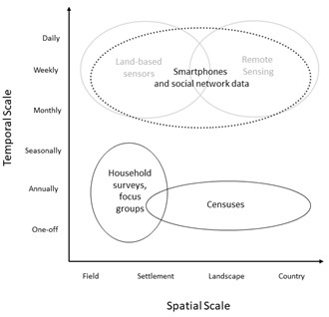

Figure 1: Smartphone surveys (dashes) have the potential to capture socio-economic data at both a high spatial scale as well as at a high frequency. With the rise of smartphone ownership and connectivity across the world, this enables social data (black) typically collected at low temporal scales to match the higher frequency and scale associated with environmental data (grey). Adapted from Willcock et al(Willcock et al. 2021).

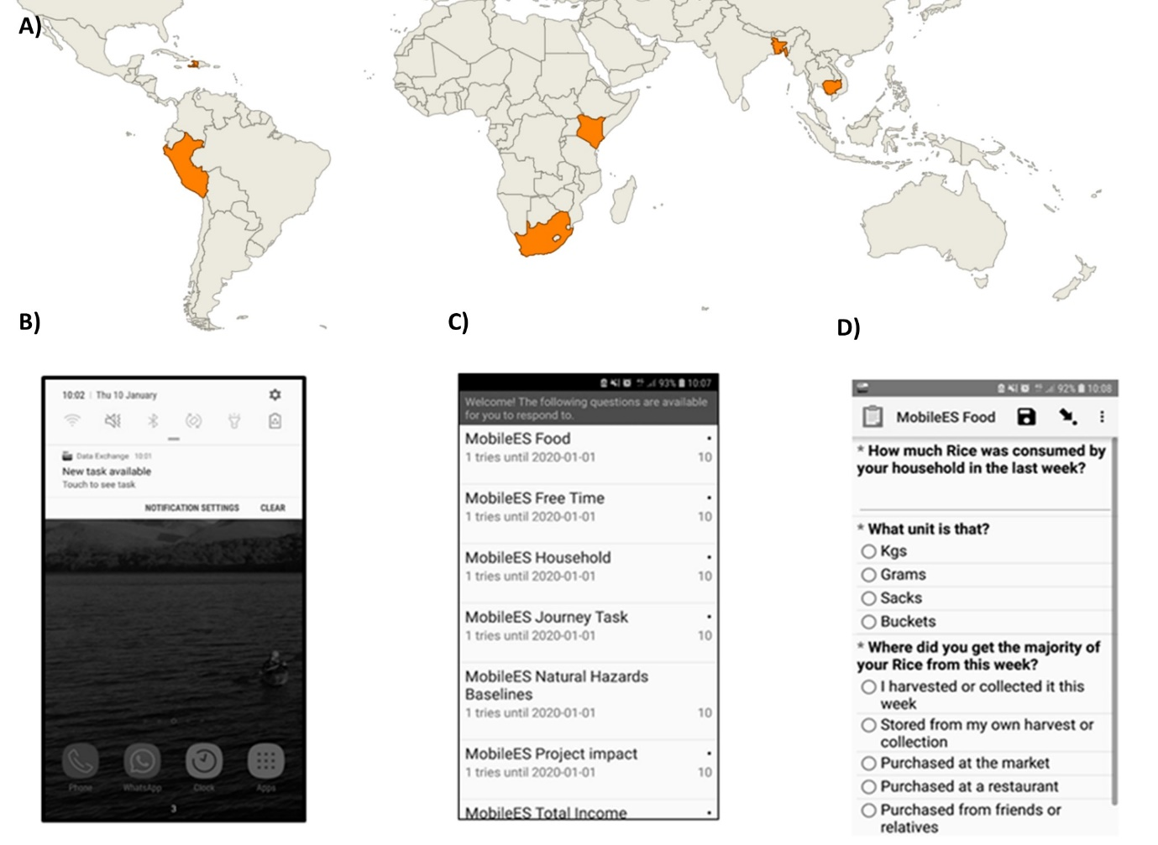

Figure 2: High spatiotemporal, self-administered smartphone surveys (S4) have previously been trialled in six countries between 2015- 2023 (A) with almost 900 total participants. An adapted ODK interface provides: (B) A notification reminding participants that there is a task available; (C) an indication of the points available, the subjects and the length of the task; and (D) the task itself with the ODK designed survey, including photo, free text and multiple-choice options among others.

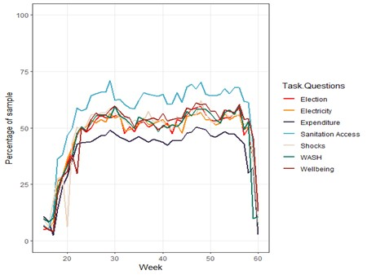

Figure 3 Data from the 2023 studies in Kenya, South Africa and Peru showing completion rates of surveys by task questions over a one year period. Topics include water access, sanitation and health (WASH), as well as shocks and wellbeing26,27).

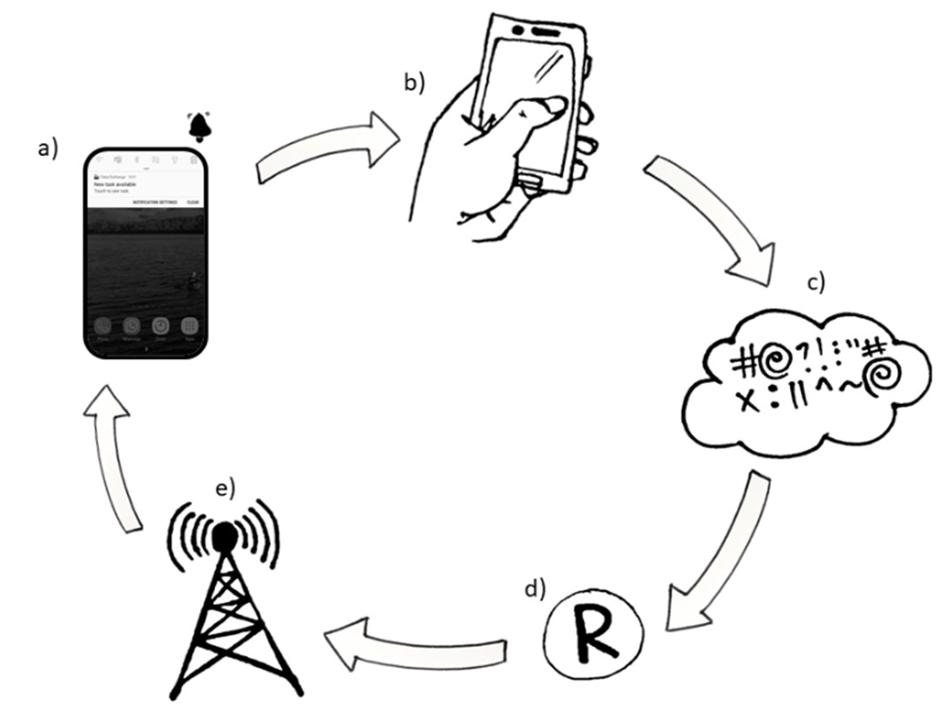

Figure 4: The Data Exchange system showing a) the adapted interface giving notifications and a filtered list of micro tasks to complete used in all case studies (Table 1). b) Participants were taken to the correct task in ODK. c) Once completed forms were encrypted & sent to a server when there is a data connection, d) data were scraped from server at regular intervals to calculate the “top ups” due to participants using the R package RuODK(Mayer 2021) . e) Top ups values were sent to mobile providers and sent directly to participants devices as compensation. Illustrations by A.R.L.

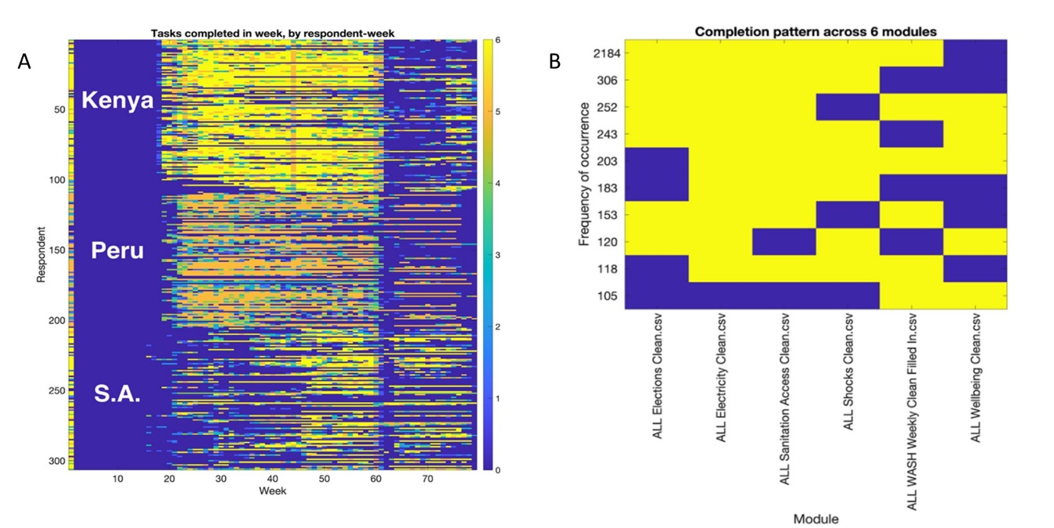

*Figure 5:**Example of high-dimensional participation analysis on S4 from 2023 studies in Kenya, South Africa and Peru*(A. R. Lewis, Bell, Casas, Kupiec-Teahan, Sanchez, et al. 2024)*: A) Multi-country dataset showing number of tasks completed by respondent, by week; B) Identification of highest-frequency non-engagement patterns in dataset shown in (A).*