Effects of cropping systems upon the three-dimensional architecture of soil systems are highly contingent upon texture
NAME(S) OF AUTHOR(S): A. bacq-labreuilª, J. crawford^{b}, S. J. mooneyª, A.L. neal^{b}, E. akkari^{b}, C. McAuliffe^{b}, X.X. Zhang^{b}, M. redmile-gordon^{b*}, K. ritzª
Affiliations:
ªDivision of Agriculture & Environmental Sciences, School of Biosciences, University of Nottingham, Sutton Bonington Campus, Leicestershire LE12 5RD, UK
^{b}Sustainable Agriculture Science, Rothamsted Research, West Common, Harpenden, AL5 2JQ, UK
* Current address: xxx
john.crawford@rothamsted.ac.uk; sacha.mooney@nottingham.ac.uk; andy.neal@rothamsted.ac.uk; elsy.akkari@rothamsted.ac.uk; xiaoxian.zhang@rothamsted.ac.uk; marc.redmile-gordon@naturalengland.org.uk; karl.ritz@nottingham.ac.uk

Corresponding Author: Aurelie Bacq-Labreuil, aurelie.bacq-labreuil@nottingham.ac.uk
Highlights
- Degree of plant presence in agricultural systems profoundly affects soil structure
- Such effects are contingent on the soil texture
- Systems involving plants invoke a greater porosity and pore size range in clay soil
- Systems involving plants invoke reduced porosity and permeability in sandy soil

Summary (250 words)
Soil delivers fundamental ecosystem functions via interactions between physical and biological processes mediated by soil structure. The structure of soil is also dynamic and modified by natural factors and management intervention. The aim of this study was to investigate the effects of different cropping systems on soil structure at contrasting spatial scales. Three systems were studied in replicated plot field experiments involving varying degrees of plant-derived inputs to the soil, viz. perennial (grassland), annual (arable), and no-plant control (bare fallow), associated with two types of soil texture (clayey and sandy). We hypothesized the presence of plants results in a greater range (diversity) of pore sizes and that perennial cropping systems invoke greater structural heterogeneity. Accordingly, the nature of the pore systems was visualised by X-ray Computed Tomography and quantified in 3D. Plants did not affect the porosity of clay soil at the mm scale, but at the μm scale, annual and perennial plant cover resulted in significantly increasing porosity, a wider range of pore sizes and greater connectivity compared to bare fallow soil. However, the opposite occurred in the sandy soil, where plants decreased the porosity and pore connectivity at the mm scale but had no significant structural effect at the μm scale. These data reveal profound effects of different agricultural management systems upon soil structural modification, which are strongly modulated by the extent of plant presence and also contingent on the inherent texture of the soil.

Keywords: X-ray CT, cropping systems, 3D image analysis, porosity, pore size distribution, pore connectivity

Introduction
Soil structure is dynamic and subject to modification by natural and anthropogenic actions, such as wetting-drying cycles or freeze-thaw action. These processes re-structure the soil with potential consequences for physical and biological processes. Water flow and gas diffusion are both affected by the porous architecture (Naveed et al., 2016). The nature and magnitude of soil microbial activity are affected by the air-water balance in soil and the availability of nutrients, and microbial communities are strongly affected by their microenvironment in soil (Chenu, 1993; Helliwell et al., 2014). Soil microbes along with plant roots are also implicated in aggregation processes via gluing and enmeshing actions (Tisdall and Oades, 1982). Microbial communities can contribute to aggregate stability and therefore help prevent against further de-structuring of soil (Chenu and Cosentino, 2011; Dorioz et al., 1993; Oades, 1993). This, in turn, might lead to the capacity of soils to adapt to changing environmental circumstances (Crawford et al., 2012; Feeney et al., 2006).
Tillage practices have a direct impact on soil structure, and often increase the macro-porosity of conventionally managed soil (Ambert-Sanchez et al., 2016). Conventional tillage can also result in the depletion of nutrients and soil organic carbon within the soil (Coleman et al., 1997) and a decline of the aggregated structure (Watts et al., 2001). Studies of a long-term (over four decades) field experiment at Rothamsted Research (Harpenden, UK) which converted grassland to arable and bare fallow managements showed a decline in soil organic carbon and nitrogen (Gregory et al., 2016) and a decrease in microbial abundance under different treatments (Hirsch et al., 2009). These studies focused on the soil micro-organisms and soil chemical properties (such as pH, organic carbon), however, there is a lack of information on the structure of the pore network of the soil under these long-term managements.
The aim of this study was to identify the effects of different cropping management systems that involve contrasting degrees of plant presence on soil structure in the context of two soil textural classes. Three long-term field cropping systems were studied: grassland (permanent plant), arable (annual plant) and bare fallow (no plant). We hypothesised that cropping management influences the inherent soil structural properties by (i) the presence of plants resulting in greater soil porosity and range of soil pore diameters due to root action; and (ii) a more persistent presence of plants invokes greater porosity and structural heterogeneity, apparent as a wider range of pore sizes in perennial systems. Structural properties of the soils were determined at two spatial scales of sample and resolution, i.e. 'core' scale (435 cm³ at 40 μm resolution) and 'aggregate' scale (circa 4 mm³ at 1.5 μm resolution). To establish the functional consequences of such structures for water flow in the soils, we also estimated their saturated hydraulic conductivity at both scales using a modelling approach.

Materials and methods
Soils
Soil cores were collected at Rothamsted Research (Hertfordshire, UK) from two long-term experiments: Highfield soil (LATLONG 51.8103N, -0.3748E), a silty-clay loam texture developed on clay-with-flints over Eocene London Clay (Batcome series) classified as a Chromic Luvisol by FAO criteria (hereafter referred to as clay soil, Table 1); and Woburn soil (LATLONG 52.0009N, -0.6137E), which is a well-drained, sandy loam from the Cottenham Series (Hodge et al., 1984) classified as a Cambric Arenosol (FAO), (referred to as sandy soil, Table 1). The replication of the treatment was uneven and based on the inherent experimental plot design. Four cylindrical cores (68 mm diameter x 120 mm height) of the grassland and arable treatments and three replicate cores of the bare fallow treatment were extracted for the clay soil, and four cores of the grassland, arable with manure (Arable manure) and bare fallow treatments and five replicate cores of the arable with inorganic fertiliser (10 kg N ha⁻¹; Arable N3) were collected for the sandy soil. All replicates were independent being derived from separate plots. All treatments had been maintained for at least 50 years. After sampling cores were stored at 4 °C prior to further analysis.

X-ray Computed Tomography (CT)
The soil cores were scanned using a Phoenix v⏐tome⏐x M scanner (GE Measurement and Control solution, Wunstorf, Germany), set at 160 kV, a current of 180 μA, detector sensitivity of 200 % and at pixel/voxel resolution of 40 μm. A total of 2,900 projection images were taken at 250 ms using an averaging of 1 image and skip of 0. The total scan time per core was 24 minutes. After scanning, each core was dismantled and aggregates were extracted for higher resolution scanning. Three randomly selected aggregates per core were scanned using a Phoenix Nanotom® (GE Measurement and Control solution, Wunstorf, Germany) set at 90 kV, a current of 65 μA and at a voxel resolution of 1.51 μm. A total of 1,440 projection images was taken at 500 ms period using an averaging of 3 images and skip of 2. The total scan time per sample was 69 minutes.
The reconstruction of all scanned images was processed using Phoenix datos⏐x2 rec reconstruction software. Scanned images were optimised to correct for any movement of the sample during the scan and noise reduced using the beam hardening correction algorithm, set at 8. As a multi-scan routine was performed on the core samples, VG StudioMax® 2.2 was used to merge the top and bottom scans to obtain a single 3D volume for the complete core. For both core and aggregate samples, image sequences were extracted (dimensions described below) for image analysis. Core samples were scanned at the prevailing water content following sampling (approximately field capacity). Soil aggregates were derived from these cores following air-drying overnight and the moisture content recorded. The soil was passed through 4,000, 2,000 and 710 μm mesh size sieves while subjected to horizontal shaking for three minutes at 300 rotations min⁻¹. Twenty aggregates were randomly selected from between the 2,000 and 710 μm sieves, and conserved in sealed containers in the dark at room temperature.

Image analysis
Initial image analysis was performed using ImageJ (Schneider et al., 2012). For both soil cores and aggregates, a uniform region of interest (ROI) was defined for each sample; 40 x 40 x 40 mm and 0.981 x 0.725 x 0.604 mm respectively. Core ROIs were positioned centrally to limit inclusion of any cracks or large stones. Cubic ROIs for aggregates were not possible because of their variable geometry, so the largest ROI accommodated by all aggregates was chosen. The coordinates of these regions were adapted for each image volume/sequence. The image pre-processing consisted of: (i) cropping to the ROI; (ii) enhancing the contrast/brightness to 0.35%; (iii) application of a 2-pixel radius median filter; (iv) converting the image format to 8-bit; (v) saving the new image volume.
All images were thresholded using the bin bi-level threshold approach by Vogel et al. (2010) via the open source software QuantIm (http://www.quantim.ufz.de/). The prescribed initial threshold values (T₁ and T₂) were obtained by first applying the Li threshold algorithm in ImageJ for each image sequence, and porosity, pore size distribution, pore connectivity and surface density determined according to Vogel et al. (2010).

Hydraulic conductivity of aggregates and inter-aggregate pores
It is not possible to measure saturated hydraulic conductivity (K_{sat}) of individual aggregates, and in order to facilitate direct comparison of K_{sat} for all sample classes, we numerically calculated the ability of both inter-aggregate and intra-aggregate pores to conduct water based on the pore-scale velocity simulated using the lattice Boltzmann model developed previously (Zhang et al., 2016, 2005; Zhang and Lv, 2007). The details of the model and how the permeability of each image was calculated are given in the Supplementary Materials. K_{sat} was calculated using prescribed sub-volumes of the ROI described above, denoted volumes of interest (VOI).

Statistical analysis
A standard analysis of variance (ANOVA) was performed on all primary variables using a split-plot design with cropping management and size classes of pores as factors. The effect of the measured porosity on saturated permeability was explored using an ANOVA to test for the equality of slopes in log transformed data within the modelled VOI. All analyses were conducted using Genstat v 17.1 (VSN International Ltd 2014).

Results
Effect of management on clay soil pore structure
Qualitative observations
Figure 1 illustrates selected 3D representations of the porous architecture from the clay soil cores (Fig. 1a, c, e) and aggregates (Fig. 1b, d, f) displayed as segmented images. For the soil cores, there was a clear decrease in the number of stones respectively arable > fallow > grass (Fig S1). Moreover, arable soils contained larger pores (> 1 mm) than the other treatments (Fig. 1c), especially at the interface with stone material (Fig.1c) whereas the bare fallow core generally had smaller pores (0.25 – 1 mm; Fig. 1a). Grass cores had a wider range of pore sizes and contained more root and organic material (Fig. 2a and S1e). A similar observation was made for soil aggregate images as the bare fallow aggregates comprised mostly small pores despite the presence of a few, larger pores (Fig. 1b and S1b), the arable aggregates appeared to only have smaller sized pores (Fig. 1d and S1d), and grass aggregates again showed the widest range of pore sizes (Fig. 1f and S1f).

Quantitative analysis
There were significant differences in porosity characteristics for the clay soil under each management system, which contrasted in nature between core and aggregate scales (Table 2 and Fig. 1). At the core scale, total pore volume was not significantly different between treatments (Table 2). At the aggregate scale, total pore volume was significantly different under all three treatments, with a distinct ranking of grassland > arable > fallow, and a two-fold difference between grassland and fallow (Table 2).
The pore size distributions were similar in their non-linear character under grassland and fallow at the core scale, showing a greater proportion of pore sizes <0.25 mm than the arable soil (i.e. > 50% of pore volume; Fig. 2a). However, the proportion of pore volume > 1.12 mm was significantly greater under grassland and arable than fallow (P<0.001; Fig. 2a). In contrast, under the arable treatment, the pore size distribution was linear within the 0.05-1.04 mm range (Fig. 2a). At the aggregate scale, the pore size distributions for pores <9.26 μm under arable and fallow treatments were not significantly different from each other, but significantly greater than grassland (Fig. 2b). For pores >11.8 μm, the relationship switched and distributions under grassland and fallow were not significantly different, but arable had a significantly lesser proportion of larger pores (Fig. 2b).
At the core scale, the surface density was significantly different under all three treatments for pore sizes <0.095 mm, with ranking of arable < fallow < grassland (Fig. 2c), with a two-fold difference between grassland and arable. For the pore sizes <0.25 mm, the surface density declined similarly under grassland and arable and there was no difference beyond the pore size 0.31 mm under all three treatments (P<0.001; Fig 2c). In contrast, at the aggregate scale, the surface density relating to the smallest pore sizes (1.86 μm) was significantly reduced under fallow than for arable and grassland, which for both at this scale were not significantly different (P<0.001; Fig. 2d). However, the decrease in surface density was greater under arable than the grassland between the pores 5.97 μm and 11.8 μm which converged towards the fallow. The surface density was not significantly different for pores >14.9 μm under all treatments (Fig 2d).
There were no significant differences in pore connectivity between any of the treatments at the core scale. At the aggregate scale, the connectivity was significantly greater under grassland and arable treatments than fallow with respect to pores <5.97 μm, with no differences beyond this (Fig. 2e). There was no change in pore connectivity within aggregates with respect to pore size under fallow across the size range measured (Fig. 2e).
At the core scale, the soil porosity within the VOI used for permeability simulation was linearly related to porosity of ROI (P<0.001), but was on average 73% greater (P<0.001; data not shown). Within this VOI, porosity was significantly greater under grassland than fallow, with arable intermediate but not significantly different from either (Table 4). Simulated water permeability mirrored these trends, and was circa two-fold greater for grassland than fallow (Table 3). There was a significant positive log-log relationship between porosity and permeability in the case of fallow and arable, and marginally so for grassland (Fig. S2a). Across all three treatments there was no significant difference between the regression coefficients (overall mean 1.12 ± 0.30; Table 4). At the aggregate scale, the porosity of VOIs and ROIs of aggregates was not different (P<0.001; data not shown). Here, mean porosity was significantly different between all treatments in the rank order of grassland>arable>fallow (Table 3). Modelled permeability in grassland treatments was double that in arable and fallow, which were not significantly different from each other (Table 3). At this scale, there was a significant positive log-log relationship between porosity and permeability in all cases which was weakest for fallow (Fig. S2b), but as for the core-scale, there was no significant difference between the regression coefficients across all treatments (Table 4; overall mean 1.0 ± 0.23).

Effect of management on sandy soil
Qualitative observations
Figures 3 and S3 illustrate the visualisation of the ROI of the four treatments. In the cores, the presence of stones decreased from bare fallow > arable N3 equivalent to arable manure > grass (Fig. 3b and S3). The bare fallow and arable N3 cores appeared relatively porous and contained some large pores (Fig. 3a and c). The arable manure and grassland showed similar types of pores: mostly medium (0.25–1.0 mm) and small pores (< 0.25 mm; respectively Fig. 3b and d). However, no noticeable difference was observed between the aggregates (Fig. 3 and S3).

Quantitative analysis
Total porosity at the core scale was significantly greater under fallow or arable N3 than grassland or arable manure with no significant difference between fallow and arable N3, nor between grassland and arable manure (Table 5). In contrast, at the aggregate scale, there were no significant differences in total porosity under all four treatments (Table 5).
The nature of the pore size distributions at the core scale could be classified into three categories: fallow and arable N3, where 70 % of the pore sizes were < 0.16 mm; arable manure where 70 % of the pore sizes were < 0.32 mm and had a greater proportion of larger pores; and grassland where 70 % of the pore sizes were < 0.32 mm and had a larger proportion of pores < 0.64mm compared to arable manure. The proportion of pores >1.1 mm range from 85.1 % (arable manure) to 94.9 % (arable N3), with the extremes being significantly different (Fig. 4a).
The pore sizes were characterised by two distinct patterns in relation to treatment associated with fallow, arable N3 treatments; and grassland and arable manure. For pore sizes <0.64 mm, Fig. 5a shows a greater proportion of pore sizes smaller than 0.16 mm under fallow and arable N3 than grassland and arable manure (respectively around 70 % and 50 %). The fallow and arable N3 treatments showed a similar pore size distribution across the size range measured whereas the distribution of pore sizes under grassland and arable manure were similar up to pores < 0.56 mm and beyond this point, the distribution diverged and there was a significantly greater proportion of the largest pore size under arable with manure than grassland (Fig. 4b).
At the aggregate scale, the same separation amongst the treatments was observed as for the core scale, although the pore size distributions were more linear, with only a significant difference for the largest pores under fallow and arable N3, than for grassland and arable manure (Fig. 4b). Pore surface density profiles also divided into two distinct groupings: fallow and arable N3, and grassland and arable manure. These were significantly greater under fallow and arable N3 than grassland and arable manure, both of which were congruent across the size range measured (Fig. 4c). The surface density at the smallest pore size (0.05 mm) was greater under fallow than arable N3, however for the larger pore size (> 0.05mm) the surface density was not significantly different and decreased similarly under both treatments. For pore sizes > 0.25 mm, there were no significant differences under all four treatments (Fig. 4c). At the aggregate scale, pore surface profiles were similar in their non-linear nature, with arable N3 being significantly lower than other treatments over the range <3.56 µm (treatment x size class P<0.001; Fig. 4d).
There were no significant differences in pore connectivity under all four treatments at the core scale (P > 0.05). At the aggregate scale, the values of the pore connectivity under all four treatments were relatively small meaning that the overall pore system was poorly connected under all treatments. The connectivity of pores at 1.86 µm was significantly different under all four treatments with a ranking of fallow > grassland > arable manure > arable N3 (Fig. 4e). There was then a general trend of decreasing connectivity above this size, with convergence of all treatments for pores >5.97 µm.

At the core scale, the soil porosity within the VOI which was used for permeability calculations was linearly related to the porosity of the entire core (P<0.001), but was on average 22% smaller (data not shown). Within this VOI, the porosity of arable manure and grassland treatments were similar (mean 17%), as was the case for Arable N3 and fallow (mean 21%), with the later pair being significantly greater than the former (P<0.01; Table 5). At this scale, modelled permeability was not significantly different between the grassland, arable manure and arable N3 treatments, but was significantly smaller in the case of fallow (Table 6). There was a significant positive log:log relationship between mean porosity and permeability for fallow, arable manure and grassland treatments, which was marginally significant for arable N3 (Fig. S4a). There was no significant difference between the regression coefficients across all treatments (Table 7; overall mean 0.68 ± 0.22). At the aggregate scale, there was a direct linear relationship between the porosity for whole aggregates and the VOI used for modelling (data not shown). There was no difference in total porosity between treatments within the VOI used for modelling permeability (Table 6; overall mean 2.22 +/- 0.44). Permeability was significantly greater for fallow and arable N3 treatments than for arable manure and grassland, with no difference between these respective pairings (Table 6). At this scale, there was a highly significant positive log:log relationship between porosity and permeability for all treatments (Fig. S4b). The regression coefficient was significantly greater in the case of fallow than all other treatments, and significantly smaller in the case of grassland than all other treatments, with arable and arable manure essentially the same, and median to fallow and grassland (Table 7).

Discussion
3D Quantification of the soil porous architecture in terms of pore connectivity, pore surface density and pore size distribution, is essential for linking soil structure to fluid flow (Vogel and Roth, 2001). Recent work has highlighted considerable benefits for 3D analyses such as we employed here over more conventional 2D analysis of pore structure (Houston et al., 2017), our data has revealed substantial effects of agricultural management systems upon both pore architecture and function from these perspectives.

Effect of management on clay soil
The presence of plants increased the soil porosity, as also shown by Helliwell et al., (2017) specifically in rhizosphere soil at 12 µm resolution. Where perennial vegetation was present, this had a greater impact than annual plants interspersed by tilling and bare fallow at both core and aggregate scales. The grassland treatment had not been ploughed for at least 150 years and contained a very low number of stones (Fig 1c) hence, the proportion of larger pores is most likely to have been induced by the diversity of plants and their inputs and the associated presence of soil biota. At both scales, grassland soil showed a greater range of pore sizes compared to arable or fallow (Figs 2a and b) which may be attributed to the presence of a greater diversity of roots, carbon inputs and microorganisms (Hirsch et al., 2009). Under the arable treatment, the frequency of stones was greater than other management systems. The presence of stones could be accounted for as a result of the regular ploughing of the soil over the past 60 years which brought them to the soil surface (Rossi et al., 2013). Another recent long-term experiment showed that under no-till soils have a significantly lower percent of macro-pores than in soils subjected to a chisel plough (Ambert-Sanchez et al., 2016), which corroborates the observation of the highest proportion of largest pores under the arable compared to grassland and fallow at the core scale. The arable treatments showed fewer larger pores at the aggregate scale which emphasizes that ploughing apparently introduced a greater macro-porosity at the core scale.
At the core scale, grassland systems had a greater surface density for the smallest pores (Fig. 2c), implying that the pore-solid interface was more accessible to micro-organisms and roots, which would be beneficial for water and nutrient uptake. In contrast, the surface density of all pores was lowest under arable management which could be due to the disturbance of the machinery but also the presence of stones because the morphology of a stone has a smoother edge than a pore. At the aggregate scale, treatments involving plants had a greater surface density of all pores than bare fallow soil. However, the surface density values were very low, therefore even though the treatment effects were relatively different from each other they had almost no effect on the surface density at that scale.

For the clay soil, the plant inputs, such as roots and organic matter, and the microbial community differences (Hirsch et al., 2009) may play an important role in governing the pore structure associated with a greater porosity, diversity of pore sizes and connectivity of the system.
The volume of interest (VOI) was derived from the region of interest (ROI). VOI was used to model the water saturation of the volume and the ROI was used to calculate the pore characteristics using QuantIm. At the core scale, basic pore characteristics were significantly linearly correlated but absolute values were different. These disparities are likely due to the heterogeneous distribution of the pores within ROI, but given the correlation, it is admissible for comparative purposes to study treatment effects. At the aggregate scale, VOI porosity was congruent with ROI porosity (data not shown).
At both scales, across all clay treatments permeability generally increased with increased porosity (Table 3). At the core scale this followed a positive power-law relationship with the exponent varying significantly between treatments (Table 4, Fig. S2a). The rate of increase in permeability with respect to porosity increased significantly from fallow to arable to grassland, i.e. there is a substantive effect of the extent of plant presence upon this relationship and the intrinsic ability of the soils to conduct water.
At the aggregate scale, the permeability of the fallow and arable treatments was not significantly different despite the difference in porosity (Table 3). However, under both these treatments, the pore size distribution was similar for the smaller pores (< 9.26 μm) and in greater proportion than grassland (Fig. 2b). Here, the increased proportion of smaller pores appears to reduce the permeability. Surprisingly, the differences in grassland and arable treatments in permeability (Table 3) were not matched by differences in pore connectivity (Fig. 2e) suggesting pore size distribution is a more important characteristic in this context, which is consistent with observation of Blackwell et al. (1990). This observation is complementary from other studies showing that the permeability differed depending on macro-porosity (Cercioglu et al., 2018) and pore-connectivity at the macroscale (Ball, 1981).

Effect of management on sandy soil
For sandy soil, there was similarity in the pore structures derived from the grassland (i.e. perennial plants) and arable manure (i.e. annual plants with organic inputs); and with the fallow and arable N3 (i.e. annual plants with inorganic inputs). This observation is supported by another experiment studying C sequestration over 70 years in this particular soil which revealed that addition of organic manure was as efficient in C sequestration as growing 3 years’ grass and clover in a rotation of 5 year arable (Johnston et al., 2017). At the core scale, the systems involving perennial and annual plants with organic inputs (manure) reduced the porosity and surface density but increased the diversity of pore sizes relative to the absence of plants and annual plants with inorganic inputs. This reduction in porosity under the influences of growing root systems in sandy soil was also observed by Helliwell et al., (2017) for the rhizosphere soil generated by tomato plants. The soil structure characteristics associated with organic arable was similar to the grassland treatment, which supports the notion that addition of organic C helps support the arable soil structure. Moreover, organic inputs decreased the soil porosity , which could decrease the runoff of water and nutrients.
At the core scale, VOI porosity was linearly correlated with ROI porosity, but the absolute values were different (data not shown). These differences might be induced by the heterogeneous distribution of the pores within the ROI, however due to the correlation, these values were admissible for the comparison of the treatment effects. The correlation between the permeability and the porosity was negative, i.e. more porous systems were less permeable, which was unexpected and contradictory with other studies (Ball, 1981; Blackwell et al., 1990; Cercioglu et al., 2018). Under the grassland and arable manure treatments the proportion of smaller pores (< 0.09 mm) was less than arable N3 and fallow. Here, a similar relationship to the clay was observed between pore size distribution and permeability: a reduced proportion of smaller pores increased the permeability of the pore systems. Therefore, carbon inputs from plants apparently increased the permeability of the pore system and its recovery from disturbance associated with management. This supports the observations of Gregory et al. (2009) who found a positive relationship between organic matter content and the resilience of soils to physical compression.
The only relative difference was observed for the pore connectivity; however, the Euler numbers were low, suggesting that the pore systems of all treatments were poorly connected. Sandy soil is predominantly composed of sand grains which are bigger in comparison with clay particles. This implies that the aggregate scale may not be the optimal scale to observe differences between treatments in the sandy soil . However, the long-term organic management had been proven to have a greater variability in intra-aggregate spatial pore structure for a fine-loamy soil (Kravchenko et al., 2014). In this study, increased organic matter inputs increased the presence of larger (> 188 μm) and smaller (<13 μm) pores. Therefore, the high resolution aggregate scale is very efficient to characterise the soil micro-structure, particularly of clayey soils (pore sizes between 2-50 µm) but this scale depends on the soil texture studied (Kravchenko et al., 2014; Peth et al., 2008).

Contrasting effect of management on both soils
The two soil textures exhibited striking differences in soil structure following application of long-term management. In both cases, the grassland and arable manure (for the sandy soil) seemed to impact on the porosity at the resolutions considered here, increasing for the clay soil and decreasing for the sandy soil. The plant inputs therefore appeared to affect the porosity of the pore system in their vicinity contingent on the soil type. Here we propose that plants modify soil porosity in their vicinity which results in improved hydraulic functions, in this case water retention and transport. Indeed, for both soils, under grassland and arable manure there was a decrease in the proportion of smaller pores, which may be also lead to a greater permeability. We found that at the core scale, pore connectivity of both textures was not significantly different. However, at the aggregate scale, the clay soils were significantly different depending on management treatment whereas the sandy aggregates were not significantly different in regard to pore structures comparing the management systems.
There was a positive power-law relationship between porosity and permeability in nearly all treatments, consistent with results reported in the literature (Luijendijk and Gleeson, 2015); this relationship suggests that soil structure is not random but, for example, is fractal in which the hydraulic property increases with porosity following a power-law (Crawford, 1994). The type of cropping system did not significantly affect this relationship except in the case of the core scale in the clay soil and the aggregate scale in the sandy soil. In both cases, permeability was much greater relative to porosity under grassland than in fallow, with arable intermediate regardless of increased organic status.

Conclusions
This study revealed profound but contrasting effects of different agricultural management systems, and in particular the role of plants, on soil structure over the long-term and in the context of two soil textures. For both soil textures, perennial and annual plants associated with organic input (for the sandy soil) increased the diversity of pore sizes. In contrast, the effect of plants on porosity and pore connectivity was markedly different between the two soil textures: for clay soil, plants increased the connectivity of the pore system, whereas for sandy soil, plants decreased the porosity and had no effect on pore connectivity. Hence the hypothesis that the presence of plants increases porosity requires qualification since plants contributed to soil porosity only in the presence of clay: for sandy soil, the presence of plants actually reduced porosity. Our results confirmed the hypothesis that perennial plants invoked greater structural heterogeneity made apparent by a wider range of pore sizes. This study also showed that addition of manure to arable soil had essentially the same effect as continual perennial plants on the modification of the soil structure. Hence organic matter can be considered as an agent which assists soil structure to recover from the tillage by increasing the diversity of the pore sizes and decreasing the porosity. Different crop/management systems create different kinds of soil structure, and for each there are a range of consequences depending on the function under consideration.
These data suggest that management systems generate soil structure differently, conferring to soil structure a variety of functions. For example, a greater proportion of smaller pores led to a decrease in modelled permeability. The contrasting effects of increased plant presence in the two textures bear an intriguing relationship to what may be considered an optimal configuration of pore architecture in the different circumstances. In the context of a cohesive soil, here clay, plant inputs induced greater porosity, pore-connectivity and permeability, which is arguably advantageous to plants and the soil biome since it increases water availability via diffuse flow paths. For a less cohesive soil, here represented by sand, the presence of plants decreased porosity and permeability, which likewise is beneficial to the plant and soil biota by increasing the propensity for water storage. The inherent cohesion of the soil may alter a plant's response to its environment in terms of optimising water storage and flow at a system level.

Acknowledgements
This work was funded by the University of Nottingham and Rothamsted Research. The Hounsfield Facility receives funding from ERC (FUTUREROOTS; Brussels, Belgium), BBSRC (Swindon, UK), and The Wolfson Foundation (London, UK). The work at Rothamsted forms part of the Soil to Nutrition (S2N) strategic programme (BBS/E/C/000I0310), and use of the Highfield Ley-Arable experiment was supported by the Long-Term Experiment National Capability (BBS/E/C/000J0300), both funded by the Biotechnology and Biological Sciences Research Council.

References
Ambert-Sanchez, M., Mickelson, S.K., Ahmed, S.I., Gray, J.N., Webber, D.F., 2016. Evaluating soil tillage practices using X-Ray computed tomography and conventional laboratory methods. Trans. ASABE 59, 455–463. https://doi.org/10.13031/trans.59.11308
Ball, B.C., 1981. Pore characteristics o f soils from two cultivation experiments. J. Soil 32, 483–498.
Blackwell, P.S., Ringrose-Voase, A.J., Jayawardane, N.S., Olsson, K.A., McKenzie, D.C., Mason, W.K., 1990. The use of air-filled porosity and intrinsic permeability to characterise macropore structure and saturated hydraulic conductivity of clay soils. J.Soil Sci. 41, 215–228.
Cercioglu, M., Anderson, S.H., Udawatta, R.P., Haruna, S.I., 2018. Effects of cover crop and biofuel crop management on computed tomography-measured pore parameters. Geoderma 319, 80–88. https://doi.org/10.1016/j.geoderma.2018.01.005
Chenu, C., 1993. Clay- or sand-polysaccharide associations as models for the interface between micro-organisms and soil: water related properties and microstructure. Geoderma 56, 143–156. https://doi.org/10.1016/0016-7061(93)90106-U
Chenu, C., Cosentino, D., 2011. Microbial regulation of soil structural dynamics, in: Ritz, K., Young, I. (Eds.), The Architecture and Biology of Soils: Life in Inner Space. CABI, Wallingford, Oxfordshire OX10 8DE, UK, pp. 37–70.
Coleman, K., Jenkinson, D.S., Croker, G.J., Grace, P.R., Klír, J., Körschens, M., Poulton, P.R., Richter, D.D., 1997. Simulating trends in soil organic carbon in long-term experiments using RothC-26.3. Geoderma 81, 29–44.
Crawford, J.W., 1994. The relationship between structure and the hydraulic conductivity of soil. Eur. J. Soil Sci. 45, 493–502.
Crawford, J.W., Deacon, L., Grinev, D., Harris, J.A., Ritz, K., Singh, B.K., Young, I., 2012. Microbial diversity affects self-organization of the soil-microbe system with consequences for function. J. R. Soc. Interface 9, 1302–1310. https://doi.org/10.1098/rsif.2011.0679
Dorioz, J.M., Robert, M., Chenu, C., 1993. The role of roots, fungi and bacteria on clay particle organization. An experimental approach. Geoderma 56, 179–194. https://doi.org/10.1016/0016-7061(93)90109-X
Feeney, D.S., Crawford, J.W., Daniell, T., Hallett, P.D., Nunan, N., Ritz, K., Rivers, M., Young, I.M., 2006. Three-dimensional microorganization of the soil-root-microbe system. Microb. Ecol. 52, 151–158. https://doi.org/10.1007/s00248-006-9062-8
Gregory, A.S., Dungait, J.A.J., Watts, C.W., Bol, R., Dixon, E.R., White, R.P., Whitmore, A.P., 2016. Long-term management changes topsoil and subsoil organic carbon and nitrogen dynamics in a temperate agricultural system. Eur. J. Soil Sci. 67, 421–430. https://doi.org/10.1111/ejss.12359
Gregory, A.S., Watts, C.W., Griffiths, B.S., Hallett, P.D., Kuan, H.L., Whitmore, A.P., 2009. The effect of long-term soil management on the physical and biological resilience of a range of arable and grassland soils in England. Geoderma 153, 172–185. https://doi.org/10.1016/j.geoderma.2009.08.002
Helliwell, J.R., Miller, A.J., Whalley, W.R., Mooney, S.J., Sturrock, C.J., 2014. Quantifying the impact of microbes on soil structural development and behaviour in wet soils. Soil Biol. Biochem. 74, 138–147. https://doi.org/10.1016/j.soilbio.2014.03.009
Helliwell, J.R., Sturrock, C.J., Mairhofer, S., Craigon, J., Ashton, R.W., Miller, A.J., Whalley, W.R., Mooney, S.J., 2017. The emergent rhizosphere: imaging the development of the porous architecture at the root-soil interface. Sci Rep 7, 14875. https://doi.org/10.1038/s41598-017-14904-w
Hirsch, P.R., Gilliam, L.M., Sohi, S.P., Williams, J.K., Clark, I.M., Murray, P.J., 2009. Starving the soil of plant inputs for 50 years reduces abundance but not diversity of soil bacterial communities. Soil Biol. Biochem. 41, 2021–2024. https://doi.org/10.1016/j.soilbio.20
Hodge, C.A.H., Burton, R.G.O., Corbett, W.M., Evans, R., Seale, R.S., 1984. Soils and their use in eastern England. Bull. 13. Soil Surv. Engl. Wales, Harpenden, United Kingdom.
Houston, A.N., Otten, W., Falconer, R., Monga, O., Baveye, P.C., Hapca, S.M., 2017. Quantification of the pore size distribution of soils: Assessment of existing software using tomographic and synthetic 3D images. Geoderma 299, 73–82. https://doi.org/10.1016/j.geoderma.2017.03.025
Johnston, A.E., Poulton, P.R., Coleman, K., Macdonald, A.J., White, R.P., 2017. Changes in soil organic matter over 70 years in continuous arable and ley-arable rotations on a sandy loam soil in England. Eur. J. Soil Sci. 68, 305–316. https://doi.org/10.1111/ejss.12415
Kravchenko, A.N., Negassa, W.C., Guber, A.K., Hildebrandt, B., Marsh, T.L., Rivers, M.L., 2014. Intra-aggregate Pore Structure Influences Phylogenetic Composition of Bacterial Community in Macroaggregates. Soil Sci. Soc. Am. J. 78, 1924. https://doi.org/10.2136/sssaj2014.07.0308
Luijendijk, E., Gleeson, T., 2015. How well can we predict permeability in sedimentary basins? Deriving and evaluating porosity-permeability equations for noncemented sand and clay mixtures. Geofluids 15, 67–83. https://doi.org/10.1111/gfl.12115
Naveed, M., Moldrup, P., Schaap, M.G., Tuller, M., Kulkarni, R., Vogel, H.J., De Jonge, L.W., 2016. Prediction of biopore- and matrix-dominated flow from X-ray CT-derived macropore network characteristics. Hydrol. Earth Syst. Sci. 20, 4017–4030. https://doi.org/10.5194/hess-20-4017-2016
Neal AL, Rossman M, Brearley C, Akkari E, Guyomar C, Clark IM, Hirsch PR (2017). Land-use influences phosphatase gene microdiversity in soils. Environmental Microbiology 19, 2740-2753.
Oades, J.M., 1993. The role of biology in the formation, stabilization and degradation of soil structure. Geoderma 56, 377–400. https://doi.org/10.1016/0016-7061(93)90123-3
Peth, S., Horn, R., Beckmann, F., Donath, T., Fischer, J., Smucker, A.J.M., 2008. Three-Dimensional Quantification of Intra-Aggregate Pore-Space Features using Synchrotron-Radiation-Based Microtomography. Soil Sci. Soc. Am. J. 72, 897. https://doi.org/10.2136/sssaj2007.0130
Rossi, R., Amato, M., Pollice, A., Bitella, G., Gomes, J.J., Bochicchio, R., Baronti, S., 2013. Electrical resistivity tomography to detect the effects of tillage in a soil with a variable rock fragment content. Eur. J. Soil Sci. 64, 239–248. https://doi.org/10.1111/ejss.12024
Schneider, C.A., Rasband, W.S., Eliceiri, K.W., 2012. NIH Image to ImageJ: 25 years of image analysis. Nat. Methods 9, 671–675.
Tisdall, J.M., Oades, J.M., 1982. Organic matter and water-stable aggregates in soils. J. Soil Sci. 33, 141–165.
Vogel, H.J., Roth, K., 2001. Quantitative morphology and network representation of soil pore structure. Adv. Water Resour. 24, 233–242. https://doi.org/10.1016/s0309-1708(00)00055-5
Watts, C.W., Whalley, W.R., Longstaff, D., White, R.P., Brooke, P.C., Whitmore, a P., 2001. Aggregation of a soil with different cropping histories following the addition of organic materials. Soil Use Manag. 17, 263–268. https://doi.org/Doi 10.1079/Sum200189
Zhang, X., Crawford, J.W., Deeks, L.K., Stutter, M.I., Bengough, A.G., Young, I.M., 2005. A mass balance based numerical method for the fractional advection-dispersion equation: Theory and application. Water Resour. Res. 41, n/a-n/a. https://doi.org/10.1029/2004wr003818
Zhang, X., Crawford, J.W., Flavel, R.J., Young, I.M., 2016. A multi-scale Lattice Boltzmann model for simulating solute transport in 3D X-ray micro-tomography images of aggregated porous materials. J. Hydrol. 541, 1020–1029. https://doi.org/10.1016/j.jhydrol.2016.08.013
Zhang, X., Lv, M., 2007. Persistence of anomalous dispersion in uniform porous media demonstrated by pore-scale simulations. Water Resour. Res. 43, 1–11. https://doi.org/10.1029/2006WR005557

Figure Captions:

Figure 1: 3D representation of clay soils under different cropping systems visualised at core (40 μm resolution; a, c, e) and aggregate (1.5 μm resolution; b, d, f) scales, displayed as thresholded images denoting pore (green) or solid (brown) phases. (a, b) bare fallow; (c.d) arable; (e, f) grassland.
Figure 2: Minkowski functions of clay soils under different cropping systems at core (40 μm resolution; a, c) and aggregate (1.5 μm resolution; b, d, e) scales: (a, b) cumulative pore distribution of cores; (c, d) surface density; (e) connectivity. Points indicate means, whiskers denote pooled standard errors
Figure 3: 3D representation of sandy soils under different cropping systems visualised at core (40 μm resolution; a, c, e, g) and aggregate (1.5 μm resolution; b, d, f, h) scales, displayed as thresholded images denoting pore (green) or solid (brown) phases. (a, b) bare fallow; (c. d) arable N3; (e, f) arable manure (g, h) grassland.
Figure 4: Minkowski functions of sandy soils under different cropping systems at core (40 μm resolution; a, c) and aggregate (1.5 μm resolution; b, d, e) scales: (a, b) cumulative pore distribution of cores; (c, d) surface density; (e) connectivity. Points indicate means, whiskers denote pooled standard errors

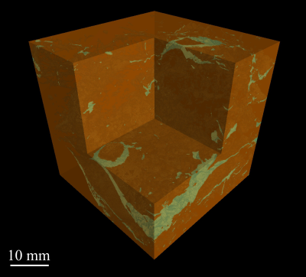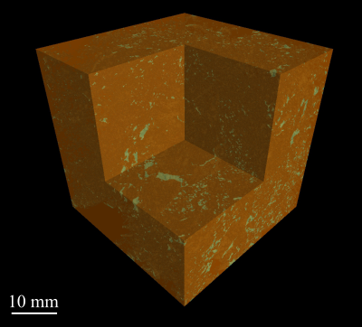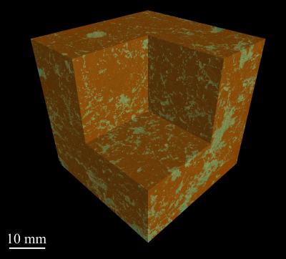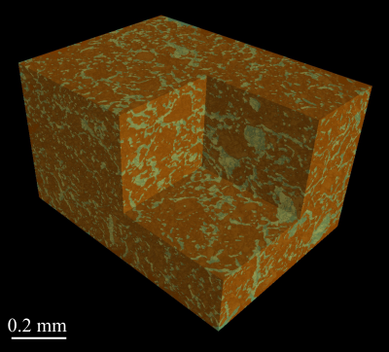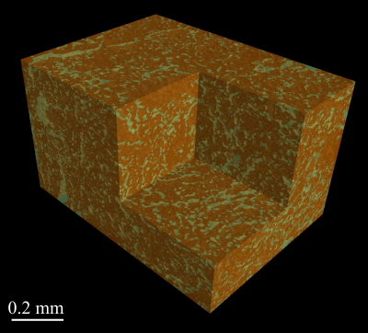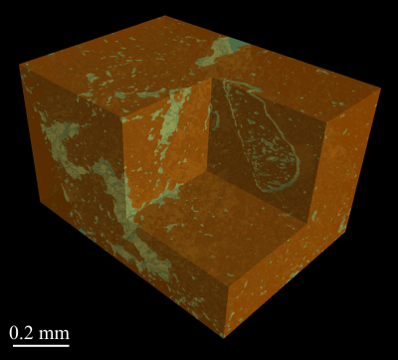
a.
b.
c.
d.
e.
f.
Core
Aggregate
Fallow
Arable
Grassland
10 mm
0.2 mm
Figure 1: 3D representation of clay soils under different cropping systems visualised at core (40 μm resolution; a, c, e) and aggregate (1.5 μm resolution; b, d, f) scales, displayed as thresholded images denoting pore (green) or solid (brown) phases. (a, b) bare fallow; (c.d) arable; (e, f) grassland.
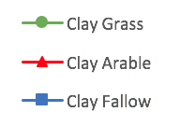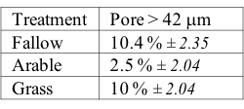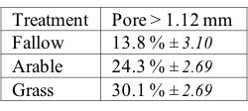
c.
d.
e.
Fallow
Arable
Grassland
b.
a.
Figure 2: Minkowski functions of clay soils under different cropping systems at core (40 μm resolution; a, c) and aggregate (1.5 μm resolution; b, d, e) scales: (a, b) cumulative pore distribution of cores; (c, d) surface density; (e) connectivity. Points show means, whiskers denote pooled s.e.
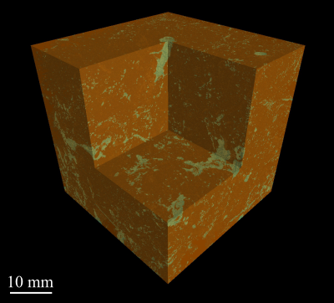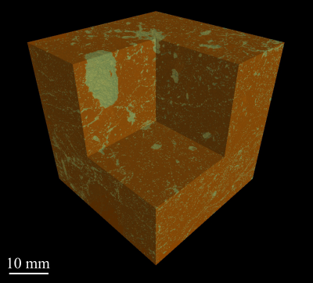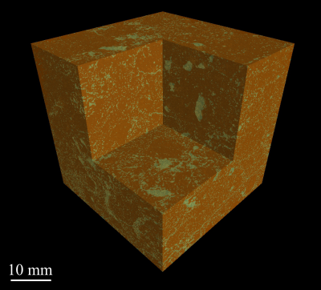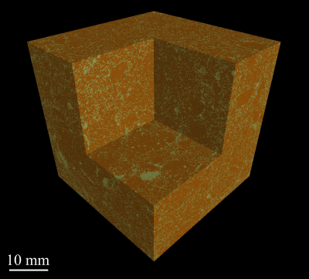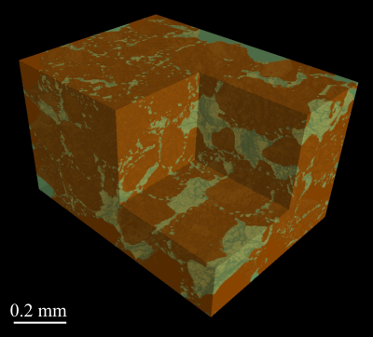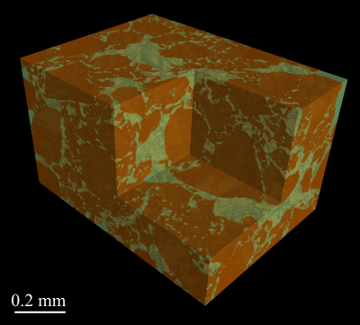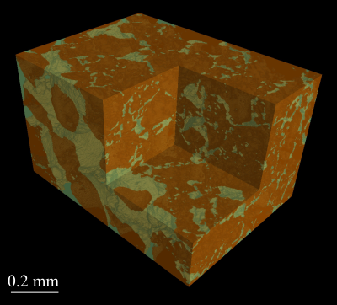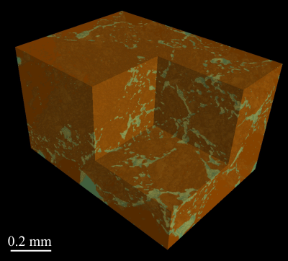Figure 3: 3D representation of sandy soils under different cropping systems visualised at core (40 μm resolution; a, c, e, g) and aggregate (1.5 μm resolution; b, d, f, h) scales, displayed as thresholded images denoting pore (green) or solid (brown) phases. (a, b) bare fallow; (c. d) arable N3; (e, f) arable manure (g, h) grassland.
a.
b.
c.
d.
e.
f.
Core
Aggregate
Fallow
Arable N3
Arable manure
10 mm
0.2 mm
g.
h.
Grassland

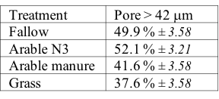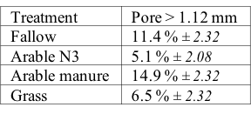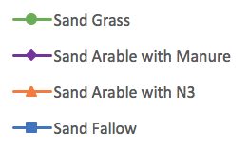
d.
e.
c.
b.
a.
Fallow
Arable N3
Arable manure
Grassland
Figure 4: Minkowski functions of sandy soils under different cropping systems at core (40 μm resolution; a, c) and aggregate (1.5 μm resolution; b, d, e) scales: (a, b) cumulative pore distribution of cores; (c, d) surface density; (e) connectivity. Points show means, whiskers denote pooled s.e.

Tables

Table 1: Summary physical and chemical data of Highfield Ley-Arable experiment soils.
Treatment | Densityª / g cm⁻³ | pHª (H₂O) /  -log(g[H⁺]L⁻¹) | Organic Carbonª / mg g⁻¹ soil | Free Organic Carbon^{b} / µg g⁻¹ soil | Intra-aggregate Organic Carbon^{b} / µg g⁻¹ soil | Nitrogenª / µg g⁻¹ soil | NaOH-EDTA extractable Phosphorus^{c} / µg g⁻¹ soil
Fallow | 1.30-1.45 | 5.1 | 0.8 | 150 | 380 | 100 |  | 235
Arable | 1.30-1.45 | 5.8 | 1.3 | 370 | 490 | 150 |  | 517
Grassland | 0.99 | 6.0 | 3.9 | 4,690 | 3,010 | 390 |  | 662
ªGregory et al., 2016; ^{b}Hirsch et al., 2009; ^{c}Neal et al., 2017

Table 2: Total porosity in relation to management type at the core (base resolution 40 μm) and aggregate (base resolution 1.5 μm) scale of the clay soil, expressed as percentage of pores relative to the total volume (mean ± pooled standard error).
Treatment | n | Core | Aggregate
Fallow | 3 | 8.07 (± 0.76) | 14.3 (± 1.08)
Arable | 4 | 8.29 (± 0.66) | 23.4 (± 0.94)
Grassland | 4 | 12.0 (± 0.66) | 31.1 (± 0.94)
P_{F} |  | 0.53 | <0.001

Table 3: Total porosity in relation to management type (expressed as percentage of pores relative to the total volume), and modelled saturated permeability, of the volume of interest used for modelling, for the clay soil at the core and aggregate scale (mean ± pooled standard error).
Treatment | n | Core |  | Aggregate
Treatment | n | Porosity (%) | Permeability (mm²) | Porosity (%) |  | Permeability (mm²)
Fallow | 3 | 9.3 (± 2.32) | 387 (± 202) | 14.8 (± 1.78) | 0.55 (± 0.09)
Arable | 4 | 12.0 (± 2.01) | 702 (± 175) | 23.0 (± 1.54) | 0.62 (± 0.08)
Grassland | 4 | 16.3 (± 2.01) | 827 (± 175) | 31.0 (± 1.54) | 1.13 (± 0.08)
P_{F} |  | 0.54 | 0.38 | 0.002 | 0.003

Table 4: Linear regression coefficients (mean ± standard error) in relation to management type of log porosity vs. log modelled saturated permeability for the clay soil, at the core and aggregate scale.
Treatment | n | Core |  | Aggregate
Treatment | n | Coefficient | P_{uncorr} | Coefficient | P_{uncorr}
Fallow | 9 | 0.27 (± 0.13) | 0.08 | 0.71 (± 0.24) | 0.02
Arable | 12 | 0.79 (± 0.07) | <0.001 | 0.93 (± 0.14) | <0.001
Grassland | 12 | 1.00 (± 0.15) | <0.001 | 1.38 (± 0.32) | 0.002
Coefficients P_{F} |  | 0.01 |  | 0.30

Table 5: Total porosity in relation to management type at the core (base resolution 40 μm) and aggregate (base resolution 1.5 μm) scale of the sandy soil, expressed as percentage of pores relative to the total volume (mean ± pooled standard error).
Treatment | n | Core | Aggregate
Fallow | 4 | 21.1 (± 0.98) | 23.7 (± 0.68)
Arable N3 | 5 | 19.6 (± 0.87) | 24.4 (± 0.61)
Arable manure | 4 | 14.6 (± 0.98) | 24.8 (± 0.68)
Grassland | 4 | 13.3 (± 0.98) | 25.4 (± 0.68)
P_{F} |  | 0.002 | <0.001

Table 6: Total porosity in relation to management type (expressed as percentage of pores relative to the total volume), and modelled saturated permeability, of the volume of interest used for modelling, for the sandy soil at the core and aggregate scale (mean ± pooled standard error).
Treatment | n | Core |  | Aggregate
Treatment | n | Porosity (%) | Permeability (mm²) | Porosity (%) |  | Permeability (mm²)
Fallow | 4 | 20.9 (± 1.55) | 266 (± 59.0) | 25.0 (± 1.71) | 2.44 (± 0.45)
Arable N3 | 5 | 21.2 (± 1.38) | 406 (± 52.8) | 26.0 (± 1.71) | 2.84 (± 0.45)
Arable manure | 4 | 16.4 (± 1.55) | 501 (± 59.0) | 24.3 (± 1.52) | 1.88 (± 0.40)
Grassland | 4 | 17.0 (± 1.55) | 464 (± 59.0) | 24.6 (± 1.71) | 1.72 (± 0.45)
P_{F} |  | 0.61 | 0.37 | 0.98 | 0.54

Table 7: Linear regression coefficients (mean ± standard error) in relation to management type of log porosity vs. log modelled saturated permeability for the sandy soil, at the core and aggregate scale.
Treatment | n | Core |  | Aggregate
Treatment | n | Coefficient | P_{uncorr} | Coefficient | P_{uncorr}
Fallow | 12 | 0.58 (± 0.25) | 0.04 | 2.69 (± 0.51) | <0.001
Arable N3 | 15 | 0.37 (± 0.18) | 0.06 | 2.08 (± 0.21) | <0.001
Arable manure | 12 | 1.08 (± 0.25) | 0.002 | 1.90 (± 0.20) | <0.001
Grassland | 12 | 0.70 (± 0.22) | 0.01 | 1.37 (± 0.13) | <0.001
P_{F} |  | 0.08 |  | 0.02

