Determinants of optimal insecticide resistance management strategies
Joseph Christopher HELPS^{a*}, Neil D. PAVELEY^{b}, Sacha WHITE^{c}, Frank VAN DEN BOSCH^{d}
ªDepartment of Computational and Systems Biology, Rothamsted Research, Harpenden, Hertfordshire, AL5 2JQ, UK.
^{b}ADAS High Mowthorpe, Duggleby, Malton, North Yorkshire, YO17 8BP, UK.
^{C}ADAS Boxworth, Cambridge, CB23 4NN, UK.
^{d}Department of Environment & Agriculture, Centre for Crop and Disease Management, Curtin University, Bentley 6102, Perth, Australia.
* Corresponding author. E-mail joe.helps@rothamsted.ac.uk. Phone: 01582 938740.

Abstract
The use of insecticides to control agricultural pests has resulted in resistance developing to most known insecticidal modes of action. Strategies by which resistance can be slowed are necessary to prolong the effectiveness of the remaining modes of action. Here we use a flexible mathematical model of resistance evolution to compare four insecticide application strategies: (i) applying one insecticide until failure, then switching to a second insecticide (sequential application), (ii) mixing two insecticides at their full label doses, (iii) rotating (alternating) two insecticides at full label dose, or (iv) mixing two insecticides at a reduced dose (with each mixture component at half the full label dose). The model represents target-site resistance.
Multiple simulations were run representing different insect life-histories and insecticide characteristics. The analysis shows that none of the strategies examined were optimal for all the simulations. The four strategies: reduced dose mixture, label dose mixture, sequential application and label dose rotation, were optimal in 52%, 22%, 20% and 6% of simulations respectively.
The most important trait determining the optimal strategy in a single simulation was whether or not the insect pest underwent sexual reproduction. For asexual insects, sequential application was most frequently the optimal strategy, while a label-dose mixture was rarely optimal. Conversely, for sexual insects a mixture was nearly always the optimal strategy, with reduced dose mixture being optimal twice as frequently as label dose mixture. When sequential application of insecticides is not an option, reduced dose mixture is most frequently the optimal strategy whatever an insect’s reproduction.
Keywords: “insecticide mixtures” “simulation model” “target-site resistance”

Introduction
The development of resistance against chemical insecticides in insects appears to be inevitable, with most arthropod pest species having evolved resistance to at least one insecticide (Tabashnik et al., 2014). Insecticide application strategies that can reduce the speed with which resistance builds up are therefore necessary. Since it is generally recognised that applying a single insecticidal mode of action repeatedly over successive applications will lead to the rapid build-up of resistance against that mode of action, using multiple insecticidal modes of actions is assumed to reduce the rate at which resistance builds up, keeping the insecticides effective for longer. However, the way in which two or more insecticides should be combined for optimum resistance management is not well understood. In this article we explore how best to combine two different insecticide modes of action to ensure their effectiveness for the longest possible time.
Four management strategies are frequently considered as ways to combine multiple insecticides (Bourguet et al., 2013). These are: mixtures, where insecticides are applied simultaneously; alternation of each insecticide in time, frequently termed a rotation; separation of each insecticide in space, often called a spatial mosaic; and applying a single insecticide until it becomes ineffective before switching to a different insecticidal mode of action, termed sequential use.
A variety of studies have been carried out in the past to try and determine which strategy (or strategies) can best prevent the development of resistance, including field studies (e.g. Parker et al. (2006)), laboratory studies (e.g. McKenzie and Byford (1993); Prabhaker et al. (1998)) as well as mathematical modelling (e.g. Argentine et al. (1994); Curtis (1985); Stratonovitch et al. (2014)). A recent review from the REX Consortium (Bourguet et al., 2013) that aimed to synergise the available experimental and theoretical studies in antibiotic, insecticide, herbicide and fungicide resistance research, concluded that mixtures in which each component was used at its full label dose (the registered maximum dose per application, specified on the label) was the optimal resistance management strategy. Indeed, for insecticides, 14 out of 16 studies showed that mixtures were the most effective resistance management strategy. The authors highlighted “multiple intragenerational killing” as the reason for this, also known as redundant killing.
There are two classical explanations for why mixtures of two insecticides, applied at full dose, should reduce the selection rate for resistance: redundant killing, and lowering the dominance of the resistant alleles (Curtis et al., 1978). With two modes of action being used simultaneously against an insect pest, redundant killing posits that individuals resistant to one mode of action would be killed by the other mode of action in the mixture and vice versa, thus reducing the level of resistance in the population. Reducing the dominance, on the other hand, posits that by using a high dose of insecticide, the heterozygote individuals in a population will be killed at as high a rate as the sensitive individuals, thus making the insect functionally recessive, irrespective of the true dominance of the resistance allele. With only resistant homozygote individuals surviving an application of insecticide, these resistant homozygote individuals will mate with the remaining sensitive individuals, again creating heterozygotes which will, again and recurrently, be killed by the high dose of pesticide applied (Curtis et al., 1978).
Despite this insecticide mixtures are not often used. There are several reasons for this. Firstly, that the use of mixtures of insecticides at their label dose increases the amount of active ingredient used compared to rotations of insecticides at their label dose, which leads to control above and beyond what is necessary, and greater environmental impact. Additionally, where the insecticides are targeting different insect species that can be damaging at different times in the crop life cycle, the application of insecticide mixtures at the wrong time would be wasteful. The Insecticide Resistance Action Committee (IRAC) advises that rotating different modes of actions is usually the best strategy (IRAC, 2012), and that if mixtures are to be used they should be used at their registered rates, be of different modes of action with no cross-resistance, have little resistance to either mode of action, and have similar periods of residual insecticidal activity (IRAC, 2012).
Most modelling studies either model a single insect and test for sensitivity in parameters (e.g. Stratonovitch et al. (2014), Argentine et al. (1994)), or start with a default parameterisation and perform a monofactorial parameter search from here (e.g. Curtis (1985)). While this provides insight around the initial parameter values, the parameter space in reality is considerably larger, and interactions between different life-cycle parameters may influence the effectiveness of different management strategies. A more comprehensive overview of the benefit of each management strategy for multiple insect pests requires a model that can test each strategy in a model pest with different life-history structures, genetics of resistance, life-cycle parameter values, and insecticidal traits. Such a model would enable a global sensitivity analysis from which general conclusions can be drawn.
Therefore we present a flexible, deterministic model describing the selection of target-site resistance in an insect pest population, in order to examine what features of an insect-insecticide system lead to different resistance management strategies being optimal. Four resistance management strategies are compared: application of one insecticide until failure, followed by application of the other (sequential application: SA); a mixture of two insecticides at their label dose (a label-dose mixture: LM); rotating two insecticides over a succession of years at their label dose (label-dose rotation: LR); and a mixture of two insecticides at a reduced dose that leads to a similar efficacy as a single insecticide at label dose (reduced-dose mixture: RM).
To gain the greatest insight, we explore this model in two ways. Firstly, a monofactorial search, starting from two initial model parameterisations, in which the insect life-cycle parameters, genetics, reproduction, as well as the effect of the insecticide and the degree of resistance towards the insecticides are all varied. Secondly, a global analysis in which the model structure and parameter values are generated randomly. In all scenarios we are testing whether a SA, LM, LR or RM results in the slowest selection for resistance to the insecticides in each particular realisation. In a farming context, the success of a resistance management strategy can be measured as the ‘effective life’ of a mode of action against a particular pest species. ‘Effective life’ is used here to convert the effect of selection into a practically meaningful output, quantified as the number of years until loss of effective control.
The aim of the paper is to examine whether particular traits, either of an insect’s life cycle or of the insecticide resistance genes, determine which of the four strategies results in the longest effective control of a given insect pest.

Methods
We first describe the simulation model, before describing the approaches used to analyse the model, as well as the model parameterisations for each approach.

2.1 Model

2.1.1 Within-year dynamics
Within each year of a simulation the insect population grows according to the specified insect life history (see below) for 100 days. On day 50 of each year, one or both insecticides are added to the system. Although in field scenarios two or more pesticide applications may be made during a year, for simplicity of the analysis here we only consider one application per year. By making this assumption we ensure that the difference between strategies can be assessed at the end of each year, over a succession of years.

2.1.2. Insect life history
The insect life history is described by one or more systems of equations. The exact structure of the system of equations is determined by the life-history of the insect in question. If the insect pest is holometabolous, then the lifecycle is described by Equations 1-4, which gives the density of each resistance genotype within the egg, larvae, pupae and adult stages ($E_{G}$, $L_{G}$, $P_{G}$, $A_{G}$, respectively). If, on the other hand, the insect is hemimetabolous, then only the larval and adult stages are modelled, as described in Equations 5 and 6.
The system of equations describes the change in the density of each genotype within each stage over time. For a diploid insect pest each stage consists of nine genotypes, whereas for a haploid insect four genotypes are modelled. Each genotype within the adult stage produces eggs (or, if hemimetabolous, larvae or nymphs) at a rate $β_{G}$ dependent on the genotype (a base birth rate affected by a genotype-dependent fitness cost, see below). Note that we refer to the immature mobile stage as larvae irrespective of the pest. The birth rate is dependent on the total density of all stages in the population ($T=E+L+P+A$) so that the population is density dependent, and when the total density of all stages approximates the carrying capacity ($K$) the birth rate approximates to zero. The proportion of births that are of genotype $G$ is given by $p_{G}$, and is described in the reproduction section below. Each stage ($S=E, L, P or A$) transitions to the next stage at a certain rate ($\frac{1}{μ_{S}}$), giving an average lifespan of each stage of $μ_{S}$. Because the stage transition rates are not time-dependent, the insect stages are not discrete in time (this is a necessary simplification to enable comparisons between model simulations, as it allows insecticide to be applied at a fixed time, without missing the target stage in the insect life cycle). In addition, a natural mortality rate ($ω_{S}$) is specified for each stage. Parameter descriptions may be found in the text or in Table 1.
$$\frac{dE_{G}}{dt}=β_{G}{p_{G}A}_{T}{\left(1-\frac{T}{K}\right)}^{+}-\left(\frac{1}{μ_{E}}+ω_{E}\right)E_{G}$$  $$\frac{dL_{G}}{dt}=\frac{1}{μ_{E}}E_{G}-\left(\frac{1}{μ_{L}}+ω_{L}\right)L_{G}-g\left(D_{1},D_{2}\right)L_{G}+η\left(V_{L_{G}}\left(t\right)-L_{G}\right) \\ \frac{dP_{G}}{dt}=\frac{1}{μ_{L}}L_{G}-(\frac{1}{μ_{P}}+ω_{P})P_{G} \\ \frac{dA_{G}}{dt}=\frac{1}{μ_{P}}P_{G}-\left(\frac{1}{μ_{A}}+ω_{A}\right)A_{G}-g\left(D_{1},D_{2}\right)A_{G}+η\left(V_{A_{G}}\left(t\right)-A_{G}\right)+ι\left(κU\left(t\right)θ_{G}-A_{G}\right)$$ | (1-4)

$$\frac{dL_{G}}{dt}=β_{G}p_{G}A_{T}{\left(1-\frac{T}{K}\right)}^{+}-\left(\frac{1}{μ_{L}}+ω_{L}\right)L_{G}-g\left(D_{1},D_{2}\right)L_{G}+η\left(V_{L_{G}}\left(t\right)-L_{G}\right) \\ \frac{dA_{G}}{dt}=\frac{1}{μ_{L}}L_{G}-\left(\frac{1}{μ_{A}}+ω_{A}\right)A_{G}-g\left(D_{1},D_{2}\right)A_{G}+η\left(V_{A_{G}}\left(t\right)-A_{G}\right)+ι\left(κU\left(t\right)θ_{G}-A_{G}\right)$$ | (5-6)
The previously undescribed parameters in the systems of equations above are briefly: the insecticide-induced mortality rate, $g\left(D_{1},D_{2}\right)$; movement from a population within the crop that is not contacted by insecticide, $η\left({V_{S}}_{G}\left(t\right)-S_{G}\right)$; movement of adults from a population outside the crop, $ι\left(κU\left(t\right)θ_{G}-A_{G}\right)$. The details of these model components are described in the sections below.

Reproduction
Reproduction may be asexual or sexual. In either case, the rate of production of new offspring is $β_{G}A_{T}(1-\frac{T}{K})$. These offspring are divided up into the different genotypes by calculating the proportion of offspring that are of genotype $G$, denoted $p_{G}$.
In a pest with asexual reproduction, the proportion of offspring that are of genotype $G$ is simply the frequency of the adult genotype, $A_{G}$ so that $p_{G}=\frac{A_{G}}{A_{T}}$ where, as before, $A_{T}=\sum_{G}{A_{G}}$.
When undergoing sexual reproduction, $p_{G}$ is calculated by incorporating sexual recombination. To do so the proportion of offspring that are genotype $G$ are calculated from the pairing of each possible genotype combination, $p_{G}(G_{i},G_{j})$, where $G_{i}$ and $G_{j}$ are two genotypes of adults. So, for example, consider 3 genotypes for a single locus: SS, SR, RR. The proportion of offspring that are SS, $p_{SS}$, may be calculated by considering the density of each 2-way combination of all adult genotypes. For example, if we consider two adults, $G_{i}=SS$ and $G_{j}=SR$, then 50% of the offspring from this pairing will be genotype SS, such that $p_{SS}\left(SS,SR\right)=0.5$. Similarly, $p_{SR}\left(SS,SR\right)=0.5$ and $p_{RR}\left(SS,SR\right)=0.0$. The proportion of new offspring that are genotype $G$ can therefore be worked out by this proportion and the adult densities. With two loci, the genotypes are instead, for example SSAA, and the combinations between all nine genotypes are calculated.
$$p_{G}=\frac{\sum_{G_{i},G_{j}}{\prod{p_{G}\left(G_{i},G_{j}\right)A_{G_{i}}A_{G_{j}}}}}{A_{T}^{2}}$$ | 7

Haplodiploidy
The above systems of equations (1-4 or 5-6) represent a diploid insect pest population. However, several important insect pests are haplodiploid. In a haplodiploid pest population, males develop from unfertilized eggs and are therefore haploid, while females develop from fertilized eggs and are diploid. To simulate a haplodiploid insect, a second set of Equations 1-4 (or 5-6 if hemimetabolous) is simulated for the haploid males (albeit with only 4 genotypes rather than 9), with the diploid state variables thus representing the females.
Reproduction of a haplodiploid insect population therefore involves recombination between the male and female insects. As with diploid insects, the rate of production of offspring is $\frac{β_{G}}{2}A_{T}(1-\frac{T}{K})$, where $A_{T}=A_{T}^{H}+A_{T}^{D}$, and superscripts $H$ and $D$ refer to the haploid and diploid insects. For simplicity, we assume that half of the offspring are haploid, and half diploid.
For the haploid offspring, the proportion that are genotype $G$, $p_{G}^{H}$, is related to the frequency of the genotype in the diploid population. As with a sexual population, we calculate the proportion of haploid genotypes that come from all diploid genotypes. That is, we calculate $p_{G}^{H}\left(G\right)$ for each diploid genotype, and multiply by the density of that diploid adults.
$p_{G}^{H}=\frac{\sum_{G_{i}}{\prod{p_{G}^{H}\left(G_{i}\right)A_{G_{i}}}}}{A_{T}}$ | 8
For diploid offspring, the calculation is the same as for diploid sexual recombination, except $p_{G}(G_{i},G_{j})$ instead considers recombination between diploid and haploid genotypes, $p_{G}(G_{i}^{D},G_{j}^{H})$.

2.1.3. Insecticide-free populations
The model includes two untreated populations, one within the field, $V(t)$, representing areas of the crop that are unexposed to the insecticide (a within-crop refuge), and one outside the crop representing movement from and to an untreated population, $U(t)$, representing immigration into and emigration from the treated crop (see Figure 1).

Within-crop refuge
The within-crop refuge, $V\left(t\right)$, is simulated by including an additional set of state variables (in an exact duplicate of Equation 1, except that $T_{G}$ includes the density of insects in both the treated and untreated populations), and removing the insecticide-dependent mortality, $g\left(D_{1},D_{2}\right)$, from the untreated population. Both the larvae and adults (the motile stages of the insect life cycle) move between the two populations at rate $η$.

External untreated population
An external untreated population is also included, $U(t)$, with immigration and emigration between the within-field population and the external population. Only the adults are assumed to move between the populations, since these are typically the winged (alate) forms of the insect pest species. The adults move between the two populations at rate $ι$. Unlike for the within-field refuge, the whole population of $U(t)$ is not simulated concurrently with Equations 2-5, but the resistance frequency changes depending on the movement from $A(t)$ into $U(t)$. The density of $U(t)$ within each year is simulated at the start of the simulation, by simulating the insect population from Equations 2-5 with no insecticide applied, and is assumed to be the same every year. We additionally assume that the external population is $κ$ times the size of the treated population, such that if $κ>1$, the untreated population is larger than the treated population and if $κ<1$ the untreated population is smaller than the treated population. The resistance frequency of the untreated population ($θ_{G}$) is changed by the flux of individuals from the treated population and vice versa (Equation 1).
 | $$\frac{{dθ}_{G}}{dt}=\frac{ι\left(A_{G}-U\left(t\right)θ_{G}\right)}{κ}$$ | (1)
Finally, the larvae and adults within the treated population are killed by the dose of insecticide in the system, and the mortality rate is given by $g(D_{1},D_{2})$, described below.

2.1.3 Insecticide dynamics
On day $t_{Spray}$ one or both insecticides are applied at a given dose ($D_{C}$), which then decays at rate $δ_{C}$ over time, where $C$ denotes insecticide 1 or 2 (Equation 6).
 | $$\frac{dD_{C}}{dt}=-δ_{C}D_{C}$$ | (6)
The applied dose of insecticide results in a mortality rate ($δ$) on the insect stages it affects (Figure 2). We have previously shown (Helps et al., 2017) that the mortality rate of a particular genotype due to a single insecticide at dose $D$ may be calculated as $g\left(D\right)=ln⁡(1+{10}^{a_{G}}D^{b_{G}})$, where $a_{G}$ and $b_{G}$ are the genotype specific intercept and gradient of the linear relationship between the log of the insecticide dose and the logit of the mortality, a traditional measure of resistance in the insecticide resistance literature. For two insecticides it follows that $g\left(D_{1},D_{2}\right)=\ln\left(\left(1+{10}^{a_{G,1}}D_{1}^{b_{G,1}}\right)\left(1+{10}^{a_{G,2}}D_{2}^{b_{G,2}}\right)\right)$ (see Supplementary Information 1), where $a_{G,1}$ is the genotype specific intercept for insecticide 1, and likewise for $a_{G,2}$, $b_{G,1}$, and $b_{G,2}$.
The dose of insecticide applied to the insect population is, depending on the strategy, either a label dose or half the label dose. The label dose is found such that the density of the sensitive stages of the insect population within the crop (in both the treated and untreated areas) is reduced by a certain proportion, $ρ$, relative to the population when not sprayed, giving a certain mortality. As the day on which the mortality is greatest varies according to the insecticide parameters, we use the largest mortality found between the day of application and twice the half-life of the insecticide. The mortality is varied when stated, with 90% mortality following a spray being the default value.

2.1.4 Insecticide resistance
In a diploid insect, each target-site resistance gene has three genotypes: $G=SS,SR,RR$, and therefore, when modelling resistance to two insecticides, the total number of genotypes modelled is nine (SS/SS, SS/SR, SS/RR, SR/SS, etc…); in a haplodiploid pest population nine diploid genotypes are modelled together with four haploid genotypes. Each genotype has an intercept ($a$) and gradient ($b$) which, together with the dose of insecticide, are used to calculate the mortality rate (see Insecticide dynamics, above); a lower intercept results in a more resistant genotype (Figure 3). The intercept of both homozygote genotypes for each insecticide is set at the start of the simulation, while the heterozygotes are specified as the weighted average of the homozygotes, determined by the genotypic dominance ($ϕ$) of the resistant allele ($a_{SR}=ϕa_{RR}+\left(1-ϕ\right)a_{SS}$), where $ϕ ϵ (0,1)$ (N.B. this is not phenotypic (or effective) dominance in which the choice of dose would determine whether the mortality of heterozygotes was more similar or dissimilar to the homozygote genotypes, but simply specifies the genotypic intercept of the heterozygote individuals). With a haploid-diploid population, the haploid resistant genotypes ($R$) are assumed to be fully dominant, and therefore have the same intercept as the diploid resistant homozygotes ($RR$). While there is evidence that the resistance tolerance in both diploid and haplodiploid species can vary between sexes (Carrière, 2003), we have not incorporated this in this study.
A fitness cost ($ζ$) is modelled by assuming that resistance reduces the birth rate of the genotype. The fitness cost in the model is therefore specified as a percentage reduction in the birth rate ($β_{RR}=\left(1-ζ\right)β_{SS}$). The same genetic dominance applies here as to the resistance phenotype. That is, $β_{SR}=ϕ(1-ζ)β_{SS}$.

2.1.5 Between-year dynamics
At the end of each year, the proportion of each genotype in the overwintering stage is recorded, and determines the genotype frequencies carried through the overwintering stage into the next year; in the first year the genotype frequencies are determined by the initial frequency of resistance, $RF_{0}$. The in-field insecticide dose, as well as the densities of all insect stages are returned to zero; no insecticide or insect stages are assumed to survive overwinter except in the overwintering stage.

2.2 Analysis
To analyse which strategy performs best the metric used in this paper is the time (in years) until mortality of the insect stage(s) targeted by the insecticide fell below 50% (measured on the fourth day after application), the ‘effective life’, as control decreases over time as resistance builds up (Figure 4). We also considered the time until one of the two resistance genes increased to above 25% (T25); the results of the criteria are similar (see Supplementary Information 2), and so we only present the results for the effective life.
The model was programmed in C++ and simulated using the Dormand-Prince iteration method (Dormand and Prince, 1980).

2.2.1 Approaches
With the model described above we aim to obtain insight into what management strategy – a sequential application (SA) of the two insecticides, a label-dose mixture (LM), a label-dose rotation (LR), or a reduced-dose mixture (RM) – is the optimal strategy to slow the decline in efficacy of the insecticides due to selection for resistance, and whether the optimal strategy for a particular situation depends on the life-history characteristics of the insect in question.
We used three approaches to explore the influence of model processes and parameters on the optimal resistance management strategy:
- Monofactorial analysis with the basic model. We use a simple parameterisation of the model (which we term the basic model, see below for exact description), and alter the model one factor at a time. With each change to the model, the four strategies (SA, LM, LR, and RM) are simulated and compared.
- Monofactorial analysis with the typical model. We parameterised the model for a ‘typical’ insect pest, using parameters for each variable that seem typical of a range of insect pest species. Sources for each parameter may be found in Table 1. We then adjusted each parameter and factor in the model from this parameterisation – each parameter was adjusted up or down by 50% one at a time, and each factor was excluded from the model in turn. In addition, we carried out the monofactorial analysis with a sexual and a haplodiploid population, but keeping the other parameters the same as in the typical model (Supplementary Information 3).
- Global analysis. The global analysis was performed by generating 10,000 realisations of an insect/insecticide interaction, by drawing each parameter (or transform of each parameter, see Table 2 for a list of all parameters included) from a uniform distribution from a range specified in Table 2 (justifications for the ranges given in Supplementary Information 4), and randomly choosing each factor. In order to ensure the combinations were not unrealistic, if the combined parameters gave an unrealistic intrinisic rate of increase (see Table 2 for range) the parameters were drawn again. Each realisation of the model was then run under each strategy (SA, LM, LR and RM) for 200 simulation years. 547 of these realisations were unsuccessful, due to the combination of parameters resulting in a population that could not be controlled to the desired efficacy. The remaining 9453 simulations were then analysed using a multinomial logistic regression model (details in Supplementary Information 2).

2.2.2 Basic model
The “basic” parameterisation of the model consists of a hemimetabolous (only larvae and adults), diploid, asexual insect life-history (equivalent to an asexual aphid population). The two insecticides affect both life-history stages of the insect pest. At the start of the year overwintering insects emerge as larvae, and there is no immigration or emigration, within-field refuge or fitness costs included in the model set-up.
The model is parameterised from Myzus persicae life history parameters in the UK, the values of which can be seen in Table 1.

2.2.3 Typical model
The “typical” model is parameterised similarly to the basic model, with the same life-history parameter values, but with the addition of each of the factors in the model, at parameter values drawn from various literature sources (Table 1). The insect model is hemimetabolous, diploid, and asexual, and includes immigration and emigration, a proportion within the population that is not contacted by the insecticide, and includes fitness costs of resistance.

2.2.4 Global analysis
The global analysis (described above) generated insect populations from parameter distributions (Table 2, more details in Supplementary Information 4). The simulation results (described above) were analysed using multinomial logistic regression to find which parameters, or interactions of parameters, had the largest effect on the categorical variable: the optimal strategy – being the strategy that resulted in the longest effective life. Details of the multinomial logistic regression can be found in Supplementary Information 2.

Results

3.1 Monofactorial parameter search – basic model
When parameterised as the basic model, applying the two insecticides at the same time as a label-dose mixture (LM) resulted in the fastest loss of efficacy with an effective life of 4 years. Sequential application (SA) of the two insecticides and label-dose rotation (LR) were intermediate strategies, with an effective life of 7 years, while a reduced-dose mixture (RM) was the optimal strategy, resulting in an effective life of 9 years (Table 3). The speed with which effective control was lost varied with changes to the reproduction system, the diploidy, adding either the external population or a within-field refuge, including a fitness cost, or making the adults not affected by the insecticide. But all of the alterations to the model still resulted in a LM strategy resulting in the fastest loss of effective control, while a RM resulted in the slowest loss of control. The relative performance of the SA and LR strategies was only different for the inclusion of a fitness cost, which resulted in a LR having a greater effective life than a SA strategy.

3.2 Monofactorial parameter search – typical model
Parameterised with all the factors included in the model, the “typical model” resulted in LM leading to the fastest loss of control, and RM the slowest, with an effective life of 11, 9, 11, and 17 years for the SA, LM, LR and RM strategies respectively (Table 4, the full results of the parameter search can be found in Supplementary Information 3). While decreasing (or increasing) the birth rate or lifespan of the larval stage shortens (or increases) the effective life under each of the application strategies, the rank order of strategies does not change much, with LM being the worst strategy with respect to the effective life, and RM remaining the best strategy, and SA and LR being intermediate strategies. This is consistent with the pattern for most parameters. Only increasing the efficacy of a label dose of insecticide, decreasing the dominance of the resistant alleles (making both resistant alleles more recessive) or including sexual reproduction (either with or without haplodiploid genetics) changed the rank order of strategies. Increased efficacy of both insecticides (such that a label-dose resulted in 99% mortality after a spray) resulted in RM becoming the worst performing strategy and LR the best. Decreased dominance (more recessive resistance genes) resulted in LM becoming the optimal strategy and LR the worst. The addition of sexual reproduction increased the effective life of LM without changing the effective life of the other strategies.
Carrying out the parameter search again, but now including sexual reproduction in the typical model from the start, SA results in the shortest effective control with an effective life of 11 years, while the other strategies result in effective lives of 20, 13, and 21 years for LM, LR and RM respectively (Supplementary Information 3, Table 2). While changing most parameters does not change which strategy is worst (always SA, occasionally equal to LR), the exclusion of immigration to and from an external population does result in LM being the worst strategy. The optimal strategy, however, for each model realisation is either LM or RM, although occasionally LR is also optimal.
When the parameter search was carried out on the typical model with sexual reproduction and haplodiploidy, the results were similar to the typical model with a diploid insect with sexual reproduction (Supplementary Information 3, Table 3). As before, SA is always the worst strategy except in the absence of immigration to or from an external population, and either LM or RM is the best strategy.

3.3 Global analysis
Of the 10000 simulations that began, 2191 did not finish, as it was not possible for the program to calculate a label dose that resulted in the mortality rate at the threshold for ‘effective control’. Of the remaining 7809 simulations, 6362 (81%) finished with effective control having been lost within the time of the simulation for at least three of the strategies, so that the optimal strategy of the four strategies could be calculated. For those strategies for which it was not possible to calculate the optimal strategy, a logistic regression was performed to test for differences between those simulations and those that did have an optimal strategy. The main variables determining whether or not effective control was lost within the time period of the simulation was whether or not the population underwent sexual reproduction (when asexual 7% didn’t lose effective control, versus 24% when sexual) as well as the fitness costs (higher fitness costs meant that effective control was more likely not to be lost).
Of those simulations that resulted in loss of effective control for at least three of the strategies, 49% had the longest effective life by applying two insecticides as a reduced-dose mixture (RM) (Figure 5). A label-dose mixture (LM) and sequential alternation (SA) were each the optimal strategy in 20% and 18% of simulations respectively, while a label-dose rotation was the optimal strategy in only 6% of the simulations. In the other 7% of simulations, the effective life was longest in a combination of two or more of the strategies.
With the 6473 simulations for which there was a single optimal strategy, stepwise model selection resulted in a final multinomial model consisting of 32 factors, parameters, and interaction terms (Supplementary Information 2, Table SI 2.2). The most critical parameter differentiating the strategies was whether or not the insect population reproduced sexually or asexually, with LM, LR and RM being more likely to be optimal in insects with sexual reproduction than in an “average” insect pest, and therefore SA being less likely. Dividing the optimal strategies of all simulations according to the reproduction strategy of the insect pest shows that of the 2160 simulations in which the insect reproduced asexually, SA was the optimal strategy for 51% of the simulations; of the 3769 simulations in which the insect population reproduced sexually, SA was the optimal strategy in only 1.7% of the simulations (Figure 6).
While the other coefficients in the model were less extreme, the next largest coefficients were for sexually reproducing insects, and involved interactions between the efficacy of the insecticides, and the rate of immigration from the external population. Without sexual reproduction the next largest coefficients were the fitness cost of each insecticide resistance gene, which decreased the probability of SA being the optimal strategy for a single realisation compared to the other strategies, and whether or not the insect had a complete life-cycle, which increased the probability of SA being optimal compared to the other strategies.
When, in a practical situation SA is not an option (see Discussion) a reanalysis without including the SA strategy shows that for asexual species RM was in most cases the optimal strategy (in 56% of simulations), followed by LR (43%) and then LM (7%, Figure 7). For sexual species, RM was optimal (in 65% of simulations) followed by LM (57%), while LR was only rarely the optimal strategy out of those considered.

Discussion
The use of multiple insecticide modes of action has often been proposed as a method by which intense selection for resistance might be avoided. However the way in which the insecticides are combined can alter the potential benefit (Roush, 1993). Current guidance recommends using rotations of different insecticidal mode of actions when targeting a single insect pest species with multiple insecticides (EPPO, 2012; IRAC, 2012), and, if using mixtures for resistance management, “each active substance should have a similar and preferably high level of activity against the target in its own right” (EPPO, 2018). Our results for the optimal management of two target-site resistance genes, suggest otherwise. Firstly, it is clear that there is not a single strategy in those we tested that provides the longest effective life for all parameterisations of this model, representing different pest life-cycle characteristics. Secondly, of the four strategies tested in this study, a rotation of two insecticides in alternating years was only rarely the optimal strategy for any given parameterisation of the model, being optimal in only 6% of the simulations run. Furthermore, of the two mixture strategies tested in this study, a mixture of two insecticides at reduced dose was more frequently optimal than mixing two insecticides at their label dose.
Despite many modelling studies carried out through the 1980s and 1990s, a conclusive picture of what application strategy works best to manage resistance has remained elusive. While several studies suggested that mixtures were always best (e.g. Mani (1985), Curtis (1985), Caprio (1998)), others have been equally convinced that alternations, and in particular spatial alternations, have been the best strategy (e.g. Muir (1977), Curtis (1981)). Our study demonstrates that the most crucial determinant of the optimal resistance management strategy is the reproduction mode of the insect. With asexual reproduction, sequential application of the two insecticides resulted in the longest effective control in over 50% of the simulations run. With an insect with sexual reproduction, however, a mixture of the two insecticides is most effective, resulting in the longest effective life in 95% of the simulations with sexual reproduction. Therefore, this study would predict that, of the strategies tested in this paper, a mixture would be best if the insect reproduces sexually, while sequential application may be best if asexual, but with reduced-dose mixtures and rotations being optimal in some cases. We cannot comment using this model on the benefit of spatial mosaics as the model used here was not spatial. It seems likely that whether a spatial mosaic acts more as a mixture or rotation is likely to be highly related the degree of inter-field movement; with high movement insect pests would be exposed to both insecticides, and so a mosaic would function more like a mixture.
The mechanism for sexual reproduction being the main determining trait for which strategy is best at prolonging effective control is not clear from this analysis. However Georghiou and Taylor (1977a) proposed a mechanism for recombination aiding resistance management. They reasoned that when the frequency of resistance is low but increasing, most resistant insects (whether SR or RR) will mate with homozygote sensitive individuals, producing heterozygote individuals and not homozygote resistant individuals. Recombination therefore maintains the resistance allele in heterozygotes, and therefore allows insects to be controlled for longer. We have previously shown that this proposed mechanism does not significantly affect the choice of dose of a single MoA (Helps et al., 2017), since applying a high dose of a single MoA increases the selection for the RR insects whether there is recombination and immigration of sensitive insects or not. However, with multiple MoAs, recombination does allow the ‘heterozygotes’ – in this case insects that are resistant to one insecticide but not the other – to be controlled by the other MoA if present, thereby slowing selection. Therefore, with recombination, mixtures slow selection. Conversely, in an asexual insect, the insecticides select for each resistant genotype at the rate determined by the amount applied, there is no recombination. Consequently, if the insecticides are applied as a label-dose mixture they receive double the amount of insecticide compared to any of the other strategies, and select rapidly for resistance.
Few studies have looked at reducing the dose of a mixture of insecticides, however one that did suggested that a reduced-dose mixture (RM) would virtually double the effective life of each insecticide (Knipling and Klassen, 1984), a finding supported by the results presented here in the analysis of the basic and typical models (Tables 3 and 4). Indeed, for the majority of simulations tested herein, RM was the optimal strategy and considerably extended the effective life. While for a sexually-reproducing insect whether a reduced-dose or label-dose mixture was optimal was dependent on the particular simulation, as Caprio (1998) found, in specific circumstances such as the basic model (even with sexual recombination), a label-dose mixture can result in very rapid loss of effective control. This agrees with the conclusion of Georghiou (1994), who stated that “management by moderation should be the basic approach and should be supplemented to the maximum possible by integrated pest management strategies”.
With an asexual insect, the analysis shows that the optimal strategy is most frequently either applying the two insecticides at a reduced-dose mixture, or applying each insecticide sequentially until they are not effective. However, the sequential application of insecticide may be difficult to achieve in practice, as farmers are unlikely to continue using an insecticide as the efficacy drops if there is an alternate mode of action available. Because of this we additionally asked, if SA was not an option, which of the three other strategies was best (Figure 7). Of those simulations for which SA was the optimal strategy, RM was the optimal for ~50% of them in the absence of SA, LR for ~30%, while only 5% went to LM, with the remaining simulations resulting in a combination of the three strategies being optimal. Therefore, in practical circumstances, RM is even more frequently the optimal strategy than when SA is included.
The analysis of the typical model suggests that the gain in effective life resulting from the inclusion of sexual reproduction is lost if there is no immigration from and to an external population which remains more sensitive than the treated population. This was confirmed with a multinomial regression model looking at the traits that determine whether LM, LR or RM is optimal in a sexually-reproducing insect pest (Table SI 2.3); immigration was by far the most important trait increasing the likelihood of LM being optimal compared to LR or RM, although the efficacy of each insecticide and the interaction between the efficacy of each insecticide were also important determinants. The importance of immigration for a label-dose mixture being an effective control strategy has been found in many studies (Georghiou and Taylor, 1977b; Tabashnik and Croft, 1982), and forms the basis of the high dose-refuge strategy that has been effective in Bt crops (Huang et al., 2011), the theory being, as described above, that susceptible immigrants mate with resistant individuals within the treated population, creating heterozygotes which can then be controlled.
The size of the external untreated population, however, was not a major determinant of the optimal management strategy, suggesting that as long as there is some transfer of insects between a treated population and an untreated population, label-dose mixtures could be effective in a sexual insect population. Presumably in this model the size of the external untreated population was always enough to allow a label-dose mixture to slow the development of resistance. While the presence of an external untreated population seems reasonable, several studies have found that the consequences of management in treated populations can alter the population densities in untreated populations, with subsequent effects on the control of resistance (Adamczyk Jr and Hubbard, 2006; Caprio, 2001; Carrière et al., 2004). These consequences suggest that if high levels of control are applied to treated fields consistently over time, the effect of untreated populations could decline. While our model did not include this possibility, the fact that susceptible and resistant individuals emigrated from the treated population into the untreated population did render the refuges less effective over time.
Perhaps as important as finding out which life-history or insecticide traits are determinants of the optimal resistance management strategy, is being aware which parameters are not. Most notably, the initial frequency of resistance, despite varying across three orders of magnitude, was not an influential factor in determining which strategy might be more important. Additionally, most life-history parameters of the insect pest, such as the lifespan of each stage, the carrying capacity of the population, or the natural mortality rates, were mostly not sufficiently influential to be included in the final regression model. While these traits do affect the rate of selection, they are not material in determining which resistance management strategy will be most appropriate to delay the build-up of resistance.
Other factors that have been thought to have a large effect on the ranking of resistance management strategies are the fitness cost of each resistance gene (having a fitness cost makes rotations more likely to be optimal), the initial frequency of resistance, and the decay rate of the two insecticides (which are thought to need to be similar for mixtures to work). While all of these appear to be true in our global analysis, they are relatively minor in comparison to the relative efficacies of the insecticides. Changing each of these in the basic or typical model did not change the rank-order of success of the strategies, suggesting they are not critical determinants of optimal strategies. While cross-resistance between two insecticides is thought to make mixtures less effective, we have not considered cross-resistance in this analysis since mixtures or rotations of insecticides within the same mode of action group is not recommended.
The results presented herein, as with the many modelling studies in the past, are purely theoretical. Despite attempting to parameterise the model as accurately as possible from literature sources, no experiments have been done to validate the results. While experiments have been carried out in the past looking at the benefits of different resistance management strategies (e.g. Macdonald et al. (1983)), laboratory experiments have been limited by the need to change the dose in order to maintain a viable population for sequential generations (e.g. Abbas et al. (2014); Prabhaker et al. (1998)). Field experiments have tended to produce inconclusive results (e.g. Parker et al. (2006)). However, until experimentally verified, the results presented should be treated with appropriate caution.

Acknowledgements
This work was partly funded by the UK Department for Environment, Food & Rural Affairs and the UK Chemicals Regulation Directorate (project number: PS2722), and the Agriculture and Horticulture Development Board (project number: RD-2012-3780). Rothamsted Research receives support from the Biotechnology and Biological Sciences Research Council (BBSRC) of the United Kingdom.

References
Abbas, N., Khan, H. A. A., Shad, S. A., 2014. Resistance of the house fly Musca domestica (Diptera: Muscidae) to lambda-cyhalothrin: mode of inheritance, realized heritability, and cross-resistance to other insecticides. Ecotoxicology 23, 791-801, doi:10.1007/s10646-014-1217-7.
Adamczyk Jr, J. J., Hubbard, D., 2006. Changes in populations of Heliothis virescens (F.)(Lepidoptera: Noctuidae) and Helicoverpa zea (Boddie)(Lepidoptera: Noctuidae) in the Mississippi Delta from 1986 to 2005 as indicated by adult male pheromone traps.
Argentine, J. A., Clark, J. M., Ferro, D. N., 1994. Computer-simulation of insecticide resistance management strategies for control of colorado potato beetle (Coleoptera, Chrysomelidae). Journal of Agricultural Entomology 11, 137-155.
Bourguet, D., Delmotte, F., Franck, P., Guillemaud, T., Reboud, X., Vacher, C., Walker, A. S., Consortium, R. E. X., 2013. Heterogeneity of selection and the evolution of resistance. Trends in Ecology & Evolution 28, 110-118.
Caprio, M. A., 1998. Evaluating Resistance Management Strategies for Multiple Toxins in the Presence of External Refuges. Journal of Economic Entomology 91, 1021-1031, doi:10.1093/jee/91.5.1021.
Caprio, M. A., 2001. Source-Sink Dynamics Between Transgenic and Non-Transgenic Habitats and Their Role in the Evolution of Resistance. Journal of Economic Entomology 94, 698-705, doi:10.1603/0022-0493-94.3.698.
Carrière, Y., 2003. Haplodiploidy, Sex, and the Evolution of Pesticide Resistance. Journal of Economic Entomology 96, 1626-1640, doi:10.1093/jee/96.6.1626.
Carrière, Y., Dutilleul, P., Ellers-Kirk, C., Pedersen, B., Haller, S., Antilla, L., Dennehy, T. J., Tabashnik, B. E., 2004. Sources, sinks, and the zone of influence of refuges for managing insect resistance to Bt crops. Ecological Applications 14, 1615-1623, doi:10.1890/03-5268.
Curtis, C. F., 1981. Possible methods of inhibiting or reversing the evolution of insecticide resistance in mosquitos. Pesticide Science 12, 557-564, doi:10.1002/ps.2780120513.
Curtis, C. F., 1985. Theoretical models of the use of insecticide mixtures for the management of resistance. Bulletin of Entomological Research 75, 259-265.
Curtis, C. F., Cook, L. M., Wood, R. J., 1978. Selection for and against insecticide resistance and possible methods of inhibiting evolution of resistance in mosquitos. Ecological Entomology 3, 273-287, doi:10.1111/j.1365-2311.1978.tb00928.x.
Dormand, J. R., Prince, P. J., 1980. A family of embedded Runge-Kutta formulae. Journal of Computational and Applied Mathematics 6, 19-26, doi:http://dx.doi.org/10.1016/0771-050X(80)90013-3.
EPPO, 2012. Insecticide co-formulated mixtures. EPPO Bulletin 42, 353-357.
EPPO, 2018. PP 1/306 (1) General principles for the development of co-formulated mixtures of plant protection products. Bulletin OEPP/EPPO Bulletin, Vol. 0, pp. 1-9.
Georghiou, G. P., 1994. Principles of insecticide resistance management. Phytoprotection 75, 51-59.
Georghiou, G. P., Taylor, C. E., 1977a. Genetic and biological influences in evolution of insecticide resistance. Journal of Economic Entomology 70, 319-323.
Georghiou, G. P., Taylor, C. E., 1977b. Operational influences in evolution of insecticide resistance. Journal of Economic Entomology 70, 653-658.
Gould, F., Anderson, A., Jones, A., Sumerford, D., Heckel, D. G., Lopez, J., Micinski, S., Leonard, R., Laster, M., 1997. Initial frequency of alleles for resistance to <em>Bacillus thuringiensis</em> toxins in field populations of <em>Heliothis virescens</em> 94, 3519-3523, doi:10.1073/pnas.94.8.3519 %J Proceedings of the National Academy of Sciences.
Helps, J. C., Paveley, N. D., van den Bosch, F., 2017. Identifying circumstances under which high insecticide dose increases or decreases resistance selection. Journal of Theoretical Biology 428, 153-167, doi:https://doi.org/10.1016/j.jtbi.2017.06.007.
Huang, F., Andow, D. A., Buschman, L. L., 2011. Success of the high-dose/refuge resistance management strategy after 15 years of Bt crop use in North America. Entomologia Experimentalis et Applicata 140, 1-16, doi:10.1111/j.1570-7458.2011.01138.x.
IRAC, 2012. IRAC International Insecticide Mixture Statement. Insecticide Resistance Action Committee, www.irac-online.org.
Knipling, E. F., Klassen, W., 1984. Influence of insecticide use patterns on the development of resistance to insecticides - a theoretical study. Southwestern Entomologist 9, 351-368.
Li, W., Qiu, S.-P., Wu, Y.-J., 2008. Triazophos residues and dissipation rates in wheat crops and soil. Ecotoxicology and Environmental Safety 69, 312-316, doi:https://doi.org/10.1016/j.ecoenv.2006.12.012.
Macdonald, R. S., Surgeoner, G. A., Solomon, K. R., Harris, C. R., 1983. Effect of 4 spray regimes on the development of permethrin and dichlorvos resistance, in the laboratory, by the housefly (Diptera, Muscidae). Journal of Economic Entomology 76, 417-422.
Mani, G. S., 1985. Evolution of resistance in the presence of 2 insecticides. Genetics 109, 761-783.
Martinez-Torres, D., Foster, S. P., Field, L. M., Devonshire, A. L., Williamson, M. S., 1999. A sodium channel point mutation is associated with resistance to DDT and pyrethroid insecticides in the peach-potato aphid, Myzus persicae (Sulzer) (Hemiptera: Aphididae). Insect Molecular Biology 8, 339-346, doi:10.1046/j.1365-2583.1999.83121.x.
McKenzie, C. L., Byford, R. L., 1993. Continuous, alternating, and mixed insecticides affect development of resistance in the horn fly (Diptera, Muscidae). Journal of Economic Entomology 86, 1040-1048.
Muir, D. A., 1977. Genetic aspects of developing resistance of malaria vectors. 2. Gene flow and control pattern. World Health Organization, Geneva.
Parker, W. E., Howard, J. J., Foster, S. P., Denholm, I., 2006. The effect of insecticide application sequences on the control and insecticide resistance status of the peach-potato aphid, Myzus persicae (Hemiptera : Aphididae), on field crops of potato. Pest Management Science 62, 307-315, doi:10.1002/ps.1162.
Prabhaker, N., Toscano, N. C., Henneberry, T. J., 1998. Evaluation of insecticide rotations and mixtures as resistance management strategies for Bemisia argentifolii (Homoptera : Aleyrodidae). Journal of Economic Entomology 91, 820-826.
Roush, R. T., 1993. Occurrence, genetics and management of insecticide resistance. Parasitology Today 9, 174-179, doi:https://doi.org/10.1016/0169-4758(93)90141-2.
Sauvion, N., Rahbé, Y., Peumans, W. J., Damme, E. J. M., Gatehouse, J. A., Gatehouse, A. M. R., 1996. Effects of GNA and other mannose binding lectins on development and fecundity of the peach-potato aphid Myzus persicae 79, 285-293, doi:doi:10.1111/j.1570-7458.1996.tb00836.x.
Stratonovitch, P., Elias, J., Denholm, I., Slater, R., Semenov, M. A., 2014. An Individual-Based Model of the Evolution of Pesticide Resistance in Heterogeneous Environments: Control of Meligethes aeneus Population in Oilseed Rape Crops. PLOS ONE 9, e115631, doi:10.1371/journal.pone.0115631.
Tabashnik, B. E., Croft, B. A., 1982. Managing pesticide resistance in crop-arthropod complexes - interactions between biological and operational factors. Environmental Entomology 11, 1137-1144.
Tabashnik, B. E., Mota-Sanchez, D., Whalon, M. E., Hollingworth, R. M., Carrière, Y., 2014. Defining Terms for Proactive Management of Resistance to Bt Crops and Pesticides. Journal of Economic Entomology 107, 496-507, doi:10.1603/ec13458.

Parameter | Description | Basic model | Typical model | Reference
$$i_{0}$$ | Starting density each year | 0.001 | 0.001 | -
$$β$$ | Birth rate | 1.0 | 1.0 | Sauvion et al. (1996)
$$K$$ | Carrying capacity | 100 | 100 | -
$$\frac{1}{μ_{L}}$$ | Life span of larvae | 7 | 7 | Sauvion et al. (1996)
$$\frac{1}{μ_{A}}$$ | Transition rate from adults to dead insects | 10 | 10 | Sauvion et al. (1996)
$$ω_{L}$$ | Natural mortality rate of larvae | 0.0 | 0.005 | Sauvion et al. (1996)
$$ω_{A}$$ | Natural mortality rate of adults | 0.0 | 0.005 | Sauvion et al. (1996)
$$ι$$ | Movement rate between external untreated population and treated population | 0.0 | 0.01 | -
$$κ$$ | Relative size of external population, U(t), compared to treated population | - | 1.0 | -
$$ϕ$$ | Proportion of crop that is not exposed to the insecticide | 0.0 | 0.01 | -
$$m$$ | Movement rate between treated and untreated areas within the crop | - | 0.1 | -
$$η$$ | Rate of emergence from overwintering population | 1.0 | 0.5 | -
$$RF_{0}$$ | Initial frequency of resistance | 1x10⁻⁵ | 1x10⁻⁵ | Gould et al. (1997)
$$ρ$$ | Mortality (%) of a label dose following a spray (maximum reduction in density)* | 90 | 90 | Personal comm. Chemicals Regulation Division, UK
$$\frac{1}{δ}$$ | Half-life of insecticide (days) | 3.5 | 3.5 | Li et al. (2008)
$$θ$$ | Genetic dominance of the resistance gene | 0.5 | 0.5 | -
$$ζ$$ | Fitness cost. The proportional reduction in the birth rate resulting from having resistance | 0.0 | 0.05 | -
$$a_{SS}$$ | Intercept of SS logit mortality – log dose line | 2.5 | 2.5 | Martinez-Torres et al. (1999)
$$a_{RR}$$ | Intercept of RR logit mortality – log dose line | -0.5 | -0.5 | Martinez-Torres et al. (1999)
$$b$$ | Gradient of every logit mortality – log dose line | 2.0 | 2.0 | Martinez-Torres et al. (1999)
$$t_{Spray}$$ | Time at which insecticide is applied | 50 | 50 | -
Table 1. Parameter descriptions and default values for the basic and typical model.
* To set the mortality following spraying the dose is adjusted with an iterative routine until the mortality is within an acceptable threshold (⁺⁄₋ 1e-5).
Factor | Scale | Elements
Reproduction and diploidy | Factor | Diploid, sexual | Diploid, asexual |  | Haplodiploid, sexual
Life cycle | Factor | Holometabolous |  | Hemimetabolous
Untreated stage | Factor | False |  | True
Parameter | Scale | Lower limit |  | Upper limit
Birth rate | Uniform | 1.0 |  | 20.0
Lifespan (all stages) | Uniform | 2 |  | 60
Mortality (all stages) | Uniform | 5% |  | 90%
Intrinsic rate of increaseª |  | 0.05 |  | 0.5
Carrying capacity | Uniform | 10 |  | 10000
Proportion of crop unexposed | Uniform | 0 |  | 0.33
Movement rate between treated and untreated populations | Uniform | 0 |  | 0.02
Untreated population size | Uniform | 0.0 |  | 10.0
Initial frequency of resistance | Power (10^{x}) | 10⁻⁷ |  | 10⁻⁴
Immigration and emigration rate | Uniform | 0.1 |  | 2.0
Emergence rate | Power (10^{x}) | 10⁻² |  | 10⁻¹
Dominance of each resistance gene | Uniform | 0.0 |  | 1.0
Gradient of each resistance gene | Uniform | 0.5 |  | 6.0
Resistance ratio | Uniform | 10 |  | 1000
Insecticide half-life | Uniform | 1 |  | 10
Fitness cost of each resistance gene (%) | Uniform | 0.0 |  | 10.0
Table 2. Parameter ranges for the global parameter search. Random parameters were chosen uniformly between the values shown, except for emergence rate and initial resistance frequency, where the exponent was chosen uniformly.
ª The intrinsic rate of increase was not randomly generated, but if the biological parameters did not result in a rate of increase within the range shown, the parameters were redrawn.
 | Parameter value | Effective life
 | Parameter value | SA | LM | LR | RM
Basic model |  | 7 | 4 | 7 | 9
+ Sexual | - | 7 | 4 | 7 | 9
+ Haplodiploid | - | 7 | 5 | 7 | 11
+ Immigration | 0.01 | 9 | 6 | 9 | 13
+ Within-field refuge | 0.1 | 9 | 6 | 9 | 12
+ Fitness cost | 10% | 10 | 5 | 11 | 19
+ Unaffected larvae | - | 11 | 9 | 11 | 12
Table 3. The effective life under each application strategy in the basic model (top row), and when each model factor is included one at a time. Where including a model factor involves a continuous parameter, the value from the typical model is used.
 | Default value | New value | Effective life
 |  |  | SA | LM | LR | RM
Typical model | - | - | 11 | 9 | 11 | 17
Parameters
Birth rate + | 1 | 2 | 7 | 6 | 7 | 9
Carrying capacity + | 100 | 200 | 12 | 10 | 13 | 20
Larval mortality rate + | 0.01 | 0.02 | 11 | 9 | 13 | 18
Adult mortality rate + | 0.01 | 0.02 | 11 | 9 | 13 | 18
Larval lifespan + | 7 | 14 | 18 | 14 | 21 | 33
Adult lifespan + | 10 | 20 | 9 | 8 | 9 | 13
Resistance ratio + | 32 | 64 | 11 | 8 | 11 | 17
Dominance + | 0.5 | 0.75 | 11 | 9 | 13 | 20
Insecticide half-life + | 3.5 | 5.25 | 11 | 8 | 11 | 17
Efficacy + | 0.9 | 0.99 | 29 | 17 | 45 | 10
External population size + | 1 | 2.0 | 11 | 9 | 13 | 18
Movement rate + | 0.1 | 0.2 | 11 | 9 | 12 | 17
Immigration rate + | 0.01 | 0.02 | 12 | 10 | 13 | 18
Initial resistance frequency + | 1x10⁻⁵ | 5x10⁻⁵ | 10 | 8 | 11 | 16
Proportion of crop untreated + | 0.01 | 0.02 | 11 | 9 | 13 | 17
Fitness cost + | 0.05 | 0.075 | 13 | 12 | 19 | 30
Model alteration
Haplodiploid genetics | - | - | 12 | 26 | 17 | 19
Sexual reproduction | - | - | 11 | 20 | 13 | 21
No immigration | - | - | 10 | 6 | 9 | 15
No untreated crop | - | - | 11 | 8 | 11 | 18
No fitness cost | - | - | 9 | 7 | 9 | 12
Unaffected larvae | - | - | 37 | 33 | 67 | >100
Table 4. The change in the effective life using the typical model (top row), and subsequently when each parameter or factor is altered in the typical model from the default value to the new value.

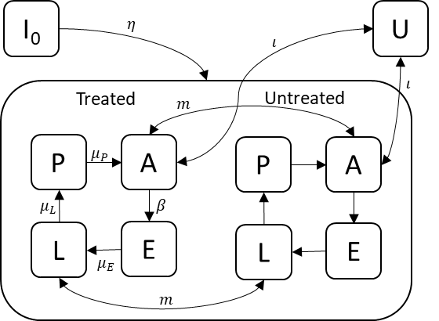
Figure 1. Within-season dynamics in the model. After overwintering, insects emerge (I₀), and transition between life-cycle stages: eggs (E); larvae (L); pupae (P); and adults (A), with the average lifespan of each stage being $1/μ_{S}$, where $S$ is the letter of each stage. Natural mortality of each stage at rate $ω_{S}$ is included, but not shown here. Some proportion ($ϕ$) of the crop is untreated, and the insects in the untreated crop are modelled as a discrete population, with movement of the adult and larval stages between the treated and untreated populations at rate $m$. Immigration and emigration of adults occurs between the crop and an external population (U) at rate $ι$.
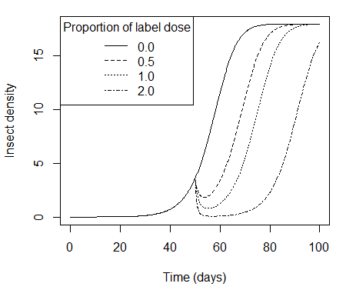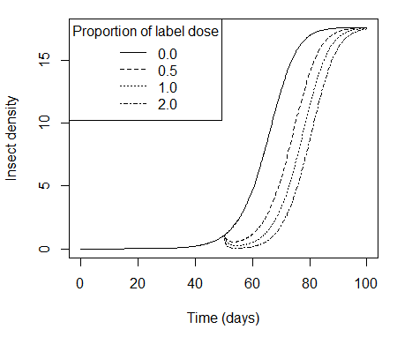
Figure 2. The density of an insect population (larvae + adults) modelled by the basic model (left) and the typical model (right), and treated with different doses of a single insecticide on day 50. A single label dose is specified to achieve 90% mortality in the days following application. Different spray applications result in different achieved mortalities.
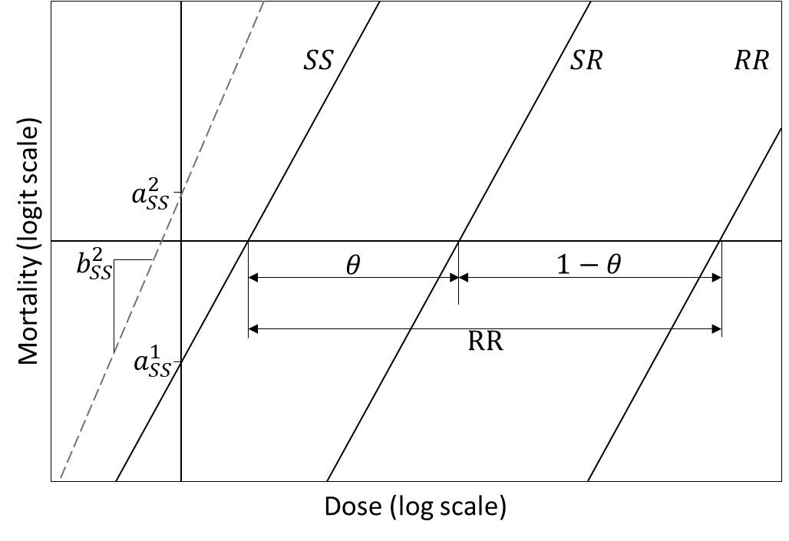
Figure 3. The mortality rate of each genotype by a certain dose of insecticide is modelled by a linear relationship between the mortality on a logit scale and dose on a log scale. One target-site resistance gene has three genotypes in a diploid insect (SS, SR, RR), each of which has an intercept ($a_{G}^{C}$) and gradient ($b_{G}^{C}$) specifying the linear relationship for each insecticide (C). The three solid lines show an example of the dose-response lines for three genotypes to insecticide 1, while the dashed line shows the dose-response line for the SS genotype to insecticide 2. The ratio between the x-intercept of RR to SS determines the resistance ratio (RR), while $θ$ specifies the genotypic dominance, and therefore the intercept of the heterozygote (SR).
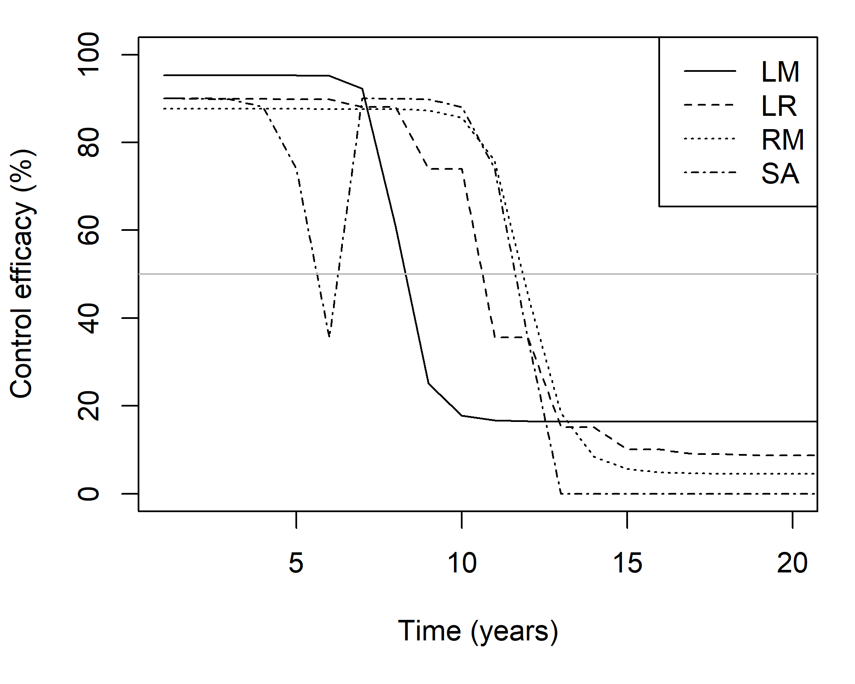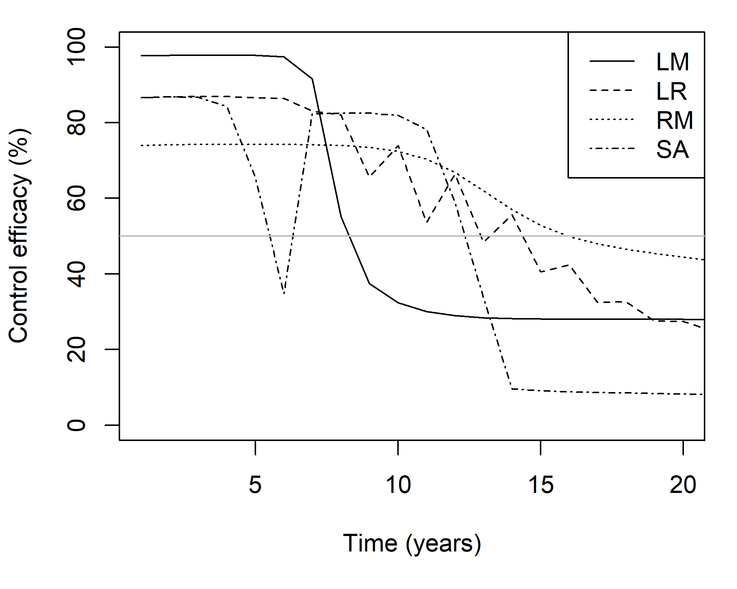
Figure 4. The % control four days after a spray application, when each strategy is applied on the basic model (left), or the typical model (right).
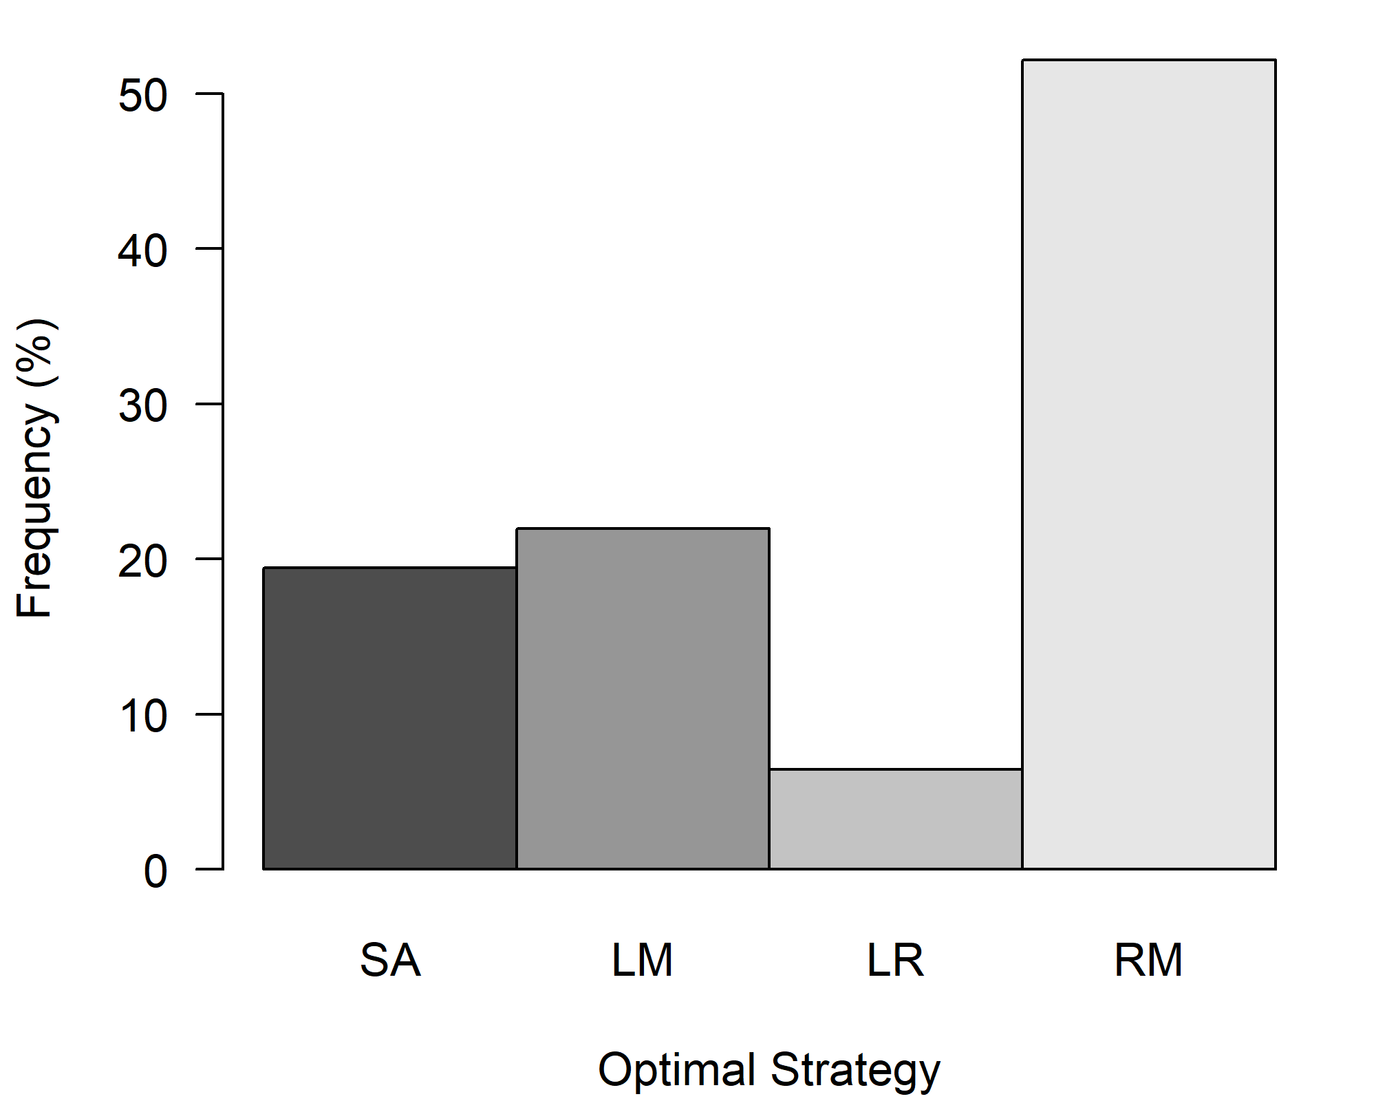
Figure 5. Frequency distribution of the optimal application strategy of each simulation, where the optimal strategy was that which gave the longest effective life from those strategies tested. The strategies are: sequential application of each insecticide until failure (SA), a mixture with each MoA at label dose (LM), a rotation with each MoA at label-dose (LR); a mixture with each MoA at a reduced dose (RM). Simulations where the effective life was the same for two or more strategies are not shown (< 7% of all simulations).
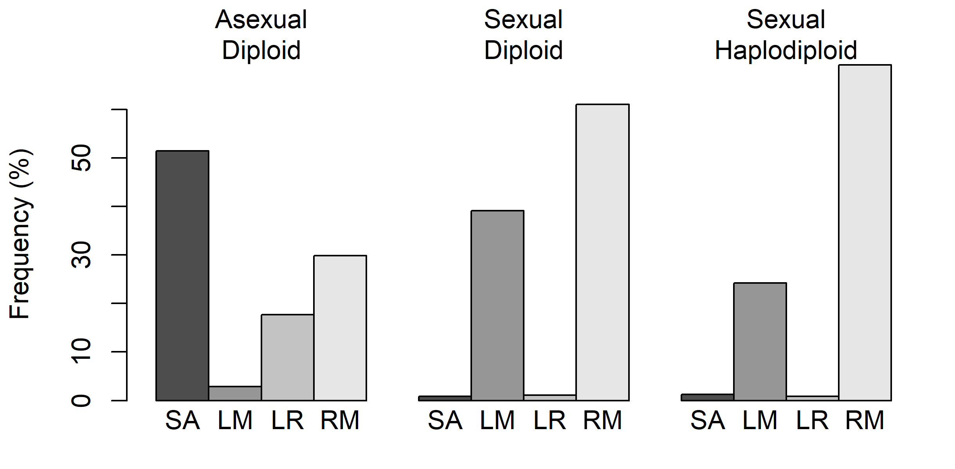
Figure 6. Frequency distribution of the optimal application strategy of each simulation, divided into asexual / sexual, and diploid / haplodiploid. As before the strategies are sequential application of each insecticide until failure (SA), a mixture with each MoA at label dose (LM), a rotation with each MoA at label dose (LR), and a mixture with each MoA at reduced dose (RM).
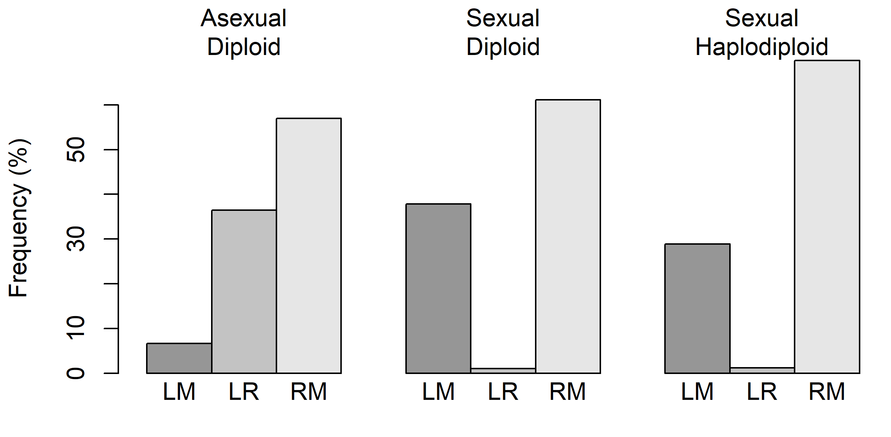
Figure 7. Frequency distribution of the optimal application strategy – out of only three of the four strategies considered in this paper (a mixture of each MoA at label dose (LM), a rotation with each MoA at label dose (LR), and a mixture with each MoA at reduced dose (RM)) – in simulations in which the insect pest is asexual.

