SUPPORTING INFORMATION II
Disease yield relationships.
Estimation of the disease free yield and yield loss coefficient: For each year yield was plotted as function of STB severity for all fungicide treatments. A linear relationship between yield and disease severity was fitted to the data
$Y= Y_{0}(1-L S)$
where Y is the yield, S, is the disease severity, Y₀, is the disease-free yield, and L is the yield loss coefficient.
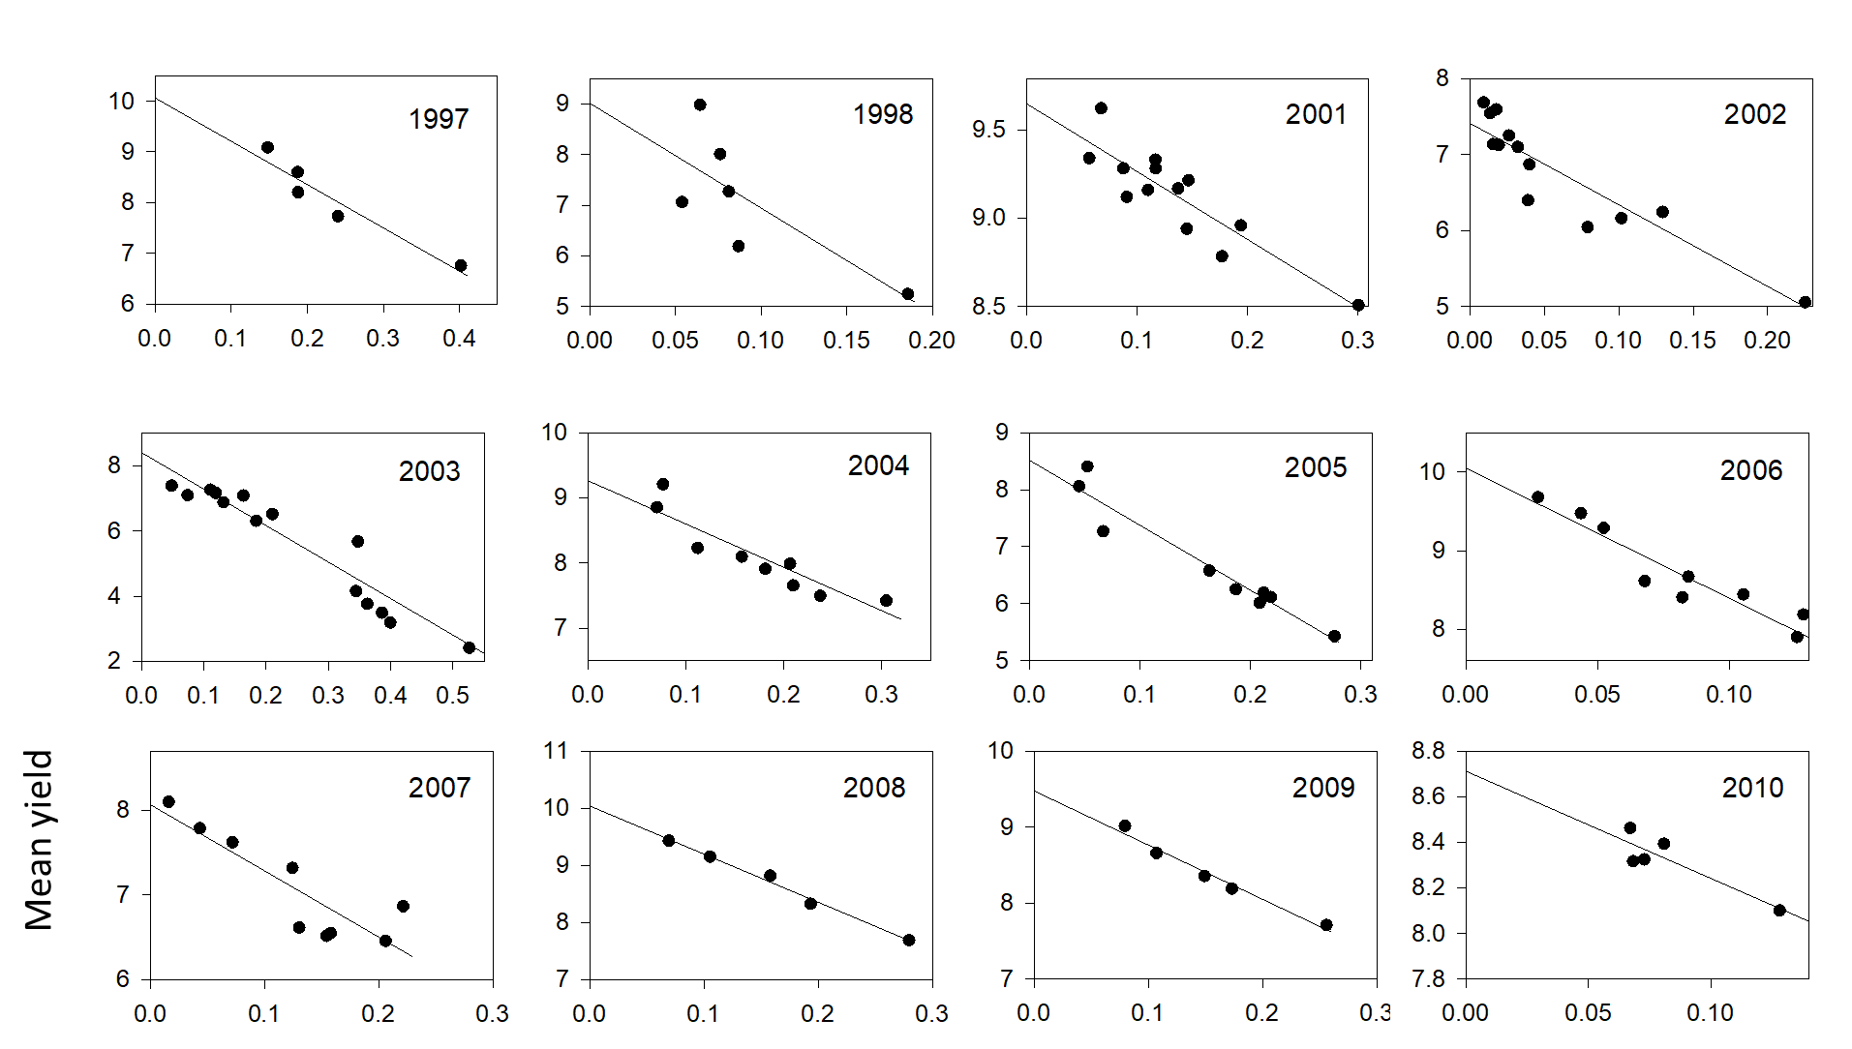
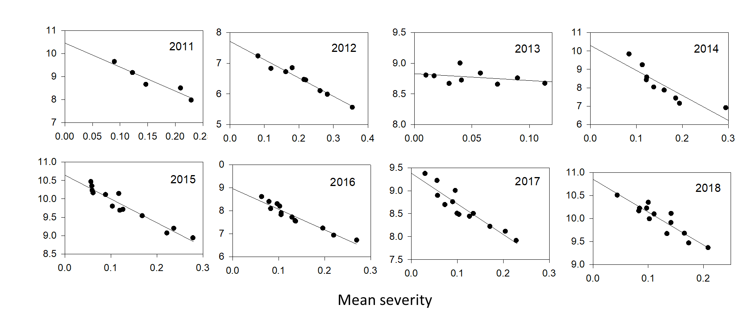

year | Max yield | Yield loss coeff L
1997 | 10.06 | 0.85
1998 | 9.01 | 2.29
2001 | 9.65 | 0.39
2002 | 7.41 | 1.46
2003 | 8.40 | 1.33
2004 | 9.26 | 0.72
2005 | 8.52 | 1.34
2006 | 10.05 | 1.65
2007 | 8.07 | 0.97
2008 | 10.04 | 0.84
2009 | 9.48 | 0.75
2010 | 8.71 | 0.54
2011 | 10.46 | 0.99
2012 | 7.71 | 0.78
2013 | 8.83 | 0.12
2014 | 10.30 | 1.32
2015 | 10.64 | 0.61
2016 | 8.96 | 1.00
2017 | 9.38 | 0.71
2018 | 10.85 | 0.65

The relationship between Y0 and L was investigated. The below figure shows the results. I linear regression analysis shows that there is no correlation between mean yield and the yield loss coefficient. The slope of the estimated relationship was -0.0832 with a standard deviation of 0.1163.

