Relationship between soil carbon sequestration and the ability of soil aggregates to transport dissolved oxygen
Xiaoxian Zhang¹, Andrew S. Gregory¹, Andrew L. Neal², Aurelie Bacq-Labreuil³,
Sacha J. Mooney³ John W Crawford⁴
¹ Department of Sustainable Agricultural Sciences, Rothamsted Research, Harpenden, AL5 2JQ, UK.
² Sustainable Agriculture Sciences, Rothamsted Research, North Wyke, EX20 2SB, UK
³ Division of Agriculture & Environmental Sciences, School of Biosciences, University of Nottingham, Sutton Bonington Campus, Leicestershire LE12 5RD, UK.
⁴ Adam Smith Business School, University of Glasgow, West Quadrangle, Glasgow. G12 8QQ. UK

Abstract
A key finding in soil carbon studies over the past decade is that soil organic carbon (SOC) stabilization is not controlled by its molecular complexity and clay content but by its physicochemical protections including occlusion in aggregates and sorption/precipitation with organo-mineral associations. The organo-mineral complexes and the adsorbed SOC could be dissolved microbially under anoxic conditions, which is an important pathway in the carbon cycle but has been overlooked by most carbon models. As it is reported that organo-mineral associations are formed in aerobic conditions and could be lost under anaerobic conditions, there should be a positive correlation between SOC and ability of the aggregates to transport dissolved oxygen. We test this using two long-term experiments with a SOC gradient at Rothamsted Research in the UK: One experiment compares the effects of different fertilizations on yield of winter wheat and the other experiment aims to study the consequence of cropping system change for SOC dynamics. Aggregates in samples taken from plots under different treatments on the two experiments were scanned using X-ray computed tomography at 1.5 μm resolution; the ability of each aggregate to transport oxygen was calculated based on the pore-scale lattice Boltzmann simulation assuming that the aggregate is saturated as this is the most anaerobic scenario. We compared porosity and diffusion coefficient of all aggregates and link them to soil carbon measured from different treatments on the two experiments. The results showed that the agronomic practice changes occurring 67 and 172 years ago substantially reshaped the intra-aggregate structure, and that the accrual of SOC is positively correlated with diffusion coefficient of the aggregates to transport oxygen. However, the diffusion coefficient increases with SOC asymptotically, plateauing when SOC exceeds a threshold value. We also found that diffusion coefficient of the aggregates in cropped soils chemically fertilized trended with their porosity approximately in the same way, deviating from those for other non-cropped treatments.

Key words: Rothamsted long-term experiments; soil organic carbon; aggregates, transport properties; pore-scale simulation.
- Introduction
Hydrological and biogeochemical functions of terrestrial ecosystems are modulated by their hierarchically structured soils (Young and Crawford 2004). Although the feedbacks between soil structure and biogeochemical reactions have been well documented (Rabotet al. 2018; Young and Crawford 2004), the underlying mechanisms are not well understood due to the opaque nature of the soils (Baveyeet al. 2018). Application of imaging technologies over the past decades has helped break this barrier, finding, for example, exoenzymes are not uniformly distributed but clustered around a specific range of pores (Guberet al. 2018; Kraychenkoet al. 2019; Lucaset al. 2020). As enzymes diffusion in soil is slow (Boudreauet al. 2008; Rothman and Forney 2007), these findings indicate that soil organic matter (SOM) decomposition is limited to the regions proximal to these pores, which has important implications for soil carbon modelling (Chenuet al. 2019; Poultonet al. 2018; Soussanaet al. 2019; Sykeset al. 2020; van Groenigenet al. 2017). This is also corroborated by recent findings that soil carbon depends only weakly on clay content but is significantly correlated with Fe and Al across a wide range of ecosystems (Rasmussenet al. 2018).
SOM retained in soil is the consequence of a multitude of interactive physicochemical and biological processes mediated by soil structure (Sixet al. 2002). Since a large fraction of soil pores are devoid of microbes and SOM (Liet al. 2018; Nunanet al. 2003), carbon metabolization is controlled by its accessibility to microbes rather than by its chemical complexity as biogeochemical reactions can proceed only at sites with microbes and substrates coexisting (Dungaitet al. 2012; Lehmann and Kleber 2015; Schmidtet al. 2011; Sulmanet al. 2014). This implicates that using effective reaction rates by averaging the microscopic processes out, as being used in most pool-based models, is inadequate to describe the volumetric-average biogeochemical reactions (Chakrawalet al. 2020; Manzoniet al. 2012), and much improved models are needed in order to reduce the uncertainties associated with prediction of the feedbacks between SOM and climate change (Lehmannet al. 2020; Schmidtet al. 2011). One such approach is the reactive continuum model by representing the decay rate of the chemically and spatially heterogeneous SOM as a random number described, for example, by a gamma or a logarithm-normal distribution function (Bolkeret al. 1998; Rothman and Forney 2007).
Both pool-based and reactive continuum models oversimplify the extremely complex system with the aim of predicting long-term soil organic carbon (SOC) change. They describe the combined impact of climatic and edaphic factors collectively using a moisture function and a temperature function assuming the impacts of soil water and temperature are multiplicative (Davidsonet al. 2006; Davidsonet al. 2012; Moyanoet al. 2013; Skoppet al. 1990). They do not however explicitly consider constraints of nutrients and soil structure, despite the consensus that a change in soil structure reshapes soil physicochemical environments, thereby altering the reactivity continuum (Baldock and Skjemstad 2000) and resulting in uncertainties in prediction of the feedbacks between soil carbon and climate change (Luoet al. 2016). Improving SOM modelling thus requires a better understanding of the underlying mechanisms (Luoet al. 2020; Smithet al. 2020), and one way is to adequately incorporate the microscopic processes into macroscale models for soil biogeochemical processes (Ebrahimi and Or 2016; Ghezzeheiet al. 2019; Yanet al. 2018).
A key finding in studies over the past two decades is that SOM persistence in soil is not controlled by its chemical complexity but by its protection by the heterogeneous soil physicochemical environments (Schmidtet al. 2011; Yuet al. 2017). It has been found that large and complex macromolecules recalcitrant to microbial decomposition only account for a small fraction of SOM and that majority of stable SOM in soil are small molecules occulated in aggregates and sorbed by metal oxides, especially iron and manganese oxides (Jones and Singh 2014; Kogel-Knabneret al. 2008; Sutton and Sposito 2005; von Lutzowet al. 2006). Organo-mineral complexities are normally formed under aerobic conditions (Chenet al. 2020; Yuanet al. 2020), and they could be dissolved microbially when the soils become anaerobic (Knorr 2013; Zhaoet al. 2017). This is an important pathway in carbon cycling and has significant implications for long-term stability of SOM (Hemingwayet al. 2019). It also contradicts the traditional view in pool-based models that oxygen limitation suppresses SOM decomposition due to the kinetic and thermodynamic constraints on microbial metabolism (Freemanet al. 2001; Huanget al. 2020; LaRowe and Van Cappellen 2011). Increasing evidence over the past few years has shown that, while anaerobic conditions supress decomposition of organic litter (Zhaoet al. 2020), microbial dissimilatory reduction could dissolve the organo-mineral associations and mobilize the older carbons as a result (Chenet al. 2020; Knorr 2013). When soil becomes aerobic, such carbon can be quickly oxidized microbially and increase greenhouse gases emission as a result (Chenet al. 2020; Wanget al. 2017).
The effects of oxygen limitation on SOM in wetlands and marine sediments have been well documented (Arndtet al. 2013; Freemanet al. 2001), but it is less known that anoxia is also prevalent in uplands due to the hierarchical structure of soils (Keiluweitet al. 2016). For example, it was found in a tropical upland soil that carbon mobilised from iron oxide dissolution following microbially-mediated reduction accounted for more than 40% of total oxidized carbon (Dubinskyet al. 2010). Even in partly saturated rhizosphere, an increase in microbial consumption of oxygen could make the rhizosphere increasingly anoxic, dissolving the organo-mineral complexes (Keiluweitet al. 2015). Therefore, there is a trade-off between aerobic and anaerobic conditions in their impact on SOM. The imbalance between microbial consumption of oxygen and the limited ability of soil to dissolve and transport oxygen could lead to prevalent development of anoxic spots, particularly inside soil aggregates. This could have a profound consequence for SOM dynamics (Hall and Silver 2015; Huanget al. 2020; Keiluweitet al. 2016; Nealet al. 2020; Sexstoneet al. 1985), and has been postulated one of mechanisms underlying the surprising acceleration of N₂O emissions over the last 10 years (Harriset al. 2021).
Organo-mineral associations are formed under aerobic conditions and are the dominant carbon stock in some systems (Chenet al. 2020; DeGryzeet al. 2004). We hence conjecture that there should be a positive correlation between stable SOM and the ability of soil aggregates to transport oxygen as long-term stabilization of the organ-mineral complexities needs the aggregates to be more aerobic. Testing this, however, needs long-term experiments with SOM gradients as carbon stabilization in soil is a slow process and could take centuries to reach new equilibria following agronomic practice changes (Poultonet al. 2018; Totscheet al. 2018).
The long-term experiments at Rothamsted Research in the UK provide a unique resource to address these questions as they have naturally generated a carbon gradient over the past 170 years. In this paper, we calculate the relationship between soil organic carbon (SOC) and ability of the aggregates to transport dissolved oxygen based on two long-term experiments: the Broadbalk Winter Wheat experiment established in 1843 to test the effects of different fertilizations on the yield of winter wheat, and the Highfield Ley-Arable experiment established in 1948 to examine the consequence of management conversion on soil functions. Aggregates in soil samples taken from plots under different treatments on the two experiments were scanned using X-ray computed tomography, and effective diffusion coefficient of dissolved oxygen in each aggregate was calculated based on pore-scale simulations assuming that the aggregate was saturated as this is the most anoxic condition. We then compared how the agricultural management and fertilization changes made 67 and 172 years ago respectively reshaped the intra-aggregate structure and its consequence for SOC preservation.
- Materials and methods
  - The long-term experiments
The experiments, established from the 1840s onwards, at Rothamsted Research in the UK are the longest-running agricultural experiments in the world that are still in operation. Details of all experiments are available online at the Electronic Rothamsted Archive (e-RA) website (http://www.era.rothamsted.ac.uk). We focussed on two experiments. Soil type and texture on the two experiments are the same, being predominantly clay loam and classified as Chromic Luvisol (FAO classification). The mean annual rainfall and temperature on the two sites are 701 mm and 10.1 °C respectively. The top 0-23 cm soil contains 25% sand, 50% silt and 25% clay, and their density was 2.56 g/cm³ (Gregoryet al. 2010). We used data of soil organic carbon from e-RA.
2.1.1 The Broadbalk Winter Wheat experiment
The Broadbalk Winter Wheat experiment started in 1843 (Latitude 51° 48’ 34.44” N; Longitude 0° 21’ 22.76” W) aiming to compare the impact of different chemical fertilizations and farmyard manure on the yield of winter wheat, with an unfertilized treatment as a control. There have been a few changes since its inception to represent the changes to farming in the UK, and further details are available in the literature (Blairet al. 2006; Wattset al. 2006) and online via the above link. The supplementary materials depict the site layout and fertilization history. In brief, the initial arrangement of the experiment was in 19 strips with each associated with a specific fertilization; a small part on the west edge of the site was taken out of cultivation in 1882 and has since returned to woodland (Broadbalk ‘Wilderness’). The pH is controlled by liming to stay at 7-7.5.
Soil samples were taken from four plots. One plot is applied with farmyard manure since 1843 at an annual rate of 35 t/ha (referred as to FYM hereafter); one plot is applied with inorganic fertilizers (144 kg/ha nitrogen, 35 kg/ha phosphorus, 90 kg/ha potassium and 12 kg/ha magnesium, annually) since 1852 (referred as to N3 hereafter); one plot fertilized annually with 192 kg/ha of N (96 kg/ha of N 1906–2000), 90 kg/ha of K and 12 kg/ha Mg since 1906 but without P (referred as to No P hereafter); one plot is a control without any kind of fertilization since 1843 (CK). All plots are tilled conventionally. Samples were taken from each plot, as well as the Wilderness woodland (referred as to woodland hereafter).
2.1.2. The Highfield Ley-Arable experiment
The Highfield Ley-Arable experiment is approximately 500 m south of the Broadbalk experiment, and the site had been under permanent grass at least since 1838. It was established in 1948 to examine the impact of land management on soil carbon and ecological yield (Gregoryet al. 2016). There are six ley-arable treatments, comprising treatments under permanent grass, permanent arable and ley-arable treatments, each in a 7 m × 50 m plot, arranged in a randomly designed block (with four blocks). After a ploughing in 1959, a plot of land of approximately 900 m² on the edge of the site has remained permanent bare fallow since by mouldboard ploughing and cultivating annually the top 23 cm of soil 2-4 times annually. Detailed description of the experiment was available online via the above link and in the literature (Gregoryet al. 2016; Jensenet al. 2019; Redmile-Gordonet al. 2020). The treatments we studied are the permanent grass (predominantly rye grass, Lolium perenne L.), continuous arable (winter wheat, Triticum aestivum L.) and bare fallow.
  - Soil imaging
Triplicate soil cores each 12 cm high and 6.8 cm in diameter were taken in October 2015 from the above plots on the two experiments. Following a pre-treatment and x-ray imaging, each core was manually broken and passed through sieves by horizontally shaking. Three aggregates were randomly selected from those retained in the sieves and they were then scanned at resolution of 1.5 μm using the Phoenix Nanotom® (GE Measurement and Control solution, Wunstorf, Germany) under 90 kV and 65 μA.
Each image was reconstructed first and then analysed using the Image J, in which a region of interest (ROI) was cropped out for ease of analysis. As the aggregates were geometrically irregular, the ROI taken from all aggregates was cuboid consisting of 400 x 480 x 650 voxels. The ROIs were segmented using the threshold method presented in Vogel and Kretzschmar (1996), and details of the imaging processing were given previously (Bacq-Labreuilet al. 2018).
  - Pore-scale simulations
The ability of the aggregate to transport oxygen was calculated numerically by mimicking oxygen movement in the pore space. Considering that the aggregate is mostly anaerobic under saturated condition, we simulated oxygen diffusion assuming the pore scale in each aggregate was filled fully by water. We acknowledged that we do not have information on pores smaller than 1.5 μm in the aggregates due to the limitation of the voxel size. In terms of microbial activities, pores smaller than 1.5 μm are not accessible to microbes (or are severely limited) and their role in microbial reductions is hence insignificant as microbial reduction can proceed only at sites with coexistence of cells and substrates. Furthermore, as the pore size decreases, the Knudsen number increases and the frictions caused by oxygen collisions with pore walls also increase (Liet al. 2017). Therefore, the pores captured in the images are representative of the ability of the aggregate to transport oxygen and other dissolved substrates which are relevant to microbial activity.
The oxygen movement was simulated using the lattice Boltzmann model developed previously (Liet al. 2018; Zhanget al. 2016). Details of the method are given in the appendix. In short, for each sample, a concentration gradient was generated in one direction by imposing a high constant concentration on one side and a low constant concentration on the opposite side to drive the oxygen to diffuse; the other four sides were treated as periodic boundaries. Once the diffusion was deemed to have reached steady state, oxygen concentration and diffusive flux in all voxels were sampled, and they were then volumetrically averaged across each section perpendicular to the concentration gradient direction. The bulk average concentration and diffusive flux were assumed to follow Fick’s law. For example, when the concentration gradient was generated in the z direction, this means
(1)
where Q_{z} is the average diffusive flux in the z direction, C is the average concentration and D_{e} is the effective diffusion coefficient describing the average ability of the aggregate to transport oxygen. At steady state, the mass balance requires Q_{z} independent of z, and the effective diffusion coefficient can thus be calculated from the pore-scale simulation as follows:
(2)
where N is the total number of pore voxels, L is the length of the image in the z direction, and is the diffusive flux component in the z direction at the voxel with coordinates , and C₁ and C₀ are the two constant concentrations imposed on the two opposite sides of the sample in the z direction. For each sample, we calculated its effective diffusion coefficient in three orthogonal directions in an attempt to examine physical heterogeneity.
  - Statistical analysis
Difference in the mean values of the variates (n=9-12) between the treatments in each of the two experiments was assessed by analysis of variance (ANOVA). The post-hoc pairwise comparisons of the treatment-means were performed using the Duncan's multiple range test with the difference considered significant at p < 0.05. All data were analysed using Matlab.
- Results
Figure 1 shows a representative image for an aggregate taken from each of the seven plots, and the woodland, to visually illustrate how changes in agricultural management and fertilizations have reshaped the intra-aggregate structure. All aggregates showed spatial heterogeneity to some extent, with the ratio of the least effective diffusion coefficient in one direction to the highest effective diffusion coefficient in another direction varying with aggregates and treatments. However, for all aggregates such ratios greater than 80%. As it was impossible to keep the orientation of the aggregates, for each aggregate we used the average of the effective diffusion coefficients in the three orthogonal directions to represent its ability to transport dissolved oxygen. Diffusion of dissolved oxygen in water depends on temperature, and its diffusion coefficient is thus not constant but increases with temperature. To highlight the impact of intra-aggregate structure, in what follows we will normalise the effective diffusion coefficient of all aggregates by diffusion coefficient of dissolved oxygen in free water under the same temperature, D, i.e., D’=D_{e}/D. Such normalization enables us to extrapolate the results to calculate effective diffusion coefficient of other dissolved substrates in the aggregates. Since the inception of the ley-arable experiment, SOC content in the soil has not yet reached new equilibria with SOC in the arable treatment still steadily declining while that in the grassland asymptotically increasing; we thus analysed the results obtained from the two experiments separately rather than pooling them.
3.1. The Broadbalk Winter Wheat experiment
Figure 2 compares the porosity and diffusion coefficient (average + SE) of the aggregates under different treatments in the wheat experiment. The most intriguing result is that the porosity and diffusion coefficient of the aggregates in the plot fertilized with farmyard manure are very close to that for aggregates taken from the naturalized woodland. In contrast, for plots chemically fertilized and unfertilized, the porosity and diffusion coefficient of their aggregates are comparable. Compared with chemical fertilizations, fertilizing with farmyard manure or returning the soil to natural woodland increases the aggregate porosity and diffusion coefficient by 73% and 159%, and 53% and 115%, respectively.
Aggregates taken from the same plot are heterogeneous, with their effective diffusion coefficient increasing with their porosity approximately in a power law. A visual check found that the change in diffusion coefficient with porosity for all aggregates can be roughly divided into two groups: one for aggregates taken from unfertilized and chemically fertilized plots, and the other group for those taken from the farmyard manure and the woodland plots. Instead of fitting the porosity-diffusion coefficient relationship for each treatment separately, we fitted the data in the two groups into two power-law functions as shown in Figure 3. The diffusion coefficient increased with porosity faster for aggregates taken from the woodland and farmyard manure plots than from those sampled from the unfertilized and chemically fertilized plots.
3.2. The Highfield Ley-Arable experiment
Figure 4 shows the porosity and effective diffusion coefficient of the aggregates sampled from the three plots under different cropping systems. Conversion to arable and bare fallow from a previous grassland changed the intra-aggregate structures and their ability to transport dissolved substrates. The conversion also rendered the aggregates more heterogeneous, especially the bare fallow as the standard errors of the porosity and effective diffusion coefficients of its aggregates are both higher than that for the arable and the grassland. Removing vegetation in the bare fallow made its aggregates less porous and permeable. Compared to the continuing grassland, fallowing the soil reduced the porosity and effective diffusion coefficient of the aggregates by 58% and 67% respectively.
As in the wheat experiment, both porosity and effective diffusion coefficient of the aggregates taken from the same plot varied with the aggregate. We fitted the porosity-diffusion coefficient relationship for the aggregates taken from the same plot to a power-law function to elucidate if they trend in the same way. Figure 5 shows the results. It is manifest that the diffusion coefficient of the aggregates in the arable and grassland plots increased with their porosity approximately in a similar way, deviating from that for the bare fallow plot. As the diffusion coefficient of a soil is modulated by its pore geometry, the above deviation implies that evolution of the intra-aggregate structure is strongly affected by plant-induced activities because the chance for roots to penetrate into the aggregates was low.
3.3. Diffusion coefficient and soil organic matter
We did not measure SOM in the aggregates and thus used the bulk soil total organic carbon (SOC) content from the e-RA database (http://www.era.rothamsted.ac.uk). We pooled the results for all treatments on the two experiments. On the Broadbalk experiment, the SOC in the top 0-23 cm in 1884 was approximately 30 Mg/ha. Following the fertilization changes, the SOC stabilized approximately 100 years after the inception of experimental treatments. The SOC in the farmyard manure treatment increased to 75 Mg/ha and that in the unfertilized treatment decreased to 25 Mg/ha, with SOC in plots with chemical fertilizations not showing noticeable changes. In the ley-arable experiment, the SOC under bare fallow, arable land and grassland was 1.34 Mg/ha, 3.42 Mg/ha and 5.8 Mg/ha, respectively.
The SOC content in each treatment was an average (Gregoryet al. 2016; Poultonet al. 2018), and Figure 6 plots its relationship with the effective diffusion coefficient of the associated aggregates. A positive correlation exists between them, with effective diffusion coefficient of dissolved oxygen in the aggregates increasing with SOC asymptotically - plateauing when SOC exceeds a threshold. Their relationship can be fitted to, where SOC represent the SOC content, and α and β are fitting parameters. The results in Figure 6 are bulk soil SOC rather than SOC in the aggregates. Since the litter content in the woodland is greater than that in other plots, the data for the woodland deviates from the fitting curves as shown in the figure. Results excluding the woodland data also fit to the formula but with different parameters as shown in Figure 6.
- Discussion
Changes in agronomic practices disturb microbial metabolisms and reshape soil structure, thereby altering SOM as a result. While abiotic and biotic factors influencing this alternation have been intensively studied, their inadequate representation in carbon models is believed to be one reason behind the uncertainties associated with these models in their prediction of the feedback between terrestrial systems and climate change (Kovenet al. 2017; Tang and Riley 2015). Particularly, the microscopic soil structures are crudely parameterized despite their imperative role in biogeochemical processes which underpin carbon cycling (Kraychenkoet al. 2019; Muelleret al. 2017). Based on x-ray imaging and pore-scale simulation, our results showed how changes in fertilization and cropping system have reshaped intra-aggregate structure, its ability to transport oxygen, as well as the consequence for SOC perseverance (Figure 6).
We did not measure SOM and organo-mineral complexes in the aggregates and instead used bulk SOC as a proxy. This is rational as aggregates are formed microbially in the proximity of plant residuals (Muelleret al. 2017), and around 90% of SOC is found inside the aggregates (Totscheet al. 2018). For organo-mineral complexes, there is mounting evidence showing that they are proportional to total SOC at a high significant level (Corneliset al. 2018; Yuet al. 2020).
4.1. Intra-aggregate structure
Since the history of the two experiments differs, we analysed their results separately rather than pooling them, however some common phenomena emerged. Adding organic matter to soil via manure application or plant residuals both enhances soil aggregation, but the relative significance of one over the other is largely elusive. Our results showed that planting with or without fertilization increases intra-aggregate porosity and its transport ability compared to the long-term bare fallow (Figures 2-5), especially when fertilized with farmyard manure. This is consistent with some recent findings (Heet al. 2020; Luet al. 2019) but contrary to one (Yuet al. 2020) which showed that long-term manure application densified soil and reduced its transport ability. One possible reason is that the organo-mineral complexes from manure application in the experiment of Yu et al (2020) increased short-range-ordered (SRO) minerals by 20 times, compared to 2 time increase in SRO minerals in our FYM plot (Yuet al. 2017). Aggregates formed by adsorption and co-precipitation of carbon with SRO minerals appear to be denser than those formed by decomposed organic matter (Crawfordet al. 2012; Rabbiet al. 2020).
Effective diffusion coefficient of aggregates depends on how pores of different sizes are spatially arranged. If spatial distributions of pores are geometrically the same, with porosity increasing the scaling-law for porosity and effective diffusion coefficient remains the same (Liet al. 2017). Based on this, we classified the aggregates in each of the two experiments into two groups: bare-fallow group and planting-group for the Highfield ley-arable experiment (Figures 2-3), and FYM-woodland group and chemical fertilization group (including zero-fertilization) for the Broadbalk winter wheat experiment (Figures 4-5). For each experiment, the two groups differed from each other significantly (p<0.05). Since roots prefer to go through loose soil and/or large pores (Atkinsonet al. 2020), they were unlikely to have penetrated the aggregates. Therefore, the difference in intra-aggregate structures between the treatments is likely to be dominated by microbial processes. The similarity between intra-aggregate structures and their ability to diffuse substrate for the group under chemical fertilization implies that the intra-aggregate structure was impacted by the quality of roots and root exudates more than by their quantity as wheat biomass under chemical fertilization was much higher than that under the unfertilized treatment (Jenkinson 1991). This is also corroborated by the results in the ley-arable experiment, where the porosity-diffusion coefficient relationship for the arable and grassland treatments trends more closely than for the bare fallow treatment (Figure 3), although their absolute values differ (Figure 2).
Deviation of the porosity-diffusion coefficient relationship for the FYM treatment from those for the chemical fertilizations means that the manure introduces other mechanisms that helped reshape the intra-aggregate structure. The increased organo-mineral complexes and microbial activity are two of the mechanisms that are already known (Clarket al. 2012; Yuet al. 2017), while others, if there are any, remain obscure.
4.2. Soil structure and organic matter
Increasing organic matter input and keeping soil aerobic has been found to enhance soil aggregation and carbon content in aggregates in a wheat-rice rotated paddy field (Huanget al. 2018), but how redox fluctuation impacts aggregate turnover and SOM in soils is less understood. All experiments reported in the literature showed that manure application and conversion to grassland increase SOM, but there is no consensus on their consequence for intra-aggregate porosity. Manure application in our experiment increased transport ability of the aggregates and SOC (Figures 4-5), consistent with the findings of some others (Heet al. 2020; Luet al. 2019) but contrary to Yu et al (2020) who showed that long-term manure application in their experiment densified soil and reduced its transport ability despite the increase in SOM. A decrease in transport ability makes substrates and enzymes difficult to move in the aggregates, which would slow down metabolic reactions and lead to carbon accumulation as a result (Davidsonet al. 2006). This explains the results of Yu et al (2020) but is at odds with our results which reveal that SOC increased with transport ability of the aggregates.
Traditional pool-based carbon models such as Roth-C implicitly represent the impact of soil structure using, for example, clay content (Guoet al. 2007). They use a humified SOM pool to collectively describe the organo-mineral complexes and other less-accessible SOM (Guoet al. 2007). Such approaches mathematically capture the reduced decomposition due to the increased inaccessibility, but miss the underlying mechanisms as the carbon immobilised in organo-mineral complexes might become mobile again for microbes to assimilate and respire when the surrounding physicochemical environment in soil changes by, for example, microbial dissimilatory reduction or root exudates (Keiluweitet al. 2015; Yuet al. 2017). Using a humified pool is thus unable to describe this reversible pathway; this is consistent with meta-analysis that SOC is weakly correlated with clay content but strongly with Fe and Al (Rasmussenet al. 2018).
SOC in the ley-arable experiment was greater than that in the wheat experiment although the soil texture on the two sites is the same. This is because SOC in the former has not yet reached new equilibria with SOC in the arable land continuing to decline while that in the grassland is asymptotically increasing. This implicates that aggregate reconstruction following an agronomical practice change is a slow process, corroborated by other research (Bacq-Labreuilet al. 2020; Totscheet al. 2018). Notwithstanding this, metagenomics analysis for the ley-arable experiment indeed found that aerobic-related genes are most abundant in the aggregates taken from the grassland and least in the aggregates taken from the bare fallow, with the arable treatment in between (Nealet al. 2020). This again proves that transport ability of the aggregates and SOC are positively correlated in the soils.
Our finding that the aggregate transport ability increases asymptotically with SOC is consistent with the C-saturation conjecture (Sixet al. 2002), but the plateau does not show in our results if the woodland data is excluded. The C-saturation concept is based on an assumption that the reactive mineral surfaces are limited (Sixet al. 2002). However, recent work found that SOM between the organo-mineral interface and the organo-organic interface is layered with the organo-mineral interface adsorbing more nitrogen-enriched organic molecules (Possingeret al. 2020). If this is generally true for all mineral soils, the potential capacity of soil minerals to immobilize carbon could be much higher than predicted from the reactive mineral surfaces.
- Conclusions
Soil aggregates sampled from plots under different land managements and fertilizations at the Rothamsted long-term experiments were scanned using x-ray computed tomography at a resolution of 1.5 μm - consistent with the size of the pores relevant to microbial activity. We calculated the effective diffusion of all aggregates under saturation as this is the most anoxic scenario for microbial reduction to dissolve organo-minerals complexes.
Changes in agricultural management and fertilizations had reshaped the intra-aggregate structure and altered SOC content. Intra-aggregate structures in soil fertilized with farmyard mature were comparable to that in the naturalized woodland, while chemical fertilization did not result in a noticeable change in intra-aggregate structure compared to no-fertilization. Aggregates under the same treatment are heterogeneous, and effective diffusion coefficient of the aggregates in vegetated soils trends with their porosity much differently from that for the bare fallow soil.
A positive correlation was found between SOC and effective diffusion coefficient of the aggregates, proving our hypothesis that enhancing stable SOC in soils needs the aggregates to be more aerobic. However, the effective diffusion coefficient increases with SOC asymptotically, plateauing when SOC content exceeds a threshold. This is consistent with the C-saturation conjecture although the plateau does not appear in our results if the woodland data is excluded.
Appendix A
Dissolved oxygen diffusion through water in the pore space was simulated using the lattice Boltzmann (LB) model we previously developed (Liet al. 2018; Zhanget al. 2016) by tracking the movement and collision of a number of fictitious particles. Unlike for fluid flow, the LB model for oxygen diffusion only considers mass balance and we hence use the following single-relaxation approach (Zhanget al. 2008):
(A1)
whereis the distribution function for particles at location x and time t moving with lattice velocity e_{i}, δx is the side-size of the voxels, δt is a time step, is the associated equilibrium distribution function, and τ is a relation parameter controlling the collision between the particles and is therefore related to the diffusion coefficient. Since oxygen diffusion in water is isotropic, we use the D3Q7 lattice restricting particles to move in seven directions: , and . The equilibrium distribution function associated with each direction is defined bywhere is the concentration at voxel located at x and is calculated during the simulation from
(A2)
The molecular diffusion coefficient of the dissolved oxygen is associated with the relaxation parameter τ in
In the LB simulation, advancing one time-step needs two stages. The first one is to calculate the collision part as, and the second one is to move the post-collision result toto become. In the second stage, whenever a particle hits a pore wall, it is bounced back to where it emanates to reflect that the pore wall is impermeable. In the above LB model, the diffusive flux vector of the oxygen in each voxel is calculated from
(A3)
Oxygen diffusion through the water in the pore space is driven by a concentration gradient generated in one direction by imposing a high and a low concentration on the two opposite sides of the sample respectively. The constant concentration boundary is solved using the method we previously proposed (Zhanget al. 2002). The diffusion was simulated to steady state - deemed to have been reached once the relative errors between diffusive fluxes calculated at two time points spanning 300 time-steps was less than 10⁻⁶ for all voxels. When diffusion was at steady state, both concentration and diffusive flux vector at all voxels were sampled to calculate the effective diffusion coefficient as detailed in the main text.
Acknowledgements
This work forms part of the soils to nutrition (S2N) strategic programme (BBS/E/C/000I0310) funded by the Biotechnology and Biological Sciences Research Council (BBSRC) of the UK. It is also funded by the project (NE/T010487/1) funded by the Natural Environmental Research Council (NERC) of the UK to Rothamsted Research. The Rothamsted Long-Term Experiments and the Electronic Rothamsted Archive (e-RA) are supported as a BBSRC-funded National Capability (BBS/E/C/000J0300).
References
Arndt, S.; Jorgensen, B.B.; LaRowe, D.E.; Middelburg, J.J.; Pancost, R.D.; Regnier, P. Quantifying the degradation of organic matter in marine sediments: A review and synthesis. Earth-Sci Rev 2013;123:53-86
Atkinson, J.A.; Hawkesford, M.J.; Whalley, W.R.; Zhou, H.; Mooney, S.J. Soil strength influences wheat root interactions with soil macropores. Plant Cell Environ 2020;43:235-245
Bacq-Labreuil, A.; Crawford, J.; Mooney, S.J.; Neal, A.L.; Akkari, E.; McAuliffe, C.; Zhang, X.X.; Redmile-Gordon, M.; Ritz, K. Effects of cropping systems upon the three-dimensional architecture of soil systems are modulated by texture. Geoderma 2018;332:73-83
Bacq-Labreuil, A.; Crawford, J.; Mooney, S.J.; Neal, A.L.; Ritz, K. Recovery of soil structure under long-term fallow in response to annual or perennial cropping requires at least 10 years after conversion. Enropean Journal of Soil Science 2020;9:9
Baldock, J.A.; Skjemstad, J.O. Role of the soil matrix and minerals in protecting natural organic materials against biological attack. Org Geochem 2000;31:697-710
Baveye, P.C.; Otten, W.; Kravchenko, A.; Balseiro-Romero, M.; Beckers, E.; Chalhoub, M.; Darnault, C.; Eickhorst, T.; Garnier, P.; Hapca, S.; Kiranyaz, S.; Monga, O.; Mueller, C.W.; Nunan, N.; Pot, V.; Schluter, S.; Schmidt, H.; Vogel, H.J. Emergent Properties of Microbial Activity in Heterogeneous Soil Microenvironments: Different Research Approaches Are Slowly Converging, Yet Major Challenges Remain. Front Microbiol 2018;9:48
Blair, N.; Faulkner, R.D.; Till, A.R.; Poulton, P.R. Long-term management impacts on soil C, N and physical fertility - Part 1: Broadbalk experiment. Soil Tillage Res 2006;91:30-38
Bolker, B.M.; Pacala, S.W.; Parton, W.J. Linear analysis of soil decomposition: Insights from the century model. Ecol Appl 1998;8:425-439
Boudreau, B.P.; Arnosti, C.; Jorgensen, B.B.; Canfield, D.E. Comment on "Physical model for the decay and preservation of marine organic carbon". Science 2008;319:2
Chakrawal, A.; Herrmann, A.M.; Koestel, J.; Jarsjo, J.; Nunan, N.; Katterer, T.; Manzoni, S. Dynamic upscaling of decomposition kinetics for carbon cycling models. Geosci Model Dev 2020;13:1399-1429
Chen, C.M.; Hall, S.J.; Coward, E.; Thompson, A. Iron-mediated organic matter decomposition in humid soils can counteract protection. Nat Commun 2020;11:13
Chenu, C.; Angers, D.A.; Barre, P.; Derrien, D.; Arrouays, D.; Balesdent, J. Increasing organic stocks in agricultural soils: Knowledge gaps and potential innovations. Soil Tillage Res 2019;188:41-52
Clark, I.M.; Buchkina, N.; Jhurreea, D.; Goulding, K.W.T.; Hirsch, P.R. Impacts of nitrogen application rates on the activity and diversity of denitrifying bacteria in the Broadbalk Wheat Experiment. Philos Trans R Soc B-Biol Sci 2012;367:1235-1244
Cornelis, J.T.; Delvaux, B.; Van Ranst, E.; Rouxhet, P.G. Sub-micrometer distribution of Fe oxides and organic matter in Podzol horizons. Geoderma 2018;323:126-135
Crawford, J.W.; Deacon, L.; Grinev, D.; Harris, J.A.; Ritz, K.; Singh, B.K.; Young, I. Microbial diversity affects self-organization of the soil-microbe system with consequences for function. J R Soc Interface 2012;9:1302-1310
Davidson, E.A.; Janssens, I.A.; Luo, Y.Q. On the variability of respiration in terrestrial ecosystems: moving beyond Q(10). Glob Change Biol 2006;12:154-164
Davidson, E.A.; Samanta, S.; Caramori, S.S.; Savage, K. The Dual Arrhenius and Michaelis-Menten kinetics model for decomposition of soil organic matter at hourly to seasonal time scales. Glob Change Biol 2012;18:371-384
DeGryze, S.; Six, J.; Paustian, K.; Morris, S.J.; Paul, E.A.; Merckx, R. Soil organic carbon pool changes following land-use conversions. Glob Change Biol 2004;10:1120-1132
Dubinsky, E.A.; Silver, W.L.; Firestone, M.K. Tropical forest soil microbial communities couple iron and carbon biogeochemistry. Ecology 2010;91:2604-2612
Dungait, J.A.J.; Hopkins, D.W.; Gregory, A.S.; Whitmore, A.P. Soil organic matter turnover is governed by accessibility not recalcitrance. Glob Change Biol 2012;18:1781-1796
Ebrahimi, A.; Or, D. Microbial community dynamics in soil aggregates shape biogeochemical gas fluxes from soil profiles - upscaling an aggregate biophysical model. Glob Change Biol 2016;22:3141-3156
Freeman, C.; Ostle, N.; Kang, H. An enzymic 'latch' on a global carbon store - A shortage of oxygen locks up carbon in peatlands by restraining a single enzyme. Nature 2001;409:149-149
Ghezzehei, T.A.; Sulman, B.; Arnold, C.L.; Bogie, N.A.; Berhe, A.A. On the role of soil water retention characteristic on aerobic microbial respiration. Biogeosciences 2019;16:1187-1209
Gregory, A.S.; Bird, N.R.A.; Whalley, W.R.; Matthews, G.P.; Young, I.M. Deformation and Shrinkage Effects on the Soil Water Release Characteristic. Soil Sci Soc Am J 2010;74:1104-1112
Gregory, A.S.; Dungait, J.A.J.; Watts, C.W.; Bol, R.; Dixon, E.R.; White, R.P.; Whitmore, A.P. Long-term management changes topsoil and subsoil organic carbon and nitrogen dynamics in a temperate agricultural system. Eur J Soil Sci 2016;67:421-430
Guber, A.; Kraychenko, A.; Razavi, B.S.; Uteau, D.; Peth, S.; Blagodatskaya, E.; Kuzyakov, Y. Quantitative soil zymography: Mechanisms, processes of substrate and enzyme diffusion in porous media. Soil Biol Biochem 2018;127:156-167
Guo, L.; Falloon, P.; Coleman, K.; Zhou, B.; Li, Y.; Lin, E.; Zhang, F. Application of the RothC model to the results of long-term experiments on typical upland soils in northern China. Soil Use Manage 2007;23:63-70
Hall, S.J.; Silver, W.L. Reducing conditions, reactive metals, and their interactions can explain spatial patterns of surface soil carbon in a humid tropical forest. Biogeochemistry 2015;125:149-165
Harris, E.; Diaz-Pines, E.; Stoll, E.; Schloter, M.; Schulz, S.; Duffner, C.; Li, K.; Moore, K.L.; Ingrisch, J.; Reinthaler, D.; Zechmeister-Boltenstern, S.; Glatzel, S.; Brüggemann, N.; Bahn, M. Denitrifying pathways dominate nitrous oxide emissions from managed grassland during drought and rewetting. Sci Adv 2021;7:eabb7118
He, L.L.; Zhao, J.; Yang, S.M.; Zhou, H.; Wang, S.Q.; Zhao, X.; Xing, G.X. Successive biochar amendment improves soil productivity and aggregate microstructure of a red soil in a five-year wheat-millet rotation pot trial. Geoderma 2020;376:9
Hemingway, J.D.; Rothman, D.H.; Grant, K.E.; Rosengard, S.Z.; Eglinton, T.I.; Derry, L.A.; Galy, V.V. Mineral protection regulates long-term global preservation of natural organic carbon. Nature 2019;570:228-+
Huang, W.J.; Ye, C.L.; Hockaday, W.C.; Hall, S.J. Trade-offs in soil carbon protection mechanisms under aerobic and anaerobic conditions. Glob Change Biol 2020;26:3726-3737
Huang, X.L.; Tang, H.Y.; Kang, W.J.; Yu, G.H.; Ran, W.; Hong, J.P.; Shen, Q.R. Redox interface-associated organo-mineral interactions: A mechanism for C sequestration under a rice-wheat cropping system. Soil Biol Biochem 2018;120:12-23
Jenkinson, D.S. THE ROTHAMSTED LONG-TERM EXPERIMENTS - ARE THEY STILL OF USE. Agron J 1991;83:2-10
Jensen, J.L.; Schjonning, P.; Watts, C.W.; Christensen, B.T.; Peltre, C.; Munkholm, L.J. Relating soil C and organic matter fractions to soil structural stability. Geoderma 2019;337:834-843
Jones, E.; Singh, B. Organo-mineral interactions in contrasting soils under natural vegetation. Frontiers in Environmental Science 2014;2
Keiluweit, M.; Bougoure, J.J.; Nico, P.S.; Pett-Ridge, J.; Weber, P.K.; Kleber, M. Mineral protection of soil carbon counteracted by root exudates. Nat Clim Chang 2015;5:588-595
Keiluweit, M.; Nico, P.S.; Kleber, M.; Fendorf, S. Are oxygen limitations under recognized regulators of organic carbon turnover in upland soils? Biogeochemistry 2016;127:157-171
Knorr, K.H. DOC-dynamics in a small headwater catchment as driven by redox fluctuations and hydrological flow paths - are DOC exports mediated by iron reduction/oxidation cycles? Biogeosciences 2013;10:891-904
Kogel-Knabner, I.; Guggenberger, G.; Kleber, M.; Kandeler, E.; Kalbitz, K.; Scheu, S.; Eusterhues, K.; Leinweber, P. Organo-mineral associations in temperate soils: Integrating biology, mineralogy, and organic matter chemistry. J Plant Nutr Soil Sci 2008;171:61-82
Koven, C.D.; Hugelius, G.; Lawrence, D.M.; Wieder, W.R. Higher climatological temperature sensitivity of soil carbon in cold than warm climates. Nat Clim Chang 2017;7:817-+
Kraychenko, A.N.; Guber, A.K.; Razavi, B.S.; Koestel, J.; Quigley, M.Y.; Robertson, G.P.; Kuzyakov, Y. Microbial spatial footprint as a driver of soil carbon stabilization. Nature Communications 2019;10:10
LaRowe, D.E.; Van Cappellen, P. Degradation of natural organic matter: A thermodynamic analysis. Geochim Cosmochim Acta 2011;75:2030-2042
Lehmann, J.; Hansel, C.M.; Kaiser, C.; Kleber, M.; Maher, K.; Manzoni, S.; Nunan, N.; Reichstein, M.; Schimel, J.P.; Torn, M.S.; Wieder, W.R.; Kogel-Knabner, I. Persistence of soil organic carbon caused by functional complexity. Nat Geosci 2020;13:529-534
Lehmann, J.; Kleber, M. The contentious nature of soil organic matter. Nature 2015;528:60-68
Li, Z.Y.; Zhang, X.X.; Liu, Y. Pore-scale simulation of gas diffusion in unsaturated soil aggregates: Accuracy of the dusty-gas model and the impact of saturation. Geoderma 2017;303:196-203
Li, Z.Y.; Zhang, X.X.; Wang, D.; Liu, Y. Direct methods to calculate the mass exchange between solutes inside and outside aggregates in macroscopic model for solute transport in aggregated soil. Geoderma 2018;320:126-135
Lu, S.G.; Yu, X.L.; Zong, Y.T. Nano-microscale porosity and pore size distribution in aggregates of paddy soil as affected by long-term mineral and organic fertilization under rice-wheat cropping system. Soil Tillage Res 2019;186:191-199
Lucas, M.; Pihlap, E.; Steffens, M.; Vetterlein, D.; Kogel-Knabner, I. Combination of Imaging Infrared Spectroscopy and X-ray Computed Microtomography for the Investigation of Bio- and Physicochemical Processes in Structured Soils. Front Environ Sci 2020;8:12
Luo, Y.Q.; Ahlstrom, A.; Allison, S.D.; Batjes, N.H.; Brovkin, V.; Carvalhais, N.; Chappell, A.; Ciais, P.; Davidson, E.A.; Finzi, A.C.; Georgiou, K.; Guenet, B.; Hararuk, O.; Harden, J.W.; He, Y.J.; Hopkins, F.; Jiang, L.F.; Koven, C.; Jackson, R.B.; Jones, C.D.; Lara, M.J.; Liang, J.Y.; McGuire, A.D.; Parton, W.; Peng, C.H.; Randerson, J.T.; Salazar, A.; Sierra, C.A.; Smith, M.J.; Tian, H.Q.; Todd-Brown, K.E.O.; Torn, M.; van Groenigen, K.J.; Wang, Y.P.; West, T.O.; Wei, Y.X.; Wieder, W.R.; Xia, J.Y.; Xu, X.; Xu, X.F.; Zhou, T. Toward more realistic projections of soil carbon dynamics by Earth system models. Glob Biogeochem Cycle 2016;30:40-56
Luo, Z.K.; Rossel, R.A.V.; Shi, Z. Distinct controls over the temporal dynamics of soil carbon fractions after land use change. Glob Change Biol 2020;26:4614-4625
Manzoni, S.; Pineiro, G.; Jackson, R.B.; Jobbagy, E.G.; Kim, J.H.; Porporato, A. Analytical models of soil and litter decomposition: Solutions for mass loss and time-dependent decay rates. Soil Biol Biochem 2012;50:66-76
Moyano, F.E.; Manzoni, S.; Chenu, C. Responses of soil heterotrophic respiration to moisture availability: An exploration of processes and models. Soil Biol Biochem 2013;59:72-85
Mueller, C.W.; Hoeschen, C.; Steffens, M.; Buddenbaum, H.; Hinkel, K.; Bockheim, J.G.; Kao-Kniffin, J. Microscale soil structures foster organic matter stabilization in permafrost soils. Geoderma 2017;293:44-53
Neal, A.L.; Bacq-Labreuil, A.; Zhang, X.X.; Clark, I.M.; Coleman, K.; Mooney, S.J.; Ritz, K.; Crawford, J.W. Soil as an extended composite phenotype of the microbial metagenome. Sci Rep 2020;10:16
Nunan, N.; Wu, K.J.; Young, I.M.; Crawford, J.W.; Ritz, K. Spatial distribution of bacterial communities and their relationships with the micro-architecture of soil. FEMS Microbiol Ecol 2003;44:203-215
Possinger, A.R.; Zachman, M.J.; Enders, A.; Levin, B.D.A.; Muller, D.A.; Kourkoutis, L.F.; Lehmann, J. Organo–organic and organo–mineral interfaces in soil at the nanometer scale. Nat Commun 2020;11:6103
Poulton, P.; Johnston, J.; Macdonald, A.; White, R.; Powlson, D. Major limitations to achieving "4 per 1000" increases in soil organic carbon stock in temperate regions: Evidence from long-term experiments at Rothamsted Research, United Kingdom. Glob Change Biol 2018;24:2563-2584
Rabbi, S.M.F.; Minasny, B.; McBratney, A.B.; Young, L.M. Microbial processing of organic matter drives stability and pore geometry of soil aggregates. Geoderma 2020;360:4
Rabot, E.; Wiesmeier, M.; Schluter, S.; Vogel, H.J. Soil structure as an indicator of soil functions: A review. Geoderma 2018;314:122-137
Rasmussen, C.; Heckman, K.; Wieder, W.R.; Keiluweit, M.; Lawrence, C.R.; Berhe, A.A.; Blankinship, J.C.; Crow, S.E.; Druhan, J.L.; Pries, C.E.H.; Marin-Spiotta, E.; Plante, A.F.; Schadel, C.; Schimel, J.P.; Sierra, C.A.; Thompson, A.; Wagai, R. Beyond clay: towards an improved set of variables for predicting soil organic matter content. Biogeochemistry 2018;137:297-306
Redmile-Gordon, M.; Gregory, A.S.; White, R.P.; Watts, C.W. Soil organic carbon, extracellular polymeric substances (EPS), and soil structural stability as affected by previous and current land-use. Geoderma 2020;363:10
Rothman, D.H.; Forney, D.C. Physical model for the decay and preservation of marine organic carbon. Science 2007;316:1325-1328
Schmidt, M.W.I.; Torn, M.S.; Abiven, S.; Dittmar, T.; Guggenberger, G.; Janssens, I.A.; Kleber, M.; Kogel-Knabner, I.; Lehmann, J.; Manning, D.A.C.; Nannipieri, P.; Rasse, D.P.; Weiner, S.; Trumbore, S.E. Persistence of soil organic matter as an ecosystem property. Nature 2011;478:49-56
Sexstone, A.J.; Revsbech, N.P.; Parkin, T.B.; Tiedje, J.M. DIRECT MEASUREMENT OF OXYGEN PROFILES AND DENITRIFICATION RATES IN SOIL AGGREGATES. Soil Sci Soc Am J 1985;49:645-651
Six, J.; Conant, R.T.; Paul, E.A.; Paustian, K. Stabilization mechanisms of soil organic matter: Implications for C-saturation of soils. Plant Soil 2002;241:155-176
Skopp, J.; Jawson, M.D.; Doran, J.W. Steady-state aerobic microbial activity as a function of soil water content Soil Sci Soc Am J 1990;54:1619-1625
Smith, P.; Soussana, J.F.; Angers, D.; Schipper, L.; Chenu, C.; Rasse, D.P.; Batjes, N.H.; van Egmond, F.; McNeill, S.; Kuhnert, M.; Arias-Navarro, C.; Olesen, J.E.; Chirinda, N.; Fornara, D.; Wollenberg, E.; Alvaro-Fuentes, J.; Sanz-Cobena, A.; Klumpp, K. How to measure, report and verify soil carbon change to realize the potential of soil carbon sequestration for atmospheric greenhouse gas removal. Glob Change Biol 2020;26:219-241
Soussana, J.F.; Lutfalla, S.; Ehrhardt, F.; Rosenstock, T.; Lamanna, C.; Havlik, P.; Richards, M.; Wollenberg, E.; Chotte, J.L.; Torquebiau, E.; Ciais, P.; Smith, P.; Lal, R. Matching policy and science: Rationale for the '4 per 1000-soils for food security and climate' initiative. Soil Tillage Res 2019;188:3-15
Sulman, B.N.; Phillips, R.P.; Oishi, A.C.; Shevliakova, E.; Pacala, S.W. Microbe-driven turnover offsets mineral-mediated storage of soil carbon under elevated CO2. Nat Clim Chang 2014;4:1099-1102
Sutton, R.; Sposito, G. Molecular structure in soil humic substances: The new view. Environ Sci Technol 2005;39:9009-9015
Sykes, A.J.; Macleod, M.; Eory, V.; Rees, R.M.; Payen, F.; Myrgiotis, V.; Williams, M.; Sohi, S.; Hillier, J.; Moran, D.; Manning, D.A.C.; Goglio, P.; Seghetta, M.; Williams, A.; Harris, J.; Dondini, M.; Walton, J.; House, J.; Smith, P. Characterising the biophysical, economic and social impacts of soil carbon sequestration as a greenhouse gas removal technology. Glob Change Biol 2020;26:1085-1108
Tang, J.Y.; Riley, W.J. Weaker soil carbon-climate feedbacks resulting from microbial and abiotic interactions. Nat Clim Chang 2015;5:56-60
Totsche, K.U.; Amelung, W.; Gerzabek, M.H.; Guggenberger, G.; Klumpp, E.; Knief, C.; Lehndorff, E.; Mikutta, R.; Peth, S.; Prechtel, A.; Ray, N.; Kogel-Knabner, I. Microaggregates in soils. J Plant Nutr Soil Sci 2018;181:104-136
van Groenigen, J.W.; van Kessel, C.; Hungate, B.A.; Oenema, O.; Powlson, D.S.; van Groenigen, K.J. Sequestering Soil Organic Carbon: A Nitrogen Dilemma. Environ Sci Technol 2017;51:4738-4739
Vogel, H.J.; Kretzschmar, A. Topological characterization of pore space in soil - Sample preparation and digital image-processing. Geoderma 1996;73:23-38
von Lutzow, M.; Kogel-Knabner, I.; Ekschmitt, K.; Matzner, E.; Guggenberger, G.; Marschner, B.; Flessa, H. Stabilization of organic matter in temperate soils: mechanisms and their relevance under different soil conditions - a review. Eur J Soil Sci 2006;57:426-445
Wang, Y.Y.; Wang, H.; He, J.S.; Feng, X.J. Iron-mediated soil carbon response to water-table decline in an alpine wetland. Nat Commun 2017;8:9
Watts, C.W.; Clark, L.J.; Poulton, P.R.; Powlson, D.S.; Whitmore, A.P. The role of clay, organic carbon and long-term management on mouldboard plough draught measured on the Broadbalk wheat experiment at Rothamsted. Soil Use Manage 2006;22:334-341
Yan, Z.F.; Bond-Lamberty, B.; Todd-Brown, K.E.; Bailey, V.L.; Li, S.L.; Liu, C.Q.; Liu, C.X. A moisture function of soil heterotrophic respiration that incorporates microscale processes. Nat Commun 2018;9:10
Young, I.M.; Crawford, J.W. Interactions and self-organization in the soil-microbe complex. Science 2004;304:1634-1637
Yu, G.H.; Chen, C.M.; He, X.H.; Zhang, X.Z.; Li, L.N. Unexpected bulk density and microstructures response to long-term pig manure application in a Ferralic Cambisol Soil: Implications for rebuilding a healthy soil. Soil Tillage Res 2020;203:8
Yu, G.H.; Xiao, J.; Hu, S.J.; Polizzotto, M.L.; Zhao, F.J.; McGrath, S.P.; Li, H.; Ran, W.; Shen, Q.R. Mineral Availability as a Key Regulator of Soil Carbon Storage. Environ Sci Technol 2017;51:4960-4969
Yuan, Y.S.; Zhang, Z.L.; Chen, L.J.; Yang, C. The formation of protected SOM facilitated by labile C input via artificial roots. Eur J Soil Biol 2020;100:9
Zhang, X.X.; Crawford, J.W.; Bengough, A.G.; Young, I.M. On boundary conditions in the lattice Boltzmann model for advection and anisotropic dispersion equation. Advances in Water Resources 2002;25:601-609
Zhang, X.X.; Crawford, J.W.; Flavel, R.J.; Young, I.M. A multi-scale Lattice Boltzmann model for simulating solute transport in 3D X-ray micro-tomography images of aggregated porous materials. J Hydrol 2016;541:1020-1029
Zhang, X.X.; Crawford, J.W.; Young, L.M. Does pore water velocity affect the reaction rates of adsorptive solute transport in soils? Demonstration with pore-scale modelling. Advances in Water Resources 2008;31:425-437
Zhao, Q.; Adhikari, D.; Huang, R.X.; Patel, A.; Wang, X.L.; Tang, Y.Z.; Obrist, D.; Roden, E.E.; Yang, Y. Coupled dynamics of iron and iron-bound organic carbon in forest soils during anaerobic reduction. Chem Geol 2017;464:118-126
Zhao, Q.; Dunham-Cheatham, S.; Adhikari, D.; Chen, C.M.; Patel, A.; Poulson, S.R.; Obrist, D.; Verburg, P.S.J.; Wang, X.L.; Roden, E.R.; Thompson, A.; Yang, Y. Oxidation of soil organic carbon during an anoxic-oxic transition. Geoderma 2020;377:9

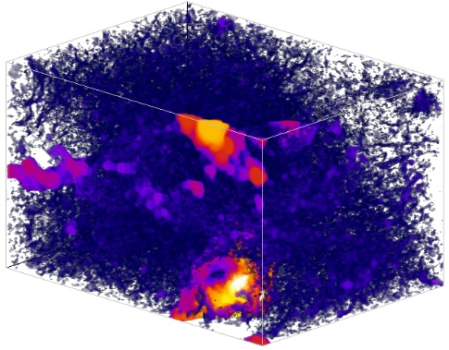  (a) | 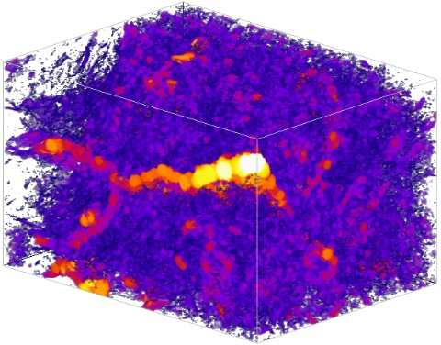  (b)
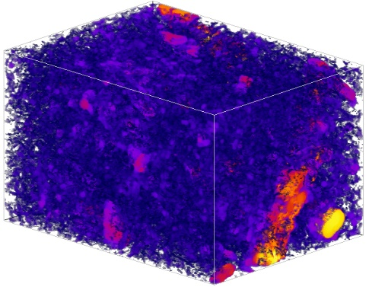  (c) | 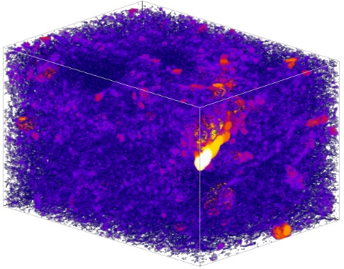  (d)
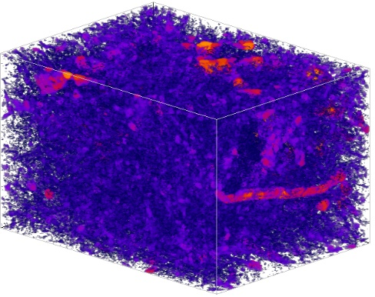  (e) | 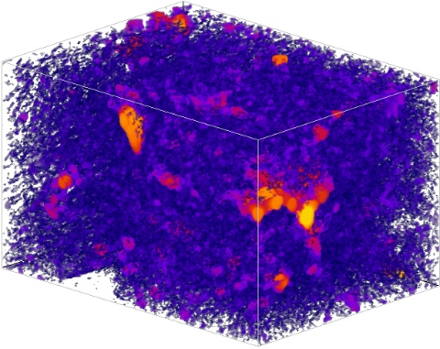  (f)
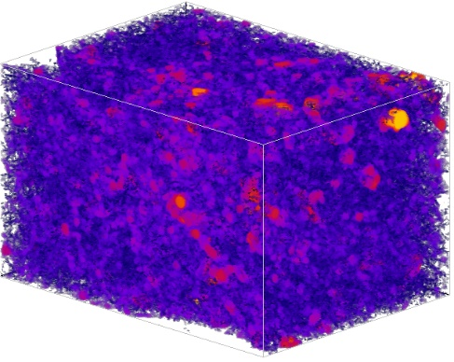  (g) | 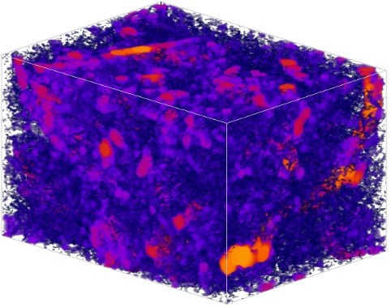  (h)
Figure 1. Representative aggregate image for soils taken from plots under different treatments in the two experiments: Highfield Ley-Arable experiment treatments bare fallow (a), arable (b), and grassland (c), and Broadbalk Winter Wheat experiment treatments N3 (d), No P (e), CK(f), FYM(g), and Woodland (h) (see text for full treatment description)

Figure 2. Change in average porosity (a) and average effective diffusion coefficient (normalized) for aggregates in soils under different treatments in the Broadbalk Winter Wheat experiment (see text for full treatment description).

Figure 3. Change in effective diffusion coefficient with porosity for all aggregates taken from soils in the Broadbalk Winter Wheat experiment (solid lines are power-law fittings) (see text for full treatment description).

Figure 4. Change in average porosity (a) and average effective diffusion coefficient (b) for aggregates in soils under different treatments in the Highfield Ley-Arable experiment.

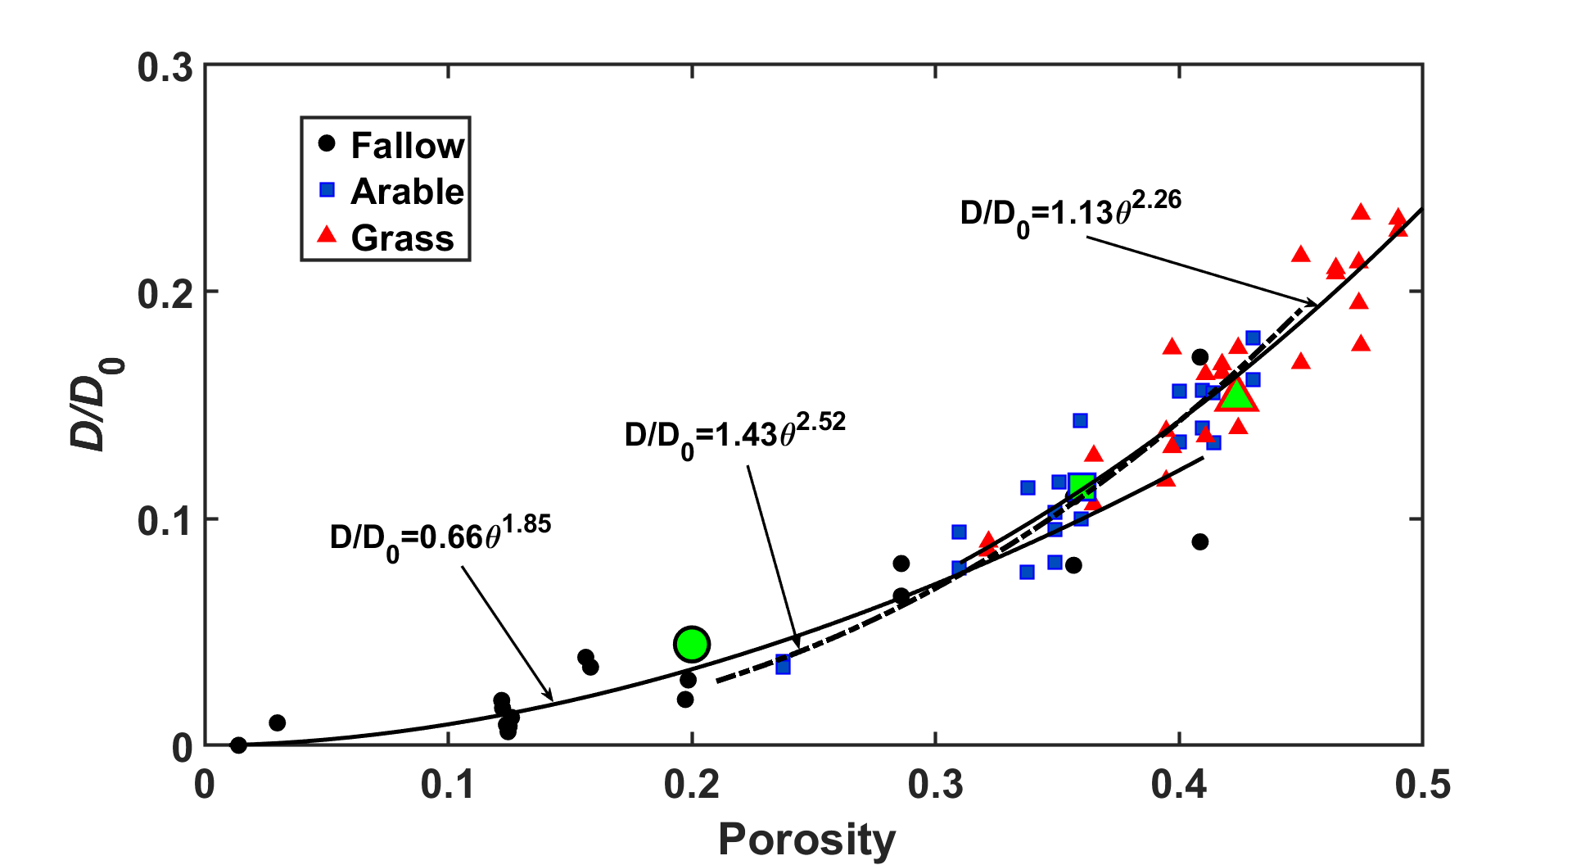
Figure 5. Change in effective diffusion coefficient (normalized) with porosity for all aggregates taken from soils in the Highfield Ley-Arable experiment (the solid lines are power-law fittings).

Figure 6. Change in the effective diffusion coefficient of aggregates with bulk SOC with results for the Broadbalk Winter Wheat and Highfield Ley-Arable experiments pooled.

