Supporting Information for
Prolonged heavy rainfall and land use drive catchment sediment source dynamics: appraisal using multiple biotracers

Hari Ram Upadhayay¹, Yusheng Zhang¹, Steven J. Granger¹, Mafalda Micale^{1,2} Adrian L. Collins¹
¹Sustainable Agriculture Sciences, Rothamsted Research, North Wyke, Okehampton, EX20 2SB UK.
²Department of Agriculture, Università degli Studi Mediterranea di Reggio Calabria, Feo di Vito
89122 Reggio Calabria - Italy

*Corresponding author: Hari Ram Upadhayay
Hari.upadhayay@Rothamsted.ac.uk

Text S1 Biotracer indices
Various alkane and fatty acid-based indices were calculated to understand the fate and dynamics of different biomarkers across the potential sediment sources.
Indices | Formula
∑Alk | =[C₂₃] + [C₂₅] + [C₂₇] + [C₂₉] + [C₃₁] + [C₃₃]
∑FFA | =[C₂₂] + [C₂₄] + [C₂₆] + [C₂₈] + [C₃₀] + [C₃₂]
∑BFA | =[C₂₂] + [C₂₄] + [C₂₆] + [C₂₈] + [C₃₀] + [C₃₂]
Odd over even pattern (OEP) | $$OEP=\frac{\left[C_{27}\right]+\left[C_{29}\right]+\left[C_{31}\right]+\left[C_{33}\right]}{\left[C_{26}\right]+\left[C_{28}\right]+\left[C_{30}\right]+\left[C_{32}\right]}$$
Even over odd pattern (EOP) | $$EOP=\frac{\left[C_{24}\right]+\left[C_{26}\right]+\left[C_{28}\right]+\left[C_{30}\right]+\left[C_{32}\right]}{\left[C_{23}\right]+\left[C_{25}\right]+\left[C_{27}\right]+\left[C_{29}\right]+\left[C_{31}\right]}$$

Text S2 Estimation of prior information
Prior information is vital for correct sediment source apportionment using unmixing modelling in a Bayesian platform (Upadhayay et al., 2020). We estimated sediment contributions from arable and grassland areas in the study catchment priori for the unmixing modelling based on cropping and grassland distribution in 2018 mapped by the Rural Payment Agency and packaged as the Crop Map of England (CROME) (https://data.gov.uk/dataset/fb19d34f-59e6-48e7-820a-fe5fda3019e5/crop-map-of-england-crome-2018). The data were further processed in ArcGIS to compute the cropping areas in the catchment. They were then combined with reported field-based estimates of soil erosion rates for different crops in England (Evans, 2005; Evans et al., 2016) to quantify the loads from all arable crops and grassland, respectively. The erosion rates used for available crops in the catchment are shown in the table below. The rates represent the median values of available samples for respective crops. The soil erosion rate from woodland distributed on clay soil was obtained from existing literature (Graves et al., 2015).
Land use | Crop type | Median Erosion rate (t ha⁻¹ yr⁻¹)
Arable | Spring Barley | 0.71
Arable | Fallow land | 0.27
Arable | Field beans - Winter | 0.22
Arable | Maize | 1.00
Arable | Winter Oat | 0.68
Arable | Winter Wheat | 0.68
Pasture | Permanent Grassland | 0.20
Woodland | Woodland | 0.01

The quantification of sediment contributions from stream banks was based on the annual load estimate from river channel bank (Wl) for the EU WFD waterbody within which the Cocktree study catchment is located (Zhang et al., 2014) and the proportion of river length in the study catchment relative (Cr) to total river length in the waterbody itself (Wr). On this basis, the annual load from stream banks in the study (BL) catchment was calculated as below:
$$BL= \frac{Cr}{Wr}Wl$$
The catchment area for the concerned waterbody is ~70 km², which is much larger than the study catchment. It is acknowledged that there is uncertainty about the assumed constant bank erosion rate per unit length with contrasting catchment sizes.

Winter 2018-19
Winter 2019-20
Fig. S1 Cumulative percent finer absolute particle size data for composite sediment samples for the contrasting winter periods.

Fig. S2 Content of (a)alkanes, (b) FFAs (free fatty acids) and (c) BFAs (bound fatty acids) in source and sediment samples. Red dots indicate outliers.
Fig. S3 Carbon isotope values of (a) C25, (b) C27, (c) C29, and (d) C31 alkanes and their biosynthetic precursor FAs in source soils (A = arable, P = pasture, W = woodland, SB = stream banks) and sediments. Red dots indicate outliers.

Fig. S4 Linear discriminant analysis of (a) alkanes, (b) FFAs (free fatty acids) and (c) BFAs (bound fatty acids) in source and sediment samples.

Fig. S5 Sediment source (A=arable, P=pasture, SB=stream banks and W=woodland) apportionment for the wet (winter 2018-19 ) and extremely wet (winter 2019-20) sediment samples using various combination of biotracer (Alkanes, FFA=free fatty acids and BFA= bound fatty acids) isotopic values. Vertical dotted line indicates prior information.

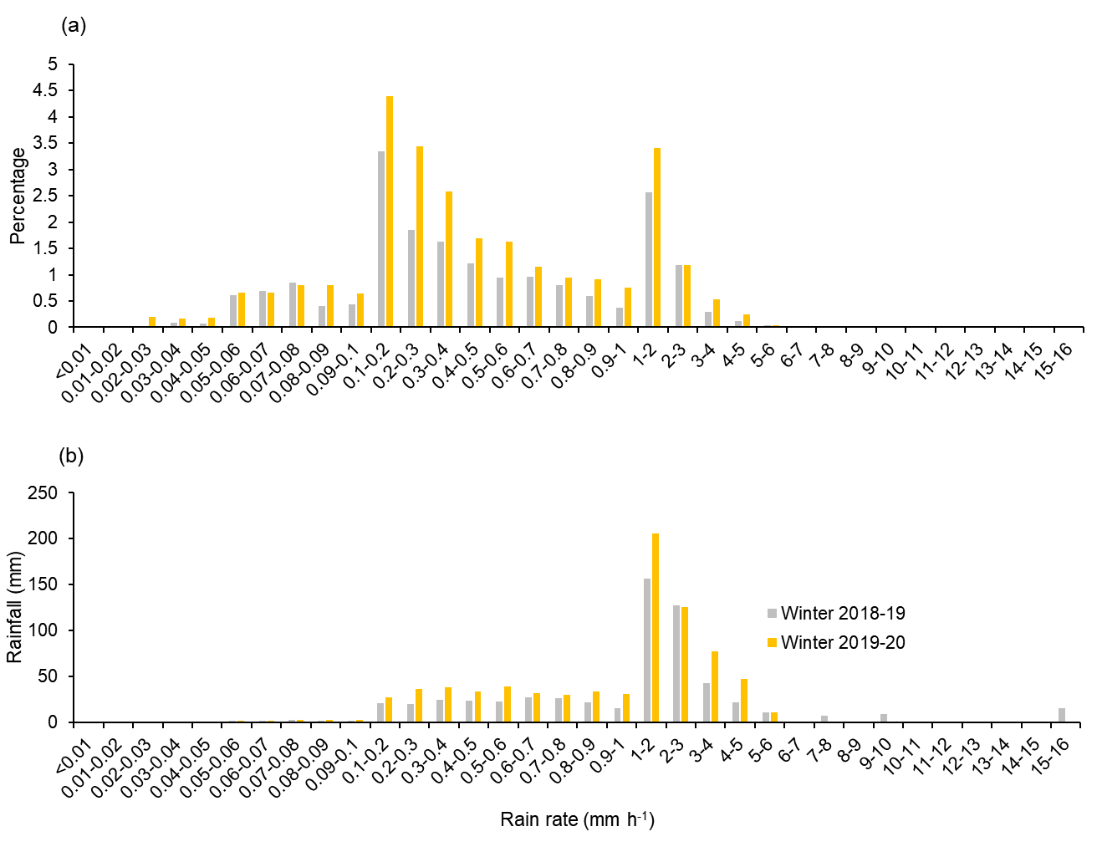
Fig. S6 Distribution of rainfall rate in winter 2018-19 and winter 2019-20 with (a) the distribution of the occurrence of rain of each intensity and (b) the distribution of rainfall volume of each intensity.
Table S1 Instrument set up parameters
Parameters | Agilent 7890A GC | Agilent 6890N/5973N GC-MS | GC-c-IRMS
Parameters | Alkanes | Fatty acids | Measurement of carbon isotopes of alkanes and fatty acids
Autosampler | 7963 (Agilent Technologies Inc., Santa Clara, CA, USA.) |  | PAL AS200 autosampler (CTC analytics, Switzerland)
Injector | Splitless | Splitless | Splitless
Injection temperature (°C) | 300 | 300 | 300
Oven program | Held at 40 ºC for 1 min, then ramped to 130ºC at 20ºC min⁻¹, then 4ºC min⁻¹ to 300ºC and held for 10 min | Held at 50°C for 2 min, then ramp at 10°C min⁻¹ to 320°C and held for 11 min | For alkanes: Held at 40 ºC for 1 min, then ramped to 130ºC at 20ºC min⁻¹, then 4ºC min⁻¹ to 300ºC and held for 10 min  For fatty acids: Held at 50°C for 2 min, then ramp at 10°C min⁻¹ to 320°C and held for 11 min
GC-column | Agilent HP-5 (30 m x 320 µm x 0.250 µm) | Agilent HP-5MS capillary column (30 m x 250 μm x 0.25 μm) | Varian CP-SIL 5CB (50 m x 320 µm x 0.12 µm) (Varian Inc. California, US)
Carrier gas and flow | Helium at 1.4 ml min⁻¹ | Helium at 1ml min⁻¹ | Helium at 1.4 ml min⁻¹
Table S2 Δ¹³C of FFAs and BFAs. Values within a column followed by the same superscript lower case letter are not statistically significantly different (***<0.001, **<0.01, *<0.05, ns = not significant).

Source | C22_{FFA-BFA} ^{ns} | C24 _{FFA-BFA}** | C26 _{FFA-BFA}** | C28 _{FFA-BFA}*** | C30 _{FFA-BFA}^{ns} | C32 _{FFA-BFA}*
Arable | -2.5±1.4 | -0.9±1.6^{ab} | -0.6±1.7ª | -1.1±1.6ª | -1.3±1.6 | -6.7±2ª
Pasture | -2.2±1.1 | -1.7±1.5ª | 0.5±1.4^{ab} | -0.6±1.2^{ab} | -1.7±1.2 | -5.8±1.4^{ab}
Woodland | -1.5±1.1 | 0±0.9^{ab} | -0.1±0.5^{ab} | -0.3±1.5^{ac} | -0.8±1.2 | -5.9±0.8^{ab}
Stream Banks | -1.9±2.5 | -1.3±3ª | 0.8±1.7^{ab} | 0.8±1.6^{bc} | -0.1±1.5 | -4.5±2^{b}
Winter2018-19 | -1.3±0.9 | -0.2±1.7^{ab} | 0.7±1.5^{ab} | 0.5±2.2^{ac} | -0.6±2.7 | -5.0±1.4^{ab}
Winter 2019-20 | -1.3±0.7 | 0.7±0.7^{b} | 1.3±1^{b} | 1.2±1.1^{c} | -0.9±1.8 | -5.9±1.2^{ab}

Table S3. Performance statistics for unmixing models. Values of the Hellinger distance range from 0–1 and values closest to 1 indicate the greatest differentiation of the estimated source contributions when compared to the model’s priors.

Biotracer | Winter period | Hellinger distance
Biotracer | Winter period | Arable | Pasture | Stream Banks | Woodland
Alkanes | Winter 2018-19 | 0.30 | 0.58 | 0.27
Alkanes | Winter 2019-20 | 0.42 | 0.65 | 0.37
FFAs | Winter 2018-19 | 0.62 | 0.71 | 0.7
FFAs | Winter 2019-20 | 0.72 | 0.61 | 0.64
BFAs | Winter 2018-19 | 0.72 | 0.7 | 0.87
BFAs | Winter 2019-20 | 0.52 | 0.62 | 0.45
Alkanes + FFAs | Winter 2018-19 | 0.66 | 0.66 | 0.73
Alkanes + FFAs | Winter 2019-20 | 0.87 | 0.67 | 0.78
Alkanes + BFAs | Winter 2018-19 | 0.51 | 0.59 | 0.49
Alkanes + BFAs | Winter 2019-20 | 0.34 | 0.62 | 0.28
FFAs + BFAs | Winter 2018-19 | 0.69 | 0.71 | 0.79
FFAs + BFAs | Winter 2019-20 | 0.33 | 0.49 | 0.23
Alkanes + FFAs + BFAs | Winter 2018-19 | 0.68 | 0.65 | 0.63
Alkanes + FFAs + BFAs | Winter 2019-20 | 0.61 | 0.63 | 0.56

References
Evans, R. 2005. Monitoring water erosion in lowland England and Wales—A personal view of its history and outcomes. CATENA 64(2), 142-161.
Evans, R., Collins, A.L., Foster, I.D.L., Rickson, R.J., Anthony, S.G., Brewer, T., Deeks, L., Newell-Price, J.P., Truckell, I.G. and Zhang, Y. 2016. Extent, frequency and rate of water erosion of arable land in Britain – benefits and challenges for modelling. Soil Use and Management 32(S1), 149-161.
Graves, A.R., Morris, J., Deeks, L.K., Rickson, R.J., Kibblewhite, M.G., Harris, J.A., Farewell, T.S. and Truckle, I. 2015. The total costs of soil degradation in England and Wales. Ecological Economics 119, 399-413.
Upadhayay, H.R., Lamichhane, S., Bajracharya, R.M., Cornelis, W., Collins, A.L. and Boeckx, P. 2020. Sensitivity of source apportionment predicted by a Bayesian tracer mixing model to the inclusion of a sediment connectivity index as an informative prior: Illustration using the Kharka catchment (Nepal). Science of The Total Environment, 136703.
Zhang, Y., Collins, A.L., Murdoch, N., Lee, D. and Naden, P.S. 2014. Cross sector contributions to river pollution in England and Wales: Updating waterbody scale information to support policy delivery for the Water Framework Directive. Environmental Science & Policy 42, 16-32.

