Supporting Information

A native promoter–gene fusion created by CRISPR/Cas9-mediated genomic deletion offers a transgene-free method to drive oil accumulation in leaves

Rupam Kumar Bhunia^{1, 2}, Guillaume N. Menard¹, Peter J. Eastmond¹

¹Department of Plant Science, Rothamsted Research, Harpenden, Hertfordshire, AL5 2JQ, UK

²National Agri-Food Biotechnology Institute (NABI), Mohali, Punjab, 140306, India

Fig. S1. Developmental expression patterns of DGAT2 and DUG1. Heat maps for DGAT2 (At3g51520) and DUG1 (At3g51510) gene expression derived from Affymetrix microarray data (Developmental Map) and RNA-Seq data (Klepikova Atlas) were generated by AtGenExpress eFP (bar.utoronto.ca/eplant/). Global Max Colour gradient setting was selected to allow quantitative comparison of gene expression between the two genes.
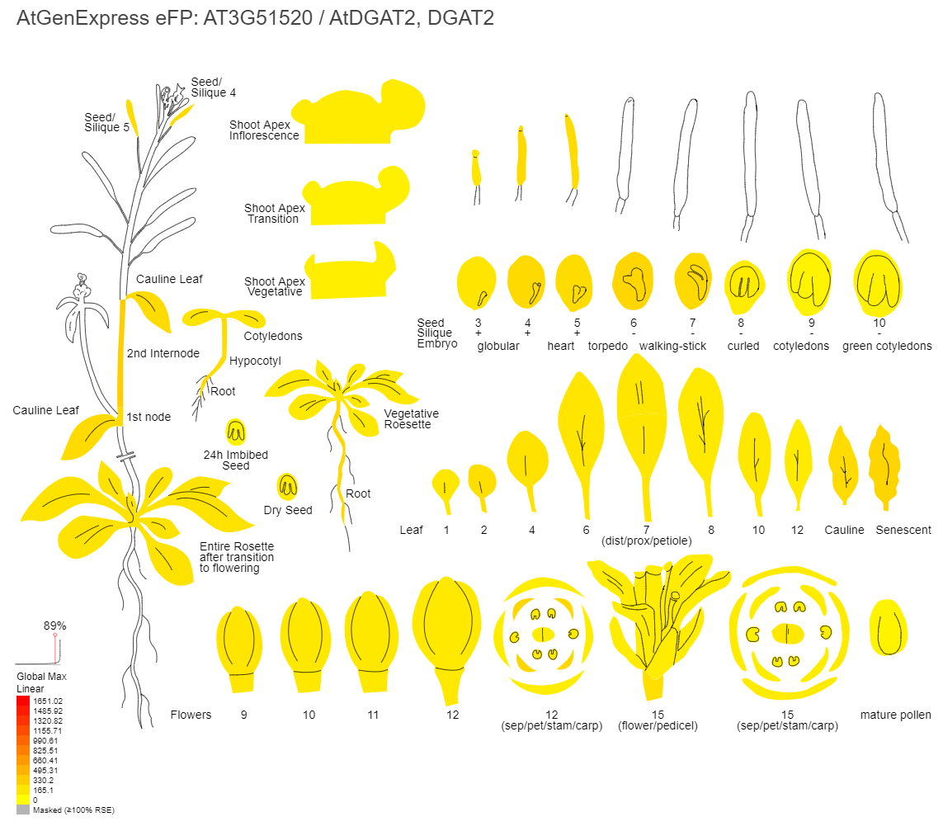
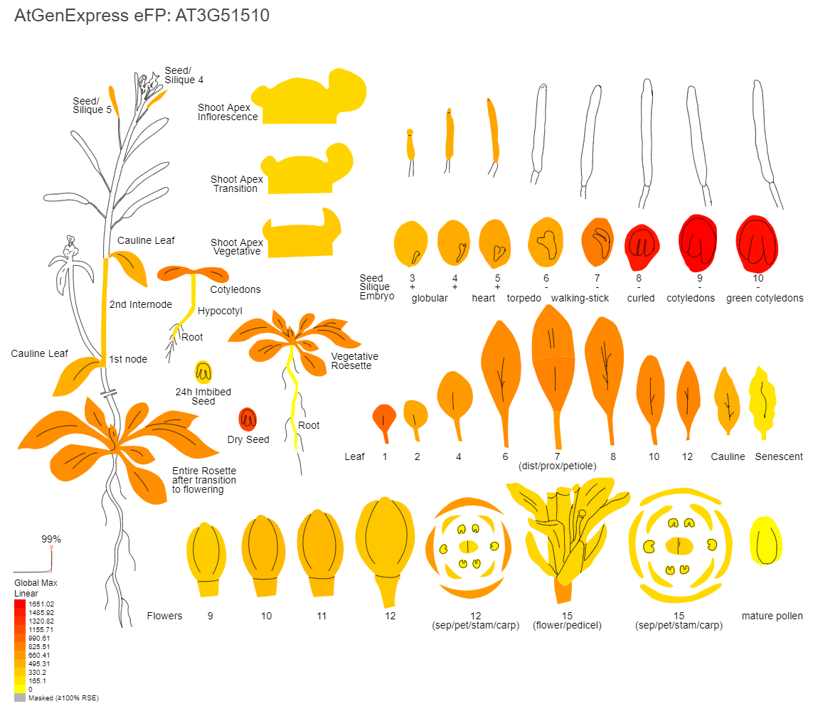
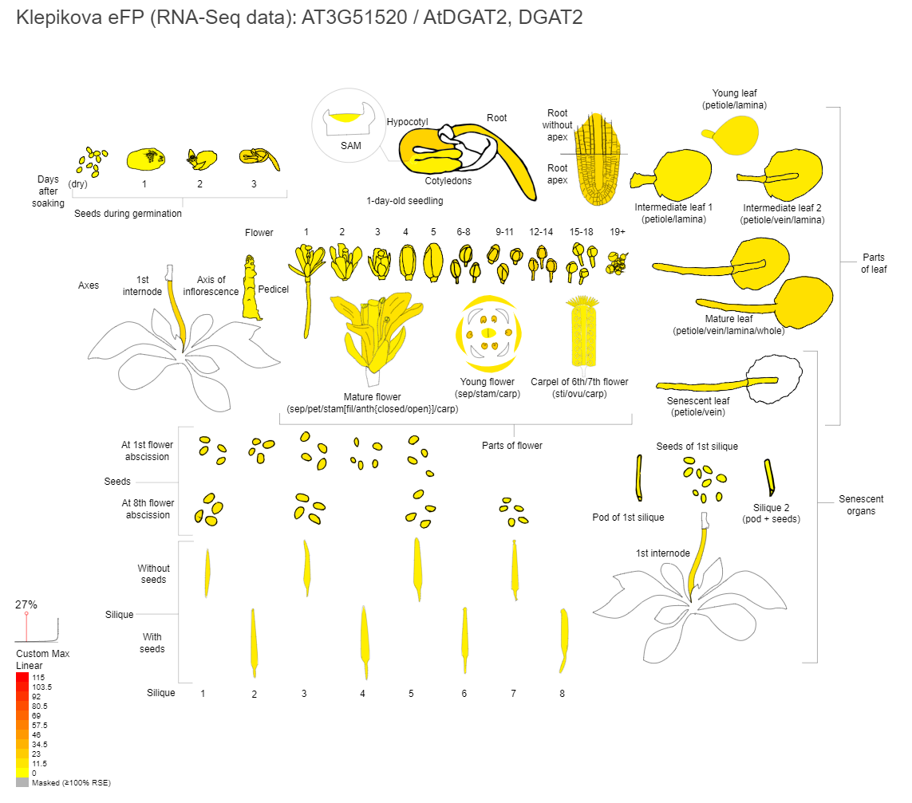
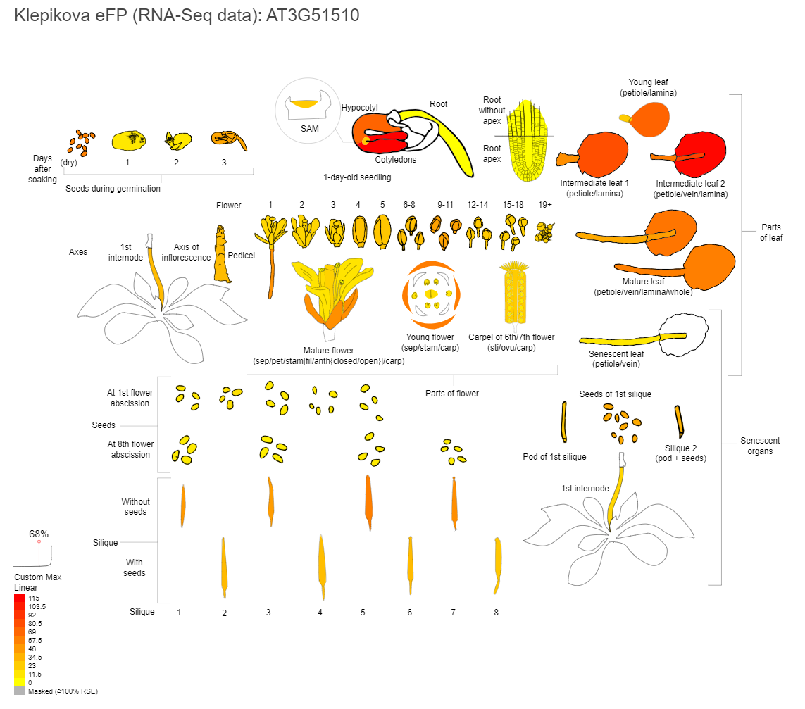

Fig. S2. gRNAs design. Untranslated sequences 5’ of the start codon were screened using CRISPR-PLANT. gRNA sites are underlined and PAMs are in bold. Double underlined nucleotides mark the putative start of transcription based on paired-end analysis.

AT3G51510 5’UTR
>Chr3:19108990..19109117 (+ strand) length=128
ACAGAATGATGATGGATTAGATATTTCTATTCAAAAACTATAACGTGTGGCTGCAAATCGATTCACCGCTTCAGACTCTGTTTTAGACCAAAGTCGAGTGAGTGCTTTCATCTTCTTCTTAAGCATCT
Class1.0 gRNA
SeqID minMM_GG minMM_AG Spacer seq (5'->3') PAM (5'->3')
Chr3:19109057-19109077:c 3 3 GTCTAAAACAGAGTCTGAAG CGGTGAATCG (gRNA1)
Chr3:19109079-19109099:c 4 4 TGAAAGCACTCACTCGACTT TGGTCTAAAA (gRNA2)

AT3G51520 5’UTR
>Chr3:19110596..19110738 (+ strand) length=143
AGTTAAAAGATTGGTTATTTGGGCTCTGCACTCAAGTGAGAGAGAAGATAGATAGATCTGAGTAGAATCTTCGATTCATTATTCGTTGTCGTCGTTCATCTGTGAGAAGCGGACAAACCAAAGAATCCACCGGAGCTAGTGAT
Class1.0 gRNA
SeqID minMM_GG minMM_AG Spacer seq (5'->3') PAM (5'->3')
Chr3:19110586-19110606 4 4 AAGTTGGGTAGTTAAAAGAT TGGTTATTTG
Chr3:19110684-19110704 5 4 CGTCGTTCATCTGTGAGAAG CGGACAAACC (gRNA3)
Chr3:19110715-19110735:c 3 3 ACTAGCTCCGGTGGATTCTT TGGTTTGTCC (gRNA4)
Chr3:19110724-19110744:c 5 5 ACCCATATCACTAGCTCCGG TGGATTCTTT
Chr3:19110727-19110747:c 4 4 ACCACCCATATCACTAGCTC CGGTGGATTC

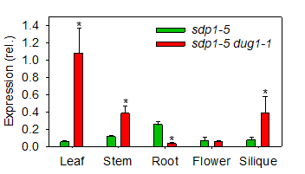
Fig. S3. DGAT2 expression in various tissues of sdp1-5 dug1-1. Measurements were performed using quantitative RT-PCR. Values are presented as mean ± SE (n=3) and are expressed relative to the geometric mean of three reference genes. Asterisks denote values significantly (P < 0.05) different from sdp1-5 (ANOVA + Tukey HSD test).

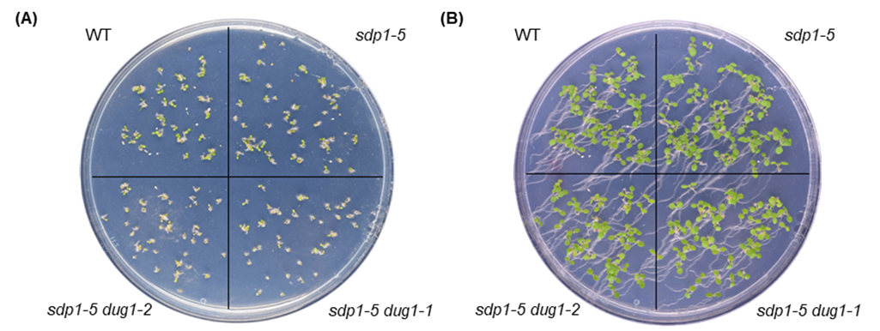
Fig. S4. Seedling establishment. Images of seedlings after (A) three days and (B) six days. The seedlings were grown on agar plates (9 cm diameter), containing half-strength Murashige and Skoog salts (pH 5.7) plus 1% (w/v) sucrose, as described in the Material and Methods section.

Table S1. Primers used in study.

Genotyping
DUG1P-F: 5’-TGTCGTTTATTTGCACCACG-3’
DGAT2G-R: 5’-AACAGAGAACAAGAGCGACG-3’

Q-PCR
QDUG1-F: 5’-TTCCTCATCCGCTCCG-3’
QDUG1-R: 5’-CAATGACTCCTGCGGC-3’
QDGAT2-F: 5’-TGGTGGAAGCCGGATT-3’
QDGAT2-R: 5’-CGGGACTTGTGCCTCT-3’
QACT8-F: 5’-GAATTACCCGACGGACA-3’
QACT8-R: 5’-ACGGTCTGCAATACCT-3’
QUBI5-F: 5’-GACGCTTCATCTCGTCC-3’
QUBI5-R: 5’-CCACAGGTTGCGTTAG-3’
QEF1α-F: 5’-TCCAGCTAAGGGTGCC-3’
QEF1α-R: 5’-GGTGGGTACTCGGAGA-3

5’-RACE
GSP1: 5’-CCAGGTACAAGAACACAACT-3’
GSP2: 5’-GAGCAACAACTCCAATCGGTAGCAC-3’

Table S2. Total lipid content of seeds.
Genotype | Lipid content (% of CDW)
WT | 27.52 ±1.12
sdp1-5 | 28.15 ±0.58
sdp1-5 dug1-1 | 27.41 ±1.12
sdp1-5 dug1-2 | 28.25 ±1.67
Values are shown as a percentage of cell dry weight (CDW) and are the mean ± SE (n=3) of measurements on seed batches from plants of each genotype. The values are not significantly different (P > 0.05, ANOVA).

