¹³C dicarboxylic acid signatures indicate temporal shifts in catchment sediment sources in response to extreme winter rainfall

Hari Ram Upadhayay*, Adrian Joynes, Adrian L. Collins
Net Zero and Resilient Farming, Rothamsted Research, North Wyke, Okehampton, EX20 2SB UK.
*Corresponding author: hari.upadhayay@rothamsted.ac.uk

Abstract
Rainfall and land use interactions drive temporal shifts in suspended sediment sources, yet the magnitude of such changes remain poorly understood due to the lack of land-use specific source tracers. We investigated α,ω-dicarboxylic fatty acids (diFAs)-root-specific biomarkers, as diagnostic tracers for apportioning sources of time-integrated suspended sediment samples collected from a grassland dominated agricultural catchment in the southwest of England during the wet winter period. Applying diFA-specific stable carbon isotope analysis and a Bayesian isotope mixing model, we show stream banks contributed most of the sediment in the early winter, i.e., October–December, (90% credible interval (CI) ranging from 44% to 79%) while winter cereals-dominated arable land contributed more than half (90% CI: 35% to 85%) of the sediment during the late winter, i.e., January–March. The dominant sediment source shifted in conjunction with a period of prolonged consecutive rainfall days in the later period suggesting that intervention required to mitigate soil erosion and sediment delivery should adapt to changing rainfall patterns. Our novel findings demonstrate that diFAs isotopic signatures are promising tracers for understanding the resistance of agricultural soils to water erosion and quantifying the interactive effects of extreme rainfall and land use on catchment sediment source dynamics.
Keywords Sediment fingerprinting; Land use; Suberin; Bayesian unmixing model

Introduction
Human activities in tandem with extreme rainfall have accelerated erosion generating excess sediment inputs into aquatic ecosystems (Foucher et al. 2021). Assembling reliable information on the relative contributions of various sources to sediment is complicated due to spatio-temporal variability in erosion processes and the need to identify land use-specific source tracers. Biotracer-based especially fatty acids and alkanes sediment source fingerprinting has shown promising results due to the strong linkage between biomarker isotopic signatures and land use (Upadhayay et al. 2022). However, these biotracers achieved limited success in discriminating functionally similar land use-based sources (Vale et al. 2022; Upadhayay et al. 2020), especially when attempting to document temporal variability in source contributions (Hirave et al. 2021). Best management for sediment-related problems can only be targeted successfully when the spatio-temporal dynamics of sediment source contributions are documented accurately.
Studying root-derived biomarkers in soil and sediment can help us to better understand land use (Jansen and Wiesenberg 2017) and responses to extreme rainfall. Suberin is one of the important biopolymers in roots consisting of alternating layers of aliphatic (fatty acids, alcohols, ω-hydroxy acids, α,ω-diacids) and aromatic compounds (Harman-Ware et al. 2021). The aliphatic portion comprises light lamellae structured by glycerol-α,ω-diacid-glycerol but also containing a ω-hydroxyacid-glycerol unit with a characteristic chain length of 22 or 24 carbon atoms (Serra and Geldner 2022). Although, long-chain (C₂₀–C₃₂) α,ω-dicarboxylic fatty acids (diFAs) comprise about 0.3% of total soil lipids (Holtvoeth et al. 2016), they are a major component of suberin (Serra and Geldner 2022). Given their chain-length dependent hydrophobicity, the degradation of diFAs in soil decreases with increasing chain length (Kashi et al. 2023). Therefore, these diFAs are considered very robust indicators of root inputs to soils (Mendez-Millan et al. 2011).
Dicarboxylic fatty acids and their associated isotopes can be utilised as source tracers to investigate transfers of land use-based sediment to aquatic systems due to their stability during transport in river systems (Feng and Simpson 2008). Recently, Pondell and Canuel (2020) reported that diFAs in sediment can differ in response to floods or dam construction. Despite their ubiquitous presence in soil and sediment, diFAs remain poorly investigated biomarkers in terms of their distribution in sediment sources spanning the land use spectrum. The suitability of diFAs-associated isotope values as fingerprints for quantifying sediment source contributions to rivers has not been tested at catchment scale. It is thus very timely to explore diFAs properties and establish whether these biomarkers are robust tracers for sediment source contributions in agricultural landscapes prone to sediment-related problems.
The aim of this research was to explore how diFAs might be used to provide information on temporal patterns in catchment sediment source contributions. We sampled winter 2019–2020 sediment from a grassland-dominated agricultural catchment in the UK. The winter of 2019–2020 was the 5th wettest on record in the UK meaning that it was a suitable study period for sediment source dynamics. The specific objectives were to: (1) assess diFAs content and associated ¹³C signatures in soils from arable land, pastureland, woodland and stream banks for potential sediment source discrimination, and; (2) estimate the relative contributions of the sediment sources to sediment sampled during winter 2019–2020. This study complements earlier work using more conventional biomarkers (Upadhayay et al. 2022).

Materials and Methods

Study catchment
The study was undertaken within a grassland-dominated lowland agricultural catchment (4.5 km²) in southwest England (Fig. S1a). See Upadhayay et al. (2022) for details. Briefly, the catchment is dominated by pasture (62%), followed by arable land (23%) and woodland (15%). High risk crops for erosion and sediment generation are grown on the arable land, including winter wheat and barley, field beans and maize. A ryegrass-clover mix dominates the pasture. Woodland is mostly concentrated in the riparian zone (Fig. S1a). Long-term mean winter i.e., October– March rainfall is approximately 661 mm (1981–2010).

Surface soil and sediment sampling
Composite soil samples were collected to characterise each land use; arable (n = 17), pasture (n = 19) and woodland (n = 6). For each sampling point, approximately 10 topsoil i.e., 2 cm sub-samples were collected randomly using a 5 cm diameter corer and composited. Samples were also taken from eroding stream bank profiles (n =11). Soil samples were freeze dried and sieved through a 63µm sieve based on the sediment particle size distribution (Upadhayay et al. 2022).
Time-integrated suspended sediment samples were collected from the catchment outlet (Fig. S1a) from October 2019 to April 2020 i.e., the winter of 2019– 2020 which received about 800 mm of rainfall (Fig. S1b). Sediment samples were retrieved at the end of December 2019 (hereafter referred to as early winter; EW) and early April 2020 (hereafter referred to as late winter; LW). Sediment samples were freeze dried.

Extraction of dicarboxylic acids and determination of ¹³C signatures
Ester-bound dicarboxylic fatty acids were extracted from dried samples by sequential chemical extraction, i.e., solvent extraction followed by alkaline hydrolysis (Upadhayay et al. 2022).The individual dicarboxylic acids were quantified and their ¹³C signatures determined using GC-MS and GC-c-IRMS, respectively. The carbon isotopic results of diFA were expressed as natural abundance (δ) in parts per mil (‰) compared to international standards i.e., Vienna Pe De Belemnite (VPDB). For details see Text S1.

Statistical analysis and source apportionment modelling
The homologous series of saturated dicarboxylic fatty acids with carbon numbers ranging from C₁₆ to C₂₈ were considered for statistical analysis. The δ¹³C values of long-chain diFAs (C₁₈–C₂₆) were used as sediment tracers in a concentration-dependent Bayesian mixing model (MixSIAR). Median and 90% Bayesian confidence intervals of the posterior source contributions were generated. For details see Text S2.

Results and discussion

Variation in dicarboxylic fatty acids content and associated ¹³C signatures across sediment sources
The total diFAs (C₁₆–C₂₈) content was highest in the woodland soil (105.9 ± 37.3 µg g⁻¹ soil) followed by the pasture (56.9 ± 19.7 µg g⁻¹ soil), arable (20.8 ± 6.9 µg g⁻¹ soil) and stream bank (15.14 ±10.4 µg g⁻¹ soil) soils. The relative abundance of two dominant diFAs i.e., C₂₂ and C₂₄ were similar in arable and pasture soils and contributed around 60% of the total diFAs content (Fig. 1a). The content of C₂₂ and C₂₄ in pasture surface soil was about three times higher compared to arable surface soil, suggesting pronounced diFAs degradation with intensive arable land use and/or higher root carbon inputs in pasture land (McNally et al. 2015) The similar diFAs contents and compositions in the arable and stream bank soils (Fig. 1b) also reflected lower root inputs and degradation of diFAs in arable soils facilitated by tillage and agricultural inputs (e.g., fertilizer and lime). Continuous tillage can result in aggregate breakdown and enhancement of suberin component availability for degradation. The diFAs contents observed in this study were comparable to those reported by previous studies (Pisani et al. 2016). In the woodland soils, C₁₆ and C₁₈ diFAs contributed about 50% of the total diFAs (Fig. 1a) which can be explained by their higher contents in tree roots and accumulation over time (Spielvogel et al. 2014).

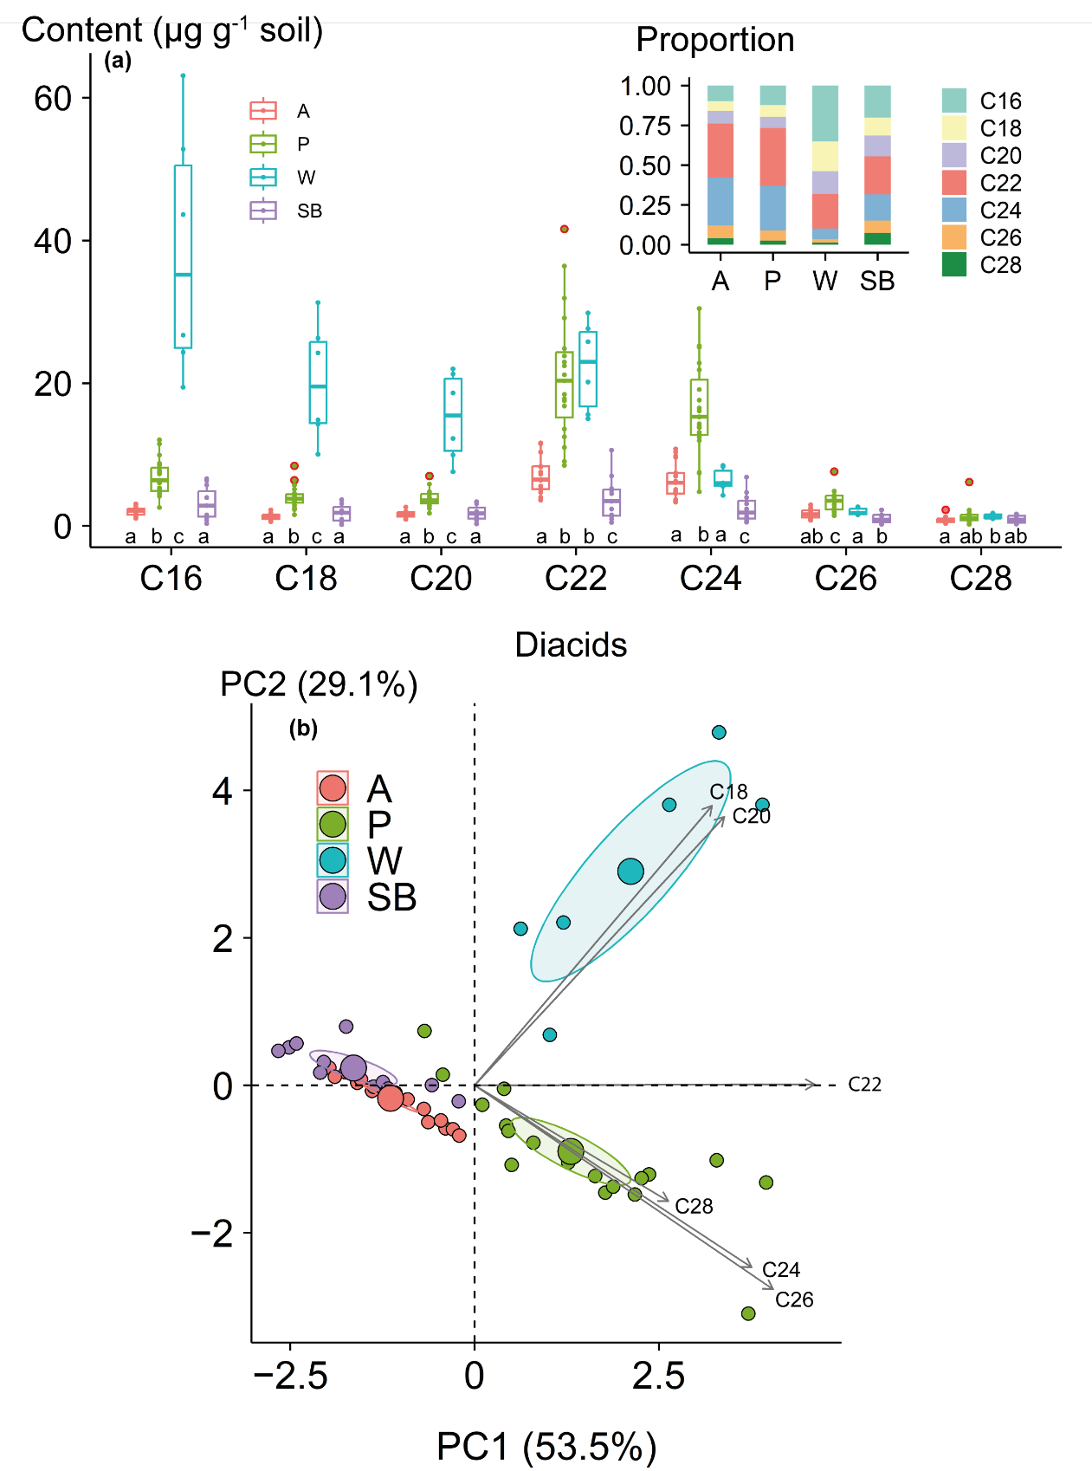
Fig. 1 a Variation of α,ω-dicarboxylic acids (diFAs) content across the sediment sources (A = arable, P = pasture, W = woodland, SB = stream banks); b and results of principal component analysis using diFAs contents. Different lowercase letters indicate significant differences between diFAs contents. Red dots represent outliers. The ellipses represent 95% confidence intervals for the corresponding means.
The carbon isotopic signature of soil diFAs ranged from −41.1 to −29.5‰ in arable, from −39.5 to −32.4‰ in pasture, from −35.9 to −30.9‰ in woodland and from −40.1 to −29.3‰ in stream banks. The measured ¹³C signatures of diFAs are in agreement with C3 biosynthetic pathways and similar to those diFAs observed in wheat roots (Mendez-Millan et al. 2011), grass (Dactylis glomerata, Festuca arundinacea and Lolium perenne) roots and associated soils (Armas-Herrera et al. 2016). The similar δ¹³C values of diFAs for arable and stream bank samples (Fig. 2, Table S1) suggested that these biomarkers are preserved in soil without significant alteration of ¹³C signatures. The δ¹³C values of C₂₈ further indicate that long-chain diFAs are very stable in the soil due to the high energy requirement for uptake by microorganisms (Kashi et al. 2023).

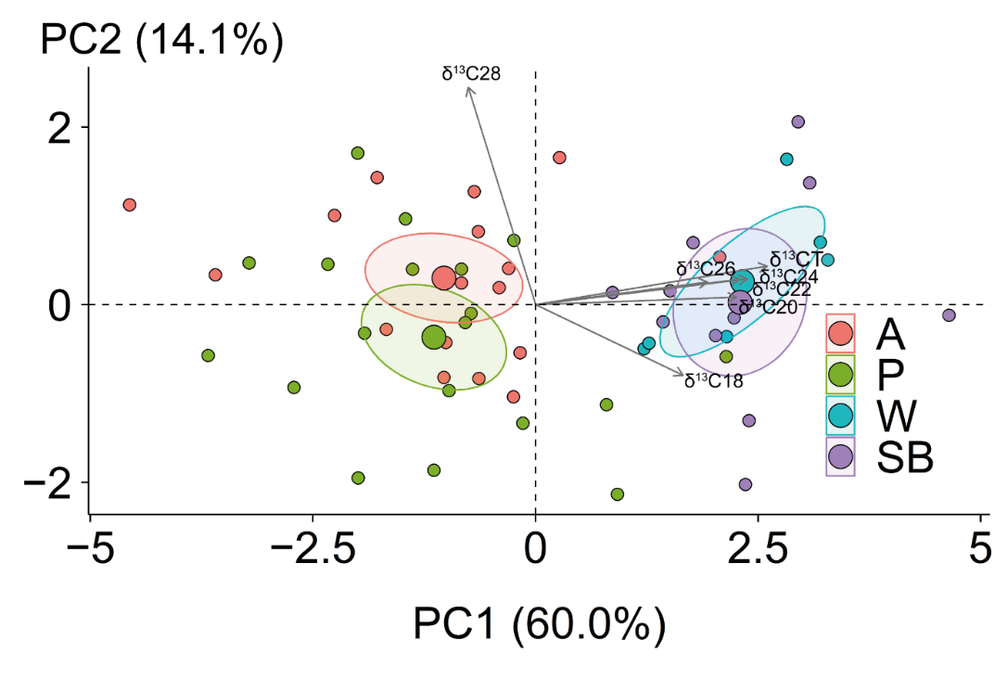
Fig. 2 Principal component analysis of δ¹³C values (‰) of α,ω-dicarboxylic fatty acids in the sediment sources (A = arable, P = pasture, W = woodland, SB = stream banks) indicate A and SB are similar. Ellipses represents 95% confidence intervals of the corresponding means.

Temporal variations in sediment dicarboxylic fatty acid signatures linked to sediment source contributions
The diFAs content and corresponding ¹³C signatures varied significantly between EW and LW sediment (Fig. 3). The observed temporal shift in the diFAs content and the associated ¹³C signal in sediment can reflect changes in the sediment sources and transport pathways over time. The estimated source contributions suggested that, during EW, stream banks were the dominant source with a median contribution of 66% (90% credible interval ranging from 44% to 79%), followed by arable land (median 30%; CI: 14% to 46%) (Fig. 4a). In contrast, the arable land was dominant during LW, with a median contribution of 65% (90% CI: 35% to 85%) (Fig. 4b). The significant temporal shift in source contributions suggested that diFAs tracers can reveal significant responses to the impact of extended rainfall (Fig. S3) on high risk arable land, confirming that these biotracers are robust indicators of soil organic matter sources in sediment (Pondell and Canuel 2020).

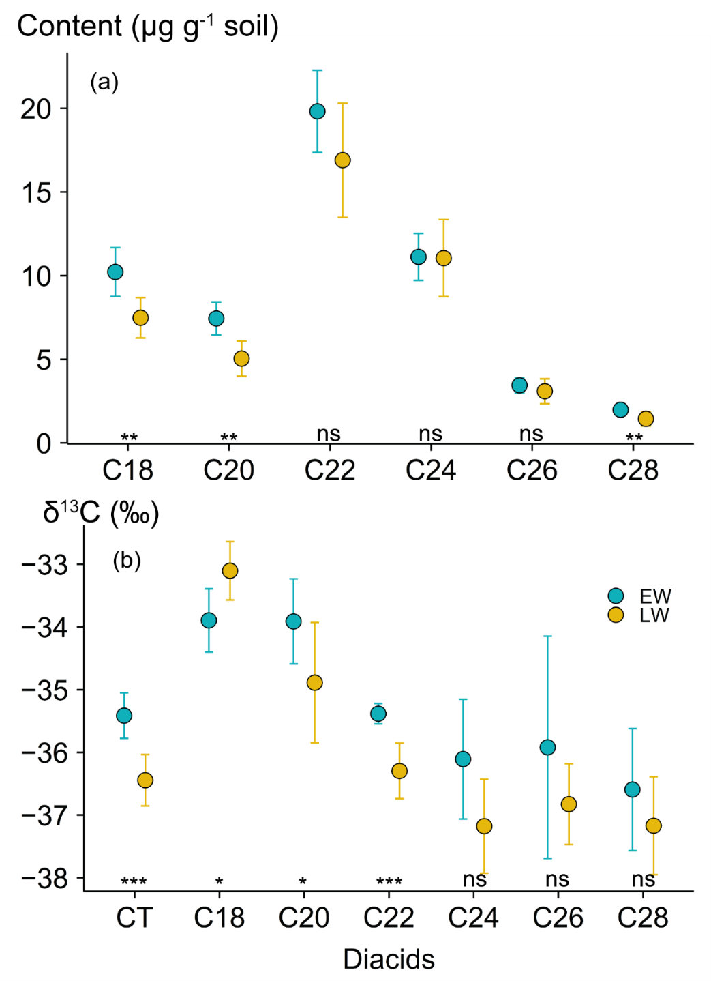
Fig. 3 Statistical differences (***<0.001, **<0.01, *<0.05, ns = not significant) of α,ω- dicarboxylic fatty acids; a content; b corresponding δ¹³C values between early winter (EW) and late winter (LW) sediment. CT indicates the content weighted δ¹³C values of long chain diFAs (C₂₀–C₂₈)
The proportion of sediment contributed from stream banks in this study is within the range i.e., 4% to 84% reported for UK streams and rivers (Abbas et al. 2023). High stream bank contributions during EW may be explained by livestock access to the channel. Livestock can degrade stream banks through dislodging trampled soil which loses cohesive strength following saturation (Terry et al. 2014). The higher arable land contribution during LW was expected due to its spatial distribution on steep slopes (Fig. S1), exposure of arable bare soils during the winter and high antecedent soil moisture (Fig. S1b) combined with prolonged rainfall (Fig. S3). Aggregate stability decreases when soil is completely saturated (Moragoda et al. 2022) reducing resistance to erosion. Consequently, saturation-excess overland flow and rill erosion can enhance runoff and sediment delivery. In a recent field scale study, the authors reported around a 77% higher sediment flux from arable land during LW compared to EW in the study catchment (Upadhayay et al. 2022).
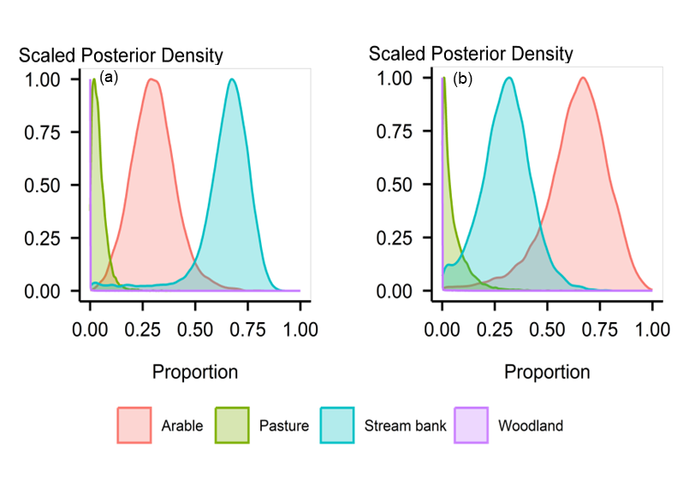
Fig. 4 Estimated sediment source contributions; a early winter (EW); b late winter (LW) using MixSIAR with prior information. Results show switches in source contributions
The diFAs used in this study are very robust indicators of root inputs in the soil which are protected in soil microaggregates (Genest et al. 2014) and can travel long distances. Source contribution insensitivity to prior information (Fig. S3) demonstrated that diFAs are very robust tracers for apportioning catchment sediment sources. This assertion is further supported by the reported absence of diFAs in aquatic plants (Pondell and Canuel 2022) and the presence of very low contents in the above ground tissues of terrestrial vegetation (Otto and Simpson 2006). Therefore, any potential uncertainties in the estimated source contributions introduced by corrupted tracer values due to riparian vegetation and algae accrual in the stream sediment are negated by using diFAs as tracers. The robust evidence for switches in sediment sources during prolonged wet periods provided this study should encourage farmers to implement sediment mitigation to adapt to changing rainfall patterns both now and in the future.

Conclusion
Long-chain dicarboxylic fatty acids content and corresponding ¹³C signatures varied in time-integrated suspended sediment samples. Variation was associated with a significant shift in the contribution of arable land to LW sediment. Prolonged heavy rainfall reduced the resistance of arable land to erosion and accelerated sediment delivery during the LW period. The novel results demonstrated that dicarboxylic fatty acids are responsive to changes in source contributions and thereby offer substantial promise for use as biotracers. Temporal sediment source apportionment can inform soil conservation and sediment management.

Acknowledgements
We acknowledge UKRI-BBSRC (UK Research and Innovation-Biotechnology and Biological Sciences Research Council) grant awards BBS/E/C/000I0330 and BB/X010961/1.
Supplementary material
This manuscript contains supplementary material.
Compliance with ethical standards
Ethical approval: Not applicable; Consent to participate: Not applicable; Consent to publish: Not applicable
Declarations
Conflict of interest The authors declare no conflict of interest. Authors have not used large language models for preparation and revision of manuscript.
Author Contribution
Conceptualisation: HRU, ALC
Methodology: HRU, AJ
Data curation: AJ, HRU
Formal analyses and investigation: HRU
Writing original draft and editing: HRU, ALC
Funding and supervision: ALC
References
Abbas G, Jomaa S, Bronstert A, Rode M (2023) Downstream changes in riverbank sediment sources and the effect of catchment size. J. Hydrol. Reg. Stud. 46, 101340. https://doi.org/10.1016/j.ejrh.2023.101340
Armas-Herrera CM, Dignac M-F, Rumpel C, Arbelo CD, Chabbi A (2016) Management effects on composition and dynamics of cutin and suberin in topsoil under agricultural use. Eur. J. Soil Sci. 67, 360-373. https://doi.org/10.1111/ejss.12328
Feng X, Simpson MJ (2008) Temperature responses of individual soil organic matter components. J. Geophys. Res. Biogeosci. 113, G03036. https://doi.org/10.1029/2008JG000743
Foucher A, Evrard O, Cerdan O, Chabert C, Lefèvre I, Vandromme R, Salvador-Blanes S (2021) Deciphering human and climatic controls on soil erosion in intensively cultivated landscapes after 1950 (Loire Valley, France). Anthropocene 34, 100287. https://doi.org/10.1016/j.ancene.2021.100287
Genest SC, Simpson MJ, Simpson AJ, Soong R, McNally DJ (2014) Analysis of soil organic matter at the solid–water interface by nuclear magnetic resonance spectroscopy. J. Environ. Chem. 11, 472–482. https://doi.org/10.1071/EN14060
Harman-Ware AE, Sparks S, Addison B, Kalluri UC (2021) Importance of suberin biopolymer in plant function, contributions to soil organic carbon and in the production of bio-derived energy and materials. Biotechnol. Biofuels 14, 75. https://doi.org/10.1186/s13068-021-01892-3
Hirave P, Glendell M, Birkholz A, Alewell C (2021) Compound-specific isotope analysis with nested sampling approach detects spatial and temporal variability in the sources of suspended sediments in a Scottish mesoscale catchment. Sci. Total Environ. 755, 142916. https://doi.org/10.1016/j.scitotenv.2020.142916
Holtvoeth J, Rushworth D, Copsey H, Imeri A, Cara M, Vogel H, Wagner T, Wolff GA (2016) Improved end-member characterisation of modern organic matter pools in the Ohrid Basin (Albania, Macedonia) and evaluation of new palaeoenvironmental proxies. Biogeosciences 13, 795–816. https://doi.org/10.5194/bg-13-795-2016
Jansen B, Wiesenberg GLB (2017) Opportunities and limitations related to the application of plant-derived lipid molecular proxies in soil science. SOIL 3, 211–234. https://doi.org/10.5194/soil-3-211-2017
Kashi H, Loeppmann S, Herschbach J, Schink C, Imhof W, Kouchaksaraee RM, Dippold MA, Spielvogel S (2023) Size matters: biochemical mineralization and microbial incorporation of dicarboxylic acids in soil. Biogeochemistry 162, 79-95. https://doi.org/10.1007/s10533-022-00990-0
McNally SR, Laughlin DC, Rutledge S, Dodd MB, Six J, Schipper LA (2015) Root carbon inputs under moderately diverse sward and conventional ryegrass-clover pasture: implications for soil carbon sequestration. Plant Soil 392, 289–299. https://doi.org/10.1007/s11104-015-2463-z
Moragoda N, Kumar M, Cohen S (2022) Representing the role of soil moisture on erosion resistance in sediment models: Challenges and opportunities. Earth-Sci. Rev. 229, 104032. https://doi.org/10.1016/j.earscirev.2022.104032
Otto A, Simpson MJ (2006) Sources and composition of hydrolysable aliphatic lipids and phenols in soils from western Canada. Org. Geochem. 37, 385–407. https://doi.org/10.1016/j.orggeochem.2005.12.011
Pisani O, Haddix ML, Conant RT, Paul EA, Simpson MJ (2016) Molecular composition of soil organic matter with land-use change along a bi-continental mean annual temperature gradient. Sci. Total Environ. 573, 470–480. https://doi.org/10.1016/j.scitotenv.2016.08.154
Pondell CR, Canuel EA (2020) Sterol, fatty acid, and lignin biomarkers identify the response of organic matter accumulation in Englebright Lake, California (USA) to climate and human impacts. Org. Geochem. 142, 103992. https://doi.org/10.1016/j.orggeochem.2020.103992
Pondell CR, Canuel EA (2022) Multi-biomarker analysis for identifying organic matter sources in small mountainous river watersheds: A case study of the Yuba river watershed. San Francisco Estuary Watershed Sci. 20
Serra O, Geldner N (2022) The making of suberin. New Phytol. 235, 848–866. https://doi.org/10.1111/nph.18202
Spielvogel S, Prietzel J, Leide J, Riedel M, Zemke J, Kögel-Knabner I (2014) Distribution of cutin and suberin biomarkers under forest trees with different root systems. Plant Soil 381, 95–110. https://doi.org/10.1007/s11104-014-2103-z
Terry JA, McW.H. Benskin C, Eastoe EF, Haygarth PM (2014) Temporal dynamics between cattle in-stream presence and suspended solids in a headwater catchment. Environ. Sci.: Process. Impacts 16, 1570–1577. http://dx.doi.org/10.1039/C3EM00686G
Upadhayay HR, Griepentrog M, Bodé S, Bajracharya RM, Cornelis W, Collins AL, Boeckx P (2020) Catchment-wide variations and biogeochemical time lags in soil fatty acid carbon isotope composition for different land uses: Implications for sediment source classification. Org. Geochem. 146, 104048. https://doi.org/10.1016/j.orggeochem.2020.104048
Upadhayay HR, Zhang Y, Granger SJ, Micale M, Collins AL (2022) Prolonged heavy rainfall and land use drive catchment sediment source dynamics: Appraisal using multiple biotracers. Water Res. 216, 118348. https://doi.org/10.1016/j.watres.2022.118348
Vale S, Swales A, Smith HG, Olsen G, Woodward B (2022) Impacts of tracer type, tracer selection, and source dominance on source apportionment with sediment fingerprinting. Sci. Total Environ. 831, 154832. https://doi.org/10.1016/j.scitotenv.2022.154832

