Title page
Pheromone stereochemical specificity in the biology of the bean beetle Acanthoscelides obtectus
Anusha Mohan-Kumar^{1,2}, Gareth Thomas¹, David M. Withall¹, John C. Caulfield¹, József Vuts¹
- Protecting Crops and the Environment, Rothamsted Research, Harpenden, AL5 2JQ
- Centre for Research in Biosciences, University of the West of England, Bristol, BS16 1QY,

Corresponding author
József Vuts
Jozsef.vuts@rothamsted.ac.uk
01582 938867
Orcid id: 0000-0001-6240-0905

Co-authors:
Anusha Mohan-Kumar: 0000-0003-0828-0337
Gareth Thomas: 0000-0003-2829-7814
David M. Withall: 0000-0001-5042-0183
John C. Caulfield: 0000-0003-1799-370X

Summary:
The dried bean beetle, Acanthoscelides obtectus, is a serious pest of legume crops, particularly Phaseolus vulgaris beans, and their management is challenging due to the beetle's cryptic larval stage. The major male-produced pheromone of A. obtectus is methyl (E,R)-2,4,5-tetradecatrienoate, crucial for female attraction, with the (S)-enantiomer emitted in smaller amounts (R:S ca. 9:1). Despite its identification half a century ago, it is still not commercially available for bruchid surveillance due to production and stability issues, with gaps in our knowledge relating to the bioactivity of the stereoisomers. We thus aim to clarify the behavioural specificity of the (R)- and (S)- enantiomers of methyl (E)-2,4,5-tetradecatrienoate, along with two commercially available isomers. Electrophysiological (EAG) assays with virgin females show that stereochemically pure methyl (E,R)-2,4,5-tetradecatrienoate is as EAG-active when part of the natural 9:1 or the racemic 1:1 blends, whereas the stereochemically pure (S)-enantiomer is inactive. Moreover, the structural analogues do not elicit significant EAG responses. Virgin females give positive behavioural responses in the olfactometer only to methyl (E,R)-2,4,5-tetradecatrienoate, but not to its antipode or the structural analogues. Furthermore, stereochemically pure methyl (E,R)-2,4,5-tetradecatrienoate elicits the same level of behavioural activity as the 9:1 blend. Curiously, presence of the (S)-enantiomer in equal proportions synergises female preference for stereochemically pure (R). These findings provide a better understanding of the pheromone biology of A. obtectus and create a platform for the development of pheromone trap-based surveillance with racemic methyl (E)-2,4,5-tetradecatrienoate.
Keywords: Acanthoscelides obtectus, chiral, enantiomer, evolution, methyl (E,R)-2,4,5-tetradecatrienoate, pheromone.
Introduction
Larvae of the dried bean beetle, Acanthoscelides obtectus Say (Coleoptera: Chrysomelidae), are major storage pests of legume crops, particularly Phaseolus vulgaris L. beans (Fabaceae) (Imura, 1990). Originating in the Neotropics, the beetle has now spread worldwide, and infestations are observed globally (Alvarez et al., 2005). The pest has multiple generations per year and can reproduce both in the field and granaries, resulting in yield losses and reduction in quality of stored seeds (Paul et al., 2010).
Detecting and controlling infestations in storage facilities or warehouses can be challenging due to the cryptic lifestyle of the larvae, which are difficult to detect visually. The first instars bore into bean seeds, feeding and developing internally until they mature into adult beetles that emerge through circular exit holes (Njoroge et al., 2017). Greater attention is being directed towards environmentally benign integrated pest management practices, i.e. a combination of chemical, cultural, biological and mechanical approaches, the efficacy of which can be increased with the development of sensitive beetle surveillance (Vuts et al., 2024). For this, the use of semiochemicals, particularly pheromones, can be a feasible option.
The major male-produced volatile sex pheromone component of A. obtectus was previously identified as methyl (E,R)-2,4,5-tetradecatrienoate, the presence of which is crucial for female attraction, although the (S)-enantiomer is also emitted in small quantities (R:S ca. 9:1) (Vuts et al., 2015). However, using methyl (E,R)-2,4,5-tetradecatrienoate for detection and monitoring poses several challenges. Firstly, the behavioural specificity of its stereoisomers is unknown. This is crucial, because the activity of optical isomers is defined by their molecular configuration (Mori, 2007; Pickett et al., 2013; Sims et al., 2022; Tumlinson et al., 1977). For example, in the scarab beetle Oryctes rhinoceros, the pheromone (R)-ethyl 4-methyloctanoate is significantly more attractive than its inactive antipode and as attractive as the racemic mixture (Hallett et al., 1995). The weevil Rhynchophorus palmarum responds more strongly to (S)- and racemic (2E)-6-methyl-2-hepten-4-ol than to the corresponding (R)-enantiomer (Oehlschlager et al., 1992). Curiously, the contact sex pheromone of Blatella germanica is less effective in eliciting courtship responses in males compared to other stereoisomers (Eliyahu et al., 2004). There are also instances where insects do not differentiate between enantiomers, such as the case of termites and the queen signal 2-methyl-1-butanol (Yamamoto et al., 2012). Therefore, an investigation into the relationship between stereochemistry and bioactivity is crucial before the practical utilization of the A. obtectus main pheromone component.
Another issue with the use of methyl (E,R)-2,4,5-tetradecatrienoate is that its synthesis is complex, costly, low yielding, and the product is unstable (Mori, 2012). This may be overcome by comparing its biological activity with that of structural analogues, which may be cheaper, more stable and more easily synthesised. Here, using a combination of electrophysiological and behavioural assays with virgin A. obtectus females, we assess the bioactivity of the two optical isomers of methyl (E)-2,4,5-tetradecatrienoate, as well as two commercially available isomers . Our aims were to 1) clarify the bioactivity of the optical isomers of methyl (E)-2,4,5-tetradecatrienoate individually, as well as in the naturally emitted 9:1 R:S and racemic 1:1 blends, and 2) determine if cheaper structural analogues were feasible to be used as attractants for field deployment.
MATERIALS AND METHODS
Insects
Acanthoscelides obtectus beetles were reared on dry Phaseolus vulgaris L. (Fabaceae) “Cannellini” beans (Waitrose limited, UK) in a controlled environment room (20 °C temperature, 60% relative humidity and a 16:8 h light: dark photoperiod). Individual beans were placed in separate wells of a plastic Eppendorf rack and covered with a transparent acetate sheet until adult beetles emerged. Male and female beetles were identified under a microscope (ZEISS, Germany), based on morphological characteristics (Nahdy, 1994), and immediately separated to ensure female beetles were virgin for electrophysiological and behavioural tests. This precaution was taken due to the observed weak response of mated females to the pheromone (Vuts et al., 2024). Moist cotton wool was provided to the beetles as a source of water.
Chemicals
Enantiomerically pure methyl (E,R)- and methyl (E,S)-2,4,5-tetradecatrienoate (purity: 99% for both 1 and 2 respectively, Fig 1) were synthesized as previously described (Mori, 2012). Methyl myristoleate (3, purity: ≥98.5%) and methyl myristate (4, purity: 99%) were obtained from Sigma-Aldrich®, Merck Life Science UK Limited (Fig. 1). Diethyl ether (Thermofisher Scientific) was re-distilled to obtain high-purity solvent.
Sample analysis
Samples of compounds 1-4 were analysed on an Agilent 7890A GC (Agilent Technologies, USA), equipped with a cool-on-column injector, flame ionization detector (FID), and a HP-1 capillary GC column (50 m length × 0.32 mm inner dimensions × 0.52 μm film thickness). The oven temperature was maintained at 30 °C for 0.5 min and increased to 5 °C/min to 150 °C where it was held for 0.1 min before increasing at 10 °C/min to 230 °C, and then held for 25 min. Retention index (=Kováts [KI] index) values were calculated using a series of C7-C22 alkanes, giving methyl (E)-2,4,5-tetradecatrienoate=1806, methyl myristoleate= 1694, methyl myristate=1709 (Figure S1 and S2).
The methyl (E)-2,4,5-tetradecatrienoate enantiomers were analysed by enantioselective GC to confirm no degradation of optical purity had taken place during storage, for which an Agilent 6890 N gas chromatograph equipped with a cool on-column injector, an FID and a 50 m × 0.32 mm ID × 0.52 μm film thickness SUPELCO® BetaDEX™ (Sigma-Aldrich, Gillingham, UK) 120 fused silica capillary column was used. The oven temperature was maintained at 30 °C for 1 min and then programmed at 4 °C/min to 180 °C where it was held for 0.1 min, then at 10 °C/min to 230 °C and held for 16 min. The mass spectra of the synthetic methyl (E,R)- and methyl (E,S)-2,4,5-tetradecatrienoate samples were compared with published data (Mori, 2012), for which an Agilent GC-triple quad (7010B GC/TQ, source temperature 220°C) coupled with an Agilent GC (8890 GC) fitted with a HP-1 capillary column (50 m × 0.32 mm inner diameter, 0.52 μm film thickness) was used. Injection was via a cool-on-column injector. The oven temperature was maintained at 30 °C for 0.1 min and increased at 5 °C/min to 150 °C, where it was held for 0.1 min, then at 10 °C/min to 230 °C and held for 26 min. The separation of synthetic methyl (E,R)- and methyl (E,S)-2,4,5-tetradecatrienoate by chiral GC is demonstrated in Figure 2 and spectral data are presented in the supplementary material (Fig. S1 and S2).
Electroantennography (EAG)
Approximately 10-day-old virgin female beetles were used to study the electrophysiological response of antennae to different doses of compounds. EAG was performed as described in Wadhams (1990), with amendments. An antenna was carefully excised from the live beetle’s head and suspended between two electrodes made from Ag-AgCl borosilicate glass filled with Ringer solution (without glucose) and connected to silver wire (0.37 mm diam., Biochrom Ltd., Cambridge, UK). The base of the antenna was connected to a grounded electrode. A glass tube positioned approximately 5 mm away from the antennal preparation was connected to a stimulus controller (CS-02; Ockenfels Syntech GmbH, Kirchzarten, Germany) and facilitated a continuous flow of charcoal-purified and humidified air towards the antenna at a rate of 10 mL/min. The signal was passed through a high-impedance amplifier (UN-06, Syntech) and recorded using the Syntech EAG software package EAG v1.0 (6/1993). The absolute negative amplitude changes in response to the stimuli were recorded in mV and normalized against the ether controls (=100%), resulting in test stimuli being expressed as percentages (Birkett et al., 2006).
The following assays were conducted.
a) Trial 1: Serial dilutions of 0.1, 1, 10 and 100 ng/µL were prepared for methyl (E,R)- and methyl (E,S)-2,4,5-tetradecatrienoate, methyl myristoleate and methyl myristate in redistilled diethyl ether. Ten µL of each standard was applied to a filter paper strip (20 mm length, 1-2 mm width; Whatman, Little Chalfont, UK), achieving an ascending test dose range of 1 ng - 1000 ng (due to the limited availability of methyl (E,R)- and methyl (E,S)-2,4,5-tetradecatrienoate, this was the highest test dose). The solvent was allowed to evaporate for 20 seconds, after which the filter paper strip was placed into a glass Pasteur pipette and delivered to the antennae for two seconds by puffing 500 mL/min of air, using a stimulus controller. Filter paper strips with 10 µL of diethyl ether served as controls and were recorded at the beginning and end of each replicate. Seven biological replicates (one replicate=one antenna from an individual beetle) were carried out, and the order in which the compounds were tested was completely randomised.
b) Trial 2: The A. obtectus pheromone is reported to be 93-94% methyl (E,R)- and 7-6% methyl (E,S)-2,4,5-tetradecatrienoate (Mori, 2012, and Vuts et al., 2015a), we thus tested the i) 9:1 (R):(S) (1000 ng in total) blend as its approximation, ii) the 1:1 (2000 ng) racemic mixture as an easier synthesis target, iii) stereochemically pure methyl (E,R)-2,4,5-tetradecatrienoate (1000 ng) and iv) stereochemically pure methyl (E,S)-2,4,5-tetradecatrienoate (1000 ng). Although EAG is generally not suitable for testing mixtures of compounds because of the different vapour pressure of components affecting the number of molecules that stimulate the antenna (Andersson et al., 2012; Roelofs, 1977), the enantiomeric mixtures of methyl (E)-2,4,5-tetradecatrienoate did not pose such problem due to the identical physicochemical properties of enantiomers. Ten biological replicates were performed as above.
As the normalised EAG data did not follow a normal distribution, the differences in antennal response as a factor of various compounds were compared using the Kruskal-Wallis test within each dose (P =0.05). The EAG response was considered independent of dosage, since sufficient time (ca. 40 s) was allowed for the antennae to return to the arbitrary zero baseline after each stimulation (Roelofs, 1977). Dunn’s multiple post-hoc test with Bonferroni corrections was carried out to compare the difference between compounds at doses where significant differences were indicated by the Kruskal-Wallis test. All statistical analyses were performed using the statistical software R (version 4.2.3, R Development Core Team 2023). The R packages used were FSA, ggplot2, gridextra and RcolorBrewer and are available in https://CRAN.R-project.org/package.
Behavioural assays
The behavioural responses of virgin female beetles aged 10 days were studied using a Perspex four-arm olfactometer (Pettersson, 1970; Vuts et al., 2015). The olfactometer comprised a middle circular Perspex piece (diam. 180 mm and height 18 mm) slightly larger than two smaller Perspex pieces of diameter 155 mm at the top and bottom, fastened together with plastic nuts and bolts. The middle piece had four equidistant lateral holes (approximately 3 mm in diameter), while the top piece had a central hole, and the lower piece was lined with Whatman filter paper. Glass arms (narrow part: 50 mm length × 2.5 mm diam., wide part: 90 mm length × 20 mm diam.) were attached to the lateral holes of centre piece of the olfactometer (Ukeh et al., 2010). The centre hole was connected to a flow meter and vacuum pump using Teflon tube. Test compounds were applied on a piece of filter paper (30 × 5 mm) and placed in the glass arms. The vacuum pump pulled air through the central opening, consequently drawing the signal through each of the four arms at a rate of 75 mL/min/arm, and later vented from the room. A single beetle was introduced through the central hole and was given 2 minutes to acclimatize. The experiment was run for 16 minutes, and every 4 minutes, the olfactometer was rotated 90° to control for any directional bias. The assay was conducted in a dark controlled environment room with a temperature of 20 °C and 60% relative humidity, equipped with an extraction fan. A single light source was provided by two 18W/35 white fluorescent light bulbs screened with red acetate fitted approximately 40 cm above the olfactometer. To eliminate visual stimuli, the olfactometer was placed in the centre of a black-walled box with an observation opening at the front. Before each bioassay, the Perspex pieces were washed with an aqueous solution of Teepol, 80% ethanol and distilled water, then air dried. The glass arms were washed with Teepol in an aqueous solution, distilled water and acetone, then dried in an oven at 150 °C for two hours. Each assay was replicated 10 times.
- Assay 1 to 4: Each of methyl (E,R)- and methyl (E,S)-2,4,5-tetradecatrienoate, methyl myristoleate and methyl myristate (1000 ng dose) vs. 10 µL of solvent (diethyl ether) in the three other arms.
- Assay 5: Methyl (E,R)-2,4,5-tetradecatrienoate (1000 ng dose) vs. 1:1 enantiomeric mixture (2000 ng dose) vs. 20 µL of solvent (diethyl ether) in two opposing arms.
- Assay 6: Methyl (E,R)-2,4,5-tetradecatrienoate (2000 ng dose) vs. 1:1 enantiomeric mixture (2000 ng dose) vs. 20 µL of solvent (diethyl ether) in two opposing arms.
- Assay 7: Methyl (E,R)-2,4,5-tetradecatrienoate (1000 ng dose) vs. 9:1 (R):(S) enantiomeric mixture (1000 ng dose) vs. 10 µL of solvent (diethyl ether) in two opposing arms.
The olfactometer was divided into five regions, corresponding to each of the four arms and the centre neutral zone. The time spent by the beetle in each region of the olfactometer was recorded using software (OLFA, Udine, Italy). Residual maximum likelihood (REML) method was used to fit a generalized linear mixed model to the square root-transformed data in Genstat (2022, 22nd edition, VSN International Ltd., Hemel Hempstead, UK). The fixed model included the main effect of treatment, while the random model controlled for the design structure of olfactometer replicate runs and areas within them (as split plots). Based on F-test, statistical significance was assessed at 5% (P = 0.05).
RESULTS
Electrophysiological assays
In trial 1, there was no significant difference in the EAG responses of virgin female A. obtectus across the tested compounds compared to ether controls at doses ranging from 1 to 100 ng (H₄ = 8.34 and H₄ = 8.3, P = 0.079 at 1 ng and 10 ng respectively, H₄ = 2.7, P = 0.599 at 100 ng), although a significant response was observed at a dose of 1000 ng ( H₄ = 16.92, P = 0.002). Post-hoc analysis revealed that the EAG response to methyl (E,R)-2,4,5-tetradecatrienoate at 1000 ng was significantly greater than both the ether control (Z = -3.27, P_{adj} = 0.01) and the isomer methyl myristoleate (Z = -3.74, P_{adj} = 0.001). Contrastingly, methyl (E,S)-2,4,5-tetradecatrienoate (Z = -1.15, P_{adj} = 1), methyl myristate (Z = -0.63, P_{adj} = 1) and methyl myristoleate (Z = 0.47, P_{adj} =1) did not elicit an antennal response significantly different from ether at the 1000 ng dose (Figure 3).
In trial 2, both methyl (E,R)-2,4,5-tetradecatrienoate (at a dose of 1000 ng) and the 1:1 racemic mixture (at a dose of 2000 ng) induced significantly greater antennal responses compared to the ether control (Z = -3.13, P_{adj} = 0.02, and Z = -2.91, P_{adj} = 0.04, respectively), as well as to methyl (E,S)-2,4,5-tetradecatrienoate at a dose of 1000 ng (Z = 2.97, P_{adj} = 0.02, and Z = 2.75, P_{adj} = 0.05, respectively) (Figure 4). Antennal response to the 9:1 (R):(S) mixture was intermediary; no significant difference was observed compared to the ether control (Z = -1.89, P_{adj} = 0.59), methyl (E,R)-2,4,5-tetradecatrienoate (Z = 1.24, P_{adj} = 1.00) and the 1:1 racemic mixture (Z = 1.02, P_{adj} = 1.00) (Figure 4).
Behavioural assays (olfactometry)
In assay 1, virgin female beetles spent significantly more time in the treatment arm containing 1000 ng of methyl (E,R)-2,4,5-tetradecatrienoate compared to the control arms containing diethyl ether (assay 1, Table 1). Contrastingly, there was no significant difference in the amount of time spent in the arm containing 1000 ng of methyl (E,S)-2,4,5-tetradecatrienoate, compared to the control arms (assay 2, Table 1). Similarly, there was no significant preference towards either of the synthetic analogues tested in assay 3 (methyl myristoleate) and assay 4 (methyl myristate, Table 1).
In assay 5, the beetles exhibited a significant preference for the 1:1 mixture of enantiomers at a 2000 ng dose compared to methyl (E,R)-2,4,5-tetradecatrienoate at a 1000 ng dose (P = 0.006), although when the dose of methyl (E,R)-2,4,5-tetradecatrienoate was doubled (2000 ng), there was no significant difference in behavioural preference between them (P = 0.4611; assay 6 in Table 1). Moreover, the beetles demonstrated similar preference for stereochemically pure methyl (E,R)-2,4,5-tetradecatrienoate (1000 ng) as for the 9:1 (R):(S) enantiomeric mixture (900:100 ng) (P = 0.2852; assay 7 in Table 1).

DISCUSSION
Our findings demonstrate that stereochemically pure methyl (E,R)-2,4,5-tetradecatrienoate elicits the same level of behavioural activity from female beetles as the natural 9:1 R:S pheromone blend, but the (S)-enantiomer is inactive. Interestingly, increasing the ratio of the (S)-enantiomer to equal proportions to the (R)-enantiomer further enhances female preference. These findings support and extend existing literature indicating that the male A. obtectus pheromone is predominantly the (R)-enantiomer (Mori, 2012; Vuts et al., 2015) and suggest a synergistic interaction with its antipode. Adding the otherwise inactive (S)-enantiomer at proportions of up to 10% does not affect the behavioural activity of stereochemically pure methyl (E,R)-2,4,5-tetradecatrienoate. However, when present in equal amounts, a significant increase in bioactivity is observed. We did not explore the specific proportion to (R) at which the (S)-enantiomer transitions from a synergist to an inactive state, but our results imply this lies between 50% and 100%. In Lymantria dispar, the inactive enantiomer inhibits or drastically reduces the response of the bioactive enantiomer when its concentration is higher than that of the bioactive enantiomer (Vité et al., 1976). The reason is due to different homologous odour-binding proteins (OBPs) in the antennae, where LdisOBP1 preferentially binds (−)-disparlure, while LdisOBP2 shows a preference for (+)-disparlure (Miller et al., 1977; Plettner et al., 2000). Other possible explanations for such a trend is that the enantiomers may bind to OBPs at distinct sites with varying levels of affinities (Sims et al., 2022) or exhibit different interactions with olfactory receptors (Saïd et al., 2003). Additionally, conformational changes in OBPs might enhance binding when both enantiomers are present (Gomez-Diaz et al., 2013; Pesenti et al., 2008; Zhang et al., 2017). For example, Anomala osakana and Popillia japonica utilize different enantiomers of japonilure despite possessing identical OBPs in their activated sensilla (Wojtasek et al., 1998). Another probable option is that enantiomeric information can be transferred via common receptor cells, as well as chiral-specific receptors (Payne et al., 1982).
The facts that the male A. obtectus pheromone composition is altered within a single generation following host shifts and the female responds plastically (Vuts et al., 2018) indicate that rapid epigenetic mechanisms at the olfactory periphery or changes in the central nervous system control transgenerational shifts in pheromone perception and information processing in females. Whilst the A. obtectus pheromone has been extensively studied due to its pest status, little attention has been given to related species. In the Mexican Altiplano, both A. obtectus and its sister species A. obvelatus feed on Phaseolus vulgaris, although the pheromone components of A. obvelatus have not yet been characterised (Alvarez et al., 2006). Thus, we emphasize the need for research at the molecular and sensillar level to elucidate how enantio-selectivity is determined in the antennae and to explore the evolutionary driving forces by studying non-pest and sibling species.
In conclusion, our study highlights the specificity and complexity of the A. obtectus pheromone system, providing insights that can enhance pheromone-based pest management strategies. Understanding these mechanisms at the enantiomeric level is crucial for developing effective and targeted pest control solutions, potentially reducing the impact of A. obtectus on stored grain products worldwide. To this end, the sensitivity of female A. obtectus to the racemic mixture of the male pheromone component has the promise to be utilized in designing effective pheromone traps for monitoring beetle populations.
Funding Information
This work was funded by a Biotechnology and Biological Sciences Research Council SWBio Studentship [BB/T008741/1] to AM-K. Rothamsted Research receives strategic funding from the Biotechnology and Biological Sciences Research Council of the United Kingdom (BBSRC). We acknowledge support from the Growing Health Institute Strategic Programme [BB/X010953/1; BBS/E/RH/230003A].
Acknowledgements
The authors are grateful to Dr Mike Birkett (Rothamsted Research, Harpenden, UK) for providing feedback on a previous draft of the manuscript.
Declaration of Interest
We declare that we have no conflicts of interest.
Author Contributions:
A. Mohan-Kumar: Conceptualization; Data curation; Formal analysis; Investigation; Methodology; Roles/Writing - original draft.
G. Thomas: Conceptualization; Investigation; Methodology; Roles/Writing – review and editing.
J. Caulfield: Conceptualization, Roles/Writing - reviewing and editing.
D. Withall: Conceptualization, Roles/Writing - reviewing and editing.
J. Vuts: Conceptualization; Investigation; Methodology; Roles/Writing – review and editing; Funding.
Data availability:
The data that supports the findings of this study are available in the supplementary material of this article.
References
Alvarez, N., McKey, D., Hossaert-McKey, M., Born, C., Mercier, L., & Benrey, B. (2005). Ancient and recent evolutionary history of the bruchid beetle, Acanthoscelides obtectus Say, a cosmopolitan pest of beans. Mol Ecol, 14(4), 1015-1024. https://doi.org/10.1111/j.1365-294X.2005.02470.x
Alvarez, N., Romero Napoles, J., Anton, K. W., Benrey, B., & Hossaert‐McKey, M. (2006). Phylogenetic relationships in the Neotropical bruchid genus Acanthoscelides (Bruchinae, Bruchidae, Coleoptera). Journal of Zoological Systematics and Evolutionary Research, 44(1), 63-74.
Andersson, M. N., Schlyter, F., Hill, S. R., & Dekker, T. (2012). What Reaches the Antenna? How to Calibrate Odor Flux and Ligand–Receptor Affinities. Chemical Senses, 37(5), 403-420. https://doi.org/10.1093/chemse/bjs009
Birkett, M. A., Chamberlain, K., Khan, Z. R., Pickett, J. A., Toshova, T., Wadhams, L. J., & Woodcock, C. M. (2006). Electrophysiological Responses of the Lepidopterous Stemborers Chilo partellus and Busseola fusca to Volatiles from Wild and Cultivated Host Plants. Journal of Chemical Ecology, 32(11), 2475-2487. https://doi.org/10.1007/s10886-006-9165-1
Eliyahu, D., Mori, K., Takikawa, H., Leal, W. S., & Schal, C. (2004). Behavioral Activity of Stereoisomers and a New Component of the Contact Sex Pheromone of Female German Cockroach, Blattella germanica. Journal of Chemical Ecology, 30(9), 1839-1848. https://doi.org/10.1023/B:JOEC.0000042405.05895.3a
Gomez-Diaz, C., Reina, J. H., Cambillau, C., & Benton, R. (2013). Ligands for pheromone-sensing neurons are not conformationally activated odorant binding proteins. PLoS biology, 11(4), e1001546.
Hallett, R. H., Perez, A. L., Gries, G., Gries, R., Pierce, H. D., Yue, J., Oehlschlager, A. C., Gonzalez, L. M., & Borden, J. H. (1995). Aggregation pheromone of coconut rhinoceros beetle,Oryctes rhinoceros (L.) (coleoptera: Scarabaeidae). Journal of Chemical Ecology, 21(10), 1549-1570. https://doi.org/10.1007/BF02035152
Imura, O. (1990, 1990//). Life Histories of Stored-Product Insects. Bruchids and Legumes: Economics, Ecology and Coevolution, Dordrecht.
International, V. (2022). Genstat for Windows 22nd Edition. In VSN International. Genstat.co.uk
Miller, J., Mori, K., & Roelofs, W. (1977). Gypsy moth field trapping and electroantennogram studies with pheromone enantiomers. Journal of Insect Physiology, 23(11-12), 1447-1453.
Mori, K. (2007). Significance of chirality in pheromone science. Bioorganic & Medicinal Chemistry, 15(24), 7505-7523.
Mori, K. (2012). Pheromone synthesis. Part 249: Syntheses of methyl (R,E)-2,4,5-tetradecatrienoate and methyl (2E,4Z)-2,4-decadienoate, the pheromone components of the male dried bean beetle, Acanthoscelides obtectus (Say). Tetrahedron, 68(7), 1936-1946. https://doi.org/https://doi.org/10.1016/j.tet.2011.12.064
Nahdy, M. S. (1994). An additional character for sexing the adults of the dried bean beetle Acanthoscelides obtectus (Say) (Coleoptera: Bruchidae). Journal of Stored Products Research, 30(1), 61-63. https://doi.org/https://doi.org/10.1016/0022-474X(94)90272-0
Njoroge, A. W., Affognon, H., Mutungi, C., Richter, U., Hensel, O., Rohde, B., & Mankin, R. W. (2017). Bioacoustics of<i>Acanthoscelides obtectus</i>(Coleoptera: Chrysomelidae: Bruchinae) on<i>Phaseolus vulgaris</i>(Fabaceae). Florida Entomologist, 100(1), 109-115. https://doi.org/10.1653/024.100.0116
Oehlschlager, A., Pierce, H., Morgan, B., Wimalaratne, P., Slessor, K., King, G., Gries, G., Gries, R., Borden, J., & Jiron, L. (1992). Chirality and field activity of rhynchophorol, the aggregation pheromone of the American palm weevil. Naturwissenschaften, 79, 134-135.
Paul, U. V., Hilbeck, A., & Edwards, P. J. (2010). Pre-harvest infestation of beans ( Phaseolus vulgaris L.) by Acanthoscelides obtectus Say (Coleoptera: Bruchidae) in relation to bean pod maturity and pod aperture. International Journal of Pest Management, 56(1), 41-50. https://doi.org/10.1080/09670870903038491
Payne, T., Richerson, J., Dickens, J., West, J., Mori, K., Berisford, C., Hedden, R., Vité, J., & Blum, M. (1982). Southern pine beetle: olfactory receptor and behavior discrimination of enantiomers of the attractant pheromone frontalin. Journal of Chemical Ecology, 8, 873-881.
Pesenti, M. E., Spinelli, S., Bezirard, V., Briand, L., Pernollet, J.-C., Tegoni, M., & Cambillau, C. (2008). Structural basis of the honey bee PBP pheromone and pH-induced conformational change. Journal of Molecular Biology, 380(1), 158-169.
Pettersson, J. (1970). An Aphid Sex Attractant. Insect Systematics & Evolution, 1(1), 63-73. https://doi.org/https://doi.org/10.1163/187631270X00357
Pickett, J. A., Allemann, R. K., & Birkett, M. A. (2013). The semiochemistry of aphids [10.1039/C3NP70036D]. Natural Product Reports, 30(10), 1277-1283. https://doi.org/10.1039/C3NP70036D
Plettner, E., Lazar, J., Prestwich, E. G., & Prestwich, G. D. (2000). Discrimination of pheromone enantiomers by two pheromone binding proteins from the gypsy moth Lymantria dispar. Biochemistry, 39(30), 8953-8962.
Roelofs, W. (1977). The scope and limitations of the electroantennogram technique in identifying pheromone components.
Saïd, I., Tauban, D., Renou, M., Mori, K., & Rochat, D. (2003). Structure and function of the antennal sensilla of the palm weevil Rhynchophorus palmarum (Coleoptera, Curculionidae)11Research supported by the European Union under contract INCO ERB-18CT-IC-970199. Journal of Insect Physiology, 49(9), 857-872. https://doi.org/https://doi.org/10.1016/S0022-1910(03)00137-9
Sims, C., Birkett, M. A., & Withall, D. M. (2022). Enantiomeric Discrimination in Insects: The Role of OBPs and ORs. Insects, 13(4), 368. https://www.mdpi.com/2075-4450/13/4/368
Team, R. C. (2023). C: A language and environment for statistical computing. In (Version version 4.2.3) R Foundation for Statistical Computing. https://www.r-project.org/
Tumlinson, J., Klein, M., Doolittle, R., Ladd, T., & Proveaux, A. (1977). Identification of the female Japanese beetle sex pheromone: inhibition of male response by an enantiomer. Science, 197(4305), 789-792.
Ukeh, D. A., Birkett, M. A., Bruce, T. J., Allan, E. J., Pickett, J. A., & Mordue Luntz, A. J. (2010). Behavioural responses of the maize weevil, Sitophilus zeamais, to host (stored-grain) and non-host plant volatiles. Pest Management Science, 66(1), 44-50. https://doi.org/10.1002/ps.1828
Vité, J., Klimetzek, D., Loskant, G., Hedden, R., & Mori, K. (1976). Chirality of insect pheromones: response interruption by inactive antipodes.
Vuts, J., Francke, W., Mori, K., Zarbin, P. H. G., Hooper, A. M., Millar, J. G., Pickett, J. A., Tóth, M., Chamberlain, K., Caulfield, J. C., Woodcock, C. M., Tröger, A. G., Csonka, É. B., & Birkett, M. A. (2015). Pheromone Bouquet of the Dried Bean Beetle, Acanthoscelides obtectus (Col.: Chrysomelidae), Now Complete. European Journal of Organic Chemistry, 2015(22), 4843-4846. https://doi.org/https://doi.org/10.1002/ejoc.201500196
Vuts, J., Powers, S. J., Venter, E., & Szentesi, Á. (2024). A semiochemical view of the ecology of the seed beetle <i>Acanthoscelides obtectus</i> Say (Coleoptera: Chrysomelidae, Bruchinae). Annals of Applied Biology, 184(1), 19-36. https://doi.org/10.1111/aab.12862
Vuts, J., Woodcock, C. M., König, L., Powers, S. J., Pickett, J. A., Szentesi, Á., & Birkett, M. A. (2018). Host shift induces changes in mate choice of the seed predator Acanthoscelides obtectus via altered chemical signalling. PLoS ONE, 13(11), e0206144.
Wadhams, L. J. (1990). The Use of Coupled Gas Chromatography: Electrophysiological Techniques in the Identification of Insect Pheromones. In A. R. McCaffery & I. D. Wilson (Eds.), Chromatography and Isolation of Insect Hormones and Pheromones (pp. 289-298). Springer US. https://doi.org/10.1007/978-1-4684-8062-7_28
Wojtasek, H., Hansson, B. S., & Leal, W. S. (1998). Attracted or Repelled?—A Matter of Two Neurons, One Pheromone Binding Protein, and a Chiral Center. Biochemical and Biophysical Research Communications, 250(2), 217-222. https://doi.org/https://doi.org/10.1006/bbrc.1998.9278
Yamamoto, Y., Kobayashi, T., & Matsuura, K. (2012). The lack of chiral specificity in a termite queen pheromone. Physiological Entomology, 37(2), 192-195.
Zhang, R., Wang, B., Grossi, G., Falabella, P., Liu, Y., Yan, S., Lu, J., Xi, J., & Wang, G. (2017). Molecular basis of alarm pheromone detection in aphids. Current Biology, 27(1), 55-61.

Figures and tables.

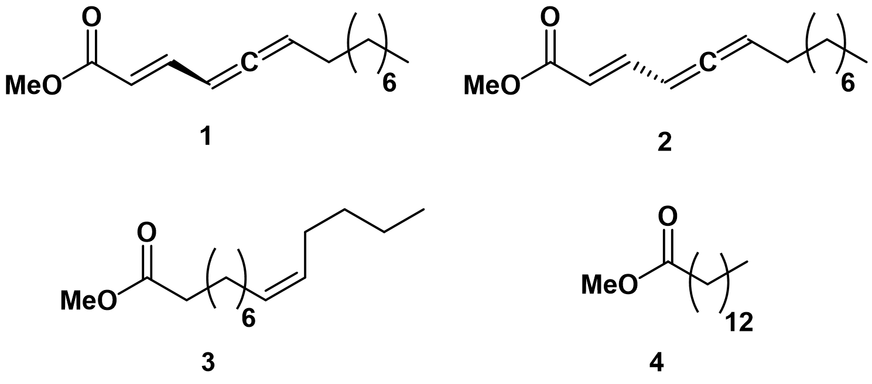

Fig. 1. Structure of methyl (E,R)-2,4,5-tetradecatrienoate (1), methyl (E,S)-2,4,5-tetradecatrienoate (2), the mono-unsaturated methyl myristoleate (3) and the saturated analogue methyl myristate (4).

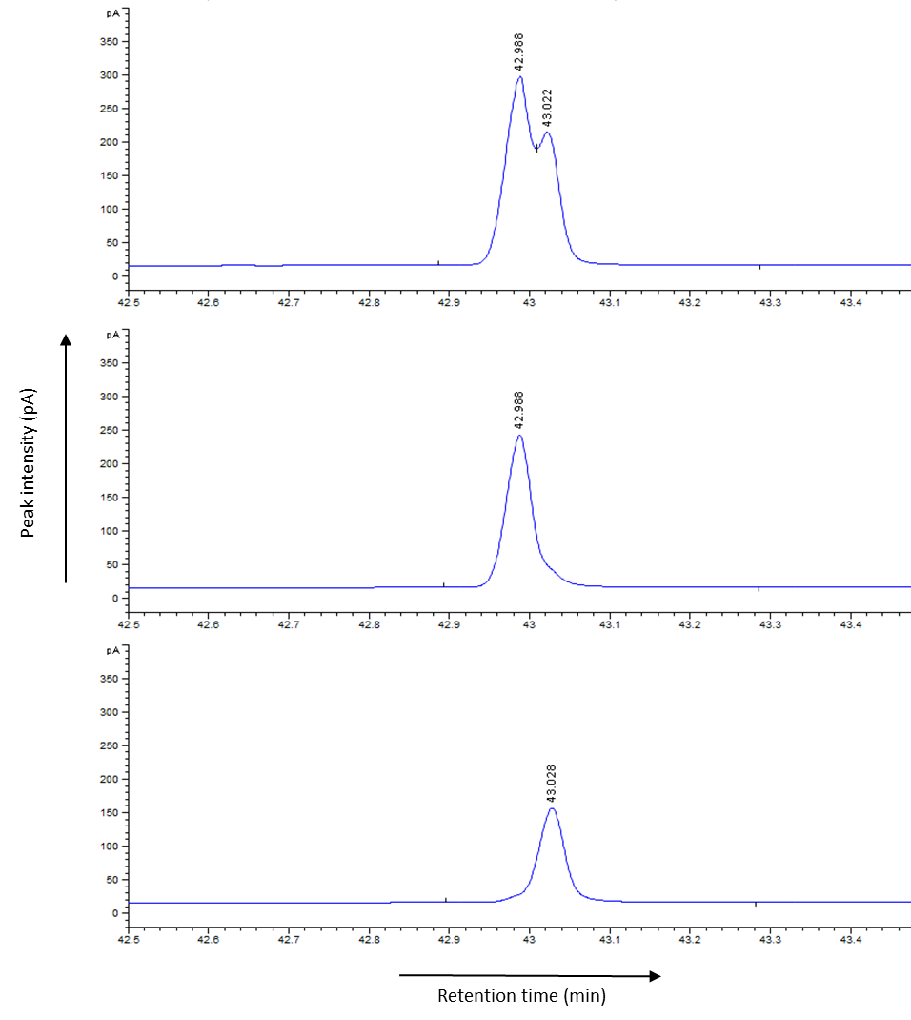
Fig. 2. Chiral GC peaks of sythetic methyl (E,R)-2,4,5-tetradecatrienoate (middle panel), methyl (E,S)-2,4,5-tetradecatrienoate (lower panel) and their mixture (upper panel).
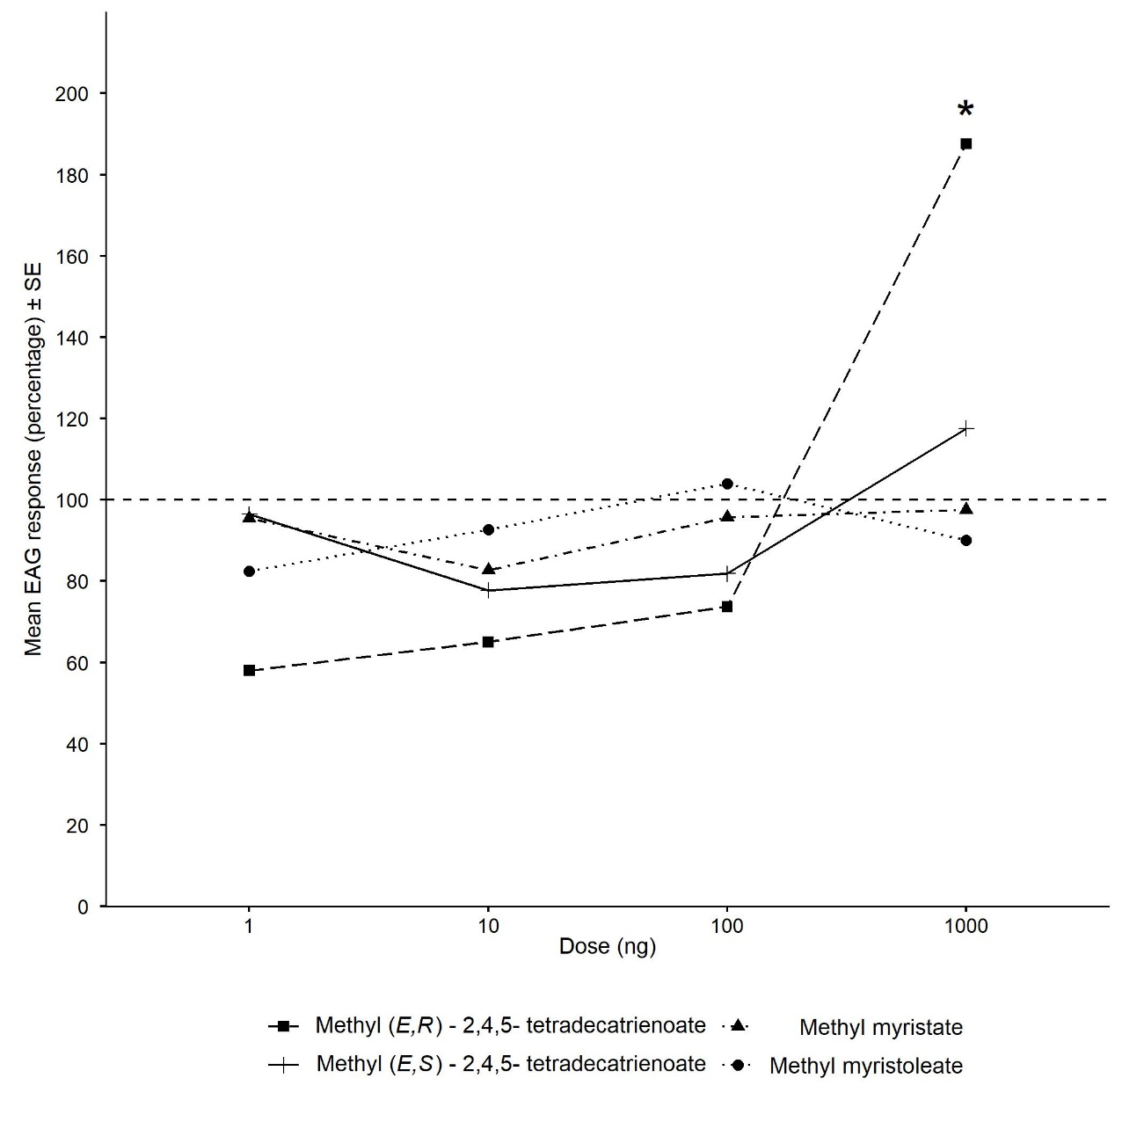
Fig. 3. Normalised EAG responses of antennae of virgin Acanthoscelides obtectus females to enantiomers of methyl (E)-2,4,5-tetradecatrienoate and mono-unsaturated and saturated synthetic analogues (*: significant at P = 0.05)
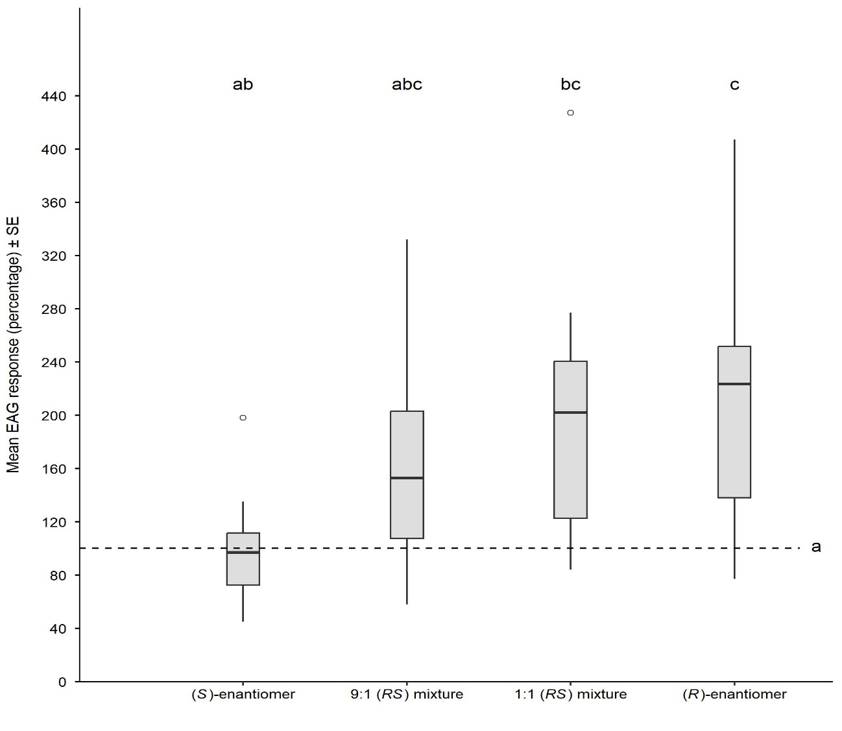
Fig. 4. Normalised EAG responses of antennae of virgin Acanthoscelides obtectus females to enantiomers of methyl (E)-2,4,5-tetradecatrienoate and their different mixtures. Box plots with the same letter are not significantly different (P =0.05). Dashed line: ether control. Kruskal-Wallis test: H₄ = 17.56, P = 0.001
Table 1. Behavioural responses of virgin Acanthoscelides obtectus females in four arm olfactometer bioassays to enantiomers of methyl (E)-2,4,5-tetradecatrienoate, their different mixtures, mono-unsaturated and saturated synthetic analogues.
Assay | Treatment | Mean time spent ±SE | Significance*
1 | a) Methyl (E,R)-2,4,5-tetradecatrienoate  b) Control | 9.646 ± 0.923  0.665 ± 0.162 | <0.001
2 | a) Methyl (E,S)-2,4,5-tetradecatrienoate  b) Control | 2.876 ± 0.768  2.165 ± 0.364 | 0.597
3 | a) Methyl myristoleate  b) Control | 0.199 ± 0.108  2.202 ± 0.408 | 0.203
4 | a) Methyl myristate  b) Control | 1.566 ± 0.362  1.764 ± 0.250 | 0.805
5 | a) 1:1 racemic mixture (2000 ng)  b) Methyl (E,R)-2,4,5-tetradecatrienoate (1000 ng)  c) Control | 3.576 ± 1.115  0.977 ± 0.716  0.086 ± 0.054 | b  a  a
6 | a) 1:1 racemic mixture (2000 ng)  b) Methyl (E,R)-2,4,5-tetradecatrienoate (2000 ng)  c) Control | 3.248 ± 1.045  1.927 ± 0.440  1.156 ± 0.306 | b  ab  a
7 | a) 9:1 R/S mixture (1000 ng)  b) Methyl (E,R)-2,4,5-tetradecatrienoate (1000 ng)  c) Control | 1.989 ± 0.729  4.21 ± 1.535  0.754 ± 0.218 | ab  b  a
*: at P = 0.05

