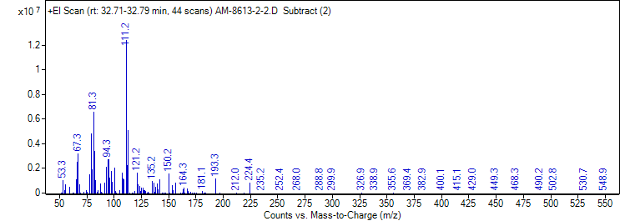
SUPPORTING INFORMATION
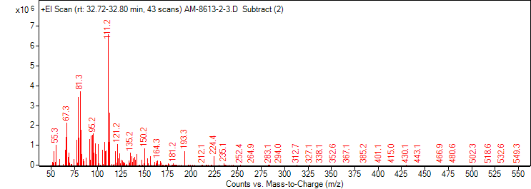
Fig. S1. Mass spectrum of methyl (E,R)-2,4,5-tetradecatrienoate
Fig. S2. Mass spectrum of methyl (E,S)-2,4,5-tetradecatrienoate

