Phoma stem canker (blackleg) of oilseed rape (canola) and other Brassica crops

Summary
Phoma stem canker (blackleg) of Brassicas is caused by Plenodomus lingam or P. biglobosus (formerly Leptosphaeria maculans and L. biglobosa), which are important pathogens of Brassicas in temperate areas, surviving on crop debris, spreading by airborne and rain-splashed spores and infected seed, to cause phoma leaf spots and stem canker, which is the main cause of yield loss.

Abstract: Phoma stem canker (blackleg) of oilseed rape, Brassicas and radish is caused by two closely-related fungi, Plenodomus lingam and P. biglobosus (formerly Leptosphaeria maculans and L. biglobosa). Plenodomus lingam is more aggressive but P. biglobosus can also be damaging and resistance genes against one may not work against the other. Both survive saprophytically on plant debris and spread by wind-dispersed ascospores, rain-splashed conidia and infected seeds. Spores germinate on leaves to infect via stomata or wounds, producing leaf spots which release rain-splashed conidia. Additionally mycelium grows via vascular tissue of the plant to the stem, where stem cankers develop and reduce yield by disrupting water transport. Infections of the pods although rare, produce infected seed, which can spread the pathogen to new locations. Classical identification has been superseded by PCR and DNA sequencing. The disease is managed by crop rotation to separate crops from debris of previous crops, resistant varieties and fungicides. Fungicides have no effect once the fungus has reached the stem, so control aims to prevent leaf spotting. A mixture of at least two fungicide modes of action is recommended e.g. a DMI (Azole; FRAC code 3) and SDHI (FRAC code 7) or QoI (FRAC code 11).

Keywords: Blackleg, phoma stem canker, phoma leaf spot, Leptosphaeria, Plenodomus

Learning outcomes
1. Provide methods for identification of the pathogens by molecular diagnostics and visual symptoms
2. Provide an understanding of the transmission and dispersal of the pathogens
3. To explain the disease cycle and provide information on management and control methods

Introduction
This article explains the current taxonomy, identification methods, disease symptoms, epidemiology and control of phoma stem canker or blackleg of Brassicas, which is caused by two species, Plenodomus lingam or P. biglobosus (formerly known as Leptosphaeria maculans and L. biglobosa and they may be known by the asexual stage, Phoma lingam). These are important plant pathogens of oilseed rape (canola; Brassica napus), vegetable Brassicas (e.g. B. oleracea: cabbage, broccoli, kale; B. rapa: turnip, pak choi) and some other herbaceous plants, mainly in temperate areas but P. lingam has not been found in China, nor in most parts of both South America and Africa. In addition, P. dezfulensis (a close relative of P. biglobosus) causes phoma leaf spot in Iran. Phoma stem canker can cause yield losses exceeding 50% in some individual fields but usually losses are 0-15%. The fungi survive saprophytically on crop debris and spread by two types of spore – ascospores, which are wind dispersed and can travel hundreds of metres and potentially longer, and conidia, which are rain-splashed short distances (e.g. <2m) but occasionally a few hundred metres as a fine spray of splashed rain in strong wind. Spread to new locations can also occur through infected seed or crop debris. Infection of leaves requires high humidity and is via stomata or wounds and the fungi grow down the leaf vascular tissue to infect the stem, where they cause stem canker, a type of dry stem rot. Fungicides are not effective once the fungus has reached the stem so prevention of leaf spots is the best control strategy, aided by good crop rotation and cultivar resistance. Identification methods by PCR and DNA sequencing are also described.

Taxonomy and Nomenclature
Phoma stem canker is caused by two closely-related species, Plenodomus lingam (Tode) Höhnel and P. biglobosus (formerly Leptosphaeria maculans and L. biglobosa), which are Ascomycetes in the class Dothideomycetes, and family Leptosphaeriaceae. The asexual stage of P. lingam is Phoma lingam. Many sources of literature refer to them as L. maculans and L. biglobosa and before 2001 P. biglobosus (L. biglobosa) was known as the weakly-aggressive, B-type or Tox⁰ type of L. maculans.
Currently there are sub-clades of both species, which are P. lingam subclades ‘brassicae’ and ‘lepidii’ and P. biglobosus subclades ‘americensis’, ‘australensis’, ‘brassicae’, ‘canadensis’, ‘erysimii’, ‘occiaustralensis’ and ‘thlaspii’ see Mendes-Pereira et al. (2003). In addition, a very close relative of P. biglobosus has been named from samples in Iran and is termed Plenodomus dezfalensis.

Description and Morphological Identification
Ascospores of both species are identical physically although the pattern of initial hyphae produced by germinating ascospores is different. P. lingam hyphae emerge initially from central cells of the ascospore and branch profusely with side branches angled almost perpendicularly from the initial hypha, while P. biglobosus produces germ tubes initially from the terminal cells at each end of the ascospore and these grow relatively long and straight hyphae, branching by dichotomising at relatively shallow angles (Huang et al, 2001). Other physical differences between the two species are the production of a dark yellow pigment in culture by P. biglobosus and production of pink to violet conidial ooze (cirri) by P. biglobosus compared to pale cream coloured cirri in P. lingam but there can be some overlapping characteristics in some isolates so molecular diagnostics are needed for complete identification (see later).
Ascomata (pseudothecia) are flattened black spheres 200–250 μm high × 300–500 μm in diameter with a single pore on the top surface. The ascomata occur alone or clustered in groups, initially immersed or partly immersed in crop debris but becoming raised above lignified material as softer dead plant tissues degrade away. The mature ascocarp can be hydrated in water and squashed or sectioned to show the outer dark pigmented thick-walled cells of the outer layer, an inner subhyaline or light brown layer of angular cells and the internal contents of sterile hairs (periphyses) and sacs (asci) containing eight ascospores. The asci are 90–110 × 10–12 μm hyaline, bitunicate (double-walled) structures sausage-shaped apart from tapering towards the base.
The ascospores are 35–70 × 5–8 μm, pale tan coloured, ellipsoids, sometimes slightly curved and comprising 6 cells divided by five septae, and sometimes slightly constricted at the central-most septum. Each cell may contain one or more guttules (vesicles). (Figure 2)
The asexual stage is produced in pycnidia, which are embedded in leaf lesions and are 150–350 μm in diameter, dark-brown to black flattened spheres with a small pore at the apex of a raised neck or spout in the centre of the upper surface. The pycnidia occur singly or more normally in groups within the leaf lesion. Alternatively, larger pycnidia occur on the surface of crop debris and are 300–700 μm in diameter and slightly more spherical that the type of pycnidia occurring in leaf lesions. In both cases, the pycnidium comprises several layers of pseudoparenchymatous cells pigmented dark brown. Conidia produced in the pycnidia are 3–5 × 1–2 μm, hyaline, aseptate, elongated spheres, occasionally with two small guttules near each end. The mass of conidia produced from the ostiole or pore of the pycnidium appear as a pale white, cream or pink-coloured ooze (cirrus), which readily disperses into water.
In culture, both P. lingam and P. biglobosus grow on common media like PDA or V8-agar at 15-25°C in the dark, producing a mat of mycelium ranging from white to pale grey in colour, sometimes with other pigments and particularly most isolates of P. biglobosus produce a dull yellow-orange pigment, which is easily seen on PDA (Figure 1). Both also produce pycnidia in culture. P. biglobosus tends to stale in culture and loses viability if kept for a long time.
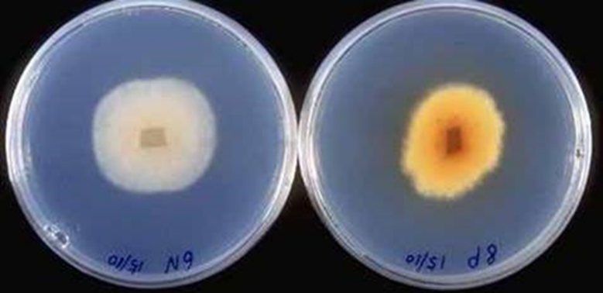
Figure 1. Cultures of P. lingam (left) and P. biglobosus (right) growing on Potato Dextrose Agar and showing yellow pigment production by P. biglobosus

Symptoms and disease cycle
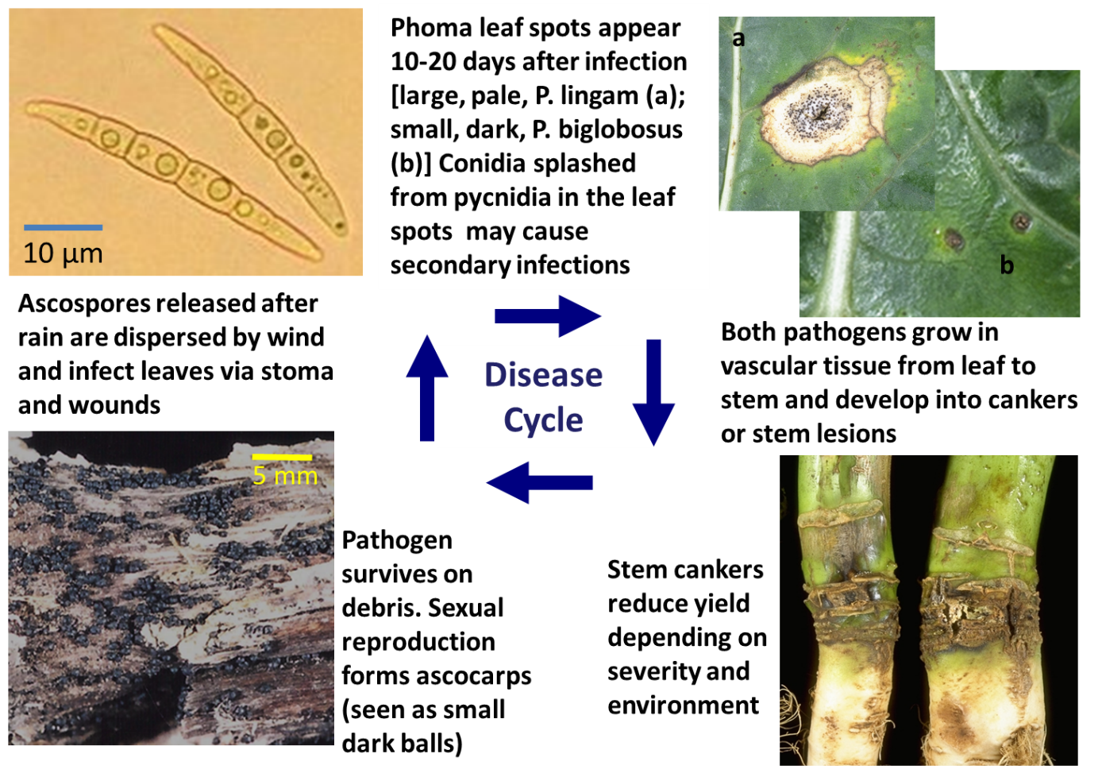
Figure 2. Disease cycle of phoma stem canker, showing air dispersed ascospores approximately 50 µm long (top left), phoma leaf spots of both types (top right), stem cankers (bottom right) and ascocarps on the surface of dead stem debris. All photos by Jon West except ascocarps which was by Rothamsted’s photography group.
The fungus survives on stem and root debris for a few years or more unless the debris is immersed by flood water, which tends to cause it to be replaced by other microbes (Peluola et al. 2013). Both pycnidia and ascocarps can be produced on the surface of crop debris. Pycnidia tend to survive on crop debris only short periods and as they empty, further fruiting body production tends to be ascocarps. In temperate locations, these mature and release wind dispersed ascospores in the autumn and to a lesser extent into the winter and spring. In Canada, due to longer, cold winters, ascospores are released from the previous season’s crop debris the following spring, while in Australia, they can be released to infect autumn-winter-sown crops of spring type canola crops and can continue to be released the following year. Factors affecting maturation and timing of ascospore release are discussed in a later section. Ascospores infect leaves in wetness films by producing hyphae that penetrate stoma, hydathodes or wounds.
Leaf spots develop about 7-20 days after infection but vary in appearance according to host resistance and leaf age. P. lingam causes pale lesions approximately 5-20 mm in diameter which develop multiple small dark specks in them (Fig.2a). These are pycnidia, which produce a type of asexually-produced spore called conidia (described earlier). Conidia can cause secondary infections by splashing short distances to other leaves and nearby plants. In contrast, P. biglobosus tends to cause small dark brown spots which may be surrounded by chlorotic tissue (Fig. 2b). The centre of some spots may degrade or drop out completely. In humid conditions, aerial mycelium may be produced, particularly at the margin of lesions.
Stem cankers and stem lesions result from the fungus growing down vascular tissue of the petiole to reach the stem. Cankers appear from flowering onwards in oilseed rape at stem positions where the infected leaf had been attached. Green stem tissue darkens to almost black immediately around the edge of cankers leading to the alternative name, blackleg, but the centre of cankers appear as a dry pale brown lesion, which with maturation towards harvest, may crack open and also develops pycnidia and later still ascocarps. The severity of canker is a product of the extent of girdling and internal stem infection and may result from several cankers coalescing. In severe cases, upper parts of the plant become drought stressed due to insufficient water transport, leading to reduced yield and premature senescence. This is exacerbated by hot and windy weather due to increased water demand. In very severe cases, the plant may lodge.
Infections of later leaves (after the rosette leaves) and bracts can lead to stem lesions, whereas stem cankers occur at the stem base or crown of the plant. Upper stem lesions tend to spread up and down the softer stem tissues more readily so the black or dark discolouration becomes more apparent.
Pod lesions can occur from late spore releases after flowering and are similar to leaf spots but occurring on the pods [siliques] and peduncles, causing some constriction and reduced development of the affected pod. These can be important by infecting seed in the pods, which is one of the main ways for the disease to be introduced to completely new locations.
Root infection also occurs either by growth of the fungus down the stem from basal stem cankers or directly from the soil where spores may have been washed or where the fungus may have survived on crop debris. Tap roots and the root collar persist longest after harvest due to their lignified, woody composition and on affected plants, appear to have blackened areas encrusted with melanised ascocarps or their empty shells.

Diagnostic Tools
Morphological discrimination of P. lingam and P. biglobosus, for instance by growing the isolated fungus on artificial agar media such as potato dextrose agar (PDA) and examining cultures for the production of pigment (see Description) can be a cost-effective method for species identification, particularly in resource-poor laboratories, but can also be time-consuming and not always reliable (King & West, 2021). Identification of the pathogens can also be attempted via isolation from infected seeds using the blotter test described by Andreoli and Maguire (1995), although again this approach can be time consuming and give inconclusive results. Thus molecular PCR-based diagnostic approaches are often used, including species-specific quantitative PCR (qPCR) assays that can determine amounts of DNA of each pathogen species in environmental samples. These can be simple SYBR-green qPCR assays, that are relatively cheap but rely on a non-specific fluorescent dye binding to amplified DNA, and thus results might be affected by any spurious non-target PCR amplification. Alternatively, Taqman qPCR diagnostics are available for Plenodomus spp. (Jacques et al. 2021) that are considered more reliable given the inclusion of an additional but expensive internal target-sequence specific probe, with fluorescence only detectable upon successful probe binding to the target DNA sequence. For all molecular-based diagnostics, however, a good understanding of Plenodomus population biology and genetics is essential to ensure the required target is being correctly amplified and identified. For example, in Europe both P. biglobosus ‘brassicae’ and the rare ‘canadensis’ subclades are present (King & West, 2021), but the SYBR green assay of Liu et al. (2006) does not detect the ‘canadensis’ subclade (Kaczmarek et al. 2023). Other molecular diagnostics, such as loop mediated isothermal amplification (LAMP), utilising six primers for each target species and operating at a single constant temperature, have also been developed for detection and discrimination of P. lingam / P. biglobosus (Omer & Wallenhammar, 2021). LAMP offers some advantages over PCR-based approaches, including purportedly improved speed, specificity and sensitivity and the potential for applied use of for this technology by end-users such as growers in the field using a portable device. Last, genomic approaches are now being used for monitoring and quantifying Plenodomus spp. in field populations. For example, work at Rothamsted Research (UK) is currently utilising minION third generation nanopore sequencing to investigate ratios of P. lingam / P. biglobosus in air and plant samples to explore how pathogen populations might be influenced by agronomic practices (e.g. application of fungicides).

Discussion points on epidemiology and control
Ascospores can be dispersed many kilometres but tend to decline to the regional background level within a few hundred metres of a source. Conidia have been shown to cause secondary infections on new leaves and adjacent plants and in some cases in Canada, they were shown to blow in a fine spray combined with wind to infect plants in adjacent fields. Management of crop debris and separation of subsequent crops to avoid close proximity to debris of the previous crop are important cultural control options to reduce disease pressure.
Plant breeders working with plant pathologists in pre-breeding schemes have developed a number of varieties of oilseed rape with resistance to P. lingam in recent years. Less is known about host resistance in vegetable brassicas and little is known about host resistance to P. biglobosus. About 20 different host resistance genes are now known in oilseed rape against P. lingam (L. maculans) (Borhan et al. 2022). At the time of writing (2024) all are named according to the former pathogen name of Leptosphaeria maculans, e.g. Rlm1 or LepR3.
In 2024, UK commercially available oilseed rape varieties have resistance ratings of 4 to 9 on a 1-9 scale. Current varieties that have excellent resistance to the disease include: Vegas (Hybrid variety rated 9) and Murray (rating 8) and others are Dolphin (7), Tennyson (7), Matrix CL (7) and Miraculix CL (7). In many cases, the most durable resistance comes from a good background level of quantitative (polygenic or partial) resistance which doesn’t stop infection but reduces the severity of disease.
Cold weather slows down disease development resulting in reduced canker severity by harvest and a delay in release of ascospores the following autumn. This is why the disease is generally not a problem in cooler locations (e.g. in the UK north of Lincolnshire). However, climate change predictions suggest that warmer weather will exacerbate this disease.
Fungicides are often used in combination with host resistance, particularly in locations where the yield potential of oilseed rape is high. Fungicides should be targeted at preventing leaf infections in initial growth stages as this prevents early infection of the stem. Although some fungicides can have a negative growth regulatory effect if applied to very young plants, in parts of Australia, where leaf infections can often occur on very young plants, growers sometimes coat fertiliser pellets with fungicide and this is drilled below the seed to boost any short-term fungicide effect from seed coatings. In Europe, it is more normal to apply one or two autumn fungicides to oilseed rape and this is done because the yield potential is relatively high due to the temperate conditions. Indeed, one or two fungicide applications, by controlling this disease were found to reduce the greenhouse gas emissions per tonne of grain produced by 15%. Fungicides have very little effect once the fungus has reached the stem. The best timing of fungicide application is after the first significant release of ascospores in the autumn, ideally before more than 10% of plants have phoma leaf spots. The timing of spore release varies each year due to the weather – in Europe, wet summers promote an early release of spores to infect autumn-sown crops (Huang et al. 2007). Ascospores in Europe are mainly from the previous season’s debris, while in North America, spring sown plants are infected from spores produced on debris of the previous or preceding crop and in Australia, autumn sown varieties are infected by ascospores released from debris 6-18 months old. In the UK, a weather-based forecasting tool is available, which forecasts the date when 10% of plants will have phoma leaf spot - see Evans et al (2007) and https://ahdb.org.uk/provision-of-oilseed-rape-decision-support-systems-to-the-uk-arable-industry.
Due to improvements in host resistance, locations that routinely used two autumn fungicides have now reduced applications to a single autumn spray unless phoma leaf spotting is very early or if the variety grown is known to be very susceptible. On more resistant varieties of oilseed rape, fungicide applications can even be omitted completely (against phoma stem canker) and particularly if phoma leaf spotting is late. Fungicide options are to use at least two modes of actions such as a DMI (FRAC code 3, e.g. mefentrifluconazole) plus an SDHI (FRAC code 7, e.g. bixafen) or a QoI (FRAC code 3, e.g. pyraclostrobin).

Further reading
Fungicide Resistance Action Committee (FRAC) - https://www.frac.info/
Bingol E, Qi AM, Karandeni-Dewage C, Ritchie F, Fitt BDL, Huang YJ. 2023. Co-inoculation timing affects the interspecific interactions between phoma stem canker pathogens Leptosphaeria maculans and Leptosphaeria biglobosa. Pest Management Science. DOI10.1002/ps.7799.
van de Wouw AP, Scanlan JL, Al-Mamun HA, Balesdent M-H, Bousset L, Burketová L, Mendoza LD, Fernando WGD, Franke C, Howlett BJ, Huang YJ, Jones EE, Koopmann B, Lob S, Mirabadi AZ, Nugent BC, Peng GRY, Rossi FR, Schreuder H, Tabone AR, Van Coller GJ, Batley J, Idnurm A. 2023. A new set of international Leptosphaeria maculans isolates as a resource for elucidation of the basis and evolution of blackleg disease on Brassica napus. Plant Pathology. DOI10.1111/ppa.13801
Stachowiak A, Olechnowicz J, Jedryczka M, Rouxel T, Balesdent MH, Happstadius I, Gladders P, Latunde-Dada A, Evans N. 2006. Frequency of avirulence alleles in field populations of Leptosphaeria maculans in Europe. European Journal of Plant Pathology 114, 67-75. DOI10.1007/s10658-005-2931-z
West JS, Fitt BDL, Leech PK, Biddulph JE, Huang Y-J, Balesdent M-H. 2002. Effects of timing of Leptosphaeria maculans ascospore release and fungicide regime on phoma leaf spot and phoma stem canker development on winter oilseed rape (Brassica napus) in southern England. Plant Pathology 51, 454-463.
West JS, Balesdent M-H, Rouxel T, Narcy JP, Huang Y-J, Roux J, Steed JM, Fitt BDL, Schmit J. 2002. Colonisation of winter oilseed rape tissues by A/Tox+ and B/Tox0 Leptosphaeria maculans (phoma stem canker) in France and England. Plant Pathology 51, 311-321.
West JS, Kharbanda PD, Barbetti MJ, Fitt BDL. 2001. Epidemiology and management of Leptosphaeria maculans (phoma stem canker) on oilseed rape in Australia, Canada and Europe. Plant Pathology 50, 10-27.

References
Andreoli C, Maguire JD 1995. Preliminary investigations on the viability of the use of abscisic-acid (aba) in crucifer seed health test for detecting Phoma-lingam. Pesquisa Agropecuaria Brasileira 30, 291-294.
Borhan MH, Van de Wouw AP, Larkan NJ. 2022. Annual Review of Phytopathology 60, 237–57. https://www.annualreviews.org/doi/10.1146/annurev-phyto-021621-120602
Evans N, Baierl A, Semenov M A, Gladders P, Fitt BDL. 2007. Range and severity of a plant disease increased by global warming. Journal of the Royal Society Interface. 5, 525-531. https://doi.org/10.1098/rsif.2007.1136
Huang YJ, Liu Z, West JS, Todd AD, Hall AM, Fitt BDL. 2007. Effects of temperature and rainfall on date of release of ascospores of Leptosphaeria maculans (phoma stem canker) from winter oilseed rape (Brassica napus) debris in the UK. Annals of Applied Biology. 151, 99-111. https://onlinelibrary.wiley.com/doi/10.1111/j.1744-7348.2007.00157.x
Huang YJ, Underwood CT, Fitt BDL, Todd AD, West JS, Koopmann B, Balesdent MH. 2001. Effects of temperature on germination and hyphal growth from ascospores of A-group and B-group Leptosphaeria maculans (phoma stem canker of oilseed rape). Annals of Applied Biology 139, 193-207. https://doi.org/10.1111/j.1744-7348.2001.tb00396.x
Jacques N, Balesdent M-H, Rouxel T, Laval V. 2021. New specific quantitative real-time PCR assays shed light on the epidemiology of two species of the Leptosphaeria maculans-Leptosphaeria biglobosa species complex. Plant Pathology 70, 643–654.
Kaczmarek J, West JS, King KM, Canning GGM, Latunde-Dada AO, Huang Y-J, Fitt BDL, Jedryczka M. 2023. Efficient qPCR estimation and discrimination of airborne inoculum of Leptosphaeria maculans and L. biglobosa, the causal organisms of phoma leaf spotting and stem canker of oilseed rape. Pest Management Science. https://doi.org/10.1002/ps.7800
King KM, West JS. 2021. Detection of the Phoma pathogens Plenodomus biglobosus subclades ‘brassicae’ and ‘canadensis’ on wasabi, and ‘canadensis’ in Europe. European Journal of Plant Pathology. https://doi.org/10.1007/s10658-021-02428-z
Mendes-Pereira, E., Balesdent, M.-H., Brun, H., & Rouxel, T. (2003). Molecular phylogeny of the Leptosphaeria maculans–L. biglobosa species complex. Mycological Research 107, 1287–1304. https://doi.org/10.1017/S0953756203008554
Omer ZS, Wallenhammar AC. 2020. Development of loop-mediated isothermal amplification assays for rapid detection of blackleg pathogens in Swedish winter oil seed rape. European Journal of Plant Pathology 157, 353-365. https://doi.org/10.1007/s10658-020-02004-x
Peluola C, Fernando WGD, Huvenaars C, Kutcher HR, Lahlali R, Peng G. 2013. Effect of flooding on the survival of Leptosphaeria spp. In canola stubble. Plant Pathology 62, 1350–1356. https://bsppjournals.onlinelibrary.wiley.com/doi/10.1111/ppa.12036

