Using a multi-scale approach to examine the effects of field margins and landscape features on predatory carabid communities in crop fields.

Kelly Jowett^{1,2}, Alice E Milne¹, Dion Garrett^{1,2}, Dan Blumgart¹, Simon G. Potts³, Deepa Senapathi³, Jonathan Storkey¹
¹Rothamsted Research, Harpenden, Hertfordshire AL5 2JQ, UK
²University of Warwick, Coventry, CV4 7AL, UK
³Centre for Agri-Environmental Research, School of Agriculture Policy and Development, University of Reading, Reading, RG6 6AR, UK
Corresponding Author: Kelly Jowett, Sustainable Agricultural Sciences, Rothamsted Research, Harpenden, Hertfordshire AL5 2JQ, UK, Kelly.jowett@rothamsted.ac.uk

Highlights

- Greatest influence on carabids in crop areas was crop type, followed by landscape
- Margin type explained relatively little variance of in-field carabid communities
- Overall, abundances were less with margins than control of ‘no margin’
- Abundances lower in spill-over zone of grass margins, and within wildflower margins
- Carabid larvae notably more abundant with an absence of field margins

Abstract
Carabid beetles are major predators in agro-ecosystems. The composition of their communities within crop environments governs the pest control services they provide. Field margins and landscape features are known to affect carabid community composition, yet evidence is currently lacking that can be used to support land management decisions targeted at optimising predation services at the farm scale. We used experimental margins across a farm site to test carabid communities in crop areas, margins, and adjacent habitats sampled in the summer. We used novel subterranean trapping with standard pitfall trapping, to distinguish above ground and below ground activity of adults and larvae in different farm habitats. Crop type was the major influence on carabid communities in crop areas. This was followed by landscape influences in terms of adjacent habitat and boundary features, and whilst significant, margin type explained relatively little variance in summer carabid communities in-field. Trap type revealed differential activity by species. Responses to crop type, landscape factors, and margin type also varied by species. Overall, abundances were less in association with margins than control of no margin. Particularly, abundances were lower in the spillover zone adjacent to grass margins, and in the wildflower margins themselves. Carabid larvae showed notably higher abundances in association with an absence of field margins. Measures to boost key carabid species in crop areas should be considered at a farm scale, taking into account potential barrier effects, and potential buffer effects.

Keywords
Carabid, pest control, field margin, , spill-over, landscape effects

1. Introduction
Carabid beetles, as predators of weed seeds and invertebrate crop pests, have been the subject of much research (Kotze et al., 2011; Kromp, 1999; Holland, 2003). This has informed the development of field scale measures aimed at boosting the abundance of carabids adjacent to crop areas, such as beetle banks, buffer strips and headlands, and tussocky grass margins (dense grass clumps). The reported success of these measures in promoting in-crop predation is divided, with the effects of interventions being highly variable between studies (Begg et al., 2017; Berendse et al., 2004; Kleijn et al., 2006; Kleijn and Sutherland, 2003; Segre et al., 2020). One reason for this is that carabid abundance and diversity will be a function of the interaction of these in-field features with crop management and the surrounding landscape. Understanding these interactions will inform the most effective strategy for habitat creation and management on farms for the enhancement of predation (Begg et al., 2017).
Studies on carabids in agricultural areas have gleaned broad insight into some of these additional factors affecting carabids. Crop type, soil type, soil moisture, cultivations, pesticides, and landscape including non-crop habitats have been proven to have significant effect on abundance and diversity (Holland and Luff, 2000; Jowett et al., 2019; 2021; Labruyere, Petit, and Ricci, 2018; Thiele, 1977; Thomas, Holland, and Brown, 2003). A key knowledge gap in this respect is understanding how these factors interact at scales larger than the individual field so that land management decisions can be taken to optimise carabid abundance and community composition in crop areas. Most studies are undertaken at either small-scale: in laboratory or plot-field scale studies, or large: in landscape scale analyses (Aguilera et al., 2020; Brooks et al., 2008; Kinnunen, Tiainen, and Tukia, 2001; Kotze et al., 2011). What is absent from the research is the knowledge of where in a farm, or a management block, field scale interventions should be placed or how the distribution of different crop types and land use in the landscape impacts carabid predation services in crop fields.
There is consensus about the importance of adjacent habitats, particularly grassland, in influencing carabid community composition, yet the extension of this to the utility of the community with respect to efficient control of crop pests has not been comprehensively investigated (Aguilera et al., 2020; Boetzl et al., 2019; Ricci et al., 2019). Tussocky grass habitats are reported to provide areas for hibernation and aestivation (summer diapause) (Dennis, Thomas, and Sotherton, 1994; Desender 1982; Sotherton 1984; 1985). However, the provision of these small-scale grass habitats does not necessarily translate to carabid spill-over and predation in crop areas (Tscharntke, Rand, and Bianchi, 2005). The value of grass margins, moreover, may not hold true for all carabid species of value to agricultural pest and weed seed control (Lagerloff and Wallin, 1993), for example, Jowett et al. (2019) found that the presence of margins did not universally increase carabid abundance in central crop areas.
Previous work shows that factors affecting presence and abundance of carabids varies by species, even when species are morphologically similar (Den Boer, Thiele, and Weber, 1979; Jowett et al., 2019; Kotze et al., 2011; Luff, 2002). The habitat preference of carabid species acts as a filter on the species occupying farm habitats, so that despite their polyphagous opportunistic nature, this results in actualised niches avoiding interspecific competition (Holland, 2002; Loreau, 1990; Niemelä, 1993). It follows that the resources necessary to promote the presence of certain species may be supplied differentially. We would, therefore, expect species to respond differently to alternative combinations of field margins, crop management and landscape context with implications for managing farms to promote the best predators of crop pests and weed seeds.
This study utilised a network of experimental field margins across a UK farm site of 330 ha to sample carabid beetles with standard pitfall traps and subterranean pitfall traps (trap is set belowground, Jowett et al., 2021). To interpret these effects in the context of the local landscape, we studied the effects of different field margin interventions over multiple farm habitats and crop combinations across the farm site. By trapping with standard and subterranean pitfalls, we sampled the whole communities of carabid beetles, in various crops, experimental margins, and adjacent landscape features, across a farm landscape. We used this data to explore three questions with the aim of elucidating carabid distributions at multiple farm scales:
- What are the key factors influencing carabid abundance and species richness in crop areas?
- How do differential species responses to management and landscape factors influence the community composition?
- Do these processes vary across scales irrespective of field level differences?

2. Material and Methods
We used 10 established experimental margins across the Rothamsted farm (330 hectares), UK, in 2017. Each margin was 210 m length, split into three sections of 70 m x 3 m each section randomly allocated to ‘grass mix’, ‘wildflower mix’, or Lepidoptera ‘moth mix’ (Blumgart et al., 2023) (Fig. 1). We used two treatments seeded with standardised mixes commercially produced for field margins. The grass mix contained four species of non-competitive grasses (Agrostis capillaris, Cynosurus cristatus, Festuca rubra and Phleum bertolonii), and the wildflower mix contains the same four grasses, plus 13 species of perennial wildflower widely used in agri-environment scheme margins (Table S1). We also included a control as an additional level in the treatment with no-sown margin (a cultivated field edge or narrow natural-grass border). The field margins were originally set up in a randomised block design, each block including the three margin treatments (Blumgart et al., 2023). We selected blocks that allowed for multiple comparisons of features of interest: crop type, adjacent habitat; and field boundary (hedgerow, trees, fences, or tracks). While the margin treatments were balanced, it was not possible to find balanced replicates of these additional factors. Rather, blocks were chosen that represented the diversity on the farm.
For each margin, we sampled along transects perpendicular to the field edge (where possible as dictated by field shapes). Sample points were georeferenced. Each field was split into three zones, (i) margin or field edge (in the case of the control treatment), (ii) crop edge (2–3 m from Margin or field edge), (iii) crop centre (defined as a representative central point of the field at least 20 m from the field edge, in most fields 40-50 m). In addition, two zones that extended back into the adjacent habitat (two-way transects) were also sampled: (i) adjacent habitat edge and, (ii) adjacent habitat centre (Fig. 1). Where a field bordered an urban area, the adjacent habitat was not sampled. All transect groups ran parallel to field side boundaries for blocking, to minimise the effect from these.
Standard pitfalls were used on all transects, with subterranean pitfall traps used on a subset of five fields, three of which were two-way (Table S1). For standard pitfalls, there were two lines for each margin/control located 10 m apart and, for subterranean traps, a single line located midway between standard pitfall transects. Where possible, controls were located near to experimental margins but avoiding control transects running in parallel to close to field edges. Where this was not possible, control treatments were split either end of margin treatments (Fig. S1).

2.1 Trapping
The standard pitfall and subterranean traps (Fig. 2) were set using 70% ethanol 30% water mix, filled to ⅓of the standard (200 ml) pitfall cup, and ¼ of the subterranean (150 ml) pot. Traps were run from the 20th of June to 8th of August 2019, in three runs; each consisted of a seven-day period. Carabid adults were identified to species (Luff, 2007). Consensus tests were carried out with individuals processing samples. All runs of the experiment were subject to similar climatic conditions and constituted the same lifecycle period in terms of community assemblages, and as such were pooled for analyses. Samples that were spoiled damaged or incomplete (around 10%) were not included in for analysis. Altogether, there were 224 traps from Run 1, 269 in Run 2, and 278 in Run 3 (table S2). We used the standard proxy measure of activity density to account for abundance.

2.2 Statistical analysis
We fitted Linear Mixed Models (LMMs) using Genstat 22nd Edition (Payne, 1993) to determine the effect of environmental factors on, (i) pooled-carabid abundance (N), and (ii) richness (S). We chose to use a LMM on logged abundance over a GLMM with Poisson distribution, because the model fit is often more stable for complex data sets (Stroup 2012).

2.3 Key factors influencing carabid abundance and species richness in crop areas and margins
To explore Q1, we subset the data to include only samples from the crop area (crop edge and crop centre), and further to pitfall traps only, as each trap type represents a different measure of activity density. The reduced factor repetition in subterranean trap data resulted in insufficient power to draw statistical conclusions with linear models but these data were used in the community analysis (see below).
We considered the factors in-field crop (winter wheat, spring barley, winter barley, spring oilseed rape (OSR), winter OSR, and spring oats), position (transect point crop centre or crop edge), margin type (grass, wildflower, control), and adjacent habitat (pooled to categories of crop, grass/scrub, or urban) as fixed effects with two-way interactions. The random model was defined as run (to examine time as a block and average temporal effects over locations), and nested within each run, field, transect, and location on the transect (i.e., plot/trap replicate). We log transformed the pooled-abundance and species richness so that residuals conformed to normality. We selected terms using backwards elimination according to the largest P-value given by the Kenward-Roger approximate F -tests. The final predictive model was chosen when all remaining terms gave significant values (P ≤ 0.05) when dropped from the model.
To explore the effects of margins, we extended the dataset to include margin transect points, so position was expanded to include margin as well. All LMMs were repeated, as above.

2.4 Carabid community composition relative to crop areas and margins
To study community differences (Q2), we analysed count data using Canonical Correspondence Analysis (CCA) and partial CCA (pCCA) in Canoco (Smilauer and Leps, 2014). Six separate analyses were done to quantify: 1) Temporal effects, including data from all sample points (species ~ run), 2) Effect of trap type, only including sample points for which there were both pitfall and subterannean trap data (species ~ trap_type | run), 3) Effect of semi-natural vs. cultivated habitats, just using data from grass + wildflower margins + grass/scrub and crop centres respectively (species ~ habitat | run), 4) Conditional effect of crop type, just using data from crop edges and centres (species ~ crop_type | run + position + margin_type + adjacent_habitat + boundary_feature), 5) Conditional effect of margins, just using data from crop edges and centre (species ~ position + margin_type | run + crop_type + adjacent_habitat + boundary_feature) and 6) Conditional effects of landscape context, just using data from crop edges and centres (species ~ adjacent_habitat+boundary_feature | run + crop_type + position + margin type). For each analysis, we excluded species occurring in less than 5 % of traps included in the input to avoid analysis bias by infrequent species.
To examine the species preferences driving community differences, we fitted LMMs to the data on abundance of carabids at a species level for the five most abundant species, and pooled carabid larvae (to ensure enough data for model terms). Both trap types were included and therefore, species could be analysed by trap type, indicating their above ground or subterranean movements in each habitat type. Random terms remained the same as pooled LMMs above, and we included the factors vegetation, transect point (centre, edge, or margin), and trap type in the fixed effects.

2.5 Carabid distribution processes
To explore the spatial dependence in carabid abundance a Linear Mixed Model (LMM) framework was used in which the log abundance was modelled for the pooled standard pitfalls and subterranean pitfalls separately (since these comprise differential activity-density). We also modelled the top five most common species with the pitfall trap data alone. In this instance, our interest was on the spatial covariance in the data, which quantifies how related observations are given their relative proximity. This is captured as a correlated random effect of the model along with an independent and identically distributed (iid) random error (known as the nugget). Run was included as a fixed affect to avoid issues related to the co-location of measurements made at different time points. As before the environmental factors expected to affect the abundance of carabids (vegetation and adjacent) were tested as potential fixed effects as well as the spatial coordinates so to account for large-scale trends. The spatial covariance in the data is described by a variogram model for which the parameters are estimated (Webster and Oliver, 2007). Initial exploration indicated that the exponential variogram model provided the best fit for the total abundance model, so we chose to use this function for all models. The exponential model is given by:
$$γ\left(h\right)=c_{0}+c_{1}\left\{1-exp(-\frac{h}{a}\right\} for h>0$$
$=0$ $for h=0$
where $c_{0}$ is the nugget $c_{1}$is the spatially correlated random component and $a$ is the distance parameter. Here $h$ denotes lag distance between observations. The quantity 3$a$ is the effective range of the spatial correlation (Webster and Oliver, 2007).
Models were fitted by sequentially adding fixed effects to the “null” model which in this case was the model with only the run factor as a fixed effect. Model fitting was done using the likfit function in the geoR package for the R platform (Diggle and Ribeiro, 2007; R Core Team, 2021). Terms were retained if there was evidence that adding fixed effects to a simpler model achieved a significant improvement by computing the log-ratio statistic (see Supplementary material).
The final fitted models were inspected to determine whether there was any longer-range trend in abundance across the farm and to characterise any spatial dependence in carabid populations and specific species.

3. Results

3.1 Summary of data
A dataset consisting of 771 trap occasions was produced (Run 1: 224, Run 2: 269, Run 3: 278), comprising 19 009 individual records of 60 carabid species. This includes an aggregate of Amara ovata and Amara similata, due to potential species overlap. Species ranking in terms of abundance was similar for all runs but differed between trap types (Table 1).

3.2 Question 1: What are the key factors influencing carabid abundance and species richness in crop areas?
The LMM of crop area abundance of carabids showed a significant effect of trap position, with significant interactions between crop and trap position, margin type and trap position, and trap position and adjacent habitat (Table S4). Counts were higher in crop centres compared to the edge for all crop types except spring oats (where crop establishment was poor in the year of the study). Within crops, there were no effects of margins and adjacent habitats on crop centre counts, however, there were effects on crop edges. Crop areas on transect lines from grass margins were significantly lower at the crop edge compared to control and wildflower margins. Abundances were greatest in spring barley (Fig. S3) and tended to be greater in crop areas adjacent to crops, and lower in crop areas adjacent to urban areas but again, when comparing within a crop, this effect was only observed in the crop edges (Fig. S4). The lowest counts were recorded at crop edges in winter wheat crops adjacent to urban areas.
The LMM for species richness in crop areas showed similar significant interactions to the total abundance model (Table S4), which may partly be explained by variance in total number of individuals caught. As with abundance, species richness in crop areas was similar in control and wildflower margins, yet crop areas on transect lines from grass margins was generally lower at the crop edge. Species richness was greatest in spring oats, at the field centre (Fig S5).

When we included the traps positioned in the margins in the LMMs, significant model terms were similar, but adjacent habitat was now lost as a significant term in the model, though it was near significant. For abundance, the LMM showed a significant effect of trap position and margin type, trap position showed a highly significant interaction with crop, and margin type showed a significant interaction with crop (Table S4). Generally, margin positions showed less abundance than crop positions, yet there was a clearly lower abundance in the margin transect position when this was in a wildflower margin (Fig. 3).

For species richness with a margin transect position, LMMs retained adjacent habitat in the model. The models showed a significant effect of trap position, a significant effect of margin type, a significant effect of adjacent and significant interactions of trap position, with terms of crop, and margin type (Table S4). The same patterns are evident by margins as abundance, particularly that species richness is reduced in margin transect positions, where that occurs within a wildflower margin (Fig S6). By adjacent habitat, where crop comparisons were enabled by repetition for spring oats and wheat, species richness was higher in crop areas adjacent to crops, and lower in crop areas adjacent to urban areas (Fig. 3B).

3.3 Question 2- How do differential species responses to management and landscape influence community composition?
The CCA testing temporal effects showed run explained 4.2 % of variance in carabid community composition, with carabid larvae and Nebria salina relatively more abundant earlier in the year, whilst Calathus fucipes and Carabus violaceus had a proportionally greater catch later in the year. Run was included as a covariate in subsequent community analyses. A pCCA testing the effect of trap type explained only 2.5 % of variance in species composition. Some species were over or under-represented by trap type – carabid larvae and Trechus quadristriatus were proportionally more abundant in subterranean traps, whilst Carabus violaceus, Calathus fuscipes, and Pterostichus madidus were more abundant in standard pitfalls. Based on the low variance explained and as traps were balanced across runs, habitats and positions, trap type was not included as a co-variate in additional multivariate analyses.
The pCCA grouping trap data into semi-natural and cultivated habitats explained 3.2 % of the variance in community composition. Six species (Harpalus rufipes, Harpalus affinis, Pterosticus melanarius, T. quadristriatus, and Amara similata/ovata agg.) were significantly relatively more abundant in cropped habitats, with no species significantly associated with semi-natural habitats. The series of pCCA testing the conditional effects of crop type, margin type + trap position and adjacent habitat + boundary feature (including the other factors as covariates in each case) partitioned the variance between the three factors. Crop type explained the largest amount of variance - 11 %. Most species had an association with spring barley and wheat, yet Amara similata/ovata agg. showed an association with winter oilseed rape. No species were associated with winter barley or spring oilseed rape (Fig. 4A). This was followed by conditional effects of landscape features (adjacent habitat + boundary) that explained 6.4% of the variance in community composition (Fig. 4B). The ordination discriminated between open, simple (crops and tracks) and closed, complex (urban and hedges) landscapes. Most species were clustered around a factor of no field boundary. Finally, trap position and margin type explained relatively little variance in community composition (2.3%). Most species had no particular association, with clustering in the centre of all axes, however, T. quadristriatus was associated with a margin opposed to the control, and A. plebeja was associated more with crop edge positions (Fig. 4C).

Retained terms and significance for species LMMs are given in Table S5. Predictions based on the LMM for P. melanarius were similar for total abundance, being more abundant at crop centres, and reflected the fact that it was the most the most common species caught in the traps (Table 1; Fig. 5A). The LMMs for H. rufipes indicated this species was equally abundant in the centre and edge of habitats (Fig. 5B). For both P. melanarius and P madidus, in the majority of crops, the difference between abundances at the edge and centre of the field were greater in the presence of grass margins, with lower abundances in edge areas, particularly in winter sown crops (barley oats and wheat) (Fig. 5A; Fig. 5C). The LMM for Amara similata/ovata agg. was unable to converge. Upon further investigation, this was likely due to extreme aggregation in winter oilseed rape, and little abundance in other crops reducing repetition of factors in model terms.
Almost all species modelled displayed markedly lower abundances in association with a wildflower margin and within the margin transect points wildflower margins had the least abundance (Fig. 5; Fig. S6). Pterostichus madidus had higher abundances in margin transect points when this constituted a grass margin and was the only species showing relative abundance in grass/scrub vegetation. Total carabid larvae were much more abundant in subterranean traps, in all vegetation types (Fig. 5D), P. madidus and Poecilus cupreus showed differential abundances by trap type, yet this was variable by vegetation (Fig. 5B; Fig. 5C; Fig. S6).

3.4 Question 3- Do processes vary across scales irrespective of field level differences?
For the total carabid abundance in pitfall traps the factors vegetation and co-ordinates trend (eastings and northings, and eastings*northings) were found to be significant. The variogram models resulting from the sequential fitting are shown in Fig. 6, with model parameters for the final model given in Supplementary Material Table S6. The variance in the carabid abundance not accounted for by the fixed effects is given by the sill of the variogram. A large proportion of this in the final model (67 %) is the nugget variance which is attributable to sources of variation spatially correlated over distances smaller than the shortest distance between observations. The spatially correlated variance has an effective range of 118.1 m. For the subterranean traps, an effective range of 353.1 m was estimated (Fig. 2B). In this case, sequential fitting of models resulted in the retention of vegetation, co-ordinates trend (eastings and northings, and eastings*northings) and adjacent factors (see Table S3 and Fig. 2B). We note, however, that there were only 161 observations for this model fit which may be too few to provide conclusive evidence.
For Pterostichus melanarius abundance in pitfall traps, the terms vegetation, and adjacent were retained as significant. The sequential variogram models in Fig. 7 reveal that vegetation accounted for a large portion of the variation observed in the null model (Fig. 7, Table S4). The spatially correlated variance has an effective range of 133.7 m. For H. rufipes abundance in pitfall traps, the terms vegetation, and co-ordinates trend were retained. The variogram models revealed that, similarly to P. Melanarius, vegetation accounted for a large portion of the variation, (Fig. 7, Table S4) and the effective range was 446 m. For P. madidus abundance terms vegetation, co-ordinates trend and adjacent were retained as the significant. The variogram functions revealed that vegetation accounted for a smaller portion of the variation, and coordinates trend accounted for a larger proportion, compared to P. Melanarius and H. rufipes (Fig. 7, Table S4). The effective range was 553 m, similar to H. rufipes. For A. ovata/similata aggregate, the vegetation and adjacent were found to be significant. The fitted model shows the variation to be nugget suggesting little to no spatial correlation (Fig. 7, Table S4). For P. cupreus, the vegetation, co-ordinates trend, and adjacent were found to be significant, with an effective range of 268 m. For pooled carabid larvae abundance in pitfall traps, the sequential fitting of models resulted in the retention of vegetation only, with an effective range of 942 m.

4. Discussion

4.1 What are the key factors influencing carabid abundance and species richness in crop areas?
Our first aim was to determine the key influences on abundance, and species richness in crop areas, as these will relate directly to the natural enemy pest control acting on the crop during the summer months (Holland and Luff, 2000; Kromp, 1999). We found that the key influence was the infield crop itself, this is not surprising as the crop governs both the microclimate, and resources available to carabids and is indicative of the fact that habitat filtering is the dominant process determining in-field carabid communities (Brooks et al., 2008; Holland and Luff, 2000; Thomas, Holland and Brown, 2003). The abundance and species richness of carabids at crop centres were relatively stable within crops, regardless of the landscape context or presence of field margins while the crop edge positions showed most variation dependant on adjacent habitat (the exception were fields neighbouring urban habitats that had lower abundance at all trap positions). This indicates different processes at within-field scales. Communities at crop centre positions are influenced primarily by the structure and resources of the crop and disturbance cycles of associated management. This contrasts with crop edge, where the habitats are more varied and complex and more subject to dispersal processes (Koivula, Hyyryläinen and Soininen, 2004; Smida and Wilson, 1985). The field centre locations generally showed greatest carabid abundance, which concurs with our previous work (Jowett et al., 2018) yet contests the literature on distance decay from edge habitats to field centres (Boetzl et al., 2018). This is likely to be an attribute of resource availability, the crop centre may be the most favourable place to find food rapidly during the period of our sampling, due to prey biomass (Fornier and Loreau, 2001). It may also reflect the fact the Pterostichus melanarius was the most abundant species caught that is adapted to open habitats (Jowett 2019).
This study was carried out on the rothamsted farm, which is primarily an arable farm typical of UK contexts: a semi-rural area of some distance from a city. While our data do not demonstrate a spillover of carabids from field edges that enhances ecosystem service provision at the time of year the traps were set (Petit et al., 2023), they are indicative of dispersal processes that maintain carabid diversity at the field scale and sustainable populations at the farm scale. Where crops intersect with other crops at boundaries the gradient is relatively uniform, especially between similar crops (Aviron et al., 2018). Where crops back onto urban environments, the edge effects will be more marked (Niemelä and Kotze, 2009). Abundance and species richness were generally lower in crop edge positions next to urban areas. Previous work found similar lack of spill-over from urban areas (Jowett et al., 2019). Where crops intersect with grass/scrub habitats, a different dynamic may be seen, with movements from a disturbed environment to a relatively stable zone. We did not see any evidence of spill-over from the grass/scrub habitats, however this may be attributed to the timing of the experiment (late summer) when migration to or from stable habitats will be limited. However, the presence of hibernation habitats outside fields has not proven to translate to increased carabid presence and pest control in crop areas, and in some cases these habitats comprise sinks, rather than sources (Holland, Birkett, and Southway, 2009; Labruyere et al., 2018).

4.2 What place does different types of margin treatment occupy within this?
Field margins have been theorised to provide of stable resources over time acting as a source environment for pest control agents to recolonise crop areas (Dennis et al., 1994; Hof and Bright, 2010; Rand, Tylianakis, and Tscharntke, 2006). When we included the margin transect points in the LMMs, interactions with margin type were significant in models. Thus, we can conclude that margin type explains the difference between carabids at margin and crop edge locations.
However, the model predictions were surprising, as total abundance and species richness were generally lower in margins than crop areas, particularly for wildflower margins; and this pattern was most distinct with species richness. This effect is particularly strong in wheat crops, where abundances were lower in the edge of the field than margin points and greatest in the centre, when next to grass margins. Therefore, experimental margins did not exhibit a spill-over effect and may even indicate a barrier effect in the case of grass margins. When resources of grassy habitats do not exceed crop habitats, they may be avoided due to the lesser permeability of the habitat (Frampton et al., 1995). Shelter resources of tussocky grasses will be exploited in hibernation or aestivation periods, and weed seed, pollen, and alternative prey resources of wildflower margins will be exploited when food resources in crops are comparatively scarce (Desender, 1982; Thomas Holland and Brown 2002). In the late summer period of our study, however, both of the margin treatments may have comprised less suitable habitat for agricultural carabids (Lagerloff and Wallin, 1993; Thomas and Marshall, 1999).
The results of this study suggest the assumption of spill-over from margins may be an overly simplistic extension of carabid ecology, ignoring the various processes acting on carabids over a field to farm scale throughout the year. The effects of margins were minimal compared to the effect of adjacent habitat, which is likely an attribute of the size of habitats as islands when considered in terms of a habitat matrix. (Davies and Margules, 1998; Lövei et al., 2006).

4.3 How does differential species responses to landscape factors influence the community composition relative to the above factors?
The multivariate analysis of carabid communities confirmed the dominant effect of in-field crop management in community assembly. The variation explained by the boundary and landscape features CCA was lower than crop, and the variation explained by margins was still lower. This suggests the influence of margins on infield carabid communities (and decisions around where to establish new ones) needs to be interpreted in the context of, potentially more important, management and landscape effects.
There were some species level preferences exhibited in the LMMs. Pterostichus madidus was the only species we found preferentially using the resources of grass/scrub habitats in the farm landscape, which is notable given the similarity of morphology and predatory niche with P. melanarius. Morphologically similar carabid species have been shown to exhibit divergent behaviour and realised niches (Gallis, Turka and Ausmane, 2017; Jowett et al., 2019). Pterostichus melanarius appeared to be influenced by the presence of grass margins with markedly lower abundances in crop edge habitats where these coincided with grass margins, which is supported by this species’ low abundance in the grass/scrub adjacent vegetation. Pterostichus melanarius is a noted hunter of more open crop habitats, with oviposition recorded as occurring in crop areas (Eyre, Luff and Leifert 2013; Purvis and Fadl, 1996; Trefas and van Lenteren, 2008; Wallin, 1988), which may explain the greater abundances in the control treatment margin transect points. Harpalus rufipes abundances were surprisingly lower in conjunction with a wildflower margin, contrary to expectations given the granivorous habit of this species. However, at the time of both runs of this study the wildflowers within the margin had not gone to seed, and the crop areas did exhibit weedy species that were setting seed at this point.
While some species may be associated with grassland and boundary features, these are not often those considered important predators of crop pests (Anderson,1997). Semi-natural habitats cannot simultaneously support both farmland and forest species (Aviron et al., 2018). Interventions targeting in-field conditions may be of more utility to promoting winter survivorship of beneficial species.
Larvae were more abundant in control treatments with no margin, this may be due to the distribution of adults in during breeding times, which may follow the most numerous species of P. melanarius. We may conclude that structural conditions were both most appropriate for adults during oviposition, and providing resources for larval development, in the field edge areas (Lagerloff and Wallin, 1993). The models also revealed specifics of species activity density, in terms of abundances in different trap types. Table 1 suggests that some species activity shifted, for example H. rufipes initially displayed more activity in subterranean trap, yet this shifted by Run 3 towards standard pitfalls (also Fig. S2). As anticipated, larvae were clearly more abundant in subterranean traps, which further underlines the need for multiple survey techniques to accurately gauge distributions of carabids (Kotze et al., 2011). Subterranean traps capture differential activity in burrowing behaviour which may indicate below-ground resource predation, such as on crop pest larvae, which may be important in such species as T. quadristriatus, which showed association with subterranean traps (Jowett et al., 2019).
The particular assemblage at a field level therefore, is primarily driven by the vegetation in terms of canopy architecture and the availability of food resources (Eyre, Luff and Leifert, 2013; Roubalah et al., 2015). Yet this is also based on the local species pool which may be altered significantly by adjacent habitat and, to a lesser extent, interface habitats such as field margins.

4.4 Do these processes vary across scales irrespective of field level differences?
There was evidence of spatial correlation in the abundance of carabid species, independent of the habitat factors considered, in the total pitfall abundance. For total abundance, the range was quantified as 118 m, which is greater than the generalised figure given in literature for carabid movements of the 50 m/day distribution (Corbett and Plant, 1993; Kotze et al., 2011), however studies have shown complete penetration in larger fields of boundary distances exceeding 100m (Holland, Birkett and Southway, 2009). Given the smaller dispersal distances cited in literature, we can assume dispersal to be active searching rather than passive diffusion, and additive. The variogram for the subterranean traps was largely nugget, which may cautiously be interpreted as suggesting that a lot of the variation is at scales shorter than the smallest observed lag interval. This aligns with the nature of subterranean movement as localised and relatively slow, or the tendency for soil organisms to aggregate in resource patches (Ettema and Wardle, 2002; Rantalainen et al., 2004).

This work suggests habitats at around 100 m can be expected to be similar in community composition, and communities may vary at larger scales due to the dispersal capabilities and behaviour of adult carabids which use multiple habitats for both foraging and across their lifecycle (Holland et al., 2005; Le Provost et al., 2023). The sequential fits of spatial models indicated again the dominant influence of vegetation. Dependant on the landscape composition this will act differentially on communities, between crops and semi-natural habitats. Fields close to each other are likely to be similar, but this effect may be overridden by dissimilar vegetative structure (Kinnunen and Tiainen, 1999; Massaloux et al., 2020a).

Our study uncovers the species preferences driving spatial autocorrelation, in differential spatial influences (Holland et al., 2005). Both P. melanarius and P. madidus display similar running morphologies and a disinclination to fly (Evans and Forsythe, 1984; Luff, 1996). As such these species can be assumed to display similar dispersal capabilities, however their effective range differs, perhaps an artefact of competitive exclusion. Since Pterostichus spp. are known to follow prey distributions in crops (Bohan et al., 2000; Haschek et al., 2012; Winder et al., 2001), would suggest P. melanarius have a foraging range of ~100m, whereby individuals coalesce on resource patches. This foraging range may be wider in such species as P. madidus and P. cupreus, by nature of actualised feeding niches diverging behaviourally under competitive conditions. We found no spatial effects on the abundance of H. rufipes, this species is flight dispersive and may be displaying selective criteria for habitat selection due to its granivorous diet (Vanbergen et al., 2010). Amara ovata/similata likewise displayed no spatial trends, however these species are reported to display aggregative tendencies (Kinnunen, Tiainen and Tukia 2001). A lesser spatial influence was evident at larger scales, in the coordinates trend. This trend could be due to site gradients, such as soil characteristics (Haschek et al., 2012).

We also found no spatial effects on the abundance of carabid larvae, as the farm scale is greater than 942 m. Larvae cannot be said to be distributed by their own preference at a farm scale; their presence is governed by the oviposition of the preceding generation, which in this case inhabited the previous crop (Holland, Birkett and Southway, 2009). The abundances in crops correspond to the presence of the previous year crops of spring barley and winter barley, an effect seen in a recent study by De Heij Benaragama and Willenborg (2022). Since the total carabid abundance in our study was greatest in the barley crop in the experiment, this suggests that adult crop preference drives next generation larval abundance (Trefas and van Lenteren, 2008). Carabid larvae have a very high mortality rate and, as such their abundance can be tied to survivorship, and so is reliant on sufficient resources; more so than the adults, as being restricted in dispersal, the larvae display strong density dependence (Betz, 1992; Holland, 2002; Thiele, 1977). Farm management (e.g., tillage) has been shown to have a large impact on survivorship (Blubaugh and Kaplan, 2015; Purvis and Fadl, 1996), however, the areas of peak abundance were in crops with contrasting management timings. This could indicate effects to be equalised across species, particularly of spring and autumn breeding distinctions. It would be of value to examine the relative presence of different carabid larvae at a species level, and by developmental growth stage (instar), in future studies; to further elucidate the processes acting on the larval abundance.
This builds a complex picture of the scales acting on carabid distributions. Divergent foraging behaviour and dispersal capabilities mean that processes are experienced differently at a species level, which is likely to influence community composition. This means that we may make management recommendations based on species and predatory potential. For P. melanarius and P. madidus, smaller field sizes, on a scale of <200 metres diameter may boost movement between crops in a rotation, enhancing crop centre predation of arthropod pests. To encourage weed seed predation from species such as H. rufipes, the approach of field penetration measures such as beetle banks may be valid in very large fields, as flight dispersal to resource patches is indicated.

5 Conclusions
Our results support the argument that agroecological approaches to enhance the ecosystem services delivered by carabids on farms needs to be implemented at scales larger than the individual field. The key influence at these larger scales is vegetative structure, therefore diverse cropping is the most vital factor. Aligning the timing of management and crop rotations could be particularly useful to promote carabid larval abundance, for instance following barley with a crop susceptible to damage from below ground pests. A key finding of this research is the utility of subterranean traps to reveal nuances in occurrence not shown by the measure of pitfall trapping and surface activity density, especially in relation to the distribution of carabid larvae.
When considering the dispersal of carabids at scales larger than the individual field, interventions such as field margins and boundary features may not ubiquitously beneficial throughout the year. There is potential spatially target interventions for improved pest control in crops, such as removing the barrier effects of margins between crops and adding margins adjacent to urban areas as buffers. When making recommendations for habitat management to boost carabid natural-enemy pest control, our findings demonstrate that the intersection plot and landscape scales is the most vital perspective.

Authors contributions
KJ, AEM, SGP, DS, and JS conceived the study. KJ, AEM, DG, DB, and JS carried out the fieldwork. KJ and DB identified the samples. KJ, AEM, JS, DG, and DB contributed to the analysis and interpretation of the data. KJ, AEM, DG, SGP, DS, and JS contributed to the manuscript.
The authors would like to acknowledge the assistance of Tom David and Jack Weatherington in sample processing.

References
Aguilera, G., Roslin, T., Miller, K., Tamburini, G., Birkhofer, K., Caballero‐Lopez, B., Lindström, S.A.M., Öckinger, E., Rundlöf, M., Rusch, A. and Smith, H.G., 2020. Crop diversity benefits carabid and pollinator communities in landscapes with semi‐natural habitats. Journal of Applied Ecology, 57(11), pp.2170-2179.
Alignier, A. and Aviron, S., 2017. Time-lagged response of carabid species richness and composition to past management practices and landscape context of semi-natural field margins. Journal of environmental management, 204, pp.282-290.
Andersen, A., 1997. Densities of overwintering carabids and staphylinids (Col., Carabidae and Staphylinidae) in cereal and grass fields and their boundaries. Journal of Applied Entomology, 121(1‐5), pp.77-80.
Aviron, S., Lalechère, E., Duflot, R., Parisey, N. and Poggi, S., 2018. Connectivity of cropped vs. semi-natural habitats mediates biodiversity: a case study of carabid beetles communities. Agriculture, Ecosystems & Environment, 268, pp.34-43.
Begg, G.S., Cook, S.M., Dye, R., Ferrante, M., Franck, P., Lavigne, C., Lövei, G.L., Mansion-Vaquie, A., Pell, J.K., Petit, S. and Quesada, N., 2017. A functional overview of conservation biological control. Crop Protection, 97, pp.145-158.
Berendse, F., Chamberlain, D., Kleijn, D. and Schekkerman, H., 2004. Declining biodiversity in agricultural landscapes and the effectiveness of agri-environment schemes. Ambio: A journal of the Human environment, 33(8), pp.499-502.
Betz, J.O., 1992. Studies on winter-active larvae of the ground beetle Carabus problematicus(Coleoptera, Carabidae). Pedobiologia, 36(3), pp.159-167.
Blubaugh, C.K. and Kaplan, I., 2015. Tillage compromises weed seed predator activity across developmental stages. Biological Control, 81, pp.76-82.
Blumgart, D., Botham, M.S., Menendez, R. & Bell, J.R. (2023) Floral enhancement of arable field margins increases moth abundance and diversity. Journal of Insect Conservation, 27(3), 455-65.
Boetzl, F.A., Krimmer, E., Krauss, J. and Steffan‐Dewenter, I., 2018. Agri‐environmental schemes promote ground‐dwelling predators in adjacent oilseed rape fields: Diversity, species traits and distance‐decay functions. Journal of Applied Ecology.
Bohan, D.A., Bohan, A.C., Glen, D.M., Symondson, W.O., Wiltshire, C.W. and Hughes, L., 2000. Spatial dynamics of predation by carabid beetles on slugs. Journal of Animal Ecology, 69(3), pp.367-379.
Brooks, D.R., Perry, J.N., Clark, S.J., Heard, M.S., Firbank, L.G., Holdgate, R., Shortall, C.R., Skellern, M.P. & Woiwod, I.P., 2008. National-scale metacommunity dynamics of carabid beetles in UK farmland. Journal of Animal Ecology,77, pp.265–274.
Collins, K.L., Boatman, N.D., Wilcox, A., Holland, J.M. and Chaney, K., 2002. Influence of beetle banks on cereal aphid predation in winter wheat. Agriculture, Ecosystems & Environment, 93(1-3), pp.337-350.Corbett, A., and Plant, R.E., 1993. Role of Movement in the Response of Natural Enemies to Agroecosystem Diversification: A Theoretical Evaluation. Environmental Entomology, Volume 22, Issue 3, 1 June 1993, Pages 519–531, https://doi.org/10.1093/ee/22.3.519
Davies, K.F. and Margules, C.R., 1998. Effects of habitat fragmentation on carabid beetles: experimental evidence. Journal of Animal Ecology, 67(3), pp.460-471.
Defra, 2020. Countryside Stewardship Mid Tier and Wildlife Offers Manual [online] Available at www.gov.uk/rpa/cs
De Heij, S.E., Benaragama, D. and Willenborg, C.J., 2022. Carabid activity-density and community composition, and their impact on seed predation in pulse crops. Agriculture, Ecosystems & Environment, 326, p.107807.
Dennis, P., Thomas, M.B. and Sotherton, N.W., 1994. Structural features of field boundaries which influence the overwintering densities of beneficial arthropod predators. Journal of Applied Ecology 31, pp.361–370.
Desender, K., 1982. Ecological and faunal studies on Coleoptera in agricultural land. II. Hibernation of Carabidae in agro-ecosystems. Pedobiologia 23, pp.295–303.
Den Boer, P.J., Thiele, H.U. and Weber, F., 1979. On the evolution of behaviour in Carabid beetles. In Proceedings of the 3rd European Carabidologists’ Meeting. Miscellaneous papers, Agricultural University Wageningen (Vol. 18, p. 222).
Diggle, P.J., and Ribeiro JR., 2001. geoR: A package for geostatistical analysis. R-NEWS Vol 1, No 2. ISSN 1609-3631.
Duflot, R., Ernoult, A., Aviron, S., Fahrig, L. and Burel, F., 2017. Relative effects of landscape composition and configuration on multi-habitat gamma diversity in agricultural landscapes. Agriculture, Ecosystems & Environment, 241, pp.62-69.
Ettema, C.H. and Wardle, D.A., 2002. Spatial soil ecology. Trends in ecology & evolution, 17(4), pp.177-183.

Evans, M.E.G. and Forsythe, T.G., 1984. A comparison of adaptations to running, pushing and burrowing in some adult Coleoptera: especially Carabidae. Journal of zoology, 202(4), pp.513-534.
Fournier, E. and Loreau, M., 2001. Activity and satiation state in Pterostichus melanarius: an experiment in different agricultural habitats. Ecological Entomology, 26(3), pp.235-244.
Frampton, G.K., Çilgi, T., Fry, G.L. and Wratten, S.D., 1995. Effects of grassy banks on the dispersal of some carabid beetles (Coleoptera: Carabidae) on farmland. Biological conservation, 71(3), pp.347-355.
Fusser, M.S., Pfister, S.C., Entling, M.H. and Schirmel, J., 2016. Effects of landscape composition on carabids and slugs in herbaceous and woody field margins. Agriculture, Ecosystems & Environment, 226, pp.79-87.
Gailis, J., Turka, I. and Ausmane, M., 2017. The most frequent ground beetles (Coleoptera, Carabidae) are differently affected by main soil treatment and crop rotation in winter wheat fields. Acta Biologica Universitatis Daugavpiliensis, 17(1), pp.29-52.
Gallé, R., Császár, P., Makra, T., Gallé-Szpisjak, N., Ladányi, Z., Torma, A., Ingle, K. and Szilassi, P., 2018. Small-scale agricultural landscapes promote spider and ground beetle densities by offering suitable overwintering sites. Landscape Ecology, 33(8), pp.1435-1446.
Gayer, C., Lövei, G.L., Magura, T., Dieterich, M. and Batáry, P., 2019. Carabid functional diversity is enhanced by conventional flowering fields, organic winter cereals and edge habitats. Agriculture, Ecosystems & Environment, 284, p.106579.
Haschek, C., Drapela, T., Schuller, N., Fiedler, K. and Frank, T., 2012. Carabid beetle condition, reproduction and density in winter oilseed rape affected by field and landscape parameters. Journal of Applied Entomology, 136(9), pp.665-674.
Hof, A.R. and Bright, P.W., 2010. The impact of grassy field margins on macro-invertebrate abundance in adjacent arable fields. Agriculture, ecosystems & environment, 139(1-2), pp.280-283.
Holland, J.M., 2002. The agroecology of carabid beetles. Intercept Limited.
Holland, J.M., Birkett, T. & Southway, S., 2009. Contrasting the farm-scale spatio-temporal dynamics of boundary and field overwintering predatory beetles in arable crops. BioControl, 54, pp.19-33.
Holland, J.M. and Luff, M.L., 2000. The effects of agricultural practices on Carabidae in temperate agroecosystems. Integrated pest management reviews, 5(2), pp.109-129.
Holland, J., Thomas, C.F.G., Birkett, T., Southway, S. and Oaten, H., 2005. Farm‐scale spatiotemporal dynamics of predatory beetles in arable crops. Journal of Applied Ecology, 42(6), pp.1140-1152.
Hyvarinen, E., Kouki, J., and Martikainen, P., 2006. A comparison of three trapping methods used to survey forest-dwelling Coleoptera. European Journal of Entomology. 103: pp.397–407.
Jowett, K., Milne, A.E., Garrett, D., Potts, S.G., Senapathi, D. and Storkey, J., 2021. Above‐and below‐ground assessment of carabid community responses to crop type and tillage. Agricultural and Forest Entomology, 23(1), pp.1-12.
Jowett, K., Milne, A.E., Metcalfe, H., Hassall, K.L., Potts, S.G., Senapathi, D. and Storkey, J., 2019. Species matter when considering landscape effects on carabid distributions. Agriculture, Ecosystems & Environment, 285, p.106631.
Kinnunen, H., Tiainen, J. and Tukia, H., 2001. Farmland carabid beetle communities at multiple levels of spatial scale. Ecography, 24(2), pp.189-197.
Kinnunen, H. and Tiainen, J., 1999.. Carabid distribution in a farmland mosaic: the effect of patch type and location. In Annales Zoologici Fennici (pp. 149-158). Finnish Zoological and Botanical Publishing Board.
Kleijn, D., Baquero, R.A., Clough, Y., Díaz, M., De Esteban, J., Fernández, F., Gabriel, D., Herzog, F., Holzschuh, A., Jöhl, R. and Knop, E., 2006. Mixed biodiversity benefits of agri‐environment schemes in five European countries. Ecology letters, 9(3), pp.243-254.
Kleijn, D. and Sutherland, W.J., 2003. How effective are European agri‐environment schemes in conserving and promoting biodiversity?. Journal of applied ecology, 40(6), pp.947-969.
Koivula, M., Hyyryläinen, V. and Soininen, E., 2004. Carabid beetles (Coleoptera: Carabidae) at forest-farmland edges in southern Finland. Journal of Insect Conservation, 8(4), pp.297-309.
Kotze, D.J., Brandmayr, P., Casale, A., Dauffy-Richard, E., Dekoninck, W., Koivula, M.J., Lövei, G.L., Mossakowski, D., Noordijk, J., Paarmann, W. and Pizzolotto, R., 2011. Forty years of carabid beetle research in Europe–from taxonomy, biology, ecology and population studies to bioindication, habitat assessment and conservation. ZooKeys, (100), p.55.
Kromp, B., 1999. Carabid beetles in sustainable agriculture: a review on pest control efficacy, cultivation impacts and enhancement. Agriculture, Ecosystems & Environment. Volume 74, Issues 1–3, June 1999, pp.187–228.
Labruyere, S., Petit, S. and Ricci, B., 2018. Annual variation of oilseed rape habitat quality and role of grassy field margins for seed eating carabids in arable mosaics. Agricultural and Forest Entomology, 20(2), pp.234-245.
Lagerlöf, J. and Wallin, H., 1993. The abundance of arthropods along two field margins with different types of vegetation composition: an experimental study. Agriculture, Ecosystems & Environment 43, pp.141–154.
Le Provost, G., Schenk, N.V., Penone, C., Thiele, J., Westphal, C., Allan, E., Ayasse, M., Blüthgen, N., Boeddinghaus, R.S., Boesing, A.L. and Bolliger, R., 2023. The supply of multiple ecosystem services requires biodiversity across spatial scales. Nature ecology & evolution, 7(2), pp.236-249.
Loreau, M., 1990. Competition in a carabid beetle community: a field experiment. Oikos, pp.25-38.
Lövei, G.L. and Sunderland, K.D., 1996. Ecology and behavior of ground beetles (Coleoptera: Carabidae). Annual review of entomology, 41(1), pp.231-256.
Lövei, G.L., Magura, T., Tóthmérész, B. and Ködöböcz, V., 2006. The influence of matrix and edges on species richness patterns of ground beetles (Coleoptera: Carabidae) in habitat islands. Global Ecology and Biogeography, 15(3), pp.283-289.
Luff, M.L., 2007. The Carabidae (ground beetles) of Britain and Ireland. Royal Entomological Society. RES Handbooks for the Identification of British Insects Volume 4 Part 2 (2nd Edition).
Luff, M.L., 1998. Provisional atlas of the ground beetles (Coleoptera, Carabidae) of Britain. Biological Records Centre Institute of Terrestrial Ecology.
Luff, M.L., 2002. Carabid assemblage organization and species composition. In: Holland, J.M., 2002. The agroecology of carabid beetles. Intercept Limited.
Massaloux, D., Sarrazin, B., Roume, A., Tolon, V. and Wezel, A., 2020a. Complementarity of grasslands and cereal fields ensures carabid regional diversity in French farmlands. Biodiversity and Conservation, 29, pp.2861-2882.
Massaloux, D., Sarrazin, B., Roume, A., Tolon, V. and Wezel, A., 2020b. Landscape diversity and field border density enhance carabid diversity in adjacent grasslands and cereal fields. Landscape Ecology, 35(8), pp.1857-1873.
McGavin, G., 1997. Expedition Field Techniques. Insects: and other terrestrial arthropods. London: Royal Geographical Society.
New, T. R., 1998. Invertebrate surveys for conservation. Oxford: Oxford University Press
Niemelä, J. and Kotze, D.J., 2009. Carabid beetle assemblages along urban to rural gradients: A review. Landscape and Urban Planning, 92(2), pp.65-71.
Niemelä, J., 1993. Interspecific competition in ground-beetle assemblages (Carabidae): what have we learned?. Oikos, pp.325-335.
Noordhuis, R., Thomas, S.R. and Goulson, D., 2001. Overwintering populations of beetle larvae (Coleoptera) in cereal fields and their contribution to adult populations in the spring. Pedobiologia, 45(1), pp.84-95.
Owen, J.A., 1995. A pitfall trap for repetitive sampling of hypogean arthropod faunas. Entomologist’s record and journal of variation, 107, pp.225-228.
Paill, W., 2000. Slugs as prey for larvae and imagines of Carabus violaceus (Coleoptera: Carabidae). In: Brandmayr, P. ed., 2000. Natural History and Applied Ecology of Carabid Beetles: Proceedings of the IXth European Carabidologists' Meeting (26-31 July 1998, Camigliatello, Cosenza, Italy) (No. 19). Pensoft Publishers. Pp 221-227
Petit, S., Carbonne, B., Etcheverria, Z., Colbach, N., Bohan, D.A., 2023. Field margins enhance weed seed predation in adjacent fields in early spring. Frontiers in Agronomy. 5, 6.
Purtauf, T., Roschewitz, I., Dauber, J., Thies, C., Tscharntke, T. and Wolters, V., 2005. Landscape context of organic and conventional farms: influences on carabid beetle diversity. Agriculture, Ecosystems & Environment, 108(2), pp.165-174.
Purvis, G. and Fadl, A., 1996, January. Emergence of Carabidae (Coleoptera) from pupation: A technique for studying the'productivity'of carabid habitats. In Annales Zoologici Fennici (pp. 215-223). Finnish Zoological and Botanical Publishing Board.
Rantalainen, M.L., Kontiola, L., Haimi, J., Fritze, H. and Setälä, H., 2004. Influence of resource quality on the composition of soil decomposer community in fragmented and continuous habitat. Soil Biology and Biochemistry, 36(12), pp.1983-1996.

Ricci, B., Lavigne, C., Alignier, A., Aviron, S., Biju-Duval, L., Bouvier, J.C., Choisis, J.P., Franck, P., Joannon, A., Ladet, S. and Mezerette, F., 2019. Local pesticide use intensity conditions landscape effects on biological pest control. Proceedings of the Royal Society B, 286(1904), p.20182898.
Rouabah, A., Villerd, J., Amiaud, B., Plantureux, S. and Lasserre-Joulin, F., 2015. Response of carabid beetles diversity and size distribution to the vegetation structure within differently managed field margins. Agriculture, Ecosystems & Environment, 200, pp.21-32.
Saska, P., Vodde, M., Heijerman, T., Westerman, P. and van der Werf, W., 2007. The significance of a grassy field boundary for the spatial distribution of carabids within two cereal fields. Agriculture, ecosystems & environment, 122(4), pp.427-434.
Schlein, O. and Büchs, W., 2006. The ground beetle Amara similata as a predator of pest larvae in oil seed rape fields; ignored but influential in biological control. In International Symposium on Integrated Pest Management in Oilseed Rape, 3 rd–5 th April 2006.
Segre, H., Segoli, M., Carmel, Y. and Shwartz, A., 2020. Experimental evidence of multiple ecosystem services and disservices provided by ecological intensification in Mediterranean agro‐ecosystems. Journal of Applied Ecology, 57(10), pp.2041-2053.
Seidl, M., González, E., Kadlec, T., Saska, P. and Knapp, M., 2020. Temporary non-crop habitats within arable fields: The effects of field defects on carabid beetle assemblages. Agriculture, Ecosystems & Environment, 293, p.106856.
Sims, I., and Cole, J., 2016. Hypogean Pitfall Trapping: A Novel Technique for Assessing Soil Biodiversity in Agroecosystems. British Journal 0f Entomology and Natural History, 29: 2016
Shmida, A. V. I., and Wilson, M. V., 1985. Biological determinants of species diversity. Journal of Biogeography, 12, 1–20. https://doi.org/10.2307/2845026
Smilauer, P. & Leps, J., 2014. Multivariate analysis of ecological data using Canoco 5. Cambridge University Press.
Sotherton, N.W., 1984. The distribution and abundance of predatory arthropods overwintering on farmland. Annals of applied Biology, 105(3), pp.423-429.
Sotherton, N.W., 1985. The distribution and abundance of predatory Coleoptera overwintering in field boundaries. Annals of applied biology, 106(1), pp.17-21.
Stroup, W.W., 2012. Generalized linear mixed models: modern concepts, methods and applications. CRC press.
Telfer, M.G., Meek, W.R., Lambdon, P., Pywell, R.F., Sparks, T.H. and Nowakowski, M., 2000. The carabids of conventional and widened field margins. Aspects of Applied Biology, 58, pp.411-416.
Thomas, C.G., Holland, J.M. and Brown, N.J., 2002. The spatial distribution of carabid beetles in agricultural landscapes.In: Holland, 2003. The agroecology of carabid beetles. Andover: Intercept, pp.305-344.
Thomas, C.F.G. and Marshall, E.J.P., 1999. Arthropod abundance and diversity in differently vegetated margins of arable fields. Agriculture, Ecosystems & Environment, 72(2), pp.131-144.
Traugott M., 1998. Larval and adult species composition, phenology and life cycles of carabid beetles (Coleoptera: Carabidae) in an organic potato field. European Journal of Soil Biology 34, 189-197.
Trefas, H. and van Lenteren, J.C., 2008. Egg-laying-site preferences of Pterostichus melanarius in mono-and intercrops. Bulletin of Insectology, 61(2), pp.225-231.
Tscharntke, T., Rand, T.A. and Bianchi, F.J., 2005, January. The landscape context of trophic interactions: insect spillover across the crop—noncrop interface. In Annales Zoologici Fennici (pp. 421-432). Finnish Zoological and Botanical Publishing Board.
Vanbergen, A.J., Woodcock, B.A., Koivula, M., Niemelä, J., Kotze, D.J., Bolger, T., Golden, V., Dubs, F., Boulanger, G., Serrano, J. and Lencina, J.L., 2010. Trophic level modulates carabid beetle responses to habitat and landscape structure: a pan‐European study. Ecological Entomology, 35(2), pp.226-235.
Van Dijk, T.S., 1994. On the relationship between food, reproduction and survival of two carabid beetles: Calathus melanocephalus and Pterostichus versicolor. Ecological Entomology, 19(3), pp.263-270.
Wallin, H., 1988. The effects of spatial distribution on the development and reproduction of Pterostichus cupreus L., P. melanarius Ill., P. niger Schall. and Harpalus rufipes DeGeer (Col., Carabidae) on arable land. Journal of Applied Entomology, 106(1‐5), pp.483-487.
Webster, R. and Oliver, M.A., 2007. Geostatistics for environmental scientists. John Wiley & Sons.
Werling, B.P. and Gratton, C., 2008. Influence of field margins and landscape context on ground beetle diversity in Wisconsin (USA) potato fields. Agriculture, Ecosystems & Environment, 128(1-2), pp.104-108.
Williams, I.H., Ferguson, A.W., Kruus, M., Veromann, E. and Warner, D.J., 2010. Ground beetles as predators of oilseed rape pests: incidence, spatio-temporal distributions and feeding. In Biocontrol-based integrated management of oilseed rape pests (pp. 115-149). Springer, Dordrecht.
Winder, L., Alexander, C.J., Holland, J.M., Woolley, C. and Perry, J.N., 2001. Modelling the dynamic spatio‐temporal response of predators to transient prey patches in the field. Ecology Letters, 4(6), pp.568-576.

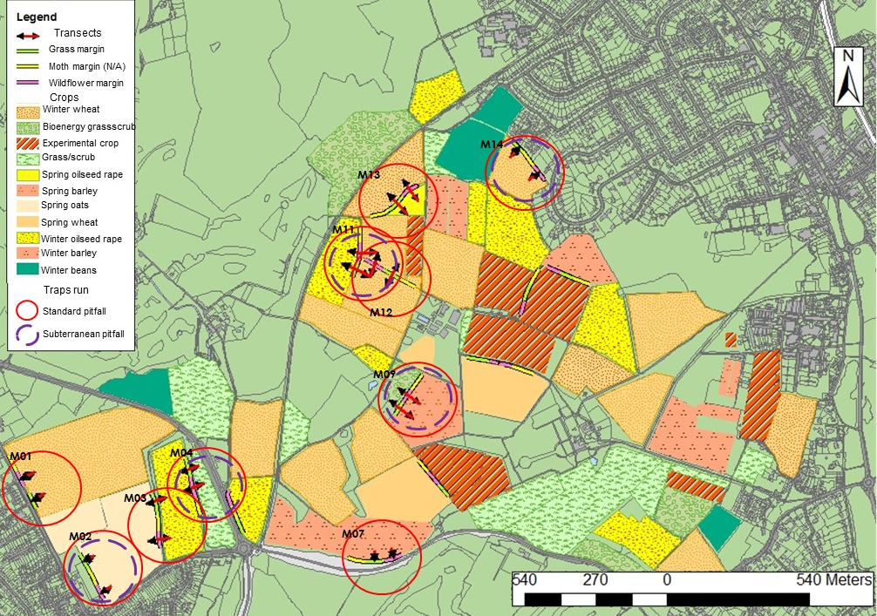
Figure 1: Rothamsted farm map with field margin locations. Selected margins, labelled M01-M14, with standard (red) and subterranean trap (purple) locations circled. Arrows denote one-way and two-way transect lines.

A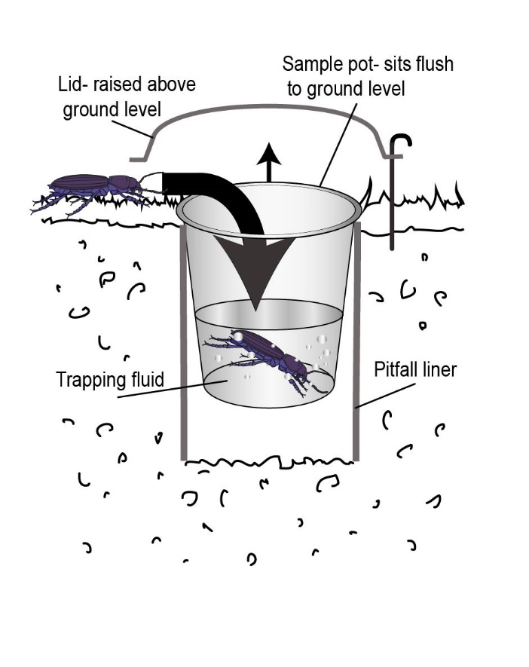 | B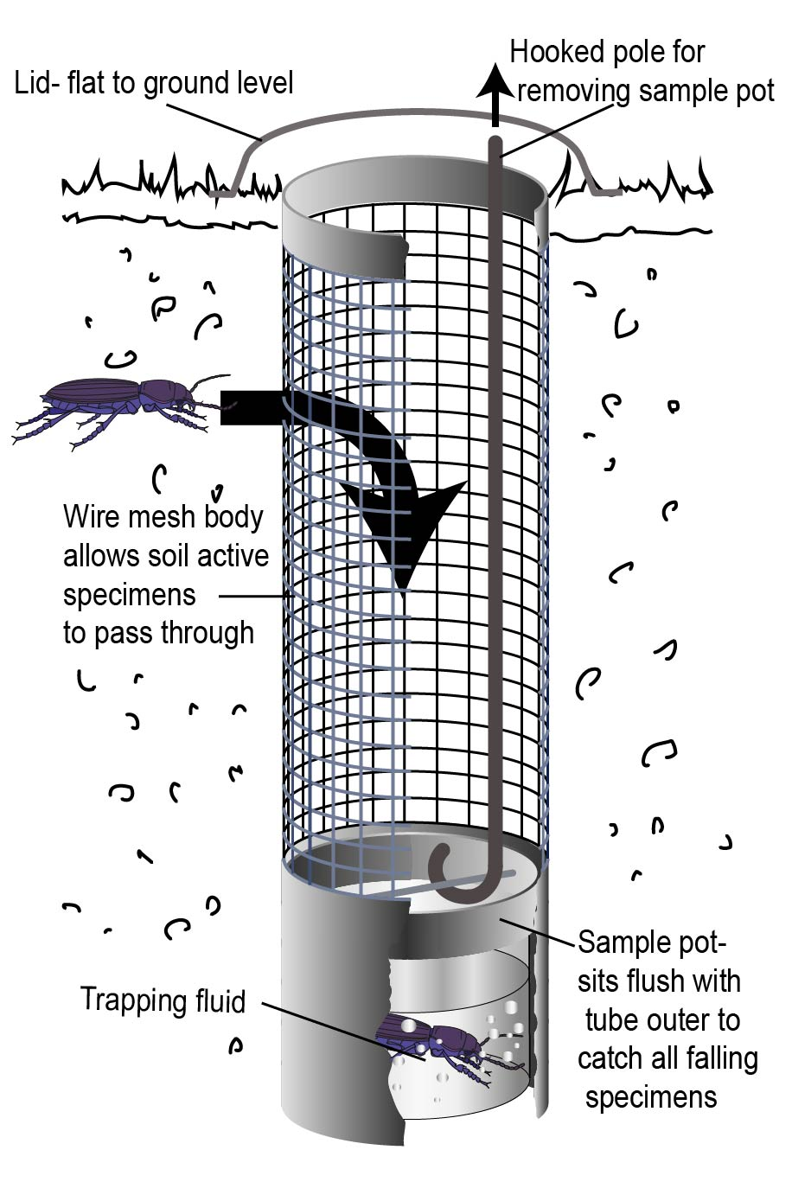

Figure 2: A) Standard pitfall trap design comprising cups of diameter 7.5 cm and depth 10 cm, set in space holding pipes, with rain covers; B) Subterranean pitfall design (based on Owens (1995)), comprising a 34 cm x 7 cm pipe with three cut-out sections 20 cm x 4 cm, bordered by wire mesh of 1.2 cm grid. A sliding section with attached sample collection cup sits inside the pipe, allowing a hooked collection from the base. A lid sits on the top, stopping surface active catch, whilst allowing access to change and reset, as appropriate.

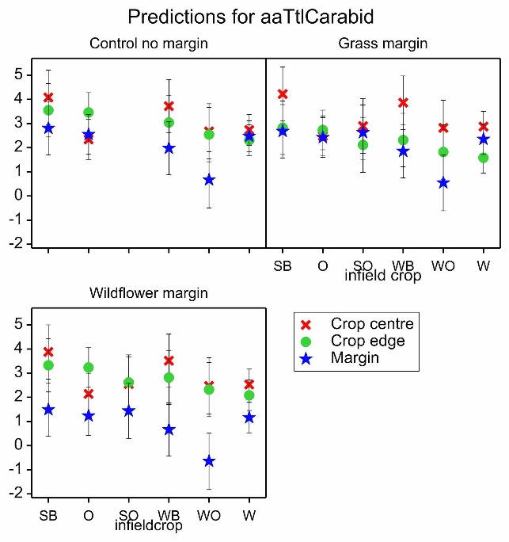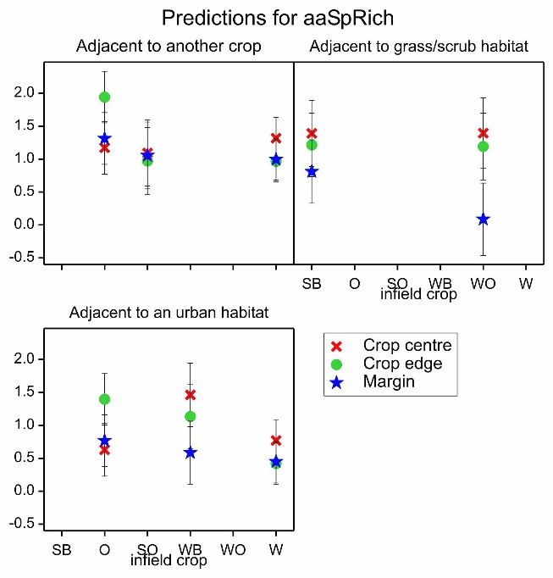
A
B
Figure 3: Linear Mixed Model (LMM) predictions for A) pooled-carabid abundance in the crop area and experimental margins by margin type, and B) species richness in the crop area and experimental margins by adjacent habitats. Predicted means with effective standard error bars. Crop centre – between 20 m and 50 m from edge, Crop edge – between 2m and 4m from field boundary, SB – spring barley, O –oats, SO – spring oilseed rape, WO – winter oilseed rape, W –wheat.

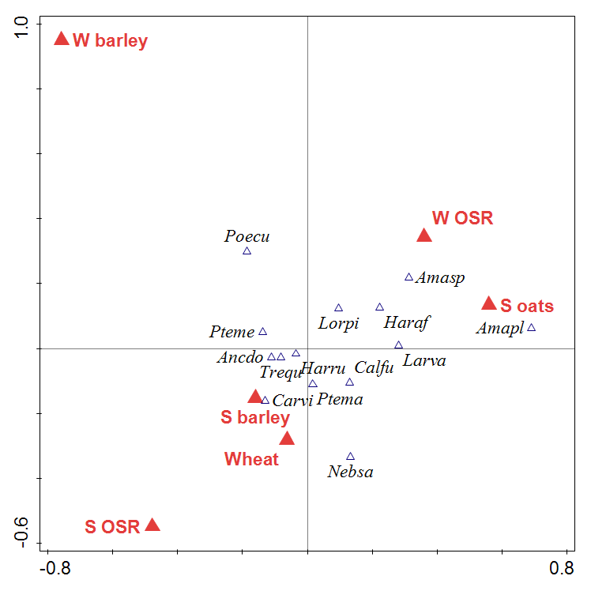  A  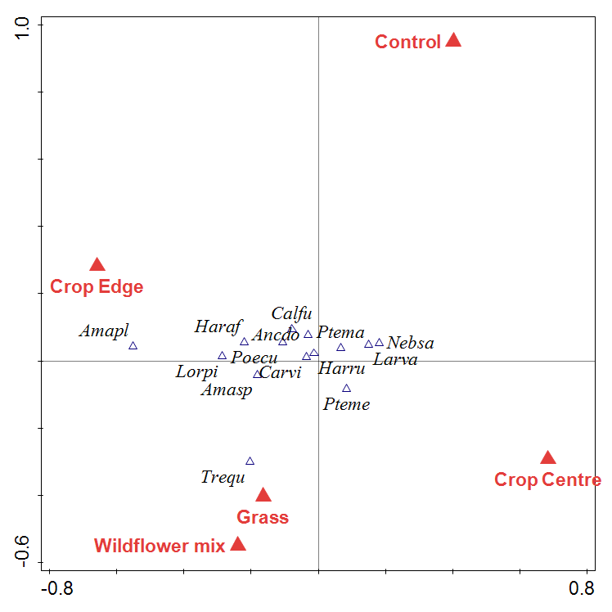 | 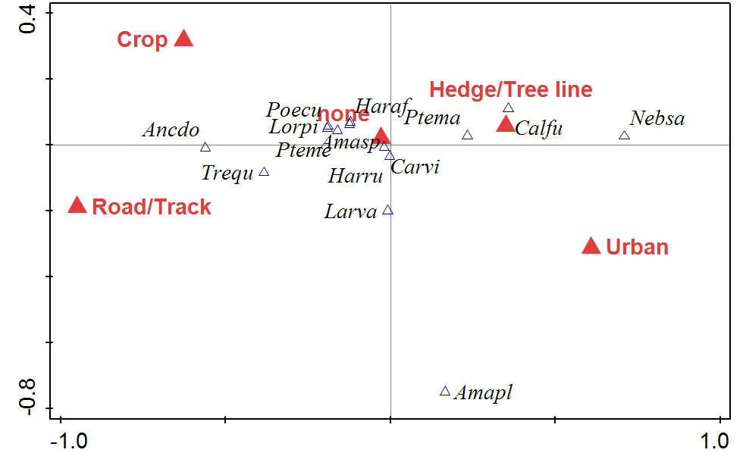  B
C

Figure 4: Canonical Correlation Analysis (CCA) plot of A) crop type, B) landscape variables: boundary features and adjacent habitat, and C) of margin type and crop position. Data points for subterranean and standard pitfalls, with spill-over and margin data points excluded. S – spring, W – winter, OSR – oil seed rape. Amasp – Amara similata/ovata agg., Amapl – Amara plebeja, Ancdo – Ancomenus dorsalis, Calfu – Calathus fuscipes, Carvi – Carabus violaceus, Haraf – Harpalus affinis, Harru – Harpalus rufipes, Larva – carabid larvae, Lorpi – Loricera pilicornis, Nebsa – Nebria salina, Poecu – Poecilus cupreus, Pteme – Pterostichus melanarius, Ptema – Pterostichus madidus, Trequ – Trechus quadristriatus.

A B
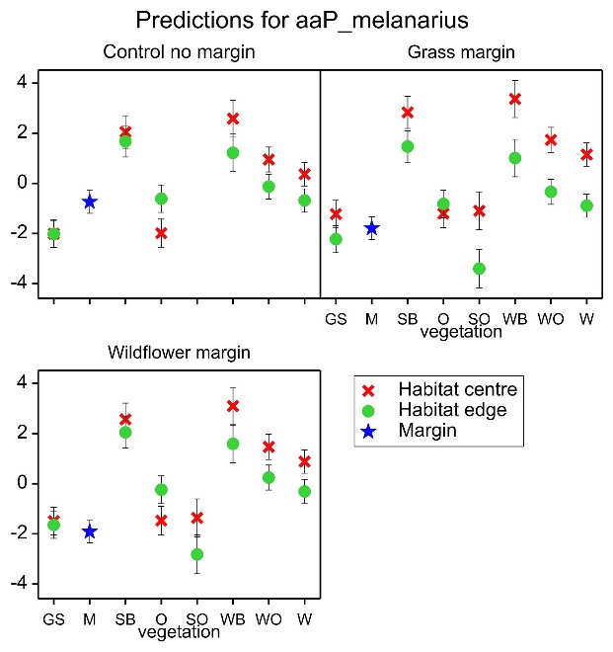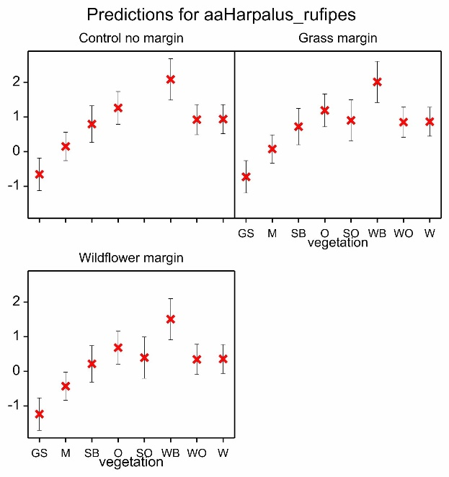
C D
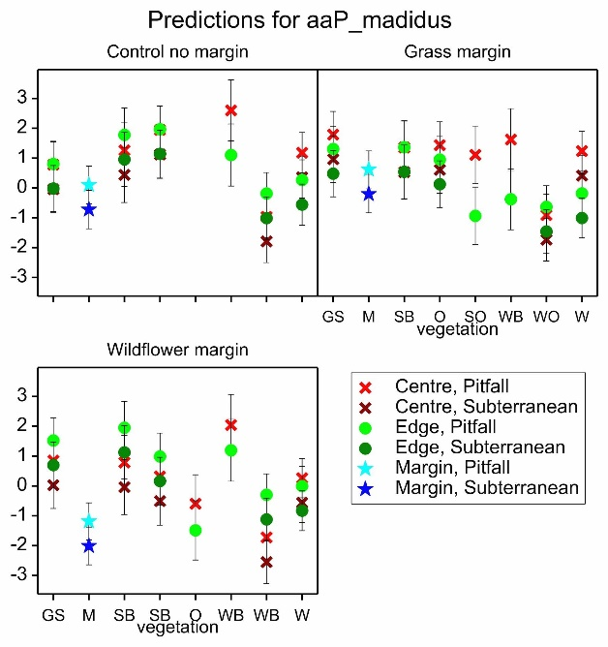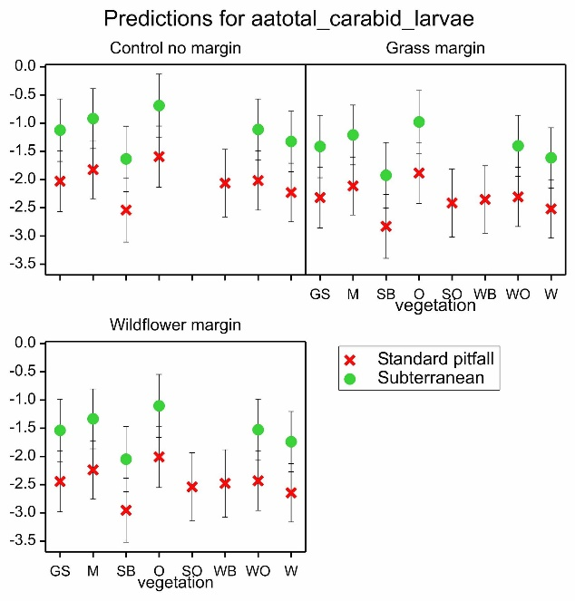

Figure 5: Fitted Linear Mixed Model (LMM) predictions for A) Pterostichus melanarius B) Harpalus rufipes C) Pterostichus madidus, and D) pooled carabid larvae abundance by margin type, predicted means with effective standard error bars. GS – grass/scrub, M – margin, SB – spring barley, O – oats, SO – spring oilseed rape, WO – winter oilseed rape, W – wheat.

Standard pitfall traps | Subterranean pitfall traps
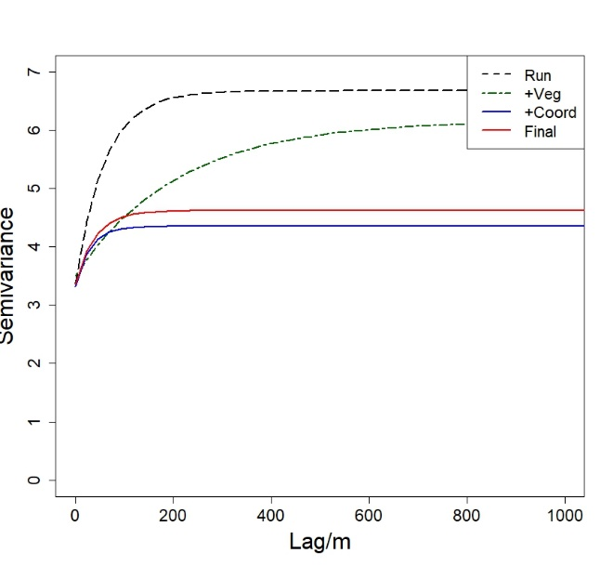  A | 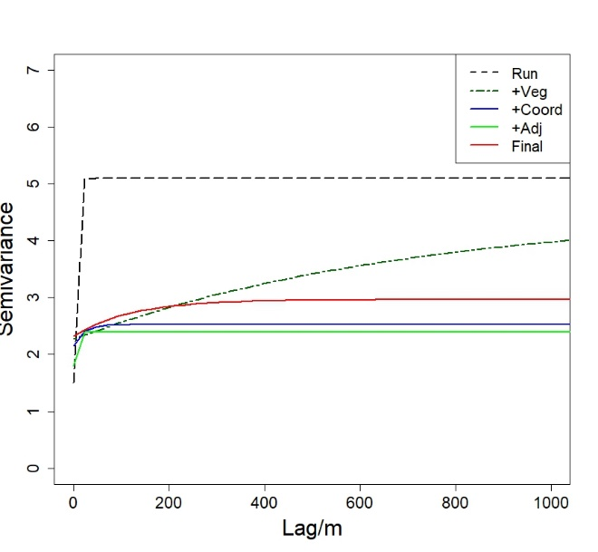  B
Figure 6: Variogram models for total abundance A) pitfall traps and, B) subterranean pitfall traps, for the null model where only Run was fitted as a fixed effect (dashed black) and for successive models with factors added as predictors. For dark green dashed vegetation was added, blue coordinates, green adjacent, and red is the final model fitted by REML (all other models fitted by maximum likelihood).

Pterostichus melanarius | Harpalus rufipes | Pterostichus madidus
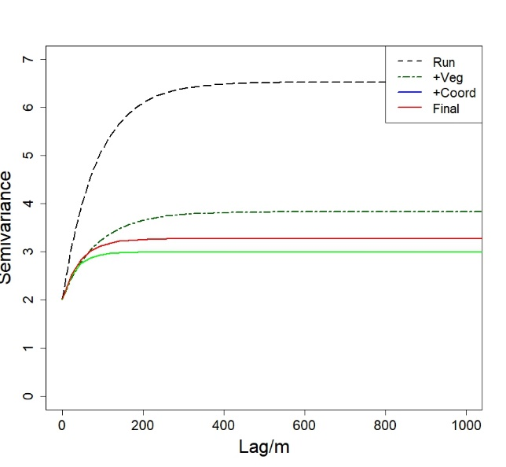 | 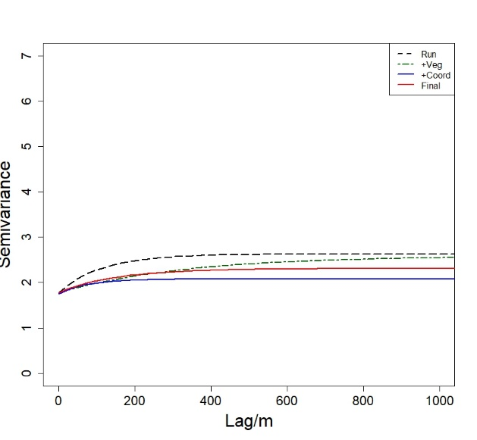 | 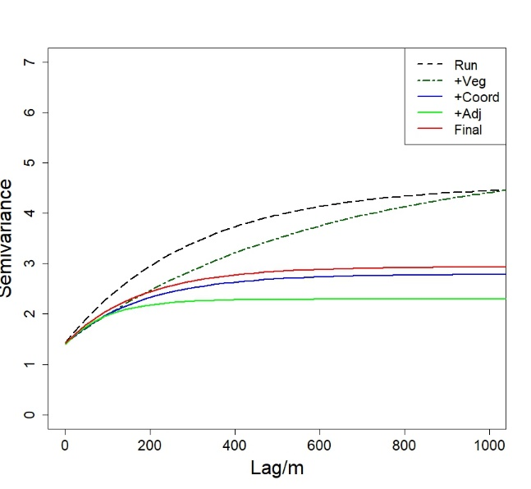
Amara ovata/similata aggregate | Poecilus cupreus | Carabid larvae
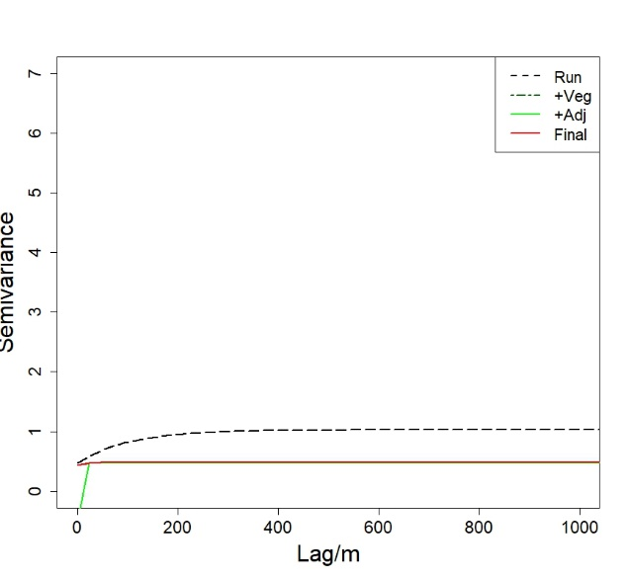 | 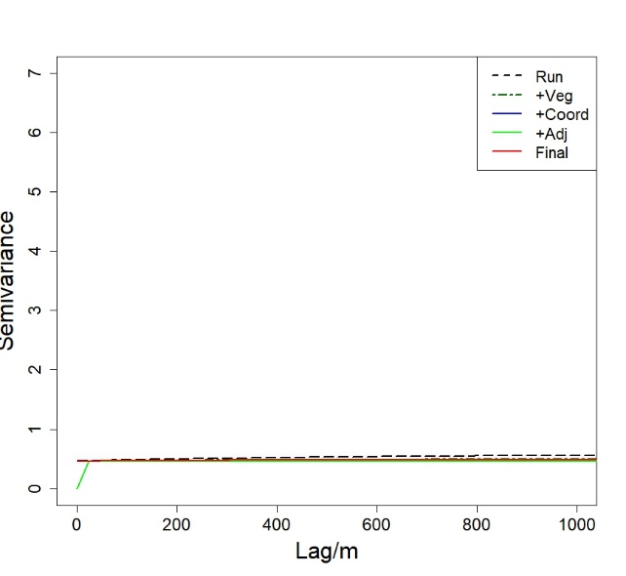 | 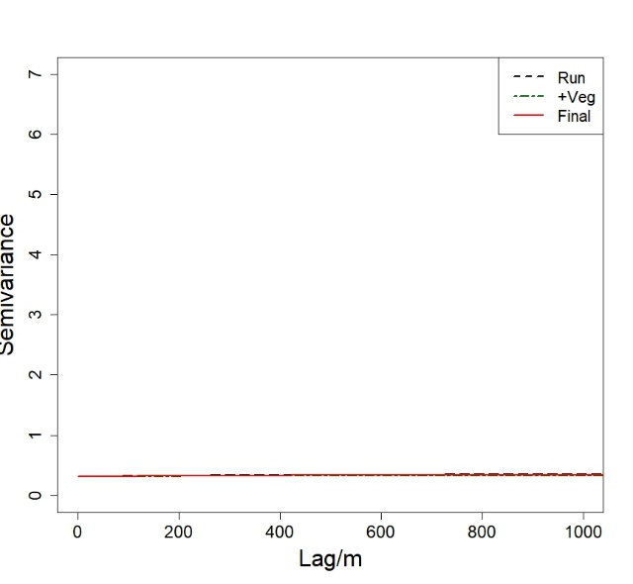

Figure 7: Variogram models for individual species, and total carabid larvae, for the null model where only Run was fitted as a fixed effect (dashed black), and for successive models with factors added as predictors. For dark blue vegetation was added, light blue coordinates, green adjacent, and red is the final model fitted by REML (all other models fitted by maximum likelihood).

Table 1: Top 15 carabid species trapped, by runs and trap type. Pitfall – standard pitfall. ST – subterranean pitfall. Colour scale denotes abundance ranking per column. See supplementary materials for full list.
 | Run 1: 20/06-10/07 |  | Run 2: 04/07-25/07 |  | Run 3: 18/07-08/08 |  | All Runs total
 | Pitfall | ST | Pitfall | ST | Pitfall | ST | Pitfall | ST | Total
Pterostichus melanarius | 1148 | 226 | 1313 | 209 | 2470 | 273 | 4931 | 708 | 5639
Harpalus rufipes | 606 | 433 | 1402 | 406 | 2474 | 300 | 4482 | 1139 | 5621
Pterostichus madidus | 690 | 110 | 1085 | 149 | 2224 | 319 | 3999 | 578 | 4577
Amara similata/ovata agg. | 281 | 71 | 166 | 206 | 154 | 36 | 601 | 313 | 914
Poecilus cupreus | 246 | 19 | 139 | 7 | 41 | 1 | 426 | 27 | 453
Harpalus affinis | 144 | 35 | 98 | 43 | 87 | 10 | 329 | 88 | 417
Trechus quadristriatus | 64 | 28 | 72 | 16 | 66 | 11 | 202 | 55 | 257
Calathus fuscipes | 24 | 3 | 68 | 2 | 133 | 1 | 225 | 6 | 231
Anchomenus dorsalis | 54 | 50 | 26 | 19 | 47 | 6 | 127 | 75 | 202
Carabus violaceus | 17 | 0 | 28 | 0 | 47 | 1 | 92 | 1 | 93
Amara plebeja | 41 | 6 | 10 | 6 | 14 | 1 | 65 | 13 | 78
Nebria salina | 32 | 11 | 5 | 8 | 8 | 4 | 45 | 23 | 68
Loricera pilicornis | 23 | 0 | 18 | 2 | 21 | 2 | 62 | 4 | 66
Bembidion lampros | 49 | 1 | 2 | 2 | 5 | 1 | 56 | 4 | 60
Pterostichus niger | 17 | 1 | 15 | 1 | 5 | 3 | 37 | 5 | 42
Total carabid larvae | 217 | 233 | 76 | 115 | 2 | 6 | 295 | 354 | 649

