Supplementary Material
Supplementary text 1
This method has options to fit by maximum likelihood (ML) or by residual maximum likelihood (REML). The ML method is appropriate to use when comparing different fixed effects structures and the REML when forming the final model because it reduces bias in the estimated random effects. Therefore we use ML for the sequential fitting process to determine the relevant fixed effects and then refitted the final model using REML. The sequential fitting was done by fitting the factors in perceived order or importance, that was first vegetation, second eastings, northings and an interaction of the two, and third adjacent. Vegetation, as in the species models, denotes the actual vegetation at the transect point, whether crop, grass/scrub, or experimental margin. Eastings and northings capture the large-scale spatial trend across a landscape level, as opposed to the autocorrelation between points which is assumed to be a stationary process. Adjacent denotes the habitat adjacent to the transect. Terms were retained if there was evidence that adding fixed effects to a simpler model achieved a significant improvement by computing the log-ratio statistic:
$$L=2\left(l_{1}-l_{0}\right)$$
where $l_{1}$ and $l_{0}$denote, respectively the maximised log-likelihoods from fitting the model with the additional fixed effects, and the simpler model without them. Under the null hypothesis, where the additional fixed effects are not related to the dependent variable, this statistic is asymptotically distributed as chi-square with degrees of freedom equal to the number of additional fixed effects. Here we assumed a significance threshold of $p=0.05$.

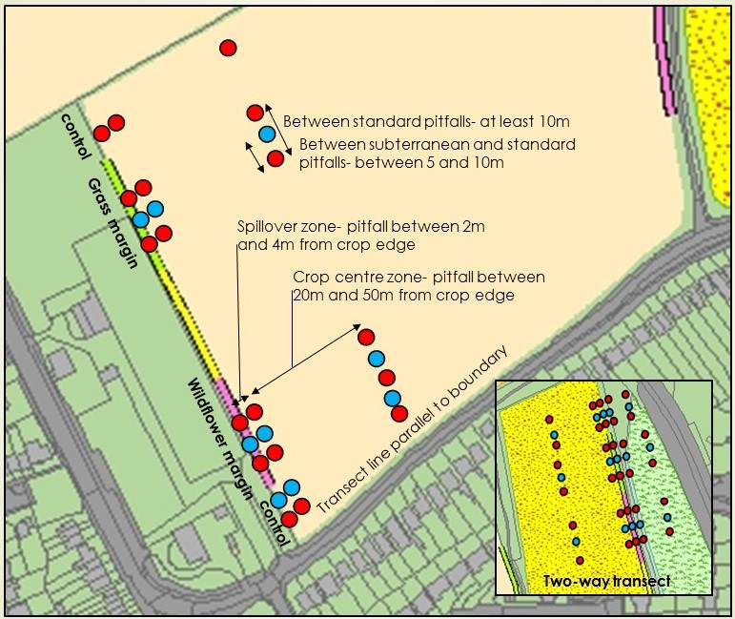
Figure S1: example of typical transect layout for one way (Margin 02), and (insert) two way transects (Margin 04).

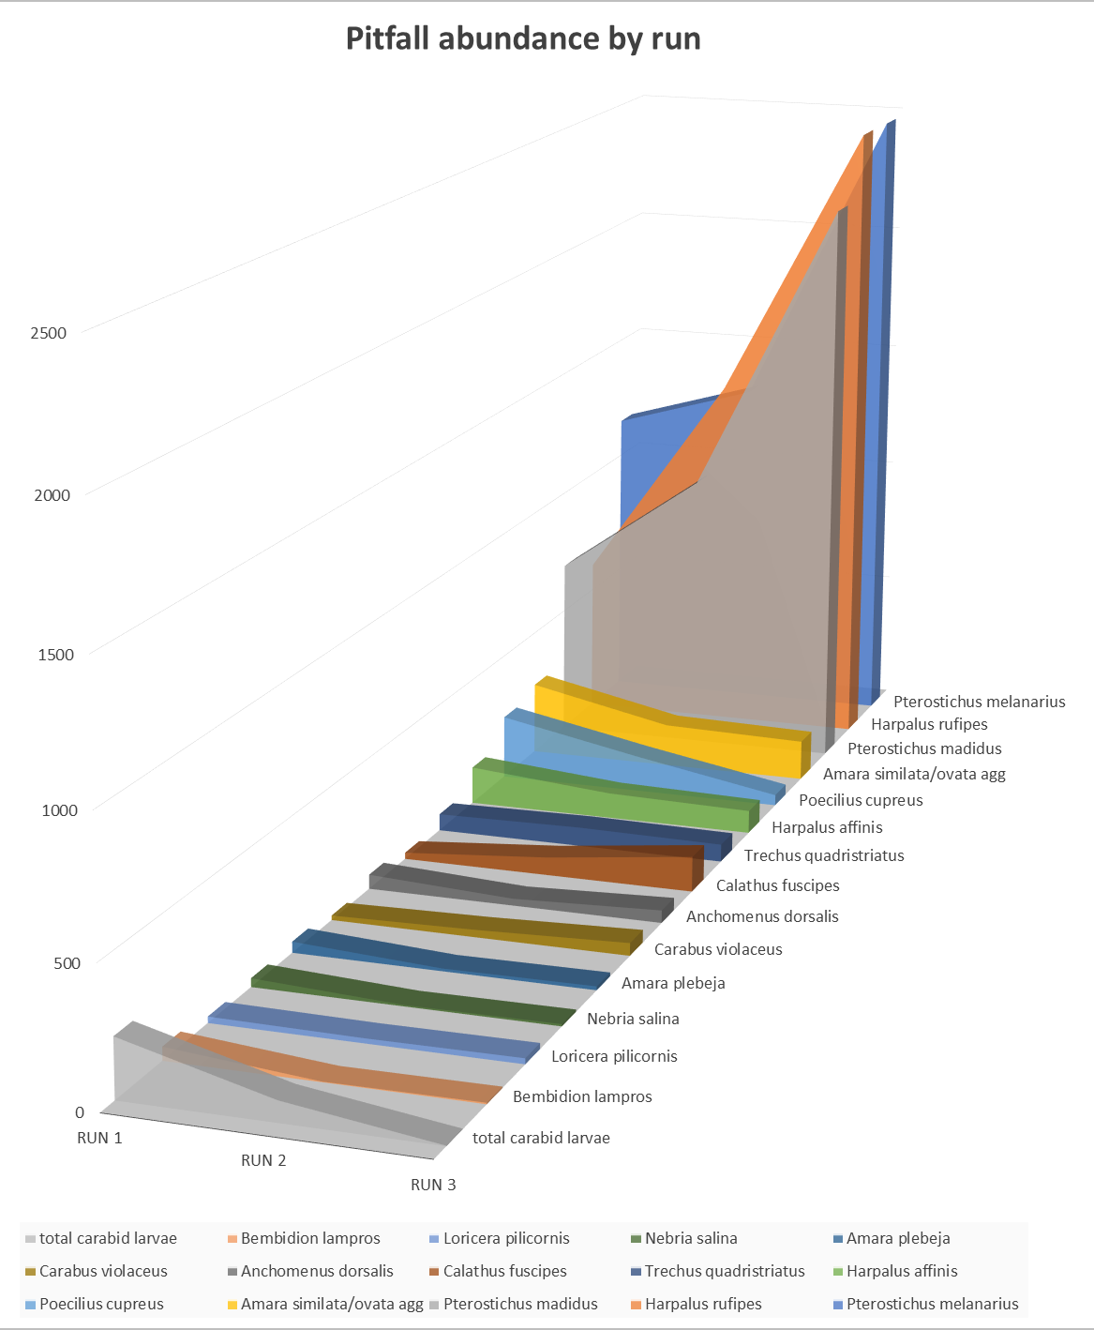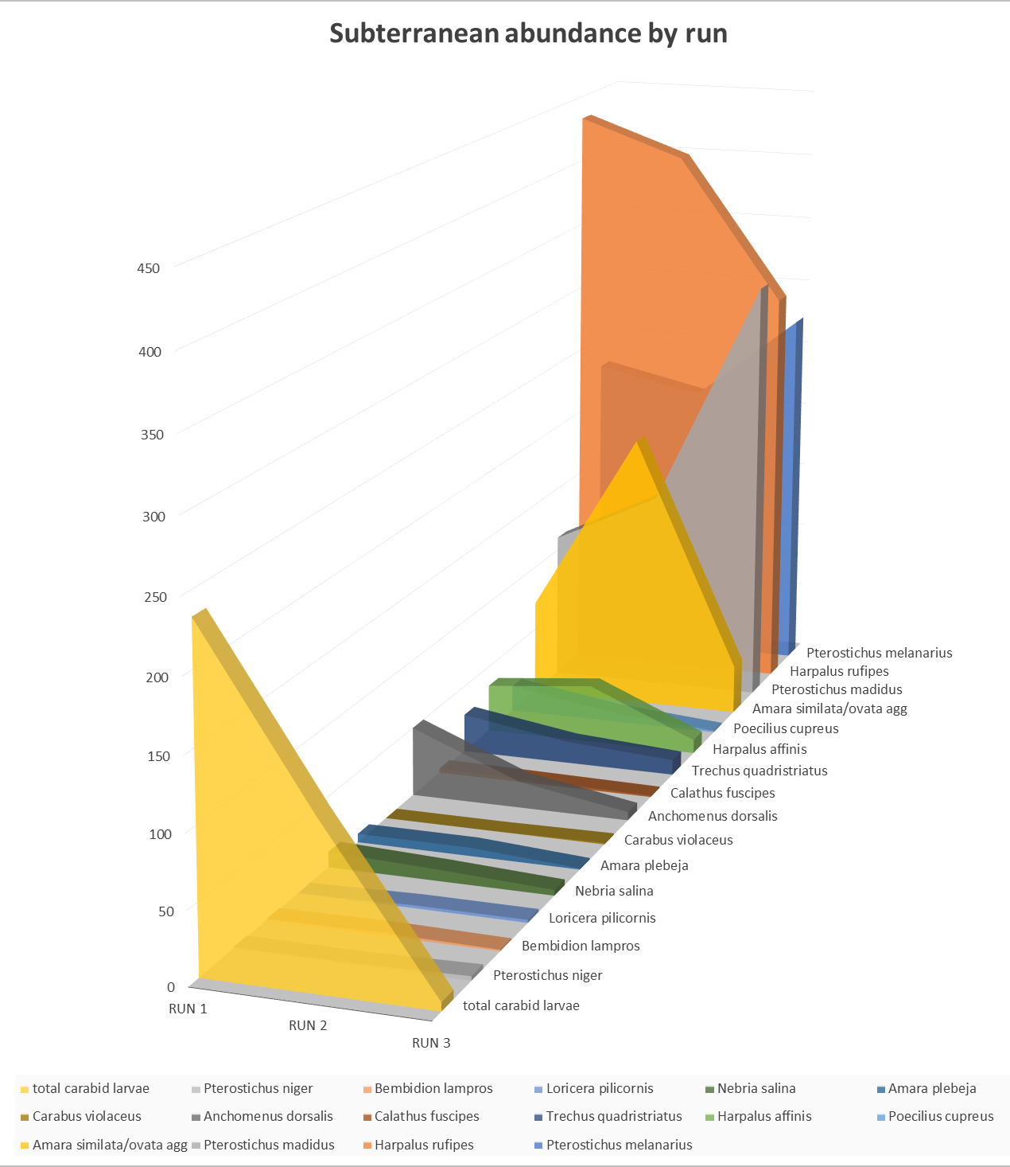

Figure S2: Top 15 carabid species trapped and carabid larvae, abundance by runs and trap type.
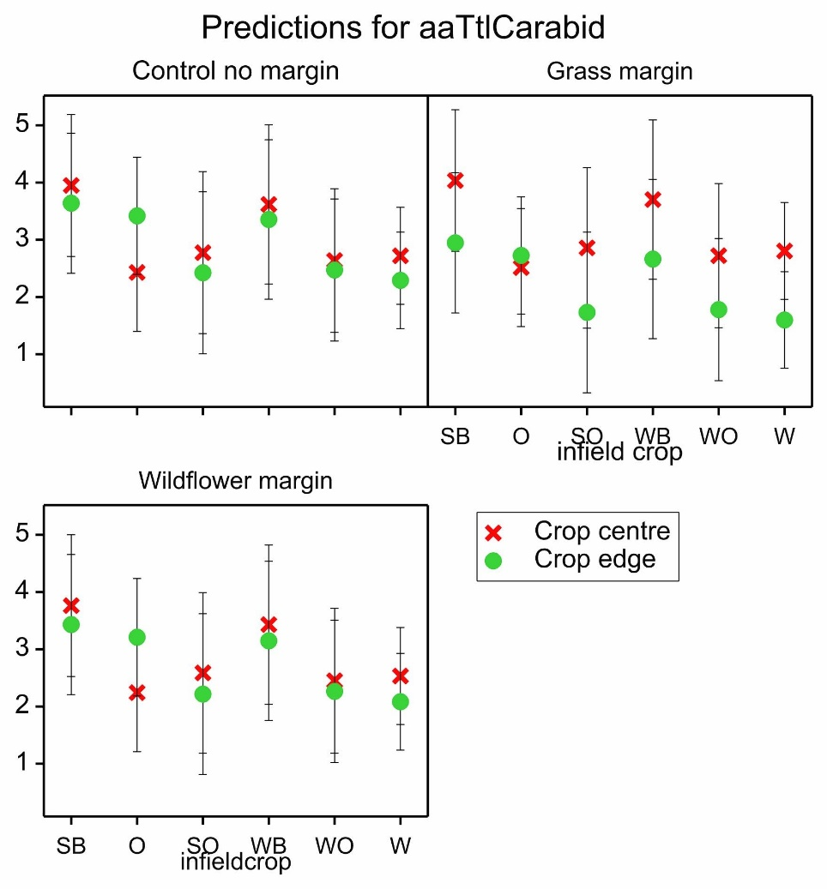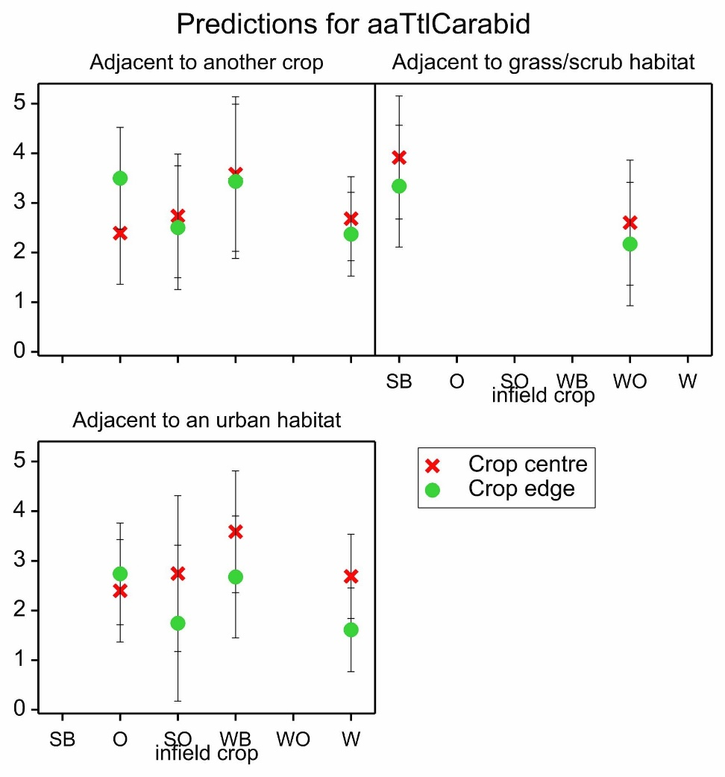
Figure S3: Fitted linear mixed model predictions for pooled-carabid abundance in the crop area by A) margin type, and B) adjacent habitat. Predicted means with effective standard error bars. Crop centre= between 20m and 50m from edge, Crop edge = between 2m and 4m from field boundary, SB= spring barley, O=oats, SO= spring oilseed rape, WO= winter oilseed rape, W=wheat.

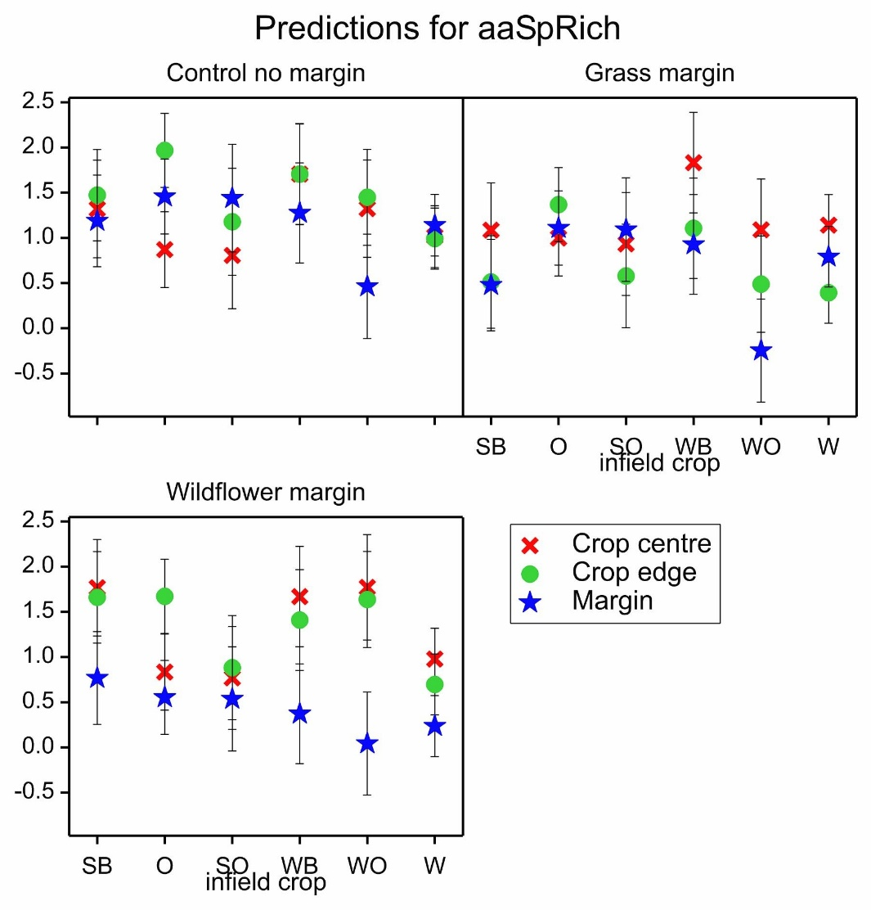
Figure S4: Fitted Linear Mixed Model (LMM) predictions for species richness in the crop area and experimental margins by margin type, predicted means with effective standard error bars. Crop centre= between 20m and 50m from edge, Crop edge = between 2m and 4m from field boundary, SB= spring barley, O=oats, SO= spring oilseed rape, WO= winter oilseed rape, W=wheat.

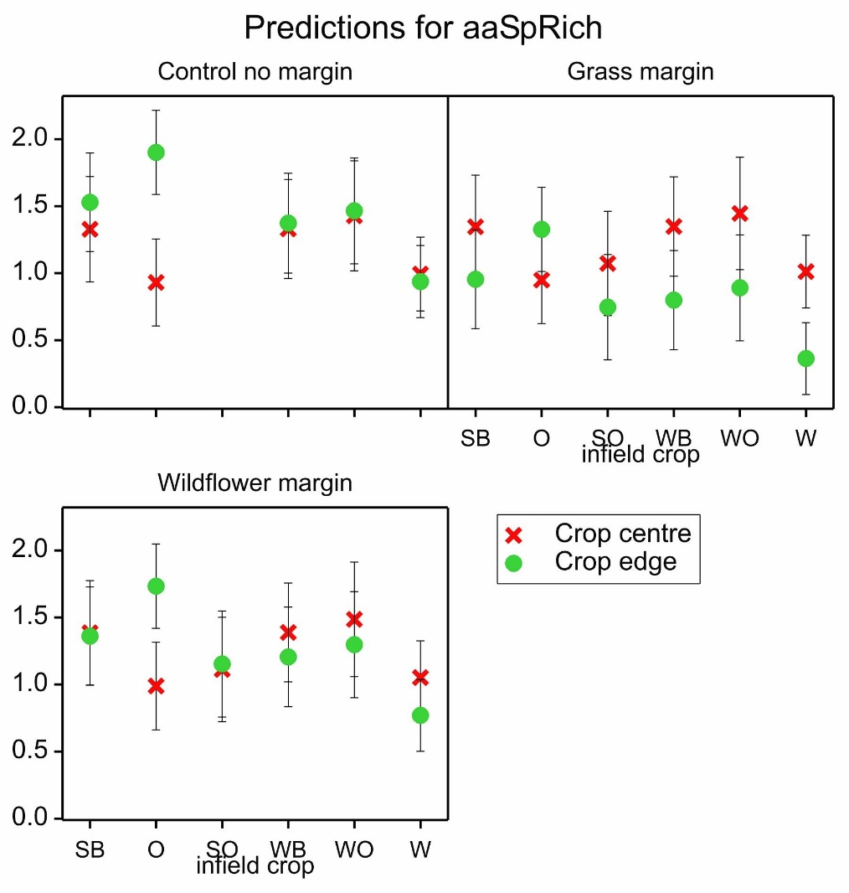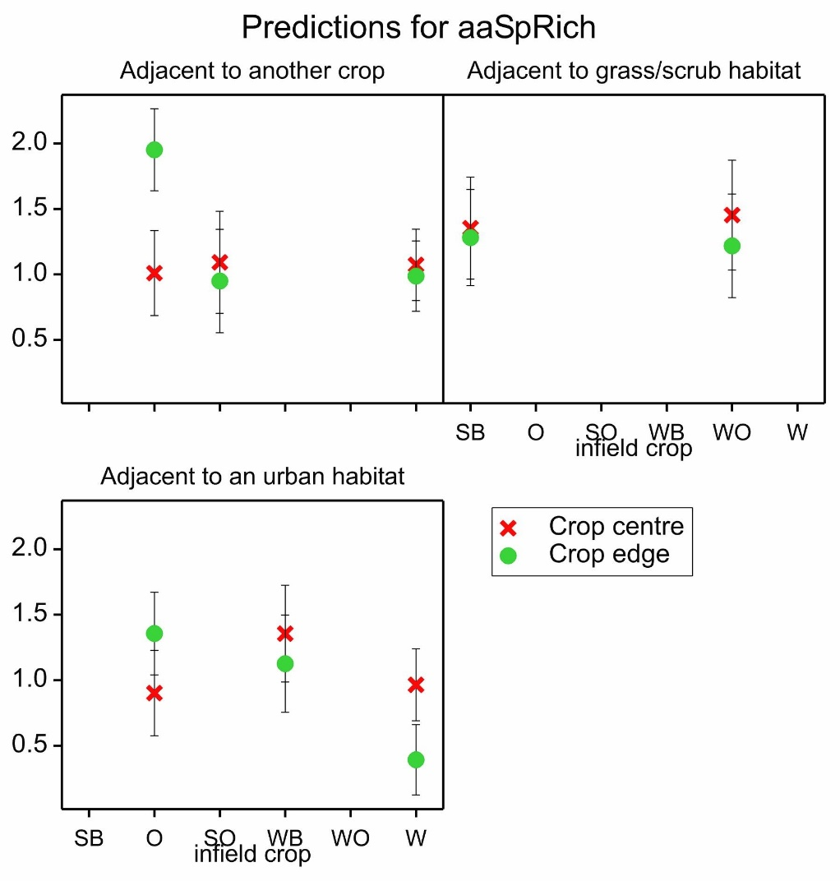
Figure S5: Fitted linear mixed model predictions for carabid species richness in the crop area by a) margin and b) adjacent habitat, predicted means with effective standard error bars. Crop centre= between 20m and 50m from edge, Crop edge = between 2m and 4m from field boundary, SB= spring barley, O=oats, SO= spring oilseed rape, WO= winter oilseed rape, W=wheat.
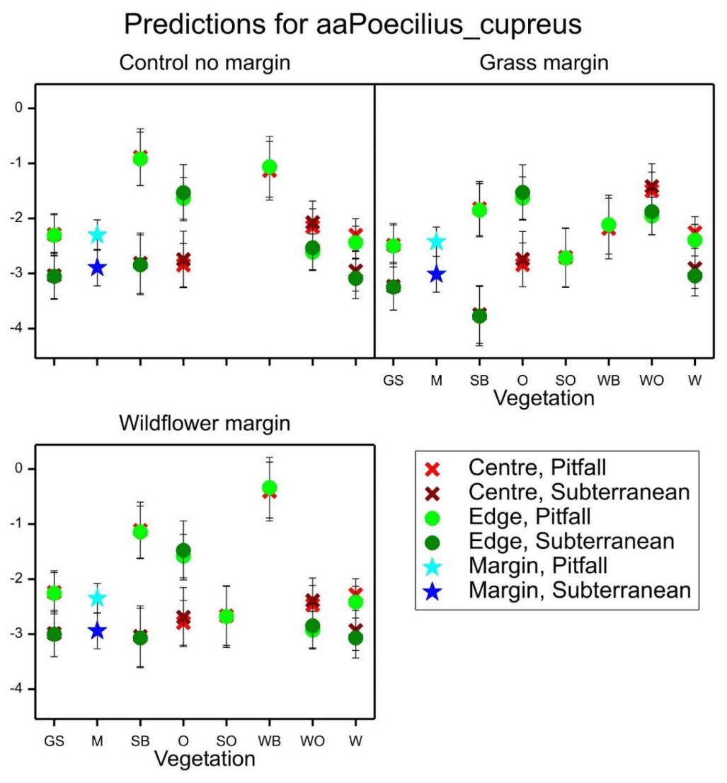
Figure S6: Fitted linear mixed model predictions for Poecilus cupreus abundance, predicted means with effective standard error bars. Centre= Habitat centre, Edge= Habitat edge, GS= grass/scrub, M= margin, SB= spring barley, O=oats, SO= spring oilseed rape, WO= winter oilseed rape, W=wheat.

Table S1: Sown margin seed mixes used in the study. Common name followed by the Latin name and percentage contained within each mix.
Grass margin mix
Common bent – Agrostis capillaris (10%)
Crested dogstail – Cynosurus cristatus (50%)
Slender creeping red-fescue – Festuca rubra (35%)
Smaller cat's-tail – Phleum bertolonii (5%)
Wildflower margin mix
Common bent – Agrostis capillaris (8 %)
Crested dogstail – Cynosurus cristatus (40 %)
Slendercreeping red-fescue – Festuca rubra (28 %)
Smaller cat's-tail – Phleum bertolonii (4 %)
Yarrow – Achillea millefolium (1.2 %)
Common knapweed – Centaurea nigra (3 %)
Wild carrot – Daucus carota (1 %)
Field scabious – Knautia arvensis (0.6 %)
Oxeye daisy – Leucanthemum vulgare (1.6 %)
Birdsfoot trefoil – Lotus corniculatus (2 %)
Musk mallow – Malva moschata (0.8 %)
Cowslip – Primula veris (0.4 %)
Selfheal – Prunella vulgaris (3 %)
Meadow buttercup – Ranunculus acris (3.2 %)
Red campion – Silene dioica (2 %)
Wild red clover – Trifolium pratense (0.2 %)
Tufted vetch – Vicia cracca (1 %)

Table S2: Selected margins for standard pitfall transects, with infield, boundary, and adjacent habitat variables. Margins with subterranean traps are indicated by *. Areas not sampled indicated in italics. OSR= Oilseed rape.
Margin |  | Infield crop | Sowing time | Adjacent habitat | Boundary
One-way margins | M1 w | 1st wheat | Winter | Urban | Hedge
One-way margins | M1 g | 1st wheat | Winter | Urban | Hedge
One-way margins | M2 w * | S oats | Spring | Urban scrub | Gappy trees
One-way margins | M2 g * | S oats | Spring | Urban scrub | Gappy trees
One-way margins | M7 w | W barley | Winter | Urban | Hedge
One-way margins | M7 g | W barley | Winter | Urban | Hedge
One-way margins | M14 w * | 1st wheat | Winter | Urban | Hedge
One-way margins | M14 g * | 1st wheat | Winter | Urban | Hedge
Two-way margins | M3 w | S oats | Spring | W OSR | Gappy trees
Two-way margins | M3 g | S oats | Spring | W OSR | Gappy trees
Two-way margins | M4 w * | W OSR | Winter | Grass/scrub | Hedge
Two-way margins | M4 g * | W OSR | Winter | Grass /scrub | Fence
Two-way margins | M9 w * | S barley | Spring | Grass/bioenergy | none
Two-way margins | M9 g * | S barley | Spring | Grass/bioenergy | none
Two-way margins | M11 w * | 1st wheat | Winter | 1st wheat | track
Two-way margins | M11 g * | 1st wheat | Winter | 1st wheat | track
Two-way margins | M12 w | 1st wheat | Winter | 1st wheat | Track
Two-way margins | M12 g | 1st wheat | Winter | 1st wheat | Track
Two-way margins | M13 w | S OSR | Spring | 1st wheat | Hedge
Two-way margins | M13 g | S OSR | Spring | 1st wheat | Hedge

Table S3: Full species list and abundances by run.
Table S4: Linear Mixed Model (LMM) predictions for crop area models.
LMM crop area abundance:
Fixed term Wald statistic n.d.f. F statistic d.d.f. F pr
infieldcrop 1.26 5 0.25 3.0 0.915
position 7.09 1 7.09 44.5 0.011
margintype 2.81 2 1.40 44.5 0.274
adjacent 0.19 1 0.19 16.0 0.274 infieldcrop.position 18.97 5 3.79 45.7 0.006
position.margintype 6.98 2 3.49 45.0 0.039 position.adjacent 5.08 1 5.08 44.9 0.029

LMM crop area species richness:
Fixed term Wald statistic n.d.f. F statistic d.d.f. F pr
infieldcrop 1.91 5 0.38 3.0 0.838
position 0.26 1 0.26 44.3 0.612
margintype 8.65 2 4.33 16.1 0.031
adjacent 0.86 1 0.86 3.0 0.423
infieldcrop.position 26.62 5 5.32 46.0 <0.001
position.margintype 9.37 2 4.69 44.9 0.014
position.adjacent 5.59 1 5.59 45.3 0.022

LMM crop area abundance plus margins:
Fixed term Wald statistic n.d.f. F statistic d.d.f. F pr
infieldcrop 1.05 5 0.21 4.1 0.942
position 43.98 2 21.99 93.3 <0.001
margintype 5.53 2 2.11 16.4 0.092
infieldcrop.position 36.86 10 3.68 97.4 <0.001
position.margintype 25.42 4 6.36 94.3 <0.001

LMM crop area species richness plus margins:
Fixed term Wald statistic n.d.f. F statistic d.d.f. F pr
infieldcrop 1.31 5 0.26 3.1 0.909
position 13.11 2 6.55 93.5 0.002
margintype 16.26 2 8.13 11.1 0.007
adjacent 2.31 1 2.31 3.0 0.226
infieldcrop.position 25.23 10 2.52 97.8 0.010
position.margintype 19.22 4 4.80 94.5 0.001
Margintype.adjacent 18.12 4 4.53 12.5 0.017

Table S5: Summary of species model predictions. Greatest predicted abundance for each species x margin or species x crop is shaded in orange, and the smallest is shaded in blue. Standard error in italics. M= margin, C=control, G=grass, W=wildflower, PF=pitfall, ST=subterranean trap. *=inestimable prediction.
 |  | M | Grass/scrub |  |  | Spring Barley |  |  | Oats |  |  | Spring OSR |  |  | Winter Barley |  |  | Winter OSR |  |  | Wheat
 |  | M | Centre |  | Edge | Centre |  | Edge | Centre |  | Edge | Centre |  | Edge | Centre |  | Edge | Centre |  | Edge | Centre |  | Edge
P. melanarius | C | -0.40  0.48 | -2.33  0.63 |  | -2.08  0.59 | 1.44  0.75 |  | 1.16  0.74 | -2.27  0.62 |  | -0.51  0.60 | * |  | * | 1.93  0.85 |  | 1.33  0.87 | 0.78  0.54 |  | -0.44  0.54 | 0.07  0.50 |  | -0.95  0.50
P. melanarius | G | -1.57  0.47 | -1.51  0.63 |  | -2.38  0.60 | 2.33  0.74 |  | 0.86  0.72 | -1.39  0.61 |  | -0.82  0.60 | -1.70  0.87 |  | -3.96  0.87 | 2.81  0.85 |  | 1.03  0.86 | 1.66  0.55 |  | -0.74  0.54 | 0.95  0.49 |  | -1.26  0.50
P. melanarius | W | -2.04  0.47 | -1.91  0.63 |  | -1.69  0.59 | 1.92  0.74 |  | 1.55  0.71 | -1.79  0.61 |  | -0.13  0.61 | -2.10  0.87 |  | -3.27  0.87 | 2.41  0.85 |  | 1.71  0.87 | 1.26  0.55 |  | -0.05  0.54 | 0.55  0.50 |  | -0.57  0.49
H. rufipes | C | -0.05  0.50 | -0.90  0.61 |  |  | 1.29  0.69 |  |  | 1.01  0.60 |  |  | * |  |  | 1.91  0.80 |  |  | 0.49  0.54 |  |  | 0.40  0.51
H. rufipes | G | -0.18  0.50 | -1.03  0.61 |  |  | 1.16  0.69 |  |  | 0.88  0.60 |  |  | 0.02  0.79 |  |  | 1.78  0.80 |  |  | 0.36  0.54 |  |  | 0.27  0.51
H. rufipes | W | -0.59  0.50 | -1.44  0.60 |  |  | 0.75  0.68 |  |  | 0.47  0.60 |  |  | -0.39  0.79 |  |  | 1.36  0.80 |  |  | -0.04  0.54 |  |  | -0.14  0.51
P. madidus | C PF | -0.21  0.33 | 0.60  0.59 |  | 0.73  0.57 | 1.13  0.80 |  | 2.08  0.77 | 1.46  0.60 |  | 1.58  0.57 | * |  | * | 1.94  0.89 |  | 0.49  0.94 | -1.28  0.46 |  | -0.58  0.48 | 0.81  0.41 |  | -0.10  0.42
P. madidus | C ST | -0.95  0.37 | 0.14  0.62 |  | -0.01  0.60 | 0.39  0.81 |  | 1.34  0.79 | 0.72  0.62 |  | 0.85  0.59 | * |  | * | * |  | * | -2.02  0.49 |  | -1.32  0.49 | 0.07  0.44 |  | -0.84  0.45
P. madidus | G PF | 0.47  0.30 | 1.07  0.63 |  | 0.71  0.60 | 0.78  0.76 |  | 1.23  0.76 | 1.21  0.58 |  | 0.84  0.57 | 0.56  0.85 |  | -1.27  0.85 | 1.47  0.94 |  | -0.47  0.88 | -1.83  0.50 |  | -1.63  0.50 | 0.52  0.38 |  | -0.88  0.38
P. madidus | G ST | -0.26  0.35 | 0.33  0.65 |  | -0.03  0.62 | 0.04  0.77 |  | 0.49  0.77 | 0.47  0.60 |  | 0.10  0.60 | * |  | * | * |  | * | -2.57  0.53 |  | -2.37  0.53 | -0.21  0.42 |  | -1.62  0.41
P. madidus | W PF | -1.31  0.31 | 0.35  0.63 |  | 1.25  0.57 | -0.07  0.80 |  | 1.64  0.73 | -0.06  0.58 |  | 0.83  0.59 | -1.35  0.84 |  | -1.93  0.85 | 1.02  0.89 |  | 0.33  0.94 | -1.99  0.52 |  | -0.53  0.48 | -0.02  0.39 |  | -0.17  0.39
P. madidus | W ST | -2.05  0.36 | -0.39  0.64 |  | 0.51  0.59 | -0.81  0.81 |  | 0.90  0.76 | -0.80  0.60 |  | 0.09  0.61 | * |  | * | * |  | * | -2.73  0.55 |  | -1.27  0.51 | -0.75  0.42 |  | -0.91  0.42
P. cupreus | PF | -2.31  0.27 | -2.08  0.45 |  | -2.16  0.42 | -0.56  0.56 |  | -0.73  0.53 | -2.71  0.41 |  | -1.10  0.41 | -2.67  0.63 |  | -2.67  0.63 | -0.39  0.58 |  | -0.66  0.60 | -1.40  0.37 |  | -2.27  0.36 | -2.19  0.31 |  | -2.31  0.31
P. cupreus | ST | -2.89  0.39 | -3.12  0.51 |  | -3.20  0.50 | -3.22  0.65 |  | -3.39  0.65 | -2.64  0.64 |  | -1.03  0.63 | * |  | * | * |  | * | -1.13  0.51 |  | -2.00  0.50 | -2.94  0.45 |  | -3.06  0.46
 |  | M | Grass/scrub |  |  | Spring Barley |  |  | Oats |  |  | Spring OSR |  |  | Winter Barley |  |  | Winter OSR |  |  | Wheat
Total carabid larvae | C PF | -1.27  0.48 | -1.56  0.55 |  |  | -2.34  0.60 |  |  | -0.87  0.54 |  |  | -1.69  0.67 |  |  | -1.64  0.66 |  |  | -1.65  0.51 |  |  | -1.81  0.49
Total carabid larvae | C ST | 0.05  0.52 | -0.24  0.57 |  |  | -1.02  0.63 |  |  | 0.45  0.57 |  |  | -0.37  0.70 |  |  | -0.32  0.70 |  |  | -0.33  0.54 |  |  | -0.49  0.53
Total carabid larvae | G PF | -1.72  0.48 | -2.01  0.54 |  |  | -2.79  0.60 |  |  | -1.32  0.54 |  |  | -2.14  0.66 |  |  | -2.09  0.66 |  |  | -2.09  0.51 |  |  | -2.26  0.49
Total carabid larvae | G ST | -0.40  0.51 | -0.68  0.57 |  |  | -1.47  0.62 |  |  | 0.01  0.57 |  |  | -0.82  0.70 |  |  | -0.76  0.69 |  |  | -0.77  0.54 |  |  | -0.93  0.52
Total carabid larvae | W PF | -1.87  0.48 | -2.16  0.54 |  |  | -2.94  0.60 |  |  | -1.47  0.54 |  |  | -2.29  0.66 |  |  | -2.24  0.66 |  |  | -2.25  0.51 |  |  | -2.41  0.49
Total carabid larvae | W ST | -0.55  0.52 | -0.84  0.57 |  |  | -1.62  0.62 |  |  | -0.15  0.57 |  |  | -0.97  0.69 |  |  | -0.92  0.69 |  |  | -0.93  0.55 |  |  | -1.09  0.52

Table S6: Fitted models for spatial factors on carabid abundance.
Model | Fixed Effects | $c_{0}$ | $$c_{1}$$ | a | Effective range
Total abundance standard pitfall traps
REML fitted | Run + Vegetation + Easting + Northing + Easting.Northing | 3.3579 | 1.2674 | 39.4187 | 118.09
Total abundance subterranean pitfall traps
REML  fitted | Run + Vegetation + Easting + Northing + Easting.Northing + Adjacent | 0.0011 | 0.0000 | 2.3168 | 353.14

Model | Fixed Effects | $c_{0}$ | $$c_{1}$$ | a | Effective range
Pterostichus melanarius abundance
REML fitted | Run + Vegetation + Adjacent | 2.0574 | 1.2567 | 44.6234 | 133.68
Harpalus rufipes abundance
REML fitted | Run + Vegetation + Easting + Northing + Easting.Northing | 0.9564 | 0.0008 | -0.0007 | 446.91
Pterostichus madidus abundance
REML fitted | Run + Vegetation + Easting + Northing + Easting.Northing = Adjacent | 1.4165 | 1.5227 | 178.0322 | 533.3369
Amara eurynota abundance
REML fitted | Run + Vegetation + Adjacent | 0.3602 | -0.1309 | 0.4341 | 42.04
Poecilus cupreus abundance
REML fitted | Run + Vegetation + Easting + Northing + Easting.Northing = Adjacent | 0.4593 | 0.0179 | 89.4625 | 268.0057
Total carabid larvae abundance
REML fitted | Run + Vegetation | -0.0674 | 0.3113 | 0.0259 | 942.73

