No evidence of increased forest loss from a mining rush in Madagascar’s eastern rainforests

Authors:
Katie Devenish^{1,2}, Simon Willcock^{1,3}, Kathryn M. Goodenough⁴, Rio Heriniaina⁵, O. Sarobidy Rakotonarivo⁶, Julia P.G. Jones^{1,7}.

Affiliations:
¹ School of Environmental and Natural Science, Bangor University, Bangor, UK.
² Global Development Institute, University of Manchester, Manchester, UK
³ Net Zero and Resilient Farming, Rothamsted Research, Harpenden, UK.
⁴ British Geological Survey, Edinburgh, UK.
⁵ Ecole Supérieure des Sciences Agronomiques et Environnementales, Université de Antsiranana, Antsiranana, Madagascar.
⁶ Ecole Supérieure des Sciences Agronomiques, Université de Antananarivo, Antananarivo, Madagascar
⁷ Department of Biology, Utrecht University, Utrecht, The Netherlands

Corresponding Author:
Katie Devenish – katie.devenish@manchester.ac.uk

Abstract
Artisanal and small-scale mining is an important livelihood activity in many biodiversity hotspots. There is substantial international concern about the negative impact of artisanal and small-scale mining on biodiversity, yet in most places this remains poorly understood. We explore the impacts of a high-profile mining rush: the 2016 sapphire rush at Bemainty, Eastern Madagascar, where tens of thousands of miners descended on a protected forest. Media coverage claimed the rush caused hundreds of hectares of deforestation and threatened lemur populations. Using the synthetic control method to estimate counterfactual outcomes, we find no evidence that mining increased forest loss or degradation. Supported by informal interviews and a lemur survey, we argue that mining at Bemainty had limited impacts on the surrounding forest, relative to other threats. Our results highlight the heterogeneity of environmental impacts from artisanal and small-scale mining and emphasize the need for more robust evaluations to inform context-specific policies.

Introduction
Artisanal and small-scale mining (ASM) is a mostly informal, labour-intensive form of mining with limited use of machinery¹. A globally important livelihood activity, ASM supports an estimated 45 million people in 80 low and middle income countries². Much ASM occurs in places which are also hotspots of biodiversity ³, such as the Amazon⁴, West and Southern Africa⁵, Madagascar⁶, and Indonesia ⁷. Where ASM occurs in areas of high biodiversity, there can be substantial trade-offs between mining and conservation^{8–11}. Yet, in most places the impacts of ASM on biodiversity have not been robustly quantified^{9,12}.
ASM can impact biodiversity in a variety of ways^{3,13,14}. It can lead to habitat loss and deforestation as miners clear land for mining and harvest wood for fuel or construction materials^{3,10,13}. Artisanal and small-scale gold mining can release toxic chemicals used in mineral processing, including mercury and cyanide, into the air and water^{15,16} . Mining, sediment panning, and releasing tailings along waterways can increase erosion and river siltation, impacting water quality and therefore freshwater biodiversity^{17,18}. ASM can also generate indirect impacts. By driving large numbers of people into remote areas ASM can increase other forms of natural resource exploitation such as logging, farming and bushmeat hunting, potentially increasing the risk of zoonotic disease transmission^{3,14}. Increased bushmeat hunting has been documented in several ASM sites¹⁹ and linked to population declines of primates in Madagascar²⁰ and other large-bodied species in the Democratic Republic of Congo²¹.
Much of the evidence of ASM-related deforestation comes from descriptive accounts from case studies^{3,22,23}. Quantitative evidence is limited and mostly focussed on artisanal gold mining in the Amazon and Ghana, where mining is extensive, uses environmentally damaging mercury, and is therefore particularly impactful^{10,24}. These studies use satellite imagery or secondary forest change data to quantify deforestation in known ASM areas^{4,5,11,25}. The most extensive analysis, quantifying deforestation around 21 ASM sites in 12 countries, found that the rate of forest loss within a 5km buffer zone varied between 0.1% and 46%¹². However, none of these studies use counterfactual methods to estimate the impacts of mining relative to alternative land uses.
Artisanal and small-scale mining rushes occur when the discovery of a high-value mineral deposit (typically gold or gemstones) sparks a rapid, uncontrolled movement of people into an area to mine^{12,26,27}. People may travel from different regions, or even countries, to take part²⁸. Mining activity typically peaks within a few months or years then declines rapidly as the deposit becomes depleted^{27,29}, although some limited mining may continue long-term. The discovery of a new deposit elsewhere or the intervention of law enforcement agents will often cut short the evolution of a mining rush²⁸. The size of a mining rush and lack of regulation mean the collective impacts can be serious.
Madagascar is a hotspot for both minerals and biodiversity^{30–32}. The ASM sector has grown rapidly over the past 30 years to become the second most important rural livelihood after agriculture, supporting an estimated half a million people^{6,12,33}. The rapid expansion of ASM across the island was sparked by a series of discoveries of high-value ruby and sapphire deposits²⁷. These discoveries triggered rushes, where thousands of people from across the island moved to the area to mine^{6,34}. Although mining within protected areas is illegal in Madagascar³⁵, some of these mining rushes occurred within protected areas, for example Zombitse-Vohibasia National Park and Ankarana Special Reserve^{6,32,36}. We focus on the particularly high-profile sapphire rush at Bemainty in Eastern Madagascar, which began in September 2016, following limited sapphire mining from 2012^{37–39} (Figure 1;see Methods).
The Bemainty rush generated substantial national and international media attention^{40,41} as it occurred within the rainforests of the Coridor Ankeniheny-Zahamena (CAZ), a protected area home to globally important biodiversity, including many endemic and threatened species, such as the critically-endangered Indri^{42–44}. At its peak, an estimated 10,000 – 30,000 people were illegally mining in several valleys (named Ambodipaiso and Antananarivo) near the village of Bemainty^{27,45}. A National Geographic article blamed the miners for causing hundreds of hectares of deforestation and threatening endangered lemur populations⁴⁰. A World Bank study reported that 43% of the forest was cleared within the mining area and 4.5% within a 5km buffer zone¹². However, these estimates cover the period 2000 –2016 yet mining at Bemainty only started in 2012³⁷ (and the rush didn’t begin until 2016³⁸). Furthermore, the global forest change dataset used in this analysis⁴⁶ detected much of this deforestation in valleys which were in fact cleared long ago (Supplementary Figure 6). Others have criticised the narrative that the Bemainty rush caused substantial forest loss, suggesting that land clearance in the valley long pre-dated the start of mining and was driven by conversion to agriculture⁴⁷. This debate emphasizes the importance of using robust methods to evaluate the environmental impacts of mining.
We evaluate whether the mining rush led to an increase in deforestation and forest degradation (defined here as temporary tree cover loss) in the Bemainty drainage basin, relative to a counterfactual scenario of no mining. We use drainage basins as our unit of analysis as basin geography influences both the distribution of gemstones (as miners were exploiting an alluvial deposit) and the potential spread of forest impacts. Counterfactual outcomes are estimated using a synthetic control; a weighted combination of control drainage basins designed to be as similar as possible to the Bemainty basin in factors influencing forest loss (see Methods). We also draw on anecdotal evidence from informal interviews and lemur surveys conducted at the mine site to explore the wider impacts and trade-offs of mining at Bemainty and assess the status of lemur populations two years after the rush. We find that the mining rush did not cause a significant increase in deforestation or forest degradation above the estimated counterfactual, and that lemur populations appear to remain healthy and diverse. To the best of our knowledge this is the first study to use robust counterfactual methods to evaluate the environmental impact of ASM.

Results
Forest loss
We find no evidence that artisanal gem mining at Bemainty, which began in 2012 and surged during the rush of 2016-2017, caused a significant increase in deforestation or forest degradation (collectively termed forest loss), relative to a counterfactual of no mining, estimated using a synthetic control. For both outcomes this finding is consistent across three different measures (raw hectares of deforestation, deforestation rate and cumulative deforestation) and two scales of analysis (first sampling control basins from the CAZ, and second from the wider province of Toamasina, Supplementary Figure 13).
While deforestation at Bemainty did increase between 2016 and 2017 (Figure 2) and was higher than the synthetic control in 2017 (particularly for cumulative deforestation), this difference is well within the range of statistical noise established using placebo tests (Figure 3). It is therefore considered a non-significant effect. Furthermore, seven of the eight similarly forested drainage basins in the CAZ also experienced an increase in deforestation between 2016 and 2017, indicating that this increase was likely driven by external factors affecting a wider area (Supplementary Table 3). There are some signs that mining may in fact have been associated with reduced, rather than increased forest loss at Bemainty. After the onset of mining, deforestation and forest degradation were mostly lower in Bemainty than the synthetic control (Figures 2 and 3). However, in almost all cases this difference is within the range of statistical noise (although it is very close to the lower boundary in many cases), and therefore cannot be differentiated from uncertainty in the estimation method ⁴⁸; Figure 3). Isolated observations of significantly lower deforestation in Bemainty in certain years (e.g., 2013) are not consistent across all outcome measures and scales of analysis (Figure 3, Supplementary Figure 13).

Lemur populations
Data from lemur surveys conducted along five transects in the Bemainty basin by R.H between October and November 2019 (see Methods) suggest that two years after the end of the rush, the lemur community in the surrounding forests appeared relatively healthy. We recorded ten of the thirteen lemur species known to occur in the CAZ⁴². Two of the three not encountered, Allocebus trichotis and Daubentonia madagascariensis, are nocturnal and we were only able to conduct one short nocturnal survey. The final species, Prolemur simus, is known to have a very limited and patchy distribution⁴⁹. The most common species recorded were the critically endangered Indri (Indri indri), followed by the critically endangered black-and-white ruffed lemur (Varecia variegate; Figure 4b and c).
Neither R.H from our team, nor gemmologists who visited the site at the peak of the rush witnessed bushmeat openly on sale⁴⁷, but five lemur traps for small-bodied lemurs were discovered during our surveys.
Interview data
Our informal interviews (carried out October - November 2019 by R.H.) do not suggest that the influx of miners resulted in extensive forest clearance or lemur hunting. Of the 73 respondents interviewed, 29 identified themselves as miners and 44 as farmers. All farmers except one were interviewed in the four established villages of Bemainty, Sahananto, Ambanany Sahambato, and Sahamatra (Figure 4). All miners interviewed were found in the temporary settlements of Antananarivo and Milliard which were constructed during the mining rush. As such, the identification as farmers or miners broadly distinguishes local residents and migrants, although some local residents (8/44) also engaged in mining alongside farming.
Most farmers interviewed stated that the environment had changed or degraded since 2016. Many of these cited mining as a cause of environmental degradation. Conversely, miners claimed that locals were responsible for most deforestation in the area:
“We are accused of cutting the forest but it is not the case, we use very few trees compared to the local community and we do not burn the forest” (Miner, Antananarivo).
Both miners and farmers reported that trees were harvested for firewood or construction materials. However, members of both groups emphasized that they do not cut mature trees, or they only use dry wood as firewood. Only five respondents mentioned deforestation for shifting agriculture (two miners and three farmers).
While some farmers said they hunt bushpig or birds, no respondents (miners or farmers) reported hunting lemurs. Four farmers, however, did acknowledge that lemurs were sometimes hunted by others in the area. Both miners and farmers stated that it was fady (taboo) to hunt and eat Indri. Many miners emphasized that they do not hunt, and some explained that they must respect the fady in order to find sapphires.
“Miners do not hunt. We are here in Antananarivo for sapphire mining, not for hunting. And the presence of Indri indri brings us good luck for finding sapphires, so we do not kill them.” (Miner, Antananarivo).
It is important to note that these interviews were conducted two years after the rush had ended, meaning that recollections may have faded, and miners interviewed may not be representative of the miners present at the peak of the rush (see Discussion). Furthermore, the number of respondents is relatively small, and sampling was opportunistic.

Discussion
We found no evidence to support claims that the high-profile mining rush at Bemainty had a substantial negative impact on the surrounding forests. We show that the presence of 10,000-30,000 miners did not cause more deforestation or forest degradation than we estimate would have occurred in the absence of mining, principally from shifting agriculture (the main driver of deforestation in the area). Additionally, field data collected two years after the rush ended shows the presence of a diverse lemur community, including apparently healthy populations of critically endangered lemur species (Indri and Black and white ruffed lemur). Here, we explore possible explanations for the limited impacts of the rush on the surrounding forests. We then evaluate the main trade-offs of mining at Bemainty and reflect on the wider implications of these findings for understandings of ASM. We finish with a call for more robust, interdisciplinary evaluations of the impacts of ASM.
Limited impacts of the mining rush on the surrounding forests
We suggest that five main factors contributed to the apparently negligible impact of the mining rush on deforestation and forest degradation. These are the geological characteristics of the deposit, the legacy of past forest clearance, the short duration of the rush, miner’s natural resource use, and the relatively larger footprint of deforestation for agriculture.
First, miners at Bemainty were exploiting a secondary sapphire deposit, where gems eroded from a host rock had been deposited in alluvial gravels of the streambed, concentrated within the two valleys⁵⁰. These geological characteristics confined mining activity to a narrow ribbon along the valley bottom, limiting the spread of mining. This echoes findings from other case studies which found that the spatial distribution of deposits, which can be extensive for secondary deposits, is a key determinant of the severity of deforestation in mining areas¹².
Second, the miners did not need to clear substantial forest for mining as much of the fertile valley floor had already been cleared for agriculture by local communities long before the rush (Supplementary Figure 6). The Ambodipaiso valley, where mining began in 2012 and re-started in 2017, had been cleared since the 1970’s when the area was first settled⁵¹. The Antananarivo valley, where the mining rush began in 2016, had been partly cleared for shifting agriculture by November 2013⁴⁵. However, while mining was restricted from spreading laterally, it did spread the length of several valleys and there appears to have been some mining-induced deforestation as activity spread north out of the Antananarivo valley in 2017 (Figures 1 and 4).
Third, the mining rush was relatively short-lived, which also likely limited the spread of impacts. The peak of the rush, when tens of thousands of miners were operating in the area, lasted less than a year. It is not known whether the end of the rush was hastened by efforts to disrupt the trade by evicting foreign buyers from the nearby mining town, or a decline in the volume of finds.
Fourth, the impact of miners harvesting timber for firewood and construction materials^{3,13} was likely small-scale and limited. In interviews miners stressed that they preferred to collect dry wood for firewood, only harvested small trees for construction materials, and did not engage in charcoal production (Supplementary Note 3). Although it is important to note that the miners interviewed were those who had chosen to remain in the valley longer-term and therefore may have different perceptions and natural resource use behaviours than very short-term migrant miners present at the peak of the rush. However, these responses do align with other reports from the field⁴⁷, and previous studies showing that rural Malagasy prefer to collect deadwood or harvest single branches for firewood, either by choice (for ease), or because of customary rules^{52,53}. While these small-scale impacts from selective harvesting may not have caused substantial deforestation, they may nonetheless have affected forest structure and therefore biodiversity⁵⁴. However, we were unable to detect such small-scale impacts in our forest degradation analysis which is based on 30m resolution satellite imagery.
Fifth, clearance for shifting agriculture is a major driver of forest loss in the CAZ^{42,55,56} and its’ large relative footprint likely contributes to the non-significant impacts of the mining rush. Our results show that mining-related forest loss in the Bemainty basin did not exceed estimated counterfactual loss from other causes (predominantly shifting agriculture) in the absence of mining. This means that 10,000-30,000 people mining in the area did not cause more deforestation than several hundred people (Supplementary Table 5) clearing land for agriculture. This highlights the considerably lower per capita deforestation footprint of artisanal mining compared to agriculture in this study area, raising interesting questions for wider rural development policy, which has typically overlooked the former and prioritised the latter^{1,57}. In fact, our results suggest that the mining rush may potentially have reduced land clearance for agriculture, contrary to findings from elsewhere^{6,58}. Previous research, from Madagascar and elsewhere, has shown that farming and mining are often complementary activities, with farmers engaging in mining during quieter agricultural periods^{58–60}. At the height of the mining rush many farmers may have temporarily abandoned farming to mine, resulting in fewer new fields being cleared^{61,62} (this was reported in a mining area north of the CAZ⁶⁰). Other farmers may have been less willing to invest in clearing new land due to the increased insecurity, fear the land would be occupied by miners, or because there was less water available for irrigating rice fields⁶³ (Supplementary Note 3).
Evidence that lemur populations at Bemainty remain healthy
A National Geographic article⁴⁰ claimed that the mining rush threatened endangered lemur populations through hunting and destruction of forest habitat. Elsewhere in Madagascar ASM has impacted wildlife populations by eroding customary practices and taboos (fady) governing natural resource use^{6,20,64,65}. For example, in the south of the CAZ, Jenkins et al ²⁰ linked the expansion of artisanal gold mining and influx of migrant miners to a weakening of fady protecting the endangered Indri, resulting in increased hunting.
However, our results provide preliminary evidence to suggest that this was not the case at Bemainty. No respondents (miners or farmers) reported hunting lemurs, and most stated that it is fady to hunt or eat Indri. This taboo is fortified by the belief amongst miners that the presence of Indri brings good luck for finding sapphires. While such interview questions are highly vulnerable to social desirability bias⁶⁶, this evidence is supported by the apparently healthy populations of Indri (a species which can be rapidly hunted to local extinction where the fady is eroded²⁰), and Black and white ruffed lemur (often one of the first species to be extirpated from an area due to over-hunting⁶⁷). The persistence of these species suggests that, at Bemainty, traditional taboos protecting Indri have withstood the pressures of human mobility and sudden population growth, and that hunting pressure from the mining rush was generally low.
There are several important caveats to these results. Firstly, lemur hunting is a sensitive topic in Madagascar as it is widely known to be illegal^{20,68}. Therefore, respondents may not have answered questions about lemur hunting truthfully, meaning it could be more prevalent than reported in direct questioning⁶⁶. Secondly, we were not able to evaluate the impact of the rush itself on lemur populations as we do not have sufficient data to estimate population sizes of key species, or appropriate baseline data from before the rush. Thirdly, the lemur surveys were conducted two years after the rush had ended. It is possible that populations of some species may have been initially impacted and subsequently recovered (although gemmologists who visited the valley reported seeing and hearing Indri during the peak of the rush^{38,47}). Nevertheless, the combined evidence from the lemur survey, informal interviews, and observations from a member of our team experienced with discussing the sensitive topic of lemur hunting in Madagascar, suggests that hunting pressure at Bemainty was relatively low.
Trade-offs of mining at Bemainty
ASM provides a vital source of income and employment for millions of people in Madagascar, but in some places this has brought serious environmental costs^{6,12,36}. However, our results suggest that at Bemainty the economic contributions made by ASM did not involve substantial trade-offs to the surrounding forests. For a time, ASM at Bemainty directly supported the livelihoods of up to 30,000 people (mostly migrants from outside the area). While we do not have data on average mining incomes from Bemainty, artisanal gemstone miners in Madagascar can generally find enough small stones to cover basic needs while larger finds can improve livelihoods^{69,70}. Income from working in ASM or related services can help to buffer economic shocks, sustain agricultural livelihoods, and enable investments in land, livestock, business, or children’s education, helping to alleviate poverty^{64,71} (Supplementary Note 3).
However, the uncontrolled nature of the mining rush did bring other concerning trade-offs. The mining rush increased crime and insecurity, and poor sanitation increased the spread of disease (Supplementary Note 3). Food security in the Bemainty villages was compromised as the mining rush affected rice production and inflated the price of basic goods^{38,39,45} (Supplementary Note 3). These impacts affected both migrant miners and the local community. However, for local farmers these costs were considered to outweigh the benefits of the mining rush, which were felt to accrue mostly to the migrant miners and not the local community (Supplementary Note 3). Poor conditions may also have pushed migrant miners to leave early, with or without a valuable find (insecurity was reported a reason for miners leaving a site in north-west Madagascar⁷⁰).
ASM can result in other environmental impacts which we were unable to assess in this study. ASM can increase erosion and siltation of waterways^{17,72}. Indeed, photos from the site show that the mining caused substantial soil disturbance, increased turbidity, and disrupted water flow (Figure 1). This likely affected freshwater biodiversity and supply of ecosystem services. This demonstrates the importance of understanding the whole geological-ecological system in areas affected by ASM to assess the full extent of potential impacts.
Contextualising our results and implications for future research
To the best of our knowledge, this study is the first to apply counterfactual methods to evaluate the impact of ASM on forest cover, relative to alternative land uses. We combine this approach with field data from lemur surveys and informal interviews to gain a more comprehensive understanding of the environmental impacts of ASM at Bemainty.
Quantitative evidence of the environmental impacts of ASM is limited. The evidence that does exist is mostly focussed on the worst cases where artisanal and small-scale gold mining has caused serious environmental damage (e.g. the Amazon and parts of Ghana where gold mining is extensive, more mechanised and involves widespread use of mercury^{10,11,15}). These cases have strongly influenced perceptions and policies towards ASM in general. While ASM for gold is widespread, approximately half of all ASM worldwide targets other minerals, including gemstones, metals, mica, quartz and stone (although estimates are very uncertain and the proportion varies between countries⁷³). Our study provides robust evidence that under certain conditions, ASM can have limited impacts on forests, even in an unregulated mining rush. The limited impacts of the mining rush on the forests of Bemainty likely resulted from context-specific factors, including the restricted extent of the deposit, land-use history, the short duration of the rush, and the large footprint of alternative land uses, combined with the low-tech mining methods which did not require chemical inputs. Where ASM occurs under similar conditions elsewhere (as is common for artisanal gem mining and some gold mining) impacts could be similarly limited. We are not naïve to the damage that can be done by ASM within protected areas, including in Madagascar⁷⁴. However, our results highlight that the impacts of ASM are highly heterogenous and suggest the need for a more nuanced, tailored approach to managing the environmental challenges of ASM.
More robust evaluations of the impacts of ASM under different conditions are needed. Future studies can improve on our approach by using high-resolution data to capture smaller-scale forest impacts, and incorporating a wider range of social (i.e., representative household surveys and interviews) and ecological data collected in the field (i.e., data on water quality, vegetation structure and composition, and species, which could be summarised into measures such as ecological integrity⁷⁵).
Conclusion
We show that an artisanal mining rush involving tens of thousands of people within a protected rainforest in Madagascar did not increase forest loss, contradicting media claims⁴⁰ that rush caused hundreds of hectares of deforestation. Instead, we found that ASM at Bemainty had a much smaller per-capita deforestation footprint than shifting agriculture, which remained the dominant driver of forest loss in the study area. Anecdotal evidence from informal interviews and a lemur survey conducted in the field support the findings of limited trade-offs to forests, and show an apparently healthy, diverse population of lemurs remaining two years after the rush. While this is just one case study, these findings emphasize that the environmental impacts of ASM are highly heterogeneous and should be considered relative to other land uses. There is a need for more case-study evaluations using robust methods to build an evidence-base of the impacts of ASM under different conditions. This would help to inform policy responses to ASM which are evidence-based, proportionate, and which focus on enhancing the socio-economic benefits and minimising the trade-offs.

Methods
Overview
To evaluate the impact of the mining rush at Bemainty on the surrounding forest, we need to estimate how much forest loss would have occurred in the absence of mining, i.e. the counterfactual. We estimate counterfactual outcomes using the synthetic control method^{48,76}. The synthetic control is a weighted average of several existing control drainage basins, weighted to be as similar as possible to Bemainty in pre-mining forest loss, and characteristics which influence deforestation. Then, we compare observed forest loss at Bemainty to counterfactual outcomes in the synthetic control, using placebo tests to assess significance⁷⁷. We run the analysis for three different measures of deforestation and forest degradation, at two scales of analysis. We draw upon additional field data (interviews and lemur surveys) to contextualise our findings and further explore the impacts of mining on forest biodiversity.
Study area
Sapphires were first discovered near the village of Bemainty within the rainforests of the Coridor Ankeniheny-Zahamena (CAZ) in Eastern Madagascar in April 2012 (Figure 1). Soon over 1,000 people were mining in the Ambodipaiso valley, north of Bemainty village^{37,39}. Visual analysis of RapidEye satellite imagery shows that by November 2013, mining had spread the ~4km length of the valley (Supplementary Figure 1). Some riverbank disturbance was still visible in June 2015, but the duration of the active mining phase is unknown.
This initial phase received little media attention at the time as it was mostly eclipsed by the much larger sapphire rush in the forest 40km to the south, in the commune of Didy³⁷. The rush near Didy, involving 10,000- 40,000 people²⁷, began in April 2012 but was relatively short-lived. In July 2012, at the behest of the conservation authorities, the government deployed the army and miners were evicted from the forests^{37,78}. Despite these efforts mining persisted, albeit at a smaller scale, at both Didy and Bemainty⁷⁹.
In September 2016, sapphires were discovered in a second valley east of Bemainty village by gold miners prospecting on land cleared for agriculture^{38,45} (visible in Supplementary Figure 1). Word of this discovery quickly spread and tens of thousands of miners from across the country flocked to the area to mine. By mid-October 2016, an estimated 10,000- 30,000 people were working in the valley known as Antananarivo, after Madagascar’s busy capital city^{27,45}. Estimates of the number of people involved are highly uncertain and some estimates were high as 45,000, although this is likely an overestimate³⁸. This rush received less political attention than the 2012 rush at Didy and resources to evict miners from the forest were unavailable, although the authorities did attempt to disrupt the trade by evicting foreign buyers from the nearest trading town⁸⁰. Yet four months later an estimated 30,000 people were still working in the area⁴⁵. As the rush developed mining spread north into several tributary valleys. In May 2017 the epicentre shifted back to the original site in the Ambodipaiso valley³⁹. Over the following months many miners left the area and by October 2017 only approximately 400 miners remained, marking the end of the rush⁴⁷. Mining continued at a much smaller scale until at least October 2019.
Mining at Bemainty was labour-intensive, informal and illegal, as it occurred within a protected area^{35,38}. Miners dug pits 2-3 m deep near the river and sieved excavated gravels in the stream^{38,45}. While most miners started out independent, by February 2017, most were working for sponsors and using more efficient water pumps and hoses to sieve the gravels⁴⁵.
Here, we take 2012, the year when artisanal gem mining first began at Bemainty, as the year of the ‘intervention’. Although the large mining rush did not start until 2016, using the period from 2012 allows us to explore the impacts of mining at different scales. In our results we mark both the onset of mining in 2012, and the start of the rush in 2016.
Unit of analysis
We use drainage basins as our unit of analysis. Drainage basins are an appropriate unit at which to measure the impacts of the mining rush as basin geography influences the distribution of gemstones and forest loss outcomes. The gems mined at Bemainty are secondary deposits which have been removed from a host rock within the catchment via erosion or weathering, transported and deposited within river sediments in the valley bottom⁵⁰. Drainage basin geography may also restrict the potential spread of impacts, as miners may be less inclined to travel over watershed ridges to harvest materials.
We use the Level 9 drainage basins data from HydroBASINS⁸¹. HydroBASINS is a global map of watershed boundaries and drainage basins at hierarchically nested scales, from the continental (Level 1) to the local (Level 12), derived from digital elevation models. At each higher level (i.e., smaller scale) drainage basins are sub-divided into their four largest tributary basins with an individual area of at least 100km², and five smaller inter-basins⁸¹. We chose to use the Level 9 basins (the second smallest in this area), as we considered this best captured the hypothesised scale of impacts (Supplementary Figure 2). Survey data from 418 villages in Masoala National Park in north-eastern Madagascar shows that on average, villagers would travel up to a maximum 1.9 hours to collect forest products⁵⁴. We applied this threshold to map the potential impact zone around the two mining valleys at Bemainty and found it best matched the scale of the Level 9 basin (Supplementary Figure 2). While this potential impact zone is likely an overestimate, as short-term migrant miners may be especially unlikely to travel far from the mine site to access resources, we wanted to ensure we captured all potential impacts within our treated unit and avoided spillovers into neighbouring control units.

Study design
A Directed Acyclic Graph depicting the assumptions underlying our study design is shown in Supplementary Figure 3. We suggest that population density, accessibility, and suitability for agriculture are all potential confounders of the causal pathway between the presence of the mining rush and deforestation, as these factors can affect both the probability that gems are discovered in the area, and deforestation. Proxies for these confounders are included as variables in the synthetic control method (Supplementary Table 1). Variables must represent baseline conditions unimpacted by the intervention of interest⁴⁸. Therefore, for our time-variant variables we use values prior to onset of mining in 2012. Our variables are: population density in 2011, population growth rate 2001-2011, mean distance to settlement, mean elevation, mean slope, mean annual precipitation, mean distance to cart track, mean distance to road, mean distance to river, mean distance to forest edge in 2011 (Supplementary Table 1). These variables have been used as proxies for suitability for agriculture and as predictors of deforestation in previous studies from Madagascar ^{82–85}. Protected status (i.e. whether the site is within an effectively managed protected area) is also a confounder. We account for this by only including drainage basins with similar protected status in the donor pool. The area of forest in a drainage basin is a competing exposure for the amount of deforestation so we also control for this (Supplementary Table 1). The synthetic control method helps to control for the influence of hidden confounders (see below).
Selection of the donor pool
The synthetic control is constructed from several control units selected from a pool of potential control units known as the donor pool^{48,77}. Units in the donor pool should not have experienced any intervention or event over the study period which the treated unit would not also have experienced in the absence of the intervention, as this could cause outcomes to diverge from the counterfactual^{48,86}. This complicates the selection of control units in our study area as there are multiple Protected Areas with different implementation dates and degrees of management. The Bemainty gem rush occurred within the forests of the Coridor Ankeniheny-Zahamena Protected Area. The CAZ was granted temporary protected status in 2005 and formally gazetted in 2015. As the transition to formal protection occurred after mining began at Bemainty, this change in status (and theoretically management) could potentially confound the impact of the mining rush⁸⁶. For example, conservation actions reducing forest loss from other causes at the same time as the mining rush could falsely indicate the mining rush had reduced forest loss. In this context, the most appropriate control units are those which experienced the same change in circumstance, but which did not have a mining rush⁴⁸. Therefore, our primary analysis only includes drainage basins which intersect the CAZ in the donor pool (N = 47).
From this selection we removed drainage basins known to contain other gem mining sites (N = 1, Didy, Figure 1), using the database compiled in Devenish et al³². We also removed basins with more than 10% overlap with another Protected Area⁸⁷ (N = 1), where forest loss outcomes may be influenced by different conservation management, implemented at different times. These other Protected Areas include Andasibe-Mantadia National Park, Analamazoatra Special Reserve and the biodiversity offsets associated with Ambatovy mine, which have been effective at slowing deforestation⁸⁸. Where less than 10% of a basin intersected another Protected Area, we edited the boundary of the basin to exclude the overlapping section. This, for example, allowed us to retain a large, and potentially well-matched basin in the centre of the CAZ where 6.5% overlapped with the Ankerana biodiversity offset. Devenish et al⁸⁸ showed that the deforestation reductions achieved within the Ankerana offset did not spillover into the surrounding forests, so we did not need to establish a wider zone of exclusion.
If control units in the donor pool are already similar to the treated unit in key factors this can help improve the accuracy of the synthetic control^{89,90}. We therefore filtered potential basins to only include ones with similar forest cover to the Bemainty basin before the intervention (i.e. in 2011). We chose 70% forest cover as the threshold for inclusion as this allowed us to include all the mostly forested drainage basins in the CAZ, striking an appropriate balance between the number of basins included and the degree of similarity to the Bemainty basin (which had 95% forest cover). This left eight drainage basins in the donor pool drawn from the CAZ (Figure 5).
Eight basins is a small donor pool, particularly for the placebo tests used to assess significance. Therefore, to increase the size of the donor pool and test the robustness of our results, we ran a second analysis sampling control basins from a wider area⁹⁰ - the former province of Toamasina. Using the same filtering criteria as above we identified 13 forested basins to comprise the donor pool (Supplementary Figure 4). This donor pool comprises eight basins from the CAZ as before plus 5 additional, unprotected forested basins from the wider province. Whilst the CAZ is officially protected, resources and conservation activities are thinly spread⁵⁵. Therefore, unprotected forests are likely to represent a more appropriate counterfactual for the CAZ than the forests within long-established and well-managed protected areas in the study area. Unfortunately, this still limits the size of the donor pool as there are very few drainage basins in the study area with over 70% forest cover which are unprotected. However, widening the selection criteria would risk including basins with substantial differences which could confound our analysis.
Outcome variable
We ran our synthetic control approach for two different outcomes – deforestation and forest degradation (together termed forest loss) – at each scale of analysis.
Data were derived from the Tropical Moist Forests product (TMF)⁹¹. The TMF dataset maps the annual extent and land cover changes within tropical moist forests globally from 1990-2021 at 30 m resolution. Loss of canopy cover in a given year is defined as either deforestation or degradation based on the duration of clearance. Deforestation is defined as the long-term conversion of forest to non-forested land, lasting over 2.5 years. Degradation is considered temporary loss of canopy cover, lasting less than 2.5 years, after which there is some forest recovery⁹¹.
We use the Deforestation Year, Annual Change, Transition Map and Annual Disruptions TMF data products. Global land cover datasets can be less accurate than national, sub-national or case-study specific data at local scales. To mitigate potential errors, we follow Vieilledent et al⁹² and mask all our TMF layers to a map of forest cover in Madagascar in 1990^{51,92}. This map is based on a national-scale remote sensing study and is therefore considered a more accurate representation of the forest present in Madagascar at the start of the study period than a global study (the difference is shown in Supplementary Figures 5 and 7). The masked TMF data aligns well with a sample of ground-truth data from the CAZ⁹³, suggesting the data is effective at classifying land cover in the study area (although the sample size of the ground-truth data [N = 63] is small; Supplementary Table 2 and Supplementary Figure 8).
Our deforestation outcome variable is the amount of deforestation per basin, per year obtained from the Deforestation Year data. We do not use the equivalent Degradation Year data as this only represents the first year forest degradation was observed in a pixel. However, pixels can be degraded multiple times during the study period. The gem rush at Bemainty occurred in the valley bottom, close to the village, where the adjacent forest is more likely to have been degraded earlier (721ha, 2% of forest in the Bemainty basin was degraded 2-3 times over the study period). To avoid missing forest degradation which occurred on previously degraded, then recovered, land we adapt the raw Annual Disruptions dataset to obtain annual data on degradation events. The Annual Disruptions dataset contains the number of times a disruption (defined as an absence of canopy cover) was observed per pixel (for pixels forested in 1990) in all satellite images from that year. Using Google Earth Engine we reclassify the data to a binary measure of whether a disruption was observed (1) or not (0) each year. Consecutive years of disruption observations represent the duration of the loss of canopy cover. However, we are primarily interested in the year of clearance (i.e. when each degradation event began). Therefore, where there are a series of disruptions spanning consecutive years, we retain the first but remove all subsequent observations in that episode (by reclassifying to zero). Then, we masked this layer to pixels classed as degraded in the final Transition Map classification. Finally, we calculated the area of forest degradation events per basin, per year as our outcome variable. By capturing pixels which are cleared for a few years and then show regrowth, a pattern which can be repeated multiple times during the study period, our measure of degradation captures the dynamics of shifting agriculture. This allows us to compare the impacts of the mining rush to the impacts of the most common alternative land use in the study area.
We measured each outcome in three different ways and repeated the analysis for each: 1) the annual deforestation/degradation rate as a percentage of forest cover present at the start of each year (to control for variation in the size of basins); 2) raw hectares of deforestation/degradation; 3) cumulative hectares of deforestation/degradation. The TMF data does not provide a specific set of annual forest cover maps so to obtain these we reclassified the TMF Annual Change datasets to only include the forest classes, including forests at any successional stage (i.e. undisturbed tropical moist forest, degraded tropical moist forest, and forest regrowth classes; see Supplementary Methods).
Synthetic control
We use the synthetic control method to estimate counterfactual forest loss at Bemainty in the absence of mining, and consequently infer the impact of the mining rush. The synthetic control is a weighted average of several existing control units in the donor pool, weighted to maximise similarity to the treated unit in characteristics and pre-intervention forest loss outcomes^{76,77}. It is based on the rationale that in cases such as this, where the intervention is applied to a single area and where there are few appropriate control units available, a weighted combination of controls may represent a better counterfactual than any individual control^{76,94}. Weighting the control units to maximise similarity in variables known to predict anthropogenic forest loss helps to control for the influence of these confounding factors, while a similar pattern of pre-intervention outcomes helps to control for the influence of unobserved factors^{77,95}. Consequently, outcomes in the synthetic control in the post-intervention period can represent a credible counterfactual for outcomes in the treated unit in the absence of the intervention.
We construct our synthetic controls using the Synth package in R⁹⁶. The study period is 1991-2021 (1991-2011 pre-intervention and 2012-2021 post-intervention). The quality of the synthetic control was assessed through the similarity in pre-intervention outcomes between Bemainty and the synthetic control. We used the Mean Square Prediction Error in the pre-treatment period as a measure of similarity and visually compared plotted outcomes to check for bias^{77,90}.
Following West et al⁹⁰ and Abadie, Diamond, and Hainmueller⁹⁷, we conducted in-time placebo tests as a validation exercise and robustness check. We falsely-assigned treatment (i.e., the start of mining) to 2009 (three years before the actual start of mining in 2012) and constructed a synthetic control using 1991-2008 forest loss outcomes. If the resulting synthetic control closely reproduces outcomes in Bemainty between 2009 and 2012 (i.e., a period without mining), this indicates that the method can produce a credible estimates of forest loss in Bemainty without mining in the real post-intervention period⁴⁸ (i.e., the counterfactual). Although this synthetic control will likely differ from that constructed in the main analysis (as using the full 1991-2012 pre-intervention data will likely change the weightings), it still presents a useful validation of the method⁹⁰. In-time placebos also act as a robustness check. If a similar magnitude effect is demonstrated after false-treatment (i.e., 2009) compared to real treatment (i.e., post 2012), the latter is likely not attributable to the intervention⁹⁷. Results from these tests are presented in Supplementary Figures 11 and 12.
Assessing the significance of our results
To determine whether any difference in post-intervention outcomes between Bemainty and the synthetic control is a significant effect of mining we use ‘in-space’ placebo tests⁷⁷. We iteratively assign false treatment in 2012 to every control basin in the donor pool (N = 8), construct a synthetic control for each, and compare outcomes between each false-treated unit and it’s synthetic control (plotted in grey in Figure 3). As these false-treated (control) basins did not experience a mining rush, any difference in outcomes over the post-intervention period results from unobserved heterogeneity and can be considered noise in the synthetic control estimation⁹⁰. We visually compare the difference in outcomes between Bemainty and it’s synthetic control to the differences obtained from the placebo tests. If the difference in outcomes between Bemainty and its synthetic control exceeds this range of noise, the effect of mining on deforestation and forest degradation can be considered significant.
For the synthetic controls constructed in the placebo tests to be an appropriate comparison, they must closely reproduce pre-intervention outcomes in their matched false-treated unit. We remove pairs where the Mean Square Prediction Error is over 5x that of the synthetic control for the Bemainty basin^{77,90}.
Field data collection
One of our team (R.H.) visited Bemainty in 2019, two years after the end of the mining rush, to conduct a lemur census and semi-structured interviews with people in the area. Data were collected over a six-week period between October and November 2019. This research was reviewed under Bangor University’s Research Ethics Framework (approval number COESE2019JJRH01A). Permission was granted by the Ministry of Environment and Sustainable Development (Number 295/19/MEED/SG/DGEF/DGRNE), Conservation International (the management authority for the CAZ), and local authorities. Four community members were recruited to assist with the field work.
Lemur surveys
Lemur surveys were conducted along 5 transects (each roughly 7km long) from villages in the Bemainty valley into the adjacent forests, along existing paths. Each transect was repeated 5-6 times. In total 27 transect surveys were conducted, covering approximately 189km. Surveys were timed to coincide with peak activity of diurnal lemurs (06:00 – 11:00, and 13:30 – 17:30). Transects could not be repeated at night due to safety concerns, although the field team did conduct a single night survey on paths around Bemainty village. As a result the nocturnal lemur community is less well characterized than the diurnal lemurs.
We used similar methods and survey effort (e.g., area covered) to other surveys of diurnal lemurs conducted in Madagascar^{98,99}. Transects were walked at a speed of 1 - 2km/hr. We recorded all visual and auditory encounters and noted the time of the encounter, species, and number of individuals.
Semi-structured interviews
We conducted 73 semi-structured interviews in five settlements in the Bemainty basin (Figure 4). The purpose was to gain a contextual understanding from local residents and sapphire miners about the impacts of mining. Interviews were opportunistic. As such, interviews were conducted mostly in the mornings and evenings when people were more likely to be home. Interviews were conducted in the local Sihanaka dialect (R.H., a native Malagasy speaker, is fluent in this) and only adults over 18 were interviewed. The purpose of the study was explained, and respondents were asked if they were happy to be interviewed.
Respondents were asked a series of questions about their natural resource use and perceptions of local environmental change, mining, tree cutting, and hunting. Respondents were also asked to name their job. There were only two responses (farmer or miner) but one person also noted they were vice-president of an association.

Data Availability Statement
The input data used in this study is available here: doi.org/10.5281/zenodo.11262783.
Code Availability Statement
The R code used to generate the results in this study is available here: doi.org/10.5281/zenodo.11262783.
Acknowledgements
We thank Kim Reuter for her work planning the fieldwork and sharing the data, and Raherimanantsoa Léa, Randrianantenaina Armand, and Randrianjatovo Harson for their assistance in the field. We also thank Rosey Perkins and Vincent Pardieu for sharing their experiences and photos from the site. This work was funded by NERC Envision training grant NE/S007423/1 awarded to KD. The fieldwork was funded by a Global Wildlife Conservation Grant awarded to Kim Reuter.
Author Contributions
KD, SW, and JPGJ conceived and designed the study. RH conducted the fieldwork and collected the field data. KD collated the spatial data, wrote the code, and performed the statistical analyses. KMG and OSR advised on the context and interpretation of results. KD and JPGJ wrote the paper which was reviewed by all authors.
Competing Interests
The authors declare no competing interests.
References
1. Hilson, G. & McQuilken, J. Four decades of support for artisanal and small-scale mining in sub-Saharan Africa: A critical review. Extractive Industries and Society 1, 104–118 (2014).
2. World Bank. State of the Artisanal and Small-Scale Mining Sector. 1–98 (2020).
3. Villegas, C., Weinberg, R., Levin, E. & Hund, K. Artisanal and Small-Scale Mining in Protected Areas and Critical Ecosystems Programme (ASM-PACE): A Global Solutions Study. (2012).
4. Asner, G. P. & Tupayachi, R. Accelerated losses of protected forests from gold mining in the Peruvian Amazon. Environmental Research Letters 12, (2017).
5. Obodai, J., Adjei, K. A., Odai, S. N. & Lumor, M. Land use/land cover dynamics using landsat data in a gold mining basin-the Ankobra, Ghana. Remote Sensing Applications: Society and Environment 13, 247–256 (2019).
6. Cook, R. & Healy, T. Artisanal and Small-Scale Mining in and Around Protected Areas and Critical Ecosystems Project (ASM PACE) - Madagascar Case Study: Artisanal Mining Rushes in Protected Areas and a Response Toolkit. (2012).
7. Meutia, A. A., Lumowa, R. & Sakakibara, M. Indonesian Artisanal and Small-Scale Gold Mining—A Narrative Literature Review. International Journal of Environmental Research and Public Health 19, (2022).
8. Laing, T. & Moonsammy, S. Evaluating the impact of small-scale mining on the achievement of the sustainable development goals in Guyana. Environmental Science and Policy 116, 147–159 (2021).
9. Hirons, M. How the Sustainable Development Goals risk undermining efforts to address environmental and social issues in the small-scale mining sector. Environmental Science and Policy 114, 321–328 (2020).
10. Barenblitt, A. et al. The large footprint of small-scale artisanal gold mining in Ghana. 781, (2021).
11. Espejo, J. C. et al. Deforestation and forest degradation due to gold mining in the Peruvian Amazon: A 34-year perspective. Remote Sensing 10, 1–17 (2018).
12. World Bank. Forest-Smart Mining: Artisanal & Small-Scale Mining in Forest Landscapes (ASM). (2019).
13. Macháček, J. Typology of environmental impacts of artisanal and small-scale mining in African Great Lakes Region. Sustainability 11, (2019).
14. Kinyondo, A. & Huggins, C. State-led efforts to reduce environmental impacts of artisanal and small-scale mining in Tanzania : Implications for fulfilment of the sustainable development goals. Environmental Science and Policy 120, 157–164 (2021).
15. Diringer, S. E. et al. River transport of mercury from artisanal and small-scale gold mining and risks for dietary mercury exposure in Madre de Dios, Peru. Environmental Sciences: Processes and Impacts 17, 478–487 (2015).
16. UN Environment. Global Mercury Assessment 2018. 270 (2019).
17. Lobo, F., Costa, M., Novo, E. & Telmer, K. Distribution of Artisanal and Small-Scale Gold Mining in the Tapajós River Basin (Brazilian Amazon) over the Past 40 Years and Relationship with Water Siltation. Remote Sensing 8, 579 (2016).
18. Mol, J. H. & Ouboter, P. E. Downstream Effects of Erosion from Small-Scale Gold Mining on the Instream Habitat and Fish Community of a Small Neotropical Rainforest Stream. Conservation Biology 18, 201–214 (2004).
19. Schure, J., Ingram, V., Tieguhong, J. C. & Ndikumagenge, C. Is the god of diamonds alone? The role of institutions in artisanal mining in forest landscapes, Congo Basin. Resources Policy 36, 363–371 (2011).
20. Jenkins, R. K. B. et al. Analysis of patterns of bushmeat consumption reveals extensive exploitation of protected species in eastern madagascar. PLoS ONE 6, (2011).
21. Spira, C., Kirkby, A., Kujirakwinja, D. & Plumptre, A. J. The socio-economics of artisanal mining and bushmeat hunting around protected areas: Kahuzi-Biega National Park and Itombwe Nature Reserve, eastern Democratic Republic of Congo. Oryx 53, 136–144 (2019).
22. Gandiwa, E. & Gandiwa, P. Biodiversity conservation versus artisanal gold mining: a case study of Chimanimani National Park, Zimbabwe. Journal of Sustainable Development in Africa 14, 29–37 (2012).
23. Macháček, J. Alluvial artisanal and small-scale mining in a river stream-Rutsiro case study (Rwanda). Forests 11, (2020).
24. Le Tourneau, J.-M. Chercheurs d’or: L’orpaillage Clandestin En Guyane Française. (CNRS Editions, 2020).
25. Dezécache, C. et al. Gold-rush in a forested El Dorado: Deforestation leakages and the need for regional cooperation. Environmental Research Letters 12, (2017).
26. ICMM. Working Together: How Large-Scale Mining Can Engage with Artisanal and Small-Scale Miners. https://www.icmm.com/en-gb/guidance/social-performance/2010/artisanal-and-small-scale-miners (2010).
27. Canavesio, R. & Pardieu, V. Rushing for gemstones and gold: Reflecting on experiences from the United States, Canada, New Zealand, Australia and Madagascar, 1848-present. The Extractive Industries and Society (2019) doi:10.1016/J.EXIS.2019.08.005.
28. Bosse Jønsson, J. & Fahy Bryceson, D. Rushing for gold: Mobility and small-scale mining in East Africa. Development and Change 40, 249–279 (2009).
29. Fahy Bryceson, D., Bosse Jønsson, J. & Clarke Shand, M. Mining mobility and settlement during an East African gold boom: Seeking fortune and accommodating fate. Mobilities 15, 446–463 (2020).
30. Myers, N., Mittermeier², R. A., Mittermeier², C. G., Da Fonseca³, G. A. B. & Kent, J. Biodiversity hotspots for conservation priorities. Nature 403, (2000).
31. Pezzotta, F. Madagascar: A Mineral and Gemstone Paradise. (Lapis International, 2001).
32. Devenish, K., Goodenough, K., Jones, J. P. G., Rakoto Ratsimba, H. & Willcock, S. Mapping to explore the challenges and opportunities for reconciling artisanal gem mining and biodiversity conservation. The Extractive Industries and Society (2023) doi:10.1016/j.exis.2023.101311.
33. World Bank. Madagascar: Governance and Development Effectiveness Review, A Political Economy Analysis of Governance in Madagascar. AFTPR, Report No. 54277-MG. (2010).
34. Canavesio, R. Exploitation informelle des pierres précieuses et développement dans les nouveaux pays producteurs. Le cas des fronts pionniers d’Ilakaka a Madagascar. (Université Michel De Montaigne Bordeaux III, 2010).
35. Code Minier. Loi no. 2023-007 pourtant refonte du code minier de Madagascar (2023).
36. Tilghman, L., Baker, M. & Deleon, S. D. Artisanal Sapphire Mining in Madagascar: Environmental and Social Impacts. University of Vermont Gemecology Reports (2007).
37. Desbureaux, S. L’insertion des instruments incitatifs dans les politiques de préservation des ressources naturelles. (Université Paris X Nanterre La Défense, Ecole des Mines ParisTech, ESCP EUROPE, 2012).
38. Perkins, R. Sapphire Rush in the Jungle East of Ambatodrazaka, Madagascar. 1–17 https://roseyperkins.com/wp-content/uploads/2016/11/SapphireRushMadagascarOctober2016by-RoseyPerkins.pdf (2016).
39. Perkins, R. Old and New Sapphire Rushes in the Bemainty Mining Area, Madagascar. 1–18 https://roseyperkins.com/wp-content/uploads/2017/06/Old-and-New-Sapphire-Rushes-in-Bemainty-Area-Madagascar2017.pdf (2017).
40. Tullis, P. How illegal mining is threatening imperilled lemurs. National Geographic (2019).
41. Carver, E. ‘Sapphire rush’ threatens rainforests of Madagascar. The Guardian (2017).
42. Goodman, S. M., Raherilalao, M. J. & Wohlauser, S. The Terrestrial Protected Areas of Madagascar: Their History, Description and Biota. Volume II: Northern and Eastern Madagascar. (Association Vahatra, Antananarivo, Madagascar, 2018).
43. Safford, R. J., Goodman, S. M., Raherilalao, M. J. & Hawkins, A. F. A. Introduction to the birds. in The New Natural History of Madagascar: Volume 2 (ed. Goodman, S. M.) (Princeton University Press, Princeton, New Jersey, 2022).
44. Gamba, M. et al. Indriidae: Indri indri, Indri, Babakoto. in The New Natural History of Madagascar: Volume 2 (ed. Goodman, S. M.) 1967–1971 (Princeton University Press, Princeton, New Jersey, 2022).
45. Pardieu, V. et al. Sapphires from the Gem Rush Bemainty Area, Ambatondrazaka (Madagascar). 1–45 https://www.gia.edu/gia-news-research/sapphires-gem-rush-bemainty-ambatondrazaka-madagascar (2017).
46. Hansen, M. C. et al. High-resolution global maps of 21st-century forest cover change. Science 342, 850–853 (2013).
47. Pardieu, V. Is the Sapphire Trade Really Driving Lemurs towards Extinction as Journalist Paul Tullis Claims on National Geographic ? https://www.linkedin.com/pulse/sapphire-trade-really-driving-lemurs-towards-paul-tullis-pardieu/?published=t (2019).
48. Abadie, A. Using synthetic controls: Feasibility, data requirements, and methodological aspects. Journal of Economic Literature 59, 391–425 (2021).
49. IUCN. Prolemur Simus. The IUCN Red List of Threatened Species. Version 2023-1. (2014).
50. Giuliani, G., Groat, L. A., Fallick, A. E., Pignatelli, I. & Pardieu, V. Ruby Deposits: A Review and Geological Classification. Minerals 10, 597 (2020).
51. Harper, G. J., Steininger, M. K., Tucker, C. J., Juhn, D. & Hawkins, F. Fifty years of deforestation and forest fragmentation in Madagascar. Environmental Conservation 34, 325–333 (2007).
52. Kull, C. A. The ‘degraded’ tapia woodlands of highland Madagascar: Rural economy, fire ecology, and forest conservation. Journal of Cultural Geography 19, 95–128 (2002).
53. Casse, T., Milhøj, A., Ranaivoson, S. & Randriamanarivo, J. R. Causes of deforestation in southwestern Madagascar: What do we know? Forest Policy and Economics 6, 33–48 (2004).
54. Allnutt, T. F., Asner, G. P., Golden, C. D. & Powell, G. V. N. Mapping recent deforestation and forest disturbance in northeastern Madagascar. Tropical Conservation Science 6, 1–15 (2013).
55. Hewson, J. et al. Land Change Modelling to Inform Strategic Decisions on Forest Cover and CO 2 Emissions in Eastern Madagascar. Environmental Conservation 46, 25–33 (2019).
56. Poudyal, M., Rakotonarivo, O. S., Razafimanahaka, J. H., Hockley, N. & Jones, J. P. G. Household economy, forest dependency & opportunity costs of conservation in eastern rainforests of madagascar. Scientific Data 5, (2018).
57. Hilson, G. Farming, small-scale mining and rural livelihoods in Sub-Saharan Africa: A critical overview. Extractive Industries and Society 3, 547–563 (2016).
58. Maconachie, R. & Binns, T. ‘Farming miners’ or ‘mining farmers’?: Diamond mining and rural development in post-conflict Sierra Leone. Journal of Rural Studies 23, 367–380 (2007).
59. Hilson, G. & Garforth, C. ‘Agricultural Poverty’ and the Expansion of Artisanal Mining in Sub-Saharan Africa: Experiences from Southwest Mali and Southeast Ghana. Population Research and Policy Review 31, 435–464 (2012).
60. Stoudmann, N. et al. A double-edged sword: Realities of artisanal and small-scale mining for rural people in the Alaotra region of Madagascar. Natural Resources Forum 45, 87–102 (2021).
61. Boadi, S., Nsor, C. A., Antobre, O. O. & Acquah, E. An analysis of illegal mining on the Offin shelterbelt forest reserve, Ghana: Implications on community livelihood. Journal of Sustainable Mining 15, 115–119 (2016).
62. Poignant, A. Small-scale mining and agriculture: Evidence from northwestern Tanzania. Resources Policy 83, 103694 (2023).
63. Baffour-Kyei, V., Mensah, A., Owusu, V. & Horlu, G. S. A. K. Artisanal small-scale mining and livelihood assets in rural southern Ghana. Resources Policy 71, 101988 (2021).
64. Walsh, A. ‘Hot money’ and daring consumption in a northern Malagasy sapphire-mining town. American Ethnologist 30, 290–305 (2003).
65. Canavesio, R. De La Durabilité à La Rentabilité , l ’ Évolution Des Systèmes de Production Dans La Région d ’ Ilakaka à Madagascar. https://halshs.archives-ouvertes.fr/halshs-00378982/document (2009).
66. Razafimanahaka, J. H. et al. Novel approach for quantifying illegal bushmeat consumption reveals high consumption of protected species in Madagascar. Oryx 46, 584–592 (2012).
67. Schmid, J. & Alonso, L. E. Une Évaluation Biologique Rapide Du Corridor Mantadia-Zahamena à Madagascar. (Conservation International, Washington DC, 2005).
68. Borgerson, C., McKean, M. A., Sutherland, M. R. & Godfrey, L. R. Who hunts lemurs and why they hunt them. Biological Conservation 197, 124–130 (2016).
69. Cartier, L. E. Livelihoods and production cycles in the Malagasy artisanal ruby–sapphire trade: A critical examination. Resources Policy 34, 80–86 (2009).
70. Walsh, A. After the rush: living with uncertainty in a malagasy mining town. Africa 82, 235–251 (2012).
71. Lawson, L. Rice, sapphires and cattle: Work lives of women artisanal and small-scale miners in Madagascar. Between the Plough and the Pick: Informal, artisanal and small-scale mining in the contemporary world 171–192 (2018) doi:10.22459/bpp.03.2018.08.
72. Rajaee, M. et al. Integrated Assessment of Artisanal and Small-Scale Gold Mining In Ghana—Part 2: Natural Sciences Review. International Journal of Environmental Research and Public Health 12, 8971–9011 (2015).
73. IGF. GLOBAL TRENDS IN ARTISANAL AND SMALL-SCALE MINING (ASM): A REVIEW OF KEY NUMBERS AND ISSUES. https://www.iisd.org/publications/report/global-trends-artisanal-and-small-scale-mining-asm-review-key-numbers-and (2017).
74. Cabeza, M., Terraube, J., Burgas, D., Temba, E. M. & Rakoarijaoana, M. Gold is not green: artisanal gold mining threatens Ranomafana National Park’s biodiversity. Animal Conservation 22, 417–419 (2019).
75. Tierney, G. L., Faber-Langendoen, D., Mitchell, B. R., Shriver, W. G. & Gibbs, J. P. Monitoring and evaluating the ecological integrity of forest ecosystems. Frontiers in Ecology and the Environment 7, 308–316 (2009).
76. Abadie, A. & Gardeazabal, J. The economic costs of conflict: A case study of the Basque country. American Economic Review 93, 113–132 (2003).
77. Abadie, A., Diamond, A. & Hainmueller, A. J. Synthetic control methods for comparative case studies: Estimating the effect of California’s Tobacco control program. Journal of the American Statistical Association 105, 493–505 (2010).
78. Pardieu, V. & Rakotosaona, N. Ruby and Sapphire Rush near Didy, Madagascar. 1–84 https://www.gia.edu/doc/Ruby-and-Sapphire-Rush-Near-Didy-Madagascar.pdf (2012).
79. Madagascar Tribune. Le général Randrianazary constate l’anarchie. Madagascar Tribune (2013).
80. Madagascar Tribune. Exploitation illicite à Bemainty-Didy: Fermeture des sites et des boutiques. Madagascar Tribune (2016).
81. Lehner, B. & Grill, G. Global river hydrography and network routing: Baseline data and new approaches to study the world’s large river systems. Hydrological Processes 27, 2171–2186 (2013).
82. Burivalova, Z., Bauert, M. R., Hassold, S., Fatroandrianjafinonjasolomiovazo, N. T. & Koh, L. P. Relevance of Global Forest Change Data Set to Local Conservation: Case Study of Forest Degradation in Masoala National Park, Madagascar. Biotropica 47, 267–274 (2015).
83. Brinkmann, K., Noromiarilanto, F., Ratovonamana, R. Y. & Buerkert, A. Deforestation processes in south-western Madagascar over the past 40 years: what can we learn from settlement characteristics? Agriculture, Ecosystems & Environment 195, 231–243 (2014).
84. McConnell, W. J., Sweeney, S. P. & Mulley, B. Physical and social access to land: Spatio-temporal patterns of agricultural expansion in Madagascar. Agriculture, Ecosystems and Environment (2004) doi:10.1016/j.agee.2003.09.012.
85. Andriatsitohaina, R. N. N. et al. Participatory Bayesian network modeling to understand driving factors of land-use change decisions: insights from two case studies in northeast Madagascar. Journal of Land Use Science 15, 69–90 (2020).
86. Ferraro, P. J. & Hanauer, M. M. Advances in Measuring the Environmental and Social Impacts of Environmental Programs. Annual Review of Environment and Resources 39, 495–517 (2014).
87. Rebioma. Système d’Aires Protégées de Madagascar. Rebioma (2017).
88. Devenish, K., Desbureaux, S., Willcock, S. & Jones, J. P. G. On track to achieve no net loss of forest at Madagascar’s biggest mine. Nature Sustainability 5, 498–508 (2022).
89. Fick, S. E., Nauman, T. W., Brungard, C. C. & Duniway, M. C. Evaluating natural experiments in ecology: using synthetic controls in assessments of remotely sensed land treatments. Ecological Applications 31, 1–16 (2021).
90. West, T. A. P., Börner, J., Sills, E. O. & Kontoleon, A. Overstated carbon emission reductions from voluntary REDD+ projects in the Brazilian Amazon. Proceedings of the National Academy of Sciences of the United States of America 117, 24188–24194 (2020).
91. Vancutsem, C. et al. Long-term (1990–2019) monitoring of forest cover changes in the humid tropics. Science Advances 7, 1–22 (2021).
92. Vieilledent, G. et al. Combining global tree cover loss data with historical national forest cover maps to look at six decades of deforestation and forest fragmentation in Madagascar. Biological Conservation 222, 189–197 (2018).
93. Razakamanarivo, H. et al. Topographical characteristics of sites in the Ankeniheny Zahamena forest corridor, Madagascar. NERC Environmental Information Data Centre https://doi.org/10.5285/5771191f-8c12-40bf-af62-2624876616de (2017).
94. Roopsind, A., Sohngen, B. & Brandt, J. Evidence that a national REDD+ program reduces tree cover loss and carbon emissions in a high forest cover, low deforestation country. Proceedings of the National Academy of Sciences of the United States of America 116, 24492–24499 (2019).
95. Sills, E. O. et al. Estimating the Impacts of Local Policy Innovation: The Synthetic Control Method Applied to Tropical Deforestation. PLOS ONE 10, e0132590 (2015).
96. Abadie, A., Diamond, A. & Hainmueller, J. Synth: An R Package for Synthetic Control Methods. Journal of Statistical Software 42, 1–17 (2011).
97. Abadie, A., Diamond, A. & Hainmueller, J. Comparative Politics and the Synthetic Control Method. American Journal of Political Science 59, 495–510 (2015).
98. Gilles, H. R. & Reuter, K. The presence of diurnal lemurs and human-lemur interactions in the buffer zone of the Ankarana National Park. Lemur News 18, 27–30 (2014).
99. Banks, M. A., Ellis, E. R. & Wright, P. C. Global population size of a critically endangered lemur, Perrier’s sifaka. Animal Conservation 10, 254–262 (2007).
100. Planet Team. Planet Application Program Interface: In Space for Life on Earth. (2017).
101. Devenish, K., Willcock, S., Goodenough, K. M., Heriniaina, R., Rakotonarivo, O. S., & Jones, J. P. G. No evidence of increased forest loss from a mining rush in a biodiversity hotspot. Data set. Zenodo. https://doi.org/10.5281/zenodo.11262783 (2024).

Figures
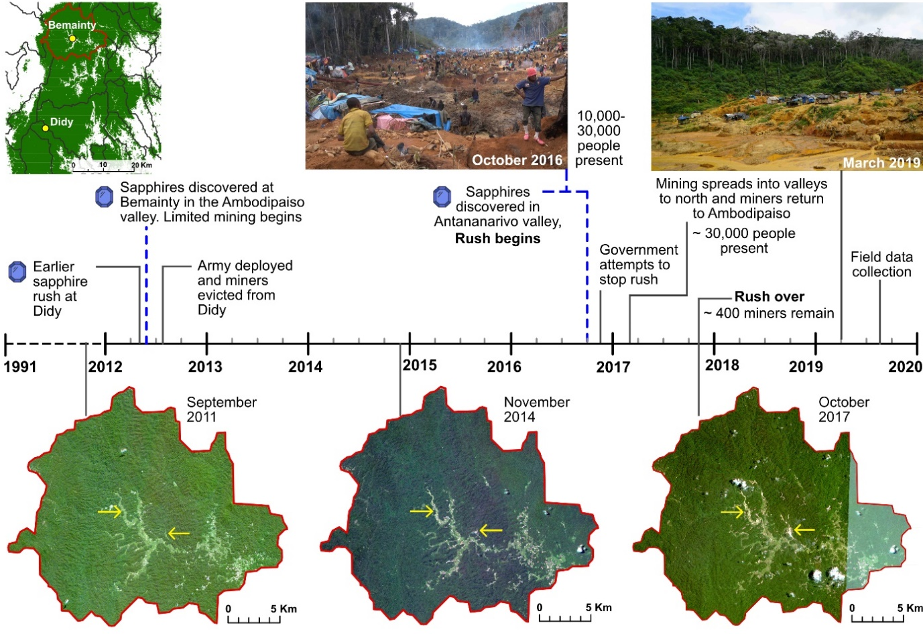
Figure 1: Timeline of the development of mining in the Bemainty drainage basin over the study period. Yellow arrows point to the Ambodipaiso (left) and Antananarivo (right) mining valleys at Bemainty. Dashed blue lines indicate the start of mining at Bemainty in 2012 and the onset of the rush in September 2016. Satellite images were captured by the RapidEye sensor and obtained from Planet¹⁰⁰. Image © 2011, Planet Labs PBC. Photo credit: Rosey Perkins.
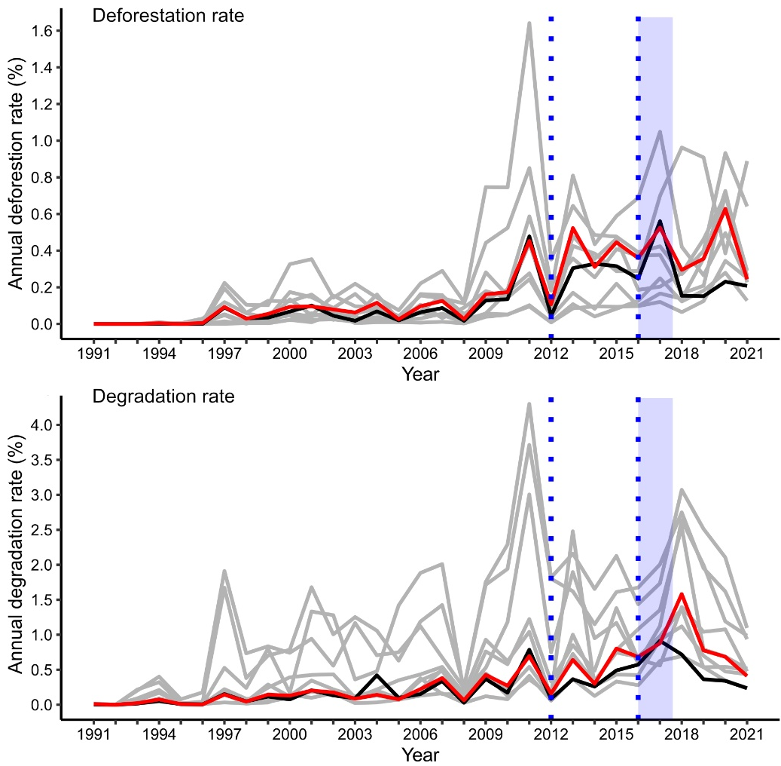
Figure 2: The annual deforestation and degradation rate within the Bemainty basin (black) compared to the synthetic control (red). Deforestation and degradation rates are shown in black for Bemainty and red for the synthetic control. Light grey lines show outcomes in the eight control drainage basins in the CAZ (i.e. the donor pool from which basins were selected to form the synthetic control). The dotted blue lines indicate the preliminary onset of mining in 2012 (left) and the start of the mining rush in 2016 (right). The light blue shaded area indicates the duration of the peak mining rush. These results are from our primary analysis focussed on the CAZ. See Supplementary Figures 9 and 10 for plots for other outcome measures.
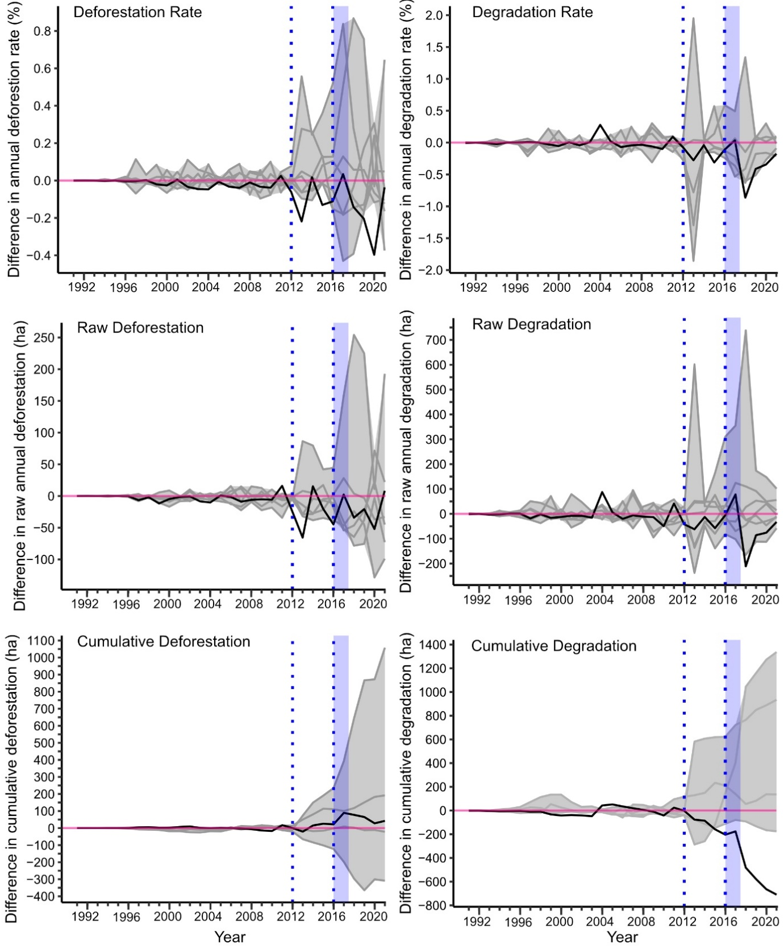
Figure 3: Using placebo tests to assess the significance of results. To assess significance, we compare the difference in deforestation and degradation between the Bemainty basin and its synthetic control (black) to results from placebo tests, which represent the statistical noise in estimation post-intervention. A strong significant effect is indicated where the black line falls outside the shaded grey area. The dotted blue lines indicate the onset of mining in 2012 (left) and the start of the mining rush in 2016 (right). The light blue shaded area indicates the duration of the peak mining rush. In the placebo tests each control basin in the donor pool (n = 8) was falsely assigned treated status and a synthetic control constructed for each. Grey lines represent the difference in outcomes between each false-treated basin and its synthetic control. Only pairs where the synthetic control is an acceptable match to the false-treated unit are included (between 4 and 8 depending on the analysis; see Methods). Results are from the primary analysis using drainage basins from the CAZ as the donor pool (see Supplementary Figure 13 for results from the wider analysis).

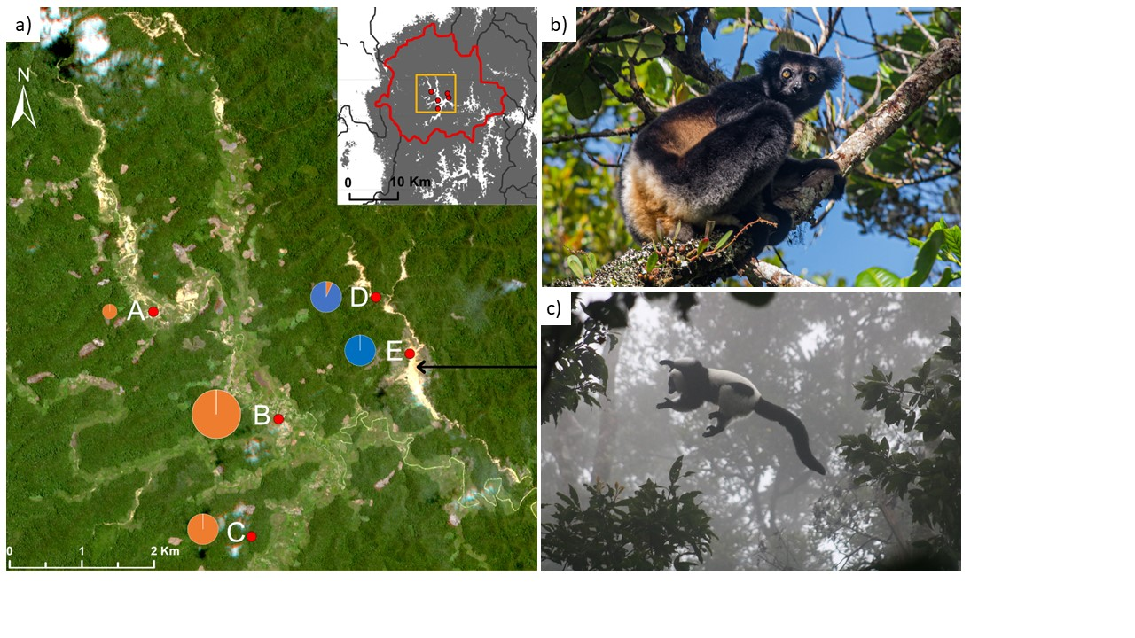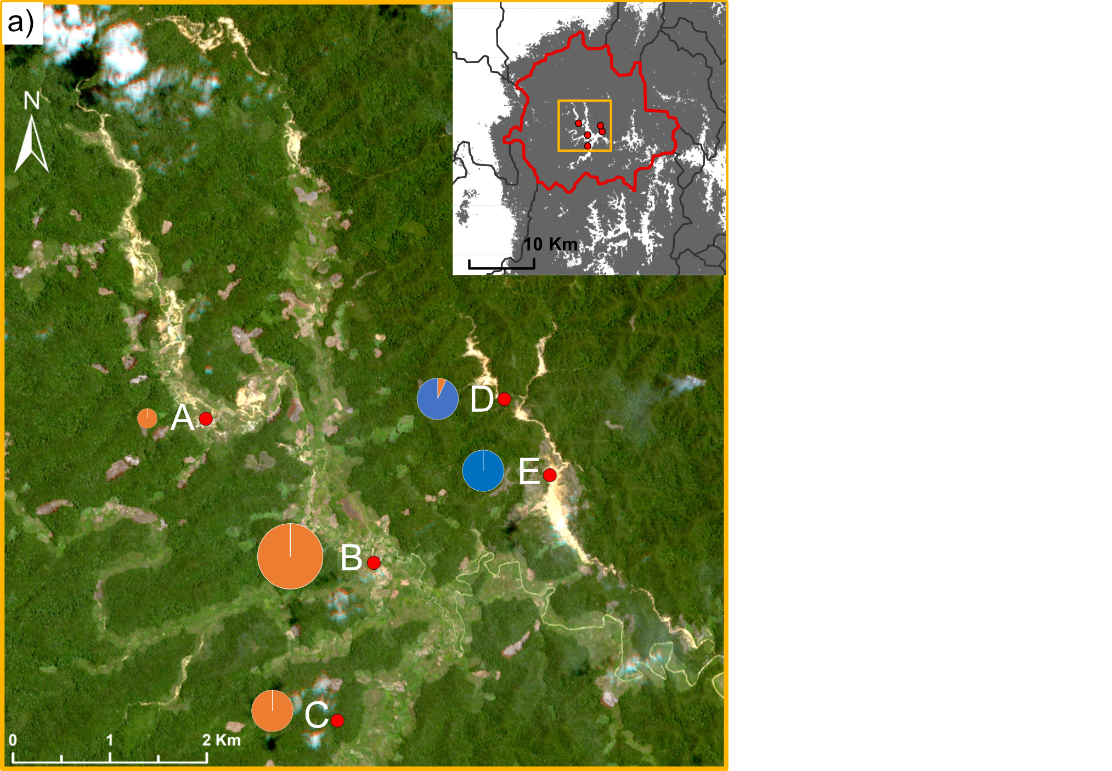
Figure 4: The location of settlements in the Bemainty valley where we conducted interviews, and two lemur species frequently encountered. a) Satellite image of the Bemainty valley from November 2017¹⁰⁰ showing the location of villages and mining settlements (red points) where interviews were conducted. Pie charts represent the proportion of respondents at each location who identified themselves as farmers (orange) or miners (blue). The size of the pie charts corresponds to the number of respondents. A = Sahananto (2 respondents), B = Bemainty (25), C = Sahamatra, D= Milliard (15), E = Antananarivo (15). Inset map shows the location of the villages within the Bemainty drainage basin (outlined in red). b and c) Two critically endangered large-bodied lemurs (Indri indri and Varecia varecia) which are highly vulnerable to over hunting were frequently encountered on transects surrounding Bemainty (pictures by Rio Heriniaina and Alex Georgiev respectively). Image © 2017, Planet Labs PBC.

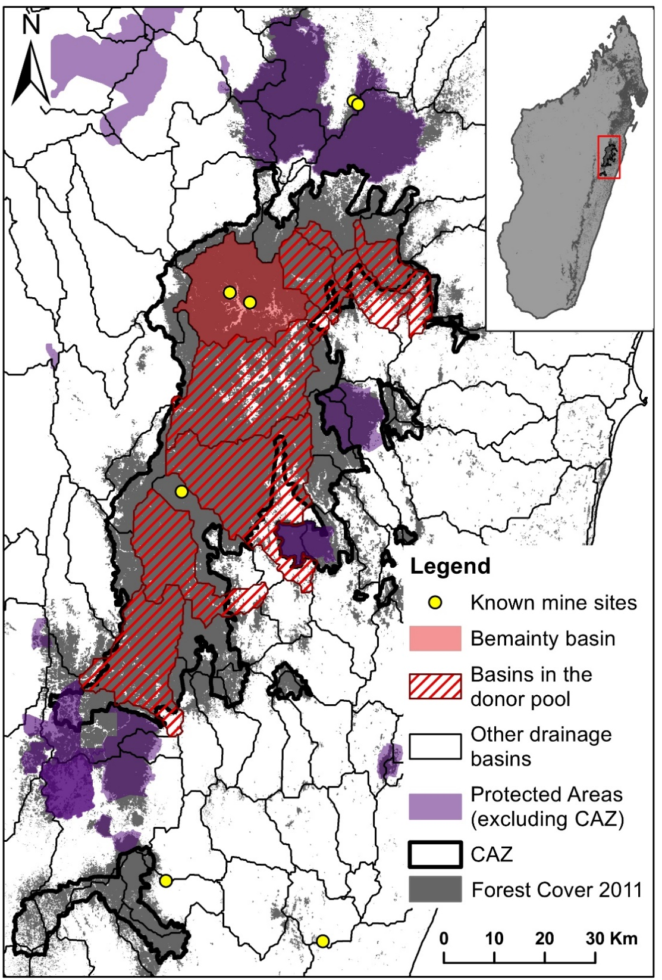

Figure 5: The Bemainty basin (red) and the eight control drainage basins in the donor pool (red hashed) for the synthetic control. For our primary analysis, selection of the donor pool is restricted to drainage basins without gem mining in the CAZ (outlined in black). Drainage basins which overlap by more than 10% with Protected Areas⁸⁷ or biodiversity offsets (shown in purple), or which contain other known gem mining sites³² (yellow points) were excluded. Yellow points in the Bemainty basin show the Ambodipaiso (left) and Antananarivo (right) mining valleys. The Forest Cover layer is derived from the Tropical Moist Forests Product⁹¹. See Supplementary Figure 4 for a similar map showing the donor pool drawn from the ex-province of Toamasina in the wider analysis.

