Supplementary Information – No evidence of increased forest loss from a mining rush in Madagascar’s eastern rainforests

Authors:
Katie Devenish^{1,2}, Simon Willcock^{1,3}, Kathryn M. Goodenough⁴, Rio Heriniaina⁵, O. Sarobidy Rakotonarivo⁶, Julia P.G. Jones^{1,7}.

Affiliations:
¹ School of Environmental and Natural Science, Bangor University, Bangor, UK.
² Global Development Institute, University of Manchester, Manchester, UK
³ Net Zero and Resilient Farming, Rothamsted Research, Harpenden, UK.
⁴ British Geological Survey, Edinburgh, UK.
⁵ Ecole Supérieure des Sciences Agronomiques et Environnementales, Université de Antsiranana, Antsiranana, Madagascar.
⁶ Ecole Supérieure des Sciences Agronomiques, Université de Antananarivo, Antananarivo, Madagascar
⁷ Department of Biology, Utrecht University, Utrecht, The Netherlands

Corresponding author:
Katie Devenish – katie.devenish@manchester.ac.uk

Supplementary Methods
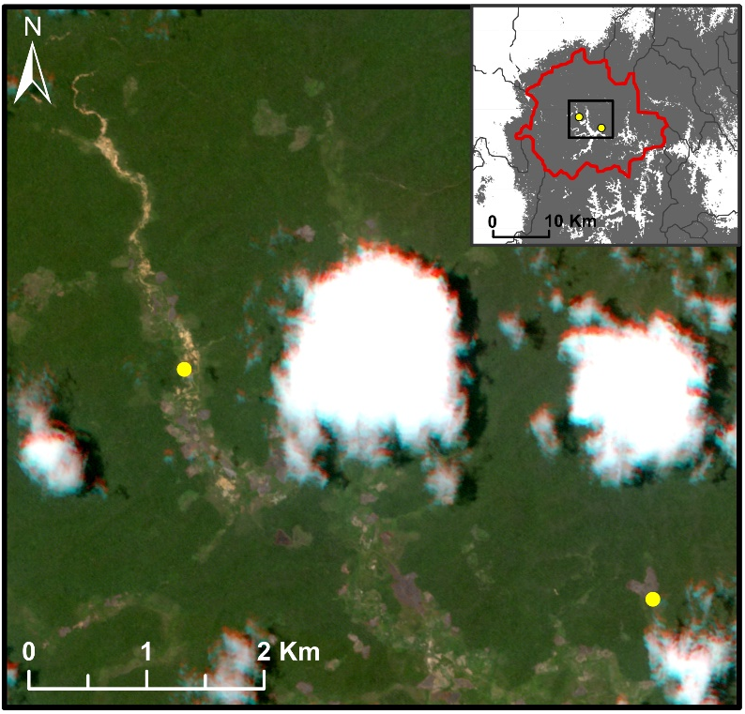
Supplementary Figure 1: Satellite image of the northern part of the Bemainty valley on 17th November 2013 taken from the RapidEye sensor¹. The image shows artisanal gem mining activity in the Ambodipaiso valley (left yellow dot), visible as disturbed yellowish sediments stretching several kilometres along the river in the upper part of the valley. The image also shows recent tavy (where forest is burned and then cleared for shifting cultivation) in the Antananarivo valley (right yellow dot) where the mining rush would later occur. Image © 2017, Planet Labs PBC.

Choosing the unit of analysis
To choose which scale of drainage basin from the HydroBASINS data to use, we mapped the potential impact zone around the two mining valleys. To define the size of this zone we drew on survey data (n = 418 individuals) from a study area in north-east Madagascar which found that, on average local people would travel up to 1.9 hours to collect forest products². Following this study², we converted travel time to distance using the Path Distance function in ArcGIS and Tobler’s function to account for the effect of slope on distance covered. We then mapped the resulting impact area (Supplementary Figure 2). This is likely an overestimate as the Path Distance function did not incorporate the difficulties of moving through forested terrain. Short-term migrant miners may also be especially unlikely to venture far from the mine site to access materials. However, we wanted to ensure we captured all potential impacts within our treated unit and avoided spillovers into neighbouring control units as much as possible. Supplementary Figure 2 maps the Level 12 and Level 9 drainage basins compared to the potential impact zone. The boundary of the Level 12 basin is extremely close to the Antananarivo valley meaning it may not capture the full spread of impacts. Therefore, we chose the Level 9 basins as our unit of analysis as this best matches the potential impact zone.
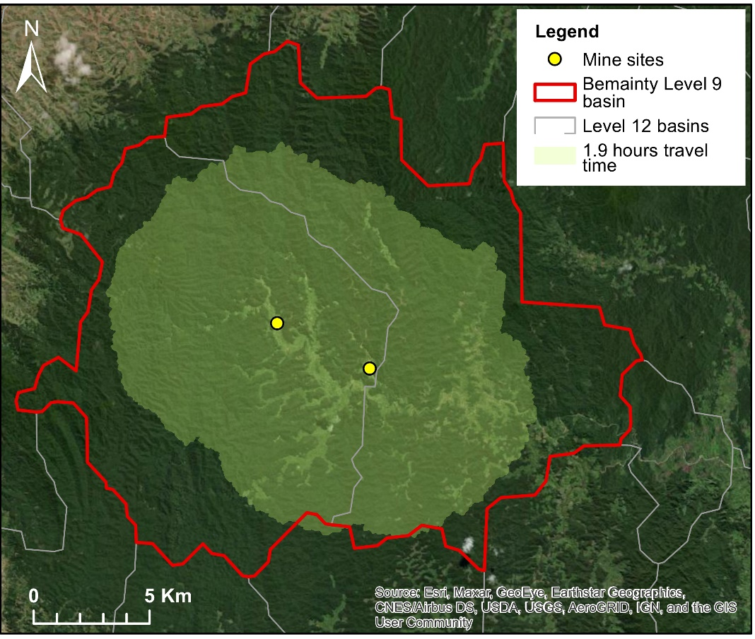
Supplementary Figure 2: The estimated area within 1.9 hours walking distance from the Antananarivo (right yellow dot) or Ambodipaiso (left yellow dot) mining valleys is shaded light green. This represents the potential spread of forest impacts from mining. The Level 9 drainage basin encompassing Bemainty is shown in red and the smaller Level 12 basins (which we decided not to use in this analysis) are shown for comparison in light grey.

Directed Acyclic Graph describing our study design
Directed Acyclic Graphs (DAGs) display causal relationships between variables and are useful to make the assumptions in a study design apparent. We suggest that population density, accessibility, and suitability for agriculture are all potential confounders of the path between the presence of a mining rush and deforestation, as these factors could affect both the probability of gems present in the area being discovered, and deforestation. Proxies for these are included in our study design (Supplementary Table 1). Protected status (i.e. whether the site is within an effectively managed protected area) is also a confounder. We account for this by only including drainage basins with similar protected status in the donor pool. The area of forest in a drainage basin is a competing exposure for the amount of deforestation so we also control for this in the analysis (Supplementary Table 1). However, unobserved confounders are likely to remain. For example, social characteristics of the local population may affect the likelihood of outsiders coming into the area to prospect for mining, as well as in-migration for farming or logging. The very specific local geology which controls the presence of gems in the river basin is an ancestor of X (the presence of mining rush) but is not a confounder as there is no direct casual path between this and deforestation in the drainage basin. While geology in general can of course affect suitability for agriculture and therefore deforestation, all drainage basins in our donor pool share a similar geology and are located within the same tectonic unit (Tucker et al., 2014).

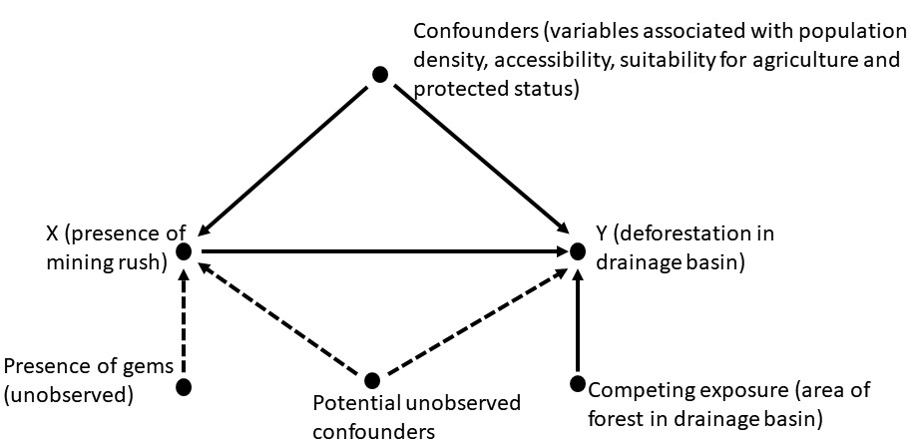
Supplementary Figure 3: Simplified Directed Acyclic Graph in which a single-headed arrow (→) represents a causal link or pathway between two variables. In this paper we explore the extent to which x (a mining rush), caused y (deforestation in the Bemainty drainage basin). We control for observable confounders directly. The synthetic control method allows unobserved confounders to be controlled for to some extent³.
Supplementary Table 1: Details of the covariates used in the synthetic control matching, including the hypothesized mechanism through which they influence deforestation and degradation, data sources, and any subsequent manipulation. References are all specific to Madagascar. All data were reprojected to WGS 1984 UTM Zone 38S.
Covariate | Hypothesised causal mechanism | Data source | Data manipulation | References
Population density 2011 (people per km²) | Demand | WorldPop unconstrainedUN-adjusted population counts 100m resolution | Summed population counts per sub-basin. Divided by the area of the sub-basin | Elmqvist et al⁴, Brinkmann et al⁵, McConnell et al⁶, Agarwal et al⁷, WorldPop⁸
Population growth 2001-2011 | Demand | WorldPop unconstrained UN-adjusted population counts 100m resolution | Calculated the percentage population growth between 2001 and 2011 using population counts per sub-basin in 2001 and 2011 | Kull⁹, Vagen¹⁰, WorldPop⁸
Mean distance to settlement (m) | Accessibility, Demand | NGA OCHA-ROSA Populated Places | Produced a distance raster using the Euclidean Distance tool in ArcMap 10.7. Calculated the mean distance to settlement per sub-basin using Zonal Statistics | Brinkmann et al⁵, McConnell et al⁶, Vagen¹⁰, NGA OCHA ROSA¹¹
Mean elevation (m) | Accessibility, Suitability for agriculture | SRTM 30m Digital Elevation Model | Calculated the mean elevation per sub-basin | Agarwal et al⁷, McConnell et al⁶, Vagen¹⁰
Mean slope (°) | Accessibility, Suitability for agriculture, Suitability for gem panning | SRTM 30m Digital Elevation Model | Derived from the DEM using the Slope tool in ArcMap 10.7. Calculated the mean slope per sub-basin | Andriatsitohaina et al¹², Burivalova et al¹³
Mean annual precipitation 1970-2000 (mm) | Suitability for agriculture | WorldClim v.2 | Calculated the mean annual precipitation per sub-basin | Fick and Hijmans¹⁴,  Andriatsitohaina et al¹², Eklund et al¹⁵
Mean distance to cart track (m) | Accessibility | FTM (Foiben Taosarintanin ’I Madagasikara) | Produced a Euclidean distance raster and calculated mean distance to cart track per sub-basin | Rasolofoson et al¹⁶
Mean distance to road (m) | Accessibility | FTM (Foiben Taosarintanin ’I Madagasikara) | Produced a Euclidean distance raster and calculated mean distance to road per sub-basin | Brinkmann et al⁵, Elmqvist et al⁴, Vagen¹⁰
Mean distance to river (m) | Accessibility, Suitability for agriculture, Suitability for gem panning | HydroSHEDS | Produced a Euclidean distance raster and calculated mean distance to river per sub-basin | Burivalova et al¹³, Allnutt et al²
Percentage forest cover 2011 | Availability | Tropical Moist Forests Annual Change dataset 2011 | Reclassified to remove non-forest pixels. Remaining classes are undisturbed, degraded and regrowing tropical moist forests. Masked to a forest cover map for Madagascar in 1990 (Vieilledent et al., 2018). The resulting layer represents the proportion of tree cover at any successional stage available to be deforested post-2011. | Vieilledent et al¹⁷, Vancutsem et al¹⁸
Mean distance to forest edge 2011 (m) | Accessibility, Suitability for agriculture | Vieilledent et al., (2018) | Calculated mean distance to forest edge per sub-basin | McConnell et al⁶
Basin area (ha) | Availability | WaterSHEDS |  | Lehner and Grill¹⁹

Selection of control units to the donor pool – secondary analysis
As a robustness check and to increase the number of control basins for the placebo tests we ran a secondary analysis sampling control units from a wider area - the ex-province of Toamasina (shown in yellow in Supplementary Figure 3). This resulted in 13 control drainage basins being selected into the donor pool. This includes the original eight control basins from the CAZ plus an additional five basins encompassing unprotected forests in the north of the province.

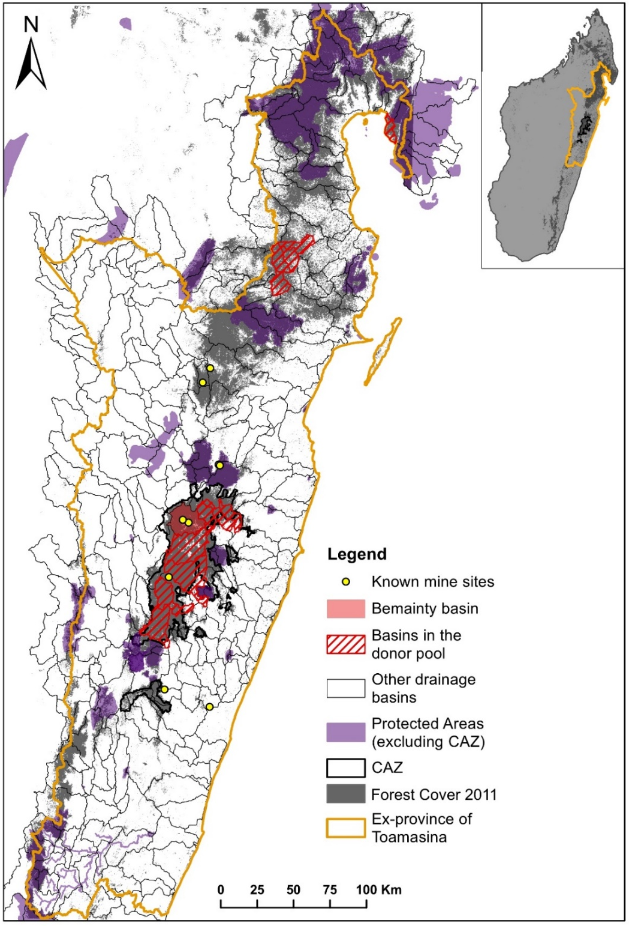

Supplementary Figure 4: Map shows the treated Bemainty basin (shaded red) and the 13 drainage basins included in the donor pool (red hashed) for the wider analysis, where units were sampled from the ex-province of Toamasina (yellow). Only drainage basins with over 70% forest cover in 2011¹⁸ were included. Drainage basins which overlap with Protected Areas²⁰ or biodiversity offsets (purple) or which contain other gem mining sites²¹ (yellow points) were excluded.

Steps to improve the accuracy of the outcome variable
We masked the TMF¹⁸ data products used in our analysis to a national-scale forest cover map^{17,22} of Madagascar in 1990, the start of our study period. We considered the national-scale study^{17,22}, which is designed to capture local specificities, is likely to be more effective at distinguishing forests from other land cover types in Madagascar than a global study.
To investigate this, we compared the original and the masked TMF data and cross-referred with other sources of data, focussing on the Bemainty basin (Supplementary Figure 4). The original TMF deforestation data indicates that the Bemainty valley was cleared during the study period, mostly between 2001 and 2010 (Supplementary Figure 4, top). However, a LANDSAT satellite image from 1989 shows that the valley had already been cleared long before (Supplementary Figure 5). This means that there are false positives in the TMF data where forest loss is identified in pixels which were not forested, perhaps due to clearance of agricultural/fallow land being mis-identified as deforestation. In contrast, the national-scale study, which maps forest change from 1953 – 2000, aligns with the satellite imagery and indicates the valley was cleared in the 1970s²². Therefore, we consider the masked map to be a more accurate representation of forest loss in Madagascar than the original global data.
Masking the TMF data to the national map of forest cover in 1990 substantially alters the data, resulting in a large reduction in estimated deforestation, particularly in the lowlands east of the CAZ (Supplementary Figure 6). There the original TMF data detects a large amount of deforestation on land which is not classed as forest in the 1990 map and is most likely agricultural land.
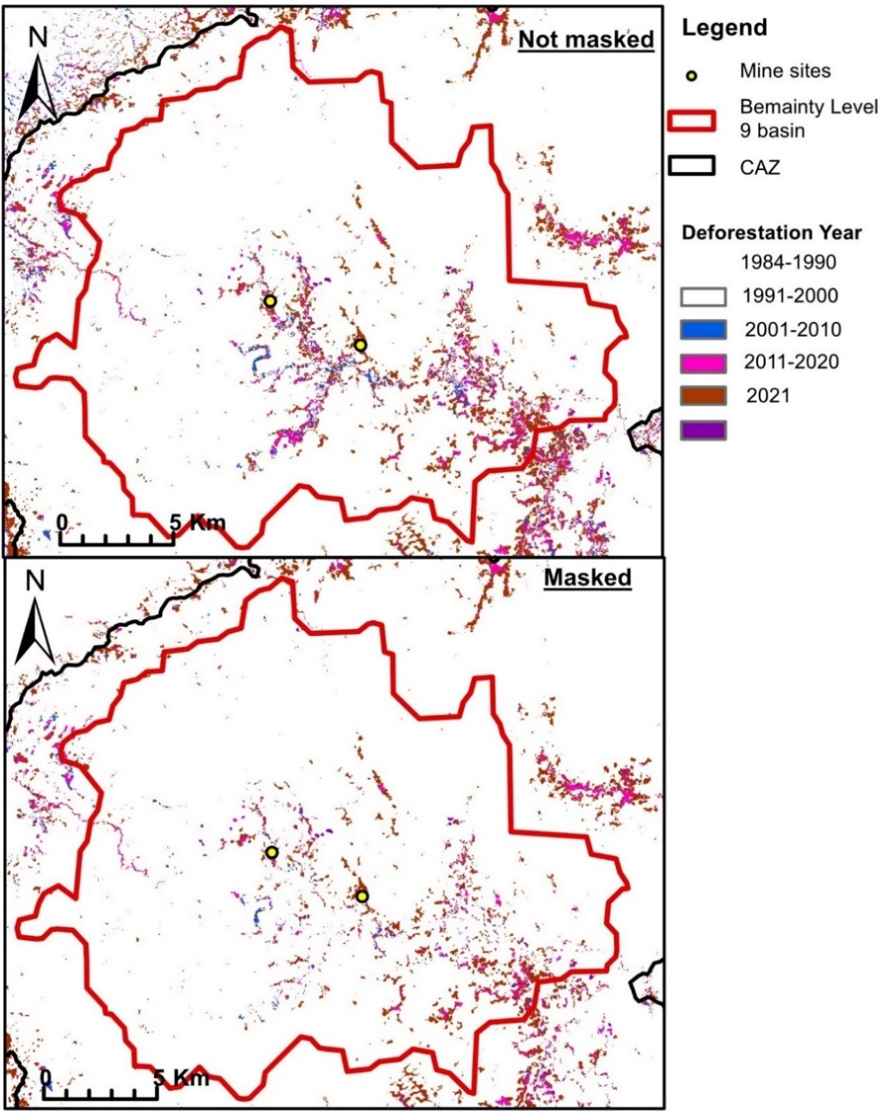 Supplementary Figure 5: Comparison of the original Tropical Moist Forests Deforestation Year data¹⁸ (top) to the data masked to a map of forest cover in 1990²² (bottom) for the Bemainty basin (outlined in red). Masking the data in this way removes many false positives, where deforestation is identified on land which is not forest. For example, the original data suggests the Bemainty valley was cleared between 2001 and 2020 while satellite imagery shows that it had already been cleared by 1989 (Supplementary Figure 6). The yellow dots represent the Antananarivo (east) and Ambodipaiso (west) mining valleys.
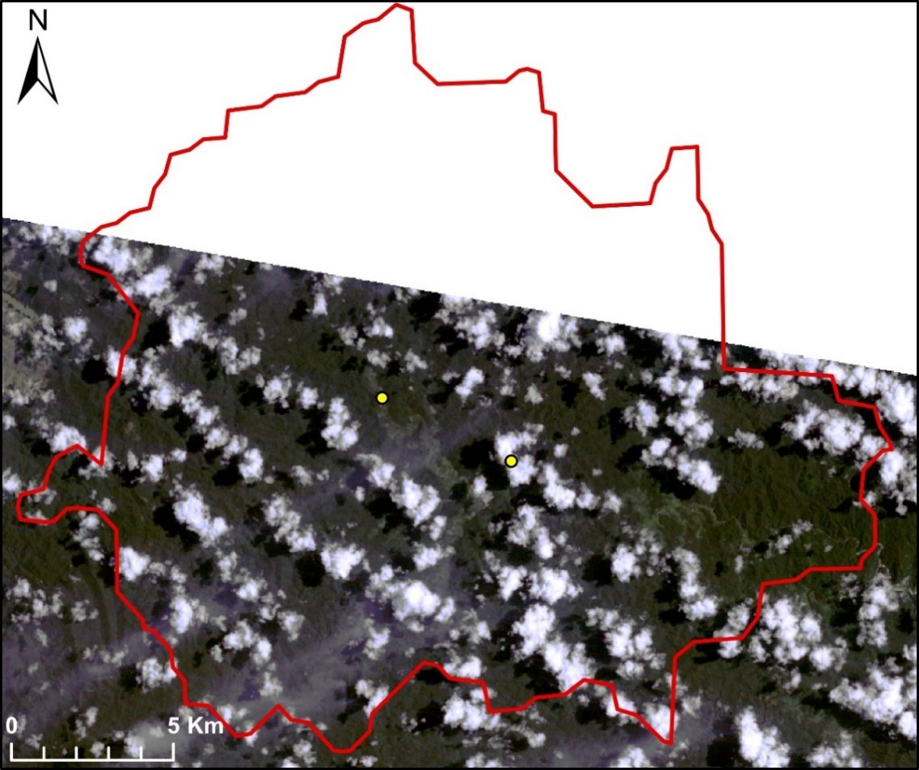
Supplementary Figure 6: LANDSAT image of the Bemainty basin from 12th March 1989. This shows that the Bemainty valley was already cleared by this date.

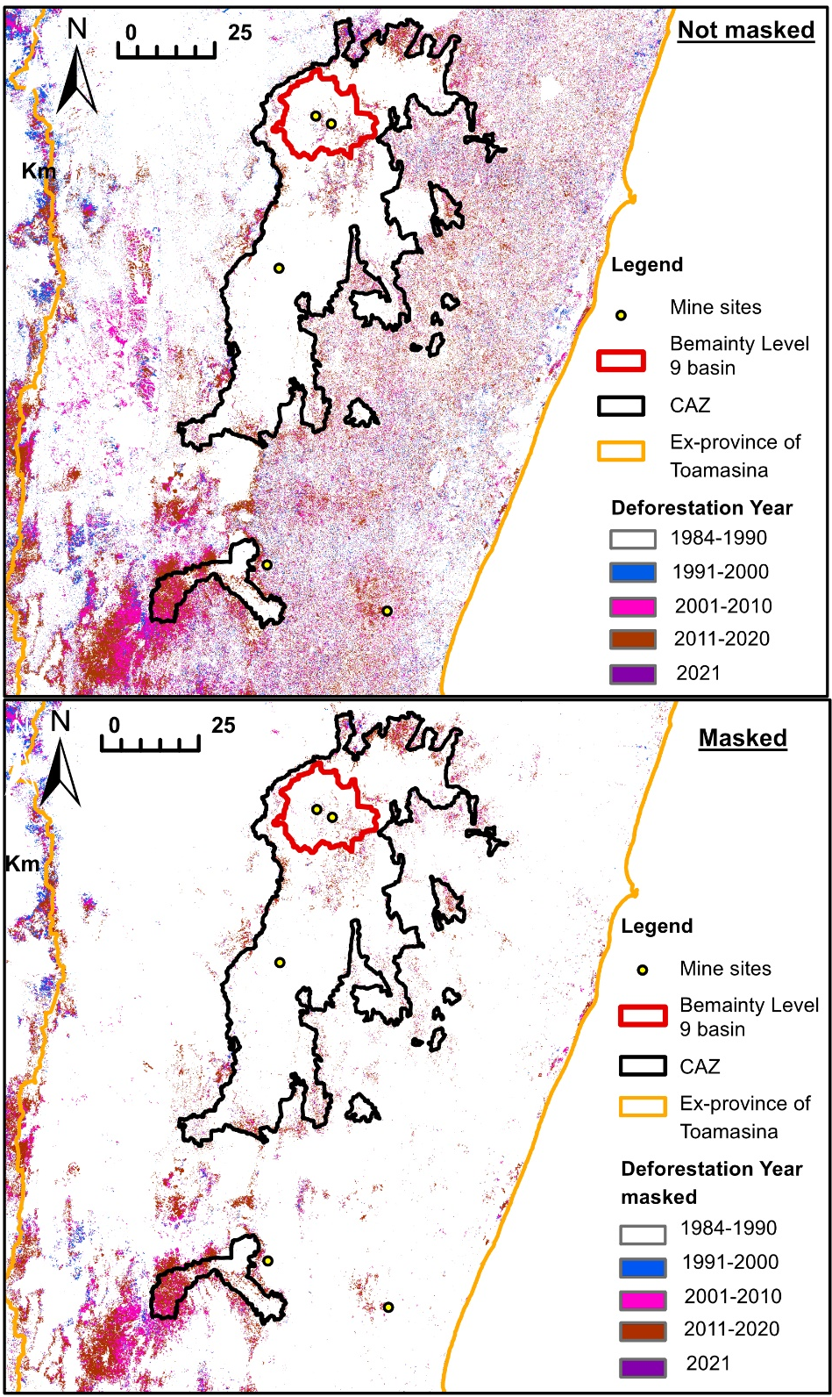

Supplementary Figure 7: Comparison of the original Tropical Moist Forests Deforestation Year data¹⁸ (top) to the data masked to a map of forest cover in 1990²² (bottom). This highlights the substantial differences between the original and masked datasets. The Bemainty drainage basin is outlined in red and the two mining valleys shown by yellow dots within.

Ground-truthing the Tropical Moist Forests data
We use land cover data from sites surveyed as part of the Payments for Global Ecosystem Services (P4GES) project to ground-truth the masked TMF data²³. This project included a carbon stock assessment of the forests of the CAZ based on soil and vegetation data collected from 132 representative sample sites. Sample sites were located within four zones of interest, two in the north and two in the southern part of the CAZ. Land cover data was needed to inform the sampling design, so the initial classification was done using satellite imagery. The land cover at each site was then validated (and revised if incorrect) during the field surveys. Additional information on land use history at each site was obtained from interviews. Land cover was classified into six categories, drawing on Styger et al²⁴:
- Closed canopy forest
- Eucalyptus plantation
- Reforestation
- Tree fallow (the first fallow period after deforestation where vegetation is dominated by young trees)
- Shrub fallow (subsequent fallow periods where the site is dominated by shrub species)
- Tany maty (degraded land. This is treeless land at the end of the fallow-cropping cycle where the land has become so degraded it is no longer suitable for agriculture.)
We use this field data to test the accuracy of the masked TMF data at distinguishing different land cover types in the CAZ (Supplementary Table 2, Supplementary Figure 7). Field surveys were conducted between April 2014 and June 2015, so we compare to the TMF Annual Change data for 2015. There were 63 surveyed sites which overlapped with our masked TMF data (masked to the area of forest in 1990²²).
Supplementary Table 2: Correspondence between land cover at 63 sites in the CAZ identified through field surveys (conducted April 2014- June 2015) and land cover classification in the TMF Annual Change dataset for 2015. E.g., 89% of sites identified as closed canopy forest in field surveys were classed as undisturbed tropical moist forest in the TMF data.
Ground- truthed land cover 2014-2015 | TMF land cover classification 2015
 | Deforested (%) | Degraded (%) | Other land cover (%) | Undisturbed tropical moist forest (%) |  | Total sites
Closed canopy | 7.1 | 3.6 | 0.0 | 89.3 |  | 28
Shrub fallow | 83.3 | 0 | 16.7 | 0.0 |  | 12
Tany maty | 90.9 | 0 | 9.1 | 0.0 |  | 11
Tree fallow | 58.3 | 8.3 | 25.0 | 8.3 |  | 12
Total sites |  |  |  |  |  | 63

Supplementary Figure 8: TMF classification of 63 sample sites by land cover category identified during field survey. N = 63.
N = 28
N = 12
N = 11
N = 12

This data indicates that for a sample of 63 sites in and around the CAZ, the TMF data¹⁸ effectively identified closed canopy forest (which most closely aligns to undisturbed tropical moist forest in the TMF classification) in 89% of cases. With the addition of the closed canopy site classed as degraded in the TMF data, which may have been degraded earlier and recovered to closed canopy by the time of the surveys, this increases to 93%. Shrub fallow, tany maty, and tree fallow were mostly classified as deforested land (i.e., pixels forested in 1990 which were cleared during the study period and remained without canopy cover in 2015), or other land cover (which includes agricultural land). Tree fallow was only mistakenly identified as undisturbed forest in one case. While the small sample size (concentrated in four areas) limits the interpretation of these results, it provides some reassuring first evidence of the effectiveness of the masked TMF data at classifying land cover in the study area.
Deriving annual forest cover layers from the Tropical Moist Forests data
We obtained annual forest cover layers by reclassifying each of the Tropical Moist Forests Annual Change layers. Undisturbed tropical moist forest, degraded tropical moist forest and forest regrowth pixels were reclassified as forest (1) and all other classes were removed.
Degraded tropical moist forest pixels are those which were tropical moist forest at the start of the time series but experienced a loss of tree cover (termed disruption), lasting less than 2.5 years, at some point between the start of the time series and the year in question. This means that some recently degraded pixels without tree cover will have been included in our measure of forest cover for each year. However, Vancutsem et al¹⁸ show that most tree loss (50%) within degraded forest pixels lasts less than 6 months, after which some vegetation recovery is observed (i.e., the disruption is no longer observed). According to this, a degraded pixel which has experienced tree loss in June 1999, for example, will likely have some vegetation recovery by January 2000 and is consequently available to be cleared again. We will be using forest cover at the end of the previous year (t-1) to calculate the deforestation rate in year t. This allows time for vegetation recovery to begin in pixels degraded in year t-1. Tropical forest does not regrow in a few months or years, it can take decades for tropical forest to recover to closed canopy state following disturbance. However, we include degraded pixels in our forest cover layers because this data is intended to represent the land available to be deforested, including forest at any successional stage. Furthermore, excluding degraded pixels from our forest cover layer would miss potentially large areas of secondary forest which had been degraded long ago, (e.g., 6% of the Bemainty basin was classed as degraded forest in 2021).
Supplementary Note 1
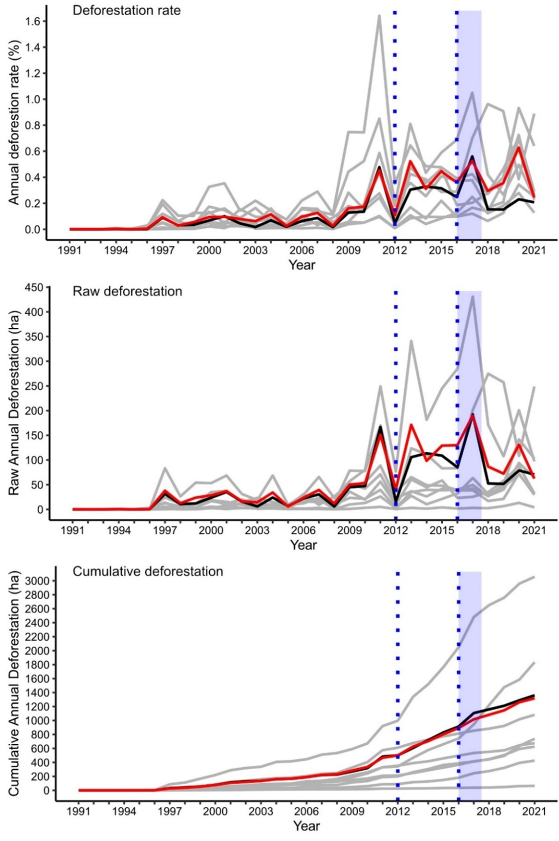
Supplementary Figure 9: Deforestation outcomes in Bemainty (black), the synthetic control (red), and the 8 control drainage basins within the CAZ donor pool (light grey), for each of the three outcome measures. The dotted blue lines indicate the onset of mining in 2012 (left) and the start of the mining rush in 2016 (right). The light blue shaded area indicates the duration of the peak mining rush. These results are from our primary analysis focussed on the CAZ.
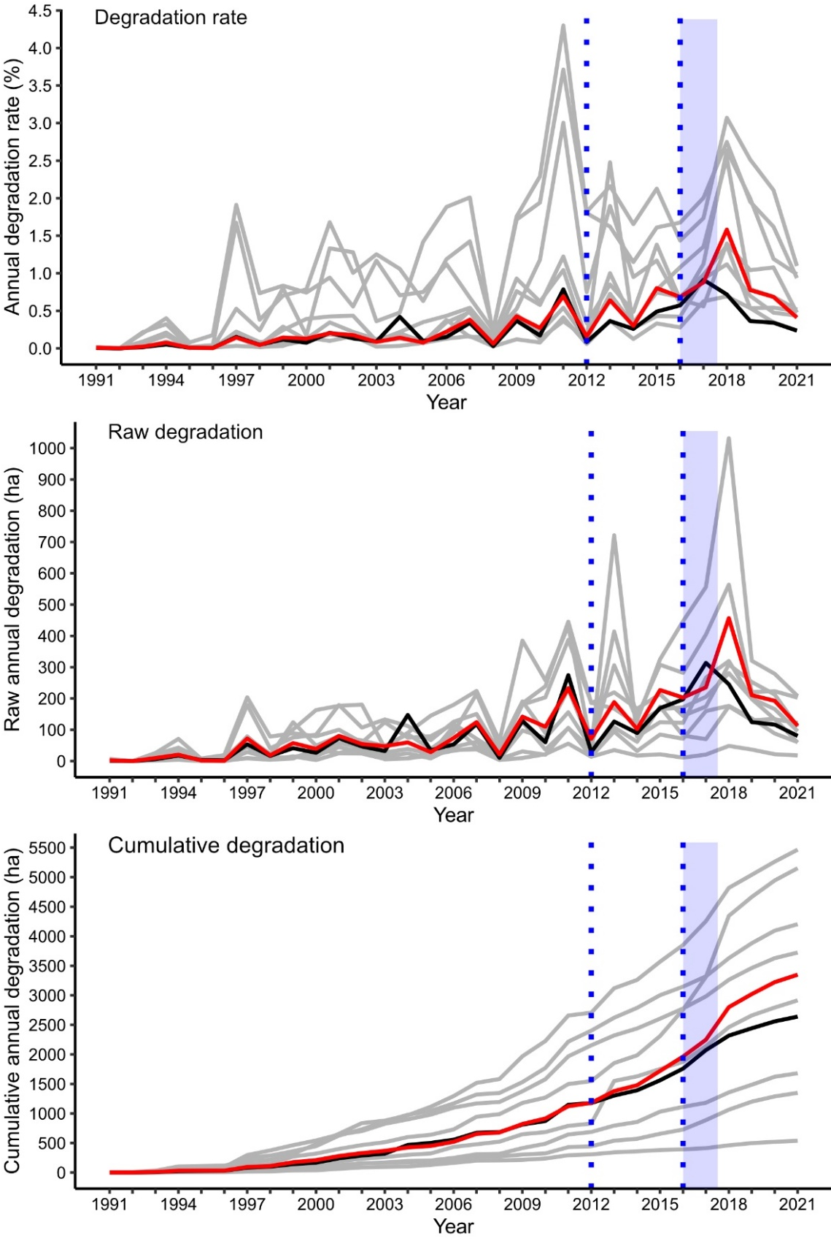
Supplementary Figure 10: Degradation outcomes in Bemainty (black), Synthetic Bemainty (red) and the 8 control drainage basins within the CAZ donor pool (light grey), for each of the three outcome measures. The dotted blue lines indicate the onset of mining in 2012 (left) and the start of the mining rush in 2016 (right). The light blue shaded area indicates the duration of the peak mining rush. These results are from our primary analysis focussed on the CAZ.

Supplementary Table 3: Annual deforestation rate in 2016 and 2017 in the Bemainty basin, Synthetic Bemainty and the 8 drainage basins in the CAZ donor pool.
Drainage Basins | Annual deforestation rate (%) |  | Change (%)
 | 2016 | 2017
Bemainty | 0.25 | 0.56 | +0.31
Synthetic Bemainty | 0.36 | 0.53 | +0.17
1 | 0.10 | 0.12 | +0.02
2 | 0.29 | 0.70 | +0.41
3 | 0.37 | 0.38 | +0.01
4 | 0.39 | 0.42 | +0.03
5 | 0.10 | 0.17 | +0.07
6 | 0.19 | 0.20 | +0.02
7 | 0.69 | 1.05 | +0.36
8 | 0.13 | 0.25 | +0.12

In-time placebo tests
In-time placebo tests were conducted to validate the method and to test the robustness of results to an alternative temporal specification (see Methods). In these placebo tests we falsely-assigned treatment to 2009 and constructed a synthetic control using forest change outcomes from 1991-2008.
The ability of the synthetic control to closely reproduce outcomes in Bemainty between 2009-2012 (i.e., a period without mining), indicates that the method can produce credible estimates of forest change in Bemainty without mining in the real post-intervention period (i.e., the counterfactual). Visually, we can see that outcomes in the synthetic control mostly track outcomes in Bemainty over the validation period (shown in grey). There is a difference in raw (and consequently cumulative) deforestation between Bemainty and its synthetic control in 2011. However, this difference (44 ha) is within the threshold of 0.5% of project area (which is 36,618 ha) considered by West et al²⁵ to be acceptable.
In contrast to the main results, the in-time placebo tests indicate higher deforestation in Bemainty in 2017, although this is a very similar magnitude (37 ha) to the difference in 2011, and therefore cannot be robustly attributed to the mining rush. Degradation is mostly lower in Bemainty than the synthetic control at the height of the mining rush (2016 and 2017).
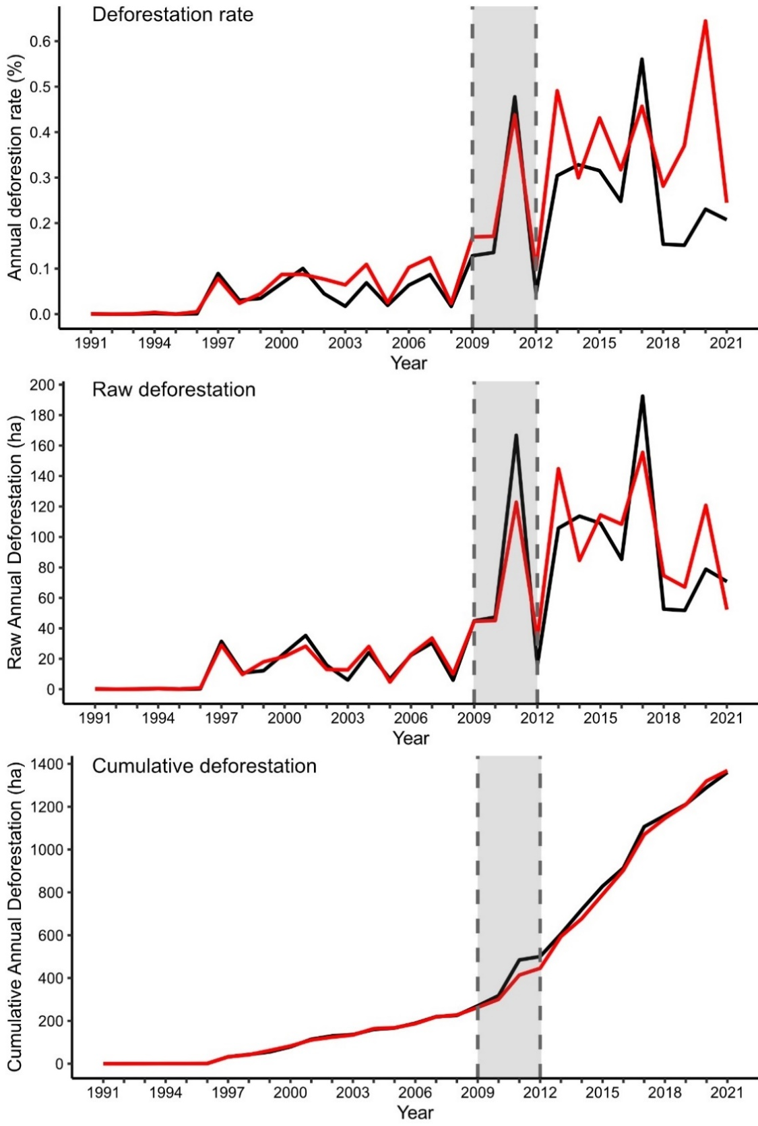
Supplementary Figure 11: Results from the in-time placebo tests for the three deforestation outcomes. Treatment was falsely-assigned in 2009 (left grey dashed line). The black line shows deforestation outcomes in Bemainty while the red line shows outcomes in the synthetic control. The shaded grey area indicates the validation period between false-treatment and actual treatment (i.e., the start of mining in 2012). The difference between the red and black lines in this period reflects the ability of the synthetic control to reproduce outcomes in Bemainty in the absence of mining. These results are for our primary analysis focussed on the CAZ.
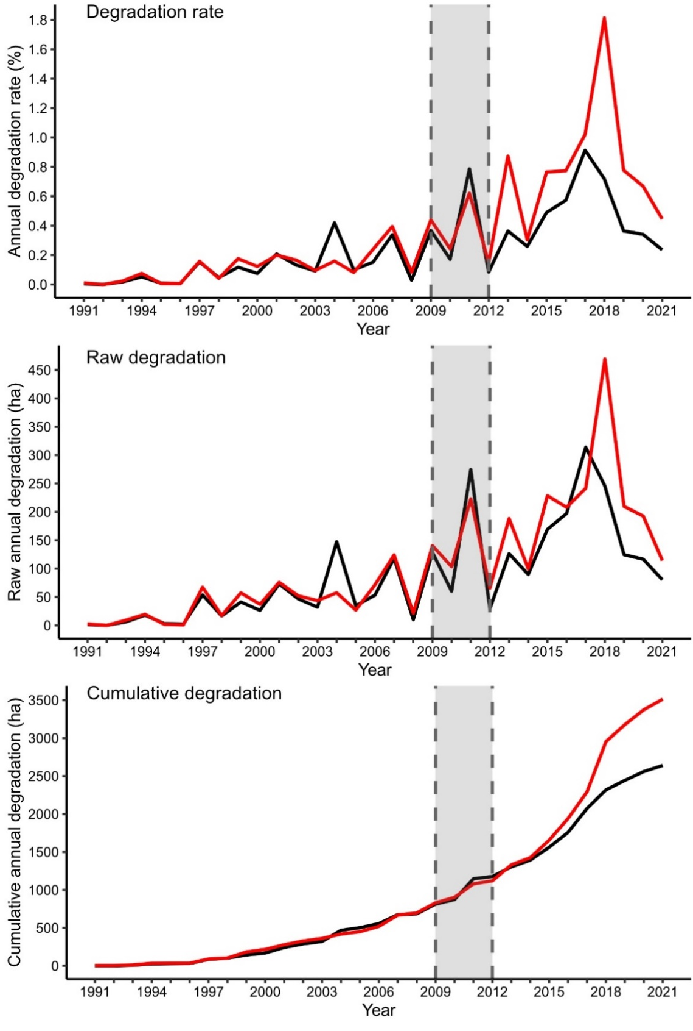
Supplementary Figure 12: Results from the in-time placebo tests for the three forest degradation outcomes. Treatment was falsely-assigned in 2009 (left grey dashed line). The black line shows degradation outcomes in Bemainty while the red line shows outcomes in the synthetic control. The shaded grey area indicates the validation period between false-treatment and actual treatment (i.e., the start of mining in 2012). The difference between the red and black lines in this period reflects the ability of the synthetic control to reproduce outcomes in Bemainty in the absence of mining. These results are for our primary analysis focussed on the CAZ.

Placebo tests to assess the significance of results from the wider analysis
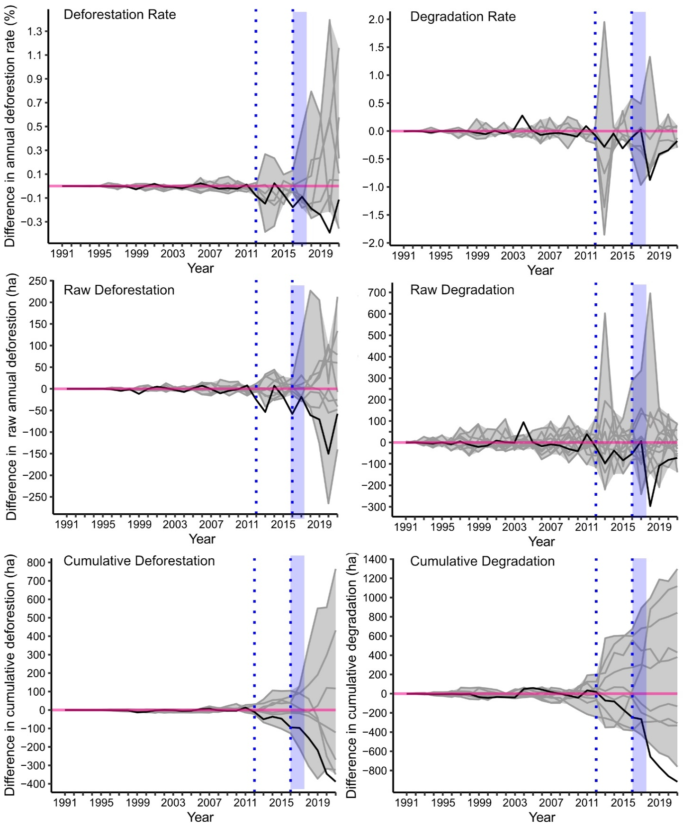
Supplementary Figure 13: The difference in deforestation and degradation between the Bemainty basin and the synthetic control (black), using placebo tests to represent the statistical noise in estimation post-intervention (shaded grey area). A strong significant effect is indicated where the black line falls outside the shaded grey area. The dotted blue lines indicate the onset of mining in 2012 (left) and the start of the mining rush in 2016 (right). The light blue shaded area indicates the duration of the peak mining rush. In the placebo tests each control basin in the donor pool was falsely assigned treated status and a synthetic control constructed for each. Grey lines represent the difference in outcomes between each false-treated basin and its synthetic control (only pairs where the synthetic control is an acceptable match to the false-treated unit are included, see Methods). Results are from the wider analysis sampling drainage basins from the ex-province of Toamasina.

Supplementary Note 2

Supplementary Table 4: Community composition and number of lemur encounters recorded during 2019 surveys at Bemainty. The list of lemur species known from the CAZ was compiled by Goodman, Raherilalao and Wohlauser²⁶. For auditory encounters N/A indicates that the species is seldom recorded from calls. Nocturnal species are indicated in bold.
Lemur species known from the CAZ | Recorded during surveys | Number of auditory encounters | Number of visual encounters | IUCN Red List category
Allocebus trichotis  Hairy-eared dwarf lemur | û | N/A | 0 | Endangered
Avahi laniger Eastern wooly lemur | ü | N/A | 2 | Vulnerable
Cheirogaleus crossleyi  Furry-eared dwarf lemur | ü | N/A | 1 | Vulnerable
Daubentonia madagascariensis  Aye-aye | û | N/A | 0 | Endangered
Eulemur fulvus Common brown lemur | ü | 2 | 26 | Vulnerable
Eulemur rubriventer  Red-bellied lemur | ü | 0 | 13 | Vulnerable
Hapalemur griseus  Eastern lesser bamboo lemur | ü | 0 | 5 | Vulnerable
Indri indri Indri | ü | 332 | 140 | Critically Endangered
Lepilemur mustelinus  Weasel sportive lemur | ü | N/A | 6 | Vulnerable
Microcebus lehilahytsara Goodman’s mouse lemur | ü | N/A | 1 | Near threatened
Prolemur simus  Greater Bamboo Lemur | û | N/A | 0 | Critically Endangered
Propithecus diadema  Diademed sifaka | ü | 0 | 23 | Critically Endangered
Varecia variegata Black and white ruffed lemur | ü | 149 | 35 | Critically Endangered

Supplementary Note 3

Supplementary Table 5: Characteristics of settlements in the Bemainty basin and estimates of the population in 2019. Population estimates were provided by the Chief of the Fokotany of Antsevabe, within which Bemainty is located. Antananarivo and Milliard are temporary mining settlements created during the mining rush. The other three villages existed prior to mining.
Village | Number of houses |  | Number of grocery shops |  | Number of houses with metal roofs |  | Estimated adult population |  | School
Antananarivo |  | 133 |  | 11 |  | 0 |  | 500 |  | No
Milliard |  | 100-120 |  | 7 |  | 0 |  | 200-300 |  | No
Sahamatra |  | 23 |  | 0 |  | 0 |  | 120 |  | No
Sahananto |  | 22 |  | 0 |  | 1 |  | 150 |  | Yes -1
Bemainty |  | 49 |  | 3 |  | 4 |  | 220-300 |  | Unknown

Interview results
In interviews, when asked about their natural resource use, both miners and farmers reported that trees were harvested for firewood or construction materials. However, members of both groups emphasized that they do not cut mature trees.
“I only use dry wood for firewood. I do not believe that miners cut many trees. We come here for sapphire mining not for cutting trees.” (Miner, Milliard).
When asked about their perceptions of sapphire mining, many farmers (55%) described the negative socio-economic impacts of the rush on the local community and/or the lack of benefits. Farmers described increased crime and insecurity, rising costs of staple foods, and declining water quality and availability, which affected rice production.
“It attracted bandits to the area. As an example, the chief of Bemainty village was shot by bandits and died. The rice production is worse because of the sapphire rush. The miners use water for extraction so we do not have water for our ricefields.” (Farmer, Bemainty)
Lack of sanitation in the densely populated mining valleys led to pollution and increased the risk of disease:
“The environment was great few years ago. With the mining, the water became scarce and dirty. Some people use the river as a toilet so it is not good for the environment and our health.”
Others reported that the sudden increase in demand from thousands of migrant miners caused high inflation in the price of food.
“…during the sapphire rush, the bandits attacked people and insecurity increased. And the price of rice increased. Before it was 200 ariary per cup and now the price is 500 ariary per cup” (Local farmer, Bemainty).
The impacts of the mining rush on rice production and food prices likely reduced food security in local villages. Miners may also have struggled with the high food prices.
Many farmers reported that the economic benefits of the mining rush were not equally shared among the local community, and mostly accrued to the migrant miners:
“Sapphire activity destroys the environment in this area. More people means more dirt. People defecate everywhere. Many people died during sapphire mining. People said that it brings positive benefits but where is that now? You can see how poor we are here.” (Farmer, Bemainty)
“Migrant people got lot of money compared to us. Now, there are few miners, but the negative impact of sapphire rush remains because there is less water for crops” (Local farmer, Bemainty)

Most miners mentioned the money which could potentially be earnt through artisanal mining, which could be used to fund investments in land, housing, or children’s education:
“I have kids who are studying at the university and I pay their fees using money from sapphire mining. This is our job and we know that sapphires can change our life.” (Miner, Antananarivo).
Several respondents (miners and farmers) recounted stories of lucky miners who had found large stones and made a lot of money. Yet many miners only reported finding small stones themselves, or no stones at all.
“I’ve only found small pieces of sapphire (0.5g or 0.6g). I have been in Milliard 2 years now. Some people got 16g, even 30g”. (Miner, Milliard).
Many miners stated that it had become harder to find sapphires so many people had left. Others emphasized the hard work required to find sapphires and the need to abide by taboos (fady).
“Working in sapphire is great and it brings money. However, it is hard to find sapphires in Antananarivo nowadays.” (Miner, Antananarivo).
"Sapphire is easy money but you need to be a hard-worker to get it and you have to follow the rules and taboos”

Supplementary references

1. Planet Team. Planet Application Program Interface: In Space for Life on Earth. (2017).
2. Allnutt, T. F., Asner, G. P., Golden, C. D. & Powell, G. V. N. Mapping recent deforestation and forest disturbance in northeastern Madagascar. Tropical Conservation Science 6, 1–15 (2013).
3. Abadie, A., Diamond, A. & Hainmueller, J. Comparative Politics and the Synthetic Control Method. American Journal of Political Science 59, 495–510 (2015).
4. Elmqvist, T. et al. Patterns of loss and regeneration of tropical dry forest in Madagascar: The social institutional context. PLoS ONE 2, (2007).
5. Brinkmann, K., Noromiarilanto, F., Ratovonamana, R. Y. & Buerkert, A. Deforestation processes in south-western Madagascar over the past 40 years: what can we learn from settlement characteristics? Agriculture, Ecosystems & Environment 195, 231–243 (2014).
6. McConnell, W. J., Sweeney, S. P. & Mulley, B. Physical and social access to land: Spatio-temporal patterns of agricultural expansion in Madagascar. Agriculture, Ecosystems and Environment (2004) doi:10.1016/j.agee.2003.09.012.
7. Agarwal, D. K., Silander, J. A., Gelfand, A. E., Dewar, R. E. & Mickelson, J. G. Tropical deforestation in Madagascar: analysis using hierarchical, spatially explicit, Bayesian regression models. Ecological Modelling 185, 105–131 (2005).
8. WorldPop. WorldPop: Global High Resolution Population Denominators Project. www.worldpop.org (2018) doi:https://dx.doi.org/10.5258/SOTON/WP00660.
9. Kull, C. A. Deforestation, erosion, and fire: Degradation myths in the environmental history of Madagascar. Environment and History 6, 423–450 (2000).
10. Vågen, T. G. Remote sensing of complex land use change trajectories-a case study from the highlands of Madagascar. Agriculture, Ecosystems and Environment (2006) doi:10.1016/j.agee.2006.01.007.
11. NGA OCHA ROSA. Madagascar Populated Places. Humanitarian Data Exchange (2007).
12. Andriatsitohaina, R. N. N. et al. Participatory Bayesian network modeling to understand driving factors of land-use change decisions: insights from two case studies in northeast Madagascar. Journal of Land Use Science 15, 69–90 (2020).
13. Burivalova, Z., Bauert, M. R., Hassold, S., Fatroandrianjafinonjasolomiovazo, N. T. & Koh, L. P. Relevance of Global Forest Change Data Set to Local Conservation: Case Study of Forest Degradation in Masoala National Park, Madagascar. Biotropica 47, 267–274 (2015).
14. Fick, S. E. & Hijmans, R. J. WorldClim 2: new 1-km spatial resolution climate surfaces for global land areas. International Journal of Climatology 37, 4302–4315 (2017).
15. Eklund, J. et al. Contrasting spatial and temporal trends of protected area effectiveness in mitigating deforestation in Madagascar. Biological Conservation 203, 290–297 (2016).
16. Rasolofoson, R. A., Ferraro, P. J., Jenkins, C. N. & Jones, J. P. G. Effectiveness of Community Forest Management at reducing deforestation in Madagascar. Biological Conservation 184, 271–277 (2015).
17. Vieilledent, G. et al. Combining global tree cover loss data with historical national forest cover maps to look at six decades of deforestation and forest fragmentation in Madagascar. Biological Conservation 222, 189–197 (2018).
18. Vancutsem, C. et al. Long-term (1990–2019) monitoring of forest cover changes in the humid tropics. Science Advances 7, 1–22 (2021).
19. Lehner, B. & Grill, G. Global river hydrography and network routing: Baseline data and new approaches to study the world’s large river systems. Hydrological Processes 27, 2171–2186 (2013).
20. Rebioma. Système d’Aires Protégées de Madagascar. Rebioma (2017).
21. Devenish, K., Goodenough, K., Jones, J. P. G., Rakoto Ratsimba, H. & Willcock, S. Mapping to explore the challenges and opportunities for reconciling artisanal gem mining and biodiversity conservation. The Extractive Industries and Society (2023) doi:10.1016/j.exis.2023.101311.
22. Harper, G. J., Steininger, M. K., Tucker, C. J., Juhn, D. & Hawkins, F. Fifty years of deforestation and forest fragmentation in Madagascar. Environmental Conservation 34, 325–333 (2007).
23. Razakamanarivo, H. et al. Topographical characteristics of sites in the Ankeniheny Zahamena forest corridor, Madagascar. NERC Environmental Information Data Centre https://doi.org/10.5285/5771191f-8c12-40bf-af62-2624876616de (2017).
24. Styger, E., Rakotondramasy, H. M., Pfeffer, M. J., Fernandes, E. C. M. & Bates, D. M. Influence of slash-and-burn farming practices on fallow succession and land degradation in the rainforest region of Madagascar. Agriculture, Ecosystems and Environment 119, 257–269 (2007).
25. West, T. A. P. et al. Action needed to make carbon offsets from forest conservation work for climate change mitigation. Science 381, 873–877 (2023).
26. Goodman, S. M., Raherilalao, M. J. & Wohlauser, S. The Terrestrial Protected Areas of Madagascar: Their History, Description and Biota. Volume II: Northern and Eastern Madagascar. (Association Vahatra, Antananarivo, Madagascar, 2018).

