The influence of large-scale climate patterns on sediment loss from agricultural land – exploration using an instrumented field and catchment scale platform
^{1*}Granger, S.J., ¹Upadhayay, H.R., ²Castelle, B. and ¹Collins, A.L.
¹Rothamsted Research, North Wyke, Okehampton, Devon, EX20 2SB, U.K.
²Univ. Bordeaux, CNRS, Bordeaux INP, EPOC, Pessac UMR 5805, France
*Corresponding author: steve.granger@rothamsted.ac.uk

Abstract
Accelerated soil erosion and sediment delivery are threats to water quality. In western Europe, weather patterns are strongly influenced by large scale climate systems such as the North Atlantic Oscillation (NAOi). Recently, however, a new climate index has been developed, called the West Europe Pressure Anomaly (WEPAi), which may be more relevant for weather in northwestern Europe. Recent attempts have tried to link variability in weather patterns as described by hydro-climatic indices and amplifications in the degradation of water quality. However, to our knowledge, no previous work has been undertaken on investigating their effects on suspended sediment concentrations.
A study was conducted in southwest England using long-term meteorological, monthly NAOi and WEPAi, and 15-min discharge and turbidity datasets collected from an instrumented field and catchment scale monitoring platform. Monthly winter precipitation totals, and air temperature were both found to be significantly positively related to NAOi, but not in the summer. Both variables were significant and more strongly related with the WEPAi for both seasons. Flow weighted mean suspended sediment concentrations calculated for both seasons over a 4-year period were compared to monthly NAOi and WEPAi. In winter months, no significant relationships were found at any scale for NAOi. However, significant positive relationships with the WEPAi were present regardless of catchment size. In the summer months there were no significant relationships with either climate indices.
Large-scale climate drivers are important in the sediment responses of agricultural landscapes. An ability to forecast monthly climate scale drivers could enable farmers to better plan for those periods when hydro-sedimentological responses are likely to be elevated. More work is needed across a range of landscape typologies to confirm that the relationships observed hold true more widely.
Keywords: NAO, WEPA, precipitation, arable, grassland, hydro-sedimentological responses
- Introduction
Accelerated soil erosion and sediment delivery are widely recognized threats to water quality, particularly in agricultural landscapes. Such emissions can contribute to the ecological degradation of aquatic environments through, siltation (Heywood and Walling, 2007; Shaughnessy et al., 2019), contaminant and nutrient transport (Droppo et al., 2009; Kronvang et al., 2012; Rocher et al., 2004), and by impacts on dissolved oxygen supply and exchanges (Jorgensen and Revsbech, 1985; Mackenthun and Stefan, 1998). Therefore, the management of soil and water resources are global policy priorities (Conley et al., 2009; Montanarella, 2015). The creation of policies and interventions for protecting these resources from excess sediment transfers are dependent on reliable and scale-appropriate information. This is due to the complex nature of the interactions of weather, source areas, local management practices and, connectivity pathways amongst other things (Mellander et al., 2018).
In western Europe, amplified weather patterns are strongly influenced by large scale climate systems over the North Atlantic Ocean, which is characterized by the Icelandic Low and Azores High surface pressure dipole. The dominant mode of atmospheric variability in the North Atlantic has long been known as the North Atlantic Oscillation (NAO), which mostly reflects the deviation around the mean of the Icelandic Low and Azores High dipole. The NAO has a strong influence on climate and weather patterns in Europe and North America and is associated with changes in the intensity and location of the jet stream (Woollings and Blackburn, 2012) and the intensity of the NAO can be expressed with an index (NAOi). In western Europe, the weather effects of the NAO differ seasonally and spatially (e.g. West et al., 2019). However, in general, it presents itself in the winter as milder, wetter conditions when the NAOi is positive, and cooler, drier conditions when the NAOi is negative. Conversely, a positive NAOi in the summer tends to be associated with warmer, drier conditions, whereas a negative NAOi tends to bring wetter conditions (Hall and Hanna, 2018). Typically, the NAOi has been the climate index commonly used to investigate how variations in large scale climate systems affect a wide variety of systems in western Europe (e.g. de Andres et al., 2019; Menzel et al., 2006; Rossello, 2011; Rust et al., 2021). Recently, however, a new climate index has been developed by Castelle et. al. (2017), called the West Europe Pressure Anomaly (WEPAi), which positive phase reflects a southward-shifted, intensified, Icelandic Low and Azores High surface pressure dipole. This climate index better explains winter mean wave height variability along the Atlantic coast of Europe from Portugal to the UK. Work by Jalón-Rojas and Castelle (2021) further showed that, while the NAOi was still relevant in explaining precipitation variability in western Europe, the WEPAi increased correlations with winter precipitation by up to 0.8, particularly in the UK and France. The WEPAi was also the only climate index that captured the extreme wet winter of 2013/14 (Castelle et al., 2017).
In recent attempts to link variability in amplified weather patterns caused by large scale climatic processes and temporal changes in water quality, Mellander et. al. (2018) demonstrated the influence that the NAO can have on annual soluble nitrogen and phosphorus losses across different catchment typologies. Snelder et al. (2022) also showed that climate variability, caused by the El Nino-Southern Oscillation, made significant contributions to water quality trends. Ulén et al. (2019) found that in monitored Swedish agricultural catchments, total nitrogen and phosphorus leaching increased significantly with winter NAOi, whereas dissolved reactive phosphorus responses were unrelated. Currently, most climate models simulate some increase in the winter NAOi in response to increasing concentrations of greenhouse gases (Gillett et al., 2003), and climate change is predicted to increase winter rainfall (Murphy et al., 2009) and extreme events (Kendon et al., 2008). Such large rainfall events govern soil erosion and sediment transfer processes, with the greatest loads of suspended sediment being transferred during the highest discharge events (Ockenden et al., 2016). However, to our knowledge no previous work has been undertaken on investigating the effect of large-scale climatic patterns, as described by hydro-climatic indices on suspended sediment concentrations (SSCs) in freshwater systems. Instead, previous studies have explored correlations between climate indices, amplified weather patterns and soluble nutrient responses only.
Considering this research gap, the aims of this study were to examine the correlations between climate indices, amplified rainfall and the SSCs of freshwaters draining agricultural land. More specifically we:
- Used long-term meteorological datasets to examine the regional expression of the NAOi and WEPAi with respect to amplified seasonal weather patterns in the southwest of England.
- Examined the effect of the NAOi and WEPAi on the SSC in agricultural drainage systems at different scales.

- Methods
  - Field sites
The study was conducted using data collected from the upper River Taw observatory (URTO) and the North Wyke Farm Platform (NWFP) in the southwest of England. The URTO comprises instrumented nested catchments within the headwaters of the River Taw, while the NWFP is an instrumented field scale agricultural research facility that sits partly within the URTO catchment area.
The URTO consists of a 19 km stretch of the river that drains an area of 41.3 km² from the river head on the upland Dartmoor granite plateau to its outlet at Peckitsford (50.7806, -3.9059). A 4.4 km² nested sub-catchment, known as Lower Ratcombe, was also monitored within the URTO with an outlet at 50.7496, -3.9148 (Figure 1). The soils of the lowland northern portion of the study catchment are typically poorly draining clay rich gley soils and brown earths, that are predominantly improved agricultural land; mainly grassland supporting beef, dairy and sheep production, with a limited amount of cultivated land, and deciduous woodland. To the south, on the granite upland, soils consist of peat and podzols which are dominated by rough acidic grasslands, heaths, and bog, which support low intensity sheep and beef agriculture. The climate is classified as temperate and most precipitation falls in the between October and March. Average annual rainfall for the period 1992 to 2014 ranged from 1601 mm on Dartmoor (50.7035, −3.9775) to 940 mm at the river mouth (51.0891, −4.1486) (Information provided by the National Meteorological Library and Archive – Met Office, UK.). River hydrology is primarily surface water driven and discharge (Q) is flashy in response to rainfall events. Base flow is maintained during extended dry periods by water stored within the peat soils on Dartmoor and rock fissures of the country rock.
The NWFP is described extensively by Orr et. al. (2016); however, in short, this consists of 15 hydrologically-isolated field scale lysimeter plots ranging in size from 1.6 to 8.1 ha which are grouped into three management systems. Drainage from each plot was collected in interceptor drains and channelled to an outlet where Q and turbidity were measured on the same 15-minute timestep. In this study, data from two field units were used that were 6.8 and 8.1 ha in size (NWFP Catchments 3 and 4, respectively). Until 2019, all NWFP fields were maintained under permanent grassland management systems; however, in the autumn of 2019 one of the three systems was converted to arable. The NWFP Catchment 3 was one of those subject to this conversion. Under this management system, crops were harvested, the soil tilled, and a new crop sown in autumn (normally September). This ‘winter’ crop grows over the winter period after vernalisation, before growth accelerates and the crop matures over the summer. The crop is then harvested again in the autumn and the cycle is repeated annually.
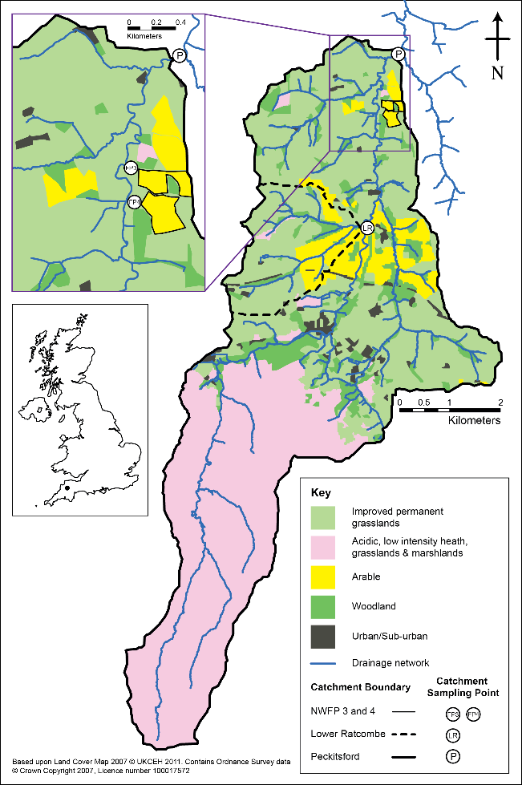

Figure 1. Map showing the location and land uses of the URTO and the NWFP catchments used within this study.

  - Hydrochemistry data
In the URTO, Q was gauged with streambed sensors within a surveyed channel section. Water velocity was measured using an ultrasound sensor (Mainstream Measurements Ltd, U.K.), while water level was measured using a pressure sensor (OTT Hydrometry, U.K.). The combined outputs were converted to Q using a flow transmitter (Mainstream Measurements Ltd, U.K.). At catchment outlets, stilling wells housed a YSI 6600 multi-parameter sonde (YSI, Xylem Inc, NY, U.S.A.) where turbidity was measured on a 4 weekly calibrated sensor. On the NWFP, Q was gauged using pressure level sensors (OTT Hydrometry, U.K.) installed in H type flumes with known water level to Q ratings. As the Q emanating from land at this scale is discontinuous and linked to soil moisture and rainfall events, when Q>0.2 l s⁻¹ water was pumped from a drainage sump to a flow cell, to prevent sensors from drying out. When Q<0.2 l s⁻¹ water subsamples were not collected and analysed. Turbidity was measured within the flow cell using YSI 6600V2 sondes (YSI, Xylem Inc, NY, U.S.A) with a sensors calibrated every 3 months. At both study sites, physical storm sampling was undertaken to develop a relationship to convert turbidity units to SSC. Collected samples were analysed for SSC through the vacuum filtration and subsequent drying at 105°C, of a known sample volume through a pre-weighed GF/C filter paper, with a particle size retention of 1.2 μm (UK Standing Committee of Analysts, 1980). Relationships were developed for each of the URTO catchment outlets, and the grass and arable sites on the NWFP. Data for the period 2018 – 2022 was used for the purposes of this study which included the extreme wet winter of 2019 – 20 (Upadhayay et al., 2021).
  - Flow-weighted mean concentrations
For each month, flow-weighted mean SSC (FWM SSC) were calculated. Because both Q and turbidity data streams contained missing values, only data pairs were used to calculate FWM SSCs. The equation for calculating the FWM SSC was:
$$FWM SSC= \frac{\sum_{1}^{n}{\left(c_{i}* t_{i}* Q_{i}\right)}}{\sum_{1}^{n}{\left(t_{i}* Q_{i}\right)}}$$
Where c_{i} is SSC concentration, t_{i} is time, and Q_{i} is discharge in the i^{th} sample. The FWM SSC is an overall measure of SSC in the river system. It incorporates the flow variability, hence provides an accurate picture of the sediment transfer under varying flow conditions.
  - Statistical analysis
A Pearson’s correlation (α = 0.05) was used to examine relationships between the data. All data were analysed using SigmaPlot (Grafiti LLC, 2023).

- Results/Discussion
  - Site long-term weather analysis
Over the most recent decade (2010 – 2019), the NAOi has mostly been positive, and increasing in value (Figure 2). In the UK, this has coincided with the climate being, on average, 5% wetter and 0.9˚C warmer than the 1961 - 1990 average, with summers being 13%, and winters 12% wetter (Kendon et al., 2020) although regional and seasonal differences occur (West et al., 2019). Since 2019, the NAOi has been broadly declining, although remaining predominantly positive.
At the study location, long term annual precipitation totals (1967 – 2022) were not found to correlate significantly with annual NAOi; however, they were significantly (p<0.05) positively correlated to mean annual (1982 – 2022) air temperature. Given the potential for seasonal variation in the response to the NAOi, the effects on the regional climate of the study site location was investigated by comparing the long-term monthly meteorological winter (Dec – Feb) and summer (Jun – Aug) rainfall totals and mean monthly mean air temperatures at ‘North Wyke’ (Met Office, 2006) (Figure 3). The data showed that both winter total monthly rainfall and average air temperature where significantly (p<0.01) positively related to NAOi which is in keeping with the expected trend of warmer wetter weather with an increase in the NAOi. However, the summer monthly NAOi was not found to have any significant relationship to either of these variables although the trend in monthly rainfall totals did reflect the expected decrease in precipitation volume with increasing summer NAOi. This shows that in the study region, the NAOi presents itself differently throughout the year and that using annual means may obscure its effects, certainly in relation to precipitation which is a key driver for soil erosion and sediment delivery patterns.
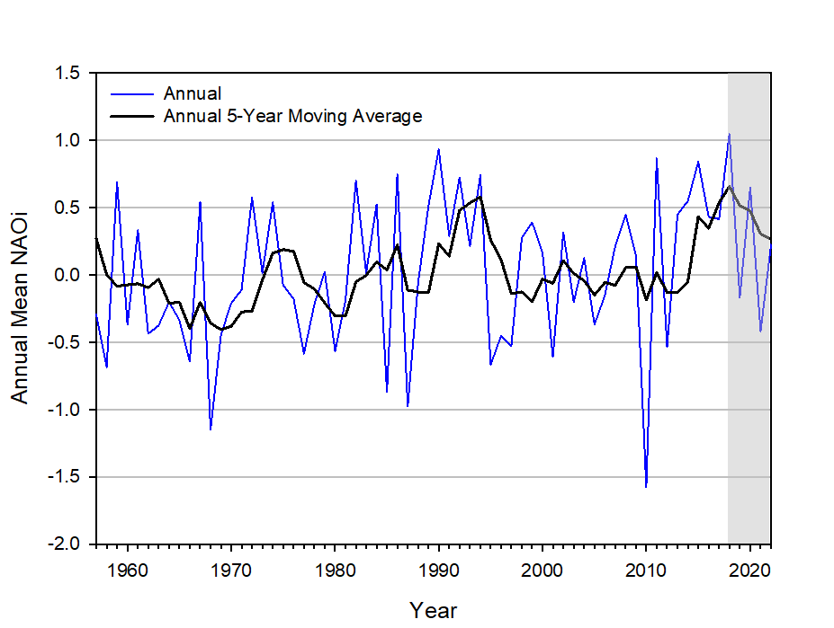
Figure 2. Time series of the station based North Atlantic Oscillation index (NAOi) provided by the NSF National Centre for Atmospheric Research, Climate Analysis Section (https://ncar.ucar.edu/). The blue line indicates the average annual NAOi, while the black line is a simple 5 year moving average. The shaded area represents the period covered by this study.

Conversely, when examining the long-term annual weather trends with the WEPAi, no significant relationship with mean annual air temperature was present. However, average annual precipitation totals were significantly positively related (p<0.001). Recent work on the WEPAi by Jalón-Rojas and Castelle (2021) has shown that in winter months, the positive phase of WEPAi reflects an intensification of the Icelandic-Low/Azores-High dipole, causing increased precipitation in western Europe. This is a similar trend to that exhibited by the NAOi, with increasing precipitation generally associated with a more positive NAOi. However, the difference in the seasonal response of precipitation to the NAOi is not apparent with the WEPAi. In summer months, a more positive WEPAi continues to be reflected by wetter weather (Castelle pers. comm.). This would explain why the annual WEPAi was much more strongly related to the total annual precipitation totals than the NAOi. When examining the seasonal relationships of weather and WEPAi this was further confirmed by strongly significant positive relationships between total monthly precipitation in both the summer and winter months (Figure 3). Interestingly, strongly significant seasonal relationships (p<0.01) were also present for average air temperature. However, unlike for precipitation these relationships were different, with increasing WEPAi associated with increasing air temperature in the winter and decreasing air temperature in the summer (Figure 3). These divergent trends would explain why the annual timescale analysis of air temperature was non-significant.

  - Seasonal effects of the NAOi on FWM SSC
In the winter months, field scale catchment FWM SSCs ranged between 1 and 44 mg l⁻¹ from the permanent grassland and 2 and 1309 mg l⁻¹ from the arable conversion field (Supplementary Table 1.). The reduced FWM SSC from the permanent grassland field when compared to the arable catchment was perhaps unsurprising. Permanent grasslands have been traditionally considered less erosive environments because the type of vegetation found in grassland should prevent significant losses of soil through erosion because the swards intercept raindrop energy, slow overland flow and stabilize the soil structure through increased root density (e.g. Fullen et al., 2006). Soils under arable management, however, tend to be subject to far greater erosion (Spiers and Frost, 1987). Factors such as reduced soil aggregate stability due to disintegration during tillage and loss of organic matter, reduced vegetation cover over the winter months, and increased soil compaction and concentrated flow pathways through machinery trafficking along tramlines all lead to elevated soil erosion and surface runoff (Evans, 2017; Keller et al., 2019; Pulley et al., 2022). It was therefore not unexpected to see higher FWM SSC from the arable catchment compared to the grassland catchment. Regardless of the relative sediment losses from the contrasting land covers at field scale, FWM SSC were not found to be significantly (p>0.05) related to NAOi, and no discernible trend was apparent (Figure 4 a and b). This might be expected from the grassland catchment because although erosion will still occur (e.g. Bilotta et al., 2008), the increased levels associated with increased rainfall would only be relatively small due to the resistance imparted by the permanent grass sward. These small differences might not be reflected in changes in the monthly NAOi which have a high degree of variability in terms of precipitation (Figure 3). However, from the arable catchment, with an increased readily mobilizable sediment source potential, any increase in precipitation associated with a more positive NAOi, might be expected to present itself in terms of higher FWM SSC more readily. This was not the case and the FWM SSC from the grassland and arable catchments were significantly positively related (p<0.001) to each other indicating that it was the same factors leading to changes in FWM SSC from both catchments.
At the URTO catchment scales, winter monthly FWM SSC were generally higher than those from the NWFP grassland field scale, but much less than those from the arable field scale catchment. At the small stream scale catchment of Lower Ratcombe, FWM SSC ranged between 1 and 167 mg l⁻¹, while at the large river scale catchment of Peckitsford they were between 9 and 77 mg l⁻¹. The intermediary nature of these FWM SSCs reflect the mixed nature of the landcover of the two catchments with both arable and grassland contributing areas. The increased FWM SSC in the stream scale catchment, when compared to the river scale, probably reflect the proportions of arable and grassland within each. In the stream scale catchment, arable land covered 17.6%, while in the river scale catchment it comprised just 6.5% (Granger et al., 2023). The relationships between FWM SSCs and NAOi at these landscape scales were also found to be non-significant, although the change in scale from field to stream/river catchment does seem to present a stronger trend. The trends in the larger catchments indicated that with a more positive NAOi, the FWM SSCs were increased (Figure 4 c and d), which would correspond with the expected trend of more precipitation when the NAOi is positive in the winter period and the mobilization of sediment from more well-connected sediment source areas with saturated soils.
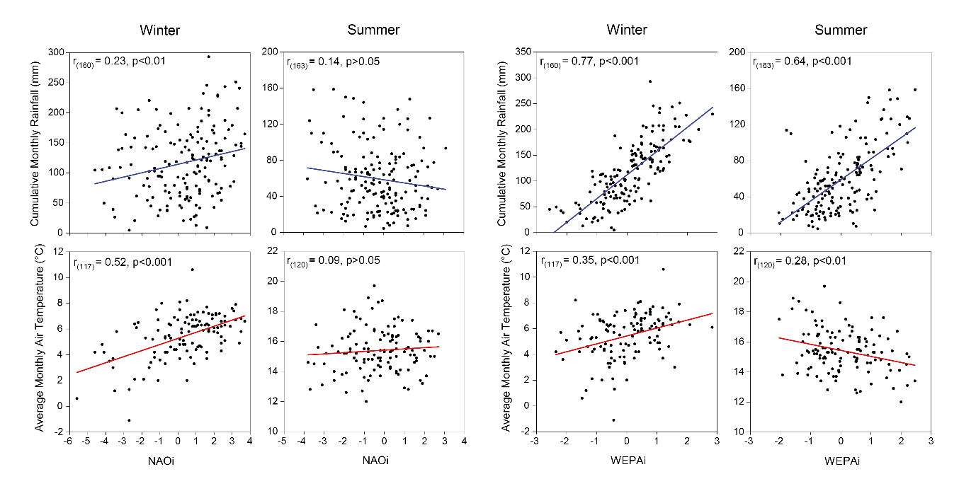
Figure 3. The relationship between long-term Winter (Dec, Jan, Feb) and Summer (Jun, Jul, Aug) monthly total cumulative rainfall (1967-2023) and monthly average air temperature (1982 – 2023) with the monthly NAOi and WEPAi. Months with <95% complete meteorological data were removed.

Given the ephemeral nature of Q from the NWFP, FWM SSCs were not considered sufficiently representative for the summer period. Low rainfall and soil moisture content in the summer meant that Q was nearly always <0.2 l s⁻¹, which is below the threshold for automated sampling of drainage water. On the rare occasion that sampling thresholds were exceeded it was typically short lived and driven by a singular significant rainfall event. This meant that on the NWFP field scale catchments, for all the summer months that occurred over the study period, 71% of them had <20% of the month covered by paired data, with 6 months having no data at all (Supplementary Table 1).
The FWM SCC from the stream and river catchments during the summer ranged between 1 and 47 mg l⁻¹, and 1 and 25 mg l⁻¹, respectively. The higher FWM SSC in the small stream catchment again probably reflected the greater % arable landcover described previously, while the lower FWM SSC when compared to winter months reflected the reduced precipitation and increased vegetation cover expected in the summer. The relationship of the FWM SSCs with the NAOi is, again, non-significant although the general trend is reversed when compared to the winter months (Figure 4 i and j). The negative relationship between FWM SCCs and the NAOi is again what might be expected given that the NAOi during the summer in this region is reportedly to be reflected by an increase in precipitation with decreasing NAOi, although this is not strongly reflected in our meteorological records (Figure 3).
Overall, the NAOi does not show any significant relationship with either winter, or summer, FWM SSC at either field or catchment scales. However, trends in the relationship, which reflect the effect of the NAOi on precipitation, do present more clearly at the catchment compared with the field scales.
  - Contrasting the relationship of the WEPAi on FWM SSC with NAOi
In the winter months, at the stream and river scale, while the NAOi and FWM SSC were not significantly related (p>0.05), a positive trend of more increasing FWM SCC with a more positive NAOi could be discerned. When FWM SSCs were compared to the WEPAi, the positive relationship between a more positive WEPAi and FWM SSC was clearly present (Figure 4 g and h), reflecting the increased precipitation with a more positive WEPAi (Figure 3). However, unlike the relationships with the NAOi, the relationship of FWM SSC with the WEPAi was much stronger (p<0.05). At the field scale, while no significant relationships or apparent trends with the NAOi were present in either the arable or grassland fields, this was not the case when using the WEPAi. Again, significant (p<0.05) positive relationships were described, with increasing FWM SSCs associated with a more positive WEPAi (Figure 4 e and f).
During the summer months, at the larger catchment scales, the trend of a more positive NAOi being associated with decreased FWM SSC was discernible, but not significant (p>0.05). When using the WEPAi, the relationships with FWM SSC remain not significant (p>0.05), but in this case, the trend was reversed from that of the NAOi and a more positive WEPAi was associated with increased FWM SSC. So, in both the case of the NAOi and the WEPAi, the trends in FWM SSC and increases in precipitation associated with the expected changes in both indices appeared to be present.
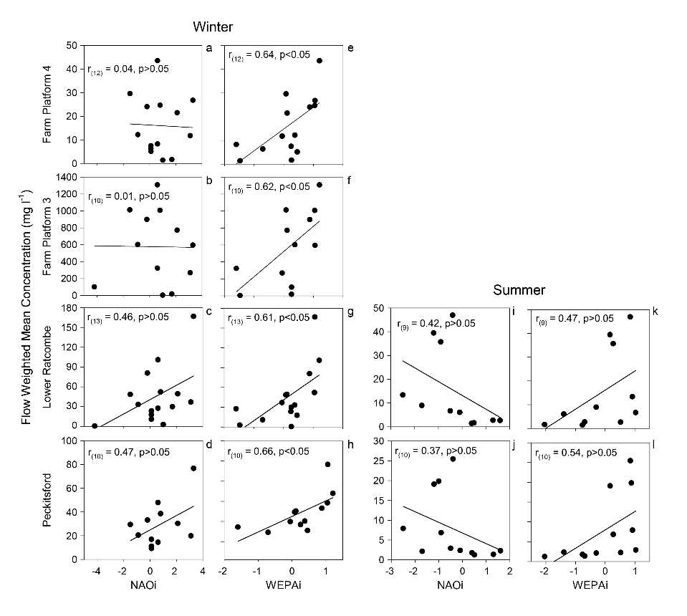
Figure 4. The relationship between monthly FWM SSCs in winter (Dec, Jan, Feb) and summer (Jun, Jul, Aug) and the monthly station NAOi and WEPAi

- Conclusions and Implications
The NAO clearly affects weather at our study location, with the NAOi being significantly positively related to winter average monthly air temperature and total monthly precipitation, although no significant relationships were found for the summer months. The relationship of the recently developed WEPAi to both monthly precipitation and air temperature was also positive and more strongly related than the NAOi. In contrast to the NAOi, the WEPAi was also significantly related to both variables in the summer, with monthly precipitation increasing, and air temperature decreasing.
Previous work has confirmed statistically significant relationships between the NAOi and nutrient responses across catchment typologies. At our study location however, although the NAOi was significantly related to precipitation, it was not significantly correlated with sediment responses at either field or catchment scales although the trends in response improved with increasing scale. This could be attributed to variability in the data coverage within different months however, the WEPAi was significantly positively related to the same FWM SSC in the winter at both field and catchment scales. However, like the NAOi, it was not significantly related to sediment responses in the summer although both indices had trends with FWM SSC that reflected changes in precipitation.
Our work has shown that it is important to take explicit account of large-scale climate drivers of the sediment responses of agricultural landscapes. These drivers can influence amplification in the unintended water quality responses and the success, or failure, mitigation programmes during specific periods of time. A greater proportion of surface soil is mobilised in response to high rainfall in winter (Pulley and Collins, 2019), but local catchment characteristics can moderate the spatial footprint of large-scale climate drivers in SSC in river systems (West et al., 2019). To this end, an ability to forecast monthly climate scale drivers, such as the WEPA, could prove invaluable and enable farmers to better plan for those periods of time when amplified impacts on hydro-sedimentological responses are likely to be elevated. More work is needed across a range of landscape typologies to confirm that the relationships observed herein hold true more widely.

Acknowledgements
Rothamsted Research receives strategic funding from UKRI-BBSRC (UK Research and Innovation-Biotechnology and Biological Sciences Research Council) and this work was funded by the Resilient Farming Futures (grant award BB/X010961/1) institute strategic programme - specifically work package 2 - BBS/E/RH/230004B; Detecting agroecosystem ‘resilience’ using novel data science methods. The North Wyke Farm Platform National Bioscience Research Infrastructure was supported by BBSRC grant: BBS/E/RH/23NB0008. Bruno Castelle was funded by project IRICOT (PEPR IRIMA). We acknowledge the interests of the Ecological Continuity Trust (ECT), whose national network of LTEs includes the NWFP experiment on which part of this research was conducted. For the purpose of open access, the author has applied a Creative Commons Attribution (CC BY) licence to any Author Accepted Manuscript version arising. We acknowledge the sea level pressure data providers in the ECA &D project (http://www.ecad.eu, (Klein Tank et al., 2002)) and the Irish Meteorological Service (http://www.met.ie/climate) for the Valentia Observatory data, which were used to compute the WEPA index. We thank Hadewij Sint for her help with data quality control and the landowners for access to the monitoring sites.

References

Bilotta G S, et al. 2008 Rethinking the contribution of drained and undrained grasslands to sediment-related water quality problems J. Environ. Qual. 37 906-914
Castelle B, Dodet G, Masselink G and Scott T 2017 A new climate index controlling winter wave activity along the Atlantic coast of Europe: The West Europe Pressure Anomaly Geophys. Res. Lett. 44 1384-1392
Conley D J, et al. 2009 Controlling Eutrophication: Nitrogen and Phosphorus Science 323 1014-1015
de Andres E G, Blanco J A, Imbert J B, Guan B T, Lo Y H and Castillo F J 2019 ENSO and NAO affect long-term leaf litter dynamics and stoichiometry of Scots pine and European beech mixedwoods Global Change Biol. 25 3070-3090
Droppo I G, Liss S N, Williams D, Nelson T, Jaskot C and Trapp B 2009 Dynamic Existence of Waterborne Pathogens within River Sediment Compartments. Implications for Water Quality Regulatory Affairs Environ. Sci. Technol. 43 1737-1743
Evans R 2017 Factors controlling soil erosion and runoff and their impacts in the upper Wissey catchment, Norfolk, England: A ten year monitoring programme Earth Surf. Process. Landf. 42 2266-2279
Fullen M A, Booth C A and Brandsma R T 2006 Long-term effects of grass ley set-aside on erosion rates and soil organic matter on sandy soils in east Shropshire, UK Soil & Tillage Research 89 122-128
Gillett N P, Graf H F and Osborn T J 2003 Climate Change and the North Atlantic Oscillation The North Atlantic Oscillation: Climatic Significance and Environmental Impact ed J. W. Hurrell, et al. (American Geophysical Union) pp 193-209
SigmaPlot 15.1.1.26 2023 Grafiti LLC, 405 Waverley St Palo Alto, CA 94301, USA.
Granger S J, Upadhayay H R and Collins A L 2023 Hydro-chemical responses at different scales in a rural catchment, UK, and implications for managing the unintended consequences of agriculture Environ. Res. 228 115826
Hall R J and Hanna E 2018 North Atlantic circulation indices: links with summer and winter UK temperature and precipitation and implications for seasonal forecasting Int. J. Clim. 38 E660-E677
Heywood M J T and Walling D E 2007 The sedimentation of salmonid spawning gravels in the Hampshire Avon catchment, UK: implications for the dissolved oxygen content of intragravel water and embryo survival Hydrol. Process. 21 770-788
Hurrell J W, Kushnir Y, Ottersen G and Visbeck M 2003 An Overview of the North Atlantic Oscillation The North Atlantic Oscillation: Climatic Significance and Environmental Impact ed J. W. Hurrell, et al. (American Geophysical Union) pp 1-35
Jalón-Rojas I and Castelle B 2021 Climate Control of Multidecadal Variability in River Discharge and Precipitation in Western Europe Water 13 257
Jorgensen B B and Revsbech N P 1985 Diffusive boundary-layers and the oxygen-uptake of sediments and detritus Limnol. Oceanogr. 30 111-122
Keller T, Sandin M, Colombi T, Horn R and Or D 2019 Historical increase in agricultural machinery weights enhanced soil stress levels and adversely affected soil functioning Soil & Tillage Research 194 104293
Kendon E J, Rowell D P, Jones R G and Buonomo E 2008 Robustness of future changes in local precipitation extremes J. Clim. 21 4280-4297
Kendon M, McCarthy M, Jevrejeva S, Matthews A, Sparks T and Garforth J 2020 State of the UK Climate 2019 Int. J. Clim. 40 1-69
Klein Tank A M G, et al. 2002 Daily dataset of 20th-century surface air temperature and precipitation series for the European Climate Assessment Int. J. Clim. 22 1441-1453
Kronvang B, Audet J, Baattrup-Pedersen A, Jensen H S and Larsen S E 2012 Phosphorus Load to Surface Water from Bank Erosion in a Danish Lowland River Basin J. Environ. Qual. 41 304-313
Mackenthun A A and Stefan H G 1998 Effect of flow velocity on sediment oxygen demand: Experiments Journal of Environmental Engineering-Asce 124 222-230
Mellander P E, Jordan P, Bechmann M, Fovet O, Shore M M, McDonald N T and Gascuel-Odoux C 2018 Integrated climate-chemical indicators of diffuse pollution from land to water Scientific Reports 8 944
Menzel A, Estrella N and Schleip C 2006 Impacts of climate variability, trends and NAO on 20th century European plant phenology Workshop on Climate Variability and Extremes in the Past 100 Years Thun, Switzerland 33 pp 221-233
Met Office 2006 UK Daily Temperature Data, Part of the Met Office Integrated Data Archive System (MIDAS) NCAS British Atmospheric Data Centre, 2024 http://catalogue.ceda.ac.uk/uuid/1bb479d3b1e38c339adb9c82c15579d8
Montanarella L 2015 Agricultural policy: Govern our soils Nature 528 32-33
Murphy J M, et al. 2009 UK Climate Projections Science Report: Climate Change Projections. Met Office Hadley Centre.
Ockenden M C, et al. 2016 Changing climate and nutrient transfers: Evidence from high temporal resolution concentration-flow dynamics in headwater catchments Sci. Total Environ. 548 325-339
Orr R J, et al. 2016 The North Wyke Farm Platform: effect of temperate grassland farming systems on soil moisture contents, runoff and associated water quality dynamics Eur. J. Soil Sci. 67 374-385
Pulley S and Collins A L 2019 Field-based determination of controls on runoff and fine sediment generation from lowland grazing livestock fields J. Environ. Manage. 249 109365
Pulley S, Morten C, Morgan S, Cardenas L M and Collins A L 2022 Sediment detachment by raindrop impact on grassland and arable fields: an investigation of controls J. Soils Sed. 22 692-703
Rocher V, Garnaud S, Moilleron R and Chebbo G 2004 Hydrocarbon pollution fixed to combined sewer sediment: a case study in Paris Chemosphere 54 795-804
Rossello J 2011 North Atlantic Oscillation influences on European airline traffic Transportation Research Part D-Transport and Environment 16 183-187
Rust W, Bloomfield J P, Cuthbert M O, Corstanje R and Holman I P 2021 Non-stationary control of the NAO on European rainfall and its implications for water resource management Hydrol. Process. 35 e14099
Schneider D P, Deser C, Fasullo J and Trenberth K E 2013 Climate Data Guide Spurs Discovery and Understanding Eos, Transactions American Geophysical Union 94 121-122
Shaughnessy A R, Sloan J J, Corcoran M J and Hasenmueller E A 2019 Sediments in Agricultural Reservoirs Act as Sinks and Sources for Nutrients over Various Timescales Water Resour. Res. 55 5985-6000
Snelder T H, Larned S T, Fraser C and De Malmanche S 2022 Effect of climate variability on water quality trends in New Zealand rivers Mar. Freshw. Res. 73 20-34
Spiers R B and Frost C A 1987 Soil water erosion on arable land in the United Kingdom Research and Development in Agriculture 4 1-11
UK Standing Committee of Analysts 1980 Suspended, settleable and total dissolved solids in waters and effluents (HMSO) London
Ulén B, Lewan E, Kyllmar K, Blomberg M and Andersson S 2019 Impact of the North Atlantic Oscillation on Swedish Winter Climate and Nutrient Leaching J. Environ. Qual. 48 941-949
Upadhayay H R, Granger S J and Collins A L 2021 Dynamics of fluvial hydro-sedimentological, nutrient, particulate organic matter and effective particle size responses during the UK extreme wet winter of 2019-2020 Sci. Total Environ. 774 145722
West H, Quinn N and Horswell M 2019 Regional rainfall response to the North Atlantic Oscillation (NAO) across Great Britain Hydrology Research 50 1549-1563
Woollings T and Blackburn M 2012 The North Atlantic Jet Stream under Climate Change and Its Relation to the NAO and EA Patterns J. Clim. 25 886-902

