Supplementary material for Chapter Four

Simulated areas
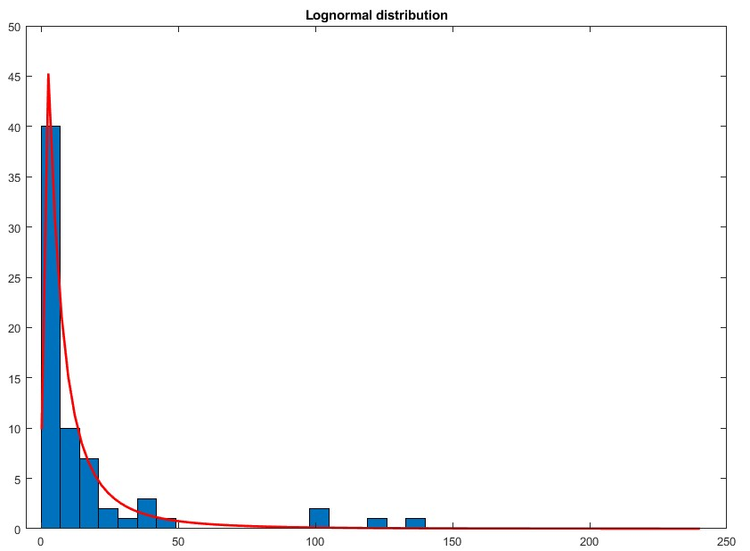
To generate the farm areas, we use the farm areas reported by the farmers in our survey (El Fartassi et al., 2024). We use the MATLAB Statistics toolbox (The Mathworks, 2022) to fit a lognormal distribution to the survey data (mu = 1.88 and sigma = 1.20). The distributions considered were Weibull, Lognormal, Gamma, and Log-logistic. We visually examined the fit by using a histogram and a quantile-quantile plot and used the chi-square goodness-of-fit test to determine the best fit. The p-value of the Lognormal distribution was higher than the log-logistic and Weibull distributions, making it the best fit for the sample.
Figure_A-1 Histogram of farm area with a lognormal distribution fit.

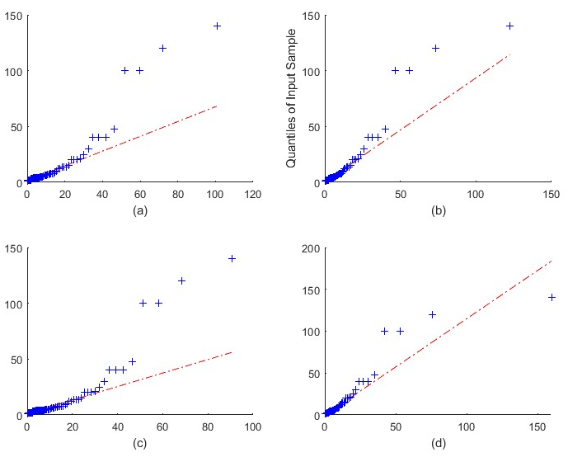
Figure_A-2 Quantile-quantile plot of the input sample quantiles of y versus theoretical quantiles from a) Weibull distribution b) Lognormal c) Gamma distribution d) Log-logistic distribution.
Table_A-1 Comparison of fit distributions for the simulated areas.
 | h | p
Lognormal | 0 | 0.2434
Loglogistic | 0 | 0.2369
Weibull | 0 | 0.0715
Gamma | 1 | 0.0047

Simulating initial groundwater attitude values
To generate initial conditions for attitude values regarding groundwater appreciation, we sampled from three parameterised beta distributions to capture attitudinal divergence across irrigation categories. For our initial conditions, we assume that those who have already invested in groundwater are more likely to have a positive attitude towards it than those who use dam water alone.
For the groundwater-only category, we defined a positively skewed beta distribution with to reflect greater hypothesized appreciation (α = 8 and β = 7, giving 62% with an attitude value greater than 0.5).
For mixed source irrigation, we used positive skew beta distribution with a smaller mode ( α = 5.5 and β = 4.3 giving 54% with an attitude value greater than 0.5).
For dam-only farmers, we defined a negatively skewed beta distribution (α = 6.4 and β = 8.6, ) giving only 23% above 0.5 to reflect a lower initial positive attitude to groundwater.

Simulating initial affordability values
The affordability values are based on the economies of scale principle, which suggests that as the scale of production increases, the cost per unit of output decreases (Michael, 2009). We assume that a farmer operating at a larger scale finds it more affordable to invest in new wells due to cost efficiencies. In contrast, smaller-scale farmers often face more constraints in their decision-making processes due to tighter operational margins and limited access to capital, which can restrict their ability to make substantial investments. Given these differences in affordability based on farm size and access to resources, we model the distinct investment capabilities of various farmer typologies using beta distributions. To generate simulated affordability data for different farmer typologies, we configure separate beta distributions by setting distinct shape parameters, α and β, for each group.
The choice of paired parameters α and β for each farmer type were deliberately chosen to sample data that conform to these general profitability assumptions across scales.
For generating simulated affordability data for small-scale farmers, we defined a beta distribution with α = 8.4 and β = 7. By setting α higher than β, this skews the distribution toward higher affordability values, with increased density above a hypothetical profitability threshold of 0.5. From this distribution, we sampled 102 data points. The number of samples is set higher to better represent the larger population size of this farmer typology.
For medium-scale farmers, we defined a beta distribution with parameters α =9 and β =6. We sampled 108 data points from this skewed distribution which represents a typical population quantity for the medium-scale farmer typology.
For large-scale farmers, we sharply skewed affordability figures by choosing more disparate beta distribution parameters at α =10 and β =5. This yields a distribution concentrated heavily towards affordability substantially exceeding the hypothetical threshold at 0.5. From this right-skewed shape, we took a sample of 38 affordability data points. The choice of distribution plus modest sampling quantity creates modelled data consistent with high-resourced, large-scale farming entities and their underlying economic capabilities.
These parameters and the resulting simulated proportions of affordability greater than 0.5 were carefully selected to mirror the economic realities of each farmer group.

Simulating initial tenancy values
Of the farmers we surveyed, 90% were owners and 10% were renters. We simulated 248 farmers following this characterization. We note that this characterization is based on our survey sample and may not necessarily represent the entire study area. A farmer's owner or tenant status represents the legal and contractual rights underpinning farm operations and so can significantly influence their PBC when it comes to investing in new infrastructure. Land ownership often provides farmers with greater PBC, as they have more autonomy in decision-making and can make long-term investments. Owned land can also serve as collateral for loans, increasing access to capital for investments in wells (Lawry et al., 2017). In contrast, tenant farmers may perceive less control over their ability to invest in new wells due to the need to negotiate with landlords and the potential for shorter lease terms, which can create uncertainty and discourage long-term investments.
To initialise values PBC for different land tenure categories, we configured separate beta distributions by setting distinct shape parameters, α and β, for owners and renters using the betarnd MATLAB function.
The choice of α and β values is not empirically based but rather selected intentionally to reflect assumptions about PBC levels exceeding a hypothetical threshold of 0.5 for each tenure category.
Specifically, a higher α skews the distribution towards more frequent PBC figures above 0.5, while a lower β also shifts density to the right of the threshold. The paired parameters for each tenure type were deliberately chosen to generate data conforming to general assumptions about PBC across owner and renter categories.
For simulating data for owners, we defined a beta distribution with parameters α = 9.1 and β = 5.9. Setting a higher α than β skews the distribution toward higher perceived control values, with increased density above the 0.5 threshold. We sampled 223 data points from this right-skewed distribution. For renters, we defined a beta distribution with symmetrical parameters α = 7.5 and β = 7.5. From this distribution, we sampled 25 data points, set lower to reflect the smaller share of agricultural land operated by renters. The parameters and resulting simulated proportions of perceived control exceeding 0.5 for each category were carefully chosen to reflect theorized differences in land tenure.
The legal and contractual rights associated with land ownership and tenancy can also interact with other factors, such as the economies of scale and access to capital, to shape a farmer's overall affordability and decision-making when investing in new wells. Following a similar approach of using beta distributions, we generated simulated affordability data for different farmer typologies as below.

Simulated salinity

Derivation of soil salinity
If $W$ is constant, then
$$S\left(t\right)=φ-\left[φ-S\left(t-1\right)\right]W\left({EC}_{w}\right)$$
Can be written
$$S\left(t\right)= φ-\left[φ-S\left(0\right)\right]W^{t}$$
After three years $S\left(t\right)=0.9E_{w}$
$$0.9E_{w}= φ-\left[φ-S\left(0\right)\right]W^{3}$$
Rearranging
$$\frac{φ-0.9E_{w}}{φ-S\left(0\right)}=W^{3}$$
Therefore
$$W={\left(\frac{φ-0.9E_{w}}{φ-S\left(0\right)}\right)}^{\frac{1}{3}}$$
Table_A-2 shows the parameter values used to fit a logistic irrigation response curve for a sowing date corresponding to the 24th of December with total irrigation as a dependent variable.
Table_A-2 Irrigation parameters.
Parameters | Value
B | 0.01041
M | 147.3
C | 4.395
A | -0.5031

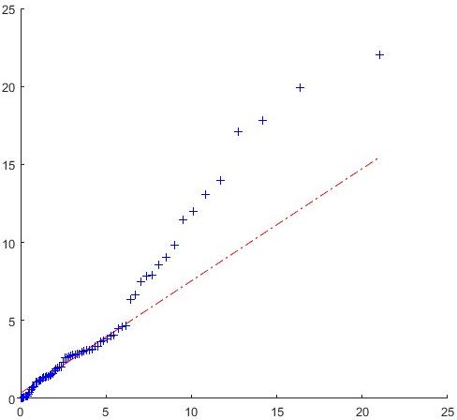
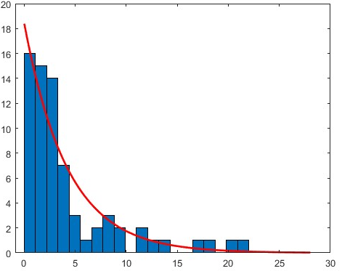
Salinity distribution
Figure_A-4 Quantile-quantile plot of the input sample quantiles of y versus theoretical quantiles from an exponential distribution.
Figure_A-3 Histogram of salinity with an exponential distribution fit.
The results show that the Kernel distribution is too sensitive and overfitting. The p-value of the exponential distribution is higher than the others, making it the best fit for the sample (Table_A-3).
Table_A-3 Comparison of fit distributions for salinity.
 | h | p
Exponential | 0 | 0.1651
Weibull | 0 | 0.0869
Gamma | 0 | 0.0805
Loglogistic | 0 | 0.0526
Lognormal | 1 | 0.0095
Table_A-4 Temporal variations in irrigation allocation and water needs in R3.
Agricultural season | Water allocation | Water need | Proportions | Caped proportions
87-88 | 197.36 | 310 | 0.64 | 0.64
88-89 | 395.32 | 310 | 1.28 | 1.00
89-90 | 340.87 | 310 | 1.10 | 1.00
90-91 | 224.43 | 310 | 0.72 | 0.72
91-92 | 303.61 | 310 | 0.98 | 0.98
92-93 | 188.12 | 310 | 0.61 | 0.61
93-94 | 149.62 | 310 | 0.48 | 0.48
94-95 | 152.59 | 310 | 0.49 | 0.49
95-96 | 110.52 | 310 | 0.36 | 0.36
96-97 | 145.56 | 310 | 0.47 | 0.47
97-98 | 173.43 | 310 | 0.56 | 0.56
98-99 | 167.37 | 310 | 0.54 | 0.54
99-00 | 162.68 | 310 | 0.52 | 0.52
00-01 | 72.62 | 310 | 0.23 | 0.23
2001-2002 | 48.39 | 310 | 0.16 | 0.16
2002-2003 | 70.25 | 310 | 0.23 | 0.23
2003-2004 | 93.48 | 310 | 0.30 | 0.30
2004-2005 | 138.99 | 310 | 0.45 | 0.45
2005-2006 | 129.23 | 310 | 0.42 | 0.42
2006-2007 | 128.53 | 310 | 0.41 | 0.41
2007-2008 | 96.03 | 310 | 0.31 | 0.31
2008-2009 | 90.45 | 310 | 0.29 | 0.29
2009-2010 | 126.59 | 310 | 0.41 | 0.41
2010-2011 | 160.18 | 310 | 0.52 | 0.52
2011-2012 | 146.79 | 310 | 0.47 | 0.47
2012-2013 | 138.03 | 310 | 0.45 | 0.45
2013-2014 | 114.45 | 310 | 0.37 | 0.37
2014-2015 | 108.81 | 310 | 0.35 | 0.35
2015-2016 | 160.08 | 310 | 0.52 | 0.52
2016-2017 | 141.49 | 310 | 0.46 | 0.46
2017-2018 | 78.46 | 310 | 0.25 | 0.25
2018-2019 | 141.79 | 310 | 0.46 | 0.46
2019-2020 | 43.70 | 310 | 0.14 | 0.14

