Supporting materials

Identifying insect predators using camera traps reveal unexpected predator communities in oilseed rape fields
Gaëtan Seimandi-Corda¹*, Thomas Hood¹, Matthew Hampson¹, Todd Jenkins^{1,2}, Daniel Blumgart¹, Jamie Hall¹, Kelly Jowett¹, Toke Thomas Høye³, Samantha M. Cook¹

¹ Protecting Crops and the Environment, Rothamsted Research, Harpenden, Hertfordshire, UK
² Agriculture and Environment Department, Harper Adams University, Newport, Shropshire, UK
³ Department of Ecoscience, Aarhus University, Aarhus, Denmark

* Corresponding author
Email address: gaetan.seimandi@outlook.fr (Gaëtan Seimandi-Corda)

Figure S1. Schematic representation of the sampling design used in the experiment to assess predation of pollen beetle and brassica pod midge larvae for one set of five cameras; two sets of five cameras were used in oilseed rape crops in both 2021 and 2022. Rotative pan traps were used only on one set in 2022.

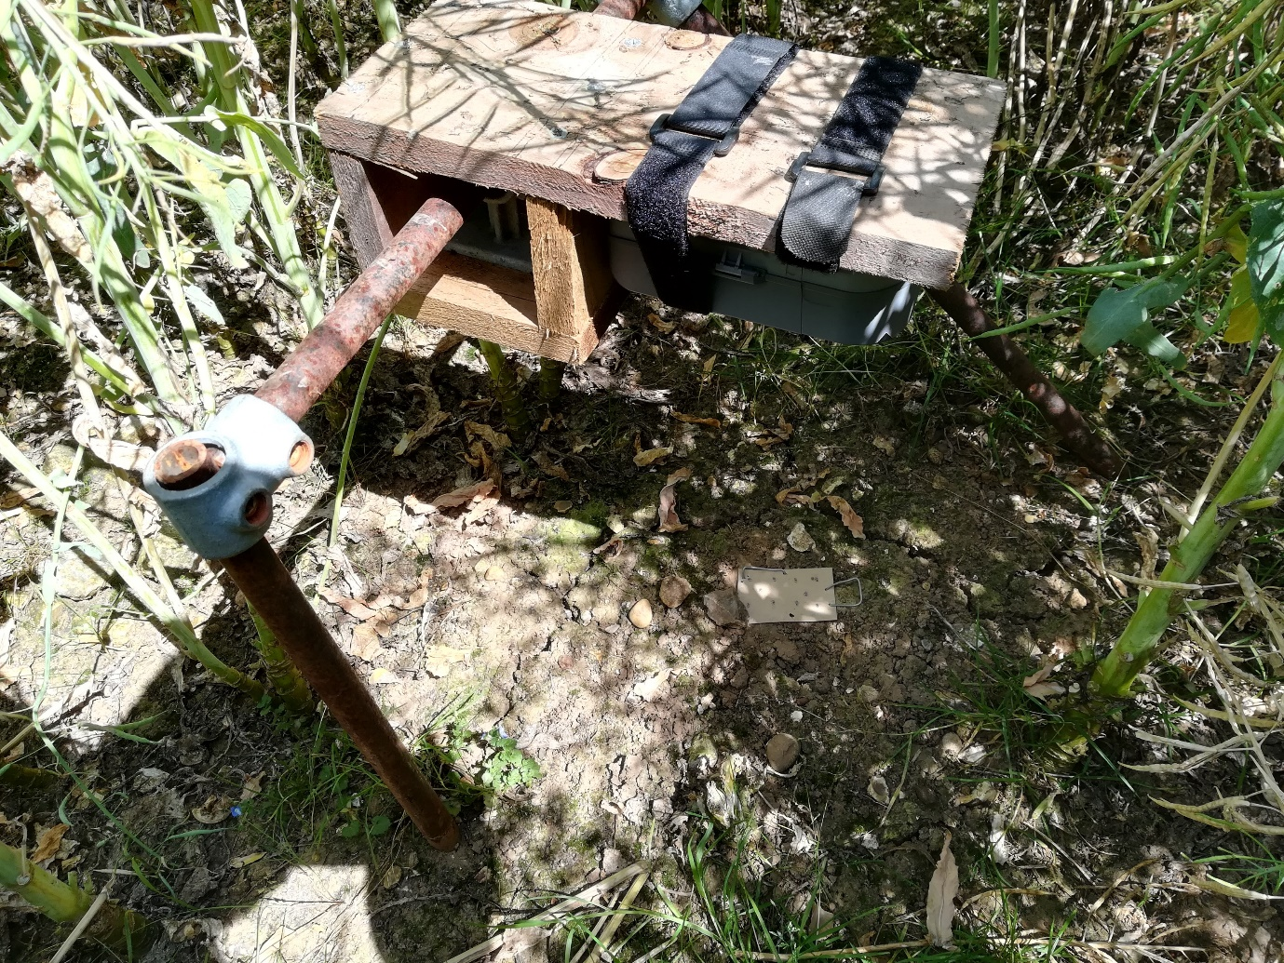
Figure S2. Tripod placed in an oilseed rape crop with a camera recording predator activity on a predation card placed on the ground and which was fixed into position with metal pegs.

Comparison of the data collected with pictures took at different time lapses
To test if the data collected with one picture taken every minute gave a reliable estimation of the card’s visitors, we compared the number of pictures with invertebrates on cards taken every 30 seconds and every minute. During the first three days of sampling in 2022 (26-28/04/22) cameras were set-up to take pictures every 30 seconds. Predation cards used on these dates contained 10 glued pollen beetle larvae (Brassicogethes aeneus). Some of the cameras ran out of batteries and did not collect pictures for 24 hours and were thus removed from the analysis. Data from 15 camera-days were collected over the three days. Two datasets were created: one dataset contained for each taxon observed the number of pictures with a visitor observed on the card with pictures collected every 30 seconds; a similar dataset was created keeping only one picture collected every minute. The adjusted R² was then extracted from a linear model explaining the number of observations with pictures taken every minute by the number of observations with pictures taken every 30 seconds.
A total of 14 taxonomic groups were observed on the cards. A significant relationship between the number of pictures with visitors observed after 30 seconds and 1 minute was found (p < 0.001) with a very high adjusted R² (0.99) (Fig. S3).
This result indicates that pictures collected every minute give a reliable estimation of the taxa present in the field.
Figure S3. Relationship between the total number of pictures with invertebrates collected with a time lapse of 30 seconds and 1 minute. The total number of pictures is summed for different taxa observed visiting predation cards containing pollen beetle larvae (Brassicogethes aeneus) in April 2022. The grey line represents the linear relationship between the two variables. Labels attached to each point indicate the taxa.

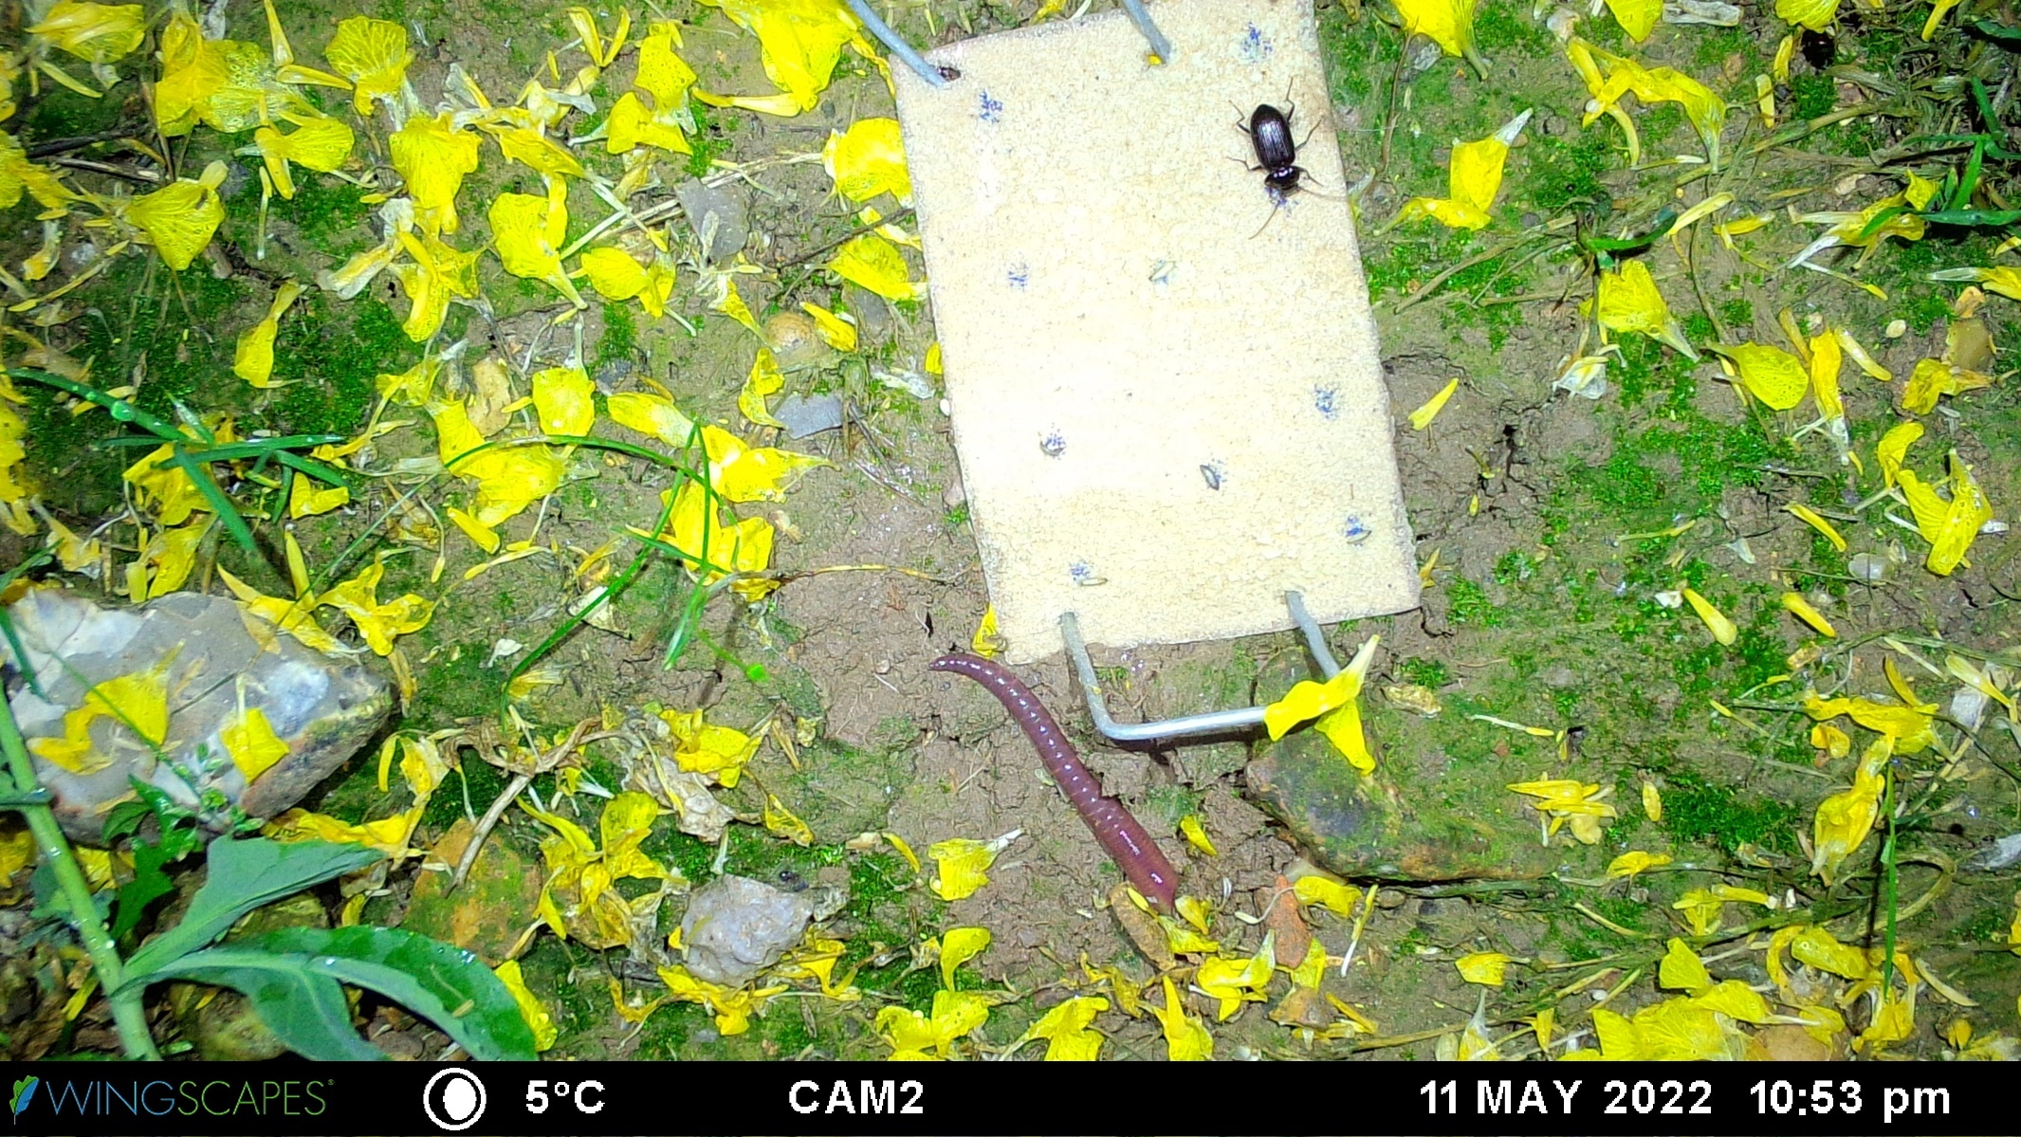Figure S4. Image collected by a camera trap on 11/05/22 at 22:53h with a Carabidae (Nebria brevicolis) feeding on a pollen beetle larva (Brassicogethes aeneus). 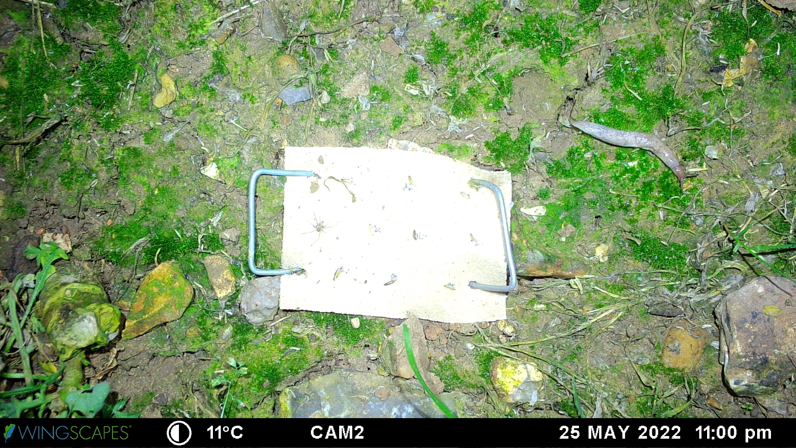 Figure S5. Image collected by a camera trap on 25/05/22 at 23:00h with an Opilione feeding on a pollen beetle larva (Brassicogethes aeneus). 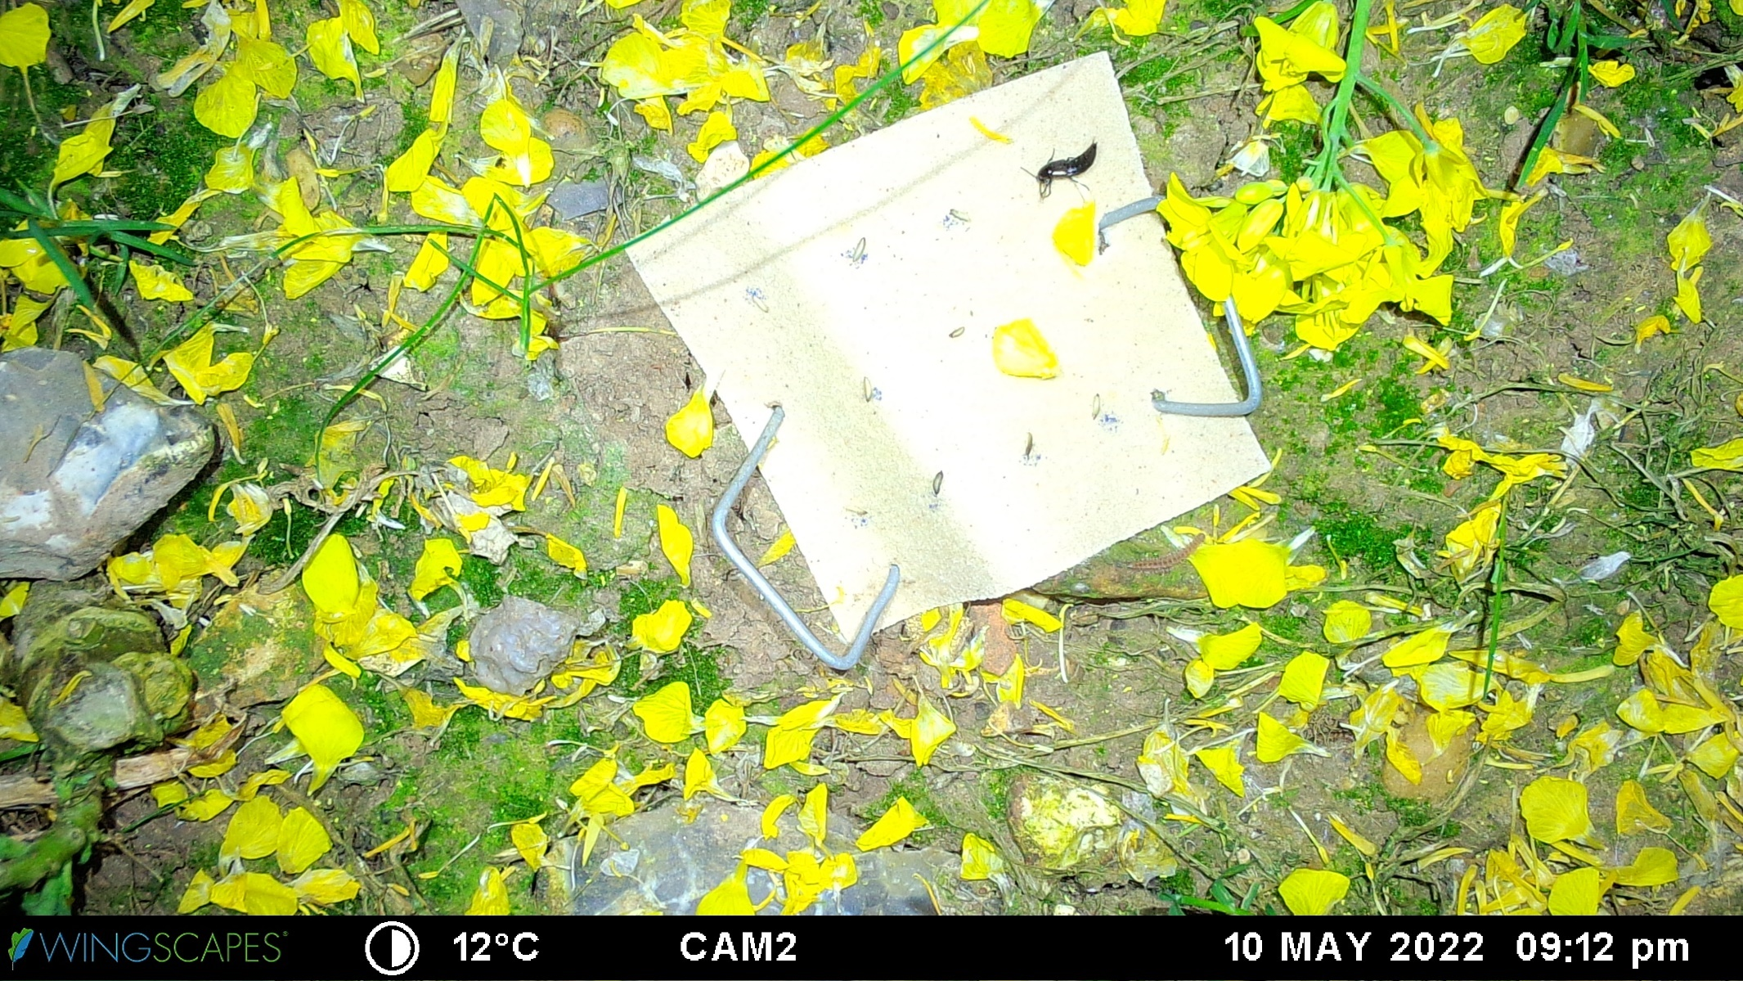 Figure S6. Image collected by a camera trap on 10/05/22 at 21:12h with a Staphylinidae feeding on a pollen beetle larva (Brassicogethes aeneus).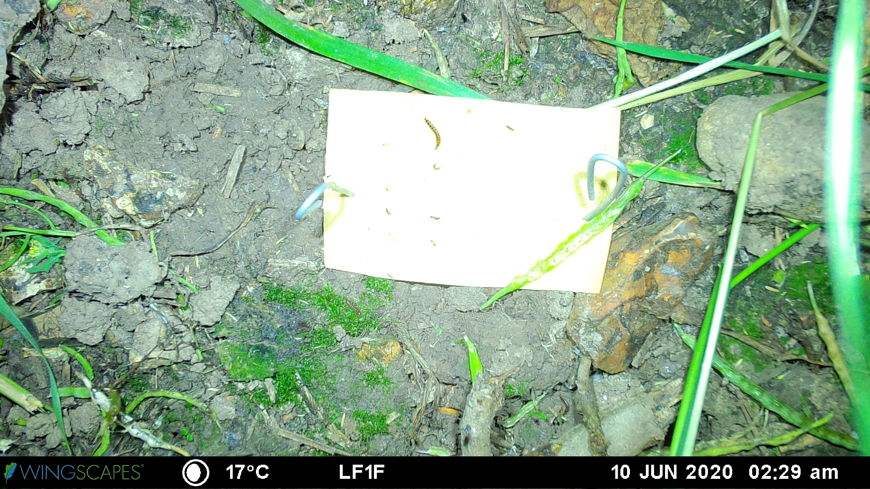 Figure S7. Image collected by a camera trap on 10/06/21 at 02:29h with a predatory larva (probably a Carabidae or a Staphylinidae) feeding on a pollen beetle larva (Brassicogethes aeneus).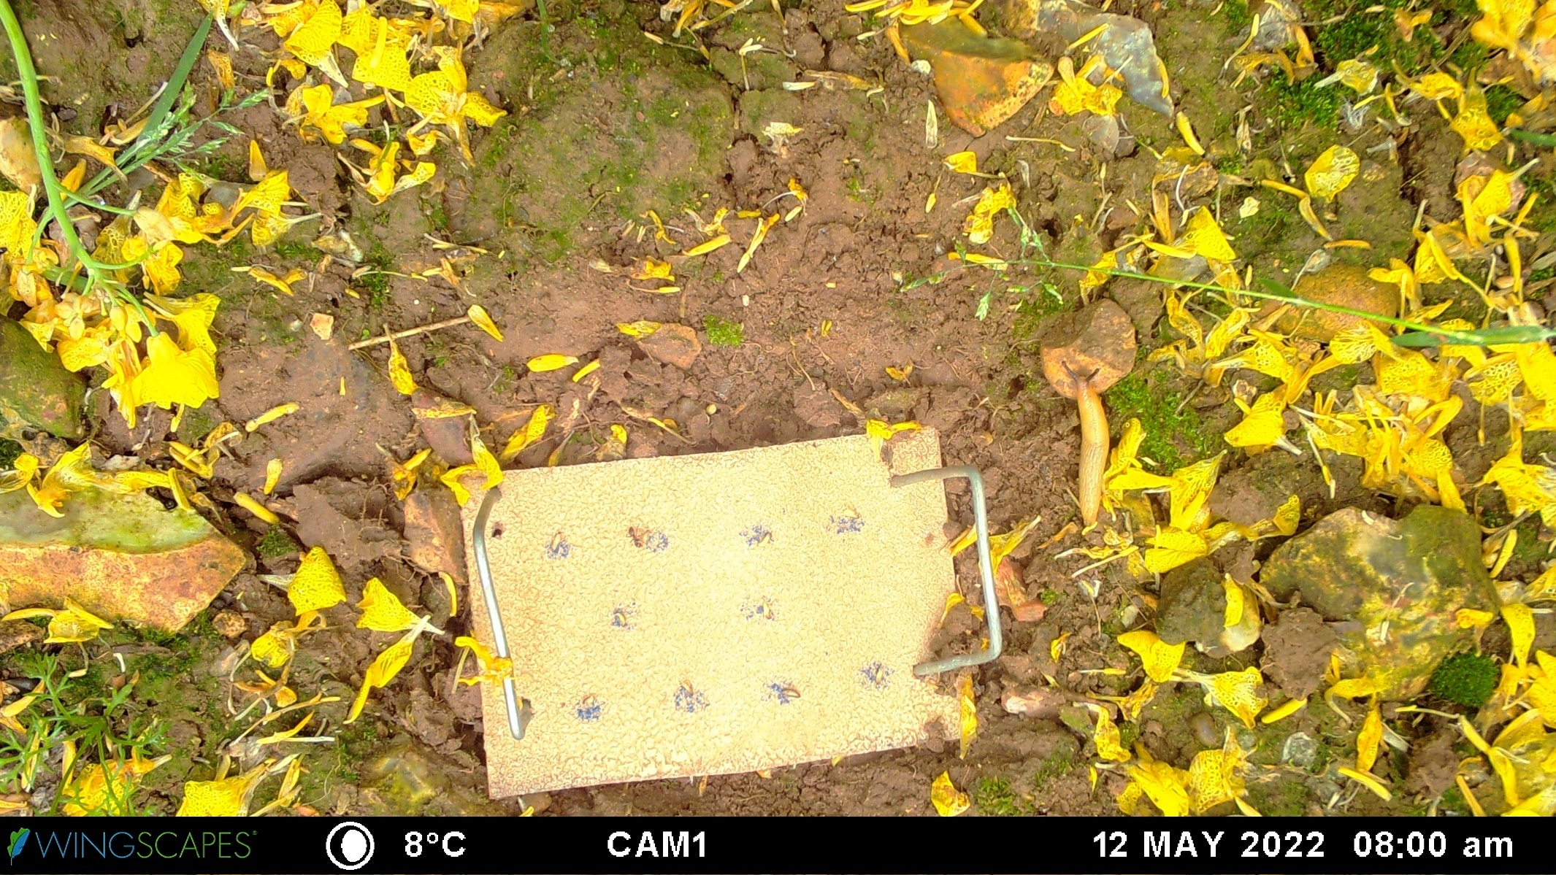 Figure S8. Image collected by a camera trap on 12/05/22 at 08:00 (am) with a Formicidae feeding on a pollen beetle larva (Brassicogethes aeneus). 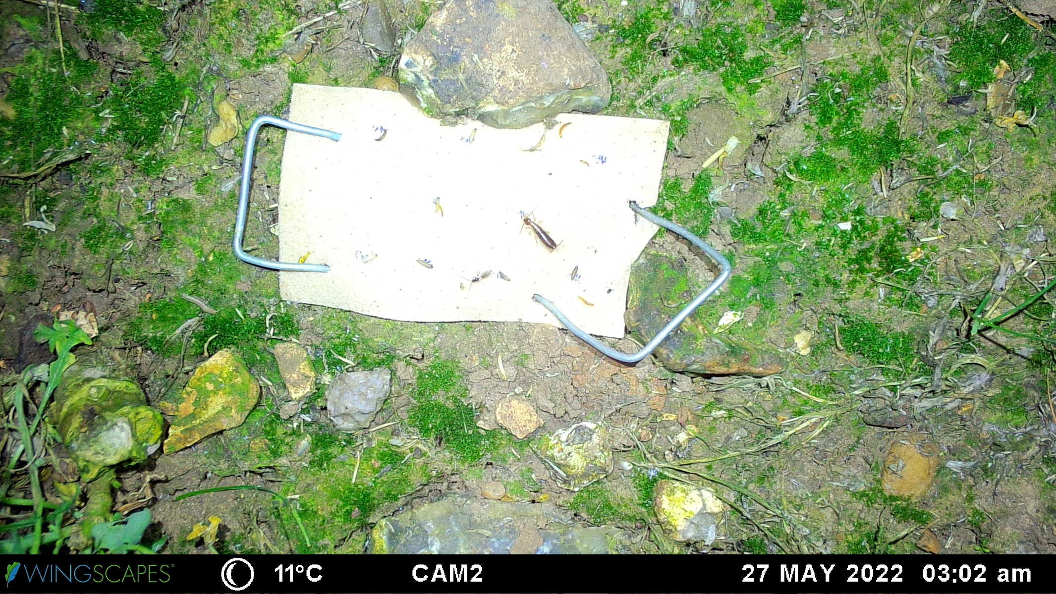 Figure S9. Image collected by a camera trap on 27/05/22 at 03:02 (am) with a Forficulidae feeding on a pollen beetle larva (Brassicogethes aeneus). Several predatory larvae and a parasitoid can also be observed visiting the predation card.

List of the videos showing examples of predations events:

Carabidae feeding - https://www.youtube.com/watch?v=hvFohuEBw-0
Opilione feeding - https://www.youtube.com/watch?v=OBd1ne0wjs8
Staphylinidae feeding - https://www.youtube.com/watch?v=5BEn5O2J4ns
Predatory larvae feeding - https://www.youtube.com/watch?v=7kOjqva87A4
Formicidae feeding - https://www.youtube.com/watch?v=v9kclseoBW0
Forficulidae feeding - https://www.youtube.com/watch?v=eKE8mTbjaQ4

Predator diurnal activity in 2021
The same method was used to document the predator activity pattern in 2021 as in 2022 (see section Data analyses from the main manuscript).
Significant differences between predator activity were found when pollen beetle larvae (χ²₄ = 27.33, p < 0.001) or brassica pod midge larvae (χ²₄ = 61.77, p < 0.001) were used on as sentinel prey. Differences in predator activity between sampling dates were also found (pollen beetles: χ²₅ = 13.24, p = 0.021; χ²₇ = 19.84, p = 0.006).
Figure S10. Mean (± SE) number of pictures with predators observed on the predation card at different times of the day. Predation cards contain a) pollen beetle larvae or b) brassica pod midge larvae. Data collected in 2021. Different letters indicate significant differences between times of the day.

Figure S11. Mean (± SE) number of pictures with predators observed on the predation card at different times of the day. Predation cards contain pollen beetle larvae (yellow bars) or brassica pod midge larvae (green bars). Data collected in 2022 and presented for each predatory taxa identified.

Figure S12. Mean (± SE) number of Carabidae visitors observed on the predation cards (grey bars) and Carabidae collected in pitfall traps (black bars) in 2021 and 2022 when pollen beetle and brassica pod midge larvae were used as sentinel prey. Small Carabidae include Bembidion sp. and Trechus sp.

Table S1. Taxa identified as predators of pollen beetle and brassica pod midge larvae in previous studies. Results from Williams et al. 2010; Öberg, Cassel‐Lundhagen, and Ekbom 2011; Gagnon 2017. Note Gagnon 2017 was conducted in Canada on Brassicogethes viridescens, a species closely related to Brassicogethes aeneus.
 |  | Carabidae |  |  |  |  |  |  |  |  |  |  |  |  |  |  |  | Araneae |  | Other
Prey species | Methods | Amara similiata | Anchomenus dorsalis | Asaphidion spp | Bembidion lampros | Bembidion sp | Clivina fossor | Harpalu rufipes | Harpalus affinis | Harpalus sp | Loricera pilicornis | Nebria brevicollis | Poecilus cupreus | Pteristichus macer | Pterostichus madidus | Pterostichus melanarius | Stomis pumicatus | Pardosa sp | Theridion impressum | Aves | Chilopoda | Coccinelidae | Formicidae | Gasteropoda | Gryllidae
Pollen beetle larvae | Spatio-temporal relationship | X | X | X |  |  |  | X | X |  |  | X | X | X
Pollen beetle larvae | Gut content analysis |  | X |  |  |  |  |  | X |  |  | X | X |  | X |  |  | X | X
Pollen beetle larvae | Feeding tests | X |  |  |  |  | X | X |  |  |  |  |  |  |  | X |  |  |  |  |  | X
Pollen beetle larvae | Camera tracking |  |  |  |  | X |  |  |  | X |  |  |  |  |  |  |  |  |  | X | X |  | X | X | X
Brassica pod midge larvae | Spatio-temporal relationship |  | X |  |  |  |  | X |  |  |  |  | X |  |  |  | X
Brassica pod midge larvae | Gut content analysis | X
Brassica pod midge larvae | Feeding tests | X | X |  | X |  |  | X |  |  | X | X | X |  | X | X
Brassica pod midge larvae | Camera tracking

Table S2. Distribution error in the models (zero-inflated GLMM) used to analyse the differences of the number of individuals between taxa of found in pitfall traps, visitation events and predation events. nbinom1: negative binomial distribution, genpois: generalized Poisson distribution.
 | 2021 |  | 2022
 | Pollen beetle | Brassica pod midge | Pollen beetle | Brassica pod midge
Pitfall trap data | genpois | genpois | nbinom1 | genpois
Visitation events | genpois | genpois | genpois | genpois
Predation events | nbinom1 | genpois | genpois | genpois

Table S3. Mean (SE) number of individuals of different taxa found in pitfall traps placed in oilseed rape fields for 24 hours. Samples collected in 2021 and 2022 next to camera traps.
 |  | 2021 |  | 2022
 | Taxa | Pollen beetle | Brassica pod midge | Pollen beetle | Brassica pod midge
Arachnida | Acari | 0.117 (0.048) | 0.225 (0.059) | 0 (0) | 0.093 (0.027)
 | Opiliones | 0.017 (0.017) | 0 (0) | 0.028 (0.028) | 0.093 (0.027)
 | Clubionidae | 0 (0) | 0 (0) | 0.009 (0.009) | 0 (0)
 | Dysderidae | 0 (0) | 0 (0) | 0.009 (0.009) | 0 (0)
 | Gnaphosidae | 0 (0) | 0.013 (0.012) | 0 (0) | 0.007 (0.007)
 | Linyphiidae | 1.383 (0.246) | 9.875 (0.874) | 0.477 (0.088) | 5.573 (0.526)
 | Lycosidae | 0.517 (0.122) | 0.5 (0.302) | 0.33 (0.064) | 0.953 (0.41)
 | Miturgidae | 0.017 (0.017) | 0 (0) | 0.009 (0.009) | 0 (0)
 | Salticidae | 0.033 (0.023) | 0.013 (0.012) | 0 (0) | 0 (0)
 | Tetragnathidae | 0 (0) | 0 (0) | 0.028 (0.016) | 0.093 (0.024)
 | Theridiidae | 0.033 (0.033) | 0 (0) | 0 (0) | 0.013 (0.009)
 | Thomisidae | 0 (0) | 0 (0) | 0 (0) | 0.013 (0.009)
 | Total Arachnida | 2.117 (0.305) | 10.625 (1.002) | 0.89 (0.116) | 6.84 (0.68)
Carabidae | Abax parallelepipidus | 0 (0) | 0.013 (0.012) | 0 (0) | 0 (0)
 | Amara sp | 2.2 (0.39) | 1.438 (0.199) | 0.294 (0.064) | 1.193 (0.129)
 | Anchomenus dorsalis | 0.383 (0.101) | 0.312 (0.075) | 0.128 (0.041) | 0.133 (0.034)
 | Asaphidion sp | 0 (0) | 0 (0) | 0 (0) | 0.007 (0.007)
 | Bembidion lampros | 0.017 (0.017) | 0 (0) | 0 (0) | 0.007 (0.007)
 | Unidentified Bembidion | 0 (0) | 0 (0) | 0.046 (0.02) | 0.007 (0.007)
 | Carabus violaceus | 0 (0) | 0 (0) | 0 (0) | 0.013 (0.009)
 | Demetrias sp | 0.017 (0.017) | 0 (0) | 0 (0) | 0 (0)
 | Harpalus affinis | 0 (0) | 0.013 (0.012) | 0.046 (0.02) | 0.087 (0.025)
 | Harpalus rufipes | 0.067 (0.032) | 0.025 (0.018) | 0.018 (0.013) | 0.073 (0.023)
 | Loricera pilicornis | 0 (0) | 0.013 (0.012) | 0.009 (0.009) | 0.1 (0.026)
 | Nebria brevicollis | 0.05 (0.028) | 0.013 (0.012) | 0.028 (0.016) | 0.027 (0.013)
 | Nebria salina | 0.017 (0.017) | 0.013 (0.012) | 0.046 (0.02) | 0.04 (0.016)
 | Poecilus cupreus | 0.183 (0.061) | 0.075 (0.039) | 0.028 (0.016) | 0.087 (0.028)
 | Pterostichus madidus | 0.05 (0.028) | 0.062 (0.027) | 0.018 (0.013) | 0.047 (0.017)
 | Pterostichus melanarius | 0.017 (0.017) | 0.1 (0.034) | 0 (0) | 0.013 (0.009)
 | Pterostichus strenuus | 0 (0) | 0 (0) | 0 (0) | 0.007 (0.007)
 | Syntomus obscuroguttatus | 0.017 (0.017) | 0 (0) | 0 (0) | 0 (0)
 | Trechus quadristriatus | 0 (0) | 0.038 (0.028) | 0 (0) | 0.007 (0.007)
 | Unidentified larvae | 0 (0) | 0.238 (0.057) | 0.073 (0.028) | 0.107 (0.033)
 | Total Carabidae | 3.017 (0.493) | 2.112 (0.245) | 0.661 (0.101) | 1.847 (0.162)
Staphylinidae | Aleochara sp | 0 (0) | 0 (0) | 0 (0) | 0.04 (0.016)
 | Unidentified Aleocharinae | 0.117 (0.048) | 0.075 (0.035) | 0.037 (0.018) | 0.387 (0.072)
 | Anotylus sp | 0 (0) | 0 (0) | 0.018 (0.013) | 0.013 (0.009)
 | Cypha sp | 0 (0) | 0 (0) | 0.009 (0.009) | 0 (0)
 | Gyrohypnus sp | 0.017 (0.017) | 0 (0) | 0 (0) | 0 (0)
 | Ilyobates sp | 0 (0) | 0 (0) | 0 (0) | 0.007 (0.007)
 | Ocypus nitens | 0 (0) | 0 (0) | 0.009 (0.009) | 0 (0)
 | Omalium sp | 0 (0) | 0 (0) | 0.009 (0.009) | 0 (0)
 | Othius punctulatus | 0 (0) | 0 (0) | 0 (0) | 0.007 (0.007)
 | Philonthus cognatus | 0.217 (0.076) | 0.038 (0.021) | 0.046 (0.02) | 0.033 (0.015)
 | Unidentified Philonthus | 0.433 (0.157) | 0.312 (0.098) | 0 (0) | 0.073 (0.021)
 | Plataraea brunnea | 0 (0) | 0 (0) | 0 (0) | 0.007 (0.007)
 | Tachinus sp | 0.7 (0.294) | 0.375 (0.159) | 0.046 (0.02) | 0.047 (0.017)
 | Tachyporus chrysomelinus | 0 (0) | 0 (0) | 0.009 (0.009) | 0 (0)
 | Tachyporus dispar | 0.017 (0.017) | 0 (0) | 0 (0) | 0 (0)
 | Tachyporus hypnorum | 0.183 (0.099) | 0 (0) | 0.119 (0.034) | 0.007 (0.007)
 | Tachyporus nitidulus | 0 (0) | 0 (0) | 0 (0) | 0.007 (0.007)
 | Unidentified Tachyporus | 0 (0) | 0 (0) | 0.009 (0.009) | 0 (0)
 | Xantholinus sp | 0.017 (0.017) | 0 (0) | 0.009 (0.009) | 0 (0)
 | Unidentified larvae | 0.117 (0.054) | 0.238 (0.057) | 0.064 (0.027) | 1.06 (0.11)
 | Total Staphylinidae | 1.7 (0.442) | 0.8 (0.205) | 0.303 (0.06) | 0.613 (0.08)
Staphylinidae and Carabidae | Total larvae | 0.117 (0.054) | 0.475 (0.091) | 0.138 (0.038) | 1.167 (0.116)
Other | Lasius niger | 0.067 (0.047) | 0.112 (0.04) | 0.128 (0.037) | 0.053 (0.021)
 | Myrmica sp | 0.083 (0.036) | 0.075 (0.035) | 0 (0) | 0.02 (0.011)
 | Total Formicidae | 0.15 (0.066) | 0.188 (0.051) | 0.128 (0.037) | 0.107 (0.029)
 | Forficulidae | 0 (0) | 0 (0) | 0 (0) | 0.007 (0.007)

Table S4. Total number of predation events / number of visitation event (number of pictures) of different predator taxa observed feeding / visiting on pollen beetle and brassica pod midge larvae in oilseed rape fields in 2021 and 2022. “Other” include Coccinella septempunctata and unidentified taxa.
 |  | 2021 |  | 2022
 | Taxa | Pollen beetle | Brassica pod midge | Pollen beetle | Brassica pod midge
Arachnid | Acari | 3/7 (18) | 16/160 (1304) | 0/23 (47) | 17/68 (297)
 | Linyphiidae | 0/22 (25) | 0/121 (126) | 0/73 (88) | 7/271 (678)
 | Lycosidae | 0/5 (6) | 0/3 (3) | 0/4 (4) | 0/4 (4)
 | Opiliones | 0/0 (0) | 0/0 (0) | 4/15 (191) | 1/33 (152)
 | Unidentified Arachnida | 0/3 (3) | 0/1 (1) | 0/13 (16) | 1/73 (235)
Carabidae | Amara sp. | 4/23 (27) | 0/18 (25) | 0/13 (22) | 2/34 (60)
 | Anchomenus dorsalis | 8/12 (50) | 0/3 (3) | 1/11 (35) | 1/42 (66)
 | Small carabids | 21/27 (233) | 0/5 (7) | 9/42 (275) | 18/160 (540)
 | Brachinus crepitans | 0/0 (0) | 0/0 (0) | 1/1 (14) | 0/0 (0)
 | Demetrias atricapillus | 0/0 (0) | 0/0 (0) | 0/1 (1) | 0/1 (1)
 | Harpalus sp. | 4/7 (82) | 1/3 (3) | 3/24 (140) | 0/20 (47)
 | Nebria sp. | 0/1 (1) | 0/0 (0) | 10/15 (101) | 1/5 (37)
 | Notiophilus sp. | 0/1 (1) | 0/2 (2) | 0/0 (0) | 0/1 (1)
 | Poecilus cupreus | 1/2 (3) | 0/0 (0) | 0/0 (0) | 0/0 (0)
 | Pterostichus sp. | 0/2 (2) | 0/0 (0) | 0/0 (0) | 0/9 (10)
 | Unidentified Carabidae | 0/4 (5) | 0/0 (0) | 0/0 (0) | 0/0 (0)
Staphylinidae | Staphylinidae sp. | 19/38 (251) | 2/47 (124) | 16/112 (317) | 8/88 (487)
Unidentified larvae | - | 74/138 (1219) | 21/144 (2355) | 173/490 (6187) | 448/2447 (31067)
Forficulidae | - | 0/0 (0) | 0/0 (0) | 1/4 (22) | 3/26 (46)
Formicidae | - | 14/30 (134) | 1/31 (150) | 129/335 (5991) | 1/57 (135)
Other | Diptera | 6/49 (85) | 3/100 (496) | 0/107 (223) | 0/240 (413)
 | Diplopod | 0/1 (1) | 0/2 (2) | 0/149 (157) | 0/302 (333)
 | Isopod | 0/2 (2) | 0/8 (9) | 0/12 (30) | 0/110 (901)
 | Other | 6/26 (143) | 0/28 (54) | 1/84 (188) | 0/152 (545)
Vertebrate | Rodentia | 2/9 (9) | 0/8 (8) | 0/0 (0) | 0/0 (0)
 | Aves | 0/0 (0) | 0/3 (3) | 0/0 (0) | 3/23 (26)

