Fig. 1. Examples of quantitative relationships between nitrogen losses (N₂O emissions and NO₃⁻ leaching) and root traits based on metadata from experiments (Table 1).
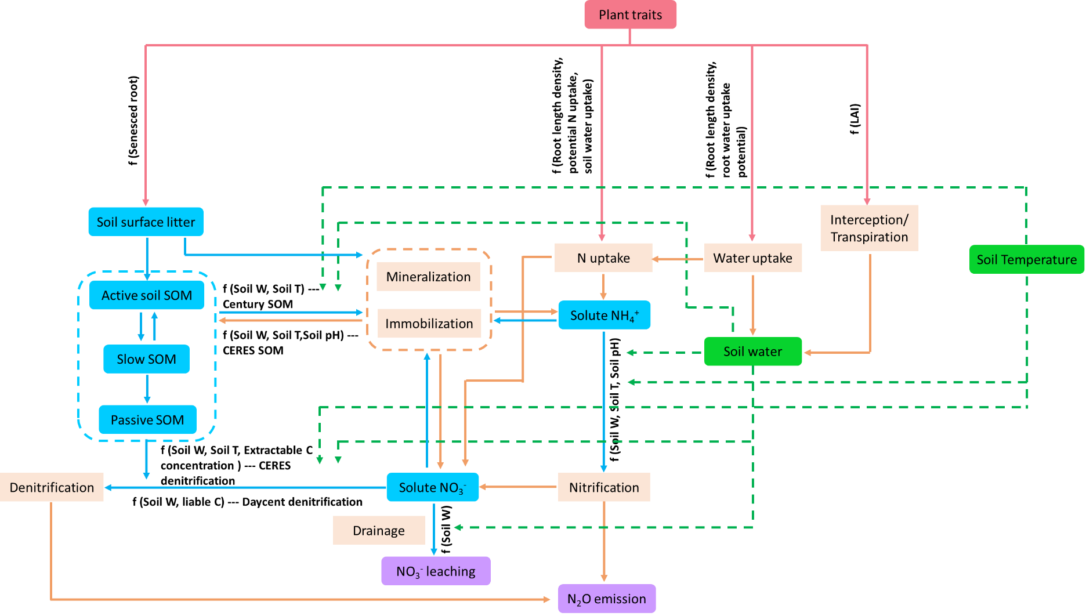

Fig. 2. Conceptual diagram depicting the potential effects of plant traits on nitrogen losses described in DSSAT. The red color box indicates plant traits; red solid arrows indicate the possible impact of plant traits; blue color boxes indicated the soil substrates; blue solid arrows indicate the possible biochemical processes in which the substrates are directly involved; green color boxes indicates soil abiotic factors and green dash arrows indicate possible processes affected by abiotic factors; light orange boxes indicate process related to soil C, N and water dynamics; light orange solid arrows indicate possible consequence of changes in processes.
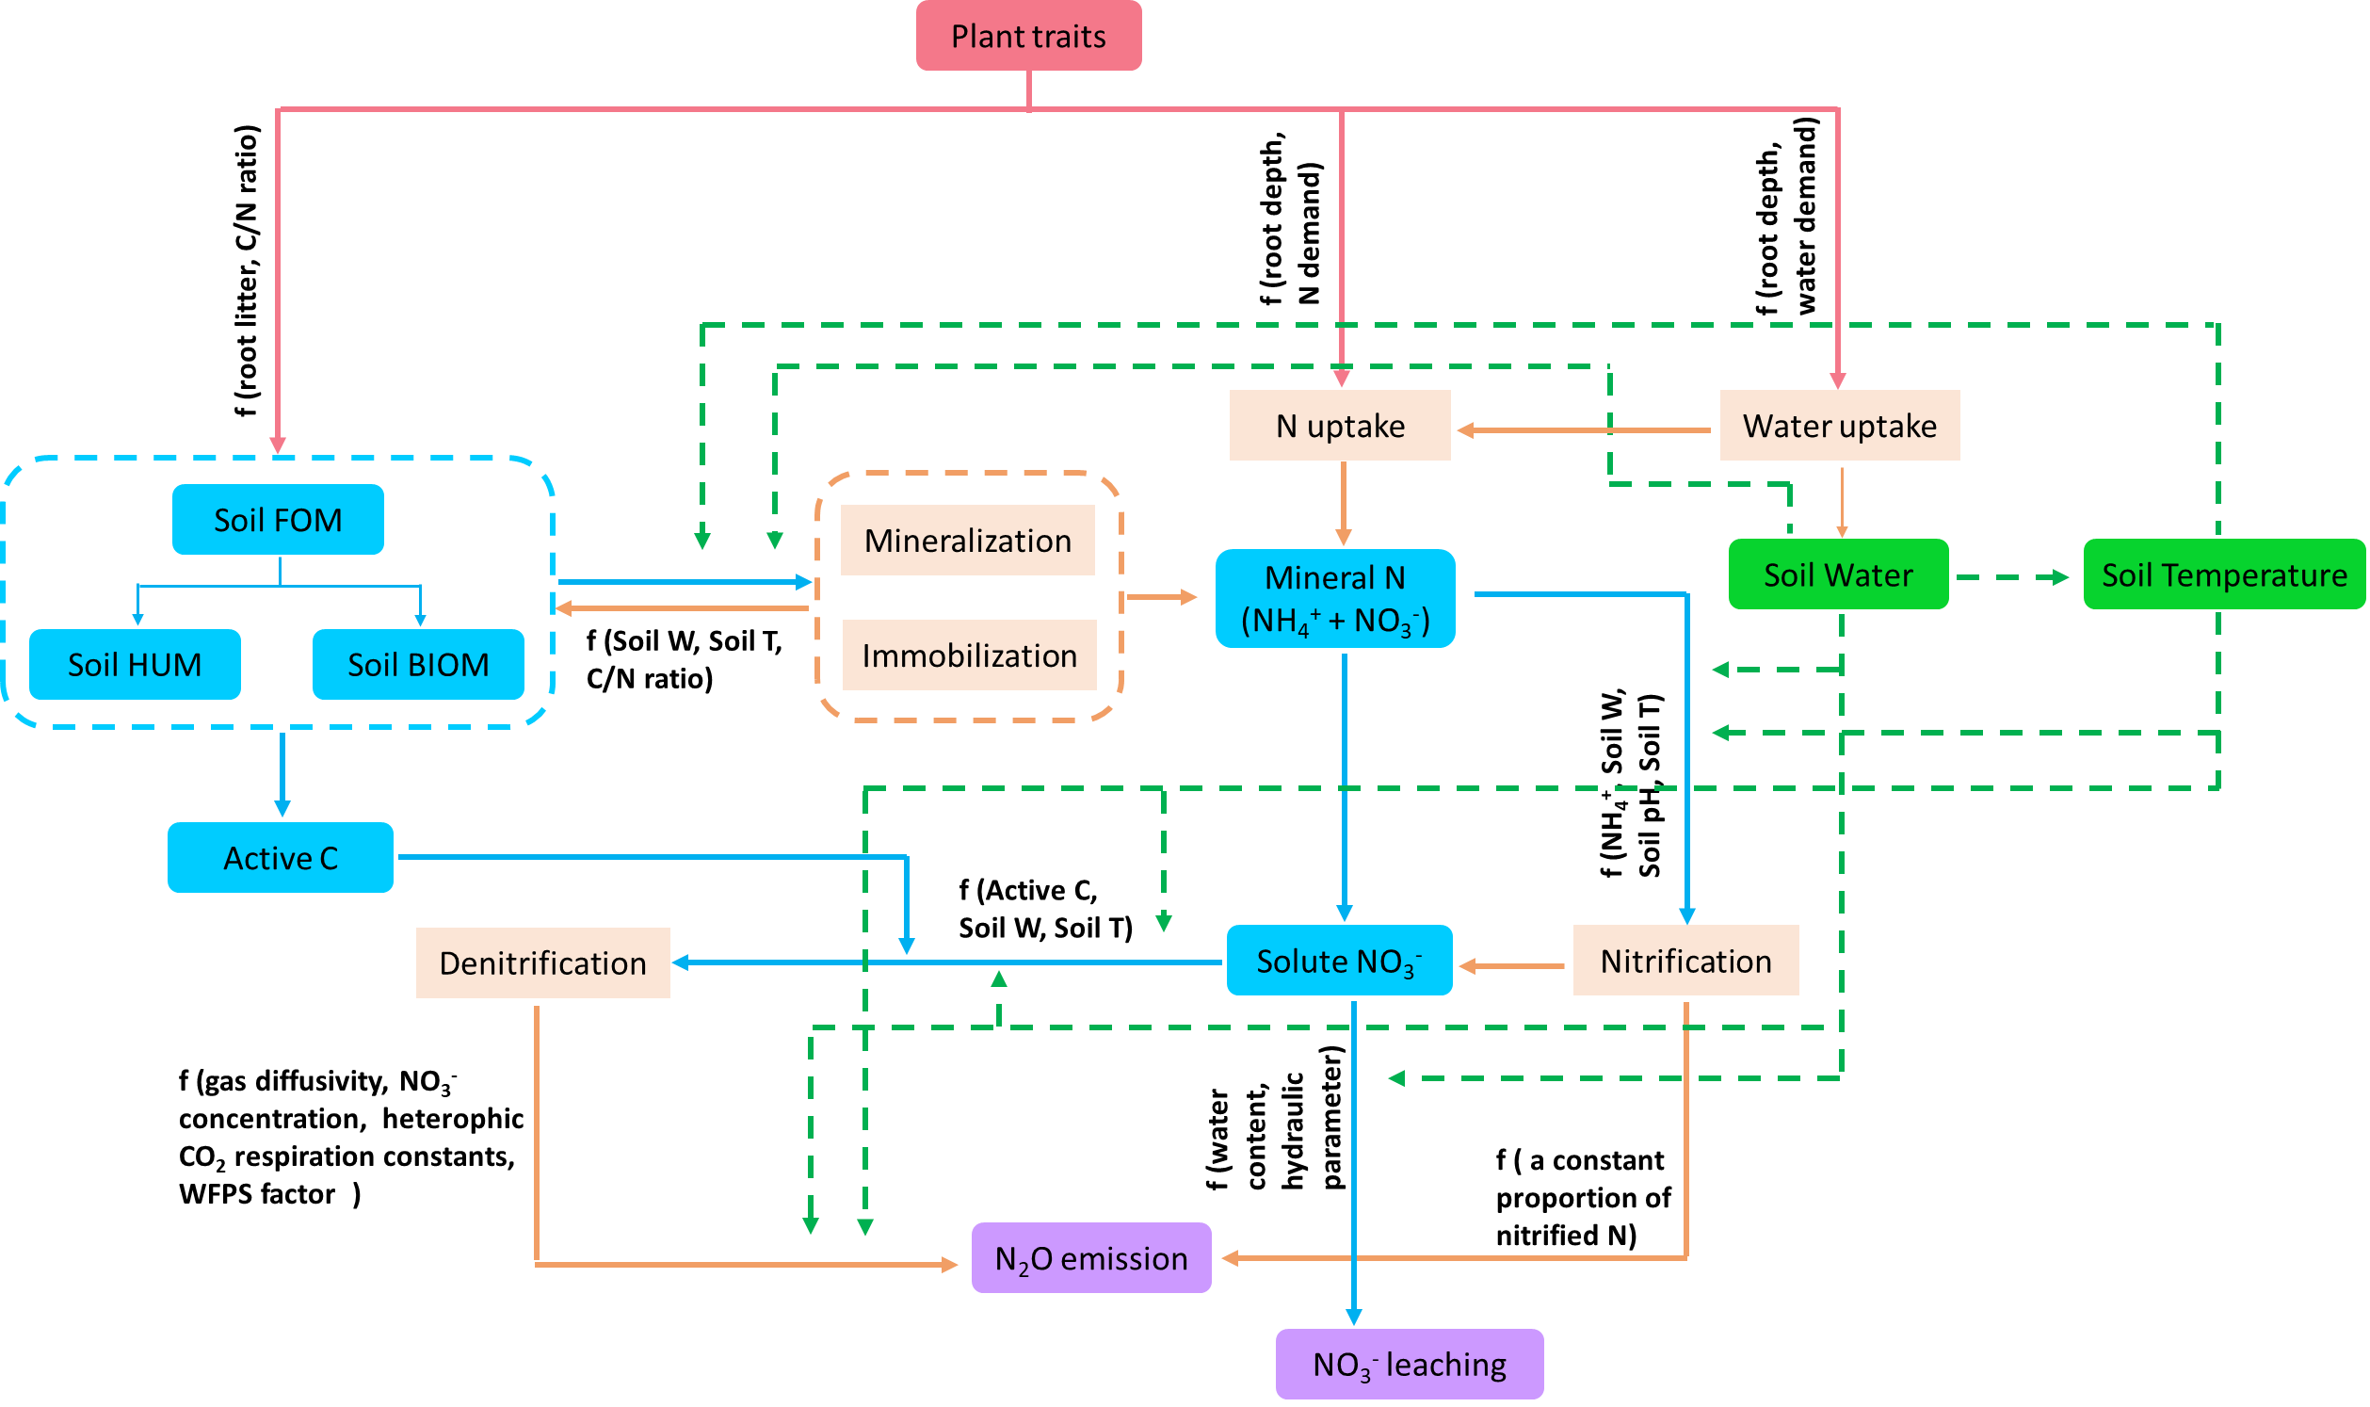
Fig. 3. Conceptual diagram depicting the potential effects of plant traits on nitrogen losses described in APSIM. The red color box indicates plant traits; red solid arrows indicate the possible impact of plant traits; blue color boxes indicated the soil substrates; blue solid arrows indicate the possible biochemical processes in which the substrates are directly involved; green color boxes indicates soil abiotic factors and green dash arrows indicate possible processes affected by abiotic factors; light orange boxes indicate process related to soil C, N and water dynamics; light orange solid arrows indicate possible consequence of changes in processes.
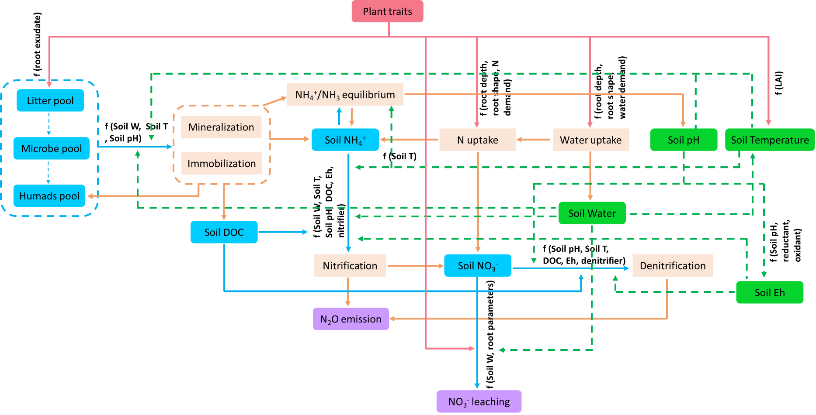

Fig. 4. Conceptual diagram depicting the potential effects of plant traits on nitrogen losses described in DNDCv.CAN. The red color box indicates plant traits; red solid arrows indicate the possible impact of plant traits; blue color boxes indicated the soil substrates; blue solid arrows indicate the possible biochemical processes in which the substrates are directly involved; green color boxes indicates soil abiotic factors and green dash arrows indicate possible processes affected by abiotic factors; light orange boxes indicate process related to soil C, N and water dynamics; light orange solid arrows indicate possible consequence of changes in processes.
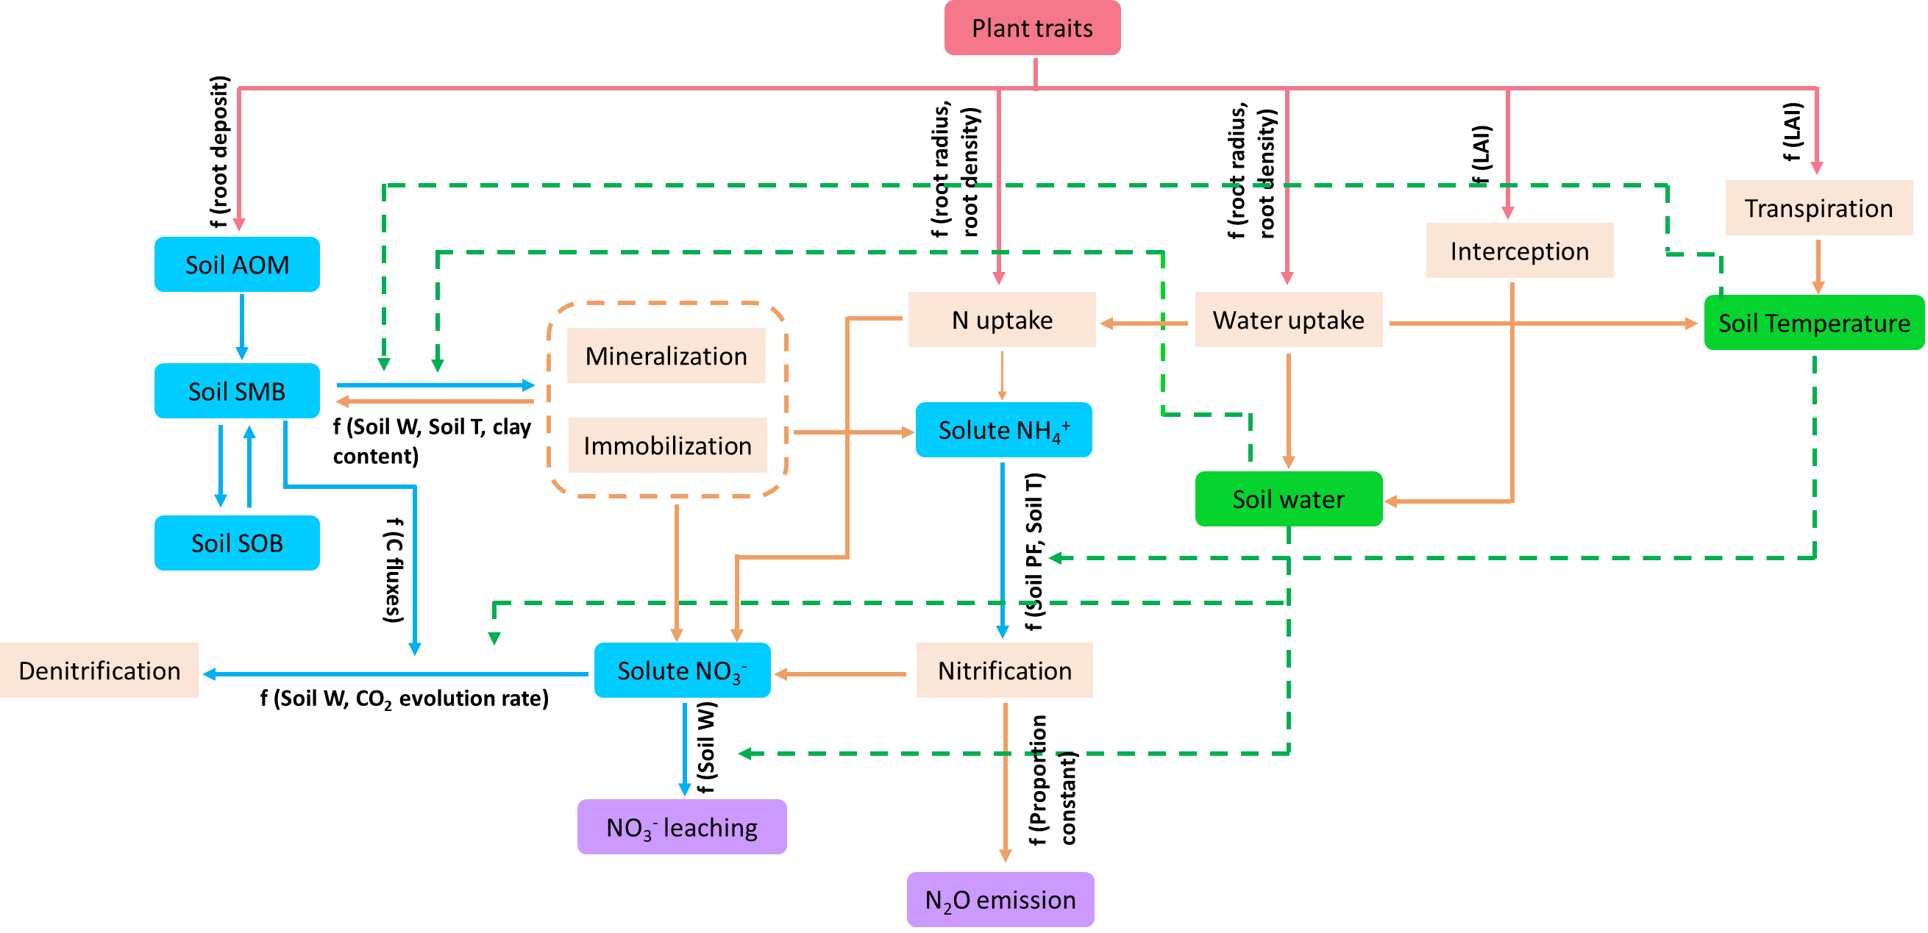

Fig. 5. Conceptual diagram depicting the potential effects of plant traits on nitrogen losses described in Daisy. The red color box indicates plant traits; red solid arrows indicate the possible impact of plant traits; blue color boxes indicated the soil substrates; blue solid arrows indicate the possible biochemical processes in which the substrates are directly involved; green color boxes indicates soil abiotic factors and green dash arrows indicate possible processes affected by abiotic factors; light orange boxes indicate process related to soil C, N and water dynamics; light orange solid arrows indicate possible consequence of changes in processes.

Fig. 6. Sensitivity analysis showing the potential effects of key root traits on nitrogen losses and crop nitrogen uptake in the models APSIM, DNDCvCAN, DSSAT, and Daisy, for spring barley (BA) or winter wheat (WH).
Table 1. Qualitative summary of relationships between root traits and nitrogen losses and plant nitrogen uptake reported in experiments.
N cycling |  | Trait |  | Direction of N loss with increasing trait values | Scale | Plant/crop | References
N loss | N₂O emission | Architectural and morphological | Root biomass | Increase | Field | Rice | Baruah et al., 2010
 |  |  |  | Decrease | Greenhouse Mesocosm | Grass | Oram et al., 2020
N loss | N₂O emission | Architectural and morphological | Specific root length | Decrease | Greenhouse Mesocosm | Grass | Abalos et al., 2014, 2018; Oram et al., 2020; Fernandez Pulido et al., 2023
N loss | N₂O emission | Architectural and morphological | Root Diameter | Increase | Greenhouse Mesocosm | Grass | Abalos et al., 2014, 2018; Fernandez Pulido et al., 2023
N loss | N₂O emission | Architectural and morphological | Root length density | Decrease | Greenhouse Mesocosm | Grass | Abalos et al., 2018; Fernandez Pulido et al., 2023
N loss | N₂O emission | Architectural and morphological | Root dry matter content | Increase | Greenhouse Mesocosm | Grass | Fernandez Pulido et al., 2023
N loss | N₂O emission | Architectural and morphological | Root/shoot ratio | Increase | Greenhouse Mesocosm | Grass | Abalos et al., 2014
N loss | N₂O emission | Architectural and morphological | Root tissue density | Decrease | Greenhouse Mesocosm | Grass | Oram et al., 2020
N loss | N₂O emission | Physiological and chemical | Root C/N ratio | Decrease | Greenhouse Mesocosm | Grass | Oram et al., 2020
N loss | N₂O emission | Physiological and chemical | Root N concentration | Increase | Greenhouse Mesocosm | Grass | Oram et al., 2020; Fernandez Pulido et al., 2023
N loss | N₂O emission | Physiological and chemical | Root C concentration | Decrease | Greenhouse Mesocosm | Grass | Oram et al., 2020
N loss | NO₃⁻ leaching | Architectural and morphological | Deep root biomass | Decrease | Sand_tube | Wheat | Ehdaie et al., 2010
N loss | NO₃⁻ leaching | Architectural and morphological | Shallow root biomass | Decrease | Sand_tube | Wheat | Ehdaie et al., 2010
N loss | NO₃⁻ leaching | Architectural and morphological | Root/shoot ratio | Decrease | Sand_tube | Wheat | Ehdaie et al., 2010
 |  |  |  |  | Greenhouse Mesocosm | Sugarcane | Takaragawa et al., 2022
N loss | NO₃⁻ leaching | Architectural and morphological | 0-0.3 m root biomass | Decrease | Greenhouse Mesocosm | Sugarcane | Takaragawa et al., 2022
N loss | NO₃⁻ leaching | Architectural and morphological | 0.3-1.0 m root biomass | Decrease | Greenhouse Mesocosm | Sugarcane | Takaragawa et al., 2022
N loss | NO₃⁻ leaching | Architectural and morphological | 0-0.1 m root biomass | Decrease | Greenhouse Mesocosm | Grass | Popay & Crush, 2011
N loss | NO₃⁻ leaching | Architectural and morphological | 0.1-0.2 m root biomass | Decrease | Greenhouse Mesocosm | Grass | Popay & Crush, 2011
N loss | NO₃⁻ leaching | Architectural and morphological | > 0.2 m root biomass | Decrease | Greenhouse Mesocosm | Grass | Popay & Crush, 2011
N loss | NO₃⁻ leaching | Architectural and morphological | Root biomass | Decrease | Sand_tube | Wheat | Ehdaie et al., 2010
 |  |  |  |  | Greenhouse Mesocosm | Grass | Popay & Crush, 2011; Moir et al., 2012
 |  |  |  | Increase | Greenhouse Mesocosm | Sugarcane | Takaragawa et al., 2022
N loss | NO₃⁻ leaching | Architectural and morphological | Root length density | Decrease | Greenhouse Mesocosm | Grass | Fernandez Pulido et al., 2023
 |  |  |  | Increase | Vegetation filter strips | Grass | Sheng et al., 2021
N loss | NO₃⁻ leaching | Architectural and morphological | Maximum root depth | Increase | Sand_tube | Wheat | Ehdaie et al., 2010
N loss | NO₃⁻ leaching | Architectural and morphological | Root depth | Decrease | Vegetation filter strips | Grass | Sheng et al., 2021
N loss | NO₃⁻ leaching | Architectural and morphological | 0-0.1 m root length | Decrease | Greenhouse Mesocosm | Grass | Popay & Crush, 2011
N loss | NO₃⁻ leaching | Architectural and morphological | 0.1-0.2 m root length | Decrease | Greenhouse Mesocosm | Grass | Popay & Crush, 2011
N loss | NO₃⁻ leaching | Architectural and morphological | > 0.2 m root length | Decrease | Greenhouse Mesocosm | Grass | Popay & Crush, 2011
N loss | NO₃⁻ leaching | Architectural and morphological | Root length | Decrease | Greenhouse Mesocosm | Grass | Popay & Crush, 2011
N loss | NO₃⁻ leaching | Architectural and morphological | 0-0.1 m root diameter | Decrease | Greenhouse Mesocosm | Grass | Popay & Crush, 2011
N loss | NO₃⁻ leaching | Architectural and morphological | 0.1-0.2 m root diameter | Increase | Greenhouse Mesocosm | Grass | Popay & Crush, 2011
N loss | NO₃⁻ leaching | Architectural and morphological | > 0.2 m root diameter | Increase | Greenhouse Mesocosm | Grass | Popay & Crush, 2011
N loss | NO₃⁻ leaching | Architectural and morphological | Root diameter | Increase | Greenhouse Mesocosm | Grass | Popay & Crush, 2011; Fernandez Pulido et al., 2023
N loss | NO₃⁻ leaching | Architectural and morphological | Root dry matter content | Decrease | Greenhouse Mesocosm | Grass | Fernandez Pulido et al., 2023
N loss | NO₃⁻ leaching | Architectural and morphological | Specific root length | Increase | Greenhouse Mesocosm | Grass | Popay & Crush, 2011; Fernandez Pulido et al., 2023
N loss | NO₃⁻ leaching | Architectural and morphological | Center of gravity of the root system | Decrease | Greenhouse Mesocosm | Sugarcane | Takaragawa et al., 2022
N loss | NO₃⁻ leaching | Physiological and chemical | Root N content | Increase | Greenhouse Mesocosm | Grass | Fernandez Pulido et al., 2023
N loss | Denitrification | Physiological and chemical | Root C exudation | Positive/Increase | Controlled light exposure and soil moisture | Wheat, barley and ryegrass | Maurer et al., 2021
N loss | Denitrification | Physiological and chemical | Root N exudation | Positive/Increase | Controlled light exposure and soil moisture | Wheat, barley and ryegrass | Maurer et al., 2021
N loss | Nitrification | Architectural and morphological | Specific root length | Negative/ Reduction | Greenhouse Mesocosm | Grasses | Cantarel et al., 2015
N loss | Nitrification | Physiological and chemical | Root N content | Positive/ Increase | Greenhouse Mesocosm | Grasses | Cantarel et al., 2015
N loss | Nitrification | Physiological and chemical | Root affinity for NH₄ | Positive/ Increase | Greenhouse Mesocosm | Grasses | Cantarel et al., 2015
N loss | Nitrification | Physiological and chemical | Exudation of nitrification inhibitors | Negative/Reduction | Chamber | Brachiaria humidicola | Subbarao et al., 2007
 |  |  |  | Negative/Reduction | Greenhouse Mesocosm | Rice, Wheat,Elymus sibiricus | Pariasca Tanaka et al., 2010; O’Sullivan et al., 2016; Sun et al., 2016
N uptake | N uptake | Architectural and morphological | Root surface area | Increase | Chamber | Rice, Cotton | Chen et al., 2020; Iqbal et al., 2020
 |  |  |  |  | Hydroponic condition | Wheat | Zhang et al., 2015
 |  |  |  | Decrease | Greenhouse Mesocosm | Rice | Fan et al., 2010
 |  |  |  |  | Field | Maize | Mu et al., 2015; Guo et al., 2022
N uptake | N uptake | Architectural and morphological | Root biomass | Increase | Chamber | Rice, Cotton | Chen et al., 2020; Iqbal et al., 2020
 |  |  |  |  | Field | Maize, Rice | Ju et al., 2015; Mu et al., 2015; Yu et al., 2015; Chu et al., 2022; Guo et al., 2022
 |  |  |  |  | Hydroponic condition | Wheat | Zhang et al., 2015
 |  |  |  |  | Greenhouse Mesocosm | Grass, Rice, Sugarcane | Fan et al., 2010; Moir et al., 2012; Takaragawa et al., 2022
 |  |  |  |  | Sand_tube | Wheat | Ehdaie et al., 2010
N uptake | N uptake | Architectural and morphological | Root biomass (0-10) | Increase | Field | Rice | Ju et al., 2015; Chu et al., 2022
N uptake | N uptake | Architectural and morphological | Root biomass (10-20) | Increase | Field | Rice | Ju et al., 2015; Chu et al., 2022
N uptake | N uptake | Architectural and morphological | Root biomass (0-0.3 m) | Decrease | Greenhouse Mesocosm | Sugarcane | Takaragawa et al., 2022
N uptake | N uptake | Architectural and morphological | Root biomass (0.3-1.0 m) | Decrease | Greenhouse Mesocosm | Sugarcane | Takaragawa et al., 2022
N uptake | N uptake | Architectural and morphological | Deep root biomass | Increase | Sand_tube | Wheat | Ehdaie et al., 2010
N uptake | N uptake | Architectural and morphological | Shallow root biomass | increase | Sand_tube | Wheat | Ehdaie et al., 2010
N uptake | N uptake | Architectural and morphological | Center of gravity of the root system | Decrease | Greenhouse Mesocosm | Sugarcane | Takaragawa et al., 2022
N uptake | N uptake | Architectural and morphological | Root/shoot ratio | Increase | Sand_tube | Wheat | Ehdaie et al., 2010
 |  |  |  |  | Field | Maize, Rice | Yu et al., 2015; Ju et al., 2015; Chu et al., 2022
 |  |  |  | Decrease | Greenhouse Mesocosm | Grass, Sugarcane | Abalos et al., 2014; Takaragawa et al., 2022
 |  |  |  |  | Chamber | Cotton | Iqbal et al., 2020
N uptake | N uptake | Architectural and morphological | Root depth | Increase | Chamber | Cotton | Iqbal et al., 2020
 |  |  |  | Decrease | Vegetation filter strips | Grass | Sheng et al., 2021
 |  |  |  |  | Sand_tube | Wheat | Ehdaie et al., 2010
N uptake | N uptake | Architectural and morphological | Root Diameter | Increase | Greenhouse Mesocosm | Grass | Abalos et al., 2014
 |  |  |  |  | Chamber | Cotton, Rice | Chen et al., 2020; Iqbal et al., 2020
 |  |  |  |  | Field | Rice | Chu et al., 2022
N uptake | N uptake | Architectural and morphological | Root length density | Increase | Field | Maize, Rice | Ju et al., 2015; Mu et al., 2015; Chu et al., 2022
 |  |  |  |  | Vegetation filter strips | Grass | Sheng et al., 2021
N uptake | N uptake | Architectural and morphological | Root volume | Increase | Field | Rice | Chu et al., 2022
 |  |  |  |  | Hydroponic condition | Wheat | Zhang et al., 2015
 |  |  |  |  | Chamber | Rice, Cotton | Chen et al., 2020; Iqbal et al., 2020
N uptake | N uptake | Architectural and morphological | Root length ratio | Decrease | Chamber | Cotton | Iqbal et al., 2020
N uptake | N uptake | Architectural and morphological | Root thickness | Increase | Chamber | Cotton | Iqbal et al., 2020
N uptake | N uptake | Architectural and morphological | Specific root length | Increase | Field | Rice | Chu et al., 2022
 |  |  |  | Decrease | Greenhouse Mesocosm | Grass | Abalos et al., 2014
N uptake | N uptake | Architectural and morphological | Root length | Increase | Field | Maize, Rice | Ju et al., 2015; Chu et al., 2022; Guo et al., 2022
 |  |  |  |  | Hydroponic condition | Wheat | Zhang et al., 2015
 |  |  |  |  | Greenhouse Mesocosm | Rice, Grass | Fan et al., 2010; Moir et al., 2012
 |  |  |  |  | Chamber | Rice | Chen et al., 2020
N uptake | N uptake | Architectural and morphological | Root tip number | Decrease | Chamber | Rice | Chen et al., 2020
N uptake | N uptake | Architectural and morphological | Root density | Increase | Chamber | Cotton | Iqbal et al., 2020
N uptake | N uptake | Architectural and morphological | Root projected area | Decrease | Chamber | Cotton | Iqbal et al., 2020
N uptake | N uptake | Architectural and morphological | Root angle opening | Increase | Field | Maize | Guo et al., 2022
N uptake | N uptake | Architectural and morphological | Root maximal width | Increase | Field | Maize | Guo et al., 2022

Table 2. Main root traits in a selection of dynamic models (APSIM, DNDCvCAN, DSSAT, and Daisy) with potential effects on nitrogen losses.
Trait Category | Trait | Models | Default values | Units
Architectural and morphological | Initial root depth | APSIM | 100 | mm
Architectural and morphological | Maximum root depth | APSIM, DNDCv.CAN | 1000; 1.51 | mm; m
Architectural and morphological | Root depth growth rate | APSIM, DSSAT | (0, 5.0, 30, 30, 30, 30, 0.0, 0.0, 0.0,0.0,0); 3.0 | mm/d; cm/d
Architectural and morphological | Root fraction of total biomass | DNDCv.CAN | 0.15 | fraction
Architectural and morphological | Maximal root/shoot ratio | Daisy | c(0.5, 0.5, 0.25) | ratio
Architectural and morphological | Density distribution of root shape | DNDCv.CAN | 5 | function number
Architectural and morphological | Root length weight ratio | DSSAT | 0.98 | cm/g
Architectural and morphological | Penetration rate parameter of root | Daisy | 1 | cm/dg C/d
Physiological and chemical | NO₃⁻ uptake/root length | DSSAT | 0.006 | mg/cm
Physiological and chemical | Conversion efficiency of root | Daisy | 0.69 | g DM-C/g Ass-C
Physiological and chemical | Fraction of assimilate for growth to root | Daisy | c(0.5, 0.45, 0.4) | fraction
Physiological and chemical | Root respiration fraction | DSSAT | 0.4 | fraction
Physiological and chemical | Critical root N concentration | APSIM | 0.02 | gN/gDM
Physiological and chemical | Root C/N ratio | DNDCv.CAN | 85 | ratio

Table 3. General information of the dataset setups for the sensitivity analysis with process-based models.
Models | Crop | Site | Soil texture | Nitrogen input (kg/ha) | Water regime | Reference
DSSAT | Spring barley | Dundee (56.45°N, 3.07°W) | Loam | 120 | Irrigated | Cammarano et al., 2019
APSIM | Spring barley | Foulum (56.30° N, 9.35° E) | Sandy loam | 140 | Rainfed | Vogeler et al., 2023
DNDCv.CAN | Spring barley | Quebec (48.85°N, 72.54°W) | Silty clay | 70 | Rainfed | Jégo et al., 2024
Daisy | Winter wheat | Foulum (56.30° N, 9.35° E) | Sandy loam | 150-165 | Rainfed | Gyldengren et al., 2020
Table 4. Research needs for improving model representation of the relationship between root traits and nitrogen losses.
Item | Action
Experiments – common traits | Document resource investment traits (e.g., root N concentration, specific root length) more consistently
Experiments – complex traits | Include complex indicators of root N uptake such as net and maximum NO₃⁻ and NH₄⁺ uptake rates
Evaluation of synergies and trade-offs | Consider interactive effects of e.g., root traits on C and N cycling
Development of 3D root component | A 3D root trait module can better represent the spatial configuration of the root system (e.g., root branching and elongation directions and rates)
Integration of phenotyping and functional gene detection into process-based models | Determine the genetic control of root phenotype; develop association between key genes/QTLs and model input parameters
Biological exudation of nitrification and denitrification inhibitors | Explore opportunities to incorporate this important root trait into process-based models
Soil microbial communities | Use easily observable root morphological traits in process-based models as proxies to predict changes induced by plants on soil microbial communities related to N cycling

