Tables
Table S1. Msatcommander search parameters for microsatellite discovery and the number of microsatellites discovered and passing initial Primer3 parameters.
Motif | Minimum no. of repeats | Microsatellites discovered
Di-nucleotide | 8 | 25
Tri-nucleotide | 5 | 36
Tetra-nucleotide | 4 | 5
Penta-nucleotide | 4 | 1
Hexa-nucleotide | 4 | 1
Total | - | 68

Table S2. Nasonovia ribisnigri cultures on Lactuca sativa that were used for microsatellite validation.
N. ribisnigri culture | Host plant | Culture origin
Nr4 | Pinokkio (S) | Chichester, 1999
Nr8 | Pinokkio (S) | York, 1999
Nr29 | Pinokkio (S) | Suffolk, 1999
4850a | Pinokkio (S) | Lincolnshire, 2003 (Hough, 2013)
WT Kent | Pinokkio (S) | Kent, 2010 (Hough, 2013)
Kent CL | Pinokkio (S) | Kent, 2009 (Hough, 2013)

Locus | Motifs repeat | Primers (5’ -> 3’) | Ta(°C) | Size range (bp) | N_{A} | H_{O} | H_{E}
Nrib7 | (AT)10 | F: CACGACGTTGTAAAACGACTCCGGACATCTTCTTCGCGT  R: TCGACTTGACCCGATTCGC | 50 | 160-175 | 9 | 0.61 | 0.75
Nrib15 | (AG)15 | F: CACGACGTTGTAAAACGACTCAACAGTCAACATCCCCAGTGT  R: TAGTCCACGCCCAACTGCAT | 50 | 125-140 | 21 | 0.47 | 0.85
Nrib26 | (AGC)5 | F: CACGACGTTGTAAAACGACTGCCTTTCTCGTACTGTGTATCG  R: ACCCTTGACGAAAAGAAAACACG | 58 | 182-196 | 12 | 0.37 | 0.79
Nrib30 | (AAT)5 | F: CACGACGTTGTAAAACGACTTTGGATATGAGACGAGCGGC  R: GGCAAGTTTAAGGGCGACGG | 50 | 175-186 | 4 | 0.16 | 0.66
Nrib31 | (AAT)6 | F: CACGACGTTGTAAAACGACAGCTGTTTTAATGCGTGCGACA  R: GATCCCTATCTCCGTCCCCG | 58 | 192-205 | 6 | 0.30 | 0.57
Nrib32 | (AAT)5 | F: CACGACGTTGTAAAACGACGGTGGTGGTGAGGAAGAGCA  R: CACGTGCAGGTCGAGTTCAA | 62 | 180-188 | 10 | 0.46 | 0.75
Nrib48 | (AAG)5 | F: CACGACGTTGTAAAACGACAGGTTTTGTGTTGGCAGCGA  R: AGGCAAGGTATATCGGCAGACC | 60 | 144-162 | - | - | -
Nrib49 | (AAC)5 | F: CACGACGTTGTAAAACGACCTTTTGCCTTGGCGTCCGAC  R: AATACACCACCGCCACCACC | 62 | 140-156 | - | - | -
Nrib51 | (AAT)6 | F: CACGACGTTGTAAAACGACTGGCGTATGTTTTCGTGGGT  R: CCCACTTGCCCACCTAGCTT | 58 | 120-134 | 9 | 0.41 | 0.59
Nrib53 | (ACG)5 | F: CACGACGTTGTAAAACGACGCGCAGAGATTTTCCCGTCG  R: ACCTGATCATCGGTCACACAAC | 58 | 130-143 | - | - | -
Nrib58 | (AAT)6 | F: CACGACGTTGTAAAACGACTAAATGGGCGTCGGGTTGGA  R: GGGTAACTGGCTCGATCGCT | 62 | 104-118 | - | - | -
Nrib59 | (AAT)6 | F: CACGACGTTGTAAAACGACACCACAGTTATCCGAGTCCAGA  R: ATTCAACTCAAACGCGCTCTAGA | 58 | 108-120 | 10 | 0.39 | 0.47
Nrib65 | (ACAT)4 | F: CACGACGTTGTAAAACGACGGCACGTCGACAGAACCCT  R: TCTGCCGGTCGTCCCTTATTT | 60 | 114-130 | - | - | -
Nrib66 | (AAAG)7 | F: CACGACGTTGTAAAACGACGCAGGCCCCGTAATTAACAGC  R: CCGTCTCTCCCCTTGCACTC | 62 | 167-182 | - | - | -
Nrib67 | (ATATT)4 | F: CACGACGTTGTAAAACGACTGAGTATTTGCCGCCGGTCT  R: CCGCTCGAGTGTGTGTACGA | 62 | 161-177 | - | - | -
Table S3: The 15 identified and developed microsatellites for Nasonovia ribisnigri and their F/R primers sets. Highlighted in bold are the eight microsatellites used for this study. Ta(°C): Annealing temperature; N_{A}: Number of alleles, H_{O} –observed heterozygosity, H_{E} –expected heterozygosity.
Table S4. The fluorescent dye parameters used for microsatellite analysis.
Trace | Expected no. of peaks | Repeat units | Range Start
6-FAM | 2 | 4 | 160-450
VIC | 2 | 4 | 200-280
NED | 2 | 4 | 200-320
PET | 2 | 4 | 140-480

Wellesbourne

Wellesbourne
Preston

Preston
Kirton II

Kirton II
Broom’s Barn

Broom’s Barn
Rothamsted

Rothamsted
Writtle

Writtle
Hereford

Hereford
Starcross

Starcross
Wye

Wye
York

Figure 5.1: The Rothamsted Insect Survey (RIS) suction trap sites throughout the UK that were used in the study.York

Figure S1: The Rothamsted Insect Survey (RIS) 12.2 m suction trap sites throughout the UK.

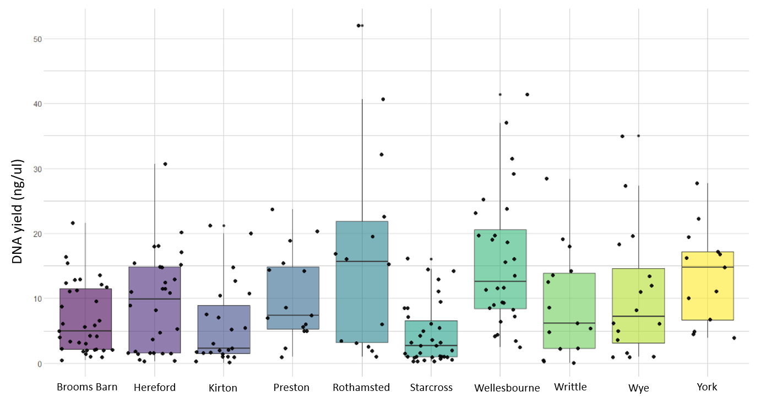
Figure 2

Figure S2: The Rothamsted Insect Survey (RIS) 12.2 m suction trap sites throughout the UK. The red line indicates the cut-off of 4 µl/ng in which samples were too low to proceed with analysis.

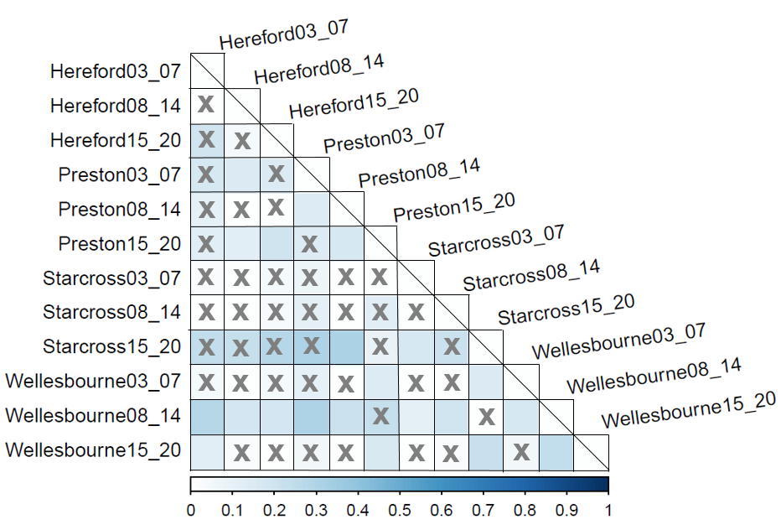
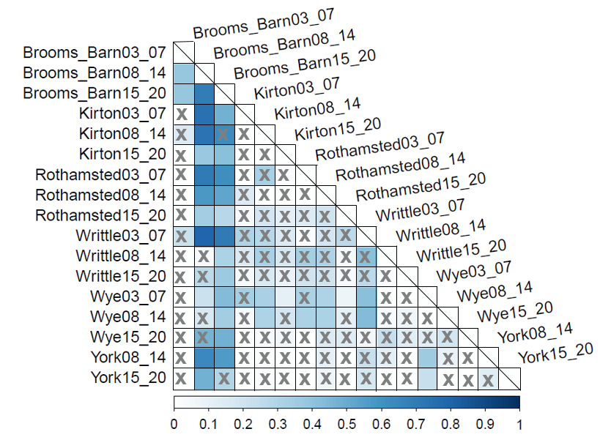
B)
A)

Figure S3: Population pairwise F_{ST} of Nasonovia ribisnigri between population sites between 2003-2020 showing the level of genetic differentiation between the East (A) and the West (B). 03_07 = 2003-2007; 08_14 = 2008-2014; 15_20 = 2015-2020. The scale bar on the x axis highlights the pairwise F_{ST} value, the darker the square, the higher the F_{ST} value. X indicates no significant F_{ST} value between two populations (significance set to F_{ST} >0.20, P = < 0.05).

