Real-time field measurements of bioaerosols in the agricultural environment: Concentrations, components and environmental impacts
Zhuo Chen^{1*}, Ian Crawford^{1*}, Emily Matthews¹, Michael Flynn¹, Thomas Bannan¹, Laura Cardenas², Jon West³, Hugh Coe¹, David Topping¹, Martin Gallagher^{1*}

¹Department of Earth and Environmental Sciences, The University of Manchester, Manchester M13 9PL, UK
²Rothamsted Research, North Wyke, Okehampton, EX20 2SB, UK
³Rothamsted Research, Harpenden, AL5 2JQ, UK

E-mail address: zhuo.chen-2@manchester.ac.uk
martin.gallagher@manchester.ac.uk
i.crawford@manchester.ac.uk

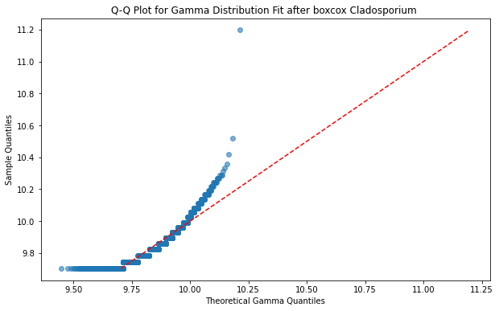
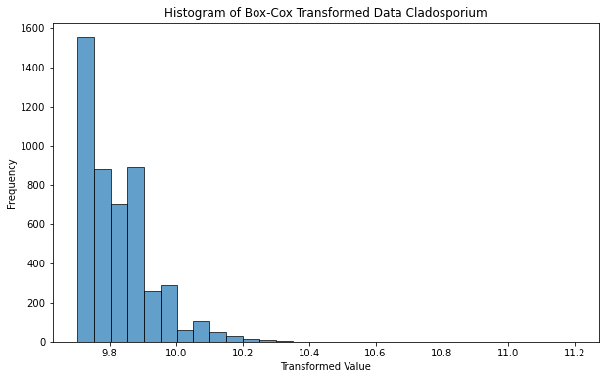
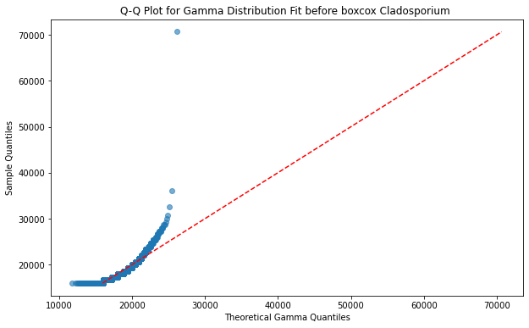
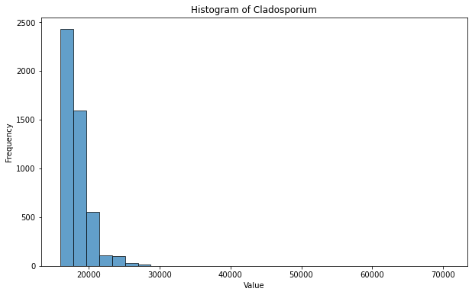

Figure S1: Q-Q plot and histogram of Cladosporium before and after Box-Cox transfer

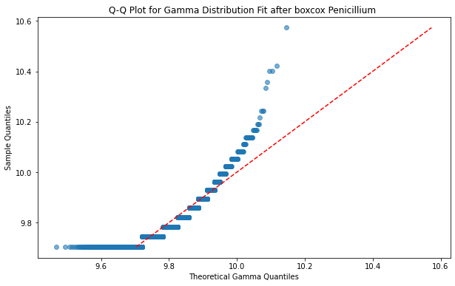
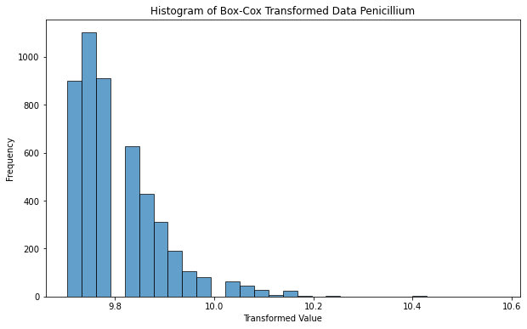
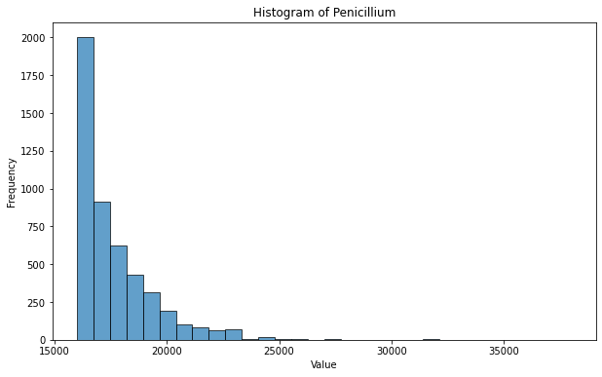
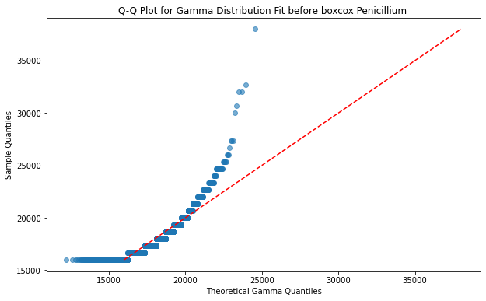

Figure S2: Q-Q plot and histogram of Penicillium before and after Box-Cox transfer

Coefficientsª
Model |  | Unstandardized Coefficients |  | Standardized Coefficients | t | Sig. | Collinearity Statistics
 |  | B | Std. Error | Beta | t | Sig. | Tolerance | VIF
1 | (Constant) | 28152.783 | 1290.049 |  | 21.823 | <.001
1 | rh | 2.289 | 6.368 | .008 | .359 | .719 | .284 | 3.523
1 | temp | 23.223 | 23.403 | .019 | .992 | .321 | .401 | 2.493
1 | wd | -6.191 | .466 | -.177 | -13.285 | <.001 | .859 | 1.164
1 | ws | 120.337 | 22.682 | .089 | 5.305 | <.001 | .539 | 1.856
1 | co | 13.836 | 3.108 | .070 | 4.453 | <.001 | .614 | 1.630
1 | no | 139.493 | 76.903 | .023 | 1.814 | .070 | .950 | 1.053
1 | no2 | -65.092 | 13.855 | -.062 | -4.698 | <.001 | .884 | 1.132
1 | o3 | -259.311 | 12.168 | -.486 | -21.311 | <.001 | .293 | 3.418
1 | NH3_cps | .012 | .017 | .010 | .676 | .499 | .765 | 1.307
a. Dependent Variable: fungi /m3

Table S1 VIF test results

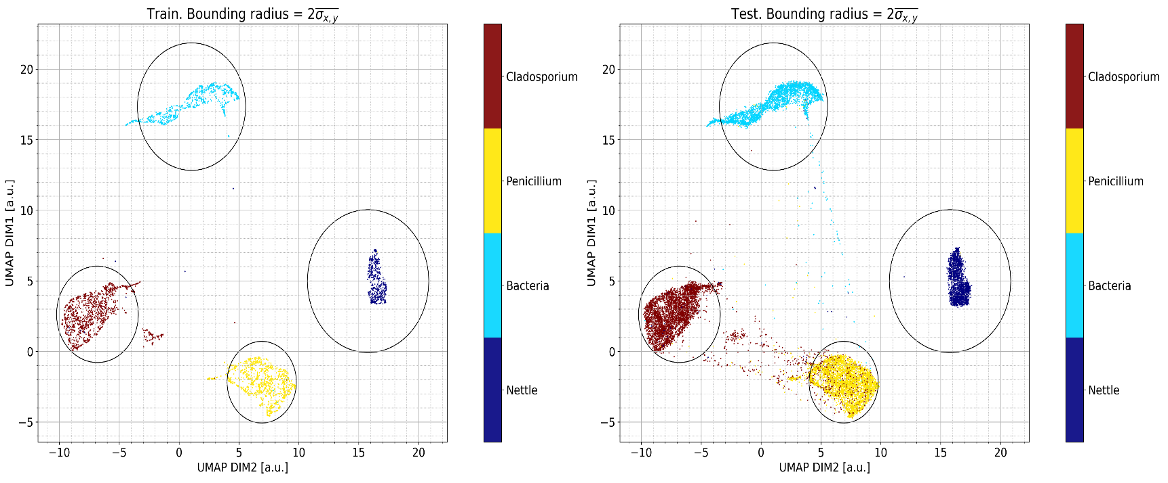Figure S3 Training data classification dimension reduce into 2D space. The radius of the classification boundary for each category was defined as twice the mean standard deviation of the x and y components of each category 2$\overline{σ_{x,y}}$. Left side, 20% of the training set training the transformer, right side, testing the remaining training set on the trained transformer.

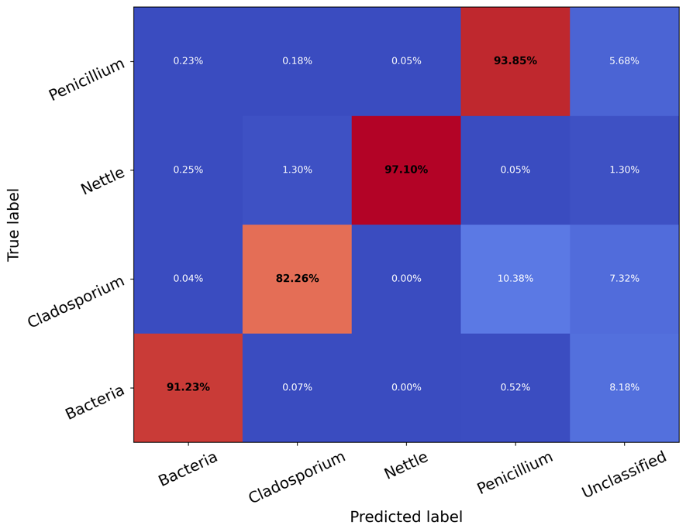
Figure S4 Confusion matrix for the UMAP model test set with five categorical labels, 2$\overline{σ_{x,y}}$ been used as boundary. Comparison of model predicted and actual values in percentage terms.

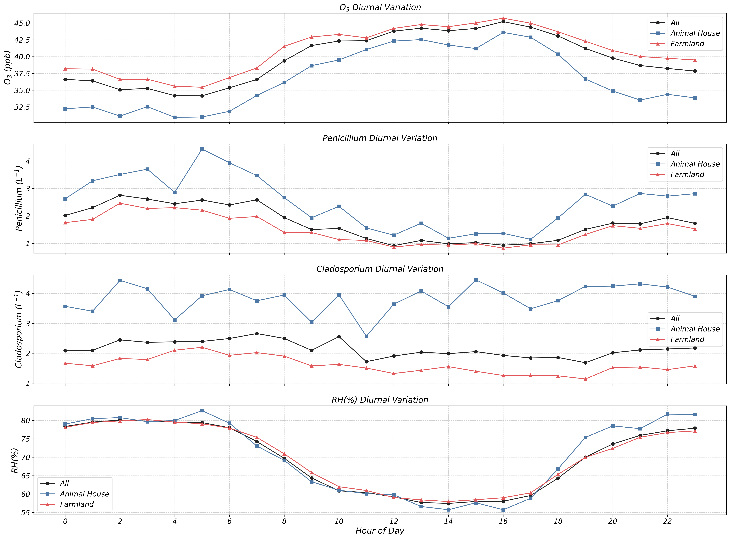
Figure S5 Daily cycling of two bioaerosols with ozone and relative humidity.

