Title: Electrostatic facilitation of odorant capture in insects
Authors:
Alexander N. Borg¹, Beth H. Harris², Liam J. O’Reilly², Fraser A. Woodburn², David M. Withall¹, Ryan A. Palmer³, Daniel Robert² and József Vuts¹
Affiliations:
1: Protecting Crops and the Environment, Rothamsted Research, Harpenden, Herts, AL5 2JQ, UK
2: School of Biological Sciences, University of Bristol, Bristol, BS8 1QU, UK
3: School of Engineering Mathematics and Technology, University of Bristol, Bristol, BS8 1QU, UK
Keywords: electrostatics, insect olfaction, odour capture, biophysics, reception

Abstract
The sense of smell (olfaction) enables organisms from prokaryotes through invertebrates to humans to detect volatile organic compounds (VOCs). For olfaction to happen, VOCs must first come into direct contact with external structures of the olfactory system. Insects have the particularity of possessing externally facing olfactory systems, an arrangement substantially different from the internalised olfactory epithelia of most vertebrates. Whilst the olfactory process is remarkably well-understood at the molecular and neural level, large questions remain as to how airborne VOCs reach dendritic terminals, where actual detection takes place. Current evidence and theories suggest transport through passive diffusion and/or by active antennal motion. Albeit empirically supported, this process may not act alone and cannot entirely explain the notable efficiency and rapid sampling rate observed in many insect species. We have gathered evidence that the olfactory systems of insects exploit electrostatic enhancement to increase, through local electrostatic Coulomb force, VOC transfer from bulk air to the sensory substrate. We found that the presence of antennal charge is necessary to evoke an electrophysiological (EAG) response, and changing the charged state of isolated antennae of Aphis fabae, Aphidius ervi, Drosophila melanogaster and Bombus terrestris increases EAG responses and sensitivity to test VOCs. Furthermore, antennal surface charge density positively correlates with EAG response amplitude. These experimental findings were supported by comparative modelling of electrostatic and fluid dynamic mechanisms in VOC capture.

Introduction
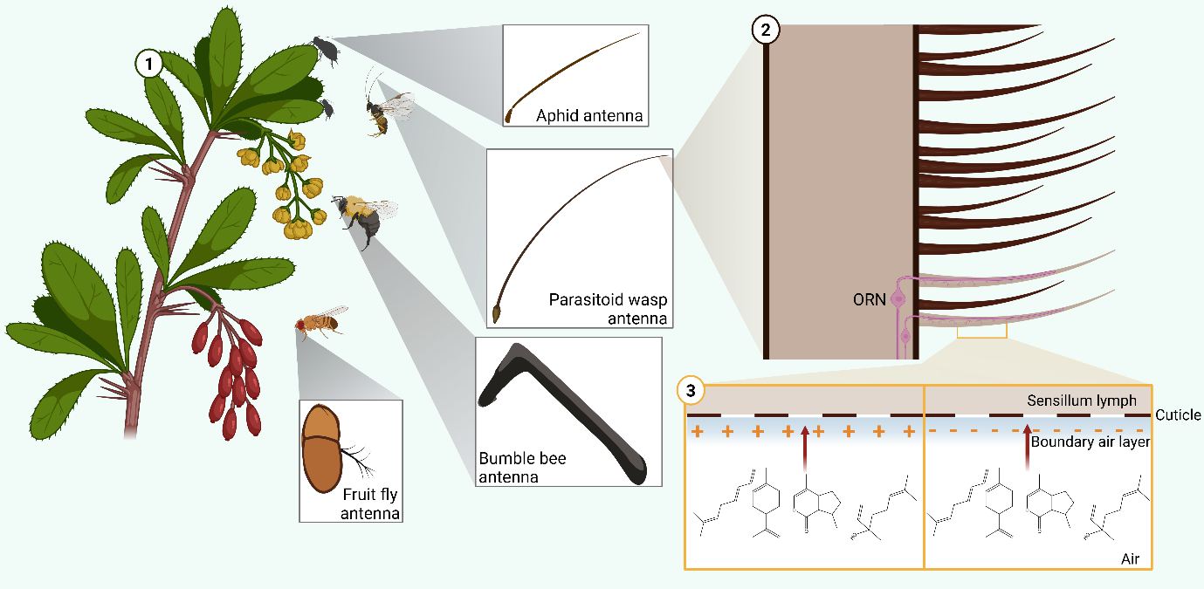
The sense of smell (olfaction) enables organisms from prokaryotes through invertebrates to humans to detect environmental chemicals (scent molecules). This creates olfactory perception that then modulates important ecological functions, including host/prey/mate location, warning conspecifics of danger and identifying suitable oviposition sites. For terrestrial organisms, olfaction relies on the capture (reception) and detection of airborne scent molecules (volatile organic compounds/VOCs). Insects have the particularity of possessing externally facing olfactory systems, an arrangement substantially different from the internalised olfactory epithelia of most vertebrates. In insects, basic olfactory sensory structures take the form of thousands of small porous hairs (sensilla), typically located on the antennae, inside which reside specialised olfactory receptor neurons (ORNs) with terminal dendrites rich in membrane-bound odorant receptors (ORs). Odorant-binding proteins (OBPs) in the sensillum lymph bind to VOCs, which are subsequently transferred to the ORs, conferring sensitivity and specificity to odour detection¹.
Figure 1 Do electrostatic forces facilitate insect olfaction? 1: The sense of smell (olfaction) is a key sensory mechanism that aids insects in finding hosts, prey, mates and oviposition sites. The primary peripheral olfactory organ in insects is the antenna, represented here with Aphis fabae (aphid), Aphidius ervi (parasitoid wasp), Bombus terrestris (bumble bee) and Drosophila melanogaster (fruit fly). Antennae capture airborne molecules, which serve as odour stimuli. 2: The antennal surface is covered with sensilla, sensory units housing olfactory receptor neurons (ORNs), which detect molecules and transduce signals to the central nervous system to create olfactory perception. Hair-like trichoid sensilla are featured here. 3: Electrostatic forces generated by charges on the antennal surface are hypothesised here to facilitate transport of volatile organic compounds across the boundary air layer to the pores of the sensillum cuticle.

Whilst the olfactory process is remarkably well-understood at the molecular and neural level, large questions remain as to how airborne VOCs reach dendritic terminals, where actual detection takes place. How and how fast do VOCs from the air medium move across the cushion of air, the boundary layer, surrounding olfactory sensilla? Current evidence and theories suggest transport through passive diffusion and/or by active antennal motion. The latter is deemed to break the boundary layer, enabling a greater and faster availability of volatiles at the receptor level inside the olfactory hairs. Albeit empirically supported, this process may not act alone and cannot entirely explain the notable efficiency and rapid sampling rate observed in many insect species.
For olfaction to happen, VOCs must first come into direct contact with external structures of the olfactory system (such as the nasal cavity in humans or the antennae of insects). Olfaction in insects is extraordinarily sensitive. For example, dipteran, lepidopteran and hymenopteran species, among others, have the ability to follow scent trails over several kilometres². Reportedly, male silk moths possess remarkable sensitivity to the female pheromone, sensing one single molecule³. Although less sensitive, even the human olfactory system can discriminate between at least one trillion different olfactory stimuli⁴. In nature, volatile concentration in an aerial odour plume can be very low and spatially patchy. The biophysical detection challenge hence resides in endowing the insect olfactory system with the capacity to capture VOCs from very sparse ambient concentrations. To understand the biophysical mechanisms at work in that context will redefine our fundamental understanding of insect olfaction, helping to bridge the gap between VOC and receptor.
To date, conventional olfactory theory states that reception of olfactory molecules happens by chance via airborne molecule diffusion to the antennal surface⁵. The very finely branched comb-like antennae of male moths are estimated to adsorb ca. a third of the scent molecules in the incident air stream⁶. In natural atmospheric conditions, this ratio is deemed to be much lower because of the patchy statistics of volatile concentration in heterogenous media. In view of published neurobiological and behavioural evidence, we have come to hypothesise the presence of an additional, biophysical mechanism that enhances the sensitivity and temporal accuracy of olfaction in arthropods – a mechanism exploiting the electrostatic (Coulomb) force (Figure 1).
Electric fields (E-fields) arise from electric charge and influence matter across a wide range of length scales: from subatomic particles, like electrons, through molecular and cellular structures to whole organisms, atmospheres, and even astrophysical environments. The electrostatic and electrodynamic interactions between charge-carrying particles largely dictate the chemistry of both the abiotic and biotic world and consequently the structure of life at many physical scales. Particularly relevant here is that the distribution and mobility of charge within materials can subtly influence biological and also ecological processes⁷. Indeed, recent work has highlighted the plethora of electrical interactions between organisms and their physical environment, their electric ecology.
Arthropods accumulate surface charge on their cuticle as they move through their environment. Whilst the exact mechanisms of cuticle charging are unclear, triboelectrification is likely to contribute significantly to this through friction between body parts such as wings and hairs, substrate and air. Hence, many animals in the terrestrial and aerial environment carry non-negligible electric charges^{7,8}. Often, but not exclusively, this charge is net-positive across the whole organism, resulting in an attractive force to sources of negative charge, owing to the Coulomb interaction^{9,10}. These charge differences facilitate ecological interactions, as observed with negatively charged pollen ‘jumping’ onto positively charged bees and butterflies prior to flower contact, aiding in pollination¹¹. Remarkably, it was shown in 1982 that the placode sensilla found on the antennae of honeybees hold a quasi-permanent electric charge. The author proposed that this charge attracts VOCs and thus enhances the capture efficiency of the olfactory receptor organ and improve its sensitivity¹², likely via dipole-dipole interactions. However, this notion has not been investigated further.
Considering the role electrostatics may play in ecological relationships, we developed an alternative theory of olfaction that involves the relative electrostatic charging of sensory structures, whereby cuticular arthropod hairs endowed with charge interact with scent molecules, influenced by their dipole moment (a measure of the uneven distribution of charge in a molecule). Notably, this interaction is predicted to occur outside the receptor at the sensillum and antennal level, influencing VOC capture, and is distinct from known nanoscale electrostatic attachment of odorant ligands to membrane-bound OBPs and ORs in the liquid phase. We propose that the charged state of both the antennal cuticle and the olfactory sensilla increases odour capture through attractive electrostatic forces (ex. Coulomb force) that overcome diffusion and advection timescales to aid the transfer of VOCs from air through the boundary layer to the sensory substrate.
Materials and Methods
Biological material
Aphis fabae Scopoli, originating from Rothamsted farm (Hertfordshire, UK, co-ordinates: 51°48'36.8"N 0°22'34.4"W), were reared on Vicia faba L. cv. “The Sutton” in ventilated Perspex cages at 20°C, 60-70% humidity and 16:8h light:dark regime. Aphidius ervi Haliday were purchased from Koppert UK Ltd. (Suffolk, UK) and stored at 5°C until use. Bombus terrestris L. were purchased as hives from Biobest UK Ltd. (Kent, UK) and kept at 20°C. Wild-type Drosophila melanogaster Meigen were purchased from Blades Biological Ltd. (Kent, UK) and stored at 20°C.
Faraday cup charge measurements
Antennal charge measurements across different treatments were recorded using a recently described Faraday cup setup.¹³ The Faraday cup was placed within a larger Faraday cage and connected to a computer via a data acquisition module (NI USB-6009, National Instruments Corporation, Austin, TX) to retrieve charge readings via MATLAB R2022a (MathWorks Inc., Nattick, MA), scripts provided in supplementary (Supplementary text 1). Insect antennae were excised using a scalpel under a stereomicroscope (model M7A Wild Heerbrugg, Switzerland) and placed on a wooden stick, which was fastened onto the top of a micromanipulator using adhesive putty and manoeuvred so that the antenna was directly over the Faraday cup opening. For the “Baseline” treatments, antennae were directly pushed into the Faraday cup using another wooden stick, recording the antennal charge. Wood was used as the material due to its electrically insulating properties and its low position on the triboelectric series, thus minimising its influence on antennal charge properties. For the “Neutralised” treatment, the antennae were treated with pulses from a plasma lighter (VEHHE™ DHQHS, Luoyang Hengshu shangmao Co. Ltd., China) by pressing the “on” button of the lighter at a 5 mm distance from the mounted antenna to provide a 2 s plasma discharge, eight times at 1 s intervals, prior to being dropped into the Faraday cup. A tungsten wire attached to an FG-100 DDS function generator (Walfront, China) and fixed on a micromanipulator was manoeuvred to touch the antennae and impart 0 V, +8 VDC and -8 VDC treatments, prior to being dropped into the Faraday cup. This was carried out for A. fabae, A. ervi and B. terrestris antennae, collecting ten replicates per treatment and species.
Statistical analysis
Raw charge recordings were converted to picocoulomb (pC) measurements using MATLAB (Supplementary text 1). All statistical analyses were carried out in R V4.3.3.¹⁴ All data within species were tested for normality and outliers removed using the “stats” V.4.3.3 package. Kruskal-Wallis and Dunn post-hoc tests, packages “stats” V4.3.3 and “dunn.test” V1.3.6 respectively, were carried out to compare charge measurements between all treatments within both B. terrestris and A. fabae. For A. ervi, this was carried out using Anova and Tukey post-hoc tests, package “stats” V4.3.3. Data were visualised in R and supplemented in BioRender (Science Suite Inc., Toronto, Canada).
Volatile antennal adsorption
Freshly excised A. ervi antennae were suspended at their bases on a glass electrode filled with Ringer solution (without glucose) and attached to a micromanipulator, as described in fig. S1. A tungsten electrode, fixed to a micromanipulator and connected to an FG-100 DDS function generator, was positioned to be touching the centre of the antenna from behind to not obstruct the flow of VOCs toward the antennae. Using the function generator, 0 V, +8 VDC or -8 VDC treatments were applied to the antennae. 100 µg of either (4aS,7S,7aR)-nepetalactone, (R)-linalool or (E)-β-farnesene was added to a piece of filter paper (10 µL applied from a 10 µg/µL diethyl ether solution) and placed for 30 min within a stream of charcoal-purified, humidified air flowing towards the antenna at 10 mL/min. Antennae were then dipped in 50 µL of re-distilled diethyl ether for 1 min to extract adsorbed compounds. Due to the low adsorption rates observed in preliminary tests, five antennae were extracted individually to create one replicate. Five replicates were collected per compound and voltage treatment. (4aS,7S,7aR)-Nepetalactone and (E)-β-farnesene were synthesised in house, assessing purity via NMR,^{15,16} whilst (R)-linalool was purchased from Botanix Ltd. (Kent, England) and was 95% pure.
Gas-chromatography
Antennal extracts, injected in 4 µL aliquots, were analysed on an Agilent 8890 GC fitted with a non-polar HP1 column (50 m length × 0.32 mm inner diameter × 0.52 μm film thickness; J&W Scientific), using the following temperature programme: 30°C for 5 min, rising at 5°C/min to 150°C, followed by a 10°C/min rise to 230°C for a total run time of 60 min. Peak IDs were confirmed by GC peak enhancement via co-injection with authentic standards for (R)-linalool, (4aS,7S,7aR)-nepetalactone and (E)-β-farnesene.¹⁷ Peak ID was further confirmed by comparison of mass spectra of extract peaks with authentic standards on an Agilent 5977B GC-MSD, using the same GC conditions as above, with ionisation by electron impact (70 eV, 220°C). Tentative identification of compounds was achieved by comparison of spectra with the National Institute of Standards and Technology (NIST) mass spectral library (2020, NIST, Gaithersburg, MD, USA). (R)-Linalool, (4aS,7S,7aR)-nepetalactone and (E)-β-farnesene amounts (ng) in antennal extracts were estimated using peak areas from a calibration curve of the respective authentic standard at 0.1, 1, 5 and 10 ng and generating a line of best fit equation (polynomial) in Microsoft Excel.
Statistical analysis
For each treatment, the amount of compound in antennal extracts was compared across treatments (0 V, +8 VDC and -8 VDC). The data were tested for normality via Shapiro-Wilk test. ANOVA and Tukey post-hoc tests were used for (4aS,7S,7aR)-nepetalactone and (R)-linalool, whilst Kruskal-Wallis and Dunn post-hoc tests were used for (E)-β-farnesene. Data were visualised in R and supplemented in Biorender.
Antennal electrophysiology (electroantennography/EAG)
Baseline EAG recordings
Electrophysiological responses were recorded for test compounds on A. fabae, female A. ervi, B. terrestris and D. melanogaster antennae at doses of 0.1 ng, 1 ng, 10 ng, 100 ng, 1 µg, 10 µg and 100 µg (delivered in 10 µL solutions), using 10 µL redistilled diethyl ether as solvent control. EAG was performed as described previously,¹⁸ with amendments. An antenna was carefully excised from a live insect and suspended between two electrodes made from Ag-AgCl borosilicate glass filled with Ringer solution (without glucose) and connected to silver wire (Ø 0.37 mm, Biochrom Ltd., Cambridge, UK). The base of the antenna was connected to a grounded electrode. A glass tube positioned approximately 5 mm away from the antennal preparation was connected to a stimulus controller (CS-02; Ockenfels Syntech GmbH, Kirchzarten, Germany) and facilitated a continuous flow of charcoal-purified humidified air towards the antenna at a rate of 1 L/min. The signal was passed through a high-impedance amplifier (UN-06, Syntech) and recorded using the Syntech EAG software package EAG v1.0 (6/1993). The absolute negative amplitude changes in response to the stimuli were recorded in mV and normalized against the positive controls (=100%), resulting in test stimuli being expressed as percentages.¹⁹ Test compounds included (E)-β-farnesene, (R)-linalool, (E)-2-heptenal (Fluka, Germany, 98%), with (E)-β-caryophyllene (SAFC, St. Louis, MO, USA, ≥80%) as positive control for A. fabae; (E)-β-farnesene, (R)-linalool, (4aS,7S,7aR)-nepetalactone, with (E)-β-caryophyllene as positive control for A. ervi; (E)-ocimene (synthesized in house and assessed for purity via NMR)²⁰, (R)-linalool, citral (Fluka, Germany, 95%), with benzaldehyde (Sigma-Aldrich, St. Louis, MO, USA, >99%) as positive control for B. terrestris; and (R)-limonene (Fluka, Germany, 98%), (R)-linalool, (E)-2-hexenal (SAFC, St. Louis, MO, USA, >95%), with (+)-fenchone (Fluka, Germany, 97%) as positive control for D. melanogaster. Ten replicates per test compound/species were recorded.
EAG recordings from antennae with a reduced state of charge (‘neutralisation’)
A modified setup was used to assess the effect of reducing the amount of antennal charge on EAG responses for A. ervi and B. terrestris, using 1 µg and 10 µg of (R)-linalool, respectively. Antennae were set up as described for baseline EAG recordings. On a single antenna, EAG responses were measured to i) 10 µL diethyl ether, ii) (R)-linalool and iii) (R)-linalool after the application of plasma bursts 5 mm from the antenna eight times. Recordings were repeated 24 times for A. ervi and 11 times for B. terrestris, leaving a 40-60 s lapse between stimulations. EAG responses were not normalised to a positive control due to the unknown effect of exposure to plasma on subsequent EAG responses.
EAG recordings from externally charged antennae
A modified EAG setup was used to assess the effect of applied charge on EAG responses across A. fabae, A. ervi, B. terrestris and D. melanogaster. Following the suspension of an insect antenna between two glass electrodes, a tungsten electrode (treatment electrode) connected to a function generator was brought into contact with the surface of the antenna from behind without obstructing the flow of VOCs toward the antennae. The treatment electrode was used to deliver charge onto the antennae at 0 V and ± 0.5, 1, 2, 4 and 8 VDC, using MATLAB R2022a to control/visualise the applied voltage. EAG responses were recorded for the above-mentioned test compounds against their respective insect species, at a single dose, across increasing charges. The charge treatment was applied in random order. All charges were tested on a single antenna leaving a 40-60 s lapse between stimulations, with a minimum of seven replicates/compound/species. At the start and end of each replicate, EAG responses were recorded for the positive control and diethyl ether at 0 V and normalised to the positive control. The dose and replicate number for each compound/species tested are shown in table S1. Doses were chosen as the lowest dose required to induce a significant EAG response in baseline EAG recordings, and their respective ten-fold lower dose.
An extended version of the above experiment was done on A. ervi antennae against 100 ng (R)-linalool under 0 V and +4, 6, 8, 10 and 12 VDC stimulations to assess the effect of increased positive charge on EAG responses (n=12).
EAG dose-response recordings from externally charged antennae
The charged EAG experimental setup was used as described above, with some modifications. A -8 VDC potential was applied to a single antenna using a tungsten electrode as above. EAG responses to increasing doses of test compounds were sequentially recorded at 0.1 ng, 1 ng, 10 ng, 100 ng, 1 µg, 10 µg and 100 µg. Positive control and 10 µL diethyl ether at 0 V were run at the start and end of each replicate as described previously, with all data normalised to the positive control. Replication number varied depending on compound and species as follows: A. fabae – (E)-β-farnesene (n=11), (R)-linalool (n=8), (E)-2-heptenal (n=8); A. ervi - (E)-β-farnesene (n=7), (R)-linalool (n=5), (4aS,7S,7aR)-nepetalactone (n=7); B. terrestris - (E)-ocimene (n=6), (R)-linalool (n=6), citral (n=5) and D. melanogaster – (R)-limonene (n=5), (R)-linalool (n=5), (E)-2-hexenal (n=5).
Statistical analysis
For baseline EAG experiments and charged dose-response recordings, normalised EAG responses were tested for normality by Shapiro-wilk test and either a Student`s t-test or Wilcoxon test (depending on normality, “Stats” package V4.3.3) was used to compare responses between each compound dose and diethyl ether.
For neutralised EAG recordings, within-species data were tested for normality using Shapiro-wilk test. For A. ervi, EAG responses for diethyl ether and (R)-linalool before and after neutralisation were statistically compared by Kruskal Wallis (“Stats” package V4.3.3) and Dunn post-hoc tests (“dunn.test” V1.3.6). For B. terrestris, Kruskal Wallis and Wilcoxon post-hoc test (“rstatix” package V 0.7.2) were used.
For charged EAG experiments, EAG recordings from within species and per compound were statistically compared between each charge treatment and its respective diethyl ether control. Data were tested for normality via Shapiro-wilk test. Depending on data distribution, either Student`s t-tests or Wilcoxon test (“Stats” package V4.3.3) was carried out between EAG responses at each charge treatment and the diethyl ether control.
Correlation analysis was carried out between normalised EAG response, voltage treatment and antennal dimensions. Excised antennae across all four species were imaged under light microscopy (Zeis Axioimager Z2 with Zeis Axiocam 512 colour camera, supplementary text 2) and antennal length, antennal inner and outer diameter and cuticle thickness measurements were taken. Antennal surface area was calculated for each species under the assumption that the antenna is cylindrical. Since data were not normally distributed, a Q-Q plot (“car” package V.3.1.2) was made to assess the most appropriate generalised linear model (GLM) distribution that fits the data. An Akaike information criterion (AIC) test was used to assess which GLM distribution between gamma, inverse gaussian or Tweedie distribution best fits the data (“Stats” package V4.3.3). A GLM with inversion Gaussian distribution was used to compare the interaction between normalised EAG response, charge treatment and antennal surface area (“Stats” package V4.3.3). Bootstrap analysis was carried out to assess accuracy for GLM outputs (“boot” package V1.3.30). Datapoints were visualised via scatterplot. Correlation analysis was carried out as above within each species to compare the relationship/interaction between normalised EAG response, voltage treatment and compound dipole moment.
All statistical analyses and visualization were carried out in R V4.3.3. Biorender was used to supplement and combine figures.
Finite element modelling

A finite element model (FEM) was produced to support and explain the experimental results. We modelled the capture of VOCs along an electrically biased antenna to assess the comparative influence of advection-diffusion and electrostatic forces. The concentration and final deposition were evaluated. COMSOL Multiphysics software V 6.2 (COMSOL inc., Stockholm, Sweden) was used for this analysis. Due to the independence of the fluid and electrical processes, each were solved individually. Upon solving, the resulting fluid and electrical fields were used to solve the advection-diffusion-charge migration of a dilute suspension of VOC.

Antennal geometries
Two bio-inspired antenna morphologies were modelled based on SEMs and empirical data to ensure biologically relevant insight. One was formed with a dense canopy of hairs, like the honeybee and parasitic wasp antennae, and the other without such hairs, like the antenna of the black bean aphid. Together these models enable the assessment of how different morphological features affect olfactory capture and whether different forms show increased capture due to either fluid flow or electrostatics.

We studied both longitudinal fluid flows, parallel to the antenna, and crossflows, perpendicular to the antenna. For longitudinal sensing, the modelled geometry consisted of a 1.35 mm long cylindrical section of 0.1 mm radius with a spherical cap in a large surrounding domain (Figure 2a). Due to rotational symmetry, only one quarter of the structure was modelled using symmetry conditions in the x-y and x-z planes. The enclosing boundaries were placed at 10 mm, 10 mm and 10 mm distances from the antenna in x, y, z directions, respectively, and were thus 100 times the radius or 10 times the antennal length from the structure. Hairs of length 19 μm and radius 1.5 μm were placed in dense canopy with an offset configuration. The first row had an angular spacing of 10° over the 90° section of antenna, followed by a row with hairs offset by 5° and rows spaced by 0.01 mm. For longitudinal flow, hairs were placed over the spherical cap and in 30 rows along the first 0.3 mm section of the cylindrical form (Figure 2a). The domain was discretised using a tetrahedral mesh consisting of 3,261,274 boundary elements in the dense array case and 172,731 boundary elements for the hairless case. The large difference in mesh elements reflects the multi-scale nature of the dense hair problem, where the hair tips presented small thin regions that required a finer discretisation.

For crossflow, we modelled a 0.2 mm short cross-section of the antenna aligned with the x-axis, using symmetry conditions at two parallel y-z planes 0.02 mm apart. Only two-rows of hairs were required to obtain results for an effectively infinite antenna. The same antennal geometry was otherwise considered (Figure 2b). The enclosing boundaries were placed at 5 mm, 5 mm and 0.02 mm in x, y, z directions, respectively. The domain was discretised using a tetrahedral mesh to solve the equations consisting of 3,033,113 boundary elements in the dense array case and 295,254 boundary elements for the hairless case.

In both cases, a mesh independence study was carried out to ensure accuracy of the computed results. Considering the most sensitive case, a dense hair array and $U_{∞}=0.1 ms^{-1}$, the following results were obtained for finer meshes:

Table 1 Mesh independence study showing relative error in capture rates for VOC capture with a finer mesh. Overall, all errors are less than 1%. The number of mesh elements depends on the number of hairs, hence the large number of boundary elements for the refine mesh in the longitudinal case.
Relative error in capture rates | Boundary elements | $$z_{c}=0$$ | $$z_{c}={10}^{-5}$$ | $$z_{c}={10}^{-4}$$ | $$z_{c}={10}^{-3}$$ | $$z_{c}={10}^{-2}$$ | $$z_{c}={10}^{-1}$$ | $$z_{c}=1$$
Longitudinal | 26,215,931 | 0.3% | 0.3% | 0.29% | 0.25% | 0.05% | 0.65% | 0.67%
Crossflow | 5,809,087 | 0.17% | 0.17% | 0.18% | 0.2% | 0.4% | 0.8% | 0.67%

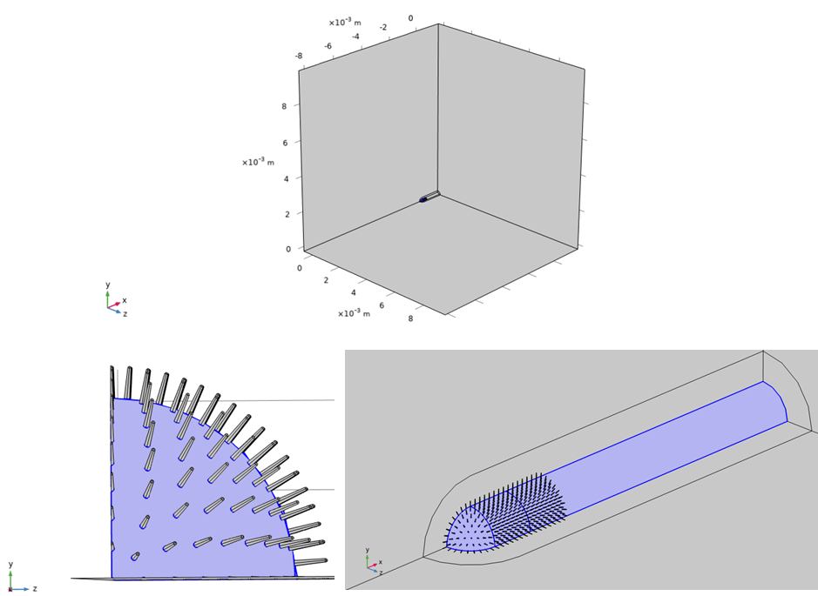
Figure 2 Geometry of modelled antenna and the computational domain. (2a) Parallel flow: The far-field walls are placed at distances of 100 times the radius from the antenna to remove boundary effects. The antenna consists of a 1.35 mm long section with 0.1 mm radius, with hairs placed over the spherical cap and along the first 0.3 mm section of the cylindrical form. The hair lengths are 0.01 mm. (2b) Perpendicular flow: The far-field walls are placed at distances of 50 times the radius from the antenna to remove boundary effects. The antenna consists of a 0.02 mm long section with 0.1 mm radius. The hair lengths are 0.01 mm.
a)
b)
Fluid-antenna interaction modelling
The steady interaction between a uniform flow of air with a constant fluid density and a fixed antenna within the described computational domain is computed by the incompressible Navier-Stokes equations:
$$∇∙u=0,$$
$ρ\left(u∙∇\right)u=∇∙[pI+μ\left(∇u+{\left(∇u\right)}^{T}\right)]$. (1)
These equations are solved on a fixed mesh subject to boundary conditions (given below), denoting the three-dimensional fluid velocity by $u$ (m/s), the dynamic viscosity by $μ$ (Ns/m²), the pressure field by p (kg /m s²) and the fluid density by $ρ$ (kg/m³). Since the background fluid is air, we set the dynamic viscosity to be 1.81x10⁻⁵ Ns/m² and fluid density to be 1 kg/m³ at 293K.
Boundaries occur at the edge of the domain and on the antenna. Conditions were prescribed therein to ensure physically accurate and consistent results. At the inlet, the direction from which the flow comes upstream of the antenna, the far-field flow was prescribed as $u=U_{∞}, v = 0, w = 0,$ where $u, v, w$ denote the velocity of the fluid in Cartesian directions$x, y, z$, and $U_{∞}$ denotes the magnitude of the freestream flow speed far from the antenna. To simulate a range of appropriate flight speeds for an insect, we evaluated three scenarios with $U_{∞}$= 0.001, 0.01 and 0.1 m/s. The outlet boundary condition, downstream of the antenna in the x-direction, was prescribed to be $p=0$. Along the antenna, a no-slip wall condition was applied $u=0, v=0, w =0$, leading to a boundary layer along the antenna. A slip wall condition was applied to the upper x-z boundary of the domain to constrain the flow with: $u=U_{∞}, v = 0, w = 0$. Symmetry conditions were applied, as previously stated, in the bounding x-y and x-z planes of the geometry due to the rotationally symmetric nature of the geometry.
Computing the electrostatic field
The electrostatic field throughout the domain was governed by the equations:
$$E=-∇V,$$
$∇^{2}V=0.$ (2)
Here, V denotes the surface electric potential and $E$ the electric field. A –8 V potential was applied to the antenna surface based on the bias applied during the experiments. Within the bounding domain, symmetric conditions were applied as above, and all other boundaries were set to 0 V far from the antenna. Regarding the hairs, their individual charge or potential were not experimentally measured and thus not prescribed here. The hairs are treated as a dielectric with a relative permittivity of 14 that polarize in the presence of the biased cuticle.
Modelling the transport of odour compounds in the domain
The transport of the dilute substance in the domain was calculated by the following equation:
$u∙∇c=D∇^{2}c+z_{c}u_{m}Fc∇^{2}V$, (3)

where $u$ is given by (1) and $V$ by (2) to determine the comparative effect of electrostatic forces and fluid dynamic influences in the transport and capture of VOCs. In (3), $c$ indicates the concentration of the substance in air (mol/m³), $D$ is the diffusion coefficient, which was defined as 6.7x10⁻⁵m²/s and $z_{c}$is the charge number of the substance (dimensionless) given in the units of elementary charge to quantify the charge of ions or single molecules. We consider this to represent an “effective charge”, since the dipole moment of VOCs produce forces several orders of magnitude below that related to an elementary charge. Hence, we considered values of $z_{c}$ = 0.00001, 0.0001, 0.001, 0.1, 1 to show the broad range and influence of volatile charge from weakly polarized dipoles to an ionic molecule of one elementary charge. The ionic mobility, $u_{m}$ = D/RT, is also calculated from input parameters, whereby R is the molar gas constant (J/mol·K) and T = 293 is temperature (K). Finally, F denotes Faraday’s constant (A·s/mol).
For the boundary condition along the antennal surface and hairs, we set $c = 0$ to simulate absorption of VOCs. The inflow concentration was $c_{0}=1$ mol/m³ at the inlet boundary to model a uniform well-mixed distribution of VOCs in the oncoming flow. Symmetry conditions were again applied to the relevant boundaries. Outlet conditions are applied to all other boundaries with $n∙D∇c=0$, $n$ the local normal of the surface. Our metric of interest here is a modified version of that presented in Claverie et al. (2022)²¹, and is denoted as the capture rate of the antenna given by:
$C_{a}=-∬_{s}D\frac{∂c}{∂n}dA/S$, $mol/s/m^{2}$, (4)
where S is the surface area of the modelled antennal section (including the hairs when present). From (4), the local gradient of the concentration over the antennal surface gives the capture rate. We divide the integrated value by the modelled surface area to enable comparisons between scenarios, since the antennal surface is much larger in the longitudinal case and when hairs are present.

Results
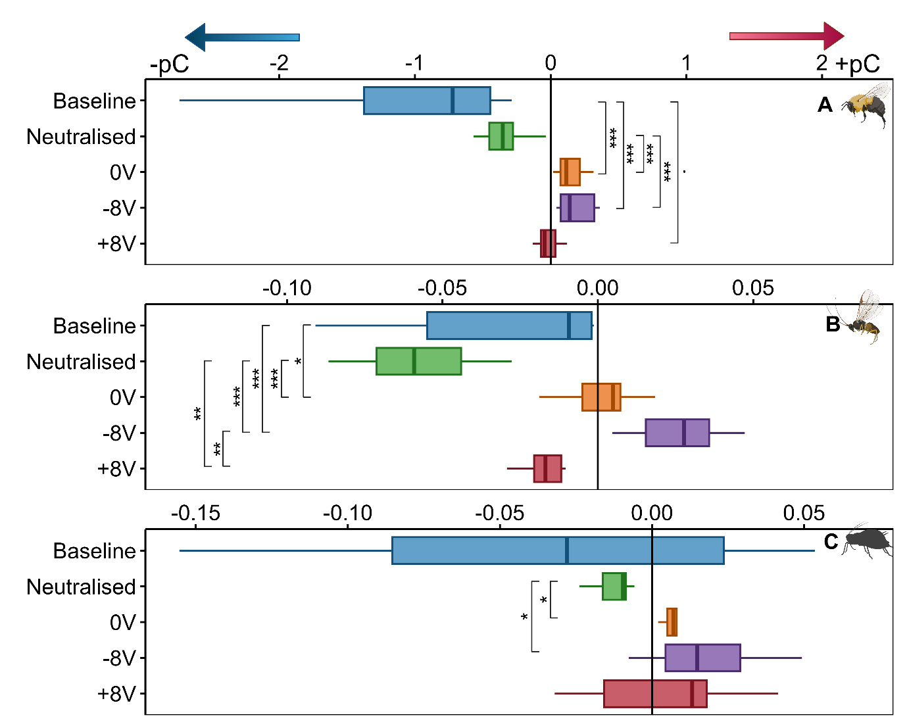
We first measured the net charge on bumble bee, aphid and parasitic wasp antennae. (Despite best efforts, measuring charge on fruit fly antennae was not possible with our setup due to their extremely small size, which likely rendered their charge below the limit of detection of the Faraday cup). Freshly amputated antennae, representing baseline measurements, showed a bias towards the negative range, but aphid antennae also bore positive values and thus had the broadest span of variation in charge (Figure 3). The amount of charge on bee antennae (Figure 3A) was estimated to be ca. two orders of magnitude higher than on the wasp and aphid antennae (Figures 3B and C, resp.). Plasma beam near the antenna generally decreased the otherwise large dispersion of charge values and reduced the amount of total charge for the bee and aphid towards a more neutral state. Contact with the tungsten electrode also produced a narrower distribution of surface charge; here, application of 0 V caused clustering of values near zero in the positive range, a shift large enough to generate a statistical difference from the native (baseline) charged state of unbiased bee and wasp antennae. This effect became even more pronounced at the -8 V bias towards the positive range for all three species, which confirms that varying the electric potential influences the magnitude and polarity of antennal charge. The +8 V bias caused a less clear effect.
Figure 3 Amount of charge (pC) on Bombus terrestris (A), Aphidius ervi (B) and Aphis fabae (C) antennae, which were freshly amputated (Baseline), exposed to a plasma beam to reduce their spatial charge (Neutralised) or treated with 0, -8 or +8 voltage (V) using a tungsten electrode. Measurement of total charge on individual antennae was made with a Faraday cup (n=10 antennae/species). Significance: .=P<0.1, *=P<0.05, **=P<0.01, ***=P<0.001, A and C: Kruskal-Wallis/Dunn test, B: ANOVA/Tukey.
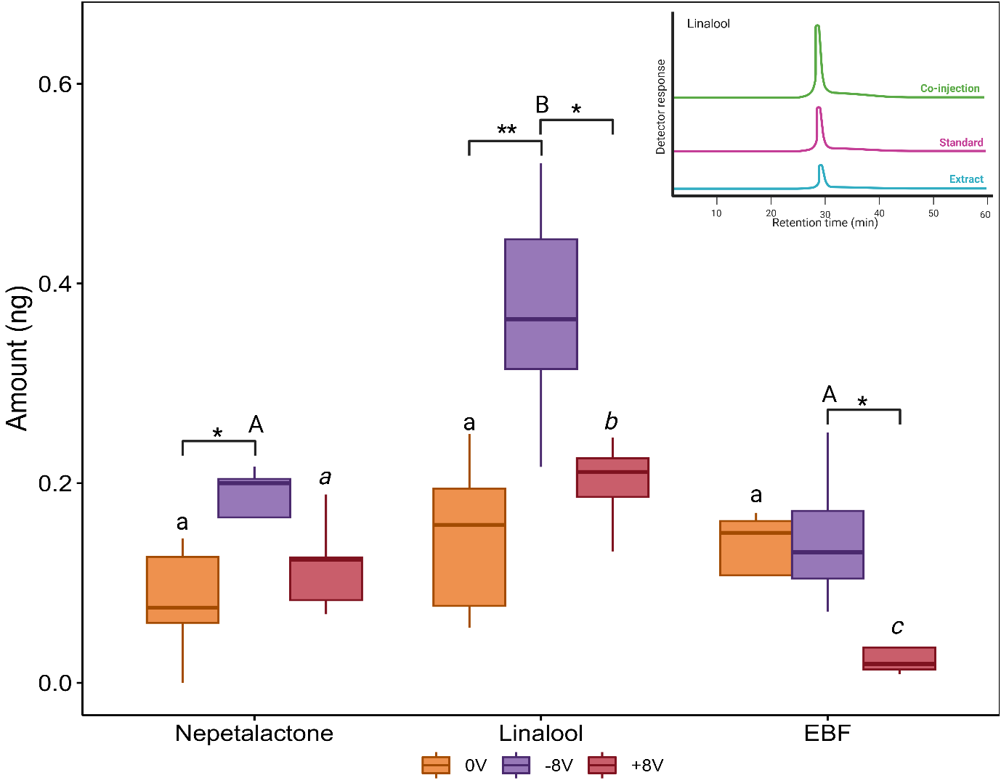
The next step was to assess the impact of surface charge on molecular adsorption from the surrounding air onto the A. ervi antenna. We found evidence of this for (4aS,7S,7aR)-nepetalactone and (R)-linalool, but not (E)-β-farnesene, where the -8 V bias increased the amount of adsorbed compounds as compared to 0 V bias (Figure 4). Under +8 V bias, E)-β-farnesene showed a reduced, but non-significant, accumulation on the antenna from the airstream enriched with the compound.
Figure 4 Amount of compound (ng) adsorbed onto Aphidius ervi antennae whilst exposed to 0, -8 and +8 V for 30 min (n=5 antennae/compound). Synthetic compounds (100 ug) were delivered to antennae through a constant stream of humidified air. Five antennae were extracted in diethyl ether after 30 min of exposure to make one replicate. EBF=(E)-β-farnesene. Significance within compounds: *=P<0.05, **=P<0.01 ANOVA/Tukey test per compound across electrical bias treatment. Significance within bias: lowercase, uppercase and italicized lettering, ANOVA/Tukey test per electrical bias treatment respectively across compounds. Insert: example GC traces showing confirmation of identity for (R)-linalool in solvent extracts from A. ervi antennae biassed with -8 V.

As antennal electrophysiological (EAG) responses indicate if a certain VOC is detectable by the peripheral olfactory system, we used the EAG technique to link antennal surface charge with odour detection. Based on the observation that a plasma beam near the antenna reduces the overall antennal charge compared to its baseline state (Figure 3), we demonstrated that EAG responses to (R)-linalool become significantly smaller on bee antennae carrying reduced charge after plasma neutralisation than on those with their baseline charge (Figure 5 G). The same effect was marginally significant on the wasp antenna (Figure 5 H).
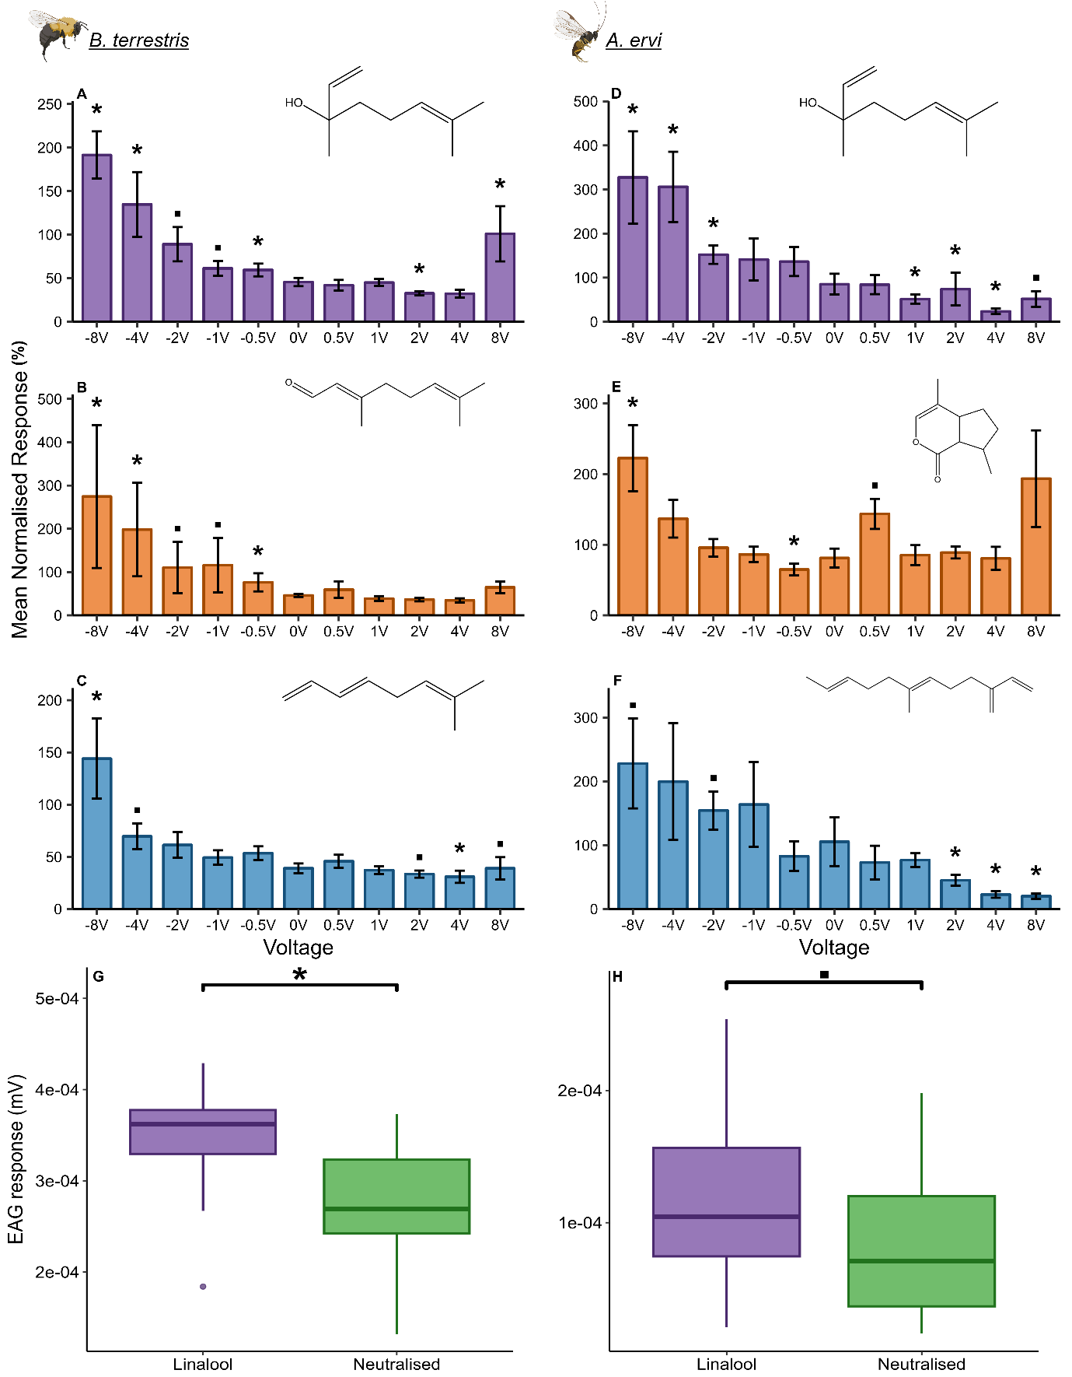
Figure 5 Electrophysiological (EAG) responses of Bombus terrestris and Aphidius ervi antennae, exposed to a range of voltages, to synthetic compounds at a dose 10 factor lower than a significant EAG-active dose (baseline measurements Figure S2, mean ±SE). A: (R)-linalool (n=8, dose=1 µg), B: citral (n=7, dose=100 ng), C: (E)-ocimene (n=7, dose=10 ng), D: (R)-linalool (n=8, dose=100 ng), E: (4aS,7S,7aR)-nepetalactone (n=11, dose=100 ng), F: (E)-β-farnesene (n=8, dose=1 µg). EAG responses were normalised to a positive control: B. terrestris = benzaldehyde, A. ervi = (E)-caryophyllene. Charge applied on antennae via tungsten electrode. Significance from diethyl ether solvent control: .=p<0.1, *=p<0.05 (Table S3 for statistical tests). Effect of charge neutralisation via plasma beam on B. terrestris (G; n=11, dose=10 µg; Kruskal-Wallis/Wilcoxon test) and A. ervi (H; n=24, dose=1 µg; Kruskal-Wallis/Dunn test) EAG responses to (R)-linalool.
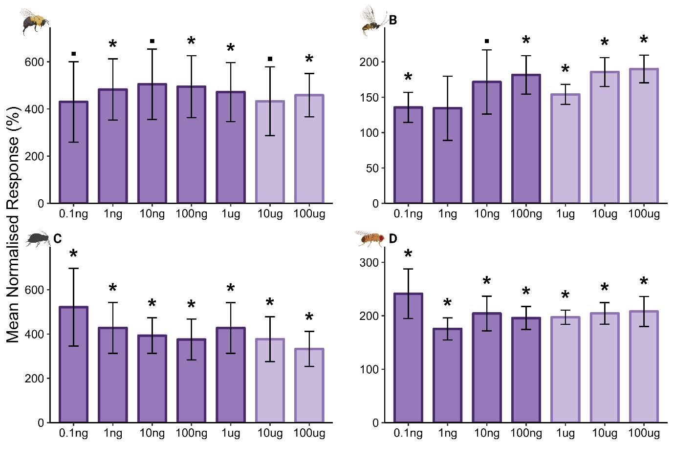
Following manipulation of antennal charge with the plasma beam, we wanted to observe the effect of positive and negative electrical bias of the antennae on EAG responses. The EAG response increased across test compounds in a voltage-dependent and asymmetrical manner across a -8 — +8 V range, predominantly biased towards negative values (Figure S3). Furthermore, charge delivered with a -8 V bias, or occasionally lower, increases antennal sensitivity (Figure 5A-F, Fig. S4) when using ten-fold lower doses than the lowest EAG-active dose from baseline measurements (Figure S2). Table 1 and Table S2 show the same trend across the four species. Extending the range of positive electrical bias up to +12 V revealed a similarly increasing response pattern as observed in the negative range and highlighting the overall asymmetry of the effect of applied charge (Figure S5). The -8 V bias also lowered antennal detection thresholds, therefore increased sensitivity, across all model species and compounds down to doses on average four orders of magnitude below the lowest EAG-active ones on uncharged antennae (Figures 6 and S6, Table 1).
Figure 6 Electrophysiological (EAG) responses of Bombus terrestris (A, n=5), Aphidius ervi (B, n=5), Aphis fabae (C, n=7) and Drosophila melanogaster (D, n=5) antennae to a range of (R)-linalool doses whilst biassed with -8 V (mean ±SE). Significance from diethyl ether solvent control: .=p<0.1, *=p<0.05 (Student`s t-test, except for B. terrestris: 100 µg = Wilcoxon test). Light purple bars represent the doses which induce a significant EAG response on uncharged antennae (baseline measurements, Figure S2).

Table 1 Electrophysiological (EAG) response (mean ±SE) and EAG response change compared to diethyl ether solvent control (ether, %) from A. fabae, B. terrestris, D. melanogaster and A. ervi antennae exposed to synthetic compounds at a dose 10 factor lower than a significant EAG-active dose (Figure S1) under +/-8 V or 0 V bias. Voltage applied via a tungsten electrode. Responses were normalised to a positive control: A. fabae and A. ervi = (E)-caryophyllene, B. terrestris = benzaldehyde, D. melanogaster = fenchone.
Voltage (V) | Mean normalised response (%) | Response change vs ether control (%)
Aphis fabae (aphid)
(E)-2-heptenal
8 | 687.4 ±481 | 744.4
0 | 84.1 ±6.8 | 91.1
-8 | 813.3 ±339.3 | 880.8
(E)-β-farnesene
8 | 1298 ±849.9 | 1405.8
0 | 100.8 ±9.3 | 109.1
-8 | 3094.4 ±1047.9 | 3351.3
(R)-linalool
8 | 2117.9 ±662.4 | 2293.7
0 | 104.5 ±13.6 | 113.2
-8 | 1156 ±373.8 | 1252.0
Bombus terrestris (bumble bee)
Citral
8 | 64.7 ±13.3 | 158.0
0 | 46 ±3.2 | 112.3
-8 | 274.6 ±165.1 | 670.5
(E)-ocimene
8 | 39 ±10.6 | 95.2
0 | 39 ±4.6 | 95.2
-8 | 144 ±38.3 | 351.6
(R)-linalool
8 | 101 ±31.7 | 246.6
0 | 45.6 ±4.8 | 111.3
-8 | 191.4 ±27.2 | 467.4
Drosophila melanogaster (fruit fly)
(E)-2-hexenal
8 | 66.7 ±17.1 | 62.5
0 | 95.4 ±22.1 | 89.4
-8 | 622.7 ±133 | 583.5
(R)-limonene
8 | 313.3 ±84.6 | 293.5
0 | 105.4 ±20.3 | 98.8
-8 | 2184.6 ±1087.9 | 2046.9
(R)-linalool
8 | 83.6 ±22.4 | 78.4
0 | 115.4 ±26.7 | 108.1
-8 | 331.3 ±27.8 | 310.4
Aphidius ervi (parasitoid wasp)
(E)-β-farnesene
8 | 20 ±3.9 | 21.3
0 | 105.4 ±38 | 112.3
-8 | 228 ±70.3 | 242.9
(R)-linalool
8 | 51.8 ±17.7 | 55.1
0 | 85.1 ±23.6 | 90.7
-8 | 327.3 ±104.5 | 348.7
(4aS,7S,7aR)-nepetalactone
8 | 193.5 ±65.3 | 206.2
0 | 81.2 ±12.1 | 86.5
-8 | 222.6 ±39.9 | 237.2

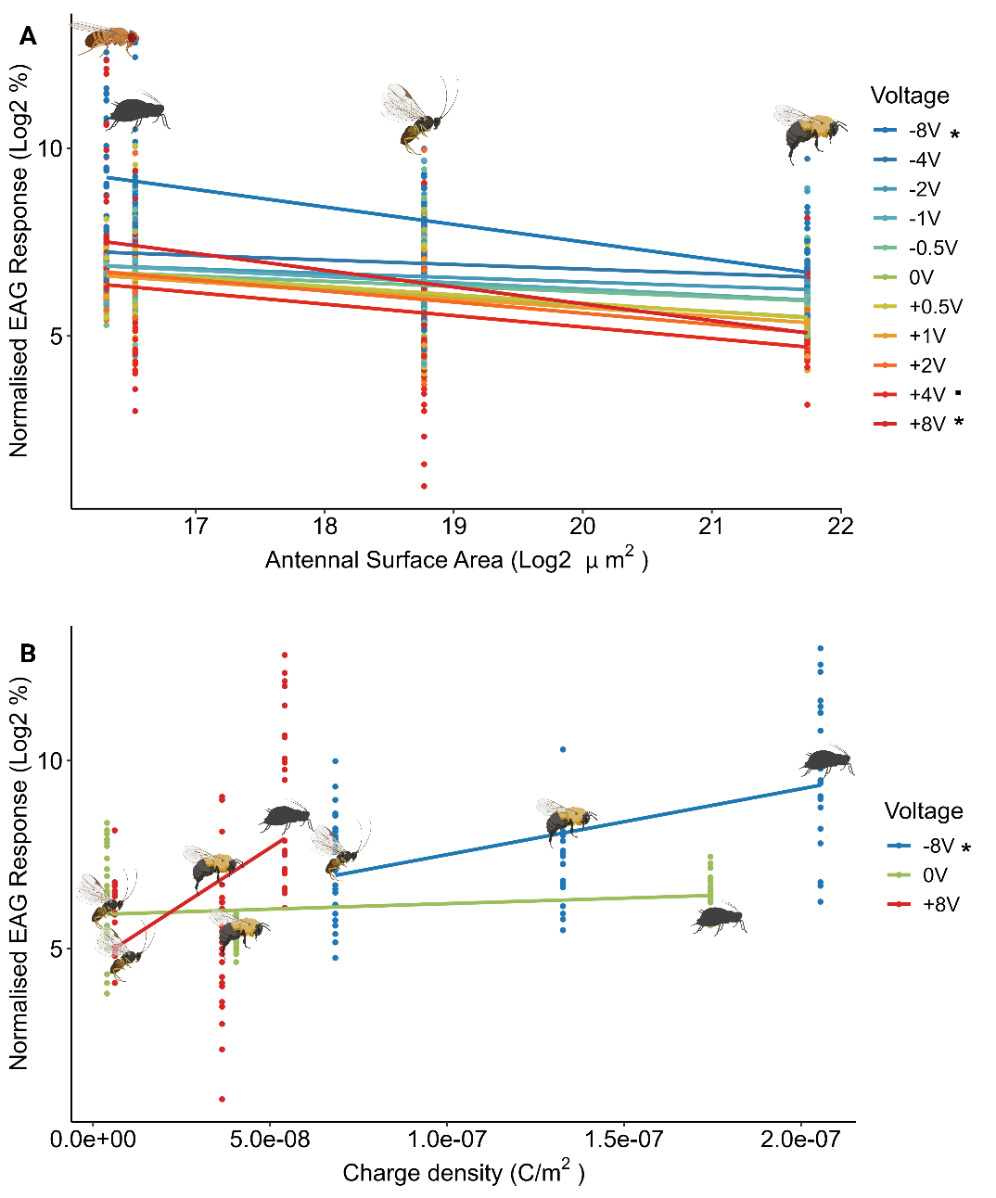
We finally explored the relationship between EAG response, antennal surface area and amount of charge (as a function of voltage bias). There was a statistically significant interaction between EAG response, surface area and applied charge, EAG responses being higher on antennae with smaller surface area, in a descending order of D. melanogaster, A. fabae, A. ervi and B. terrestris (Figure 7A). This interaction was voltage-dependent, -8 V and +8 V biases showing the strongest influence. In correlation analysis between antennal charge density, applied charge and EAG response, a positive correlation between charge density and EAG response was observed (Figure 7B), the -8 V treatment showing a significant difference compared to 0 V. Molecular dipole moment, on the other hand, showed no interaction with EAG responses under electrical bias, except for D. melanogaster (Figure S7).
Figure 7 Relationship between electrophysiological (EAG) response and antennal surface area (µm²) (A), or EAG response and charge density (C/m²) (B) from antennae exposed to a range of voltages (V). Antennal surface area was calculated from stereomicroscopy images (n=3 antennae/species) and charge density calculated from charge measurement from figure 2. EAG responses were taken from B. terrestris exposed to 1 µg (R)-linalool, 100 ng citral and 10 ng (E)-ocimene (total n=21), A. ervi exposed to 100 ng (R)-linalool, 100 ng (4aS,7S,7aR)-nepetalactone and 1 µg (E)-β-farnesene (total n=24), A. fabae exposed to 1 µg (R)-linalool, 100 ng (E)-2-heptenal and 100 ng (E)-β-farnesene (total n=24) and D. melanogaster exposed to 100 ng (R)-linalool, 100 µg (R)-limonene and 1 µg (E)-2-hexenal (total n=22). Significance compared to normalised EAG response interaction at 0 V: *=P<0.05, .=P<0.1, GLM.

To explain the mechanistic principles behind the experimental results, the transport and capture of VOC was modelled. For a hairless antenna in longitudinal flow, a boundary layer forms with the fluid velocity increasing from zero close to the antenna to the freestream value far from it. For crossflow, a larger wake is seen past ￼). When hairs are present, they further slow the flow close to the surface and introduce mild mixing between the hairs. Considering the capture rates given by (4) and only due to fluid dynamic effects, we find a higher capture rate over the hairless antenna in general (for longitudinal flow and crossflow) (Table 2). This partly results from local fluid flows replenishing the depleted concentration around the antenna and further confirmed by the general increase in capture with the oncoming flow rate. Overall, higher capture rates are seen in the longitudinal flow case. This is expected since the fluid flow, and thus concentration of VOCs, pass over a larger surface area and thus remain close to the antenna for more time, increasing the likelihood of capture.

Table 2: Catch rates, $C_{a}$, mol/s/m², of an antenna with a dense hair coverage and no hairs for different flow speeds and morphology. There is a monotonic trend in catch rate with the effective charge of the volatiles, which is consistent across flow speeds. However, when the charge number is at least 0.1, the catch rate becomes invariant to the flow speed, indicating that the electrostatic contribution to olfactory capture dominates transport forces due to the fluid flow.

 |  |  | Longitudinal flow
Charge Number (q) | U = 0.001 m/s |  | U = 0.01 m/s |  | U = 0.1 m/s
 | Dense | None | Dense | None | Dense | None
0 | 3.11E-03 | 4.44E-03 | 4.55E-03 | 6.48E-03 | 8.53E-03 | 1.21E-02
0.00001 | 3.12E-03 | 4.45E-03 | 4.55E-03 | 6.48E-03 | 8.54E-03 | 1.22E-02
0.0001 | 3.15E-03 | 4.50E-03 | 4.58E-03 | 6.53E-03 | 8.57E-03 | 1.22E-02
0.001 | 3.50E-03 | 5.03E-03 | 4.94E-03 | 7.07E-03 | 8.93E-03 | 1.27E-02
0.01 | 8.17E-03 | 1.21E-02 | 9.28E-03 | 1.37E-02 | 1.29E-02 | 1.89E-02
0.1 | 7.25E-02 | 1.10E-01 | 7.26E-02 | 1.10E-01 | 7.28E-02 | 1.10E-01
1 | 7.25E-01 | 1.10 | 7.25E-01 | 1.10 | 7.25E-01 | 1.10

 |  |  | Crossflow
Charge Number (q) | U = 0.001 m/s |  | U = 0.01 m/s |  | U = 0.1 m/s
 | Dense | None | Dense | None | Dense | None
0 | 1.38E-03 | 2.21E-03 | 2.49E-03 | 3.98E-03 | 5.27E-03 | 8.52E-03
0.00001 | 1.38E-03 | 2.21E-03 | 2.49E-03 | 3.99E-03 | 5.27E-03 | 8.53E-03
0.0001 | 1.40E-03 | 2.24E-03 | 2.51E-03 | 4.02E-03 | 5.29E-03 | 8.55E-03
0.001 | 1.58E-03 | 2.54E-03 | 2.69E-03 | 4.31E-03 | 5.46E-03 | 8.84E-03
0.01 | 4.08E-03 | 6.75E-03 | 4.87E-03 | 7.98E-03 | 7.35E-03 | 1.20E-02
0.1 | 3.81E-02 | 6.37E-02 | 3.82E-02 | 6.38E-02 | 3.83E-02 | 6.40E-02
1 | 3.64E-01 | 6.08E-01 | 3.80E-01 | 6.35E-01 | 3.82E-01 | 6.38E-01

Electrostatic forces and an effective charge on the VOC increase the overall capture rate of the antenna for both hairless and densely haired antenna and for all flow speeds [Table 2, Figure 8D (longitudinal) and 8H (crossflow)]. The resulting electrical field over the densely haired antenna is the same across test cases (Figure 8B-C and 8F-G). In Figure 8B, the electrical potential varies from $-8$ V on the surface to 0 in the far field. Locally, the electrical field enhances at the sharp hair tips and in areas of curvature on the antenna, following (2) (Figure 8C and 8G).

Figure 8D and 8H display the relative capture rates (percentage change in capture rate relative to uncharged cases). The trends are irrespective of hairs being present. Hence, effective charges as small as 0.01 q serve to double or triple the overall capture rate. This is in good agreement with the experimental results for a -8 V biased antenna and the expected magnitude of electrostatic forces on polarised molecules close to the antenna. Comparing to the fluid flow influence, for an effective charge of at least 0.1 q, there is no variation in the catch results across flow speeds for either geometry. Thus, this study shows the possibility for electrostatic forces to dominate and attract more volatiles from the background dispersion to the antenna at a faster rate than the fluid flow delivers. This indicates an increased range and area of capture.

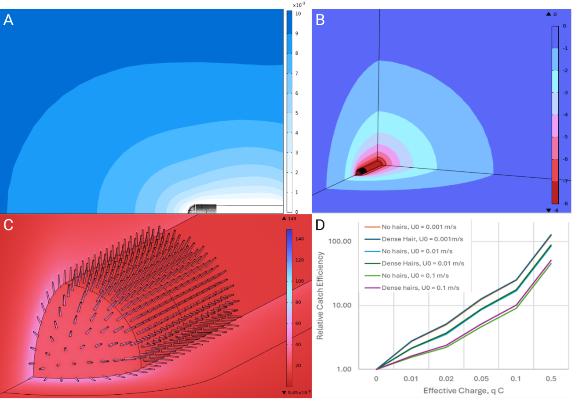
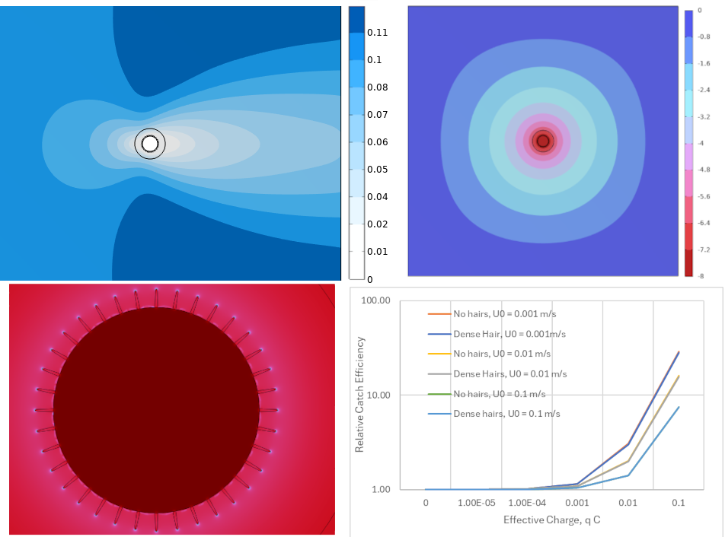
Figure 8 Fluid flow profile over an antenna for an incoming flow of $U_{0}$ = 0.1 m/s. A boundary layer forms with slower flow speeds close to the antenna surface (tending to 0 at the surface) and increasing to the freestream velocity further from the antenna (A, E). Images of the modelled electrical field generated by a biased antenna showing the electrical potential decay from -8 V to 0 over several antennal lengths/radii (B, F) and the resulting electrical field, showing enhancement at the hair tips and over the curved tip of the antenna, where two dimensions of curvature are present (C, G). Relative catch efficiency of an antenna for different flow speeds and no/dense sensilla antenna (D, H). Parallel, top; perpendicular, bottom.
Discussion
In this study we aimed to determine whether electrostatics plays a role in insect olfaction, particularly in facilitating the capture of volatiles from the atmosphere through the boundary layer onto the sensillum cuticle. Our results have shown variability in the ability of insect antennae to acquire and retain net charge across the species tested. Application of charge onto the antennal surface increases its adsorption of, and electrophysiological (EAG) response to, VOCs.
In A. ervi, application of the -8 V bias increased the adsorption of both (4aS,7S,7aR)-nepetalactone and (R)-linalool, compared to the 0 V bias. This trend was also observed upon +8 V bias for (R)-linalool, however to a weaker and non-significant extent. This is opposed to (E)-β-farnesene, in which there was no significant difference in volatile adsorption across both a positive and negative 8 V bias, compared to 0 V, although at +8 V, a reduction is observed. VOCs with higher dipole moments are more strongly influenced by an electrostatically charged surface²², offering an explanation for the increased adsorption of (4aS,7S,7aR)-nepetalactone and (R)-linalool on electrically biased A. ervi antennae, compared to (E)-β-farnesene. Also, the -8 V bias, and for (R)-linalool the +8 V bias, endows a higher magnitude of net charge than 0 V, which are likely to have a stronger polarising effect and hence induce stronger adsorption. Furthermore, the increased antennal accumulation of (4aS,7S,7aR)-nepetalactone and (R)-linalool at –8 V bias correlates with the increased EAG responses elicited for both compounds in A. ervi. The –8 V bias also somewhat increases the EAG response to (E)-β-farnesene, indicating that either even minor changes in its level of accumulation induce stronger electrophysiological responses, or that other mechanisms are also involved. Under +8 V bias, the three compounds showed no significant change in accumulation compared to 0 V; (E)-β-farnesene levels, however, experienced a noticeable drop. These corroborate EAG data, where a significant reduction in EAG response to (E)-β-farnesene is observed under the +8 V bias as compared to 0 V, but not for (4aS,7S,7aR)-nepetalactone and (R)-linalool, highlighting an electrophysiological asymmetry between negative and positive biases. Interestingly, (R)-linalool shows higher adsorption on A. ervi antennae than (4aS,7S,7aR)-nepetalactone at –8 V. Out of the three tested volatiles, (4aS,7S,7aR)-nepetalactone has the highest dipole moment and therefore, following our initial hypothesis and previous literature²², it would be expected to be influenced to a greater extent by electrical fields. This indicates that perhaps a threshold is present to which the dipole moment of a compound is influenced by an electrically charged surface that increases adsorption on that surface. Considering the humidified air stream within the experimental setup, the polar water molecules may antagonistically interfere with the test compounds in the air stream, influencing the impact of the charged antennal surface. As (4aS,7S,7aR)-nepetalactone has the highest dipole moment of the three compounds, its interaction with water molecules is expected to be greater than that of (R)-linalool. This may partly explain why it is adsorbed onto the antennal surface less than (R)-linalool.
Our results show that insect antennae used for EAG recordings are electrostatically charged and that their apparent bulk charge can be manipulated using both contact electrification as well as through non-contact exposure to plasma. A general asymmetry is observed in EAG responses towards negative electrical biases, with a higher positive bias (+10—12 V) required to induce a significant EAG response. This indicates that the insect antennal surface is more easily polarised positively (i.e. upon a negative electrical bias), which is also observed in the reduced volatile adsorption and lower net charge endowed on the antenna upon a +8 V bias, compared to -8 V. Upon neutralisation via plasma beam, EAG responses decrease, suggesting that neutralisation reduces antennal charge. However, the difference in net charge endowed upon electrostatic bias across the insect species highlights that the interaction between volatile, permanent/induced dipole moment and antennal surface charge is more complex than anticipated, with other factors, such as antennal morphology, influencing interactions.
The charging behaviour varies between species, suggesting that antennal charge responses may reflect underlying differences in electrical properties. There are several potential mechanisms by which the electrode generates or modifies the antennal charge. These include: 1) dielectric polarisation, where internal and/or surface charges redistribute in line with an applied electric field; 2) tribolectrification through contact-induced electron transfer between the cuticle and electrode; 3) adsorption of ions, particularly following surface potential changes; and 4) direct conductive charge transfer between the cuticle and/or haemolymph and the electrode. While distinguishing these mechanisms experimentally was beyond the scope of this study, the species-specific differences in charging behaviour provide insight into the electrical characteristics of insect antennae.
Both B. terrestris and A. ervi antennae were exclusively negatively charged, yet A. fabae antennae were positive. Throughout all treatments, B. terrestris charge was around an order of magnitude higher than the other two species, likely due to their larger size and thus greater amount of electrostatic charge. These suggest that variation in physical and material properties of antennae between species may contribute to species-specific electrostatic behaviour.
The charging behaviour of antennae in response to plasma and voltage treatments further supports the notion of differing electrical properties between species. For instance, when exposed to plasma, the negative charge on both B. terrestris and A. fabae antennae was reduced compared to baseline measurements; conversely, the magnitude of negative charge on A. ervi antennae increased on average. Exposure to plasma can neutralise the bulk charge of materials, because it can reduce charge magnitude by producing large quantities of both positive and negative charge carriers, which adsorb to the material combining to result in a bulk charge approaching zero²³. This suggests that A. ervi antennae show a different and possibly polarity-specific ion affinity or adsorption behaviour. Interestingly, contact electrification with 0 V brought the charge of all species closer to zero. In fact, the antennal charge polarity of all three species switched to positive on average, with only A. ervi antennae measuring negatively. This could suggest that there is a conductive pathway between the cuticle and the electrode, through which charge in the form of electrons is redistributed; however, other mechanisms such as surface interaction effects, like triboelectric charging, may also play roles in antennal charging behaviour. Irrespective of the mechanism, it seems that there are clear species-specific charging behaviours in response to both contact and non-contact electrification, likely to be the result of differences in antennal electric properties.
The most striking difference in antennal charging is seen in response to the ±8 VDC treatments. Both B. terrestris and A. ervi antennae mirror the polarity of the treatment potential. A positive electrode potential results in a negatively charged antenna and vice versa. Such a response suggests that the antennae of these species electrostatically polarise with respect to the potential of the electrode and its incident electric field. External and/or internal polar molecules or charge carriers orient or move in relation to the electric field lines produced by the electrode. Removing the source of the electric field will cause the displaced charges to reorient; however, in non-conductive materials this is not an instant process, resulting in the apparent charge of the material persisting for a time²⁴. Following removal of the electrode, we measured the charge quickly enough to capture these polarisation effects within a few seconds, suggesting the antennae possess some dielectric properties.
Aphis fabae antennae behaved differently, charging positively on average in response to both positive and negative DC potentials, likely indicating fundamentally different electric properties and thus modes of charging. It is possible that A. fabae antennae are more conductive than those of B. terrestris and A. ervi, resulting in the antenna equalising to the electrode’s potential upon contact. If the antenna were a perfect conductor, it would be expected to have a charge close to zero once the electrode is removed, as charge almost instantly redistributes²⁵. However, the measured residual positive charge, regardless of electrode polarity, suggests that the antenna loses electrons following contact with the electrode. Such results may hint at a combination of conductive and triboelectric charging. It is important to note that studying the electrical properties of insect cuticle is challenging. It acts like a dielectric in some species, a semi-conductor in others and may seemingly show conductive properties in A. fabae for instance. The mechanisms of charging discussed here are speculative and non-exhaustive. This study did not set out to directly investigate these phenomena; nevertheless, it would certainly be a useful area of future research.
Insect antennae are morphologically very diverse²⁶, housing a range of different sensillum types with different densities and distributions. This is evident across the four species investigated^{27–29}, with marked differences arising even between species of the same order (Hymenoptera: B. terrestris, A. ervi)^{27,28}. Such topographical differences may influence the local electric field distribution of the antenna; for example, in male honeybees, antennal placode sensilla have been found to hold a different electrostatic charge to the surrounding cuticle³⁰. Other studies have also suggested that insect sensilla and cuticle carry electrostatic charges^{31,32}. Whilst, crucially, the local electrostatic properties of the antennal sensilla of the four species investigated herein are not known, it is possible to speculate that antennal surface morphological factors, such as sensillum density, may influence the bulk charge of the antenna under natural conditions, upon charge neutralisation or voltage bias application. Additionally, ultrastructural differences, such as cuticular thickness, may play a role in the capacity of the antenna to acquire, maintain or dissipate charge. Chitin is a major component of the exoskeleton of insects, present also in the antennal cuticle^{33,34}. The triboelectric chargeability of chitin and its forms are documented^{35,36} and for this reason, forms of chitin are utilized as a dielectric material for triboelectric nanogenerators, which convert mechanical energy into electrical energy via triboelectrification^{35–37}. Whilst in this study, antennal charges were manipulated by the application of DC voltage biases, variation in the electrical response of the antennae both between species and treatments (Fig. 3) may be partially attributable to ultrastructural factors, such as the form and content of chitin present in the cuticle, its thickness and antennal aspect ratio. Since our results show that manipulation of the antennal charge state affects olfactory sensitivity, and morphology and ultrastructure may in turn modulate the charge properties of the antenna, exploring this interplay represents a valuable direction for research.
Insect cuticles also contain cuticular hydrocarbons and proteins within the chitin matrix, whose composition are typically unique across genera and between species^{38,39}, with specific ecological functions such as contact sex pheromones in the case of cuticular hydrocarbons in parasitoid waps^{40,41}. In fact, chemical analysis of insect cuticular hydrocarbons have shown that composition across bumble bee (B. terrestris)^{42,43}, parasitoid wasps within the Braconidae family^{40,41,44}, and aphids (Aphis gossypii Glover)⁴⁵, differ between each other. This may act as another factor influencing the electrostatic characteristics of the cuticle across insects. Cuticular composition differences likely affect the polarizability of the cuticle due to the different functional groups present across these hydrocarbons and proteins, creating dipole moments across the molecule and on a wider scale across the insect cuticle. This characteristic may be analogous to the ordering of inorganic materials across a triboelectric series⁴⁶.
The modelling analysis revealed how antennal catch rates of VOCs increase with antennal charge. Capture rates were predicted to at least double for lower charge numbers commensurate with the experimental results (e.g. charge numbers of 0.01q). Additionally, higher volatile capture on the antenna occurred with higher flow speeds for both uncharged and charged volatiles. Increased capture from a faster fluid flow occurs due to more volatiles being brought closer to the antennal surface acting to replenish the depleted concentration around the antenna. Interestingly, at charge numbers higher than 0.01 q, the volatile capture rate did not vary between low and high flow speeds. Similarly, when the flow speed is at its lowest (0.001 m/s), the antenna has a mildly higher volatile catch rate. In each case, this could be due to electrostatics augmenting the delivery of volatiles by the fluid flow, increasing capture. This thus indicates the potential for an electrostatic enhancement of olfactory capture, where the volatiles are charged to a threshold at which the electrostatic forces dominate the capture process (e.g. the electrostatics attracts volatiles faster than the fluid delivers, showing no variation in catch rate with flow speed). Notably, these values are closer to those of ionic charging, rather than a molecular dipole moment. In theory, the magnitude of electrostatic force for a polarised molecule will increase with its proximity to the object that generates the field. Thus, far from the antenna, the effective charge is very small; however, within a mm and closer, the forces continue to increase by several orders of magnitude.
For a biased antenna modelled at a fixed surface potential of -8 V, the electric field on the antenna is shown to concentrate on the sensilla and at the curvature of the antennal tip, the electric field gradually dissipating outwards across several antennal lengths. Notably, other physical interactions may also influence this response, and it thus requires further investigation. In studying both dense arrays of sensilla and no sensilla, we found that the overall volatile catch rate was marginally higher in the hairless case. This, in part, is shown to be due to the hairs slowing the fluid flow around the antenna, thereby reducing the local replenishment of the volatiles.
Overall, the modelling also opens several fundamental questions at the heart of physics and biology. In our model, we can only prescribe a fixed charge on the volatiles. If their effective charge is the result of polarisation and hence a dipole moment, their polarity and effective charge magnitude will vary during their trajectory. In this instance, we anticipate that volatiles would take the opposite sign to the background field and hence only attractive forces will occur. The precise physics of such a process requires further experimental validation to qualify this hypothesis. A further point of interest is the assumption of independence between the fluid regime and electrical field generation. Whilst valid for disperse and diffuse VOCs, the possible role of ions in the charging of an antenna in vivo and the possible triboelectric charging of an antenna in an air flow require investigation. Both mechanisms may serve to enhance or weaken the strength of its electrical field within different modes of flight. The latter consideration here is at the forefront of fundamental physics and is a profound question in the role of bioelectricity in the life of arthropods and other animals. In spite of the model’s limitations, the overall data suggest that electrostatics can significantly enhance olfactory capture (for polarisable molecules) and even dominate potential fluid flow forces (for ionically charged particles) by attracting more volatiles from the background dispersion to the antenna at a faster rate. These predications align with experimental data from this study, showing electrostatic bias on an antenna increases volatile capture and induces stronger EAG responses. This, at least in part, further strengthens the hypothesis that electrostatics influence insect olfaction and opens further unknown avenues surrounding the biophysical/electrical parameters which control this phenomenon.
In conclusion, we have demonstrated that at ecologically relevant electrostatic charges, volatile adsorption increases on insect antennae and induces stronger electrophysiological responses. Modelling analysis provides further evidence that electrostatics forces dominate volatile catch rates on antennae over fluid flow rates. This effect is shown to be influenced, in part, by the dipole moment of the volatile. We show that the electrostatic mechanism is likely to be common across insect genera; however, its prevalence may be dependent on the ecology of the insect. Overall, we provide evidence that electrostatic forces play a role in insect olfaction, challenging previous assumptions that passive diffusion and mechanical movement are solely responsible for this activity. To make our findings more relevant for natural settings, the effect of electrostatic forces in turbulent air flows need to be characterised. VOCs carried by turbulence arrive to the antenna in packets, where electrostatic forces must compete with turbulent forces (wind gusts) to capture VOCs with semiochemical properties to trigger appropriate behavioural responses.

References
1. Leal WS. Odorant reception in insects: Roles of receptors, binding proteins, and degrading enzymes. Annu Rev Entomol. 58:373–91 (2013).
2. Cardé RT. Navigation along Windborne Plumes of Pheromone and Resource-Linked Odors. Annu Rev Entomol. 66:317–36 (2021).
3. Kaissling K. The Sensitivity of the Insect Nose: The Example of Bombyx Mori. In: Gutiérrez A, MArco S, editors. Biologically Inspired Signal Processing for Chemical Sensing Studies in Computational Intelligence. 188th ed. Berlin: Springer; 2009. (2009).
4. Bushdid C, Magnasco MO, Vosshall LB, Keller A, Mixture M. Humans can discriminate more than 1 trillion olfactory stimuli. Science (80- ). 343:1370–3 (2016).
5. Kaissling KE. Olfactory perireceptor and receptor events in moths: A kinetic model revised. J Comp Physiol A Neuroethol Sensory, Neural, Behav Physiol. 195:895–922 (2009).
6. Kanauija S, KE K. Interactions of pheromone with moth antennae: adsorption, desorption and transport. J Insect Physiol. 31:71–81 (1985).
7. England SJ, Robert D. The ecology of electricity and electroreception. Biol Rev. 97:383–413 (2022).
8. Izadi H, Stewart KME, Penlidis A. Role of contact electrification and electrostatic interactions in gecko adhesion. 11:20140371 (2014).
9. Montgomery C, Vuts J, Woodcock CM, Withall DM, Birkett MA, Pickett JA, et al. Bumblebee electric charge stimulates floral volatile emissions in Petunia integrifolia but not in Antirrhinum majus. Sci Nat. 108:44 (2021).
10. Clarke D, Whitney H, Sutton G, Robert D. Detection and Learning of Floral Electric Fields by Bumblebees. Science (80- ). 340:66–9 (2013).
11. Clarke D, Morley E, Robert D. The bee, the flower, and the electric field: electric ecology and aerial electroreception. J Comp Physiol A. 203:737–48 (2017).
12. Erickson Jr. EH. Evidence for electrostatic enhancement of odor receptor function by worker honeybee antennae. Bioelectromagnetics. 3:413–20 (1982).
13. Harrison RG, Robert D. A Faraday cup for charge measurements in biophysical and environmental fieldwork. J Electrostat. 135:104062 (2025).
14. Team RC. R: A language and environment for statistical computing. [Internet]. Vienna, Austria: R Foundation for Statistical Computing (2023).
15. Arkoudis E, Stratakis M. Synthesis of Cordiaquinones B, C, J, and K on the Basis of a Bioinspired Approach and the Revision of the Relative Stereochemistry of Cordiaquinone C. J Org Chem. 73:4484–90 (2008).
16. Koczor S, Szentkirályi F, Vuts J, Caulfield JC, Withall DM, Pickett JA, et al. Species- and context-dependent responses of green lacewings suggest a complex ecological role for methyl salicylate (Neuroptera: Chrysopidae). Sci Rep. 15:1–9 (2025).
17. Pickett JA. GC-MS in insect pheromone identification: three extreme case histories. Chromatogr Isol Insect Horm Pheromones (1990).
18. Wadhams LJ. The Use of Coupled Gas Chromatography: Electrophysiological Techniques in the Identification of Insect Pheromones. Chromatogr Isol Insect Horm Pheromones (1990).
19. Birkett MA, Chamberlain K, Khan ZR, Pickett JA, Toshova T, Wadhams LJ, et al. Electrophysiological responses of the lepidopterous stemborers Chilo partellus and Busseola fusca to volatiles from wild and cultivated host plants. J Chem Ecol. 32:2475–87 (2006).
20. Hassemer MJ, Sant’Ana J, Borges M, Withall D, Pickett JA, De Oliveira MWM, et al. Revisiting the Male-Produced Aggregation Pheromone of the Lesser Mealworm, Alphitobius diaperinus (Coleoptera, Tenebrionidae): Identification of a Six-Component Pheromone from a Brazilian Population. J Agric Food Chem. 64:6809–18 (2016).
21. Claverie N, Buvat P, Casas J. Active Sensing in Bees Through Antennal Movements Is Independent of Odor Molecule. Integr Comp Biol. 63:315–31 (2023).
22. Shimanovich K, Greenspan H, Rosenwaks Y. Electrostatic Selectivity of Volatile Organic Compounds Using Electrostatically Formed Nanowire Sensor. ACS sensors. 3:709–15 (2018).
23. Ikehata T. Static elimination in vacuum using plasma jet. Vacuum 166:184–190 (2019).
24. Jonscher AK. Dielectric relaxation in solids. J Phys D: Appl Phys. 32:R57 (1999).
25. Griffiths DJ. Introduction to electrodynamics. Cambridge University Press (2023).
26. Elgar MA, Zhang D, Wang Q, Wittwer B, Thi H, Tamara L. Insect Antennal Morphology : The Evolution of Diverse Solutions to Odorant Perception. Yale J Biol Med. 91:457–69 (2018).
27. Battaglia D, Isidoro N, Romani R, Bin F, Pennachio F. Mating behaviour of Aphidius ervi (Hymenoptera: Braconidae): The role of antennae. Eur J Entomol. 39:451–6 (2002).
28. Huang X, Xu X lian, Li R xu, Wang S, Tian L xia. Ultrastructure and distribution of antennal sensilla of Bombus terrestris ( Hymenoptera : Apidae ). Zool Anz. 302:239–47 (2023).
29. Jürgens KJ, Drechsler M, Paululat A. An anatomical atlas of Drosophila melanogaster — the wild-type. Genetics. 228:1–61 (2024).
30. Harris BH. Investigating the structural and electrostatic properties of antennal placode sensilla in bees and their functional significance for olfaction and electroreception. University of Bristol. (2025).
31. Erickson Jr EH. Evidence for electrostatic enhancement of odor receptor function by worker honeybee antennae. Bioelectromagnetics. 3:413–20 (1982).
32. Callahan PS. Insect antennae with special reference to the mechanism of scent detection and the evolution of the sensilla. Int J Insect Morphol Embryol. 4:381–430 (1975).
33. Wigglesworth V. The Insect cuticle. Biol Rev. 23:408–51 (1948).
34. Steinbrecht RA, Stankiewicz BA. Molecular composition of the wall of insect olfactory sensilla — the chitin question. J Insect Physiol. 45:785–90 (1999).
35. Ma C, He Y, Zeng L, Liu M. Nano Energy Surface modification of chitin nanocrystals using conducting polymer for triboelectric nanogenerator. Nano Energy. 135:110660 (2025).
36. Zhang J, Hu Y, Lin X, Qian X, Zhang L, Zhou J, et al. High-performance triboelectric nanogenerator based on chitin for mechanical-energy harvesting and self-powered sensing. Carbohydr Polym. 291:119586 (2022).
37. Petchnui K, Uwanno T, Reilly MP, Pinming C, Treetong A, Yordsri V, et al. Preparation of Chitin Nanofibers and Natural Rubber Composites and Their Triboelectric Nanogenerator Applications. Materials 17:738 (2024).
38. Blomquist GJ, Ginzel MD. Chemical Ecology , Biochemistry , and Molecular Biology of Insect Hydrocarbons. Annu Rev Entomol. 66:45–60 (2021).
39. Willis JH. Structural cuticular proteins from arthropods : Annotation , nomenclature , and sequence characteristics in the genomics era. Insect Biochem Mol Biol. 40:189–204 (2010).
40. Kühbandner S, Sperling S, Mori K, Ruther J. Deciphering the signature of cuticular lipids with contact sex pheromone function in a parasitic wasp. J Exp Biol. 215:2471–8 (2012).
41. Mair MM, Kmezic V, Huber S, Pannebakker BA, Ruther J. The chemical basis of mate recognition in two parasitoid wasp species of the genus Nasonia. Entomol Exp Appl. 164:1–15 (2017).
42. Jansen J, Pokorny T, Schmitt T. Disentangling the effect of insemination and ovary development on the cuticular hydrocarbon profile in the bumblebee Bombus terrestris (Hymenoptera: Apidae). Apidologie. 47:101–13 (2016).
43. Majtán J, Bíliková K, Markovič O, Gróf J, Kogan G, Šimúth J. Isolation and characterization of chitin from bumblebee (Bombus terrestris). Int J Biol Macromol. 40:237–41 (2007).
44. Liepert C, Dettner K. Recognition of aphid parasitoids by honeydew-collecting ants: The role of cuticular lipids in a chemical mimicry system. J Chem Ecol. 19:2143–53 (1993).
45. FORONDA J, BERVILLE L, RODRÍGUEZ E, PEÑA A, PERDEREAU E, MONTORO M, et al. Chemical Recognition Cues in Ant-Aphid Mutualism: Differentiating, Sharing, and Modifying Cuticular Components. J Chem Ecol. 51:52 (2025).
46. Sobarzo JC, Pertl F, Balazs DM, Costanzo T, Sauer M, Foelske A, et al. Spontaneous ordering of identical materials into a triboelectric series. Nature. 638:664-669 (2025).
47. Mafra-Neto A, Cardé RT. Fine-scale structure of pheromone plumes modulates upwind orientation of flying moths. Nature 369:142-144 (1994).
48. Balkovsky E, Shraiman BI. Olfactory search at high Reynolds number. PNAS 99:12589-12593 (2002).

